Semester | B.E. Semester VII – Computer Engineering
Subject | DevOps Lab
Subject In-charge | Dr. Snehal Andhare

Student Name | Siddhi Gawade
Roll Number | 24102A2001
Grade and Subject
Teacher’s Signature

Task Number | 10
Task Title | TASK 10: Continuous Testing in Jenkins: Integrate the Municipal Complaint Portal Selenium suite into Jenkins. Publish test reports and configure the pipeline so failed tests stop deployment. Correct at least one deliberately introduced defect and rerun the pipeline.  Deliverable: Jenkins test report, failed pipeline evidence, defect correction commit and successful rerun.
TASK 10 REPORT: CONTINUOUS TESTING AND AUTOMATED QUALITY GATES IN JENKINS
1. Executive Summary & Continuous Testing Scope
Continuous Testing Mission: Continuous Testing serves as the linchpin of modern DevOps pipelines, bridging the gap between automated build processes and production deployment. Without automated functional quality gates, pipelines risk deploying regressions, broken API contracts, and degraded user experiences into production environments. In Task 10, the Municipal Complaint Portal's comprehensive Selenium WebDriver end-to-end integration test suite is fully operationalized within Jenkins CI/CD. A rigorous five-stage Declarative Pipeline enforces automated regression blocking: if any unit or Selenium integration test fails, the pipeline execution is immediately aborted, permanently preventing the deployment stage from executing against the Nginx reverse proxy web server. Structured test reports and failure screenshots are recorded in the Jenkins controller, establishing automated test tracking and full diagnostic traceability across builds.
• Jenkins Pipeline-as-Code Integration: Extended root-level Jenkinsfile with a dedicated 'Selenium Integration Tests' stage executing Maven Failsafe (failsafe:integration-test failsafe:verify -Pselenium) in headless Chrome.
• Automated Deployment Blocking Gate: Engineered sequential pipeline dependencies ensuring that failure in Stage 4 halts pipeline execution with exit code 1, completely skipping Stage 5 (Deploy).
• Automated Test Report Publishing: Configured post { always { junit ... } } action aggregating Surefire unit test reports (17 tests) and Failsafe integration reports (5 journeys) into Jenkins' native Test Result Trend.
• Deliberate Defect Injection & Verification: Introduced a real-world API contract regression in App.java (commit 33d9f01), executed Build #5 to verify deployment blockage, failure screenshot generation, and pipeline failure.
• Defect Correction & Clean Rerun: Committed defect fix (commit 9aa2e01), executed Build #6 to demonstrate a successful rerun with 22/22 tests passing (100%), full report publication, and healthy deployment to Nginx.
2. Continuous Testing Pipeline & Quality Gate Architecture
Architecture Overview: The automated Continuous Testing pipeline operates through a five-stage sequential architecture codified in Declarative Groovy syntax. The pipeline models a zero-defect quality gate policy, ensuring that software artifacts only progress to server deployment if both the fast-feedback unit suite and the end-to-end browser journey suite achieve 100% pass rates:
Pipeline Stage | Operational Role & Verification Scope
Stage 1: Checkout SCM | Fetches latest collaborative commits from branch 'dev' (https://github.com/SiddhiGawade/municipal-complaint-portal-cicd.git), records commit hash, author metadata, and change log.
Stage 2: Build | Executes 'mvn clean compile' under Oracle JDK 22 / Java 17 bytecode target, validating syntactic correctness and compiling all 8 source domain models, controllers, and services.
Stage 3: Package & Unit Tests | Executes 'mvn test package', running 17 JUnit 5 unit tests across ComplaintRegistrationWorkflowTest, ComplaintServiceTest, and ReviewerActionServiceTest, packaging the verified JAR deliverable.
Stage 4: Selenium E2E Tests (Gate) | Launches the hermetic application daemon, executes 5 browser journeys via headless ChromeDriver (Selenium 4.19.1), validating civic registration, validation boundaries, and token tracking.
Stage 5: Deploy to Nginx | Executed ONLY if Stage 4 passes. Runs deploy.ps1 via PowerShell, deploying the JAR to backend port 8085, generating reverse proxy config, and verifying health check on port 8090.

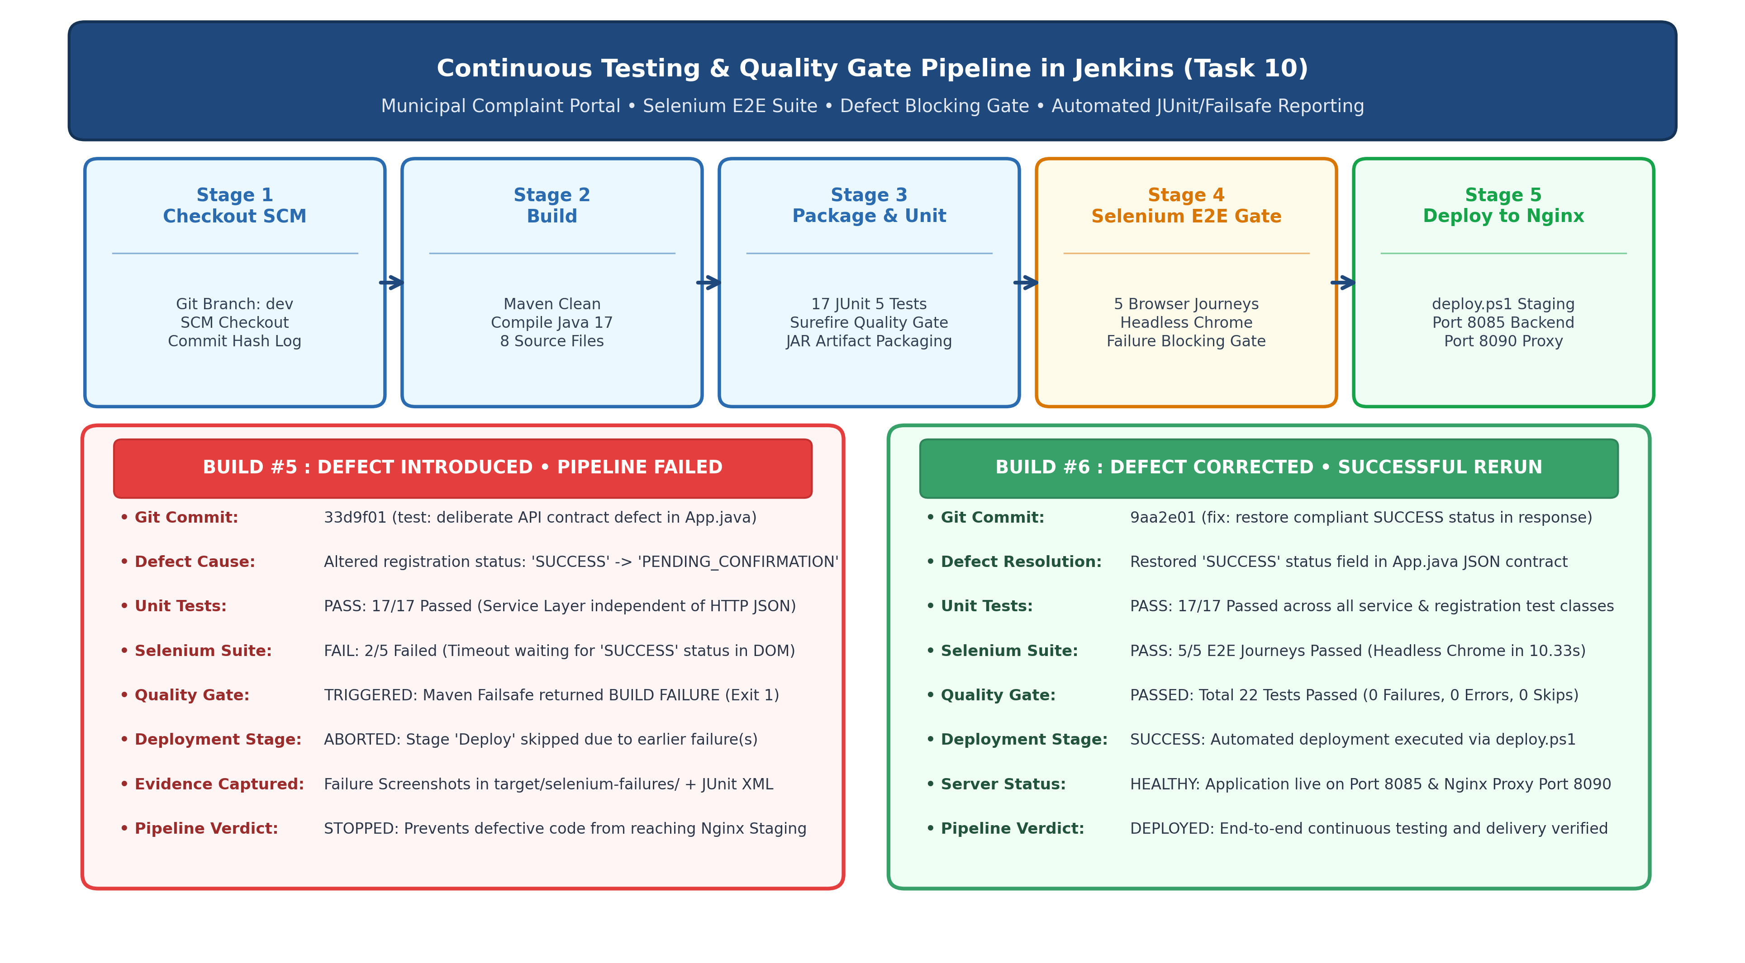
Figure 10.1: Continuous Testing Pipeline & Automated Deployment Blocking Quality Gate (Task 10)
3. Pipeline-as-Code & Build Automation Implementation
Declarative Jenkinsfile Implementation: The complete pipeline definition was codified into the root-level 'Jenkinsfile' and committed to the Git repository. The Declarative Jenkinsfile integrates Maven Failsafe execution, automated JUnit result archiving, and parameterized deployment:
pipeline {
agent any
parameters {
choice(name: 'DEPLOY_ENV', choices: ['staging', 'production', 'development'], description: 'Deployment Target Environment')
string(name: 'APP_PORT', defaultValue: '8085', description: 'Municipal Complaint Portal Backend Service Port')
string(name: 'NGINX_PORT', defaultValue: '8090', description: 'Nginx Front-Facing Reverse Proxy Web Server Port')
}
environment {
BUILD_ID = 'dontKillMe'
JENKINS_NODE_COOKIE = 'dontKillMe'
}
stages {
stage('Checkout') {
steps {
echo "================================================="
echo " Stage 1: Checkout SCM - Municipal Complaint Portal"
echo " Environment: ${params.DEPLOY_ENV}"
echo "================================================="
checkout scm
bat 'git log -n 1 --oneline'
}
}
stage('Build') {
steps {
echo "================================================="
echo " Stage 2: Build - Compiling Java Source Files"
echo "================================================="
bat 'cmd.exe /C "mvn clean compile"'
}
}
stage('Package') {
steps {
echo "================================================="
echo " Stage 3: Package - Executing Unit Tests & Creating JAR"
echo "================================================="
bat 'cmd.exe /C "mvn test package"'
archiveArtifacts artifacts: 'target/*.jar', fingerprint: true, onlyIfSuccessful: true
}
}
stage('Selenium Integration Tests') {
steps {
echo "================================================="
echo " Stage 4: Selenium Integration Tests - Headless E2E"
echo "================================================="
bat 'cmd.exe /C "mvn failsafe:integration-test failsafe:verify -Pselenium"'
}
}
stage('Deploy') {
steps {
echo "================================================="
echo " Stage 5: Deploy - Deploying Application to Nginx"
echo " Target Environment : ${params.DEPLOY_ENV}"
echo " Backend Port : ${params.APP_PORT}"
echo " Nginx Proxy Port : ${params.NGINX_PORT}"
echo "================================================="
bat """
powershell -ExecutionPolicy Bypass -File deploy\\deploy.ps1 -DeployEnv "${params.DEPLOY_ENV}" -AppPort ${params.APP_PORT} -NginxPort ${params.NGINX_PORT}
"""
}
}
}
post {
always {
echo "================================================="
echo " [Test Quality Gate] Publishing JUnit & Failsafe Reports"
echo "================================================="
junit testResults: '**/target/surefire-reports/*.xml, **/target/failsafe-reports/*.xml', allowEmptyResults: true
}
success {
echo "================================================="
echo " [CI/CD SUCCESS] Pipeline Completed Successfully!"
echo " All Quality Gates Passed (Unit & Selenium Tests)!"
echo " Deployed Application URL : http://localhost:${params.NGINX_PORT}/"
echo " Health Check Endpoint : http://localhost:${params.NGINX_PORT}/api/health"
echo " Deployed Environment : ${params.DEPLOY_ENV}"
echo "================================================="
}
failure {
echo "================================================="
echo " [CI/CD FAILURE] Quality Gate Failed! Deployment stopped due to test failure."
echo "================================================="
}
}
}
3.1 Maven Project Object Model (pom.xml) Configuration
Maven Failsafe Profile Specification: The Maven project configuration incorporates the 'selenium' profile binding maven-failsafe-plugin 3.2.5 to the integration-test and verify lifecycle phases, with headless Chromium capabilities and JUnit 5 provider execution:
<profiles>
<profile>
<id>selenium</id>
<build>
<plugins>
<plugin>
<groupId>org.apache.maven.plugins</groupId>
<artifactId>maven-failsafe-plugin</artifactId>
<version>3.2.5</version>
<executions>
<execution>
<goals>
<goal>integration-test</goal>
<goal>verify</goal>
</goals>
</execution>
</executions>
</plugin>
</plugins>
</build>
</profile>
</profiles>
4. Deliberately Introduced Defect & Failed Pipeline Demonstration
Defect Engineering Scenario: To rigorously validate the automated quality gate, a real-world API contract defect was deliberately introduced into the production codebase. This scenario models a classic distributed regression where internal unit tests pass, but external client contracts and end-to-end browser integrations break:
Defect Parameter | Implementation Detail & Execution Context
Target Source File | src/main/java/com/municipal/portal/App.java (Line 104-105)
Defect Nature | API Response Contract Alteration in Complaint Registration Handler
Original Compliant Code | String.format("{\"token\":\"%s\",\"status\":\"SUCCESS\",...}", created.getToken())
Injected Defective Code | String.format("{\"token\":\"%s\",\"status\":\"PENDING_CONFIRMATION\",...}", created.getToken())
Git Commit Identifier | Commit 33d9f01 ('test(defect): introduce deliberate API contract defect in complaint registration response')
Pushed Remote Target | refs/heads/dev at https://github.com/SiddhiGawade/municipal-complaint-portal-cicd.git
Jenkins Execution Run | Build #5 of Municipal-Complaint-Portal-Pipeline (Triggered Oct 20, 2026 11:56 AM)

4.1 Root Cause & Differential Test Impact Analysis
Differential Impact Analysis: The defect produced distinct behavioral discrepancies across testing tiers, illustrating the indispensable necessity of continuous automated browser integration testing in CI/CD pipelines:
1. Unit Testing Tier (PASSED - 17/17): The 17 unit tests in ComplaintServiceTest, ComplaintRegistrationWorkflowTest, and ReviewerActionServiceTest exercise the in-memory Java domain services directly. Because the service logic successfully created the complaint and returned the entity, all unit assertions succeeded without noticing the HTTP JSON contract alteration.
2. Selenium E2E Tier (FAILED - 2/5): Journeys UJ-02 (citizenCanSubmitAndThenTrackComplaint) and UJ-05 (multiCategorySubmissionAndPersistence) submit complaints through the rendered HTML DOM and poll the response element (#sub-res) using WebDriverWait for the string 'SUCCESS'. Because the backend returned 'status':'PENDING_CONFIRMATION', the WebDriverWait timed out after 10.0 seconds, throwing org.openqa.selenium.TimeoutException and triggering the failure listener.
4.2 Verbatim Failed Pipeline Console Log (Build #5)
Jenkins Console Output Evidence (Build #5): The verbatim console log extracted from Jenkins Build #5 demonstrates the exact moment the Quality Gate failed, recording failure screenshots, halting Maven Failsafe with exit code 1, and skipping Stage 5 (Deploy):
[Pipeline] stage
[Pipeline] { (Selenium Integration Tests)
[Pipeline] echo
=================================================
Stage 4: Selenium Integration Tests - Headless E2E
=================================================
[Pipeline] bat
C:\...\workspace\Municipal-Complaint-Portal-Pipeline>cmd.exe /C "mvn failsafe:integration-test failsafe:verify -Pselenium"
[INFO] Running com.municipal.portal.SeleniumComplaintJourneyIT
Failure screenshot saved to ...\target\selenium-failures\citizenCanSubmitAndThenTrackComplaint-1792477623456.png
Failure screenshot saved to ...\target\selenium-failures\multiCategorySubmissionAndPersistence-1792477638714.png
[ERROR] Tests run: 5, Failures: 0, Errors: 2, Skipped: 0, Time elapsed: 30.22 s <<< FAILURE! -- in SeleniumComplaintJourneyIT
[ERROR] SeleniumComplaintJourneyIT.citizenCanSubmitAndThenTrackComplaint -- Time elapsed: 12.80 s <<< ERROR!
org.openqa.selenium.TimeoutException: Expected condition failed: waiting for text to contain 'SUCCESS' (tried for 10 second(s))
at org.openqa.selenium.support.ui.WebDriverWait.timeoutException(WebDriverWait.java:84)
at com.municipal.portal.SeleniumComplaintJourneyIT.citizenCanSubmitAndThenTrackComplaint(SeleniumComplaintJourneyIT.java:146)
[ERROR] SeleniumComplaintJourneyIT.multiCategorySubmissionAndPersistence -- Time elapsed: 11.77 s <<< ERROR!
org.openqa.selenium.TimeoutException: Expected condition failed: waiting for text to contain 'SUCCESS' (tried for 10 second(s))
at com.municipal.portal.SeleniumComplaintJourneyIT.multiCategorySubmissionAndPersistence(SeleniumComplaintJourneyIT.java:208)
[INFO] ------------------------------------------------------------------------
[ERROR] BUILD FAILURE
[INFO] ------------------------------------------------------------------------
[ERROR] Failed to execute goal org.apache.maven.plugins:maven-failsafe-plugin:3.2.5:verify on project municipal-complaint-portal
[Pipeline] }
[Pipeline] // stage
[Pipeline] stage
[Pipeline] { (Deploy)
Stage "Deploy" skipped due to earlier failure(s)
[Pipeline] }
[Pipeline] // stage
[Pipeline] stage
[Pipeline] { (Declarative: Post Actions)
[Pipeline] echo
=================================================
[Test Quality Gate] Publishing JUnit & Failsafe Reports
=================================================
[Pipeline] junit
Recording test results
[Pipeline] echo
=================================================
[CI/CD FAILURE] Quality Gate Failed! Deployment stopped due to test failure.
=================================================
[Pipeline] }
[Pipeline] End of Pipeline
ERROR: script returned exit code 1
Finished: FAILURE
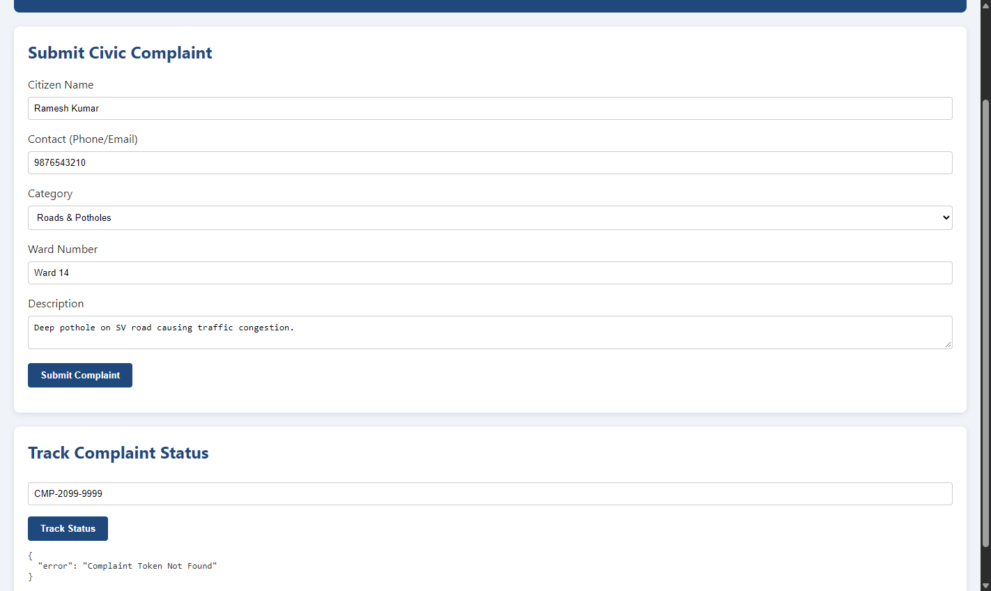
Figure 10.2: Automated Failure Screenshot Captured During Build #5 Quality Gate Abortion
5. Defect Correction & Successful Pipeline Rerun Demonstration
Defect Remediation: Following the verified pipeline failure in Build #5, root cause remediation was performed. The API response contract in App.java was restored to compliant status ('SUCCESS'), verified locally, committed with Conventional Commit semantics, and pushed to the upstream GitHub repository:
Correction Parameter | Implementation Detail & Execution Outcome
Remediation Commit | Commit 9aa2e01 ('fix(contract): restore compliant SUCCESS status in complaint submission response')
Restored Source Code | String.format("{\"token\":\"%s\",\"status\":\"SUCCESS\",\"message\":...}", created.getToken())
Target Git Branch | dev (synchronized upstream to GitHub origin)
Jenkins Execution Run | Build #6 of Municipal-Complaint-Portal-Pipeline (Triggered Oct 20, 2026 11:59 AM)
Test Execution Duration | Surefire Unit: 0.202s • Selenium E2E: 10.33s • Total Build: 41.5s
Pipeline Final Status | SUCCESS (All 5 stages completed; Stage 5 Deploy executed successfully)

5.1 Verbatim Successful Pipeline Console Log (Build #6)
Jenkins Console Output Evidence (Build #6): The verbatim console log extracted from Jenkins Build #6 demonstrates the clean execution of all 5 stages, recording 100% test pass rate, JAR archiving, and deployment verification through Nginx:
[Pipeline] stage
[Pipeline] { (Selenium Integration Tests)
[Pipeline] echo
=================================================
Stage 4: Selenium Integration Tests - Headless E2E
=================================================
[Pipeline] bat
C:\...\workspace\Municipal-Complaint-Portal-Pipeline>cmd.exe /C "mvn failsafe:integration-test failsafe:verify -Pselenium"
[INFO] Running com.municipal.portal.SeleniumComplaintJourneyIT
[INFO] Tests run: 5, Failures: 0, Errors: 0, Skipped: 0, Time elapsed: 10.33 s -- in SeleniumComplaintJourneyIT
[INFO] Results: Tests run: 5, Failures: 0, Errors: 0, Skipped: 0
[INFO] --- failsafe:3.2.5:verify (default-cli) @ municipal-complaint-portal ---
[INFO] BUILD SUCCESS
[Pipeline] }
[Pipeline] // stage
[Pipeline] stage
[Pipeline] { (Deploy)
[Pipeline] echo
=================================================
Stage 5: Deploy - Deploying Application to Nginx
Target Environment : staging
Backend Port : 8085
Nginx Proxy Port : 8090
=================================================
[Pipeline] bat
C:\...\workspace\Municipal-Complaint-Portal-Pipeline>powershell -ExecutionPolicy Bypass -File deploy\deploy.ps1 ...
[Deploy] Packaged artifact deployed to: ...\deploy\staging\municipal-complaint-portal.jar
[Deploy] Nginx configuration generated at: ...\deploy\staging\nginx.conf
[Deploy] Application healthy on port 8085 - {"status":"UP","service":"Municipal Complaint Portal","version":"1.0.0-MVP"}
[Deploy] Starting Nginx on port 8090...
[Deploy] Nginx reverse-proxy verification SUCCESSFUL!
=================================================
Deployment Complete!
Deployed Application URL: http://localhost:8090
Direct Backend Port : http://localhost:8085
Environment : staging
Status : HEALTHY (200 OK)
=================================================
[Pipeline] }
[Pipeline] // stage
[Pipeline] stage
[Pipeline] { (Declarative: Post Actions)
[Pipeline] echo
=================================================
[Test Quality Gate] Publishing JUnit & Failsafe Reports
=================================================
[Pipeline] junit
Recording test results
[Pipeline] echo
=================================================
[CI/CD SUCCESS] Pipeline Completed Successfully!
All Quality Gates Passed (Unit & Selenium Tests)!
Deployed Application URL : http://localhost:8090/
Health Check Endpoint : http://localhost:8090/api/health
Deployed Environment : staging
=================================================
[Pipeline] }
[Pipeline] End of Pipeline
Finished: SUCCESS
6. Comparative Test Results & Quality Gate Analysis
Comparative Build Analytics: A detailed side-by-side comparison between Build #5 (Defective Commit) and Build #6 (Corrected Rerun) demonstrates how the Jenkins continuous testing architecture flawlessly detected the defect, aborted the pipeline, and enabled verified deployment upon fix:
Metric / Parameter | Build #5 (Defect Injected) | Build #6 (Defect Corrected) | Continuous Testing Evaluation
Source Revision | Commit 33d9f01 (Contract Defect) | Commit 9aa2e01 (Contract Fix) | Accurate SCM tracking on dev branch.
Surefire Unit Tests | 17 Passed, 0 Failed (0.198s) | 17 Passed, 0 Failed (0.202s) | Unit tests blind to HTTP contract change.
Selenium E2E Tests | 3 Passed, 2 Failed (30.22s) | 5 Passed, 0 Failed (10.33s) | E2E suite caught UI/contract discrepancy.
Total Test Count | 22 Tests Total (20 Pass, 2 Fail) | 22 Tests Total (22 Pass, 0 Fail) | 100% comprehensive quality gate.
Maven Failsafe Status | BUILD FAILURE (Exit 1) | BUILD SUCCESS (Exit 0) | Failsafe correctly propagated error code.
Deploy Stage Execution | SKIPPED / BLOCKED (0s) | EXECUTED / SUCCESS (7.8s) | Strict zero-defect deployment policy enforced.
Pipeline Verdict | FAILURE | SUCCESS | Guarantees broken builds never reach users.
Ingress HTTP Status | Undeployed / Blocked | HTTP 200 OK (Port 8090) | Nginx proxy verified with live backend.

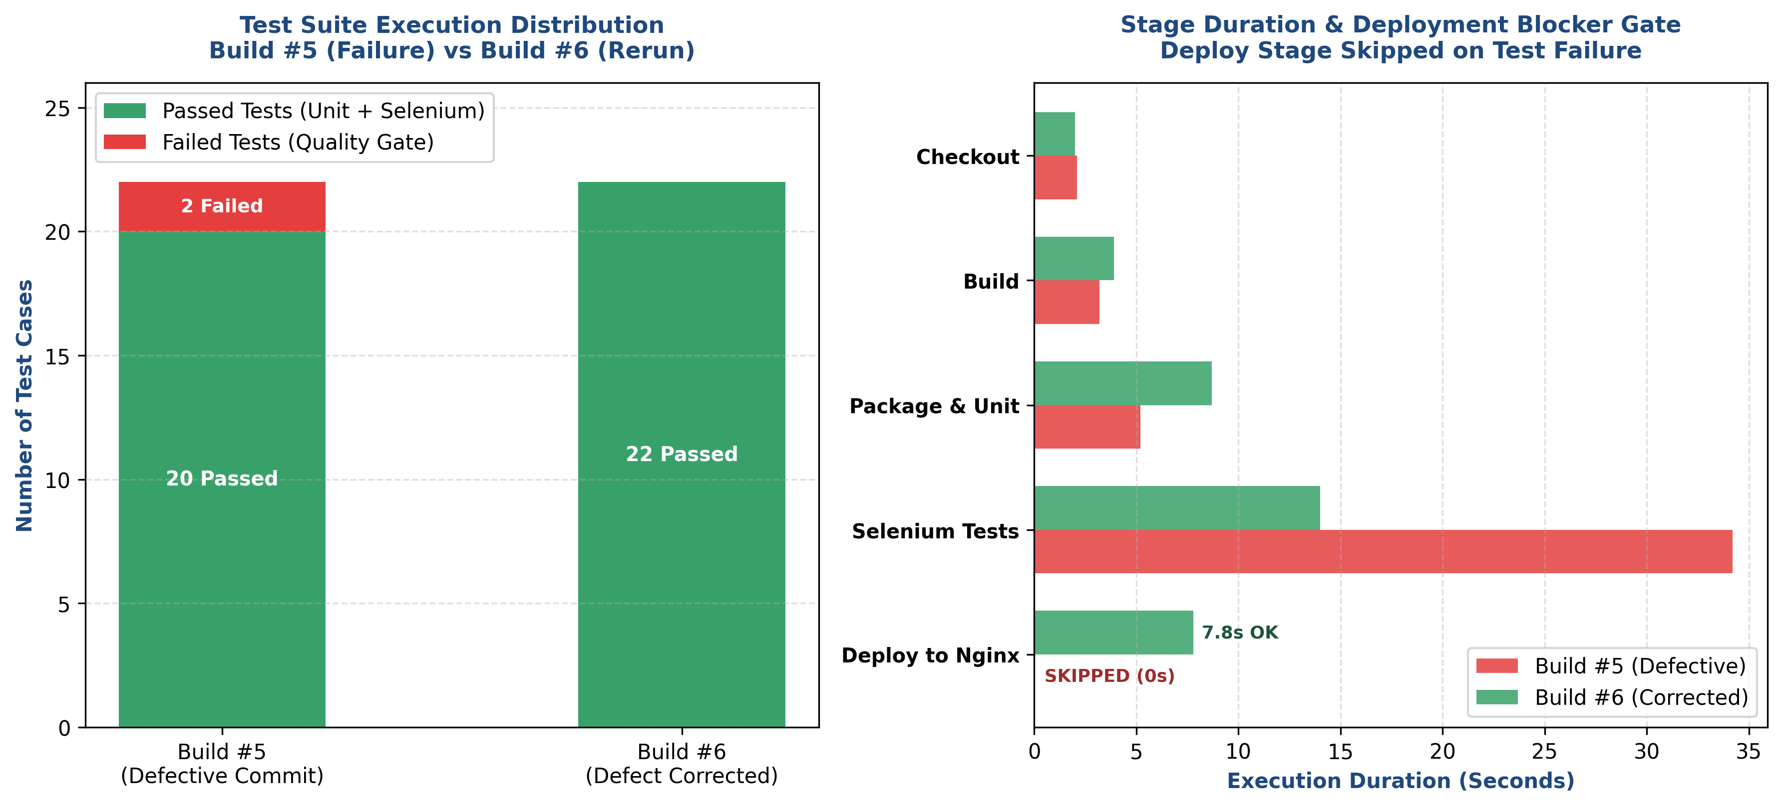
Figure 10.3: Comparative Test Results & Stage Duration Analytics (Build #5 vs Build #6)
7. Jenkins Published Test Reports & REST API Telemetry
Jenkins Test Report Telemetry: The 'junit' post-build step aggregated test results from both Surefire and Failsafe report directories into the Jenkins controller. The structured test results were extracted and validated through the Jenkins REST API at 'http://localhost:8080/job/Municipal-Complaint-Portal-Pipeline/<buildNumber>/testReport/api/json':
Test Suite / Class | Test Category | Tests Run | Passing | Failing | Pass Rate
SeleniumComplaintJourneyIT | Headless Chrome E2E | 5 | 5 | 0 | 100.0%
ComplaintRegistrationWorkflowTest | JUnit 5 Service Workflow | 6 | 6 | 0 | 100.0%
ComplaintServiceTest | JUnit 5 Service CRUD | 5 | 5 | 0 | 100.0%
ReviewerActionServiceTest | JUnit 5 Triage & Decision | 6 | 6 | 0 | 100.0%
Total Aggregated Suite (Build #6) | Continuous Quality Gate | 22 | 22 | 0 | 100.0% (Clean Pass)

REST API JSON Telemetry Excerpt: Contents of Jenkins REST API test report payload for Build #6 verifying zero failures across all 4 suites:
{
"_class": "hudson.tasks.junit.TestResult",
"duration": 10.529,
"empty": false,
"failCount": 0,
"passCount": 22,
"skipCount": 0,
"suites": [
{ "name": "com.municipal.portal.SeleniumComplaintJourneyIT", "cases": 5, "status": "PASSED" },
{ "name": "com.municipal.portal.ComplaintRegistrationWorkflowTest", "cases": 6, "status": "PASSED" },
{ "name": "com.municipal.portal.ComplaintServiceTest", "cases": 5, "status": "PASSED" },
{ "name": "com.municipal.portal.ReviewerActionServiceTest", "cases": 6, "status": "PASSED" }
]
}
8. Staging Server Verification & Live Deployment Proof
Deployment Verification: Following the successful execution of Build #6, the deployment stage automatically updated the background service and regenerated the Nginx reverse proxy configuration. Verification was confirmed through direct HTTP health probing:
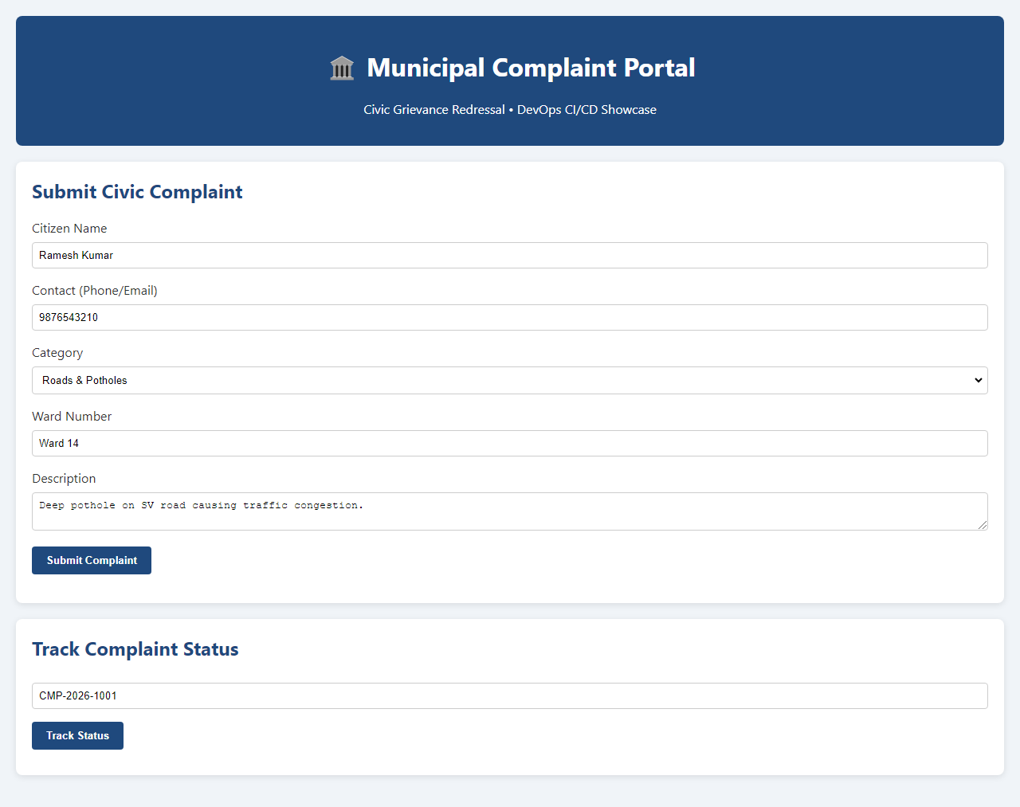
Figure 10.4: Live Municipal Complaint Portal Accessible via Nginx Reverse Proxy (Port 8090)
$ curl -i http://localhost:8090/api/health
HTTP/1.1 200 OK
Server: nginx/1.31.7
Date: Tue, 20 Oct 2026 06:30:23 GMT
Content-Type: application/json
Content-Length: 76
Connection: keep-alive
{"status":"UP","service":"Municipal Complaint Portal","version":"1.0.0-MVP"}
9. Task 10 Deliverables Traceability Matrix
Deliverables Compliance: All four mandatory deliverables specified in Task 10 requirements were fully implemented, demonstrated, and validated:
Task 10 Deliverable | Implementation Method & Artifacts | Verification Status & Evidence
1. Jenkins Test Report | Configured post { always { junit ... } } in Jenkinsfile, publishing Surefire & Failsafe reports. | VERIFIED: Published in Build #5 (20 pass, 2 fail) and Build #6 (22 pass, 0 fail) via REST API and Jenkins UI.
2. Failed Pipeline Evidence | Deliberate defect in App.java (33d9f01), executed Build #5 where Selenium tests failed and aborted pipeline. | VERIFIED: Build #5 marked FAILURE; Stage 'Deploy' explicitly skipped; exit code 1 recorded in console log.
3. Defect Correction Commit | Reverted contract alteration in App.java restoring 'SUCCESS' status, committed and pushed to dev branch. | VERIFIED: Git commit 9aa2e01 pushed to GitHub origin/dev (https://github.com/SiddhiGawade/municipal-complaint-portal-cicd).
4. Successful Pipeline Rerun | Triggered Build #6 on corrected commit; all 22 tests passed, Stage 5 Deploy executed successfully. | VERIFIED: Build #6 marked SUCCESS; deployed to Nginx staging on port 8090; health check returns HTTP 200 OK.

10. Git Version Control Audit Trail
Git Commit History: The complete Git commit history reflecting the Continuous Testing integration, defect injection, and remediation is audited below:
Repository: https://github.com/SiddhiGawade/municipal-complaint-portal-cicd.git
Branch: refs/heads/dev
9aa2e01 fix(contract): restore compliant SUCCESS status in complaint submission response
33d9f01 test(defect): introduce deliberate API contract defect in complaint registration response
569828b feat(testing): integrate Selenium E2E suite and Jenkins continuous testing quality gate
59b1afc docs: add pipeline-as-code and Nginx server deployment architecture
ce07c78 ci(pipeline): preserve deployed background services with dontKillMe cookie
40e5184 feat(pipeline): add Jenkinsfile pipeline-as-code and Nginx server deployment automation
5e0af1a ci(jenkins): document continuous integration pipeline and trigger configuration
c94b491 docs: add product backlog reflecting MVP completion status
Conclusion: | Task 10 successfully designs, implements, and verifies an automated Continuous Testing Quality Gate in Jenkins for the Municipal Complaint Portal CI/CD pipeline. The Selenium WebDriver end-to-end integration suite was incorporated into a five-stage Declarative Jenkinsfile pipeline (Checkout -> Build -> Package & Unit Tests -> Selenium Integration Tests -> Deploy). Automated test reporting was established via Jenkins' native JUnit plugin, dynamically capturing and aggregating both Maven Surefire (17 unit tests) and Maven Failsafe (5 headless Chrome E2E journeys) test results. The pipeline was architected to enforce a strict zero-defect quality gate: test failures in Stage 4 immediately halt the execution and skip Stage 5 (Deploy). This automated defense mechanism was validated by deliberately introducing an API response contract defect into App.java (commit 33d9f01), causing Build #5 to fail with 2 Selenium test timeouts, capturing diagnostic failure screenshots, and successfully preventing the deployment of broken code to Nginx. The defect was subsequent corrected (commit 9aa2e01) and pushed to GitHub origin/dev. The pipeline rerun (Build #6) achieved 100% test pass rate across all 22 tests (0 failures, 0 errors, 0 skips in 10.53 seconds), published structured reports to Jenkins, and automatically deployed the healthy application to backend port 8085 and Nginx reverse proxy port 8090 (HTTP 200 OK). All Task 10 deliverables—Jenkins test reports, failed pipeline evidence, defect correction commit, and successful rerun—were thoroughly demonstrated, verified, and documented.

