TASK 15

Final Release,
Documentation & Viva
Municipal Complaint Portal | End-to-End DevOps
Release decision | Local quality gates | External rollout
HOLD - not a production release | PASS - 17/17 unit; 5/5 Selenium | PENDING - Docker registry and Ansible target

Evidence snapshot: 2026-10-20T14:04:16+05:30
Git branch: dev | HEAD: abc900735330
Prepared as a reproducible technical report. Test success is reported separately from image publication and remote provisioning.

1. Executive summary
The Task 15 package documents the portal architecture, test gates, Docker delivery design, Ansible provisioning and recovery procedure, troubleshooting, known limitations, and a prioritized improvement plan. The current workspace passes its local unit and Selenium suites and a loopback health smoke test.
The complete release is not claimed. The current Docker build context is untracked, Docker base images are not cached, no registry publish was performed, and no authorized Linux host is configured. Existing Jenkins build #6 is a successful historical native JAR/Nginx run at revision 9aa2e01; it predates the Docker pipeline commit.

2. Architecture
The portal uses the JDK HTTP server, service-level validation, and an in-memory concurrent complaint map. Jenkins is the build and test orchestrator. Docker packaging and Jenkins staging deployment are one delivery path; Ansible provisions a separate Debian/Ubuntu target and is not invoked by the current Jenkinsfile.
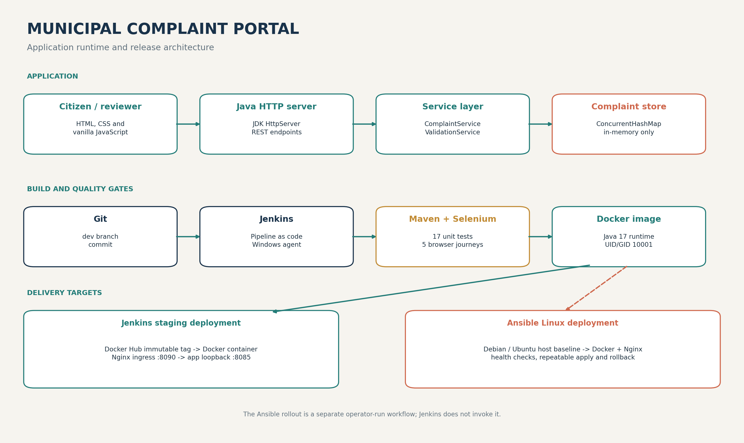
Figure 1. Runtime and delivery architecture. Backend port 8085 is loopback-bound by default; Nginx exposes port 8090.

3. Release workflow and quality gates
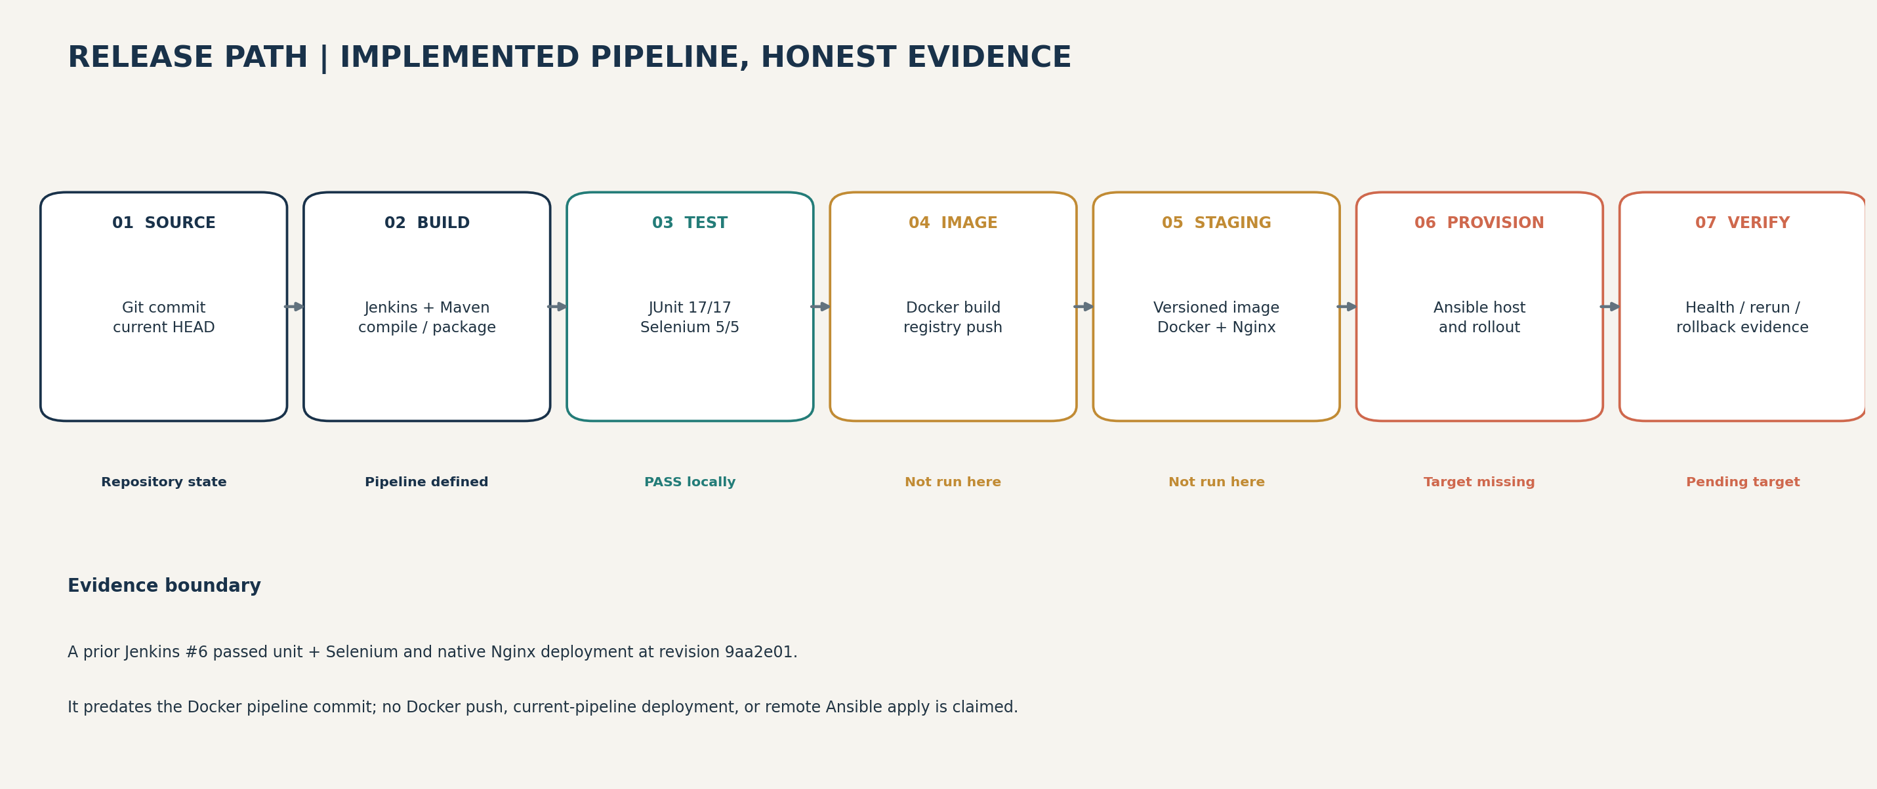
Figure 2. Release gates and verification boundary for this snapshot.
Stage | Implementation | Current evidence
Checkout/version | Git SCM; tag includes Maven version, build number, commit | Local HEAD abc900735330; Jenkins #6 used 9aa2e01
Build and unit gate | Maven compile/package; archive JAR and publish JUnit | 17 tests passed locally
Selenium gate | Failsafe integration tests run before Docker build/push | 5 tests passed locally
Docker build/publish | Multi-stage Java 17 image; immutable and latest tags | Not run; base images absent and no pull/push performed
Staging deployment | Deploy script replaces environment container; health/evidence archive | Current Docker pipeline not verified
Ansible rollout | Host baseline, versioned image, health checks, recovery | Not run; reserved inventory target and no Ansible binary

4. Validation results
Check | Result | Scope
Maven unit tests | PASS: 17 tests; 0 failures; 0 errors | Offline run against current workspace.
Selenium/Failsafe | PASS: 5 tests; 0 failures; 0 errors | Headless Chrome; cached ChromeDriver; CDP warning was non-fatal.
Ansible YAML | PASS | PyYAML parses site, task14, health_checks, and requirements files.
Ansible syntax check | NOT RUN | Ansible Core is not installed on this controller.
Local app smoke test | PASS: HTTP 200, JSON status UP | Temporary loopback JAR process; stopped after probe.
Existing local backend/ingress | PASS: HTTP 200 on ports 8085 and 8090 | Read-only probes; deployment provenance not established.
Docker image/registry | NOT RUN | Base images are absent locally; no external pull/publish.
Remote provisioning/rollback | NOT RUN | No real host, SSH identity, or sudo authorization; inventory remains placeholder.

JUnit XML files and a machine-readable validation record are included under TASKS_REPORTS/Task15_Evidence. The report distinguishes local test evidence from deployment evidence.

5. Deployment and operations
The Jenkinsfile derives an immutable Docker reference from the Maven version, Jenkins build number, and Git commit. Unit and Selenium gates precede image creation and registry push. Deployment uses the immutable tag, checks the backend and Nginx proxy, and archives a JSON evidence file.
The Ansible playbook installs Docker/Nginx on Debian-family hosts, deploys a tagged image on loopback port 8085, validates the Nginx listener on port 8090, repeats safely, and restores the prior image ID on candidate failure. Its rollback exercise must run only on a non-production target with a known-good release already available.
mvn -o test
mvn -o failsafe:integration-test failsafe:verify -Pselenium
ansible-playbook -i ansible/inventory.ini ansible/task14.yml --syntax-check
ansible-playbook -i ansible/inventory.ini ansible/task14.yml --diff -e portal_image=<registry>/<repository>:<immutable-tag>
Full environment requirements, secret handling, commands, idempotency checks, and rollback procedure are in TASK15_FINAL_RELEASE.md and ansible/TASK14_RUNBOOK.md.

6. Troubleshooting guide
Symptom | First response
Dockerfile missing in Jenkins | Confirm Dockerfile and .dockerignore are tracked in the checked-out commit.
Docker pull/push fails | Check authorized network access, registry namespace, and Jenkins token credential without printing secrets.
Container unhealthy / Nginx 502 | Inspect container logs and backend health on 8085; validate Nginx proxy target and port 8090.
Chrome session cannot start | Check Chrome/ChromeDriver compatibility and use the approved cached driver path.
Ansible host unreachable | Replace 192.0.2.10, verify SSH with the inventory, and check sudo/become setup.
Second Ansible run changes tasks | Use the same immutable tag; compare --diff and investigate drift before asserting idempotency.
Rollback rehearsal fails early | Ensure a different candidate tag and a healthy prior image exist on the non-production target.

7. Limitations and future plan
- Complaint data is in memory and is lost on application restart or container replacement.
- Production authentication/authorization, TLS, rate limits, privacy controls, and audit retention are not delivered.
- Durable attachment storage, malware scanning, and an operational database are not configured.
- There is no centralized observability, autoscaling, multi-node failover, or rolling deployment.
- Container base images are not digest-pinned; SBOM, image signing, and vulnerability gates are future work.
Priority | Enhancement
P0 | Track Docker build context; run the current Docker Jenkins pipeline and an authorized non-production Ansible rollout.
P1 | Add relational persistence, migrations, backup/restore; add reviewer identity and authorization.
P1 | Pin image digests; generate SBOM; scan dependencies/images; sign and verify provenance.
P2 | Add structured observability, SLOs, alerting, rolling delivery, security/load/accessibility tests.

8. Demonstration and viva
The attached portal screenshot was captured from the local application on a temporary loopback port. A browser-based presentation and viva question set accompany this report. A screen recording is not included; record the live Jenkins, registry, and target steps after the pending credentials and target are available.
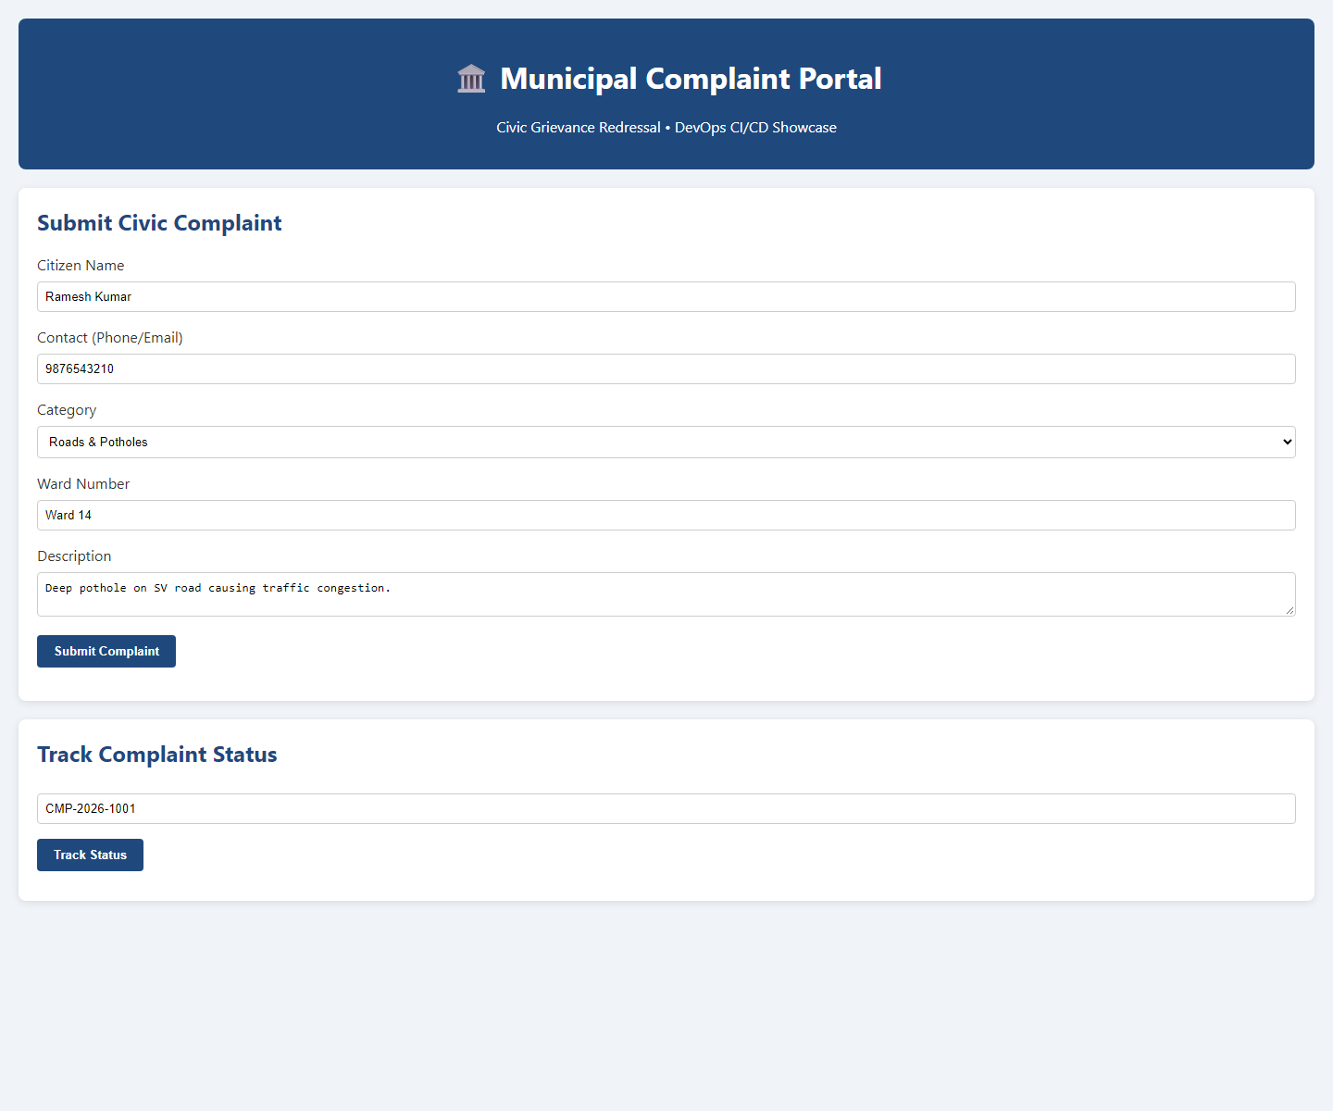
Figure 3. Local portal smoke-test screenshot. This is not a Docker or remote-host deployment screenshot.
The viva guide is TASKS_REPORTS/Task15_Viva_QA.md. The HTML presentation is TASKS_REPORTS/Task15_Viva_Presentation.html. The operator runbook is TASK15_FINAL_RELEASE.md.

