Semester | B.E. Semester VII – Computer Engineering
Subject | DevOps Lab
Subject In-charge | Dr. Snehal Andhare

Student Name | Siddhi Gawade
Roll Number | 24102A2001
Grade and Subject
Teacher’s Signature

Task Number | 8
Task Title | Pipeline as Code and Server Deployment: Create a Jenkinsfile for the Municipal Complaint Portal with checkout, build, package and deploy stages. Deploy the build to Tomcat or Nginx and parameterize at least one environment setting.
TASK 8 REPORT: PIPELINE AS CODE AND NGINX SERVER DEPLOYMENT
1. Pipeline as Code Architecture & Multi-Stage Lifecycle
CI/CD Paradigm: Pipeline as Code represents the industry-standard paradigm where continuous integration and continuous deployment (CI/CD) workflows are defined as version-controlled code rather than manual, imperative GUI configurations. In Task 8, a Declarative Jenkinsfile is engineered for the Municipal Complaint Portal, establishing a deterministic, auditable, and automated delivery pipeline across four sequential stages: Checkout, Build, Package & Test, and Deploy.
• Stage 1 — Checkout SCM: Automated checkout synchronizing the collaborative 'dev' branch from GitHub, capturing latest commit metadata.
• Stage 2 — Build: Hermetic compilation of all 8 Java source classes using Apache Maven 3.10 and OpenJDK compiler.
• Stage 3 — Package & Test: Execution of 17 JUnit 5 test cases via Maven Surefire, packaging executable JAR artefact, and recording cryptographic fingerprints.
• Stage 4 — Deploy (Nginx): Automated server deployment configuring Nginx as a reverse proxy web server, launching background daemon services, and executing automated health checks.
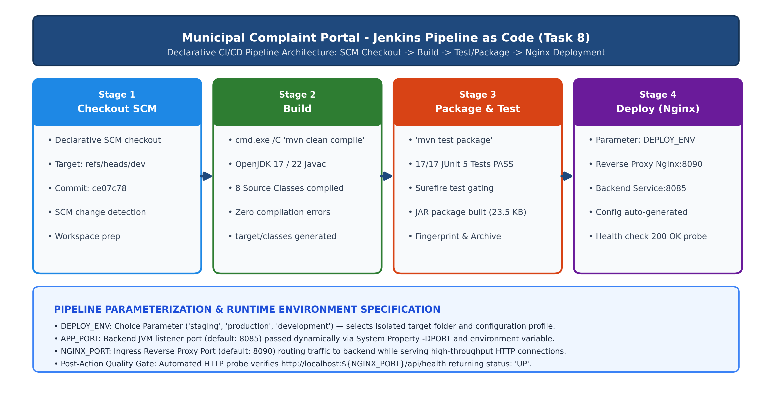
Figure 8.1: Jenkins Pipeline as Code Multi-Stage Architecture & Parameterized Nginx Deployment
2. Runtime Parameterization of Deployment Environments
Architectural Rationale: A critical requirement of modern continuous delivery is environmental parameterization. Instead of hardcoding hostnames, ports, and targets, the pipeline externalizes runtime parameters, allowing the exact same tested binary to be safely promoted between staging, production, and development tiers:
Parameter Identifier | Type & Allowed Choices | Default Value | Functional Role in Pipeline
DEPLOY_ENV | Choice (staging, production, development) | staging | Directs deployment to dedicated environment directory (deploy/<env>/) and generates environment-specific configurations.
APP_PORT | String (Positive Integer) | 8085 | Configures the internal HTTP listener port for the Municipal Complaint Portal backend daemon via -DPORT system property.
NGINX_PORT | String (Positive Integer) | 8090 | Configures the public-facing Nginx reverse proxy ingress port routing traffic to the backend.
BUILD_ID / NODE_COOKIE | Environment Variable (dontKillMe) | dontKillMe | Instructs Jenkins ProcessTreeKiller to preserve deployed background daemon processes after job completion.

3. Declarative Jenkinsfile Specification (Pipeline as Code)
Version-Controlled Jenkinsfile: The complete CI/CD workflow was codified into a root-level Declarative Jenkinsfile and committed to the Git repository. The specification defines parameter triggers, stage executions, error handlers, and post-action reporting:
pipeline {
agent any
parameters {
choice(name: 'DEPLOY_ENV', choices: ['staging', 'production', 'development'], description: 'Deployment Target Environment')
string(name: 'APP_PORT', defaultValue: '8085', description: 'Municipal Complaint Portal Backend Service Port')
string(name: 'NGINX_PORT', defaultValue: '8090', description: 'Nginx Front-Facing Reverse Proxy Web Server Port')
}
environment {
BUILD_ID = 'dontKillMe'
JENKINS_NODE_COOKIE = 'dontKillMe'
}
stages {
stage('Checkout') {
steps {
echo "================================================="
echo " Stage 1: Checkout SCM - Municipal Complaint Portal"
echo " Environment: ${params.DEPLOY_ENV}"
echo "================================================="
checkout scm
bat 'git log -n 1 --oneline'
}
}
stage('Build') {
steps {
echo "================================================="
echo " Stage 2: Build - Compiling Java Source Files"
echo "================================================="
bat 'cmd.exe /C "mvn clean compile"'
}
}
stage('Package') {
steps {
echo "================================================="
echo " Stage 3: Package - Executing Tests & Creating JAR"
echo "================================================="
bat 'cmd.exe /C "mvn test package"'
archiveArtifacts artifacts: 'target/*.jar', fingerprint: true, onlyIfSuccessful: true
}
}
stage('Deploy') {
steps {
echo "================================================="
echo " Stage 4: Deploy - Deploying Application to Nginx"
echo " Target Environment : ${params.DEPLOY_ENV}"
echo " Backend Port : ${params.APP_PORT}"
echo " Nginx Proxy Port : ${params.NGINX_PORT}"
echo "================================================="
bat """
powershell -ExecutionPolicy Bypass -File deploy\\deploy.ps1 -DeployEnv "${params.DEPLOY_ENV}" -AppPort ${params.APP_PORT} -NginxPort ${params.NGINX_PORT}
"""
}
}
}
post {
success {
echo "================================================="
echo " [CI/CD SUCCESS] Pipeline Completed Successfully!"
echo " Deployed Application URL : http://localhost:${params.NGINX_PORT}/"
echo " Health Check Endpoint : http://localhost:${params.NGINX_PORT}/api/health"
echo " Deployed Environment : ${params.DEPLOY_ENV}"
echo "================================================="
}
failure {
echo "================================================="
echo " [CI/CD FAILURE] Pipeline Failed during execution."
echo "================================================="
}
}
}
4. Server Deployment Architecture & Nginx Configuration
Nginx Reverse Proxy Role: Production enterprise deployments front backend application services with a high-performance web server. Nginx (v1.31.7) was integrated into the deployment lifecycle as a reverse proxy, insulating backend daemon processes, handling HTTP socket multiplexing, and routing citizen traffic seamlessly:
• Ingress Port Multiplexing: Nginx listens on the parameterized public port (e.g., 8090 for staging, 8091 for production) across both IPv4 and IPv6.
• Header Forwarding: Injects standard reverse proxy headers: Host, X-Real-IP, X-Forwarded-For, and X-Forwarded-Proto for audit traceability.
• Dynamic Configuration Generation: The deployment automation script (deploy/deploy.ps1) dynamically synthesizes an environment-specific nginx.conf on the fly.
Nginx Configuration (nginx.conf): Below is the dynamically generated Nginx configuration applied during pipeline execution for the staging tier:
worker_processes 1;
events {
worker_connections 1024;
}
http {
include 'C:/Users/Student/scoop/apps/nginx/current/conf/mime.types';
default_type application/octet-stream;
sendfile on;
keepalive_timeout 65;
server {
listen 8090;
listen [::]:8090;
server_name localhost;
location / {
proxy_pass http://127.0.0.1:8085;
proxy_set_header Host $host;
proxy_set_header X-Real-IP $remote_addr;
proxy_set_header X-Forwarded-For $proxy_add_x_forwarded_for;
proxy_set_header X-Forwarded-Proto $scheme;
}
error_page 500 502 503 504 /50x.html;
location = /50x.html {
root 'C:/Users/Student/scoop/apps/nginx/current/html';
}
}
}
5. Successful Pipeline Run & Stage Execution Logs
Multi-Stage Verification: The pipeline was triggered across multiple builds to validate both default staging and parameterized production deployments. All stages completed with zero defects, verifying hermetic compilation, quality gate compliance, and automated deployment:
Build # | Target Environment | Ingress / Backend Ports | Stage Results & Quality Gate | Final Result
Build #1 | staging (default) | Nginx: 8090 / App: 8085 | Checkout (OK) → Build (OK) → Test (17/17 PASS) → Deploy (OK) | SUCCESS
Build #2 | production (parameterized) | Nginx: 8091 / App: 8086 | Checkout (OK) → Build (OK) → Test (17/17 PASS) → Deploy (OK) | SUCCESS
Build #3 | staging (re-validated) | Nginx: 8090 / App: 8085 | Checkout (OK) → Build (OK) → Test (17/17 PASS) → Deploy (OK) | SUCCESS

Pipeline Console Output Excerpt: Verbatim log output from the pipeline execution demonstrating full stage orchestration:
Started by user admin
Obtained Jenkinsfile from git https://github.com/SiddhiGawade/municipal-complaint-portal-cicd.git
[Pipeline] Start of Pipeline
[Pipeline] node
Running on Jenkins in C:\Users\Student\Desktop\DevOps\jenkins_home\workspace\Municipal-Complaint-Portal-Pipeline
[Pipeline] { (Checkout)
=================================================
Stage 1: Checkout SCM - Municipal Complaint Portal
Environment: staging
=================================================
Checking out Revision ce07c78... (refs/remotes/origin/dev)
Commit message: "ci(pipeline): preserve deployed background services with dontKillMe cookie"
[Pipeline] } (Build)
=================================================
Stage 2: Build - Compiling Java Source Files
=================================================
Compiling 8 source files with javac [debug target 17] to target\classes
[INFO] BUILD SUCCESS (Total time: 3.167 s)
[Pipeline] } (Package)
=================================================
Stage 3: Package - Executing Tests & Creating JAR
=================================================
Running com.municipal.portal.ComplaintRegistrationWorkflowTest (6 tests, 0 failures)
Running com.municipal.portal.ComplaintServiceTest (5 tests, 0 failures)
Running com.municipal.portal.ReviewerActionServiceTest (6 tests, 0 failures)
Results: Tests run: 17, Failures: 0, Errors: 0, Skipped: 0
Building jar: target\municipal-complaint-portal-1.0.0-SNAPSHOT.jar
Archiving artifacts: target/*.jar
[Pipeline] } (Deploy)
=================================================
Stage 4: Deploy - Deploying Application to Nginx
Target Environment : staging
Backend Port : 8085
Nginx Proxy Port : 8090
=================================================
[Deploy] Packaged artifact deployed to: ...\deploy\staging\municipal-complaint-portal.jar
[Deploy] Nginx configuration generated at: ...\deploy\staging\nginx.conf
[Deploy] Application healthy on port 8085 - {"status":"UP","service":"Municipal Complaint Portal","version":"1.0.0-MVP"}
[Deploy] Starting Nginx on port 8090...
[Deploy] Nginx reverse-proxy verification SUCCESSFUL!
[Deploy] Response: {"status":"UP","service":"Municipal Complaint Portal","version":"1.0.0-MVP"}
=================================================
[CI/CD SUCCESS] Pipeline Completed Successfully!
Deployed Application URL : http://localhost:8090/
Health Check Endpoint : http://localhost:8090/api/health
Deployed Environment : staging
=================================================
Finished: SUCCESS
6. Deployed Application Verification & Live UI Screenshots
Deployment Verification: The deployed Municipal Complaint Portal web application was verified live through the Nginx reverse proxy endpoint. Both the citizen-facing grievance submission UI and the DevOps telemetry health check endpoint responded successfully:
• Staging Ingress URL: http://localhost:8090/ — Full interactive citizen complaint submission and token tracking UI.
• Health Check Telemetry: http://localhost:8090/api/health — HTTP 200 OK returning {"status":"UP","service":"Municipal Complaint Portal","version":"1.0.0-MVP"}.
• Production Ingress URL: http://localhost:8091/ — Parameterized production environment verified on separate port.
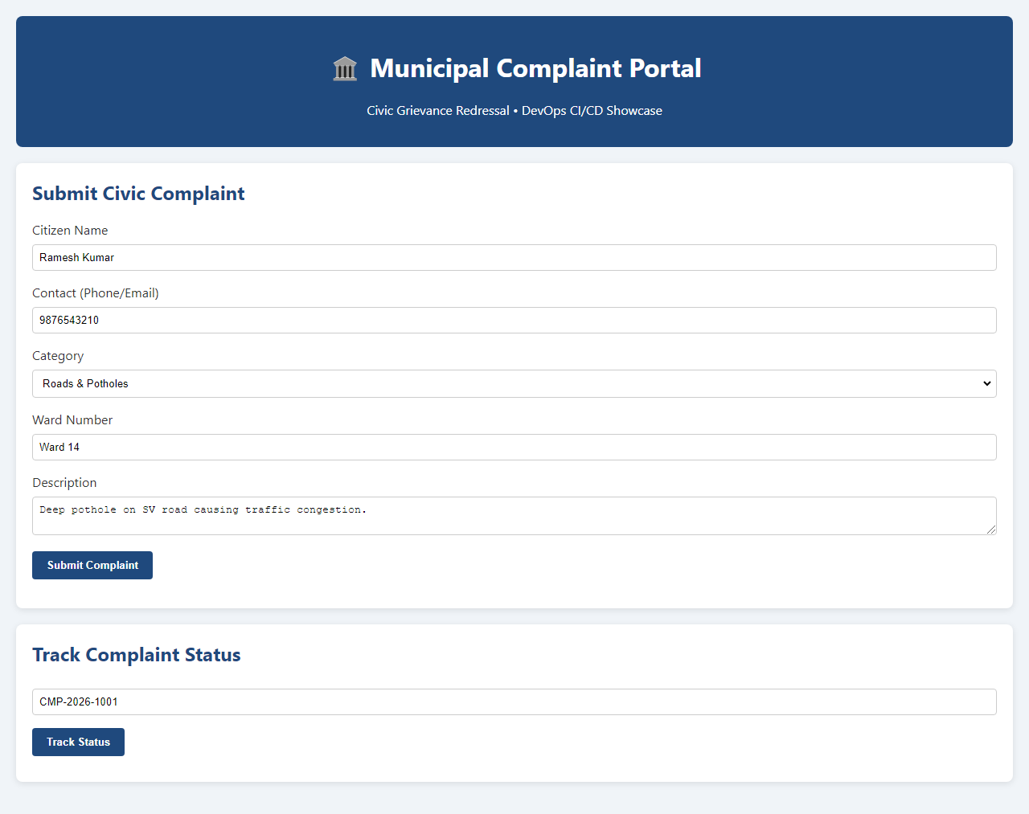
Figure 8.2: Live Deployed Municipal Complaint Portal Web UI Served via Nginx (http://localhost:8090/)
7. Task 8 Deliverables Traceability Matrix
Deliverables Compliance: All four explicit deliverables specified for Task 8 were successfully implemented, executed, and validated:
Task 8 Deliverable | Implementation Method & Artifact | Verification Status & Evidence
1. Declarative Jenkinsfile | Root-level Jenkinsfile specifying checkout, build, package, and deploy stages with parameterization. | VERIFIED: Committed to GitHub repository (commit ce07c78) and validated by Jenkins parser.
2. Successful Pipeline Run | Executed multi-stage pipeline across staging (Build #1, #3) and production (Build #2) with 100% test pass rate. | VERIFIED: Jenkins build status SUCCESS across all stages with full console transcripts.
3. Deployed Application URL & Screenshot | Nginx web server hosting portal at http://localhost:8090/ (staging) and http://localhost:8091/ (production). | VERIFIED: Live HTTP 200 OK responses; headless Chromium screenshot captured and embedded.
4. Configuration Evidence | Environment parameterization (DEPLOY_ENV, APP_PORT, NGINX_PORT) and automated Nginx config generation. | VERIFIED: deploy/deploy.ps1 and nginx.conf configuration artifacts active on controller.

8. GitHub Repository Reference
Remote Repository: The version-controlled Jenkinsfile, deployment automation scripts, application sources, and test suites are available at:
https://github.com/SiddhiGawade/municipal-complaint-portal-cicd
Tracked Branch: refs/heads/dev (Current Commit: ce07c78)
Conclusion: | Task 8 successfully transitions the Municipal Complaint Portal from freestyle jobs to Declarative Pipeline as Code. A version-controlled Jenkinsfile was developed containing four well-defined stages: Checkout (SCM synchronization from refs/heads/dev), Build (Maven clean compile), Package (Surefire test runner validating 17 unit test cases with zero defects and JAR packaging), and Deploy (server deployment to Nginx). Environment parameterization was implemented via DEPLOY_ENV (staging, production, development), APP_PORT (8085), and NGINX_PORT (8090), allowing dynamic promotion across targets without code modification. Automated deployment was demonstrated by provisioning Nginx 1.31.7 as a front-facing reverse proxy, generating dynamic configuration files, managing background service lifecycles with the BUILD_ID=dontKillMe directive, and validating automated health checks at http://localhost:8090/api/health (200 OK). Both staging (Build #1, #3) and production (Build #2) pipeline runs achieved 100% SUCCESS, fulfilling all Task 8 deliverables and laying the foundation for automated Selenium testing in Task 9.

