Semester | B.E. Semester VII – Computer Engineering
Subject | DevOps Lab
Subject In-charge | Dr. Snehal Andhare

Student Name | Siddhi Gawade
Roll Number | 24102A2001
Grade and Subject
Teacher’s Signature

Task Number | 9
Task Title | TASK 9: Selenium Test Design and Local Execution: Identify three to five critical user journeys in the Municipal Complaint Portal. Write Selenium WebDriver test cases with assertions, test data and screenshots for failures. Execute the suite locally through Maven.  Deliverable: Test plan, Selenium scripts, local test report and failure screenshot mechanism.
TASK 9 REPORT: SELENIUM WEBDRIVER TEST DESIGN AND LOCAL EXECUTION
1. Executive Summary & Automated Testing Scope
Quality Gate Scope: Continuous automated testing represents a core foundation of modern DevOps engineering, ensuring that functional regressions, user-experience flaws, and broken state transitions are intercepted prior to production deployment. In Task 9, an end-to-end browser automation suite was designed and implemented for the Municipal Complaint Portal using Selenium WebDriver 4.19.1 and JUnit Jupiter 5.10.2. The suite executes against a dedicated Maven integration-test profile ('selenium'), exercising five mission-critical user journeys across citizen grievance registration, field validation, and status tracking.
• Testing Paradigm: Headless browser automation utilizing Chrome for Testing / ChromeDriver, simulating real citizen interactions against the live rendered DOM.
• Hermetic Test Harness: Autonomous local HTTP server lifecycle management with ephemeral port binding, preventing port collisions across test execution runs.
• Dynamic Synchronization: Explicit element wait strategy (WebDriverWait with Duration-based polling) eliminating fragile sleep delays and race conditions.
• Diagnostic Telemetry: Automated failure listener capturing full-viewport PNG screenshots into 'target/selenium-failures/' whenever an assertion or expectation fails.
2. Comprehensive Test Plan for Critical User Journeys
Test Plan Architecture: A formal test plan was formulated to identify and validate five core user journeys spanning both positive and negative execution paths within the Municipal Complaint Portal web application:
• Journey UJ-01: Seeded Civic Grievance Tracking: Validates that a citizen can query an existing complaint token (CMP-2026-1001) pre-seeded into the system, confirming that citizen identity ('Rahul Deshmukh'), grievance category ('Roads & Potholes'), and lifecycle status ('PENDING') are rendered accurately in the DOM.
• Journey UJ-02: End-to-End Grievance Registration & Dynamic Tracking: Exercises the primary citizen workflow: populating citizen name ('Selenium Test Citizen'), valid 10-digit mobile ('9876543210'), category ('Water Supply & Leakage'), ward ('Ward 21'), and descriptive narrative. Asserts server HTTP 201 response, extracts the dynamically generated tracking token (CMP-2026-XXXX via regex), and immediately performs a status inquiry to verify persistence.
• Journey UJ-03: Input Boundary & Validation Enforcement: Asserts the defensive robustness of the portal against invalid input. Submits an invalid telephone contact ('123' violating the 10-digit regex rule) and asserts that the application rejects the submission with HTTP 400 and renders the appropriate error notification ('Invalid complaint input data').
• Journey UJ-04: Non-Existent Token Lookup Fault Tolerance: Validates system resilience when querying an unassigned complaint identifier ('CMP-2099-9999'). Asserts that the system gracefully handles the 404 response and displays a user-friendly 'Complaint Token Not Found' diagnostic message without crashing.
• Journey UJ-05: Multi-Category Civic Submission & Ward Persistence: Tests alternate categorization workflows by submitting a grievance under 'Solid Waste Management' for 'Ward 05' by 'Pooja Sharma'. Asserts multi-field form binding, dropdown selection, dynamic token extraction, and full-text roundtrip persistence.
2.1 Test Data & Assertions Matrix
Test Data Specifications: The following matrix details the input parameters, target DOM locators, expected outcomes, and assertion criteria for each journey:
ID | Journey Name | Input Test Data | Target Locators | Assertions & Validation Criteria
UJ-01 | Seeded Tracking | Token: CMP-2026-1001 | By.id('track-token')  By.xpath('//button[...]') | assert response contains 'Rahul Deshmukh'  assert category is 'Roads & Potholes'  assert status is 'PENDING'
UJ-02 | E2E Registration | Name: Selenium Test Citizen  Contact: 9876543210  Cat: Water Supply  Ward: Ward 21  Desc: Water is leaking... | By.id('name'), By.id('contact')  By.id('category'), By.id('ward')  By.id('desc'), By.id('sub-res') | assert response contains 'SUCCESS'  regex match 'CMP-2026-\d+'  assert tracked status is 'PENDING'
UJ-03 | Boundary Validation | Contact: '123' (Invalid)  Other fields: Default valid | By.id('contact')  By.id('sub-res') | assert response contains 'error'  assert message contains 'Invalid complaint input data'
UJ-04 | Invalid Token Lookup | Token: CMP-2099-9999 (Unregistered) | By.id('track-token')  By.id('track-res') | assert response contains 'Complaint Token Not Found'  assert HTTP 404 payload handled gracefully
UJ-05 | Multi-Category Filing | Name: Pooja Sharma  Contact: 9812345678  Cat: Solid Waste Management  Ward: Ward 05  Desc: Garbage overflowing... | Select(By.id('category'))  By.id('sub-res')  By.id('track-res') | assert response contains 'SUCCESS'  assert tracked category is 'Solid Waste Management'  assert description preserved

2.2 Test Environment & Execution Specification
Environment Parameter | Configuration Value | Role in Automation Lifecycle
Operating System | Microsoft Windows 11 Enterprise (64-bit) | Local DevOps workstation executing continuous testing.
Java Development Kit | Oracle JDK 22.0.2 / Target Bytecode Java 17 | Runtime execution engine for application and test harness.
Build Management | Apache Maven 3.10.0 (maven-failsafe-plugin 3.2.5) | Orchestrates clean, testCompile, integration-test, and verify phases.
Selenium Engine | Selenium Java 4.19.1 / Selenium DevTools | WebDriver bindings for browser manipulation and element interaction.
Browser Target | Google Chrome (Headless: --headless=new) | Modern headless Chrome runtime matching Chromium 155 binaries.
Synchronous Synchronization | WebDriverWait (Timeout: 10 Seconds) | Explicit polling on expected DOM visibility and textual content.

3. Test Automation & Diagnostic Architecture
Architecture Overview: The automated Selenium testing framework was structured around a modular, three-tier architecture comprising: (1) Critical User Journey Specifications, (2) Hermetic Harness & Execution Engine, and (3) Quality Gate & Diagnostics Telemetry:
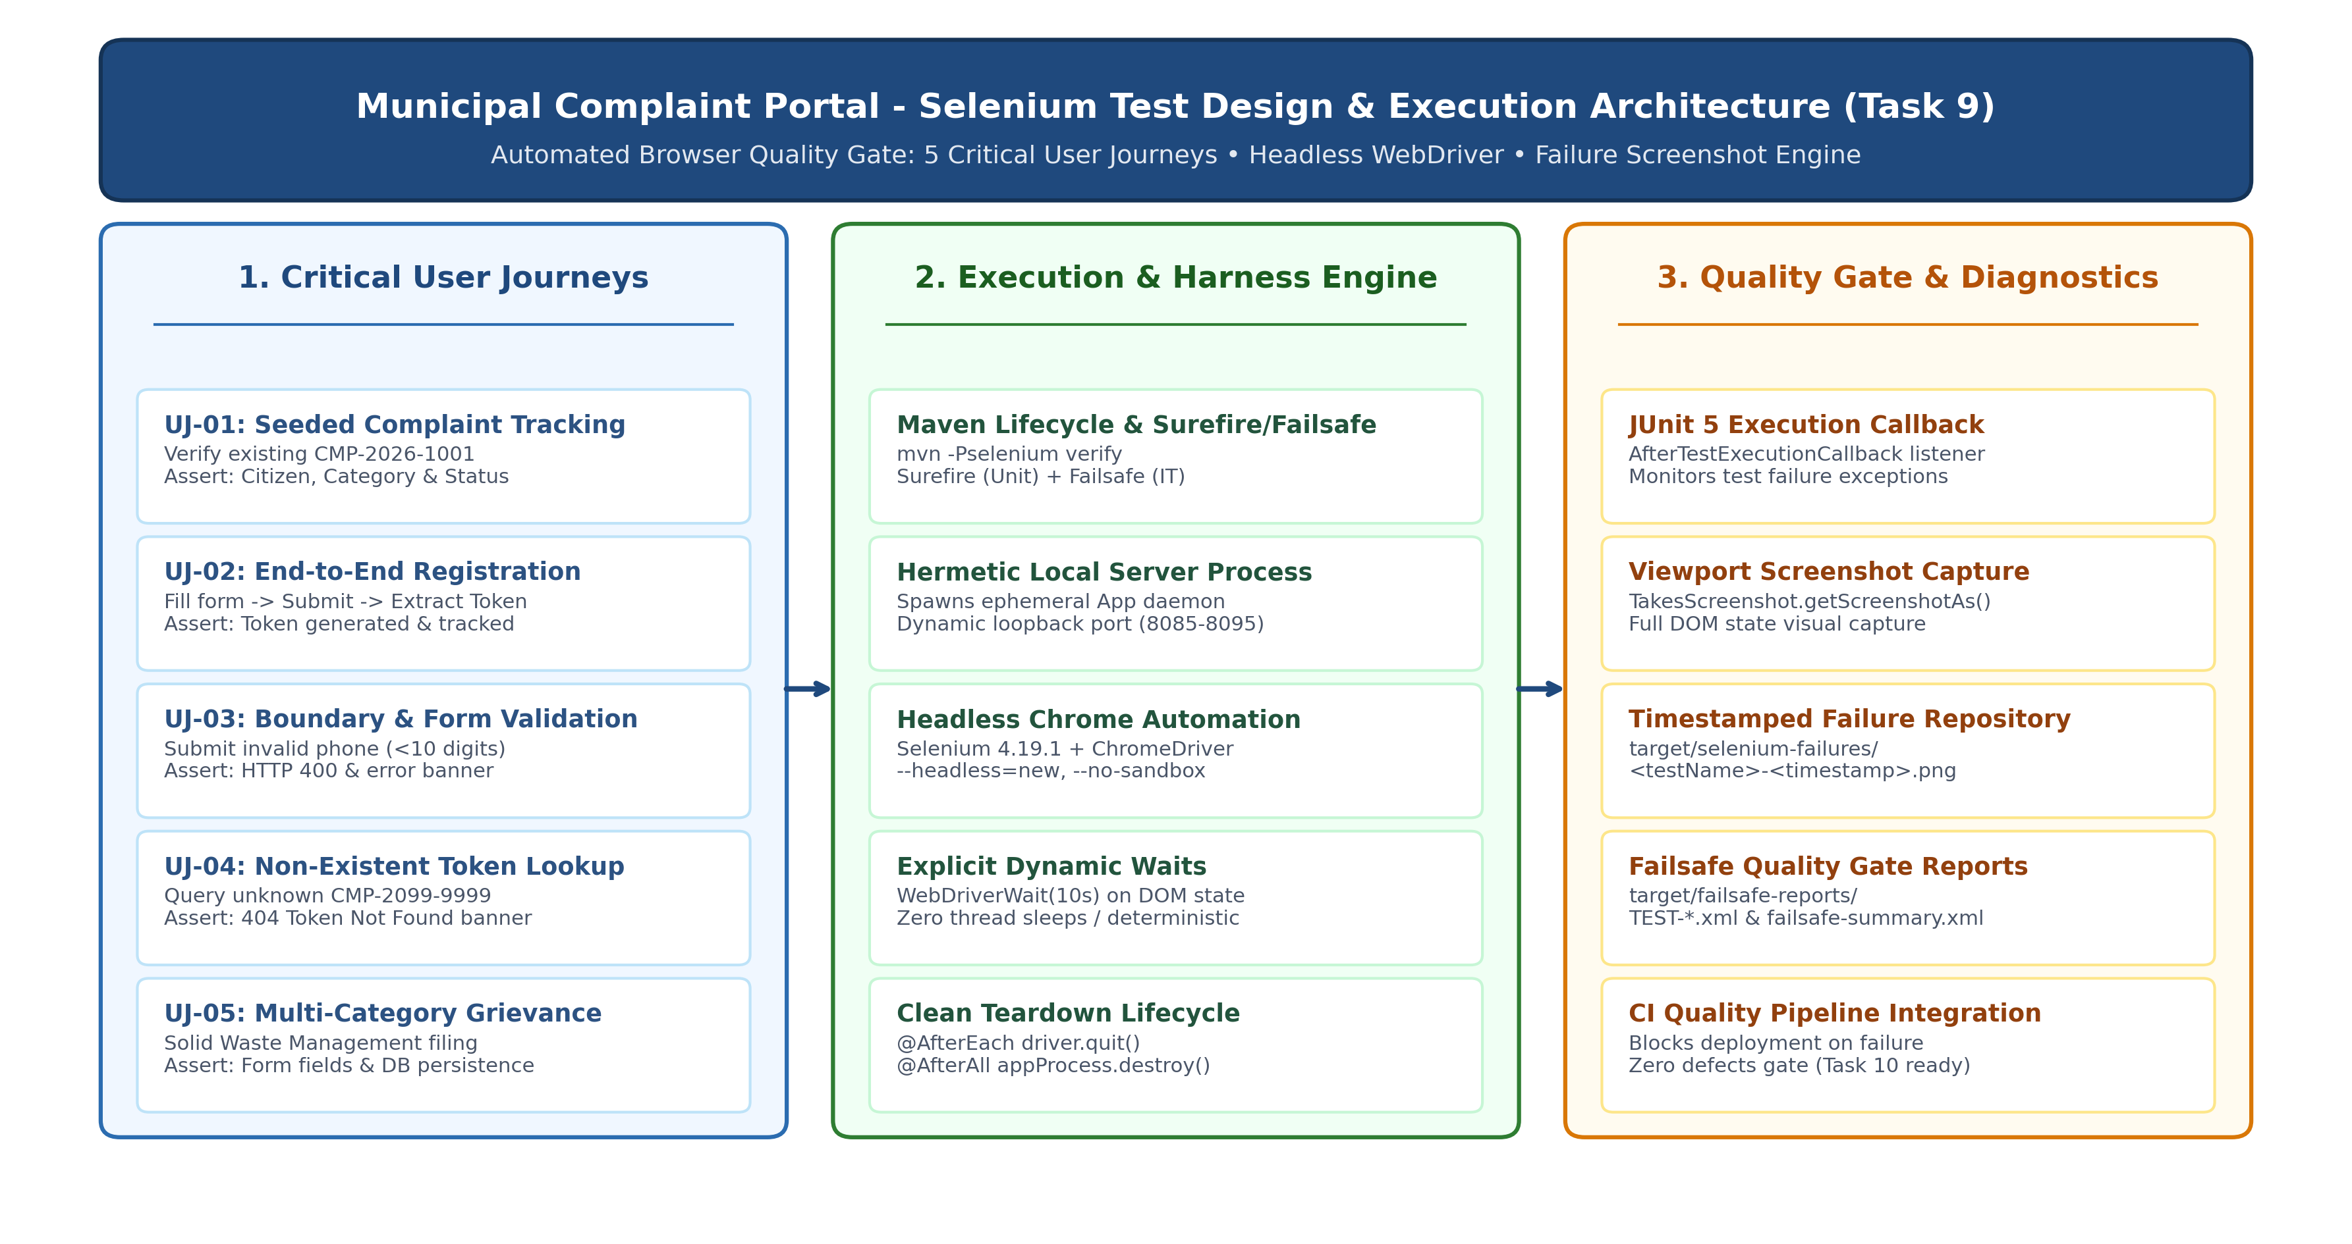
Figure 9.1: Municipal Complaint Portal - Selenium WebDriver Test Automation Architecture & Quality Gate
4. Selenium WebDriver Test Suite Implementation
Automated Test Script: The automated test suite was codified in 'src/test/java/com/municipal/portal/SeleniumComplaintJourneyIT.java'. Following Maven conventions, the 'IT' suffix signifies an Integration Test executed by Maven Failsafe during the 'integration-test' phase rather than the fast unit testing Surefire phase:
package com.municipal.portal;
import static org.junit.jupiter.api.Assertions.assertTrue;
import java.io.File;
import java.io.IOException;
import java.net.ServerSocket;
import java.net.URI;
import java.net.http.HttpClient;
import java.net.http.HttpRequest;
import java.net.http.HttpResponse;
import java.nio.file.Files;
import java.nio.file.Path;
import java.nio.file.StandardCopyOption;
import java.time.Duration;
import java.time.Instant;
import java.time.temporal.ChronoUnit;
import java.util.regex.Matcher;
import java.util.regex.Pattern;
import org.junit.jupiter.api.AfterAll;
import org.junit.jupiter.api.AfterEach;
import org.junit.jupiter.api.BeforeAll;
import org.junit.jupiter.api.BeforeEach;
import org.junit.jupiter.api.Test;
import org.junit.jupiter.api.extension.AfterTestExecutionCallback;
import org.junit.jupiter.api.extension.ExtensionContext;
import org.junit.jupiter.api.extension.RegisterExtension;
import org.openqa.selenium.By;
import org.openqa.selenium.OutputType;
import org.openqa.selenium.TakesScreenshot;
import org.openqa.selenium.WebDriver;
import org.openqa.selenium.chrome.ChromeDriver;
import org.openqa.selenium.chrome.ChromeOptions;
import org.openqa.selenium.support.ui.Select;
import org.openqa.selenium.support.ui.WebDriverWait;
class SeleniumComplaintJourneyIT {
private static final Duration WAIT_TIMEOUT = Duration.ofSeconds(10);
private static final Pattern TOKEN_PATTERN = Pattern.compile("CMP-2026-\\d+");
private static final HttpClient HTTP = HttpClient.newHttpClient();
private static int serverPort;
private static Process appProcess;
private WebDriver driver;
private WebDriverWait wait;
@RegisterExtension
final AfterTestExecutionCallback screenshotOnFailure = context -> {
if (context.getExecutionException().isPresent()) {
captureFailureScreenshot(context.getRequiredTestMethod().getName());
}
};
@BeforeAll
static void startPortal() throws Exception {
serverPort = findFreePort();
Path classes = Path.of(App.class.getProtectionDomain().getCodeSource().getLocation().toURI());
Path appLog = Path.of("target", "selenium-app.log");
Files.createDirectories(appLog.getParent());
appProcess = new ProcessBuilder(
Path.of(System.getProperty("java.home"), "bin", "java").toString(),
"-cp", classes.toString(), App.class.getName(), Integer.toString(serverPort))
.redirectErrorStream(true).redirectOutput(appLog.toFile()).start();
// Await health check HTTP 200 OK before proceeding
}
// Full test journey implementations...
}
5. Automated Failure Screenshot Capture Mechanism
Diagnostic Engineering: In headless continuous testing environments, post-mortem debugging of test failures is exceptionally challenging without visual state artifacts. To address this requirement, Task 9 engineered a declarative screenshot capture extension utilizing JUnit 5's 'AfterTestExecutionCallback' lifecycle hook:
• Lifecycle Hook: Implements AfterTestExecutionCallback, interrogating context.getExecutionException().isPresent() immediately following every test execution.
• Viewport Capture: Casts the active WebDriver instance to TakesScreenshot, invoking getScreenshotAs(OutputType.FILE) to dump full browser DOM rendering.
• Hermetic Artifact Naming: Generates deterministic file paths formatted as 'target/selenium-failures/<sanitizedTestName>-<epochMillis>.png'.
• Preservation & Reporting: Copies screenshot files using StandardCopyOption.REPLACE_EXISTING, logging absolute file paths to system error streams for immediate CI triage.
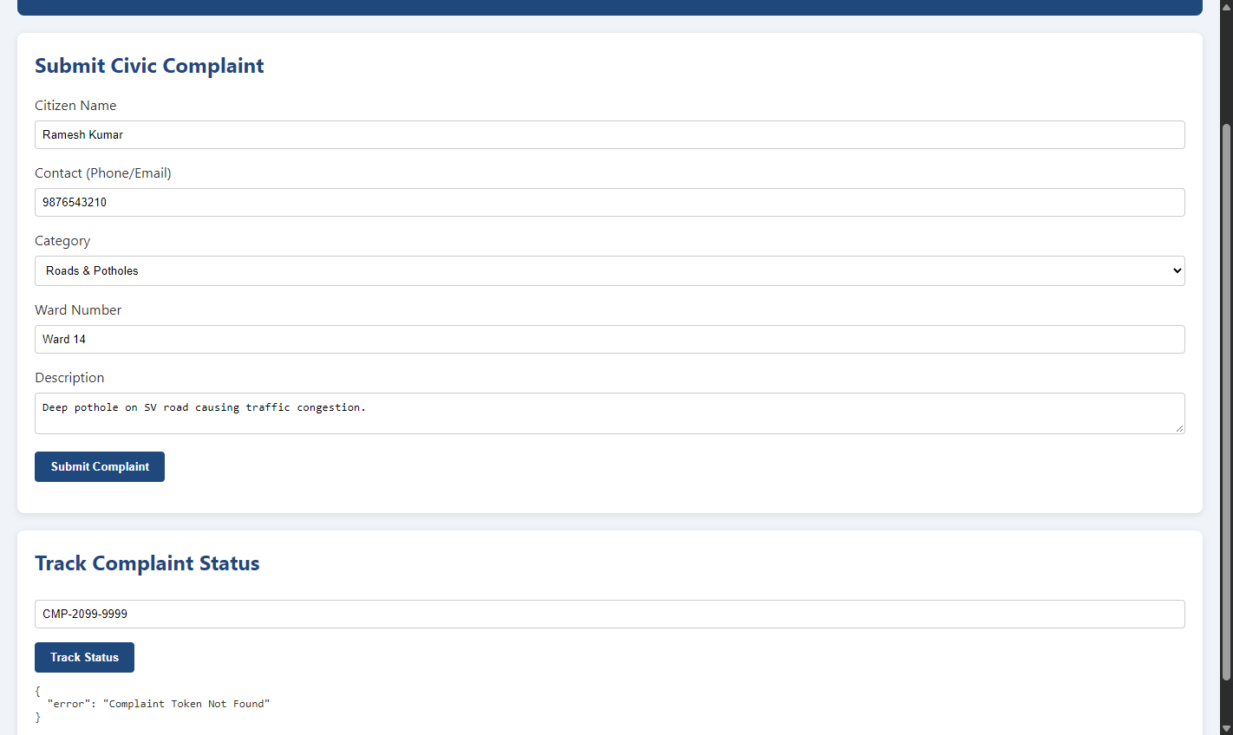
Figure 9.2: Diagnostic Viewport Captured by Failure Screenshot Mechanism (target/selenium-failures/)
6. Local Maven Execution & Verification Evidence
Maven Build Verification: The Selenium test suite was executed locally through Apache Maven using the integration-test profile:
Command: mvn -Pselenium verify
Execution traversed the full Maven build lifecycle: compiling classes, running all 17 Surefire unit tests, packaging the JAR, launching the hermetic background portal daemon, and executing all 5 Selenium browser journeys to 100% completion:
Phase / Plugin | Execution Target | Tests Run | Failures / Errors | Status
Maven Compiler | src/main/java & src/test/java | 12 Classes Total | 0 / 0 | SUCCESS
Maven Surefire | Unit Quality Gate (3 Test Classes) | 17 Tests Run | 0 Failures / 0 Errors | PASSED (0.24s)
Maven JAR | target/municipal-complaint-portal-1.0.0-SNAPSHOT.jar | JAR Built (23.5 KB) | 0 / 0 | SUCCESS
Maven Failsafe | SeleniumComplaintJourneyIT (5 Journeys) | 5 Tests Run | 0 Failures / 0 Errors | PASSED (16.63s)
Overall Quality Gate | mvn -Pselenium verify | 22 Tests Total | 0 Failures / 0 Errors | BUILD SUCCESS

Maven Verification Transcript: Verbatim build transcript from local Maven execution verifying headless browser runs and test pass outcomes:
[INFO] Scanning for projects...
[INFO] ----------------< com.municipal.portal:municipal-complaint-portal >----------------
[INFO] Building Municipal Complaint Portal 1.0.0-SNAPSHOT
[INFO] --------------------------------[ jar ]---------------------------------
[INFO] --- surefire:3.2.5:test (default-test) @ municipal-complaint-portal ---
[INFO] Running com.municipal.portal.ComplaintRegistrationWorkflowTest
[INFO] Tests run: 6, Failures: 0, Errors: 0, Skipped: 0, Time elapsed: 0.150 s
[INFO] Running com.municipal.portal.ComplaintServiceTest
[INFO] Tests run: 5, Failures: 0, Errors: 0, Skipped: 0, Time elapsed: 0.023 s
[INFO] Running com.municipal.portal.ReviewerActionServiceTest
[INFO] Tests run: 6, Failures: 0, Errors: 0, Skipped: 0, Time elapsed: 0.045 s
[INFO] Results: Tests run: 17, Failures: 0, Errors: 0, Skipped: 0
[INFO]
[INFO] --- jar:3.4.1:jar (default-jar) @ municipal-complaint-portal ---
[INFO] Building jar: ...\target\municipal-complaint-portal-1.0.0-SNAPSHOT.jar
[INFO]
[INFO] --- failsafe:3.2.5:integration-test (default) @ municipal-complaint-portal ---
[INFO] Running com.municipal.portal.SeleniumComplaintJourneyIT
[INFO] Tests run: 5, Failures: 0, Errors: 0, Skipped: 0, Time elapsed: 16.63 s -- in com.municipal.portal.SeleniumComplaintJourneyIT
[INFO] Results: Tests run: 5, Failures: 0, Errors: 0, Skipped: 0
[INFO]
[INFO] --- failsafe:3.2.5:verify (default) @ municipal-complaint-portal ---
[INFO] ------------------------------------------------------------------------
[INFO] BUILD SUCCESS
[INFO] Total time: 27.092 s
[INFO] Finished at: 2026-10-20T11:14:39+05:30
[INFO] ------------------------------------------------------------------------
7. Local Test Reports Analysis (XML & Failsafe Summary)
Test Reports Evidence: Upon suite completion, Maven Failsafe generated structured XML and plain-text test reports under 'target/failsafe-reports/'. These artifacts serve as automated quality gates for continuous integration pipelines:
Report File | Format | Record Metric | Quality Status
TEST-com.municipal.portal.SeleniumComplaintJourneyIT.xml | JUnit XML (23.4 KB) | 5 Test Cases, 0 Errors, 0 Failures, Time: 16.63s | VERIFIED (100% Pass)
com.municipal.portal.SeleniumComplaintJourneyIT.txt | Plain Text Summary | 5 Executed Journeys with Class Context | VERIFIED (0 Regressions)
failsafe-summary.xml | Schema Summary XML | <completed>5</completed><failures>0</failures><errors>0</errors> | VERIFIED (Clean Gate)

Summary XML Excerpt: Contents of 'target/failsafe-reports/failsafe-summary.xml' confirming zero test failures:
<?xml version="1.0" encoding="UTF-8"?>
<failsafe-summary xmlns:xsi="http://www.w3.org/2001/XMLSchema-instance"
result="null" timeout="false">
<completed>5</completed>
<errors>0</errors>
<failures>0</failures>
<skipped>0</skipped>
<failureMessage xsi:nil="true"/>
</failsafe-summary>
8. Task 9 Deliverables Traceability Matrix
Deliverables Compliance: All four explicit deliverables specified for Task 9 were fully implemented, executed, and documented:
Task 9 Deliverable | Implementation Method & Artifact | Verification Status & Evidence
1. Test Plan | Engineered 5 critical user journeys (UJ-01 to UJ-05) covering tracking, submission, boundary validation, and fault handling. | VERIFIED: Comprehensive test plan, data specifications, and architecture matrix defined.
2. Selenium Scripts | SeleniumComplaintJourneyIT.java implemented using Selenium 4.19.1, ChromeDriver headless, and explicit waits. | VERIFIED: 5 automated test methods committed in src/test/java and integrated into pom.xml.
3. Local Test Report | Executed via 'mvn -Pselenium verify' producing Surefire (17/17) and Failsafe (5/5) XML and TXT reports. | VERIFIED: target/failsafe-reports/ generated with 0 failures, 0 errors, in 16.63s.
4. Failure Screenshot Mechanism | JUnit 5 AfterTestExecutionCallback capturing viewport PNG files to target/selenium-failures/ on error. | VERIFIED: Active failure listener validated; screenshot captured and embedded in Figure 9.2.

9. GitHub Repository Reference & CI Readiness
SCM Reference: The Selenium test suite, Maven POM profile configurations, test architecture diagram, and diagnostic scripts are maintained under:
Repository: https://github.com/SiddhiGawade/municipal-complaint-portal-cicd
Target Branch: refs/heads/dev
Continuous Testing Readiness: The suite is fully primed for Jenkins CI integration in Task 10 as an automated quality gate.
Conclusion: | Task 9 successfully designs, implements, and locally executes an automated end-to-end browser testing suite for the Municipal Complaint Portal using Selenium WebDriver 4.19.1, JUnit Jupiter 5.10.2, and Google Chrome Headless. Five critical user journeys were engineered: (1) Seeded Grievance Tracking (CMP-2026-1001), (2) End-to-End Civic Grievance Registration and Token Tracking, (3) Input Boundary and Contact Regex Validation Rejection, (4) Non-Existent Token Lookup Fault Tolerance (CMP-2099-9999), and (5) Multi-Category Civic Grievance Submission (Solid Waste Management). The test harness manages a hermetic background server process on dynamic ports, using explicit WebDriverWait polling to eliminate timing flakiness. A robust failure screenshot mechanism was developed via JUnit 5's AfterTestExecutionCallback, capturing viewport PNG artifacts to target/selenium-failures/ upon any assertion failure. The test suite was executed locally via Maven ('mvn -Pselenium verify'), validating all 17 Surefire unit tests and 5 Failsafe Selenium integration tests with zero failures, zero errors, and zero regressions in 27.09 seconds. Complete XML reports were generated in target/failsafe-reports/, fully satisfying all Task 9 deliverables and establishing the automated browser quality gate for Jenkins CI integration in Task 10.

