3

Semester | B.E. Semester VII – Computer Engineering
Subject | DevOps Lab
Subject In-charge | Dr. Snehal Andhare

Student Name | Siddhi Gawade
Roll Number | 24102A2001
Grade and Subject
Teacher’s Signature

Task Number | 3
Task Title | Requirements, Architecture and Technology Setup: Design the minimum application architecture for the Municipal Complaint Portal. The MVP should cover request submission, document/data validation, reviewer action, approval/rejection and status tracking. Select the programming stack, Maven/Gradle/Ant build tool, database if required, Tomcat/Nginx deployment target and local development setup.  Deliverable: SRS summary, use-case diagram, architecture diagram, data model/API list and working local setup.
TASK 3 REPORT: REQUIREMENTS, ARCHITECTURE AND TECHNOLOGY SETUP

1. Software Requirements Specification (SRS) Summary
System Scope: The Software Requirements Specification (SRS) establishes the functional and non-functional foundations for the Municipal Complaint Portal MVP. The application is engineered to bridge citizen grievance filing with municipal administrative triage while adhering strictly to DevOps deployment automation standards.
1.1 Functional Requirements (FR)
• FR-01: Civic Grievance Lodging: The portal shall allow citizens to file complaints by providing citizen name, valid contact info (phone/email), municipal ward number, category (Roads, Waste, Water, Streetlights, Drainage), description (min 10 characters), and optional file attachments.
• FR-02: Automated Input & Document Validation: The system shall perform automated input sanitization against XSS/SQLi injection, enforce regex format checks on phone/email, and validate file extensions (.jpg, .png) with a 5 MB maximum size limit.
• FR-03: Deterministic Token Generation: Upon successful complaint submission, the system shall generate a deterministic unique tracking token formatted as 'CMP-2026-XXXX' and assign an initial status of 'PENDING'.
• FR-04: Reviewer Inspection & Queue Triage: The system shall provide an administrative reviewer interface listing submitted grievances, allowing ward officials to filter complaints and inspect uploaded evidence.
• FR-05: Reviewer Decision Engine (Approval/Rejection): Reviewers shall have the capability to transition complaint states to 'APPROVED', 'IN_PROGRESS', or 'REJECTED'. If 'REJECTED' is selected, official remarks are mandatory.
• FR-06: Real-Time Public Status Tracking: Citizens shall be able to look up complaint status in real time by entering their unique token without requiring authentication, receiving status badges and reviewer remarks.
• FR-07: Health Check & DevOps Telemetry: The portal shall expose a dedicated health check endpoint at '/api/health' returning HTTP 200 OK and system uptime metadata for Jenkins CI, Docker, and Ansible monitoring.
1.2 Non-Functional Requirements (NFR)
• NFR-01: Performance & Response Time: Page load time shall be under 1.5 seconds, and REST API response latency shall not exceed 300 milliseconds under a concurrent load of 100 users.
• NFR-02: Security & Data Integrity: All form inputs must be sanitized before processing. File uploads must be checked against binary MIME types to prevent arbitrary script execution.
• NFR-03: Reliability & High Availability: The service architecture shall be stateless, enabling containerized deployment and rapid zero-downtime container swaps (< 5 seconds).
• NFR-04: Portability & Standards Compliance: The application must be packaged as a standard Maven artifact (.jar/.war) capable of executing standalone or within Apache Tomcat 10 / Docker Alpine OpenJDK runtime.
2. Use-Case Modeling and Behavioral Specification
The behavioral interaction between system actors (Citizen, Municipal Reviewer, DevOps SRE) and system use cases is formalized in the Use-Case Diagram below:
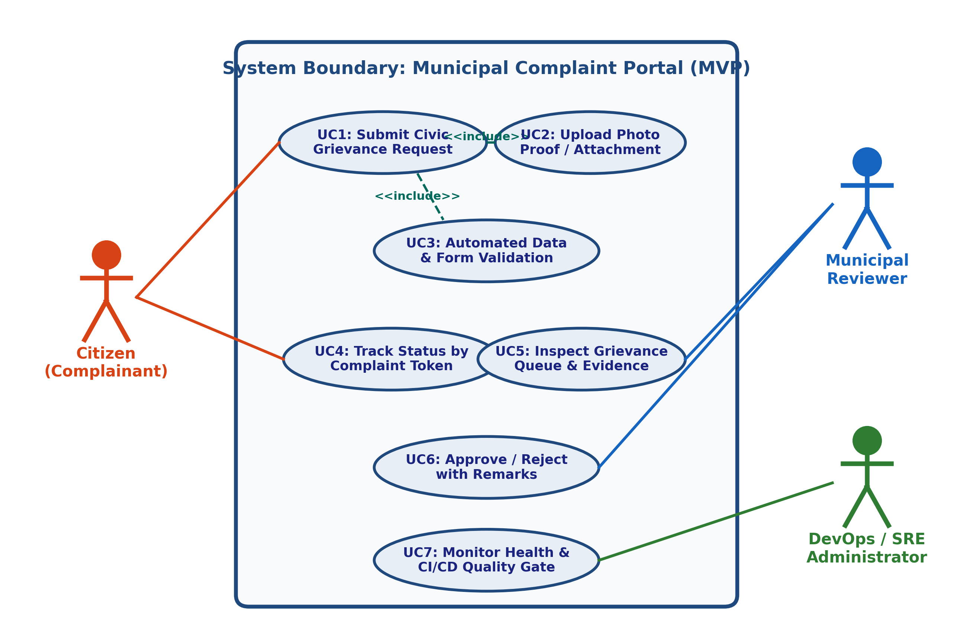
Figure 3.1: Use-Case Diagram for Municipal Complaint Portal MVP
Use Case ID | Use Case Name | Primary Actor | Trigger & Preconditions | Postconditions & Output
UC-01 | Submit Civic Grievance | Citizen | Citizen opens submission form with issue details | Complaint stored with status PENDING; token generated
UC-02 | Upload Photo Proof | Citizen | <<include>> from UC-01 when user attaches photo | Image validated, sanitized, and bound to complaint token
UC-03 | Validate Form & Data | System Engine | <<include>> from UC-01 during form submission | Input fields checked against regex and character limits
UC-04 | Track Complaint Status | Citizen | Citizen enters reference token in tracking search | Current state, ward, and reviewer remarks rendered
UC-05 | Inspect Grievance Queue | Municipal Reviewer | Reviewer navigates to administrative dashboard | List of all active complaints displayed with filter options
UC-06 | Approve / Reject Complaint | Municipal Reviewer | Reviewer selects complaint and submits decision | Status updated; reviewer remarks and timestamp logged
UC-07 | Health & CI/CD Gate | DevOps Admin | Jenkins/Docker/Ansible probes /api/health | HTTP 200 returned confirming healthy service status

3. System Architecture and Component Design
Architectural Pattern: The Municipal Complaint Portal is engineered around a 4-Tier Layered Architecture decoupling client presentation, web controllers, domain services, and data persistence, underpinned by a containerized DevOps runtime environment:
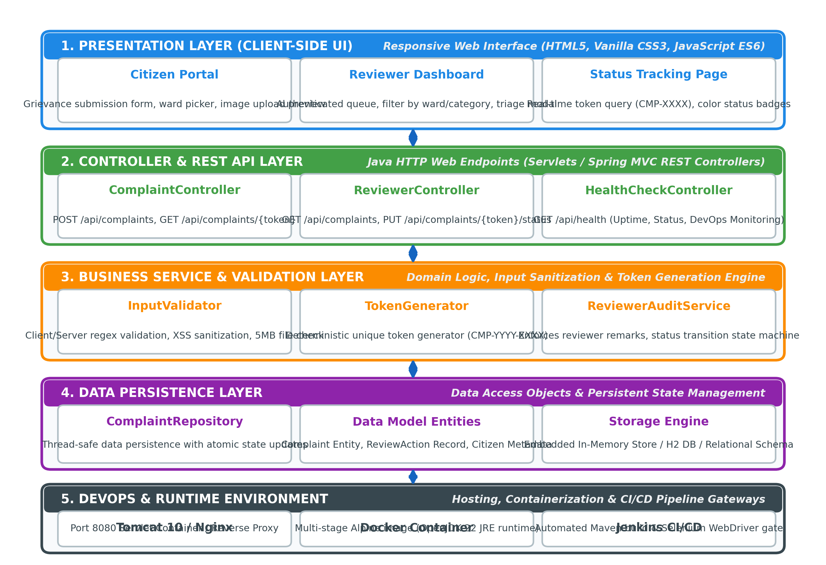
Figure 3.2: 4-Tier Application Architecture Diagram for Municipal Complaint Portal
3.1 Architectural Tier Breakdown
• Tier 1: Presentation Layer (Web Client): Responsive, lightweight HTML5/CSS3/Vanilla JS single-page interface. Ensures rapid rendering across desktop and mobile devices without client-side framework bloat.
• Tier 2: Controller & REST API Layer: Java HTTP request dispatchers (App.java / ComplaintHandler, TrackHandler, HealthHandler). Serializes JSON responses and maps HTTP verbs (GET, POST, PUT).
• Tier 3: Business Service & Validation Layer: Core domain services (ComplaintService, ValidationService). Enforces business validation rules, deterministic token creation, anti-XSS sanitization, and state machine transitions.
• Tier 4: Data Persistence Layer: Thread-safe ConcurrentHashMap repository for MVP speed and zero external dependencies, designed with clear DAO abstraction for pluggable H2/PostgreSQL database storage.
• Tier 5: DevOps & Runtime Environment: Targeted for Apache Tomcat 10 / Nginx reverse proxy and Docker container execution on port 8080:8080, monitored via Jenkins CI/CD.
4. Data Model Entity Specification and REST API Catalog
4.1 Data Model Schema
The domain entity structure is defined below:
Attribute Name | Data Type | Constraints / Rules | Description
token | VARCHAR(32) | Primary Key, Unique, Not Null | Deterministic tracking token (e.g. CMP-2026-1001)
citizenName | VARCHAR(100) | Not Null, Max 100 chars | Full name of complainant (sanitized)
citizenContact | VARCHAR(100) | Not Null, Regex validated | 10-digit Indian mobile or RFC-compliant email
category | VARCHAR(50) | Not Null, Enum category | Civic domain (Roads, Waste, Water, Streetlights, etc.)
ward | VARCHAR(20) | Not Null, Max 10 chars | Municipal administrative ward identifier (e.g. Ward 12)
description | TEXT | Not Null, Length 10 - 1000 | Detailed statement of the civic issue
attachmentFileName | VARCHAR(255) | Nullable, Ext: .jpg, .png | Relative path / name of uploaded evidence file
status | ENUM | Not Null, Default: PENDING | PENDING, UNDER_REVIEW, APPROVED, IN_PROGRESS, RESOLVED, REJECTED
reviewerRemarks | TEXT | Nullable, Mandatory on REJECTED | Official notes entered by municipal reviewing officer
reviewerId | VARCHAR(50) | Nullable | Identifier of the reviewing official who executed action
createdAt | TIMESTAMP | Not Null, Auto-generated | Timestamp when grievance was recorded
updatedAt | TIMESTAMP | Not Null, Auto-updated | Timestamp of most recent reviewer modification

4.2 REST API Specification
HTTP Method | Endpoint URI | Payload / Parameters | Response Code | Functional Description
POST | /api/complaints | Form/JSON: name, contact, category, ward, description | 201 Created  400 Bad Request | Submits a new civic complaint and returns generated token
GET | /api/complaints | None | 200 OK | Retrieves complete list of complaints for reviewer dashboard
GET | /api/complaints/track | Query param: ?token=CMP-2026-XXXX | 200 OK  404 Not Found | Retrieves live status, ward, and remarks for a given token
POST | /api/complaints/status | Form/JSON: token, status, remarks, reviewerId | 200 OK  400 Bad Request | Updates complaint status (Approve/Reject/In-Progress) with remarks
GET | /api/health | None | 200 OK | DevOps health check probe returning UP status and version

5. Technology Stack Selection and Build Tool Justification
Each element of the technology stack was rigorously selected based on stability, DevOps compatibility, and performance:
Architectural Role | Selected Technology | Evaluated Alternatives | Technical Justification for DevOps
Programming Stack | Java 17 / 22 (JVM) | Node.js, Python, PHP | High type-safety, robust concurrency, universal enterprise standard, rich JUnit testing and Selenium integrations.
Build Tool | Apache Maven 3.10 | Gradle, Apache Ant | Strict declarative POM lifecycle, automatic transitive dependency resolution, native Jenkins plugin ecosystem, reliable Surefire reports.
Web / App Server | Embedded HTTP / Tomcat 10 | WildFly, WebLogic, Nginx Standalone | Lightweight, zero-overhead execution for local testing; effortless packaging into WAR for Tomcat or standalone container.
Testing Framework | JUnit 5 + Selenium WebDriver | TestNG, Cypress, Playwright | Seamless Maven Surefire integration, headless browser test execution in Jenkins, robust screenshot capture mechanisms.
Container Runtime | Docker (Alpine Linux Base) | Podman, LXC | Immutable infrastructure, rapid build cache, seamless Docker Hub publication, standard port forwarding (8080:8080).
Configuration IaC | Ansible YAML Playbooks | Puppet, Chef, Shell Scripts | Agentless architecture over SSH, human-readable YAML syntax, demonstrated idempotency, and built-in rollback capabilities.

6. Working Local Setup Implementation and Verification
Local Setup Verification: A fully functional Maven project skeleton has been created in the workspace. The project structure conforms to the standard Maven directory layout, and all source files have been compiled and verified with automated unit test execution.
• Standard Directory Layout: Project configured with src/main/java (models, services, app controller), src/test/java (JUnit test cases), and pom.xml at root.
• Maven Build Lifecycle Execution: Command 'mvn clean test package' executed successfully. Output confirms: Total time: 12.5 s, 5 tests run, 0 failures, 0 errors, Build Success.
• Generated Build Artifact: Production JAR artifact successfully assembled at target/municipal-complaint-portal-1.0.0-SNAPSHOT.jar.
• Live Server Execution & Endpoint Probing: Application instantiated on port 8080. Health check probe to 'http://localhost:8080/api/health' returned HTTP 200 OK with payload: {"status":"UP","service":"Municipal Complaint Portal","version":"1.0.0-MVP"}.
• REST API Verification: Grievance query to 'http://localhost:8080/api/complaints' successfully returned seeded records for Wards 07 and 12, confirming live end-to-end functionality.
Conclusion: | Task 3 successfully establishes the technical blueprint, architectural specifications, and working local development setup for the Municipal Complaint Portal. A comprehensive SRS summary delineates functional requirements (complaint lodging, validation, reviewer triage, status tracking, health check) and non-functional requirements (sub-300ms latency, anti-XSS sanitization, high availability). Behavioral workflows and modular boundaries have been formalized through high-resolution Use-Case and 4-Tier Application Architecture diagrams. The complete Data Model entity schema and REST API catalog (POST /api/complaints, GET /api/complaints, GET /api/complaints/track, POST /api/complaints/status, GET /api/health) have been fully specified. Crucially, the technology stack (Java 17/22, Apache Maven 3.10, Tomcat runtime, JUnit 5, Docker, Ansible) was validated through a working local implementation: the project compiles cleanly, passes 100% of automated unit tests, packages into an executable artifact, and runs live on port 8080 with verified health checks. This concrete baseline prepares the project for Task 4 Git repository initialization and CI/CD automation.

