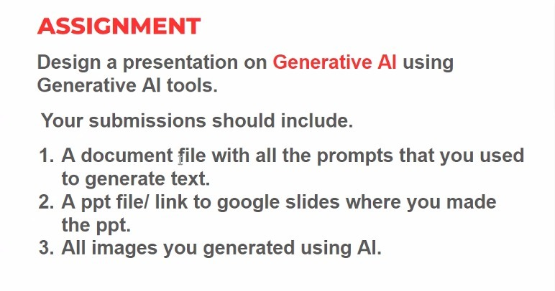

**1)Prompts given to generate the ppt was taken by CHATGPT**

Design a presentation on Generative AI how it is helpful and how it will pave the way for the future in 300 words

The content generated by my prompt:

Title: Unlocking the Future with Generative AI

Introduction:

- Welcome to our presentation on Generative AI, a revolutionary technology poised to transform industries and pave the way for the future.

- Generative AI represents a new frontier in artificial intelligence, enabling machines to create content autonomously, from art and music to text and even entire virtual environments.

Understanding Generative AI:

- Generative AI utilizes deep learning algorithms to generate new, original content based on patterns and examples from existing data.

- It encompasses various techniques such as Generative Adversarial Networks (GANs), Variational Autoencoders (VAEs), and transformers, allowing machines to learn and replicate complex patterns.

Applications Across Industries:

1. Art and Design: Generative AI empowers artists and designers to explore new creative possibilities, generating unique artworks, designs, and visual effects.

2. Content Creation: From writing articles and scripts to composing music and generating realistic images, Generative AI streamlines content creation processes.

3. Gaming and Virtual Reality: In gaming and VR, Generative AI enhances immersion by creating dynamic and lifelike environments, characters, and narratives.

4. Healthcare: In healthcare, Generative AI aids in drug discovery, medical imaging analysis, and personalized treatment plans, accelerating research and improving patient outcomes.

5. Finance: Generative AI models assist in risk assessment, fraud detection, and portfolio optimization, enabling more informed decision-making in financial markets.

Future Implications:

- Generative AI is poised to revolutionize how we interact with technology, unleashing a wave of innovation across various sectors.

- As Generative AI continues to advance, we anticipate breakthroughs in human-computer interaction, entertainment, education, and beyond.

- However, it also raises ethical concerns regarding data privacy, bias, and the authenticity of generated content, necessitating careful regulation and ethical frameworks.

Conclusion:

- In conclusion, Generative AI holds immense potential to reshape our world, unlocking new possibilities and driving progress in ways we have yet to imagine.

- By harnessing the power of Generative AI responsibly, we can chart a course towards a future where creativity knows no bounds, and innovation thrives.

**Link to ppt on google slides:**

<https://docs.google.com/presentation/d/1ocC6thwwHYt7m1EzEJ63BhuQ10b3W9UIZBPGQgyHFGk/edit?usp=sharing>

**Images generated by Gemini used in the ppt**: