HomeBase Database -
This document summarizes the enhancements made to the Mental Health Clinic Database. It includes the database tables, relationships, and implemented rules and triggers that ensure data accuracy, maintain referential integrity, and enforce business logic for clinic operations.

Database Design Summary

Main Tables
1. PROVIDER – Stores clinician or doctor information.
2. PATIENT – Stores patient details and links to their primary provider.
3. VISIT – Logs each appointment with the corresponding patient and provider.
4. ASSESSMENT – Contains patient survey results for each visit.

Relationships (Foreign Keys)
Relationship | From (Child) | To (Parent) | Type | Meaning
1 | PATIENT.primary_provider_id | PROVIDER.provider_id | 1:M | Each provider has many patients
2 | VISIT.patient_id | PATIENT.patient_id | 1:M | Each patient has many visits
3 | VISIT.provider_id | PROVIDER.provider_id | 1:M | Each provider conducts many visits
4 | ASSESSMENT.visit_id | VISIT.visit_id | 1:M | Each visit can have one or more assessments
Delete Rules:
- Deleting a Patient automatically deletes related Visits and Assessments (CASCADE).
- Deleting a Provider is blocked if patients are still assigned (NO ACTION).

Smart Rules and Triggers
No | Trigger Name | Table | Purpose | Rule Enforced
1 | trg_ValidateAssessmentTiming | ASSESSMENT | Enforces 90-day rule for assessments | Only first visit or ≥90 days since last
2 | trg_PreventProviderDeletion | PROVIDER | Prevents deleting active providers | Provider must have no patients
3 | trg_ValidateVisitDate | VISIT | Prevents future visit dates | Visit date must be today or earlier
4 | trg_PreventOverlappingVisits | VISIT | Prevents double-booking | No duplicate (patient + provider + date)
5 | trg_ValidatePatientAge | PATIENT | Checks patient’s age | Must be at least 5 years old

Audit Trail Triggers
Trigger | Table | Action | Logged Information
trg_AuditPatientChanges | PATIENT | UPDATE | Old vs. new patient data
trg_LogPatientDeletion | PATIENT | DELETE | Deleted patient record
trg_LogVisitDeletion | VISIT | DELETE | Deleted visit record
trg_AuditAssessmentChanges | ASSESSMENT | INSERT/UPDATE | New or modified assessment scores

Constraints and Checks
Type | Example Rule | Purpose
CHECK | visit_date <= GETDATE() | Prevents future visit dates
CHECK | gender IN ('Male','Female','Other','Prefer not to say') | Ensures valid gender values
CHECK | duration > 0 | Ensures positive duration
CHECK | q1_answer–q10_answer BETWEEN 1 AND 5 | Enforces valid survey score range
NOT NULL | Primary key and essential fields | Prevents missing critical data
COMPUTED COLUMN | assessment_score = SUM(q1–q10) | Automatically calculates total assessment score

Summary
The Mental Health Clinic Database was enhanced with triggers to automate rule enforcement, foreign keys for relational integrity, audit logs for change tracking, and constraints to ensure data validity. These improvements help prevent data entry mistakes, maintain consistency, and support compliance with healthcare standards.

Some Test cases :
Patient with primary provider - list:

Delete Duplicates :
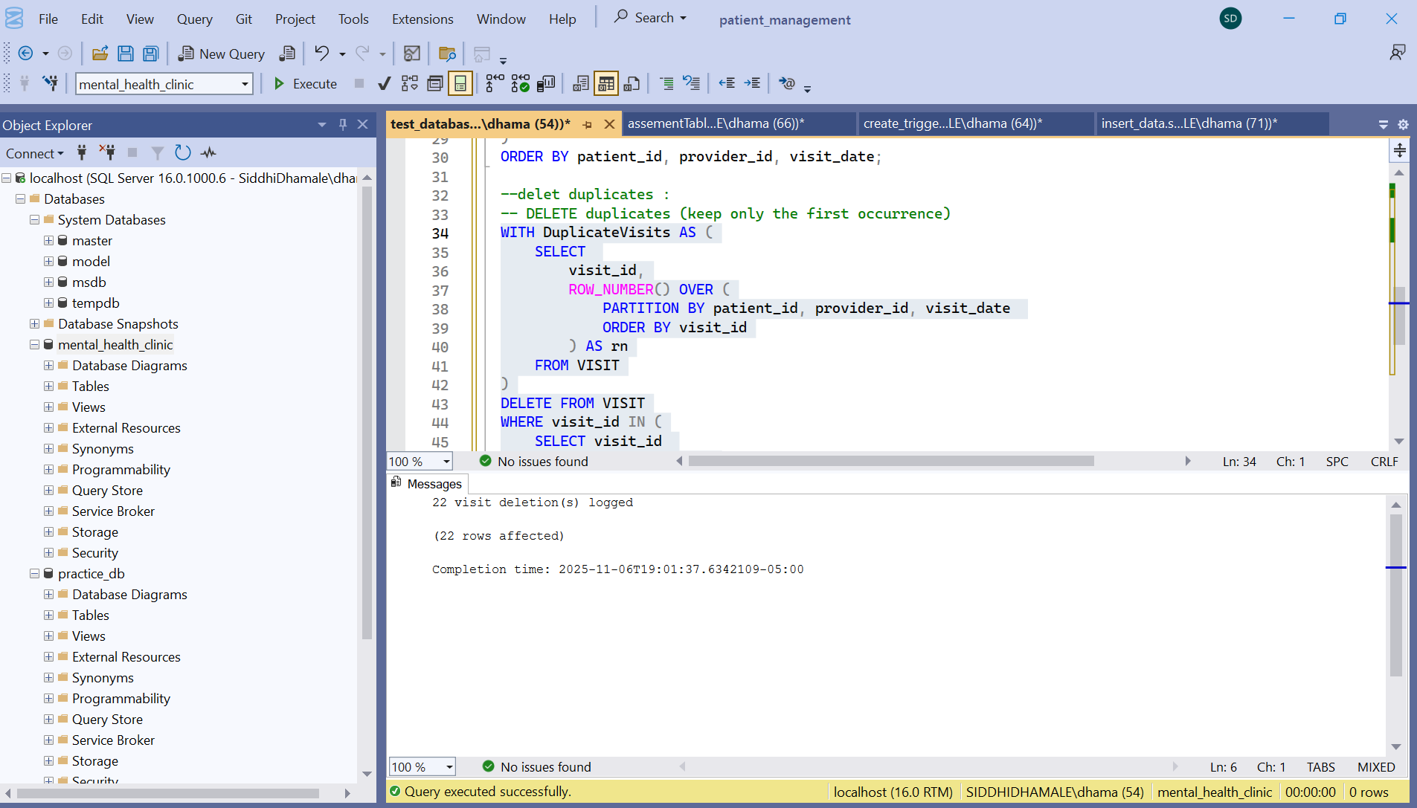

Trigger to prevent Duplicate Visits:
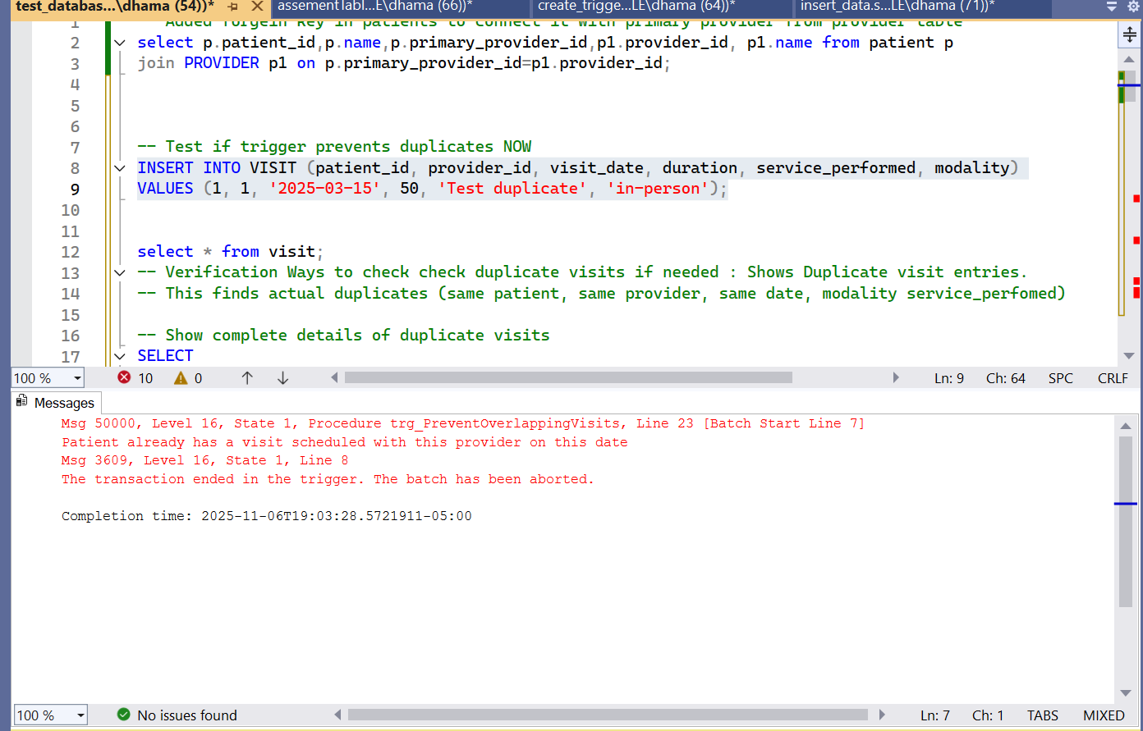

Can’t add new assessments for this patient as they next assessment must be added after 3 months:
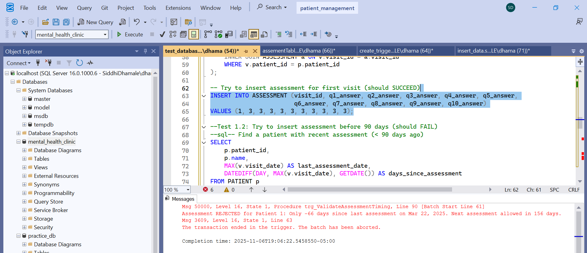
Can add new visit with same attributes just different provider :
-- Insert with different provider (should SUCCEED)
INSERT INTO VISIT (patient_id, provider_id, visit_date, duration, service_performed, modality) VALUES (1, 2, '2025-03-15', 60, 'Different provider', 'in-person');

10 patients having higher assessment score :

Avg visits in a month :

Delete provider without patients

Try to insert visit with future date (should FAIL) (handled by trigger)

Insert visit with past date
-- Insert visit with past date
INSERT INTO VISIT (patient_id, provider_id, visit_date, duration, service_performed, modality)
VALUES (1, 1, '2025-01-15', 60, 'Past visit', 'in-person');

-- Get audit log count before update
SELECT COUNT(*) AS before_count FROM AUDIT_LOG WHERE table_name = 'PATIENT';

-- Update patient record
UPDATE PATIENT
SET state = 'New York'
WHERE patient_id = 1;

-- Check audit log after update
SELECT * FROM AUDIT_LOG
WHERE table_name = 'PATIENT'
AND record_id = 1
ORDER BY changed_date DESC;

-- Verify count increased
SELECT COUNT(*) AS after_count FROM AUDIT_LOG WHERE table_name = 'PATIENT';

This section outlines the key tests performed to verify that all triggers, constraints, and relationships in the Mental Health Clinic Database function correctly.

Rule 1: Assessment Timing (First Visit + Every 90 Days)
- Verified first assessment is allowed for new patients.
- Attempted early assessment (<90 days) — correctly rejected.
- Inserted assessment after 90+ days — accepted.
- Stored procedure confirmed eligibility logic.

Rule 2: Provider Deletion Restriction
- Prevented deletion of provider with active patients.
- Successfully deleted provider with no assigned patients.
- Verified reassignment of patients allows provider deletion.

Rule 3: No Future Visit Dates
- Blocked insertion of future-dated visits.
- Allowed visits on current and past dates.
- Prevented updates changing visit dates to the future.

Rule 4: No Double-Booking
- Prevented duplicate visits for same patient, provider, and date.
- Allowed same date with a different provider or different date with the same provider.

Rule 5: Minimum Patient Age (≥5 Years)
- Blocked patients under 5 years old.
- Allowed patients aged 5 and above.
- Prevented DOB updates making existing patients underage.

Audit Trail Validation
- Confirmed all patient updates, visit deletions, and assessment changes are logged in the audit table.

Cascade Delete Tests
- Deleting a patient automatically removed related visits.
- Deleting a visit automatically removed related assessments.

Check Constraint Validation
- Rejected invalid gender, modality, and out-of-range assessment scores.
- Prevented negative visit durations.

