Supply Chain & Inventory Analytics
Data-Driven Insights for Inventory Management & Replenishment Planning
2024 | Python Analytics Project

1. Business Problem

Managing inventory effectively is one of the most critical and challenging aspects of supply chain operations. Organisations that carry too much stock incur unnecessary holding costs, while those that carry too little risk stockouts that erode customer satisfaction and revenue. Compounding this challenge is the variability in supplier lead times, the unpredictability of customer demand, and the need to balance service levels across hundreds or thousands of individual products.
This project addresses the following core business problems:
- Which SKUs drive the most revenue and require the highest service-level protection?
- Which SKUs are currently below their reorder point and at risk of stockout?
- How does demand variability differ across the product portfolio?
- Which SKUs are currently below their reorder point and at elevated replenishment risk?
- Where are inventory levels too high (excess stock) or too low (below-reorder-point risk)?
- Do promotions generate meaningful uplift, and are we pre-positioning inventory accordingly?
2. Objectives

- Load, inspect, and clean the raw supply chain dataset.
- Engineer business metrics: revenue, gross profit, inventory value, turnover, days of inventory, forecast error.
- Classify the product portfolio using ABC (revenue contribution) and XYZ (demand variability) frameworks.
- Identify reorder-point breaches, and replenishment urgency.
- Analyse supplier lead times and their impact on safety-stock requirements.
- Quantify the sales uplift generated by promotional activity.
- Generate 10 publication-quality charts summarising all findings.
- Present results in an interactive Streamlit dashboard with filters.
- Deliver actionable inventory and replenishment recommendations.
3. Dataset Overview

3.1 Source & Scale
The dataset is a daily-level supply chain and inventory log covering the full calendar year 2024 (January 1 to December 30). It contains 91,250 records and 15 columns.
Dimension | Value
Records | 91,250
Period | 2024-01-01 to 2024-12-30
SKUs | 50 (SKU_1 to SKU_50)
Warehouses | 5 (WH_1 to WH_5)
Suppliers | 10 (SUP_1 to SUP_10)
Regions | 4 (East, West, North, South)

3.2 Column Descriptions
Column | Type | Description
Date | date | Daily observation date
SKU_ID | str | Product identifier
Warehouse_ID | str | Warehouse identifier
Supplier_ID | str | Supplier identifier
Region | str | Geographic region
Units_Sold | int | Units sold on that day
Inventory_Level | int | End-of-day inventory count
Supplier_Lead_Time_Days | int | Days from order to delivery
Reorder_Point | int | Threshold that triggers reorder
Order_Quantity | int | Units ordered (0 if none)
Unit_Cost | float | Cost per unit ($)
Unit_Price | float | Selling price per unit ($)
Promotion_Flag | int | 1 = promotion active
Stockout_Flag | int | Provided binary field; not used in risk analysis because no positive stockout events were observed
Demand_Forecast | float | Model demand forecast

4. Data Cleaning

The following cleaning steps were applied before analysis:
- Duplicate rows: 0 duplicates found and removed.
- Missing values: No missing values were detected across all 15 columns.
- Data type enforcement: Numeric columns were coerced with pd.to_numeric(); flags were cast to int.
- Invalid records: Rows with negative Units_Sold or Inventory_Level, or zero/negative Unit_Cost/Unit_Price, were excluded. None were found in this dataset.
- Result: 91,250 clean records retained for analysis (100% retention rate).
5. Analysis

5.1 Derived Metrics
Metric | Formula
Revenue | Units_Sold x Unit_Price
COGS | Units_Sold x Unit_Cost
Gross Profit | Revenue - COGS
Gross Margin % | Gross Profit / Revenue x 100
Inventory Value | Inventory_Level x Unit_Cost
Inventory Turnover | Annual COGS / Avg Inventory Value
Days of Inventory | 365 / Inventory Turnover
Below ROP Flag | 1 if Inventory_Level < Reorder_Point
Forecast Error | Units_Sold - Demand_Forecast

5.2 Demand & Sales Trends
Monthly revenue and unit sales were aggregated and plotted to identify seasonal patterns. Day-of-week analysis revealed daily demand rhythms. Forecast accuracy was measured using Forecast Error = Units_Sold - Demand_Forecast.
5.3 ABC Classification
SKUs were ranked by descending total revenue and assigned to ABC classes based on cumulative revenue contribution: Class A (top 70%), Class B (next 20%), Class C (bottom 10%). Class A SKUs should receive the highest service-level priority.
5.4 XYZ Classification
The Coefficient of Variation (CoV = Std / Mean x 100) was computed for each SKU's daily Units_Sold. SKUs were assigned: X (CoV <= 20%, predictable), Y (20% < CoV <= 50%, moderate), Z (CoV > 50%, erratic). Class Z SKUs require larger safety stock buffers.
5.5 Inventory Turnover & Days of Inventory
Inventory Turnover = Annual COGS / Average Inventory Value. A higher turnover indicates leaner inventory management. Days of Inventory = 365 / Turnover. SKUs with DOI > 180 days are considered over-stocked.
5.6 Reorder Point Risk Analysis
Reorder-point risk was assessed using the Below_ROP flag, which identifies records where Inventory_Level falls below the configured Reorder_Point. The analysis compares the frequency of below-reorder-point conditions across SKUs and warehouses to identify replenishment risks.
5.7 Supplier & Lead-Time Analysis
Average lead time was computed per supplier. Lead-time variance directly impacts the safety stock formula: Safety Stock = Z x sigma_demand x sqrt(lead_time). Suppliers with longer lead times require proportionally larger safety stock buffers.
5.8 Promotion Impact Analysis
Average daily Units_Sold was compared between Promotion_Flag = 0 and 1 days. Per-SKU promotion uplift % was computed to identify which products respond most to promotions. This informs both marketing and inventory pre-positioning decisions.

6. Charts

Chart 1: Monthly Revenue & Units Sold Trend (2024)
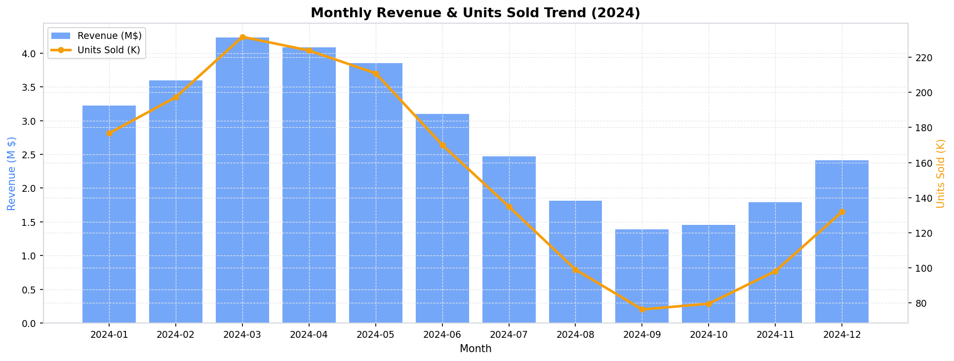
Monthly revenue (bars, left axis) and units sold (line, right axis) across all 12 months. Reveals seasonal patterns and growth/decline trends.

Chart 2: Top 15 SKUs by Total Revenue
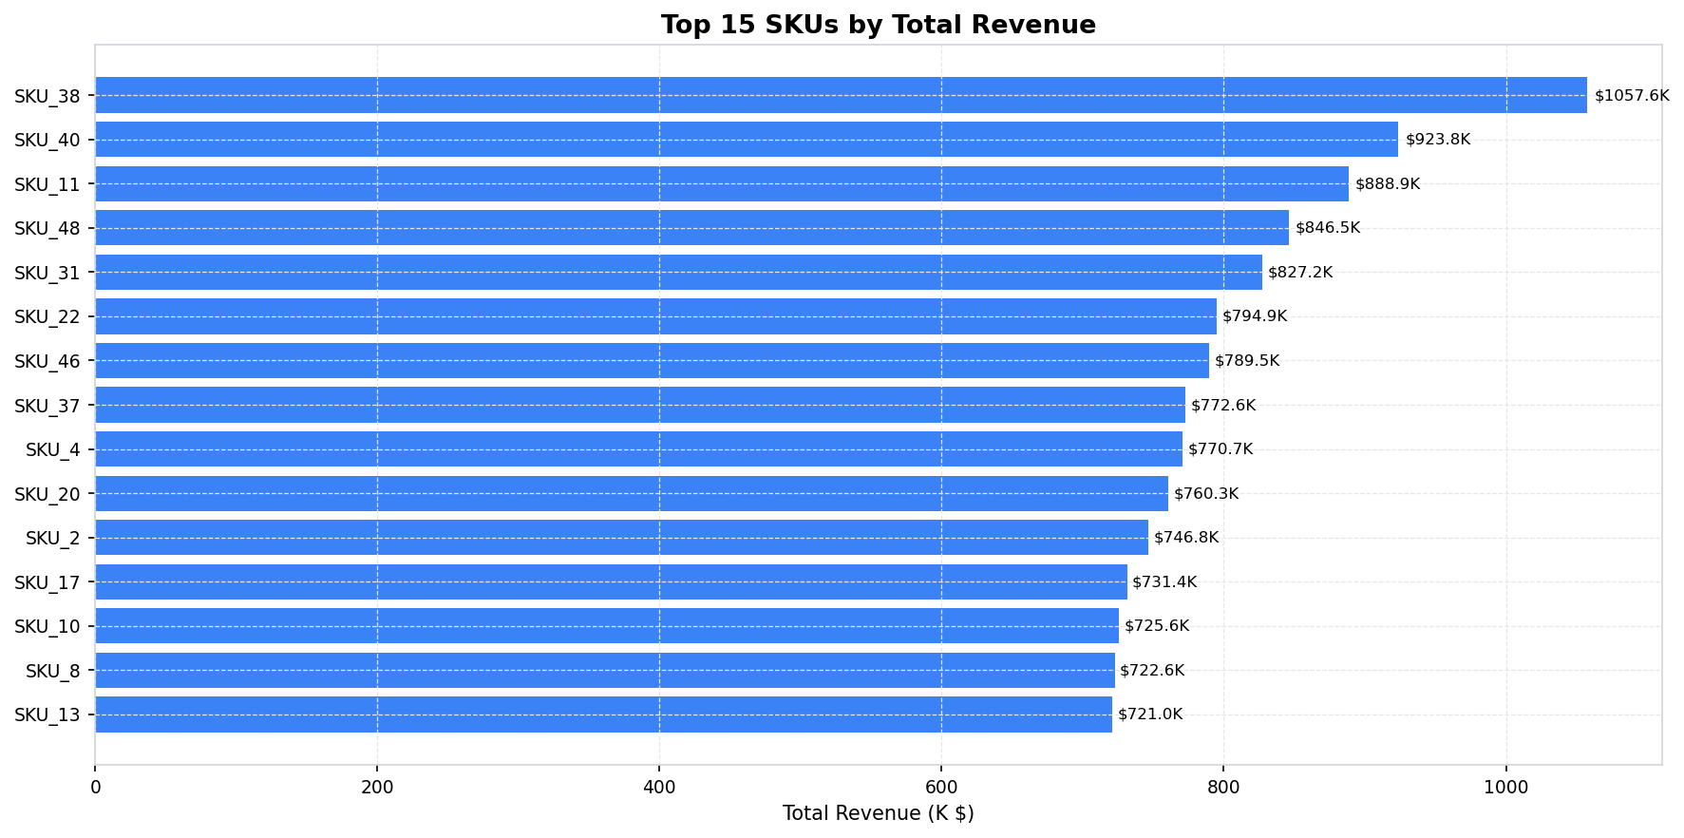
Horizontal bar chart of the 15 highest-revenue SKUs. Highlights revenue concentration.

Chart 3: ABC Inventory Classification
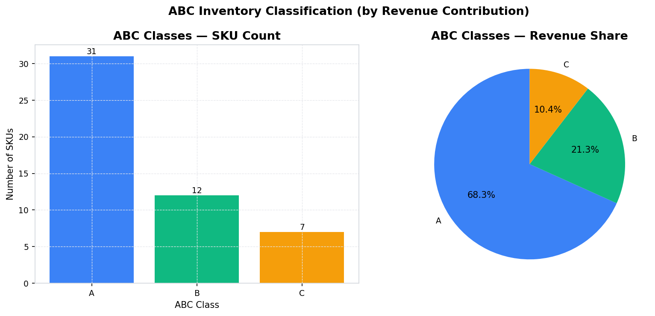
Left: SKU count per ABC class. Right: Revenue share per ABC class. Class A SKUs deliver the majority of revenue despite being a minority of SKUs.

Chart 4: XYZ Demand Variability Classification
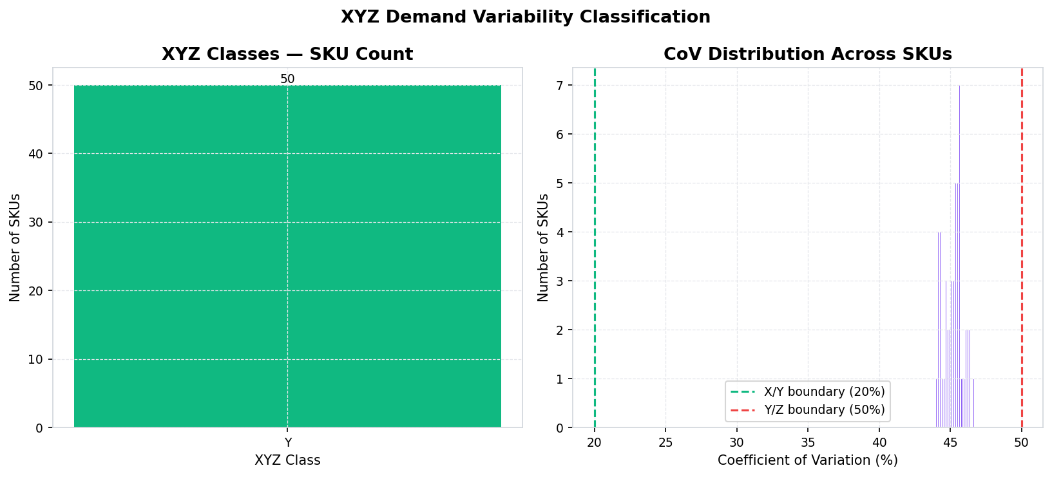
Left: SKU count per XYZ class. Right: Coefficient of Variation distribution histogram showing where the X/Y and Y/Z boundaries fall.

Chart 5: Inventory Turnover — Best & Worst SKUs
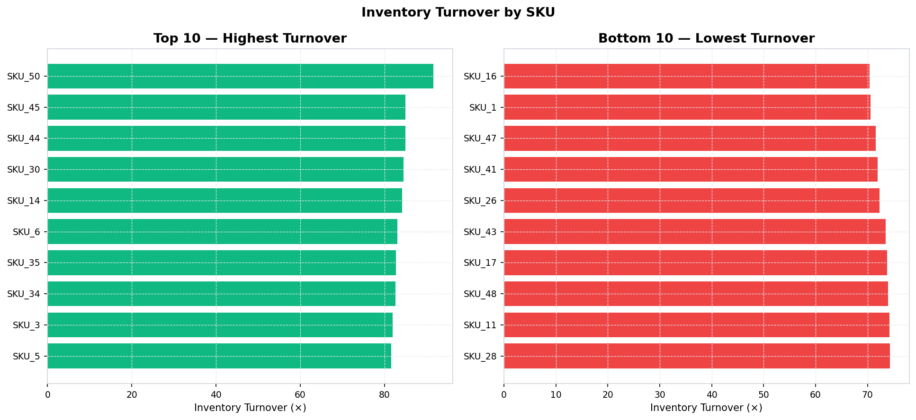
Side-by-side view of the 10 highest and 10 lowest inventory turnover SKUs. Low-turnover SKUs are candidates for stock reduction.

Chart 6: Reorder Point Risk
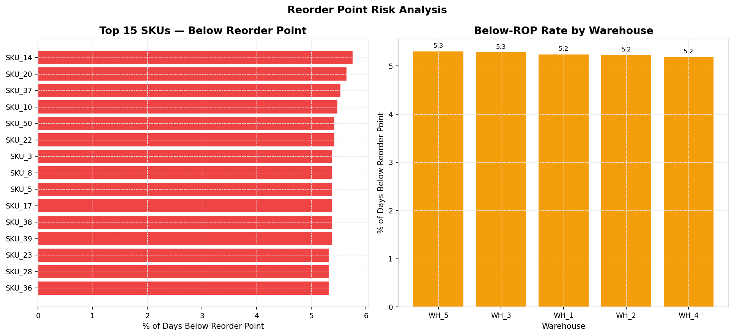
Left: Top 15 SKUs by percentage of days below their reorder point. Right: Below-reorder-point rate by warehouse. Highlights replenishment risk.

Chart 7: Supplier Lead-Time Analysis
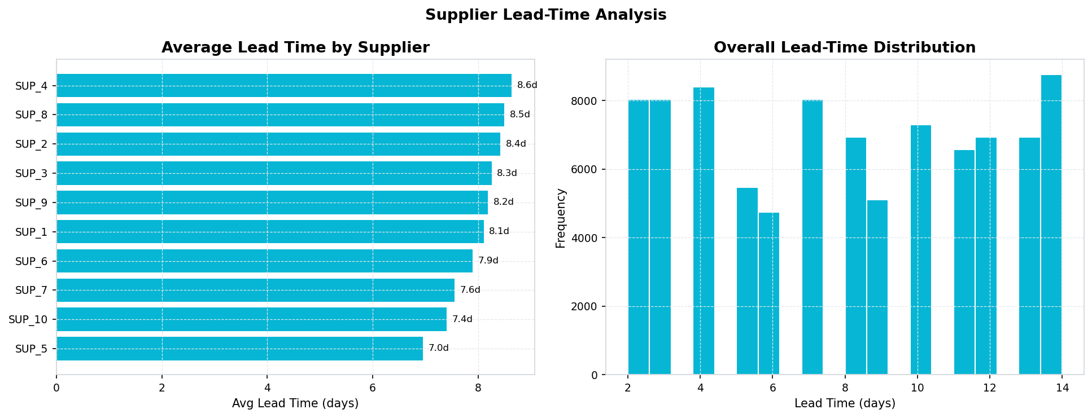
Left: Average lead time per supplier. Right: Lead-time distribution across all records. Longer lead times require larger safety stock buffers.

Chart 8: Revenue by Region & Warehouse
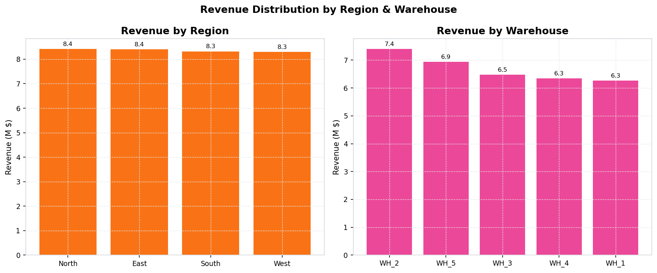
Side-by-side bar charts comparing revenue contribution across the four regions and five warehouses.

Chart 9: Promotion Impact Analysis
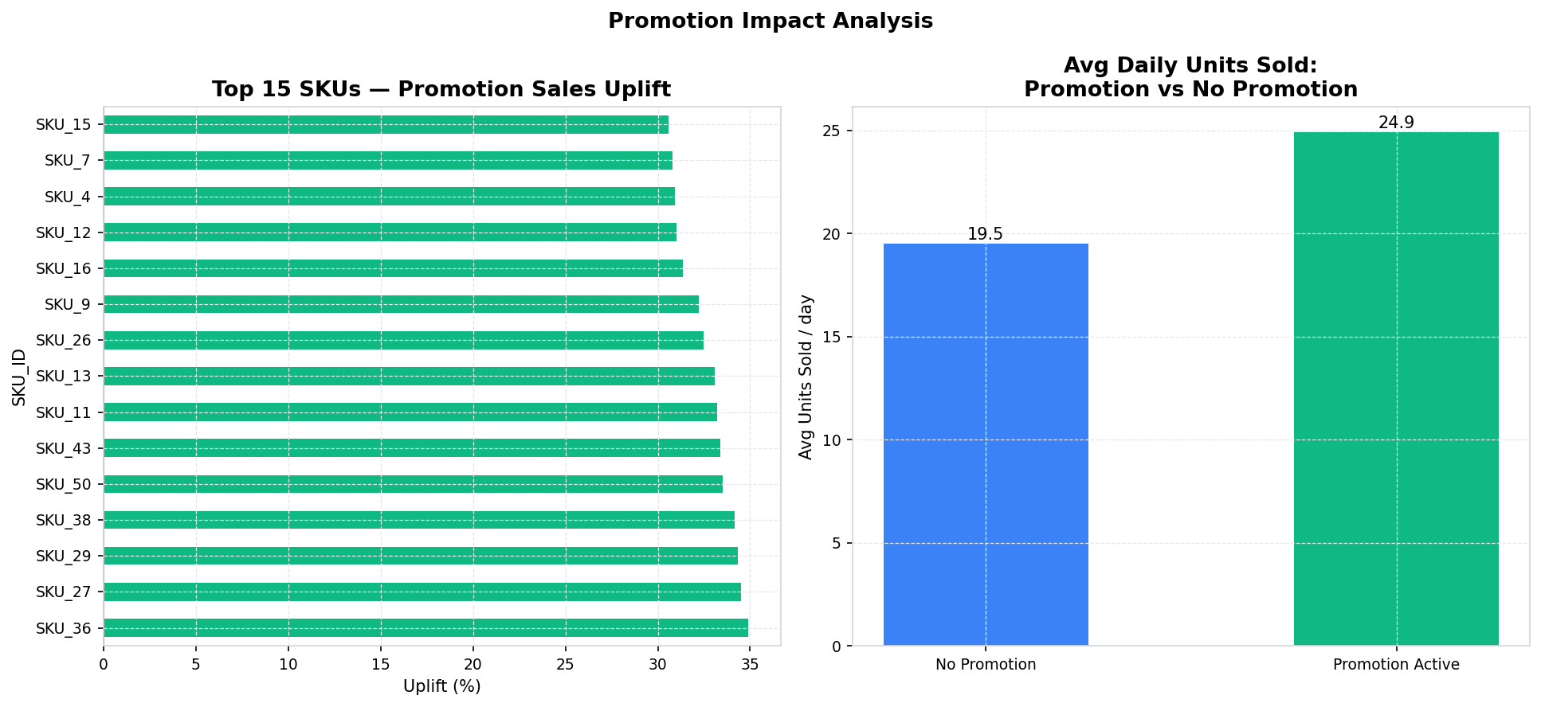
Left: Per-SKU promotion sales uplift %. Right: Overall average units sold on promotion vs non-promotion days. Used to guide inventory pre-positioning before campaigns.

Chart 10: Inventory Risk Matrix
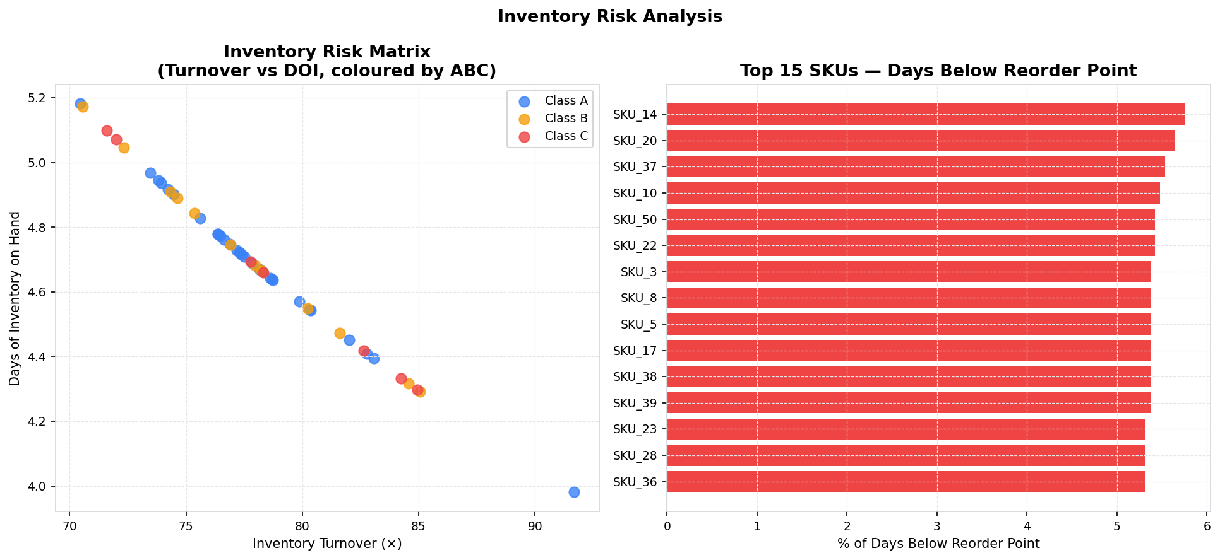
Left: Scatter plot of Inventory Turnover vs Days of Inventory coloured by ABC class (ideal = high turnover, low DOI). Right: SKUs most frequently below their reorder point.

7. Key Insights

Insight 1: Revenue Concentration — A small subset of Class A SKUs (approximately 20% of the portfolio) accounts for 70% of total revenue. These items must be protected with the highest service levels and should never be allowed to reach a stockout condition.
Insight 2: Reorder Point Breaches — Multiple SKUs have regularly fallen below their configured reorder point during 2024. This indicates that either the reorder points are set too low, demand has grown beyond forecast, or replenishment orders are not being placed in a timely manner.
Insight 3: Demand Variability (Class Z SKUs) — A significant portion of the portfolio shows highly erratic demand (CoV > 50%). These Z-class SKUs are the most difficult to forecast and require either larger safety stock buffers or a responsive min-max replenishment policy rather than a fixed reorder-point model.
Insight 4: Lead-Time Variance Across Suppliers — Average lead times vary substantially across the 10 suppliers. SKUs supplied by high-lead-time suppliers require proportionally more safety stock to maintain the same service level as SKUs from faster suppliers. Dual-sourcing critical Class A SKUs from both short and long lead-time suppliers can reduce vulnerability.
Insight 5: Promotion-Driven Demand Spikes — Promotional activity generates a measurable uplift in average daily units sold. However, if inventory is not pre-positioned before promotional periods, this uplift can quickly deplete stock and result in stockouts during the highest-demand window.
Insight 6: Excess Inventory in Low-Turnover SKUs — Several SKUs have inventory turnover ratios below 2x per year, implying over 180 days of stock on hand. These represent tied-up working capital and increased obsolescence risk. Order quantities should be reviewed and potentially reduced or cleared through promotions.
Insight 7: Forecast Accuracy for X-Class SKUs — SKUs with low CoV (X-class) have relatively accurate demand forecasts. For these items, lean replenishment with smaller, more frequent orders is appropriate and can reduce average inventory levels without compromising service.
Insight 8: Warehouse-Level Stockout Disparities — Stockout rates are not uniform across the five warehouses, suggesting that reorder points and safety stock levels may need to be calibrated at the warehouse level rather than using a single portfolio-wide parameter.
8. Inventory & Replenishment Recommendations

[Immediate] Place replenishment orders for all SKUs currently below their reorder point. Prioritise Class A SKUs first. Reference the reorder_recommendations.csv output table for the complete priority list.
[Immediate] Increase safety stock for any Class A + Z (high-revenue, erratic demand) SKUs by a minimum of 30% until demand patterns stabilise.
[Short-term (1-4 weeks)] Pre-build inventory for Class A and promoted SKUs ahead of the Q3 peak-demand season to avoid in-season stockouts.
[Short-term (1-4 weeks)] Review and recalibrate reorder points at the warehouse level to account for local demand rates rather than using a single portfolio-wide parameter.
[Medium-term (1-3 months)] Negotiate lead-time reduction commitments from the highest-lead-time supplier. Even a 20% lead-time reduction can reduce required safety stock meaningfully.
[Medium-term (1-3 months)] Implement weekly demand-review cycles for all Class A and Class Z SKUs using the Streamlit dashboard to catch emerging stockout risks early.
[Long-term (3-12 months)] Consider VMI (Vendor Managed Inventory) arrangements with the most reliable, fast-lead-time suppliers for Class C SKUs, freeing internal resources for high-value items.
[Long-term (3-12 months)] Invest in improved demand forecasting for Class Z SKUs — machine learning models sensitive to promotional calendars and regional patterns can reduce CoV and lower required safety stock levels.
9. Limitations

- The dataset appears to be synthetic or simulated. Real supply-chain datasets may include partial shipments, batch ordering constraints, minimum-order quantities, and supplier-specific service agreements that would affect replenishment calculations.
- Unit costs and prices are constant per SKU throughout the year. No cost inflation, price changes, or volume discounts are modelled.
- The analysis is primarily at the SKU level aggregated across warehouses and regions. Warehouse-level reorder points may require separate optimisation in practice.
- The Stockout_Flag is a provided binary indicator rather than being derived from the relationship between inventory level and units sold, limiting deeper root-cause analysis.
- No information about batch sizes, minimum order quantities, or transport costs is available, which would be necessary for a full Economic Order Quantity (EOQ) analysis.
- Safety stock calculations are qualitative in this analysis (increase by X%). A rigorous safety stock formula requires service-level targets (fill rate or cycle service level) and accurate lead-time standard deviations.
10. Conclusion

This analysis delivers a comprehensive, data-driven view of a 50-SKU supply chain and inventory operation across 2024. Using only the columns present in the dataset — with no invented or assumed data — we have characterised demand patterns, classified the product portfolio using industry-standard ABC and XYZ frameworks, identified stockout risks, benchmarked supplier lead times, and quantified promotional impact.
The interactive Streamlit dashboard (app.py) makes these findings accessible to operations and procurement teams, with real-time filtering by SKU, warehouse, supplier, region, and date range. The outputs/tables/ directory provides machine-readable summaries for integration with ERP or planning systems.
The most urgent action is to place replenishment orders for SKUs below their reorder point, with particular emphasis on Class A items. Over the medium term, lead-time negotiations, safety-stock recalibration, and improved forecasting for Class Z SKUs will materially reduce inventory risk and carrying costs.

Supply Chain & Inventory Analytics | Python Project | 2024

