ONLINE RETAIL BUSINESS INTELLIGENCE & ANALYTICS
Project Report
Data Analytics with AI Internship – Aug 2026
Prepared by: Siddhi Bhavsar
Repository: Siddhib2004/IBM_Siddhi_Online_Retail_Project

1. Executive Summary
This project implements an end-to-end Business Intelligence and Analytics solution for online retail transaction data. The application moves from raw data ingestion and quality checks to descriptive, diagnostic, predictive and prescriptive analytics, and presents the results through an interactive Streamlit dashboard.
The generated project outputs cover 13 monthly periods from December 2010 through December 2011. Across the monthly output, recorded revenue totals approximately £10,642,110.80, with 19,960 monthly order counts. The highest monthly revenue occurs in Nov-2011 at £1,503,866.78. The repository also contains a three-month Random Forest revenue forecast for January–March 2012.

2. Project Objectives
- Build a reusable pipeline for loading and cleaning Online Retail transaction data.
- Calculate core retail KPIs such as revenue, orders, customers, products, units sold and average order value.
- Analyze monthly revenue and order trends and identify important products and geographic markets.
- Perform diagnostic analysis around cancellations, product concentration, customer concentration and metric relationships.
- Forecast the next three months of revenue using a Random Forest regression model.
- Convert analytical findings into business-oriented recommendations.
- Expose the complete workflow through an interactive Streamlit dashboard and exportable CSV outputs.

3. Dataset and Data Source
The project uses the UCI Machine Learning Repository Online Retail dataset. The repository README identifies the dataset as the UCI Online Retail dataset and includes an Online Retail.xlsx file. The transaction schema includes invoice number, stock code, description, quantity, invoice date, unit price, customer ID and country.
The analysis treats invoice numbers beginning with 'C' as cancellation transactions. Positive sales records are retained for revenue analysis, while cancellation information remains available for diagnostic analysis.

4. Technology Stack
Technology | Purpose
Python | Core implementation
Pandas | Data loading, cleaning, transformation and aggregation
NumPy | Numerical calculations
OpenPyXL | Reading Excel input
Plotly | Interactive charts
Streamlit | Interactive dashboard
Scikit-learn | Random Forest regression and evaluation metrics

5. System Architecture and Analytical Workflow
The implemented workflow follows the sequence:
Raw Excel Data → Cleaning → KPI Layer → Descriptive Analysis → Diagnostic Analysis → Predictive Forecast → Prescriptive Recommendations → Dashboard/CSV Outputs

The main implementation is contained in project.py. It loads the Excel workbook, applies cleaning rules, computes business metrics, creates analysis tables, trains the forecasting model, generates recommendations, saves outputs and renders the Streamlit interface.

6. Data Cleaning and Feature Engineering
- Remove completely empty rows and duplicate records.
- Convert InvoiceDate to datetime and Quantity, UnitPrice and CustomerID to numeric values.
- Trim text fields such as Description, Country, InvoiceNo and StockCode.
- Create an IsCancelled flag from invoice numbers beginning with C.
- Remove records without valid dates, quantities, unit prices or product descriptions from sales analysis.
- Retain only non-cancelled transactions with positive quantity and positive unit price for revenue calculations.
- Create Revenue = Quantity × UnitPrice.
- Create Year, Month, MonthName, YearMonth, Day, DayName and Hour features.

7. KPI and Descriptive Analysis
The application calculates revenue, unique orders, unique customers, unique products, total units, average order value, units per order and revenue per customer. Monthly metrics additionally include revenue growth.
Indicator | Observed result from repository outputs
Revenue across monthly output | £10,642,110.80
Monthly order-count total | 19,960
Peak revenue month | Nov-2011 — £1,503,866.78
Latest month change | -57.59% vs. Nov-2011
Average monthly revenue | £818,623.91

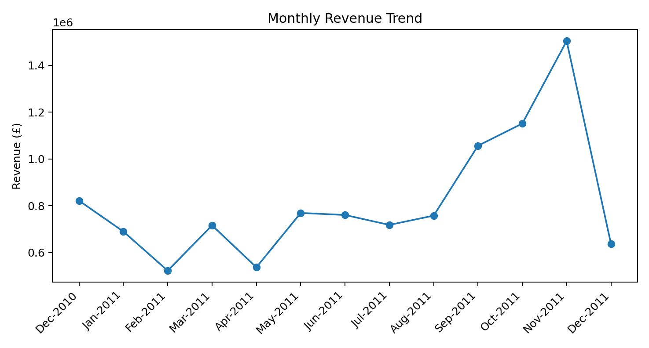Figure 1. Monthly revenue trend derived from outputs/months_kpis.csv.

8. Product and Geographic Analysis
The product analysis output ranks products by revenue and also records units and order counts. The leading entries include DOTCOM POSTAGE, REGENCY CAKESTAND 3 TIER, PAPER CRAFT, LITTLE BIRDIE, WHITE HANGING HEART T-LIGHT HOLDER and PARTY BUNTING.
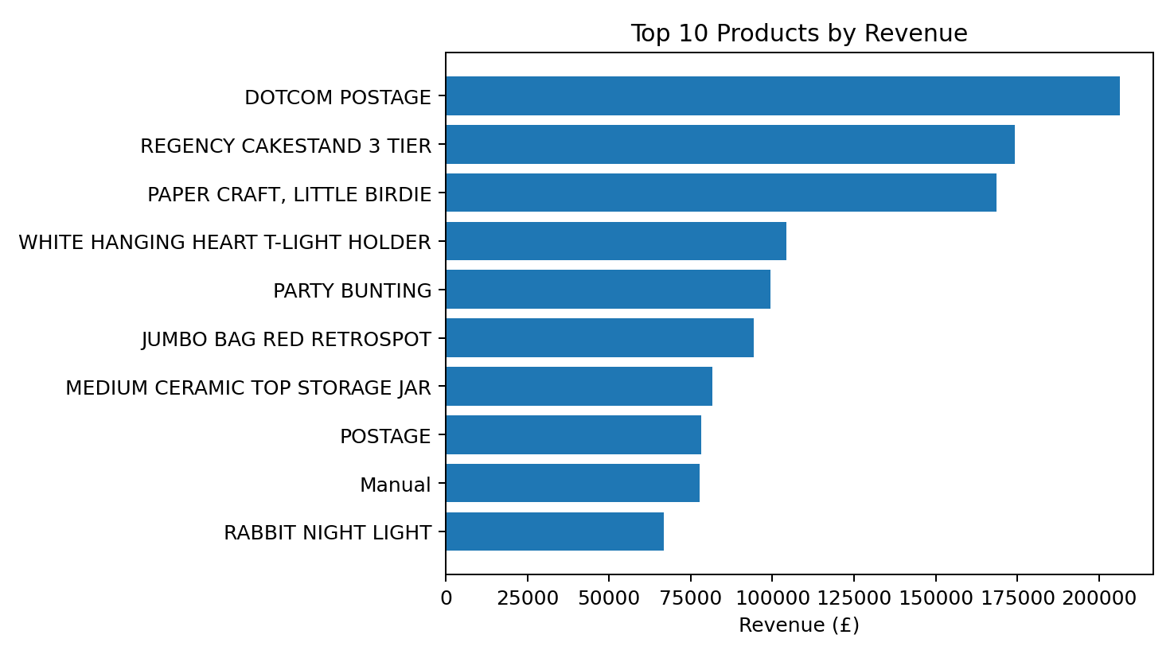
Figure 2. Top 10 products by revenue.

Geographically, the country analysis shows the United Kingdom as the largest revenue market in the generated output, at approximately £9,001,744.09, followed by the Netherlands, EIRE, Germany and France.
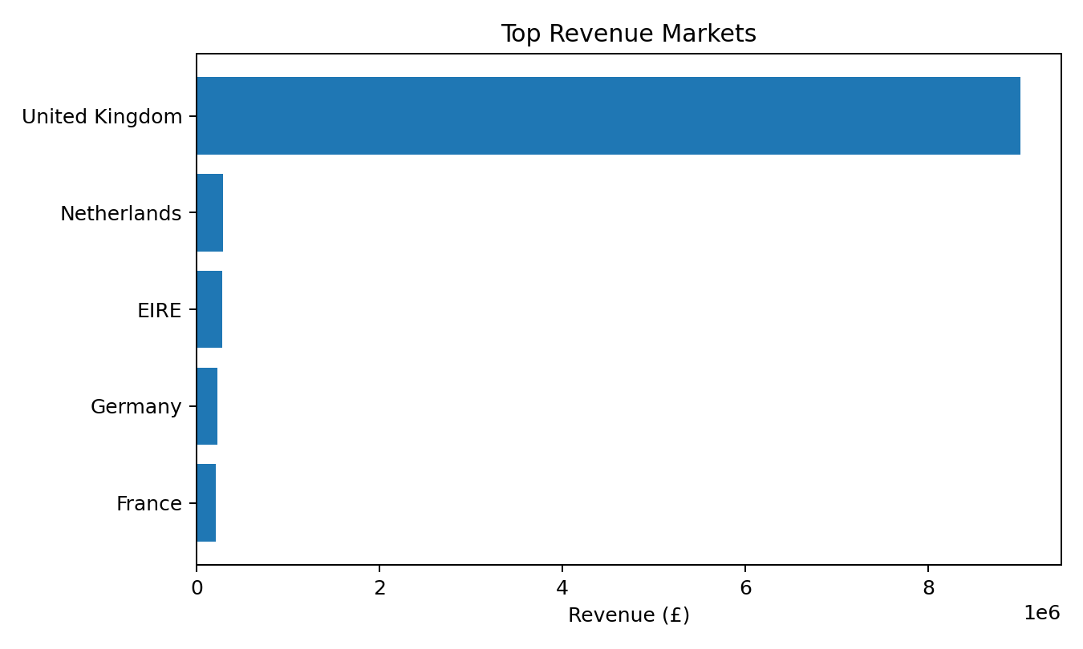
Figure 3. Leading revenue markets.

9. Diagnostic Analytics
The diagnostic module is designed to identify potential business risks and concentration patterns rather than only describe historical totals. It calculates cancellation rate, product revenue concentration, country revenue concentration, customer revenue concentration and correlations among quantity, unit price and revenue.
- Cancellation analysis helps identify operational issues that may affect realized sales.
- Product concentration highlights dependence on a limited part of the assortment.
- Country concentration indicates how strongly revenue is associated with specific geographic markets.
- Customer concentration measures the contribution of the top 10 customers to total revenue.
- Correlation analysis provides a compact view of relationships among transaction quantity, unit price and revenue.

10. Predictive Analytics – Revenue Forecasting
The predictive component uses RandomForestRegressor from scikit-learn. Features include year, month, one-month lagged revenue, two-month lagged revenue, three-month lagged revenue and a three-month rolling mean. A time-ordered 80/20 train-test split is used.
- Number of trees: 300
- Random state: 42
- Maximum depth: 8
- Minimum samples per leaf: 2
- Evaluation metrics: MAE, RMSE and R²
- Forecast horizon: 3 months
Using the monthly values published in the repository, the forecast output is approximately £780,277.00 for January 2012, £805,949.26 for February 2012, and £808,924.58 for March 2012. The average forecast is £798,383.62 per month, compared with £1,097,640.28 for the preceding three actual months.
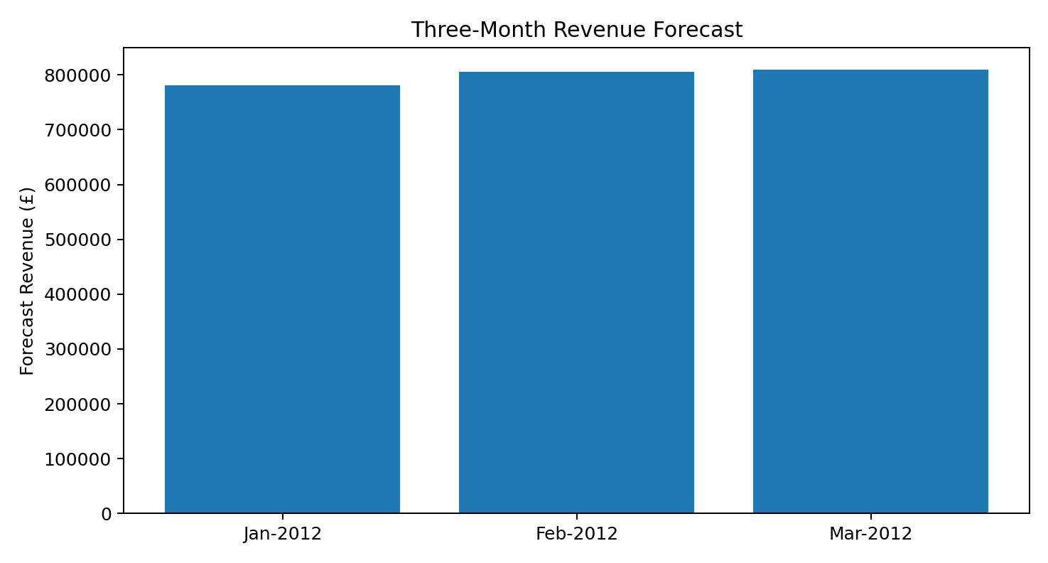
Figure 4. Three-month revenue forecast.

11. Prescriptive Analytics and Business Insights
- Prioritize inventory and visibility for the highest-revenue products while monitoring their availability.
- Review low-revenue products for assortment, pricing, bundling or lifecycle decisions.
- Use the country revenue distribution to support market-specific retention and localization analysis.
- Monitor cancellations by month and product to identify operational issues.
- Use customer concentration analysis to identify high-value customers for retention and cross-selling.
- Investigate the sharp December 2011 revenue decline relative to November before using historical growth rates for planning.
- Treat the machine-learning forecast as a planning signal rather than a guaranteed outcome.

12. Interactive Dashboard
The Streamlit application provides separate navigation pages for Executive Dashboard, Data Quality & Cleaning, Descriptive Analysis, Diagnostic Analysis, Predictive Analysis, Prescriptive Analysis, Detailed Tables and Project Methodology. The dashboard also supports uploading an Excel file through the sidebar when the default dataset is unavailable.

13. Output Files
- cleaned_sales_data.csv – cleaned positive sales transactions with engineered fields.
- monthly_kpis.csv – monthly revenue, orders, customers, units, AOV and growth.
- product_analysis.csv – product-level revenue, units and orders.
- country_analysis.csv – country-level revenue, orders and customers.
- revenue_forecast.csv – actual monthly revenue plus three forecast months.

14. Limitations
- The forecasting model uses historical transaction information only.
- The forecast does not explicitly model promotions, holidays, inventory constraints, price changes or external economic factors.
- Revenue forecasting is based on a relatively short monthly time series, so model performance should be interpreted cautiously.
- The dashboard's conclusions depend on the quality and coverage of the uploaded transaction dataset.

15. Future Enhancements
- Add customer-level RFM segmentation and cohort retention analysis.
- Introduce product-category and basket-affinity analysis.
- Compare multiple forecasting models such as gradient boosting, ARIMA/Prophet-style approaches and seasonal baselines.
- Add automated model monitoring and forecast confidence intervals.
- Add interactive filters for country, product, customer and date.
- Deploy the Streamlit dashboard to a cloud platform with controlled data upload and authentication.

16. Conclusion
The project demonstrates a complete retail analytics workflow that combines data engineering, business intelligence, visualization and machine learning. It converts transaction-level records into decision-support outputs including KPIs, trend analysis, product and country analysis, diagnostic indicators, a three-month revenue forecast and prescriptive business actions. The architecture is modular enough to support future additions such as customer segmentation, advanced forecasting and deeper retail optimization.

17. References
1. Siddhib2004. IBM_Siddhi_Online_Retail_Project. GitHub repository.
2. UCI Machine Learning Repository. Online Retail dataset.
3. Project source code: project.py and requirements.txt in the repository.
Report prepared from the repository contents and generated output tables available at the time of report creation.

