**Converting to RST**

**Installing pandoc**

Pandoc is a powerful document-transformation utility. We’ll use it to do simple conversions, but it is capable of much more. Visit the [pandocwebsite](http://pandoc.org/installing.html) for installation instructions for your platform.

| **Format** | **Description** |
| --- | --- |
| commonmark | Markdown variant |
| docbook | XML-based markup |
| docx | Microsoft Word |
| epub | Ebook format |
| haddock | Doc format produced by tool used on Haskell code |
| html | HTML |
| json | JSON pandoc AST |
| latex | Older typesetting syntax |
| markdown | Simple formatting syntax meant to produce HTML |
| markdown_github | Github flavored markdown |
| markdown_mmd | Multi-markdown flavored markdown |
| markdown_phpextra | PHP flavored markdown |
| markdown_strict | Markdown with no added pandoc features |
| mediawiki | Popular wiki language |
| native | Pandoc native Haskell |
| odt | Open document text (used by LibreOffice) |
| opml | Outline processor markup language |
| org | Org mode for Emacs |
| rst | reStructuredText |
| t2t | Wiki-like formatting syntax |
| textile | A formatting syntax similar to RST and markdown |
| twiki | Popular wiki formatting syntax |

**Using terminal**

Using a terminal, navigate to the directory containing the documents you wish to convert. Next, issue the following command for each file you’d like to convert.

***pandoc filename –o newname***

where,

filename = file to convert for eg mytext.html

newname = new file name for eg mytext.rst (we are converting from html to rst)

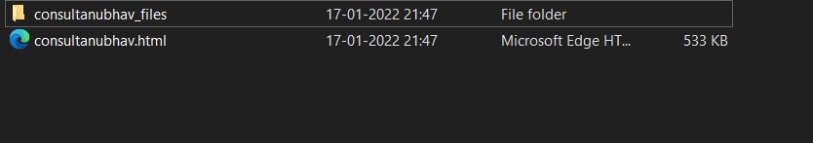

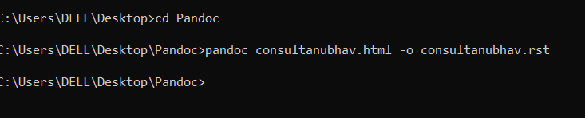

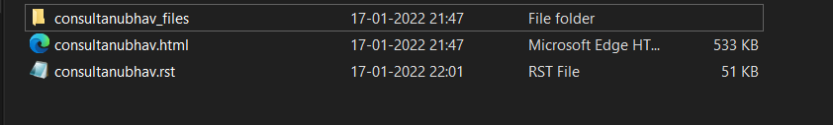

As you can see a .rst file of out html file is created after running a command in Windows terminal.

**Converting Multiple Files using pandoc**

There are 2 approaches to so this task

1. Using python code to generate commands for each file
2. Using pypandoc

We have multiple html files in a folder as shown below,

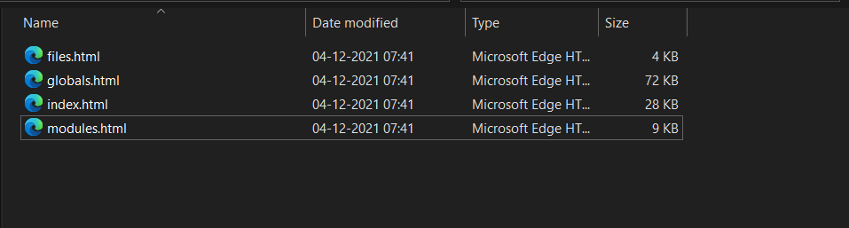

**Using python code to generate commands for each file**

Below given is a python code to generate commands for each file in a folder.

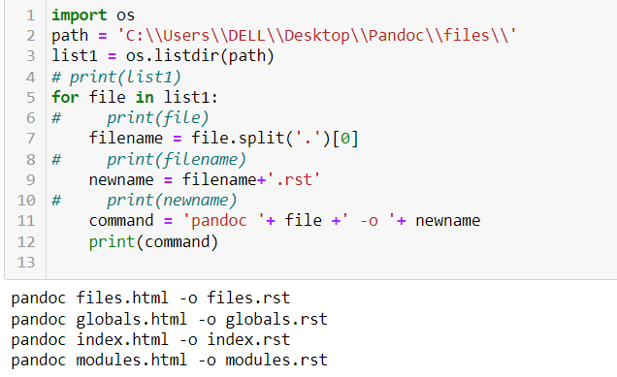

As we can see in the output we got command to execute for each file.

Now, we can just copy the output and paste it in terminal and all commands are executed.

We have all our .rst files converted from .html files as shown in below image.

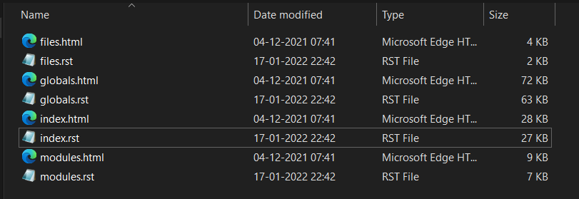

**Using pypandoc**

Pypandoc uses pandoc, so it needs an available installation of pandoc. For some common cases (wheels, conda packages), pypandoc already includes pandoc (and pandoc-citeproc) in its prebuilt package.

Install via pip install pypandoc.

You can read more about pypandoc [here](https://pypi.org/project/pypandoc/).

Pypandoc provides a method convert_file() which is used to convert our files from html to rst.

Below, given is the code that we use to convert multiple files in a folder to rst format.

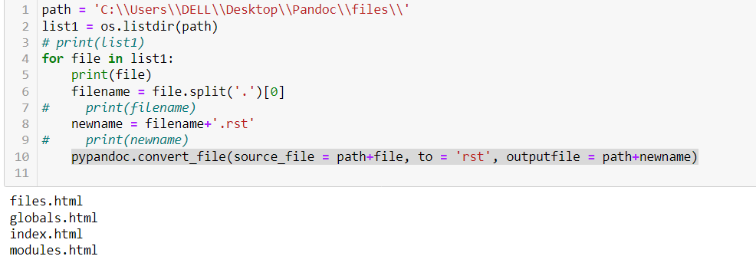

All the RST files are saved at given outputfile path.

By this way it becomes much easier to convert all files from a folder to another format using python. It becomes easier than following terminal way when you have multiple files to convert.