
Pongle V2
Simple scope draft
A focused next step from the working scorekeeping prototype into profiles, table locations, match history, and early ratings.

Hi Cody,
Here is how I would think about V2 in a simple and realistic way. V1 proved the scoring experience can work during real games. V2 should add just enough structure so Pongle can remember who played, where they played, what the result was, and start helping people find better games.
Main idea: keep the scoring experience, then add the simplest online layer needed for players, tables, and match records.
Core V2  Profiles, table locations, match history, opponent selection, and result confirmation. | Timeline  Target under one month for the focused V2 scope, assuming quick feedback and no wishlist expansion. | Goal  Help a player find a table, play a match, save the result, and find better future games.

I am treating the recent scorekeeper polish as V1 work. This draft is focused on V2: the online layer for players, tables, match history, and ratings.
What I Think V2 Should Include
Priority | Feature | Plain meaning | Effort
1 | Player profiles | Basic player info, phone number as the unique ID, optional photo, match history, and early rating. | Medium
2 | Table locations | Add real tables with address/map point, notes, visibility, and who added the table. | Medium
3 | Opponent selection | Choose an existing player or quickly enter a new person before saving a match. | Medium
4 | Match history | Save match/game results from the scoring flow: players, table, date, game scores, and winner. | Medium
5 | Guest / unclaimed profiles | If Canon is not on Pongle yet, create his profile from name + phone and let him claim it later. | Harder
6 | SMS invite + consent | Send the non-user an invite, then let him consent and claim the profile before it becomes a full account. | Harder
7 | Result confirmation | Let both players confirm the result so ratings are more trustworthy. | Harder
8 | Pongle rating | Start with a simple rating that feels more fun and approachable than a bland ITTF-style number. | Harder
9 | Share card | Create a clean result card that can be shared after a match. | Medium

Specific Things I Heard From You
Decision | How I would handle it
Phone as ID | Use phone number as the unique user identifier, with email optional instead of required.
Unclaimed profile | Support guest-style profiles first, then let that person claim the profile later.
Canon use case | A player can add Canon by first name, last name, and phone number before Canon joins Pongle.
SMS invite then consent | Canon receives an invite, reviews/consents, and then claims the profile.
Duplicate merge | If duplicate profiles happen, provide a merge path that keeps matches, games, and rating history.
Ratings tone | Make Pongle rating feel simple, useful, and more fun than a bland ITTF-style system.

Simple V2 Architecture
At a high level, V2 adds one online layer around the existing scorekeeper. The app stays simple for players, while Supabase quietly stores the players, tables, matches, and confirmations behind the scenes.
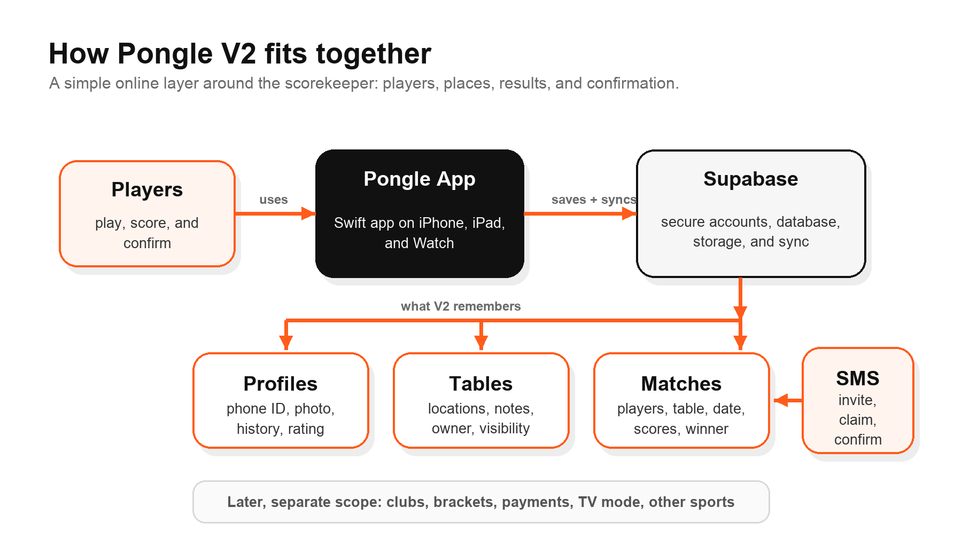
The important idea: users should feel like they are just playing and saving results. The technical pieces should stay mostly invisible.
What I Would Save For Later
I would not put everything into V2. Tournament brackets, full club management, payments, credits, subscriptions, AirPods input, TV display mode, and pickleball or other sports are all possible later. They are good ideas, but they would make V2 much bigger and more expensive if we include them now.
Timeline And Scope Boundary
For the full V2 scope below, I would treat this as one fixed-price project once the scope is confirmed. Target timeline: under one month, roughly 3-4 weeks, assuming we keep V2 focused and testing feedback is quick.
That timeline assumes we keep V2 focused: profiles, table locations, opponent selection, saved match history, guest/unclaimed profiles, SMS invite/consent, result confirmation, duplicate merging, a simple Pongle rating, and a share card. It does not include brackets, payments, full club admin, TV app, AirPods input, or other sports.
Suggested Build Order
Order | Scope | Timing
Step 1 | Profiles, table locations, opponent selection, saved match/game history, and simple profile/table screens. | 1-2 weeks
Step 2 | Guest/unclaimed profiles, SMS invite/claim/consent flow, result confirmation, duplicate-profile merge, early Pongle rating, and share cards. | 2-3 weeks
Later | Clubs, brackets, payments, subscriptions, AirPods input, TV display mode, and other sports. | Separate scope

Data Model In Salesforce Terms
Object | Main fields | Relationship
Profiles | first name, last name, phone as unique ID, email, photo, claimed/guest/unclaimed, rating | A profile plays matches, confirms results, and may add tables.
Tables | name, venue, address, map location, visibility, notes, photo, added by | A table can have many matches and can belong to a venue/club later.
Matches | players, table, date/time, match format, winner, confirmation status | A match belongs to one table and has multiple games.
Games | game number, player scores, first server, side order, winner | Games belong to a match and create the match result.
Confirmations | match, player, confirmed/disputed/pending, timestamp | Confirmations make match history and ratings more trustworthy.
Merge records | old profile, new profile, reason, timestamp | Needed if one person ends up with duplicate profiles.

Backend Note
I would not build this on top of Salesforce. The Salesforce way of thinking is useful for modeling the data, but Pongle should use a mobile-first backend. My recommendation is Supabase for accounts, database, storage, and sync. Firebase would also be possible, but I would keep the current native Swift iPhone/iPad/Apple Watch app as the front end either way.
Ongoing Running Costs
These are third-party costs you would pay directly to run Pongle after launch. They are separate from the fixed build cost. Current public prices can change, but this is the realistic starting picture.
Cost item | Expected cost | Plain meaning
Apple Developer Program | $99 / year | Needed to publish, use TestFlight, and distribute the app under your own Apple account.
Supabase | Free for early testing; likely $25 / month for production | Stores profiles, tables, match history, photos, and sync. Usage overages only matter if the app grows.
SMS invites / phone verification | Usage-based; usually small at early volume | Used for invite, claim, and confirmation messages. Cost depends on provider, country, and message volume.
Domain / email | Optional, usually low | Only needed if Pongle wants a website, branded support email, or custom auth/email sender.
Apple hosting, TestFlight, push notifications, Apple Maps | Included / no separate basic fee | Normal App Store/TestFlight distribution and standard Apple platform features do not add a separate server bill.

Practical estimate: once V2 is live, you should expect roughly $25-$50/month plus the $99/year Apple Developer account, before any large-scale SMS usage or marketing spend.
Success For V2
V2 is successful if a user can add a real table, choose or enter an opponent, play a match, save the result, see match history, and start building a lightweight Pongle rating profile. That is enough to test with real users without overbuilding the whole long-term platform too early.
My recommendation is to keep V2 focused, learn from real players, and then decide what the next layer should be.

