Target Case Study

Q1. Import the dataset and do usual exploratory analysis steps like checking the structure & characteristics of the dataset.
- Data type of columns in a table
order_items table
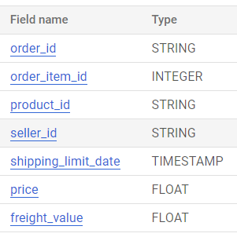
String type – These are the columns with array/list of characters stored.
Eg: order_id , product_id, seller_id
Integer type – These are the columns with numbers both positive and negative stored without any decimal value.
Eg: order_item_id
Timestamp type – These are the columns that record the timestamp of a particular record. This involves both date and time.
Eg: shipping_limit_date
Float type – These are the columns with numbers both positive and negative stored with decimal value.
Eg: price, freight_value

- Time period for which the data is given:

This can be obtained by using min, max functions on order_purchase_timestamp column in orders table
Query:
select
min(order_purchase_timestamp) as start_time_period,
max(order_purchase_timestamp) as end_time_period
from `target_sql.orders`;

Query result:

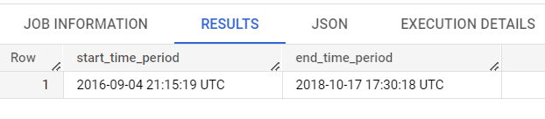

The time period of this dataset is from ‘2016-09-04’ to ‘2018-10-17’ i.e 2016 – 2018.

- Cities and States of customers ordered during the given period

We can solve this question by joining customers and orders table and obtaining customer_id, city, state for the given time period

Query:
select
c.customer_id,
c.customer_city,
c.customer_state
from `target_sql.customers` c
left join `target_sql.orders` o on c.customer_id = o.customer_id;

Query result

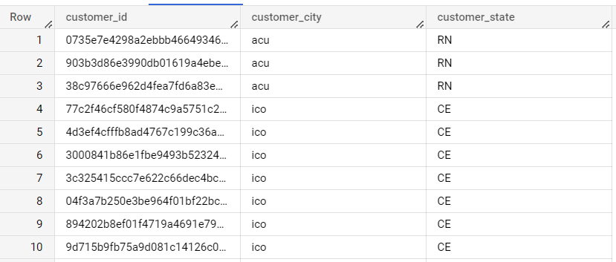
Insights:
Most customer orders came from the following top five cities:
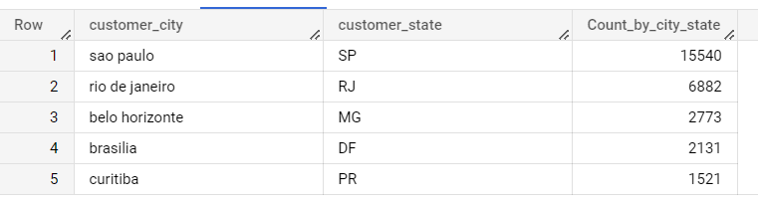

Q2. In-depth Exploration

- Is there a growing trend on e-commerce in Brazil? How can we describe a complete scenario? Can we see some seasonality with peaks at specific months?

- We can answer the first part of question by looking at the orders trend starting from 2016 till 2018

Query:
select t.Year, count(*) Ord_count, Round(sum(t.price)) Ord_value
from
(
select *,
extract(year from o.order_purchase_timestamp) as Year
from `target_sql.orders` o
inner join `target_sql.order_items` oi on o.order_id = oi.order_id
) t
group by t.Year
order by t.Year;

Query Result:

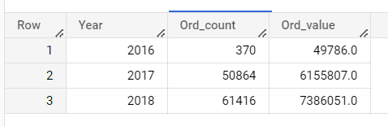

Insights:

We can clearly see an increasing trend of orders in terms of both order number and order value.

- We can answer the second part of the question by replicating the same for months over the time period.

Query:

select t.Month, count(*) Ord_count, Round(sum(t.price)) Ord_value
from
(
select *,
extract(month from o.order_purchase_timestamp) as Month
from `target_sql.orders` o
inner join `target_sql.order_items` oi on o.order_id = oi.order_id
) t
group by t.Month
order by t.Month;

Query Result:

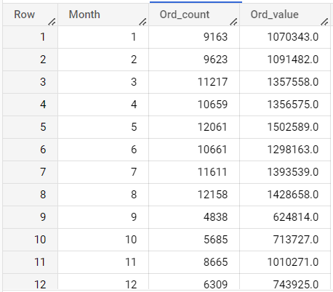

Insights:

As seen in the result above, the sales are peaking during the months of March, April, May, June, July, August which are mostly summer seasons.

In terms of Quarters in FY, it is Q1 and most of Q2.

- What time do Brazilian customers tend to buy (Dawn, Morning, Afternoon or Night)?

We can obtain the order count in the specific timings of the day by using CTE, case end and group by functions on orders table.

Query:

with hour_cte as
(
select *,
extract(hour from order_purchase_timestamp) as Hour
from `target_sql.orders`
)

select t.Time_of_day, count(*) Ord_Count
from
(
select *,
case
when Hour between 0 and 6 then 'Dawn'
when Hour between 7 and 12 then 'Morning'
when Hour between 13 and 18 then 'Afternoon'
when Hour between 19 and 23 then 'Night'
end as Time_of_day
from hour_cte
) t
group by t.Time_of_day
order by Ord_Count desc;

Query Results:

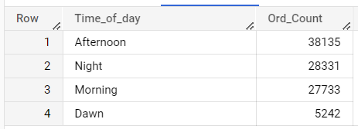

Insights:

We can clearly see from the above result that Brazilians tend to order more during Afternoon time followed by Night time.

Q3. Evolution of E-commerce orders in the Brazil region:
- Get month on month orders by state:

This can be obtained by using customers, orders, order_items table and using group by states and months of purchase time_stamp

Query:

select c.customer_state,
extract(month from o.order_purchase_timestamp) as Month,
count(*) Ord_Count,
round(sum(oi.price)) Ord_Value
from `target_sql.customers` c
inner join `target_sql.orders` o on c.customer_id = o.customer_id
inner join `target_sql.order_items` oi on o.order_id = oi.order_id
group by c.customer_state, Month
order by c.customer_state, Month;

Query Results:

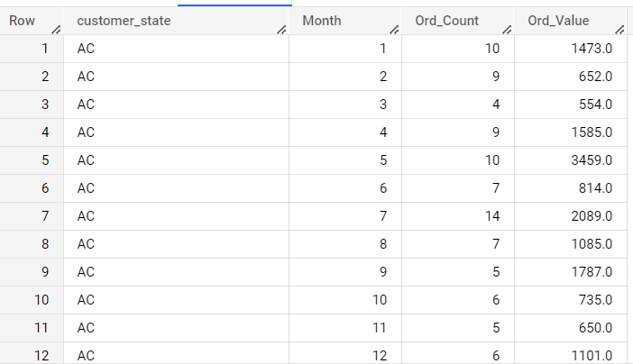

Insights:

Most orders were placed in the state SP during the months of August, May and July as shown in the table below

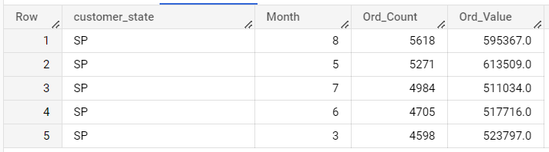

- Distribution of customers across the states in Brazil

This can be obtained by joining customers, orders, order_items table and using group by states and aggregating on count of orders and sum of price of orders placed.

Query:

select
c.customer_state,
count(*) Ord_Count,
round(sum(oi.price)) Ord_Value
from `target_sql.customers` c
inner join `target_sql.orders` o on c.customer_id = o.customer_id
inner join `target_sql.order_items` oi on o.order_id = oi.order_id
group by c.customer_state
order by Ord_Count desc, Ord_Value desc;

Query Results:

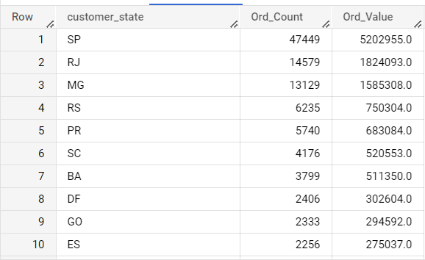

Insights:

As seen in the table above, most orders have come from the states with codes SP followed by RJ and MG

Q4. Impact on Economy: Analyze the money movement by e-commerce by looking at order prices, freight and others.
- Get % increase in cost of orders from 2017 to 2018 (include months between Jan to Aug only) - You can use “payment_value” column in payments table:

This can be calculated by group 2017 Jan to Aug data and 2018 Jan to Aug data and comparing the difference between payment values of respective years

Query:

with yr17_cte as
(
select t.Year, sum(t.payment_value) ord_cost
from
(
select
extract (month from o.order_purchase_timestamp) Month,
extract (year from o.order_purchase_timestamp) Year,
p.payment_value
from `target_sql.orders` o
inner join `target_sql.payments` p on o.order_id = p.order_id
) t
where t.Year = 2017 and t.Month <=8
group by t.Year
),

yr18_cte as
(
select x.Year, sum(x.payment_value) ord_cost
from
(
select
extract (month from o.order_purchase_timestamp) Month,
extract (year from o.order_purchase_timestamp) Year,
p.payment_value
from `target_sql.orders` o
inner join `target_sql.payments` p on o.order_id = p.order_id
) x
where x.Year = 2018 and x.Month <=8
group by x.Year
)

select y17.Year Yr2017,
y18.Year Yr2018,
round(((y18.ord_cost-y17.ord_cost)/y17.ord_cost)*100,2) per_incr_ord_cost
from yr17_cte as y17,yr18_cte as y18;

Query Results:

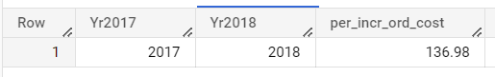

Insights:

There is a 137% increase in cost of orders from 2017 to 2018.

- Mean & Sum of price and freight value by customer state:

This can be obtained by joining customers, orders, order_items table and using group by states and aggregating on avg, sum of price of orders placed and avg, sum of freight_value.

Query:

select
c.customer_state,
round(avg(oi.price)) Mean_price,
round(sum(oi.price)) Sum_price,
round(avg(oi.freight_value)) Mean_freight_value,
round(sum(oi.freight_value)) Sum_freight_value
from `target_sql.customers` c
inner join `target_sql.orders` o on c.customer_id = o.customer_id
inner join `target_sql.order_items` oi on o.order_id = oi.order_id
group by c.customer_state
order by c.customer_state;

Query Results:

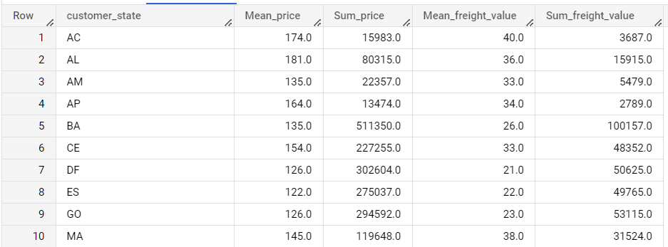

Insights:

Mean price is highest for state with code PB
Sum price is highest for state with code SP
Mean freight value is highest for state with code PB
Sum freight value is highest for state with code SP

Q5. Analysis on sales, freight and delivery time.
- Calculate days between purchasing, delivering and estimated delivery:

This can be calculated using the orders table and the columns purchase_timestamp, delivery_date, estimated_delivery_date.

Query:

select
order_id,
order_purchase_timestamp,
order_estimated_delivery_date,
order_delivered_customer_date,
timestamp_diff(order_estimated_delivery_date , order_purchase_timestamp, day) as ETA_days,
timestamp_diff(order_delivered_customer_date , order_purchase_timestamp, day) as No_delivery_days,
timestamp_diff(order_delivered_customer_date , order_estimated_delivery_date, day) as Late_days
from `target_sql.orders`;

Query Results:
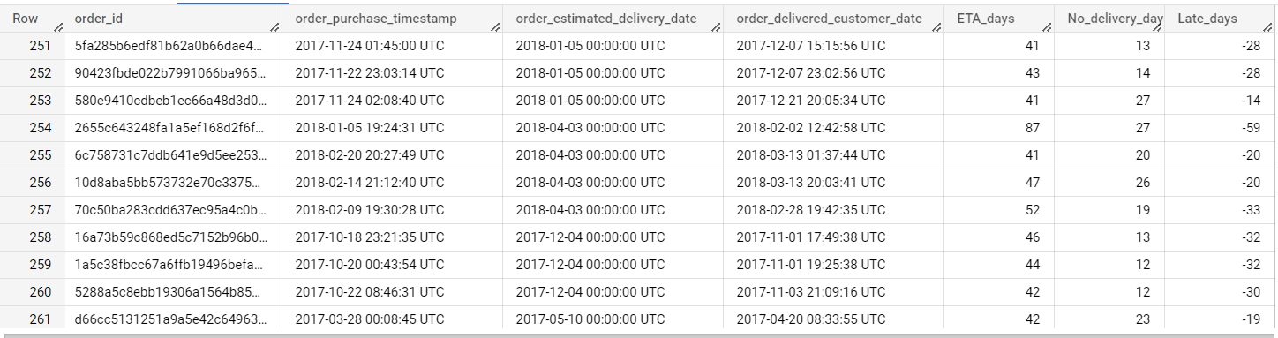

Insights:

The following are the top 10 orders where delivery delay was close to 6 months than the expected delivery days.

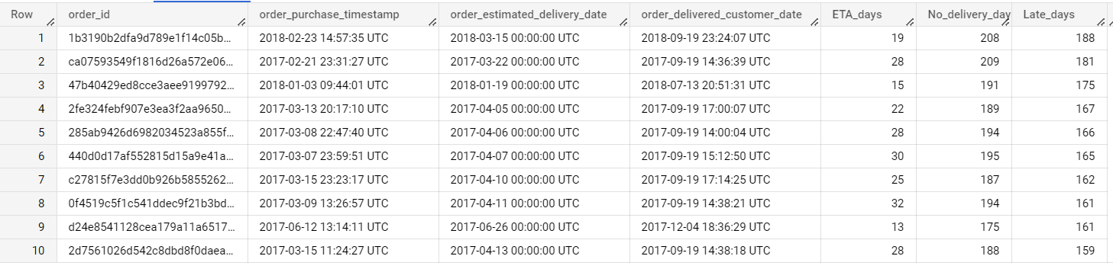
- Find time_to_delivery & diff_estimated_delivery

This can be calculated using the orders table and the columns purchase_timestamp, delivery_date, estimated_delivery_date.

Query:

select
order_id,
timestamp_diff(order_delivered_customer_date,order_purchase_timestamp, day) as time_to_delivery,
timestamp_diff(order_delivered_customer_date,order_estimated_delivery_date, day) as diff_estimated_delivery
from `target_sql.orders`;

Query Results:

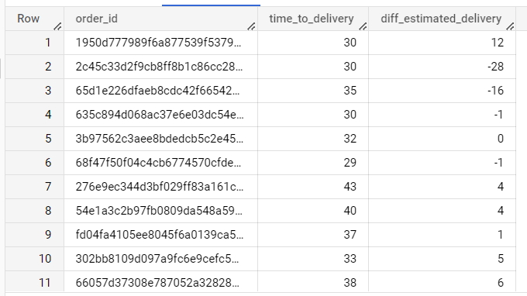

Insights:

Below are some of the orders which had the fastest delivery times.

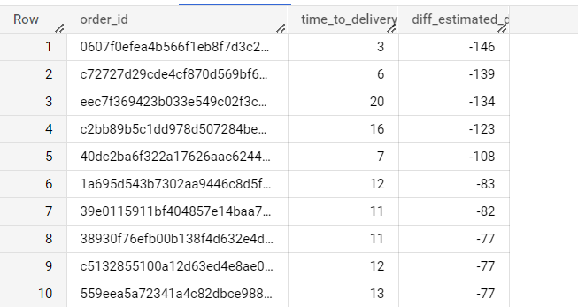

- Group data by state, take mean of freight_value, time_to_delivery, diff_estimated_delivery

This can be obtained by joining customers, orders, order_items table and using group by states and aggregating on avg of freight_value, time_to_delivery, diff_estimated_delivery.

Query:

select
t.customer_state,
round(avg(t.freight_value)) Mean_freight_value,
round(avg(t.time_to_delivery)) Mean_time_to_delivery,
round(avg(t.diff_estimated_delivery)) Mean_diff_estimated_delivery
from
(
select
*,
timestamp_diff(order_delivered_customer_date , order_purchase_timestamp, day) as time_to_delivery,
timestamp_diff(order_delivered_customer_date , order_estimated_delivery_date, day) as diff_estimated_delivery
from `target_sql.customers` c
inner join `target_sql.orders` o on c.customer_id = o.customer_id
inner join `target_sql.order_items` oi on o.order_id = oi.order_id
) t
group by t.customer_state
order by t.customer_state;

Query Results:

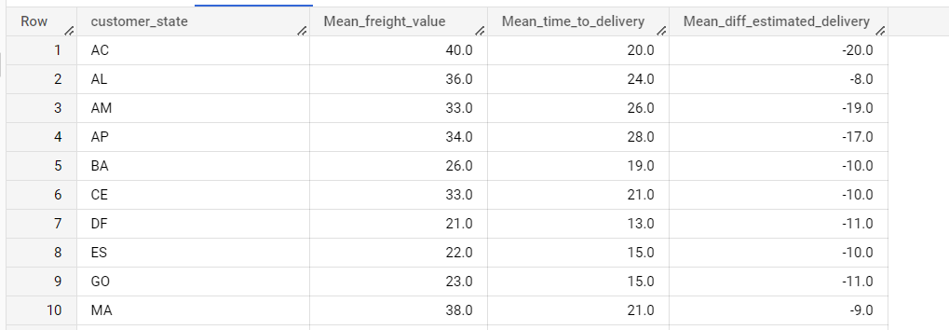

Insights:

Mean freight value is highest for state with code PB
Mean time to delivery is highest for state with code RR
Mean difference in estimated delivery is highest for state with code AL
Mean freight value is lowest for state with code SP
Mean time to delivery is lowest for state with code SP
Mean difference in estimated delivery is lowest for state with code AC

- Sort the above data to get the following:
- Top 5 states with highest/lowest average freight value - sort in desc/asc limit 5
Highest Avg freight Value

Query:

select
t.customer_state,
round(avg(t.freight_value)) Mean_freight_value,
round(avg(t.time_to_delivery)) Mean_time_to_delivery,
round(avg(t.diff_estimated_delivery)) Mean_diff_estimated_delivery
from
(
select
*,
timestamp_diff(order_delivered_customer_date , order_purchase_timestamp, day) as time_to_delivery,
timestamp_diff(order_delivered_customer_date , order_estimated_delivery_date, day) as diff_estimated_delivery
from `target_sql.customers` c
inner join `target_sql.orders` o on c.customer_id = o.customer_id
inner join `target_sql.order_items` oi on o.order_id = oi.order_id
) t
group by t.customer_state
order by Mean_freight_value desc
limit 5;

Query Results:

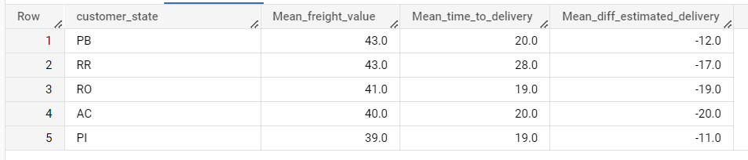

Lowest Avg Freight Value

Query:

select
t.customer_state,
round(avg(t.freight_value)) Mean_freight_value,
round(avg(t.time_to_delivery)) Mean_time_to_delivery,
round(avg(t.diff_estimated_delivery)) Mean_diff_estimated_delivery
from
(
select
*,
timestamp_diff(order_delivered_customer_date , order_purchase_timestamp, day) as time_to_delivery,
timestamp_diff(order_delivered_customer_date , order_estimated_delivery_date, day) as diff_estimated_delivery
from `target_sql.customers` c
inner join `target_sql.orders` o on c.customer_id = o.customer_id
inner join `target_sql.order_items` oi on o.order_id = oi.order_id
) t
group by t.customer_state
order by Mean_freight_value
limit 5;

Query Results:

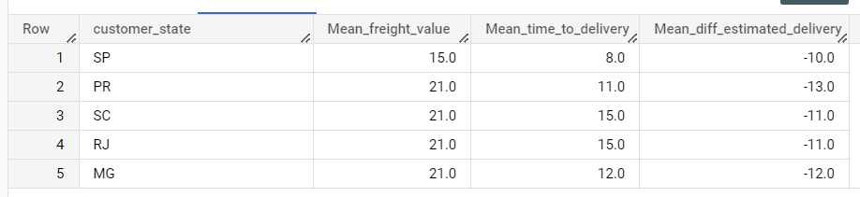

- Top 5 states with highest/lowest average time to delivery

Highest Avg time to delivery

Query:

select
t.customer_state,
round(avg(t.freight_value)) Mean_freight_value,
round(avg(t.time_to_delivery)) Mean_time_to_delivery,
round(avg(t.diff_estimated_delivery)) Mean_diff_estimated_delivery
from
(
select
*,
timestamp_diff(order_delivered_customer_date , order_purchase_timestamp, day) as time_to_delivery,
timestamp_diff(order_delivered_customer_date , order_estimated_delivery_date, day) as diff_estimated_delivery
from `target_sql.customers` c
inner join `target_sql.orders` o on c.customer_id = o.customer_id
inner join `target_sql.order_items` oi on o.order_id = oi.order_id
) t
group by t.customer_state
order by Mean_time_to_delivery desc;

Query Results:

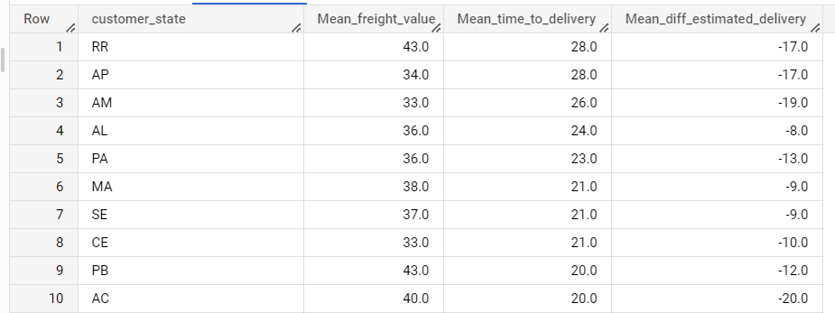

Lowest Avg time to delivery

Query:
select
t.customer_state,
round(avg(t.freight_value)) Mean_freight_value,
round(avg(t.time_to_delivery)) Mean_time_to_delivery,
round(avg(t.diff_estimated_delivery)) Mean_diff_estimated_delivery
from
(
select
*,
timestamp_diff(order_delivered_customer_date , order_purchase_timestamp, day) as time_to_delivery,
timestamp_diff(order_delivered_customer_date , order_estimated_delivery_date, day) as diff_estimated_delivery
from `target_sql.customers` c
inner join `target_sql.orders` o on c.customer_id = o.customer_id
inner join `target_sql.order_items` oi on o.order_id = oi.order_id
) t
group by t.customer_state
order by Mean_time_to_delivery;

Query Results:

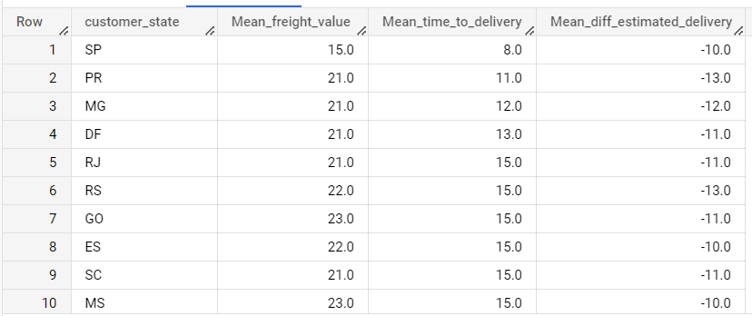

- Top 5 states where delivery is really fast/ not so fast compared to estimated date.

Highest Avg diff_estimated_delivery

Query:
select
t.customer_state,
round(avg(t.freight_value)) Mean_freight_value,
round(avg(t.time_to_delivery)) Mean_time_to_delivery,
round(avg(t.diff_estimated_delivery)) Mean_diff_estimated_delivery
from
(
select
*,
timestamp_diff(order_delivered_customer_date , order_purchase_timestamp, day) as time_to_delivery,
timestamp_diff(order_delivered_customer_date , order_estimated_delivery_date, day) as diff_estimated_delivery
from `target_sql.customers` c
inner join `target_sql.orders` o on c.customer_id = o.customer_id
inner join `target_sql.order_items` oi on o.order_id = oi.order_id
) t
group by t.customer_state
order by Mean_diff_estimated_delivery desc;

Query Results:

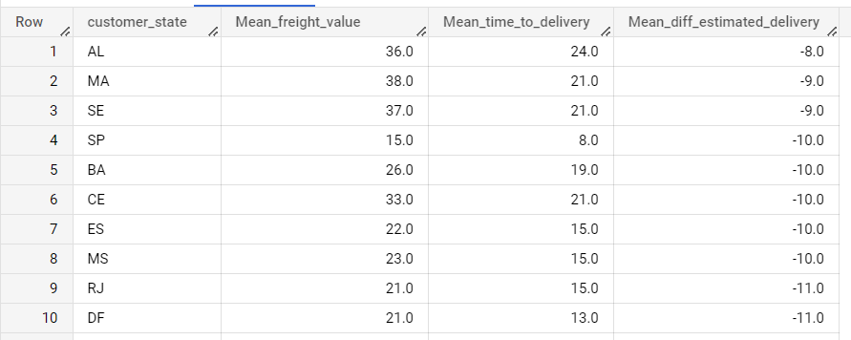

Lowest Avg time to delivery

Query:
select
t.customer_state,
round(avg(t.freight_value)) Mean_freight_value,
round(avg(t.time_to_delivery)) Mean_time_to_delivery,
round(avg(t.diff_estimated_delivery)) Mean_diff_estimated_delivery
from
(
select
*,
timestamp_diff(order_delivered_customer_date , order_purchase_timestamp, day) as time_to_delivery,
timestamp_diff(order_delivered_customer_date , order_estimated_delivery_date, day) as diff_estimated_delivery
from `target_sql.customers` c
inner join `target_sql.orders` o on c.customer_id = o.customer_id
inner join `target_sql.order_items` oi on o.order_id = oi.order_id
) t
group by t.customer_state
order by Mean_diff_estimated_delivery;

Query Results:
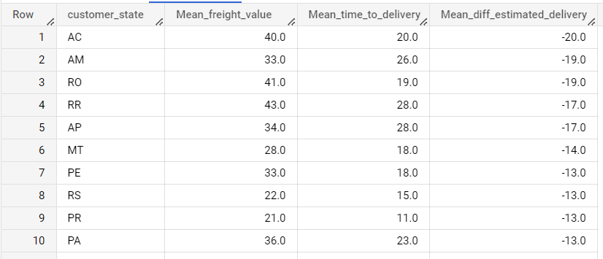
Q5. Payment type analysis:
- Month over Month count of orders for different payment types

This can be obtained by joining orders and payments table and extracting month from purchase timestamp column to group by payment type and month and aggregate on count.

Query:

select t.payment_type, t.Month, count(*) as Ord_Count
from
(
select
*,
extract(month from o.order_purchase_timestamp) as Month
from `target_sql.orders` o
inner join `target_sql.payments` p on o.order_id = p.order_id
) t
group by t.payment_type, t.Month
order by t.payment_type, t.Month;

Query Results:

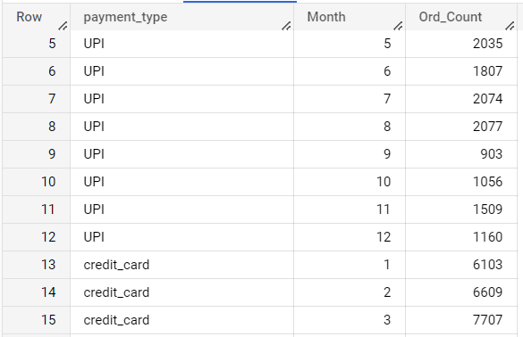

Insights:

The payment type credit card had the most number of transactions followed by UPI as shown in the table below.

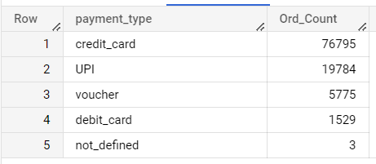

- Count of orders based on the no. of payment installments.

This can be obtained by joining orders and payments table and grouping by payment installments and aggregate on count.

Query:

select p.payment_installments, count(*) as Ord_Count
from `target_sql.orders` o
inner join `target_sql.payments` p on o.order_id = p.order_id
group by p.payment_installments
order by p.payment_installments;

Query Results:

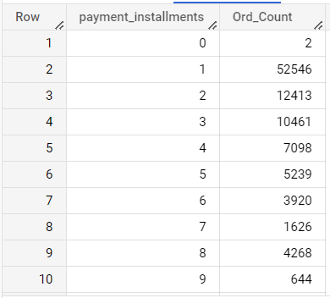
Insights:

Payment installment periods of 22, 23, 21 months seem to be the least popular choices.

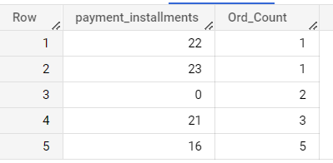

Recommendations derived from Insights:
- As most customer orders came from Sao Paulo and Rio de Janeiro, opening more retail stores in these cities will help serve the demand.

- From 2016-2018, we can clearly see an exponential increasing trend of orders, to generalize upon this investing more in Brazil would make sense.

- The sales seem to be soaring in the summer months. The products which are much in demand during this period can identified and inventory for the same can be replenished on a timely basis.

- The orders seem to be at their peak during afternoon times. If it’s an online website that’s picking up the order details, we need to make sure that the servers are up on running during these busy times to avoid customer dissatisfaction.

- Business has grown by 137% between 2017 and 2018, this clearly indicates the large scope for Target as a retailer in Brazil.

- Mean price of orders is highest in Paraiba state. This means more value products seem to sell more in this state. Hence luxury goods sales can be pushed in this region.

- There are some exception cases where delay in delivery date was close to 6 months more than the promised date. More probe into such orders and products has to be conducted in order to understand the reason behind the delay. We need to identify whether it’s normal for certain kinds of goods or is it a one-time delay resulting from supply chain management delays.

- Orders that had the fastest delivery times got good feedback from customers. This clearly emphasizes the need to improve delivery times for all the products across all regions to penetrate the market better.

- Average time to deliver orders is highest in Roraima state. Trying to setup a warehouse stocking all the most sold inventory items can reduce this number.

- Average difference in time between estimated delivery date and actual delivery date is highest in Alagoas state. Probe must be conducted in understanding what went wrong between the time period where goods have already been shipped from the main warehouse and reaching the local warehouse & from local warehouse to the customer through delivery agent.

- The payment type of credit card has the most transactions. Care must be taken to maintain the payment gateway servers functioning at all times in order for the customer to have a smooth payment experience.
- Least popular plans for installments are for between 21 and 23 months. Target can try to partner with credit card firms to offer more incentive to customers for buying products with installments between the above-mentioned period.

