**WEEK 1**

**DATA STRUCTURES AND ALGORITHMS**

**Exercise 1: Inventory Management System**

1Q. Explain why data structures and algorithms are essential in handling large inventories.

A. Data Structures and Algorithms are very essential for handling large inventories because use of efficient ds algorithms reduces response time for search,insert,delete and update operations.they also help in organizing them logically and maintaining performance.

2Q. Discuss the types of data structures suitable for this problem.

A. ArrayList is suitable for ordered storage but is slow in searching and updating. HashMap is ideal for fast search,insert,delete operations as we use keys.

**CODE:**

package InventoryManagementSystem;

//product class

public class Product {

    //attributes

    private int productId;

    private String productName;

    private int quantity;

    private double price;

    public Product(int productId, String productName, int quantity, double price) {

        this.productId = productId;

        this.productName = productName;

        this.quantity = quantity;

        this.price = price;

    }

    //methods for operations

    public int getProductId() {

        return productId;

    }

    public void setProductName(String productName) {

        this.productName = productName;

    }

    public void setQuantity(int quantity) {

        this.quantity = quantity;

    }

    public void setPrice(double price) {

        this.price = price;

    }

    //displaying details of products

    public void display() {

        System.out.println("ID: "+ productId + ", Name: " + productName +", Quantity: " + quantity + ", Price: " + price);

    }

}

package InventoryManagementSystem;

import java.util.*;

//managing the inventory

public class InventoryManager {

    //data structure of managing products

    private HashMap<Integer, Product> inventory = new HashMap<>();

    //adding

    public void addProduct(Product product) {

        inventory.put(product.getProductId(), product);

        System.out.println("Product Added Successfully");

    }

    //updating

    public void updateProduct(int productId, String name, int quantity, double price) {

        Product p = inventory.get(productId);

        if (p != null) {

            p.setProductName(name);

            p.setQuantity(quantity);

            p.setPrice(price);

            System.out.println("Product Updated Sucessfully");

        } else {

            System.out.println("Product Not Found!");

        }

    }

    //deleting

    public void deleteProduct(int productId) {

        if (inventory.remove(productId) != null) {

            System.out.println("Product Removed Successfully");

        } else {

            System.out.println("Product Not Found!");

        }

    }

    //displaying

    public void displayAllProducts() {

        if (inventory.isEmpty()) {

            System.out.println("No products in inventory.");

            return;

        }

        for (Product p : inventory.values()) {

            p.display();

        }

    }

}

package InventoryManagementSystem;

import java.util.*;

public class Main {

    public static void main(String[] args) {

        InventoryManager manager = new InventoryManager();

        Scanner sc = new Scanner(System.in);

        int choice;

        //using dowhile

        do {

            System.out.println("\nINENTORY MANAGEMENT SYSTEM");

            System.out.println("\n1. Add Product\n2. Update Product\n3. Delete Product\n4. Display Products\n5. Exit");

            System.out.print("Enter Your Choice: ");

            choice = sc.nextInt();

            //switchcase for choosing the ops

            switch (choice) {

                case 1:

                    System.out.print("Enter ID, Name, Quantity, Price: ");

                    int id = sc.nextInt();

                    String name = sc.next();

                    int qty = sc.nextInt();

                    double price = sc.nextDouble();

                    manager.addProduct(new Product(id, name, qty, price));

                    break;

                case 2:

                    System.out.print("Enter ID to update: ");

                    int uid = sc.nextInt();

                    System.out.print("Enter new Name, Quantity, Price: ");

                    String uname = sc.next();

                    int uqty = sc.nextInt();

                    double uprice = sc.nextDouble();

                    manager.updateProduct(uid, uname, uqty, uprice);

                    break;

                case 3:

                    System.out.print("Enter ID to delete: ");

                    int did = sc.nextInt();

                    manager.deleteProduct(did);

                    break;

                case 4:

                    manager.displayAllProducts();

                    break;

                case 5:

                    System.out.println("Exiting...");

                    break;

                default:

                    System.out.println("Invalid choice.");

            }

        } while (choice != 5);

        sc.close();

    }}

3Q. Analyze the time complexity of each operation (add, update, delete) in your chosen data structure

A. Using HashMap the tc for ADD : O(1), UPADTE : O(1), DELETE : O(1) as we do each operation using the keys.

4Q. Discuss how you can optimize these operations.

A. we can use TreeMap for getting sorted product id’s, databases like mysql for real word applications.

**OUTPUT:**

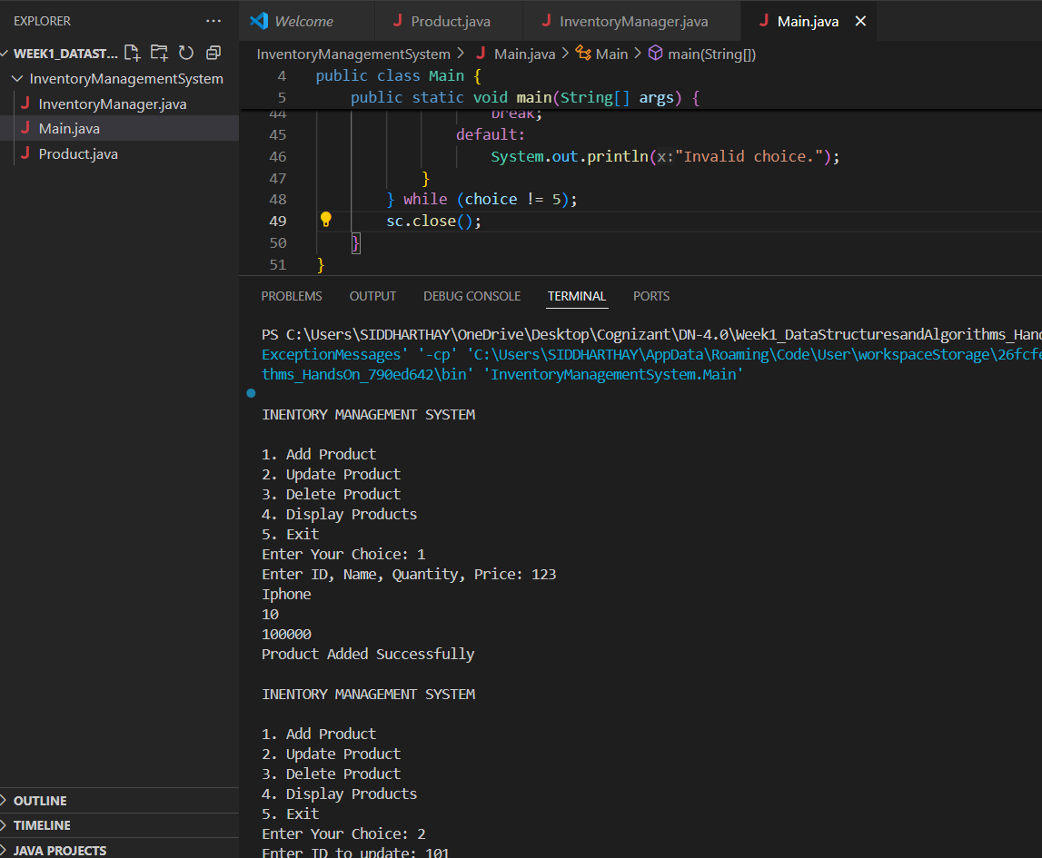

**Exercise 2: E-commerce Platform Search Function**

1Q. Explain Big O notation and how it helps in analyzing algorithms.

A. Big O notation describes the complexity of an algorithms in terms of time and space,and shows how time or space complexities increase with input size

2Q. Describe the best, average, and worst-case scenarios for search operations.

A. Search Algorithm best average worst

Linear Search O(1) O(n) O(n)

Binary Search O(1) O(logn) O(logn)

**CODE :**

package EcommercePlatformSearchFunction;

public class Product {

    //atributes

    private int productId;

    private String productName;

    private String category;

    public Product(int productId, String productName, String category) {

        this.productId = productId;

        this.productName = productName;

        this.category = category;

    }

    //ops

    public int getProductId() {

        return productId;

    }

    public String getProductName() {

        return productName;

    }

    public String getCategory() {

        return category;

    }

    public void display() {

        System.out.println("ID: " + productId + ", Name: " + productName + ", Category: " + category);

    }

}

package EcommercePlatformSearchFunction;

import java.util.*;

public class Search{

    //linear search by name

    public static int linearSearch(Product[] products, String name) {

        for (int i = 0; i < products.length; i++) {

            if (products[i].getProductName().equalsIgnoreCase(name)) {

                return i;

            }

        }

        return -1;

    }

    //binary search by name (on sorted array)

    public static int binarySearch(Product[] products, String name) {

        int low = 0;

        int high = products.length - 1;

        while (low <= high) {

            int mid = (low + high) / 2;

            int compare = products[mid].getProductName().compareToIgnoreCase(name);

            if (compare == 0) return mid;

            else if (compare < 0) low = mid + 1;

            else high = mid - 1;

        }

        return -1;

    }

    //sorting array for bs

    public static void sortProductsByName(Product[] products) {

        Arrays.sort(products, Comparator.comparing(Product::getProductName, String.CASE_INSENSITIVE_ORDER));

    }

}

package EcommercePlatformSearchFunction;

public class Main {

    public static void main(String[] args) {

        Product[] products = {

            new Product(101, "Laptop", "Electronics"),

            new Product(102, "Shoes", "Fashion"),

            new Product(103, "Smartphone", "Electronics"),

            new Product(104, "CricketBat", "Sports")

        };

        String key = "CricketBat";

        //linear search

        int lidx = Search.linearSearch(products, key);

        System.out.println("Linear Search:");

        if (lidx != -1) products[lidx].display();

        else System.out.println("Product not found.");

        // Binary Search (requires sorting first)

        Search.sortProductsByName(products);

        int bidx = Search.binarySearch(products, key);

        System.out.println("Binary Search:");

        if (bidx != -1) products[bidx].display();

        else System.out.println("Product not found.");

    }

}

3Q. Compare the time complexity of linear and binary search algorithms.

A. Search Algorithm best average worst

Linear Search O(1) O(n) O(n)

Binary Search O(1) O(logn) O(logn)

4Q. Discuss which algorithm is more suitable for your platform and why.

A. Binary Search is more suitable for platforms like e commerce due to its requirements for fast accessing and managing products nature as we can sort the products in advance which is needed for binary search where linear search is only suitable for small or unsorted data.

**OUTPUT :**

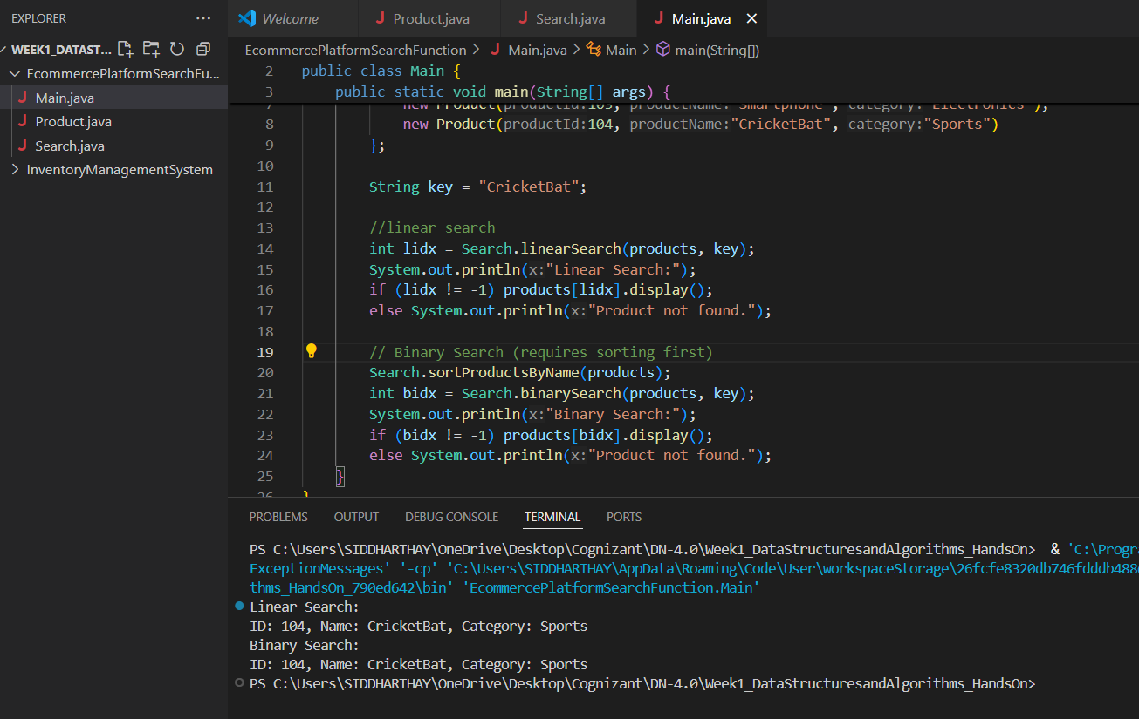

**Exercise 3: Sorting Customer Orders**

**CODE :**

package SortingCustomerOrders;

public class Order {

    //attributes

    private int orderId;

    private String customerName;

    private double totalPrice;

    public Order(int orderId, String customerName, double totalPrice) {

        this.orderId = orderId;

        this.customerName = customerName;

        this.totalPrice = totalPrice;

    }

    //ops

    public double getTotalPrice() {

        return totalPrice;

    }

    public void display() {

        System.out.println("Order ID: " + orderId + ", Customer: " + customerName + ", Total: " + totalPrice);

    }

}

package SortingCustomerOrders;

//sorting algos

public class Sort {

    //bubble sort

    public static void bubbleSort(Order[] orders) {

        int n = orders.length;

        for (int i=0; i<n-1; i++) {

            boolean swapped = false;

            for (int j=0; j<n-i-1; j++) {

                if (orders[j].getTotalPrice() < orders[j+1].getTotalPrice()) {

                    Order temp = orders[j];

                    orders[j] = orders[j+1];

                    orders[j+1] = temp;

                    swapped = true;

                }

            }

            if (!swapped) break;

        }

    }

    //quick sort

    public static void quickSort(Order[] orders, int low, int high) {

        if (low < high) {

            int pi = partition(orders, low, high);

            quickSort(orders, low, pi-1);

            quickSort(orders, pi+1, high);

        }

    }

    private static int partition(Order[] orders, int low, int high) {

        double pivot = orders[high].getTotalPrice();

        int i = low-1;

        for (int j=low; j<high; j++) {

            if (orders[j].getTotalPrice() > pivot) {

                i++;

                Order temp = orders[i];

                orders[i] = orders[j];

                orders[j] = temp;

            }

        }

        Order temp = orders[i+1];

        orders[i+1] = orders[high];

        orders[high] = temp;

        return i+1;

    }

}

package SortingCustomerOrders;

public class Main {

    public static void main(String[] args) {

        // for bubble sort

        Order[] orders = {

            new Order(1, "Siddhu", 7070),

            new Order(2, "Ram", 800),

            new Order(3, "Ashs", 2400),

            new Order(4, "Chai", 1500)

        };

        System.out.println("Before Sorting Orders:");

        for (Order o : orders) o.display();

        //bubble sort

        Sort.bubbleSort(orders);

        System.out.println("\nBubble Sort:");

        for (Order o : orders) o.display();

        //for quick sort

        orders = new Order[]{

            new Order(1, "Siddhu", 7070),

            new Order(2, "Ram", 800),

            new Order(3, "Ashs", 2400),

            new Order(4, "Chai", 1500)

        };

        //quick sort

        Sort.quickSort(orders, 0, orders.length-1);

        System.out.println("\nQuick Sort:");

        for (Order o : orders) o.display();

    }

}

**OUTPUT :**

