**WEEK 2**

**JUNIT TESTING EXERCISES**

**Exercise 1: Setting Up JUnit**

**Set Up** :

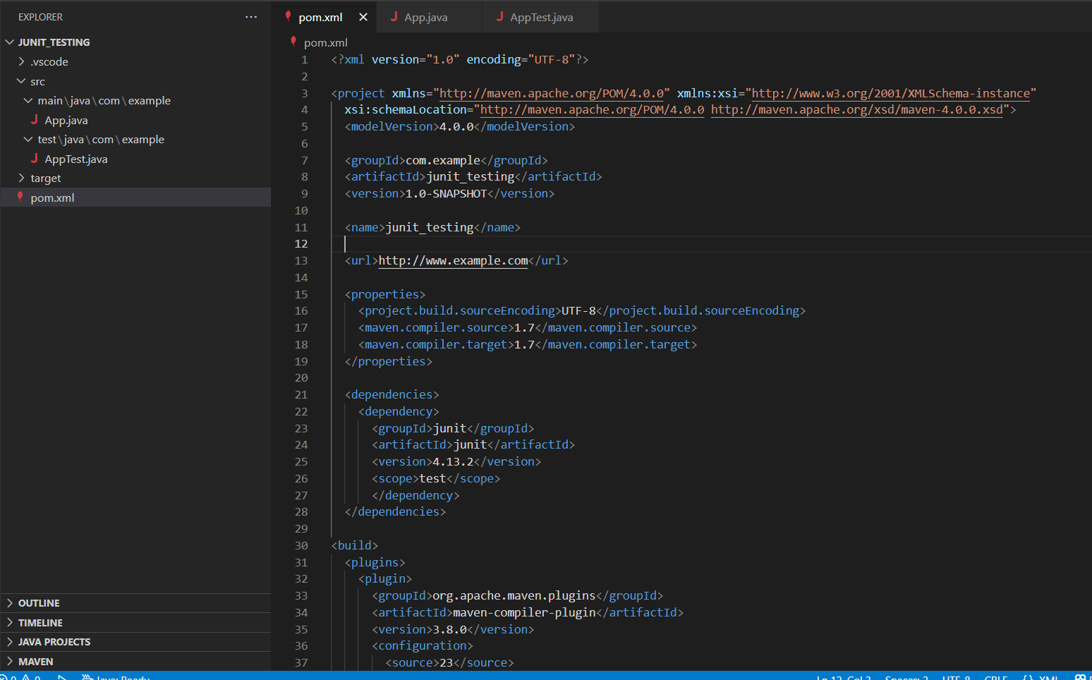

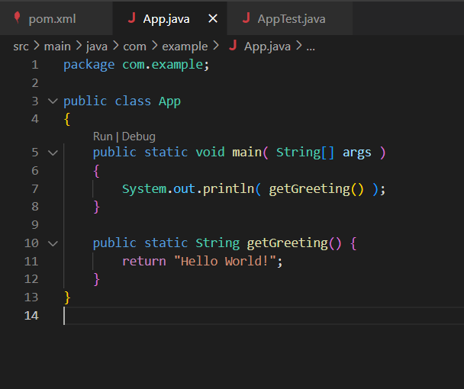 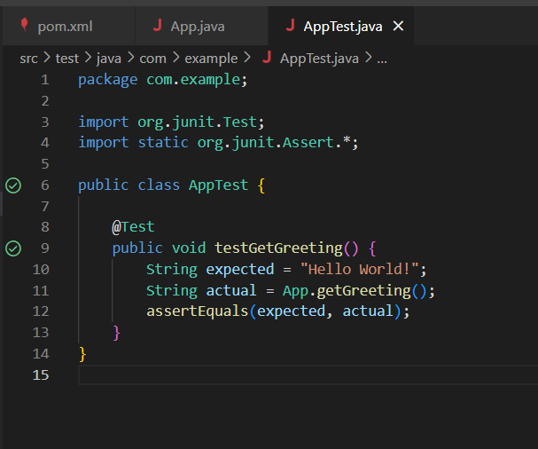

**Test Results:**

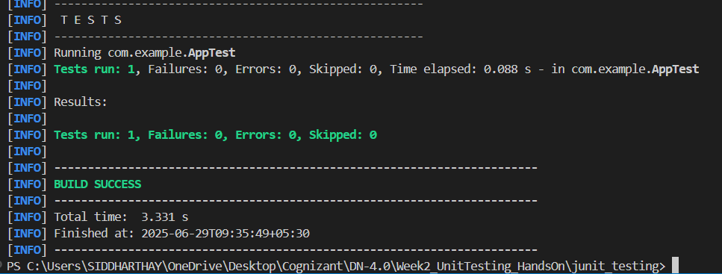

**Exercise 2: Writing Basic JUnit Tests**

**Creating Java main class:**

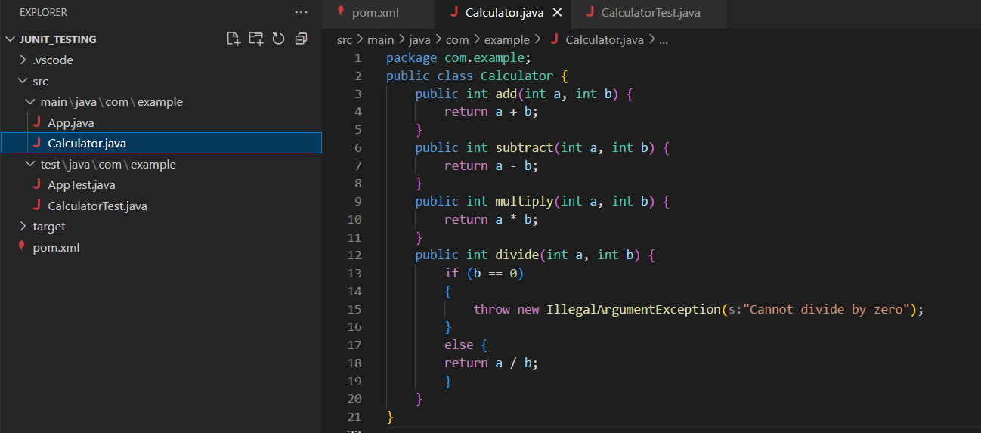

**Creating test class:**

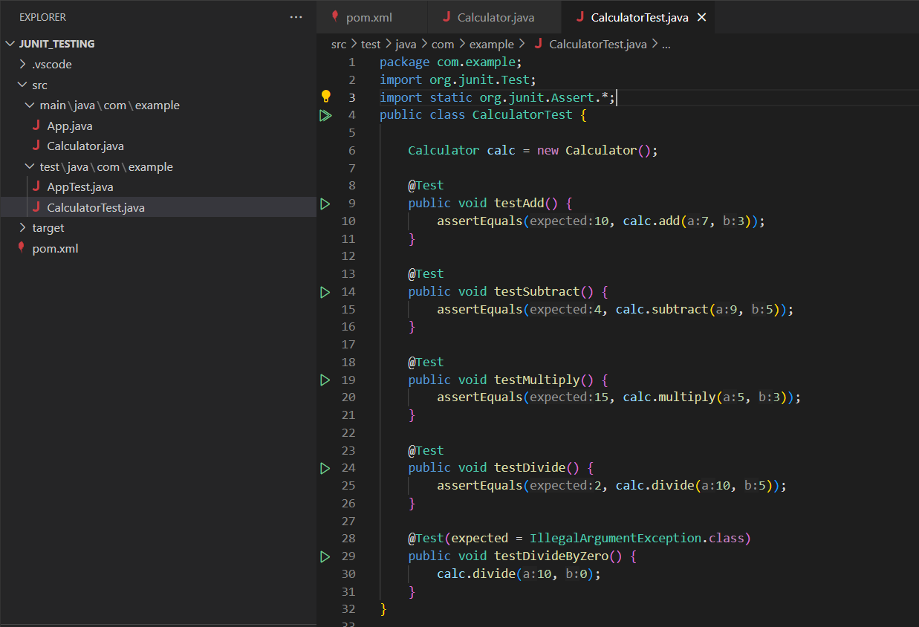

**Test Results:**

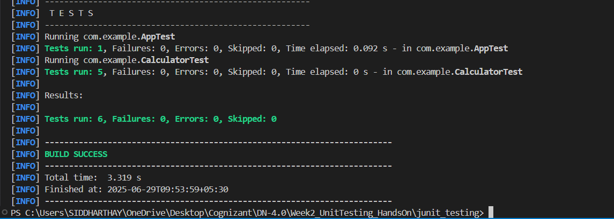

**Exercise 3: Assertions in JUnit**

**Creating AssertionsTest Class:**

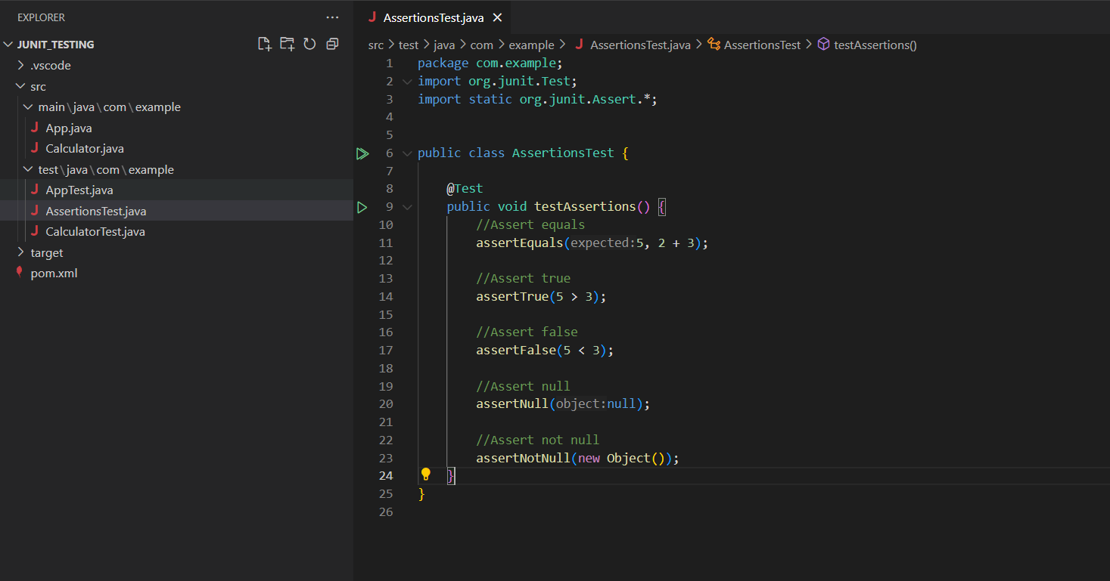

**Test Results:**

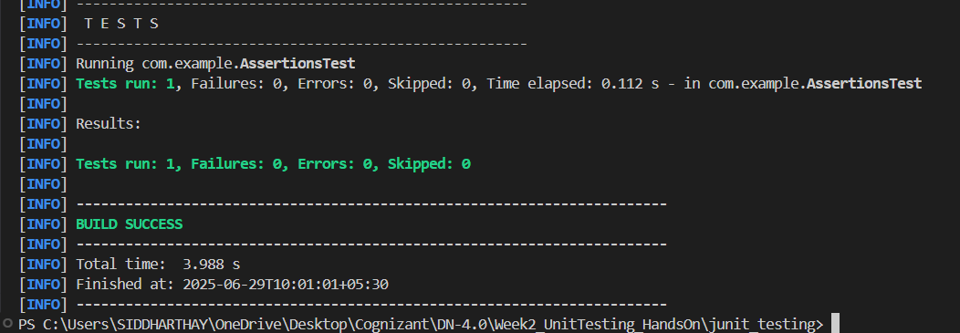

**Exercise 4: Arrange-Act-Assert (AAA) Pattern, Test Fixtures, Setup and Teardown Methods in JUnit**

**Test Fixtures, Setup, Teardown methods using AAA Pattern:**

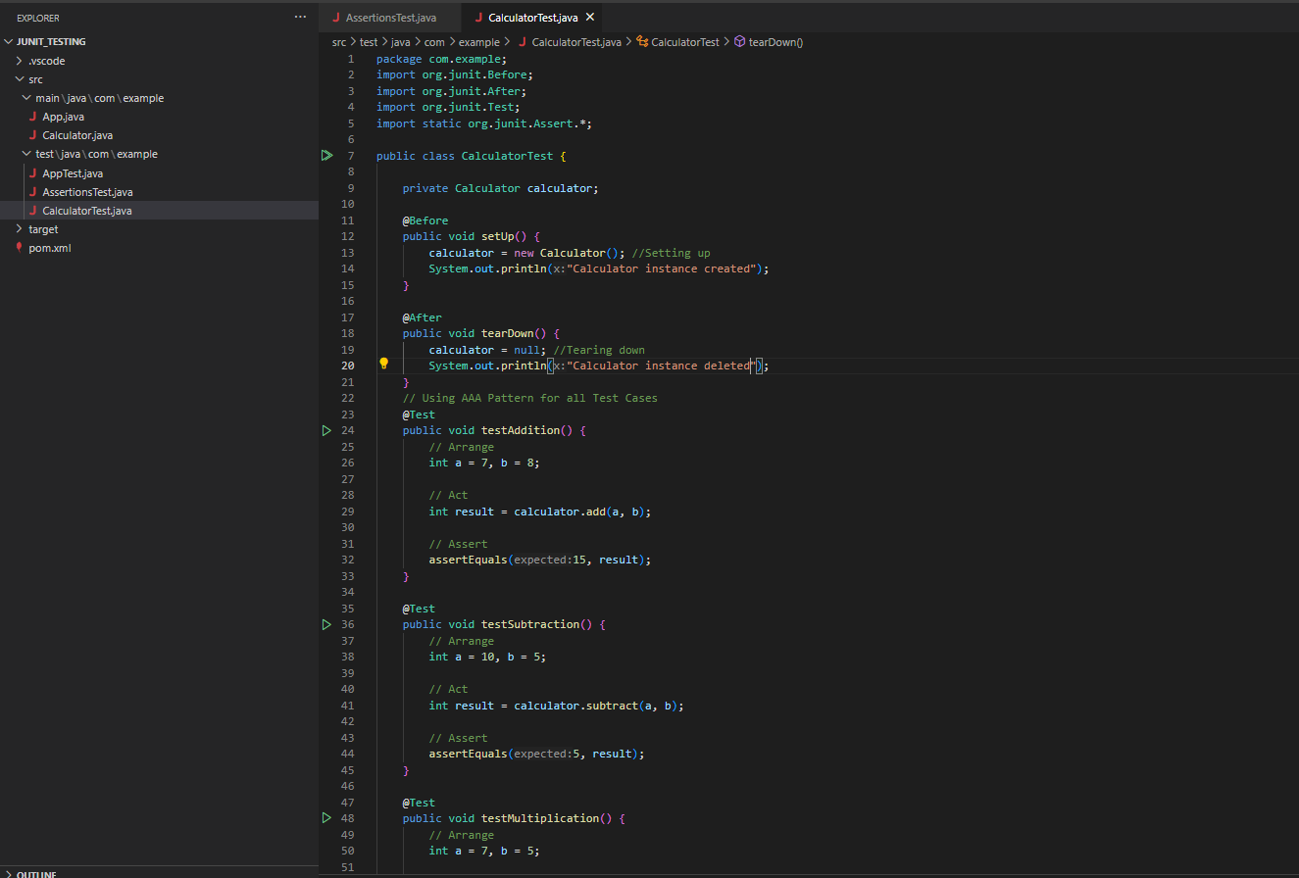

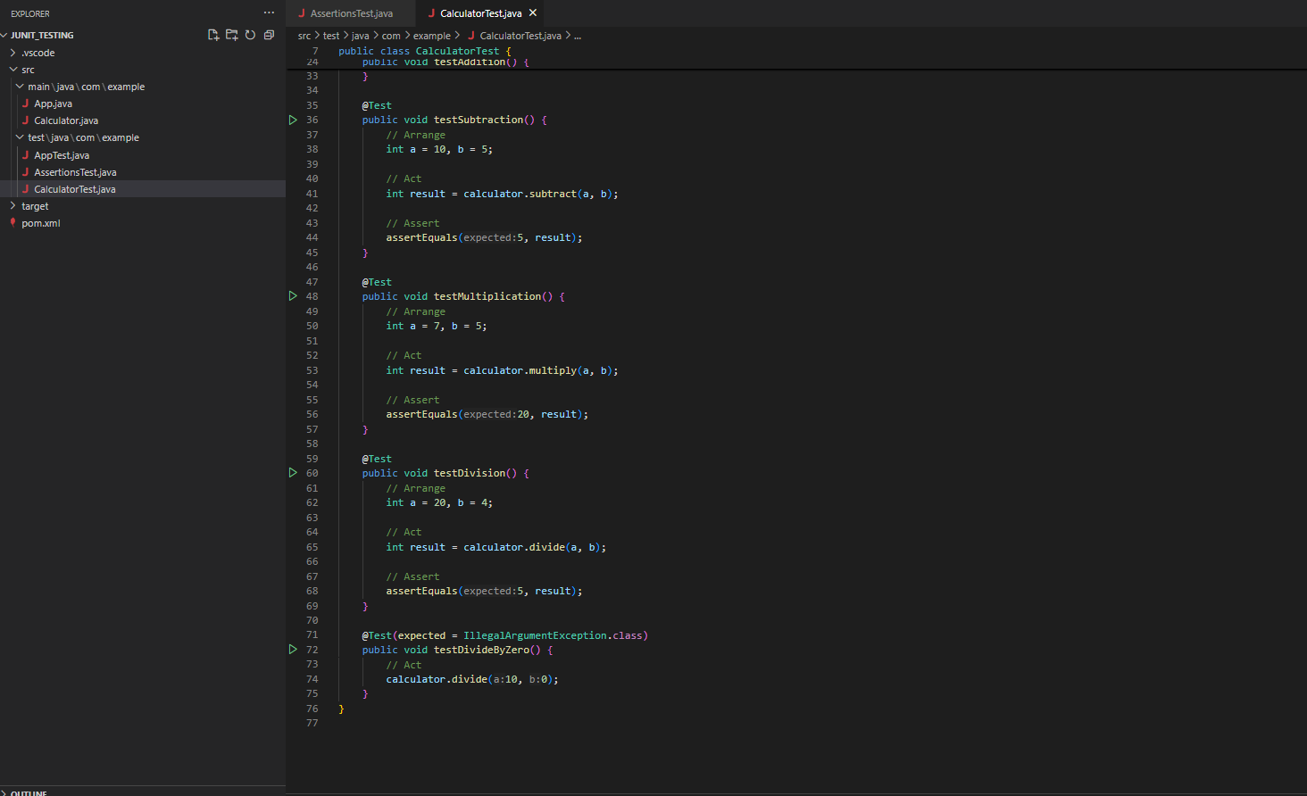

**Test Results:**

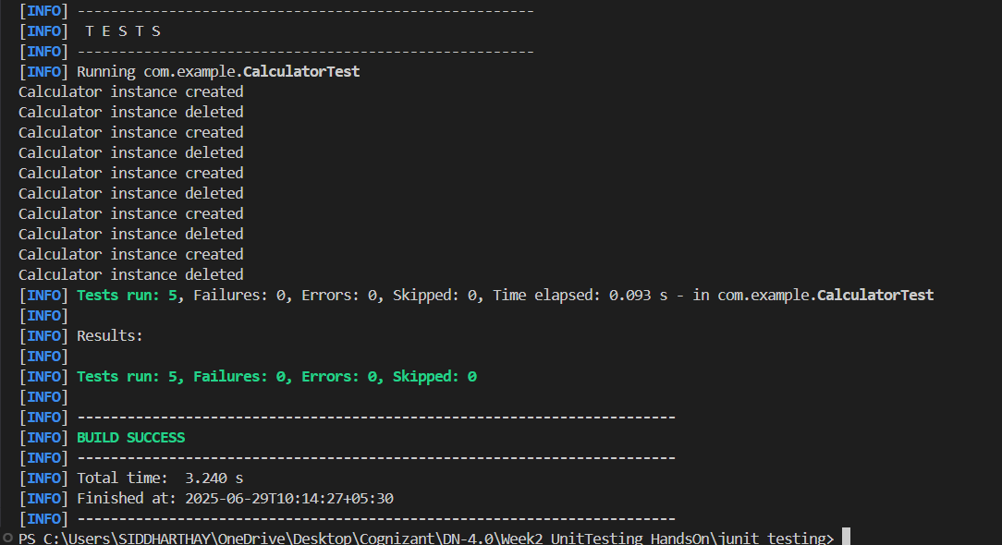

**MOCKITO EXERCISES**

**Exercise 1: Mocking and Stubbing** (using the solution codes given in exercises)

**External API:**

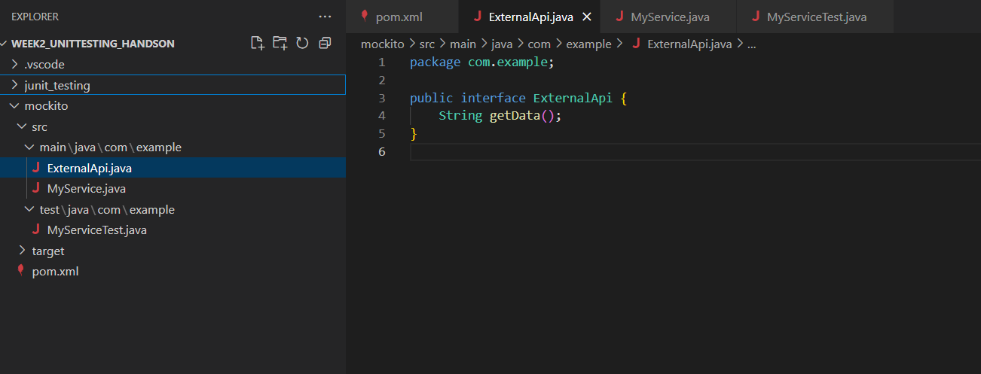

**Stubbing:**

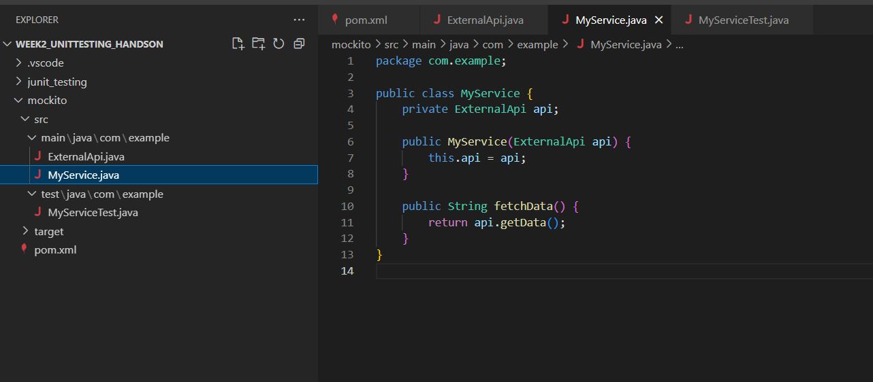

**Mocking and Verfying:**

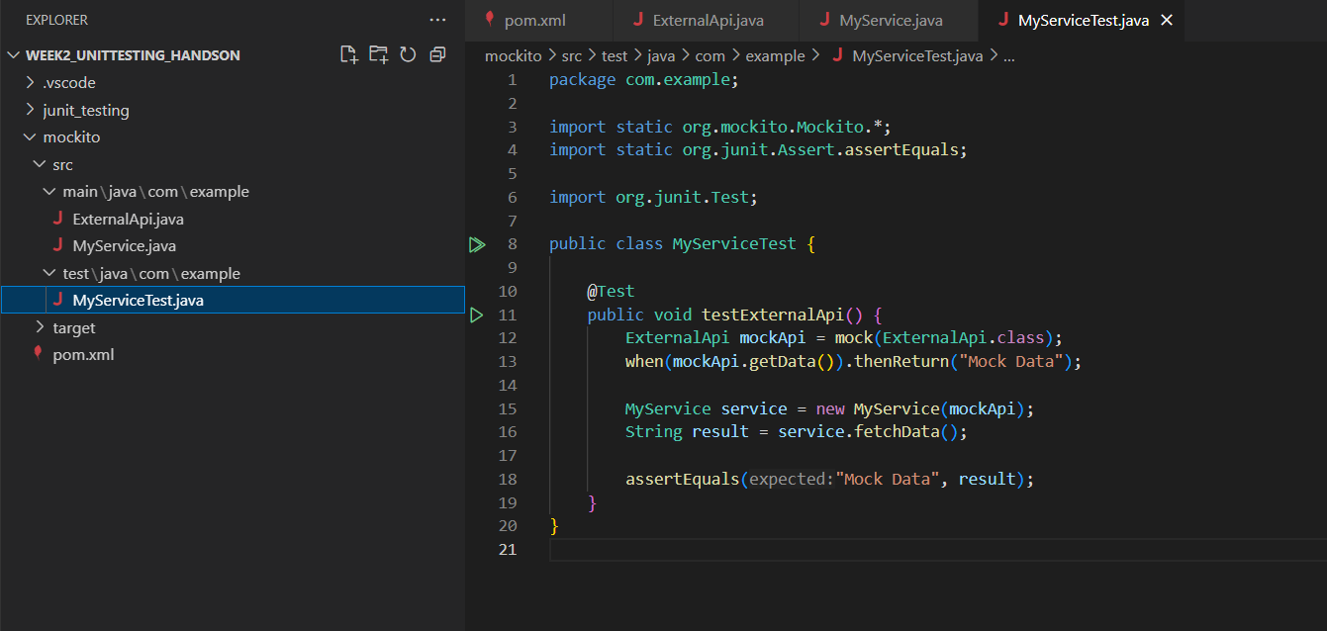

**Test Results:**

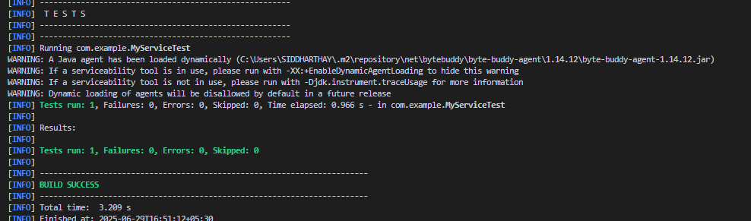

**Exercise 2: Verifying Interactions**

**External API:**



**Stubbing:**



**Mocking and Verfying:**

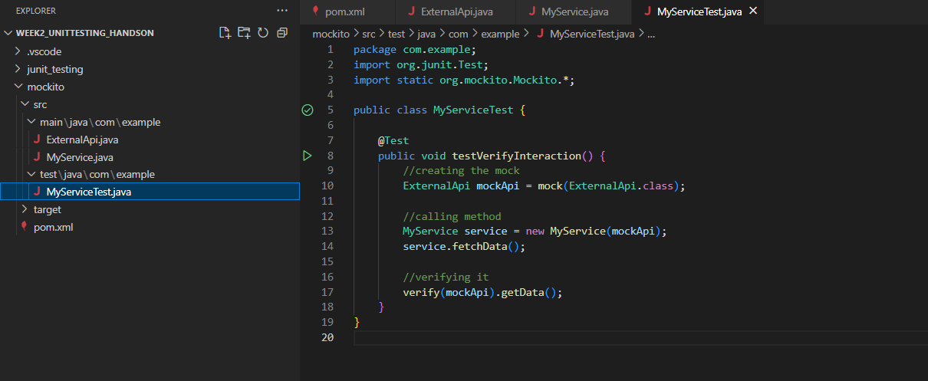

**Test Results:**

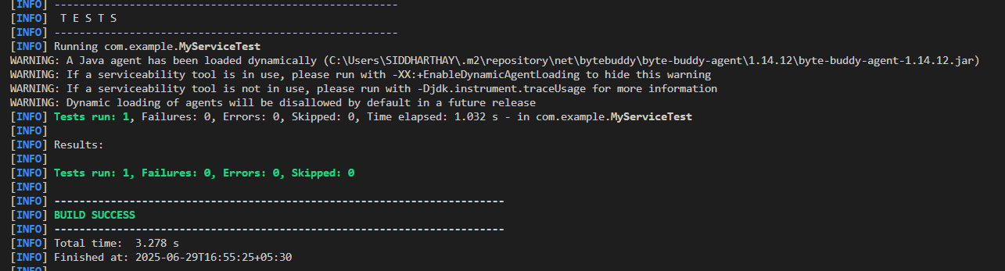

**Exercise 3: Argument Matching**

**External API:**

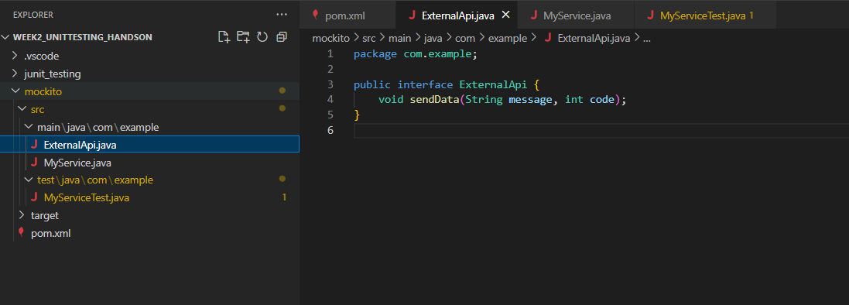

**Stubbing:**

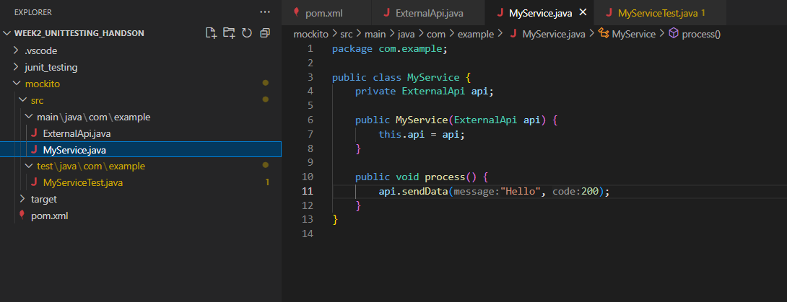

**Mocking and Verfying:**

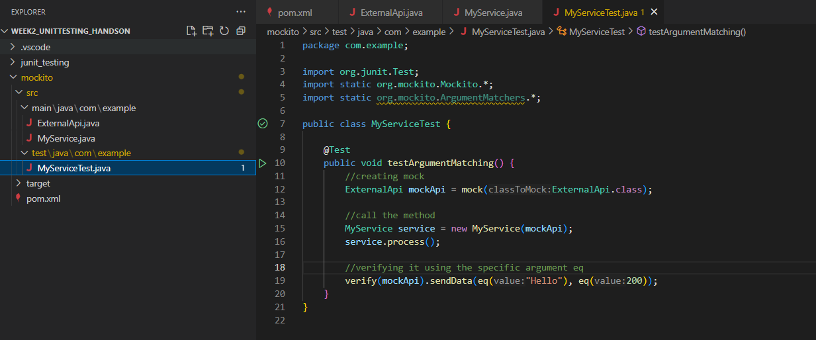

**Test Results:**

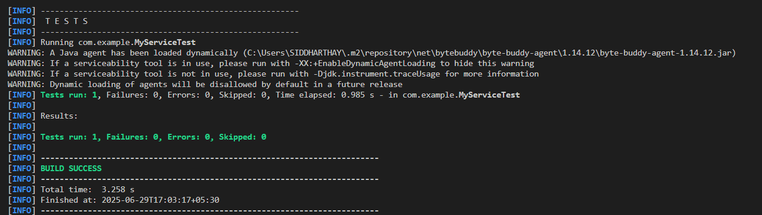

**Exercise 4: Handling Void Methods**

**External API:**

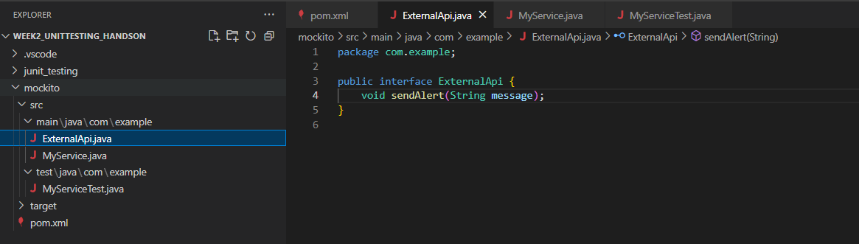

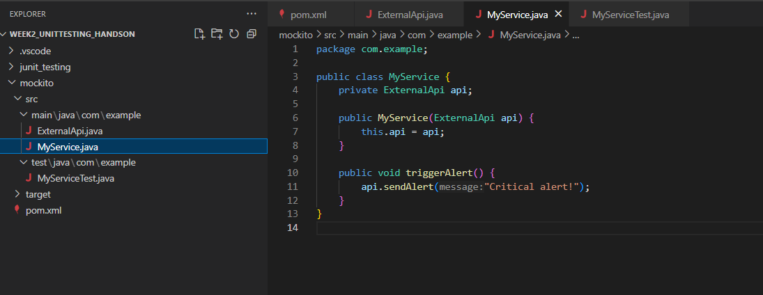

**Mocking, Stubbing and Verifying:**

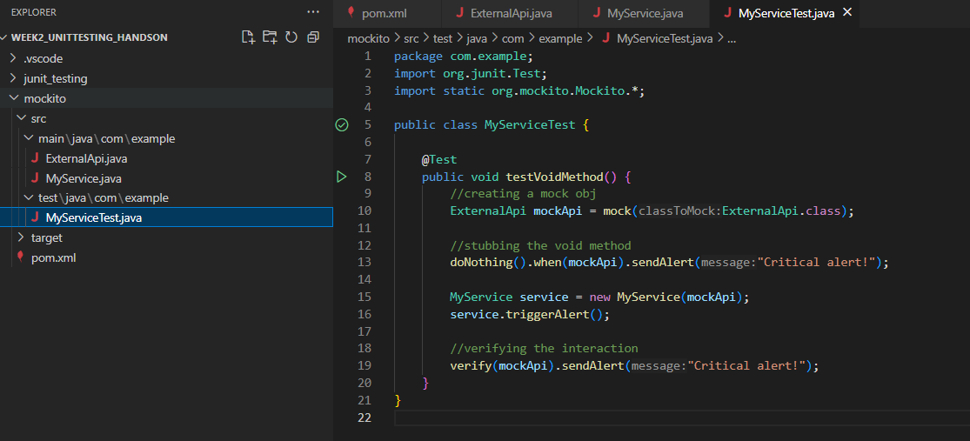

**Test Results:**

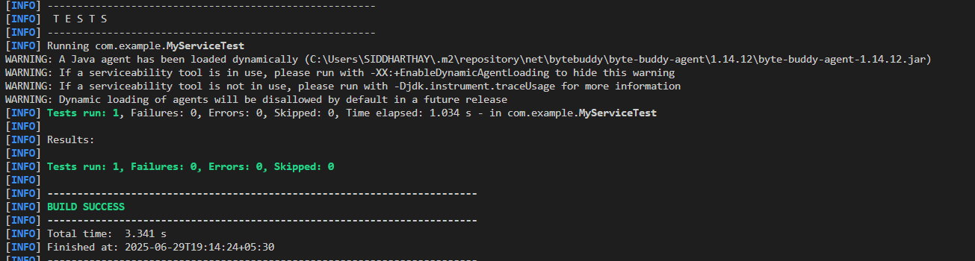

**Exercise 5: Mocking and Stubbing with Multiple Returns**

**External API:**

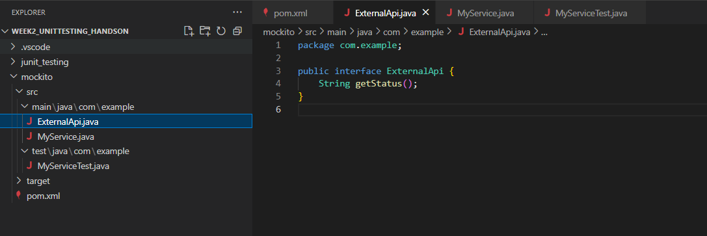

**Stubbing:**

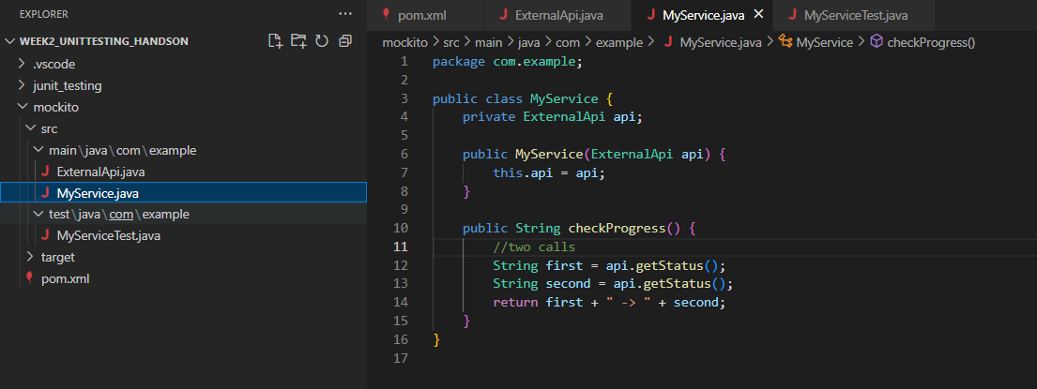

**Testing:**

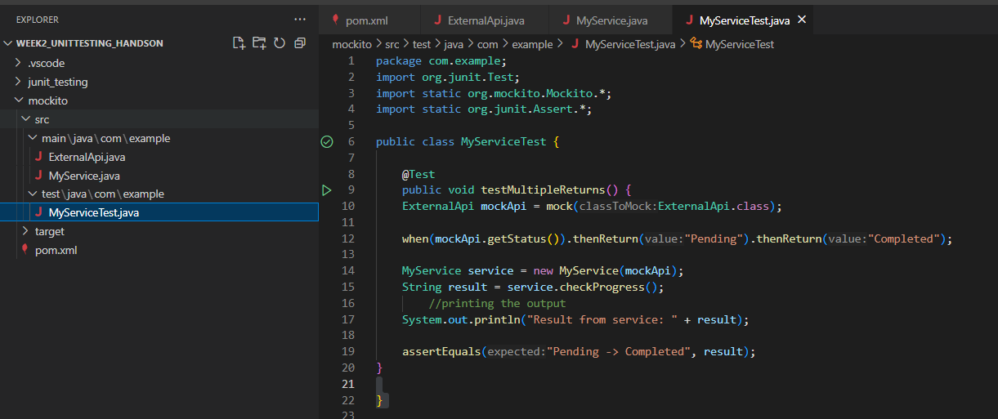

**Test Results:**

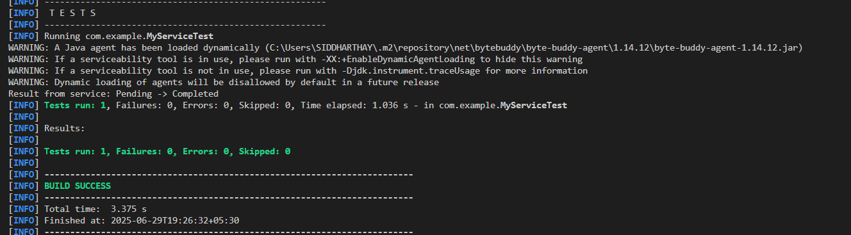

**Exercise 6: Verifying Interaction Order**

**External API:**

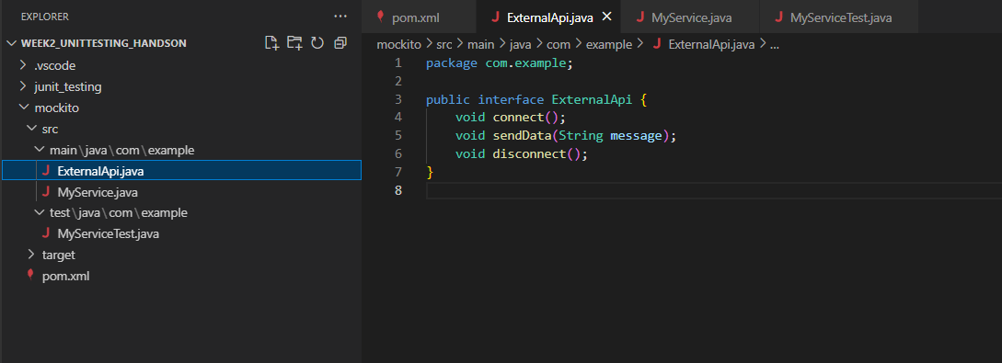

**Stubbing:**

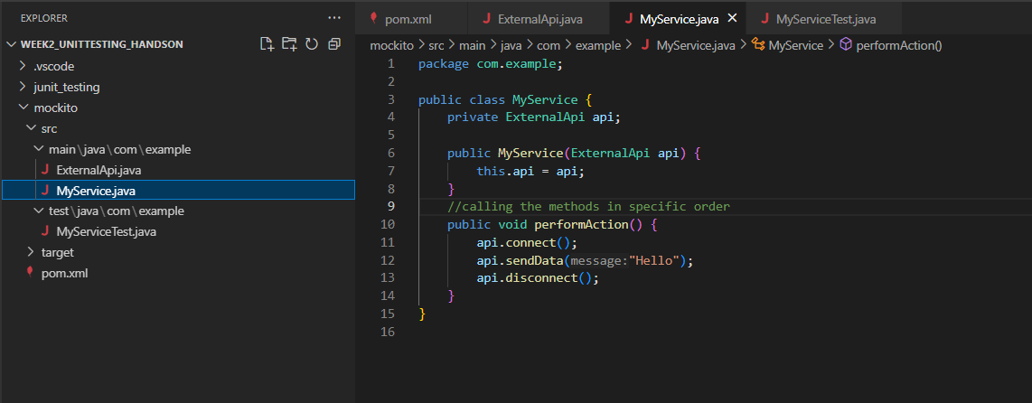

**Testing/Verifying:**

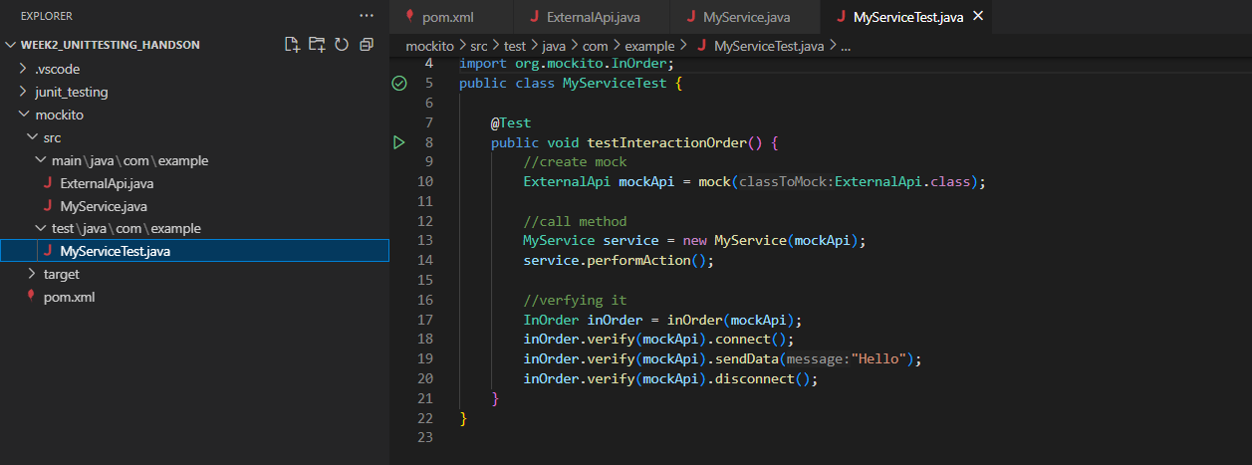

**Test Results:**

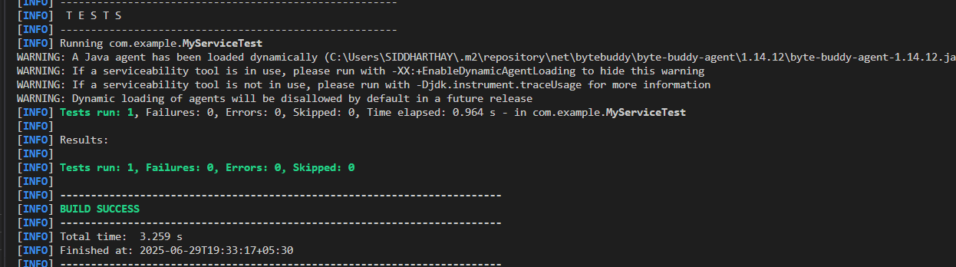

**Exercise 7: Handling Void Methods with Exceptions**

**External API:**

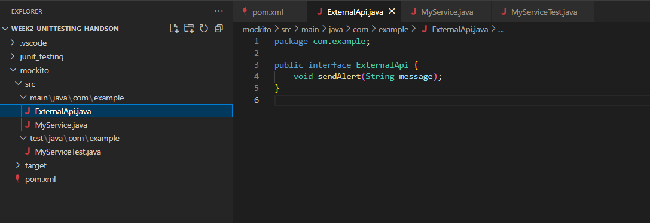

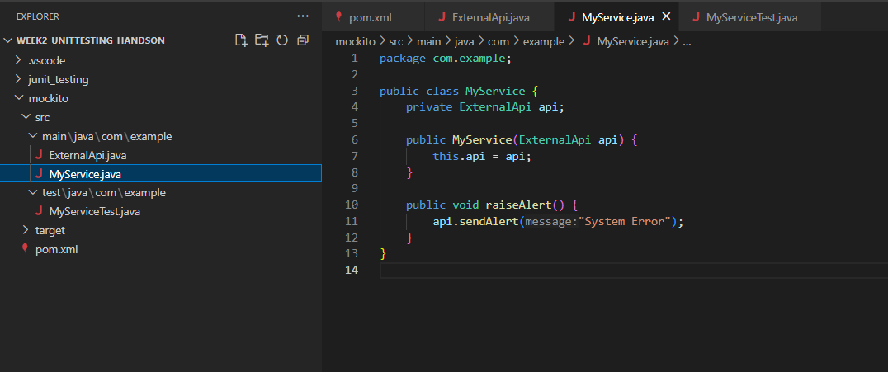

**Testing / Verifying:**

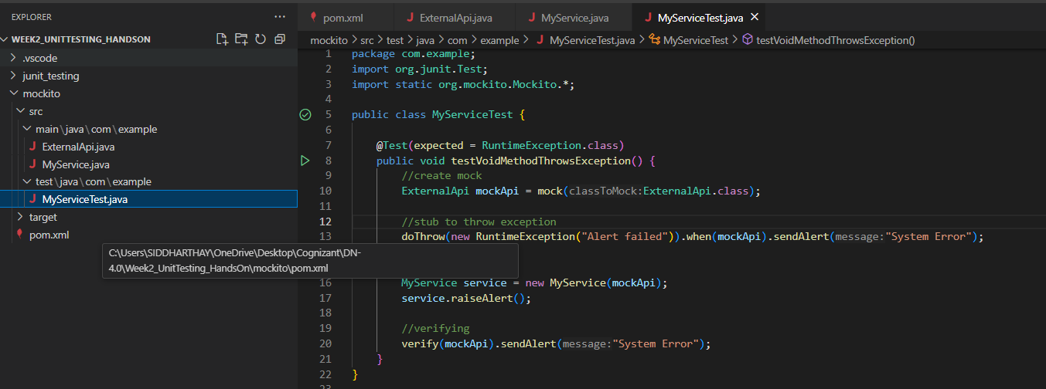

**Test Results:**

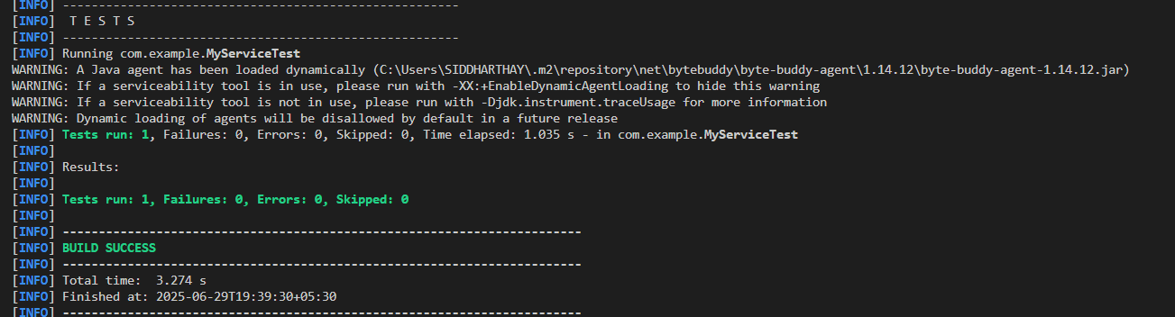

**Logging using SLF4J Exercises**

**Exercise 1: Logging Error Messages and Warning Levels**

**Added the Dependencies:**

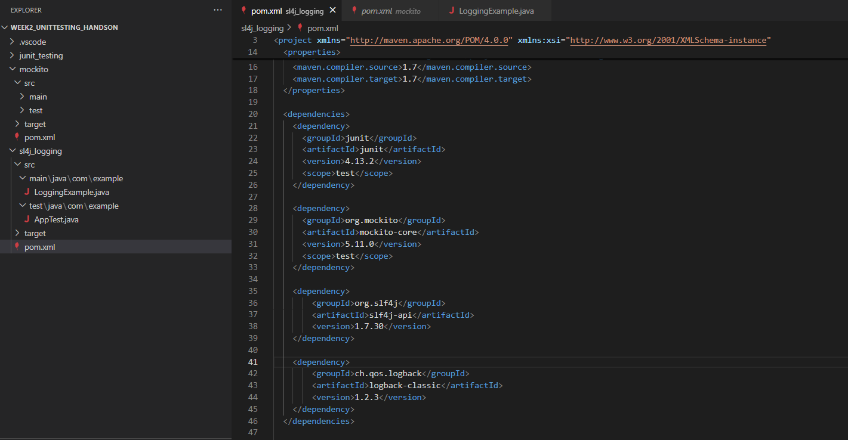

**LoggingExample.java**

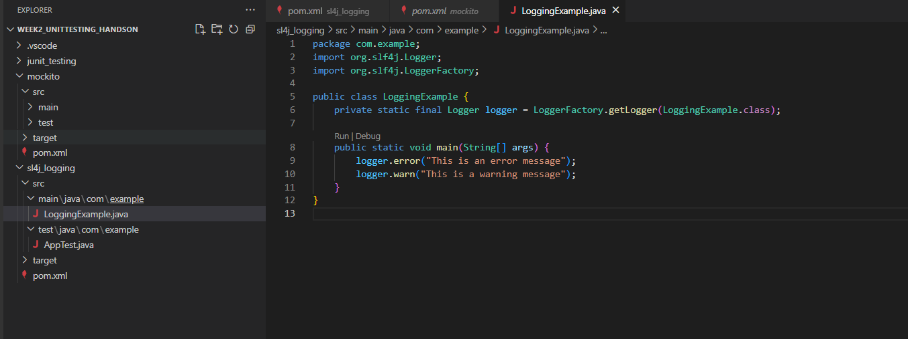

**Test Results:**

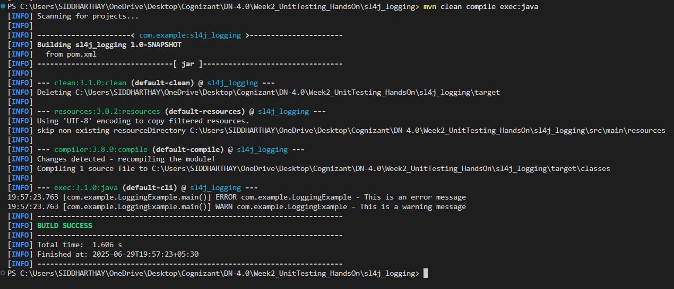

**Exercise 2: Parameterized Logging**

**Dependencies are placed**

**ParameterizedLoggingExample.java**

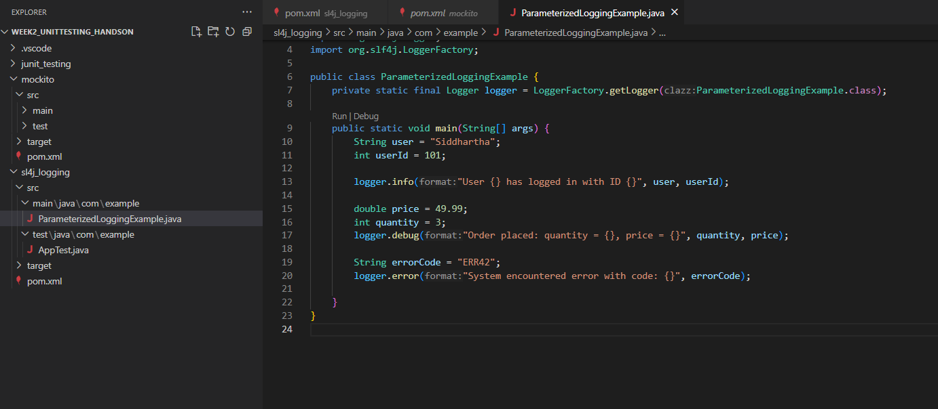

**Test Results:**

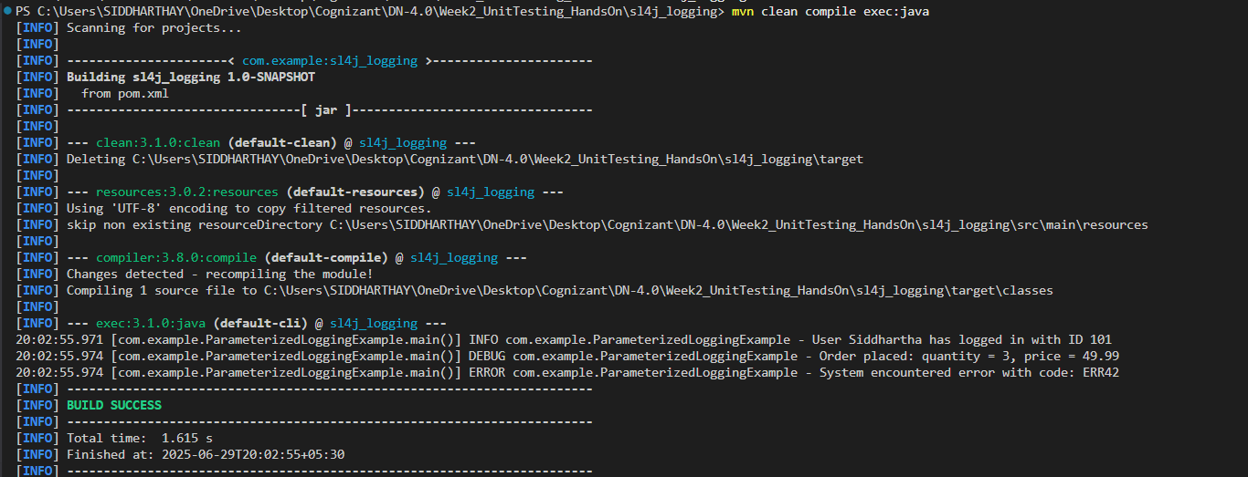

**Exercise 3: Using Different Appenders**

**logback.xml for defining different appenders:**

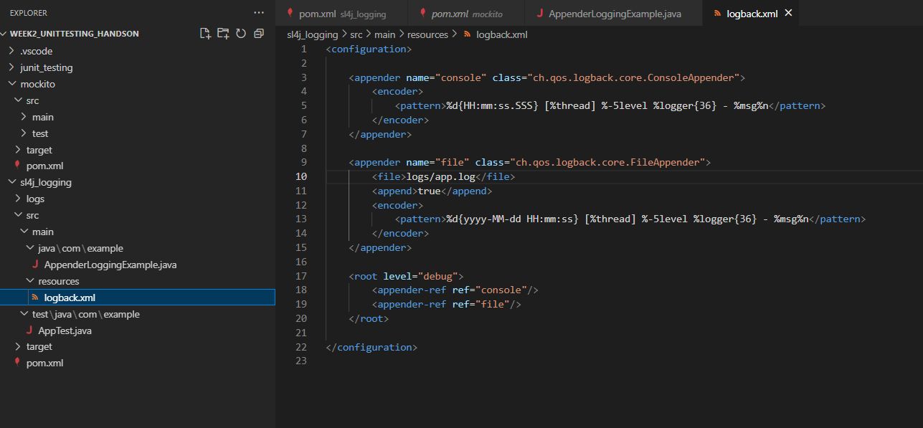

**AppenderLoggingExample.java**

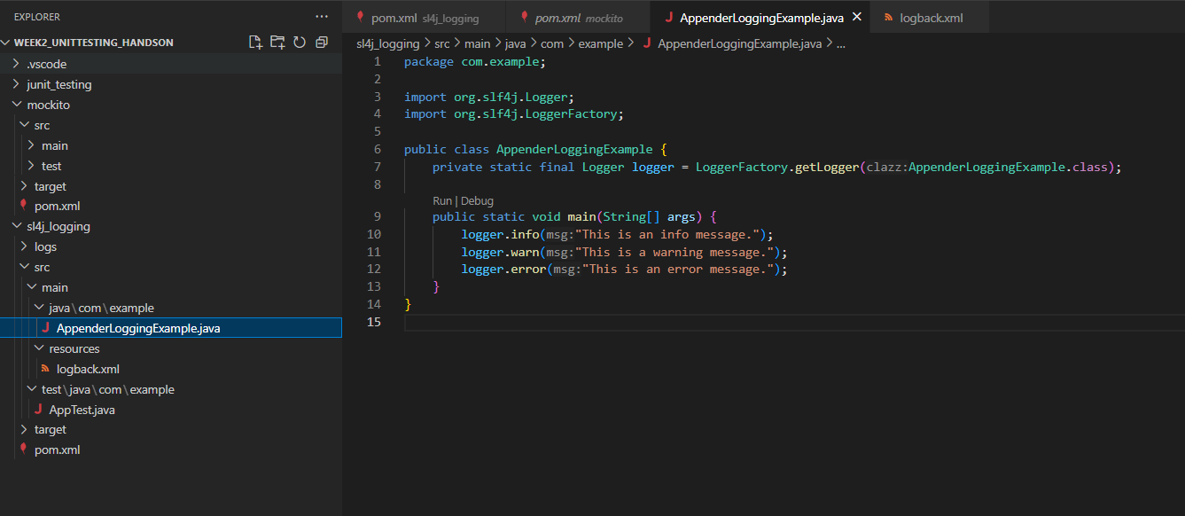

**Test Results:**

