**WEEK 3**

**SPRING DATA JPA WITH HIBERNATE**

**Hands on 1**

**Spring Data JPA - Quick Example**

**1. Eclipse Project using Spring Initializr**

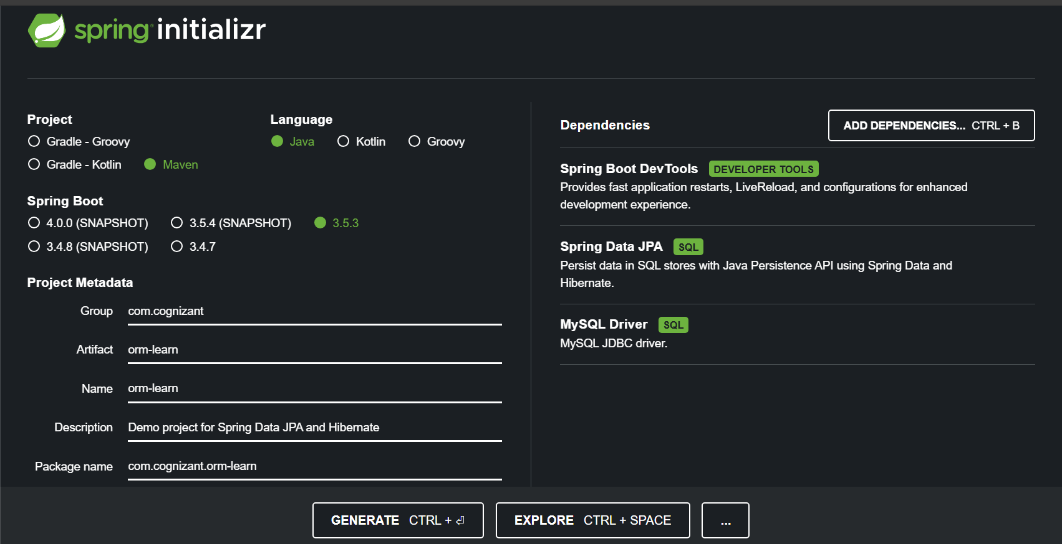

**2. Project Structure**

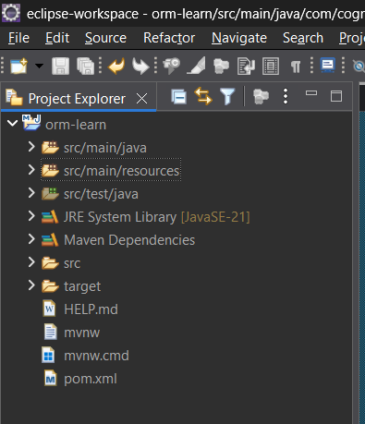

**3. Dependencies in pom.xml**

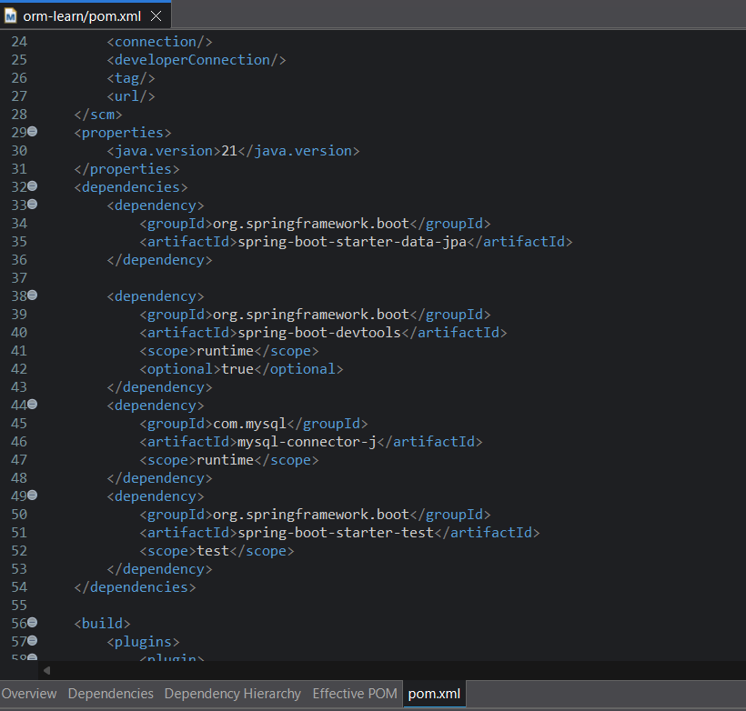

**4. application.properties configuration**

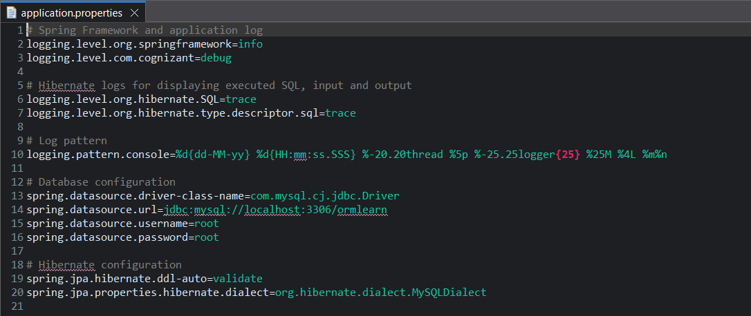

**5. Country Entity Class**

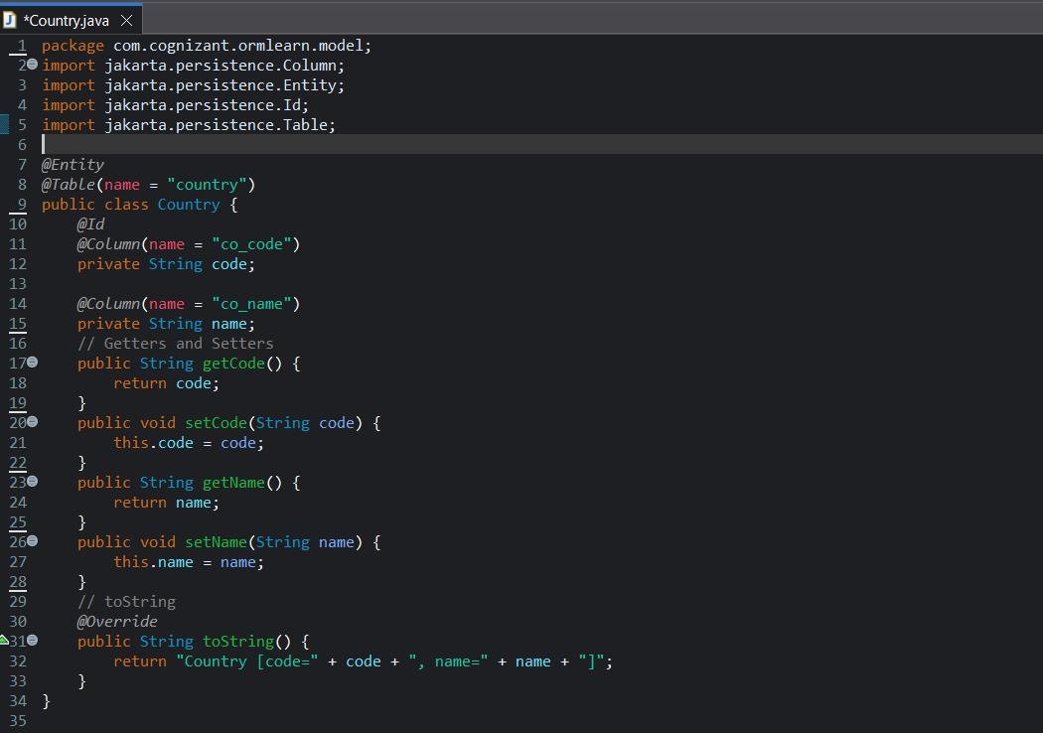

**6. Country Repository Interface**

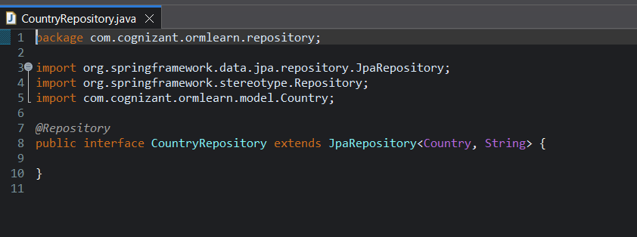

**7. Service Class**

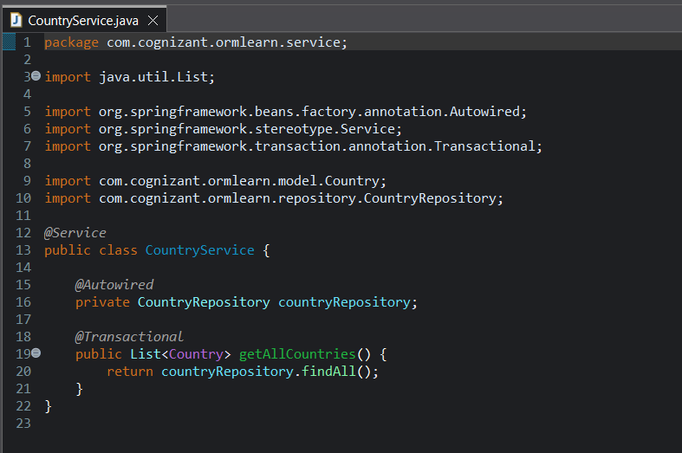

**8. OrmLearnApplication Main Class for testing**

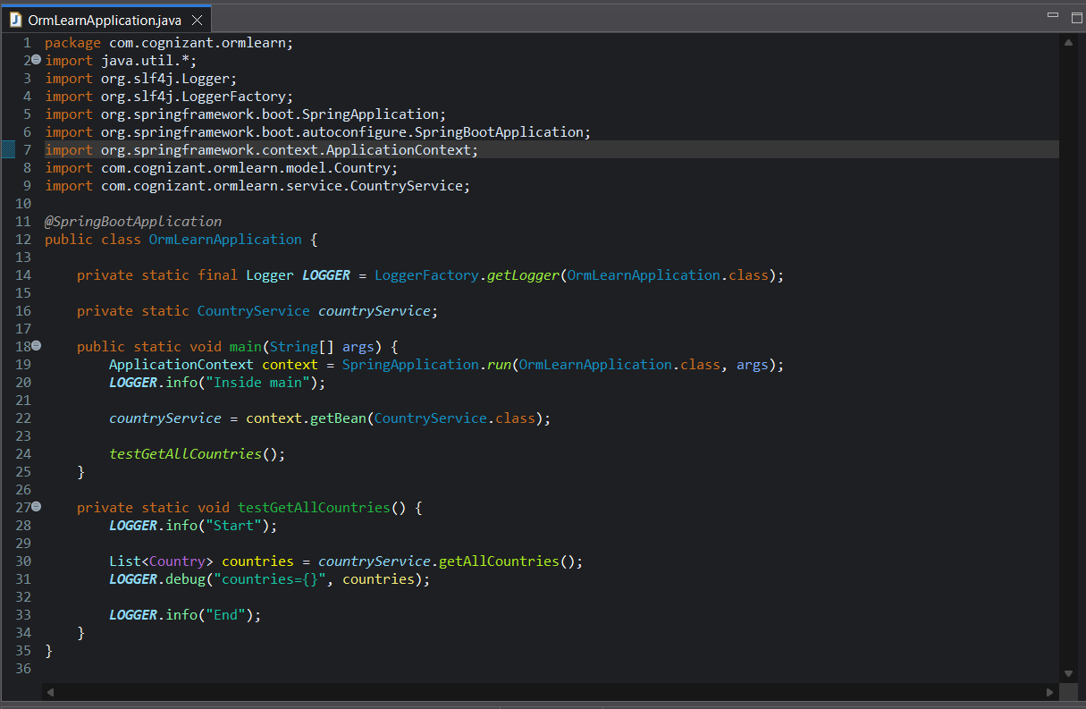

**9. country table creation and view in MySQL Database**

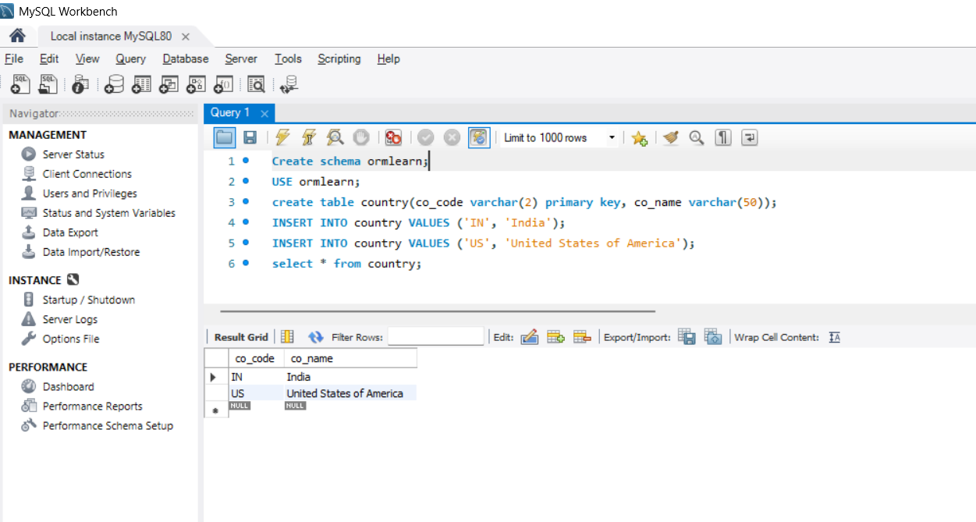

**10. OUTPUT :**

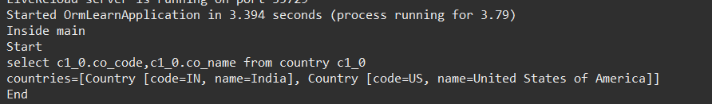

**Hands on 4**

**Difference between JPA, Hibernate and Spring Data JPA**

My Answer:

**JPA (Java Persistence API):**

* It is basically a blueprint containing a set of rules for ORM (object relational mapping), which defines a way for java applications to communicate with relational databases
* It provides annotations for mapping java objects to database tables and also defines how to perform CRUD (create, read, update and delete) operations.
* It is not an implementation, just a specification.

**Hibernate:**

* It is the ORM tool/framework which actually implements the JPA specification.
* It provides the actual code and features to interact with database and handles all operations.

**Spring Data JPA:**

* It can be seen as a abstraction layer which is build on top of JPA and hibernate which simplifies data access.
* It reduces boilerplate code by providing different interfaces like JpaRepository, which automatically generates implementation for common database operations.

**1. using spring initializr for creating project**

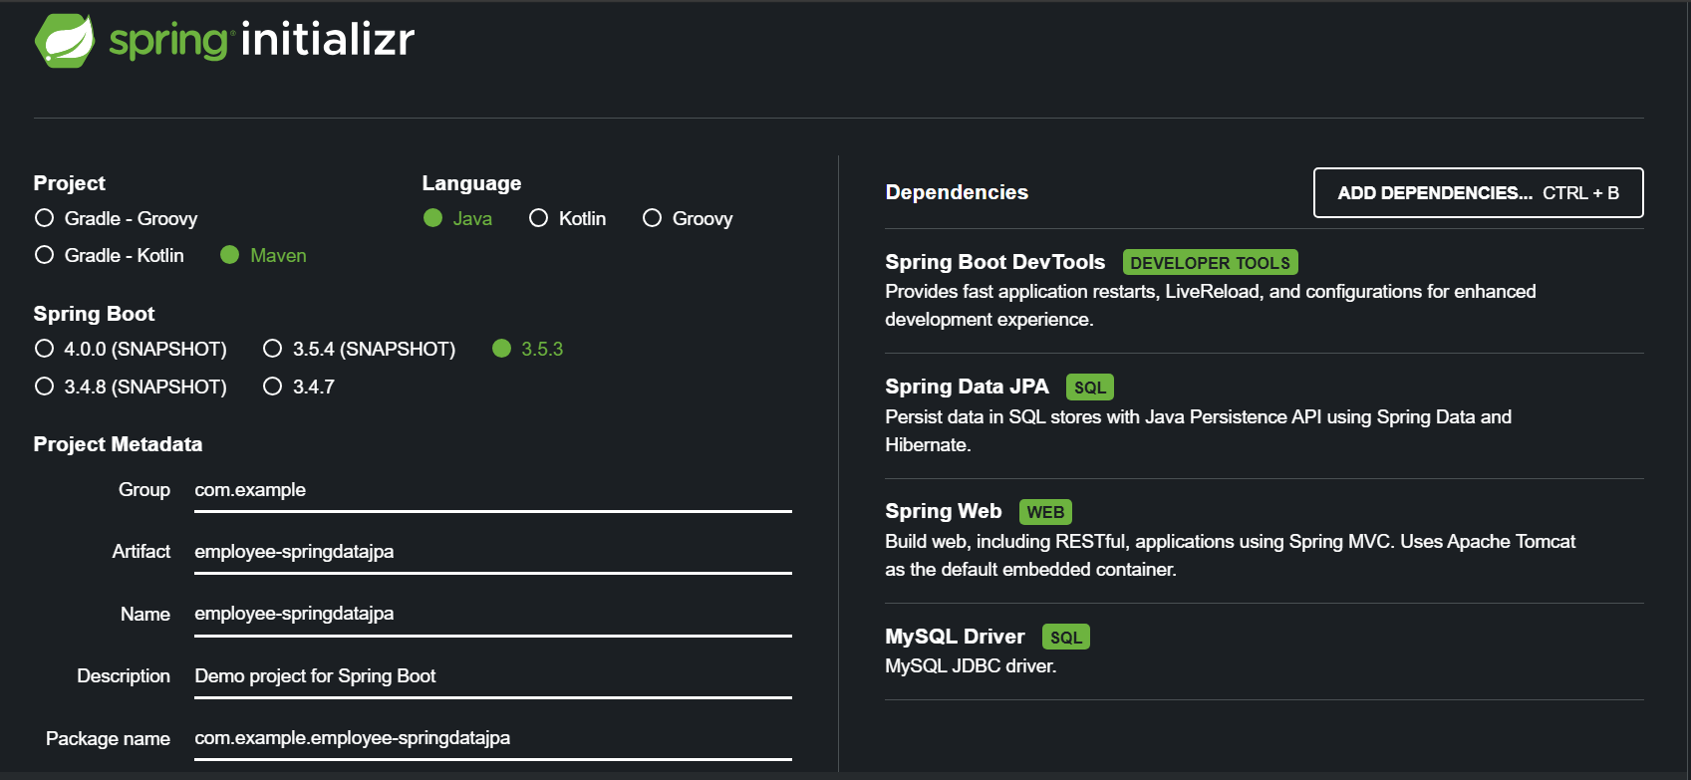

**2. application.properties for configuration:**

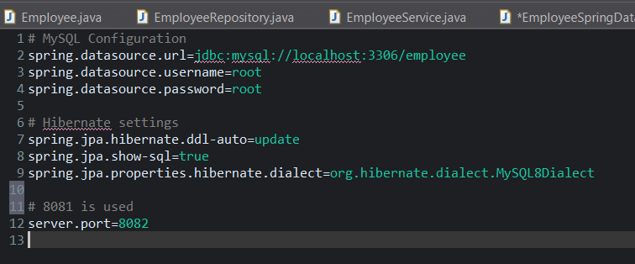

**3. Main Class**

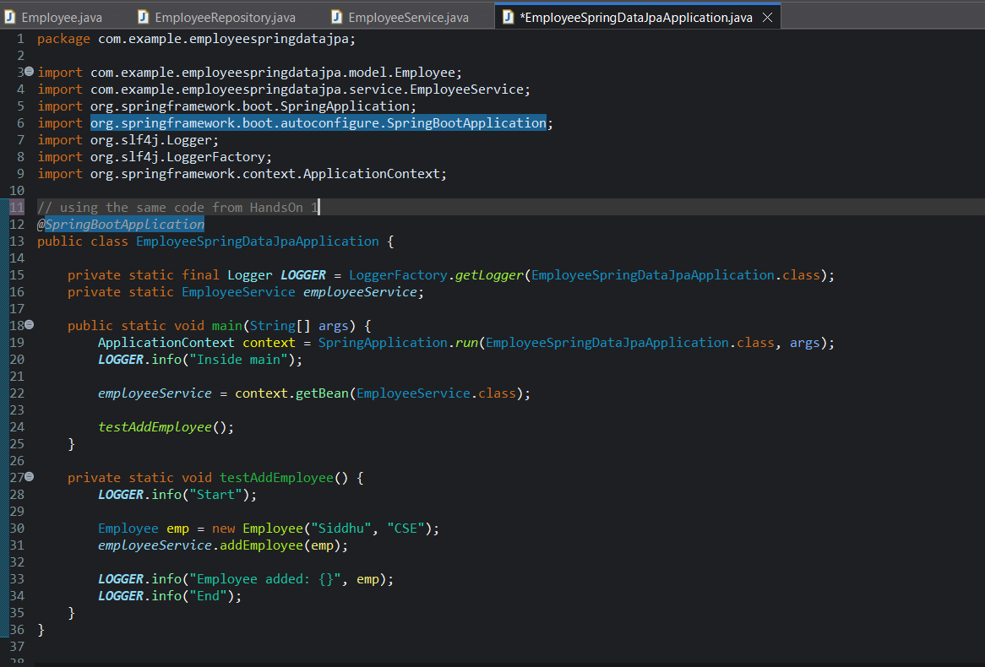

**4. Entity Employee class**

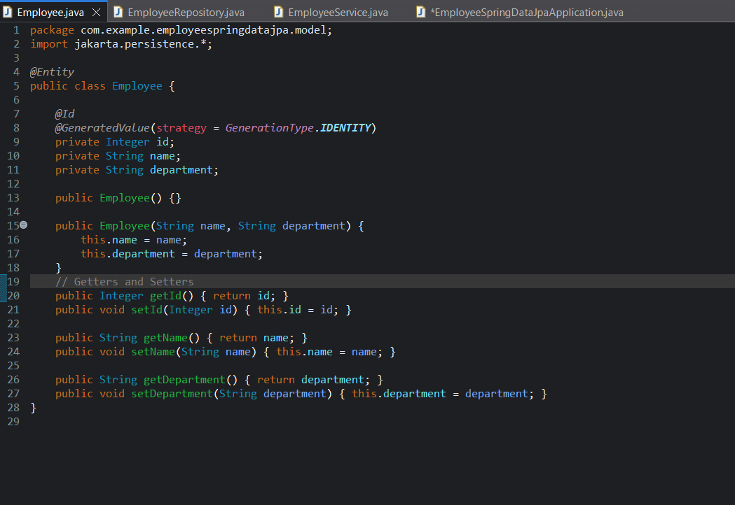

**5. Spring Data JPA EmployeeRespository.java**

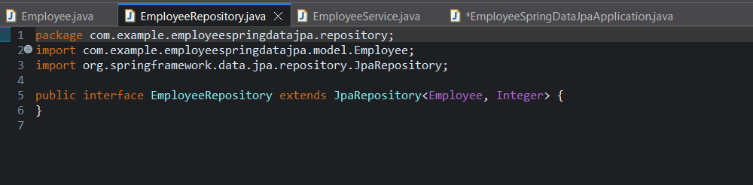

**6. EmployeeService.java**

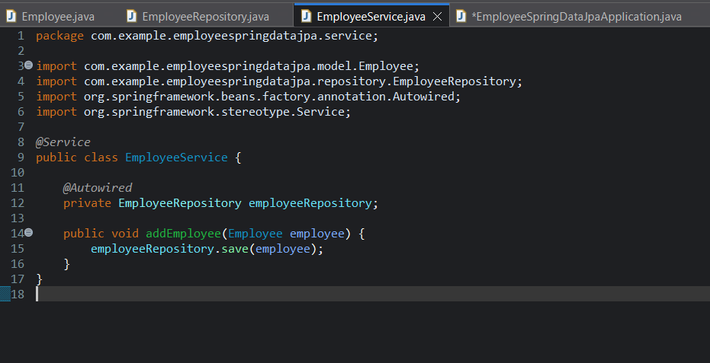

**7. Output:**

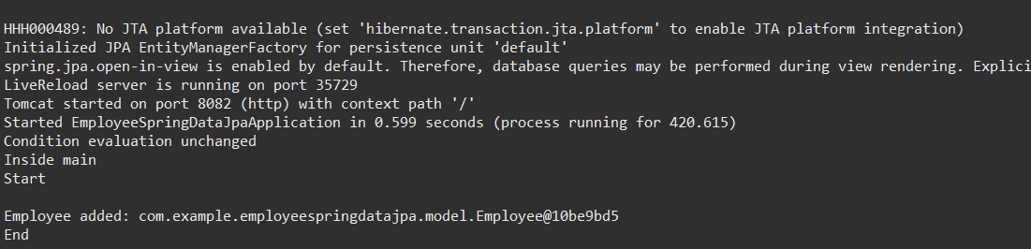

**8. MySQL TABLE:**

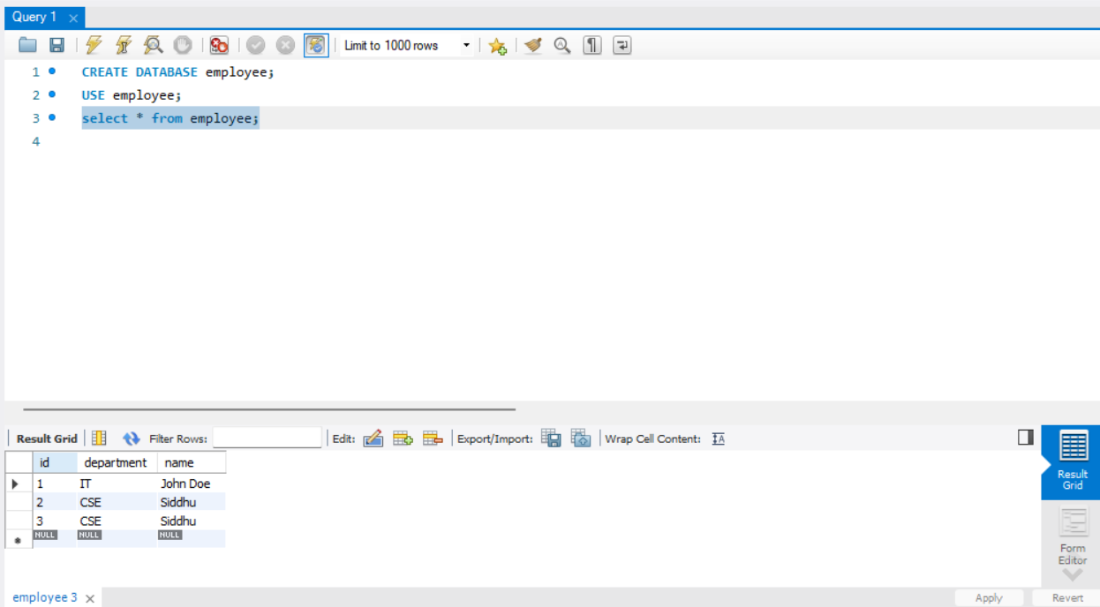

**Hands on 5,6,7,8,9**

**Implement services for managing Country**

An application requires for features to be implemented with regards to country. These features needs to be supported by implementing them as service using Spring Data JPA.

* Find a country based on country code
* Add new country
* Update country
* Delete country
* Find list of countries matching a partial country name

**1. Firstly Populating the table Country**

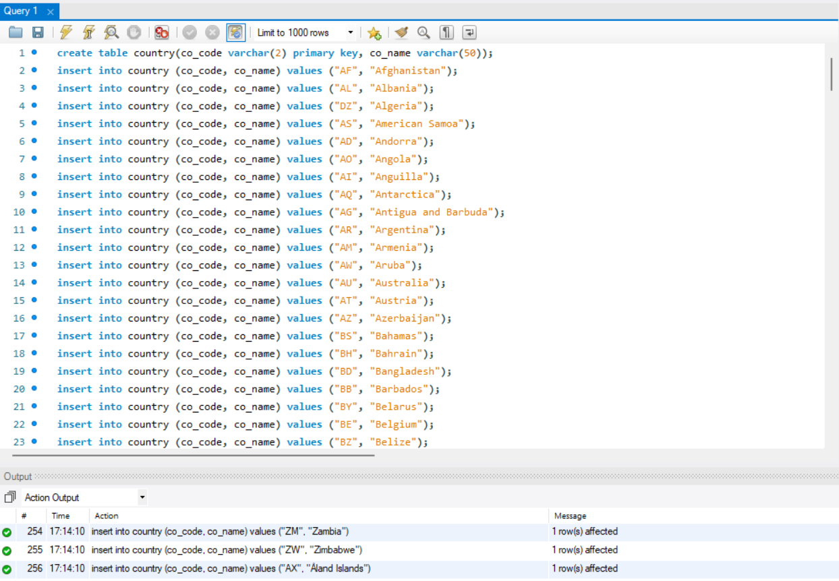

**2. Entity Class Country.java for mapping country table to SQL database:**

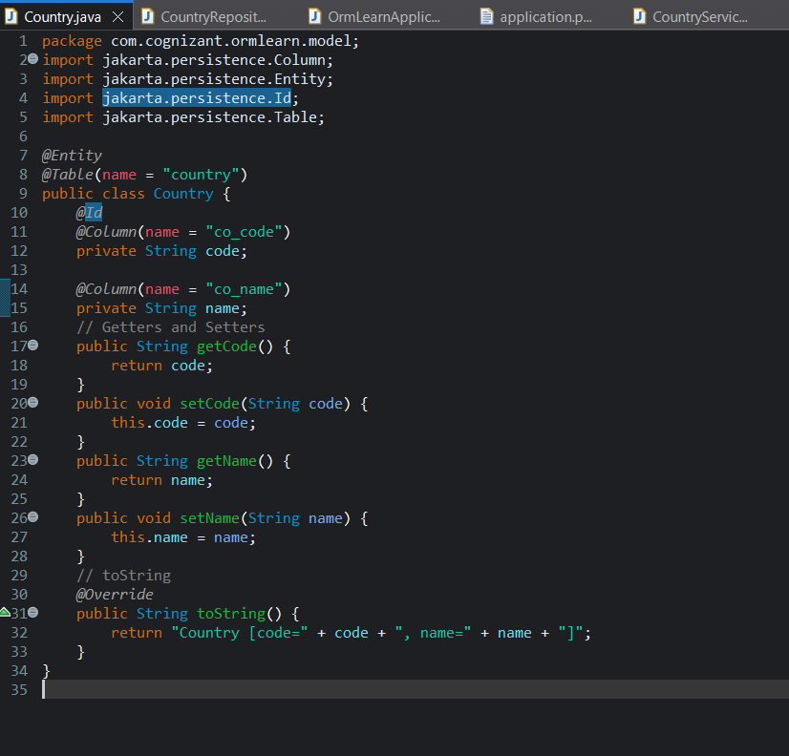

**3. Data Access Layer:**

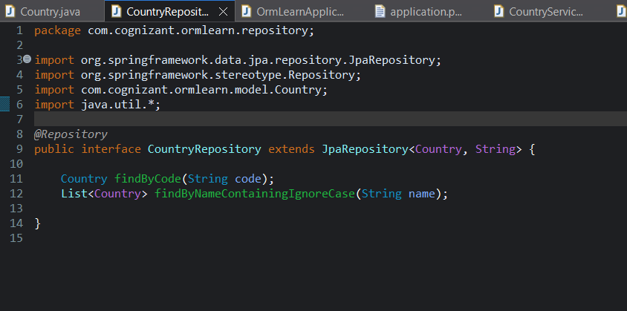

**4. Service.java for business logic methods**

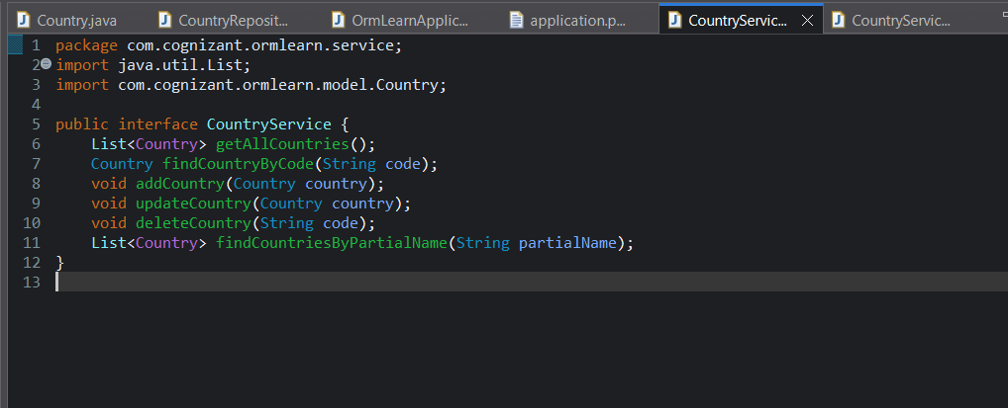

**Exception Class for HandsOn 7**

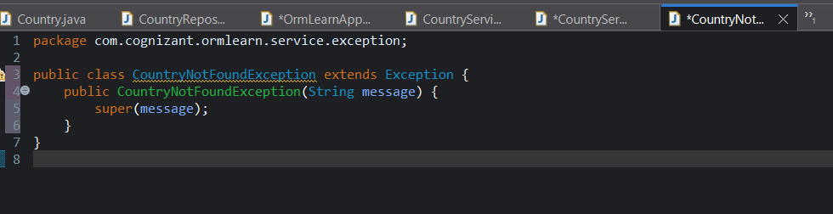

**5. CountryServiceImp implements CountryService and uses CountryRepository to interact with database**

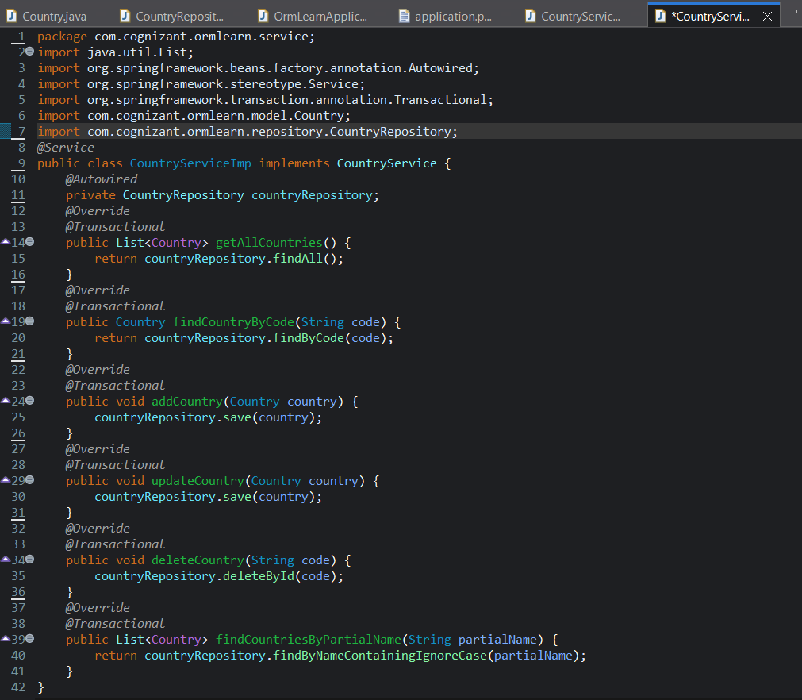

**6. Main Class to run the application**

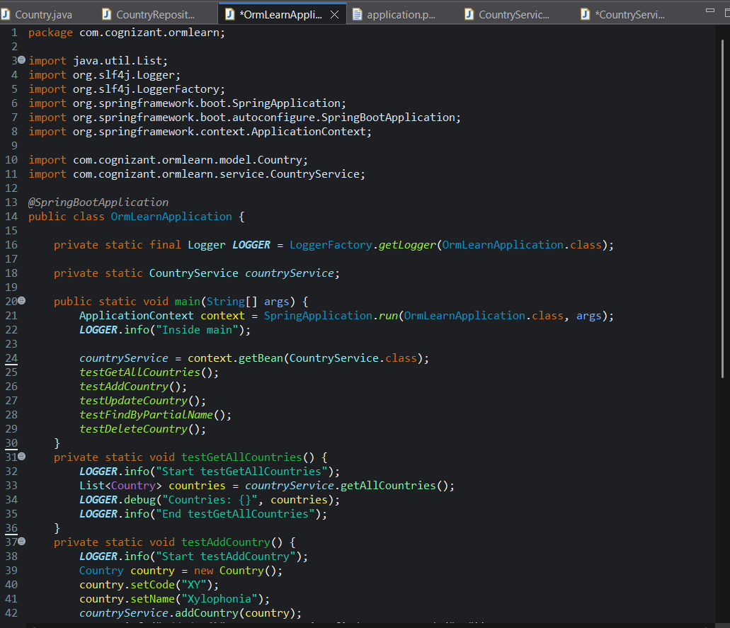

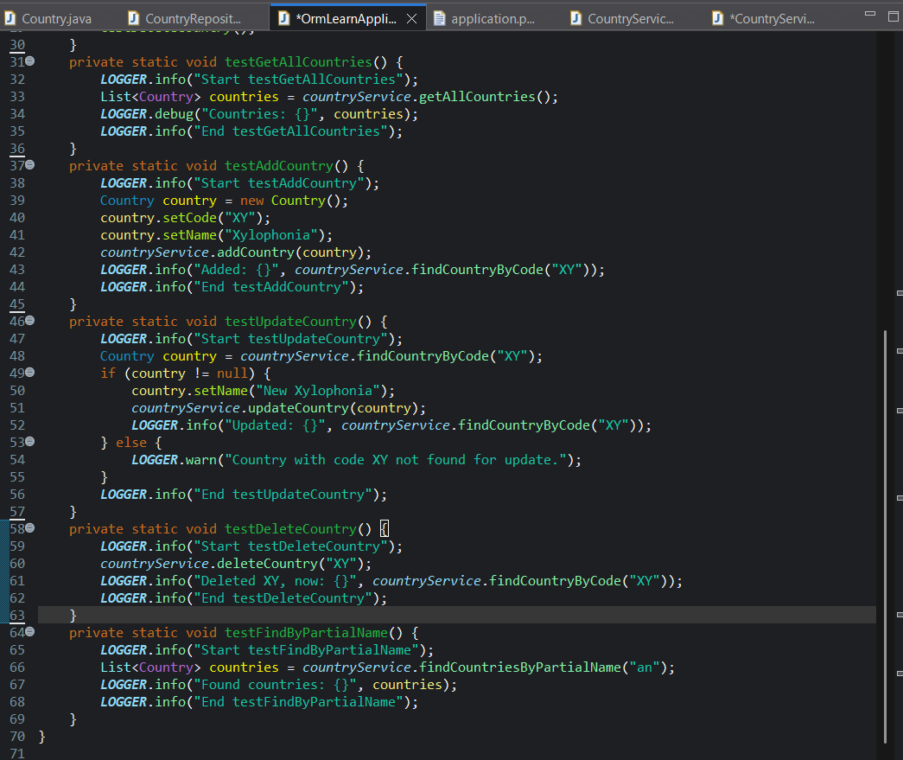

**7. Output/Results:**

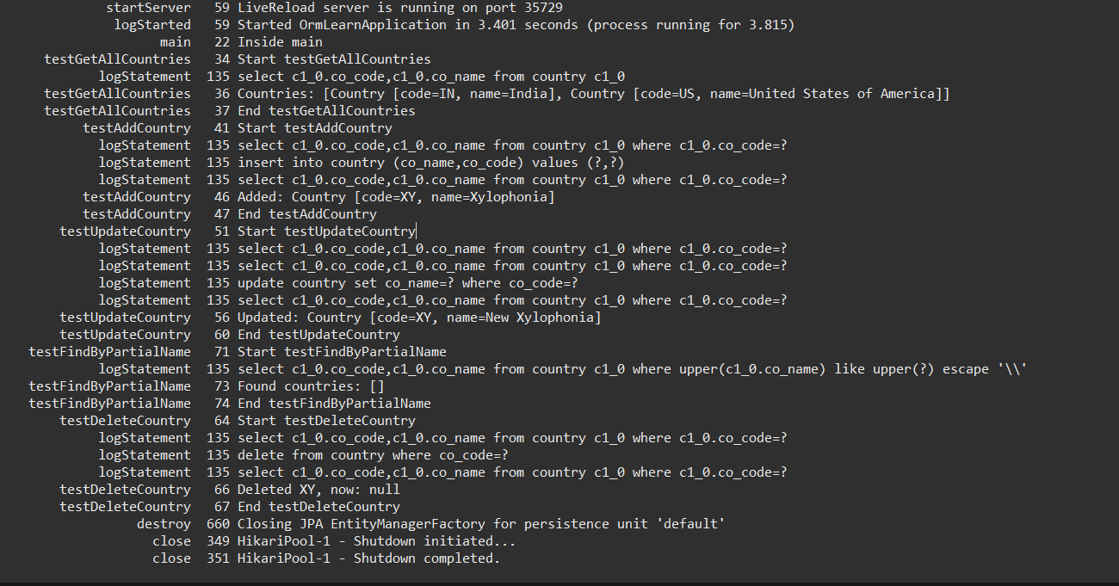

**2. spring-data-jpa-handson**

**Hands on 1**

**Write queries on country table using Query Methods**

**1. Main Class for calling the query methods:**

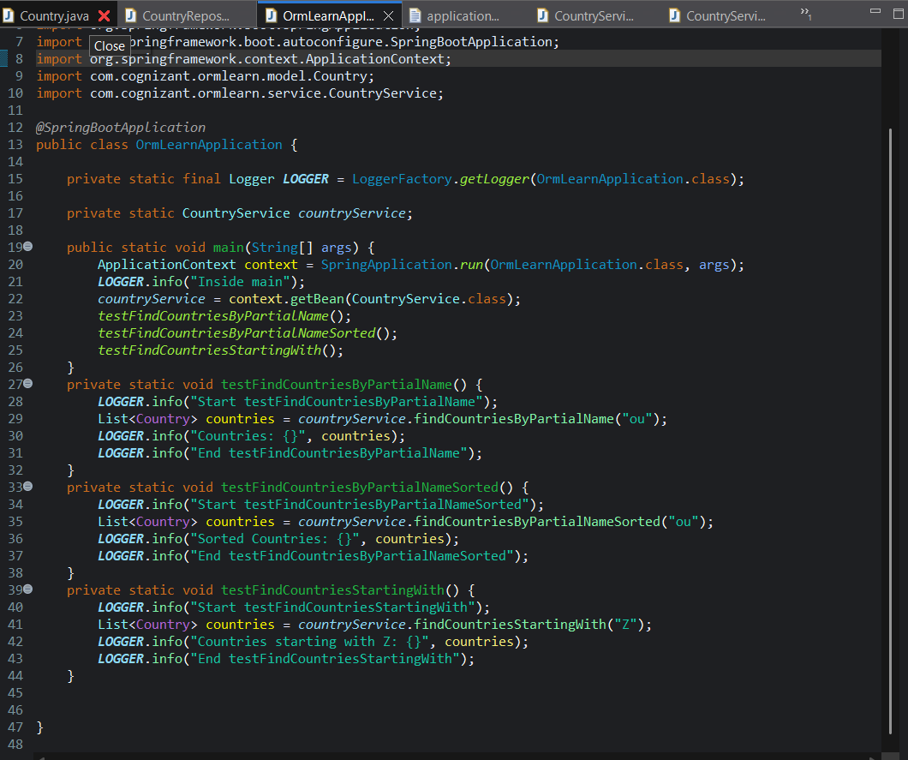

**2. Data Access Layer**

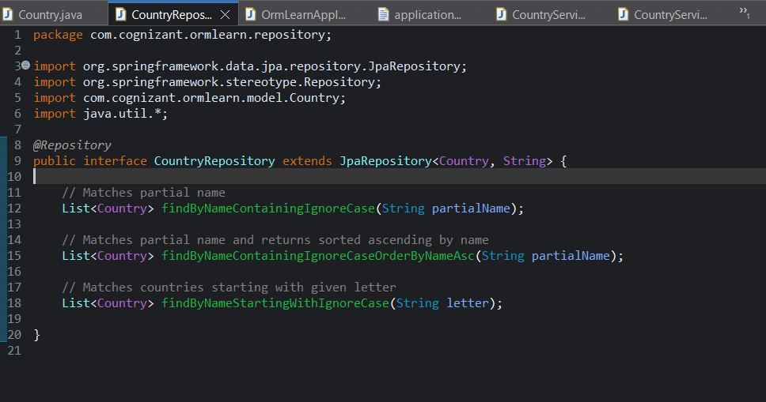

**3. Service class for business logic**

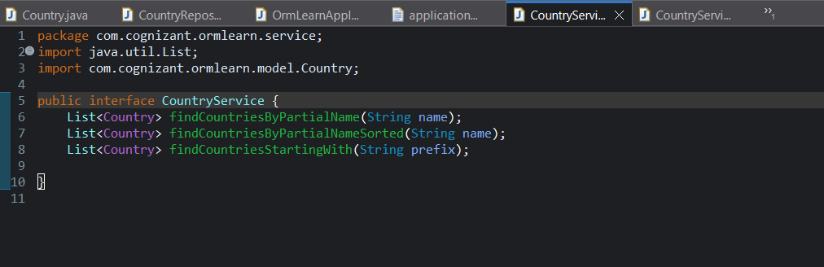

**4. Service implementation class**

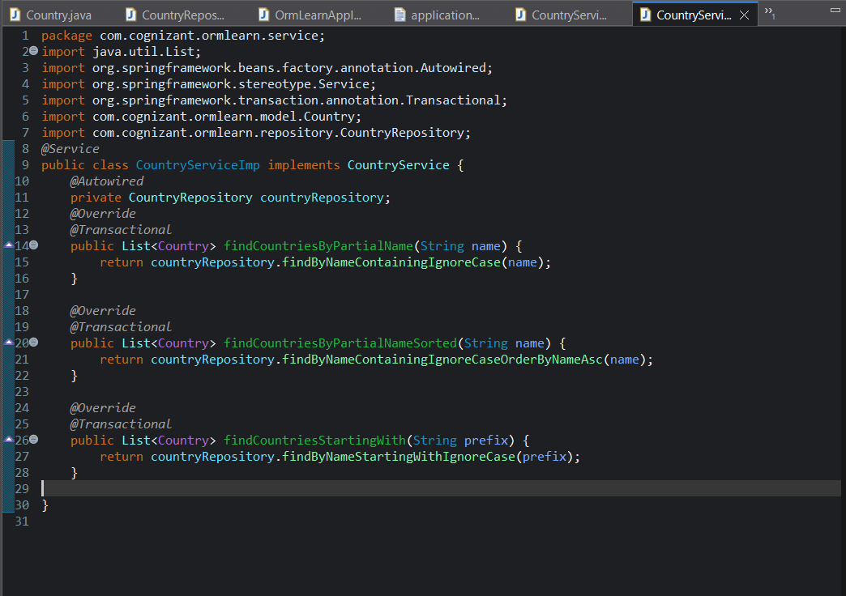

**5. Output:**

