**WEEK 4**

**SPRING REST USING SPRING BOOT**

**1. Spring Rest HandsOn.docx**

**Hands on 1**

**Create a Spring Web Project using Maven**

**1. Creating the Spring Web Project using Spring Initializr:**

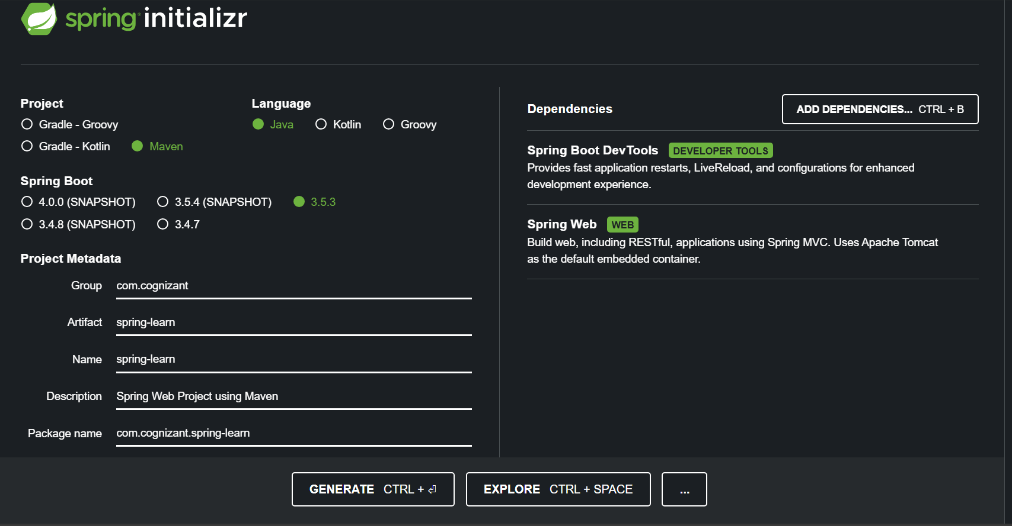

**2. Project Structure after Importing it into Eclipse:**

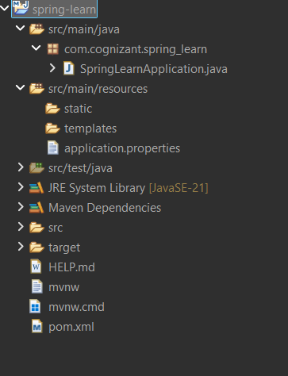

**3. Building the Project using Maven(proxy):**

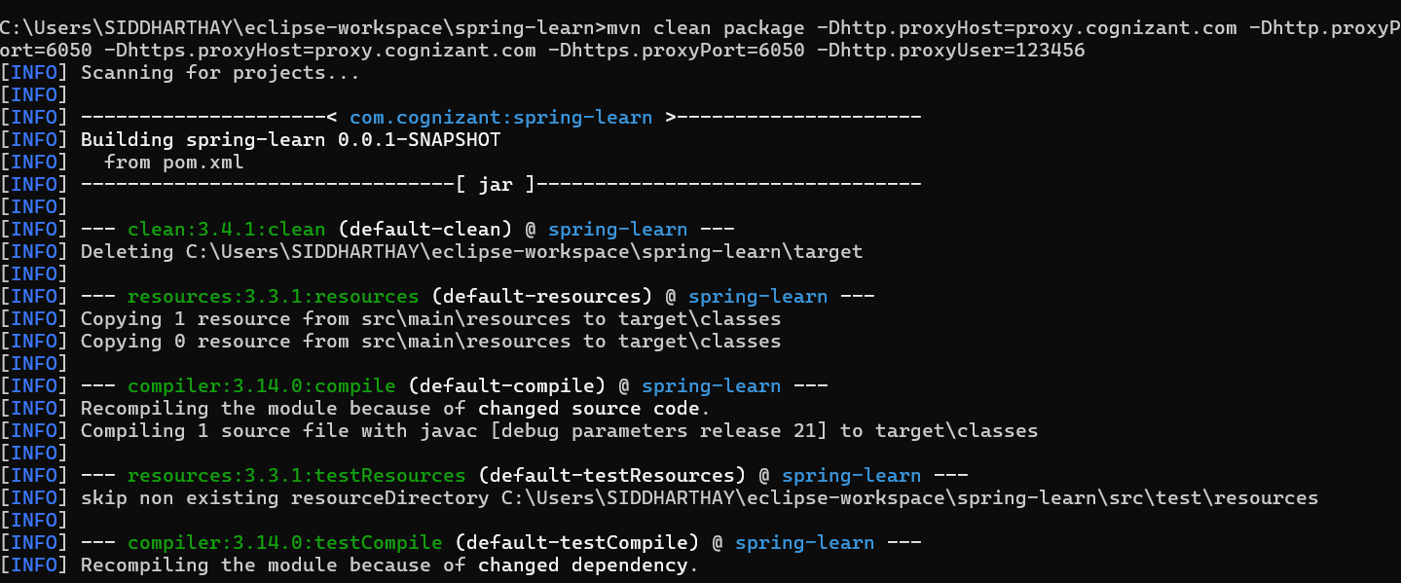

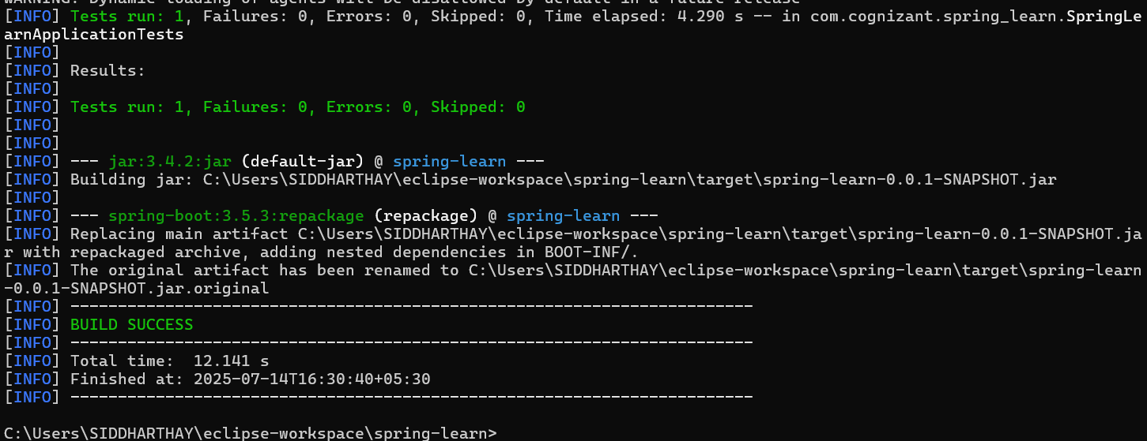

**4. Adding Logging in Main() method:**

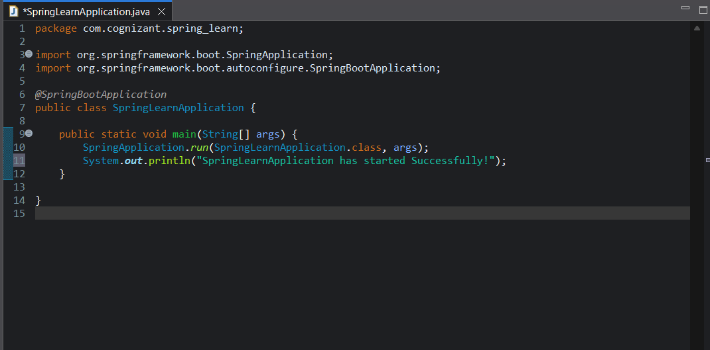

**5. Output:**

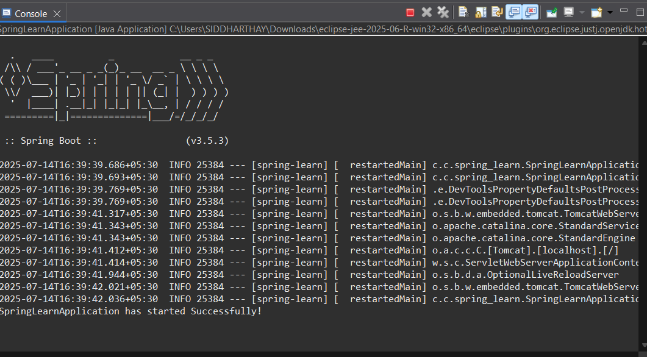

**Hands on 4**

**Spring Core – Load Country from Spring Configuration XML** 

**1. country.xml config file bean definition of country class:**

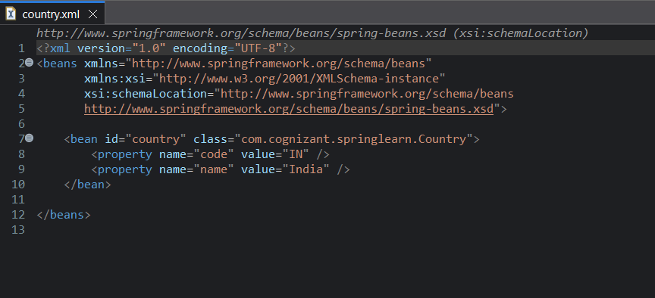

**2. Country.java shows all getter and setter methods**

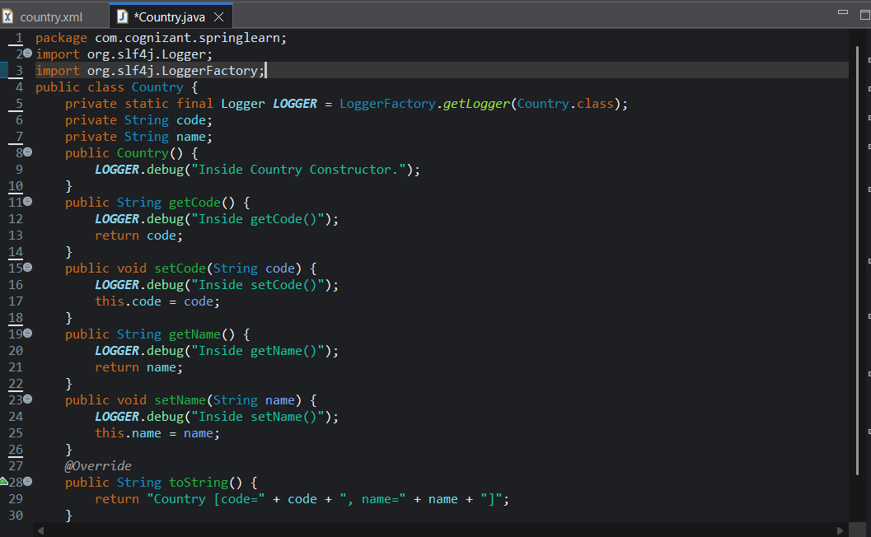

**3. Main class shows displayCountry() method and how bean is loaded:**

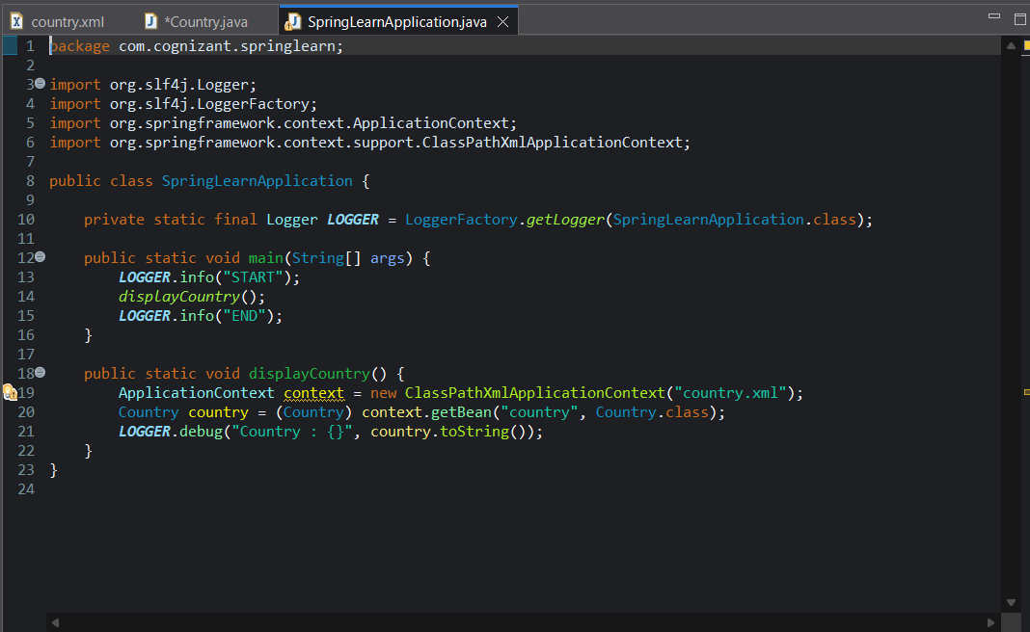

**4. Console showing debug logs:**

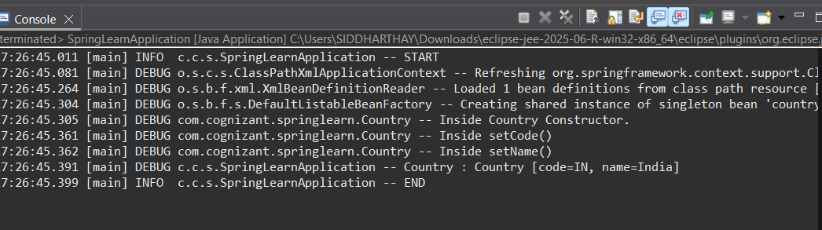

**2. Spring Rest HandsOn.docx**

**Hello World RESTful Web Service**   
  
Write a REST service in the spring learn application created earlier, that returns the text "Hello World!!" using Spring Web Framework. Refer details below:  
  
**Method:** GET  
**URL:** /hello  
**Controller:** com.cognizant.spring-learn.controller.HelloController  
**Method Signature:** public String sayHello()  
**Method Implementation:** return hard coded string "Hello World!!"  
**Sample Request**: http://localhost:8083/hello  
**Sample Response:** Hello World!!

**1. HelloController.java Rest Controller:**

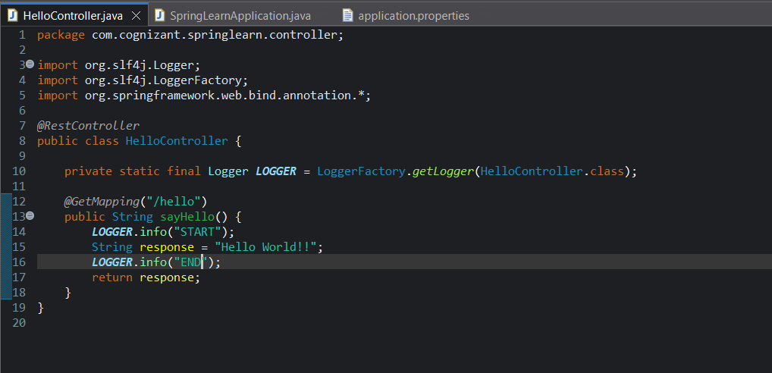

**2. Main() for running the application:**

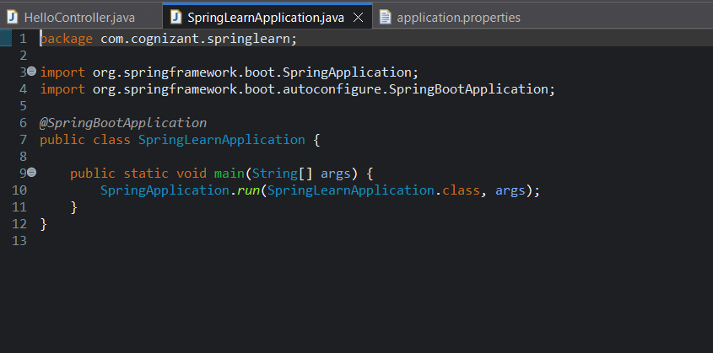

**3. Console:**

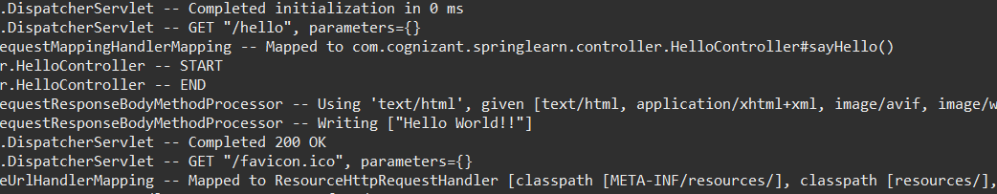

**4. Response through web browser:**

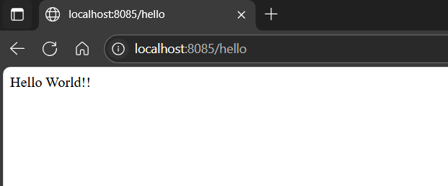

**5. Response through Postman:**

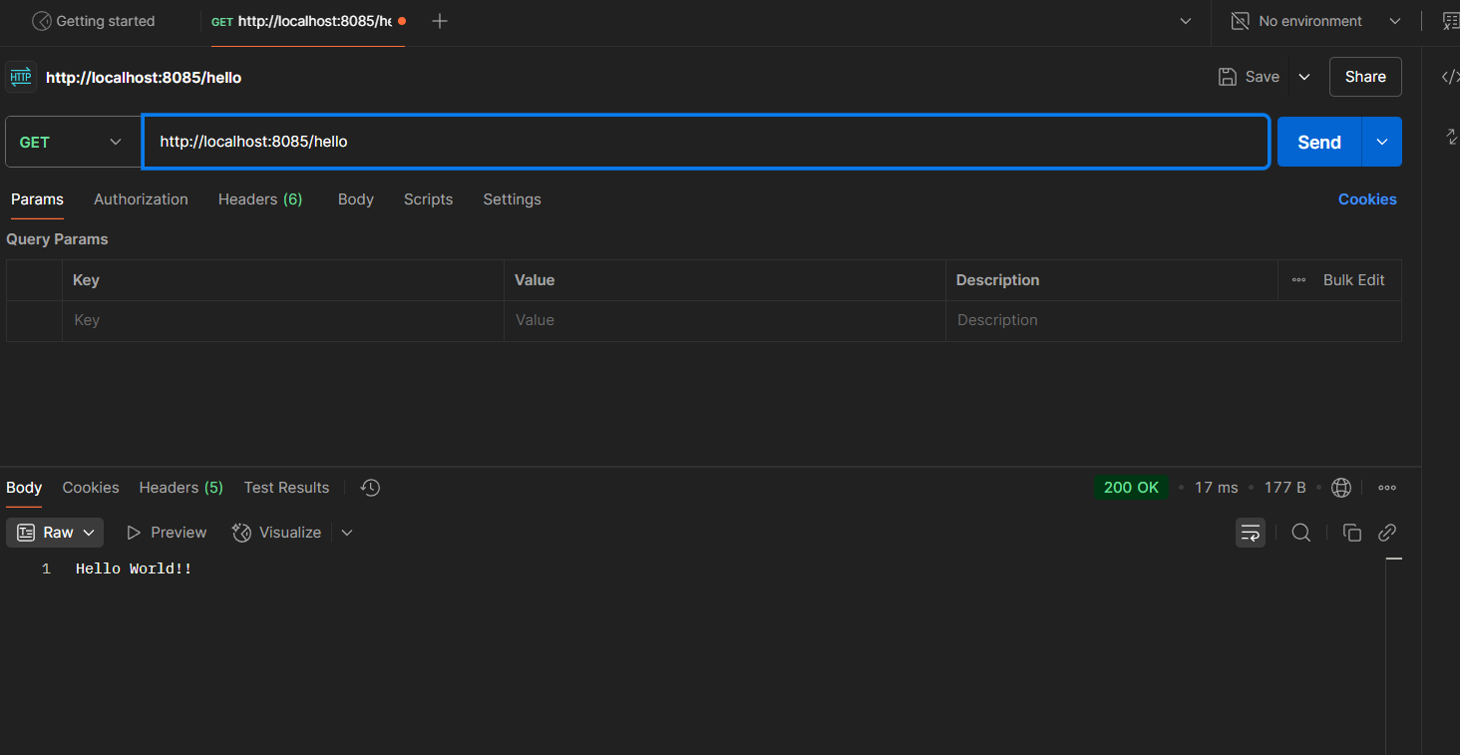

**REST - Country Web Service**   
  
Write a REST service that returns India country details in the earlier created spring learn application.

**1. CountryController.java handles REST API requests** 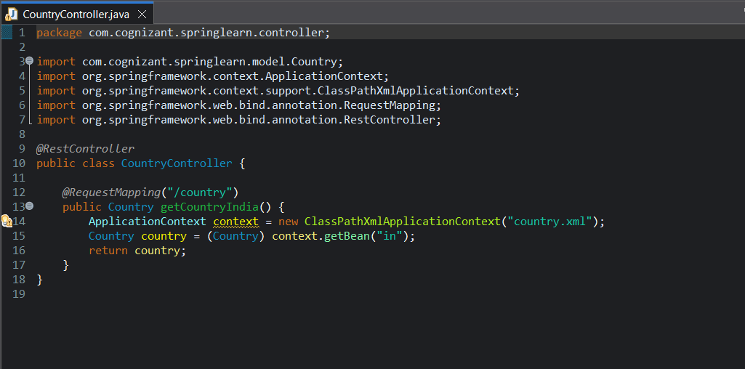

**2. country.xml configures country bean**

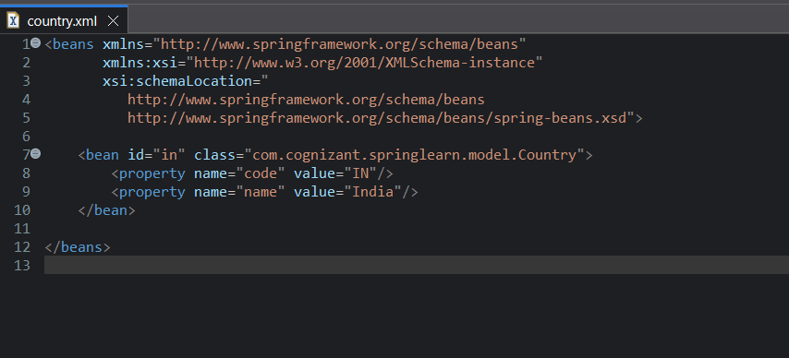

**3. Country.java model class contains getter and setter methods**

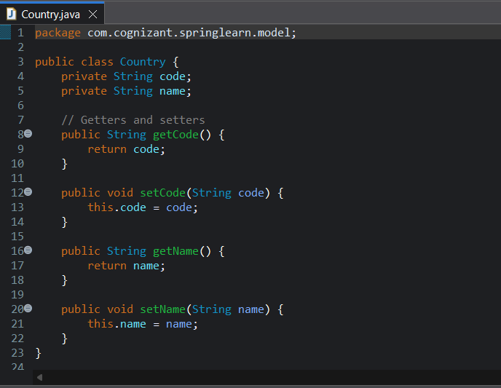

**4. Console output:**

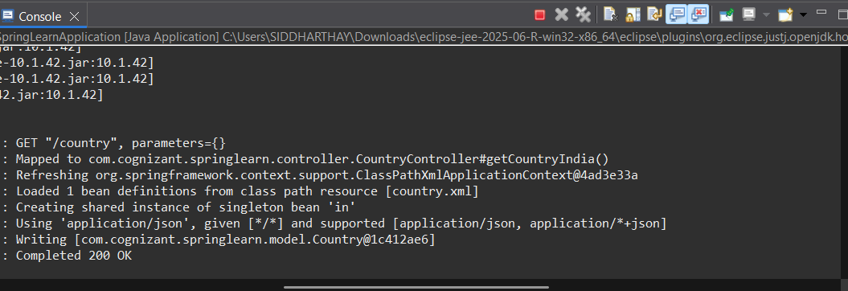

**5. Response through web browser:**

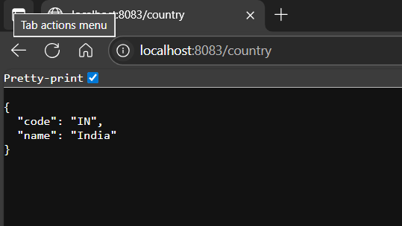

**6. Response through Postman:**

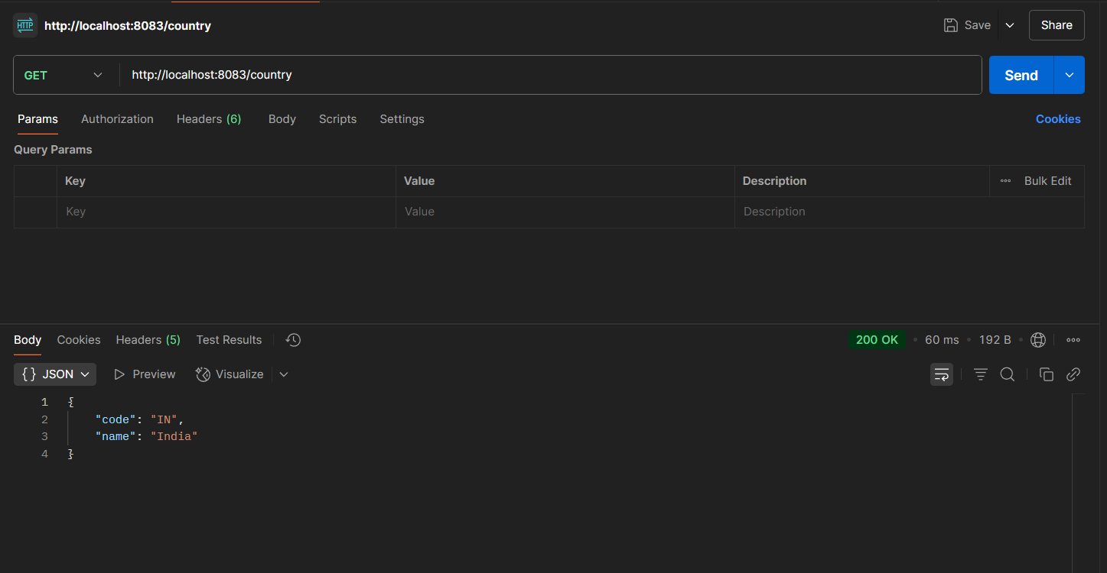

**REST - Get all countries**   
Write a REST service that returns all the countries.

**1. CountryController.java to handles REST API requests:**

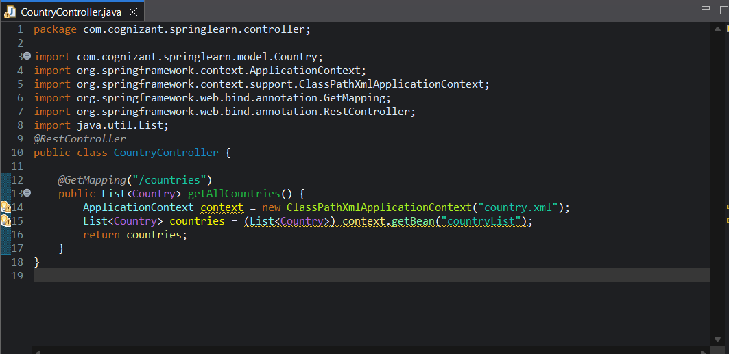

**2. country.xml configures all country bean**

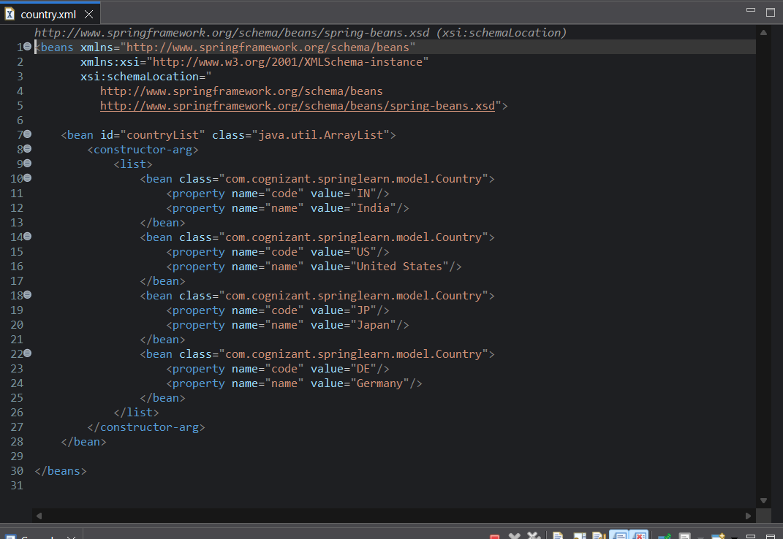

**3. Country.java model class contains getter and setter methods**

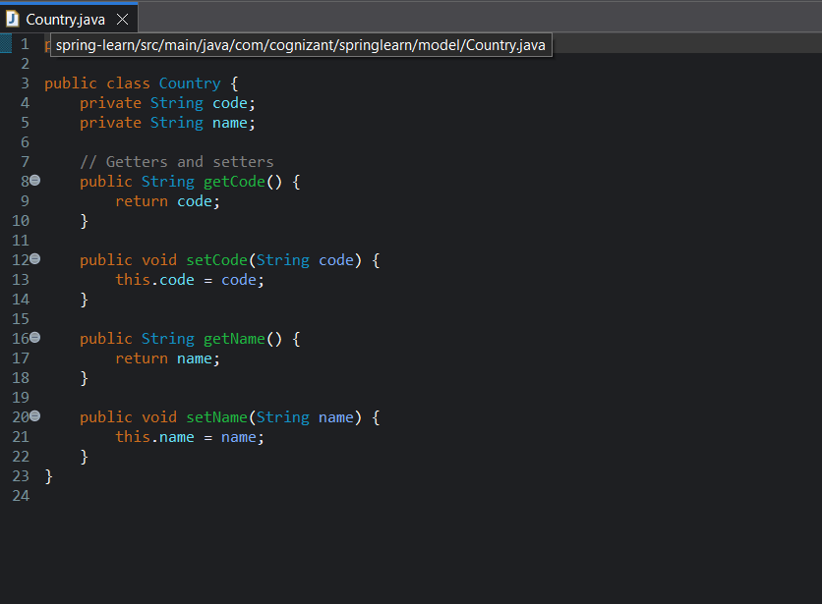

**4. Console Output:**

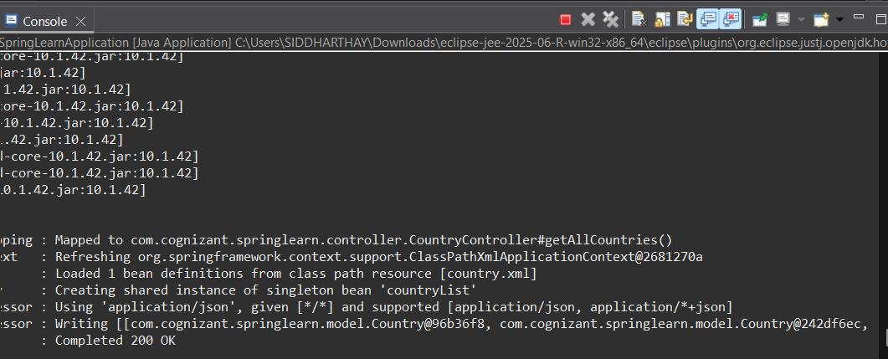

**5. Response through Web Browser:**

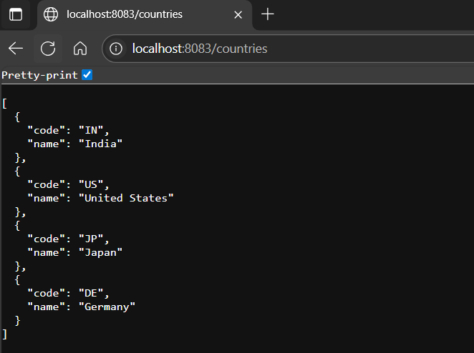

**5. Response through Postman:**

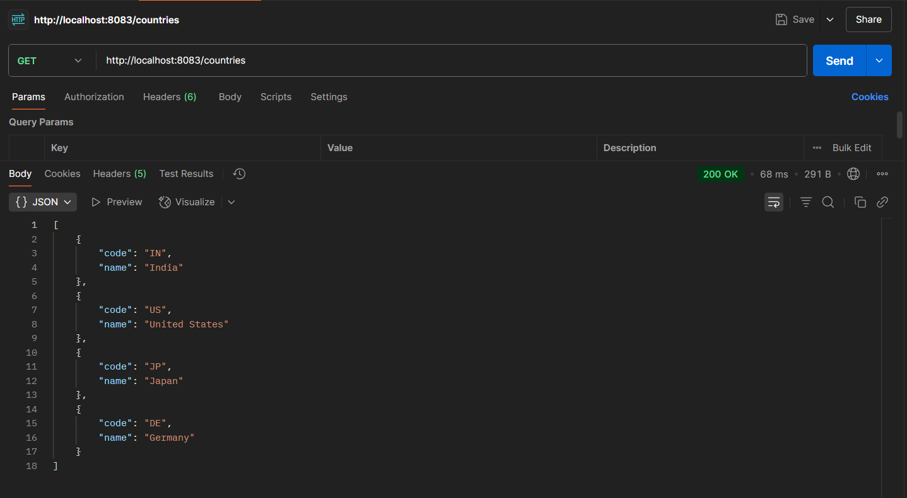

**REST - Get country based on country code**   
  
Write a REST service that returns a specific country based on country code. The country code should be case insensitive.

**1. CountryController.java to handles REST API requests:**

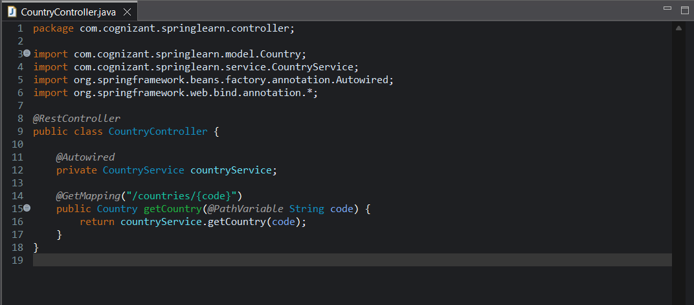

**2. country.xml configures all country bean**

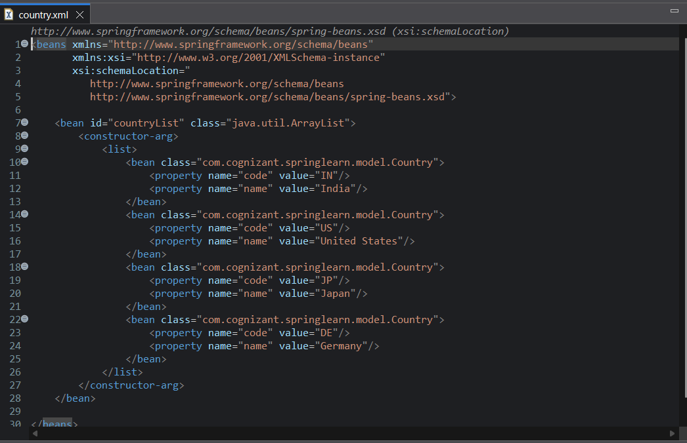

**3. CountryService.java contains the business logic:**

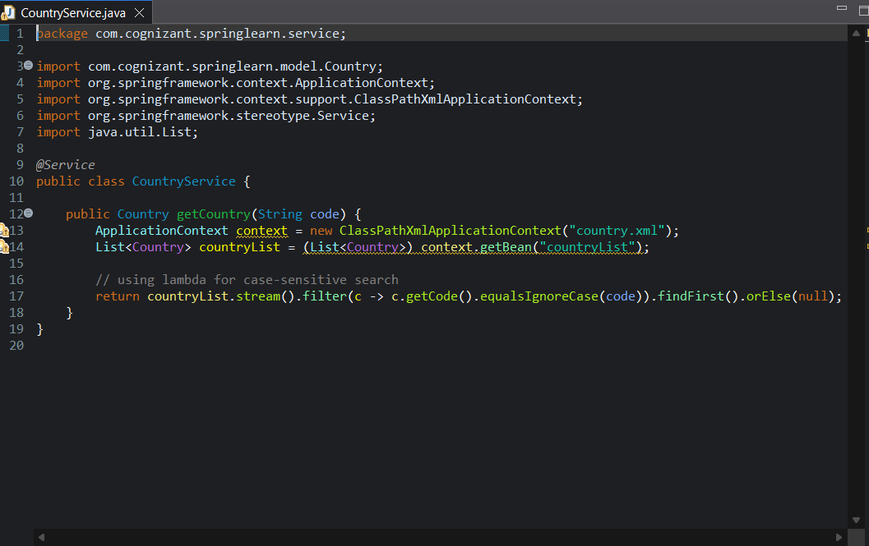

**4. Console Output:**

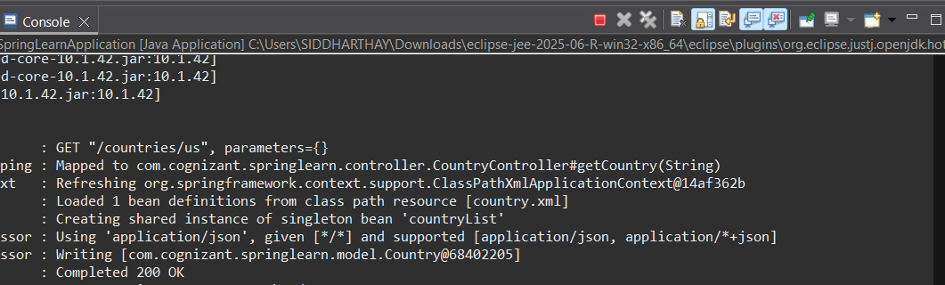

**5. Responses through Web Browser and Postman:**

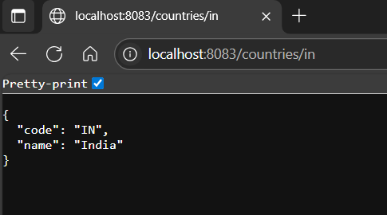

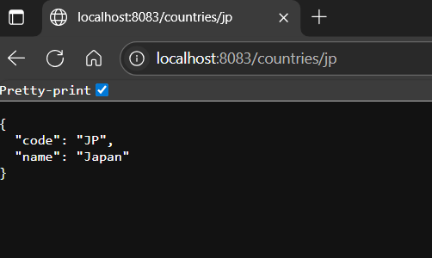

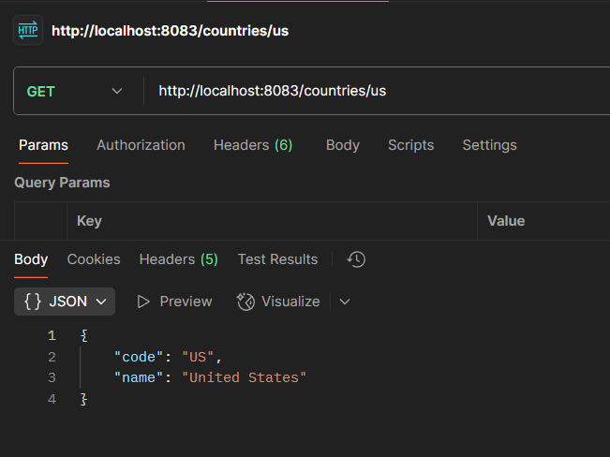

**3. Spring Rest HandsOn.docx**

**Create static employee list data using spring xml configuration**

**1. Project Structure**

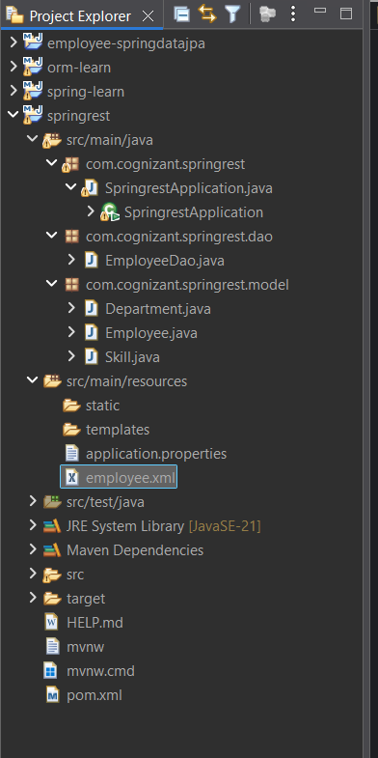

**2. employee.xml for bean configuration**

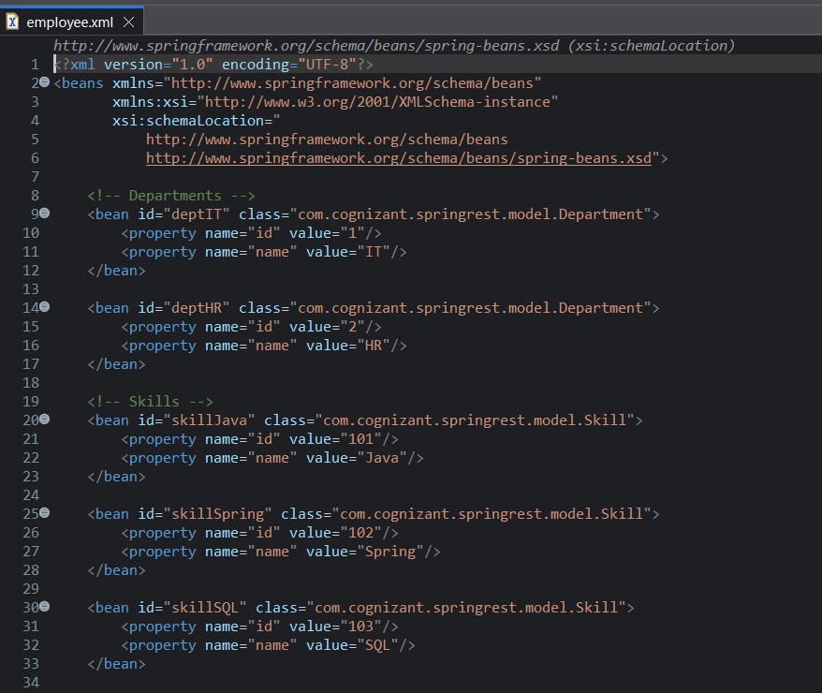

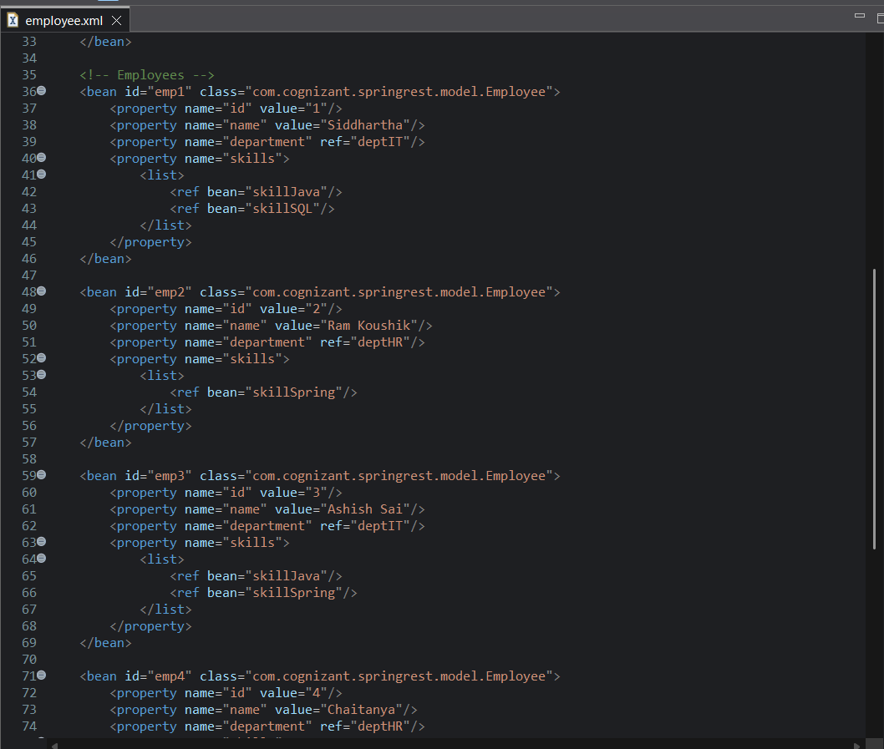

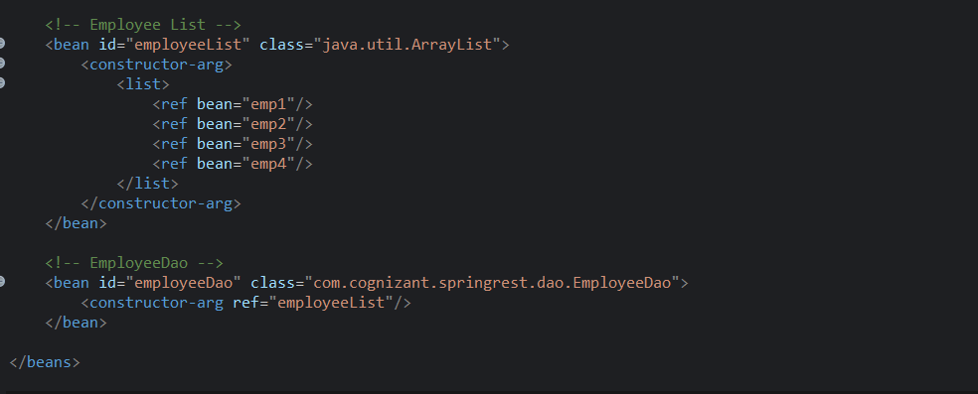

**3,4 Department,Skill.java contain getter and setter methods for departments and Skills**

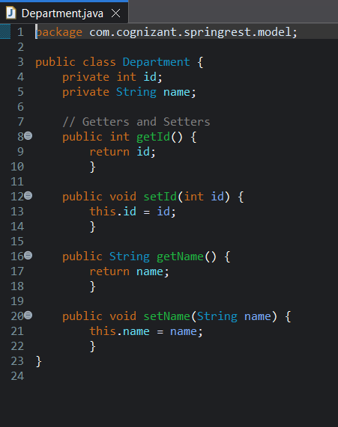 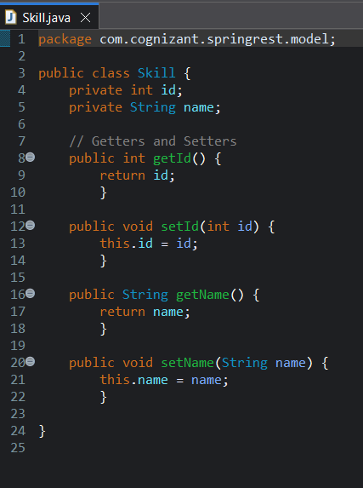

**5. Employee.java contains employee getter and setter methods**

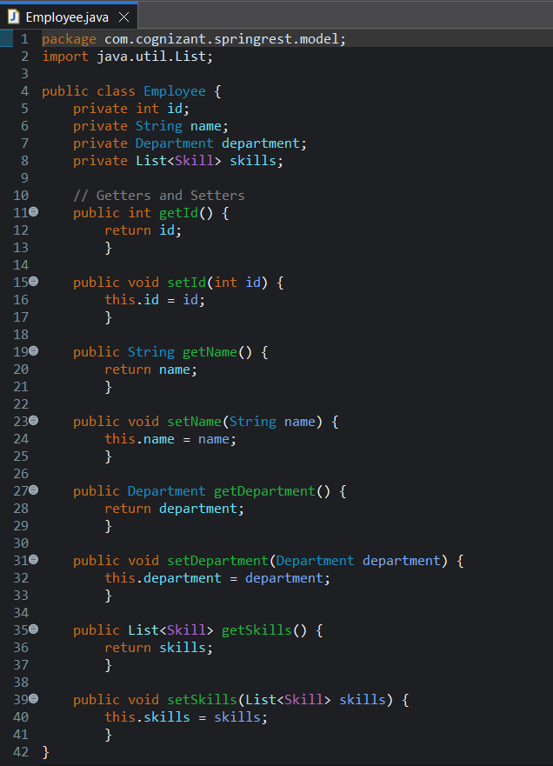

**6. EmployeeDao.java returns Employee list**

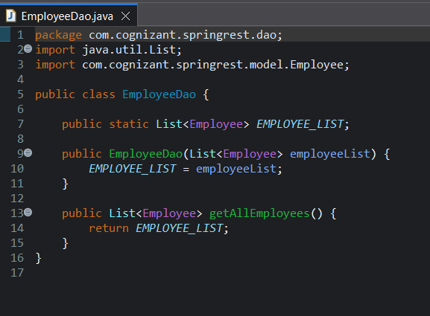

**7. SpringrestApplication Main Class prints the employee details**

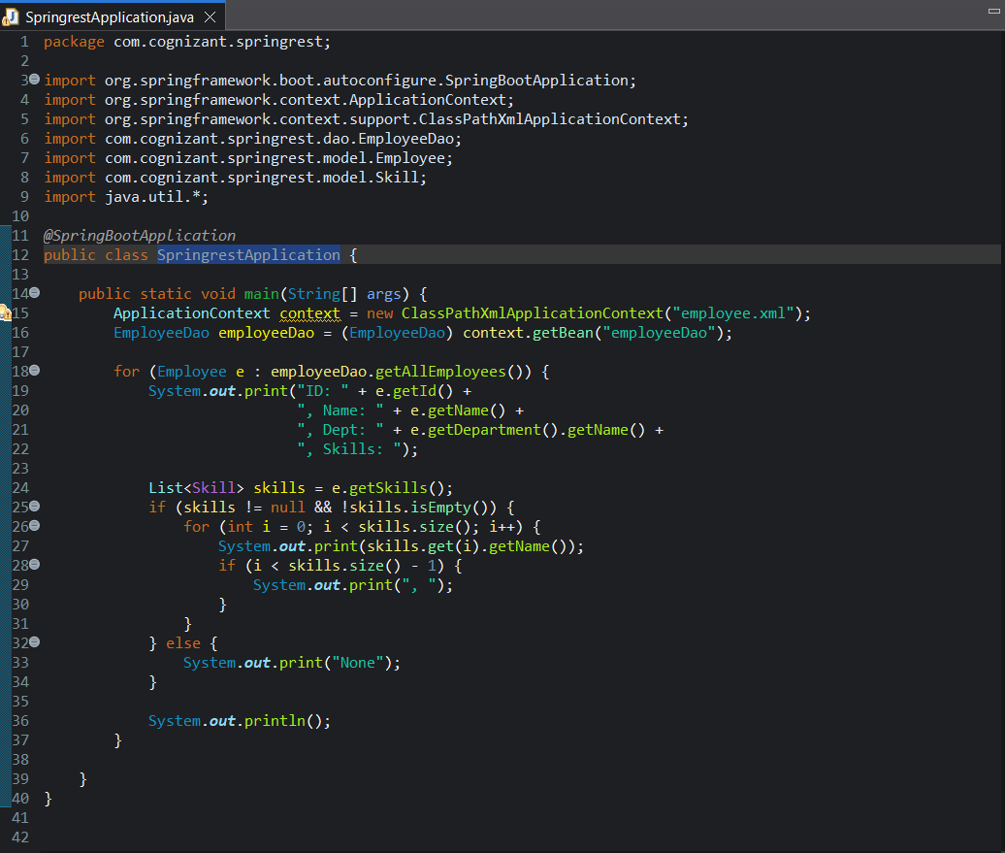

**8. Console Output:**

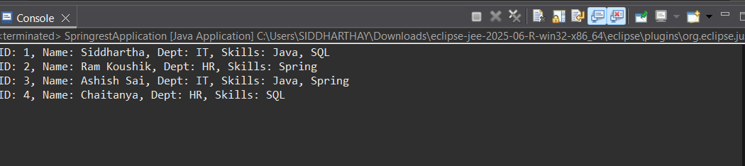

**Create REST service to gets all employees**

* In EmployeeService, incorporate the following:
  + Change the annotation for this class from @Component to @Service
  + Create method getAllEmployees() that invokes employeeDao.getAllEmployees() and return the employee list
  + Define @Transactional annotation for this method.

* In EmployeeController, incorporate the following:
  + Include a new get method with name getAllEmployees() that returns the employee list
  + Mark this method as GetMapping annotation with the URL as '/employees'
  + Within this method invoke employeeService.getAllEmployees() and return the same.

​

* Test ​the service using postman.

**1. EmployeeService.java:**

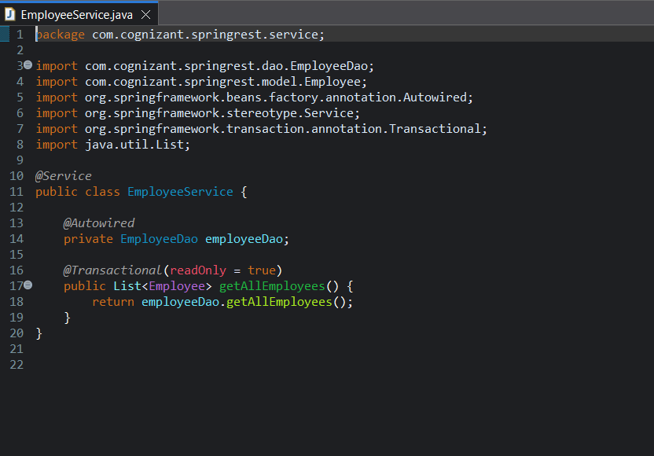

**2. EmployeeController.java:**

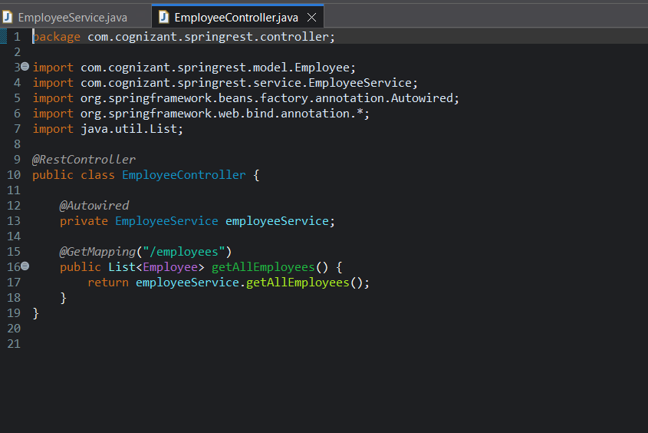

**3. EmployeeDao.java:**

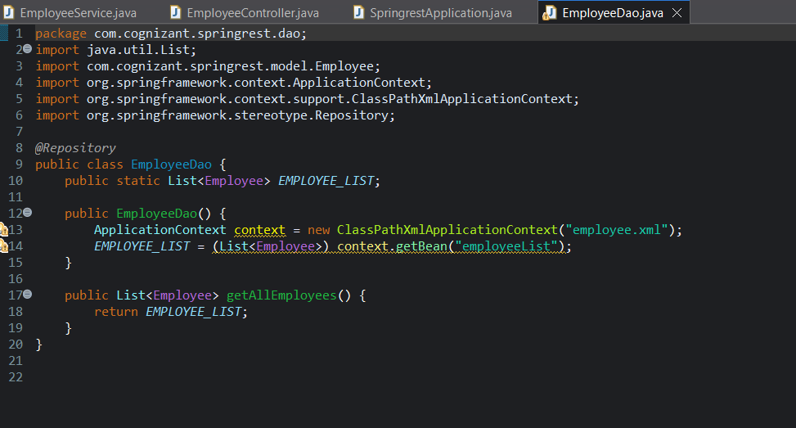

**4. Main Class SpringrestApplication.java:**

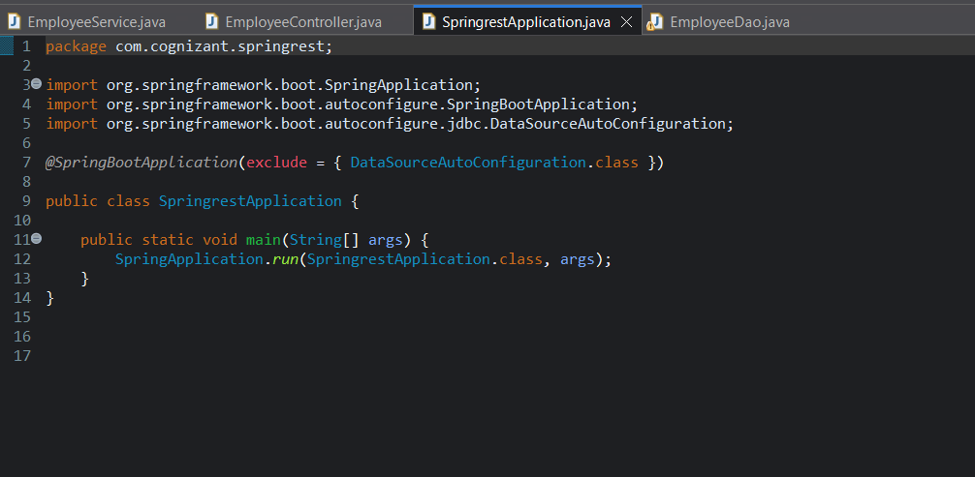

**5. Testing in Postman:**

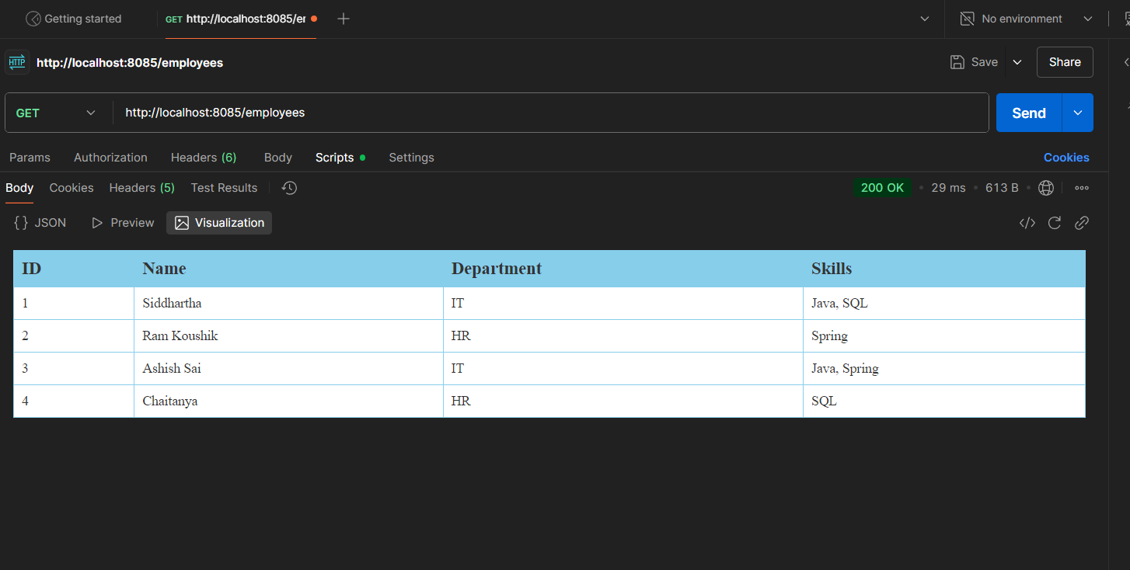

**5. JWT – HandsOn**

**Create authentication service that returns JWT**

* **Create authentication controller and configure it in SecurityConfig**

**1. AuthenticationController.java:**

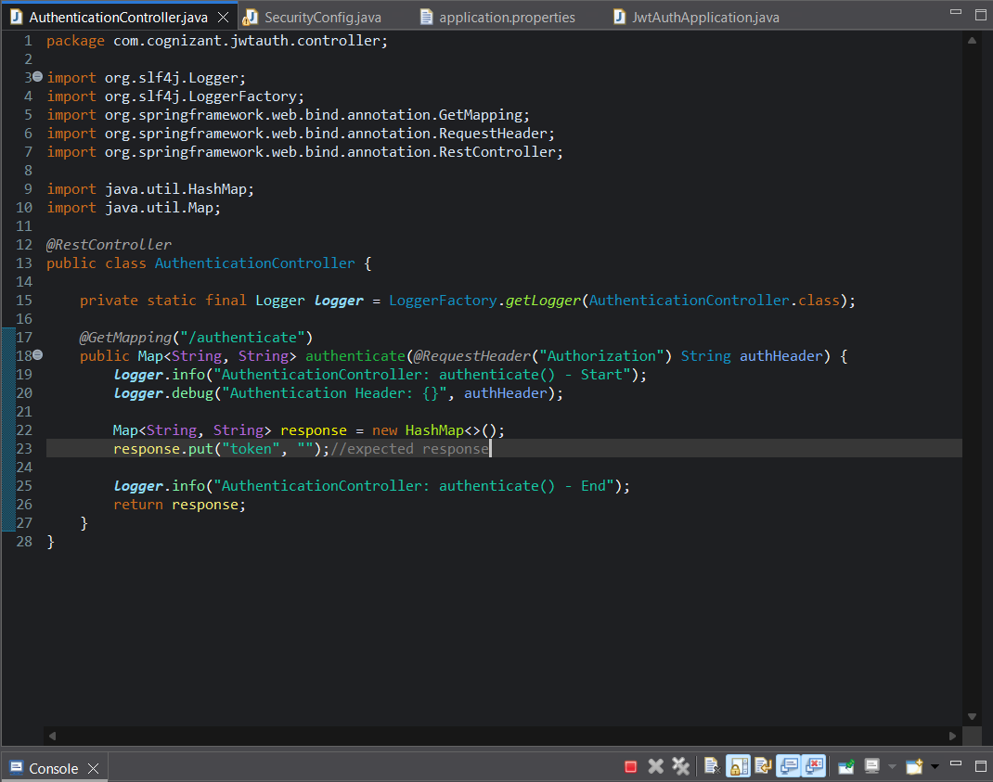

**2. SecurityConfig.java:**

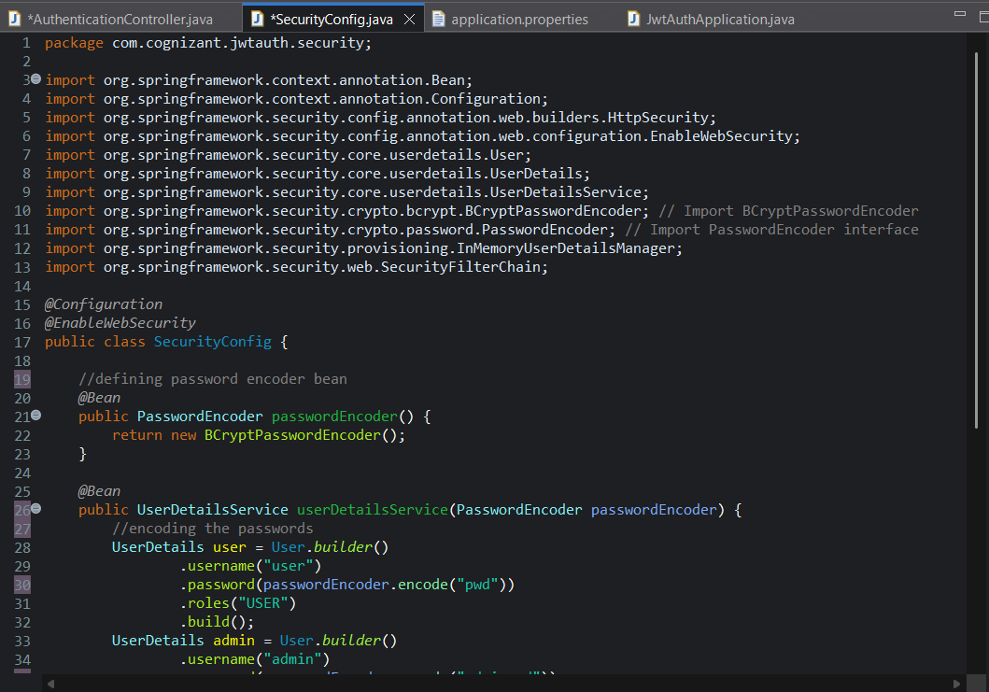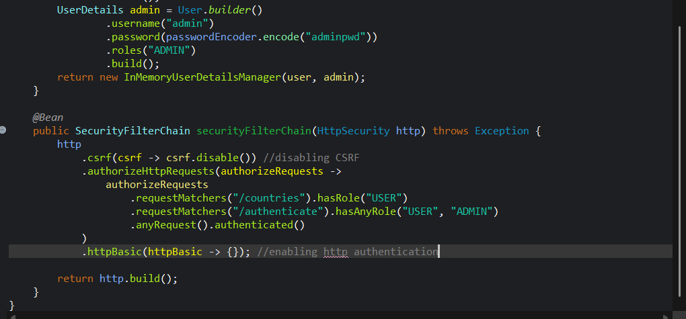

**3. Main SpringBootApplication Class:**

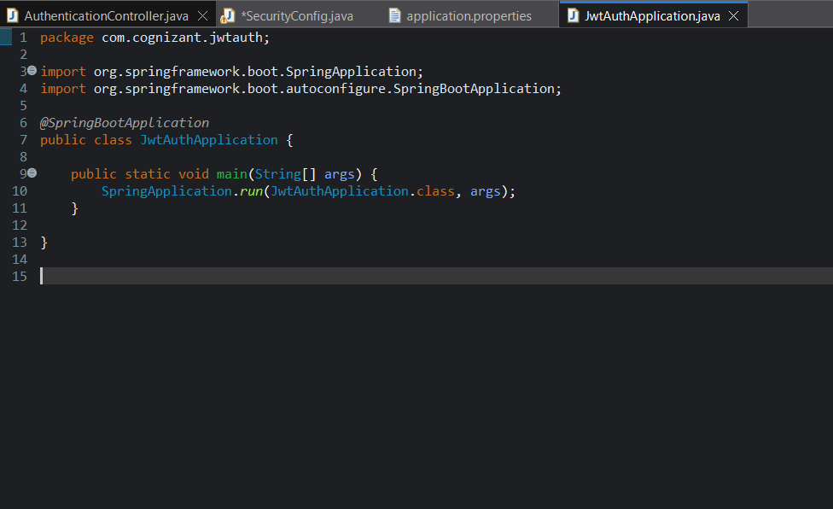

**4. Expected Response:**

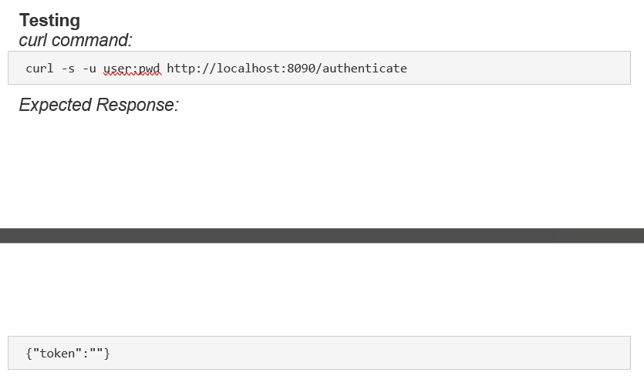

**5. Actual Response:**

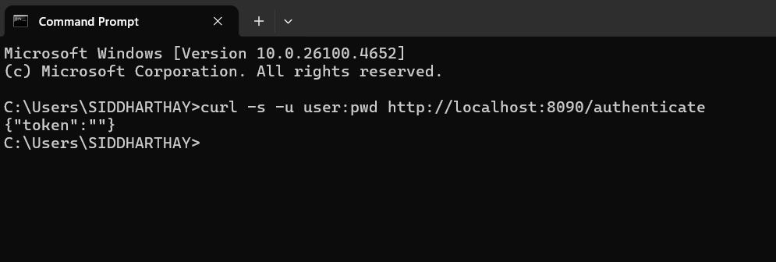

**6. Console Log Verification:**

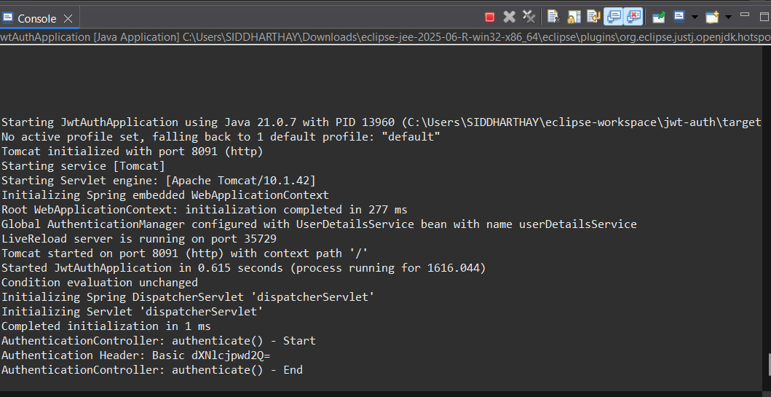

* **Read Authorization header and decode the username and password**

**1. AuthenticationController.java:**  
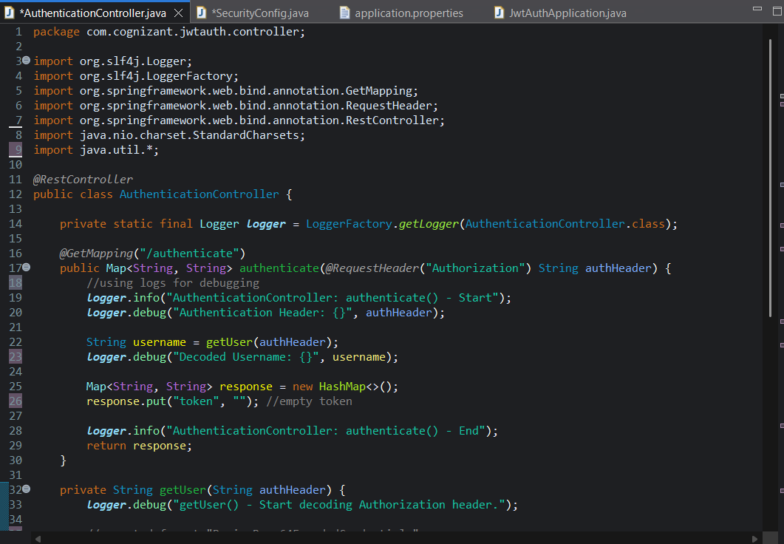 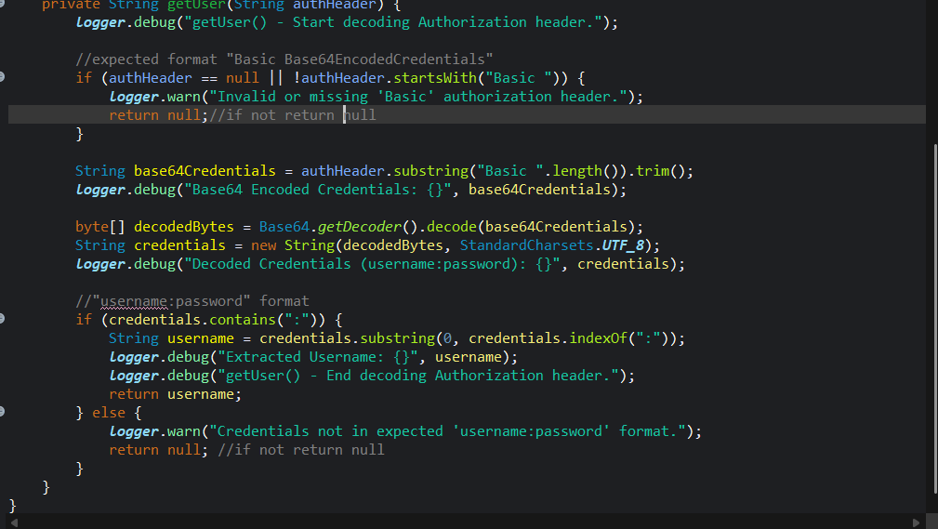

**2. SecurityConfig.java:**

 

**3. Response**

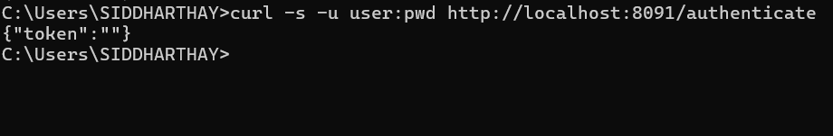

**4. Console Log Verification:**

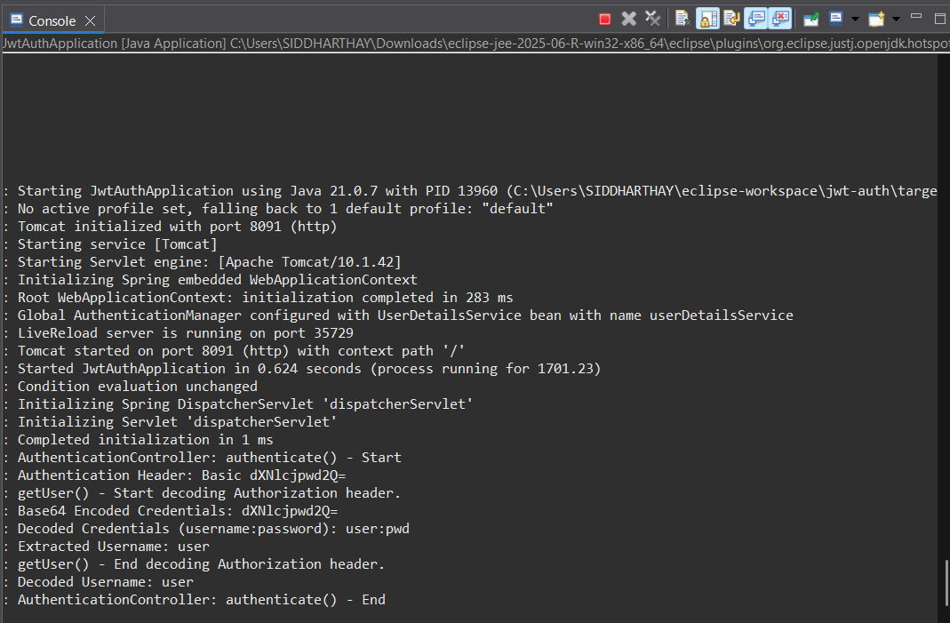

* **Generate token based on the user**

**1. adding the dependencies:**

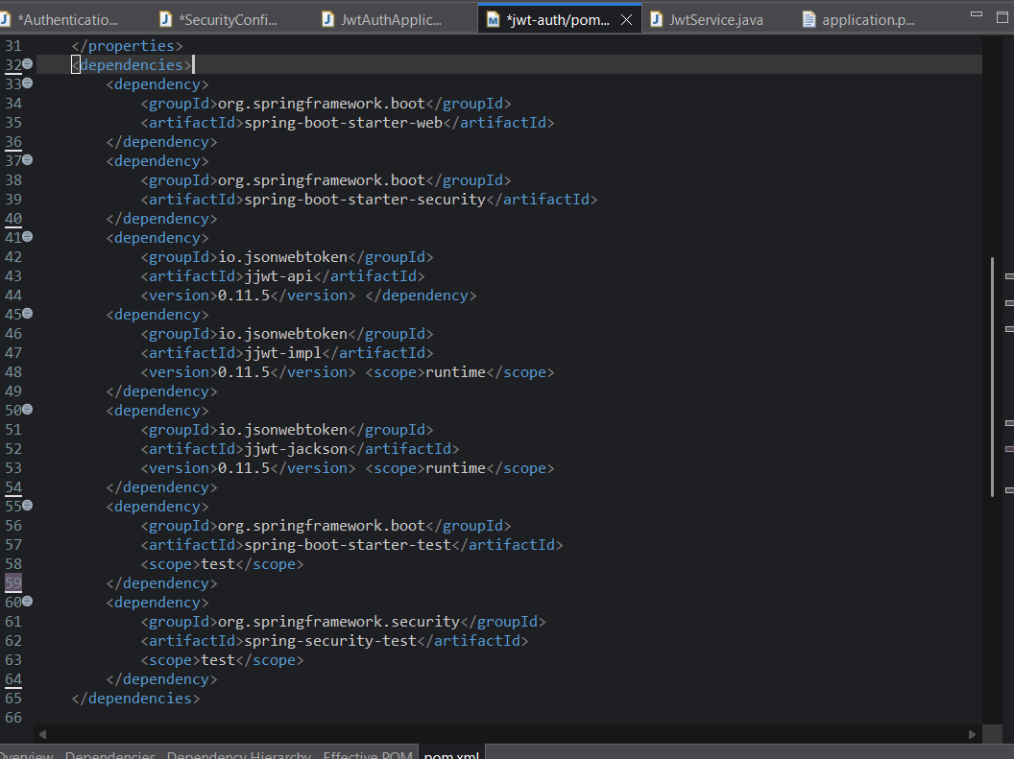

**2. AuthenticationController.java:**

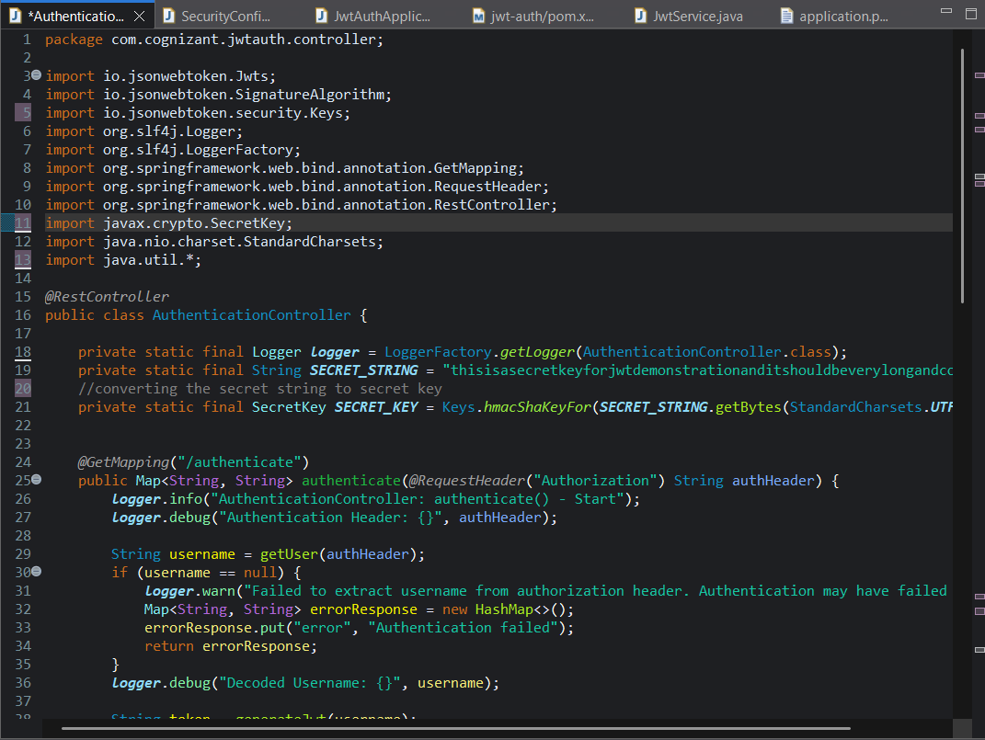

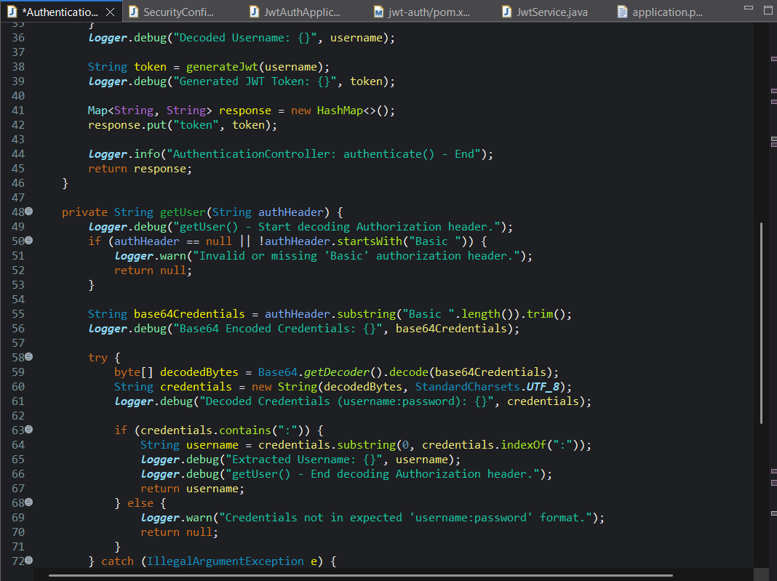

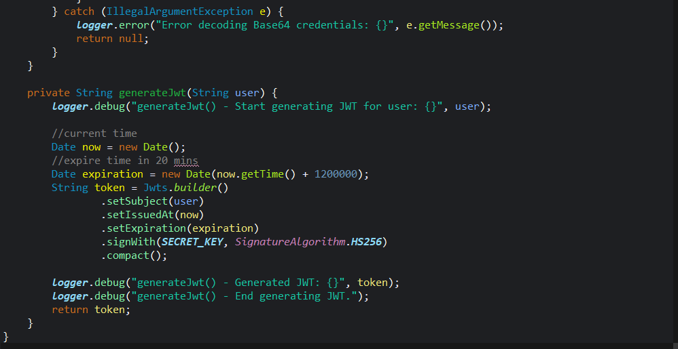

**3. curl command response:**

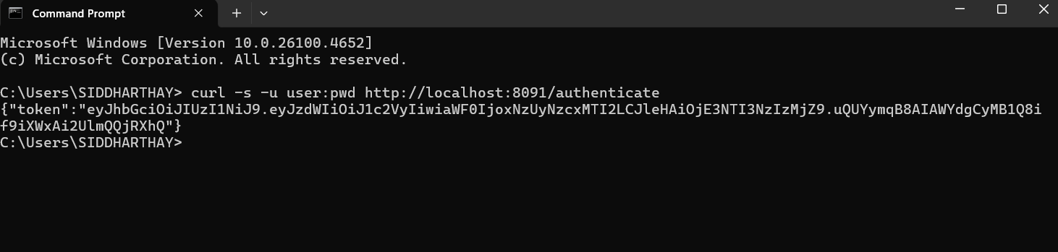

**4. Console Log verification:**

