**Week 5**

**Microservices with Spring Boot 3 and Spring Cloud**

**2. Microservices with API gateway**

**1. Creating Microservices for account and loan HandsOn**

**(i)Account Microservice**

**Generating project using spring initializr:**

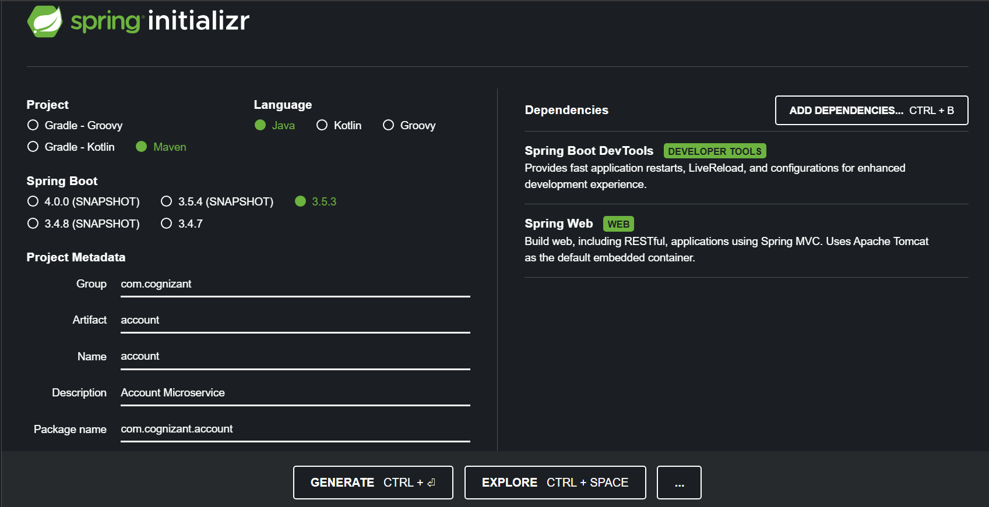

**mvn clean package install:**

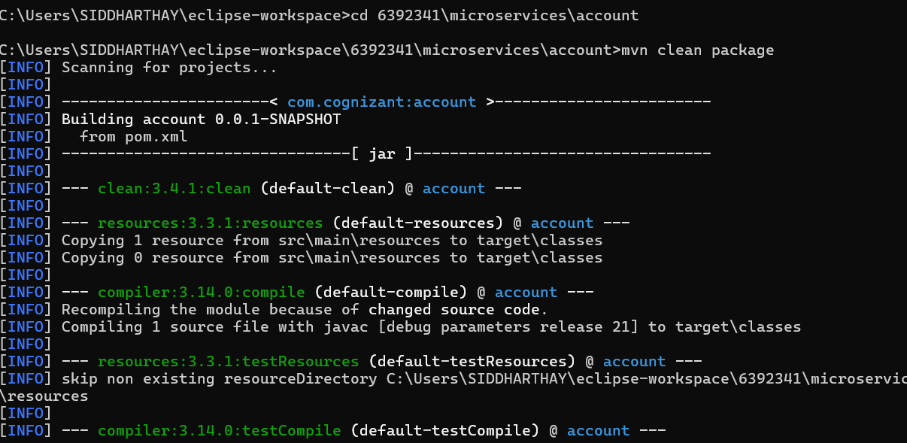

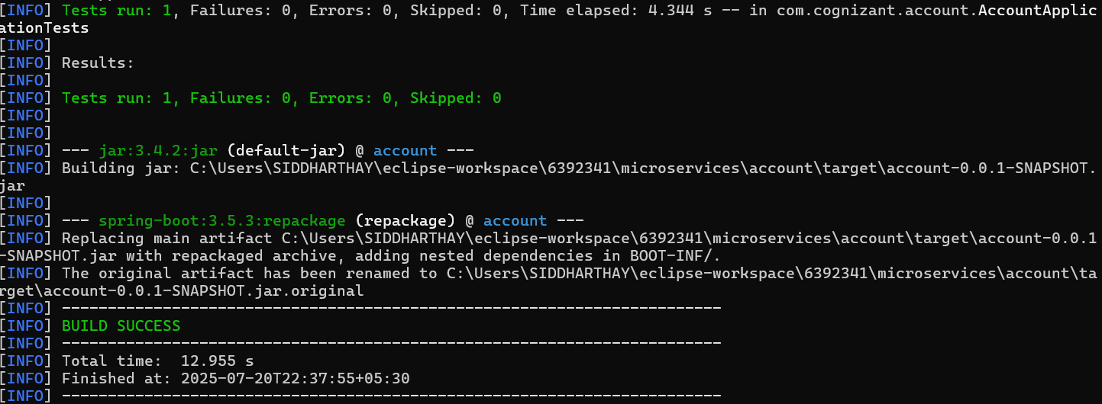

**Main AccountApplication.java class:**

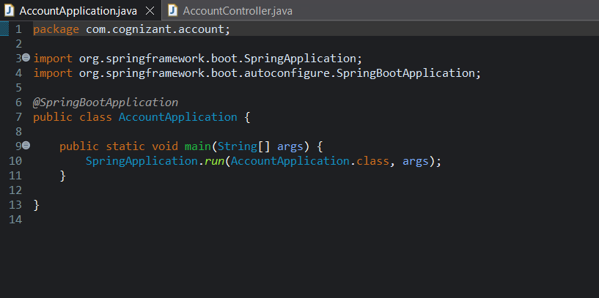

**AccountController.java class:**

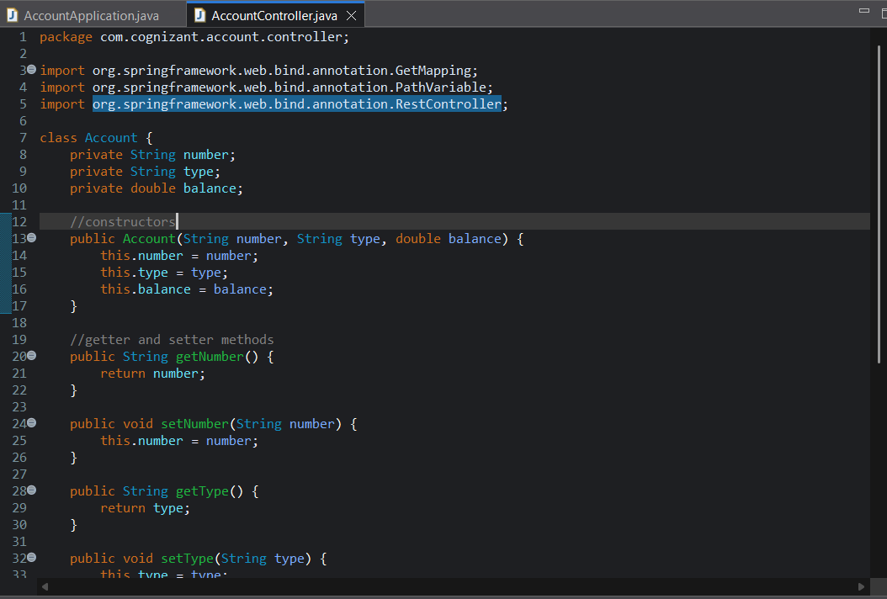

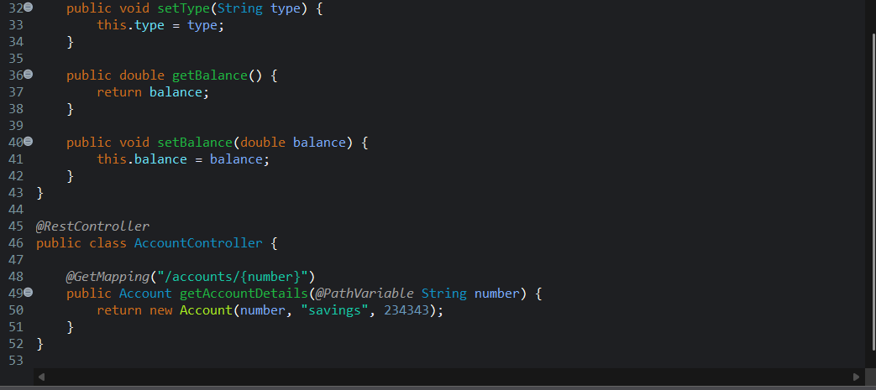

**Console output:**

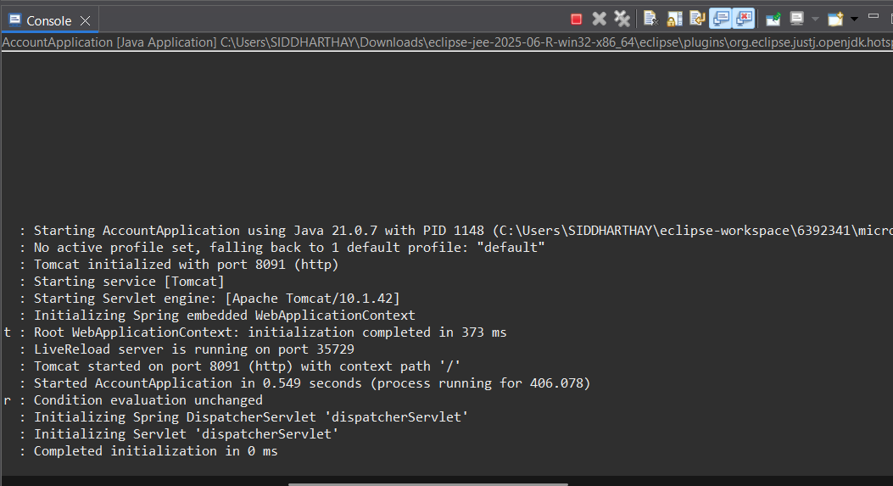

**Testing in Web Browser:**

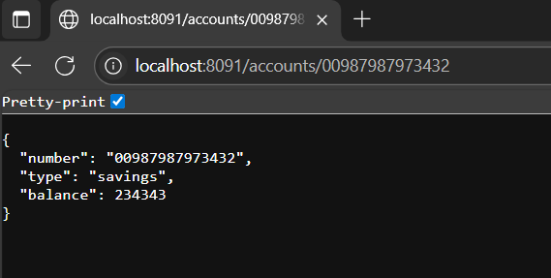

**(ii) Loan Microservice**

**Generating project using spring intializr:**

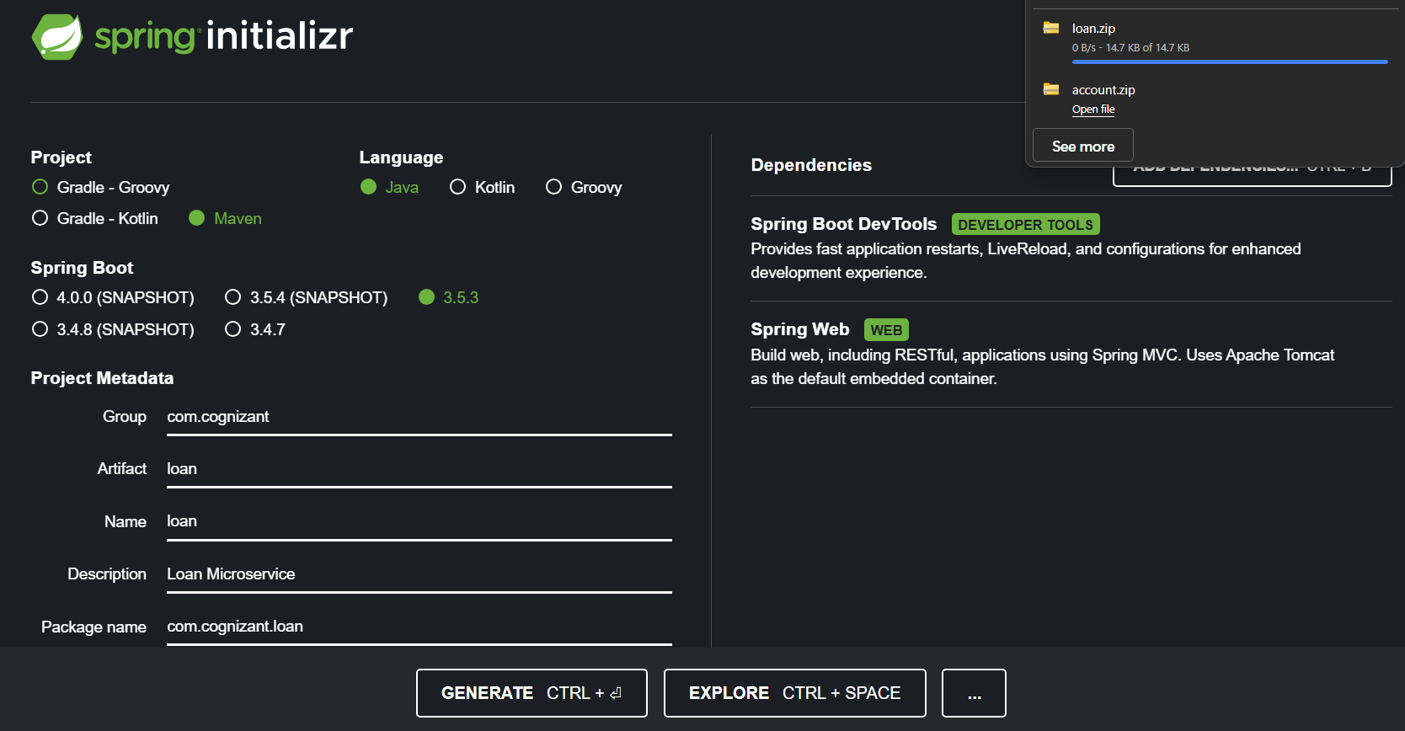

**Main LoanApplication.java class:**

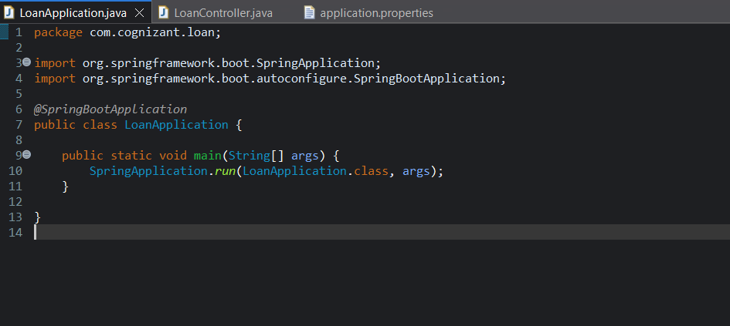

**LoanController.java class:**

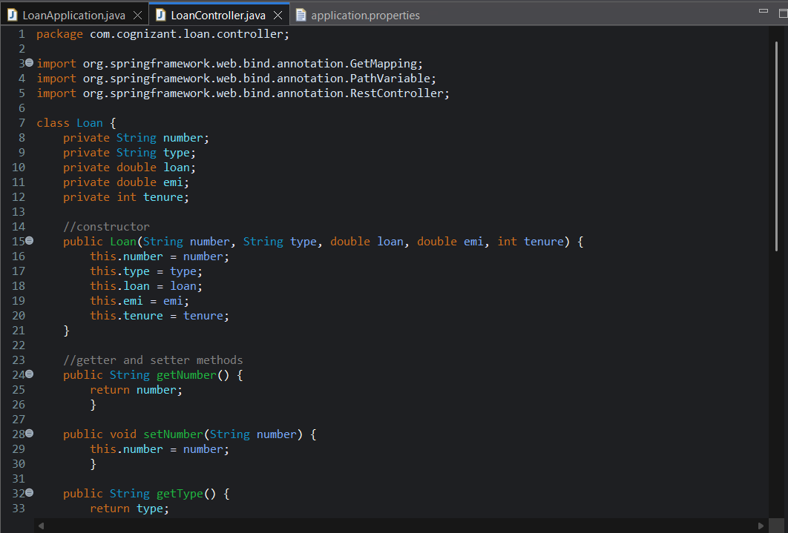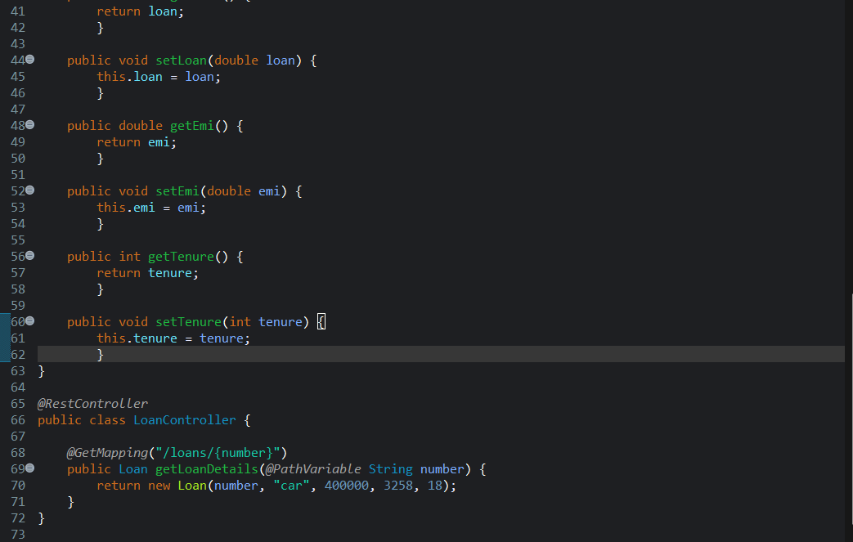

**Console output:**

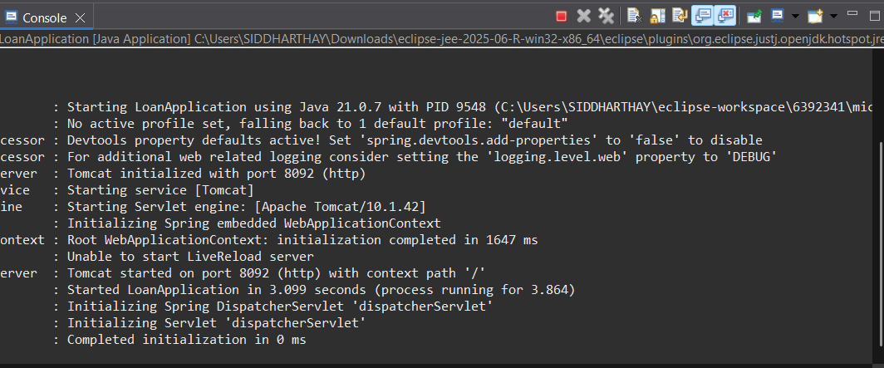

**Switching between console of Account and loan:**

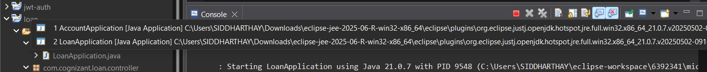

**Test Response in web browser:**

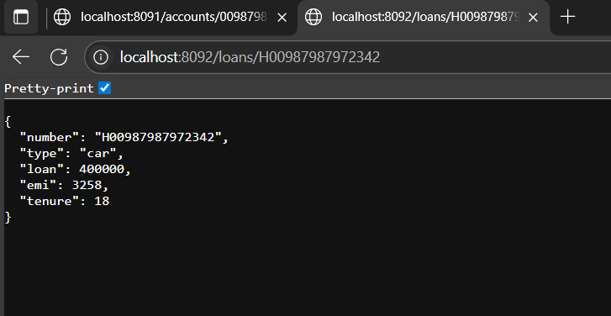

**2. Create Eureka Discovery Server and register microservices**

**(i) Create and Launch Eureka Discovery Server**

**Generating project for Eureka discovery server:**

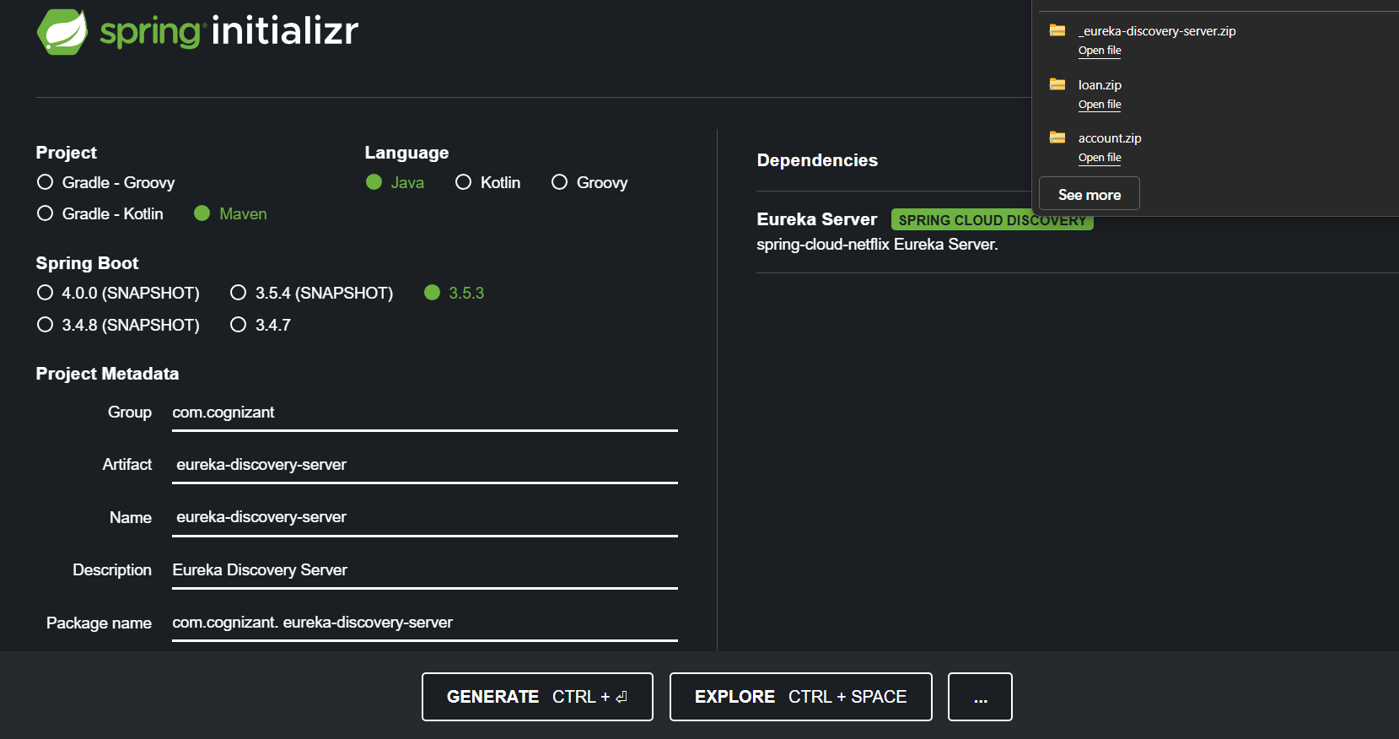

**Eureka Server Class:**

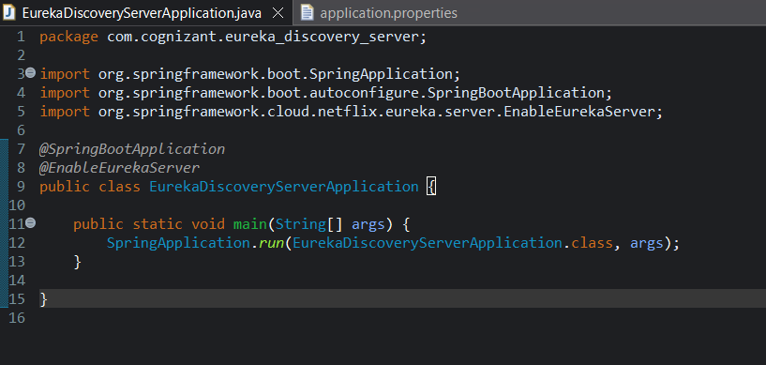

**Application.properties:**

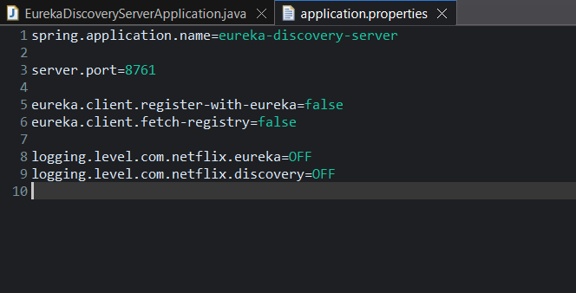

**Console output on running:**

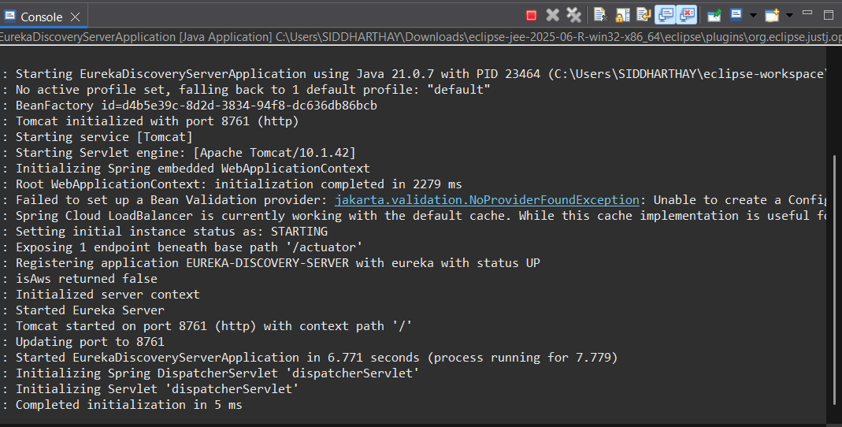

**Eureka Dashboard with 0 instances:**

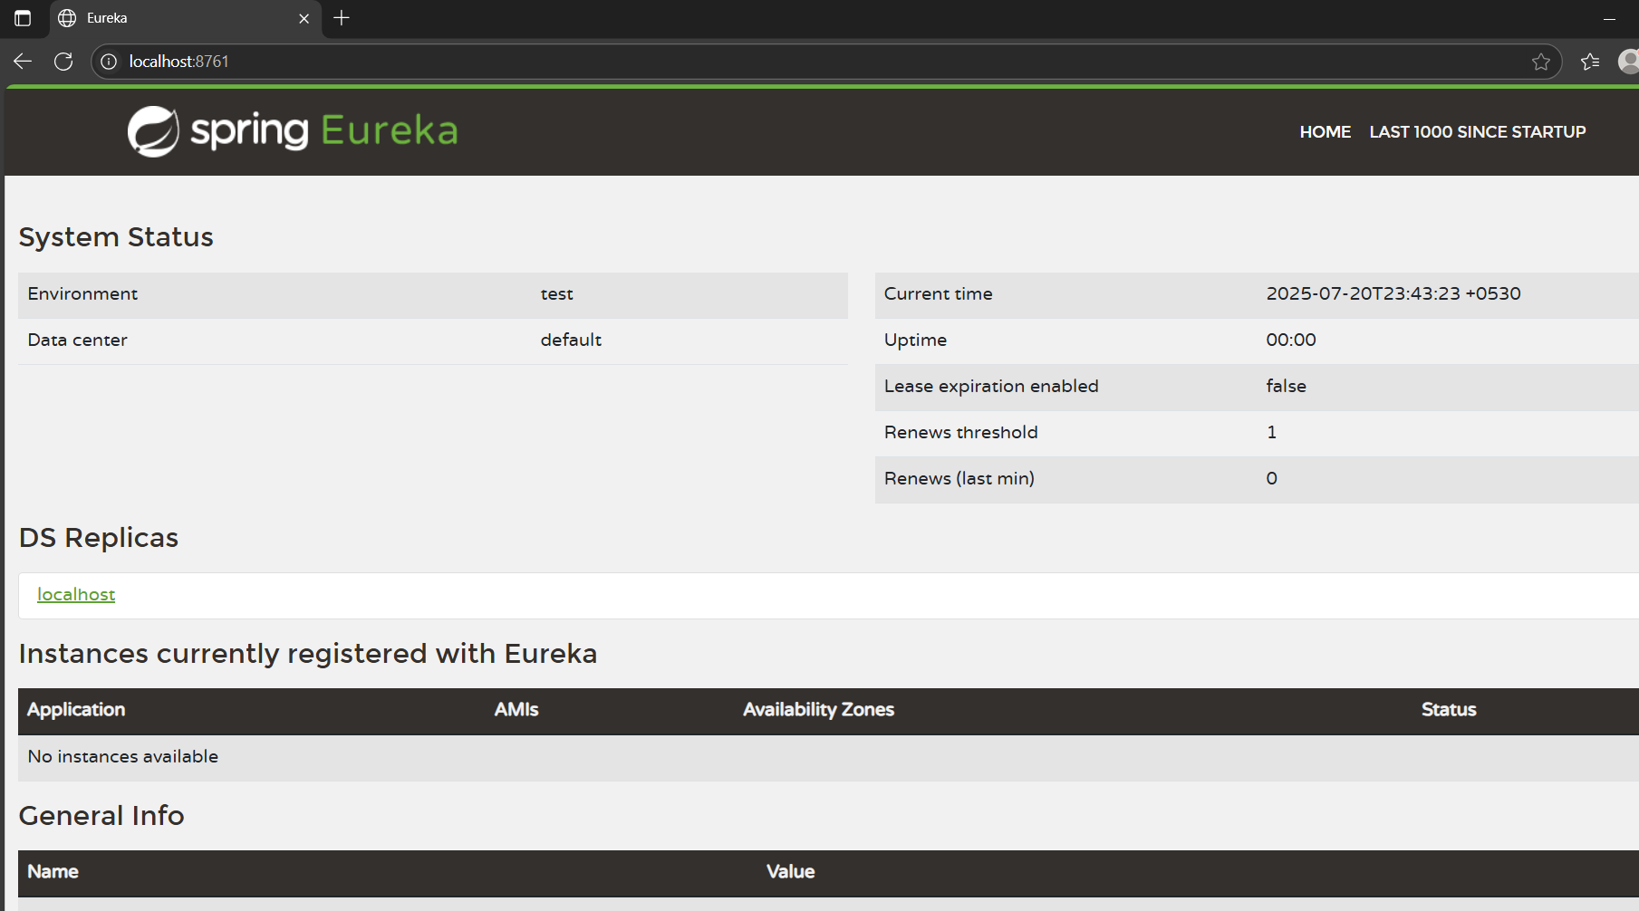

**(ii) Register Account,Loan REST API to eureka discovery**

**Adding enablediscoveryclient for account service:**

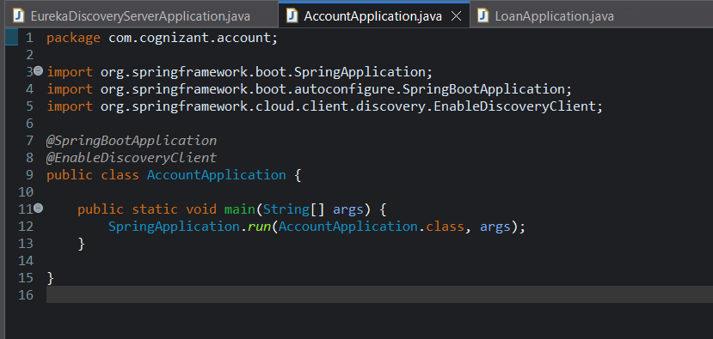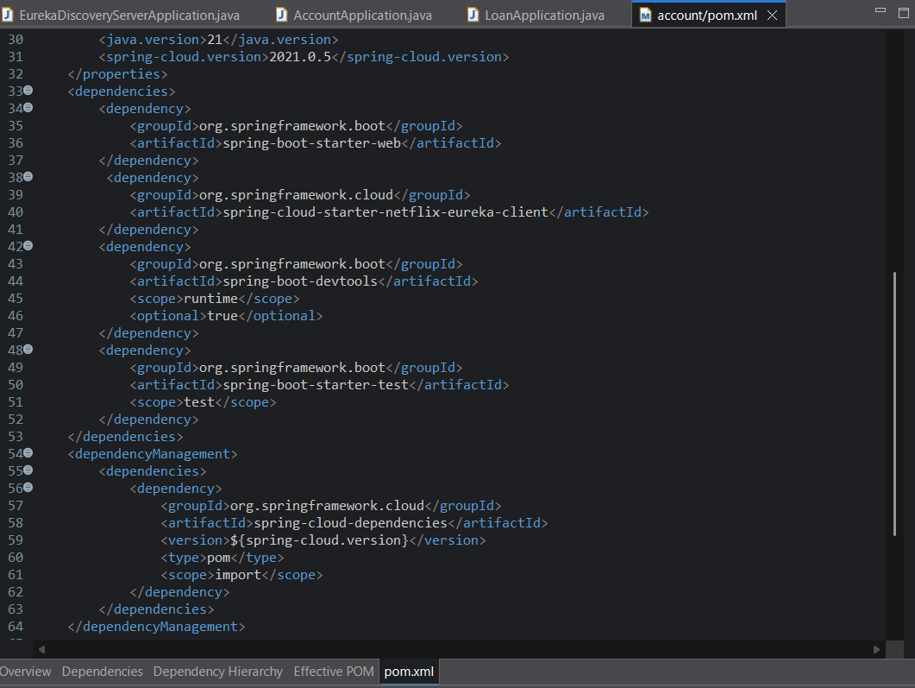

**Adding enablediscoveryclient for loan service:**

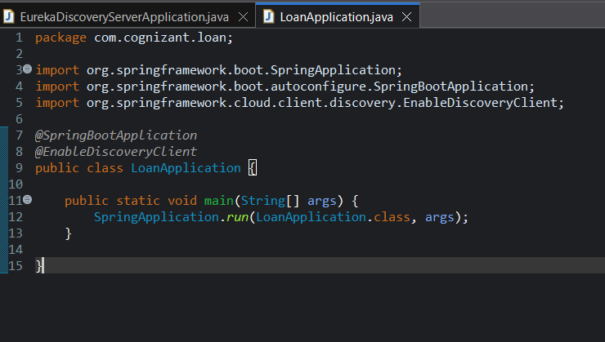

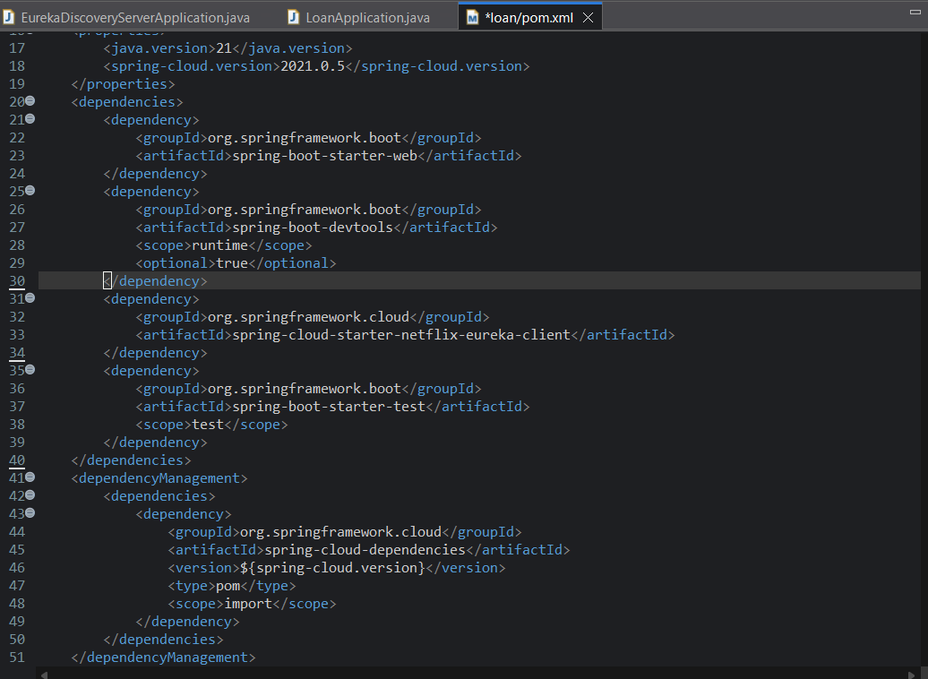

**(iii) Create the API Gateway**

**Generating project for api-gateway:**

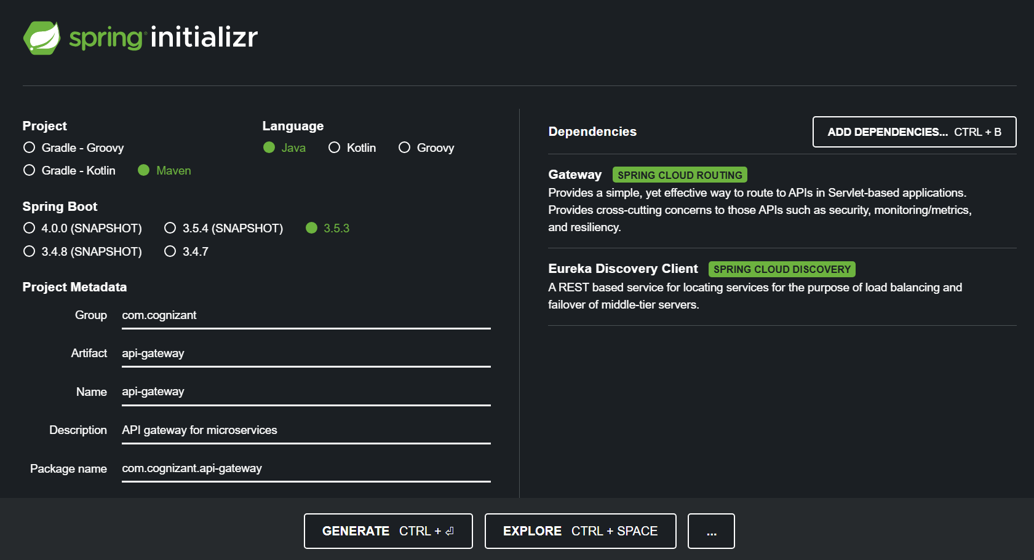

**ApiGatewayApplication.java:**

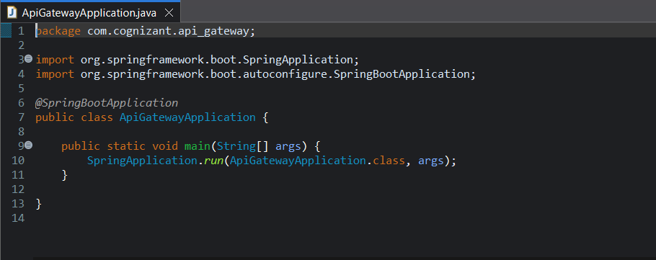

**GlobalFilter for logging requests LoggingFilter.java:**

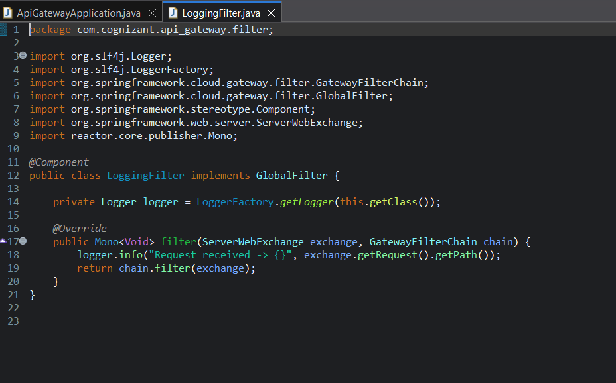

**Application.properties:**

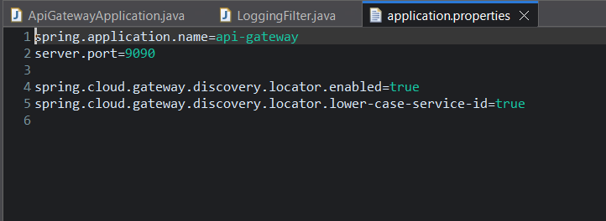

**Api-gateway pom.xml:**

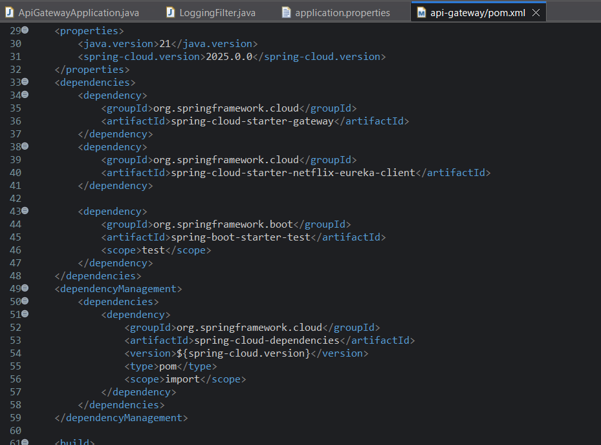

**Eureka dashboard with 3 instances after starting all services:**

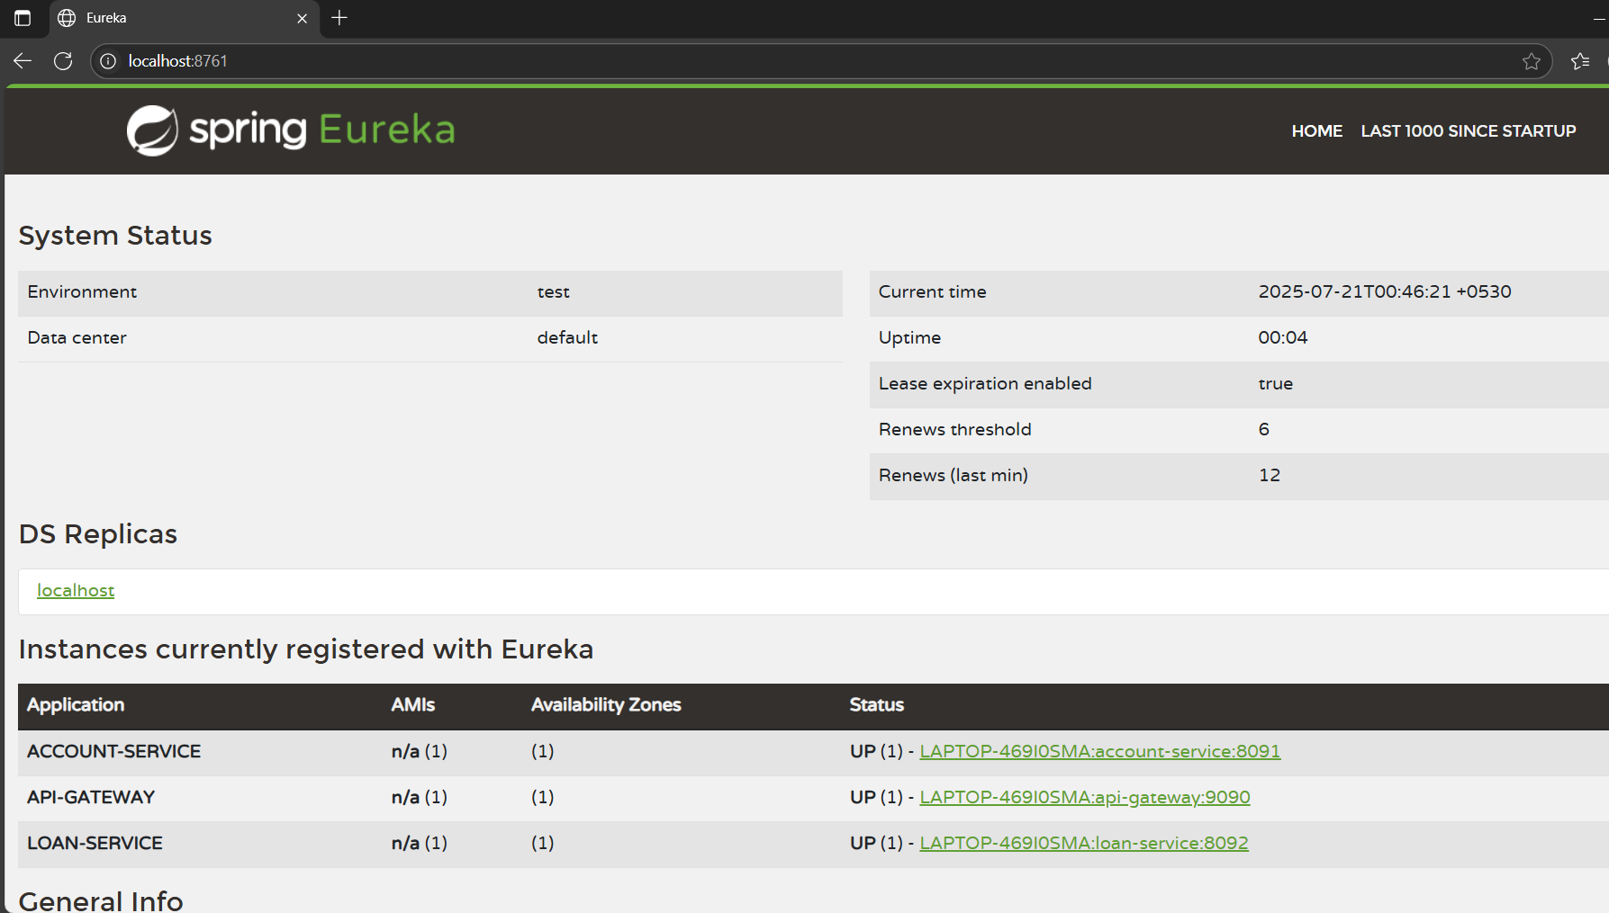

**Testing account service through api-gateway:**

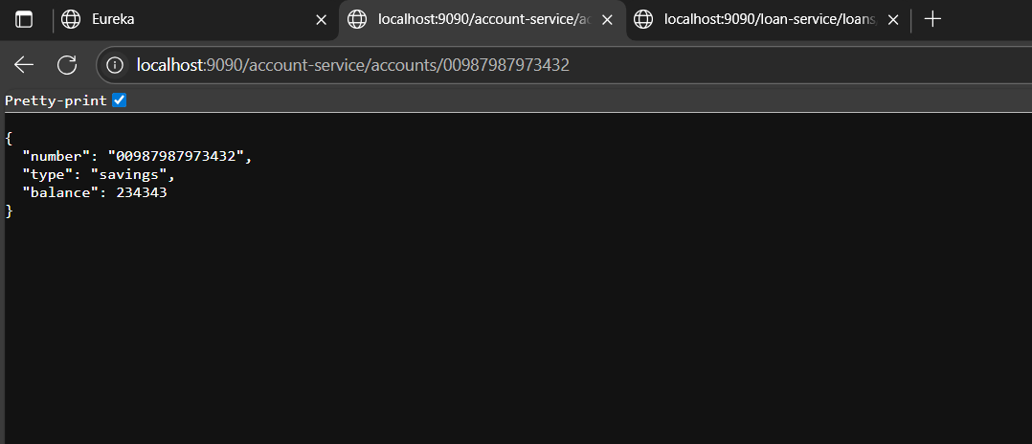

**Testing loan service through api-gateway:**

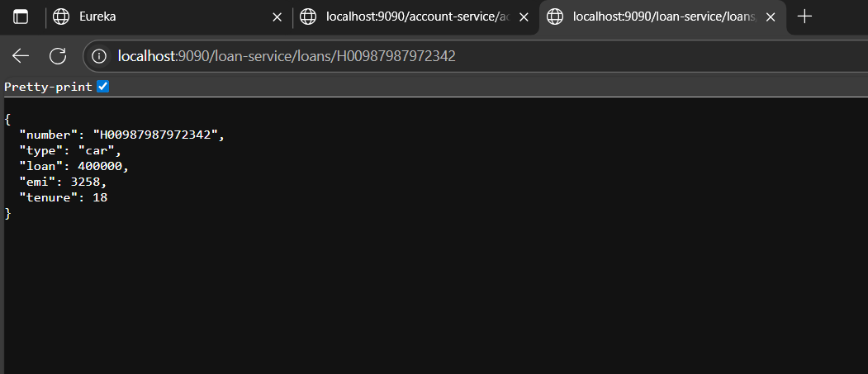

**Console Log of api-gateway:**

