**Week 6**

**React**

**1. ReactJS-HOL**

**-> nodejs and npm already installed**

**i. installing create react app**

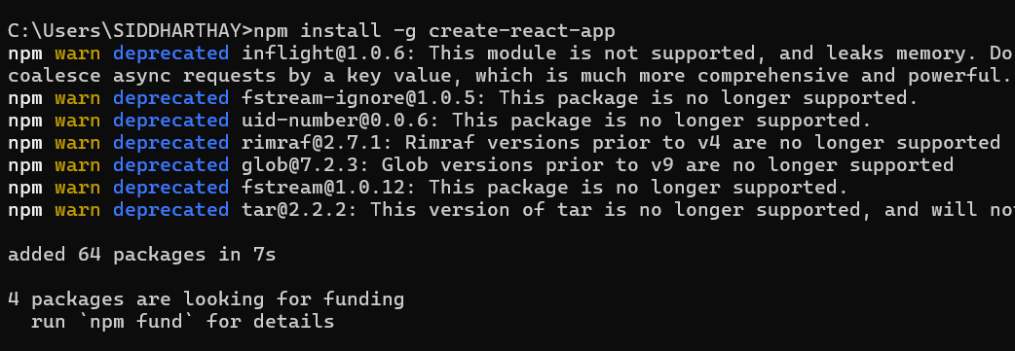

**ii. creating react application “myfirstreact”**

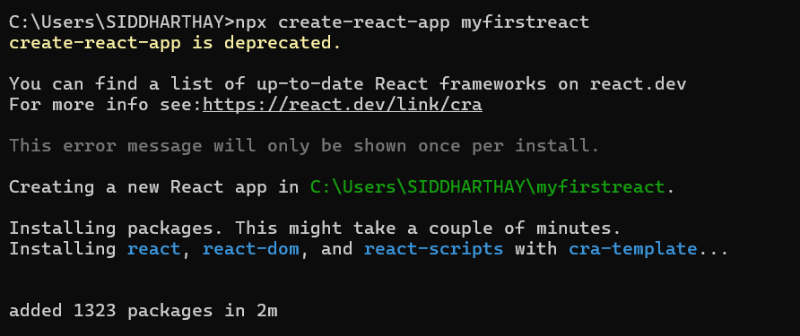

**iii. replacing the App.js code as told**

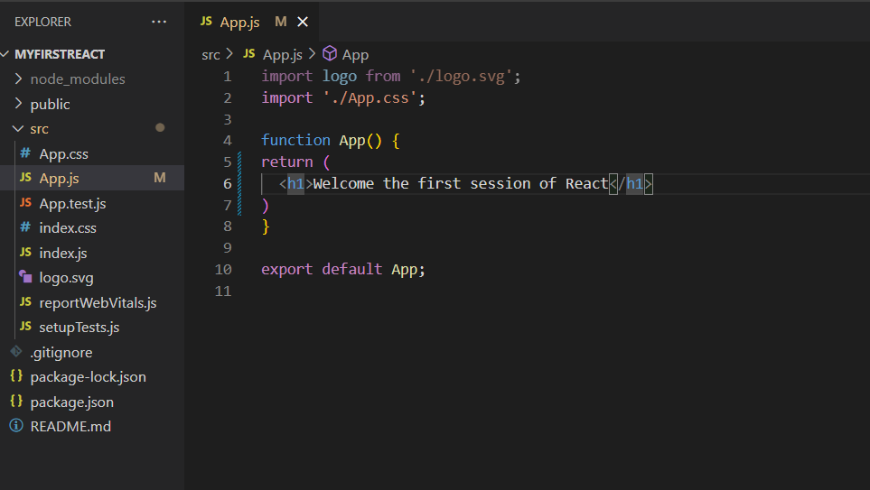

**iv. starting the application**

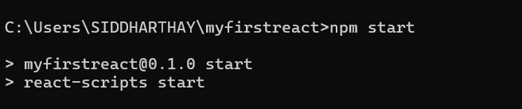

**v. testing through web browser “localhost:3000”**

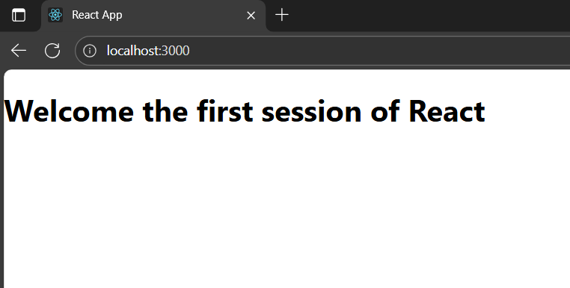

**2. ReactJS-HOL**

**i. creating the react application “studentapp”**

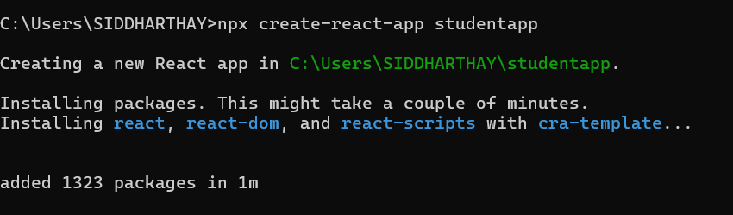

**ii. Creating Components Folder and adding Home, About, Contact**

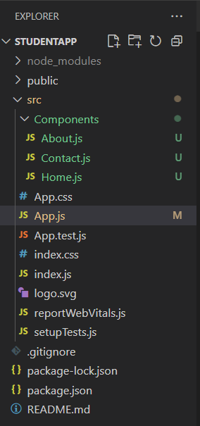

**iii. Code for Home.js**

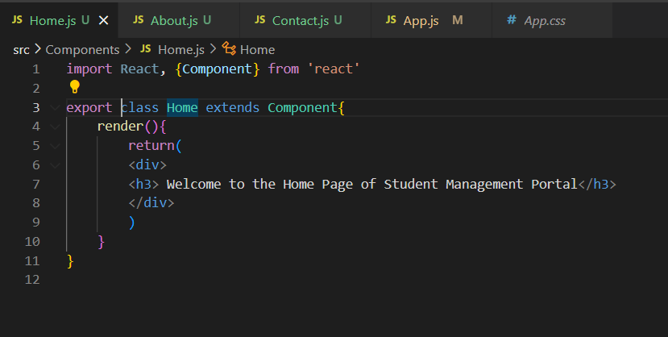

**iv. Code for About.js**

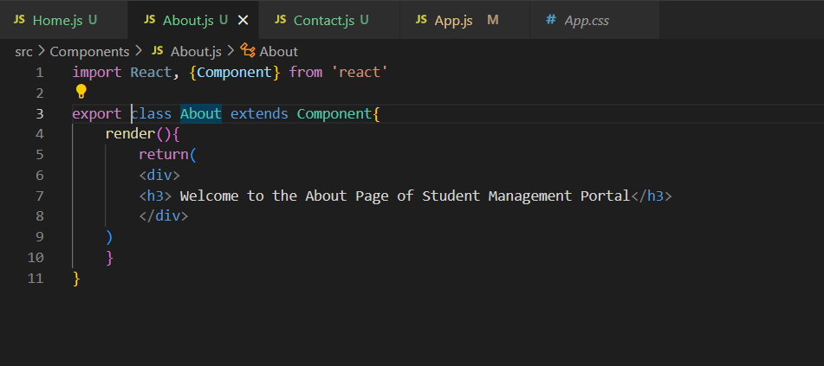

**v. Code for Contact.js**

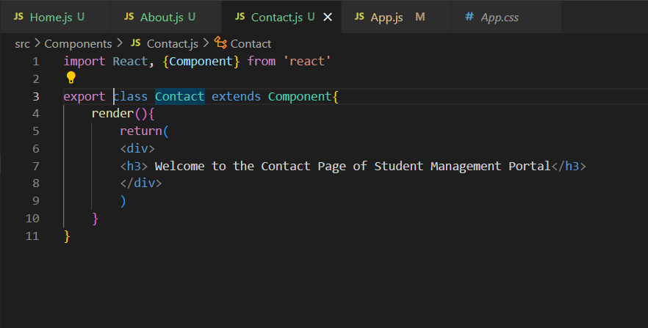

**vi. App.js**

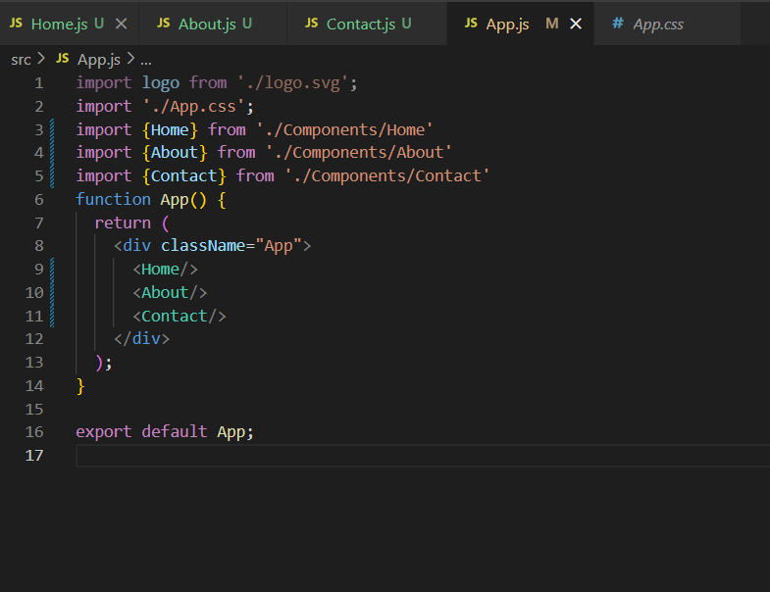

**vii. Starting the application**

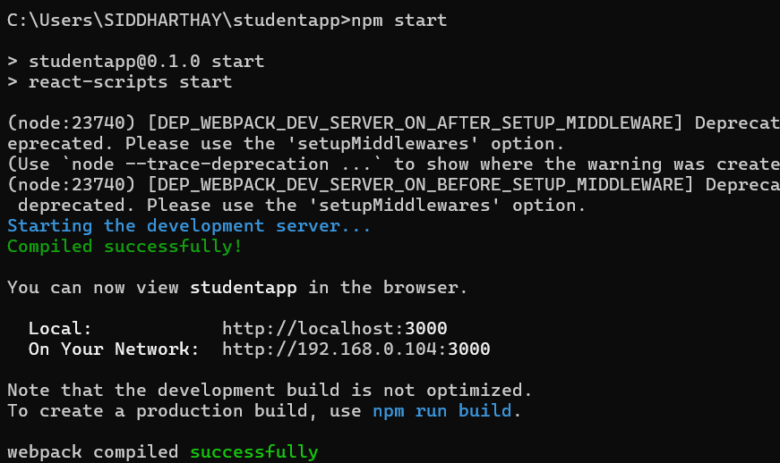

**viii. Output : “locathost:3000”**

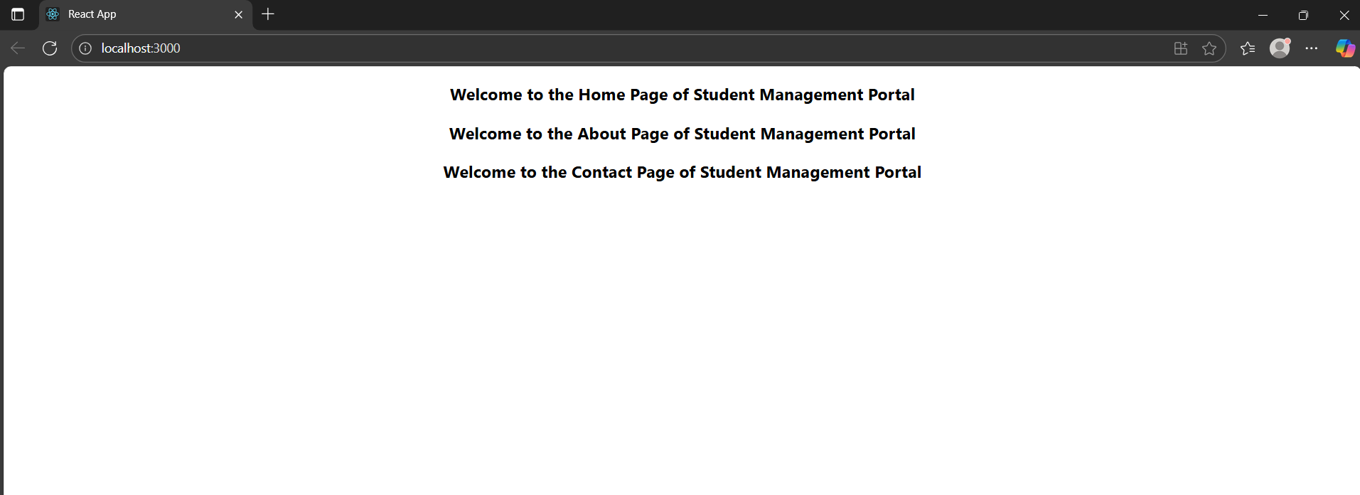

**3. ReactJS-HOL**

**i. creating application “scorecalculatorapp”**

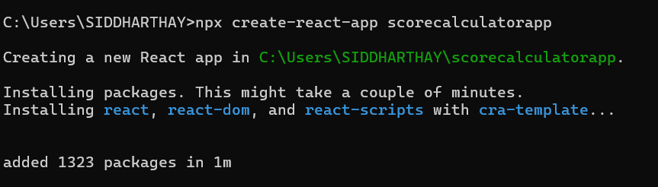

**ii. Creating Components and Stylesheets folder to add the following codes**

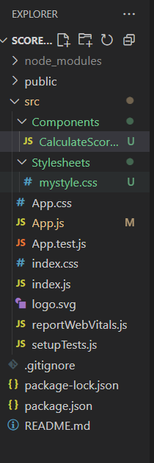

**iii. Components/CalculateScore.js**

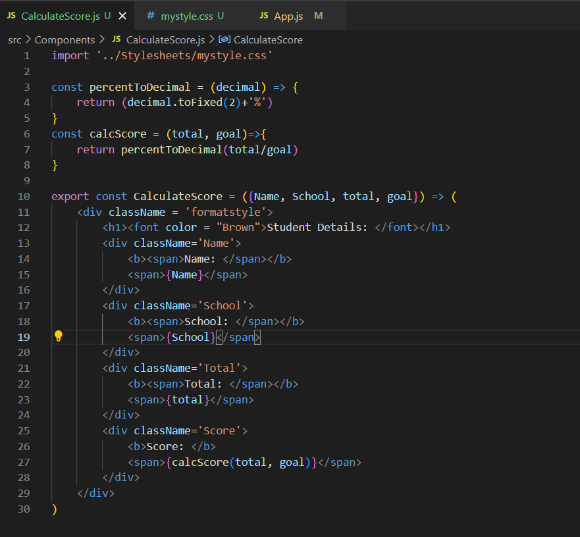

**iv. Stylesheets/mystyle.css**

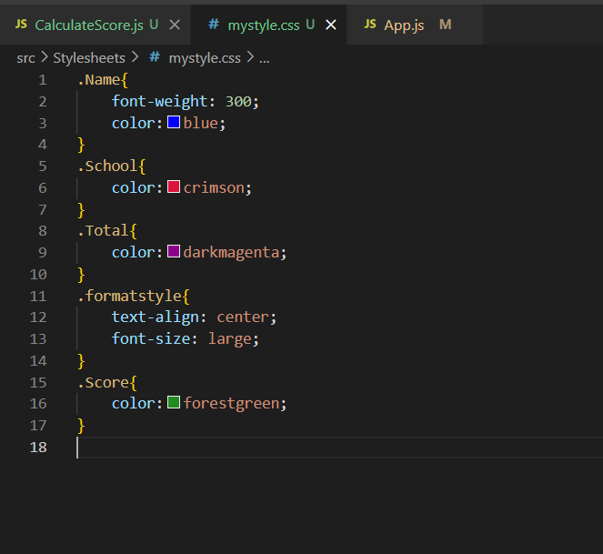

**v. App.js to invoke the components**

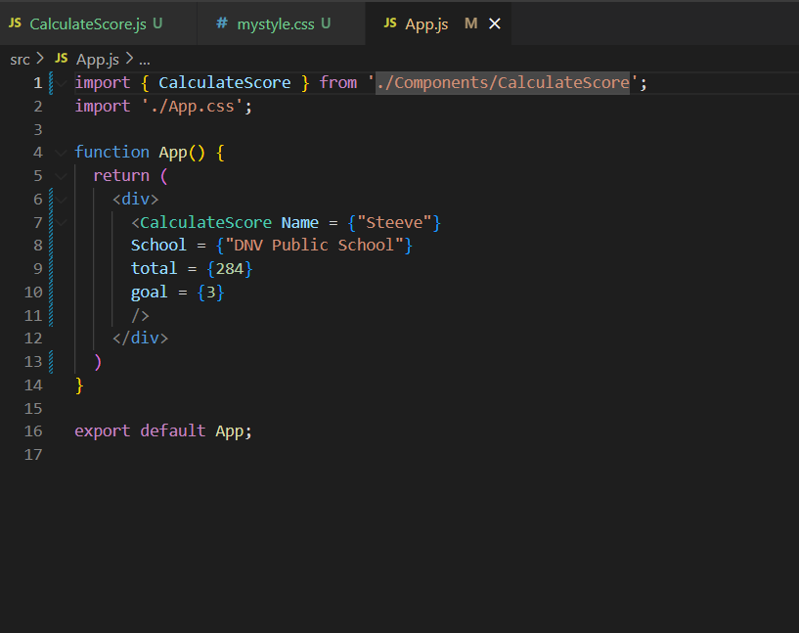

**vi. starting the application**

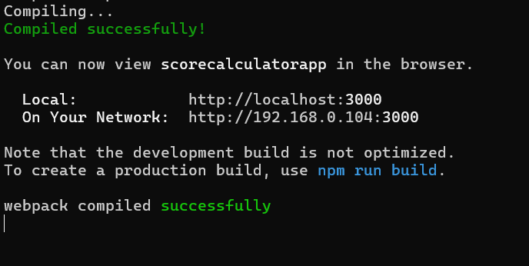

**vii. Output through “localhost:3000”**

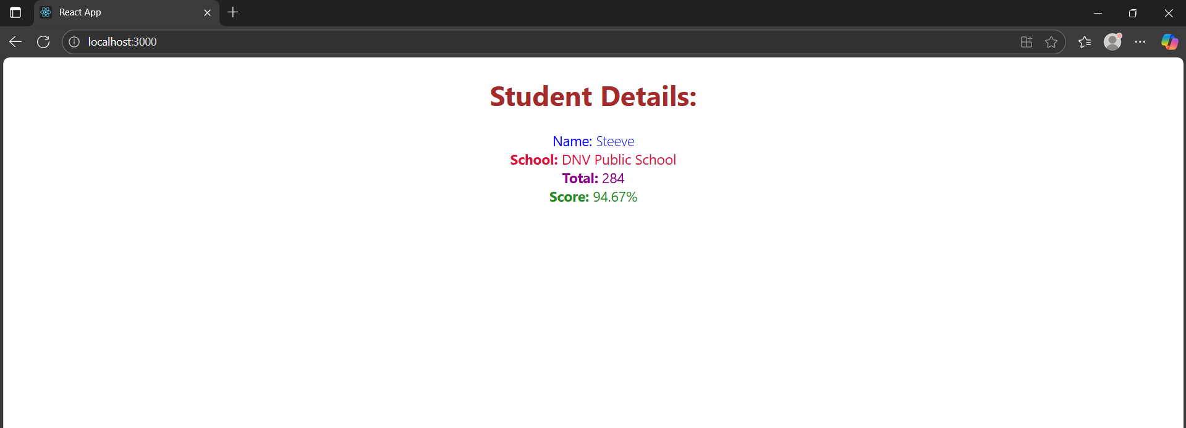

**4. ReactJS-HOL**

**i. creating the application “blogapp”**

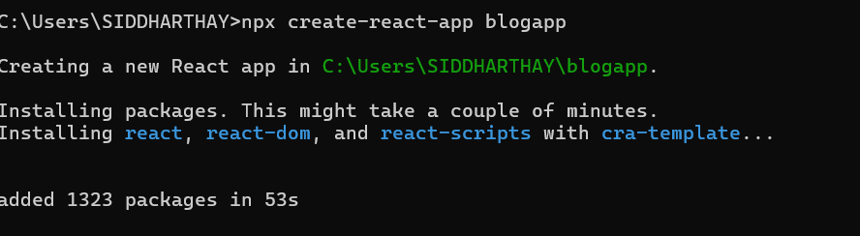

**ii. Post.js with properties**

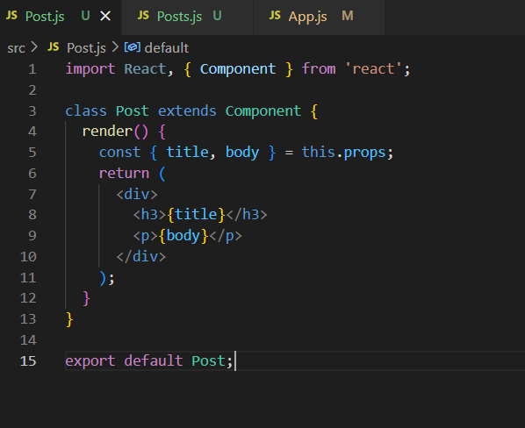

**iii. Posts.js for lifecycle management (loadPosts, componentDidMount, componentDidCatch)**

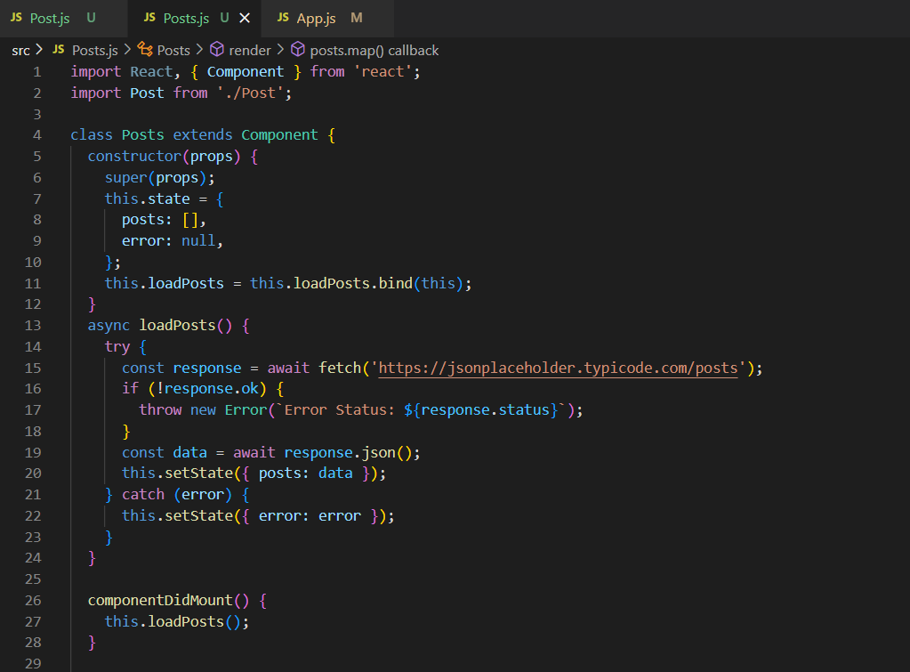

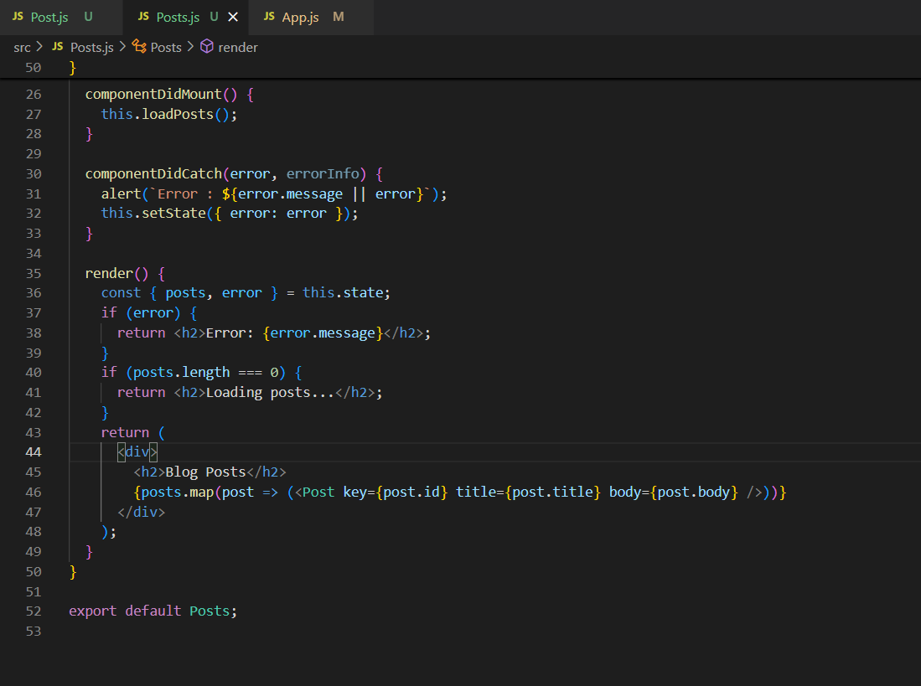

**iv. adding the posts component to App component**

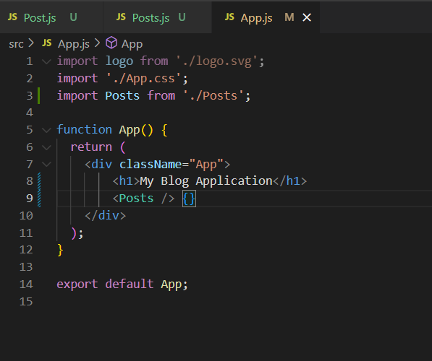

**v. starting the application**

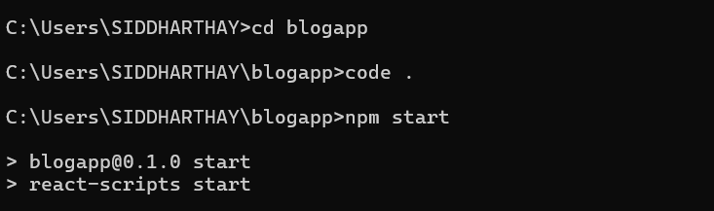

**vi. Output : through “localhost:3000”**

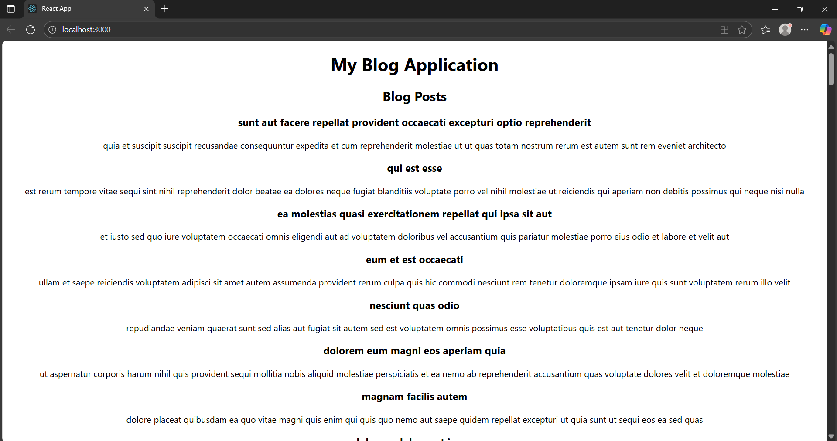

**vii. posts source:** <https://jsonplaceholder.typicode.com/posts>

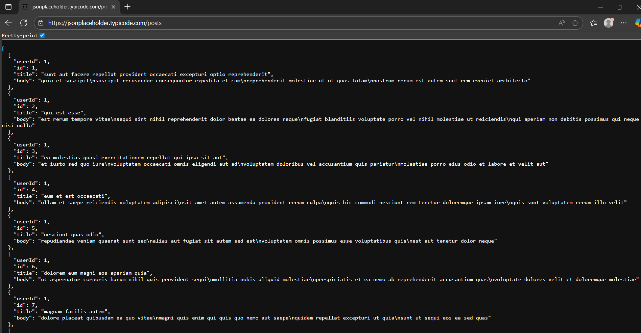

**5. ReactJS-HOL**

**i. unzipped the cohortstracker.zip**

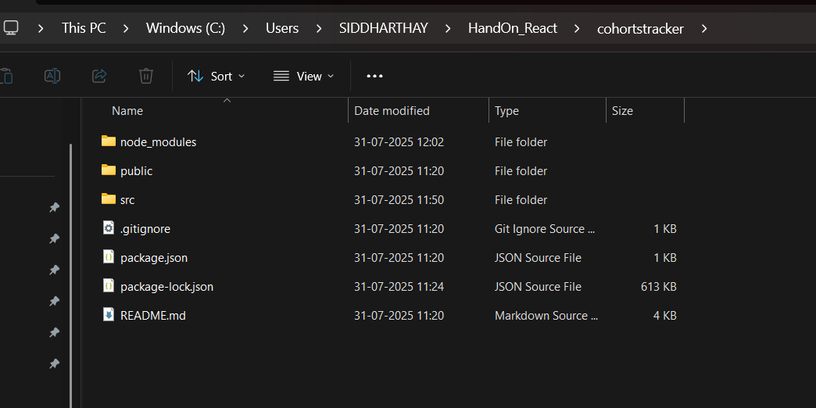

**ii. restoring npm packages**

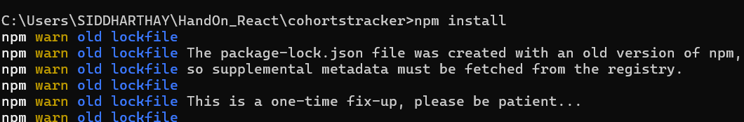 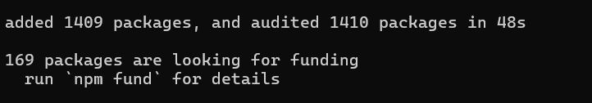

**iii. CohortDetails.module.css styling for box and text**

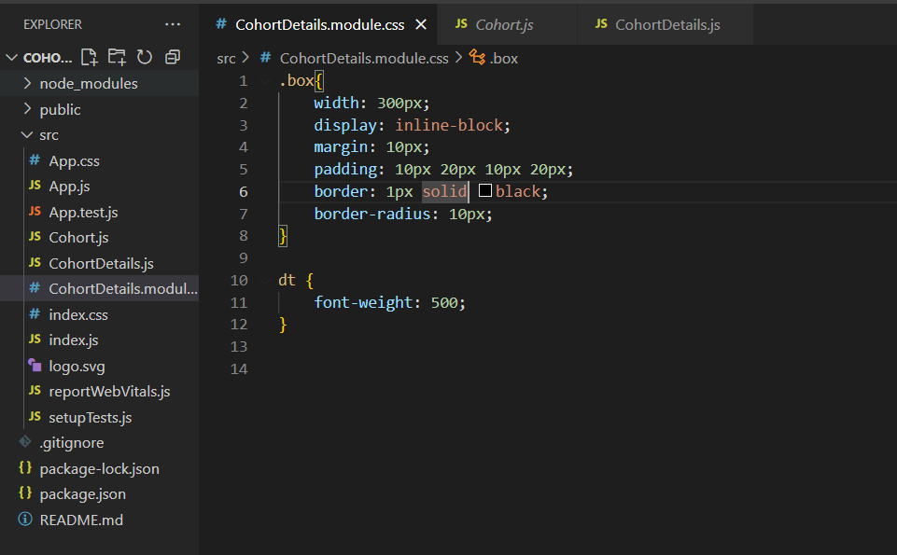

**iv. importing styles from ‘CohortDetails.module.css’**

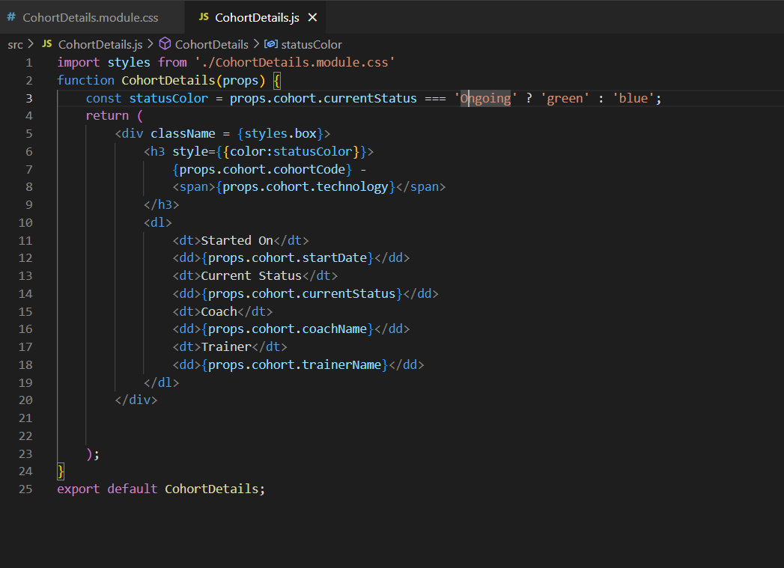

**v. Cohorts Data for reference**

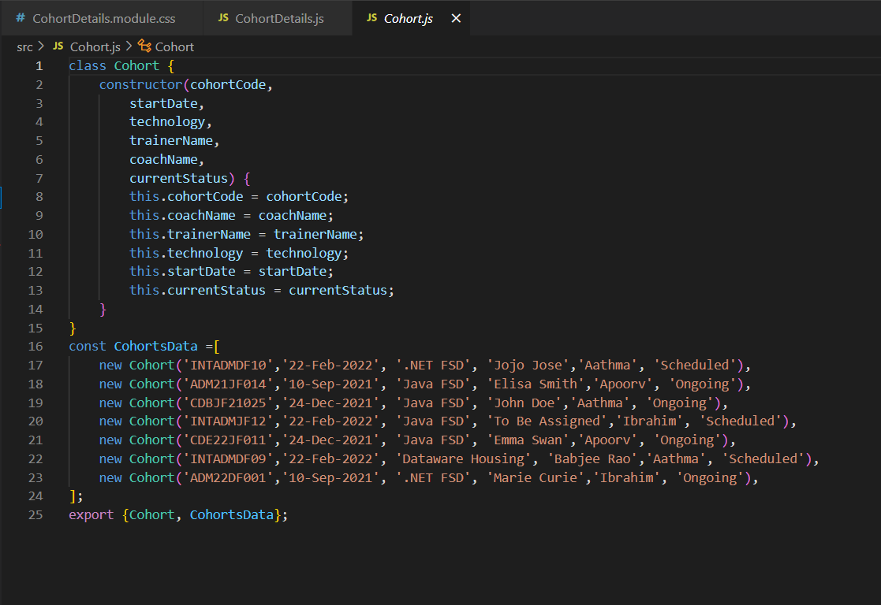

**vi. Output: “localhost:3000”**

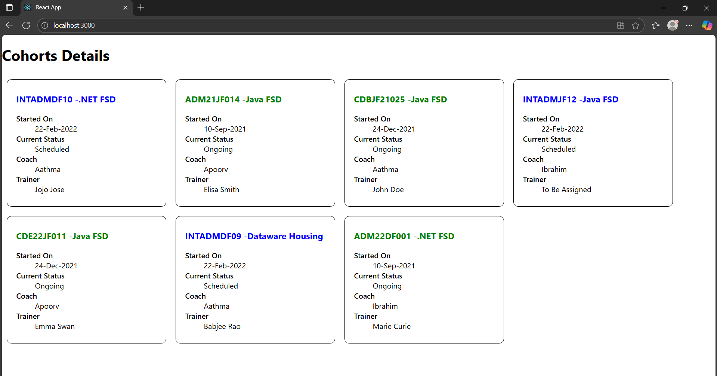

**6. ReactJS-HOL**

**i. creating the application**

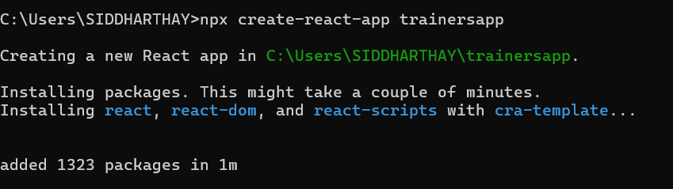

**ii. Trainer.js with trainer properties**

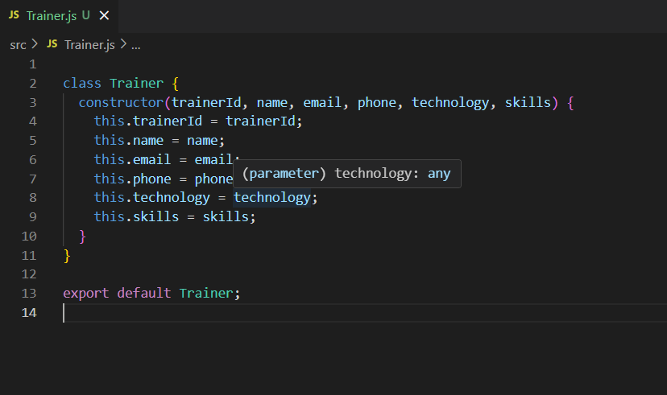

**iii. TrainersMock.js for Trainers Details**

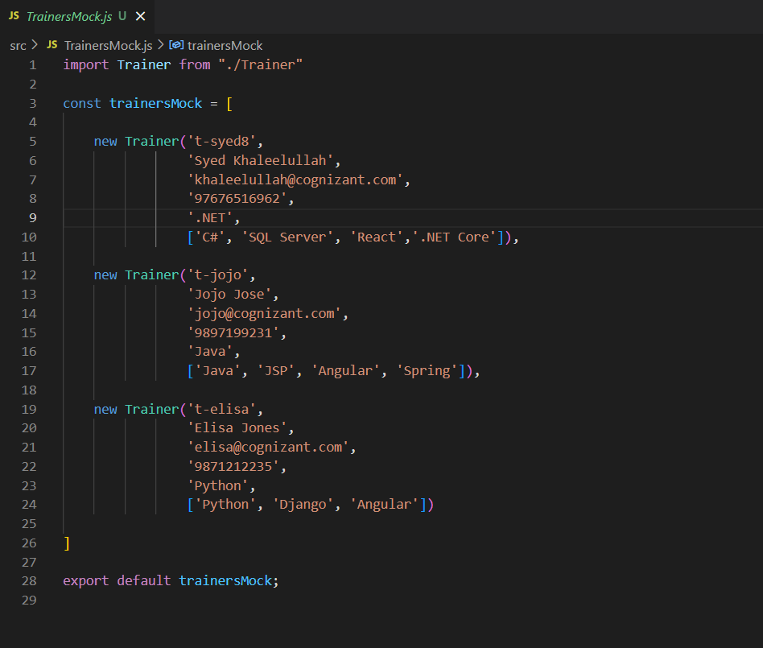

**iv. installing react router for dom**

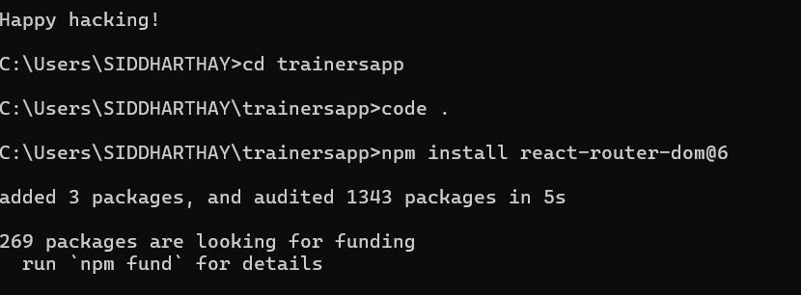

**v. TrainersList.js for rendering trainer’s data as List**

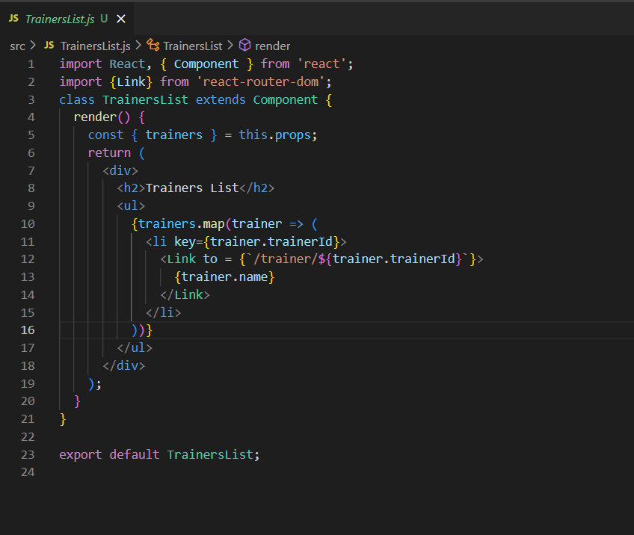

**vi. Home.js for displaying the following message**

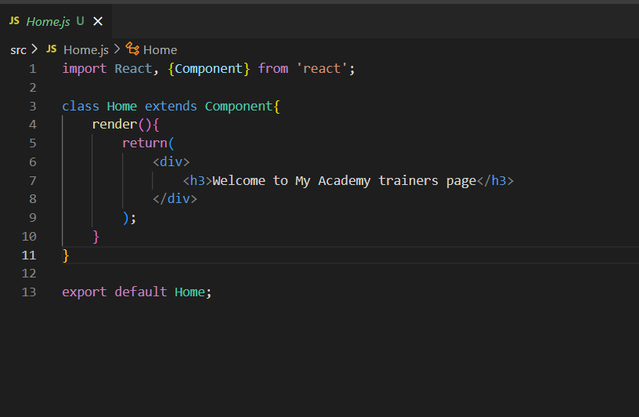

**vii. TrainerDetails.js for querying and displaying trainer data**

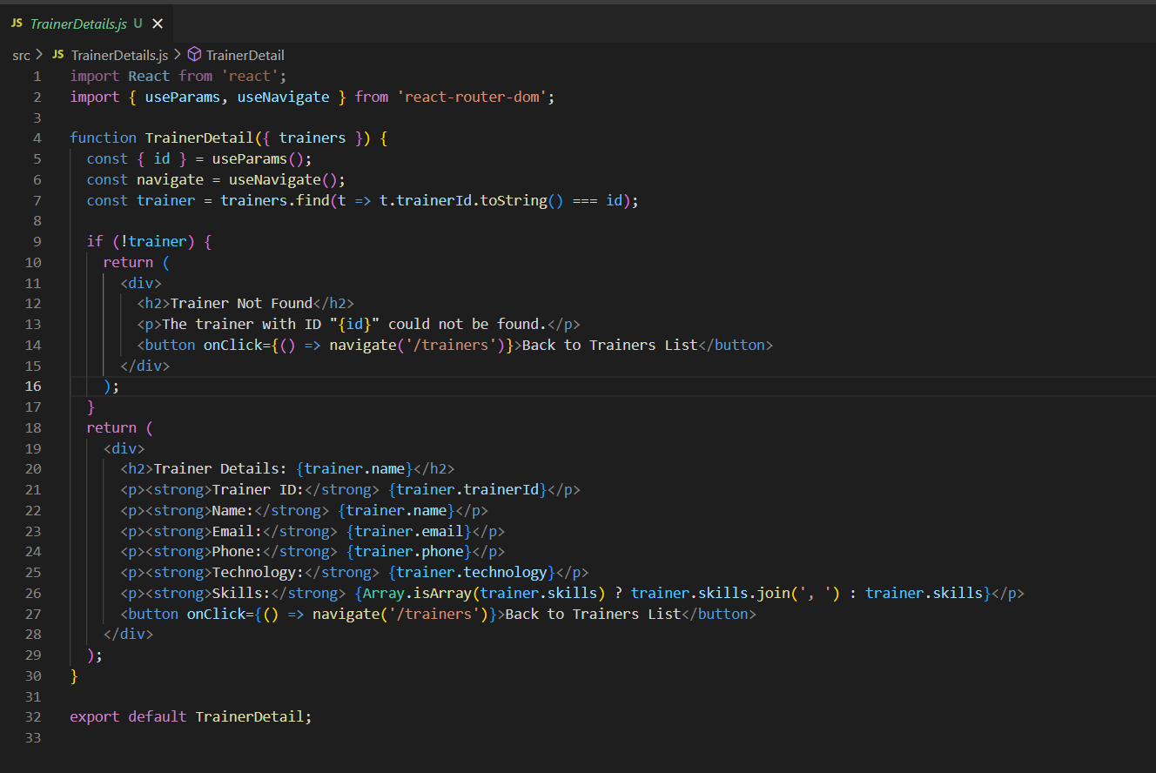

**viii. App.js modified to support routing and defining navigation links**

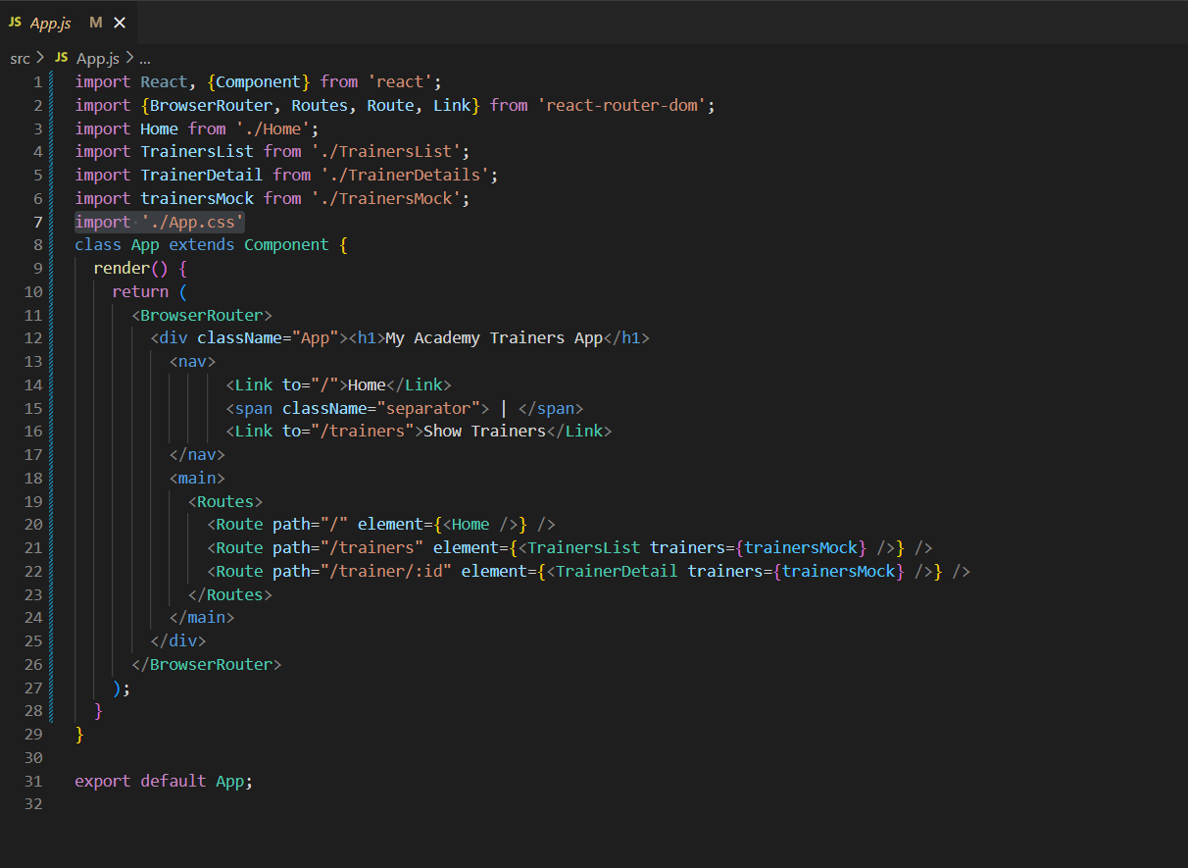

**ix. starting the application**

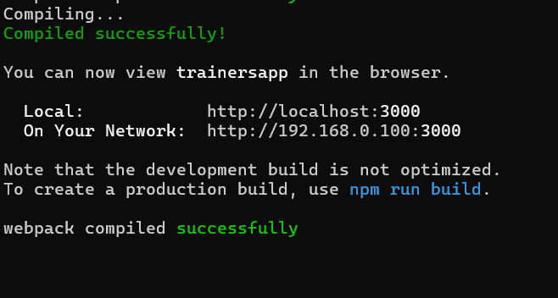

**x. Outputs: “localhost:3000”**

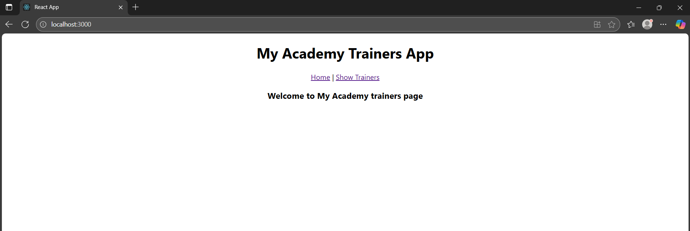

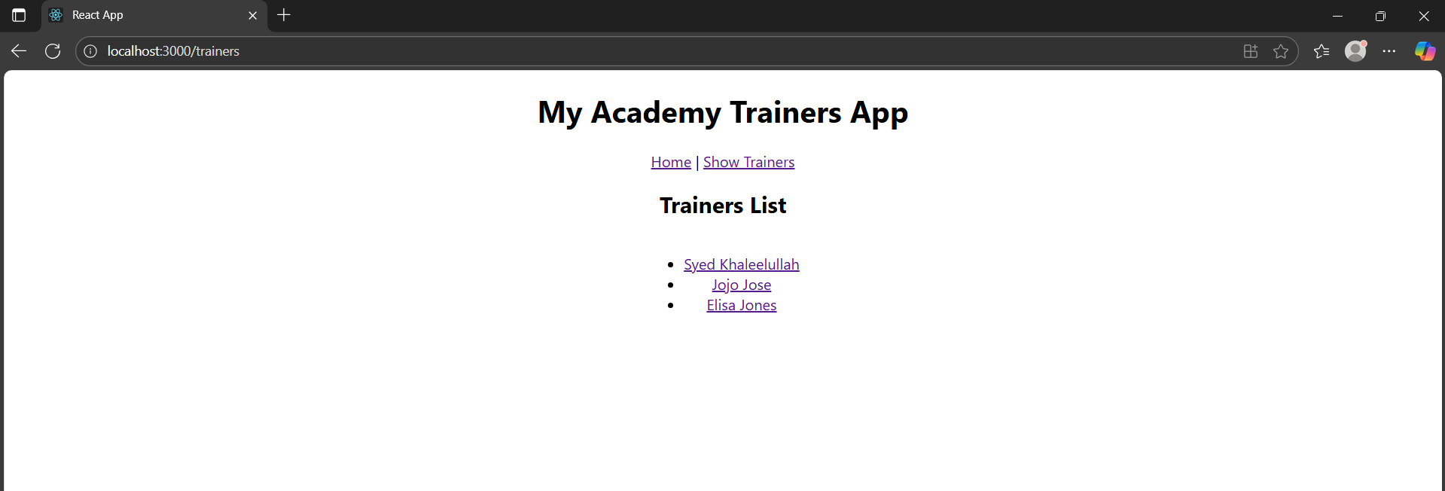

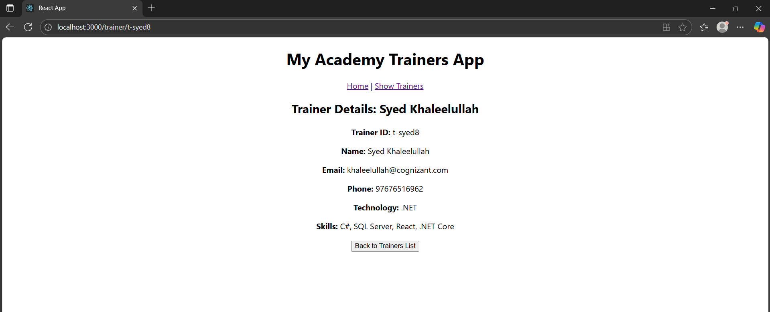

**7. ReactJS-HOL**

**i. creating app “shoppingapp”**

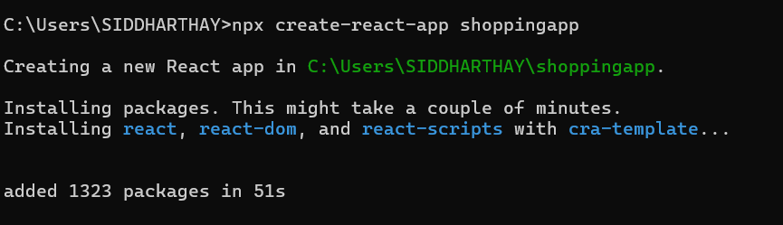

**ii. Cart.js for table data**

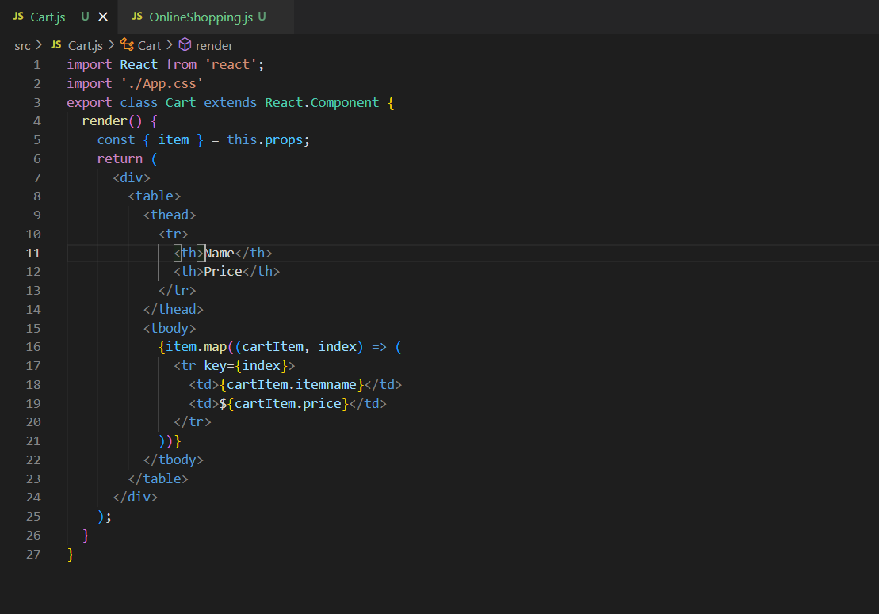

**iii. OnlineShopping.js for Cart Info and title**

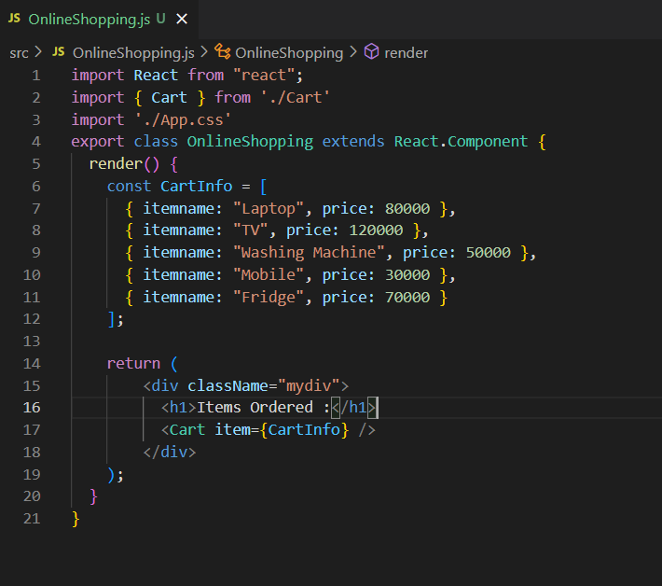

**iv. App.js displaying the component**

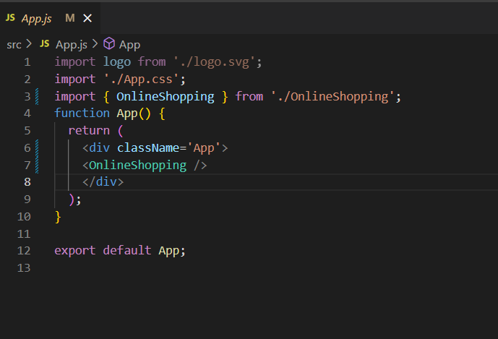

**v. App.css for styling the Shopping Pages as required**

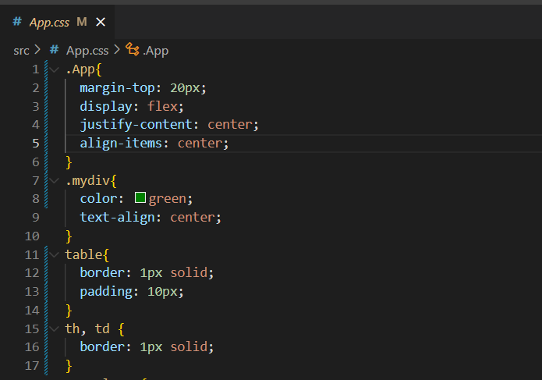

**vi. starting the application**

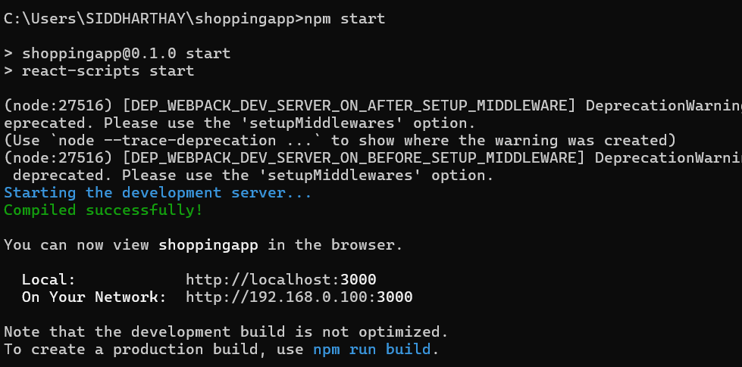

**vii. Output: “localhost:3000”**

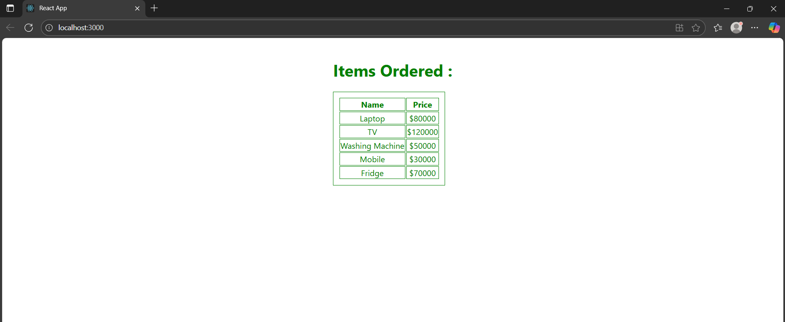

**8. ReactJS-HOL**

**i. creating application “CountPeople”**

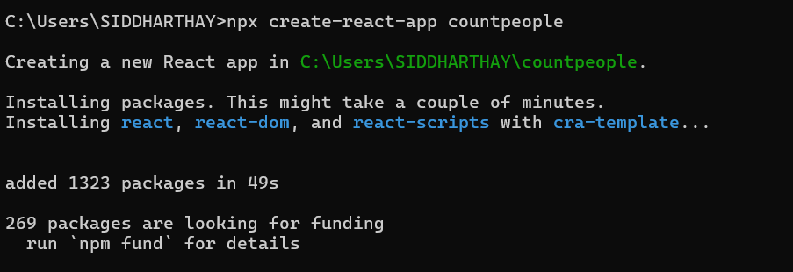

**ii. CountPeople.js with upadteEntry(), updateExit() and returning the result**

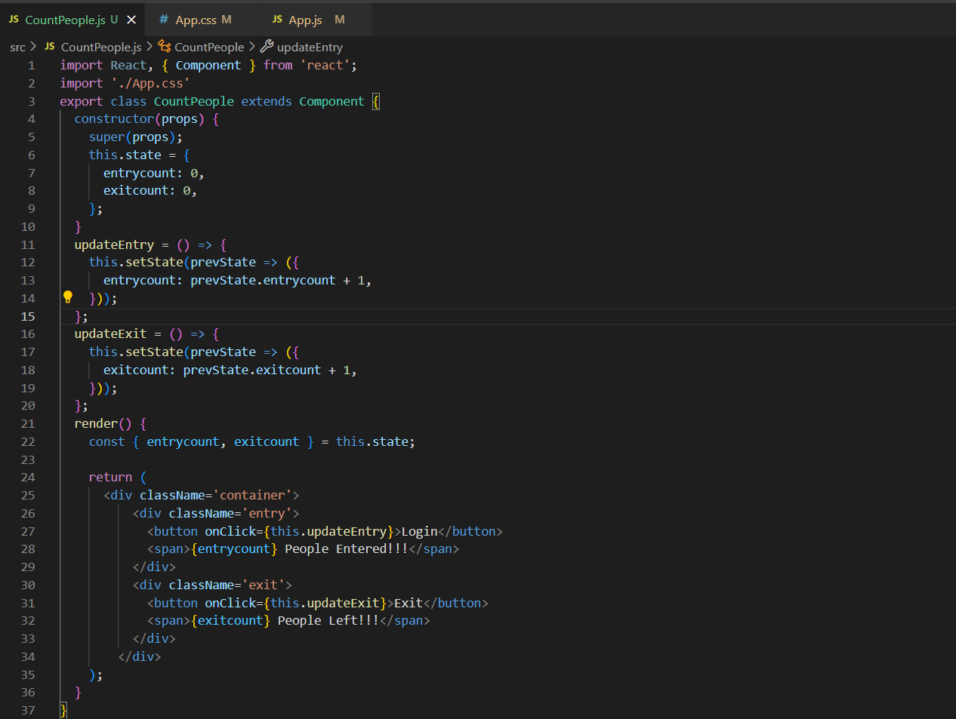

**iii. App.js Main code for Displaying the component**

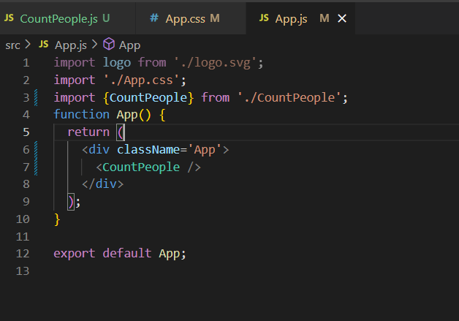

**iv. App.css for Styling the page as needed**

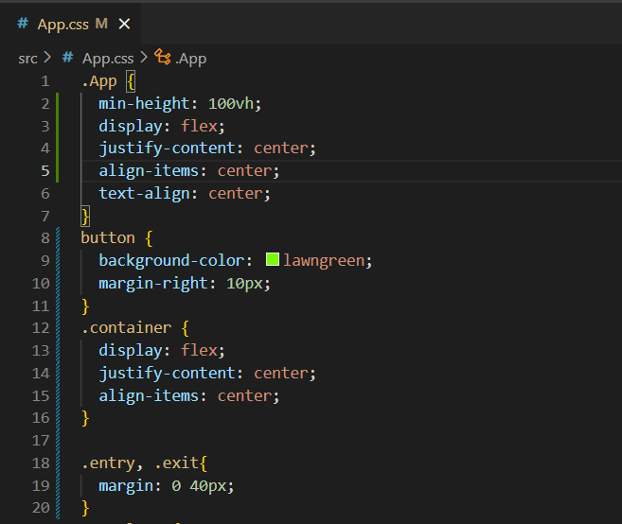

**v. Output: “localhost:3000”**

