**WEEK 7**

**REACT HANDSON EXERCISES**

**9. ReactJS – HOL**

**i. creating the application “cricketapp”**

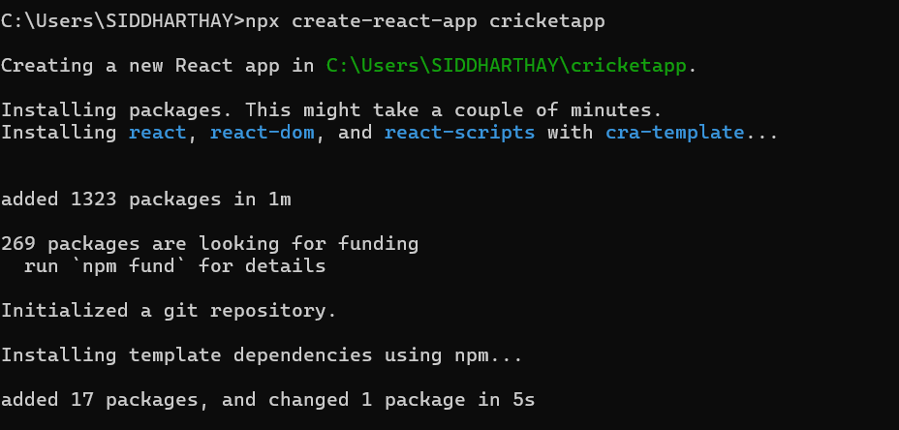

**ii. Adding components ListofPlayers and IndianPlayers**

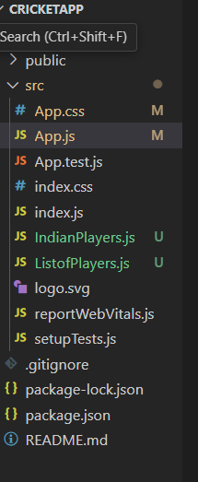

**iii. ListofPlayers.js**

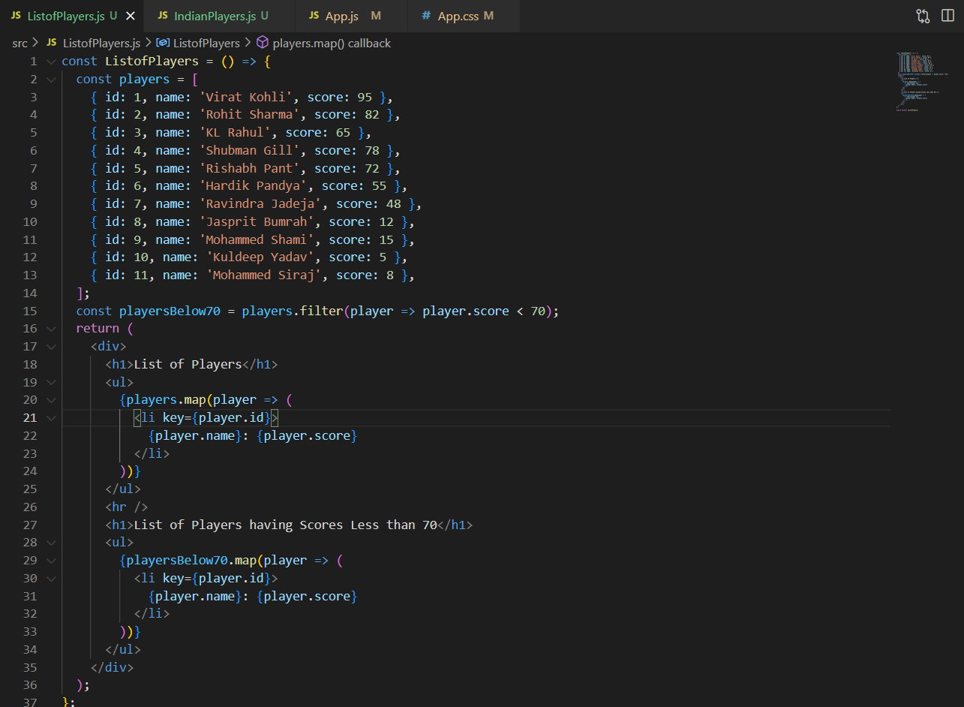

**iv. IndianPlayers.js**

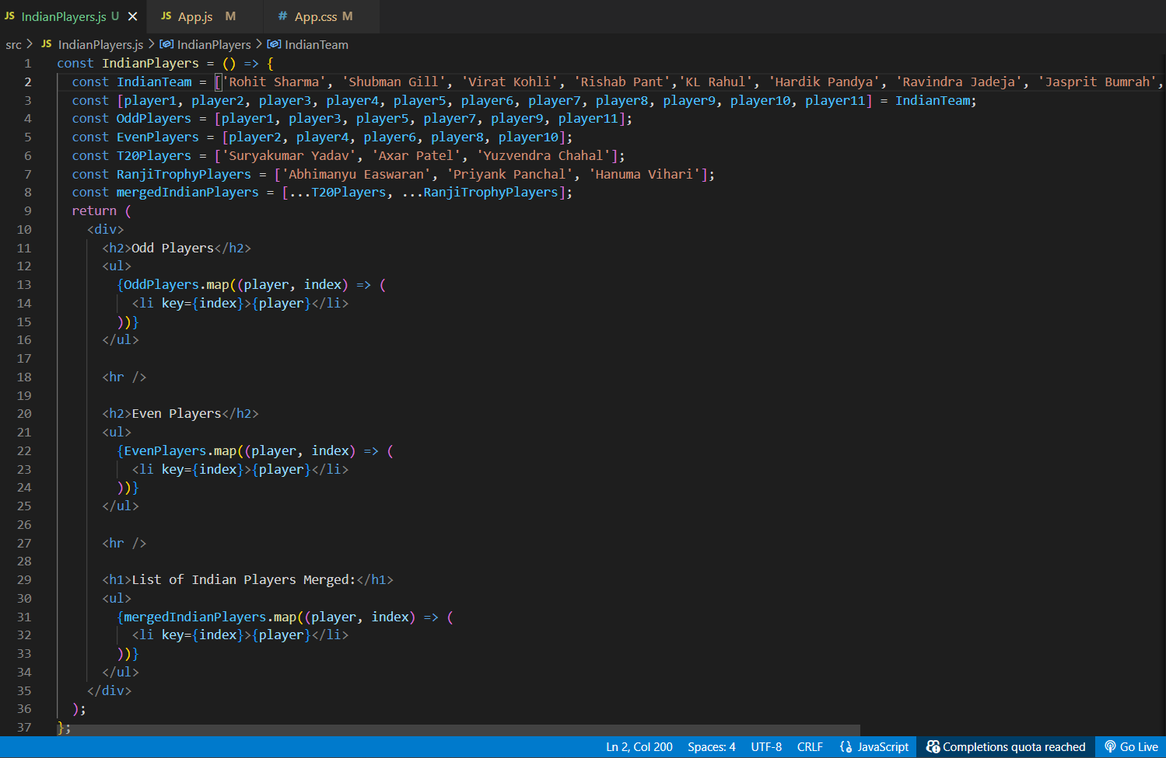

**v. App.js with flag = true**

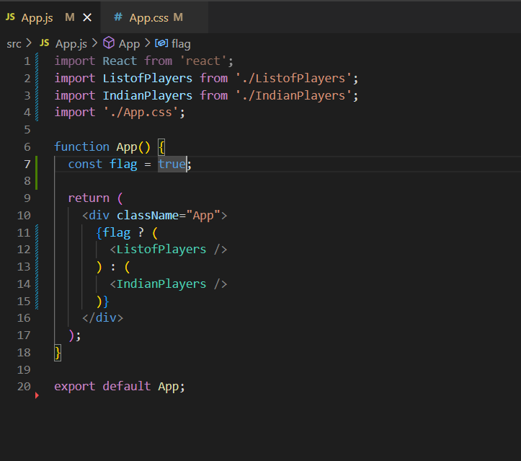

**vi. Output when “flag = true”**

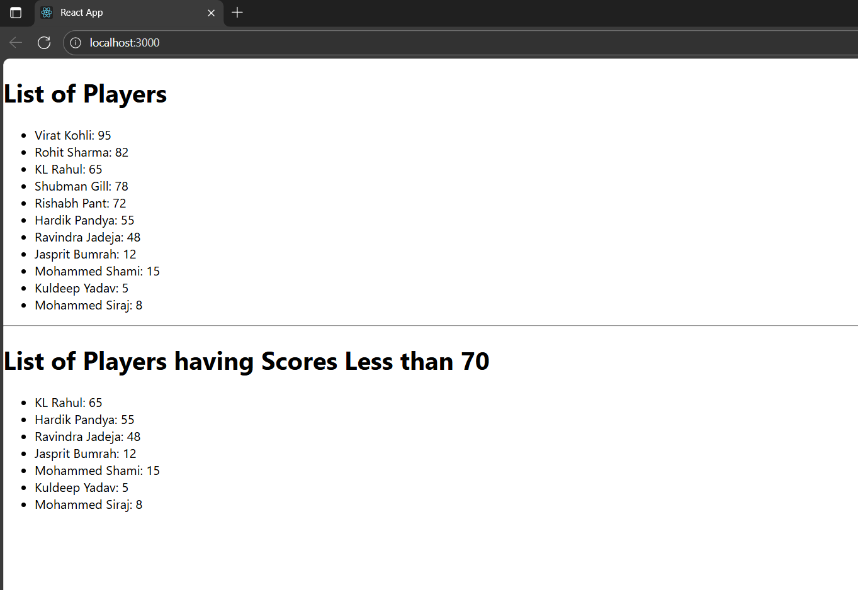

**vii. Output when “flag = false”**

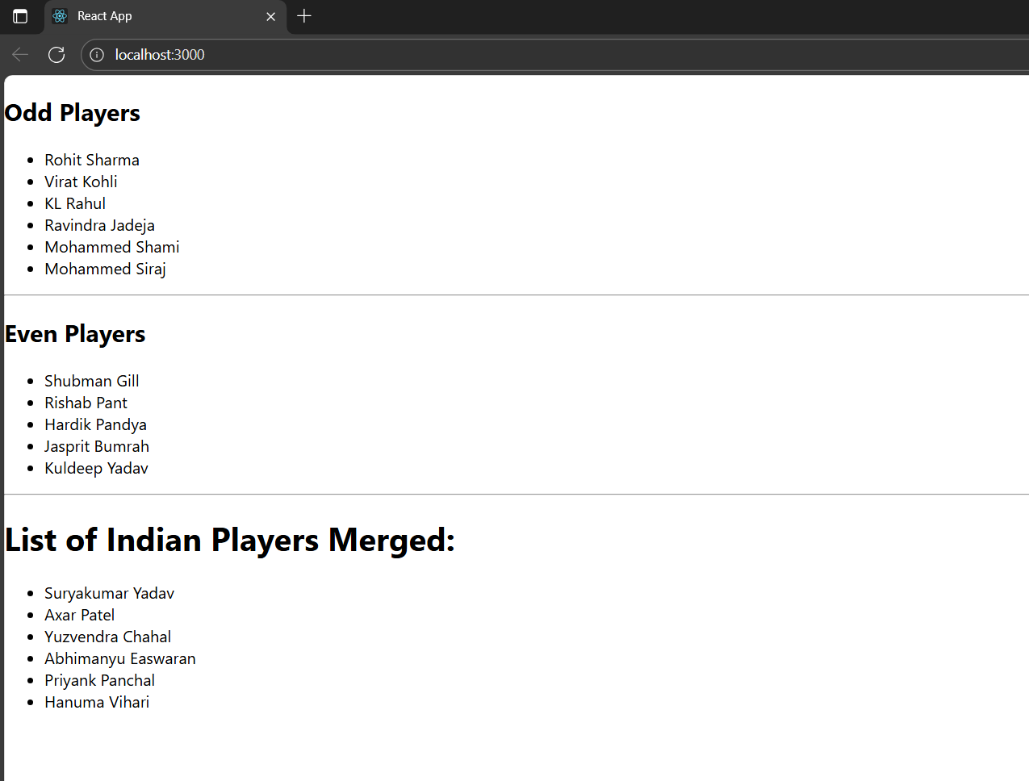

**10. ReactJS – HOL**

**i. creating application “officespacerentalapp”**

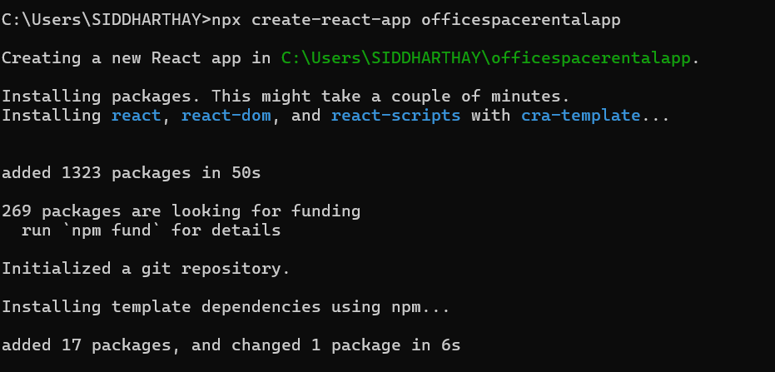

**ii. App.js using react jsx to create elements and attributes and display**

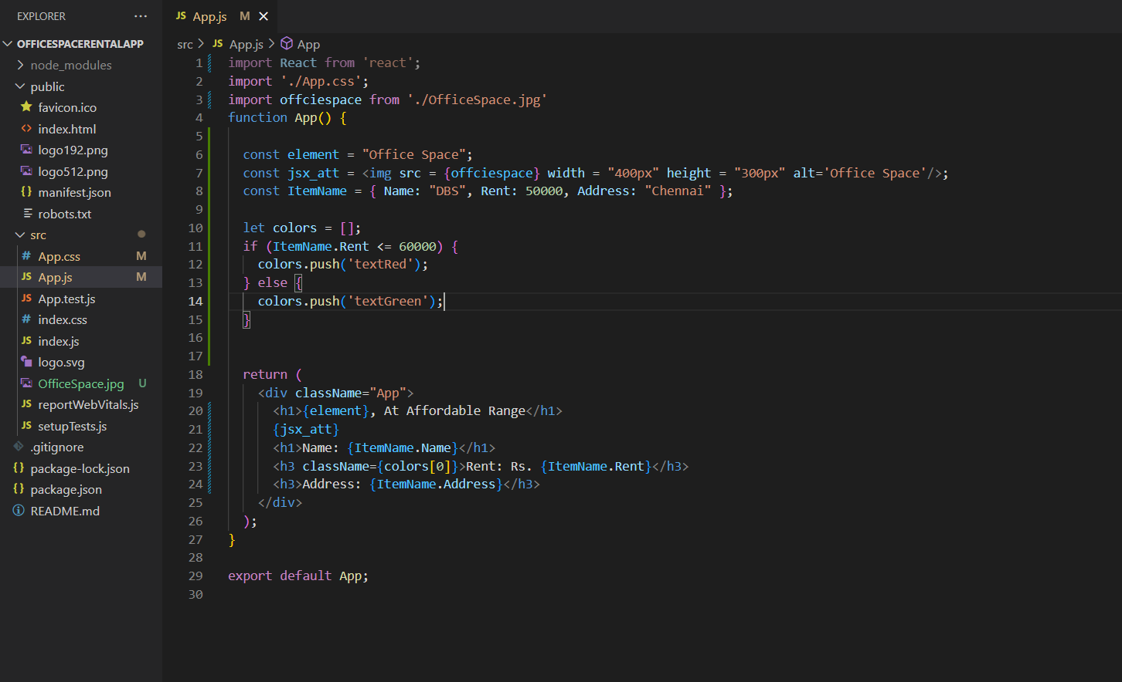

**iii. css for text color of rent**

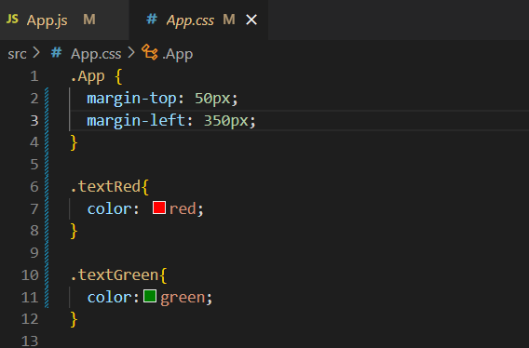

**iv. output**

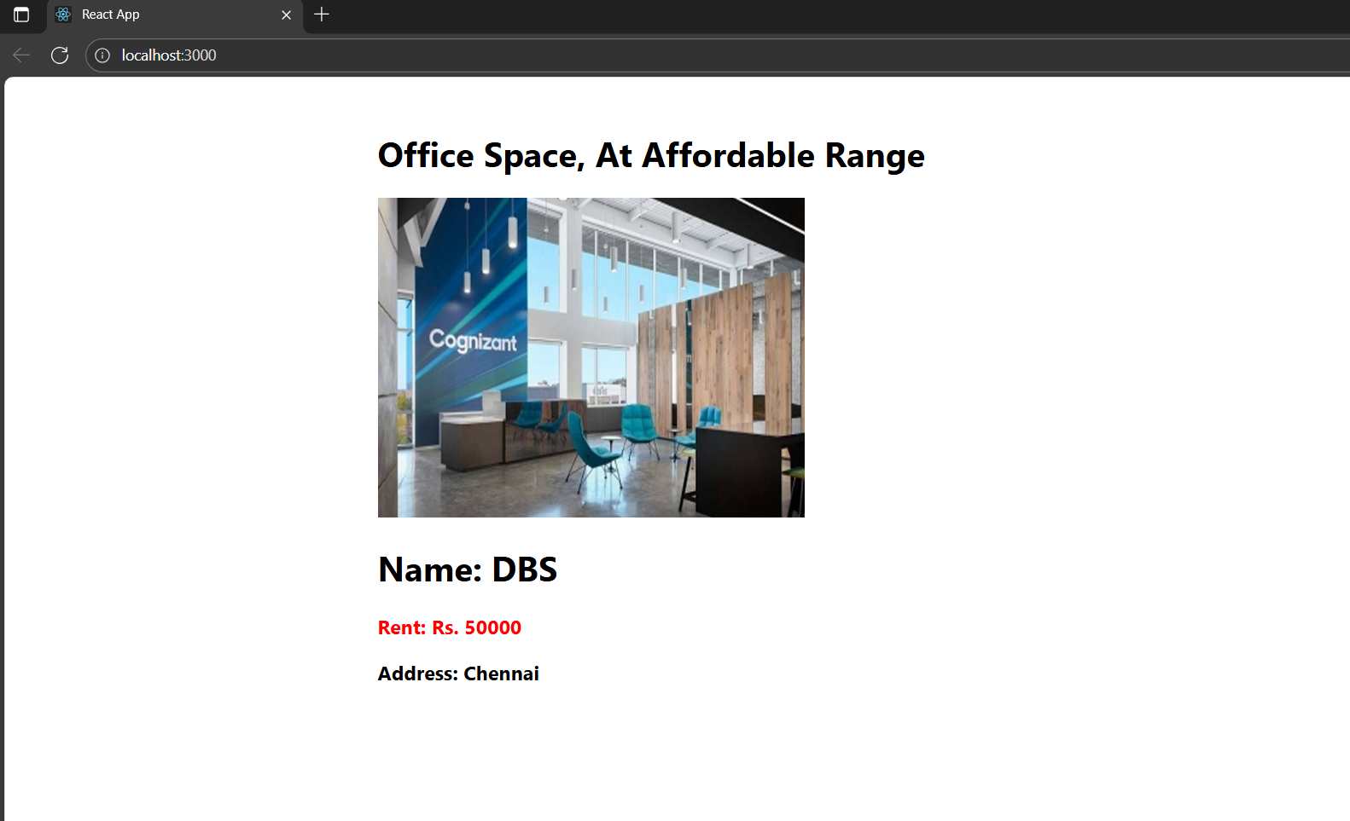

**11. ReactJS – HOL**

**i. created application “eventexamplesapp”**

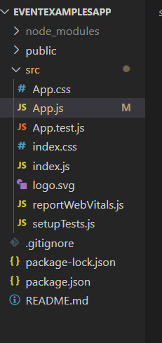

**ii. App.js to handle different Events**

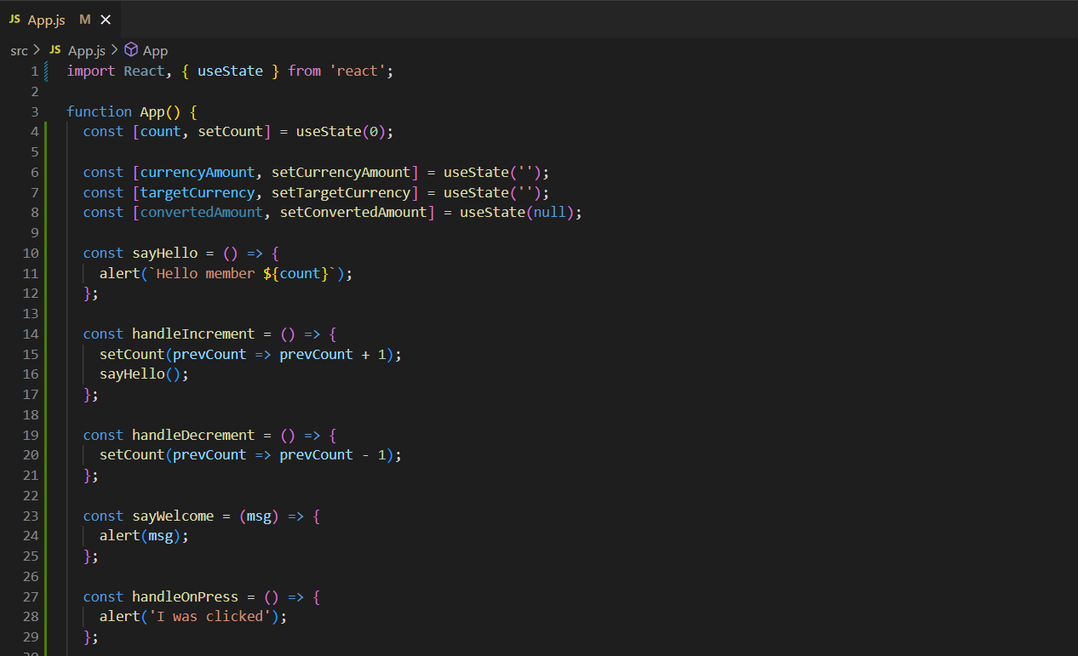

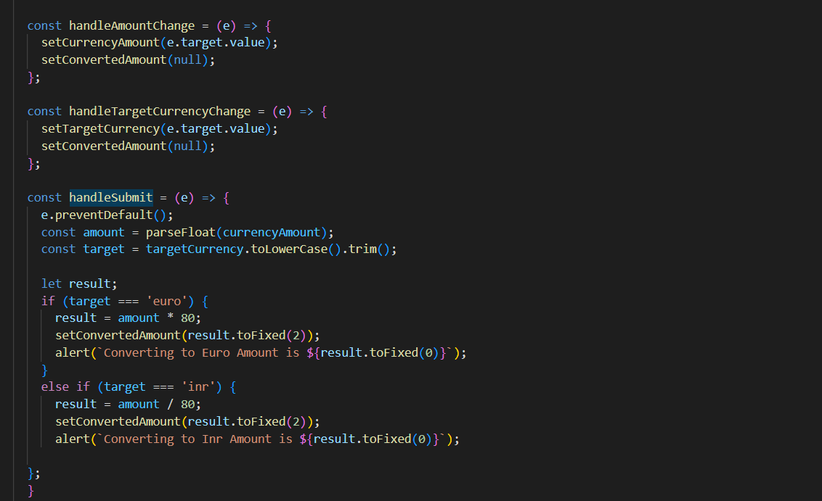

**-> Displaying**

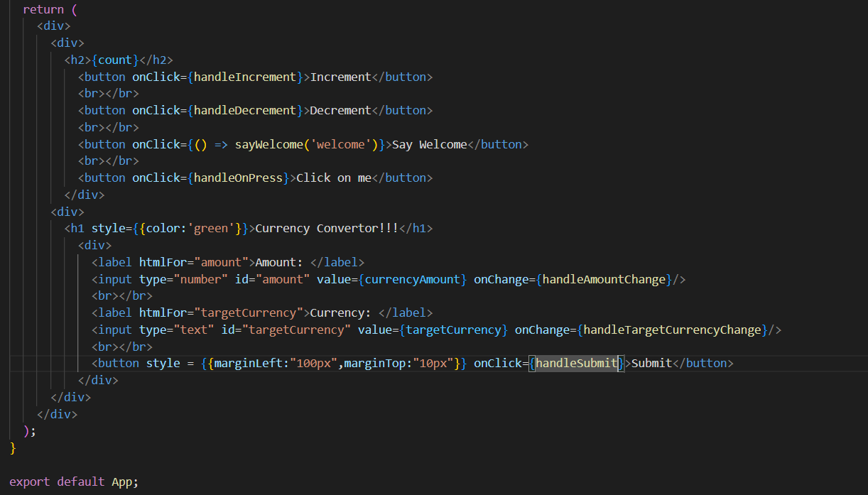

**iv. Output ScreenShots**

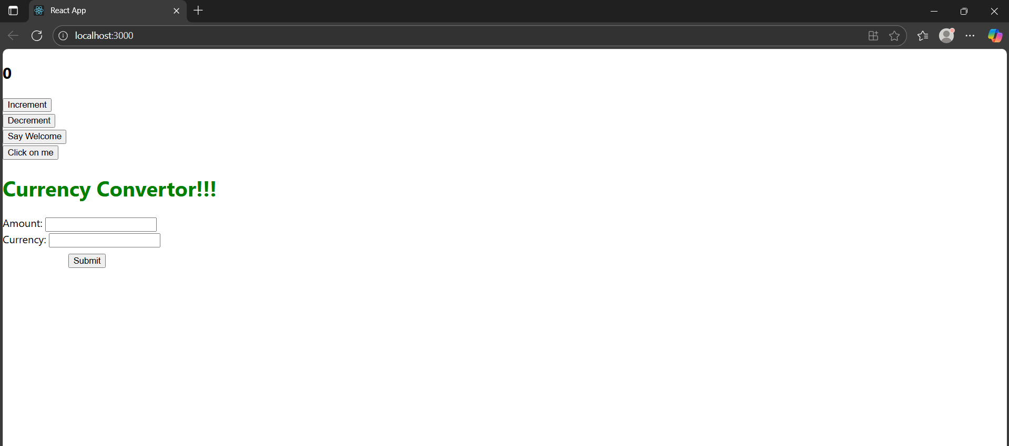

**-> Incrementing and Static Hello Message**

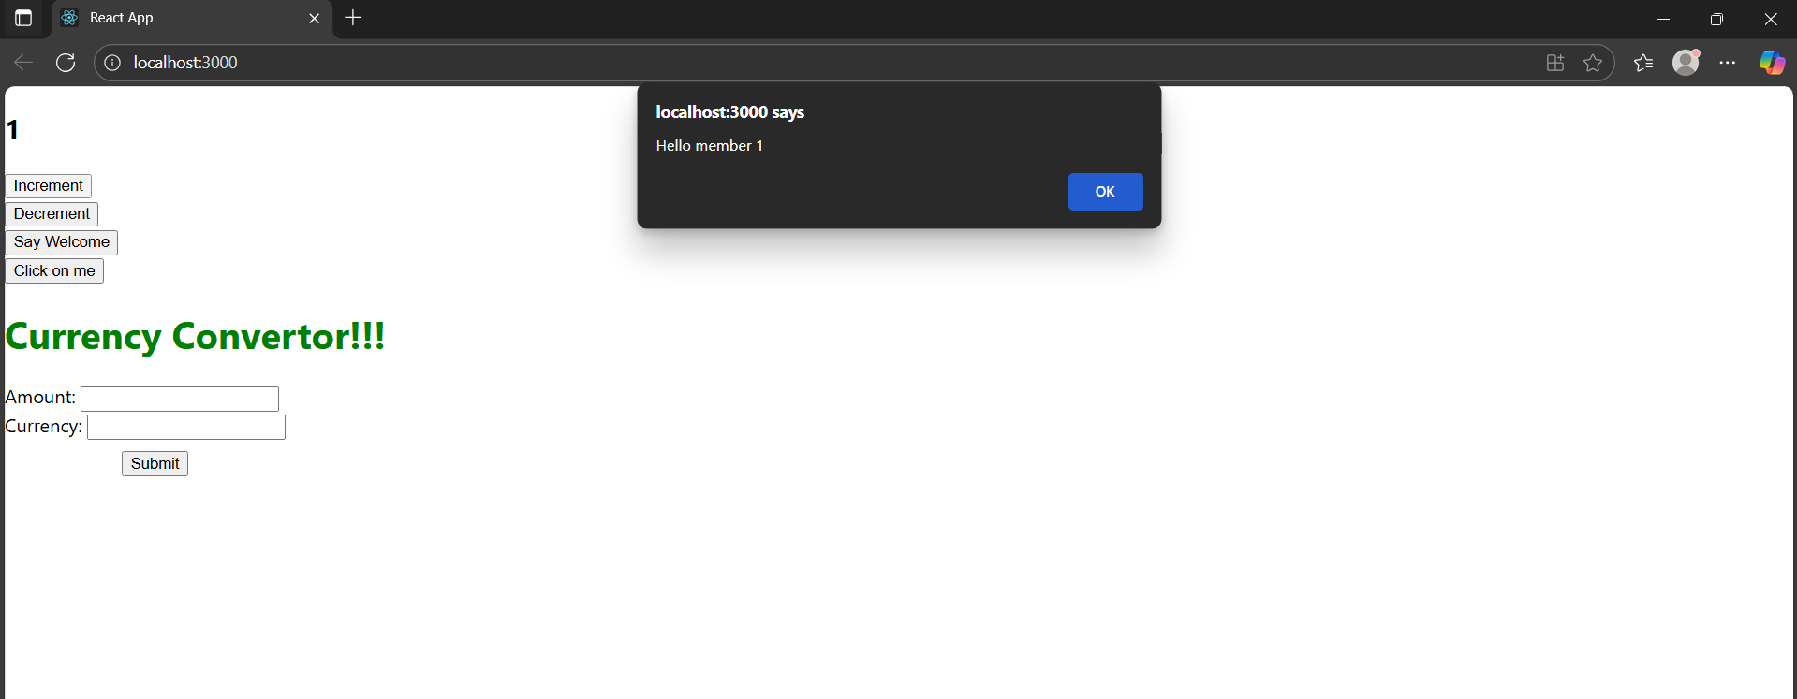

**-> welcome message**

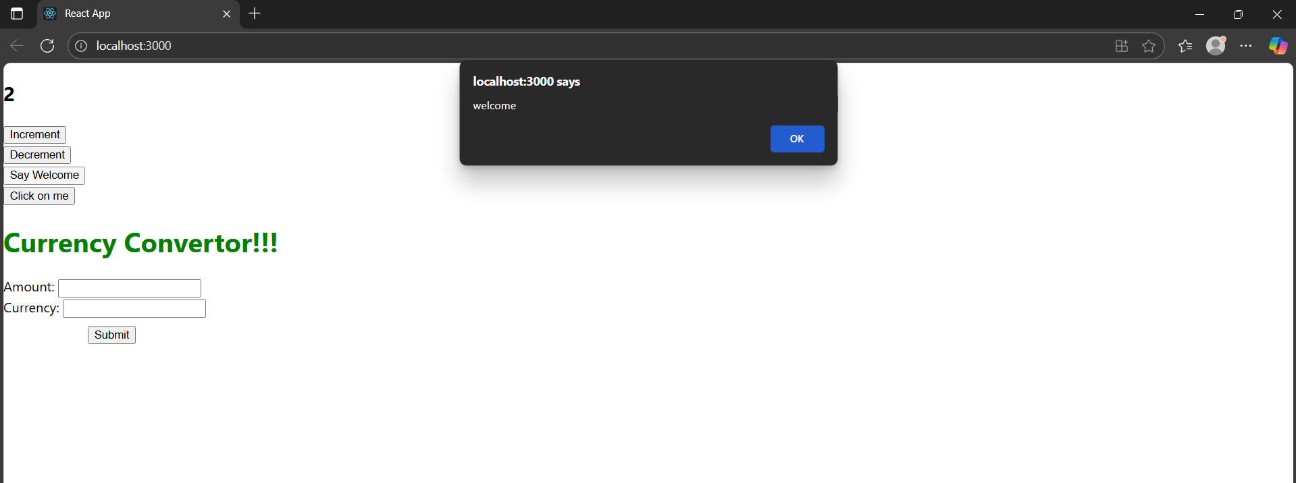

**-> Synthetic event OnPress to display “I was clicked” message**

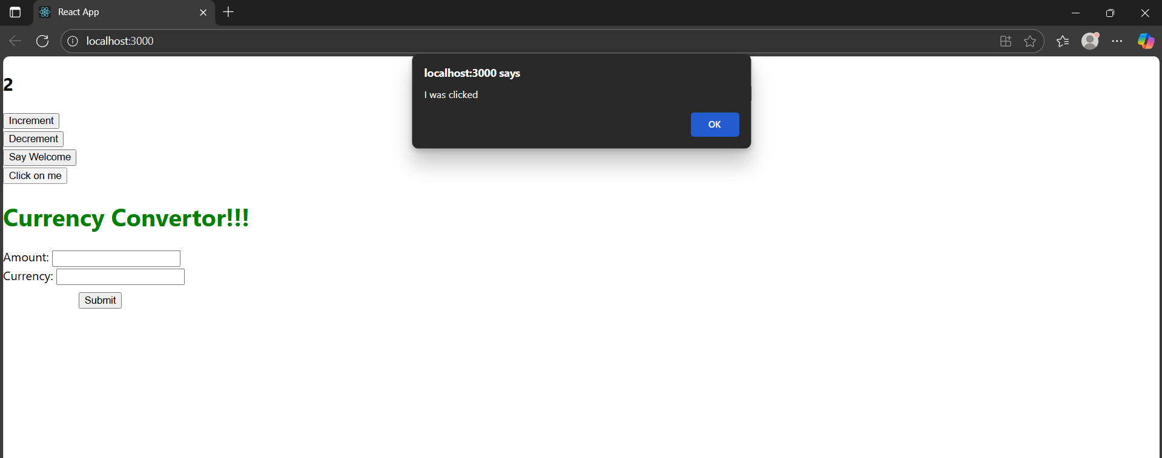

**-> Euro to Inr conversion**

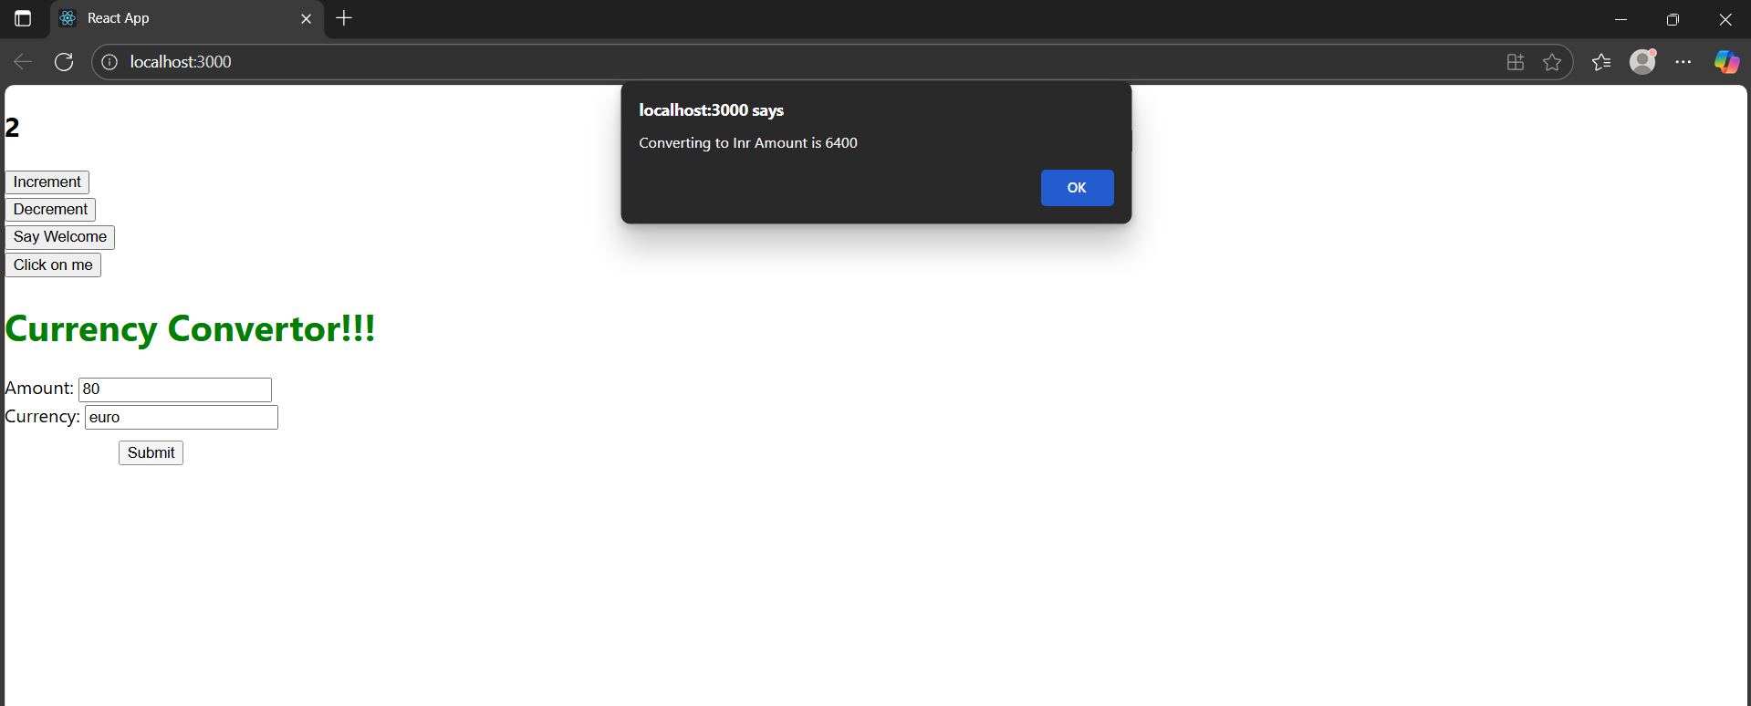

**-> Inr to Euro conversion**

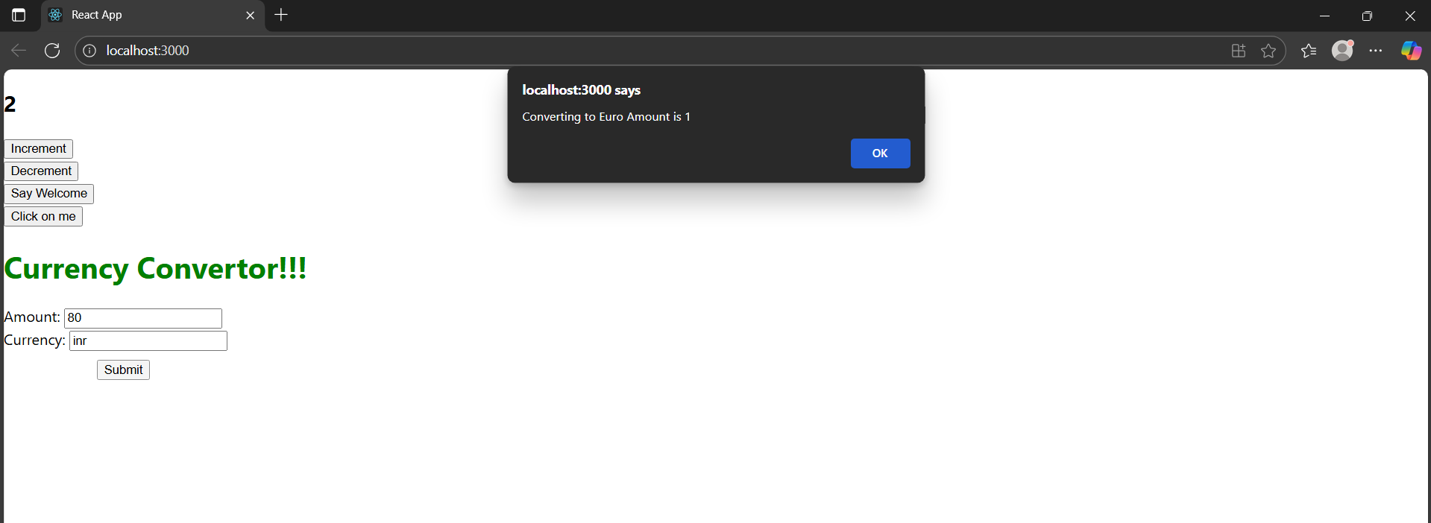

**12. ReactJS – HOL**

**i. creating application “ticketbookingapp”**

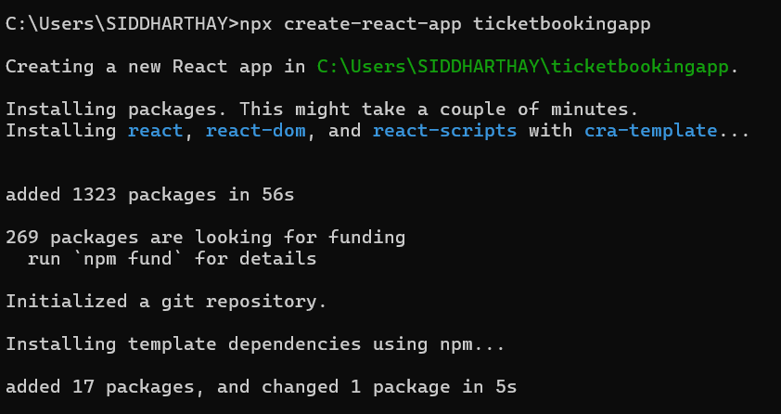

**ii. App.js**

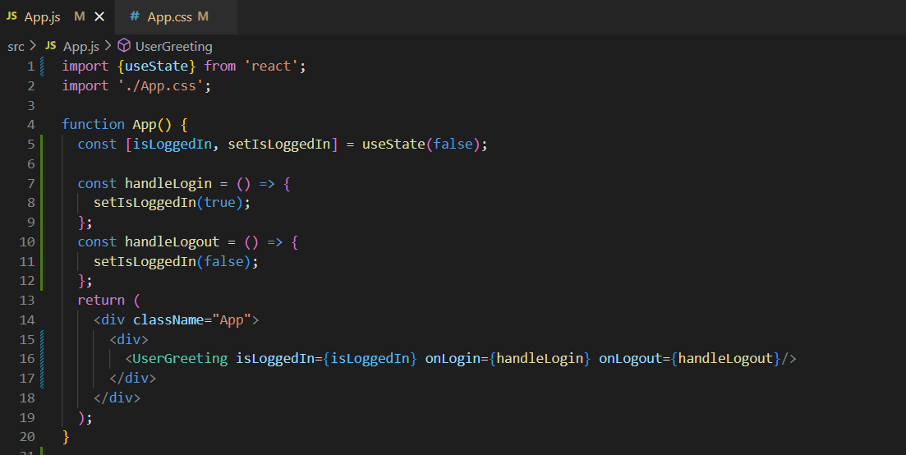

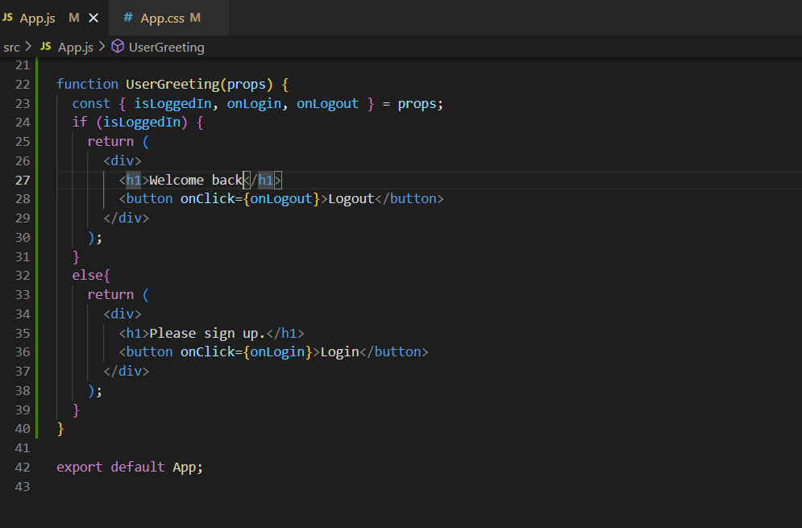

**iii. output before login**

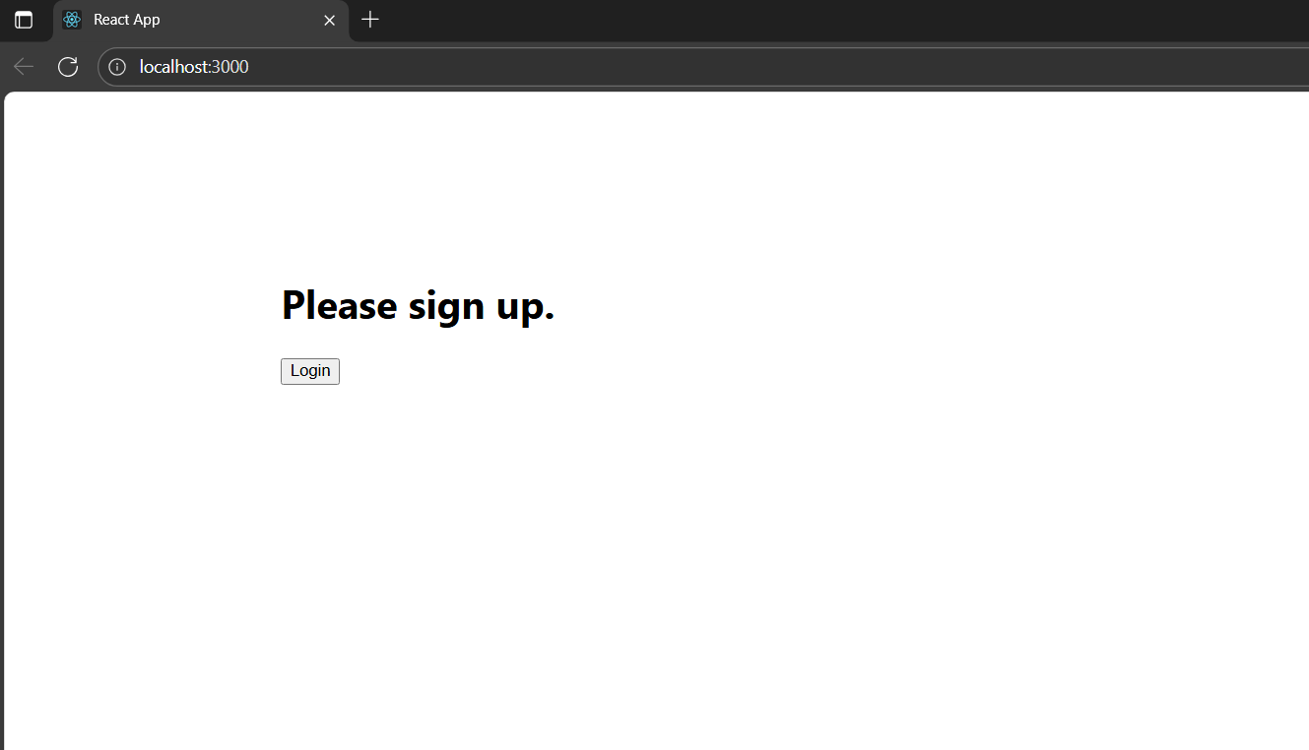

**iv. output after login**

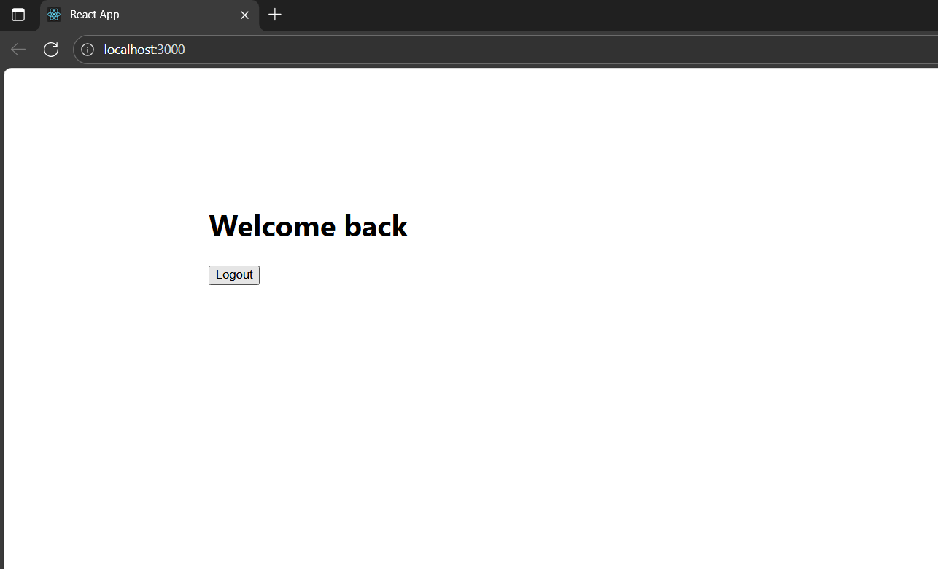

**13. ReactJS – HOL**

**i. creating application “bloggerapp”**

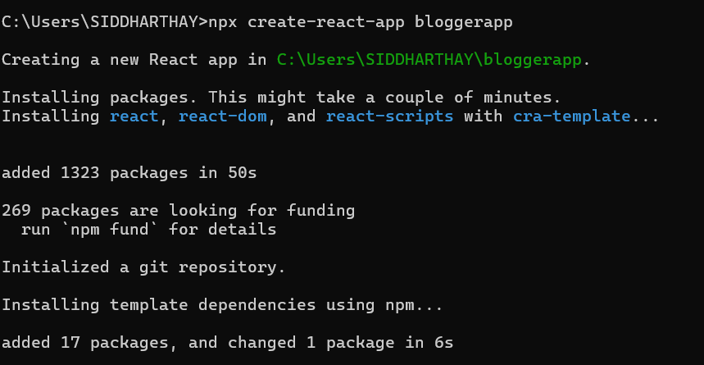

**ii. App.js implementing conditional rendering**

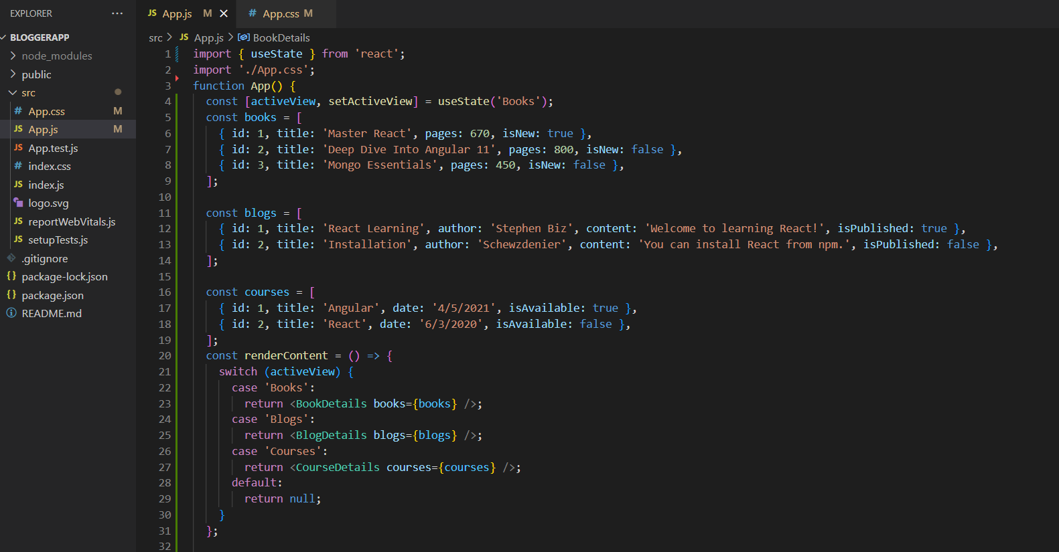

**-> setting the view based on buttonclick and rendering content**

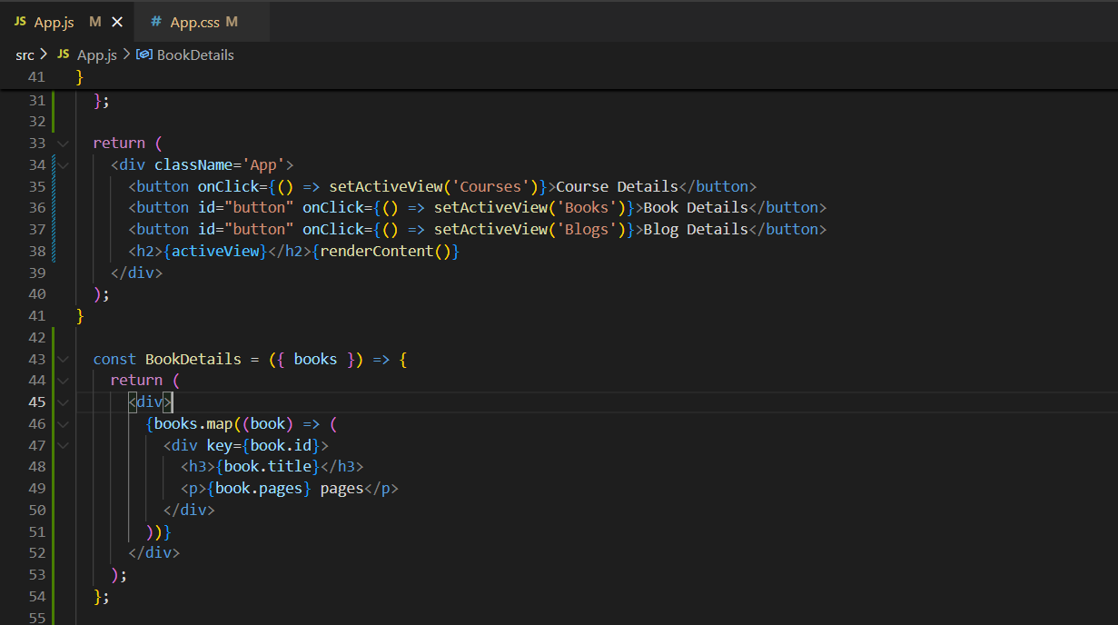

**-> 3 components (Books,Courses,Blogs)**

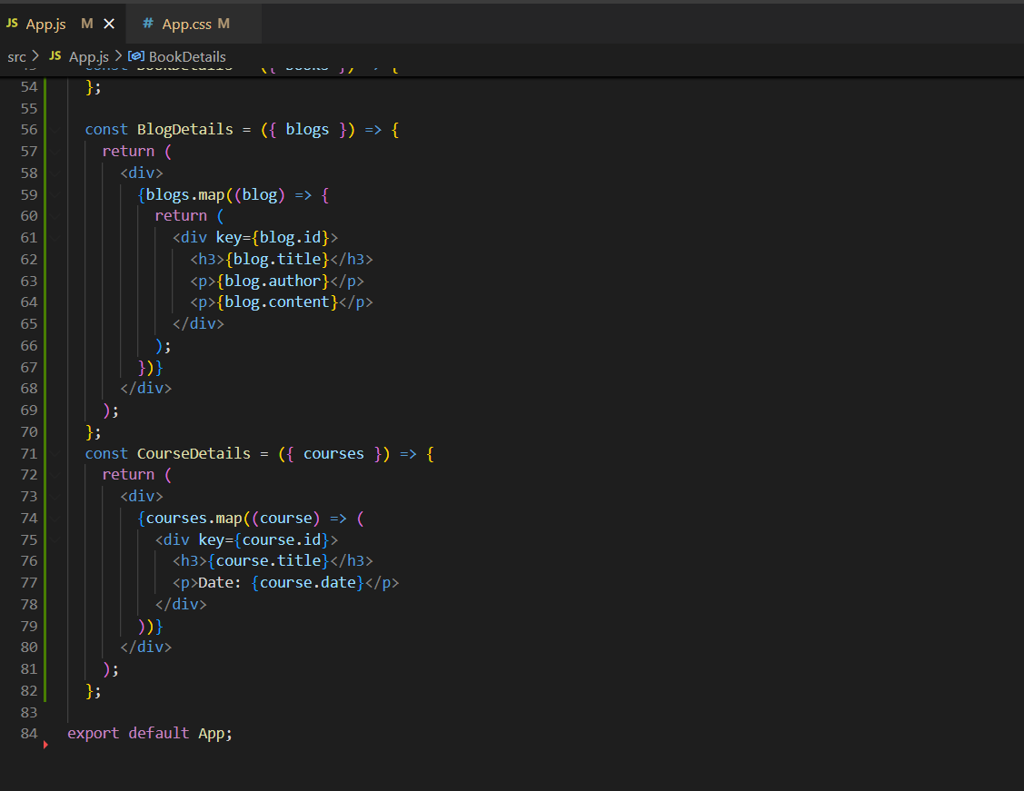

**iii. Initial output “Books”**

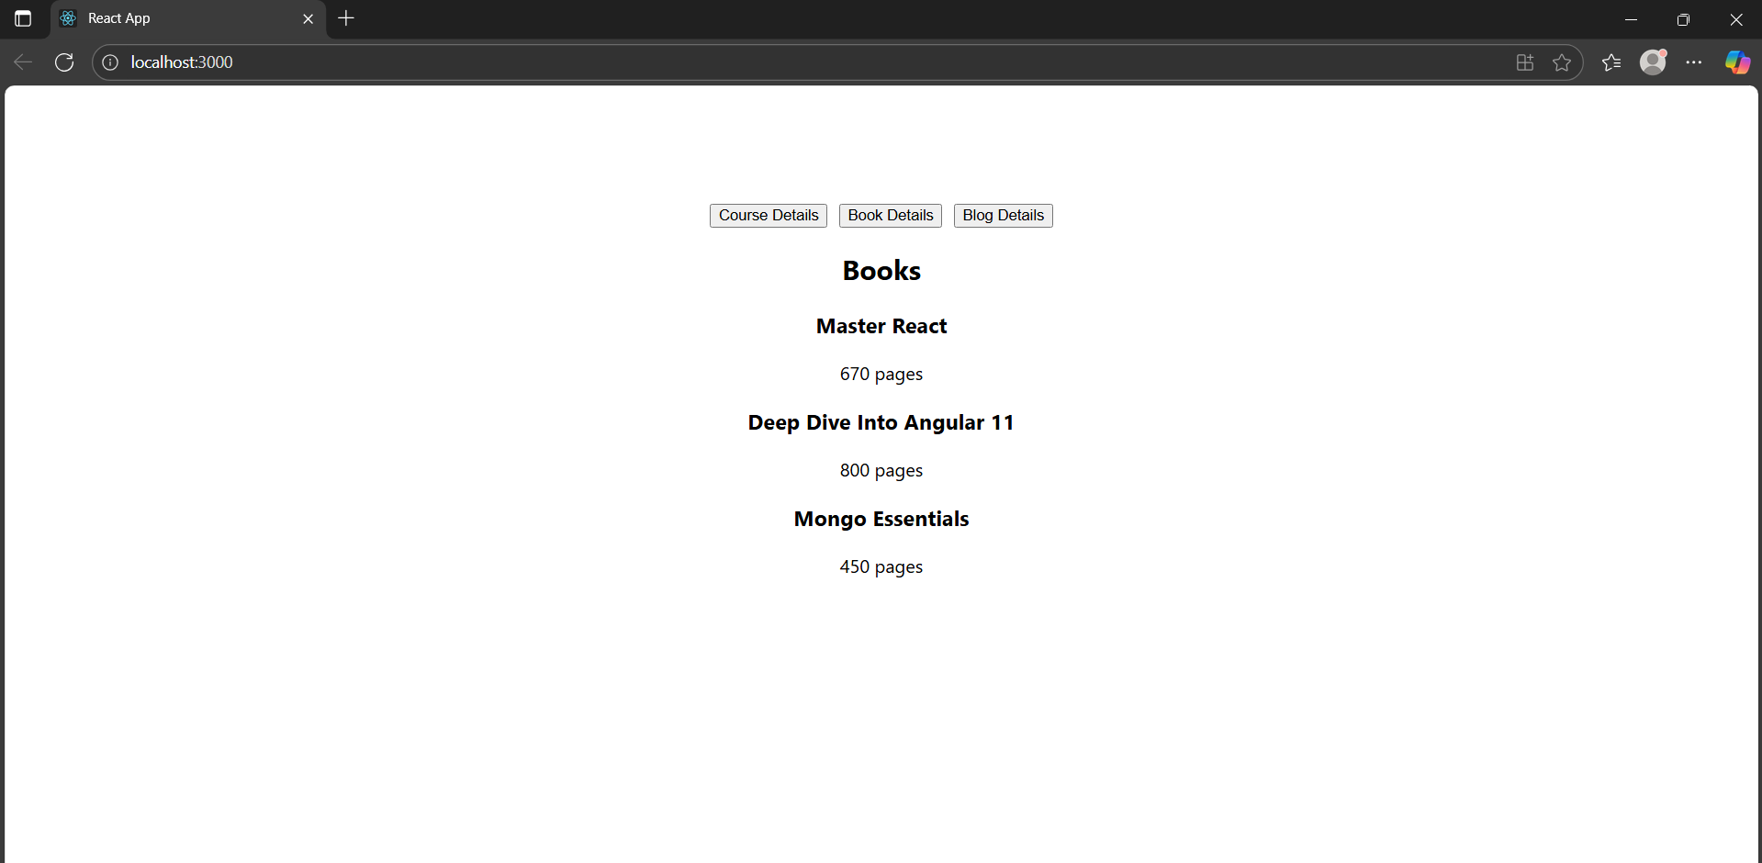

**-> conditional rendering “Courses”**

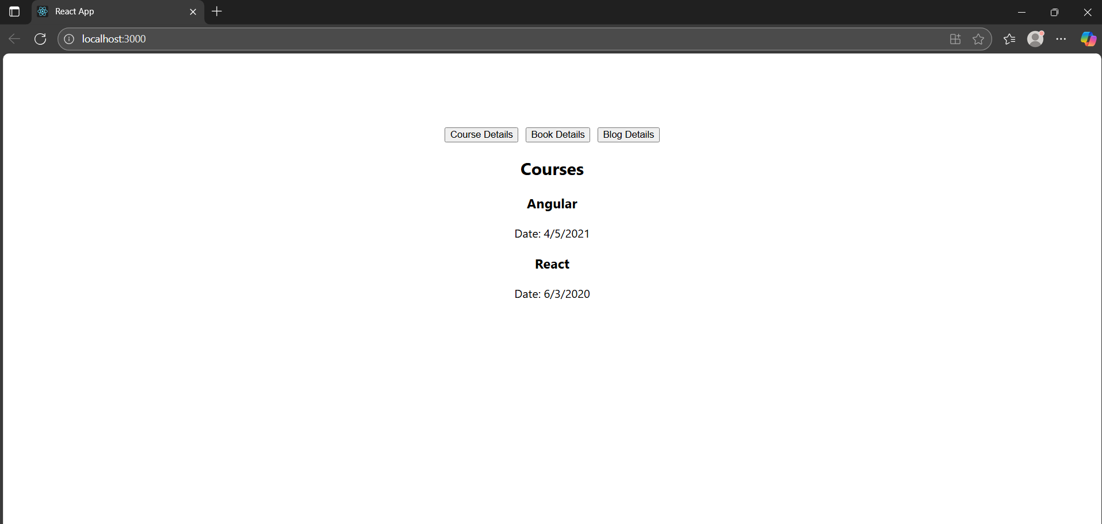

**-> conditional rendering “Blogs”**

