**WEEK 8**

**GIT**

**1. Git – HOL**

**i. checking if Git is properly installed or not**

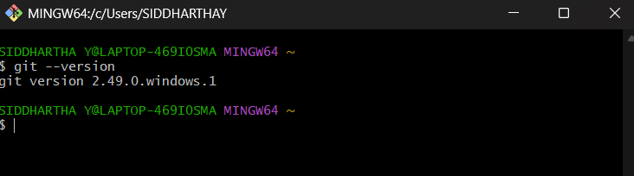

**ii. after configuring user details and integrating notepad++**

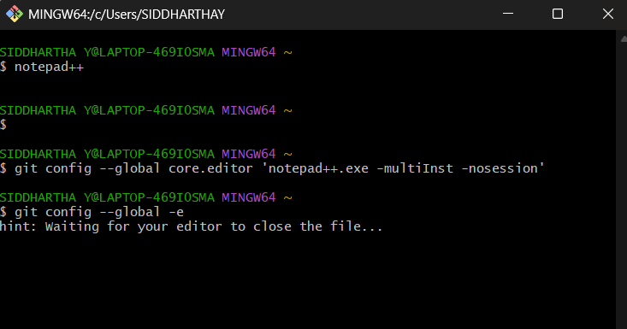

**iii. verifying the default editor**

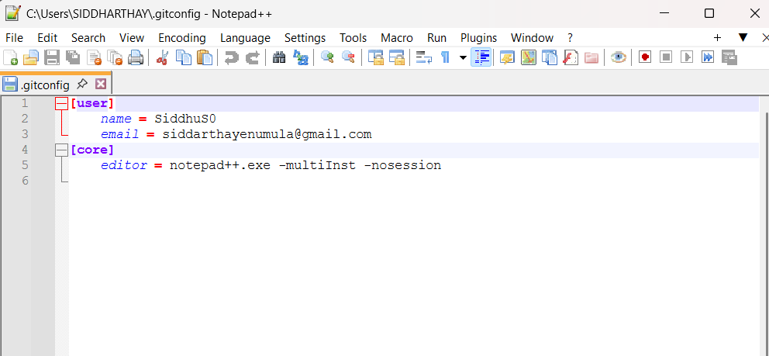

**iv. adding a file to source code repo**

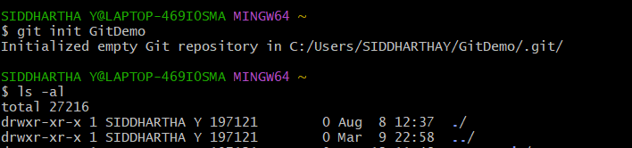

**V. creating a file “welcome.txt”**

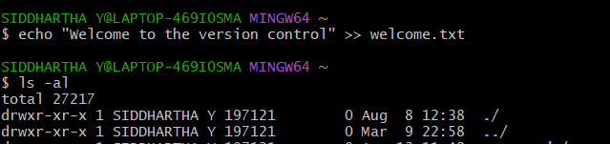 

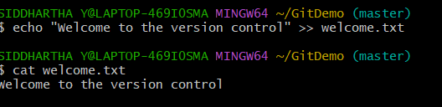

**vi. Checking the status**

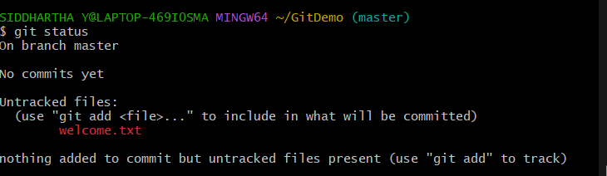

**vii. staging the changes**

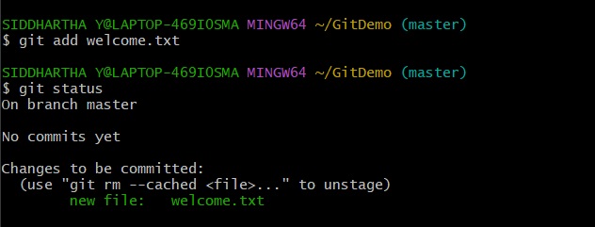

**viii. commiting it**

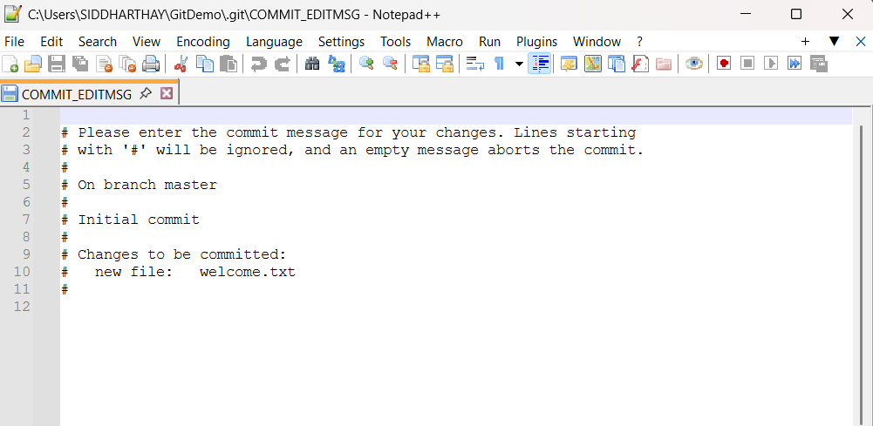

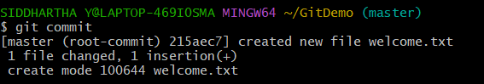

**ix. after signing up to GitLab and creating remote repo “GitDemo”**





**x. merging them and pushing it to the remote repo**

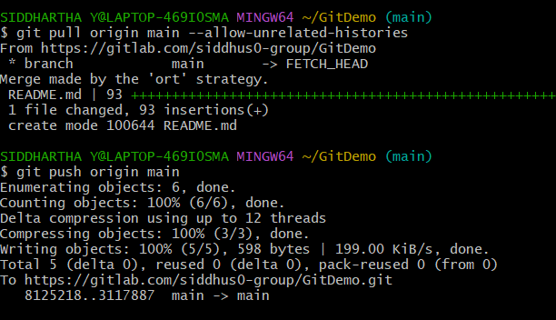

**Output:**

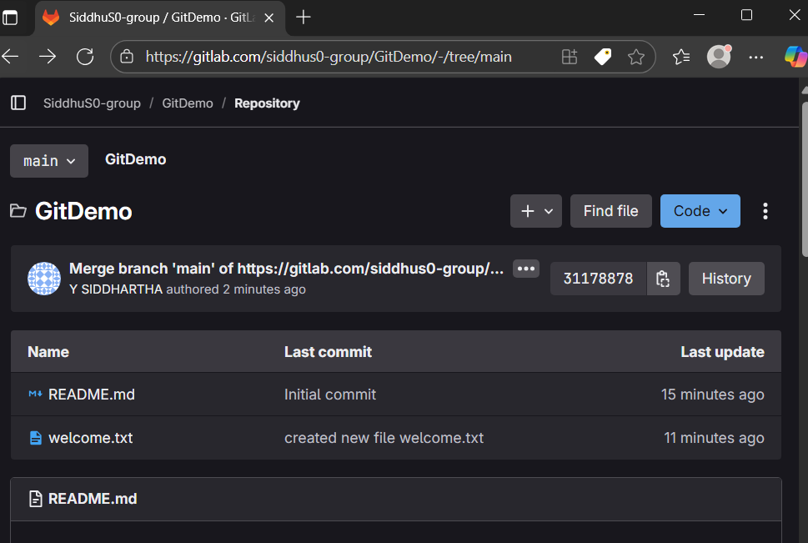

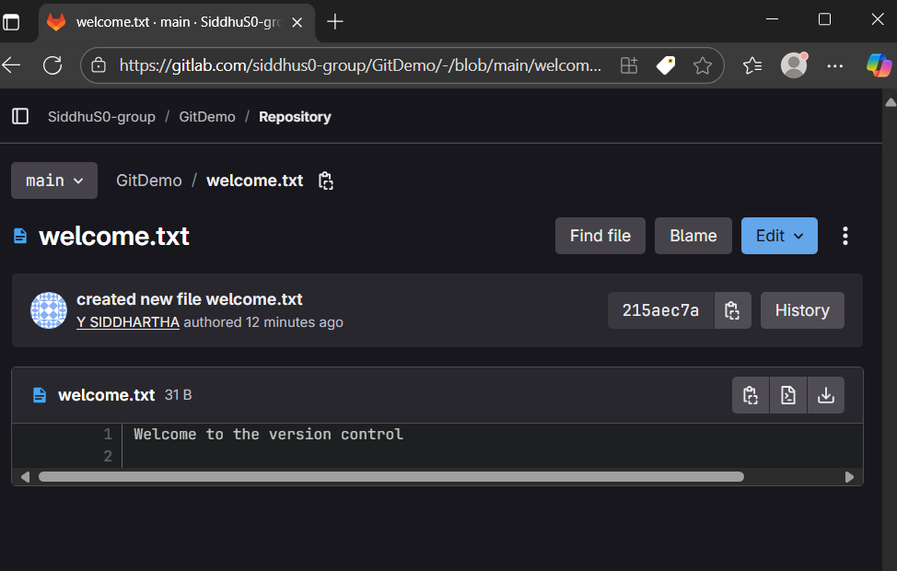

**2. Git – HOL**

**-> Implementing “git ignore” command to ignore un wanted files**

**-> created .log extension file and a log directory which are to be ignored**

**-> created a “.gitignore” file to ignore the unwanted files**

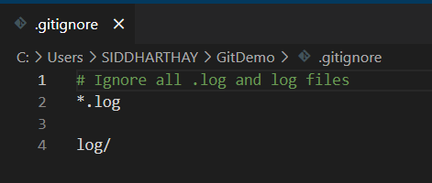

**-> checking the status and staging “.gitignore”**

**-> committing the changes**

**-> verifying through “git status“ that even though .log and log directory are not tracked git is ignoring them**

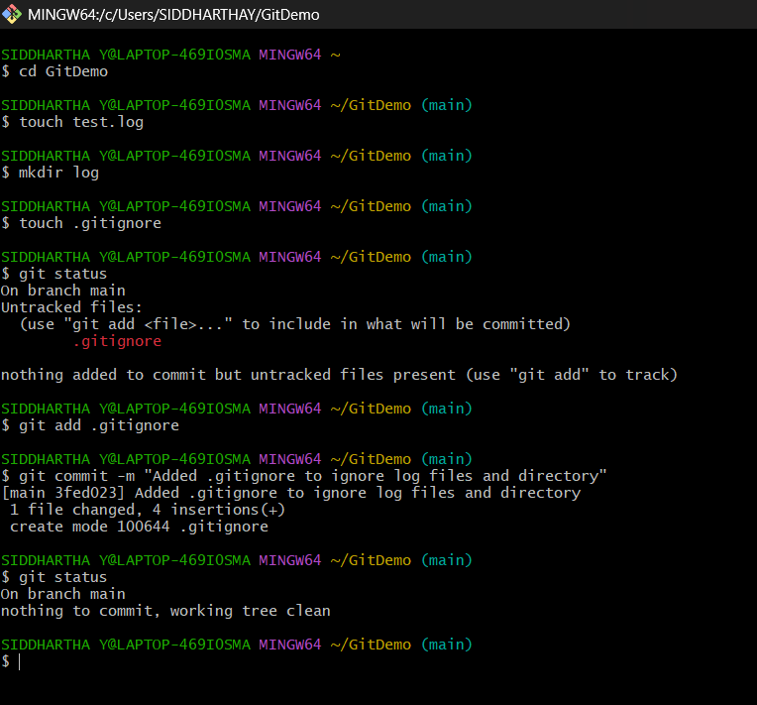

**3. Git – HOL**

**-> configuring p4mergetool for git**

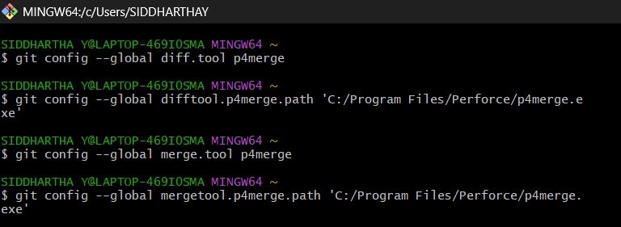

**-> Branching:**

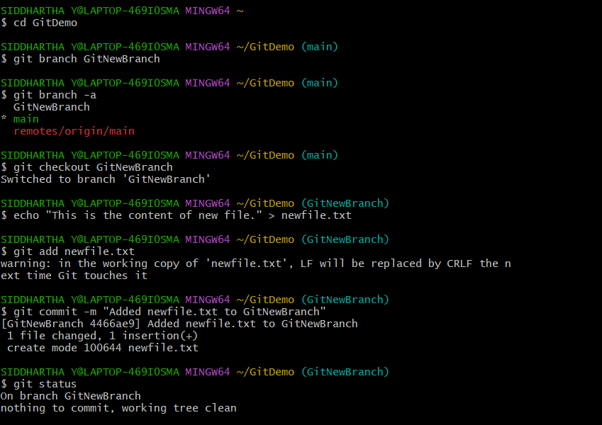

**-> Merging**

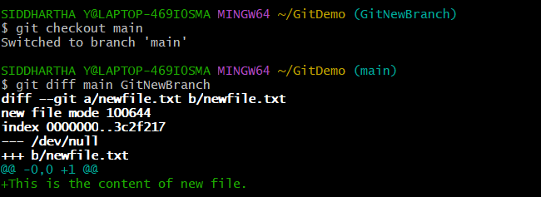

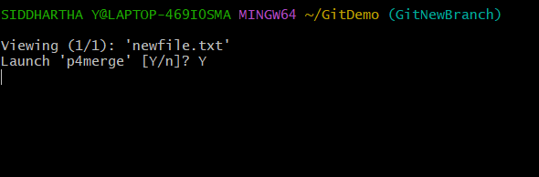

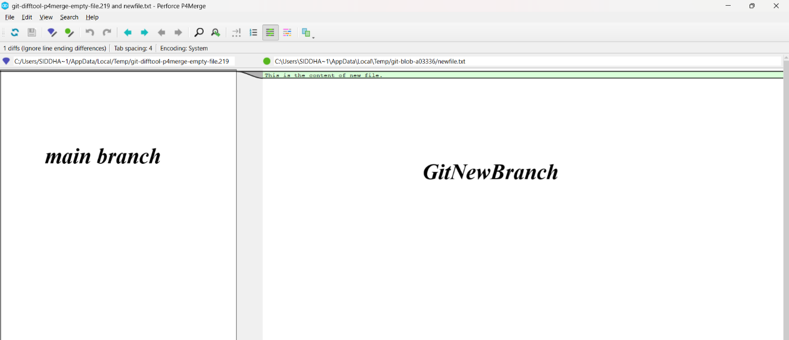

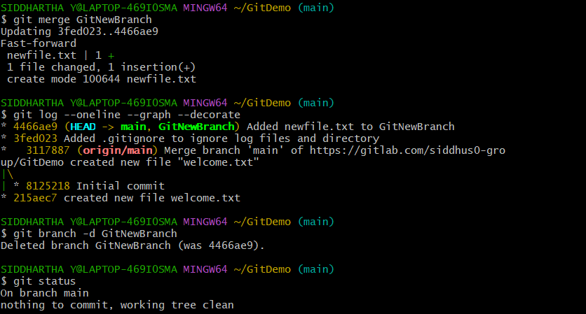

**4. Git – HOL**

**Steps (1 - 5)**

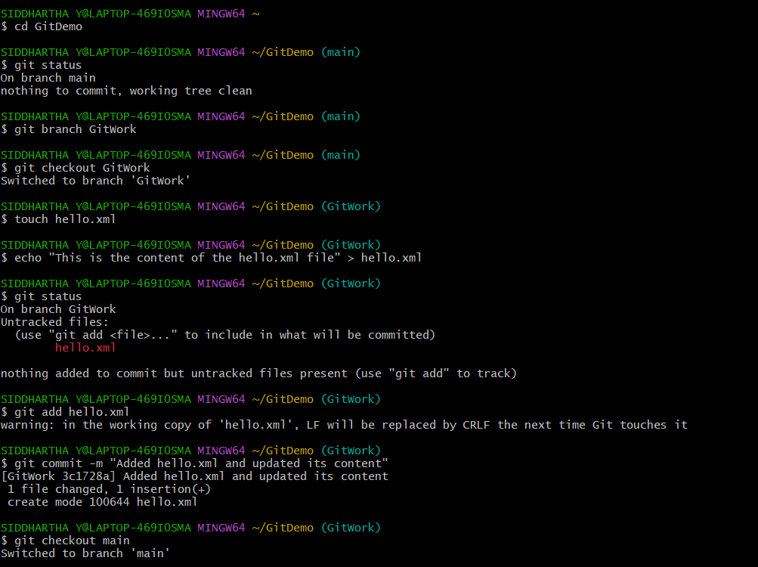

**Steps (6 - 8)**

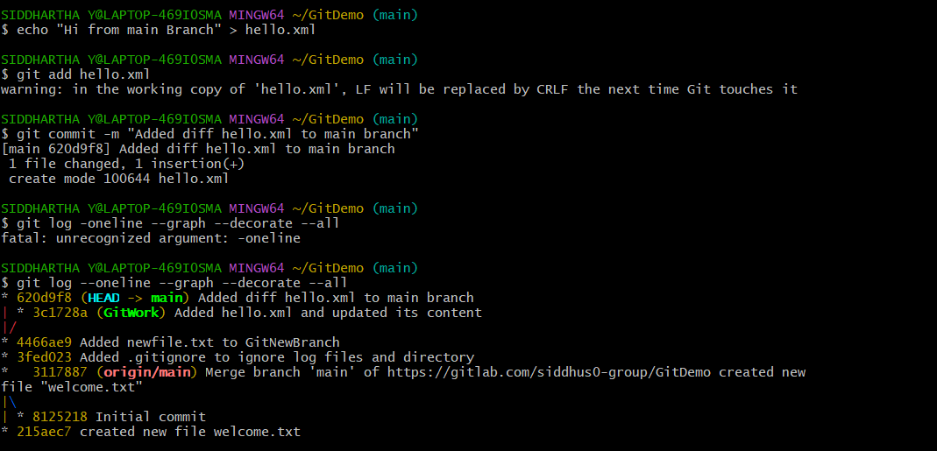

**Steps (9 - 10)**

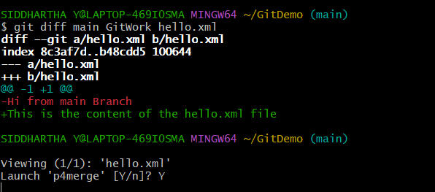

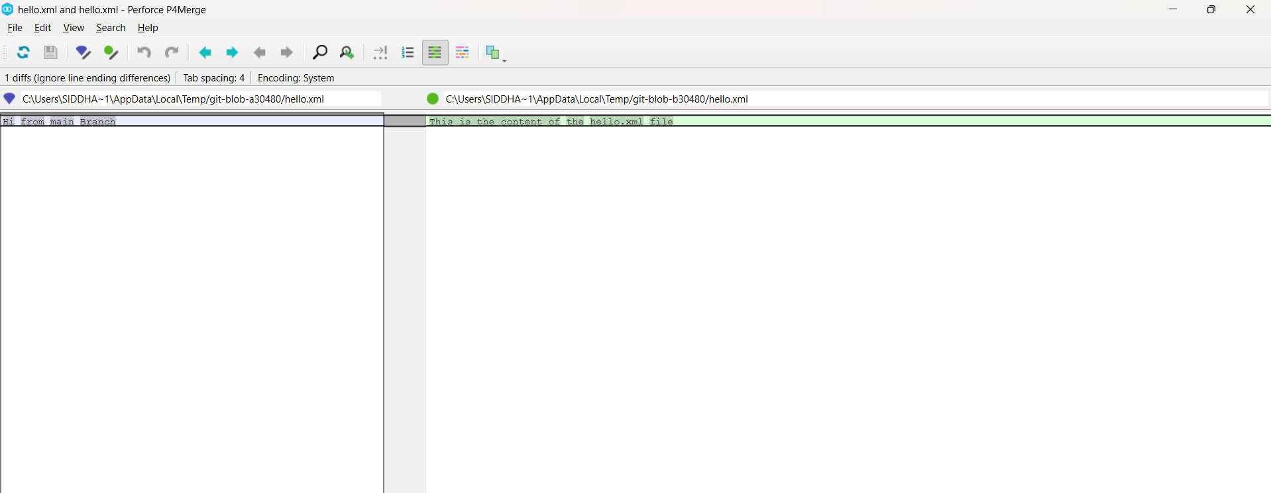

**Steps (11 - 13)**

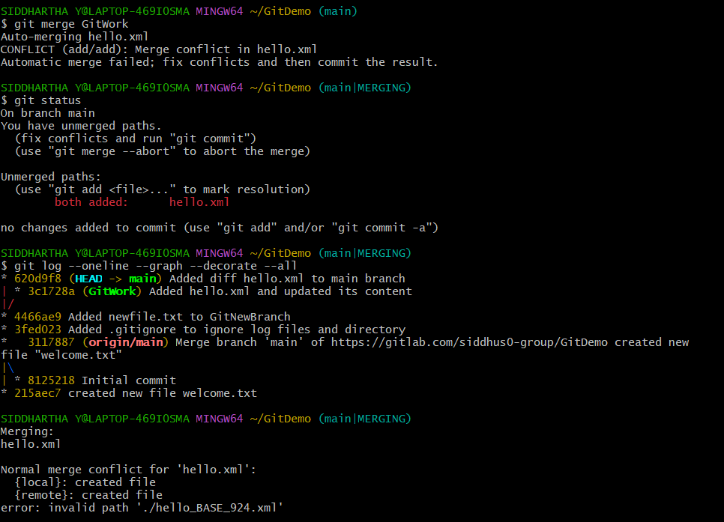

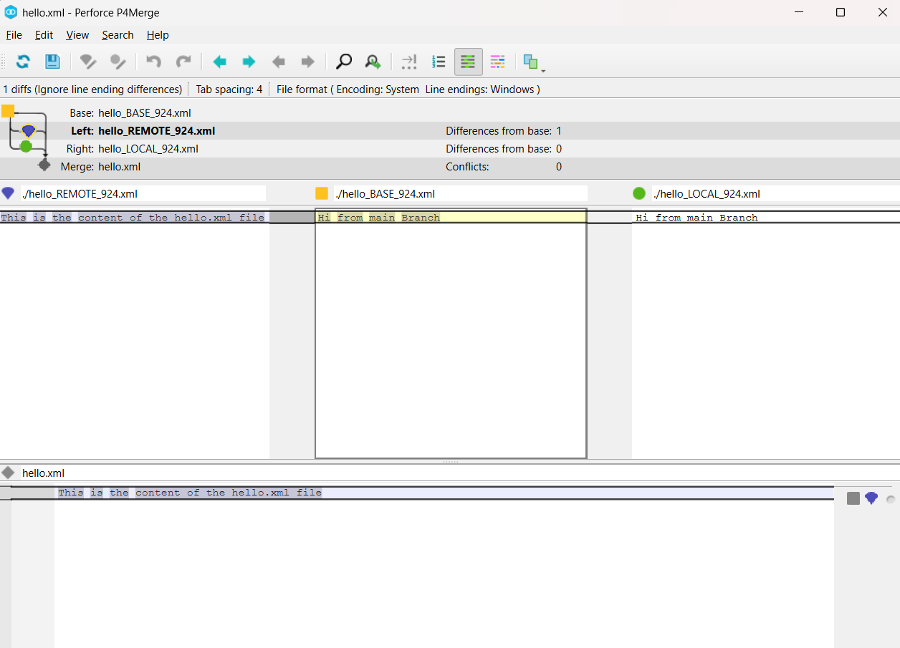

**Steps (14 - 19)**

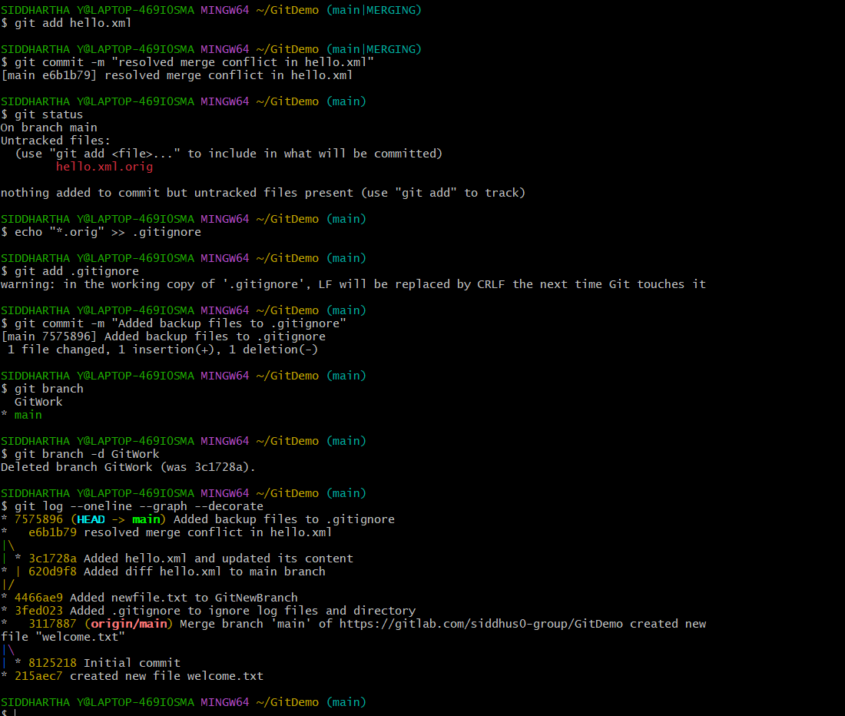

**5. Git – HOL**

**-> Since I have already updated the “Git-T03-HOL_002” there was nothing to push so I updated some new info and push it for this assignment**

