## Foreign Object Debris (FOD) Detection System Using AI Rob

**ABSTRACT**

* This project presents an innovative solution for runway inspection utilizing a AI-Drone equipped with an optical camera.
* The challenges faced by current methods of Foreign Object Debris (FOD) detection on airport runways, such as radar and stationary cameras, due to high false positive rates.
* The system employs an ESP32 microcontroller to provide real-time notifications to the ground station in the event of detecting foreign objects on the runway.
* The integration of Drone technology aims to enhance runway safety and improve efficiency in airport operations.
* Testing different machines to make sure they work well in all kinds of weather.
* The paper introduces a novel approach using Unmanned Aerial Vehicles (UAVs) equipped with RGB cameras and AI detectors trained using deep learning methods to detect FOD on runways.
* Remove the unwanted debris on runway using AI Drone and automatically identify the object.

## INTRODUCTION

* + Foreign Object Debris (FOD) is a critical safety concern in aviation due to its potential to damage aircraft and disrupt operations.
  + Current FOD detection methods like radar and stationary cameras have limitations, including high false-positive rates.
  + Integrating Unmanned Aerial Vehicles (UAVs) with Artificial Intelligence (AI) technology offers a promising solution for more accurate and efficient FOD detection on airport runways.
  + The combination of UAVs and AI can lead to improved detection capabilities, shorter runway closure times, and fewer disruptions for airports and airlines.
  + This innovative approach has the potential to revolutionize FOD detection practices in the aviation industry, enhancing safety and operational efficiency.
  + Using UAVs and AI for FOD detection can make airports safer, operations smoother, and overall efficiency better in the aviation industry.

LITERATURE SURVEY

|  |  |  |  |
| --- | --- | --- | --- |
| **S.NO** | **TITLE OF THE PAPER** | **AUTHOR & YEAR** | **METHODOLOGY** |
| 1 | Foreign Object Debris (FOD) Classification Through Material Recognition Using Deep Convolutional Neural Network  With Focus on Metal | Syeda Mahrukh Zainab &2023 | The methodology involved utilizing Deep Convolutional Neural Networks (DCNN) for material recognition, focusing on metal objects commonly found in Foreign Object Debris (FOD) at airports, achieving an average classification accuracy of 92%. |
| 2 | Foreign Object Debris Material Recognition base on Ensemble Learning Algorithm | Dina R.Shaker and Ayad R.Abbas & 2022 | The methodology involved combining LDA and GLCM feature extraction methods to extract 8 features for image classification. Machine learning algorithms like KNN, Adaboost, and Random Forest Tree were then used to classify FOD materials with precision rates ranging from 94.2% to 99.7% |
| 3 | Deep learning-based foreign object detection method for airport runway safety | Zhe Wang  & July 5, 2022. | The methodology involves designing a specialized dataset for airport runway scenarios and implementing deep learning networks for detection and recognition tasks. Validation experiments are conducted to assess the system's performance and accuracy. |

# PROBLEM DEFINITION

* + - The aviation industry faces challenges with traditional runway inspection methods, which may lead to delays, safety concerns, and operational inefficiencies.
    - Manual inspections are limited in speed and coverage,

making it imperative to explore innovative solutions.

* + - The project addresses the need for a more advanced and automated approach to runway inspections by integrating AI-Drone technology and real-time communication.
    - By addressing these challenges, the proposed system aims to provide a more reliable and efficient solution for runway inspections, ensuring the safety and smooth operation of airports.

EXISTING METHOD

* Mechanical Sweepers: Utilize mechanical sweepers designed specifically for airports to collect debris efficiently
* Blowers: Airports can employ blowers to remove dust, debris, and FOD from runways and taxiways
* Manual Sweeping: Manual sweeping with hand brooms or airfield sweepers can effectively remove FOD from critical areas
* Periodic Cleaning: Implement regular cleaning schedules using FOD razor sweepers to keep runways, taxiways, and aprons clear of small debris
* Detection Systems: Install detection systems that use sweepers to collect FOD and deposit it into designated areas for disposal

# DRAWBACKS IN EXISTING

* + Removal of Human Oversight: In some contexts, the removal of humans from decision-making processes can lead to ethical concerns and decreased accountability. Autonomous systems may lack the ability to consider nuanced ethical and moral considerations, leading to potential negative outcomes
  + Reduced Human Interaction: Automation and AI-driven processes may lead to reduced human interaction, which can negatively impact customer experiences and relationships. Lack of human touch and empathy in certain contexts may result in dissatisfaction among stakeholders
  + Utilization of OpenCV: Developers often use OpenCV, a popular computer vision library, to implement stationary object detection algorithms. OpenCV provides tools and functions for image processing, including methods for detecting stationary objects in real-time applications

# PROPOSED METHOD

* + The proposed method involves equipping a Drone with an optical camera to conduct automated runway inspections.
  + The Drone is programmed to autonomously navigate the runway, capturing images with the optical camera.
  + These images are then processed using computer vision algorithms to detect foreign objects.
  + In case of detection, the ESP32 microcontroller triggers a notification to the ground station, alerting personnel to the presence of foreign objects on the runway.
  + By integrating these components, the project ensures a timely response to potential hazards on the runway, contributing to the overall safety and efficiency of airport operations.

**Component Details:**

* **ESP32**
* **Electromagnet**
* **GPS**
* **Relay**
* **Buzzer**
* **Motor**
* **Battery**

EXECUTION

* + - Drone Navigation: The Drone is programmed to follow a predefined path for systematic coverage of the entire runway.
    - Image Capture: The optical camera captures images of the runway surface during the Drone's flight.
    - Image Processing: Computer vision algorithms analyze the captured images to identify foreign objects based on predefined criteria.
    - ESP32 Notification: Upon detection, the ESP32 microcontroller sends a real-time notification to the ground station.

**Drone FOD Block diagram**

Motor 2

RELAY 3

RELAY 2

Motor1

REL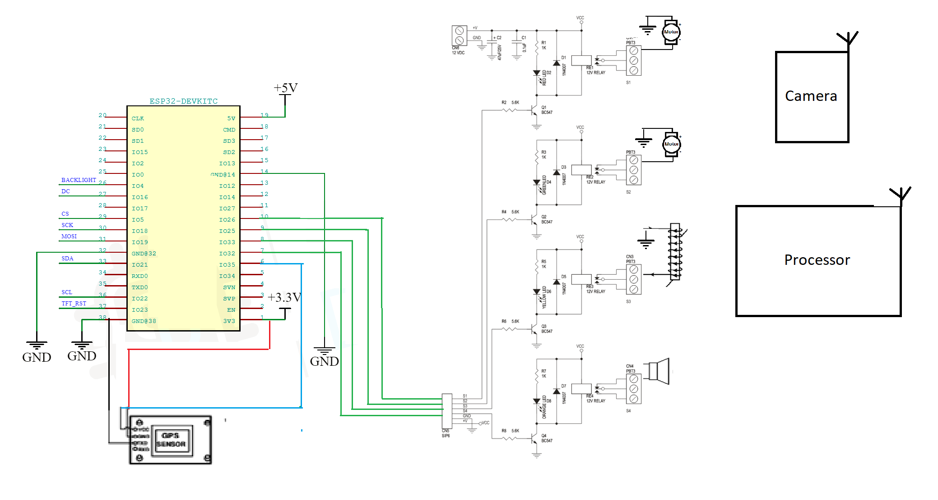AY 1

ESP32

Electromagnet

Battery

Ground station

Processor

**Drone FOD Circuit diagram**

ESP-32

# Product Overview

ESP32 is a single 2.4 GHz Wi-Fi-and-Bluetooth combo chip designed with the TSMC low-power 40 nm technology. It is designed to achieve the best power and RF performance, showing robustness, versatility and reliability in a wide variety of applications and power scenarios.

The ESP32 series of chips includes ESP32-D0WD-V3, ESP32-D0WDR2-V3, ESP32-U4WDH, ESP32-S0WD [(NRND)](https://www.espressif.com/en/products/longevity-commitment?id=nrnd), ESP32-D0WDQ6-V3 [(NRND)](https://www.espressif.com/en/products/longevity-commitment?id=nrnd), ESP32-D0WD [(NRND)](https://www.espressif.com/en/products/longevity-commitment?id=nrnd), and ESP32-D0WDQ6 [(NRND)](https://www.espressif.com/en/products/longevity-commitment?id=nrnd), among

which,

* ESP32-S0WD [(NRND)](https://www.espressif.com/en/products/longevity-commitment?id=nrnd), ESP32-D0WD [(NRND)](https://www.espressif.com/en/products/longevity-commitment?id=nrnd), and ESP32-D0WDQ6 [(NRND)](https://www.espressif.com/en/products/longevity-commitment?id=nrnd) are based on chip revision v1 or chip revision v1.1.
* ESP32-D0WD-V3, ESP32-D0WDR2-V3, ESP32-U4WDH, and ESP32-D0WDQ6-V3 [(NRND)](https://www.espressif.com/en/products/longevity-commitment?id=nrnd) are based on

chip revision v3.0 or chip revision v3.1.

For details on part numbers and ordering information, please refer to Section 1 ESP32 Series Comparison. For details on chip revisions, please refer to [*ESP32 Chip Revision v3.0 User Guide*](https://www.espressif.com/sites/default/files/documentation/ESP32_ECO_V3_User_Guide__EN.pdf)and

[*ESP32 Series SoC Errata*](https://www.espressif.com/sites/default/files/documentation/eco_and_workarounds_for_bugs_in_esp32_en.pdf).

The functional block diagram of the SoC is shown below.



In-Package Flash or PSRAM

SPI

I2C I2S SDIO UART

TWAI® ETH

RMT PWM

Touch sensor DAC ADC

Timers

Bluetooth link controller

Bluetooth baseband

Wi-Fi MAC

Wi-Fi baseband

RF

receive

Clock generator

RF

transmit

Core and memory

2 (or 1) x Xtensa® 32-bit LX6 Microprocessors

Cryptographic hardware acceleration

SHA

RSA

ROM

SRAM

AES

RNG

RTC

PMU

ULP

coprocessor

Recovery memory

ESP32 Functional Block Diagram

## Features

Wi-Fi

* 802.11b/g/n
* 802.11n (2.4 GHz), up to 150 Mbps
* WMM
* TX/RX A-MPDU, RX A-MSDU
* Immediate Block ACK
* Defragmentation
* Automatic Beacon monitoring (hardware TSF)
* 4 × virtual Wi-Fi interfaces
* Simultaneous support for Infrastructure Station, Soft AP, and Promiscuous modes

Note that when ESP32 is in Station mode, performing a scan, the Soft AP channel will be changed.

* Antenna diversity

Bluetooth®

* Compliant with Bluetooth v4.2 BR/EDR and Bluetooth LE specifications
* Class-1, class-2 and class-3 transmitter without external power amplifier
* Enhanced Power Control
* • +9 dBm transmitting power
* NZIF receiver with –94 dBm Bluetooth LE sensitivity
* Adaptive Frequency Hopping (AFH)
* Standard HCI based on SDIO/SPI/UART
* High-speed UART HCI, up to 4 Mbps
* Bluetooth 4.2 BR/EDR and Bluetooth LE dual mode controller
* Synchronous Connection-Oriented/Extended (SCO/eSCO)
* CVSD and SBC for audio codec
* Bluetooth Piconet and Scatternet
* Multi-connections in Classic Bluetooth and Bluetooth LE
* Simultaneous advertising and scanning

CPU and Memory

* Xtensa® single-/dual-core 32-bit LX6 microprocessor(s)
* CoreMark® score: 1 core at 240 MHz: 504.85 CoreMark; 2.10 CoreMark/MHz

Clocks and Timers

* Internal 8 MHz oscillator with calibration
* Internal RC oscillator with calibration
* External 2 MHz ~ 60 MHz crystal oscillator (40 MHz only for Wi-Fi/Bluetooth functionality)
* External 32 kHz crystal oscillator for RTC with calibration
* Two timer groups, including 2 × 64-bit timers and 1 × main watchdog in each group
* One RTC timer
* RTC watchdog

Advanced Peripheral Interfaces

* 34 × programmable GPIOs
  + 5 strapping GPIOs
  + 6 input-only GPIOs
  + 6 GPIOs needed for in-package flash/PSRAM (ESP32-D0WDR2-V3, ESP32-U4WDH)
* 12-bit SAR ADC up to 18 channels
* 2 × 8-bit DAC
* 10 × touch sensors
* 4 × SPI
* 2 × I2S
* 2 × I2C
* 3 × UART
* 1 host (SD/eMMC/SDIO)

## Pin Layout

CAP1 CAP2 VDDA XTAL_P XTAL_N VDDA GPIO21 UОTXD UОRXD GPIO22 GPIO19

VDD3P3_CPU

VDDA 1

48

47

46

45

44

43

42

41

40

39

38

37

LNA_IN 2

VDD3P3 3

VDD3P3 4

SENSOR_VP 5

SENSOR_CAPP 6

SENSOR_CAPN 7

SENSOR_VN 8

CHIP_PU 9

VDET_1 10

36 GPIO23

35 GPIO18

ESP32 49 GND

34 GPIO5

33 SD_DATA_1

32 SD_DATA_О

31 SD_CLK

30 SD_CMD

29 SD_DATA_3

28 SD_DATA_2

27 GPIO17

VDET_2 11

32K_XP 12

26 VDD_SDIO

32K_XN GPIO25 GPIO26 GPIO27 MTMS MTDI

VDD3P3_RTC

MTCK

MTDO GPIO2 GPIOО GPIO4

25 GPIO16

13

14

15

16

17

18

19

20

21

22

23

24

VDDA LNA_IN VDD3P3 VDD3P3 SENSOR_VP SENSOR_CAPP SENSOR_CAPN SENSOR_VN CHIP_PU VDET_1 VDET_2 32K_XP

48

47

46

45

44

43

42

41

40

39

CAP1 CAP2 VDDA XTAL_P XTAL_N VDDA GPIO21 UOTXD UORXD

GPIO22

32K_XN GPIO25

15

16

17

18

19

20

21

22

23

24

1

2

3

4

5

6

7

8

9

10

11

12

13

14

38 GPIO19

37 VDD3P3_CPU

ESP32 49 GND

36 GPIO23

35 GPIO18

34 GPIO5

33 SD_DATA_1

32 SD_DATA_O

31 SD_CLK

30 SD_CMD

29 SD_DATA_3

28 SD_DATA_2

27 GPIO17

26 VDD_SDIO

25 GPIO16

Relay:

Channel 5V Optical Isolated Relay Module This is a LOW Level 5V 4-channel relay interface board, and each channel needs a 15-20mA driver current. It can be used to control various appliances and equipment with large current. It is equipped with high-current relays that work under AC250V 10A or DC30V 10A. It has a standard interface that can be controlled directly by microcontroller. This module is optically isolated from high voltage side for safety requirement and also prevent ground loop when interface to microcontroller.

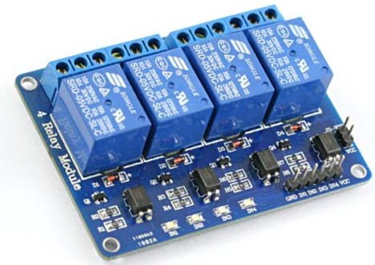

# Brief Data:

* Relay Maximum output: DC 30V/10A, AC 250V/10A.
* 4 Channel Relay Module with Opto-coupler. LOW Level Trigger expansion board, which is compatible with Arduino control board.
* Standard interface that can be controlled directly by microcontroller ( 8051, AVR, *PIC, DSP, ARM, ARM, MSP430, TTL logic).
* Relay of high quality low noise relays SPDT. A common terminal, a normally open, one normally closed terminal.
* Opto-Coupler isolation, for high voltage safety and prevent ground loop with microcontroller.

# Schematic:

VCC and RY-VCC are also the power supply of the relay module. When you need to drive a large power load, you can take the jumper cap off and connect an extra power to RY-VCC to supply the relay; connect VCC to 5V of the MCU board to supply input signals.

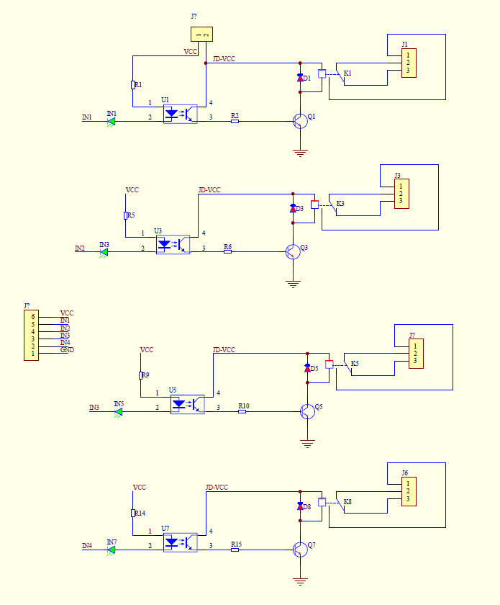

**Operating Principle:**

See the picture below: A is an electromagnet, B armature, C spring, D moving contact, and E fixed contacts. There are two fixed contacts, a normally closed one and a normally open one. When the coil is not energized, the normally open contact is the one that is off, while the normally closed one is the other that is on.

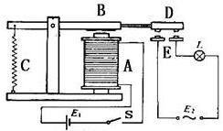

Supply voltage to the coil and some currents will pass through the coil thus generating the electromagnetic effect. So the armature overcomes the tension of the spring and is attracted to the core, thus closing the moving contact of the armature and the normally open (NO) contact or you may say releasing the former and the normally closed (NC) contact. After the coil is de-energized, the electromagnetic force disappears and the armature moves back to the original position, releasing the moving contact and normally closed contact. The closing and releasing of the contacts results in power on and off of the circuit.

# Input:

VCC : Connected to positive supply voltage (supply power according to relay voltage)

GND : Connected to supply ground.

IN1: Signal triggering terminal 1 of relay module

IN2: Signal triggering terminal 2 of relay module

IN3: Signal triggering terminal 3 of relay module

IN4: Signal triggering terminal 4 of relay module

# Output:

Each module of the relay has one NC (normally close), one NO (normally open) and one COM (Common) terminal. So there are 4 NC, 4 NO and 4 COM of the channel relay in total. NC stands for the normal close port contact and the state without power. NO stands for the normal open port contact and the state with power. COM means the common port. You can choose NC port or NO port according to whether power or not.

**Motor:**

A **gear motor** is a specific type of electrical motor that is designed to produce high torque while maintaining a low horsepower, or low speed, motor output. Gear motors can be found in many different applications, and are probably used in many devices in your home.

Gear motors are commonly used in devices such as can openers, garage door openers, washing machine time control knobs and even electric alarm clocks. Common commercial applications of a gear motor include hospital beds, commercial jacks, cranes and many other applications that are too many to list

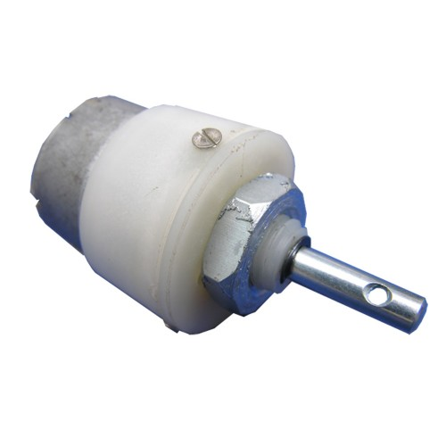

**Basic Principles of Operation**

A gear motor can be either an AC (alternating current) or a DC (direct current) electric motor. Most gear motors have an output of between about 1,200 to 3,600 revolutions per minute (RPMs). These types of motors also have two different speed specifications: normal speed and the stall-speed torque specifications.

Gear motors are primarily used to reduce speed in a series of gears, which in turn creates more torque. This is accomplished by an integrated series of gears or a gear box being attached to the main motor rotor and shaft via a second reduction shaft. The second shaft is then connected to the series of gears or gearbox to create what is known as a series of reduction gears. Generally speaking, the longer the train of reduction gears, the lower the output of the end, or final, gear will be.

An excellent example of this principle would be an electric time clock (the type that uses hour, minute and second hands). The synchronous AC motor that is used to power the time clock will usually spin the rotor at around 1500 revolutions per minute. However, a series of reduction gears is used to slow the movement of the hands on the clock.

For example, while the rotor spins at about 1500 revolutions per minute, the reduction gears allow the final secondhand gear to spin at only one revolution per minute. This is what allows the secondhand to make one complete revolution per minute on the face of the clock.

**SPECIFICATION**

1. Voltage: 12.0VDC

2. Output Speed: 200 +/- 10% RPM

3. No-Load output current: =< 50 mA

4. Rotation Output: CW / CCW

5. Noise: No Gear Noise

6. Stall output: : Slip Gear, Broken Gear is no allowed

7. Output shaft of the axial clearance: =< 0.1 ~ 0.3mm, Horizontal clearance requirement =< 0.05 Electrical Spec 1. No-Load Speed: 5700 RPM 2. No-Load Current: =< 30mA 3. Rotation: CW 4. Motor#: 370

**Electromagnet**

**Object Lifting and Holding**: An electromagnet can be used to lift and hold metallic objects. This could be useful in scenarios where you need to transport or manipulate metallic objects remotely, such as in automated assembly lines or material handling systems.

**Buzzer – Electromagnetic**

This buzzer is an electromagnetic type audio signaling device, which has a coil inside which oscillates a metal plate against another, which when given voltage difference produces sound of a predefined frequency. You must be aware of such sounds of buzzer like BEEP sound in many appliances.

# **Features**

* These high reliability electromagnetic buzzers are applicable to general electronics equipment.
* Compact, pin terminal type electromagnetic buzzer with 2048 Hz output.
* Pin type terminal construction enables direct mounting onto printed circuit boards.

# **Applications**

# Security Alerts, Clocks, travel watches, keyboards, toys, various alarms of equipment’s.

# **Specification**

|  |  |
| --- | --- |
| **Parameter** | **Value** |
| Operating Voltage | 3-15V DC |
| Current Consumption | 60mA |
| Frequency | 2048 Hz |
| Sound Pressure at 10cm | 80 db at 12V DC |
| Coil DC Resistance | 60 Ohms |
| Operating Temperature | -40 to +80 deg C |

Line Follow Drone:

A line-following drone is a type of autonomous drone designed to follow a line or a path marked on the ground, typically with a high-contrast color like black on a white surface or vice versa. These drones are commonly used in various applications such as industrial automation, warehouse logistics, and educational purposes. Here's a general description of how a line-following drone works:

1. **Sensors**: The key component of a line-following drone is its sensors. These sensors detect the line or path on the ground and provide feedback to the drone's control system, enabling it to make necessary adjustments to stay on course. The most commonly used sensors for this purpose are infrared (IR) sensors or reflective optical sensors.
2. **Control System**: The control system of the drone processes the input from the sensors and determines the appropriate action to keep the drone following the line. It typically consists of a microcontroller or a similar computing device programmed to interpret sensor data and issue commands to the drone's actuators.
3. **Actuators**: Actuators are the mechanisms responsible for executing the commands generated by the control system. In a line-following drone, the actuators usually control the drone's movement, such as motors that drive wheels or tracks. The control system adjusts the speed and direction of these actuators based on the feedback from the sensors to keep the drone aligned with the line.
4. **Algorithm**: The control algorithm dictates how the drone responds to sensor inputs to maintain its position on the line. Common algorithms include proportional-integral-derivative (PID) control, where the drone adjusts its position based on the error between the detected line position and the desired position.
5. **Power Source**: Line-following drones are typically powered by batteries, providing the necessary electrical energy to drive the motors, operate the sensors, and run the control system.
6. **Mechanical Design**: The physical design of the drone also plays a crucial role in its performance. It should be able to maintain stability and maneuverability while following the line accurately. The chassis, wheels or tracks, and any additional features like suspension or damping systems contribute to the overall effectiveness of the drone.

Overall, a line-following drone combines sensor technology, control systems, actuators, and mechanical design to autonomously navigate along a predefined path. It's a classic example of droneic technology used in various fields to automate repetitive tasks and demonstrate principles of droneics and control systems.

# RESULTS & DISCUSSIONS

* + - The system demonstrated efficient detection of foreign objects, improving runway safety.
    - The Drone 's ability to cover the entire runway quickly enhances the inspection process compared to traditional methods.
    - However, challenges such as varying weather conditions and object recognition accuracy need further consideration.
    - Continuous refinement of the algorithm and sensor calibration is essential for optimizing performance.

# INFERENCE

* + - The successful execution of the proposed method indicates the potential for Drone -based runway inspections to revolutionize airport safety protocols.
    - Real-time notifications enable swift responses to foreign object detection, minimizing the risk of operational disruptions and enhancing overall runway safety.