Solar Fault Detection Using IOT and Machine Learning

## ABSTRACT

*The power generated from solar panel is to be efficiently monitored and managed to reduce the generation losses in solar power generation. Generally, we use solar plants to build in the locations where people can’t reach on daily basis so this approach will help them to virtually control their systems from faraway places. It monitors the panel load by using the IoT technologies and the data which are received from the panels are send to the cloud through the internet for the future use. It also helps the remote users to monitor the solar power plant. The user can get the information about the current and previous average parameter like voltage, temperature and current. This will facilitate the fault detection and preventive maintenance of solar. In this paper we use the application Internet of thing (IOT) to control and monitor the solar power (renewable energy). This system is designed to solve the problem occur in solar power generation like management problem, maintenance and to reduce the time of repair. Using this technology, the cost of solar energy (renewable energy) generation reduces. This also provide real time information to the user help to monitor the system. The main purpose of this paper is that the solar panel can collect or capture maximum solar radiation and maintain the system more reliably and efficiently.*

***Keywords:*** *Renewable energy, IoT, Remote monitoring, solar panels*

# INTRODUCTION

The Internet of things (IOT) is an emerging technology that efficiently and effectively improving our daily life activities. It reduces our cost of living by automating the manual processes. It integrates the physical objects and devices via internet for synchronized communication. Here, solar panels and solar plants are used for producing electricity in natural manner with the help of sun light. These systems are manually operated by humans. So, there is a need of efficient approach which automatically control and monitor the current, voltage and other parameters of solar systems and provides real time statistics to users. Simply, the Internet of things means the network of Physical objects. This provides us the connection of each and every object

In the world by means of wireless sensor network. Some of the devices, buildings, vehicles and other objects embedded with the software, sensors, electronics and network connectivity enables these objects to collect and exchange the data. This IoT (Internet of Things) is achieved by wireless sensor networks, 2G/3G/4G networks, GSM, GPRS, RFID, WI-FI,

GPS, microcontroller, microprocessor, etc.[10,11] Empowering advancements for the Internet of Things are considered and gathered.[7,9] They are classified as follows:

* Advance that empower “things” to

Accept contextual information.

* Advance that empower “things” to

Process the relevant data, and

* Innovation to enhance security and protection.

Accepting the information and processing that relevant data can provide an understanding which is needed to build the “intelligence” into “things”. This is the highlighted feature which differentiates IOT from standard internet. The system consists of a controller incorporated with ESP32 Module, voltage sensor and current sensor. The ESP32 Module is a controller integrated with Wi-Fi and Bluetooth support. The sensors check the predefined conditions that are programmed and detects the output voltage and current. The module alerts to the users or the maintenance in charge and uses the things speak cloud to show the received data from sensor and GUI to display. By using the IoT we can enable the machine to machine communication M2M or device to device communication without human intervention.

# METHODOLOGY

The main objective of this research is to design and implement a Smart Remote monitoring system using IOT that is capable of monitoring the Solar power conditioning unit which consist of solar charge controller and provides the facility to charge the battery bank either through solar or grid and stores data in the cloud database through an easy manageable web interface (firebase). This will decrease the maintenance cost and will increase the

efficiency of the system. This system mainly consists of embedded system ESP32 module network. In proposed system, host network and embedded system forms a core of IOT system. In this network we used an ESP32 module to connect Solar panels to the Internet via cloud computing. The proposed system is used for monitoring of solar energy using IoT.[4,5] ESP-32 is a micro controller which is used to read the sensor values. Current sensor and voltage divider are connected to the ESP-32. ESP-32 is connected to ESP32 module through USB cable. ESP32 module is working as a server. The data from the ESP-32 is display on the web page through ESP32. The system consists of current sensors, voltage sensors, voltage regulator, cloud setup, measurement and other sensors. This also includes microcontroller-based data processing of data acquired from the sensors. Solar power plant monitoring will enhance future decision-making process for large scale solar power plant and grid integration of such plants. Microcontroller plays a very essential role in this process to intermediate between input modules and output modules.[8] Once the system is successfully designed and simulated on the software it will be ready for fabrication and the online control system using IOT will be manufactured.

**Component Details:**

* **Esp-32**
* **Voltage Sensor**
* **Current Sensor**
* **Solar Panel**

POWER SUPPLY

ESP32

SOLAR VOLTAGE SENSOR 1

PROCESSOR

SOLAR VOLTAGE SENSOR 2

SOLAR VOLTAGE SENSOR (GND)

SOLAR CURRENT SENSOR

*Circuit Diagram*

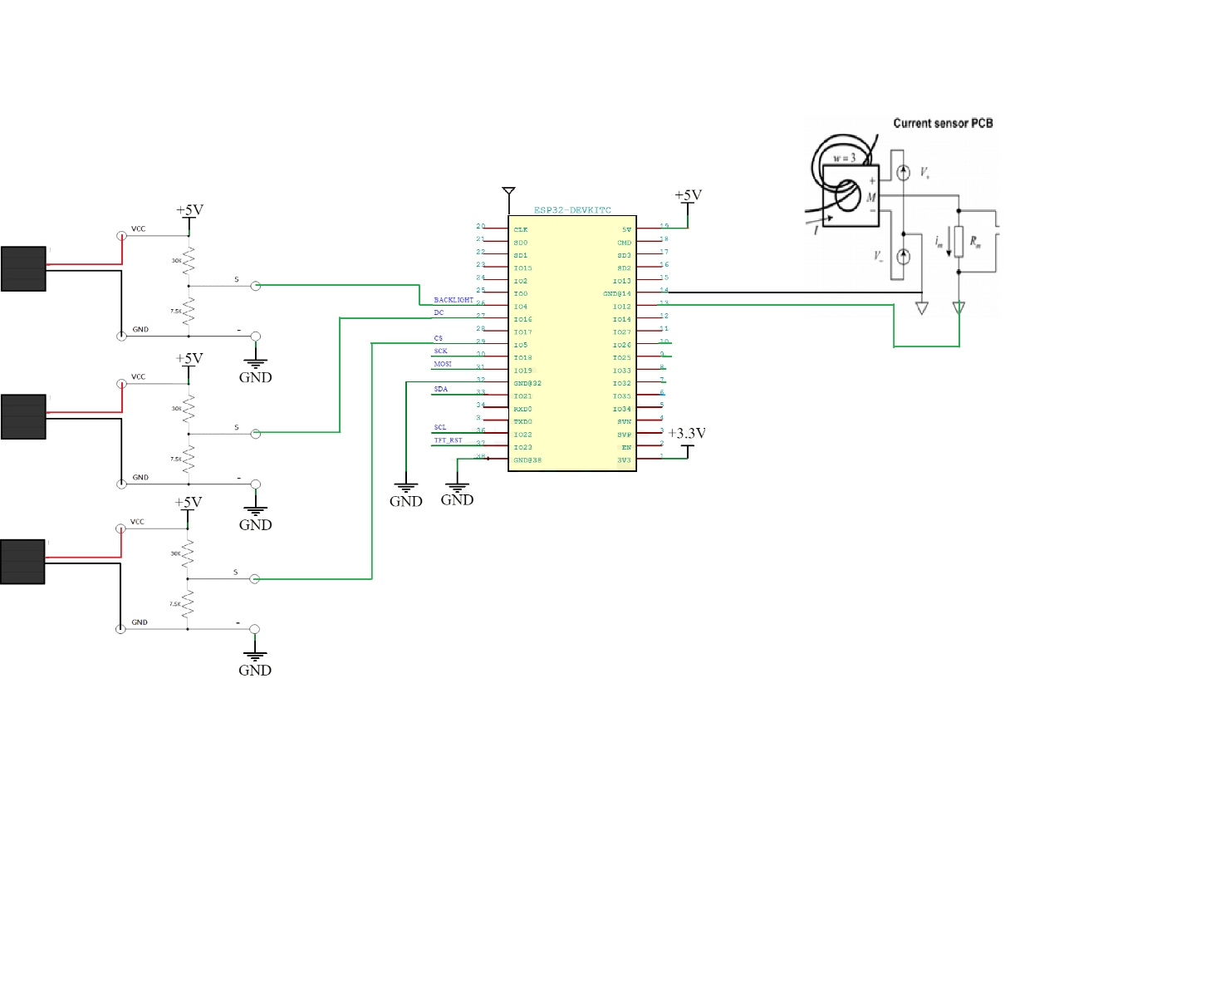

# Esp32:

# Product Overview

ESP32 is a single 2.4 GHz Wi-Fi-and-Bluetooth combo chip designed with the TSMC low-power 40 nm technology. It is designed to achieve the best power and RF performance, showing robustness, versatility and reliability in a wide variety of applications and power scenarios.

The ESP32 series of chips includes ESP32-D0WD-V3, ESP32-D0WDR2-V3, ESP32-U4WDH, ESP32-S0WD [(NRND)](https://www.espressif.com/en/products/longevity-commitment?id=nrnd), ESP32-D0WDQ6-V3 [(NRND)](https://www.espressif.com/en/products/longevity-commitment?id=nrnd), ESP32-D0WD [(NRND)](https://www.espressif.com/en/products/longevity-commitment?id=nrnd), and ESP32-D0WDQ6 [(NRND)](https://www.espressif.com/en/products/longevity-commitment?id=nrnd), among

which,

* ESP32-S0WD [(NRND)](https://www.espressif.com/en/products/longevity-commitment?id=nrnd), ESP32-D0WD [(NRND)](https://www.espressif.com/en/products/longevity-commitment?id=nrnd), and ESP32-D0WDQ6 [(NRND)](https://www.espressif.com/en/products/longevity-commitment?id=nrnd) are based on chip revision v1 or chip revision v1.1.
* ESP32-D0WD-V3, ESP32-D0WDR2-V3, ESP32-U4WDH, and ESP32-D0WDQ6-V3 [(NRND)](https://www.espressif.com/en/products/longevity-commitment?id=nrnd) are based on

chip revision v3.0 or chip revision v3.1.

For details on part numbers and ordering information, please refer to Section 1 ESP32 Series Comparison. For details on chip revisions, please refer to [*ESP32 Chip Revision v3.0 User Guide*](https://www.espressif.com/sites/default/files/documentation/ESP32_ECO_V3_User_Guide__EN.pdf)and

[*ESP32 Series SoC Errata*](https://www.espressif.com/sites/default/files/documentation/eco_and_workarounds_for_bugs_in_esp32_en.pdf).

The functional block diagram of the SoC is shown below.



In-Package Flash or PSRAM

SPI

I2C I2S SDIO UART

TWAI® ETH

RMT PWM

Touch sensor DAC ADC

Timers

Bluetooth link controller

Bluetooth baseband

Wi-Fi MAC

Wi-Fi baseband

RF

receive

Clock generator

RF

transmit

Core and memory

2 (or 1) x Xtensa® 32-bit LX6 Microprocessors

Cryptographic hardware acceleration

SHA

RSA

ROM

SRAM

AES

RNG

RTC

PMU

ULP

coprocessor

Recovery memory

## Features

Wi-Fi

* 802.11b/g/n
* 802.11n (2.4 GHz), up to 150 Mbps
* WMM
* TX/RX A-MPDU, RX A-MSDU
* Immediate Block ACK
* Defragmentation
* Automatic Beacon monitoring (hardware TSF)
* 4 × virtual Wi-Fi interfaces
* Simultaneous support for Infrastructure Station, Soft AP, and Promiscuous modes

Note that when ESP32 is in Station mode, performing a scan, the Soft AP channel will be changed.

* Antenna diversity

Bluetooth®

* Compliant with Bluetooth v4.2 BR/EDR and Bluetooth LE specifications
* Class-1, class-2 and class-3 transmitter without external power amplifier
* Enhanced Power Control

• +9 dBm transmitting power

* NZIF receiver with –94 dBm Bluetooth LE sensitivity
* Adaptive Frequency Hopping (AFH)
* Standard HCI based on SDIO/SPI/UART
* High-speed UART HCI, up to 4 Mbps
* Bluetooth 4.2 BR/EDR and Bluetooth LE dual mode controller
* Synchronous Connection-Oriented/Extended (SCO/eSCO)
* CVSD and SBC for audio codec
* Bluetooth Piconet and Scatternet
* Multi-connections in Classic Bluetooth and Bluetooth LE
* Simultaneous advertising and scanning

CPU and Memory

* Xtensa® single-/dual-core 32-bit LX6 microprocessor(s)
* CoreMark® score: 1 core at 240 MHz: 504.85 CoreMark; 2.10 CoreMark/MHz

Clocks and Timers

* Internal 8 MHz oscillator with calibration
* Internal RC oscillator with calibration
* External 2 MHz ~ 60 MHz crystal oscillator (40 MHz only for Wi-Fi/Bluetooth functionality)
* External 32 kHz crystal oscillator for RTC with calibration
* Two timer groups, including 2 × 64-bit timers and 1 × main watchdog in each group
* One RTC timer
* RTC watchdog

Advanced Peripheral Interfaces

* 34 × programmable GPIOs
  + 5 strapping GPIOs
  + 6 input-only GPIOs
  + 6 GPIOs needed for in-package flash/PSRAM (ESP32-D0WDR2-V3, ESP32-U4WDH)
* 12-bit SAR ADC up to 18 channels
* 2 × 8-bit DAC
* 10 × touch sensors
* 4 × SPI
* 2 × I2S
* 2 × I2C
* 3 × UART
* 1 host (SD/eMMC/SDIO)
* 1 slave (SDIO/SPI)
* Ethernet MAC interface with dedicated DMA and IEEE 1588 support
* TWAI®, compatible with ISO 11898-1 (CAN Specification 2.0)
* RMT (TX/RX)
* Motor PWM

## 

## Pin Layout

CAP1 CAP2 VDDA XTAL_P XTAL_N VDDA GPIO21 UОTXD UОRXD GPIO22 GPIO19

VDD3P3_CPU

VDDA 1

48

47

46

45

44

43

42

41

40

39

38

37

LNA_IN 2

VDD3P3 3

VDD3P3 4

SENSOR_VP 5

SENSOR_CAPP 6

SENSOR_CAPN 7

SENSOR_VN 8

CHIP_PU 9

VDET_1 10

36 GPIO23

35 GPIO18

ESP32 49 GND

34 GPIO5

33 SD_DATA_1

32 SD_DATA_О

31 SD_CLK

30 SD_CMD

29 SD_DATA_3

28 SD_DATA_2

27 GPIO17

VDET_2 11

32K_XP 12

26 VDD_SDIO

32K_XN GPIO25 GPIO26 GPIO27 MTMS MTDI

VDD3P3_RTC

MTCK

MTDO GPIO2 GPIOО GPIO4

25 GP

13

14

15

16

17

18

19

20

21

22

23

24

VDDA LNA_IN VDD3P3 VDD3P3 SENSOR_VP SENSOR_CAPP SENSOR_CAPN SENSOR_VN CHIP_PU VDET_1 VDET_2 32K_XP

48

47

46

45

44

43

42

41

40

39

CAP1 CAP2 VDDA XTAL_P XTAL_N VDDA GPIO21 UOTXD UORXD

GPIO22

32K_XN GPIO25

15

16

17

18

19

20

21

22

23

24

1

2

3

4

5

6

7

8

9

10

11

12

13

14

38 GPIO19

37 VDD3P3_CPU

ESP32 49 GND

36 GPIO23

35 GPIO18

34 GPIO5

33 SD_DATA_1

32 SD_DATA_O

31 SD_CLK

30 SD_CMD

29 SD_DATA_3

28 SD_DATA_2

27 GPIO17

26 VDD_SDIO

25 GPIO16

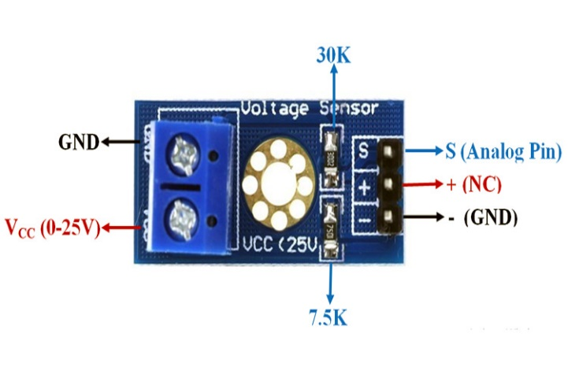

**Voltage Sensor**

**Voltage Sensor** is a precise low-cost sensor for measuring voltage. It is based on the principle of resistive voltage divider design. It can make the red terminal connector input voltage to 5 times smaller

### **Voltage Sensor Module Pinout Configuration**

|  |  |
| --- | --- |
| **Pin Name** | **Description** |
| VCC | Positive terminal of the External voltage source (0-25V) |
| GND | Negative terminal of the External voltage source |
| S | Analog pin connected to Analog pin of Arduino |
| + | Not Connected |
| - | Ground Pin connected to GND of Arduino |

### **Voltage Detection Sensor Module Features & Specifications**

* Input Voltage: 0 to 25V
* Voltage Detection Range:  0.02445 to 25
* Analog Voltage Resolution: 0.00489V
* Needs no external components
* Easy to use with Microcontrollers
* Small, cheap and easily available
* Dimensions: 4 × 3 × 2 cm

### **Brief about Voltage Sensor Module**

Voltage Detection Sensor Module is a simple and very useful module that uses a potential divider to reduce any input voltage by a factor of 5. This allows us to use the Analog input pin of a microcontroller to monitor voltages higher than it capable of sensing. For example, with a 0V - 5V Analog input range, you are able to measure a voltage up to 25V. This module also includes convenient screw terminals for easy and secure connections of a wire.

The internal **circuit diagram of the Voltage Sensor Module** is given below.

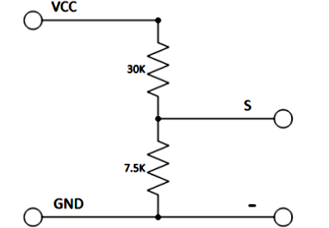

The voltage circuit consists of a voltage divider circuit of two resistors in which R1 is 30K and R2 is 7.5K.

**Current Sensor**

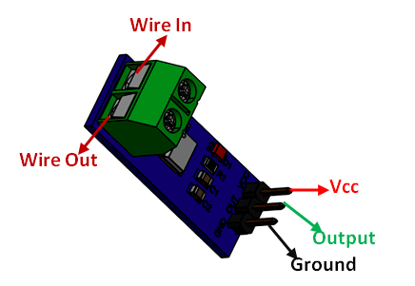

### **Pin Configuration**

|  |  |  |
| --- | --- | --- |
| **Pin Number** | **Pin Name** | **Description** |
| 1 | Vcc | Input voltage is +5V for typical applications |
| 2 | Output | Outputs Analog voltage proportional to current |
| 3 | Ground | Connected to ground of circuit |
| T1 | Wire In | The wire through current has to be measured is connected here |

### **Specifications**

* Measures both AC and DC current
* Available as 5A, 20A and 30A module
* Provides isolation from the load
* Easy to integrate with MCU, since it outputs analog voltage
* Scale Factor

|  |  |  |
| --- | --- | --- |
| * 5A Module | * 20A Module | * 30A Module |
| * 185mV/Amp | * 100mV/Amp | * 66mV per Amp |

### **Where to use ACS712 Module**

The **ACS712 Module** uses the famous **ACS712 IC** to **measure current** using the Hall Effect principle. The module gets its name from the IC (ACS712) used in the module, so for you final products use the IC directly instead of the module.

These ACS712 module can measure current AC or DC current ranging from +5A to -5A, +20A to -20A and +30A to -30A. You have to select the right range for your project since you have to trade off accuracy for higher range modules. This modules outputs Analog voltage (0-5V) based on the current flowing through the wire; hence it is very easy to interface this module with any [microcontroller](https://components101.com/microcontrollers). So if you are looking for a module to measure current using a microcontroller for you project, then this module might be the right choice for you.

### **How to use the ACS712 Module**

As told earlier it is very simple to **interface the ACS712 Module with Microcontrollers**. The below diagram would be more illustrative

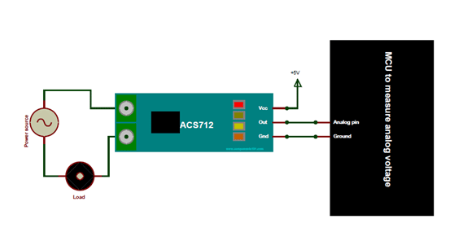

The ACS712 module has two phoenix terminal connectors (green colour ones) with mounting screws as shown above. These are the terminals through which the wire has to be passed. In our case I am measuring the current drawn by the motor so the wires that is going to the load (motor) is passed through the ACS 712 Module. Make sure the module is connected in series with the load and be extra cautious to avoid shorts.

On the other side we have three pins. The Vcc is connected to +5V to power the module and the ground is connected to the ground of the MCU (system). Then the analog voltage given out by the ACS712 module is read using any analog pin on the Microcontroller.

**Solar Panel:**

# TECHNICAL DATA

**Electrical Data** : All Data refers to STC (1000W/m2, AM1.5G, 25°C)

|  |  |  |  |  |  |
| --- | --- | --- | --- | --- | --- |
| **Model Name** | **LGV12V40** | **LGV12V50** | **LGV12V75** | **LGV12V100** | **LGV12V160** |
| **Peak Power Pmax (Wp)** | 40 | 50 | 75 | 100 | 160 |
| **Maximum Voltage Vmp (V)** | 17.50 | 18.00 | 18.00 | 18.00 | 18.20 |
| **Maximum Current Imp (A)** | 2.46 | 2.78 | 4.17 | 5.66 | 8.79 |
| **Open Circuit Voltage Voc (V)** | 21.00 | 22.00 | 22.00 | 22.00 | 22.20 |
| **Short Circuit Current Isc (A)** | 2.54 | 3.28 | 4.67 | 6.06 | 9.34 |
| **Maximum System Voltage** | 600 VDC | 600 VDC | 600 VDC | 600 VDC | 1000 VDC |
| **Max Rated Current Series (Fuse Rating)** | 6A | 6A | 6A | 10A | 15A |
| **Solar Cell Size (in mm)** | 39x156.75 | 52x156.75 | 78x156.75 | 99x156.75 | 156.75x156.75 |
| **No. of Solar Cells per module** | 36 | 36 | 36 | 36 | 36 |

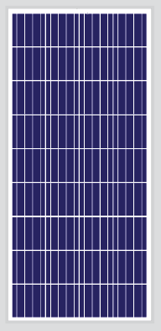

STC :1000W/m2 Irradiance, 25°C Cell Temperature, AM1.5G Spectrum according to EN 60904-3 Average relative effciency reduction of < 5% at 200W/m2 according to

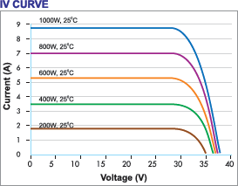

# PERMIISSBLE OPERATING CONDITIONS

|  |  |
| --- | --- |
| **Tc of Open Circuit Voltage (ß)** | -0.31%/°C ± 0.02 |
| **Tc of Short Circuit Voltage (α)** | 0.057%/°C ± 0.01 |
| **Tc of Power (ϒ)** | -0.41%/°C ± 0.02 |
| **NOCT** | 45 ± 2°C |
| **Temperature Range** | -40°C to +85 °C |
| **Limiting Reverse Current (Ir)** | 15 A |

**MECHANICAL DATA**

|  |  |
| --- | --- |
| **Junction Box** | IP 65 rated with bypass diodes |
| **Application Class** | Class A (Safety Class II ) |
| **Substrate (Glass)** | High transmission low iron tempered glass |
| **Cells Encapsulant** | EVA (Ethyelene Vinyl Acetate) - FC/UFC |
| **Back Sheet** |  |
| **Frame** |  |
| **Mechanical Load Test** | Sustain Heavey wind & snow loads (2400 Pa & 5400 Pa or 550 Kg/m2 |
| Maximum diameter of 24 mm with hail impact of 83 Km/h |

# PROPOSED WORK

**System Design**

The solar panel voltage and current is monitored with the help of sensors like current sensor and voltage sensor. The current sensor gives the value of current flowing through the solar panel and the voltage sensor gives the value of voltage appear across the solar panel. Both the sensor’s data is given to ESP32 module which is combination of controller and wi- fi module.

This module is programmed with the help of ESP-32 IDE software. First ESP32 works as a microcontroller and fetch the current sensor and voltage sensor output data through serial ports. This data is then displayed on the LCD display in the form of voltage, current and power value. Now ESP32 works as a wi-fi module. First this ESP32 connect with the Internet through wi-fi then ESP32 send the data available on the serial to the cloud with the help of MQTT (Message Queuing Telemetry Transport) protocol. This data is transferred to the cloud and stored in cloud platform. We are using AWS (Amazon web services) as a cloud platform and with the help of API we can access the data stored in AWS through internet.

# IMPLEMENTATION [12]

**Hardware Setup**

Solar energy generated by solar panel is in the form of DC current therefore we use Dc bulb for usage. One terminal is connected to the battery while another

terminal is connected to the current sensor.Bread board is used for complex circuit and also helps to build voltage divider. Current & voltage value is sensed by ESP-32 through analog pins. With these values, ESP-32 programming calculates power and energy. Further output is sent to the ESP32 module through USB cable and ESP-32 is considered as the server. The monitor displays the web page & cloud data.

# Table 1

|  |  |  |
| --- | --- | --- |
| **Sr. No** | **Components** | **Specifications** |
| 1. | Solar panel | 12 Watts |
| 2. | Load | Light/dc motor |
| 3. | Processor | ESP32 module |
| 4. | Current sensor | ACS712(30Amp) |
| 5. | Voltage sensor | Voltage divider (25V) |

**Software Setup**

The open-source ESP-32 Software (IDE)

– is used in system for upload the code on to board. The sensor and circuit are connected to the Module for communicate with them to sense current and voltage. We write the code in “C” for the sensing and calculating the power and energy.

We use web page for monitoring system, the monitoring page displays the table contains voltage, current and power. The web page shows the real time data of solar panel.

We use blink app to create an app for mobile user that can access the real time data of solar panel. Using this we can make a dashboard within app which shows the values in the app. The data stored in the AWS cloud platform is accessed with a unique API key then we can access the data and monitor the data.

# CONCLUSION AND FUTURE SCOPE

Implementing Renewable Energy technologies is one of the most recommended way of reducing the environmental impact. Because of the frequent power cut, it is important to use the renewable energy and monitoring it. Monitoring guides the user in analysis of the renewable energy usage. This system is cost effective and its efficiency is about 95%.This enables the efficient use of

renewable energy and also it reduces the electricity issues.

The main benefit of using IOT in solar energy is that we can see exactly what’s happening with all your assets from one central control panel. By connecting your devices to a cloud network, you can identify where the problem is originated and you can dispatch a technician to fix it before it disrupts your entire system.

Without IOT, it would be difficult to determine whether the problem is network- related or hardware-related. Using the IOT, your system will be less susceptible to outages and productivity issues. By installing an all-in-one edge-to-cloud IOT solution to connect your solar assets, you can manage even with thousands of individual devices connected to our network. In addition to providing companies with real-time alerts, leveraging IOT in solar energy can lead to improve with all your assets from one central control panel. By connecting your devices to a cloud network, you can identify where the problem is occurring.

# ACKNOWLEDGMENT

We acknowledge the efforts and hard work by the experts who have contributed towards the development of the intelligent remote monitoring system. We would like to thank Mr. Suraj Rajan, MD Quadtech for helping us throughout the project with their constant guidance.

# REFERENCES

1. Kekre, A., & Gawre, S. K. (2017, October). Solar photovoltaic remote monitoring system using IOT. In *2017 International conference on recent innovations in signal processing and embedded systems (RISE)* (pp. 619- 623). IEEE.
2. Adhya, S., Saha, D., Das, A., Jana, J., & Saha, H. (2016, January). An IoT based smart solar photovoltaic remote monitoring and control unit. In *2016 2nd international conference on control, instrumentation, energy & communication (CIEC)* (pp. 432-436). IEEE.
3. Shrihariprasath, B., & Rathinasabapathy, V. (2016, March). A smart IoT system for monitoring solar PV power conditioning unit. In *2016 World Conference on Futuristic*

*Trends in Research and Innovation for Social Welfare (Startup Conclave)* (pp. 1-5). IEEE.

1. Patil, S., Vijayalashmi, M., & Tapaskar, R. (2017). Solar energy monitoring system using IOT. *Indian Journal of Scientific Research*, 149- 156.
2. Phung, M. D., De La Villefromoy, M., & Ha, Q. (2017, August). Management of solar energy in microgrids using IoT-based dependable control. In *2017 20th international conference on electrical machines and systems (ICEMS)* (pp. 1-6). IEEE.
3. Katyarmal, M., Walkunde, S., Sakhare, A., & Rawandale, U. S. (2018). Solar power monitoring system using IoT. *Int Res J Eng Technol (IRJET), 5*(3), 2395-0056.
4. Nordrum, A. (2016). Popular internet of things forecast of 50 billion devices by 2020 is outdated. *IEEE spectrum*, 18(3).
5. https://nevonprojects.com/iot-solar- power-monitoring-system
6. Internet of things (Nov 2016). Retrieved from

<http://cerasis.com/2015/10/20/10-> things-to-know-about-theinternet-of- things

1. International Telecommunication Union. (2012). Internet of Things Global Standards Initiative.
2. Bartolomeo, M. (2014). Internet of things: Science fiction or business fact. *A Harvard Business Review Analytic Services Report, Tech. Rep.*
3. Purusothaman, S. D., Rajesh, R., Bajaj, K. K., & Vijayaraghavan, V. (2013, November). Implementation of ESP-32-based multi-agent system for rural Indian microgrids. In *2013 IEEE Innovative Smart Grid Technologies- Asia (ISGT Asia)* (pp. 1-5). IEEE.