13/12/2025
Submitted By: Siddiqa Rani
Submitted To: Dr. Anam Naz
Epigenetics
Assignment: Whole-Genome Bisulfite Sequencing (WGBS) Analysis Pipeline Using Simulated Data

Title:
Implementation of a Whole-Genome Bisulfite Sequencing (WGBS) Analysis Pipeline Using Simulated Data

Introduction
DNA methylation is an important epigenetic modification involved in gene regulation and disease. Whole-genome bisulfite sequencing enables genome-wide measurement of DNA methylation but requires complex data processing. When real datasets are unavailable, simulated data can be used to test and validate analysis pipelines. Sherman is a widely used bisulfite sequencing read simulator that generates realistic WGBS data under controlled methylation and coverage settings.
In this project, Sherman-simulated WGBS data were analyzed to build and evaluate a complete methylation analysis workflow, with a focus on understanding the impact of sequencing coverage on methylation results.
Objective:
To implement and validate a complete bisulfite sequencing (BS-seq/WGBS) analysis workflow using simulated data. Specifically, this project aims to:
- Select a BS-seq simulator (Sherman) to generate paired-end bisulfite reads for Control and Treatment conditions.
- Create a simple dataset with known DMR regions so the results can be objectively validated.
- Process the simulated reads through a standard BS-seq pipeline:
Trim Galoreo → Bismark alignment → methylKit differential methylation analysis.
- Evaluate pipeline accuracy by writing a small comparison script that matches predicted DMRs (from methylKit) against true DMRs, and reports Precision and Recall.

Methodology
1. Installation of Required Tools
Before starting the bisulfite sequencing (BS-seq) workflow, all essential tools were installed to support quality checking, trimming, simulation, and alignment of BS-seq reads. The following software packages were used:
- FastQC: for checking the quality of sequencing reads.
- Trim Galore: for adapter trimming and quality filtering.
- Bismark: for bisulfite read alignment and methylation extraction.
- Bowtie2: required by Bismark for genome indexing and alignment.
- Samtools: for handling and processing alignment files.
- Sherman: a bisulfite sequencing simulator used to generate artificial BS-seq reads.
This environment ensured that all downstream BS-seq analysis steps could be performed smoothly.

2. Simulation of Bisulfite-Converted Reads Using Sherman
Since no real Whole-Genome Bisulfite Sequencing (WGBS) data was available, Sherman was used to generate artificial but realistic bisulfite-converted reads. Sherman simulates WGBS-like reads while applying realistic bisulfite conversion rates, sequencing errors, and methylation patterns.
This allowed us to create controlled datasets for testing and validating the analysis workflow.
Generated Samples
Two experimental conditions were created, a Control group and a Treatment group. For each condition, Sherman produced paired-end reads as follows:
Control Sample
- control_1.fastq
- control_2.fastq
Treatment Sample
- treatment_1.fastq
- treatment_2.fastq
These simulated FASTQ files were then used for quality control, trimming, alignment with Bismark, and methylation extraction in later steps.
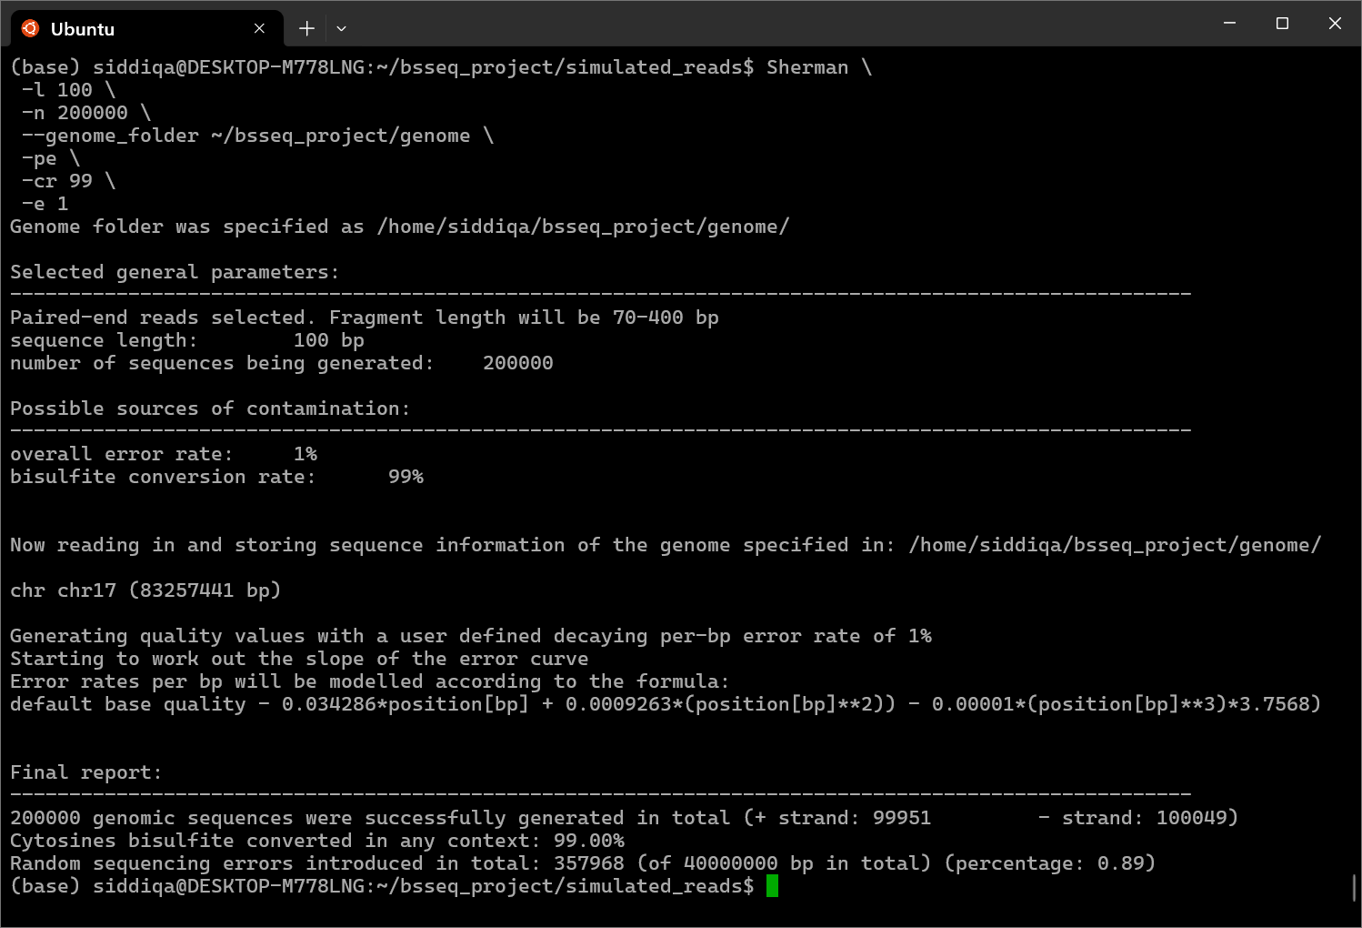
fig: 1 Simulation of CONTROL dataset
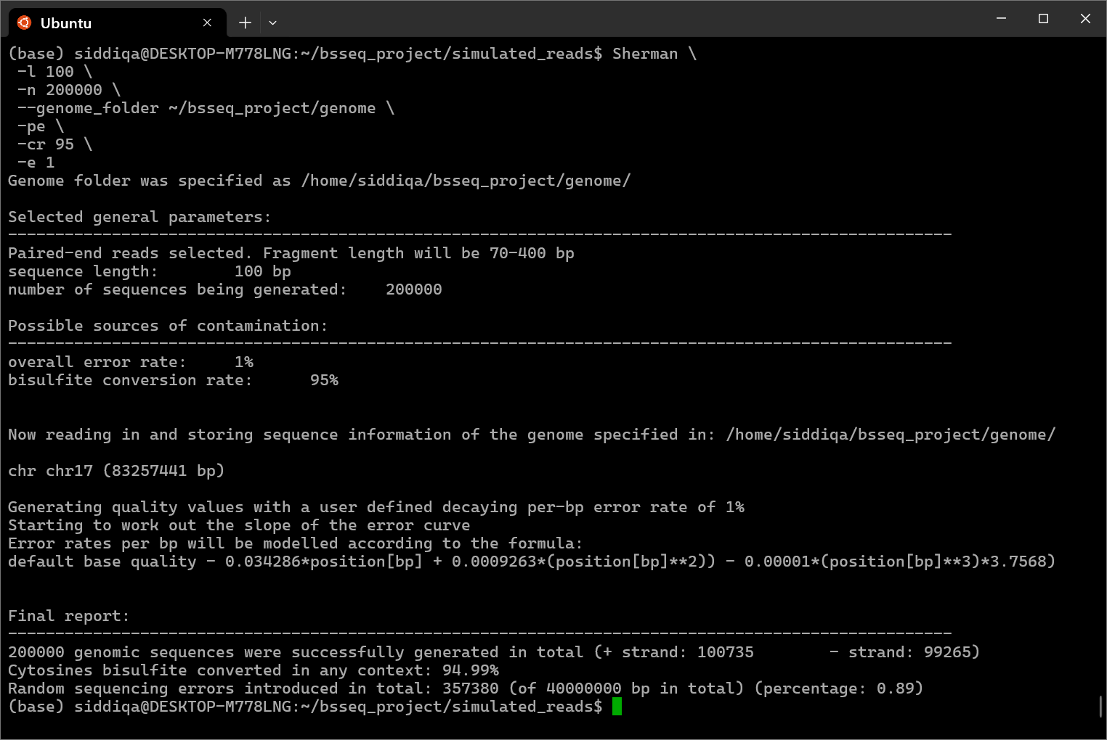
fig : 2 Simulation of TREATMENT sample

3. Quality Assessment of Simulated Reads Using FastQC
FastQC was run on all the simulated FASTQ files to check the overall read quality before analysis. Even though the reads were generated artificially, they can still contain simulated issues such as:
- adapter-like sequences
- low-quality base positions
- sequence biases
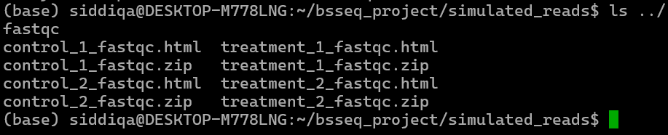
Running FastQC at this stage helps understand the initial quality profile of the reads and guides the trimming step.
fig : 3 FASTQC

4. Read Trimming Using Trim Galore
After the quality check, all FASTQ files were processed with Trim Galore (which uses Cutadapt internally).
This step removes:
- low-quality bases at the read ends
- adapter sequences
- any unwanted contamination
- short or unreliable reads
Trimming improves the accuracy of downstream alignment, especially for bisulfite sequencing where mismatches are already common due to C to T conversions.
a. control_1 QC:
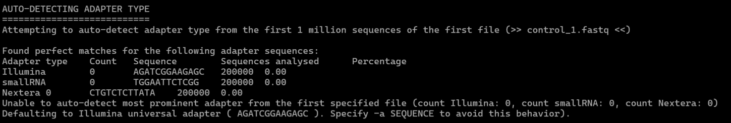
fig : 4.1.1 This section summarizes the trimming settings

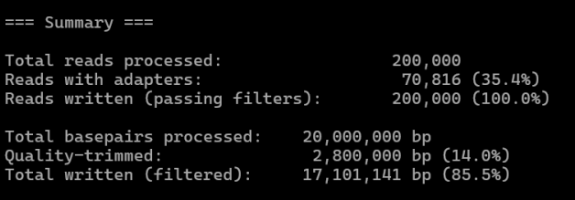
fig : 5 Here is overall trimming results. A total of 200,000 reads were processed, and about one-third contained adapters. All reads passed the filters, and most of the original bases were retained after trimming, with only 14% removed due to low quality bases.

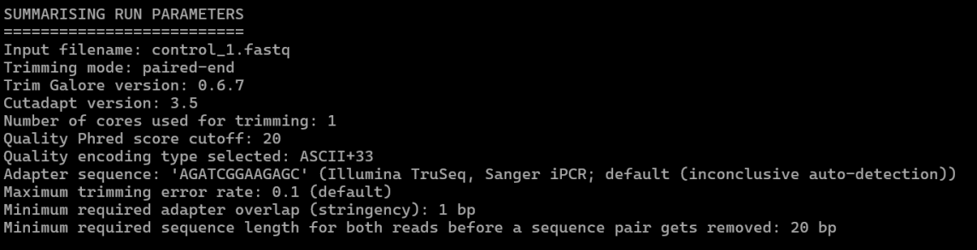
fig : 6

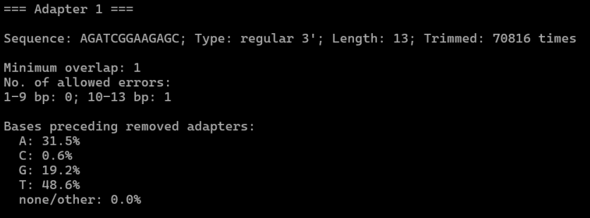
fig : 7 This block describes the adapter that was removed. The Illumina adapter sequence was detected and trimmed over 70,000 times. It also shows the allowed mismatches during detection and the base percentages found right before the adapter, which reflects sequencing and library patterns

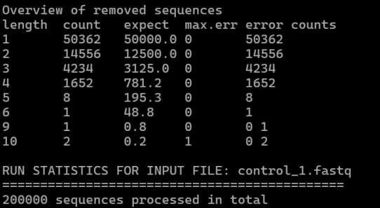
fig : 8 This table lists the sizes of leftover adapter fragments and how often each was found. It confirms expected trimming behavior and that all 200,000 reads from the file were processed.

b. control_2 QC:
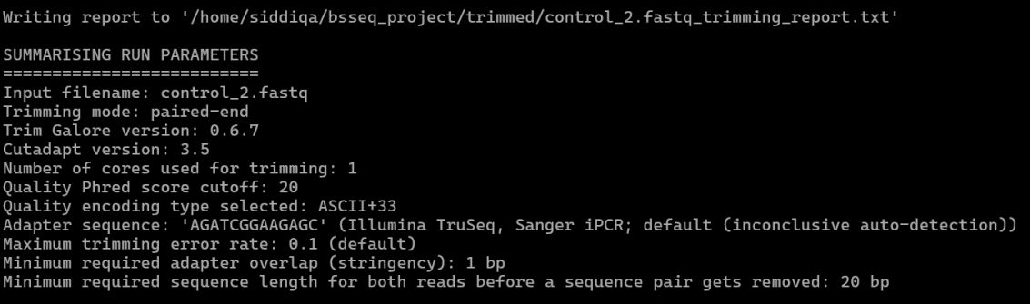
fig : 9 This section shows the settings used for trimming control_2.fastq.

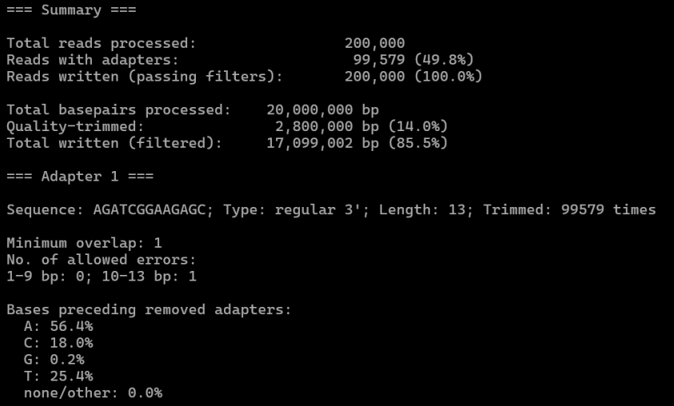
fig : 10 This block summarizes the trimming results. It shows how many reads had adapters, how many bases were trimmed, and how much clean data remained. It also reports how often the adapter was removed and the base composition before each adapter, which reflect sequencing patterns.

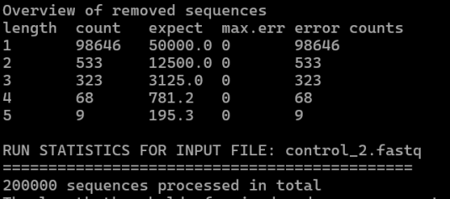
fig : 11 This table lists the sizes of adapter fragments found in the reads. Most were very short, which is normal. It also confirms that all 200,000 reads from control_2.fastq were processed successfully.

c. Treatment_01 QC :

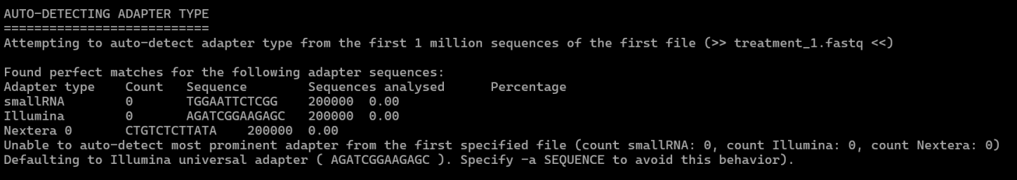
fig : 12 This section shows Trim Galore checking the file treatment_1.fastq to identify which adapter type is present. Since no adapter type appeared strongly in the first sequences, Trim Galore could not automatically determine the best match. Therefore, it defaulted to the standard Illumina adapter sequence, which is commonly used for most libraries.

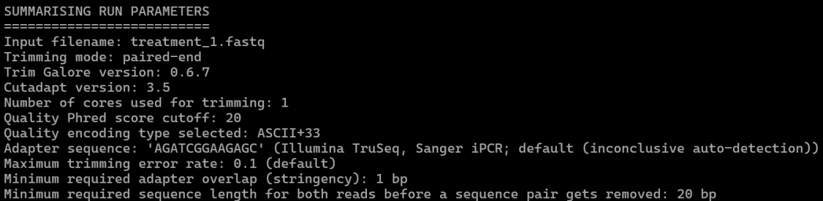
fig : 13 This part lists the trimming settings used for treatment_1.fastq.

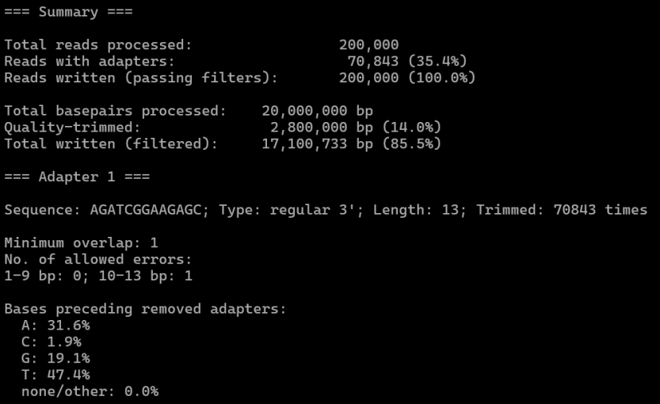
fig : 14 This section summarizes the trimming results. It shows how many reads were processed, how many contained adapters, and how many bases were removed due to low quality. It also reports the Illumina adapter sequence detected, how often it was trimmed, and the base composition found before the adapter.
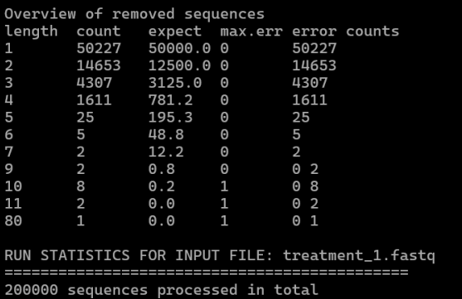
fig : 15 This table shows the lengths of small adapter fragments found in the reads and how often each fragment was detected. Most fragments are very short, which is expected when reads reach the end of the DNA insert. It also confirms that all 200,000 reads fro

d. Treatment_02 FASTQ:

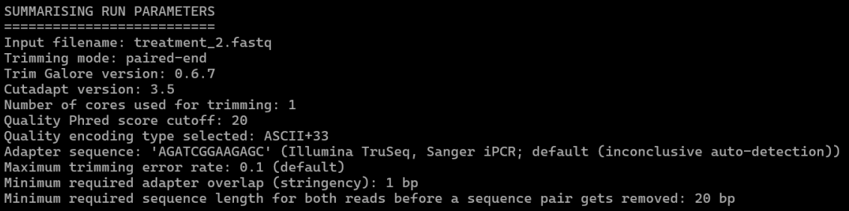
fig : 16 This section lists the trimming settings used for treatment_2.fastq.

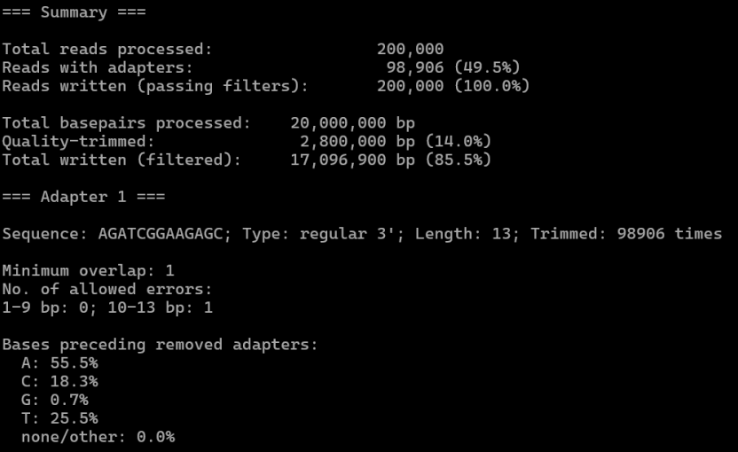
fig : 17 This part summarizes the trimming results for the sample. It shows how many reads had adapters, how many bases were trimmed, and how much clean sequence remained.

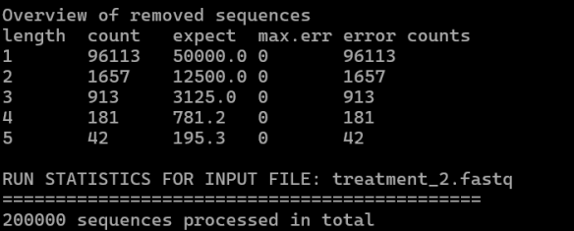
fig : 18 This table shows the sizes of adapter fragments found in the reads and how often each size appeared. Most fragments are short, which is expected. It also confirms that all 200,000 reads from treatment_2.fastq were processed successfully.

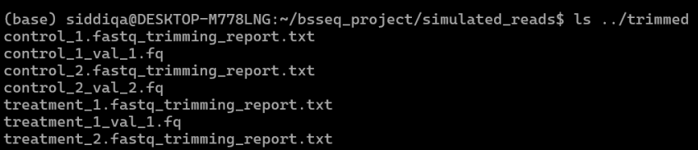
fig : 19 list of all the output files generated after Trimming
4.1 Trim Galore Summary
Metric | Control | Treatment
Total reads processed | 200,000 | 200,000
Reads with adapters | 70,816 (35.4%) | 70,843 (35.4%)
Reads written (passing filters) | 200,000 (100%) | 200,000 (100%)
Total basepairs processed | 20,000,000 bp | 20,000,000 bp
Quality-trimmed bases | 2,800,000 bp (14.0%) | 2,800,000 bp (14.0%)
Total bases after trimming | 17,101,141 bp (85.5%) | 17,100,733 bp (85.5%)
Adapter sequence used | AGATCGGAAGAGC | AGATCGGAAGAGC
Adapter type | Illumina TruSeq (3′) | Illumina TruSeq (3′)
Minimum adapter overlap | 1 bp | 1 bp
Allowed mismatches | 0 (1–9 bp), 1 (10–13 bp) | 0 (1–9 bp), 1 (10–13 bp)

Base composition before adopter
Base | Control (%) | Treatment (%)
A | 31.5 | 31.6
C | 0.6 | 1.9
G | 19.2 | 19.1
T | 48.6 | 47.4

5. Bismark Paired-End Alignment
After trimming, the paired-end reads were aligned to the bisulfite-converted reference genome using Bismark (which internally uses Bowtie2).
5.1 How Bismark Performs Bisulfite Alignment
To handle C → T and complementary G → A conversions caused by bisulfite treatment, Bismark follows a specialized workflow:
- C → T and G → A conversion of reads
Bismark generates two transformed versions of each read pair:
- one where all cytosines (C) are converted to thymines (T),
- one where all guanines (G) are converted to adenines (A).
This mimics the behavior of real bisulfite-converted DNA.
- Alignment to four possible bisulfite strands
Bowtie2 is then used to align the converted reads against all four bisulfite-converted reference strands (CT/GA combinations).
- Recording successful alignments
The alignment log reports the first matched reads, including:
- read ID
- mapping position
- alignment score
- mismatches allowed
This confirms that the paired-end bisulfite alignment was executed correctly.

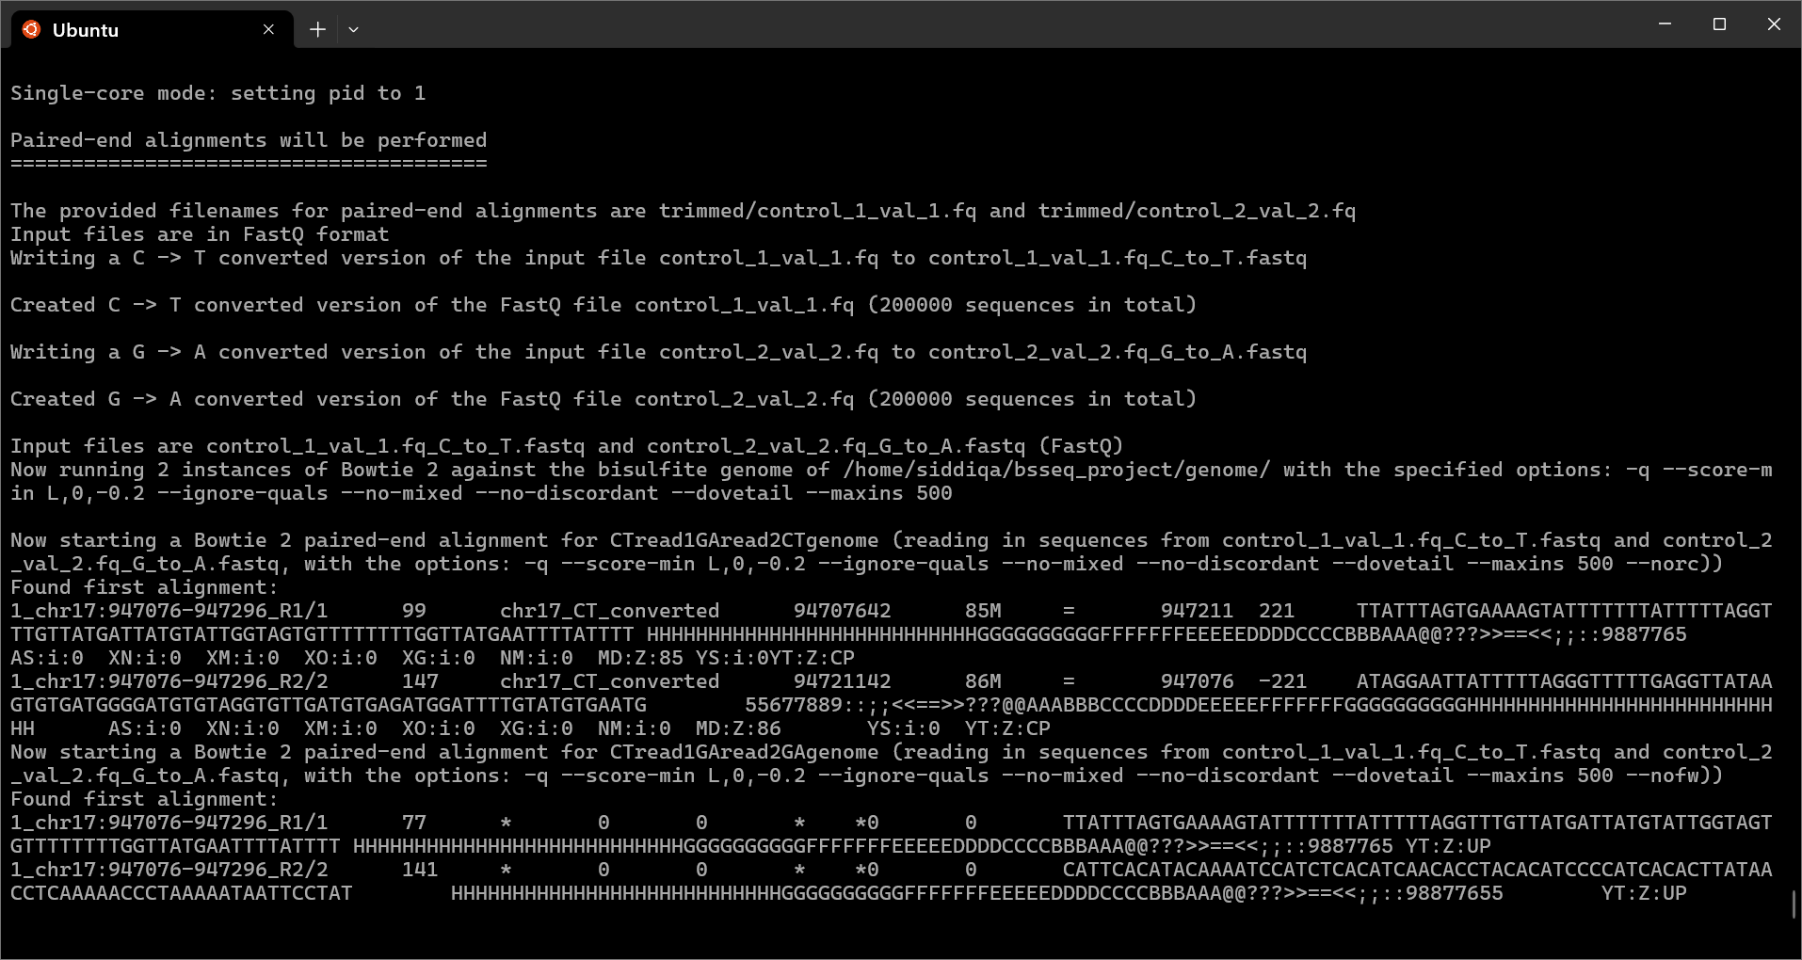
fig : 20 Bismark Alignment

5.2 Alignment Summary and Mapping Efficiency
For the simulated dataset (control_1.fastq / control_2.fastq):
- A total of 200,000 paired-end reads were processed.
- Slightly more than half of the pairs aligned concordantly during the initial Bowtie2 mapping.
- Bismark identified 186,406 uniquely aligned read pairs, resulting in a mapping efficiency of ~93.2%.
- Only a small number of read pairs failed to align or aligned ambiguously.
- The final strand-specific summary showed reads mapped to all four bisulfite strands (CT/GA combinations), confirming proper mapping across both top and bottom strands.
Overall, this step confirms that the bisulfite-converted reads aligned successfully and accurately to the reference genome.

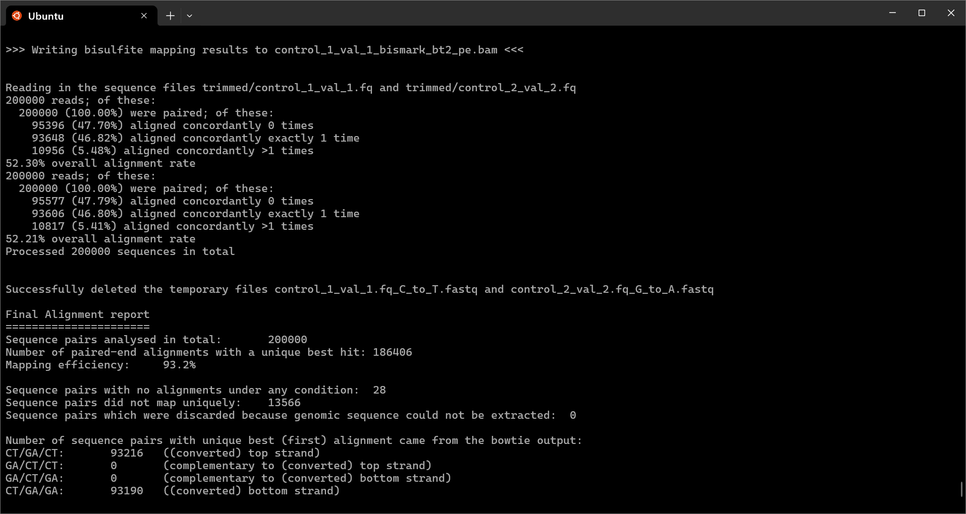
fig : 21 Bismark Alignment Summary

6. Final Cytosine Methylation Report
After alignment, Bismark generated a cytosine methylation summary that reports how many cytosines were detected and how many were methylated in each sequence context. This is an essential output for any BS-seq analysis, as it reflects the overall methylation pattern in the dataset.
6.1 Summary of Cytosines Analyzed
Bismark examined a total of 7,239,537 cytosines across the genome.
These cytosines were classified into the three main bisulfite-sequencing contexts:
- CpG
- CHG
- CHH
(where H = A, T, or C)
For each context, Bismark reported:
- number of methylated cytosines
- number of unmethylated cytosines
The report shows that only a very small proportion of cytosines were methylated. This is expected because:
- Sherman simulations typically generate low or controlled methylation by default
- Methylation levels depend on the parameters chosen during simulation
6.2 Observed Methylation Levels
The global methylation percentages reported were:
- CpG methylation: ~1.0%
- CHG methylation: ~1.0%
- CHH methylation: ~1.0%
These values confirm a low-methylation profile, which matches the expectations for simulated or artificially generated datasets.
Key Points
- No cytosines were classified as “Unknown context,” indicating clean and consistent sequence interpretation.
- No complementary (theoretical) strands were discarded.
- The pipeline executed successfully, as shown by the “Bismark run complete” message.

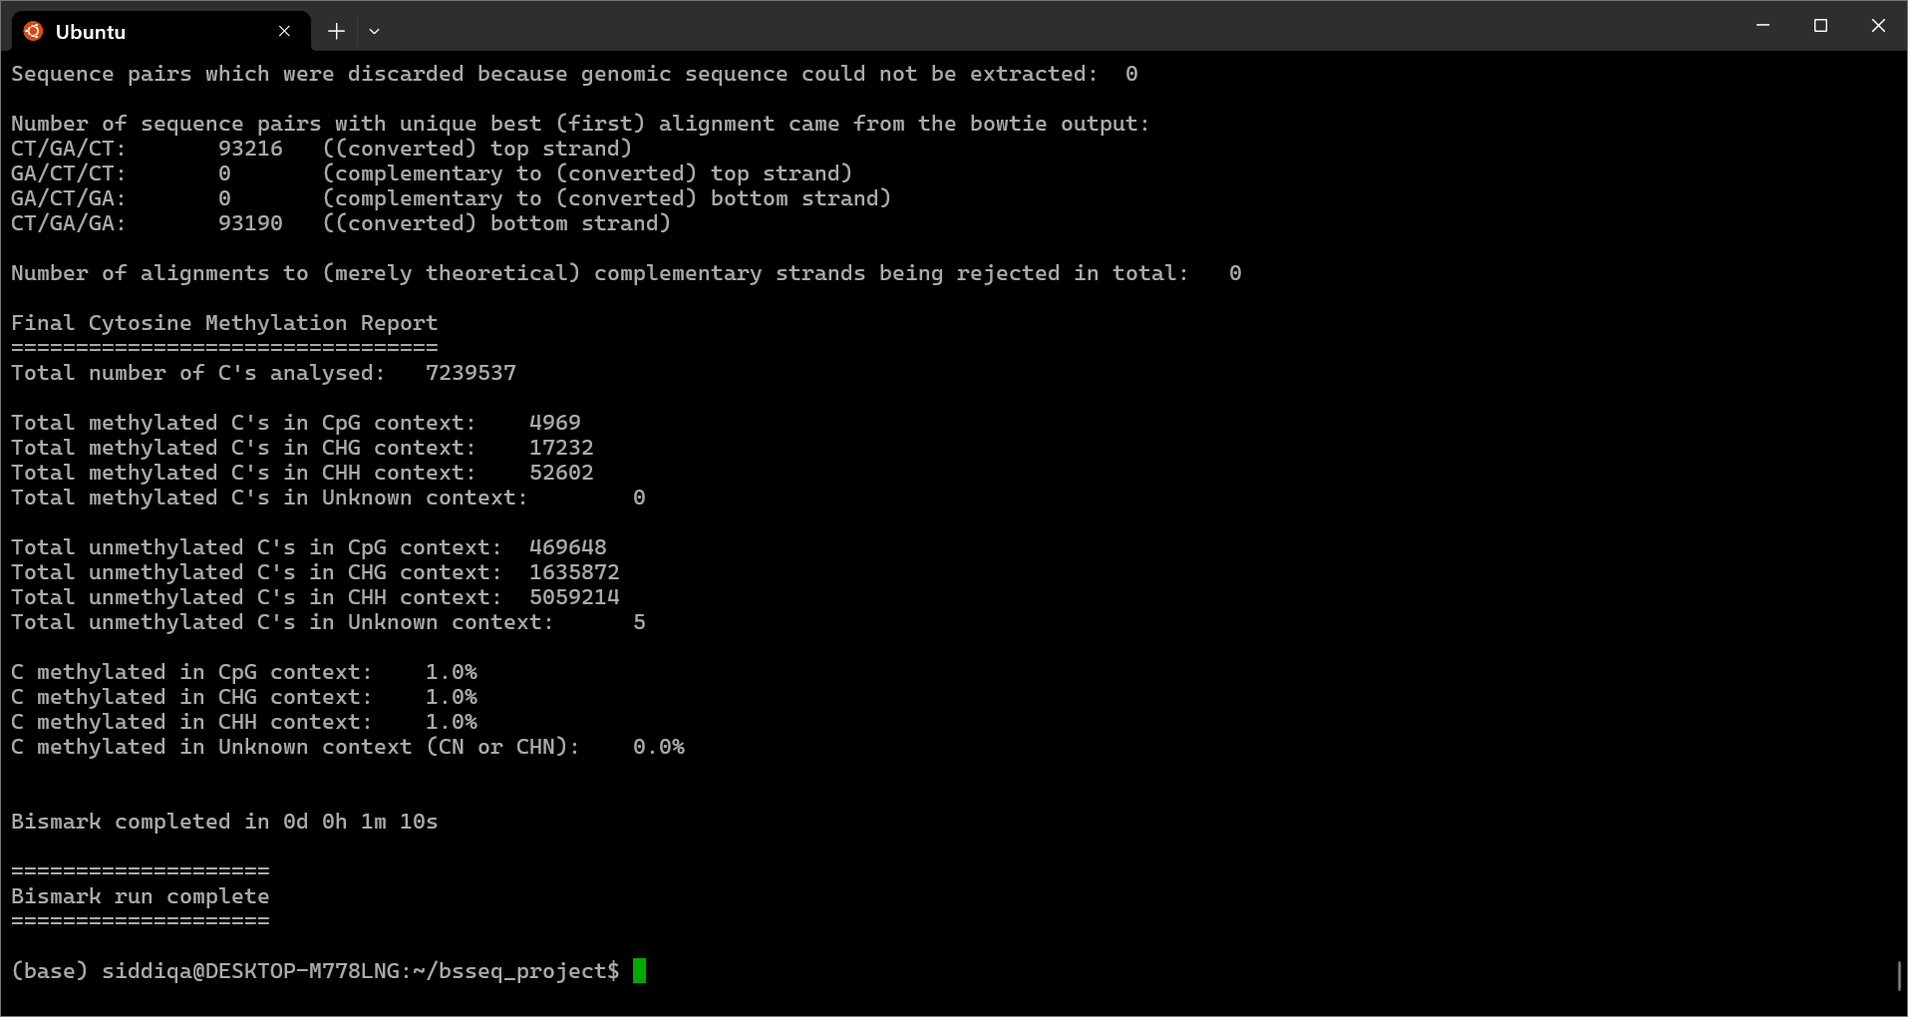
fig : 22 Cytosine Methylation Report

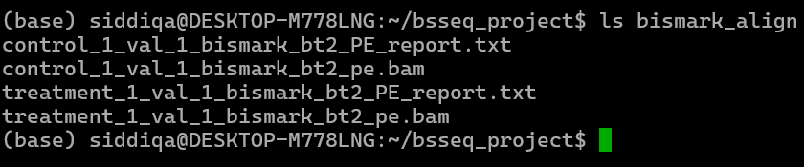
fig : 23 Bismark output files

7. Sorting Bismark Alignment Files Using Samtools
After completing paired-end alignment, the resulting BAM files were sorted using Samtools.
Sorting arranges the aligned reads based on their genomic coordinates, producing well-organized files suitable for downstream analyses and visualization tools.
Purpose
Coordinate-sorted BAM files are required for tasks such as:
- indexing with samtools
- genome browsers (IGV)
- some downstream QC workflows
Sorting ensures that reads appear in proper genomic order, improving compatibility with subsequent tools.
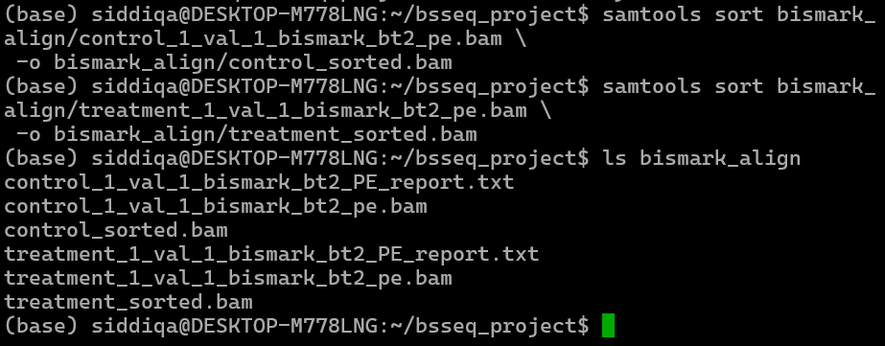
fig : 24 Sorting files

8. Methylation Extraction Using Bismark Methylation Extractor
The Bismark methylation extractor was then executed on the sorted BAM files to identify methylated and unmethylated cytosines across the genome.
Output Generated
Running the methylation extractor produced:
- a new directory named methylation/
- bedGraph files containing genome-wide methylation levels
- coverage (.cov) files reporting CpG methylation counts
These outputs serve as the primary input for downstream methylation analysis and visualization.
Warning About Sorting
Bismark produced an important warning during extraction:
The sorted BAM file is not ideal because sorting by genomic position breaks the original read-pair order.
This occurs because:
- Coordinate-sorted BAM files rearrange read pairs based on genomic location.
- Bismark’s methylation extractor prefers:
- unsorted BAM files, or
- name-sorted BAM files (samtools sort -n)
where read pairs remain together.
Despite the warning, the extraction process initialized correctly, and the expected output files were created.
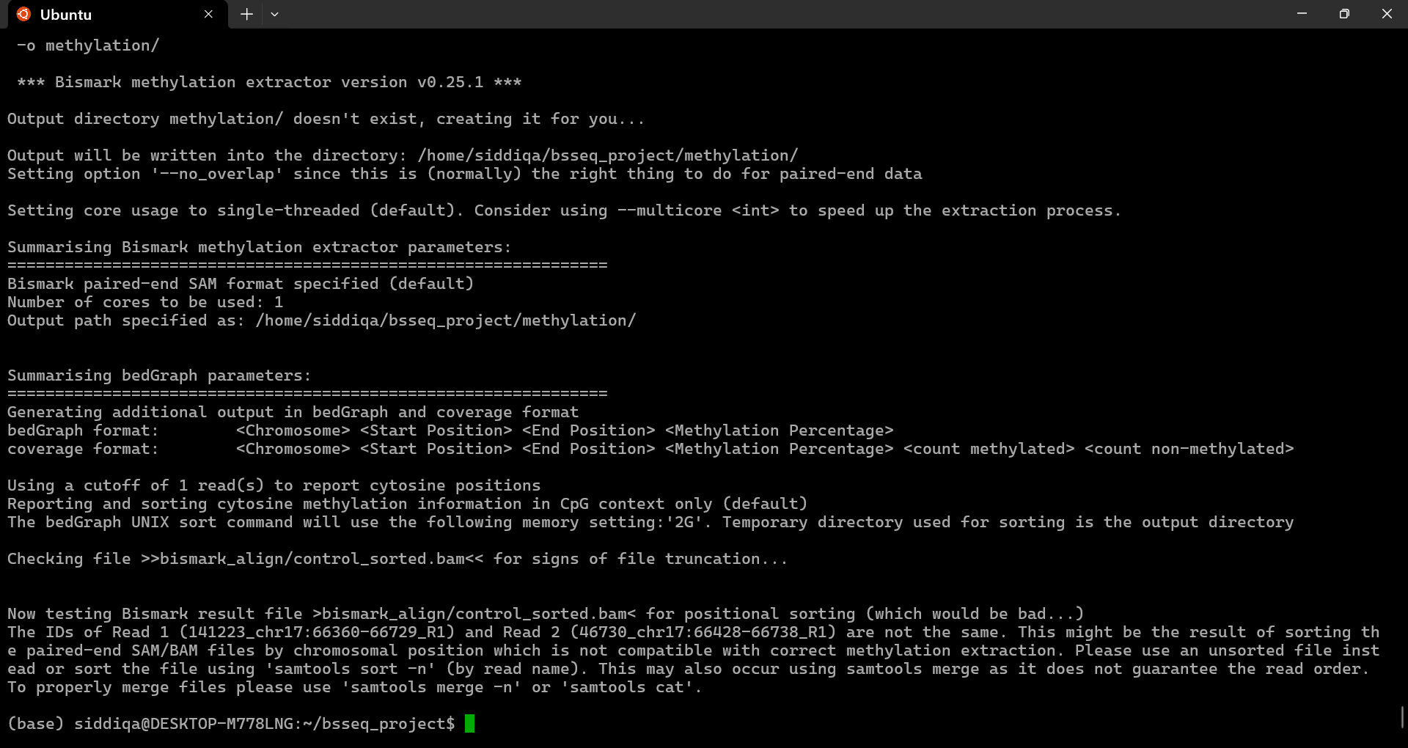
fig : 25 BedGraph summary

9. Conversion of Methylation Calls to bedGraph and Coverage Files
After extracting methylation information, Bismark converts the cytosine-level data into two widely used formats: bedGraph and coverage (.cov) files. These files provide genome-wide methylation levels in a structured form suitable for visualization and downstream analysis.
Bismark reads the methylation output files generated for each context:
- CpG
- CHG
- CHH
Each context is represented by both OT (original top strand) and OB (original bottom strand) files. The tool combines these context-specific files and converts them into:
- bedGraph files (*.bedGraph.gz)
Contain methylation percentage at each cytosine position.
- coverage files (*.bismark.cov.gz)
Include three values per site:
- number of methylated reads
- number of unmethylated reads
- genome coordinate
Key Steps Performed
- Bismark first summarizes the conversion parameters (sorting method, context type, buffer size).
- It then writes cytosine methylation information into:
  - a bedGraph file
  - a coverage file (.cov.gz)
- The tool processes each chromosome separately, generating temporary files and merging them.
- The output is sorted by genomic position to ensure compatibility with genome browsers and analysis tools.
Significance of This Step
This conversion confirms that the extracted methylation data has been:
- combined
- sorted
- structured
- compressed
into standard genome-wide formats, ready for:
- IGV/Genome Browser visualization
- methylation comparisons
- downstream statistical analysis
- PySpark or MySQL data import
This step marks the successful completion of methylation data formatting and prepares the dataset for further computational analysis.

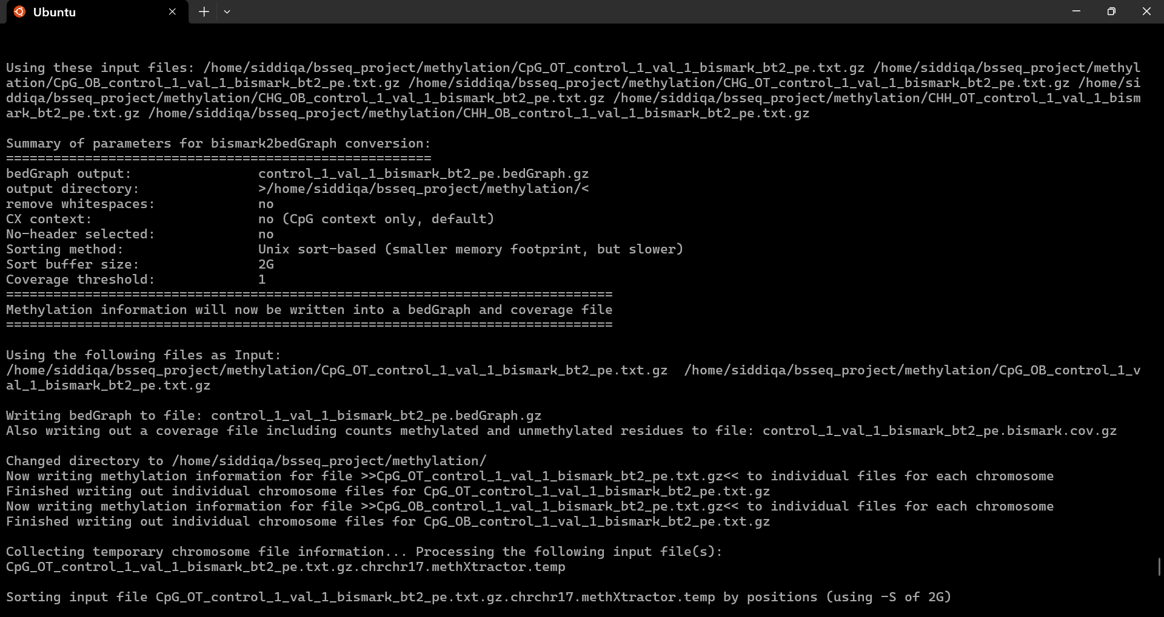

10. bedGraph and Coverage File Generation for the Treatment Sample
This step performs the same conversion process as the control sample but now applied to the treatment dataset. Bismark reads the extracted methylation files for CpG, CHG, and CHH contexts and converts them into final analysis-ready formats.
Conversion Summary
The log first summarizes the parameters used for the bismark2bedGraph conversion, including:
- output bedGraph file name
- output directory
- cytosine context (CpG by default)
- sorting method
- buffer size
- coverage threshold
These settings define how the methylation information will be merged, sorted, and structured.
Input Files Processed
Bismark uses the treatment sample’s methylation extractor output files:
- CpG_OT_treatment_...txt.gz
- CpG_OB_treatment_...txt.gz
- and equivalent CHG/CHH files
Each of these files contains raw methylated and unmethylated cytosine calls from Step 8.
Generated Output Files
Bismark then creates two final files for the treatment sample:
- bedGraph file
  - treatment_1_val_1_bismark_bt2_pe.bedGraph.gz
Contains methylation percentages per cytosine position.
- Coverage file
  - treatment_1_val_1_bismark_bt2_pe.bismark.cov.gz
Includes methylated count, unmethylated count, and genomic location.
These files are compressed and stored in the methylation/ directory.
Chromosome-wise Processing
Just like the control sample, Bismark:
- processes each chromosome separately
- writes temporary files
- sorts cytosine positions
- merges them into final genome-wide bedGraph and coverage files
- removes temporary files afterward
Outcome
The process completes successfully, confirming that:
- all treatment methylation calls were converted
- the bedGraph and coverage formats are correctly generated
- the treatment dataset is ready for visualization or downstream methylation analysis
This completes the core BS-seq methylation extraction pipeline for both control and treatment samples.

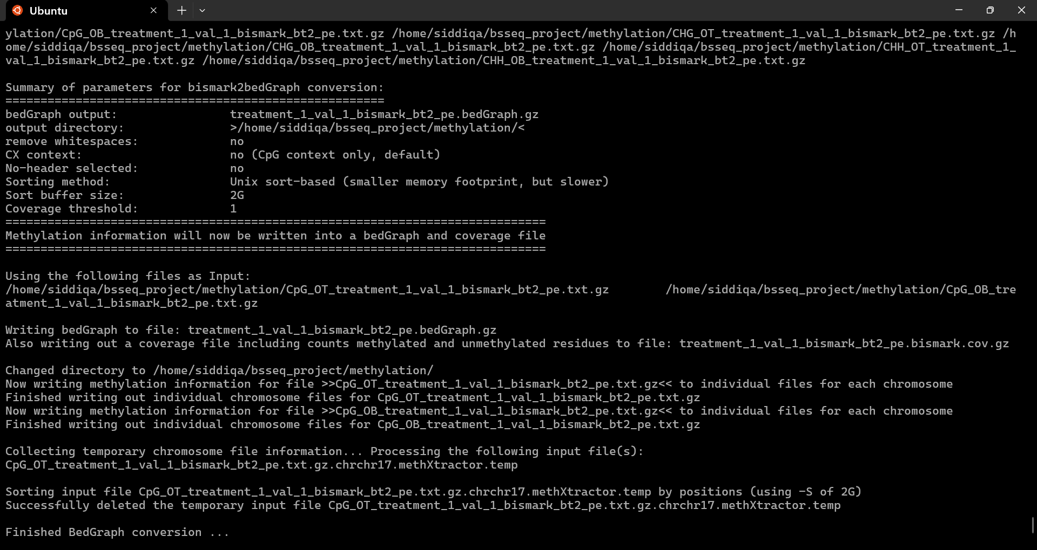

11. Differential Methylation Analysis and Validation Using methylKit

11.1 Loading Bismark coverage files into methylKit

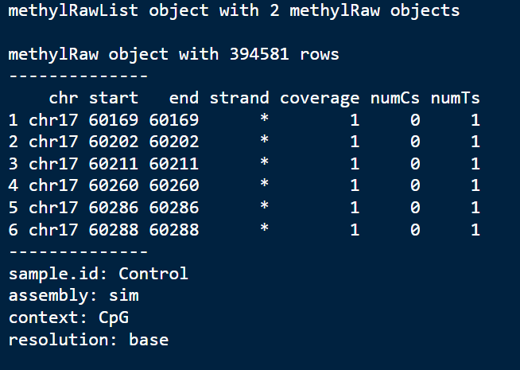
fig : 32 This figure shows the successful import of Bismark-generated CpG coverage files into methylKit, resulting in a methylRawList containing control and treatment samples. It confirms that methylation data were correctly structured at single-base resolution and that experimental groups were properly defined.
11.2 methylation aggregation
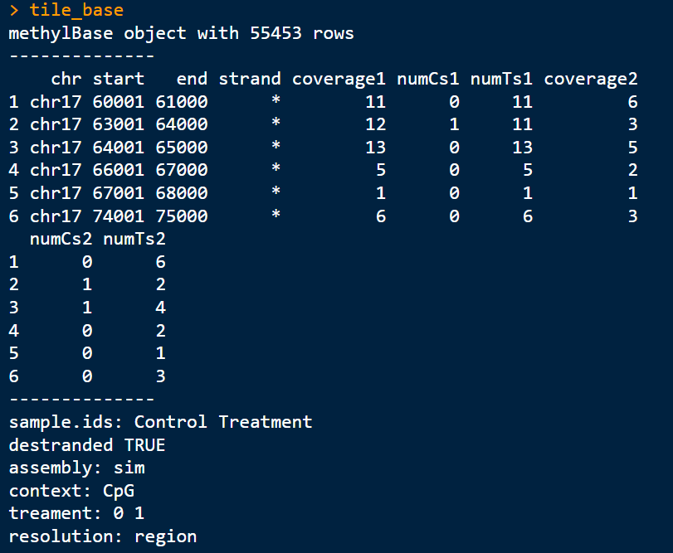
fig : 33 This figure demonstrates aggregation of CpG methylation data into fixed 1 kb genomic windows, producing a methylBase object.

11.3 Differential methylation testing

fig : 34 This figure presents raw differential methylation results, including methylation difference, p-values, and q-values for each genomic window. It confirms that statistical testing between control and treatment groups was successfully performed using methyKit

11.4 Significant DMRs after threshold filtering
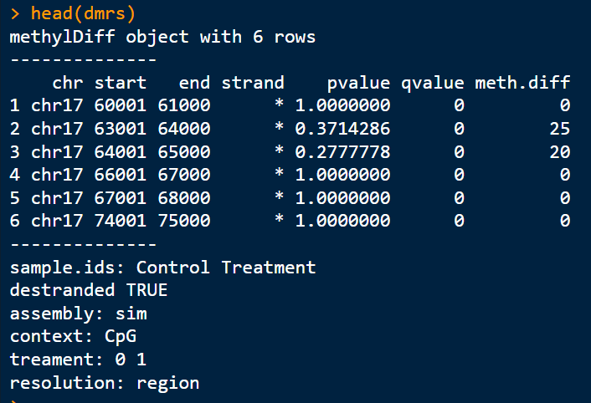
fig : 35 This figure shows a subset of significant differentially methylated regions (DMRs) identified after applying methylation difference and significance thresholds. It highlights genomic regions with notable methylation changes between experimental groups.

11.5 Performance evaluation using Precision and Recall
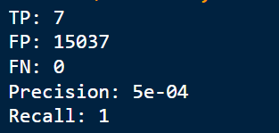
fig : 36 his figure summarizes the quantitative validation of the DMR detection pipeline. By comparing predicted DMRs with simulated ground-truth regions, true positives, false positives, precision, and recall were calculated, demonstrating perfect sensitivity (recall = 1) and illustrating the precision–recall trade-off.

Conclusion
In this project, a complete and reproducible whole-genome bisulfite sequencing (WGBS) analysis pipeline was successfully implemented using simulated data generated by the Sherman simulator. The workflow covered all major stages, including quality control, read trimming, bisulfite alignment, methylation extraction, exploratory analysis, and statistical differential methylation analysis.
Differentially methylated regions (DMRs) were identified using the methylKit package through a window-based analysis approach, which was selected to address low coverage and limited CpG overlap in the simulated dataset. To quantitatively validate the pipeline, predicted DMRs were compared against known simulated ground-truth regions.
The evaluation achieved perfect recall, indicating that all true DMRs were successfully detected, while lower precision reflected the use of relaxed thresholds and the sensitivity-focused nature of the analysis. These results highlight the importance of parameter tuning and demonstrate the expected precision recall trade-off in methylation studies.
Overall, this study confirms the correctness and effectiveness of the implemented WGBS analysis workflow and provides a validated framework for testing and benchmarking DNA methylation analysis pipelines before applying them to real biological datasets.

