**BolD**

*Italic*

3 no heading

H2O

a2+b2

Old Price ~~500~~  New price 300

Make colorful

|  |  |  |  |
| --- | --- | --- | --- |
| Hello | Hi | Hello | Hell |
| Hello | Good | No |
| 12 | 121 | 365 |
| 86556 | 6564 | 4342 | ok |

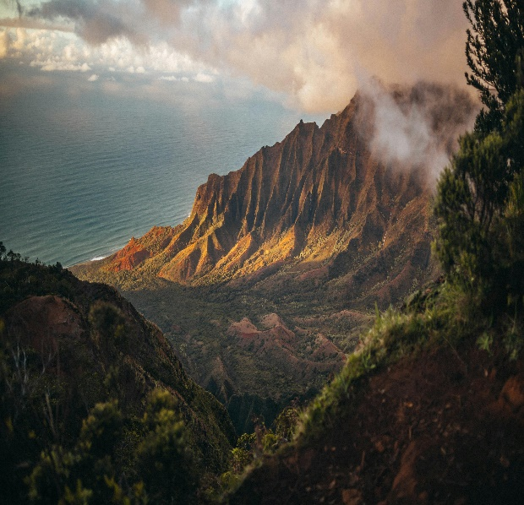

[](https://www.youtube.com/watch?v=KLuTLF3x9sA)

This is Bangladesh

**Class Student**

1. Mollika
   1. Rajbari sadar
   2. Web Development
2. Mita khatun
3. Roksana khatun