FeedbackIQ — Evaluation Results
Supporting material for the dissertation results chapter — sentiment classification, retrieval, and RAG chatbot evaluation.

1. Sentiment Classification Evaluation
Five sentiment classifiers were compared on the same held-out test set (n = 128,539 reviews, three classes: positive, neutral, negative): two classical ML baselines (Naive Bayes, Logistic Regression, both TF-IDF-based), a rule-based baseline (VADER), a pre-trained transformer (RoBERTa, no fine-tuning), and a fine-tuned transformer (DistilBERT — the dissertation's own contribution).

1.1 Overall Model Comparison
Model | Accuracy | Macro F1 | Weighted F1 | Precision | Recall
DistilBERT (fine-tuned) | 82.4% | 0.824 | 0.824 | 0.825 | 0.825
Logistic Regression | 80.3% | 0.803 | 0.803 | 0.803 | 0.803
Naive Bayes | 75.6% | 0.758 | 0.758 | 0.762 | 0.756
RoBERTa (pre-trained) | 63.3% | 0.569 | 0.571 | 0.606 | 0.631
VADER | 51.4% | 0.438 | 0.440 | 0.521 | 0.515

The fine-tuned DistilBERT model achieves the highest accuracy (82.4%) and macro F1 (0.824), outperforming both classical baselines and the pre-trained RoBERTa model without task-specific fine-tuning. Logistic Regression is the strongest classical baseline (80.3% accuracy), while VADER — a lexicon-based method with no learned parameters — performs weakest (51.4%), particularly on the neutral class.

1.2 Confusion Matrices
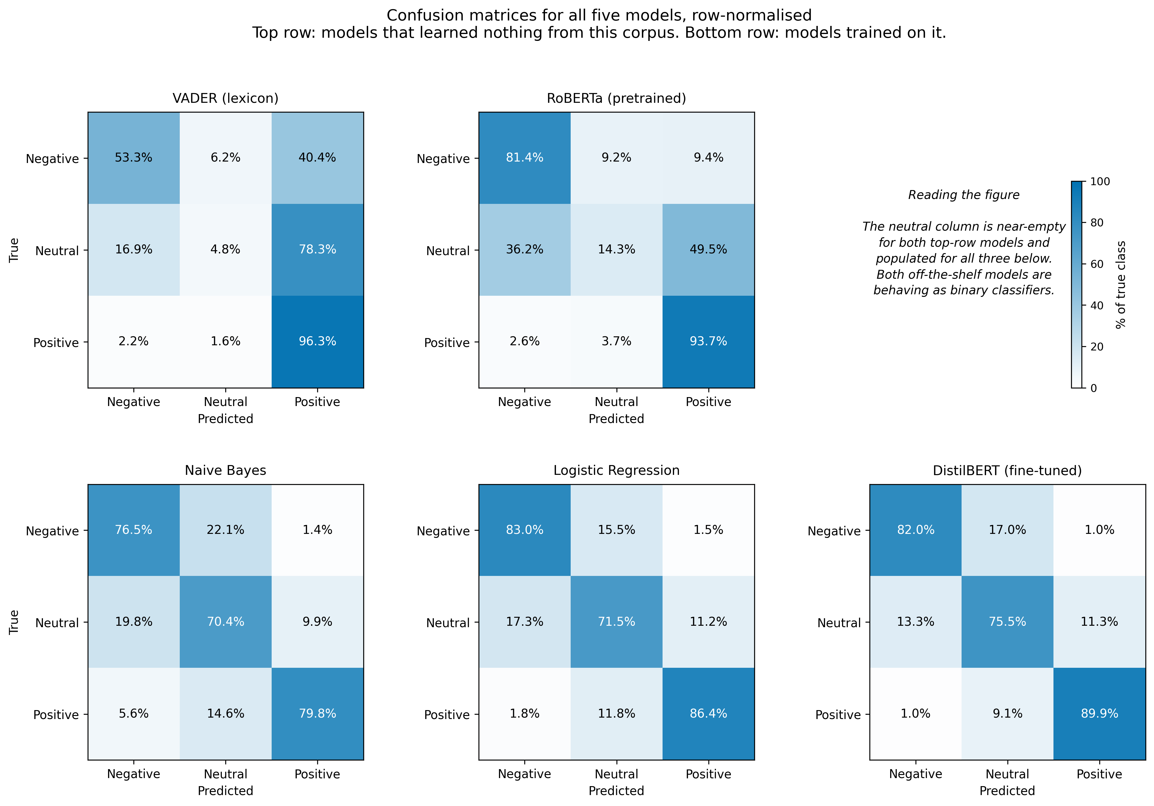
Figure 1. Confusion matrices for all five sentiment classifiers (rows: actual class, columns: predicted class).

1.3 Statistical Significance (McNemar's Test)
Pairwise McNemar's tests were run on a paired subset of predictions to check whether accuracy differences between models are statistically significant rather than due to chance. Note: the per-pair accuracy figures below come from the smaller paired-comparison subset used for McNemar's test, not the full 128,539-review test set in Table 1.1 — the two are not directly comparable row-for-row.
Model A | Model B | A Acc. | B Acc. | p-value | Better Model
VADER | DistilBERT (fine-tuned) | 0.5539 | 0.8417 | 1.59e-89 | DistilBERT (fine-tuned)
VADER | Logistic Regression | 0.5539 | 0.7444 | 1.55e-37 | Logistic Regression
Naive Bayes | DistilBERT (fine-tuned) | 0.6983 | 0.8417 | 2.57e-36 | DistilBERT (fine-tuned)
VADER | RoBERTa (pre-trained) | 0.5539 | 0.6944 | 3.21e-36 | RoBERTa (pre-trained)
RoBERTa (pre-trained) | DistilBERT (fine-tuned) | 0.6944 | 0.8417 | 2.09e-33 | DistilBERT (fine-tuned)
Logistic Regression | DistilBERT (fine-tuned) | 0.7444 | 0.8417 | 1.66e-21 | DistilBERT (fine-tuned)
VADER | Naive Bayes | 0.5539 | 0.6983 | 3.00e-21 | Naive Bayes
Naive Bayes | Logistic Regression | 0.6983 | 0.7444 | 1.55e-06 | Logistic Regression
Logistic Regression | RoBERTa (pre-trained) | 0.7444 | 0.6944 | 2.60e-04 | Logistic Regression
Naive Bayes | RoBERTa (pre-trained) | 0.6983 | 0.6944 | 0.817 (n.s.) | — no significant difference

Every comparison is statistically significant (p < 0.05) except Naive Bayes vs. RoBERTa (pre-trained), which are statistically indistinguishable on this subset (p = 0.817). DistilBERT's improvement over every other model is significant at p < 1e-20 in all cases.

2. Retrieval Evaluation
Two retrieval methods were compared on the same 30-query evaluation set over 642,692 indexed reviews: TF-IDF (sparse, keyword-based) and semantic search using sentence embeddings (all-MiniLM-L6-v2, 384-dim) with a FAISS index.
Metric | TF-IDF | Semantic Search (FAISS)
Precision@3 | 0.90 | 0.90
Avg. similarity score | 0.5593 | 0.6833
Avg. retrieval time | 127.6 ms | 21.7 ms
Query success rate | 100% | 100%

Both methods achieve identical Precision@3 (0.90) on this query set, but semantic search returns a higher average similarity score (0.683 vs. 0.559) and is roughly 6x faster (21.7ms vs. 127.6ms average retrieval time), since it queries a pre-built FAISS index rather than recomputing sparse TF-IDF similarity at query time. This is the retrieval method used in the deployed RAG chatbot.

3. RAG Chatbot Evaluation (RAGAS)
The RAG pipeline (scripts/evaluate_rag.py) is evaluated using two RAGAS metrics that don't require a hand-labelled reference answer: Faithfulness (does every claim in the answer trace back to the retrieved reviews — the direct hallucination signal) and Answer Relevancy (does the answer actually address the question asked). ContextPrecision and ContextRecall are intentionally excluded, as both require a ground-truth reference answer per question, which this evaluation set does not have.
Two custom, deterministic checks supplement RAGAS: platform_hallucination (does the answer name a platform, e.g. Amazon, that wasn't actually present in the retrieved reviews) and fabrication_risk (an LLM-judge check for unverifiable specific claims, used for the LLM-only baseline condition where no retrieved context exists to check faithfulness against). The suite covers nine experiments: LLM-only vs. RAG, top-k retrieval comparison, prompt engineering ablation, hallucination analysis across in-scope and edge-case questions, retriever comparison (similarity vs. MMR), conversation memory, metadata-tagging ablation, out-of-scope guard accuracy, and latency.
Results pending: this evaluation suite makes live Groq API calls and was not run as part of this document. Run `python scripts/evaluate_rag.py --fast` for a quick smoke test, or `python scripts/evaluate_rag.py` for the full sweep, from the project root with GROQ_API_KEY configured. Results are written to data/results/evaluation_rag/ and will also appear automatically on the app's Evaluation page once generated.
Limitation to report: the RAGAS judge reuses the same Groq model (llama-3.1-8b-instant) configured for answer generation. Using the same model as both generator and judge is a documented self-grading bias risk — worth noting explicitly if this evaluation setup is kept for the final dissertation.

