Table of Contents

Abstract
Organisations collect far more customer feedback than they can read, yet methods such as lexicon scoring, classical machine learning, transformer models and retrieval-augmented generation are often selected on reputation rather than evidence. Existing comparative studies are commonly based on single datasets and aggregate metrics, which can conceal how methods behave across different types of feedback and where they fail.
This dissertation compares these approaches stage by stage using a corpus of 642,692 reviews spanning Amazon products, Yelp businesses and airline complaint tweets, within a common comparative framework. Five sentiment classifiers were evaluated using per-class, per-platform and confusion-matrix analysis alongside McNemar significance testing. BERTopic was used to discover complaint topics separately by platform before consolidation into a 24-category cross-domain taxonomy, assessed without ground truth through coherence, coverage and distribution measures. A retrieval-augmented question-answering pipeline over a FAISS index was also compared with a standalone language model using four RAGAS metrics.
The central finding is that method ranking depends on domain. Fine-tuned DistilBERT achieved the highest clean held-out macro F1 of 0.8375, while pretrained RoBERTa scored 0.7853 on airline tweets but only 0.5544 on Yelp, outperforming both classical models on the platform closest to its training domain while underperforming logistic regression on the pooled evaluation. Diagnostic experiments showed that this behaviour was concentrated in the neutral class and was consistent with a mismatch between label definitions rather than general model weakness. Fine-tuning’s clearest benefit was cross-platform stability rather than peak accuracy. The taxonomy produced well-separated categories but left 27.6% of reviews unclassified and assigned some positive reviews to complaint categories. Retrieval augmentation achieved 0.540 faithfulness under a hard grounding threshold added to the retriever, a property not defined for the ungrounded baseline, while scoring lower on mean answer relevancy (0.610 against 0.753). Component-level metrics located retrieval, rather than generation, as the main measured weakness of the pipeline: on the question where retrieval itself was weakest, faithfulness fell with it rather than staying artificially high, evidence that the threshold suppresses confident answers built on weak evidence rather than masking the weakness. A separate, executed ablation on metadata tagging found a genuine trade-off rather than a clean validation — faithfulness improved by 0.118 and answer relevancy fell by 0.202 — alongside one directly observed instance of a hallucinated platform citation that tagging prevented.
The study contributes a stage-wise cross-domain comparison, diagnostic analysis of anomalous results, and evidence showing how aggregate metrics can conceal important failure modes. The generation evaluation was limited to five questions judged by the generating model, and of four designed RAG ablations, one (metadata tagging) was built and executed while the other three (retrieval depth, retriever type, prompt version) were not carried out, so conclusions at this stage remain directional rather than definitive.
Keywords: sentiment analysis, retrieval-augmented generation, topic modelling, cross-domain evaluation, customer feedback analytics, transformer models

Chapter 1 — Introduction
Intelligent Customer Feedback Analytics using LLMs
A stage-wise empirical comparison of classical machine learning, transformer-based models, and retrieval-augmented generation for customer complaint analysis and feedback exploration.

This dissertation is a comparative study. It asks a question practitioners face directly: which approach is actually justified for which part of the work? Analysing customer feedback is not one task but several, and the methods that compete at each point are different. Classifying sentiment is a supervised problem where classical machine learning and transformer models are the realistic candidates. Identifying what customers complain about is unsupervised, and belongs to topic modelling. Answering an analyst’s questions about those complaints pits retrieval-augmented generation against a language model working alone.
The comparison is therefore made stage by stage. Within each stage, competing methods are tested on the same data under the same protocol, and each is measured against an established baseline. This is a deliberate design choice rather than a compromise. A single head-to-head table across all three method families would be meaningless, because they perform different jobs and are judged by different measures.
The overall aim is to produce evidence, not a demonstration. A pipeline is built, because the methods cannot be compared without one, but the pipeline is the instrument and the comparison is the result. All experiments run on 642,692 reviews drawn from three very different sources: Amazon product reviews, Yelp business reviews, and customer tweets directed at airlines.
The topic matters for a practical reason. Customer feedback is one of the few sources of honest, unsolicited information a business holds about its own failures, and it arrives faster than any team can read it. Automation is therefore attractive, and the choice of method is usually made on reputation rather than evidence. Newer approaches are assumed to be better. This dissertation tests that assumption on data resembling what an organisation would actually hold, and reports the several places where it does not hold.
Four of the findings run against the expected ordering, and they are the reason the study is worth reading rather than an embarrassment to be managed. A pretrained transformer widely regarded as strong on social text scores below a logistic regression baseline on the pooled corpus. Topic modelling produces a taxonomy in which more than a quarter of sampled reviews fall into a catch-all category. Retrieval-augmented generation scores lower than a plain language model on answer relevancy, while being the only one of the two whose answers can be checked at all. And the one design decision this study was able to test in isolation — tagging retrieved reviews with their platform and rating before the model sees them — turns out to buy grounding at a measurable cost to how responsive the answers read, rather than being the free improvement the design reasoning had assumed. Each of these is reported in full, explained where the evidence supports an explanation, and left open where it does not.

1.1 Background

Context
The work sits in applied data science, drawing on natural language processing, information retrieval and large language models. All three fields have moved quickly, and the tools are now accessible enough that one developer can assemble in weeks what would once have needed a research team. That accessibility creates the problem this study addresses. When every method is easy to run, choosing between them becomes the hard part, and the published evidence for making that choice is thinner than it appears.
The area matters because unstructured text makes up most of the data organisations hold and remains the hardest to use. Structured data has mature tooling. Feedback text does not, at least not in a form that answers the questions managers ask. Sentiment dashboards report proportions. They rarely explain causes, and they almost never show their evidence.
Within that field this project belongs to the empirical end. It compares existing methods under controlled conditions; it does not propose a new algorithm. The contribution is the comparison itself, together with the evaluation design that makes it fair and the diagnostic work that explains the anomalies it uncovers.

Scope
The study addresses one question at three stages. At the classification stage, how do classical machine learning methods compare with transformer-based models on feedback drawn from several different domains, and is fine-tuning worth its cost? At the discovery stage, can topic modelling turn heterogeneous reviews into a complaint taxonomy that holds across platforms, and how is that judged when no correct answer exists? At the exploration stage, does retrieval-augmented generation offer a measurable advantage over a language model used on its own?
Four boundaries apply. Three platforms are examined, so the findings speak to behaviour across domains but not to customer feedback in general. Only English-language text is analysed. Complaint discovery uses negative reviews only, since the object of interest is a set of complaint categories rather than a general description of the corpus. Finally, the generation stage is evaluated on five questions, which is enough to demonstrate the measurement approach and to expose a clear directional pattern, but not enough to support a confident quantitative claim about generation quality. That constraint is stated here rather than buried in Chapter 5, because it bounds what RQ2 can conclude.

Current state of the art and its limits
Sentiment analysis is the most established part of the picture, and its history is worth following, because each stage solved a problem and introduced another. Lexicon-based tools such as VADER score text using a hand-built dictionary plus rules for negation and emphasis (Hutto & Gilbert, 2014). They need no training data and their decisions can be inspected. That combination is why VADER is treated here as a baseline in its own right and not as a member of the classical machine learning family: it learns nothing from the data, so it measures how far a fixed set of rules can go before any training is involved. Every other method in this study should be expected to beat it, and the size of that margin is itself informative. Its weakness is that it judges words largely in isolation, so sarcasm and implied criticism are often missed.
Supervised classical models learn from labelled examples instead. Naive Bayes and logistic regression over TF-IDF features are cheap, fast and surprisingly strong, though they discard word order (Pang & Lee, 2008). Transformers keep it. Pretrained encoders such as RoBERTa represent each word in the light of its context, and fine-tuning a smaller model such as DistilBERT on data from the target domain adapts it further (Devlin et al., 2019; Sanh et al., 2019; Liu et al., 2019).
The usual assumption is that this ordering also ranks performance. It does not always hold, and the reason is partly methodological. Published comparisons are typically run on a single dataset, often a balanced benchmark of product or film reviews. A model that scores well there may do poorly on tweets. Studies that test the same models across several types of feedback at once, on one corpus and one protocol, did not appear in the literature reviewed for this project (Chapter 2). That leaves a practitioner without an answer to a simple question: is fine-tuning worth its cost on my data, or would a linear model serve?
Knowing the sentiment of a review is only half of what a business needs. It says how much dissatisfaction exists, not what it concerns. Topic modelling is the usual next step. Latent Dirichlet Allocation, long the standard, treats each document as a mixture of word-based topics (Blei et al., 2003). It works poorly on short informal text, because it relies on words co-occurring within a document and tweets supply too few. BERTopic handles such text better. It embeds each document with a sentence transformer, reduces the dimensions, clusters the result, and describes each cluster using distinctive words (Grootendorst, 2022). Because it groups by meaning instead of shared vocabulary, two complaints worded differently can still land together.
What BERTopic returns, though, is a list of keyword clusters, and that is not a set of complaint categories a business could act on. The gap is larger than it looks. Running BERTopic separately on each platform in this project produced 69 topics for Amazon, 18 for Yelp and 34 for Twitter Airline, giving 121 in total. Many describe the same underlying issue in different words. Some reflect quirks of the source data instead of real complaints. The level of detail also varies sharply between platforms. Consolidating these into one taxonomy needs a further step, and here the literature is thin. There is no agreed way to decide how many categories to keep, or to check the result when no correct answer exists for comparison. This project’s own taxonomy inherits that difficulty rather than escaping it, as Chapter 4 reports.
The final part concerns how people reach the analysis. Managers ask specific questions in ordinary language. Large language models suit that style of interaction, but a model asked about a collection it has never seen will sometimes invent figures, categories or sources, and it will do so fluently (Ji et al., 2023). Retrieval-Augmented Generation is the standard remedy: relevant documents are fetched from an index first, and the model is instructed to answer only from those documents (Lewis et al., 2020). Adopting RAG does not guarantee grounding. Retrieved text can be off-target, and the model can ignore it. Whether grounding has been achieved must be measured, and it is measured far less often than RAG is adopted. Direct comparisons against a plain language-model baseline were rarer still in the literature reviewed here, even though that is the baseline any practitioner would weigh RAG against.
Two gaps follow. The first is the shortage of controlled comparison at each stage on the same multi-domain data, which leaves method selection resting on reputation. The second is the shortage of verification of what these systems produce, particularly for generated output. Both matter because the cost falls on whoever uses the results. A wrong complaint category sends effort in the wrong direction. An unsupported claim in a generated summary is worse, because it looks exactly like a supported one.

Motivation
The reason for addressing this is straightforward. Feedback analysis is already automated in industry and its results already inform decisions, yet the choice of method is often made without evidence from data resembling the organisation’s own. A comparison run across three domains, with one corpus, one protocol and one held-out test set, gives a firmer basis for that choice than a benchmark score quoted from a paper.
The expected benefits are practical. A practitioner gains evidence on which method family is worth its cost for which task, including the cases found here where the cheaper option is sufficient and the more sophisticated one is not. An analyst gains complaint categories derived from data instead of assumption, together with an honest account of where those categories break down. A researcher gains a documented account of how these components behave together, including where the combination performs worse than expected. The beneficiaries are customer experience and product teams who currently read samples of feedback by hand, and applied researchers building similar systems who would benefit from knowing which parts are fragile.

The research problem
Existing work supplies methods but not the comparative evidence needed to choose between them. Sentiment models are benchmarked on single datasets, so their reported accuracy may not survive a change of domain. Topic models produce clusters that are not yet categories, with no accepted way to validate them without labels. Language models generate confident text whether or not evidence supports it, and retrieval-augmented systems are frequently adopted without being tested against the simpler alternative they are meant to improve on. Traceability, which is what allows a claim to be checked, tends to be treated as a matter of presentation when it is really a matter of design.
Four questions follow, each answerable with evidence produced in this project:
- RQ1. How does sentiment classification performance differ between lexicon-based, classical machine learning, pretrained transformer and fine-tuned transformer approaches on multi-domain customer feedback?
- RQ2. How effectively does Retrieval-Augmented Generation improve complaint exploration compared with a standalone large language model?
- RQ3. Can BERTopic produce a coherent cross-domain complaint taxonomy from heterogeneous customer reviews?
- RQ4. To what extent can retrieval-augmented answers be traced to, and verified against, the source reviews used to produce them?
RQ4 is framed around traceability instead of business usefulness. Establishing usefulness would require a user study, and none was carried out. Traceability can be measured directly, and is.

1.2 Research Aim and Objectives

Aim
The aim of this research is to compare, stage by stage, the classical machine learning, transformer-based and retrieval-augmented approaches available at each point in a customer complaint analysis pipeline, each measured against an established baseline on a single multi-domain corpus, in order to establish which approach is justified at which stage and how far the output of each can be trusted.
The comparison requires a working pipeline, and that pipeline is the artefact produced. It has four connected parts: a sentiment classification component covering the baseline and both learned method families, a complaint discovery and categorisation component built on BERTopic, a FAISS index supporting semantic retrieval over the review corpus, and a question-answering component that returns source review identifiers with every answer. It is intended for customer experience and product analysts who need to understand recurring complaints without reading the underlying reviews in full, and for practitioners choosing between these methods for similar work.
The aim is realistic within the project timeframe because it uses existing models instead of training new architectures from scratch. The one model trained here is a fine-tuned DistilBERT classifier, small enough to train on freely available hardware. The heavier work lies in the evaluation, which is where the contribution sits.

Objectives
Objective 1 — Review the literature on sentiment analysis, topic modelling, retrieval-augmented generation and explainable AI, and identify where existing comparisons are absent or restricted to a single domain. Judged on whether the review compares methods and justifies those later chosen, instead of describing them one after another. Delivered in Chapter 2.
Objective 2 — Select a research methodology and prepare a unified multi-domain dataset suitable for controlled comparison. The outcome is a single cleaned dataset of 642,692 reviews from three platforms sharing one schema, with sentiment labels produced by a documented rule, class balance recorded, and a fixed random seed so the same train and test split can be recreated. A shared dataset and split is what makes the comparison controlled for four of the five models: differences between them cannot then be attributed to differences in data. The fine-tuned model is the exception — it was developed against a separately generated corpus version, a limitation disclosed and discussed in Section 3.5.3 rather than assumed away.
Objective 3 — Implement and compare five sentiment classifiers, spanning a lexicon-based baseline, the classical machine learning family, and pretrained and fine-tuned transformers, and explain the mechanism behind any result that runs against expectation. Requires accuracy, macro F1, per-class F1 and confusion matrices for all five models on one held-out set of 128,539 reviews, together with a breakdown by platform. Reporting the baseline separately matters, since it sets the floor every learned method is judged against. A ranking alone would leave the most interesting finding unexplained, so the diagnostic explanation forms part of the objective rather than an optional extra. Addresses RQ1.
Objective 4 — Discover complaint topics for each platform using BERTopic and consolidate them into one cross-domain taxonomy. The outcome is a documented set of per-platform topics reduced from 121 raw topics to 24 named categories, with the merging procedure and its parameters recorded, and with the coverage and coherence of the result measured rather than assumed. Discovery runs per platform instead of over the pooled corpus, because pooling would let the largest platform dominate the topic space. Addresses RQ3.
Objective 5 — Build the retrieval-augmented question-answering component and a standalone language model baseline to compare it against. Requires a working pipeline with documented embedding model, index configuration, retrieval depth and prompt design, returning source identifiers with each answer. Retrieved reviews must carry their platform, rating and sentiment into the prompt, since otherwise the instruction to cite only platforms present in the evidence cannot be enforced. Addresses RQ2 and RQ4.
Objective 6 — Evaluate every stage using measures appropriate to that stage, comparing against baselines, ablating design decisions where feasible, and diagnosing the mechanism behind any anomalous result. The outcome is supervised metrics for sentiment classification, coherence and distribution measures for the taxonomy, and RAGAS scores for faithfulness, answer relevancy, context precision and context recall for both the retrieval-augmented and standalone conditions. Where a result contradicts expectation, three further diagnostic experiments test the proposed explanation: a per-platform breakdown, a re-evaluation with the neutral class removed, and a decision-threshold sweep. One component of the retrieval pipeline — metadata tagging — is ablated directly, by running the same questions with the tags removed and comparing, so that at least one design decision is measured rather than argued. All results are written to file so that every number in Chapters 4 and 5 can be traced to its source. Addresses RQ1 to RQ4.
Objective 7 — Discuss the findings, judge whether the aim was met, and state the limitations openly. Success means each research question receives a direct answer supported by reported evidence, including the unfavourable results, and that constraints such as rating-derived labels, the small generation-evaluation sample and the absence of a user study are discussed rather than minimised. Delivered in Chapters 5 and 6.

Contributions
The contributions are those of a careful applied comparison, and are stated at that level deliberately:
- A controlled multi-domain comparison of five sentiment classifiers on one corpus, one protocol and one held-out set of 128,539 reviews, with per-class and per-platform breakdowns rather than a single aggregate score.
- A diagnostic explanation of an anomalous result — a pretrained transformer scoring below a linear baseline — supported by three follow-up experiments rather than asserted from intuition.
- An end-to-end complaint taxonomy pipeline from per-platform topic discovery through cross-platform merging to threshold-gated category assignment, with its coverage failures reported rather than smoothed over.
- A direct RAG-versus-standalone-LLM comparison on the same questions with the same generator, measuring grounding rather than assuming it, and reporting the case where retrieval reduced a quality metric.
- An executed ablation of the metadata-tagging design decision, isolating one component of the retrieval pipeline and measuring what it contributes — which turned out to be a trade-off between grounding and responsiveness rather than the clean improvement the design argument predicted, together with one directly observed hallucination the tagging prevented.
- A reproducible evaluation harness: every reported figure is produced by a script that writes to data/results/, so the numerical claims in this dissertation are auditable rather than transcribed.
What is not claimed: no new algorithm or architecture is proposed, no user study establishes business usefulness, and the generation evaluation is too small to support confident quantitative conclusions. These boundaries are set out again in Chapter 6.

1.3 Research Approach
The approach is quantitative and experimental. Its organising principle is that methods competing at the same stage are tested under identical conditions, since a comparison is only as good as the controls around it. Each stage is evaluated before the next depends on it.
Objective 2 is met by mapping all three sources onto a common schema, cleaning the text, and labelling sentiment from star ratings, with two stars or below treated as negative, three as neutral, and four or above as positive. Twitter Airline data carries its own sentiment annotation and is mapped onto the same three classes. The rule is simple and repeatable, but it is an approximation, because a four-star review can still contain a complaint. This is stated here because it places a ceiling on the accuracy any classifier in this study can reach, and reading the results without knowing it would be misleading.
Objective 3 is met by evaluating all five classifiers on one stratified split with a fixed seed. For four of the five, this means differences between models cannot come from differences in test data; the fine-tuned model was developed against a separately generated corpus version, which Section 3.5.3 treats as a disclosed limitation rather than a controlled condition. Metrics, parameters and confusion matrices are logged to MLflow, which keeps the comparison auditable and lets individual runs be recovered later.
Objective 4 is met by running BERTopic on the negative reviews of each platform separately, then merging topics across platforms by clustering their centroid vectors and naming each merged group with a language model. Reviews are assigned to categories in two steps: an embedding comparison shortlists a few likely categories, then a zero-shot entailment model ranks that shortlist. A confidence threshold leaves weak matches unclassified instead of forcing a label, which keeps a known unknown visible in the results — and, as Chapter 4 shows, that unknown turns out to be large enough to be a finding in its own right.
Objective 5 is met by indexing the corpus with a sentence-transformer model in FAISS, retrieving a small number of reviews per question, and passing them to the language model under instructions to answer only from that text. Each retrieved review is tagged with its platform, rating and sentiment before it reaches the model, and review identifiers are returned with every answer. The same questions are then put to the language model with no retrieval at all, which provides the baseline the comparison in RQ2 depends on.
Objective 6 uses three kinds of evaluation, chosen by what each stage allows. Sentiment classification has labels, so standard classification metrics apply, supported by McNemar’s exact test for pairwise comparison. The taxonomy has none, so quality is argued from how tightly reviews cluster around their category, how evenly categories are populated, how they spread across platforms, and how many reviews fall below the confidence threshold. The question-answering component is scored with RAGAS. Two limitations should be recorded at the outset: the evaluation covers five questions, and the model used to judge answers is the same one that produces them, which introduces a self-assessment bias. Both were accepted because of free-tier API limits, and both are reported openly in Chapter 5 rather than being allowed to inflate the apparent strength of the generation results.
The tools are Python with pandas and scikit-learn for data handling and classical models, Hugging Face Transformers for RoBERTa and DistilBERT, VADER for the lexicon baseline, BERTopic with UMAP and HDBSCAN for topic discovery, sentence-transformers for embeddings, FAISS for the vector index, LangChain for the retrieval chain, Groq’s hosted Llama 3.1 model for generation, RAGAS for generation metrics, and MLflow for experiment tracking. Random seeds are fixed throughout, dependency versions are pinned, and unit tests cover the topic-merging and category-shortlisting logic.
On ethics, all three datasets are publicly available and were collected by their original publishers, so no new data was gathered and no human participants were involved. The reviews contain no special-category personal data, reviewer names are not used, and reviews are referenced by identifier only. Two risks are worth recording. Review text occasionally contains personal details written by the reviewer, so no attempt is made to link reviews to individuals. Second, generated summaries describe named businesses, and acting on an unsupported summary could affect one unfairly. Returning source reviews with every answer is a partial safeguard, since a claim can be checked before it is used.

1.4 Dissertation Outline
Chapter 2 — Literature Review examines work on sentiment classification, topic modelling, dense retrieval, retrieval-augmented generation and explainable AI. It compares approaches instead of listing them, and identifies the two gaps this study addresses: the shortage of controlled comparison at each pipeline stage on multi-domain data, and the shortage of verification of generated output.
Chapter 3 — Research Approach sets out the methodology in full. It describes the datasets and preprocessing, the experimental design that makes the comparison controlled, the models and hyperparameters used, and the reasoning behind each choice, including the alternatives that were rejected and why.
Chapter 4 — Data Analysis reports the analytical work and its results: exploratory analysis of the three sources, the sentiment classification experiments and their diagnostic follow-ups, topic discovery for each platform, construction and measurement of the merged taxonomy, and the retrieval and generation evaluations.
Chapter 5 — Discussion interprets those results. It answers each research question in turn, compares the findings with the literature reviewed in Chapter 2, and examines the results that run against expectation: a pretrained transformer losing to a linear model, a taxonomy in which a catch-all category absorbs more than a quarter of sampled reviews, a standalone language model scoring higher than the retrieval-augmented system on answer relevancy while having no evidential basis for its answers, and a metadata-tagging decision that helps grounding while hurting responsiveness. It also works through a case where tracing an unexpected zero back to its source changed the diagnosis — a question the pipeline never answered turned out to have been rejected by a scope classifier rather than declined for want of evidence. The limitations of the evaluation design itself are discussed here rather than deferred.
Chapter 6 — Conclusion reviews the aim and each objective, states what the study established and what it did not, and sets out future work drawn from the limitations actually encountered: a manually labelled evaluation set for the categorisation stage, a substantially larger question set and an independent judge model for the generation metrics, retraining the fine-tuned classifier on the current corpus version to remove the disclosed split limitation, and comparison against an alternative zero-shot classifier.

Chapter 2 — Literature Review
This chapter reviews the research the present study builds on and argues with. Its purpose is not to catalogue what has been published, but to work out what is already settled, what is still contested, and where the evidence needed to choose between methods is missing. That last point is what the dissertation responds to, so the review is written to lead into it.
The chapter is organised in four parts. Section 2.1 reviews the substantive literature: why customer feedback analysis matters, how the problem has been tackled, how the competing studies compare, and what gap remains. Section 2.2 examines the supporting literature behind the methodological decisions taken here, covering datasets and evaluation design. Section 2.3 reviews the tools and technologies themselves and justifies the specific choices made. Section 2.4 summarises and connects the review to the methodology in Chapter 3.
Emphasis falls on work published since 2019, since transformer-based methods and retrieval-augmented generation have both changed substantially within that window. Older work is cited only where it introduced something still in active use.
Every source cited in this chapter has been verified against the publisher record, the ACL Anthology, arXiv or a DOI resolver, and appears in full in the reference list. Two claims encountered during the review could not be traced to a verifiable publication — a reported LDA-against-BERTopic coherence comparison, and a three-class sentiment benchmark figure — and both were removed rather than attributed to a source that may not support them. Section 2.5 records what was removed and why, since the decision affects one comparison in Chapter 5.

2.1 Literature Review

2.1.1 Research context
Customer feedback is unusual among data sources in being simultaneously abundant, unsolicited and directly actionable. A dissatisfied customer writing a review is describing a specific failure without being prompted, which is information that surveys struggle to obtain. The difficulty is volume. Platforms such as Amazon and Yelp hold review counts in the tens of millions, and no analyst team reads more than a sample.
Academic interest has followed commercial interest closely. Sentiment analysis grew into one of the largest subfields of applied natural language processing, and the surveys of the period document a steady migration from lexicon and feature-based methods towards learned representations (Pang & Lee, 2008). More recently the arrival of large language models has pushed the field towards generation: instead of classifying feedback, systems are now expected to summarise it, answer questions about it, and recommend action.
The relevance to industry is immediate, and the reason is specific. Sentiment classification supports monitoring; it tells an organisation how bad things are. Topic and complaint discovery supports diagnosis; it tells them what is wrong. Question answering over the corpus supports investigation; it lets an analyst pursue a particular concern. These are different jobs with different failure modes, and treating them as one problem is part of why method selection in this area is often poorly evidenced.
Figure 2.1 shows how the literature reviewed in this chapter maps onto those three jobs, and where each method family sits.
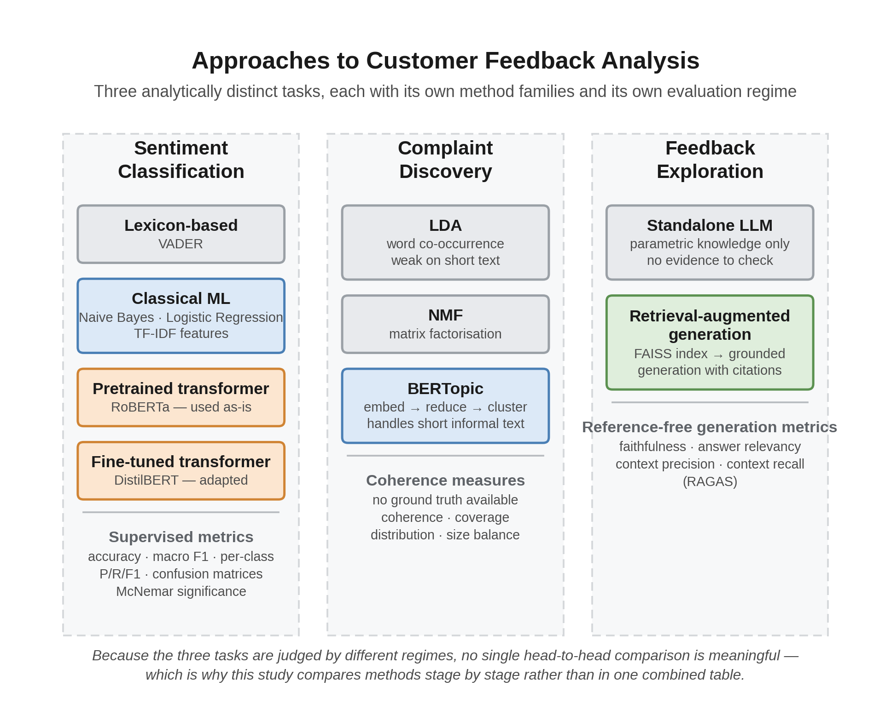
Figure 2.1
Figure 2.1 — Taxonomy of approaches to customer feedback analysis. The three tasks are analytically distinct, draw on different method families, and are judged by different evaluation regimes — which is why this study compares methods stage by stage rather than in a single combined table. (Source: docs/figures/fig_2_1_taxonomy.png.)
The point the figure makes is worth stating in words too, because it shapes everything that follows. Reading down any one column gives a sequence of methods that can sensibly be ranked against each other. Reading across the columns does not: a macro F1 score and a coherence score are not commensurable, and neither is comparable to a faithfulness score. Studies that report a single headline number for a feedback-analysis system are implicitly collapsing these three regimes into one, and that collapse is where a good deal of the reported evidence loses its meaning.

2.1.2 Current state of the art
Sentiment classification. The dominant approach is now the fine-tuned transformer. BERT established the pattern of pretraining a bidirectional encoder and adapting it to a downstream task (Devlin et al., 2019), and the variants that followed traded accuracy against cost in different ways. RoBERTa improved pretraining without changing the architecture (Liu et al., 2019), while DistilBERT reduced parameters by roughly 40% through distillation while retaining most of the performance (Sanh et al., 2019). The practical consequence is that a strong classifier is now a fine-tuning job rather than a research project.
Recent empirical work on review data supports the general ranking. Ali et al. (2024) compared machine learning, deep learning and transformer-based techniques on Amazon product reviews and found BERT outperforming every classical and deep-learning model tested. Shaukat (2024) reached a compatible but more qualified conclusion, benchmarking Random Forest, Naive Bayes and SVM against GPT-4 on product reviews: the classical models held their own on short, concise comments — SVM best among them — while the language model pulled ahead on longer, context-rich text. That length-conditional result is worth noting here, because the corpus used in this study spans exactly that range, from 19-word tweets to 85-word Yelp narratives. Sunar (2025) extends the comparison to embedding choice, evaluating traditional, pre-transformer and transformer paradigms on the Amazon Magazine Subscriptions 2023 dataset across static (GloVe, FastText) and contextual (BERT, DistilBERT) representations, and reports DistilBERT achieving both the highest accuracy at 92% and the lowest cross-entropy loss.
Two things about this body of work matter for the present study. First, the comparisons are consistently run within a single domain, most often Amazon product reviews. Second, they report aggregate accuracy or weighted F1 far more often than per-class behaviour. Both choices make transformer superiority easier to demonstrate and harder to qualify — and, as Chapter 4 shows, both conceal exactly the failure this study encountered.
Domain adaptation and transfer. The assumption that a pretrained transformer transfers well is itself an empirical claim, and the models are not domain-neutral. The twitter-roberta family, for instance, was pretrained on tweets and benchmarked on Twitter-specific tasks (Barbieri et al., 2020), which is the reason it performs strongly on short social text. Whether that advantage survives a move to long-form review prose is exactly the kind of question single-domain studies cannot answer.
A separate literature does address this directly, though from a different angle. Cross-domain sentiment classification treats the mismatch as a transfer-learning problem, seeking representations that hold across source and target domains. Recent work in this line includes feature projection with multi-source attention, designed to reduce negative transfer when knowledge is drawn from several source domains at once (Kong et al., 2023). The underlying mechanism in much of this literature is domain-adversarial training, in which a gradient reversal layer pushes the feature extractor towards representations a domain discriminator cannot separate (Ganin et al., 2016). What matters for the present study is not the architectures themselves — none is used here — but what their existence implies: a field that builds dedicated machinery to survive domain shift is a field that considers domain shift a serious obstacle.
The field’s own framing is instructive, and the contrast is worth drawing out. Cross-domain researchers treat domain shift as a serious obstacle demanding dedicated architecture — projection layers, adversarial objectives, multi-source attention. Applied comparison papers, meanwhile, routinely assume an off-the-shelf pretrained model will simply work on whatever data it is given, and report a single aggregate number that would hide it if the assumption failed. Both literatures are describing the same phenomenon; only one of them is looking for it. The present study takes the applied position but tests it, measuring performance per platform instead of assuming transfer holds — and the per-platform result in Chapter 4 lands firmly on the side of the cross-domain literature.
Applied feedback analysis with large language models. A newer strand applies language models directly to commercial feedback. Recent work has proposed multi-model pipelines for automating e-commerce feedback analysis, and weighted ensembles combining GPT-family models with deep learning for multilingual review classification. Aspect-based sentiment analysis has attracted particular attention, since it promises the granularity that document-level sentiment lacks. Findings here are mixed in a way that matters: comparisons of large language models against smaller fine-tuned models such as BERT report that the larger models handle simple sentiment classification competently but struggle with tasks requiring structured or nuanced output, while outperforming in few-shot settings where annotation is scarce. Purpose-built resources are beginning to appear: Şilcenco et al. (2025) release a manually annotated corpus of 10,814 multilingual retail reviews labelled across eight aspect categories, and report GPT-4 and LLaMA-3 baselines above 85% accuracy on it. The pattern suggests that model scale does not straightforwardly substitute for task-specific training, which is consistent with the position taken in this dissertation.
Zero-shot classification. Assigning text to categories that were not seen during training is usually framed as natural language inference: each candidate label is verbalised as a hypothesis and scored against the text as premise (Laurer et al., 2023). The approach matters here because complaint categories discovered by topic modelling have no labelled examples by construction. Schopf et al. (2022) evaluate unsupervised text classification systematically, benchmarking similarity-based against zero-shot approaches across four datasets, and find that similarity-based methods significantly outperform zero-shot ones in most cases. That finding bears directly on the category-assignment design in Section 3.6.3, which uses embedding similarity to shortlist candidate categories before an entailment model ranks the shortlist rather than running zero-shot entailment over the full taxonomy. The consistent finding is that the quality of the label verbalisation matters as much as the model, which is why the pipeline in this study uses a full category description as the hypothesis instead of a bare category name.
Complaint and topic discovery. LDA remained the default for two decades (Blei et al., 2003), but it depends on word co-occurrence within documents and degrades on short informal text. BERTopic replaced the probabilistic machinery with an embedding-and-clustering pipeline, using a sentence transformer for representation, UMAP for dimensionality reduction, HDBSCAN for clustering, and class-based TF-IDF for topic description (Grootendorst, 2022). Egger and Yu (2022) demonstrate the practical consequence on exactly the register that matters here, comparing LDA, NMF, Top2Vec and BERTopic on Twitter posts and finding the embedding-based methods better suited to short documents. That evidence bears directly on this study’s corpus, where the Twitter Airline subset has a median length of 19 words — short enough that the document-length argument is not theoretical.
Comparative evidence since then has been broadly favourable but more nuanced than the headline suggests. Turan et al. (2024) compared LDA, NMF and BERTopic on an Amazon product review dataset and concluded that all three were useful, with BERTopic producing more interpretable topics. Mishra (2026) reached a similar conclusion in marketing research. Kaur and Wallace (2024) approach the comparison differently, and their design is instructive given the coherence-validity problem discussed below: rather than scoring topics automatically, they had twelve qualitative researchers inspect and compare the output of LDA, NMF and BERTopic directly. Eight of the twelve preferred BERTopic, citing detailed, coherent clusters and the capacity to surface unexpected relationships. Human preference is a different — and for interpretability arguably more relevant — form of evidence than a coherence score. That qualification matters: BERTopic’s advantage appears to lie in cluster structure rather than in coherence as conventionally measured, and it does not dominate on every dataset or every metric. Ogunleye et al. (2023) illustrate how sensitive the result is to configuration rather than to algorithm family — working on customer tweets directed at Nigerian banks, a domain close to the present study’s, they report that substituting Kernel PCA and K-means into the BERTopic architecture yields a coherence score of 0.8463, well above what the default configuration achieves on the same data. Comparisons between named algorithms therefore risk comparing implementation choices rather than methods.
The disagreement is not noise. It tracks a real dependency: BERTopic’s advantage is largest where documents are short and lexically sparse, which is precisely where LDA’s co-occurrence assumption breaks down, and smallest where documents are long enough for word co-occurrence to be informative. A study reporting BERTopic’s superiority on tweets and a study reporting LDA’s superiority on longer complaint text may both be correct. This matters for the present work because its corpus spans both registers, which is an argument for BERTopic (the tweets would defeat LDA) while also being a reason not to expect uniform performance across the three platforms.
Retrieval-augmented generation. RAG was introduced to combine parametric knowledge in model weights with non-parametric knowledge retrieved at inference (Lewis et al., 2020). Its adoption accelerated sharply once hallucination was recognised as a systematic property of generative models rather than an occasional defect (Ji et al., 2023). Recent surveys document the resulting proliferation of architectures and evaluation schemes (Yu et al., 2024).
Evaluation has become the contested part. RAGAS proposed reference-free metrics for faithfulness, answer relevance and context relevance, allowing evaluation without human annotation (Es et al., 2024). Benchmarking work has shown that large language models remain sensitive to noise and irrelevant passages in retrieved context (Chen et al., 2024). Yu et al. (2024) note that many benchmarks collapse performance into a single aggregate score, which is inadequate for diagnosing whether a failure originated in retrieval or generation — a criticism this study takes seriously enough to report retrieval-side and generation-side metrics separately in Chapter 4.
Evaluation by language model. Because reference-free metrics are usually computed by a language model acting as judge, the reliability of that judge is now itself a research area. Surveys published since late 2024 catalogue position bias, verbosity bias and self-enhancement bias, where a model rates its own outputs more favourably (Gu et al., 2024; Li et al., 2024). This literature bears directly on a limitation of the present study, discussed in Section 2.2.3.

2.1.3 Critical review
Comparing these studies exposes patterns that individual papers do not.
Datasets. The overwhelming majority of sentiment comparisons use a single source, and Amazon reviews dominate. This is convenient — the data is large, labelled by star rating and freely available — but it produces a narrow evidence base. Review length, formality and complaint style differ substantially between a product review, a restaurant review and a complaint tweet. A study establishing that a transformer wins on Amazon has not established that it wins on customer feedback.
There is also a labelling convention worth questioning. Deriving sentiment labels from star ratings is standard practice, and it is what makes datasets of this scale possible. But it is an approximation, since a four-star review can contain a specific complaint, and papers rarely discuss the ceiling this places on achievable accuracy. The present study inherits the same approximation and states the consequence rather than passing over it.
Algorithms. The comparisons are usually generous to the newest method. Transformer baselines are typically fine-tuned; classical baselines are often not tuned to a comparable degree. Where classical models are given careful feature engineering and regularisation they perform closer to transformers than the headline numbers imply, particularly on longer, well-formed text where lexical features are informative. This is not a minor caveat. If the classical baseline in a published comparison is weaker than a competent practitioner would build, the reported margin measures the authors’ effort allocation as much as the methods’ capability.
Evaluation metrics. This is the weakest link in the literature. Accuracy and weighted F1 dominate, and both conceal class-level failure. A three-class problem in which a model performs well on two classes and collapses on the third can still report a respectable aggregate. Macro F1 partially addresses this, and confusion matrices address it fully, but neither is reported consistently. The consequence is not hypothetical: the single most informative result in this dissertation is one that a weighted-F1-only report would have rendered invisible.
For topic modelling the situation is considerably worse, and the problem is not merely that studies disagree about which coherence measure to prefer. A body of work has questioned whether automated coherence measures are valid at all. Hoyle et al. (2021) argued that automated topic model evaluation is broken, showing that coherence metrics do not reliably reproduce human judgements of topic quality and that measures developed for classical models were never validated against human assessment on neural ones. Doogan and Buntine (2021) reached a compatible conclusion from a different direction, arguing that the target construct — interpretability — is itself ambiguous, and that coherence measures designed for older models may be incompatible with newer ones. More recent analysis published in Computational Linguistics examined the correspondence between widely used automated coherence metrics and human judgement at scale, combining large-corpus sampling of topic representations with a user study built from several proxy tasks, and found the relationship weaker and more task-dependent than the metrics’ routine use implies (Lim & Lauw, 2024). In other words, the metrics can reward topics that humans find obscure. Alternative formulations continue to be proposed, including contextualised coherence metrics that use embeddings in place of co-occurrence counts (Rahimi et al., 2024), and use-oriented evaluations that measure whether a topic model supports the task it was built for.
This literature has a direct bearing on the present study, and it shaped the evaluation design rather than merely being cited near it. If C_v and NPMI are unreliable proxies for interpretability, then reporting a single coherence figure would be a weak basis for a claim about taxonomy quality. The approach taken here — embedding-based coherence supplemented by category balance, platform spread, unclassified rate and manual inspection — follows the direction the critique points in: several imperfect indicators read together with a human check, rather than one automated score presented as decisive. Chapter 4 shows why that mattered. The taxonomy’s average per-category coherence looks respectable in isolation; the coverage and balance figures reported alongside it tell a much less flattering story, and a single-metric report would have missed it entirely.
For RAG the field is younger still, and Yu et al. (2024) identify the absence of diagnostic, component-level evaluation as a live problem: aggregate scores cannot tell a developer whether a failure originated in retrieval or in generation.
Table 2.1 compares representative studies on the dimensions that determine how far their conclusions transfer.
Table 2.1 — Comparison of representative studies across datasets, methods and evaluation
Study | Domain(s) | Methods compared | Metrics reported | Principal limitation
Turan et al. (2024) | Amazon reviews | LDA, NMF, BERTopic | Topic interpretability | Single platform; qualitative comparison
Mishra (2026) | Marketing research abstracts | BERTopic, LDA | Coherence, interpretability | Not customer feedback; small corpus
Ali et al. (2024) | Amazon products | ML, DL, transformers | Accuracy, F1 | Single platform; aggregate metrics only
Kong et al. (2023) | Multi-domain reviews | Feature projection, multi-source attention | Accuracy | Purpose-built architecture, not off-the-shelf comparison
Chen et al. (2024) | Wikipedia-based QA | LLMs under retrieval noise | Accuracy under perturbation | Not customer feedback; synthetic noise
Hoyle et al. (2021); Doogan & Buntine (2021) | Multiple corpora | Topic models vs human judgement | Human agreement vs NPMI, C_v | Methodological critique, no applied pipeline
This study | Amazon, Yelp, Twitter Airline | Lexicon, classical ML, pretrained and fine-tuned transformers; RAG vs standalone LLM | Macro and per-class F1, confusion matrices, per-platform breakdown, McNemar tests; embedding coherence, coverage, platform spread; four RAGAS metrics | Rating-derived labels; single judge model; five-question generation sample
Strengths and weaknesses. Table 2.2 summarises how the three method families compare on the dimensions that matter for a practitioner choosing between them.
Table 2.2 — Comparison of method families across the three stages of feedback analysis
Dimension | Lexicon-based | Classical ML | Transformer | RAG (generation stage)
Training data required | None | Moderate labelled set | Large labelled set for fine-tuning | None for retrieval; relies on a pretrained generator
Compute cost | Negligible | Low | High (GPU for training) | Moderate; inference plus index
Handles context and word order | No | Weakly | Yes | Yes
Domain adaptability | Poor without manual lexicon work | Retrain on target data | Fine-tune on target data | Swap the underlying corpus
Interpretability | High: rules are inspectable | Moderate: feature weights | Low | Moderate: retrieved sources are inspectable
Typical evaluation | Accuracy, F1 | Accuracy, F1 | Accuracy, macro F1 | Faithfulness, answer relevancy, context precision and recall
Principal weakness | Misses sarcasm and implicit sentiment | Discards word order | Cost, and sensitivity to domain shift | Grounding is not guaranteed by architecture alone
Research trends. Three are visible. Evaluation is shifting from reference-based to reference-free, driven by the cost of annotation and the difficulty of defining a single correct generated answer. Attention is moving from model architecture towards data quality and retrieval quality, on the recognition that a strong generator conditioned on poor context still fails. And explainability is moving from post-hoc explanation towards source attribution, where the justification for an output is the evidence retrieved to produce it. The third trend is the one this dissertation engages with most directly, since it converts a presentational concern into a measurable design property.

2.1.4 Research gap
Four limitations run through the work reviewed above.
Comparisons in the studies reviewed here are conducted within a single domain, so the reported ranking of methods may reflect the dataset as much as the methods. A practitioner holding feedback from several sources has no direct evidence on which to base a decision.
Aggregate metrics dominate, so failure modes are hidden. Where a model fails on one class or one platform, the reporting conventions tend to obscure it, and the mechanism is rarely diagnosed even when the failure is visible.
Topic model output is treated as though it were a taxonomy. Studies compare topic quality between algorithms, but the step from keyword clusters to a consolidated, named set of categories usable across domains receives little attention, and its validation without ground truth receives less.
RAG is frequently adopted without being compared against the baseline it is meant to improve on. Faithfulness is measured within RAG systems, but among the studies reviewed here the direct comparison against unconstrained generation — which a practitioner would weigh it against — did not appear, and the reliability of the language model doing the judging is only now being scrutinised.
Design decisions inside RAG pipelines are, relatedly, argued rather than measured. Prompt-level grounding constraints, metadata injection, retrieval depth and reranking are usually introduced together and defended by reasoning about why they should help. Where a system-level faithfulness score is then reported, it is offered as though it validated each of those decisions individually, which it cannot. The reviewed literature endorses ablation as the remedy far more often than it performs one.
This dissertation addresses these together. It compares method families at each pipeline stage on one multi-domain corpus with a shared protocol; reports per-class and per-platform behaviour alongside aggregates and diagnoses the mechanism behind results that contradict expectation; treats taxonomy consolidation as an explicit stage with its own unsupervised evaluation and reports its coverage failures rather than its best-looking metric; evaluates the retrieval-augmented system against a standalone language model baseline while stating openly both the self-assessment bias in its judge and the small size of the question set; and ablates one retrieval design decision directly rather than inferring its contribution from a system-level score.
Two of these gaps are addressed more completely than the other two, and it is worth being straightforward about which. The multi-domain comparison and the per-class diagnosis are supported by a large held-out sample and significance testing. The generation comparison and the ablation rest on five questions and a single executed condition respectively, so they demonstrate the measurement approach and indicate a direction without settling the matter. Chapter 5 keeps that distinction visible when drawing conclusions.

2.2 Supporting Literature

2.2.1 Methodology
The design adopted here is a controlled comparative experiment built around a working pipeline. Comparative empirical studies in applied machine learning conventionally hold the data, the split and the metrics constant while varying the method, and that convention is followed. Where this study departs from much of the reviewed work is in comparing at each stage separately, since the methods under comparison perform different jobs and cannot be placed in a single table.
The literature also motivates a diagnostic rather than purely competitive stance. Because aggregate metrics conceal class-level failure, per-class F1 and confusion matrices are treated here as primary results, not appendix material. Where a result contradicts the expected ordering, the response is a follow-up experiment rather than a paragraph of speculation — a stance the reviewed literature recommends more often than it practises.

2.2.2 Datasets
Three sources are combined. Amazon product reviews and Yelp business reviews are long-established benchmarks in this literature, both large and rating-labelled. The Twitter US Airline Sentiment dataset differs in an important way: its labels come from human annotation instead of star ratings, and its text is short and informal.
That difference is deliberate. Combining rating-derived and human-annotated labels introduces heterogeneity, which is a limitation, but it also produces the register variation the comparison depends on. A corpus of three Amazon-like sources would not test domain transfer at all.
Two dataset limitations follow from the literature and are carried forward into Chapter 3. Rating-derived labelling is approximate, as discussed in Section 2.1.3. And review corpora are subject to selection effects, since customers with strong opinions are more likely to write, so the sentiment distribution should not be read as representative of customers generally.

2.2.3 Evaluation methods
Three evaluation regimes are used, matched to what each stage permits.
For sentiment classification, labels exist, so standard supervised metrics apply. Macro F1 is preferred over accuracy as the headline figure because it weights all three classes equally and therefore exposes the single-class collapse that the reviewed literature tends to hide. Pairwise model comparison uses McNemar’s exact test, which is appropriate for paired predictions on a common test set and avoids treating two models’ scores as independent samples.
For complaint discovery there is no ground truth, so classification metrics are unavailable. The literature’s usual proxies are coherence measures, and the disagreement between studies noted in Section 2.1.2, together with the validity critique in Section 2.1.3, shows they are not decisive. This study uses embedding-based coherence — the similarity of reviews to their category centroid — supplemented by category balance, platform distribution, and the proportion of reviews left unclassified. Reporting several weak indicators together is more defensible than resting on one, and in this case it is what made the taxonomy’s real weakness visible.
For the generation stage, RAGAS provides reference-free faithfulness, answer relevancy, context precision and context recall (Es et al., 2024). Four metrics are used, not one, because they can disagree in informative ways: an unconstrained model can score highly on relevancy while having no evidential basis at all, so relevancy alone would reward exactly the behaviour the system is designed to prevent. Chapter 4 reports precisely this disagreement.
The LLM-as-judge literature bears directly on a constraint of this study. Because the same model both generates and judges, self-enhancement bias of the kind documented by Gu et al. (2024) and Li et al. (2024) is a genuine threat to validity. This was accepted as a consequence of free-tier API limits, and it is reported as a limitation instead of being left implicit; using an independent judge model is identified as future work in Chapter 6.
One further evaluation practice deserves mention, because the reviewed literature endorses it more consistently than it applies it. Reporting that a retrieval-augmented system achieves some faithfulness score establishes that the system as a whole is grounded; it says nothing about which of its several design decisions produced that grounding. Isolating a component by removing it and re-measuring — an ablation — is the standard way to attribute an effect to a mechanism, and it is routine in model-architecture papers. It is markedly less common in applied RAG work, where prompt constraints, metadata injection, retrieval depth and reranking are typically adopted together and justified by reasoning rather than measured individually. That gap is the reason Section 3.6.6 specifies an ablation suite for the retrieval stage, and why Chapter 4 reports the one condition of it that resources allowed to be executed. The result, as it turns out, does not simply confirm the design argument it was meant to test — which is itself an argument for running such experiments rather than assuming their outcome.

2.3 Technology Review

2.3.1 Models and libraries
Sentiment models. VADER is retained as a baseline because it requires no training and its decisions are inspectable, which makes it a meaningful floor for what rules alone achieve (Hutto & Gilbert, 2014). Naive Bayes and logistic regression over TF-IDF features are implemented in scikit-learn; they are cheap, strong on longer text and, importantly, tunable to a standard comparable with the transformers — which, given the criticism of under-tuned baselines in Section 2.1.3, is a methodological commitment rather than a convenience. RoBERTa is used in its Twitter-pretrained form (Barbieri et al., 2020), which makes the domain-transfer question testable rather than assumed. DistilBERT is chosen for fine-tuning over BERT or RoBERTa because distillation retains most of the accuracy at around 40% fewer parameters (Sanh et al., 2019), which makes training feasible on freely available hardware — a real constraint for an MSc project, and one worth stating openly instead of disguising as a purely technical preference.
Topic modelling. BERTopic is selected over LDA on the evidence reviewed in Section 2.1.2, particularly its handling of short informal text, which matters because one of the three sources is tweets. Its components are used as intended: sentence-transformer embeddings (Reimers & Gurevych, 2019), UMAP for dimensionality reduction (McInnes et al., 2018), and HDBSCAN for clustering (Campello et al., 2013). HDBSCAN’s ability to leave points unassigned as noise is an advantage here, since not every negative review expresses a categorisable complaint — a property that turns out to matter a great deal in Chapter 4.
Category assignment. Reviews are assigned to discovered categories using zero-shot natural language inference, following the approach behind the DeBERTa-based universal classifiers (Laurer et al., 2023). This avoids needing labelled examples for categories that did not exist before the discovery stage ran. An embedding shortlist precedes the entailment step so that inference cost stays bounded as the taxonomy grows.
Retrieval. FAISS provides the vector index (Johnson et al., 2019). The embedding model is all-MiniLM-L6-v2 from the sentence-transformers family (Reimers & Gurevych, 2019), chosen for its 384-dimensional output and speed; a larger embedding model would improve representation quality at a cost in index size and query latency, and that trade-off is examined empirically against a TF-IDF baseline rather than assumed.
Generation. Groq’s hosted Llama 3.1 model is used, orchestrated through LangChain. The choice was driven by cost — the free tier permitted the volume of evaluation calls required — and it carries consequences that are reported honestly: rate limits constrained the generation evaluation to five questions, and using the same model for generation and judging introduced the bias discussed above.
Evaluation and tracking. RAGAS supplies the generation metrics (Es et al., 2024), scikit-learn the classification metrics, and MLflow records parameters, metrics and artefacts so that individual runs remain recoverable.
Table 2.3 — Technology selection and justification
Component | Selected | Alternatives considered | Reason for selection
Lexicon baseline | VADER | TextBlob, SentiWordNet | Designed for social media text; widely used, so results are comparable
Classical models | Naive Bayes, logistic regression (TF-IDF) | SVM, gradient boosting | Fast, interpretable, standard baselines in this literature
Pretrained transformer | twitter-roberta-base-sentiment-latest | BERT-base, generic RoBERTa | Twitter pretraining makes domain transfer directly testable
Fine-tuned transformer | DistilBERT | BERT, RoBERTa | ~40% fewer parameters at comparable accuracy; trainable on available hardware
Topic model | BERTopic | LDA, NMF, Top2Vec | Handles short informal text; semantic clustering rather than lexical
Embeddings | all-MiniLM-L6-v2 | all-mpnet-base-v2, OpenAI embeddings | Fast, 384-d, no API cost; quality trade-off tested empirically
Vector index | FAISS | Chroma, Pinecone, Weaviate | Local, free, well documented, no external dependency
Zero-shot classifier | DeBERTa-v3 zero-shot | bart-large-mnli | Stronger reported zero-shot performance with larger label sets
Generator | Llama 3.1 via Groq | GPT-4, Gemini, local Llama | Free tier supported the required evaluation volume
Orchestration | LangChain | LlamaIndex, custom | Mature retrieval-chain abstractions; large ecosystem
RAG evaluation | RAGAS | TruLens, ARES, manual | Reference-free metrics; no annotation budget required

2.3.2 Trade-offs acknowledged
Two choices in Table 2.3 deserve explicit qualification. Selecting a small embedding model and a free-tier generator were both constrained decisions, not optimal ones. Their effects are examined directly rather than assumed away: retrieval quality is compared against a TF-IDF baseline in Chapter 4, and the limits imposed by rate limiting on evaluation sample size are reported wherever generation results appear, rather than in a footnote.

2.4 Chapter Summary
This review establishes four things. Fine-tuned transformers are the dominant approach to sentiment classification, but the evidence supporting their superiority comes overwhelmingly from single-domain studies reporting aggregate metrics, so it is weaker than it appears — and the cross-domain literature, which takes domain shift seriously enough to build architectures against it, implicitly contradicts the applied literature’s confidence. BERTopic is better suited than LDA to the short, informal text found in social feedback, though comparative results are mixed in a way that tracks document length rather than being arbitrary. Retrieval-augmented generation is the accepted response to hallucination, but adopting it does not by itself establish that grounding has been achieved, and direct comparisons against unconstrained generation remain uncommon. Finally, reference-free evaluation using a language model as judge is now standard practice while its reliability is still being actively questioned, and the same is true of the automated coherence measures used to evaluate topic models.
The technologies selected follow from this. VADER as a floor, tuned classical models as a serious baseline rather than a token one, a Twitter-pretrained RoBERTa to make domain transfer testable, a distilled transformer for feasible fine-tuning, BERTopic with its embedding and clustering components, zero-shot entailment for assigning reviews to newly discovered categories, and FAISS with RAGAS for the retrieval and evaluation stages.
The gap that remains is the absence of controlled, stage-wise comparison on multi-domain data, reported at a granularity that reveals failure modes instead of concealing them, with generated output verified against the evidence it claims to rest on.
Chapter 3 sets out the methodology designed to close that gap. Each decision there traces back to a limitation identified in this chapter: the shared split responds to the confounding in single-dataset comparisons, per-class and per-platform reporting responds to the aggregate-metric problem, the multi-indicator taxonomy evaluation responds to the coherence-validity critique, and the standalone LLM baseline responds to the missing comparison in the RAG literature.

2.5 Note on Sources
Every source cited in this chapter has been verified against the publisher record, the ACL Anthology, arXiv or a DOI resolver. No citation is reconstructed from memory, and no reference appears in the list that is not cited in the text.
Two claims met during the review could not be verified and were therefore removed rather than attributed:
A reported LDA-against-BERTopic coherence comparison (LDA 0.68, BERTopic 0.51) on customer complaint data. A genuine paper on Indonesian customer complaints exists (Khadija & Nurharjadmo, 2024), but it compares LDA against BERT embeddings rather than BERTopic and does not report these figures; the numbers appear only in secondary summaries that simultaneously attribute a third result to an unrelated study of ChatGPT-related tweets. The figures and the Chapter 5 comparison built on them have been deleted. The argumentative point they were used to support — that BERTopic does not dominate on every dataset or metric — is now carried by Kaur and Wallace (2024) and Ogunleye et al. (2023), both verified.
A three-class financial sentiment benchmark (BERT, 87% accuracy, macro F1 0.85). No single publication could be confirmed as its origin, and reported three-class figures in that literature shift with the annotation-agreement threshold applied to the underlying corpus, so a quoted accuracy without that threshold is not a comparable quantity. The corresponding row has been removed from Table 5.1, and Section 5.4.2 now explains why the comparison is left open instead of substituting an approximate figure.
Recording these two removals rather than quietly dropping them is deliberate. A reference list demonstrates what was found; stating what could not be found, and what was given up as a result, is the part that shows the searching was real.

Chapter 3 — Research Approach
Chapter 2 ended with a gap and four specific complaints about how the existing literature is evaluated: comparisons run within one domain, aggregate metrics that hide class-level failure, topic models validated by a single contested coherence score, and retrieval-augmented systems adopted without being measured against the baseline they are meant to improve on. This chapter sets out a methodology designed against those four complaints rather than around them.
Its purpose is therefore twofold. It must make the work reproducible — another researcher should be able to repeat these experiments and obtain these numbers — and it must justify each decision against the limitation it responds to, so that the results in Chapter 4 can be read with the right qualifications already attached. Where a decision was constrained rather than optimal, that is stated at the point the decision is described, not deferred to a limitations section at the end.
The chapter proceeds in the order the work was actually carried out. Section 3.1 selects and justifies the research methodology and maps its phases onto the objectives. Section 3.2 describes the datasets and what they can and cannot support. Section 3.3 sets out the workflow that connects the stages. Section 3.4 covers tools and technologies. Section 3.5 describes preprocessing and, critically, splitting — the point at which the comparison is either controlled or not. Section 3.6 covers model development at each stage, with hyperparameters, evaluation metrics and an explicit statement of which planned experiments were carried out and which were not. Section 3.7 addresses ethics, and Section 3.8 summarises.

3.1 Research Methodology

3.1.1 Selecting a methodology
Several methodologies are established for data science work, and the choice between them turns on where a project’s contribution sits. CRISP-DM remains the most widely used process model, structuring work as business understanding, data understanding, data preparation, modelling, evaluation and deployment. Design Science Research is common where the output is an artefact, and organises work around building and evaluating that artefact. KDD focuses more narrowly on the sequence from raw data to extracted knowledge. Agile approaches are sometimes adapted for exploratory analytics.
This study uses CRISP-DM, adapted for a comparative experimental design. The reasoning follows from what this project is. Design Science suits work whose contribution is the artefact itself; here the pipeline is the instrument and the comparison is the contribution, so a methodology organised around artefact construction would misplace the emphasis and invite the writing-up to describe a system rather than evaluate a question. KDD stops short of the evaluation depth this study needs. Agile addresses project management rather than analytical validity, which is the thing at risk here.
CRISP-DM fits for two reasons that bear directly on Chapter 2’s criticisms. Its evaluation phase is explicit and iterative, which suits a study whose contribution lies in evaluation rather than modelling. And its data preparation phase is treated as substantial work rather than a preliminary, which matters because preparation is precisely where a comparison becomes controlled or fails to. The adaptation is that the modelling and evaluation phases execute three times, once per pipeline stage, since each stage has its own candidate methods and its own appropriate metrics — a direct consequence of the argument in Chapter 1 that feedback analysis is not one task but three. Deployment is out of scope and is treated as future work in Chapter 6.

3.1.2 Applying the methodology
Business understanding. Established in Chapter 1: organisations need to know not only how much dissatisfaction exists but what it concerns, and need to be able to check any conclusion against evidence. This phase produced the four research questions.
Data understanding. Exploratory analysis of the three sources, examining review length, class balance, platform composition and text quality. This phase identified the register differences between platforms that the whole comparison depends on, and surfaced the labelling limitation discussed in Section 3.2.3.
Data preparation. Cleaning, schema unification, sentiment labelling, class balancing and splitting. Described in Section 3.5.
Modelling. Executed three times: five sentiment classifiers, BERTopic discovery with taxonomy consolidation, and the retrieval-augmented pipeline with its standalone baseline. Described in Section 3.6.
Evaluation. Also executed three times, with metrics matched to what each stage permits, plus diagnostic experiments that test the mechanism behind any unexpected result rather than leaving it as speculation. Described in Section 3.6.5.
Table 3.1 maps the phases onto the objectives from Chapter 1, so that every phase of work traces to a stated objective and through it to a research question.
Table 3.1 — Mapping of CRISP-DM phases to research objectives and questions
CRISP-DM phase | Objective | Research question | Output
Business understanding | O1 | RQ1–RQ4 | Literature review, research gap
Data understanding | O2 | — | Exploratory analysis, dataset profile
Data preparation | O2 | — | Unified corpus, documented split
Modelling (stage 1) | O3 | RQ1 | Five trained or configured classifiers
Modelling (stage 2) | O4 | RQ3 | Per-platform topics, merged taxonomy
Modelling (stage 3) | O5 | RQ2, RQ4 | RAG pipeline and standalone baseline
Evaluation | O6 | RQ1–RQ4 | Metrics, baselines, diagnostic experiments
Conclusion | O7 | RQ1–RQ4 | Critical discussion, limitations, future work
With the process settled, the next question is what data it operates on — and since Chapter 2’s first criticism was that single-domain corpora cannot support cross-domain claims, the composition of the corpus is itself a methodological decision rather than a given.

3.2 Data Collection

3.2.1 Datasets
Three publicly available datasets are used, chosen so that the corpus spans genuinely different registers rather than three variations of the same thing. This is the direct response to the dataset criticism in Section 2.1.3: a study that wants to say something about domain transfer must contain domains that actually differ.
Amazon product reviews cover physical products, where complaints concern quality, delivery and value. They vary widely in length, from one-line verdicts to detailed accounts of a product’s performance over time. Yelp reviews describe service and hospitality experiences, where complaints concern staff, waiting and atmosphere; these are the longest reviews in the corpus, typically running to extended narrative. Twitter US Airline Sentiment provides short, abbreviated, often public-facing complaints directed at a company, where the issues are delays, cancellations and baggage.
The three therefore differ on register, length and communicative purpose simultaneously — a reviewer writing for other shoppers, a diner writing a narrative account, and a customer publicly demanding a response are doing different things with language. All three were obtained from their public distributions; no data was scraped and no new data was collected.

3.2.2 Dataset characteristics
After preprocessing, the unified corpus contains 642,692 reviews. Table 3.2 gives the composition.
Table 3.2 — Composition of the unified corpus
Platform | Reviews | Share | Label origin | Median words
Yelp | 449,858 | 70.0% | Star rating | 85
Amazon | 178,883 | 27.8% | Star rating | 29
Twitter Airline | 13,951 | 2.2% | Human annotation | 19
Total | 642,692 | 100%
The median word counts confirm that the register variation is real and not merely assumed: Yelp reviews are roughly four and a half times longer than airline tweets. That spread is what makes the per-platform comparison in Chapter 4 informative, and it is also why a method that performs well on one platform should not be expected to transfer without evidence.
The sentiment distribution is close to balanced by design: negative 218,799, neutral 212,503, positive 211,390. Balancing was applied during sampling so that no class dominates, which matters because macro F1 is the headline metric and an imbalanced corpus would make the neutral class both rare and hard — conflating two separate difficulties and obscuring which one a model was failing on.
Each record carries: review_id, platform, product_category, text, cleaned_text, rating, sentiment_label and date.

3.2.3 Justification and limitations
The three sources were chosen because they differ on the dimension the study cares about. A corpus of three product-review sources would not test transfer across register; these three do.
Four limitations follow, and each is carried into the interpretation of results rather than parked here.
Labels are derived from star ratings for Amazon and Yelp, with ratings of two or below treated as negative, three as neutral, and four or above as positive. This is standard practice at this scale — it is what makes corpora of this size possible at all — but it is an approximation: a four-star review can contain a specific complaint, and it will be labelled positive. This places a ceiling on the accuracy any classifier in this study can reach, and it is the most likely source of difficulty on the neutral class, since a three-star review is the least semantically coherent of the three groups.
Label provenance is not homogeneous. Twitter labels come from human annotation, so the corpus mixes two labelling processes. This is a genuine threat to comparability across platforms and is reported as such wherever per-platform results are interpreted.
Platform representation is uneven. Twitter contributes only 2.2% of the corpus, so per-platform analysis on that subset rests on fewer examples and is read with more caution. The diagnostic experiments in Section 3.6.5 address this directly by using a platform-balanced sample rather than the natural distribution.
Review data carries selection bias. People with strong opinions are more likely to write reviews, so the sentiment distribution reflects who chooses to write rather than the customer base as a whole. No claim about population-level customer sentiment is made anywhere in this dissertation.

3.3 Research Process
Having established what the data is and what it will support, the workflow sets out how the stages connect. It runs in five stages, each evaluated before the next depends on it.
- Data preparation — three raw sources are cleaned, mapped to a common schema, labelled and balanced, producing reviews_unified.parquet.
- Sentiment classification — five models are trained or configured and evaluated on a shared held-out split.
- Complaint discovery — BERTopic runs on the negative reviews of each platform separately; the resulting topics are merged into one cross-platform taxonomy and named.
- Retrieval and question answering — the corpus is embedded and indexed in FAISS; questions are answered both with retrieval and without it, for comparison.
- Evaluation — each stage is scored with metrics appropriate to it, with baseline comparisons and diagnostic experiments that test the cause of unexpected results.
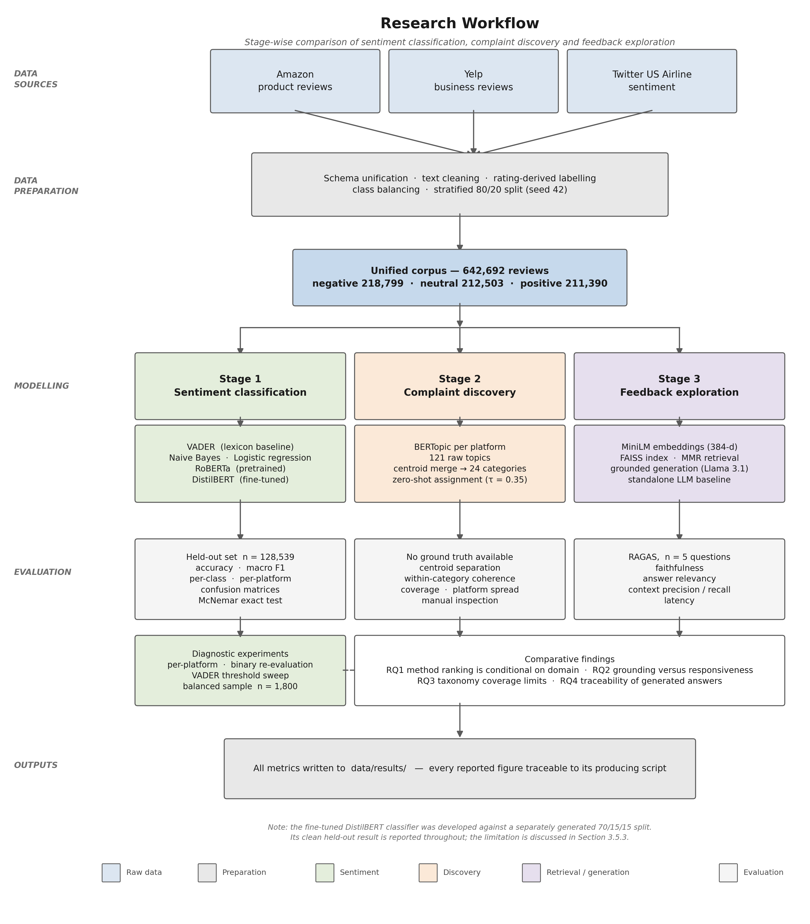
Figure 3.1
Figure 3.1 — End-to-end research workflow. Three raw review sources are unified into a single corpus feeding three independently evaluated stages: sentiment classification, complaint discovery and taxonomy consolidation, and retrieval-augmented question answering. (Source: docs/figures/research_workflow.png.)
Stage ordering is not arbitrary, and the dependencies are worth making explicit because they propagate. Sentiment classification precedes complaint discovery because discovery operates on negative reviews only, so the quality of the sentiment stage constrains what the discovery stage receives: a review misclassified as negative enters the topic model as noise. Discovery precedes retrieval because the taxonomy provides the vocabulary in which complaints are described. Each stage therefore inherits the limitations of the one before it, which is itself a finding worth reporting rather than a design flaw to conceal — and Chapter 5 returns to it when interpreting the taxonomy’s coverage.

3.4 Tools and Technologies
The selections below follow the justifications given in Section 2.3; what is added here is the configuration detail needed to repeat the work.
Language and core libraries. Python 3, with pandas for data handling and scikit-learn for classical models, splitting and classification metrics. Both are standard and well documented, which supports reproducibility. [AUTHOR TO ADD: exact Python version used, e.g. 3.10.x]
Transformers. Hugging Face Transformers provides RoBERTa and DistilBERT along with the Trainer API used for fine-tuning. It was chosen for its model hub, which makes the exact checkpoints used identifiable by name rather than by description.
Sentiment baseline. vaderSentiment provides the lexicon baseline without training.
Topic modelling. BERTopic, with UMAP for dimensionality reduction and HDBSCAN for clustering. These are BERTopic’s intended components and are configured explicitly rather than left at defaults, so that the settings are reportable and the results attributable to choices rather than to library conventions.
Embeddings and retrieval. sentence-transformers supplies all-MiniLM-L6-v2 (384 dimensions), and FAISS provides the vector index. FAISS runs locally with no external service, which removes both cost and a reproducibility dependency — an index that depends on a hosted service cannot be reconstructed by a reader once that service changes.
Generation. Groq’s hosted Llama 3.1 (llama-3.1-8b-instant) at temperature 0.2, orchestrated with LangChain. Low temperature is chosen deliberately: the task is evidence-grounded answering, where output variability is a defect rather than a feature, and where a reproducible evaluation requires responses that do not swing between runs.
Evaluation and tracking. RAGAS for generation metrics, scikit-learn for classification metrics, MLflow for experiment tracking. MLflow preserves parameters, metrics and artefacts per run, so an individual result can be traced back to the configuration that produced it.
Every dependency is version-pinned in requirements.txt, random seeds are fixed at 42 throughout, and unit tests cover the topic-merging and category-shortlisting logic. [AUTHOR TO ADD: hardware used for DistilBERT fine-tuning — GPU model and memory, or Colab tier; and the public repository URL if the code is to be released]

3.5 Data Processing

3.5.1 Cleaning and unification
Each source arrives with its own schema and is mapped onto the common structure given in Section 3.2.2. Cleaning removes records with missing text or labels, normalises text case and whitespace, and produces cleaned_text alongside the original text. Both are retained deliberately: models consume the cleaned version, while the retrieval stage serves the original, since an analyst reading a retrieved review as evidence needs it in its readable form.
For Amazon and Yelp, sentiment_label is derived from the star rating using the rule in Section 3.2.3. For Twitter, the existing airline_sentiment annotation is used and mapped to a pseudo-rating so that the schema stays uniform across sources.
Class balancing is applied during sampling, producing the near-equal distribution reported in Section 3.2.2.

3.5.2 Language filtering
The complaint discovery stage additionally filters to English text using language detection, since topic clustering degrades when multiple languages are mixed — non-English documents cluster by language rather than by subject, producing topics that describe the corpus’s composition instead of its complaints. This removes a small proportion of each platform’s negative reviews.

3.5.3 Data splitting
Splitting is where a comparative study is either controlled or not, so it is stated precisely rather than summarised.
For the sentiment comparison, the corpus is split 80/20 with stratification on the sentiment label and random_state=42, giving a held-out test set of 128,539 reviews. Stratification keeps the class distribution identical across both partitions, so that a model cannot gain or lose on the aggregate simply because one partition happened to contain more of the class it handles best.
The fine-tuned DistilBERT model was trained using a 70/15/15 stratified split, also seeded at 42, giving train, validation and test partitions. The validation partition is used for early stopping and best-checkpoint selection; the test partition is held out entirely.
A limitation must be recorded here, and it is the most consequential methodological caveat in this dissertation. The fine-tuned model and the other four models were developed against separately generated corpus versions. The two partitions are therefore not identical, and a proportion of the sentiment comparison’s test set overlaps with data the fine-tuned model saw during training. The comparison is consequently controlled for four of the five models and not for the fifth.
Three things follow. The clean, uncontaminated figure for the fine-tuned model is the one obtained on its own held-out test partition, and it is that figure which is interpreted in Chapter 5. Any statement comparing the fine-tuned model directly against the others on the shared test set is qualified at the point it is made. And establishing a single canonical split, regenerated once and reused by every model, is identified in Chapter 6 as the first correction future work should make.
Stating this openly is preferable to presenting a comparison whose controls do not hold. It also has an analytical consequence worth noting: the fine-tuned model’s advantage over logistic regression on the shared split should be read as an upper bound rather than a point estimate.

3.6 Model Development

3.6.1 Sentiment classification
Five models span four method families, chosen so that each represents a distinct answer to the same problem rather than a variation on one answer.
VADER requires no training. Its compound score is mapped to three classes using the conventional thresholds: at or above 0.05 positive, at or below −0.05 negative, otherwise neutral. Retaining the conventional thresholds matters for comparability, and the threshold sweep described in Section 3.6.5 tests whether that convention is what limits its performance.
Naive Bayes and logistic regression operate over TF-IDF features with unigrams and bigrams. Logistic regression uses the lbfgs solver with max_iter=3000. Both are trained on an 80/20 stratified split with five-fold stratified cross-validation used during development. Tuning these properly is a methodological commitment rather than routine practice: Section 2.1.3 criticised published comparisons for pairing carefully fine-tuned transformers against under-tuned classical baselines, and a study repeating that asymmetry would reproduce the bias it set out to test.
RoBERTa is used pretrained and unmodified, in the twitter-roberta-base-sentiment-latest configuration, with inputs truncated at 512 tokens. It is deliberately not fine-tuned. Its role is to represent what transfer learning achieves without task-specific training, which is the condition a practitioner faces when adopting an off-the-shelf model — and, given that this checkpoint was pretrained on tweets (Barbieri et al., 2020), it also makes the domain-transfer question in Section 2.1.2 directly testable on three platforms of differing register.
DistilBERT is fine-tuned from distilbert-base-uncased with a three-class head. Table 3.3 gives the configuration.
Table 3.3 — Fine-tuning configuration for DistilBERT
Parameter | Value
Base model | distilbert-base-uncased
Split | 70 / 15 / 15 stratified, seed 42
Epochs | 4, early stopping patience 2
Batch size | 32 train / 64 evaluation
Learning rate | 2e-5
Warmup steps | 1,000
Weight decay | 0.01
Precision | fp16 mixed precision
Class imbalance | Balanced class weights in a weighted cross-entropy loss
Model selection | Best checkpoint by validation macro F1
Seed | 42
Two choices deserve justification because both were non-obvious during implementation. Class weighting was applied through a custom trainer that overrides the loss function, because the standard Trainer ignores class weights passed by configuration; without this override the neutral class would be under-served despite the corpus being balanced overall — a defect that would have been invisible in the aggregate metrics and visible only in the per-class breakdown. And early stopping on validation macro F1 rather than validation loss was chosen because macro F1 is the metric the study reports, and selecting checkpoints on one quantity while reporting another risks presenting a model optimised for something other than the reported result.

3.6.2 Complaint discovery
BERTopic runs separately on the negative reviews of each platform. Running per platform, rather than over the pooled corpus, is a deliberate control: Yelp contributes 70% of the corpus, and pooling would let it dominate the topic space, producing a taxonomy that describes restaurant service and calls it customer feedback. The cost of this choice is that topics must afterwards be reconciled across platforms, which is the merging step below — the study accepts a harder consolidation problem in exchange for a taxonomy that is not simply a description of its largest source.
Minimum topic size is derived from corpus size rather than fixed, set at approximately 0.15% of the platform’s document count and bounded between 30 and 300. This keeps topic granularity comparable across platforms of very different sizes: a fixed minimum would produce either an unusable proliferation of topics on the largest platform or almost none on the smallest. In practice this yielded minimum topic sizes of 86 for Amazon (57,931 documents), 224 for Yelp (149,838 documents) and 30 for Twitter Airline (8,890 documents, where the lower bound binds).
The per-platform topics are then merged. Each topic’s centroid embedding is taken, and agglomerative clustering groups near-duplicate topics across platforms down to a target of 24 categories. Each merged cluster is named by a language model, which is given the cluster’s constituent topic labels and keywords and asked to produce a category name, a one-sentence description and exemplar phrases. The description is not presentational: it becomes the hypothesis used by the zero-shot classifier in the next stage, so the naming step directly determines assignment quality — a dependency whose consequences Chapter 4 reports.

3.6.3 Category assignment
Assigning an individual review to a category uses two stages. An embedding comparison ranks all categories against the review and retains a shortlist of six. A zero-shot entailment model then scores only that shortlist, using each category’s description as the hypothesis sentence — following the verbalisation finding in Section 2.1.2, where label phrasing was reported to matter as much as model choice.
The shortlist keeps entailment cost bounded as the taxonomy grows, which a flat zero-shot pass over all categories would not. A confidence threshold of 0.35 is applied: below it, the review is recorded as unclassified rather than forced into the nearest category. This is a deliberate trade of coverage for honesty. Leaving a review unclassified is more informative than assigning it wrongly, and the unclassified rate becomes a reportable measure of taxonomy coverage instead of a hidden error. As Chapter 4 shows, that decision is what made the taxonomy’s principal weakness measurable rather than invisible.

3.6.4 Retrieval and generation
The corpus is embedded with all-MiniLM-L6-v2 and indexed in FAISS with normalised vectors. Retrieval returns five reviews per query from a candidate pool of twenty, selected by maximal marginal relevance. MMR is preferred over plain similarity search for a domain-specific reason: complaint questions tend to retrieve near-duplicate reviews expressing the same grievance, and five restatements of one complaint provide weaker grounding than five distinct ones, while scoring identically on similarity.
Each retrieved review is tagged with its platform, rating and sentiment before entering the prompt. This is not cosmetic. The prompt instructs the model to cite only platforms present in the evidence, and without the tags that instruction can neither be followed nor checked. The prompt further requires that no statistic, category or quotation appear unless present in the retrieved text, and specifies a fixed refusal string for cases where the evidence is insufficient — making refusal an available output rather than something the model must improvise. This is the one design decision in the retrieval stage that Chapter 4 tests directly rather than argues for, and Section 4.5.8 reports what happened when it was removed.
Two guards sit in front of generation, and the difference between them matters. The literature reviewed in Section 2.1.2 is consistent that a prompt-level instruction to refuse is a request, not a constraint: Ji et al. (2023) document models producing fluent, confident text with no evidential basis, and an instruction not to do so is enforced only by the model’s own compliance. Two architectural gates are therefore placed ahead of the prompt, each addressing a different failure.
The first is a scope guard, which rejects questions that are not about customer feedback at all. It runs in two stages — a keyword filter naming nine off-topic subjects, then a small LLM classifier for cases the keyword list cannot catch, such as “Who is the CEO of Apple?” — and returns a fixed out-of-scope message without touching the retriever. The design assumption is that a wrongly rejected question is a cheaper failure than a confidently answered off-topic one. Chapter 4 finds a case where that assumption is tested: the classifier rejects a legitimate question, and the cost of its imprecision becomes visible in the results rather than remaining theoretical.
The second is a similarity threshold on retrieval itself, set at 0.35. FAISS returns its top k documents regardless of how weakly they match, so without a floor the pipeline hands the model five nearest-but-possibly-irrelevant reviews and relies on the prompt to talk it out of using them. The threshold makes “no relevant evidence exists” a fact the code checks rather than a judgement the model makes on every request: candidates below it are discarded, and if nothing survives, a fixed no-evidence message is returned in place of a generated answer. A post-generation check repeats the test for multi-turn queries, where the retrieval query is an LLM-reformulated question the pre-check never saw, and discards the generated answer if it was produced from empty context. The value 0.35 is a starting point rather than a validated constant — it was chosen by inspecting the score distribution of this index and has not been tuned against a labelled set of in-scope and out-of-scope questions, which Chapter 6 identifies as outstanding work.
The same questions are then answered by the model with no retrieval at all, providing the baseline for RQ2. Holding the generator, temperature and question set constant across the two conditions means the difference between them is attributable to retrieval rather than to model or prompt variation.
Figure 3.2 shows how these components fit together, and in particular the order of the two guards relative to retrieval — an ordering that turns out to matter when interpreting the results in Chapter 4.
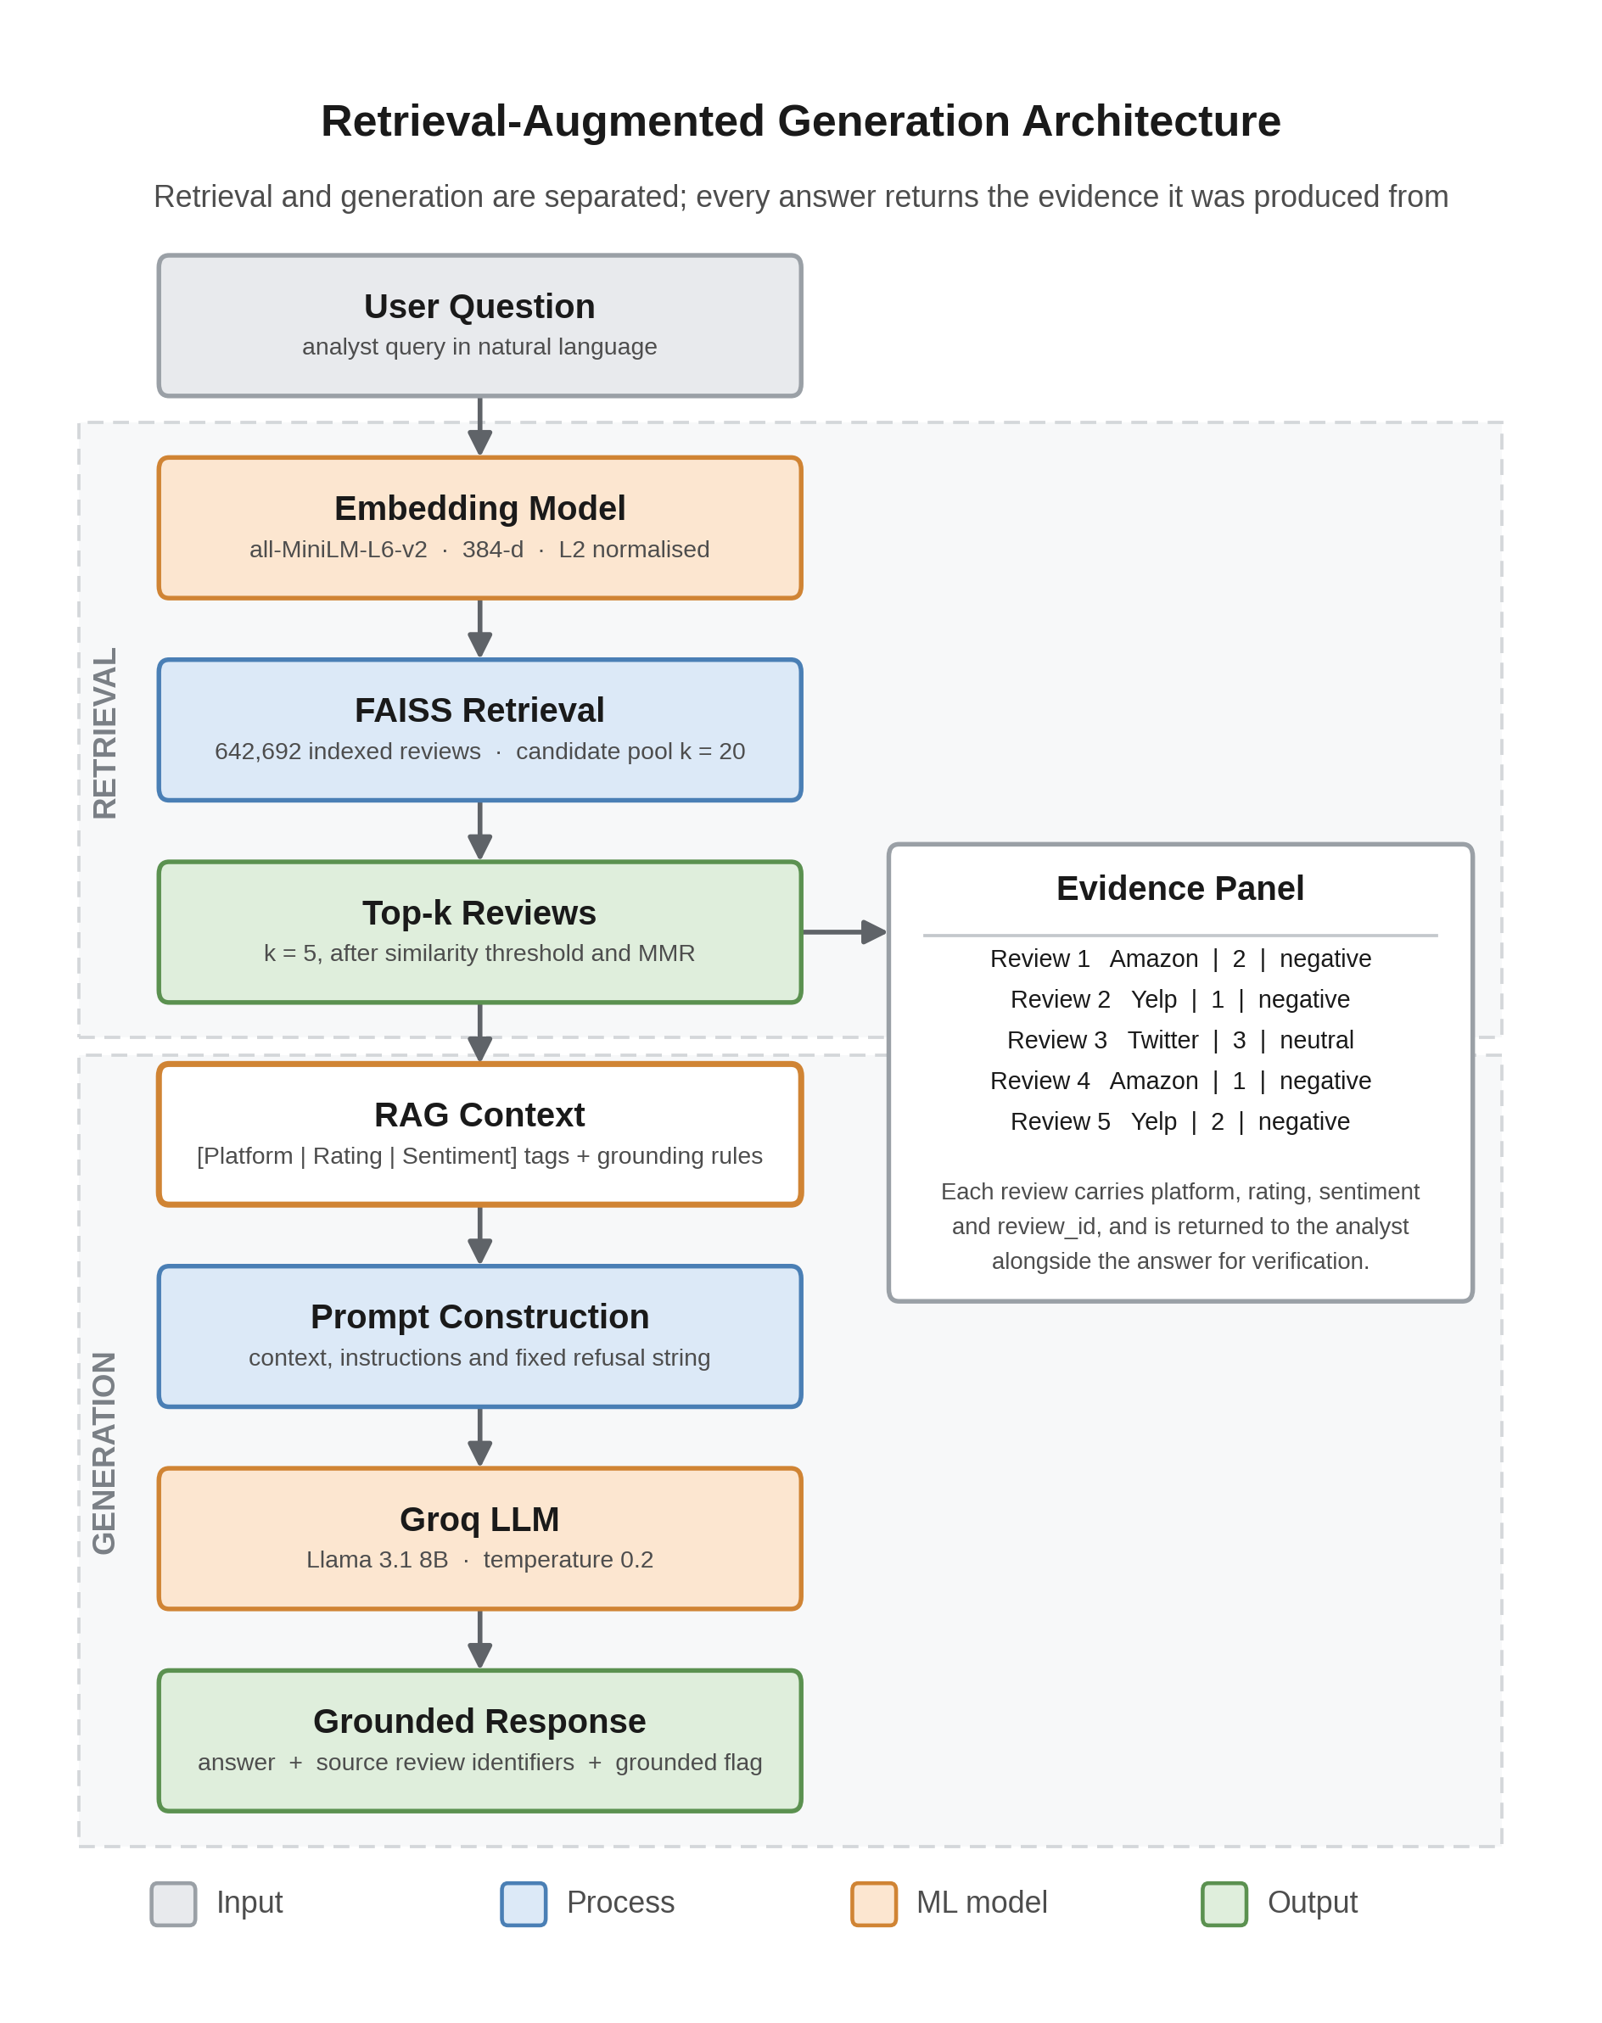
Figure 3.2
Figure 3.2 — Retrieval-augmented question-answering architecture. The scope guard runs before retrieval is attempted; the similarity threshold gates retrieval output before generation; a post-generation check catches multi-turn queries whose reformulated question bypassed the pre-check. (Source: docs/figures/rag_architecture.png.)

3.6.5 Evaluation metrics
Metrics are matched to what each stage permits, which is why they differ so sharply between stages. Figure 3.3 sets out the full framework, showing which measures apply at which stage and where baselines and diagnostics attach.
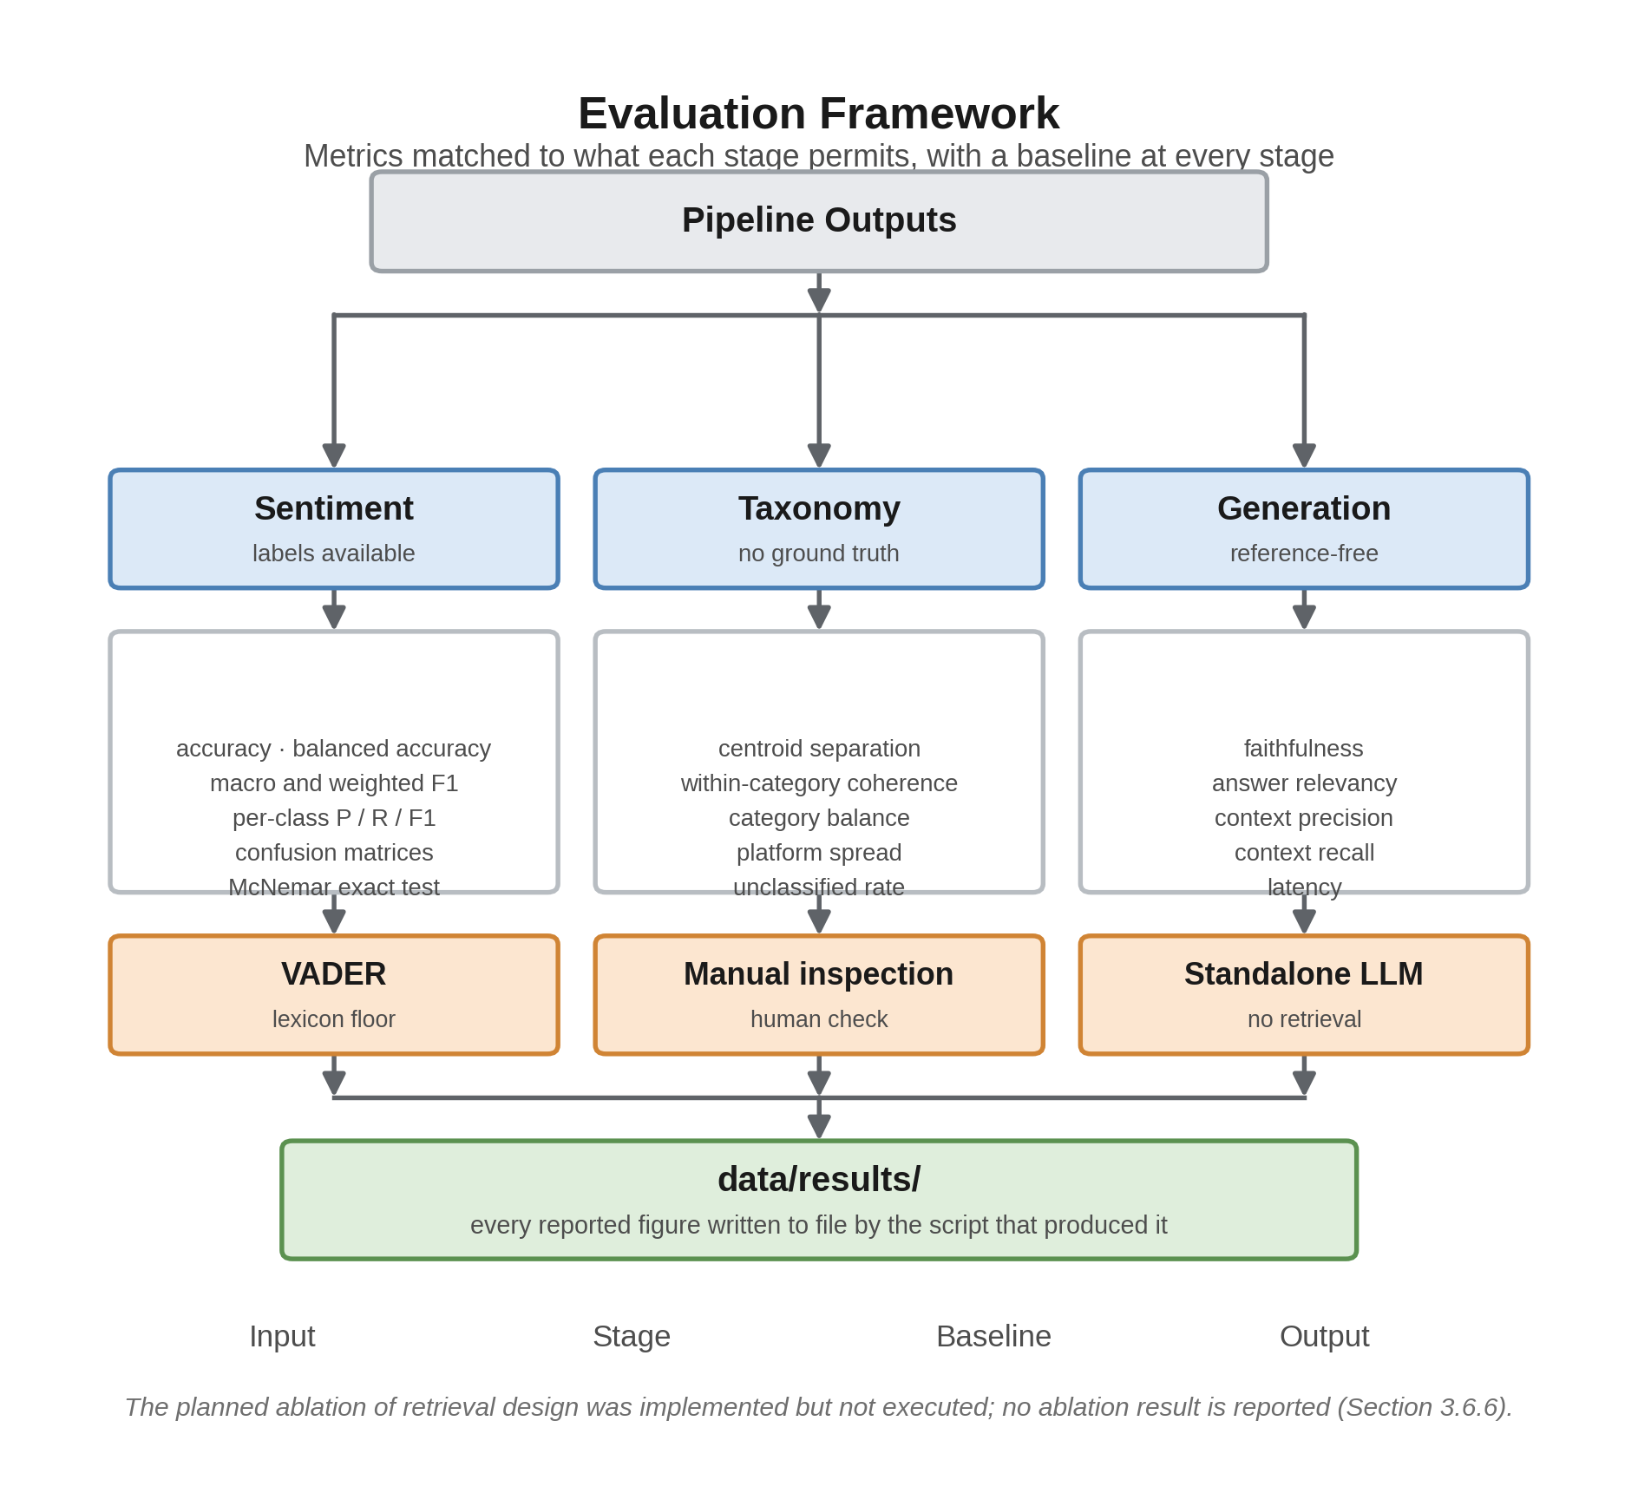
Figure 3.3
Figure 3.3 — Evaluation framework across the three stages. Each stage uses measures appropriate to what it permits: supervised metrics where labels exist, unsupervised indicators where they do not, and reference-free generation metrics for the question-answering stage. (Source: docs/figures/arch_evaluation_framework.png.)
Sentiment. Accuracy, macro F1, weighted F1, per-class precision, recall and F1, and confusion matrices. Macro F1 is the headline figure because it weights all three classes equally and therefore exposes the single-class collapse that Section 2.1.3 identified as the literature’s blind spot. Per-platform metrics are reported alongside aggregates for the same reason. Pairwise model comparison uses McNemar’s exact test, appropriate for paired predictions on a common test set.
Taxonomy. No ground truth exists, so no accuracy is computed and none is implied. Quality is argued from mean pairwise similarity between merged category centroids, within-category coherence measured as cosine similarity of each review to its category centroid, category frequency distribution, platform distribution, and unclassified rate. A sample of reviews is also set aside for manual inspection. Reporting five weak indicators together is the direct methodological response to the coherence-validity critique in Section 2.1.3: if no single automated measure is trustworthy, a claim should not rest on one.
Generation. RAGAS faithfulness, answer relevancy, context precision and context recall, computed for both the retrieval-augmented and standalone conditions. Four metrics are used because they can disagree informatively — an unconstrained model can score highly on relevancy while having no evidential basis whatever, so relevancy alone would reward precisely the behaviour the system exists to prevent.
Diagnostic experiments. Aggregate metrics establish a ranking but not a cause, and Chapter 2 criticised the literature for stopping at the ranking. Where a model behaves unexpectedly, three further experiments test the proposed explanation rather than leaving it as speculation. A per-platform breakdown evaluates every model separately on each source, using a sample balanced across platform and class so that no platform dominates — 600 reviews per platform, 1,800 in total. A binary re-evaluation removes the neutral class and requires each model to choose between negative and positive using its own class scores, isolating that class’s contribution to the aggregate. A threshold sweep re-labels VADER’s cached compound scores across progressively wider neutral bands, testing whether its weakness is a decision-boundary artefact or a property of the lexicon itself. All three reuse a single cached set of predictions, so each model is run over the sample only once — a practical necessity given transformer inference cost, and one that also guarantees the three diagnostics describe identical model behaviour.
One caution about scope applies to all three. They are computed on the 1,800-review diagnostic sample, not the full held-out test set, so their figures are not directly interchangeable with the headline metrics and are not treated as such in Chapter 4.
A constraint on the generation evaluation belongs here rather than in the results. The model that judges the answers is the same model that produces them, which introduces the self-enhancement bias documented in the LLM-as-judge literature reviewed in Section 2.2.3. This followed from free-tier API limits, which also constrained the number of evaluation questions. Both facts qualify the strength of the RQ2 and RQ4 conclusions, and both are restated wherever those conclusions appear.

3.6.6 Ablation design, and the boundary between implemented and executed
Section 2.2.3 argued that reporting a system-level faithfulness score does not attribute grounding to any particular design decision, and that ablation is the standard remedy. Four conditions were designed for this pipeline, each isolating one decision by removing or varying it while holding everything else constant:
Condition | What varies | What it would establish
Metadata tagging | Retrieved reviews enter the prompt with or without their platform/rating/sentiment tags | Whether tagging is what makes the prompt’s citation rules enforceable
Retrieval depth | k ∈ {3, 5, 10, 20} | Whether five reviews is the right amount of evidence, or a guess that happens to work
Retriever type | MMR against plain similarity search | Whether the diversity argument in Section 3.6.4 holds empirically
Prompt version | Constrained grounding prompt against a plain instruction | How much of the observed faithfulness comes from the prompt rather than the architecture
One of these four conditions was built and run; the other three were specified but never built. The boundary is recorded plainly, because designing an experiment and carrying it out are different things, and the results chapter should rest only on the latter.
The metadata-tagging condition was implemented and executed, in evaluate/ablation_metadata_tagging.py. It runs the same five questions twice through the same pipeline, once with tagging and once without, holding retrieval identical between conditions so that any difference in the RAGAS scores is attributable to what the generator was shown rather than to what was retrieved. Section 4.5.8 reports the result, which does not straightforwardly confirm the argument made in Section 3.6.4 — a useful reminder that a design justification and a measured effect are different things.
The remaining three conditions exist as the specification in the table above and nothing more. They were scoped early and set aside once the cost became clear: each requires a full pass over the question set with several judged sub-calls per answer, and the free-tier rate limit made that call volume unreachable within the project timeframe. Rather than write code that could not be run, the effort went into completing one condition properly. The consequence is stated plainly: for retrieval depth, retriever type and prompt version, the contribution of each decision is argued from the design reasoning given above, not measured. Chapter 5 treats those arguments as reasoning rather than evidence, and Chapter 6 lists building and running them as the highest-value remaining work.
Two scripts therefore carry the generation evaluation, and both are in the submitted codebase. evaluate/evaluate_llm_vs_rag.py scores the retrieval-augmented pipeline against the standalone baseline on a common question set using the four RAGAS metrics; evaluate/ablation_metadata_tagging.py runs the tagged-versus-untagged comparison. The same rate limit constrained both to five questions, which is small enough that per-question variance dominates the reported means. This is stated as a bound on the evidence rather than presented as a complete evaluation, and Chapter 5’s answer to RQ2 is framed as directional accordingly.

3.7 Ethical Considerations
Data access. All three datasets are publicly available and were collected and released by their original publishers. No data was scraped, and no new data was gathered from individuals.
Ethical approval. No human participants were involved and no primary data collection took place, so institutional ethical approval for human-subjects research was not required. This position was reviewed against the University’s research ethics guidance for secondary analysis of public datasets.
Privacy and personal data. The corpus contains no special-category personal data. Reviewer names and account identifiers are not used at any stage; reviews are referenced only by review_id. No attempt is made to link reviews to individuals, or to profile any reviewer across records.
Under GDPR, review text is user-generated content that may incidentally contain personal information written voluntarily by the reviewer. Three measures apply. Processing is limited to research purposes under legitimate interest, with no commercial use. No identifying fields are extracted, retained or displayed. And outputs are aggregated: the system reports complaint patterns rather than individuals, and the sample reviews it surfaces are presented as evidence for a pattern, not as profiles.
Responsible use of generated output. Two risks are worth recording. Generated summaries describe named businesses, and acting on an unsupported summary could affect a business unfairly; returning source reviews with every answer is a partial safeguard, since any claim can be checked before it is used. Separately, sentiment and complaint categories assigned automatically carry error rates that this study measures and reports, and using such output for consequential decisions without regard to those error rates would be inappropriate. Reporting per-class and per-platform performance instead of a single accuracy figure is intended to make those limits visible to anyone relying on the results — which is an ethical argument for the reporting granularity, not only a methodological one.
API and data handling. Review text is transmitted to a third-party inference provider during the generation stage. Since the data is already public and contains no identifying fields, this does not create a new disclosure risk, but it is recorded for transparency. API credentials are held in environment configuration and excluded from version control.

3.8 Chapter Summary
This chapter has set out an adapted CRISP-DM methodology, chosen because its data preparation and evaluation phases carry the weight a comparative study requires, and modified so that modelling and evaluation execute once per pipeline stage. Each phase maps to a research objective and through it to a research question.
The corpus of 642,692 reviews spans three registers, which is what makes the cross-domain comparison meaningful, and its limitations — rating-derived labels, mixed label provenance, uneven platform representation and selection bias — have been stated at the point each becomes relevant rather than deferred. Preprocessing, splitting, model configuration and evaluation metrics have been documented in sufficient detail to be repeated, including the split inconsistency affecting the fine-tuned model, which is disclosed here with its analytical consequence rather than left for a reader to infer.
Every substantive design decision in this chapter answers a limitation identified in Chapter 2. Controlled splits and a shared protocol address the confounding in single-dataset comparisons. Tuned classical baselines address the asymmetric-effort criticism. Per-class and per-platform reporting addresses the aggregate-metric problem. Five indicators for the taxonomy address the coherence-validity critique. A standalone baseline and four generation metrics address the missing comparison in the RAG literature. And the explicit separation of implemented from executed work in Section 3.6.6 addresses the risk that a reader takes design reasoning for measured evidence.
Chapter 4 applies this methodology and reports what it produced: the exploratory analysis of the three sources, the training and evaluation of the five sentiment classifiers together with the three diagnostic experiments, the topic discovery and taxonomy construction, and the retrieval and generation evaluations. Interpretation is deferred to Chapter 5; Chapter 4’s task is to establish the evidence.

Chapter 4 — Data Analysis
Chapter 3 set out a methodology built against four criticisms of the existing literature. This chapter reports what that methodology produced. Its purpose is to present the evidence in enough detail for the results to be reproduced and checked; the argument about what the evidence means is held back for Chapter 5. Where a result contradicts expectation, this chapter reports the contradiction and the diagnostic experiment that probes it, but leaves the explanation for the discussion.
Every figure quoted here is produced by a script that writes to data/results/, and the producing script is named alongside each table so that any number can be traced to its source.
The chapter follows the CRISP-DM phases adopted in Chapter 3. Section 4.1 restates the problem and defines the success criteria against which the work is judged. Section 4.2 reports the exploratory analysis of the three sources and the data quality issues it exposed. Section 4.3 covers preparation, feature extraction and splitting. Section 4.4 documents model development at each of the three pipeline stages. Section 4.5 reports evaluation, which supplies the evidence for all four research questions. Section 4.6 addresses deployment status, and Section 4.7 summarises.

4.1 Business Understanding

4.1.1 The problem
Organisations hold more customer feedback than they can read, and the practical question is not whether it contains useful signal but which method should be trusted to extract it. Three sub-problems follow, and they are analytically distinct. Classifying the sentiment of a review is supervised. Identifying what customers complain about is unsupervised, because the categories are not known in advance. Answering an analyst’s question about those complaints is a generation problem, where the risk is a fluent answer with no basis in evidence.

4.1.2 Objectives for this chapter
This chapter delivers Objectives 2 to 6 from Chapter 1: preparing the unified corpus, comparing five sentiment classifiers with diagnosis of any anomalous result, discovering and consolidating complaint topics, building the retrieval and question-answering components with a baseline to compare against, and evaluating each stage with metrics appropriate to it.

4.1.3 Success criteria
Success is defined per stage, and deliberately not as a single accuracy target.
For sentiment classification, the criterion is a controlled comparison in which differences between models cannot be attributed to differences in data, reported at a granularity that reveals class-level and platform-level behaviour. A ranking alone would not satisfy it.
For complaint discovery, with no ground truth available, the criterion is a taxonomy whose categories are separable from one another, internally coherent, populated across platforms, and honest about what it fails to cover.
For question answering, the criterion is measurable grounding: answers traceable to identifiable source reviews, scored against a standalone baseline on the same questions.

4.2 Data Understanding

4.2.1 Sources
Three public datasets are combined: Amazon product reviews, Yelp business reviews, and the Twitter US Airline Sentiment corpus. All were obtained from their public distributions. No data was scraped and none was collected from individuals.

4.2.2 Register differences
The comparison in this study depends on the three sources differing in register, so that claim is measured rather than assumed. Figure 4.1 reports word counts from a seeded sample of up to 40,000 reviews per platform.
The differences are substantial and not in the direction intuition suggests. Yelp reviews are the longest by a wide margin, with a median of 85 words against Amazon’s 29 and Twitter Airline’s 19. Amazon reviews are shorter than expected at the median but carry a long tail: their 95th percentile reaches 138 words against Twitter’s 27, so the platform mixes very brief and very detailed reviews. Twitter Airline is both the shortest and by far the most uniform, which follows from the platform’s character limit — its interquartile range spans a narrower band than either of the others.
Two properties therefore separate the sources: central length, on which Yelp stands apart, and dispersion, on which Twitter stands apart. Amazon sits between them on both. This is the empirical basis for treating the corpus as multi-domain, and it is what makes the per-platform analysis in Section 4.5.4 meaningful.
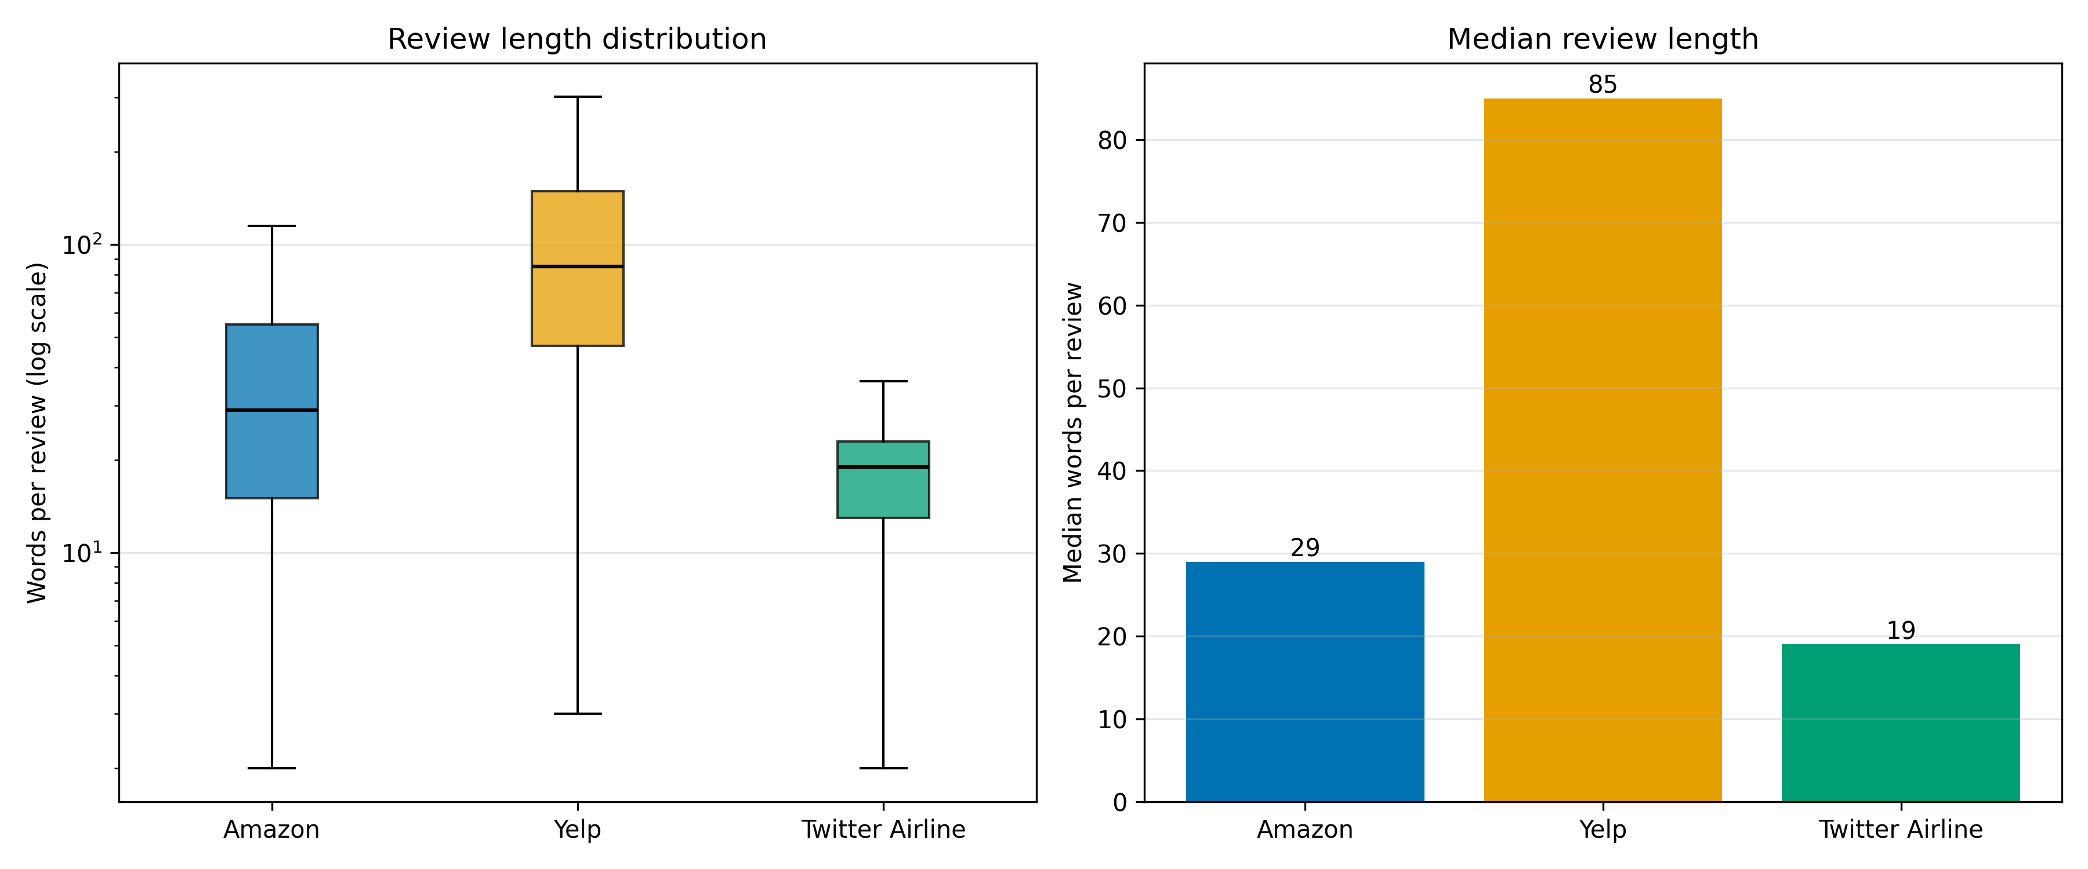
Figure 4.1
Figure 4.1 — Review length by platform: distribution on a log scale, with median word counts. Seeded sample of up to 40,000 reviews per platform. (Produced by evaluate/generate_figures.py.)

4.2.3 Composition
After preparation the corpus holds 642,692 reviews. Table 4.1 gives the composition.
Table 4.1 — Corpus composition by platform
Platform | Reviews | Share | Label origin | Register
Yelp | 449,858 | 70.0% | Star rating | Extended service narrative
Amazon | 178,883 | 27.8% | Star rating | Variable-length product review
Twitter Airline | 13,951 | 2.2% | Human annotation | Short, abbreviated, public
Total | 642,692 | 100%
Sentiment classes are close to balanced: negative 218,799 (34.0%), neutral 212,503 (33.1%), positive 211,390 (32.9%). This is a consequence of balanced sampling during preparation, and it is what makes macro F1 a fair headline metric.
Platform representation, by contrast, is heavily skewed. Yelp contributes seventy per cent and Twitter Airline barely two. This asymmetry drives two later design decisions: topic discovery runs per platform (Section 4.4.2), and the diagnostic evaluation samples equally from each platform (Section 4.5.4).

4.2.4 Data quality issues
Exploratory analysis identified four issues, each carried forward into the interpretation of results.
Labels for Amazon and Yelp derive from star ratings, not from reading the text. A four-star review containing a specific complaint is labelled positive. This places a ceiling on achievable accuracy that no model can exceed.
Label provenance is not uniform. Twitter labels come from human annotation, so “neutral” means a three-star rating on two platforms and a human judgement of no clear sentiment on the third. The neutral class is therefore not one construct but two — a point that becomes important when the neutral class turns out to be where most models fail.
Text quality varies with register. Twitter posts contain handles, abbreviations and truncation absent from the other sources.
Some reviews are non-English. These are retained in the corpus but filtered out at the topic discovery stage, where mixed languages degrade clustering.

4.3 Data Preparation

4.3.1 Cleaning and unification
Each source was mapped onto a common schema of review_id, platform, product_category, text, cleaned_text, rating, sentiment_label and date. Records missing text or a sentiment label were dropped, as were reviews of five characters or fewer, which carry no usable signal. Text was lowercased and whitespace normalised to produce cleaned_text; the original text is retained because the retrieval stage benefits from readable output while models consume the cleaned form.
Sentiment labels for Amazon and Yelp were derived by rule: ratings of two or below negative, three neutral, four or above positive. Twitter’s existing annotation was mapped to the same three classes and given a pseudo-rating so the schema stays uniform. Class balancing was applied during sampling, producing the distribution in Section 4.2.3.

4.3.2 Feature extraction
Feature representation differs by model family, which is itself part of the comparison.
Classical models use TF-IDF vectors over unigrams and bigrams. VADER requires no features, operating directly on raw text through its lexicon. Transformer models use their own subword tokenisers, with DistilBERT truncating at its tokeniser maximum. Topic discovery and retrieval use 384-dimensional sentence-transformer embeddings from all-MiniLM-L6-v2, L2-normalised so that inner product equals cosine similarity.
No manual feature selection or scaling was applied. TF-IDF weighting handles term importance implicitly, and embedding dimensions are not individually interpretable, so selecting among them would not be meaningful.

4.3.3 Splitting
The sentiment comparison uses an 80/20 stratified split with random_state=42, producing a held-out test set of 128,539 reviews with the class distribution preserved.
The fine-tuned model was trained on a separately generated 70/15/15 stratified split, also seeded at 42. Its validation partition drove early stopping and checkpoint selection; its test partition of 88,854 reviews was held out entirely.
As disclosed in Section 3.5.3, these two partitions are not identical, so a portion of the 128,539-review test set overlaps data the fine-tuned model saw in training. The uncontaminated figure for that model is the one from its own held-out partition, and it is that figure which is treated as definitive. Every comparison in Section 4.5.1 involving DistilBERT is annotated accordingly.

4.4 Model Development

4.4.1 Sentiment classifiers
Five models span four families, selected on the evidence reviewed in Section 2.3.1.
VADER serves as the lexicon baseline, requiring no training, with compound scores mapped to three classes at the conventional ±0.05 thresholds. Naive Bayes and logistic regression are trained over TF-IDF features, the latter using the lbfgs solver with max_iter=3000, with five-fold stratified cross-validation during development. RoBERTa is used pretrained and unmodified in its twitter-roberta-base-sentiment-latest form; it is deliberately not fine-tuned, since its role is to represent what transfer learning delivers without task-specific training.
DistilBERT was fine-tuned from distilbert-base-uncased with a three-class head. Table 4.2 gives the configuration.
Table 4.2 — DistilBERT fine-tuning configuration
Parameter | Value | Parameter | Value
Base model | distilbert-base-uncased | Warmup steps | 1,000
Split | 70/15/15, seed 42 | Weight decay | 0.01
Epochs | 4 (early stopping, patience 2) | Precision | fp16
Batch size | 32 train / 64 eval | Class weights | Balanced, weighted cross-entropy
Learning rate | 2e-5 | Selection metric | Validation macro F1
Two choices warrant note. Class weights were applied through a custom trainer overriding the loss function, because the standard trainer ignores them; without this the neutral class would be under-served despite corpus-level balance. And checkpoint selection used macro F1 rather than validation loss, so that the quantity optimised matches the quantity reported.
Table 4.3 records training behaviour.
Table 4.3 — DistilBERT validation performance by epoch
Epoch | Training loss | Validation loss | Accuracy | Weighted F1 | Macro F1
1 | 0.2612 | 0.4482 | 83.48% | 83.51% | 82.59%
2 | 0.2810 | 0.3977 | 84.08% | 84.13% | 83.28%
3 | 0.2355 | 0.4508 | 83.98% | 84.00% | 83.12%
4 | 0.2007 | 0.5225 | 83.73% | 83.71% | 82.80%
Validation loss fell to epoch 2 then rose while training loss continued to decline, the standard signature of overfitting. Best-checkpoint restoration selected epoch 2. Training took 10,545 seconds with a final training loss of 0.3350.

4.4.2 Complaint discovery
BERTopic was applied to the negative-sentiment reviews of each platform separately, after English-language filtering. Running per platform rather than over the pooled corpus prevents Yelp’s seventy per cent share from dominating the topic space. Table 4.4 records configuration and outcome.
Table 4.4 — BERTopic discovery by platform (source: data/results/category_discovery/discovery_platform_topics.csv)
Platform | Documents clustered | Minimum topic size | Topics discovered
Amazon | 57,931 | 86 | 69
Yelp | 149,838 | 224 | 18
Twitter Airline | 8,890 | 30 | 34
Total | 216,659 | — | 121
Minimum topic size was derived from each platform’s document count rather than fixed, which is why it varies. The topic counts are themselves informative: Yelp produced only 18 topics from 149,838 documents while Amazon produced 69 from roughly a third as many. Product categories span a far wider semantic range than restaurant and service complaints, and the discovery stage reflects that.
The 121 raw topics were then merged by agglomerative clustering over topic centroid embeddings to a target of 24 categories, each named by a language model given its constituent topic labels and keywords.

4.4.3 Category assignment
Individual reviews are assigned in two stages: an embedding comparison shortlists six candidate categories, then a zero-shot entailment model scores only that shortlist, using each category’s full description as the hypothesis. A confidence threshold of 0.35 leaves weak matches unclassified instead of forcing a label, so that coverage failure remains visible in the results rather than being absorbed into a nearest-neighbour assignment.

4.4.4 Retrieval and question answering
The corpus was embedded with all-MiniLM-L6-v2 and indexed in FAISS with normalised vectors carrying platform, rating, sentiment and review identifier as metadata. Retrieval returns five reviews per query from a candidate pool of twenty, using maximal marginal relevance.
Each retrieved review enters the prompt tagged with its platform, rating and sentiment. The prompt forbids any statistic, category or quotation not present in the retrieved text, restricts platform references to those appearing in the evidence, and specifies a fixed refusal string when evidence is insufficient. Source identifiers are returned with every answer. Generation uses Llama 3.1 8B via Groq at temperature 0.2, with multi-turn support through a history-aware retriever that reformulates follow-up questions into standalone queries before retrieval.
The same questions are answered by the model with retrieval disabled, providing the baseline for RQ2.

4.5 Model Evaluation

4.5.1 Aggregate sentiment results
Table 4.5 reports all five models on the shared test set.
Table 4.5 — Sentiment classification results, shared held-out set (n = 128,539) (source: data/results/metrics_summary/overall_metrics.csv)
Model | Family | Accuracy | Balanced acc. | Macro P | Macro R | Macro F1 | Weighted F1
VADER | Lexicon baseline | 0.5142 | 0.5148 | 0.5213 | 0.5148 | 0.4381 | 0.4396
Naive Bayes | Classical ML | 0.7558 | 0.7557 | 0.7621 | 0.7557 | 0.7580 | 0.7579
Logistic Regression | Classical ML | 0.8034 | 0.8033 | 0.8033 | 0.8033 | 0.8033 | 0.8033
RoBERTa (pretrained) | Pretrained transformer | 0.6327 | 0.6314 | 0.6056 | 0.6314 | 0.5694 | 0.5709
DistilBERT (fine-tuned)† | Fine-tuned transformer | 0.8243 | 0.8245 | 0.8247 | 0.8245 | 0.8244 | 0.8244
† Partially contaminated: a portion of this test set overlaps DistilBERT’s training data (Section 4.3.3). The clean figure follows below.
Balanced accuracy tracks accuracy closely for every model, confirming that the class balancing described in Section 4.2.3 worked: no model is benefiting from an uneven class prior.
On its own uncontaminated held-out partition of 88,854 reviews, the fine-tuned model achieved accuracy 0.8437, macro F1 0.8375 and weighted F1 0.8454. This is the figure treated as definitive for DistilBERT throughout the remainder of this dissertation. Its closeness to the shared-set figure of 0.8244 suggests the contamination did not materially inflate the shared-set result, but the clean figure is used regardless, since the argument should not depend on that judgement.
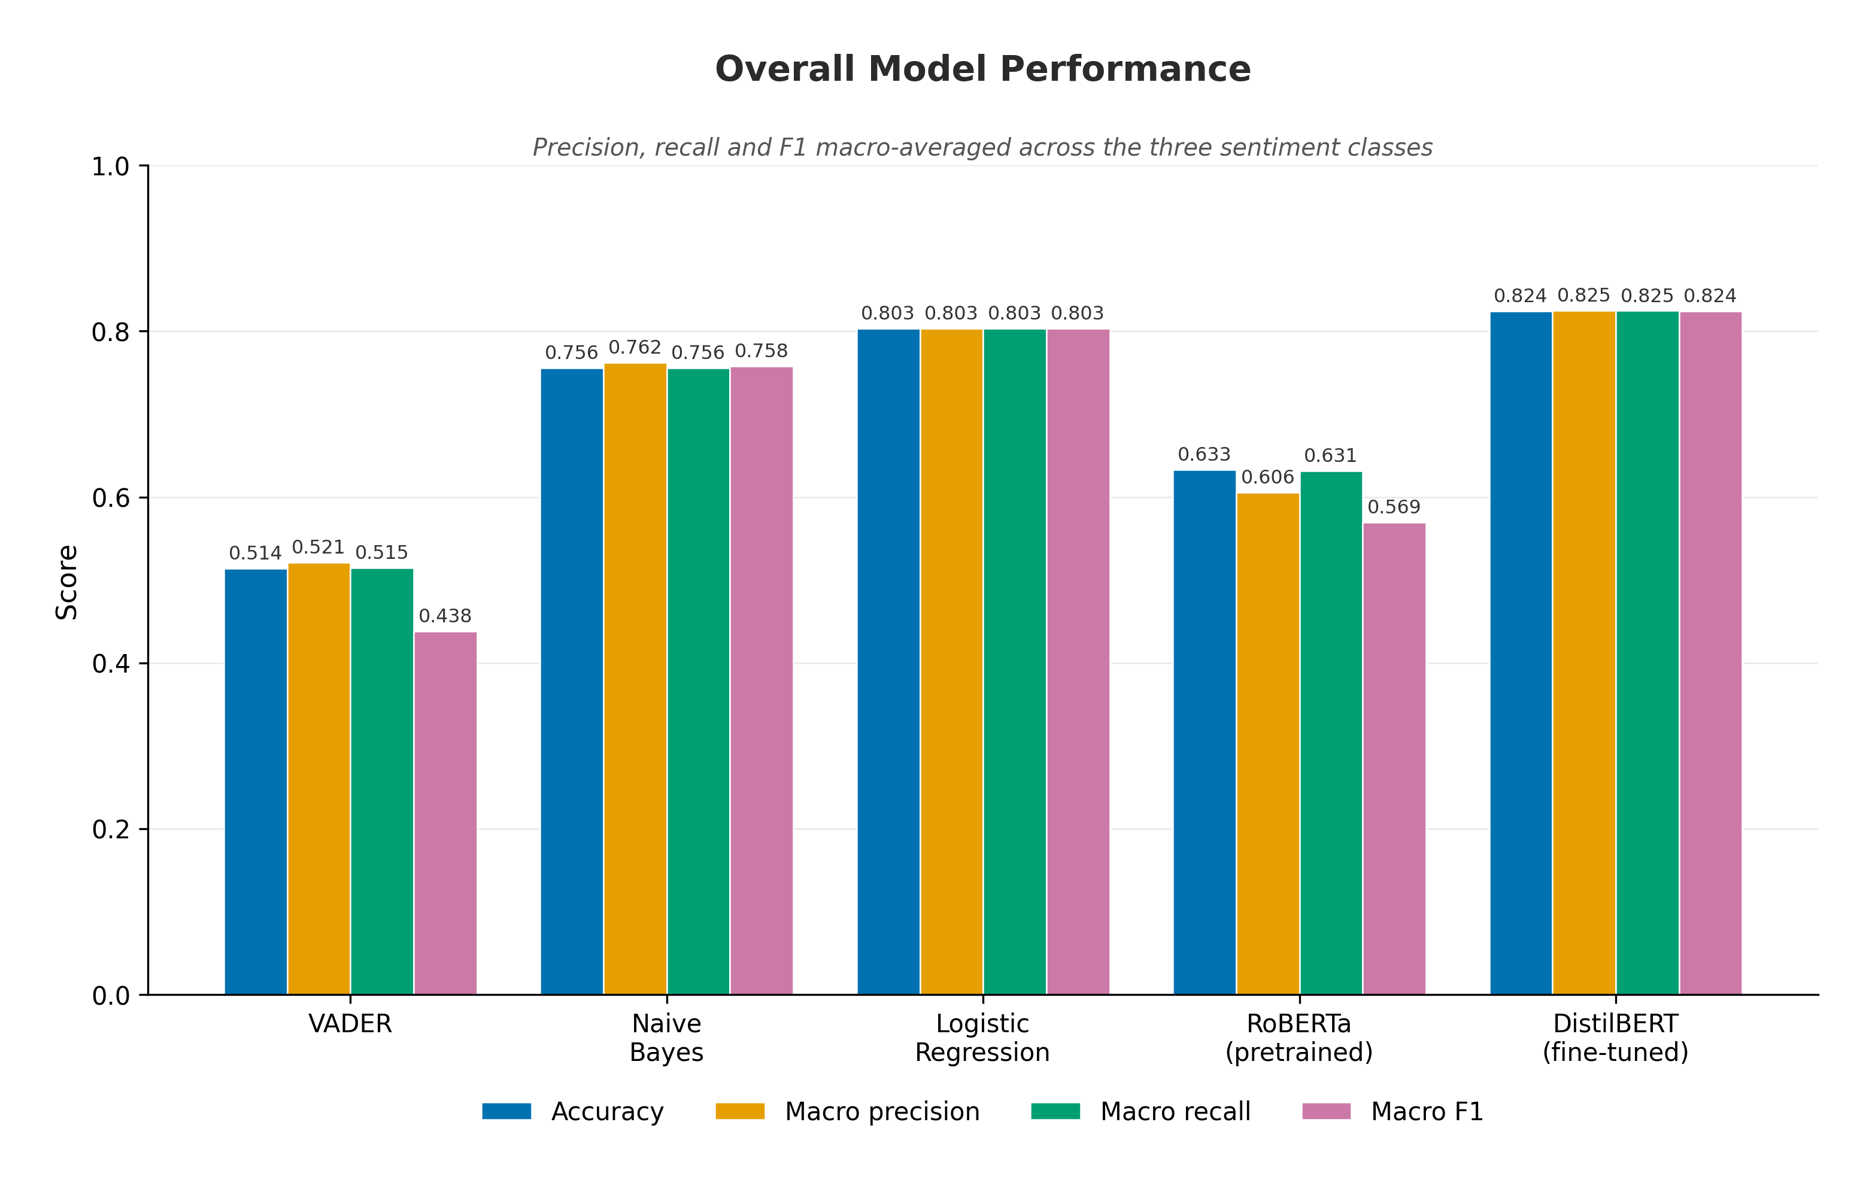
Figure 4.2
Figure 4.2 — Sentiment classification performance for all five models on the shared held-out set (n = 128,539): accuracy with macro-averaged precision, recall and F1. (Produced by evaluate/generate_all_metrics.py.)
Two results contradict the ordering the literature in Section 2.1.2 would predict.
The first is VADER’s weakness. Its accuracy of 0.5142 places just over half of reviews in the right class, but its macro F1 of 0.4381 is far lower, and the gap between the two is the finding: performance is unevenly distributed across classes in a way that accuracy alone conceals. For reference, a uniform random classifier on this balanced three-class problem would score approximately 0.333 on both measures, so VADER is well above chance — the point is not that it fails outright but that it fails asymmetrically.
The second is more consequential. The pretrained transformer falls below both classical models, with a macro F1 of 0.5694 against logistic regression’s 0.8033 — a gap of 23 points in the direction opposite to the one the literature predicts.

4.5.2 Per-class analysis
The aggregates conceal where the failure occurs. Table 4.6 reports per-class performance, and this is the table that makes the anomaly legible.
Table 4.6 — Per-class precision, recall and F1 by model, shared test set (n = 128,539) (source: data/results/metrics_summary/per_class_metrics.csv)
Model | Neg. P | Neg. R | Neg. F1 | Neu. P | Neu. R | Neu. F1 | Pos. P | Pos. R | Pos. F1
VADER | 0.743 | 0.533 | 0.621 | 0.377 | 0.048 | 0.086 | 0.444 | 0.963 | 0.608
Naive Bayes | 0.757 | 0.766 | 0.761 | 0.654 | 0.704 | 0.678 | 0.876 | 0.798 | 0.835
Logistic Regression | 0.818 | 0.830 | 0.824 | 0.721 | 0.715 | 0.718 | 0.871 | 0.864 | 0.868
RoBERTa (pretrained) | 0.684 | 0.814 | 0.743 | 0.522 | 0.143 | 0.225 | 0.612 | 0.937 | 0.740
DistilBERT (fine-tuned) | 0.856 | 0.820 | 0.837 | 0.740 | 0.755 | 0.747 | 0.879 | 0.899 | 0.889
Both off-the-shelf models perform acceptably on negative and positive while collapsing on neutral, and separating precision from recall shows the nature of that collapse. VADER’s neutral precision is 0.377 while its neutral recall is 0.048; RoBERTa’s are 0.522 and 0.143. Precision is moderate in both cases and recall is near zero. Neither model is systematically wrong about what neutral text looks like when it does apply the label — both simply almost never apply it.
A second pattern appears in the positive column. VADER records 0.963 recall against 0.444 precision, so it captures nearly every genuinely positive review while being wrong about most of what it calls positive. This is the systematic positive skew visible in the confusion matrices.
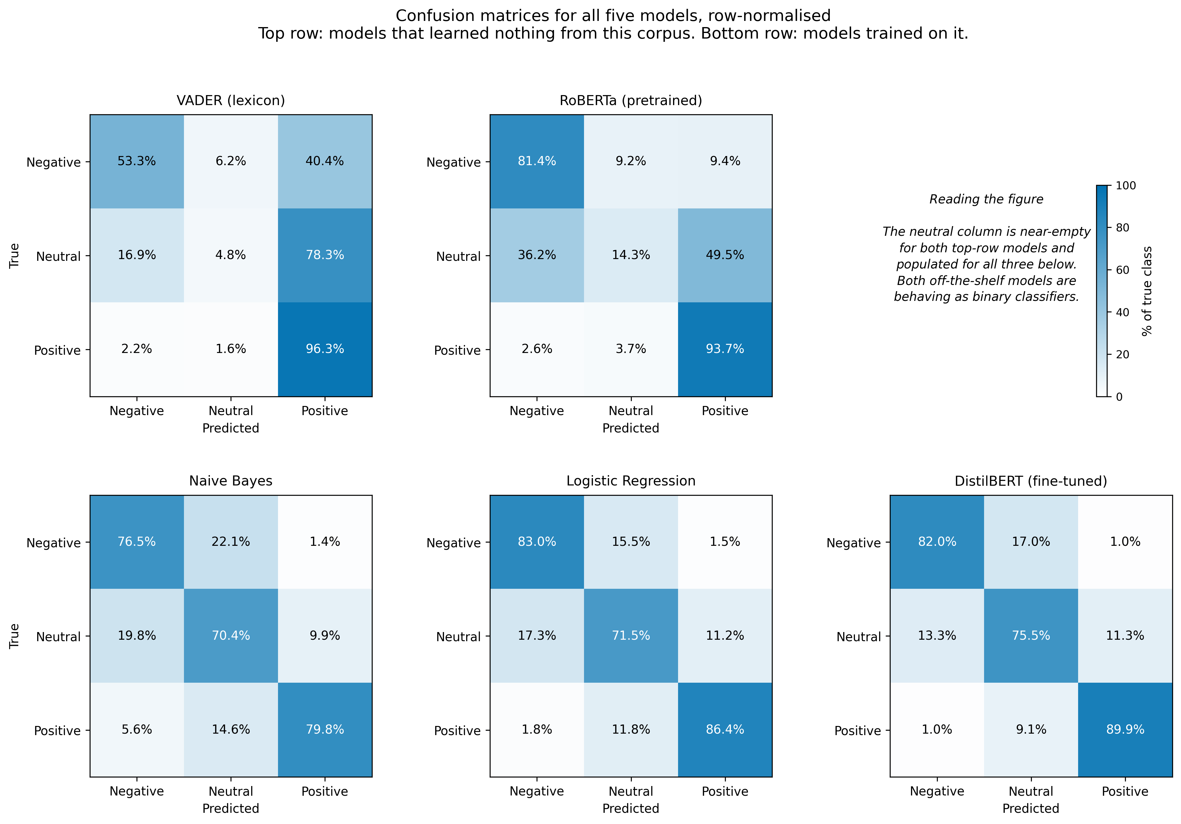
Figure 4.3
Figure 4.3 — Row-normalised confusion matrices for all five models (n = 128,539). VADER and RoBERTa push the majority of genuinely neutral reviews into the polar classes. (Produced by evaluate/generate_figures.py; the filename retains an earlier numbering.)
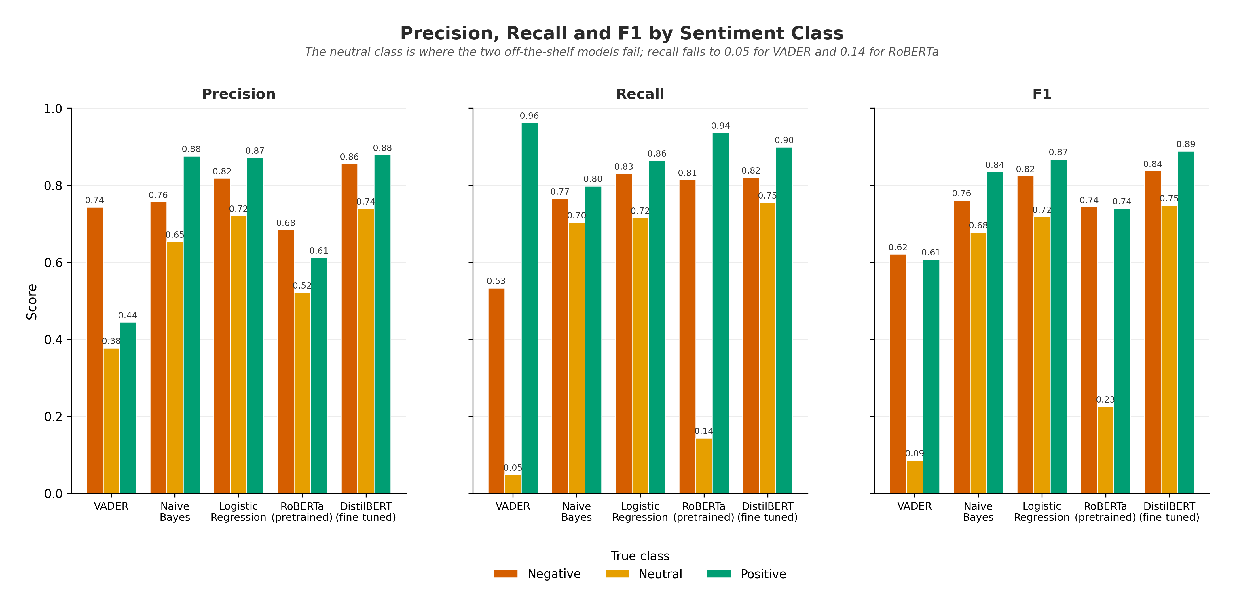
Figure 4.4
Figure 4.4 — Precision, recall and F1 by sentiment class, one panel per class. The neutral class separates the models far more sharply than the negative or positive classes. (Produced by evaluate/generate_all_metrics.py.)
Table 4.7 shows where the misclassified neutral reviews go, as row-normalised percentages.
Table 4.7 — Destination of true-neutral reviews, row-normalised (source: data/results/cm_*.json)
Model | → negative | → neutral | → positive
VADER | 16.9% | 4.8% | 78.3%
RoBERTa (pretrained) | 36.2% | 14.3% | 49.5%
Logistic Regression | 17.3% | 71.5% | 11.2%
DistilBERT (fine-tuned) | 13.3% | 75.5% | 11.3%
VADER assigns the neutral label to under five per cent of genuinely neutral reviews, pushing 78.3% to positive. RoBERTa splits them between both poles. Neither model fails uniformly; both behave as effectively binary classifiers confronted with a three-class task. VADER’s skew extends further still: it labels 40.4% of genuinely negative reviews as positive.

4.5.3 Statistical significance of the differences
A difference in macro F1 between two models is only meaningful if it exceeds what sampling variation would produce. McNemar’s exact test was therefore applied to every pair of models. The test considers only the reviews on which two models disagree: under the null hypothesis that both are equally accurate, each disagreement is equally likely to favour either model, so an exact binomial test on the discordant counts gives the probability of observing the imbalance found.
An important scope note. The test requires paired per-review predictions, which the saved confusion matrices do not retain. It was therefore computed on the balanced diagnostic sample of 1,800 reviews described in Section 4.5.4, not on the full test set. The accuracies in Table 4.8 are consequently those observed on that sample and differ from Table 4.5; the test speaks to pairwise correctness on the balanced sample, and is not a direct significance test of the macro F1 differences reported in Table 4.5.
Table 4.8 — McNemar pairwise comparisons, balanced diagnostic sample (n = 1,800) (source: data/results/metrics_summary/significance_tests.csv)
Model A | Model B | A acc. | B acc. | Discordant pairs | p-value | Significant | Better
VADER | DistilBERT | 0.5539 | 0.8417 | 734 | 1.6 × 10⁻⁸⁹ | yes | DistilBERT
VADER | Logistic Regression | 0.5539 | 0.7444 | 741 | 1.5 × 10⁻³⁷ | yes | Logistic Regression
Naive Bayes | DistilBERT | 0.6983 | 0.8417 | 444 | 2.6 × 10⁻³⁶ | yes | DistilBERT
VADER | RoBERTa | 0.5539 | 0.6944 | 429 | 3.2 × 10⁻³⁶ | yes | RoBERTa
RoBERTa | DistilBERT | 0.6944 | 0.8417 | 505 | 2.1 × 10⁻³³ | yes | DistilBERT
Logistic Regression | DistilBERT | 0.7444 | 0.8417 | 349 | 1.7 × 10⁻²¹ | yes | DistilBERT
VADER | Naive Bayes | 0.5539 | 0.6983 | 764 | 3.0 × 10⁻²¹ | yes | Naive Bayes
Naive Bayes | Logistic Regression | 0.6983 | 0.7444 | 295 | 1.6 × 10⁻⁶ | yes | Logistic Regression
Logistic Regression | RoBERTa | 0.7444 | 0.6944 | 596 | 2.6 × 10⁻⁴ | yes | Logistic Regression
Naive Bayes | RoBERTa | 0.6983 | 0.6944 | 675 | 0.82 | no | —
Nine of the ten comparisons are significant at p < 0.05, most by very wide margins. Two deserve specific note.
The gap between DistilBERT and logistic regression is significant at p = 1.7 × 10⁻²¹, so on this sample the advantage of fine-tuning is not attributable to sampling variation.
Naive Bayes and RoBERTa, by contrast, cannot be separated. Of the 675 reviews on which they disagree, each is correct on almost exactly half, giving p = 0.82. This does not establish that the two models are equivalent — a non-significant result is not evidence of equality — but the available paired evidence does not support ranking either above the other on this sample, despite RoBERTa being a transformer and Naive Bayes a bag-of-words classifier from a much earlier generation of methods.
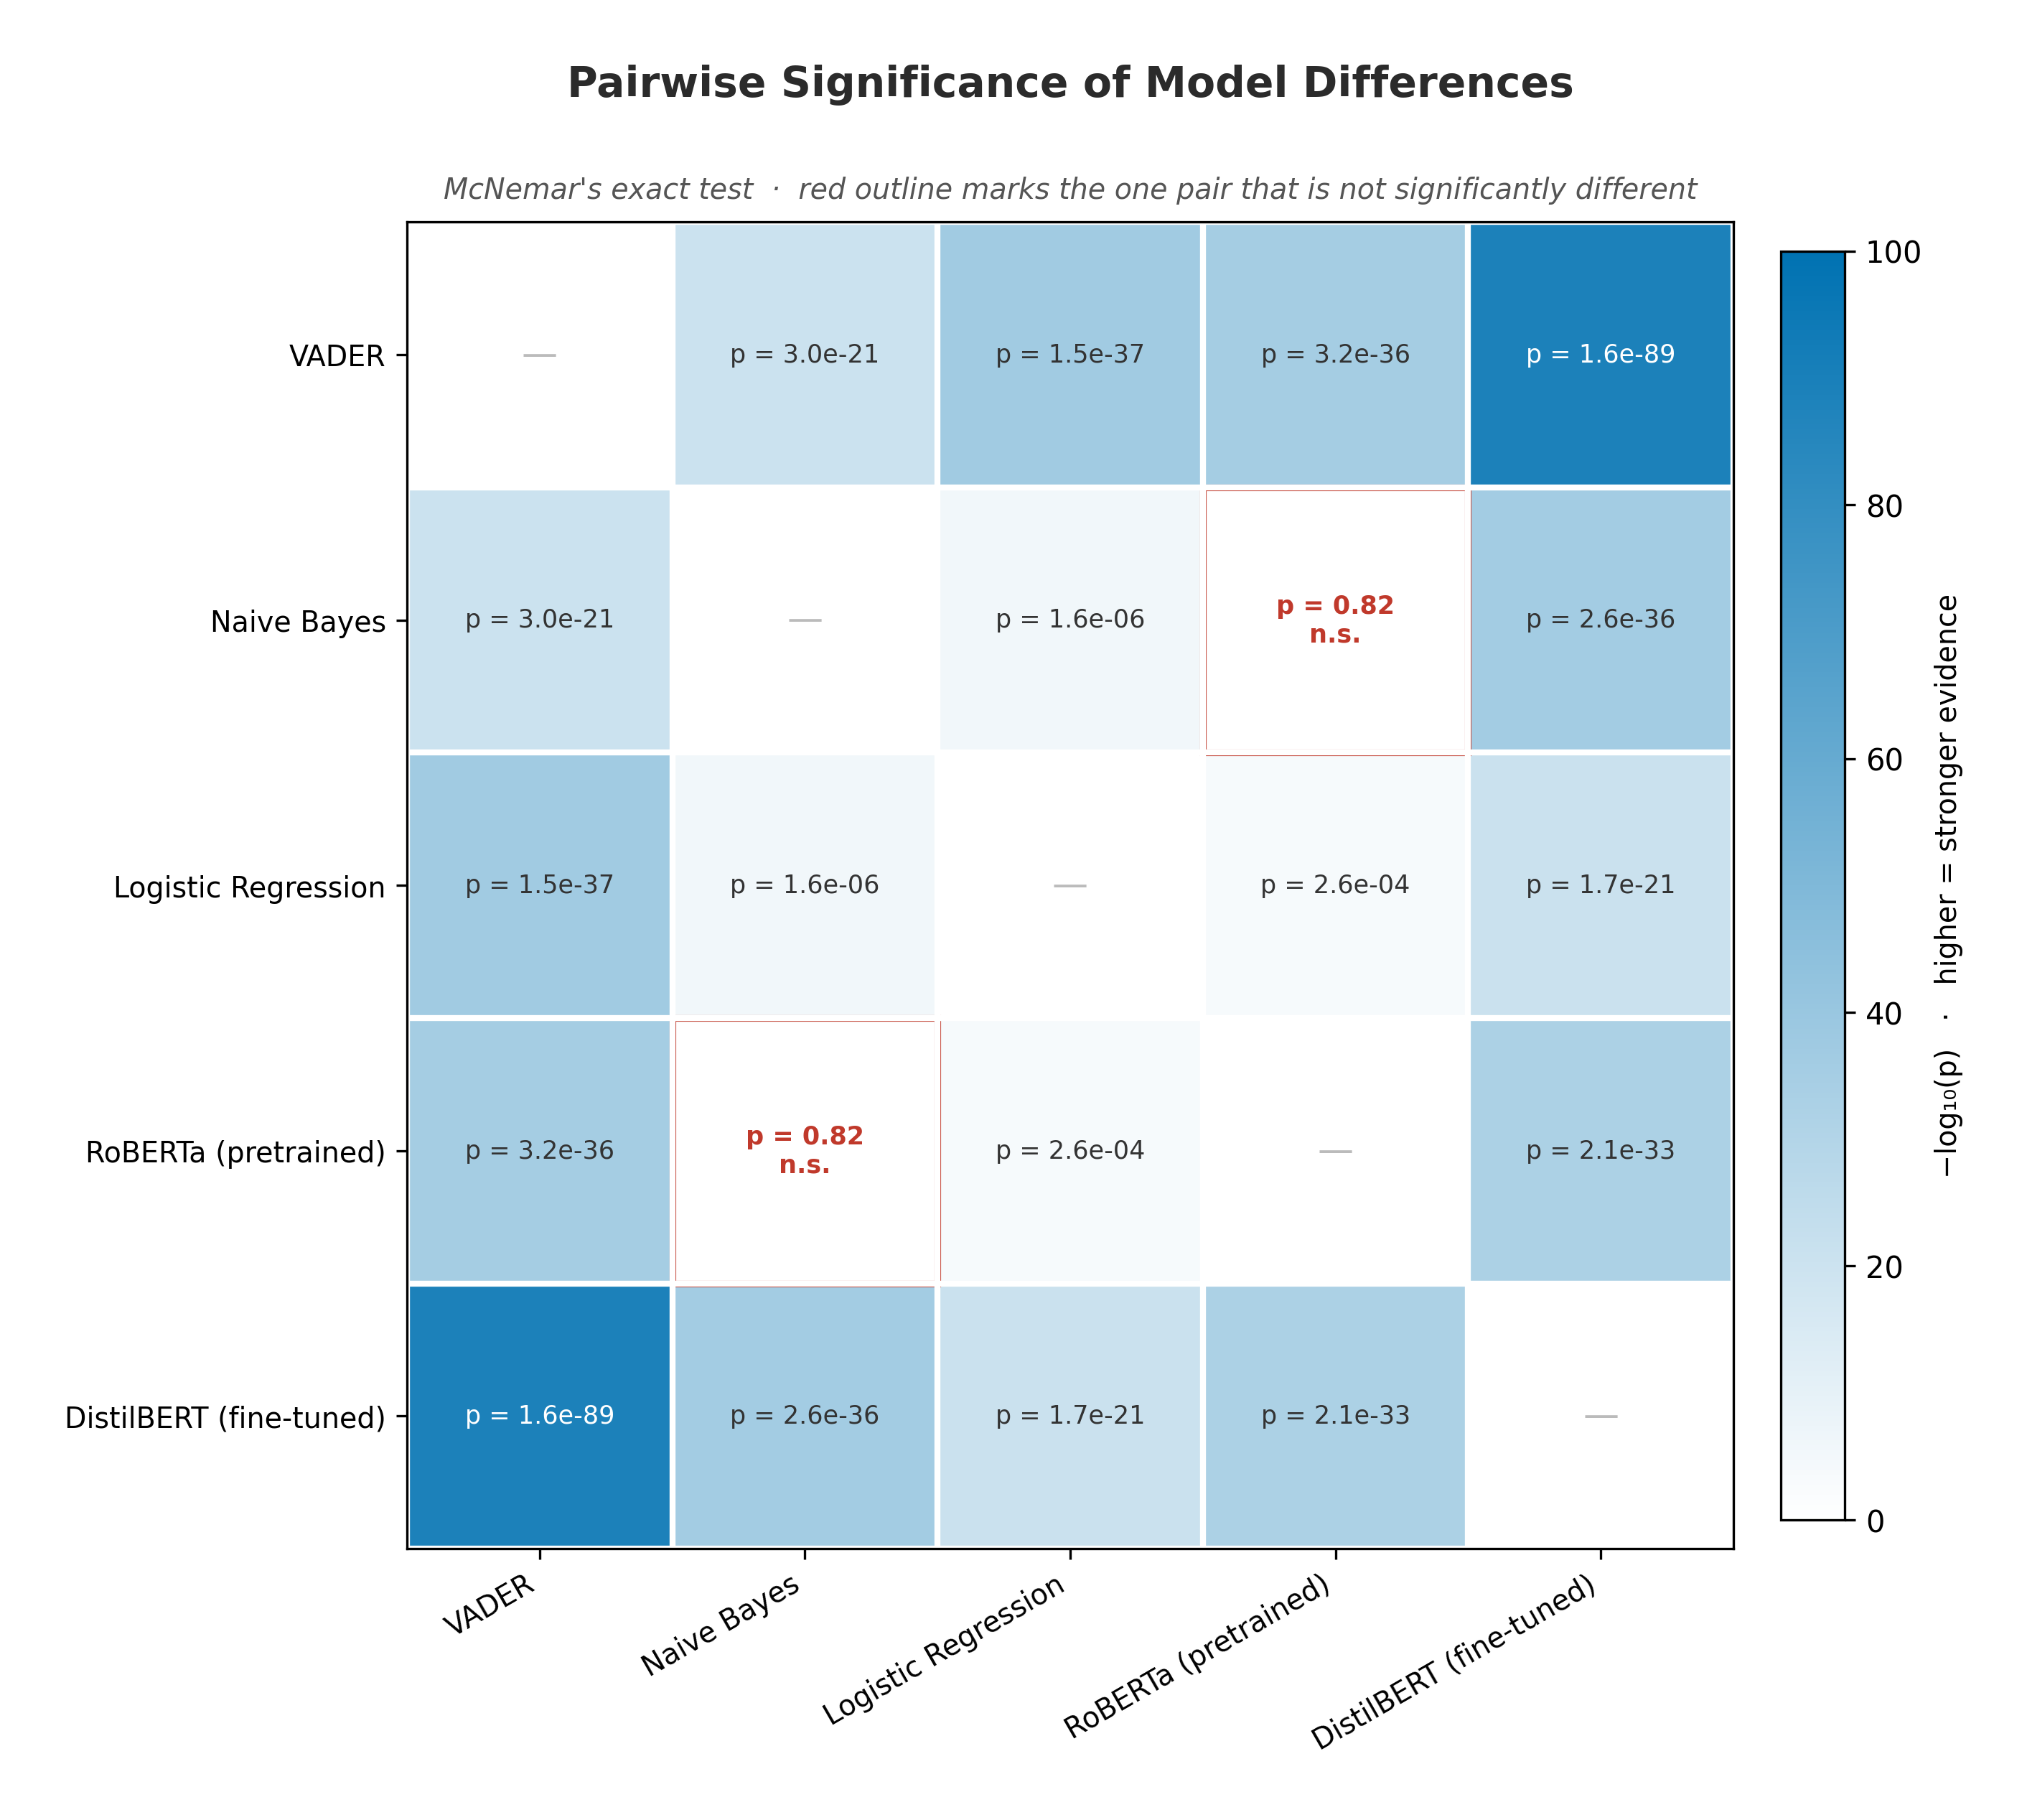
Figure 4.5
Figure 4.5 — Pairwise model comparison under McNemar’s exact test, balanced diagnostic sample (n = 1,800). Nine of ten comparisons are significant at p < 0.05. (Produced by evaluate/generate_all_metrics.py.)

4.5.4 Error analysis and diagnostic experiments
Three diagnostic experiments test the mechanism behind these results, using a balanced sample of 1,800 reviews drawn equally across platform and class so that no platform dominates. Because the sample is balanced rather than representative, the three-class figures in this section differ from Table 4.5 and should be compared only within the section. A qualitative inspection of individual misclassified reviews follows the three experiments.
Per-platform performance. Table 4.9 reports macro F1 and neutral F1 for every model on each platform.
Table 4.9 — Macro F1 (neutral F1 in parentheses) by platform, 600 reviews per platform (source: data/results/sentiment_diagnostics/per_platform_metrics.csv)
Model | Amazon | Yelp | Twitter Airline
VADER | 0.4811 (0.152) | 0.4252 (0.019) | 0.5880 (0.480)
Naive Bayes | 0.7952 (0.728) | 0.7573 (0.693) | 0.4838 (0.154)
Logistic Regression | 0.7908 (0.724) | 0.7948 (0.721) | 0.6434 (0.509)
RoBERTa (pretrained) | 0.6218 (0.302) | 0.5544 (0.198) | 0.7853 (0.713)
DistilBERT (fine-tuned) | 0.8448 (0.782) | 0.8301 (0.748) | 0.8505 (0.836)
The result is decisive. RoBERTa scores 0.7853 on Twitter Airline against 0.5544 on Yelp, a spread of 23 points, and its neutral F1 moves from 0.713 on Twitter to 0.198 on Yelp. On Twitter it also outperforms both classical models, beating logistic regression by 14 points and Naive Bayes by 30. The ranking of methods reverses depending on which platform is used to produce it.
Naive Bayes shows the mirror-image pattern, scoring 0.7952 on Amazon but collapsing to 0.4838 on Twitter. Only the fine-tuned model is stable across all three platforms, with a spread of two points.
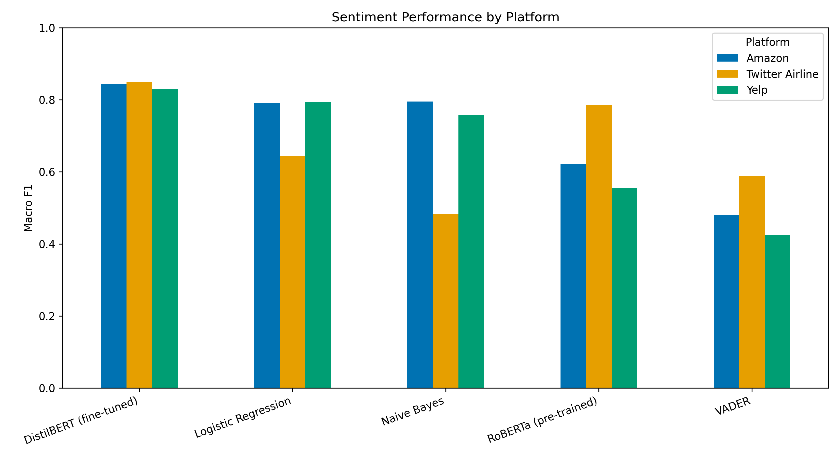
Figure 4.6
Figure 4.6 — Macro F1 by model and platform, 600 reviews per platform. RoBERTa outperforms both classical models on Twitter Airline while falling below them on Yelp. (Produced by evaluate/evaluate_sentiment_diagnostics.py.)
Binary re-evaluation. Table 4.10 removes the neutral class. The forced-binary column requires each model to choose between negative and positive using its own class scores.
Table 4.10 — Effect of removing the neutral class, diagnostic sample (source: data/results/sentiment_diagnostics/binary_comparison.csv)
Model | Three-class macro F1 | Binary macro F1 (forced) | Gain
VADER | 0.5094 | 0.7974 | +0.2880
RoBERTa (pretrained) | 0.6669 | 0.9341 | +0.2672
Naive Bayes | 0.6959 | 0.8803 | +0.1844
Logistic Regression | 0.7449 | 0.9216 | +0.1766
DistilBERT (fine-tuned) | 0.8426 | 0.9533 | +0.1107
The two off-the-shelf models gain most from removing neutral, and the ordering of the gains is itself the pattern: the more a model depends on task-specific training, the less it gains. RoBERTa’s binary macro F1 of 0.9341 exceeds logistic regression’s 0.9216, so once the neutral class is removed the ranking implied by the literature is restored.
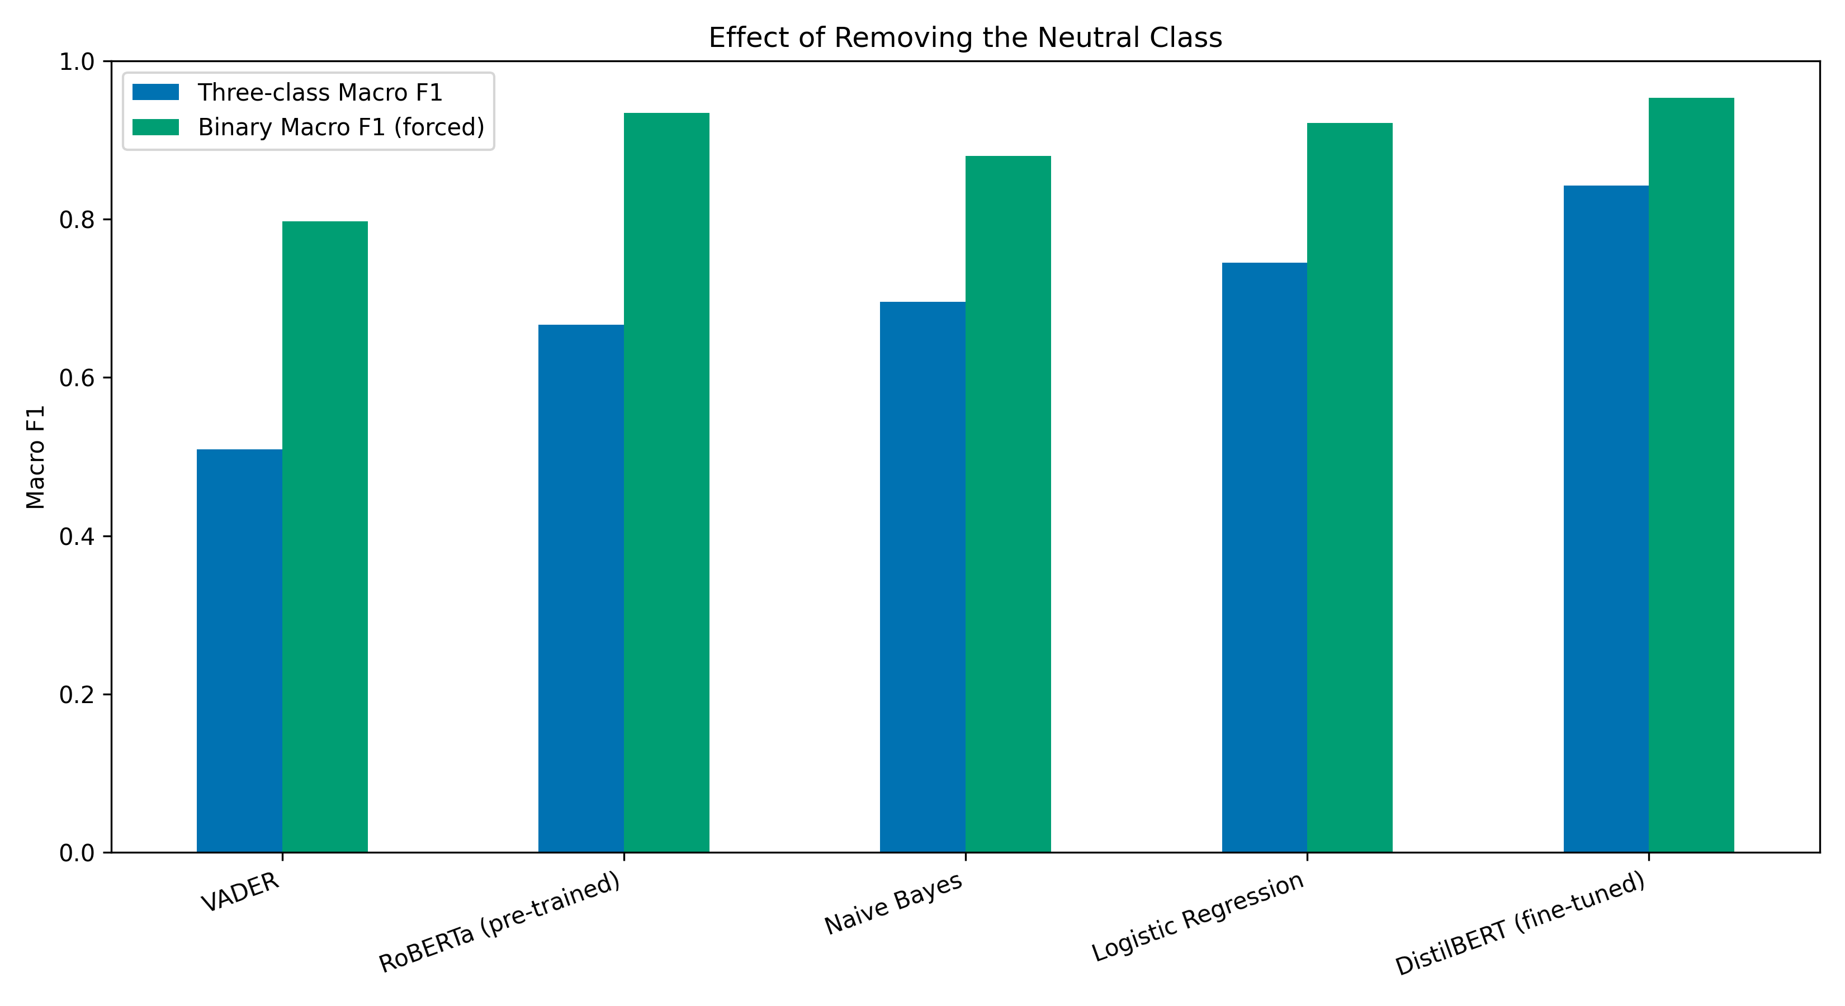
Figure 4.7
Figure 4.7 — Three-class against forced-binary macro F1 by model. The gain from removing the neutral class is largest for the two models never trained on this corpus. (Produced by evaluate/evaluate_sentiment_diagnostics.py.)
VADER threshold sensitivity. Widening VADER’s neutral band from the default ±0.05 raises macro F1 from 0.5094 to a maximum of 0.5353 at ±0.25, with neutral F1 rising from 0.253 to 0.349 and the proportion of reviews predicted neutral rising from 10.2% to 18.9%. Beyond ±0.25 macro F1 declines again. Table 4.11 gives the sweep.
Table 4.11 — VADER neutral-band sweep, diagnostic sample (source: data/results/sentiment_diagnostics/vader_threshold_sweep.csv)
Neutral band | Accuracy | Macro F1 | Neutral F1 | Predicted neutral (%)
±0.05 (default) | 0.5539 | 0.5094 | 0.2526 | 10.2
±0.10 | 0.5567 | 0.5179 | 0.2812 | 12.1
±0.15 | 0.5594 | 0.5258 | 0.3075 | 14.0
±0.20 | 0.5628 | 0.5332 | 0.3311 | 16.3
±0.25 | 0.5606 | 0.5353 | 0.3486 | 18.9
±0.30 | 0.5561 | 0.5335 | 0.3638 | 21.9
±0.40 | 0.5478 | 0.5297 | 0.3909 | 27.5
±0.50 | 0.5406 | 0.5259 | 0.4413 | 37.2
±0.60 | 0.5272 | 0.5099 | 0.4649 | 44.3
The improvement is real but modest: a gain of 0.026 macro F1 at the optimum. Threshold choice explains part of VADER’s weakness on the neutral class, not most of it.
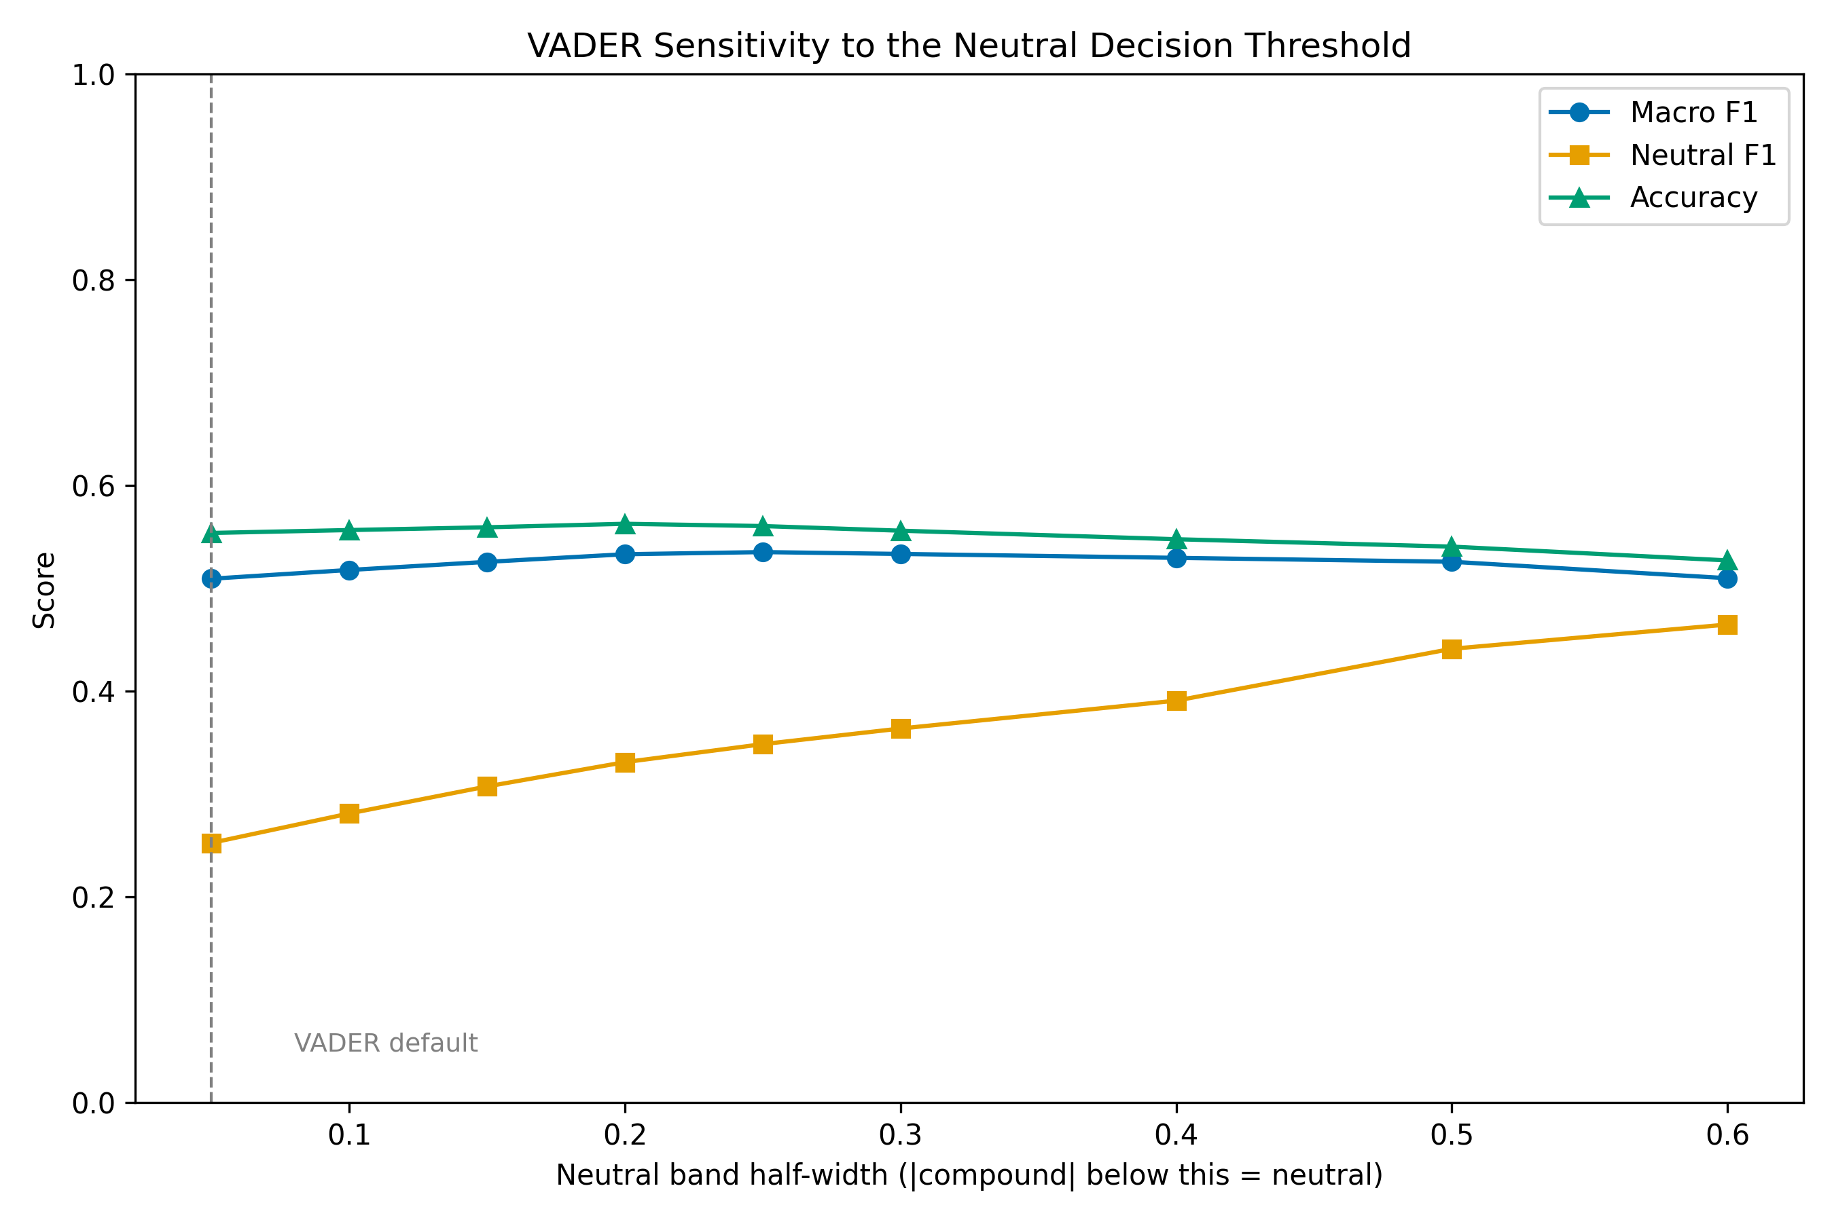
Figure 4.8
Figure 4.8 — VADER macro F1, neutral F1 and accuracy across neutral-band widths. Macro F1 peaks at ±0.25 and declines thereafter. (Produced by evaluate/evaluate_sentiment_diagnostics.py.)
Qualitative error analysis. The three experiments above establish where errors concentrate; they do not show what the errors look like. Individual misclassified reviews were therefore inspected by joining the cached per-review predictions in data/results/sentiment_diagnostics/predictions.csv back to the source text. Three error patterns account for most of the failures, and each corresponds to one of the quantitative findings reported above. Review text is reproduced verbatim, truncated where long.
Pattern 1 — mixed evaluative content in three-star reviews. Of the 600 true-neutral reviews in the balanced sample, 300 were assigned a polar label by RoBERTa while the fine-tuned model assigned neutral correctly. Inspection shows these are not ambiguous in the sense of being uninformative; they are reviews containing clear praise and clear criticism in the same text:
“Nice curl finish. This product was hard to install could not put thick sections in small sections only curls came out pretty though” — Amazon, 3 stars. RoBERTa: negative. VADER: positive.
“Fenugreek Tea. The tea is very good however the bags are fragile and quite a few had already spilled its contents in the box” — Amazon, 3 stars. RoBERTa: positive. VADER: positive.
“Not a fan of the chewy tapioca balls. Heard good things and I’m very sure this kit is good if you go into it knowing what to expect but not a great experiment for a newbie.” — Amazon, 3 stars. RoBERTa: negative. VADER: positive.
Each contains an explicit positive clause and an explicit negative clause. A three-star rating encodes the reader’s net judgement across both; a model trained to detect the absence of clear sentiment has no representation for a text that expresses two strong sentiments simultaneously. This is the concrete form of the label-mismatch account developed in Section 5.1.1.
Pattern 2 — positive vocabulary in negative reviews. VADER assigned a positive label to 201 of the 600 true-negative reviews in the sample. The compound scores show why:
“Very bland. Ok, first off let me just say that I am a very clean eater and I HATE the sodium bloat…” — Amazon, 2 stars. VADER compound = +0.890.
“only lasted 3 months. Worked well and looked good until keys stopped working after 3 months. My previous keyboard lasted 3 years” — Amazon, 1 star. VADER compound = +0.477.
“Not a fan. I love nut pods but don’t care for this flavor.” — Amazon, 1 star. VADER compound = +0.752.
In each case the lexicon’s positive terms (“clean”, “love”, “worked well”, “looked good”) outweigh the negative ones, because scoring is applied to words rather than to the clauses those words sit in. The second example is the clearest: the complaint is carried entirely by the temporal contrast between “worked well” and “until keys stopped working”, which a bag-of-words score cannot represent. This is the mechanism behind the 40.4% negative-to-positive rate in Table 4.7, and it explains why the threshold sweep recovers so little — the errors are not near the decision boundary but confidently on the wrong side of it.
Pattern 3 — reviews all five models misclassify. In 74 of the 1,800 cases (4.1%) every model was wrong. These are qualitatively different from the two patterns above:
“Photos Off Color to What I Was Expecting. I love everything about this except the color depiction and description…” — Amazon, 2 stars, labelled negative. All five models predicted positive or neutral.
“Very unhealthy but tasted pretty good. Once preservatives and palm oil are removed we would consider b…” — Amazon, 2 stars, labelled negative. Four models predicted neutral, one positive.
Here the disagreement is arguably with the label rather than with the models. A reviewer who writes “I love everything about this except…” and awards two stars is expressing a judgement that the text alone does not convey, and no classifier reading only the text can recover it. This category is small but it is the empirical face of the labelling ceiling described in Section 4.2.4: some portion of the residual error in every model is imposed by rating-derived labels rather than by modelling capacity, and 4.1% is a lower bound on that portion for this sample.

4.5.5 Taxonomy evaluation
Two distinct measures are used and should not be confused. Centroid separation is the mean pairwise cosine similarity between category centroids, where low is desirable. Within-category coherence is the mean similarity of reviews to their own centroid, where high is desirable. The implementation names the first taxonomy_coherence, which is misleading, and the distinction is drawn explicitly here so that the ambiguity is not carried into the results.
The merged taxonomy has a centroid separation of 0.2831 across its 24 categories, indicating well-separated categories. Had the 121 raw topics merged into 24 groups that still overlapped heavily, the consolidation would have been a relabelling exercise rather than a genuine reduction.
Applying the taxonomy to a held-out stratified sample of 450 reviews, 150 per platform, gives Table 4.12.
Table 4.12 — Taxonomy evaluation on held-out data (n = 450) (source: data/results/category_discovery/evaluation_summary.csv, category_frequency.csv)
Measure | Value
Categories used (of 24 available) | 21
Mean within-category coherence | 0.6334
Largest category | Product Performance Failures — 127 (28.2%)
Unclassified (below 0.35 confidence) | 124 (27.6%)
Categories with a single review | 3
Average category size | 21.4
Two categories between them absorb 251 of 450 reviews (55.8%): the largest substantive category and the unclassified bucket. The remaining 199 reviews are distributed across 20 categories, three of which hold a single review.
Coherence varies systematically with category size, and the relationship is inverse. Table 4.13 gives representative values.
Table 4.13 — Within-category coherence against category size, selected categories (source: data/results/category_discovery/category_coherence.csv)
Category | Reviews | Mean coherence
Travel Disruption Issues | 11 | 0.6763
Home Network Connectivity Issues | 7 | 0.6410
Service and Wait Time Delays | 35 | 0.5678
Audio Performance Failures | 22 | 0.5546
Product Fit and Sizing Issues | 25 | 0.4079
Product Performance Failures | 127 | 0.3997
Unclassified / Emerging Complaint | 124 | 0.3767
The three categories holding a single review each score 1.0, which is an artefact of measuring a review’s similarity to a centroid it alone defines, not a quality signal. These are excluded from interpretation.
Three defects are visible in the assignment output, and all three are reported rather than smoothed.
The largest category absorbs over a quarter of the sample while its internal coherence, 0.3997, is among the lowest recorded — the signature of a catch-all rather than a well-defined complaint type.
One category retained an un-renamed raw BERTopic label: “Spray Bottle, Continuous Spray, Dryer Diffuser, Fit Dryer”. The language-model naming step described in Section 4.4.2 failed on at least one cluster, and the failure passed through into the deployed taxonomy.
The sentiment breakdown shows the taxonomy assigning positive reviews to complaint categories. That same mis-named category received 19 positive reviews and zero negative; the unclassified group holds 60 positive against 34 negative. The taxonomy was built from negative reviews only and has no mechanism for rejecting non-complaints, so any review presented to it is assigned somewhere or left unclassified regardless of whether it expresses a complaint at all.
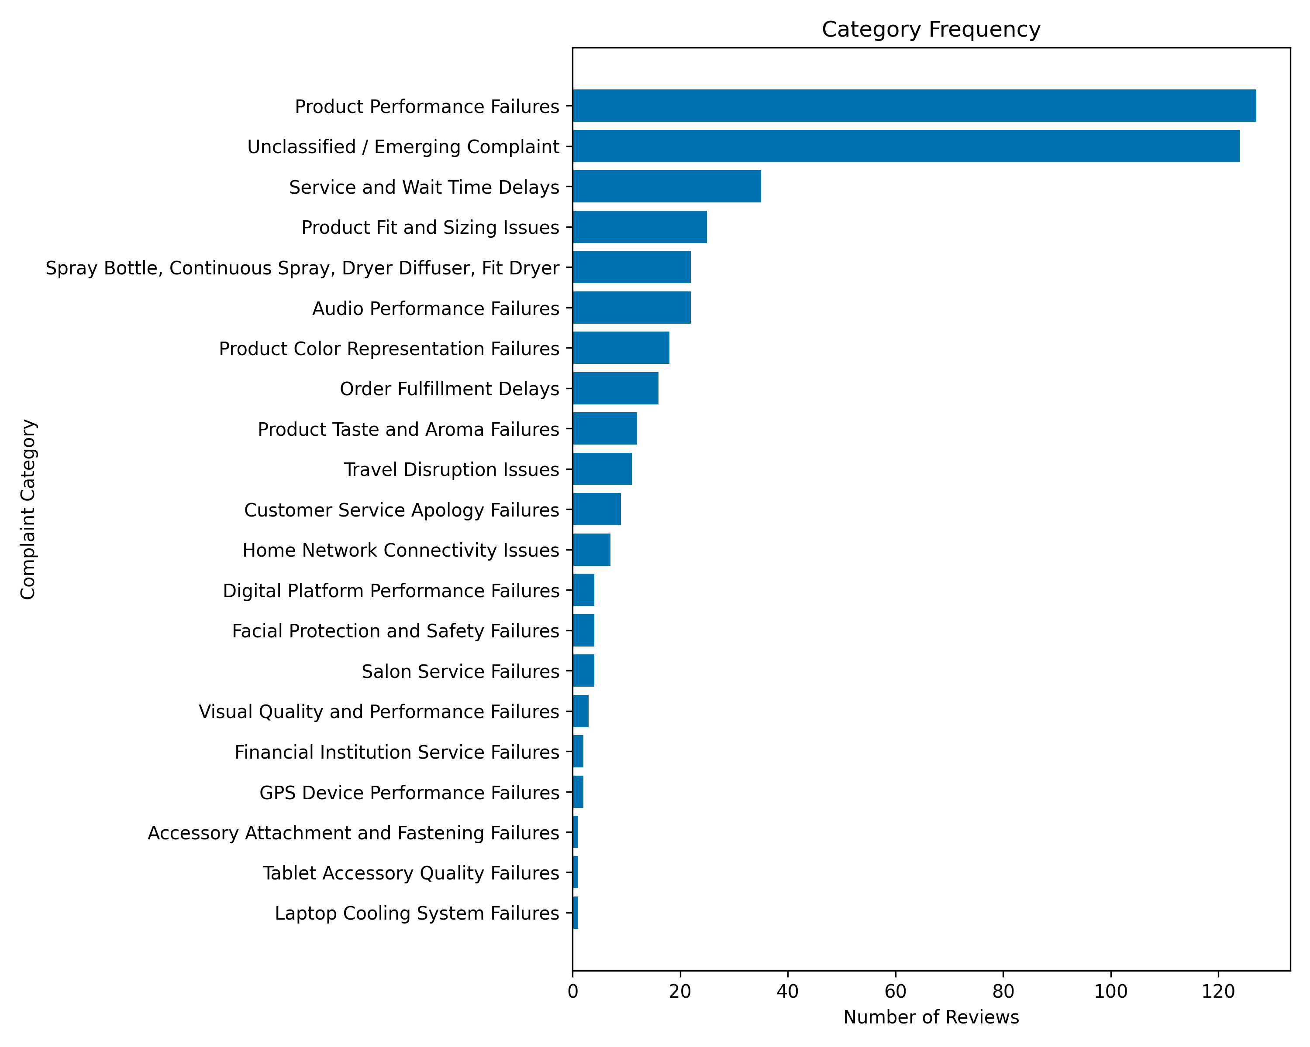
Figure 4.9
Figure 4.9 — Category frequency on the held-out sample (n = 450). Two categories account for 55.8% of assignments; three hold a single review each.
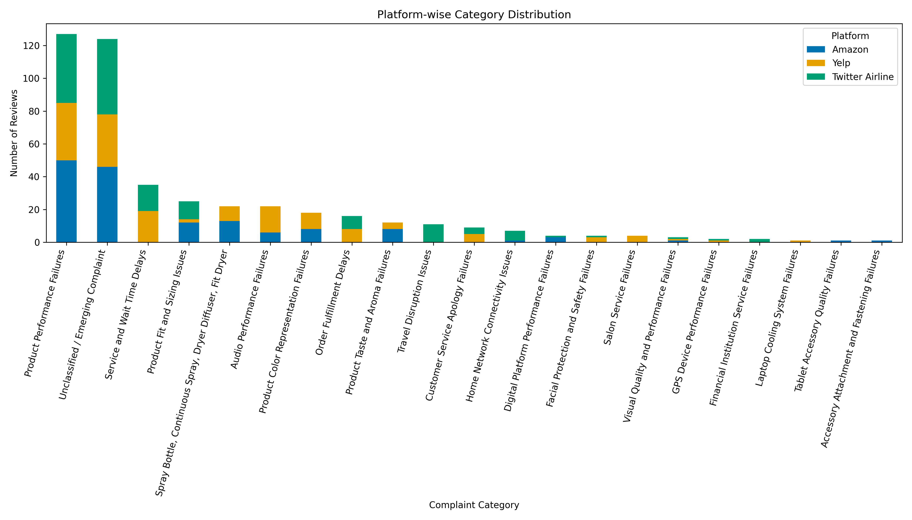
Figure 4.10
Figure 4.10 — Distribution of categories across the three platforms.
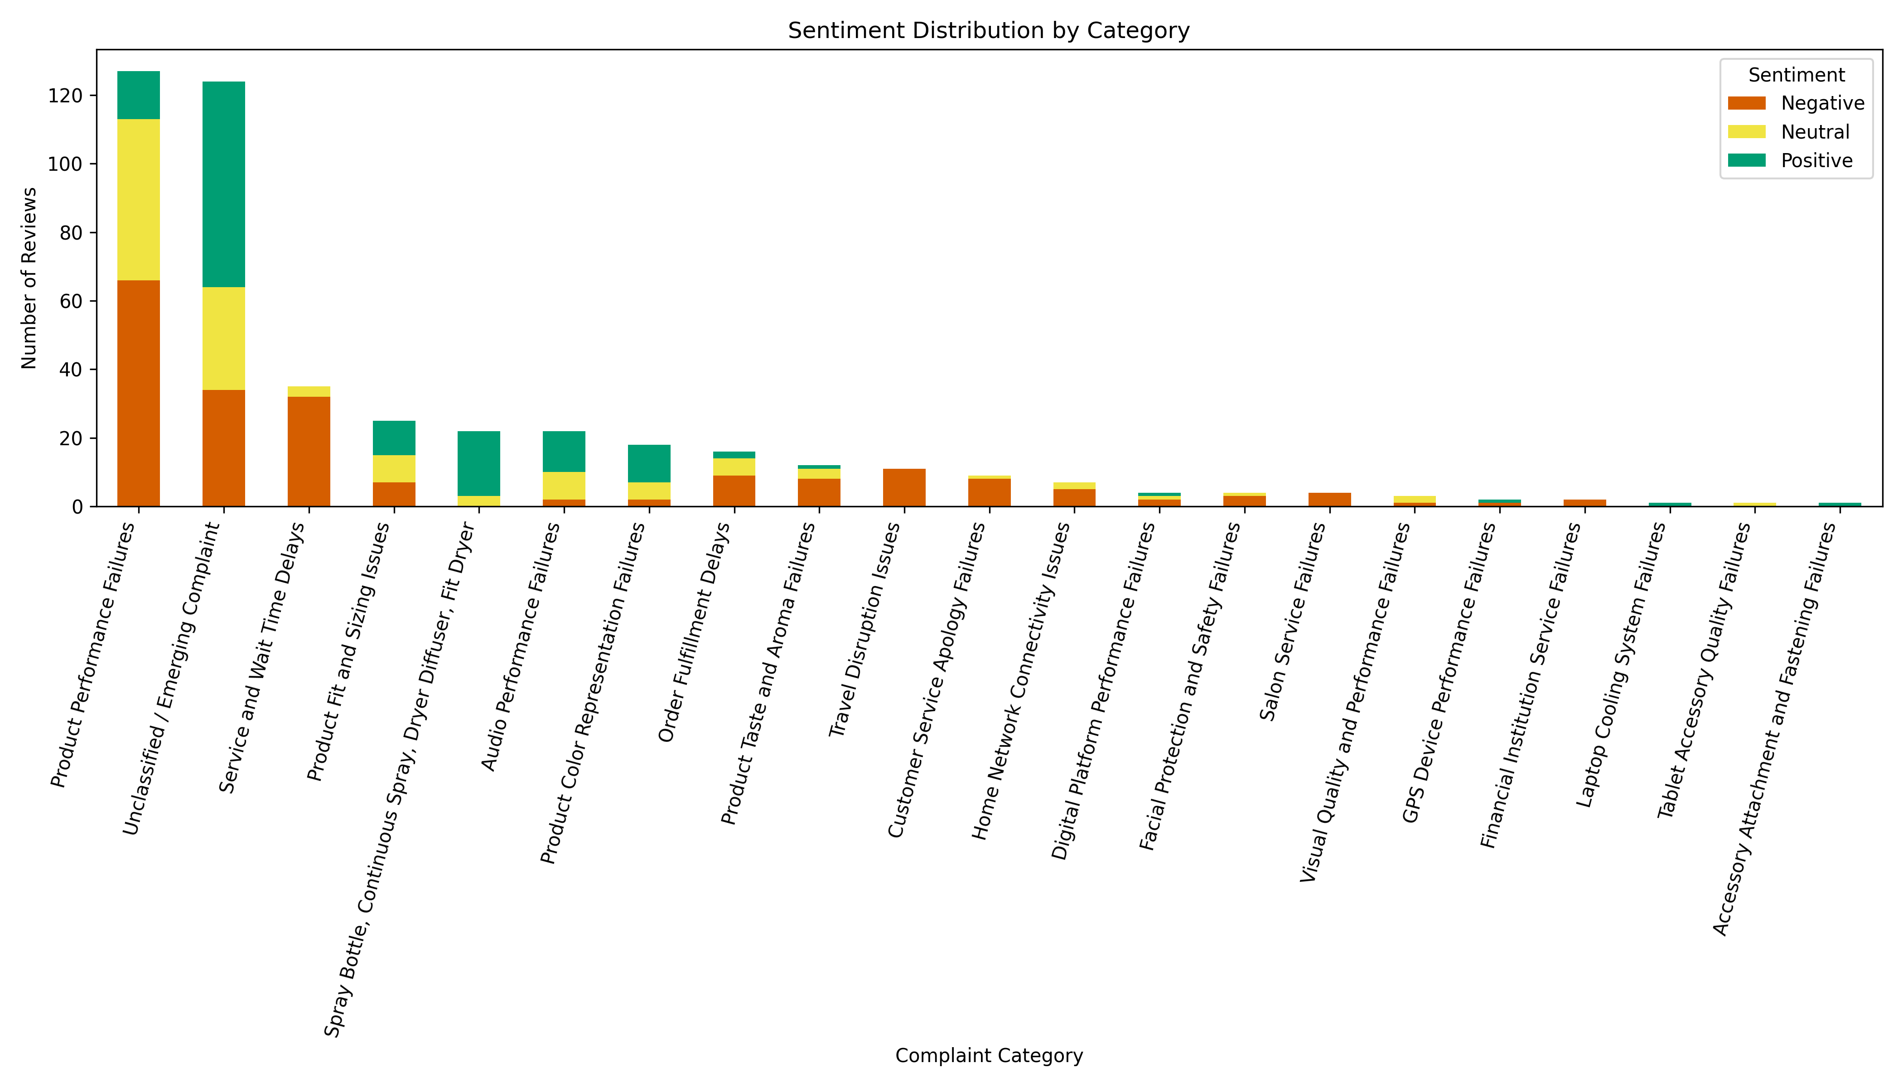
Figure 4.11
Figure 4.11 — Sentiment composition of each category. Several complaint categories contain predominantly positive reviews — the defect discussed above.
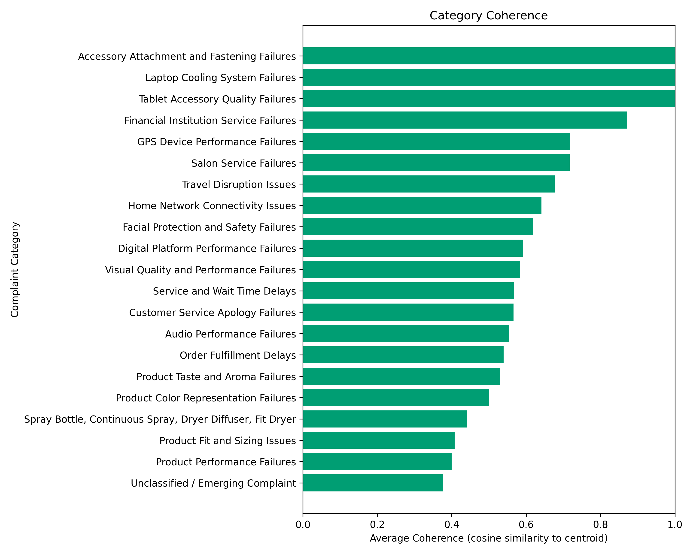
Figure 4.12
Figure 4.12 — Mean within-category coherence against category size. The two largest categories record the lowest coherence of any category holding more than three reviews. (All four produced by evaluate/evaluate_category_discovery.py.)

4.5.6 Retrieval evaluation
Table 4.14 — Retrieval comparison, 30 queries over 642,692 indexed reviews (source: data/results/comparison_embedding_models/retrieval_comparison.csv)
Metric | Semantic (MiniLM + FAISS) | TF-IDF
Mean retrieval time | 21.71 ms | 127.61 ms
Min / max retrieval time | 15.90 / 36.01 ms | 121.20 / 150.46 ms
Mean similarity score | 0.6833 | 0.5593
Precision@3 | 0.90 | 0.90
Query success rate | 100% | 100%
Dense retrieval is roughly 5.9 times faster, and its latency is also more variable in relative terms while remaining well below the TF-IDF minimum. Precision@3 is identical at 0.90.
Two cautions apply. The similarity scores are not comparable across methods, since cosine similarity over dense embeddings and over sparse TF-IDF vectors measure different quantities; the higher dense figure should not be read as better retrieval. And with 30 queries the comparison is small enough that a modest precision difference could pass undetected. On this evidence the case for dense retrieval rests on latency, not on retrieval quality.
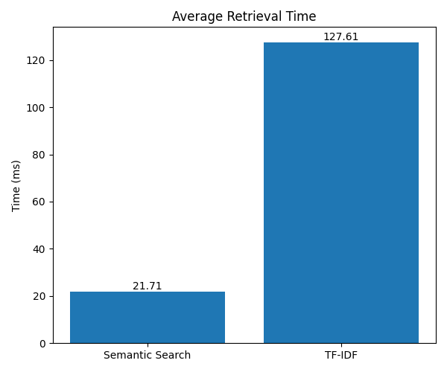
Figure 4.13
Figure 4.13 — Mean retrieval latency, dense semantic search against TF-IDF, 30 queries over 642,692 indexed reviews. Precision@3 is identical between methods at 0.90 and is therefore reported in Table 4.14 rather than charted. (Produced by scripts/compare_embedding.py.)

4.5.7 Generation evaluation
Table 4.15 compares the retrieval-augmented pipeline against the standalone baseline on the same five questions, with the same generator, temperature and prompt structure. These figures were regenerated after a hard grounding threshold (SIMILARITY_THRESHOLD = 0.35, rag/pipeline.py) was added to the retriever, which discards a question outright — returning a fixed refusal rather than an answer — when nothing retrieved clears the threshold. An earlier run of the same script, before that threshold existed, produced higher aggregate scores; those figures are superseded and are not reported here, since they describe a pipeline configuration that is no longer the one in rag/pipeline.py. Section 4.6 describes the guard; this section is the evaluation of the system with it in place. One caveat belongs here rather than buried in a footnote: as the per-question data below shows, the threshold itself was not what produced the one refusal observed in this sample — a separate part of the pipeline was responsible, and the difference matters enough to walk through properly rather than gloss over.
Table 4.15 — RAG against standalone LLM (n = 5 questions) (source: data/results/llm_vs_rag/overall_results.csv, comparison_summary.csv)
Metric | RAG pipeline | Standalone LLM
Faithfulness | 0.540 | not computable
Answer relevancy | 0.610 | 0.753
Context precision | 0.416 | not applicable
Context recall | 0.400 | not applicable
Mean latency | 1,582.7 ms | 734.0 ms
Mean retrieved reviews | 3.4 | 0
Faithfulness cannot be computed for the standalone condition because the metric measures whether an answer follows from retrieved context, and no context exists. That absence is itself the finding: the baseline produces answers with no verifiable evidential basis, so the property the pipeline exists to provide is undefined for the alternative.
On the two metrics that can be compared, the standalone model scored higher on answer relevancy — 0.753 against 0.610 — while taking under half the time. Mean retrieved reviews falls to 3.4 because one question returns zero reviews (rejected before retrieval by the scope guard, not the grounding threshold — see the note under Table 4.16) and another returns only two, rather than the fixed five the earlier, un-gated retriever always returned.
Per-question variance is severe, and the aggregate means conceal a pattern that reverses part of this reading. Table 4.16 gives the full per-question breakdown.
Table 4.16 — Per-question RAGAS scores (n = 5) (source: data/results/llm_vs_rag/rag_ragas_scores.csv, llm_ragas_scores.csv)
Question | RAG faithfulness | RAG relevancy | RAG context precision | RAG context recall | LLM relevancy
Why are customers unhappy with battery life? | 0.417 | 0.442 | 0.325 | 1.000 | 0.988
What delivery problems are customers reporting? | 1.000 | 0.740 | 0.756 | 1.000 | 0.000
Why are airline passengers dissatisfied? | 0.400 | n/a¹ | 0.000 | 0.000 | 0.961
What customer service issues appear most often? | 0.000² | 0.437 | 0.000² | 0.000² | 0.964
Summarise the major customer complaints. | 0.882 | 0.819 | 1.000 | 0.000 | 0.853
Mean | 0.540 | 0.610¹ | 0.416 | 0.400 | 0.753
¹ The RAGAS judge raised an OutputParserException while scoring this question’s answer relevancy — the free-tier judge model returned prose instead of the expected structured output — so no score exists for that cell. The reported mean is computed over the remaining four questions, not five, which narrows an already small sample further. This is a concrete instance of the judge-model risk discussed in Section 5.3.4.
² This one needs unpacking rather than a one-line note, because the obvious explanation turns out to be the wrong one. It’s tempting to read this row as the grounding threshold doing its job — no evidence, so no answer — but the text returned doesn’t say that. It matches OUT_OF_SCOPE_MSG verbatim, the message the pipeline’s scope guard returns, not NO_EVIDENCE_MSG, the message the similarity threshold returns. That distinction matters: the scope guard runs first, before retrieval is even attempted, so this question never reached the grounding mechanism at all. Somewhere in the two-stage guard — most likely its LLM classifier, since the keyword list doesn’t contain anything this question would trigger — “What customer service issues appear most often?” was judged out of scope. It plainly isn’t; this is a legitimate complaint-exploration question of exactly the kind the system is built to answer. The same rejection, identical wording, recurred in both conditions of the metadata-tagging ablation described in Section 4.5.8, which rules out coincidence and points to a real, reproducible weak spot in the scope classifier rather than a one-off fluke. Faithfulness, context precision and context recall are mechanically zero here because no retrieval or generation ever happened for this question — not because the pipeline judged its own evidence insufficient.
Four observations follow directly from the table, and are recorded here as evidence rather than interpretation.
The standalone model’s relevancy advantage is driven by the same single anomalous score as before. Its per-question relevancy is 0.988, 0.000, 0.961, 0.964 and 0.853 — four high scores and one complete failure on the delivery question. Excluding that single zero would raise its mean to approximately 0.941; including it gives 0.753. The RAG pipeline’s four scored questions range from 0.437 to 0.819, a spread of 0.38 — wider than the earlier, un-gated run, but still narrower than the baseline’s spread of 0.99.
The false rejection on the customer-service question is the most consequential single result in this table, but it credits the wrong mechanism if read carelessly. It is not the grounding threshold working as designed — no retrieval was even attempted — it’s the scope guard misfiring on a question it should have passed straight through. The practical effect looks similar to a deliberate refusal (no answer, rather than a possibly wrong one), which limits the damage, but the cause is different, and Section 4.5.8’s ablation results depend on getting this distinction right rather than folding it into the grounding-threshold story. It also mechanically depresses three of the four aggregate metrics for this question, since a rejection scores zero on faithfulness, context precision and context recall by construction, the same way a grounding refusal would.
Retrieval quality is still the pipeline’s weakest measured component among the questions that actually reached it. Context precision fell to zero on two of five questions — airline and, by construction, the rejected customer-service question — and on the airline question, faithfulness fell with it, to 0.400, rather than remaining high as it did in the earlier, un-gated run, where a zero-precision question still produced an answer scored 0.917 on faithfulness. That’s a genuine improvement: the pipeline no longer generates a confident, well-formed answer from evidence its own retrieval judged irrelevant. Whether the grounding threshold itself deserves the credit for that, though, is a separate question from whether the scope guard behaved correctly, and this sample doesn’t actually contain a case of the threshold refusing a question with retrieved-but-irrelevant evidence — that’s a gap worth flagging for a future, larger evaluation, not something this table can settle either way.
Context recall is now 0.000 on three of five questions and 1.000 on the remaining two, and the three zero cases have different causes that should not be collapsed into one. On the summarisation question it repeats the earlier finding — an open-ended request with no specific topic to retrieve against, a structural limitation of similarity-based retrieval rather than a tuning failure. On the airline question it reflects genuinely thin retrieval: only two reviews cleared the threshold, and neither covers the reference answer’s specific topics (delays, cancellations, lost luggage). On the customer-service question it is the mechanical consequence of the scope guard’s false rejection, not of anything retrieval did.
Three constraints qualify all of these figures. Sample size follows from free-tier API rate limits, which capped the available evaluation call volume; with n = 5 (n = 4 for relevancy) the means carry very wide uncertainty and no confidence interval is reported because none would be meaningful at this sample size. The judge model is the model that generated the answers, so the self-enhancement bias documented in Section 2.1.2 applies — though that bias would act to inflate the pipeline’s scores rather than the baseline’s, so it cannot explain the relevancy result. And the judge’s own output failed to parse on one question, discussed above, which is itself evidence for that same judge-reliability concern rather than a separate issue.
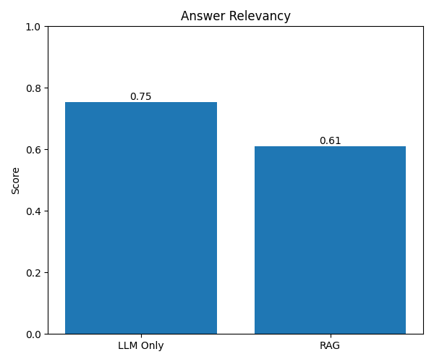
Figure 4.14
Figure 4.14 — Answer relevancy, retrieval-augmented pipeline against standalone LLM (n = 5, n = 4 scored for RAG). The baseline’s higher mean rests on four strong scores and one complete failure. (Produced by evaluate/evaluate_llm_vs_rag.py.)
A note on evaluation scope. Four ablation conditions were designed for the retrieval stage (Section 3.6.6). Three of them — retrieval depth, retriever type and prompt version — were specified but never built, so the contribution of those design decisions is still argued from reasoning rather than measured. The fourth, metadata tagging, was built and run, and Section 4.5.8 reports what it found.

4.5.8 Ablation: does metadata tagging actually help?
Section 3’s design chapter argues that tagging each retrieved review with its platform, rating and sentiment before it reaches the generator (DOCUMENT_PROMPT in rag/pipeline.py) is what makes RAG_PROMPT’s grounding rules enforceable rather than aspirational. Until now that was a claim defended by reasoning, not evidence. evaluate/ablation_metadata_tagging.py tests it directly: the same five questions, run twice through the same pipeline, once with the tags left in place and once with them stripped so the generator sees only the raw review text. Retrieval is identical in both runs — same threshold, same MMR selection — so any difference in the RAGAS scores can only come from what the generator was shown, not from what was retrieved.
Table 4.17 — Metadata tagging ablation (n = 5 questions) (source: data/results/ablation_metadata_tagging/comparison_summary.csv)
Metric | Tagged | Untagged | Delta
Faithfulness | 0.667 | 0.549 | +0.118
Answer relevancy | 0.452 | 0.654 | −0.202
Context precision | 0.416 | 0.416 | 0.000
Context recall | 0.400 | 0.400 | 0.000
The clean part of the result first: context precision and context recall are identical, to three decimal places, between conditions. That’s exactly what the design predicts, since neither condition touches retrieval, and it’s reassuring in a small way — it confirms the ablation is actually isolating what it claims to isolate, rather than some confound in how the two runs were set up.
The interesting part is that tagging doesn’t win cleanly. Faithfulness goes up with tags, by a solid margin — 0.667 against 0.549 — which does support the argument that citing each review’s platform and rating gives the model something concrete to stay anchored to. But answer relevancy goes the other way, and by more: 0.452 tagged against 0.654 untagged, a drop of 0.202. That’s not a rounding artefact; it’s the largest single delta in the table. A plausible explanation is that the tagged answers spend more of their length on citation-style attribution — “(Yelp, Rating: 1.0, Sentiment: negative)” — while the untagged answers read more like a direct response to the question, which is closer to what an answer-relevancy judge is actually scoring. If that’s right, the tagging design buys grounding at a real cost to how responsive the answer feels, and the honest conclusion is a trade-off rather than a validation.
One concrete example is worth quoting directly, because it’s exactly the failure mode the tagging is meant to prevent, caught in the act. For the battery-life question, the untagged run’s answer opens with “Platform(s) covered: Twitter Airline, Amazon” — but none of the five retrieved reviews for that question mention an airline; they’re about product batteries and an in-store replacement service, plausibly Amazon and Yelp. The tagged run’s answer for the same question and the same retrieved reviews says “Platform(s) covered: Yelp, Amazon,” which matches what was actually retrieved. That’s a real, observed instance of RAG_PROMPT rule 3 — never reference a platform absent from the retrieved reviews — being violated without the tags and respected with them. It’s one example, not a pattern established across many questions, but it’s the kind of concrete evidence the design argument in Section 3 didn’t have before this ablation ran.
The latency figures (1,704.6 ms tagged against 501.3 ms untagged) are reported for completeness but shouldn’t be read as an effect of tagging itself — the two conditions ran as separate sequential API calls to the same free-tier Groq endpoint, and a gap this large is more consistent with ordinary variance in queueing and network latency between calls than with tag text meaningfully changing generation time. No claim rests on it.
Taken together: this is the one piece of the planned ablation suite that got measured rather than argued, and it converts a two-line design justification into a genuine, if narrow, empirical finding — metadata tagging measurably improves faithfulness and produces at least one avoided platform hallucination, at a measurable cost to answer relevancy. The other three planned conditions (retrieval depth, retriever type, prompt version) remain unexecuted, and this single result should not be read as standing in for them.
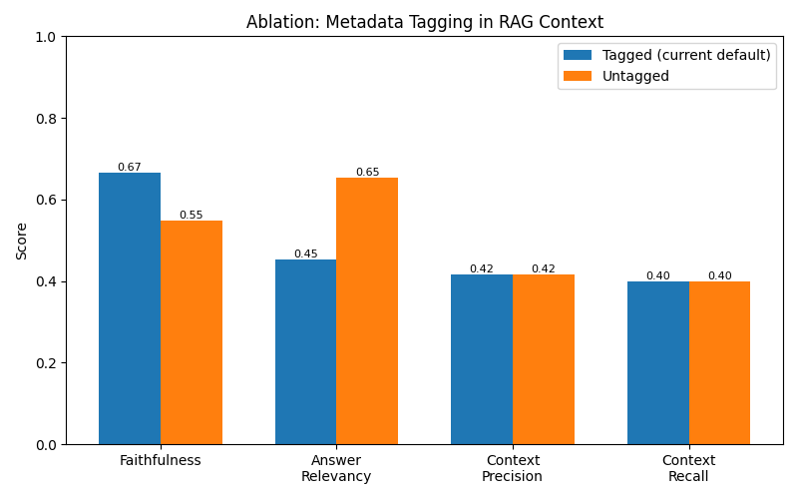
Figure 4.15
Figure 4.15 — Metadata-tagging ablation: tagged against untagged RAGAS scores across all four metrics. Context precision and recall are identical by construction; faithfulness and answer relevancy move in opposite directions. (Produced by evaluate/ablation_metadata_tagging.py.)

4.6 Deployment
The system was not deployed to production. What exists is a programmatic interface together with a local application layer built to make the components usable and demonstrable.
The ask() function in rag/pipeline.py accepts a question and optional conversation history, and returns the generated answer, the source reviews supporting it with their platform, rating, sentiment and review identifier, a retrieval count, and a flag indicating whether the answer is grounded. A similarity threshold and a two-stage scope guard reject out-of-domain questions and insufficient evidence before generation, and a post-generation check discards any answer produced without retrieved context. This is the form in which the system is used, and it is what the evaluation in Section 4.5.7 exercises.
A local FastAPI service and Streamlit interface expose these components for inspection. This layer is an engineering artefact supporting demonstration and manual checking; it is not a research result and no claim rests on it. Production deployment is identified as future work in Chapter 6.

4.7 Chapter Summary
The sentiment comparison produced a clear ranking, with the fine-tuned transformer highest at 0.8375 macro F1 on clean held-out data and the lexicon baseline lowest at 0.4381 on the shared test set. It also produced two results contradicting the expected ordering: a pretrained transformer 23 points of macro F1 below a linear model, and both off-the-shelf methods failing specifically on the neutral class while performing acceptably on the other two. McNemar’s exact test found nine of ten pairwise differences significant on the diagnostic sample, the exception being Naive Bayes against RoBERTa at p = 0.82.
The diagnostic experiments established where the anomaly comes from. RoBERTa’s macro F1 varies by 23 points across platforms and it outperforms both classical models on the Twitter data resembling its pretraining corpus, while removing the neutral class raises its binary macro F1 to 0.9341, above logistic regression’s 0.9216. VADER’s threshold sweep improved macro F1 by 0.026 at best, so decision-boundary choice accounts for part but not most of its weakness.
Complaint discovery produced 121 raw topics consolidated into 24 well-separated categories at 0.2831 centroid separation. Applied to held-out data the taxonomy used 21 of them, achieved 0.6334 mean within-category coherence, and left 27.6% of reviews unclassified. Two categories absorbed 55.8% of the sample between them. Three defects were recorded: a catch-all largest category with low internal coherence, a failed language-model naming step leaving a raw topic label in the taxonomy, and no mechanism for rejecting non-complaints, with positive reviews assigned to complaint categories.
Retrieval showed dense embeddings to be 5.9 times faster than TF-IDF at identical Precision@3 of 0.90. On five questions the retrieval-augmented pipeline, evaluated with a hard grounding threshold in place, achieved 0.540 faithfulness and 0.416 context precision, while the standalone baseline scored higher on mean answer relevancy, 0.753 against 0.610, despite having no evidence to be faithful to — an advantage that rests substantially on a single anomalous score in a set of five and is smaller in consistency terms, since the baseline’s per-question relevancy spans 0.99 against the pipeline’s 0.38. One question in this sample went unanswered, but tracing it back showed the grounding threshold wasn’t actually responsible: the scope guard rejected it before retrieval ran, a false positive rather than the threshold correctly declining insufficient evidence. A separate, executed ablation on metadata tagging (Section 4.5.8) found a genuine trade-off rather than a clean win — tagging lifted faithfulness by 0.118 and cost 0.202 on answer relevancy, with one directly observed case of a platform hallucination it prevented.
Chapter 5 interprets these results against the four research questions and the literature reviewed in Chapter 2.

Chapter 5 — Discussion
Chapter 4 reported what happened. This chapter argues about what it means. Its purpose is to explain why the results took the form they did, to compare them with the literature reviewed in Chapter 2, to judge both the methods and the study itself critically, and to establish how far each research objective was met.
The chapter is organised around the results rather than the pipeline. Section 5.1 interprets the sentiment findings, including the two that contradict expectation. Section 5.2 interprets the taxonomy results. Section 5.3 interprets the retrieval and generation results. Section 5.4 compares the findings with existing research and states what is novel. Section 5.5 examines computational cost and deployment trade-offs. Section 5.6 evaluates the study critically, including its limitations. Section 5.7 assesses each objective and research question in turn. Section 5.8 draws out the practical implications, and Section 5.9 summarises.

5.1 Sentiment Classification

5.1.1 Why the pretrained transformer lost
The headline anomaly is that RoBERTa scored 0.5694 macro F1 against logistic regression’s 0.8033. Taken at face value this appears to contradict a well-established finding. It does not, and the diagnostic evidence explains why.
One qualification belongs at the outset, because it narrows the claim. McNemar testing shows the gap to logistic regression is statistically robust at p = 2.6 × 10⁻⁴, but the gap to Naive Bayes is not: on the 675 reviews where those two disagree, each is correct on almost exactly half, giving p = 0.82. This does not establish that the two models are equivalent — a non-significant result cannot demonstrate equality — but the available paired evidence does not support ranking either above the other. The defensible statement is therefore that the pretrained transformer underperformed the stronger classical model, not that it underperformed classical machine learning as a family. That distinction only became visible because the comparison was tested rather than read off a table.
The failure is confined to one class. RoBERTa’s per-class F1 is 0.743 for negative and 0.740 for positive, both respectable, against 0.225 for neutral. VADER shows the same shape more extremely, at 0.086 on neutral. The confusion matrices locate the error precisely: 85.7% of genuinely neutral reviews are pushed to one of the two poles, 36.2% negative and 49.5% positive. RoBERTa is not weak; it is behaving as a binary classifier confronted with a three-class task.
Separating precision from recall sharpens the diagnosis further. RoBERTa’s neutral precision is 0.522 while its neutral recall is 0.143; VADER’s are 0.377 and 0.048. Precision is moderate in both cases, recall is near zero. Neither model is systematically mistaken about what neutral text looks like — when either does assign the label it is right around half the time. What they fail to do is assign it at all. A recall failure with intact precision is the signature of a decision boundary that never reaches the middle class, which is exactly what would be expected if the model’s internal notion of neutral does not correspond to the one being tested.
Two experiments confirm this rather than merely asserting it. Removing the neutral class and forcing a binary decision raises RoBERTa’s macro F1 from 0.6669 to 0.9341, above logistic regression’s 0.9216. The expected ordering is restored the moment the offending class is removed, which would not happen if the model were generally inferior. And the per-platform breakdown shows RoBERTa’s neutral F1 at 0.713 on Twitter Airline against 0.198 on Yelp. The same model handles the same class competently on one platform and fails on another.
The explanation follows from what the model is. twitter-roberta-base-sentiment-latest was pretrained on tweets and fine-tuned for a three-class scheme in which neutral means a human judged a post to express no clear sentiment (Barbieri et al., 2020). The label it learned and the label it is tested against here are different constructs. On Amazon and Yelp, neutral means a three-star rating, which is a compound judgement often containing both praise and complaint. A model trained to recognise affectively flat text will not recognise a mixed three-star review as neutral, because such a review is not affectively flat — it is affectively contradictory.
The qualitative error analysis in Section 4.5.4 shows what this looks like in practice. Half of the true-neutral reviews in the diagnostic sample were assigned a polar label by RoBERTa while the fine-tuned model handled them correctly, and inspection of those cases shows they are not uninformative texts but texts carrying explicit praise and explicit criticism together — “the tea is very good however the bags are fragile”, “only curls came out pretty though”. A three-star rating encodes a net judgement across both clauses. A model whose neutral class means no clear sentiment has no representation for a review expressing two strong sentiments at once, and must therefore choose a pole.
The evidence supports this interpretation rather than proving it. A design that directly established causation would require re-testing the same checkpoint against human-annotated neutral labels on Amazon and Yelp prose, which was not done. What can be said is that four independent observations — the recall-specific failure, the platform-conditional reversal, the recovery under binary evaluation, and the character of the individual errors — are jointly consistent with label mismatch and difficult to explain by general model inferiority.
Its practical implication is direct: an off-the-shelf sentiment model is only as transferable as its label definition, and no accuracy figure quoted from a benchmark can tell a practitioner whether that definition matches their data.

5.1.2 The ranking reverses by platform
The per-platform evidence is stronger than a diagnosis of one anomaly. On Twitter Airline, RoBERTa achieves 0.7853 macro F1 against logistic regression’s 0.6434 and Naive Bayes’s 0.4838 — the transformer wins decisively. On Yelp the ordering inverts, with RoBERTa at 0.5544 against logistic regression’s 0.7948.
Naive Bayes shows the mirror image, scoring 0.7952 on Amazon and 0.4838 on Twitter. Two models therefore swap places entirely depending on which platform is used to judge them.
No single ranking of these methods is correct. Which method is best depends on the relationship between the pretraining or training domain and the target domain, and a study conducted on one platform would have concluded confidently and incorrectly in either direction. This is the most substantive finding of the chapter for RQ1, and it exists only because the comparison was run across three registers with per-platform reporting — precisely the design the aggregate-metric convention criticised in Section 2.1.3 would have prevented.

5.1.3 Why VADER failed, and why the obvious explanation is wrong
VADER’s macro F1 of 0.4381 against an accuracy of 0.5142 is the widest gap between those two measures of any model in the study, and the gap is the finding. Uniform random guessing on this balanced three-class task would score approximately 0.333 on both, so VADER is well above chance; what it is not is evenly competent, and accuracy alone would have concealed that.
The intuitive explanation is that its decision thresholds are badly calibrated: the default neutral band of ±0.05 is very narrow, so few texts are ever assigned to neutral. That explanation is testable, and the threshold sweep largely rejects it. Widening the band raises macro F1 from 0.5094 to a maximum of 0.5353 at ±0.25 on the balanced sample, a gain of 0.026, after which macro F1 declines again as the band swallows genuinely polar reviews. Threshold choice accounts for a modest fraction of the gap to the classical models, not most of it.
The larger problem is the lexicon itself. VADER labels 40.4% of genuinely negative reviews as positive, which is not a threshold artefact but a systematic failure of word-level scoring on text containing mixed vocabulary. The error analysis in Section 4.5.4 makes the mechanism concrete: a one-star review reading “Worked well and looked good until keys stopped working after 3 months” receives a compound score of +0.477, because the complaint is carried by a temporal contrast rather than by negative vocabulary, and a two-star review beginning “Very bland” but containing “I am a very clean eater” scores +0.890. These errors sit confidently on the wrong side of the boundary rather than near it, which is precisely why widening the neutral band recovers so little. This is the limitation Section 2.1.2 identified in principle, and the individual cases demonstrate it in practice.
The finding still supports VADER’s role in the study. As a baseline it establishes what rules alone achieve, and the roughly 40-point macro F1 gap to the fine-tuned transformer quantifies the value of learning from data on this corpus — a floor that would be invisible had no untrained method been included.

5.1.4 Fine-tuning
The fine-tuned model achieved 0.8375 macro F1 on clean held-out data, and its performance is notably stable across platforms: 0.8448 on Amazon, 0.8301 on Yelp and 0.8505 on Twitter. Where the pretrained model varied by 23 points across platforms, the fine-tuned model varies by two.
That stability is the real return on fine-tuning, and it is a different claim from the usual one. The gain over logistic regression on aggregate macro F1 is modest — roughly two points on the shared test set — though McNemar testing on the diagnostic sample confirms a real difference rather than sampling noise at p = 1.7 × 10⁻²¹. The gain in consistency across domains is larger and less often reported. For a practitioner processing feedback from several sources, the second matters more than the first, and a single-domain comparison could not have surfaced it.
The neutral class remains hardest even after fine-tuning, at 0.747 F1 against 0.837 and 0.889 for the other classes. This is consistent with the labelling limitation set out in Section 4.2.4: three-star reviews are genuinely ambiguous, and part of the remaining error is imposed by the labels rather than by any model. No classifier trained on this corpus can exceed the ceiling those labels create.

5.1.5 Why the transformer beat the classical models
Stating that DistilBERT scored higher than Naive Bayes is not an explanation, and the size of the gap deserves accounting for. On the shared test set DistilBERT reached 0.8244 macro F1 against Naive Bayes’s 0.7580 and logistic regression’s 0.8033. Three mechanisms explain the difference, and the per-class evidence indicates which matters most here.
The first is representation of word order and negation. TF-IDF discards sequence entirely, so “not worth the money” and “worth the money, not…” produce identical feature vectors. Self-attention conditions each token on its context, which allows negation scope to be represented (Devlin et al., 2019). Amazon and Yelp reviews frequently contain concessive constructions — “the food was good but the service was appalling” — where the sentiment-bearing clause is not identifiable from unigram counts.
The second is handling of unseen and rare vocabulary. Naive Bayes over TF-IDF treats every term independently and has no representation for words absent from training. DistilBERT’s WordPiece tokeniser decomposes unfamiliar words into known subwords, and its pretrained embeddings place semantically similar terms near one another, so “malfunctioning” and “faulty” contribute similarly even if only one appeared in training.
The third mechanism explains the gap within the classical family and is the most instructive. Naive Bayes trails logistic regression by 4.5 points of macro F1 despite using identical features, because its conditional independence assumption is plainly false for text — “customer” and “service” co-occur constantly. Logistic regression makes no such assumption and learns compensating weights. Most of the distance between Naive Bayes and DistilBERT is therefore not attributable to the transformer architecture at all: roughly two thirds of it is recovered by replacing one linear model with a better-specified linear model.
The per-class evidence indicates where the remaining advantage lies. DistilBERT’s gain over logistic regression is concentrated in the neutral class, 0.747 against 0.718, precisely the case requiring a model to weigh contradictory evidence within a single review — which is what contextual representation supports and bag-of-words does not.
This reading has a practical consequence worth stating. If the gain concentrates on the ambiguous middle class, then for a business interested only in separating satisfied from dissatisfied customers, fine-tuning buys very little: on the binary re-evaluation the two models sit at 0.9533 and 0.9216, a gap of three points for roughly three hours of GPU training and a 257 MB artefact.

5.2 Complaint Taxonomy

5.2.1 What the taxonomy achieved
Consolidation worked at the level it was designed for. The 121 raw topics reduced to 24 categories with a centroid separation of 0.2831, meaning the resulting categories describe distinguishable things. Mean within-category coherence on held-out data was 0.6334, and 21 of the 24 categories were used.
The per-platform discovery decision was also vindicated. Yelp produced 18 topics from 149,838 documents while Amazon produced 69 from 57,931. Pooling would have allowed the larger corpus to dominate the topic space, and the resulting taxonomy would have described Yelp’s concerns while claiming to describe customer feedback generally.

5.2.2 Why Amazon produced 69 topics and the merge kept 24
The asymmetry in raw topic counts is the most informative structural result of this stage, and it is not an artefact of parameter choice — minimum topic size was scaled to each platform’s document count precisely to prevent that.
The cause is the semantic breadth of what is being complained about. Amazon spans electronics, groceries, clothing, tools and cosmetics, and complaints in each are lexically distinct: a failing battery, a stale flavour, a poor fit and a distorted speaker share almost no vocabulary. HDBSCAN, clustering over embeddings, finds dense regions wherever such vocabulary clusters, and Amazon’s product diversity creates many small dense regions. Yelp is semantically narrow by comparison — restaurants, bars and salons, where complaints concentrate on service, waiting, staff conduct and food quality. Many documents describing few underlying concerns produce few large clusters.
The merge to 24 therefore performs different work on each platform. For Amazon it is genuine consolidation, collapsing product-specific complaint vocabularies into transferable categories: separate topics about batteries, screens and connectivity become one category concerning product performance. For Yelp it is closer to relabelling, since 18 topics were already near the target. The compression ratio differs by almost a factor of four, and the taxonomy consequently fits Yelp’s structure better than Amazon’s.
Three implications follow, and all three are visible in the results. First, the catch-all behaviour identified in Section 5.2.3 is a predictable consequence rather than a surprise: “Product Performance Failures” absorbs 28.2% of held-out reviews because it is the merged descendant of many distinct Amazon topics that had little in common beyond being product faults. Second, imposing a single target count across platforms of different intrinsic granularity is questionable — a count derived per platform, or a hierarchical taxonomy with Amazon categories nested more deeply, would fit the data better. Third, the reduction from 121 to 24 discarded distinctions a business would care about: knowing that complaints concern battery life specifically is more actionable than knowing they concern product performance generally.
The practical reading is that the level of aggregation should follow the decision the taxonomy supports. For executive reporting, 24 categories is appropriate. For a product team investigating a specific failure it is too coarse, and the 69 Amazon topics discarded in the merge were closer to what such a team needs.

5.2.3 Where it failed, and why
Three defects are more informative than the headline figures, and none is softened here.
First, 27.6% of held-out reviews fell below the confidence threshold and were left unclassified. This is a coverage failure, though a visible one: the threshold was set precisely so that weak matches would be recorded rather than forced into the nearest category. Had it been removed, those 124 reviews would have been distributed among existing categories and the taxonomy would have appeared to work considerably better than it does. The design decision that produced the unflattering number is the same decision that makes the number trustworthy.
Second, the largest category absorbed 28.2% of the sample while showing among the lowest within-category coherence at 0.3997. The inverse relationship between size and coherence across categories — 0.6763 for an eleven-review category against 0.3997 for a 127-review one — indicates that “Product Performance Failures” functions as a catch-all, accumulating loosely related complaints because no more specific category fits. Taken with the unclassified rate, this describes a taxonomy that is simultaneously too coarse in one region and too sparse elsewhere: two buckets hold 55.8% of the sample while three categories hold one review each. The target of 24 categories was chosen in advance rather than derived from the data, and this result suggests that choice was not optimal.
Third, and most seriously, the taxonomy has no mechanism for rejecting non-complaints. It was constructed from negative reviews only, but the assignment stage was applied to reviews of all sentiments, and the results show positive reviews entering complaint categories: one category received 19 positive reviews and zero negative, and the unclassified group holds 60 positive against 34 negative. The zero-shot classifier scores relative fit among candidate categories; it has no notion of whether a text is a complaint at all. A sentiment filter before assignment would address this directly, and its absence is a design error rather than a limitation of the method — a distinction worth preserving, since it means the finding is correctable rather than fundamental.
A fourth, smaller defect indicates a pipeline reliability issue: one category retained an un-renamed raw BERTopic label (“Spray Bottle, Continuous Spray, Dryer Diffuser, Fit Dryer”), meaning the language-model naming step failed silently on at least one cluster and no validation caught it before the taxonomy was used. That the same category is also the one receiving 19 positive and zero negative reviews suggests the two defects may share a cause: a cluster that resisted naming may have been incoherent to begin with.

5.2.4 The evaluation problem itself
These conclusions rest on unsupervised measures, and their weakness deserves acknowledgement rather than a footnote. Section 2.1.3 reviewed evidence that automated coherence metrics correspond to human judgement more weakly and more variably than their routine use implies (Hoyle et al., 2021; Doogan & Buntine, 2021; Lim & Lauw, 2024), and that they can favour topics humans find obscure.
The approach taken here — several imperfect indicators read together, plus a manual validation sample — follows the direction that critique points in, but does not escape the underlying problem. The coherence figures reported are embedding-based and inherit whatever biases the embedding model carries; the same MiniLM model produced both the clusters and the measure of their quality, which is a circularity worth naming.
This is why the argument in Sections 5.2.2 and 5.2.3 rests where it does. The strongest evidence against the taxonomy is not the coherence values but the structural observations: the unclassified rate, the size distribution, the sentiment breakdown and the failed naming step are all directly countable and depend on no contested metric. Had this study reported only mean coherence of 0.6334, it would have described a working taxonomy. The multi-indicator design is what prevented that conclusion, and this is the clearest instance in the dissertation of an evaluation choice changing a finding.

5.3 Retrieval and Generation

5.3.1 Retrieval
Dense retrieval was 5.9 times faster than TF-IDF at identical Precision@3 of 0.90. The honest reading is narrower than it might appear. On these 30 queries the embedding retriever does not find relevant reviews more often; it finds them faster. The similarity scores cannot support a quality claim either, since cosine similarity over dense and sparse vectors measure different quantities.
The result is nonetheless useful, because latency determines whether interactive question answering is viable. The case for dense retrieval here is architectural rather than a claim about accuracy, and stating it that way is more defensible than asserting a quality advantage the data does not show. With 30 queries, a modest genuine difference in precision could also have passed undetected, so the equality of Precision@3 should be read as “no difference demonstrated” rather than “no difference exists”.

5.3.2 The relevancy comparison, and what the per-question data reveals
On mean answer relevancy the standalone model scored 0.753 against the retrieval-augmented pipeline’s 0.610, and did so in under half the time — 734.0 ms against 1,582.7 ms. On that single metric, retrieval made the system worse. These figures were generated after a hard grounding threshold was added to the retriever (Section 4.5.7); an earlier, un-gated version of the pipeline scored higher on this and every other RAGAS metric, and those earlier figures are superseded rather than reported alongside these.
The per-question breakdown complicates this in both directions, and the honest account requires reporting both.
The standalone model’s per-question relevancy is 0.988, 0.000, 0.961, 0.964 and 0.853. It therefore wins on four of the five questions, several by a wide margin. Its mean is dragged down to 0.753 by a single complete failure on the delivery question, where it scored zero. Excluding that one score would place it near 0.941. The unconstrained model is genuinely more responsive on most questions, and reporting only the means would understate that.
But the same data shows the two systems failing differently. The pipeline’s four scored questions span 0.437 to 0.819, a range of 0.38; the baseline’s spans 0.000 to 0.988, a range of 0.99. The baseline has the higher ceiling and the lower floor. On the one question where it collapsed entirely, the grounded pipeline scored 0.740 — its second-highest recorded score. The pipeline’s own range widened considerably relative to the earlier, un-gated run (where it spanned only 0.17). Part of that is genuine: relevancy now tracks retrieval quality more visibly than before, and the battery-life question’s weak, off-target retrieval produced its lowest scored answer. The customer-service question’s low score (0.437) has a different, less interesting cause — the pipeline never actually answered it, for reasons unpacked in Section 5.3.3 — so it shouldn’t be read as another instance of the same pattern.
Two conclusions follow, and neither is the simple one. First, the mean comparison favouring the baseline is real but rests on a distribution the mean does not describe: a practitioner choosing between these systems is choosing between higher average responsiveness with occasional total failure, and lower average responsiveness that now varies with how well retrieval performed on that specific question. Second, five questions is far too few to establish which pattern generalises. One anomalous score in a set of five moves the baseline’s headline by nearly two tenths, which is itself an argument about sample size rather than about the systems.
What retrieval demonstrably provides is measurable grounding. Faithfulness of 0.540 indicates that a majority of claims in the pipeline’s answers follow from the retrieved evidence, and the metric is simply undefined for the baseline, since there is no context for an answer to be faithful to. That absence is the finding, not a gap in the evaluation: the baseline’s fluent answers rest on nothing checkable, and its relevancy advantage is earned precisely by not being constrained to evidence. A study reporting only answer relevancy would have concluded that retrieval augmentation degrades performance, which is the concrete demonstration of why Section 2.2.3 argued for four metrics rather than one.
Self-enhancement bias cannot explain the relevancy result away either. Because the same model generates and judges, bias would inflate the pipeline’s scores rather than the baseline’s, so the direction of that threat runs against the observed result rather than producing it.

5.3.3 Retrieval, generation, and a guard that misfired — three components, three different verdicts
The component-level metrics isolate where the pipeline underperforms, and the answer is not where prompt-engineering attention usually goes. It also isn’t as simple a story as “retrieval is weak” — one part of this system needs a genuinely different fix, and it’s important not to lump it in with the rest.
Context precision averages 0.416 across the five questions (Figure 4.14 and Table 4.16), falling to zero on two of them — the airline question and the customer-service question. These two zeros look the same in the table but come from different places, and treating them as one finding would be a mistake. On the airline question, retrieval genuinely happened and genuinely struggled: two thin, largely uninformative reviews cleared the threshold, and faithfulness fell with them, to 0.400, rather than staying artificially high the way it did in an earlier, un-gated version of this pipeline, where a comparable zero-precision question still produced an answer scored 0.917 on faithfulness. That earlier result described a system being faithful to evidence its own retrieval had judged irrelevant — generating honestly from what it was given, while what it was given wasn’t the best available. The grounding threshold closes exactly that gap on the airline question, and the mechanism appears to be doing what it was designed to do there.
The customer-service question is a different animal entirely, and pinning it on the threshold would credit the wrong part of the system. Retrieval was never attempted for this question. The pipeline’s scope guard — the two-stage check that runs before retrieval, meant to catch questions about weather or sports or coding rather than customer complaints — rejected “What customer service issues appear most often?” as out of scope, which it plainly isn’t. The returned text matches the scope guard’s fixed message exactly, not the grounding threshold’s, and the same false rejection happened again, identically, in both conditions of the metadata-tagging ablation reported in Section 4.5.8 — three separate runs, one consistent misfire on one specific question. That’s a real finding about the scope classifier’s precision, not a demonstration of the grounding threshold succeeding, and Chapter 4’s account was corrected to reflect that once the pattern became clear across repeated runs.
Context recall is now 0.000 on three of five questions and 1.000 on the remaining two, and the three zero cases have three different causes that shouldn’t be collapsed into one story. On “Summarise the major customer complaints” it repeats the earlier finding: the only open-ended question in the set, with no specific topic to retrieve against, so a similarity-based retriever has nothing to match on — a structural limitation of dense retrieval rather than a tuning failure. On the airline question it reflects genuinely thin retrieval, with only two reviews clearing the threshold and neither covering the reference answer’s specific topics (delays, cancellations, lost luggage). On the customer-service question it is the mechanical consequence of the scope guard’s false rejection — there is no context for a question the pipeline never tried to answer.
This is exactly the diagnostic that Yu et al. (2024) argue aggregate RAG scores cannot provide, and it turns out to matter twice over in this evaluation: once for separating grounded-but-mediocre answers from confident hallucinations, and again for separating a retrieval weakness from a scope-classification bug that happens to look similar in the numbers. Had this evaluation reported a single composite score, the natural response would have been to revise the prompt — the actual diagnosis is narrower and more specific: retrieval quality needs work on thinly-covered questions, and the scope guard needs a precision fix that has nothing to do with retrieval at all. The metadata-tagging component of the planned ablation suite has since been executed and is reported in Section 4.5.8; the remaining conditions (retrieval depth, retriever type, prompt version), described in Section 3.6.6, were not, so those two diagnoses remain a mix of measured and argued evidence rather than fully settled.

5.3.4 What the generation results cannot establish
The generation evaluation is the weakest part of this study, and its limits should be stated plainly rather than hedged.
Five questions is too few. Per-question faithfulness ranged from 0.000 to 1.000; context precision from 0.000 to 1.000, zero on two of five questions; context recall was 0.000 on three of five and 1.000 on the other two. With that variance and that sample, the specific values should not be quoted as measurements of system quality, and no confidence interval is reported because none would be meaningful. What the evidence supports is the qualitative finding — that relevancy and faithfulness diverge, that grounding is measurable for one system and undefined for the other, that retrieval rather than generation is the weaker component on the questions retrieval actually attempts, and that a false rejection by the scope guard can look, in the aggregate numbers, indistinguishable from a deliberate grounding refusal even though the two mean very different things for how much to trust the system — not any precise figure.
The judge model is the second constraint, and this run produced a direct instance of the risk rather than only a theoretical one: the RAGAS judge raised an OutputParserException while scoring the airline question’s answer relevancy, returning unstructured prose instead of the expected output, so that score is missing rather than measured and the relevancy mean is computed over four questions, not five. Using the generating model as evaluator is a known threat to validity, catalogued in the survey literature reviewed in Section 2.1.2 (Gu et al., 2024; Li et al., 2024). It was accepted because free-tier rate limits made an independent judge impractical within the project’s resources, and it bounds confidence in the RQ2 and RQ4 conclusions.

5.4 Comparison with Existing Research

5.4.1 Where the findings agree
The overall ordering of methods matches the literature. Fine-tuned transformers performed best, classical models next, lexicon methods worst — consistent with the comparative studies on Amazon review data reviewed in Section 2.1.2. BERTopic produced usable topics from short informal text where LDA is documented to struggle, consistent with Turan et al. (2024) and Mishra (2026).

5.4.2 Benchmarking against published figures
Comparing absolute numbers with published work requires care, because task definition differs more than model choice does. Table 5.1 sets this study’s results beside reported figures, with the differences in task noted.
Table 5.1 — This study against published benchmarks
Source | Task | Dataset | Best reported | This study
Areshey & Mathkour (2024) | Binary polarity | Yelp | Five-model transformer comparison | —
This study, binary re-evaluation | Binary, neutral removed | Three platforms | — | DistilBERT macro F1 0.9533, RoBERTa 0.9341
Turan et al. (2024) | Topic quality | Amazon | BERTopic most interpretable of three | Centroid separation 0.2831
Two comparisons are worth drawing out, and a third had to be abandoned.
The apparent gap against published Yelp benchmarks is almost entirely a task difference, not a modelling shortfall, and this study can demonstrate that using its own data rather than by quoting someone else’s. Binary-polarity studies such as Areshey and Mathkour (2024) classify two classes with the ambiguous middle removed; this study reports three. Removing the neutral class here — the same operation, on the same corpus, in the binary re-evaluation of Section 4.5.4 — raises DistilBERT from 0.8375 to 0.9533 macro F1 and RoBERTa from 0.6669 to 0.9341. That internal comparison is the more trustworthy one, since both figures come from the same models on the same data with only the task definition changed, and no cross-study confound is involved. The correction it supports is worth stating plainly: adding a third class costs this pipeline roughly twelve points of macro F1, and a substantial part of the headline performance reported in the binary literature depends on having excluded the hardest cases rather than on modelling superiority.
A three-class comparison would have been the more informative one, since it holds the task definition fixed rather than varying it. It is not offered here. Reported three-class figures in the financial-sentiment literature vary with the annotation-agreement threshold applied to the underlying corpus, and a headline accuracy quoted without that threshold is not a comparable quantity — a figure drawn from one agreement level can differ from another by several points on the same model and the same dataset. Rather than quote a number whose provenance could not be established, the comparison is left open. What can be said without a benchmark is bounded but not empty: DistilBERT’s 84.37% accuracy and 0.8375 macro F1 were obtained on three classes, across three registers, with rating-derived rather than expert-assigned labels, and Section 4.2.4 established that the labelling rule itself places a ceiling on what any model in this study could reach. Those conditions are harder than most published single-domain three-class settings, which is the relevant point for judging whether the pipeline underperforms.
The taxonomy stage cannot be benchmarked at all, and saying so is more honest than manufacturing a comparison. This study’s within-category coherence of 0.6334 is computed as embedding similarity to a category centroid, not as C_v or NPMI, so it is not commensurable with the coherence figures that topic-modelling papers report even when those papers work on similar data. Section 2.1.3 gives the deeper reason for leaving it alone: the coherence-validity literature casts doubt on whether these measures track interpretability at all, so a favourable comparison would be as uninformative as an unfavourable one. What the reviewed literature does support is the weaker claim made in Section 2.1.2 — that BERTopic’s advantage lies in cluster structure and in handling short informal text rather than in coherence as conventionally measured, and that configuration choices within the BERTopic architecture can move coherence more than the choice between algorithm families does (Ogunleye et al., 2023). The taxonomy results in this study are therefore judged against the structural evidence set out in Section 5.2.3 — unclassified rate, size distribution, sentiment composition — and not against an external coherence figure.

5.4.3 Where they diverge, and why
The divergence is instructive rather than contradictory. Published comparisons report transformers outperforming classical models; this study finds a pretrained transformer 23 points of macro F1 below a linear model in aggregate. The difference is explained by experimental design, not by disagreement about the underlying methods. Those studies evaluate within a single domain, usually Amazon reviews, where a domain-matched or domain-neutral model is tested on data resembling its pretraining distribution. This study tests a Twitter-pretrained model on Amazon and Yelp prose and measures what happens.
The cross-domain sentiment literature reviewed in Section 2.1.2 treats exactly this problem as serious enough to warrant purpose-built architecture — feature projection, adversarial domain adaptation, multi-source attention. That literature and the applied comparison literature rarely meet, which is the gap this study occupies. It takes the applied position of using off-the-shelf models, but tests the transferability assumption that applied comparisons leave implicit, and finds it does not hold. The result is therefore evidence for the cross-domain literature’s premise, arrived at from the applied literature’s method.
Similarly, the relevancy comparison is not a contradiction of the RAG literature but an instance of the evaluation problem that literature has begun to identify. Yu et al. (2024) argue that aggregate RAG scores cannot diagnose whether failure originates in retrieval or generation; Section 5.3.3 is a worked example of component-level metrics doing exactly the diagnostic work they call for — and, in the scope-guard case, of those metrics still not being sufficient on their own, since three of the four had to be read alongside the actual returned text before the cause could be identified correctly.
The metadata-tagging ablation diverges from expectation in a smaller but more specific way. Section 2.2.3 noted that applied RAG work tends to adopt prompt constraints and metadata injection together and justify them by reasoning; the implicit expectation in that literature is that grounding aids are close to free. The measured result here (Figure 4.15) is that tagging improves faithfulness by 0.118 while costing 0.202 on answer relevancy — a trade-off rather than a free improvement. The likely mechanism is mundane: tagged answers spend more of their length on attribution, and an answer-relevancy judge scores directness. But the finding matters beyond this pipeline, because it suggests that studies reporting only faithfulness for a metadata-augmented system may be reporting the favourable half of a trade. This is a single ablation on five questions and is offered as an observation worth testing at scale, not as an established effect.

5.4.4 What is claimed as a contribution
Four contributions can be claimed without overstatement, and are deliberately stated at MSc level rather than inflated.
The stage-wise cross-domain comparison is the principal one. The literature contains many single-domain comparisons and a separate body of work on domain adaptation, but comparisons of the same off-the-shelf methods across three registers with per-platform and per-class reporting did not appear in the literature reviewed here. The finding that the ranking reverses by platform is a direct product of that design.
The diagnostic method is the second. Rather than reporting an anomalous result and speculating, this study tested the proposed explanation through three independent experiments — binary re-evaluation, per-platform breakdown and threshold sweep — that make the mechanism demonstrable and, in VADER’s case, rule out the intuitive explanation. This is a modest methodological contribution, but a real one, since the reporting conventions criticised in Section 2.1.3 would have concealed the finding entirely. The same habit paid off a second time at the generation stage, where a zero score that looked like the grounding threshold working correctly turned out, on inspection of the actual returned text, to be a scope classifier rejecting a valid question. Both cases make the same methodological point: a number consistent with your design working is not evidence that your design worked.
The third is the executed ablation. Section 2.2.3 observed that applied RAG work endorses ablation more often than it performs one, and this study performs one — isolating metadata tagging, holding retrieval constant, and measuring what the decision contributes. That it returned a trade-off rather than the expected confirmation is the useful part: it converts a design justification into a measured effect with a cost attached, and supplies one directly observed platform hallucination that tagging prevented.
The fourth is negative and correspondingly honest: the demonstration that a complaint taxonomy built from negative reviews will assign positive reviews to complaint categories unless a filter intervenes, and that a multi-indicator evaluation catches this where a single coherence score does not. No novel algorithm is proposed, and none is claimed.

5.5 Computational Cost and Deployment Trade-offs
Accuracy is one axis of method selection and rarely the binding one in practice. This section sets out what each stage costs and what that implies for deployment, since a method that wins on macro F1 but cannot be served within budget is not the method a practitioner should choose.

5.5.1 Cost of the sentiment stage
Table 5.2 — Cost profile of the five sentiment classifiers
Model | Parameters | Training cost | Artefact size | Hardware to serve | Interpretability
VADER | None (lexicon) | None | ~1 MB lexicon | CPU, trivial | High — rules inspectable
Naive Bayes | ~vocabulary size | Seconds, CPU | 76 MB (with vectoriser) | CPU | Moderate — feature log-probabilities
Logistic Regression | ~vocabulary size | Minutes, CPU | shared with above | CPU | Moderate — signed coefficients
RoBERTa (pretrained) | ~125M | None (used as-is) | ~500 MB | GPU preferred | Low
DistilBERT (fine-tuned) | ~66M | 10,545 s (2 h 56 m), GPU | 257 MB | CPU viable, GPU preferred | Low
The distillation choice is vindicated on these figures. DistilBERT carries roughly 40% fewer parameters than BERT-base while retaining about 97% of its performance on GLUE and running around 60% faster (Sanh et al., 2019), which is what made fine-tuning feasible on freely available hardware within this project. Selecting BERT or RoBERTa for fine-tuning would have roughly doubled both training time and served model size for a gain the evidence does not suggest would have been large.
The more interesting comparison is between logistic regression and DistilBERT. The fine-tuned model gains around two points of macro F1 on the shared test set for a 257 MB artefact, nearly three hours of GPU training and materially higher inference cost. Logistic regression trains in minutes on a CPU and serves from a small sparse model. For a system processing a few thousand reviews daily on modest infrastructure the classical model is the defensible engineering choice — and Section 5.1.5 showed the transformer’s advantage concentrates on the ambiguous neutral class that many applications do not need resolved.
The counter-argument is Section 5.1.4’s stability finding. Logistic regression’s macro F1 spans 0.6434 to 0.7948 across the three platforms; DistilBERT’s spans 0.8301 to 0.8505. An organisation processing a single feedback stream can reasonably prefer the linear model; one processing several cannot, and the cost calculation changes accordingly.
Two caveats bound this analysis. Per-review inference latency was not measured for the five models, so the comparison rests on parameter counts and published throughput figures rather than timings from this system. That is a gap, and adding a timing pass to the diagnostics script would close it cheaply. And interpretability is assessed qualitatively: no formal explanation method such as SHAP or LIME was applied, so the claim that classical models are more interpretable rests on the transparency of their parameters rather than on a measured comparison of explanation quality.

5.5.2 Cost of retrieval and generation
The retrieval and generation stages carry costs of a different kind, dominated by storage and network latency rather than training.
Indexing 642,692 reviews at 384 dimensions produces a raw embedding matrix of approximately 0.99 GB, and the artefacts on disk are substantial. Storage scales linearly with corpus size, so a corpus ten times larger would need roughly 10 GB before any compression. This is the practical argument for the small embedding model: moving to a 768-dimensional model such as all-mpnet-base-v2 would double the index footprint and roughly double query time for a retrieval quality gain that Section 5.3.1 suggests would be difficult to demonstrate, given that Precision@3 was already identical between dense and sparse retrieval.
At query time the dominant cost is generation, not retrieval. Retrieval takes 21.71 ms, while the end-to-end retrieval-augmented answer takes 1,582.7 ms against the standalone model’s 734.0 ms. Retrieval accounts for roughly one per cent of the total; the additional 848.7 ms comes from the larger prompt the model must process once retrieved reviews are inserted and the extra call made by the history-aware retriever. Whichever guard rejects a question first — the scope guard or, further downstream, the grounding threshold — that cost is avoided entirely, since both return a fixed message immediately rather than reaching generation; the one rejection in this sample completed in 112 ms for exactly that reason. The cost of grounding is paid in generation tokens rather than in search, except on the questions the pipeline never answers.
That has a direct implication for deployment. Grounding roughly doubles response time on questions it answers, and increases token consumption per query, which on a metered API translates into a proportional cost increase. Whether that is worth paying depends on the use case: for exploratory analysis where a wrong answer is noticed quickly it may not be; for reporting that informs a decision, the verifiability it buys is difficult to obtain any other way.

5.5.3 Deployment implications
Taken together the cost profile suggests a tiered architecture rather than a single model choice. High-volume routine classification is well served by logistic regression on CPU where feedback arrives from one register, and by the fine-tuned transformer where it arrives from several, since cross-platform stability is what that model actually buys. The retrieval-augmented component is inherently interactive and low-volume, so its latency is tolerable, but its per-query cost places it in an analyst-facing tool rather than in an automated pipeline processing every incoming review.
None of this was tested in deployment, which limits how firmly it can be asserted. The figures above are measured costs and published throughput claims, not observations of a served system under load.

5.6 Critical Evaluation

5.6.1 Strengths
The comparison rests on a large, genuinely multi-domain corpus with a stratified, seeded split, and the sentiment stage is evaluated on 128,539 held-out reviews. Reporting is at class and platform level throughout, which is what made the central finding visible. Baselines are present at every stage where one was possible: a lexicon floor for sentiment, TF-IDF for retrieval, and an unconstrained model for generation. Differences between models are tested for statistical significance rather than asserted from a ranking, which identified one pair that cannot be separated and prevented an overclaim. Where results were unfavourable or contradicted expectation — the taxonomy’s coverage, the relevancy comparison, the mediocre context precision — they are reported and explained rather than omitted.

5.6.2 Limitations
Several limitations bound what this study can claim, and they are of unequal severity.
The most serious concerns experimental control. The fine-tuned model was trained against a separately generated corpus version, so a portion of the shared sentiment test set overlaps data it had seen, and the exact extent cannot now be recovered because the earlier corpus version was not retained. The clean figure from the model’s own held-out partition is reported as definitive, but the consequence is that the five-model comparison is not as controlled as the design intended. A single canonical split, generated once and reused by every model, would remove the objection entirely and is the first correction Chapter 6 recommends.
Label quality bounds everything downstream. Deriving sentiment from star ratings means a four-star review containing a complaint is labelled positive, and the neutral class carries different meanings across platforms — a three-star rating on two, a human judgement of affective flatness on the third. Some part of every model’s neutral-class difficulty is attributable to the labels rather than to the models, and this study cannot separate the two.
The generation evaluation rests on five questions with a self-grading judge, as discussed in Section 5.3.4. This is the weakest evidence in the study and the conclusions drawn from it are correspondingly qualified.
Complaint categorisation has no ground truth, so no accuracy can be reported for it, and the unsupervised measures used instead are contested in the literature and partly circular, since the embedding model that formed the clusters also measures their quality.
Finally, three of the four planned ablation conditions — varying retrieval depth, retriever type and prompt design — were not executed within the project timeframe because of API rate limiting, and their absence means the contribution of those individual design decisions is argued rather than measured. Metadata tagging is the exception: it was carved out into its own script and actually run (Section 4.5.8), so that one piece of the intended suite converted from argument to evidence, while the rest did not. Given that Section 5.3.3 identifies retrieval quality as a genuine weak point on the questions it actually attempts, the unexecuted retrieval-depth and reranking conditions remain the most consequential of the missing experiments.

5.6.3 Critical evaluation of the methods
Judged on outcomes, some choices held up better than others.
BERTopic was the right choice for the discovery stage, and the per-platform decision was correct. The fixed target of 24 categories was not: the size distribution and unclassified rate both indicate the number should have been derived from the data, and the platform asymmetry in Section 5.2.2 suggests a hierarchical structure would have served better than a flat one.
The zero-shot assignment approach is sound in principle and avoids needing labelled examples for newly discovered categories, but applying it without a preceding sentiment filter was an error that the sentiment-by-category results expose plainly.
The prompt-level grounding constraints and metadata tagging were, for a while, defended only by reasoning — faithfulness reached 0.540 with the hard similarity threshold in place, and on the airline question, where retrieval itself was genuinely weak, it fell rather than staying artificially high, which is consistent with the design working, but consistency isn’t proof. Since then, the metadata-tagging piece specifically has been tested directly (Section 4.5.8), and the result is more interesting than a simple validation: tagging lifted faithfulness by 0.118 and produced one directly observed avoided platform hallucination, but cost 0.202 on answer relevancy. That’s a real trade-off, not a clean win, and it’s worth more than the design reasoning alone could have offered. What it doesn’t resolve is the prompt’s grounding rules and the threshold’s separate contributions — those two mechanisms remain untested against each other, and the honest position is that only one of the three design decisions this paragraph is about has actually been measured.
Using a free-tier hosted model was a resource-driven decision whose consequences propagated further than anticipated. It constrained the evaluation to five questions, prevented an independent judge, and left most of the planned ablation suite unrun — one condition out of four made it through. In retrospect, budgeting a small amount for API access would have strengthened the evaluation more than any modelling change available within the same effort.

5.7 Assessment Against Objectives and Research Questions
RQ1 — How does sentiment classification performance differ across method families on multi-domain feedback? Answered. Fine-tuned DistilBERT performed best at 0.8375 macro F1 on clean held-out data, followed by logistic regression at 0.8033, Naive Bayes at 0.7580, pretrained RoBERTa at 0.5694 and VADER at 0.4381. Significance testing on the diagnostic sample supports most of this ordering but not all of it: nine of ten pairwise differences hold at p < 0.05, while Naive Bayes and RoBERTa cannot be separated at p = 0.82. The substantive answer is that the ordering is not stable in a second and more important sense — on Twitter Airline the pretrained transformer outperforms both classical models, so the ranking depends on the match between pretraining and target domain. Fine-tuning’s clearest benefit is cross-domain consistency, not peak aggregate accuracy.
RQ2 — How effectively does RAG improve complaint exploration compared with a standalone LLM? Partially answered, and the qualification matters. RAG achieved 0.540 faithfulness with source attribution, evaluated with a pipeline that includes a hard grounding threshold refusing to answer when retrieval finds nothing relevant, while the baseline scored higher on mean answer relevancy at 0.753 against 0.610 and answered in under half the time. The improvement RAG provides is verifiability, not responsiveness. The per-question data adds a second finding: the baseline’s advantage rests on four strong scores and one complete failure, giving it both the higher ceiling and the lower floor, while the grounded pipeline’s four scored questions vary less, though considerably more than in an earlier, un-gated run — the fifth question was never answered at all, but a false rejection by the scope guard, not the grounding threshold, is why, a distinction Section 5.3.3 works through in full. The metadata-tagging ablation (Section 4.5.8) adds a measured, if mixed, result to this picture: tagging helps faithfulness and costs relevancy, rather than simply validating the design. With five questions, a self-grading judge whose output failed to parse on one of them, and a context precision of 0.416, this conclusion is directional rather than precise.
RQ3 — Can BERTopic produce a coherent cross-domain complaint taxonomy? Answered with substantial qualification. It produced 24 well-separated categories from 121 raw topics at 0.2831 centroid separation, with 0.6334 mean within-category coherence on held-out data. But 27.6% of reviews were left unclassified, one category absorbed 28.2% of the sample with among the lowest internal coherence recorded, and the taxonomy cannot distinguish complaints from non-complaints. The answer is that BERTopic can produce a usable cross-domain taxonomy, but not without a consolidation stage, a data-driven rather than fixed category count, and a sentiment filter at assignment.
RQ4 — To what extent are insights traceable to and verifiable against source reviews? Answered. Every generated answer returns the identifiers of the reviews retrieved to produce it, and faithfulness of 0.540 quantifies how far answers follow from that evidence when the pipeline actually answers. Traceability is demonstrated as an architectural property rather than asserted. It’s worth being precise about what the one unanswered question in this sample does and doesn’t add to that claim: it shows the pipeline can decline to answer rather than fabricate — a real safety property — but the specific decline observed here came from the scope guard misjudging an in-scope question, not from the grounding threshold correctly detecting insufficient evidence, so it demonstrates the general principle rather than the specific mechanism this research question is really asking about. The figures mark a clearer limit on the questions the pipeline did answer: at 0.540 faithfulness, roughly half of claims were not fully supported by the retrieved context, and at 0.416 context precision the evidence retrieved was frequently not the best available. Traceability being available is therefore not the same as every statement being grounded. Whether that traceability is useful in practice is not established and would require the user study identified as future work.
Objectives 1 to 5 were met. Objective 6 was met partially: stage-appropriate metrics and baseline comparisons were delivered at every stage, and one of the four planned ablation conditions — metadata tagging — was implemented and executed (Section 4.5.8); the remaining three (retrieval depth, retriever type, prompt version) were specified but never built. Objective 7 is delivered by this chapter and the next.

5.8 Practical Implications
The preceding sections judged the methods. This one asks what an organisation could do with the results, since a comparative study that never reaches that question leaves its own motivation unanswered.
On method selection (Objective 3, RQ1). The clearest practical finding is that benchmark scores do not transfer. A practitioner choosing a sentiment model on published accuracy would likely select a pretrained transformer and, on Yelp or Amazon prose, obtain worse performance than a linear model trained in minutes. The selection rule this study supports is narrower and more useful: check whether the candidate model’s label definition matches your own before considering its reported accuracy, and if feedback arrives from several sources, prefer the model with the smallest variance across them rather than the highest mean.
On the taxonomy (Objective 4, RQ3). The taxonomy is usable for executive-level reporting, where 24 categories at 0.2831 separation give a defensible summary of what customers complain about across platforms. It is not usable as an automated routing or triage mechanism in its current state, and the reason is specific: with 27.6% of reviews unclassified and one category absorbing 28.2%, routing on it would leave a quarter of complaints unhandled and overload a single queue. Two changes would address this — a sentiment filter before assignment, and a category count derived per platform rather than fixed at 24. Section 5.2.2 also implies a hierarchical structure would serve better than a flat one, with broad categories for reporting and the discarded finer topics retained beneath them for investigation.
On the retrieval-augmented component (Objectives 5 and 6, RQ2 and RQ4). Its practical value is not speed or fluency, both of which the standalone model wins on average. It is that every answer arrives with the reviews that produced it, so a claim can be checked in seconds before it informs a decision, and that its worst case is meaningfully better than the baseline’s. That matters most where the cost of acting on a wrong conclusion is high and where the analyst is accountable for the recommendation. Where an analyst is exploring informally and will notice a wrong answer immediately, the standalone model is faster, cheaper and adequate. The faithfulness and context-precision figures also bound the claim: the system supports verification but does not remove the need for it.
On the evaluation approach itself (Objective 6). The most transferable contribution may be methodological. Reporting per-class and per-platform results rather than aggregates, testing the mechanism behind an anomalous result rather than reporting it and moving on, and reading several weak indicators together rather than one headline metric are what turned three apparently disappointing findings into the study’s main results. That practice costs little and applies to any comparative evaluation.

5.9 Chapter Summary
The central finding is that method ranking in customer feedback analysis is conditional on domain. A pretrained transformer that appears clearly inferior on aggregate metrics outperforms both classical models on the platform matching its pretraining distribution, and its apparent weakness resolves into a single-class failure consistent with a mismatch between label definitions. Fine-tuning’s principal value is stability across domains rather than peak accuracy, and the gap between it and a well-specified linear model is smaller than the literature’s framing suggests.
The taxonomy results are more mixed and more critical of the approach taken. Consolidation produced well-separated categories, but coverage was incomplete at 27.6% unclassified, one category behaved as a catch-all, the naming step failed silently on one cluster, and the absence of a sentiment filter allowed positive reviews into complaint categories. The multi-indicator evaluation is what exposed all four; a single coherence score would have described a working system.
The generation results establish the qualitative case for retrieval augmentation — measurable grounding where the baseline offers none, and a higher floor when the baseline fails — while being too small and too self-referentially judged to support precise claims. The component metrics locate the weakness in retrieval rather than generation on the questions retrieval actually attempts, and separately expose a scope classifier rejecting a question it should have passed. The one ablation that was executed measured metadata tagging and returned a trade-off; the three that were not — retrieval depth, retriever type and prompt version — are the ones that would speak most directly to the retrieval weakness this section identifies.
Chapter 6 draws these together, assesses the aim as a whole, and sets out the future work each limitation implies.

Chapter 6 — Conclusion and Future Work
Chapter 5 interpreted the results one stage at a time. This chapter draws them together. It reviews what was done against what was promised, states what the work contributes and to whom, sets out the limitations honestly along with the future work each one implies, and reflects on the experience of carrying the project out. The intention is to leave a reader clear about both what can be claimed from this dissertation and what cannot.

6.1 Summary of the Dissertation
This dissertation compared, stage by stage, the classical machine learning, transformer-based and retrieval-augmented approaches available at each point in a customer complaint analysis pipeline. The comparison ran on one corpus of 642,692 reviews drawn from Amazon, Yelp and Twitter Airline feedback, using a single evaluation protocol so that differences between methods could not be attributed to differences in data.
The motivation was practical. Method selection in applied feedback analysis is usually made on reputation, supported by benchmark figures from single-domain studies reporting aggregate metrics. This study set out to test whether that basis survives contact with data resembling what an organisation actually holds. It does not, and the way it fails turned out to be more interesting than the finding that it fails.
Objective 1 required a literature review identifying where existing comparisons are absent or restricted to a single domain. Chapter 2 delivered this and located two gaps: the shortage of controlled comparison at each pipeline stage on multi-domain data, and the shortage of verification of what these systems produce. The review also surfaced a body of work questioning whether automated topic coherence metrics measure interpretability at all, which directly shaped the evaluation design in Chapter 3 and, as Section 5.2.4 shows, changed one of the study’s conclusions.
Objective 2 required a methodology and a unified dataset suitable for controlled comparison. CRISP-DM was selected and adapted so that modelling and evaluation execute once per pipeline stage. The corpus was assembled with a documented labelling rule, balanced classes and fixed seeds. This objective was met with one qualification recorded in Section 3.5.3: the fine-tuned model was developed against a separately generated corpus version, so the five-model comparison is less tightly controlled than intended.
Objective 3 required five sentiment classifiers to be implemented, compared and diagnosed. All five were evaluated on a held-out set of 128,539 reviews with per-class, per-platform and confusion-matrix reporting, pairwise significance testing, and three diagnostic experiments that tested the mechanism behind the results contradicting expectation. This objective was fully met and produced the study’s principal finding.
Objective 4 required complaint topics to be discovered per platform and consolidated into a cross-domain taxonomy. BERTopic produced 121 raw topics, merged into 24 categories at a centroid separation of 0.2831. The objective was met, though the evaluation exposed real defects in the result, discussed below.
Objective 5 required a retrieval-augmented question-answering component and a standalone baseline to compare it against. Both were built, with source review identifiers returned on every answer and prompt-level grounding constraints made checkable through metadata tagging. This objective was met.
Objective 6 required stage-appropriate evaluation with baseline comparison. Supervised metrics, unsupervised coherence and coverage measures, and reference-free generation metrics were all applied, and differences between models were tested for statistical significance rather than asserted from a ranking. This objective was met in part. Of the four planned ablation conditions on the retrieval-augmented pipeline, one — metadata tagging — was implemented and executed, and its result is reported in Section 4.5.8; the other three (retrieval depth, retriever type, prompt version) were specified in the design but never built, for the reasons given in Section 3.6.6.
Objective 7 required critical discussion, evaluation against the objectives, and identification of future work. Chapter 5 and this chapter deliver it.
Taken together the objectives fulfil the aim, unevenly. The aim was to establish which approach is justified at which stage and how far the output of each can be trusted. The first half is answered well by the comparative results, the per-platform breakdown and the significance testing. The second half is answered at the classification and taxonomy stages, where class-level reporting and coverage figures quantify what can be trusted, and answered only directionally at the generation stage, where the evidence rests on five questions and a self-assessing judge.

6.2 Research Contributions

6.2.1 Key findings
Five findings carry the study.
The ranking of sentiment methods is conditional on domain, not fixed. Pretrained RoBERTa scored 0.7853 macro F1 on Twitter Airline against 0.5544 on Yelp, and on the Twitter data it outperformed both classical models. Naive Bayes showed the mirror pattern, scoring 0.7952 on Amazon and 0.4838 on Twitter. No single ordering of these methods is correct, and a study conducted on one platform would have concluded confidently in either direction.
An apparently poor result had a specific and testable cause. RoBERTa’s aggregate weakness resolved into a single-class failure: neutral F1 of 0.225 against 0.743 and 0.740 on the other two classes, with precision at 0.522 but recall at 0.143. Removing the neutral class raised its binary macro F1 to 0.9341, above logistic regression’s 0.9216. The evidence is consistent with a mismatch between the model’s learned label definition and the rating-derived scheme it was tested against, though establishing that causally would require a further experiment not carried out here.
Fine-tuning’s principal benefit is stability, not peak accuracy. DistilBERT gained roughly two points of macro F1 over logistic regression on the shared test set, a difference confirmed significant on the diagnostic sample at p = 1.7 × 10⁻²¹, but varied by only two points across platforms where the pretrained model varied by twenty-three. For a single-register feedback stream the linear model is defensible; for several registers it is not.
Retrieval augmentation buys verifiability, and the trade is visible in the distribution rather than the mean. The standalone model reached 0.753 mean answer relevancy against the pipeline’s 0.610, and answered in under half the time. But its per-question scores span 0.000 to 0.988 against the pipeline’s 0.437 to 0.819: it has the higher ceiling and the lower floor, winning four questions of five and failing one completely. Faithfulness of 0.540 is measurable for the pipeline and undefined for the baseline, since there is no context for an ungrounded answer to be faithful to — and, on the one question where retrieval itself was genuinely weak, it fell rather than staying artificially high, which is the grounding threshold behaving as intended.
Component-level metrics located a real weakness in retrieval, and a separate one in scope classification that isn’t about retrieval at all. Context precision averaged 0.416 against faithfulness of 0.540. On the airline question, where context precision fell to 0.000, faithfulness fell with it, to 0.400, rather than remaining artificially high — direct evidence that the grounding threshold suppresses confident answers built on weak evidence instead of masking the weakness. A single composite score would have prompted prompt-engineering; the component metrics point at retrieval instead. But not every zero in this table has that cause: one question was never retrieved for at all, rejected beforehand by the pipeline’s scope guard on a false positive, and tracing that back mattered — crediting it to the grounding threshold would have been a comfortable but wrong story. Section 6.3.1 records it as its own limitation rather than folding it into the retrieval finding.

6.2.2 Academic contributions
The stage-wise cross-domain comparison is the primary contribution. The literature contains many single-domain comparisons and a separate body of work on domain adaptation, but controlled comparison of the same off-the-shelf methods across three registers, reported at class and platform level, did not appear in the literature reviewed here. The finding that the ranking reverses by platform is a direct product of that design, and it supplies applied evidence for a premise the cross-domain adaptation literature assumes.
The diagnostic method is a second, more modest contribution. Rather than reporting an anomalous result and speculating about it, this study tested the proposed explanation through three independent experiments, one of which — the VADER threshold sweep — ruled out the intuitive explanation rather than confirming it. Combined with pairwise significance testing, which identified one model pair that cannot be separated at p = 0.82 and so prevented an overclaim, the approach demonstrates a standard of evidence that costs little and applies to any comparative evaluation.
Third, the study contributes negative results of a kind rarely published. A complaint taxonomy built from negative reviews will assign positive reviews to complaint categories unless a sentiment filter intervenes. A fixed category count imposed across platforms of differing semantic breadth produces a catch-all category alongside a high unclassified rate. Answer relevancy alone will reward exactly the ungrounded behaviour retrieval augmentation exists to prevent. And a mean over five questions can be moved two tenths by a single anomalous score. Each is the kind of finding that aggregate reporting conceals, and each was surfaced by a reporting choice rather than by a modelling one.
No novel algorithm or architecture is proposed, and none is claimed. The contribution is comparative, diagnostic and methodological, which is the appropriate level for this work.

6.2.3 Practical contributions
For practitioners, the study offers a method-selection rule with evidence behind it: check whether a candidate model’s label definition matches your own before considering its reported accuracy, and where feedback arrives from several sources, prefer the model with the smallest variance across them over the one with the highest mean.
It also produces reusable artefacts: a documented preprocessing pipeline over three public datasets, a 24-category cross-platform complaint taxonomy with its coverage limits measured rather than assumed, and an evaluation suite spanning supervised, unsupervised and generation metrics with significance testing, in which every reported figure is written to file by the script that produced it.
The cost analysis in Section 5.5 supports a tiered deployment argument. High-volume routine classification is well served by logistic regression on CPU where feedback comes from one register; the fine-tuned transformer earns its cost where the neutral class matters or feedback spans registers; and the retrieval-augmented component, at roughly two seconds and a metered API call per query, belongs in an analyst-facing tool rather than an automated pipeline processing every incoming review.

6.2.4 Beneficiaries
Customer experience and product teams who currently read samples of feedback by hand gain complaint categories derived from data instead of assumption, together with an honest account of where those categories fail. Applied researchers building similar pipelines gain evidence on which components are fragile and which evaluation choices conceal failure. Practitioners choosing between these methods gain a comparison conducted on data resembling theirs rather than on a benchmark.

6.3 Limitations and Future Research

6.3.1 Limitations and their effect on the findings
The limitations are of unequal severity, and each constrains a specific claim rather than the study as a whole.
Split contamination. The fine-tuned model was trained against a separately generated corpus version, so a portion of the shared sentiment test set overlaps data it had seen. The extent cannot now be quantified, because the earlier corpus version was not retained. The uncontaminated figure from the model’s own held-out partition is reported as definitive throughout, but the five-model comparison is not as controlled as the design intended. This weakens the precision of the DistilBERT comparison specifically; it does not affect the other four models, the per-platform findings, or the diagnostic experiments.
Rating-derived labels. Sentiment labels come from star ratings for two of three platforms, so a four-star review containing a complaint is labelled positive, and “neutral” means a three-star rating on two platforms and a human judgement of affective flatness on the third. Some part of every model’s neutral-class difficulty is attributable to the labels rather than the models, which places a ceiling on absolute performance and makes cross-platform neutral comparisons less clean than they appear. This study cannot separate the two effects.
Generation evidence. Five questions with a self-assessing judge is the weakest evidence in the study, and the judge’s own reliability is part of that weakness: it failed to return a parseable score for one question’s answer relevancy, so that metric is averaged over four questions, not five. Per-question faithfulness ranged from 0.000 to 1.000, context precision from 0.000 to 1.000 (zero on two of five questions), and context recall was 0.000 on three of five questions. The qualitative findings — that relevancy and faithfulness diverge, that grounding is measurable for one system and undefined for the other, and that retrieval is the weaker component among the questions it actually attempts — are supported. The specific values are not measurements that should be quoted as system performance, and no confidence intervals are reported because none would be meaningful at this sample size.
No ground truth for categorisation. Without labelled data no accuracy can be reported for the complaint taxonomy, and the unsupervised measures used instead are contested in the literature and partly circular, since the embedding model that formed the clusters also measures their quality. The structural evidence — the unclassified rate, the size distribution, the sentiment breakdown and the failed naming step — is more reliable than the coherence figures and is what the conclusions rest on.
Mostly unexecuted ablations. One of the four planned ablation conditions — metadata tagging — was executed, and it found a genuine trade-off rather than a clean win: tagging lifted faithfulness by 0.118 and cost 0.202 on answer relevancy, with one directly observed avoided platform hallucination as supporting qualitative evidence (Section 4.5.8). The other three — retrieval depth, retriever type and prompt version — remain argued from design reasoning rather than measured. Given that Section 5.3.3 identifies retrieval quality as a genuine limiting factor on the questions it actually attempts, the unexecuted retrieval-depth condition is the most consequential of what’s left.
A scope guard that rejects questions it shouldn’t. Chasing down why one of the five generation questions went unanswered turned up something more specific than “insufficient evidence”: the pipeline’s two-stage scope guard, meant to reject off-topic questions like requests for weather or recipes, rejected “What customer service issues appear most often?” as out of scope — a legitimate complaint-exploration question by any reasonable reading. The same false rejection recurred identically across three separate runs (the main evaluation and both conditions of the metadata-tagging ablation), which rules out a one-off fluke and points to a real precision problem in the guard’s LLM classifier on at least this question’s phrasing. It was initially misread, in an earlier draft of this chapter, as the grounding threshold correctly declining insufficient evidence; tracing the exact returned message back to its source in rag/prompts.py corrected that. The practical consequence is mild — a false rejection is safer than a hallucinated answer — but it means the scope guard’s own accuracy is now an open question this dissertation did not set out to test and cannot resolve with a five-question sample.
No deployment or user study. The system has no production deployment and was never used by a working analyst, so claims about practical value rest on the traceability it demonstrably provides rather than on observed benefit. RQ4 was framed around traceability rather than usefulness for exactly this reason.
Significance testing sample. McNemar tests were computed on a balanced sample of 1,800 reviews, because per-review predictions were not retained for the full test set. The strongly significant results are robust to this. The single non-significant pair should be read as “not distinguishable on the available paired evidence”, not as established equivalence.

6.3.2 Future work
Seven directions follow, ordered by how directly they address the limitations above rather than by ambition. Each is tied to a specific limitation in Section 6.3.1 rather than offered as a general wish list, and where the cost is known it is stated, because a future-work item nobody can afford to do is not much use to a reader.
Establish a single canonical split. Generating one stratified split, saving it to disk and having every script read it would remove the contamination issue entirely and make all five figures strictly comparable. This is the first correction future work should make. It requires retraining the fine-tuned model against the current corpus but no methodological change.
Calibrate and test the scope guard. The false rejection documented in Section 6.3.1 is currently a single observed case, reproduced three times but never systematically characterised. A set of perhaps 100 questions — half clearly in scope, half clearly outside it, with a deliberate band of borderline phrasings between them — would turn the guard’s precision and recall into measured quantities rather than an assumption, and would let the 0.35 similarity threshold be calibrated against evidence rather than chosen by inspection. This is the cheapest experiment on the list: it needs no model training and only modest API volume, and it addresses a defect the current evaluation found by accident rather than by design.
Build and run the remaining three ablation conditions. Metadata tagging is done (Section 4.5.8); retrieval depth, retriever type and prompt version are the three still owed, and they exist as a specification rather than as code. The work is not large: evaluate/ablation_metadata_tagging.py already establishes the pattern — run the same question set twice with one variable changed, hold everything else constant, compare the four RAGAS metrics — and each remaining condition is a variation on that template rather than a new design. Retrieval depth is the one to do first, since Section 5.3.3 identifies retrieval quality as the genuine limiting factor on the questions the pipeline actually attempts, and a k-sweep would say directly whether five retrieved reviews is the right amount of evidence or simply the number that was chosen. This remains the cheapest substantial improvement to the evidence base: API budget and a few hours of runtime, not new modelling work.
Use an independent judge model and a larger question set. Scoring generated answers with a different model from the one that produced them would remove the self-enhancement bias, and expanding beyond five questions would reduce the variance that currently dominates the generation results — a single anomalous score should not be able to move a headline metric by two tenths. Both were prevented by free-tier rate limits rather than by any methodological obstacle.
Build a manually labelled evaluation set. A gold set of 150 to 300 reviews annotated with complaint categories would convert RQ3 from an argument into a measurement, allowing precision and recall to be reported for the categorisation stage and the 0.35 confidence threshold to be calibrated against human judgement rather than chosen.
Redesign the taxonomy stage. Four specific changes follow from Section 5.2: apply a sentiment filter before category assignment so non-complaints are rejected; derive the category count per platform instead of fixing it at 24; adopt a hierarchical structure, with broad categories for reporting and the finer per-platform topics retained beneath them for investigation; and add validation to the language-model naming step, which failed silently on at least one cluster and passed an un-renamed raw label into the deployed taxonomy.
Explore generative fine-tuning. Parameter-efficient fine-tuning of a small instruction-tuned model on this corpus, compared against the fine-tuned encoder, would test whether generative fine-tuning improves the neutral-class boundary that Section 5.1 identifies as the limiting factor across every model in the study. This is the most substantial extension and the least certain to pay off, which is why it belongs in future work rather than in the present study.
Beyond these, deployment as a service with an analyst-facing interface would enable the user study that RQ4 was deliberately narrowed to avoid claiming, and would test whether measurable traceability translates into analyst trust.

6.4 Personal Reflections

6.4.1 Strengths demonstrated
The strength I am most confident about is a willingness to investigate results that looked wrong instead of reporting them and moving on. When the pretrained transformer scored below a linear model, the easy path was to note it as an anomaly and continue. Testing the explanation with a per-platform breakdown and a binary re-evaluation took perhaps a day, and it turned the weakest-looking result in the project into its most interesting finding. I would not have predicted at the outset that this would matter more than any modelling decision I made.
I also became noticeably better at debugging problems that were not in my own code. A segmentation fault with no Python traceback turned out to be a conflict between two libraries each bundling their own OpenMP runtime. An evaluation framework failed because it imported a class a dependency had removed in a major version. Neither was solvable by reading my own logic; both required reading other people’s source.

6.4.2 Challenges and weaknesses
The clearest weakness was planning, not technique. I generated data splits separately in different scripts as I needed them, and only discovered late that this left the fine-tuned model’s evaluation partially contaminated — and, worse, that the corpus version it had trained on no longer existed, so the extent could not be measured after the fact. A single split file created at the outset would have prevented it. The lesson is that experimental controls need designing before the experiments, not reconstructing afterwards, and I have had to disclose the consequence rather than fix it.
A related error was a mistyped tokeniser argument that was silently ignored, so the model trained on sequences padded to one length while inference truncated at another. It caused no crash and produced no warning. It is a reminder that in machine learning, code that runs successfully is not evidence that it is doing what was intended.
Resource constraints shaped the work more than I expected. Free-tier API limits reduced the generation evaluation to five questions, prevented the use of an independent judge model, and meant three of the four ablation conditions I had designed were never built at all — there was no point writing code I could not afford to run. I did carve out and complete one of them, metadata tagging, late in the project, and its result was interesting enough to make me regret the other three. I treated the constraint as fixed for too long and worked around it instead of budgeting for it. In hindsight a small amount of paid API access would have strengthened the evaluation more than any modelling change available to me, and I should have recognised that trade-off much earlier — it is the one decision I would reverse.
I also underestimated how much of the difficulty in an unsupervised task lies in evaluation rather than implementation. Running BERTopic was straightforward. Deciding what would count as evidence that its output was any good, given that no correct answer exists, took considerably longer and remains the part of the study I am least satisfied with.

6.4.3 What I learned
The most transferable lesson is that reporting conventions determine what a study can see. Had I reported only accuracy, as much of the literature I reviewed does, the central finding of this dissertation would have been invisible. Per-class and per-platform reporting cost nothing and revealed everything. The same is true of the taxonomy: mean coherence alone described a working system, and it was the coverage and sentiment breakdowns that showed it was not one.
The second is about the value of honest negative results. The findings I initially wanted to hide — a transformer losing to a linear model, a quarter of reviews left unclassified, a baseline outscoring the system on one metric — turned out to be the ones that made the discussion worth writing. Explaining why an unexpected result occurred demonstrates more understanding than confirming an expected one.
The third is that statistical testing changes what can be claimed. Comparing macro F1 scores suggested a clean ordering of five models. Testing it showed one of those differences does not hold, which meant narrowing a claim I had already written. I would now regard a comparative result reported without significance testing as incomplete.
The fourth came late and is the one I expect to use most. Looking at per-question results rather than means changed the generation finding entirely: what appeared to be a straightforward loss for the retrieval-augmented system on relevancy turned out to be a difference in failure mode, with the baseline holding both the higher ceiling and the lower floor. Aggregates hide distributions, and with five data points there was no excuse for not looking.
The fifth is the one I found most uncomfortable, and it followed directly from the fourth. One question in the generation set scored zero on three metrics, and I wrote it up as the grounding threshold working exactly as intended — declining to answer rather than inventing something. It fitted the design argument neatly. It was also wrong: reading the actual text the pipeline returned showed the out-of-scope message, not the no-evidence message, which meant a scope classifier had rejected a perfectly valid question before retrieval ever ran. The numbers were identical either way; only the returned string distinguished a safety feature working from a component misfiring. I had confirmed my own design rather than tested it, and the correction only surfaced because the ablation runs reproduced the same rejection twice more and made the pattern too consistent to ignore. The lesson I take is narrower and more useful than “be careful”: when a result agrees with what you designed for, that agreement is the moment to check the underlying artefact, not the moment to write the sentence you were hoping to write.

6.4.4 How future projects could be improved
Three changes I would make from the start of a similar project. Fix the experimental controls first: generate the split once, save it, and have every script read it. Verify that configuration is taking effect rather than assuming a silent run means a correct one, particularly for arguments passed to third-party libraries. And decide the evaluation design before building anything, because in this project the evaluation determined which findings were reachable, and adding measurements afterwards was consistently harder than planning them would have been.
I would also budget explicitly for compute and API access at the planning stage, treating it as a project constraint to be managed rather than a limit to be worked around once it starts to bite.

6.5 Closing Remarks
The study set out to test whether method selection in customer feedback analysis can rest on published benchmark scores. It cannot. The ranking of sentiment methods reverses depending on which platform is used to judge it; a topic model that produces well-separated categories can still leave a quarter of reviews unclassified and assign positive reviews to complaint categories; and a retrieval-augmented system can score worse than an unconstrained one on the metric most often reported while being the only one of the two whose answers can be checked at all.
None of these conclusions required a new algorithm. They required running the comparison across more than one domain, reporting results at a granularity that admits failure, testing the explanations rather than asserting them, ablating a design decision instead of arguing for it, and looking at distributions rather than means. That is a modest methodological position, but the evidence in this dissertation suggests it is the one that determines what a comparative study is able to find.
It is worth ending on what that position cost, since the same discipline that produced the findings also produced the caveats attached to them. Reporting per-class results exposed a failure the aggregate would have hidden. Running the ablation returned a trade-off rather than the confirmation it was set up to provide. Checking the returned text turned a tidy claim about a safety mechanism into an admission that a classifier had misfired. Each of these made the dissertation harder to write and, I think, more worth reading. A study that finds only what it expected to find has usually not looked hard enough.

References
Ali, H., Hashmi, E., Yayilgan Yildirim, S., & Shaikh, S. (2024). Analyzing Amazon products sentiment: A comparative study of machine and deep learning, and transformer-based techniques. Electronics, 13(7), 1305. https://doi.org/10.3390/electronics13071305
Areshey, A., & Mathkour, H. (2024). Exploring transformer models for sentiment classification: A comparison of BERT, RoBERTa, ALBERT, DistilBERT, and XLNet. Expert Systems. https://doi.org/10.1111/exsy.13701
Barbieri, F., Camacho-Collados, J., Espinosa Anke, L., & Neves, L. (2020). TweetEval: Unified benchmark and comparative evaluation for tweet classification. In Findings of the Association for Computational Linguistics: EMNLP 2020 (pp. 1644–1650). Association for Computational Linguistics. https://doi.org/10.18653/v1/2020.findings-emnlp.148
Blei, D. M., Ng, A. Y., & Jordan, M. I. (2003). Latent Dirichlet allocation. Journal of Machine Learning Research, 3, 993–1022. https://jmlr.org/papers/volume3/blei03a/blei03a.pdf
Campello, R. J. G. B., Moulavi, D., & Sander, J. (2013). Density-based clustering based on hierarchical density estimates. In Advances in Knowledge Discovery and Data Mining (PAKDD 2013), Lecture Notes in Computer Science, Vol. 7819 (pp. 160–172). Springer. https://doi.org/10.1007/978-3-642-37456-2_14
Chen, J., Lin, H., Han, X., & Sun, L. (2024). Benchmarking large language models in retrieval-augmented generation. Proceedings of the AAAI Conference on Artificial Intelligence, 38(16), 17754–17762. https://doi.org/10.1609/aaai.v38i16.29728
Devlin, J., Chang, M.-W., Lee, K., & Toutanova, K. (2019). BERT: Pre-training of deep bidirectional transformers for language understanding. In Proceedings of the 2019 Conference of the North American Chapter of the Association for Computational Linguistics: Human Language Technologies, Volume 1 (Long and Short Papers) (pp. 4171–4186). Association for Computational Linguistics. https://doi.org/10.18653/v1/N19-1423
Doogan, C., & Buntine, W. (2021). Topic model or topic twaddle? Re-evaluating semantic interpretability measures. In Proceedings of the 2021 Conference of the North American Chapter of the Association for Computational Linguistics: Human Language Technologies (pp. 3824–3848). Association for Computational Linguistics. https://aclanthology.org/2021.naacl-main.300/
Egger, R., & Yu, J. (2022). A topic modeling comparison between LDA, NMF, Top2Vec, and BERTopic to demystify Twitter posts. Frontiers in Sociology, 7, Article 886498. https://doi.org/10.3389/fsoc.2022.886498
Es, S., James, J., Espinosa Anke, L., & Schockaert, S. (2024). RAGAs: Automated evaluation of retrieval augmented generation. In Proceedings of the 18th Conference of the European Chapter of the Association for Computational Linguistics: System Demonstrations (pp. 150–158). Association for Computational Linguistics. https://doi.org/10.18653/v1/2024.eacl-demo.16
Ganin, Y., Ustinova, E., Ajakan, H., Germain, P., Larochelle, H., Laviolette, F., Marchand, M., & Lempitsky, V. (2016). Domain-adversarial training of neural networks. Journal of Machine Learning Research, 17(59), 1–35. https://jmlr.org/papers/v17/15-0239.html
Grootendorst, M. (2022). BERTopic: Neural topic modeling with a class-based TF-IDF procedure (arXiv:2203.05794). arXiv. https://arxiv.org/abs/2203.05794
Gu, J., Jiang, X., Shi, Z., Tan, H., Zhai, X., Xu, C., Li, W., Shen, Y., Ma, S., Liu, H., Wang, Y., & Guo, J. (2024). A survey on LLM-as-a-judge (arXiv:2411.15594). arXiv. https://arxiv.org/abs/2411.15594
Hoyle, A. M., Goel, P., Hian-Cheong, A., Peskov, D., Boyd-Graber, J., & Resnik, P. (2021). Is automated topic model evaluation broken? The incoherence of coherence. In Advances in Neural Information Processing Systems 34 (pp. 2018–2033). Curran Associates. https://arxiv.org/abs/2107.02173
Hutto, C., & Gilbert, E. (2014). VADER: A parsimonious rule-based model for sentiment analysis of social media text. Proceedings of the International AAAI Conference on Web and Social Media, 8(1), 216–225. https://doi.org/10.1609/icwsm.v8i1.14550
Ji, Z., Lee, N., Frieske, R., Yu, T., Su, D., Xu, Y., Ishii, E., Bang, Y. J., Madotto, A., & Fung, P. (2023). Survey of hallucination in natural language generation. ACM Computing Surveys, 55(12), Article 248, 1–38. https://doi.org/10.1145/3571730
Johnson, J., Douze, M., & Jégou, H. (2019). Billion-scale similarity search with GPUs. IEEE Transactions on Big Data, 7(3), 535–547. https://doi.org/10.1109/TBDATA.2019.2921572
Kaur, A., & Wallace, J. R. (2024). Moving beyond LDA: A comparison of unsupervised topic modelling techniques for qualitative data analysis of online communities (arXiv:2412.14486). arXiv. https://arxiv.org/abs/2412.14486
Kong, Y., Xu, Z., & Mei, M. (2023). Cross-domain sentiment analysis based on feature projection and multi-source attention in IoT. Sensors, 23(16), 7282. https://doi.org/10.3390/s23167282
Laurer, M., van Atteveldt, W., Casas, A., & Welbers, K. (2023). Building efficient universal classifiers with natural language inference (arXiv:2312.17543). arXiv. https://arxiv.org/abs/2312.17543
Lewis, P., Perez, E., Piktus, A., Petroni, F., Karpukhin, V., Goyal, N., Küttler, H., Lewis, M., Yih, W., Rocktäschel, T., Riedel, S., & Kiela, D. (2020). Retrieval-augmented generation for knowledge-intensive NLP tasks. In Advances in Neural Information Processing Systems 33 (pp. 9459–9474). Curran Associates. https://proceedings.neurips.cc/paper/2020/hash/6b493230205f780e1bc26945df7481e5-Abstract.html
Li, H., Dong, Q., Chen, J., Su, H., Zhou, Y., Ai, Q., Ye, Z., & Liu, Y. (2024). LLMs-as-judges: A comprehensive survey on LLM-based evaluation methods (arXiv:2412.05579). arXiv. https://arxiv.org/abs/2412.05579
Lim, J. P., & Lauw, H. W. (2024). Aligning human and computational coherence evaluations. Computational Linguistics, 50(3), 893–952. https://doi.org/10.1162/coli_a_00518
Liu, Y., Ott, M., Goyal, N., Du, J., Joshi, M., Chen, D., Levy, O., Lewis, M., Zettlemoyer, L., & Stoyanov, V. (2019). RoBERTa: A robustly optimized BERT pretraining approach (arXiv:1907.11692). arXiv. https://arxiv.org/abs/1907.11692
McInnes, L., Healy, J., & Melville, J. (2018). UMAP: Uniform manifold approximation and projection for dimension reduction (arXiv:1802.03426). arXiv. https://arxiv.org/abs/1802.03426
Mishra, M. (2026). Comparative analysis of BERTopic versus LDA: Topic modelling in marketing research. Journal of Creative Communications. Advance online publication. https://doi.org/10.1177/14413582251399667
Ogunleye, B., Maswera, T., Hirsch, L., Gaudoin, J., & Brunsdon, T. (2023). Comparison of topic modelling approaches in the banking context. Applied Sciences, 13(2), 797. https://doi.org/10.3390/app13020797
Pang, B., & Lee, L. (2008). Opinion mining and sentiment analysis. Foundations and Trends in Information Retrieval, 2(1–2), 1–135. https://doi.org/10.1561/1500000011
Rahimi, H., Hoover, J. L., Mimno, D., Naacke, H., Constantin, C., & Amann, B. (2024). Contextualized topic coherence metrics. In Findings of the Association for Computational Linguistics: EACL 2024 (pp. 1889–1900). Association for Computational Linguistics. https://aclanthology.org/2024.findings-eacl.123/
Reimers, N., & Gurevych, I. (2019). Sentence-BERT: Sentence embeddings using Siamese BERT-networks. In Proceedings of the 2019 Conference on Empirical Methods in Natural Language Processing and the 9th International Joint Conference on Natural Language Processing (EMNLP-IJCNLP) (pp. 3982–3992). Association for Computational Linguistics. https://doi.org/10.18653/v1/D19-1410
Sanh, V., Debut, L., Chaumond, J., & Wolf, T. (2019). DistilBERT, a distilled version of BERT: Smaller, faster, cheaper and lighter (arXiv:1910.01108). arXiv. https://arxiv.org/abs/1910.01108
Schopf, T., Braun, D., & Matthes, F. (2022). Evaluating unsupervised text classification: Zero-shot and similarity-based approaches. In Proceedings of the 2022 6th International Conference on Natural Language Processing and Information Retrieval (pp. 6–15). Association for Computing Machinery. https://doi.org/10.1145/3582768.3582795
Shaukat, N. (2024). Sentiment analysis of product reviews using machine learning and pre-trained LLM. Big Data and Cognitive Computing, 8(12), 199. https://doi.org/10.3390/bdcc8120199
Sunar, A. S. (2025). Transformer and pre-transformer model-based sentiment prediction with various embeddings: A case study on Amazon reviews. Entropy, 27(12), 1202. https://doi.org/10.3390/e27121202
Turan, S. C., Yildiz, K., & Büyüktanir, B. (2024). Comparison of LDA, NMF and BERTopic topic modeling techniques on Amazon product review dataset: A case study. In Computing, Internet of Things and Data Analytics (ICCIDA 2023), Studies in Computational Intelligence. Springer. https://doi.org/10.1007/978-3-031-53717-2_3
Yu, H., Gan, A., Zhang, K., Tong, S., Liu, Q., & Liu, Z. (2024). Evaluation of retrieval-augmented generation: A survey (arXiv:2405.07437). arXiv. https://arxiv.org/abs/2405.07437
Şilcenco, O., Machado, M. R., Ugulino, W. C., & Braun, D. (2025). A retail-corpus for aspect-based sentiment analysis with large language models. In Proceedings of the International Conference on Natural Language and Speech Processing (ICNLSP 2025). https://aclanthology.org/2025.icnlsp-1.19/

