School of Computer Science and Electronic Engineering
MSc Data Science
Academic Year 2024-2025
Intelligent Customer Feedback Analytics using Large Language Models: A Stage-Wise Empirical Comparison of Classical Machine Learning, Transformer-Based Models and Retrieval-Augmented Generation
A project report submitted by: Mohammad Asim Siddique [INSERT STUDENT ID]
A project supervised by: [INSERT SUPERVISOR NAME]
A report submitted in partial fulfilment of the requirement for the degree of Master of Science
University of Surrey
School of Computer Science and Electronic Engineering
Guildford, Surrey GU2 7XH
United Kingdom.
Tel: +44 (0)1483 300800

ABSTRACT
Organisations collect far more customer feedback than they can read, yet methods such as lexicon scoring, classical machine learning, transformer models and retrieval-augmented generation are often selected on reputation rather than evidence. Existing comparative studies are commonly based on single datasets and aggregate metrics, which can conceal how methods behave across different types of feedback and where they fail.
This dissertation compares these approaches stage by stage using a corpus of 642,692 reviews spanning Amazon products, Yelp businesses and airline complaint tweets, within a common comparative framework. Five sentiment classifiers were evaluated using per-class, per-platform and confusion-matrix analysis alongside McNemar significance testing. BERTopic was used to discover complaint topics separately by platform before consolidation into a 24-category cross-domain taxonomy, assessed without ground truth through coherence, coverage and distribution measures. A retrieval-augmented question-answering pipeline over a FAISS index was compared with a standalone language model using four RAGAS metrics, and one design decision within that pipeline was ablated directly.
The central finding is that method ranking depends on domain. Fine-tuned DistilBERT achieved the highest clean held-out macro F1 of 0.8375, while pretrained RoBERTa scored 0.7853 on airline tweets but only 0.5544 on Yelp, outperforming both classical models on the platform closest to its training domain while underperforming logistic regression on the pooled evaluation. Diagnostic experiments showed this behaviour was concentrated in the neutral class and was consistent with a mismatch between label definitions rather than general model weakness. Fine-tuning’s clearest benefit was cross-platform stability rather than peak accuracy. The taxonomy produced well-separated categories but left 27.6% of reviews unclassified and assigned some positive reviews to complaint categories. Retrieval augmentation achieved 0.540 faithfulness, a property not defined for the ungrounded baseline, while scoring lower on mean answer relevancy (0.610 against 0.753). Component-level metrics located retrieval, rather than generation, as the pipeline’s main measured weakness. The executed ablation found metadata tagging to be a trade-off rather than a clean improvement: faithfulness rose by 0.118 while answer relevancy fell by 0.202, alongside one directly observed hallucinated platform citation that tagging prevented.
The study contributes a stage-wise cross-domain comparison, diagnostic analysis of anomalous results, an executed ablation of one retrieval design decision, and evidence showing how aggregate metrics conceal important failure modes. The generation evaluation was limited to five questions judged by the generating model, and three of four designed ablations were not carried out, so conclusions at that stage remain directional rather than definitive.

HIGHLIGHTS
- Sentiment method ranking reverses by platform: RoBERTa 0.7853 on tweets, 0.5544 on Yelp
- Pretrained transformer’s failure isolated to one class; binary re-evaluation restores ranking
- Fine-tuning buys cross-platform stability, not peak accuracy, across three feedback registers
- RAG scored lower on relevancy than an ungrounded baseline while being the only verifiable one
- Metadata-tagging ablation: faithfulness +0.118, answer relevancy −0.202 — a measured trade-off
- Multi-indicator evaluation exposed taxonomy defects a single coherence score would have hidden

ACKNOWLEDGEMENTS
[INSERT YOUR ACKNOWLEDGEMENTS HERE — your supervisor, family, friends, and anyone who supported the work.]
Sign in the box below to certify that the work carried out is your own. By signing this box you are certifying that your dissertation is free from plagiarism. Make sure that you are fully aware of the Department guidelines on plagiarism (see the student handbook). The penalties if you are caught are severe. All material from other sources must be properly referenced and direct quotes must appear in quotation marks.
I certify that the work presented in the dissertation is my own unless referenced
Signature………………………………………….
Date………………………………………..
Note to reader: the Table of Contents, List of Tables and List of Figures are Word fields. Select all (Ctrl+A) and press F9 to populate page numbers before printing.
TOTAL NUMBER OF WORDS: 25,611

Table of Contents
Table of contents — select all and press F9 to update.

List of Tables
Table 2.1: Comparison of representative studies across datasets, methods and evaluation
Table 2.2: Comparison of method families across the three stages of feedback analysis
Table 2.3: Technology selection and justification
Table 3.1: Mapping of CRISP-DM phases to objectives and research questions
Table 3.2: Composition of the unified corpus
Table 4.1: Corpus composition by platform
Table 4.2: BERTopic discovery by platform
Table 4.3: Sentiment classification results, shared held-out set (n = 128,539)
Table 4.4: Macro F1 (neutral F1 in parentheses) by platform, 600 reviews per platform
Table 4.5: Effect of removing the neutral class, diagnostic sample
Table 4.6: Taxonomy evaluation on held-out data (n = 450)
Table 4.7: Retrieval comparison, 30 queries over 642,692 indexed reviews
Table 4.8: RAG against standalone LLM (n = 5 questions)
Table 4.9: Per-question RAGAS scores (n = 5)
Table 4.10: Metadata tagging ablation (n = 5 questions)
Table 5.1: This study against published work
Table 5.2: Cost profile of the five sentiment classifiers

List of Figures
Figure 2.1: Taxonomy of approaches to customer feedback analysis. The three tasks are analytically…
Figure 3.1: End-to-end research workflow. Three raw review sources are unified into a single corpus…
Figure 3.2: Retrieval-augmented architecture. The scope guard runs before retrieval is attempted; the…
Figure 3.3: Evaluation framework across the three stages
Figure 4.1: Review length by platform: distribution on a log scale, with median word counts. Seeded…
Figure 4.2: Category frequency on the held-out sample (n = 450). Two categories account for 55.8% of…
Figure 4.3: Sentiment composition of each category. Several complaint categories contain predominantly…
Figure 4.4: Metadata-tagging ablation: tagged against untagged RAGAS scores across all four metrics.…

CHAPTER 1: INTRODUCTION
This dissertation asks a question practitioners face directly: which method is actually justified for which part of customer feedback analysis? The work is a comparative study. A pipeline is built, because the methods cannot be compared without one, but the pipeline is the instrument and the comparison is the result.
Feedback analysis is not one task but three, and different methods compete at each: sentiment classification is supervised, complaint discovery is unsupervised, and answering an analyst’s question sets retrieval-augmented generation against a language model working alone. The comparison is therefore made stage by stage, with competing methods tested on the same data under the same protocol against an established baseline. A single table spanning all three would be meaningless, since the methods do different jobs and are judged by different measures.
All experiments run on 642,692 reviews from three deliberately dissimilar sources: Amazon product reviews, Yelp business reviews, and customer tweets to airlines. Customer feedback is one of the few sources of honest, unsolicited information a business holds about its own failures, and it arrives faster than any team can read it. Automation is attractive, and the choice of method is usually made on reputation rather than evidence — newer is assumed better. This study tests that assumption on data resembling what an organisation would actually hold, and reports the several places it does not hold.
Four findings run against the expected ordering, and they are why the study is worth reading. A pretrained transformer widely regarded as strong on social text scores below logistic regression on the pooled corpus. Topic modelling produces a taxonomy in which more than a quarter of sampled reviews fall into a catch-all category. Retrieval-augmented generation scores lower than a plain language model on answer relevancy, while being the only one of the two whose answers can be checked. And the one design decision tested in isolation — tagging retrieved reviews with their platform and rating — buys grounding at a measurable cost to how responsive the answers read, rather than being the free improvement the design reasoning assumed.

1.1 Background

Context and scope
The work sits in applied data science, drawing on natural language processing, information retrieval and large language models. The tools are now accessible enough that one developer can assemble in weeks what once needed a research team, and that accessibility creates the problem addressed here: when every method is easy to run, choosing between them becomes the hard part, and the published evidence for that choice is thinner than it appears. Sentiment dashboards report proportions; they rarely explain causes and almost never show their evidence.
The study addresses one question at three stages. How do classical methods compare with transformers on feedback from several domains, and is fine-tuning worth its cost? Can topic modelling turn heterogeneous reviews into a taxonomy that holds across platforms, and how is that judged when no correct answer exists? Does retrieval-augmented generation offer a measurable advantage over a language model alone?
Four boundaries apply. Three platforms are examined, so the findings speak to cross-domain behaviour rather than to customer feedback in general. Only English text is analysed. Complaint discovery uses negative reviews only. And the generation stage is evaluated on five questions — enough to demonstrate the measurement approach and expose a directional pattern, not enough to support a confident quantitative claim. That constraint is stated here rather than buried in Chapter 5, because it bounds what RQ2 can conclude.

The state of the art and its limits
Sentiment analysis is the most established part of the picture. Lexicon tools such as VADER score text using a hand-built dictionary plus rules for negation and emphasis (Hutto and Gilbert, 2014). They need no training data and their decisions can be inspected, which is why VADER is treated here as a baseline in its own right rather than a member of the classical family: it learns nothing from the data, so it measures how far fixed rules go before any training is involved. Its weakness is judging words largely in isolation, so sarcasm and implied criticism are missed.
Supervised classical models learn from labelled examples. Naive Bayes and logistic regression over TF-IDF features are cheap, fast and surprisingly strong, though they discard word order (Pang and Lee, 2008). Transformers keep it: pretrained encoders such as RoBERTa represent each word in context, and fine-tuning a smaller model such as DistilBERT adapts it further (Devlin et al., 2019; Sanh et al., 2019; Liu et al., 2019).
The usual assumption is that this ordering also ranks performance. It does not always hold, and the reason is partly methodological. Published comparisons are typically run on a single dataset, often a balanced benchmark of product reviews. A model scoring well there may do poorly on tweets. Studies testing the same models across several feedback types at once, on one corpus and one protocol, did not appear in the literature reviewed for this project. That leaves a practitioner without an answer to a simple question: is fine-tuning worth its cost on my data, or would a linear model serve?
Knowing sentiment is only half of what a business needs. It says how much dissatisfaction exists, not what it concerns. Latent Dirichlet Allocation, long the standard, treats each document as a mixture of word-based topics (Blei et al., 2003) and works poorly on short informal text, because it relies on words co-occurring within a document and tweets supply too few. BERTopic handles such text better, embedding each document with a sentence transformer, reducing dimensions, clustering, then describing each cluster by its distinctive words (Grootendorst, 2022). Because it groups by meaning rather than shared vocabulary, two differently worded complaints can still land together.
What BERTopic returns, though, is a list of keyword clusters, not a set of actionable complaint categories. The gap is larger than it looks. Running BERTopic per platform here produced 69 topics for Amazon, 18 for Yelp and 34 for Twitter Airline — 121 in total. Many describe the same underlying issue in different words; some reflect quirks of the source data; the level of detail varies sharply between platforms. Consolidating these needs a further step, and here the literature is thin. There is no agreed way to decide how many categories to keep, or to validate the result when no correct answer exists.
The final part concerns how people reach the analysis. Managers ask specific questions in ordinary language. Language models suit that, but a model asked about a collection it has never seen will sometimes invent figures, categories or sources, and will do so fluently (Ji et al., 2023). Retrieval-augmented generation is the standard remedy: relevant documents are fetched first, and the model is instructed to answer only from those (Lewis et al., 2020). Adopting RAG does not guarantee grounding — retrieved text can be off-target, and the model can ignore it. Whether grounding has been achieved must be measured, and it is measured far less often than RAG is adopted. Direct comparison against a plain baseline was rarer still in the literature reviewed here, even though that is the baseline any practitioner would weigh RAG against.
Two gaps follow: the shortage of controlled comparison at each stage on the same multi-domain data, and the shortage of verification of what these systems produce. Both matter because the cost falls on whoever uses the results. A wrong complaint category sends effort in the wrong direction. An unsupported claim in a generated summary is worse, because it looks exactly like a supported one.

Research questions
Four questions follow, each answerable with evidence produced here:
- RQ1. How does sentiment classification performance differ between lexicon-based, classical machine learning, pretrained transformer and fine-tuned transformer approaches on multi-domain customer feedback?
- RQ2. How effectively does retrieval-augmented generation improve complaint exploration compared with a standalone large language model?
- RQ3. Can BERTopic produce a coherent cross-domain complaint taxonomy from heterogeneous customer reviews?
- RQ4. To what extent can retrieval-augmented answers be traced to, and verified against, the source reviews used to produce them?
RQ4 is framed around traceability rather than business usefulness. Establishing usefulness would require a user study, and none was carried out. Traceability can be measured directly, and is.

1.2 Research Aim and Objectives

Aim
To compare, stage by stage, the classical machine learning, transformer-based and retrieval-augmented approaches available at each point in a customer complaint analysis pipeline, each measured against an established baseline on a single multi-domain corpus, in order to establish which approach is justified at which stage and how far the output of each can be trusted.
The artefact produced is the pipeline the comparison requires: a sentiment classification component covering the baseline and both learned families, a complaint discovery and categorisation component built on BERTopic, a FAISS index supporting semantic retrieval, and a question-answering component returning source review identifiers with every answer. It is intended for customer experience and product analysts who need to understand recurring complaints without reading every review, and for practitioners choosing between these methods.
The aim is realistic within the timeframe because it uses existing models rather than training new architectures. The one model trained here is a fine-tuned DistilBERT classifier, small enough for freely available hardware. The heavier work lies in the evaluation, which is where the contribution sits.

Objectives
- Review the literature on sentiment analysis, topic modelling, retrieval-augmented generation and explainable AI, identifying where existing comparisons are absent or restricted to a single domain. Judged on whether the review compares methods and justifies those later chosen, rather than describing them in sequence. Delivered in Chapter 2.
- Prepare a unified multi-domain dataset suitable for controlled comparison: one cleaned corpus of 642,692 reviews from three platforms sharing a schema, with sentiment labels from a documented rule, class balance recorded, and a fixed seed so the split can be recreated. A shared split is what makes the comparison controlled for four of the five models; the fine-tuned model is the exception, disclosed in Section 3.5.1.
- Implement and compare five sentiment classifiers spanning a lexicon baseline, the classical family, and pretrained and fine-tuned transformers — and explain the mechanism behind any result running against expectation. Requires accuracy, macro F1, per-class F1 and confusion matrices on one held-out set of 128,539 reviews, with a per-platform breakdown. A ranking alone would leave the most interesting finding unexplained, so diagnosis forms part of the objective. Addresses RQ1.
- Discover complaint topics per platform using BERTopic and consolidate them into one cross-domain taxonomy: 121 raw topics reduced to 24 named categories, with the merging procedure and parameters recorded, and coverage and coherence measured rather than assumed. Discovery runs per platform because pooling would let the largest platform dominate. Addresses RQ3.
- Build the retrieval-augmented question-answering component and a standalone baseline. Requires documented embedding model, index configuration, retrieval depth and prompt design, returning source identifiers with each answer. Retrieved reviews must carry platform, rating and sentiment into the prompt, since otherwise the instruction to cite only platforms present in the evidence cannot be enforced. Addresses RQ2 and RQ4.
- Evaluate every stage using stage-appropriate measures, comparing against baselines, ablating design decisions where feasible, and diagnosing anomalous results. Supervised metrics for classification; coherence and distribution measures for the taxonomy; RAGAS faithfulness, answer relevancy, context precision and context recall for both generation conditions. Three diagnostic experiments test the proposed explanation of the anomaly: a per-platform breakdown, a re-evaluation without the neutral class, and a decision-threshold sweep. One retrieval design decision — metadata tagging — is ablated directly, so at least one is measured rather than argued. All results are written to file. Addresses RQ1–RQ4.
- Discuss the findings, judge whether the aim was met, and state the limitations openly. Success means each research question receives a direct answer supported by reported evidence, including unfavourable results. Delivered in Chapters 5 and 6.

Contributions
Stated at the level of a careful applied comparison, deliberately:
- A controlled multi-domain comparison of five sentiment classifiers on one corpus, one protocol and one held-out set of 128,539 reviews, with per-class and per-platform breakdowns rather than a single aggregate.
- A diagnostic explanation of an anomalous result — a pretrained transformer below a linear baseline — supported by three follow-up experiments rather than asserted.
- An end-to-end complaint taxonomy pipeline, from per-platform discovery through cross-platform merging to threshold-gated assignment, with its coverage failures reported rather than smoothed over.
- A direct RAG-versus-standalone comparison on the same questions with the same generator, measuring grounding rather than assuming it, and reporting the case where retrieval reduced a quality metric.
- An executed ablation of the metadata-tagging decision, which returned a trade-off between grounding and responsiveness rather than the predicted improvement, together with one directly observed hallucination that tagging prevented.
- A reproducible evaluation harness: every reported figure is produced by a script writing to data/results/, so numerical claims are auditable rather than transcribed.
Not claimed: no new algorithm or architecture, no user study establishing business usefulness, and a generation evaluation too small for confident quantitative conclusions. These boundaries are restated in Chapter 6.

1.3 Research Approach
The approach is quantitative and experimental, organised so that methods competing at the same stage are tested under identical conditions — a comparison is only as good as the controls around it. Each stage is evaluated before the next depends on it.
The three sources are mapped onto a common schema, cleaned, and labelled from star ratings: two or below negative, three neutral, four or above positive. Twitter Airline carries its own annotation, mapped to the same classes. The rule is simple and repeatable but approximate, since a four-star review can still contain a complaint. This places a ceiling on the accuracy any classifier here can reach, and reading the results without knowing it would be misleading.
All five classifiers are evaluated on one stratified split with a fixed seed, so for four of them differences cannot come from differences in test data. Metrics and parameters are logged to MLflow, keeping the comparison auditable.
BERTopic runs on the negative reviews of each platform separately; topics are merged across platforms by clustering centroid vectors, and each merged group is named by a language model. Reviews are assigned in two steps — an embedding comparison shortlists likely categories, then a zero-shot entailment model ranks the shortlist. A confidence threshold leaves weak matches unclassified rather than forcing a label, keeping a known unknown visible. As Chapter 4 shows, that unknown proves large enough to be a finding in its own right.
The corpus is indexed with a sentence-transformer model in FAISS. Questions retrieve a small number of reviews, which are passed to the language model under instructions to answer only from that text; each is tagged with platform, rating and sentiment first, and identifiers are returned with every answer. The same questions are then put to the model with no retrieval, providing the RQ2 baseline.
Evaluation uses three regimes, chosen by what each stage allows. Classification has labels, so standard metrics apply, with McNemar’s exact test for pairwise comparison. The taxonomy has none, so quality is argued from how tightly reviews cluster around their category, how evenly categories are populated, how they spread across platforms, and how many fall below the threshold. Question answering is scored with RAGAS. Two limitations belong on record at the outset: the evaluation covers five questions, and the model judging answers is the model producing them, introducing self-assessment bias. Both follow from free-tier API limits, and both are reported openly rather than allowed to inflate the generation results.
Tools are Python with pandas and scikit-learn, Hugging Face Transformers for RoBERTa and DistilBERT, VADER for the lexicon baseline, BERTopic with UMAP and HDBSCAN for discovery, sentence-transformers for embeddings, FAISS for the index, LangChain for the retrieval chain, Groq’s hosted Llama 3.1 for generation, RAGAS for generation metrics, and MLflow for tracking. Seeds are fixed, dependency versions pinned, and unit tests cover the topic-merging and category-shortlisting logic.
On ethics, all three datasets are public and were collected by their original publishers, so no new data was gathered and no participants involved. Reviews contain no special-category personal data, reviewer names are unused, and reviews are referenced by identifier only. Two risks are recorded: review text occasionally contains personal detail written by the reviewer, so no attempt is made to link reviews to individuals; and generated summaries describe named businesses, where acting on an unsupported summary could affect one unfairly. Returning source reviews with every answer is a partial safeguard, since a claim can be checked before it is used.

1.4 Dissertation Outline
Chapter 2 reviews work on sentiment classification, topic modelling, dense retrieval and retrieval-augmented generation, comparing approaches rather than listing them, and identifies the two gaps this study addresses.
Chapter 3 sets out the methodology: datasets and preprocessing, the experimental design that makes the comparison controlled, models and hyperparameters, and the reasoning behind each choice including alternatives rejected.
Chapter 4 reports the analytical work and results: exploratory analysis, the sentiment experiments and their diagnostic follow-ups, topic discovery and taxonomy construction, and the retrieval, generation and ablation evaluations.
Chapter 5 interprets those results, answers each research question, compares the findings with Chapter 2’s literature, and examines the results running against expectation. It also works through a case where tracing an unexpected zero back to its source changed the diagnosis: a question the pipeline never answered turned out to have been rejected by a scope classifier rather than declined for want of evidence.
Chapter 6 reviews the aim and objectives, states what was and was not established, and sets out future work drawn from the limitations actually encountered.

CHAPTER 2: LITERATURE REVIEW
This chapter reviews the research the present study builds on and argues with. Its purpose is not to catalogue what has been published, but to work out what is already settled, what is still contested, and where the evidence needed to choose between methods is missing. That last point is what the dissertation responds to, so the review is written to lead into it.
The chapter is organised in four parts. Section 2.1 reviews the substantive literature: why customer feedback analysis matters, how the problem has been tackled, how the competing studies compare, and what gap remains. Section 2.2 examines the supporting literature behind the methodological decisions taken here, covering datasets and evaluation design. Section 2.3 reviews the tools and technologies themselves and justifies the specific choices made. Section 2.4 summarises and connects the review to the methodology in Chapter 3.
Emphasis falls on work published since 2019, since transformer-based methods and retrieval-augmented generation have both changed substantially within that window. Older work is cited only where it introduced something still in active use.
Every source cited here was verified against the publisher record, the ACL Anthology, arXiv or a DOI resolver. Two claims met during the review could not be traced to a verifiable publication — a reported LDA-against-BERTopic coherence comparison, and a three-class sentiment benchmark figure — and both were removed rather than attributed to a source that may not support them. The consequence for Chapter 5 is recorded in Section 5.4, where the comparison built on the second of those figures is replaced by this study’s own binary re-evaluation.

2.1 Literature Review

2.1.1 Research context
Customer feedback is unusual among data sources in being simultaneously abundant, unsolicited and directly actionable. A dissatisfied customer writing a review is describing a specific failure without being prompted, which is information that surveys struggle to obtain. The difficulty is volume. Platforms such as Amazon and Yelp hold review counts in the tens of millions, and no analyst team reads more than a sample.
Academic interest has followed commercial interest closely. Sentiment analysis grew into one of the largest subfields of applied natural language processing, and the surveys of the period document a steady migration from lexicon and feature-based methods towards learned representations (Pang & Lee, 2008). More recently the arrival of large language models has pushed the field towards generation: instead of classifying feedback, systems are now expected to summarise it, answer questions about it, and recommend action.
The relevance to industry is immediate, and the reason is specific. Sentiment classification supports monitoring; it tells an organisation how bad things are. Topic and complaint discovery supports diagnosis; it tells them what is wrong. Question answering over the corpus supports investigation; it lets an analyst pursue a particular concern. These are different jobs with different failure modes, and treating them as one problem is part of why method selection in this area is often poorly evidenced.
Figure 2.1 shows how the literature reviewed in this chapter maps onto those three jobs, and where each method family sits.
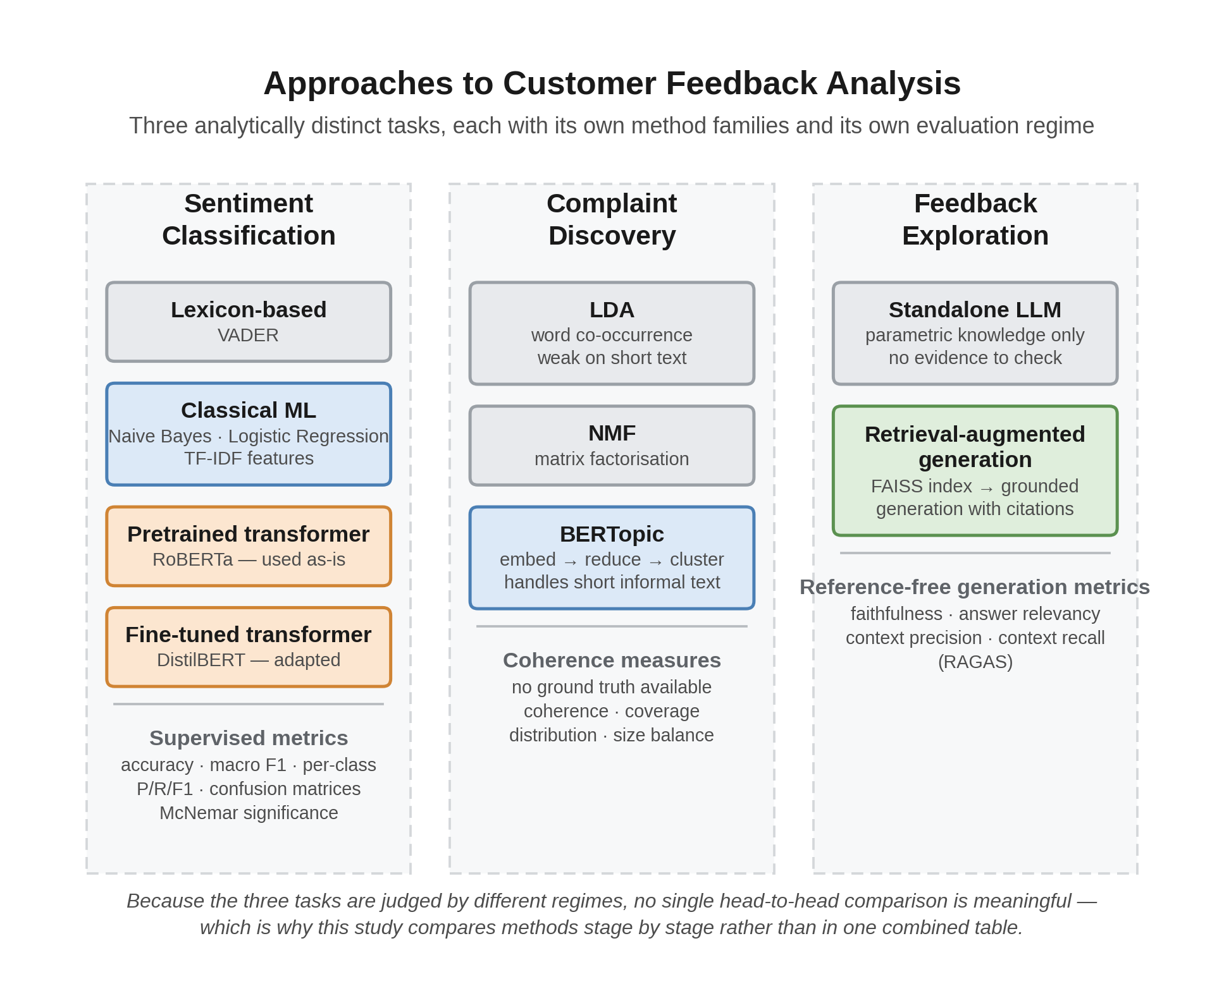
Figure 2.1
Figure 2.1 — Taxonomy of approaches to customer feedback analysis. The three tasks are analytically distinct, draw on different method families, and are judged by different evaluation regimes — which is why this study compares methods stage by stage rather than in a single combined table. (Source: docs/figures/fig_2_1_taxonomy.png.)
The point the figure makes is worth stating in words too, because it shapes everything that follows. Reading down any one column gives a sequence of methods that can sensibly be ranked against each other. Reading across the columns does not: a macro F1 score and a coherence score are not commensurable, and neither is comparable to a faithfulness score. Studies that report a single headline number for a feedback-analysis system are implicitly collapsing these three regimes into one, and that collapse is where a good deal of the reported evidence loses its meaning.

2.1.2 Current state of the art
Sentiment classification. The dominant approach is now the fine-tuned transformer. BERT established the pattern of pretraining a bidirectional encoder and adapting it to a downstream task (Devlin et al., 2019), and the variants that followed traded accuracy against cost in different ways. RoBERTa improved pretraining without changing the architecture (Liu et al., 2019), while DistilBERT reduced parameters by roughly 40% through distillation while retaining most of the performance (Sanh et al., 2019). The practical consequence is that a strong classifier is now a fine-tuning job rather than a research project.
Recent empirical work on review data supports the general ranking. Ali et al. (2024) compared machine learning, deep learning and transformer-based techniques on Amazon product reviews and found BERT outperforming every classical and deep-learning model tested. Shaukat (2024) reached a compatible but more qualified conclusion, benchmarking Random Forest, Naive Bayes and SVM against GPT-4 on product reviews: the classical models held their own on short, concise comments — SVM best among them — while the language model pulled ahead on longer, context-rich text. That length-conditional result is worth noting here, because the corpus used in this study spans exactly that range, from 19-word tweets to 85-word Yelp narratives. Sunar (2025) extends the comparison to embedding choice, evaluating traditional, pre-transformer and transformer paradigms on the Amazon Magazine Subscriptions 2023 dataset across static (GloVe, FastText) and contextual (BERT, DistilBERT) representations, and reports DistilBERT achieving both the highest accuracy at 92% and the lowest cross-entropy loss.
Two things about this body of work matter for the present study. First, the comparisons are consistently run within a single domain, most often Amazon product reviews. Second, they report aggregate accuracy or weighted F1 far more often than per-class behaviour. Both choices make transformer superiority easier to demonstrate and harder to qualify — and, as Chapter 4 shows, both conceal exactly the failure this study encountered.
Domain adaptation and transfer. The assumption that a pretrained transformer transfers well is itself an empirical claim, and the models are not domain-neutral. The twitter-roberta family, for instance, was pretrained on tweets and benchmarked on Twitter-specific tasks (Barbieri et al., 2020), which is the reason it performs strongly on short social text. Whether that advantage survives a move to long-form review prose is exactly the kind of question single-domain studies cannot answer.
A separate literature does address this directly, though from a different angle. Cross-domain sentiment classification treats the mismatch as a transfer-learning problem, seeking representations that hold across source and target domains. Recent work in this line includes feature projection with multi-source attention, designed to reduce negative transfer when knowledge is drawn from several source domains at once (Kong et al., 2023). The underlying mechanism in much of this literature is domain-adversarial training, in which a gradient reversal layer pushes the feature extractor towards representations a domain discriminator cannot separate (Ganin et al., 2016). What matters for the present study is not the architectures themselves — none is used here — but what their existence implies: a field that builds dedicated machinery to survive domain shift is a field that considers domain shift a serious obstacle.
The field’s own framing is instructive, and the contrast is worth drawing out. Cross-domain researchers treat domain shift as a serious obstacle demanding dedicated architecture — projection layers, adversarial objectives, multi-source attention. Applied comparison papers, meanwhile, routinely assume an off-the-shelf pretrained model will simply work on whatever data it is given, and report a single aggregate number that would hide it if the assumption failed. Both literatures are describing the same phenomenon; only one of them is looking for it. The present study takes the applied position but tests it, measuring performance per platform instead of assuming transfer holds — and the per-platform result in Chapter 4 lands firmly on the side of the cross-domain literature.
Applied feedback analysis with large language models. A newer strand applies language models directly to commercial feedback, and its findings are mixed in a way that matters here. Comparisons against smaller fine-tuned models report that larger models handle simple sentiment classification competently but struggle where structured or nuanced output is required, while winning in few-shot settings where annotation is scarce. Şilcenco et al. (2025) supply a purpose-built resource — 10,814 manually annotated multilingual retail reviews across eight aspect categories, with GPT-4 and LLaMA-3 baselines above 85% accuracy. The pattern is that scale does not straightforwardly substitute for task-specific training, which is the position this dissertation tests directly by pairing a fine-tuned encoder against a much larger generator at different pipeline stages.
Zero-shot classification. Categories discovered by topic modelling have no labelled examples by construction, so assignment is framed as natural language inference: each candidate label is verbalised as a hypothesis and scored against the text as premise (Laurer et al., 2023). Two findings shape the design in Section 3.6.2. Schopf et al. (2022) benchmark similarity-based against zero-shot approaches across four datasets and find similarity-based methods significantly better in most cases — which is why this pipeline shortlists by embedding similarity before applying entailment rather than running entailment across the full taxonomy. And label verbalisation matters as much as model choice, which is why a full category description is used as the hypothesis rather than a bare category name.
Complaint and topic discovery. LDA remained the default for two decades (Blei et al., 2003), but it depends on word co-occurrence within documents and degrades on short informal text. BERTopic replaced the probabilistic machinery with an embedding-and-clustering pipeline, using a sentence transformer for representation, UMAP for dimensionality reduction, HDBSCAN for clustering, and class-based TF-IDF for topic description (Grootendorst, 2022). Egger and Yu (2022) demonstrate the practical consequence on exactly the register that matters here, comparing LDA, NMF, Top2Vec and BERTopic on Twitter posts and finding the embedding-based methods better suited to short documents. That evidence bears directly on this study’s corpus, where the Twitter Airline subset has a median length of 19 words — short enough that the document-length argument is not theoretical.
Comparative evidence since then is broadly favourable but more nuanced than the headline suggests, and the disagreement between studies is not noise. Turan et al. (2024) found all three of LDA, NMF and BERTopic usable on Amazon reviews with BERTopic most interpretable, and Mishra (2026) reached a similar conclusion in marketing research. Two studies complicate that. Kaur and Wallace (2024) replaced automated scoring with human judgement, having twelve qualitative researchers compare the output of all three directly; eight preferred BERTopic for its cluster detail, which is a more relevant form of evidence for interpretability than a coherence score and suggests BERTopic’s advantage lies in cluster structure rather than coherence as conventionally measured. Ogunleye et al. (2023), working on customer tweets to Nigerian banks — a domain close to this one — show how sensitive results are to configuration rather than algorithm family, reporting coherence of 0.8463 when Kernel PCA and K-means replace BERTopic’s defaults. Comparisons between named algorithms therefore risk comparing implementation choices.
The pattern underneath is a real dependency: BERTopic’s advantage is largest where documents are short and lexically sparse, exactly where LDA’s co-occurrence assumption fails, and smallest where documents are long enough for co-occurrence to be informative. A study finding BERTopic superior on tweets and one finding LDA superior on longer complaint text may both be correct. This corpus spans both registers, which argues for BERTopic — the tweets would defeat LDA — while also being a reason not to expect uniform performance across the three platforms.
Retrieval-augmented generation. RAG was introduced to combine parametric knowledge in model weights with non-parametric knowledge retrieved at inference (Lewis et al., 2020). Its adoption accelerated sharply once hallucination was recognised as a systematic property of generative models rather than an occasional defect (Ji et al., 2023). Recent surveys document the resulting proliferation of architectures and evaluation schemes (Yu et al., 2024).
Evaluation has become the contested part. RAGAS proposed reference-free metrics for faithfulness, answer relevance and context relevance, allowing evaluation without human annotation (Es et al., 2024). Benchmarking work has shown that large language models remain sensitive to noise and irrelevant passages in retrieved context (Chen et al., 2024). Yu et al. (2024) note that many benchmarks collapse performance into a single aggregate score, which is inadequate for diagnosing whether a failure originated in retrieval or generation — a criticism this study takes seriously enough to report retrieval-side and generation-side metrics separately in Chapter 4.
Evaluation by language model. Because reference-free metrics are usually computed by a language model acting as judge, the reliability of that judge is now itself a research area. Surveys published since late 2024 catalogue position bias, verbosity bias and self-enhancement bias, where a model rates its own outputs more favourably (Gu et al., 2024; Li et al., 2024). This literature bears directly on a limitation of the present study, discussed in Section 2.2.3.

2.1.3 Critical review
Comparing these studies exposes patterns that individual papers do not.
Datasets. The overwhelming majority of sentiment comparisons use a single source, and Amazon reviews dominate. This is convenient — the data is large, labelled by star rating and freely available — but it produces a narrow evidence base. Review length, formality and complaint style differ substantially between a product review, a restaurant review and a complaint tweet. A study establishing that a transformer wins on Amazon has not established that it wins on customer feedback.
There is also a labelling convention worth questioning. Deriving sentiment labels from star ratings is standard practice, and it is what makes datasets of this scale possible. But it is an approximation, since a four-star review can contain a specific complaint, and papers rarely discuss the ceiling this places on achievable accuracy. The present study inherits the same approximation and states the consequence rather than passing over it.
Algorithms. The comparisons are usually generous to the newest method. Transformer baselines are typically fine-tuned; classical baselines are often not tuned to a comparable degree. Where classical models are given careful feature engineering and regularisation they perform closer to transformers than the headline numbers imply, particularly on longer, well-formed text where lexical features are informative. This is not a minor caveat. If the classical baseline in a published comparison is weaker than a competent practitioner would build, the reported margin measures the authors’ effort allocation as much as the methods’ capability.
Evaluation metrics. This is the weakest link in the literature. Accuracy and weighted F1 dominate, and both conceal class-level failure. A three-class problem in which a model performs well on two classes and collapses on the third can still report a respectable aggregate. Macro F1 partially addresses this, and confusion matrices address it fully, but neither is reported consistently. The consequence is not hypothetical: the single most informative result in this dissertation is one that a weighted-F1-only report would have rendered invisible.
For topic modelling the situation is worse, and the problem is not merely that studies disagree about which coherence measure to prefer — a body of work questions whether these measures are valid at all. Hoyle et al. (2021) showed that coherence metrics do not reliably reproduce human judgements of topic quality, and that measures developed for classical models were never validated against human assessment on neural ones. Doogan and Buntine (2021) reached a compatible conclusion from a different direction: the target construct, interpretability, is itself ambiguous. Lim and Lauw (2024) tested the correspondence at scale against a user study and found it weaker and more task-dependent than routine use implies. The metrics can, in short, reward topics humans find obscure. Alternatives continue to be proposed, including embedding-based coherence in place of co-occurrence counts (Rahimi et al., 2024).
This literature has a direct bearing on the present study, and it shaped the evaluation design rather than merely being cited near it. If C_v and NPMI are unreliable proxies for interpretability, then reporting a single coherence figure would be a weak basis for a claim about taxonomy quality. The approach taken here — embedding-based coherence supplemented by category balance, platform spread, unclassified rate and manual inspection — follows the direction the critique points in: several imperfect indicators read together with a human check, rather than one automated score presented as decisive. Chapter 4 shows why that mattered. The taxonomy’s average per-category coherence looks respectable in isolation; the coverage and balance figures reported alongside it tell a much less flattering story, and a single-metric report would have missed it entirely.
For RAG the field is younger still, and Yu et al. (2024) identify the absence of diagnostic, component-level evaluation as a live problem: aggregate scores cannot tell a developer whether a failure originated in retrieval or in generation.
Table 2.1 compares representative studies on the dimensions that determine how far their conclusions transfer.
Table 2.1 — Comparison of representative studies across datasets, methods and evaluation
Study | Domain(s) | Methods compared | Metrics reported | Principal limitation
Turan et al. (2024) | Amazon reviews | LDA, NMF, BERTopic | Topic interpretability | Single platform; qualitative comparison
Mishra (2026) | Marketing research abstracts | BERTopic, LDA | Coherence, interpretability | Not customer feedback; small corpus
Ali et al. (2024) | Amazon products | ML, DL, transformers | Accuracy, F1 | Single platform; aggregate metrics only
Kong et al. (2023) | Multi-domain reviews | Feature projection, multi-source attention | Accuracy | Purpose-built architecture, not off-the-shelf comparison
Chen et al. (2024) | Wikipedia-based QA | LLMs under retrieval noise | Accuracy under perturbation | Not customer feedback; synthetic noise
Hoyle et al. (2021); Doogan & Buntine (2021) | Multiple corpora | Topic models vs human judgement | Human agreement vs NPMI, C_v | Methodological critique, no applied pipeline
This study | Amazon, Yelp, Twitter Airline | Lexicon, classical ML, pretrained and fine-tuned transformers; RAG vs standalone LLM | Macro and per-class F1, confusion matrices, per-platform breakdown, McNemar tests; embedding coherence, coverage, platform spread; four RAGAS metrics | Rating-derived labels; single judge model; five-question generation sample
Strengths and weaknesses. Table 2.2 summarises how the three method families compare on the dimensions that matter for a practitioner choosing between them.
Table 2.2 — Comparison of method families across the three stages of feedback analysis
Dimension | Lexicon-based | Classical ML | Transformer | RAG (generation stage)
Training data required | None | Moderate labelled set | Large labelled set for fine-tuning | None for retrieval; relies on a pretrained generator
Compute cost | Negligible | Low | High (GPU for training) | Moderate; inference plus index
Handles context and word order | No | Weakly | Yes | Yes
Domain adaptability | Poor without manual lexicon work | Retrain on target data | Fine-tune on target data | Swap the underlying corpus
Interpretability | High: rules are inspectable | Moderate: feature weights | Low | Moderate: retrieved sources are inspectable
Typical evaluation | Accuracy, F1 | Accuracy, F1 | Accuracy, macro F1 | Faithfulness, answer relevancy, context precision and recall
Principal weakness | Misses sarcasm and implicit sentiment | Discards word order | Cost, and sensitivity to domain shift | Grounding is not guaranteed by architecture alone
Research trends. Three are visible. Evaluation is shifting from reference-based to reference-free, driven by the cost of annotation and the difficulty of defining a single correct generated answer. Attention is moving from model architecture towards data quality and retrieval quality, on the recognition that a strong generator conditioned on poor context still fails. And explainability is moving from post-hoc explanation towards source attribution, where the justification for an output is the evidence retrieved to produce it. The third trend is the one this dissertation engages with most directly, since it converts a presentational concern into a measurable design property.

2.1.4 Research gap
Four limitations run through the work reviewed above.
Comparisons in the studies reviewed here are conducted within a single domain, so the reported ranking of methods may reflect the dataset as much as the methods. A practitioner holding feedback from several sources has no direct evidence on which to base a decision.
Aggregate metrics dominate, so failure modes are hidden. Where a model fails on one class or one platform, the reporting conventions tend to obscure it, and the mechanism is rarely diagnosed even when the failure is visible.
Topic model output is treated as though it were a taxonomy. Studies compare topic quality between algorithms, but the step from keyword clusters to a consolidated, named set of categories usable across domains receives little attention, and its validation without ground truth receives less.
RAG is frequently adopted without being compared against the baseline it is meant to improve on. Faithfulness is measured within RAG systems, but among the studies reviewed here the direct comparison against unconstrained generation — which a practitioner would weigh it against — did not appear, and the reliability of the language model doing the judging is only now being scrutinised.
Design decisions inside RAG pipelines are, relatedly, argued rather than measured. Prompt-level grounding constraints, metadata injection, retrieval depth and reranking are usually introduced together and defended by reasoning about why they should help. Where a system-level faithfulness score is then reported, it is offered as though it validated each of those decisions individually, which it cannot. The reviewed literature endorses ablation as the remedy far more often than it performs one.
This dissertation addresses these together. It compares method families at each pipeline stage on one multi-domain corpus with a shared protocol; reports per-class and per-platform behaviour alongside aggregates and diagnoses the mechanism behind results that contradict expectation; treats taxonomy consolidation as an explicit stage with its own unsupervised evaluation and reports its coverage failures rather than its best-looking metric; evaluates the retrieval-augmented system against a standalone language model baseline while stating openly both the self-assessment bias in its judge and the small size of the question set; and ablates one retrieval design decision directly rather than inferring its contribution from a system-level score.
Two of these gaps are addressed more completely than the other two, and it is worth being straightforward about which. The multi-domain comparison and the per-class diagnosis are supported by a large held-out sample and significance testing. The generation comparison and the ablation rest on five questions and a single executed condition respectively, so they demonstrate the measurement approach and indicate a direction without settling the matter. Chapter 5 keeps that distinction visible when drawing conclusions.

2.2 Supporting Literature

2.2.1 Methodology
The design adopted here is a controlled comparative experiment built around a working pipeline. Comparative empirical studies in applied machine learning conventionally hold the data, the split and the metrics constant while varying the method, and that convention is followed. Where this study departs from much of the reviewed work is in comparing at each stage separately, since the methods under comparison perform different jobs and cannot be placed in a single table.
The literature also motivates a diagnostic rather than purely competitive stance. Because aggregate metrics conceal class-level failure, per-class F1 and confusion matrices are treated here as primary results, not appendix material. Where a result contradicts the expected ordering, the response is a follow-up experiment rather than a paragraph of speculation — a stance the reviewed literature recommends more often than it practises.

2.2.2 Datasets
Three sources are combined. Amazon product reviews and Yelp business reviews are long-established benchmarks in this literature, both large and rating-labelled. The Twitter US Airline Sentiment dataset differs in an important way: its labels come from human annotation instead of star ratings, and its text is short and informal.
That difference is deliberate. Combining rating-derived and human-annotated labels introduces heterogeneity, which is a limitation, but it also produces the register variation the comparison depends on. A corpus of three Amazon-like sources would not test domain transfer at all.
Two dataset limitations follow from the literature and are carried forward into Chapter 3. Rating-derived labelling is approximate, as discussed in Section 2.1.3. And review corpora are subject to selection effects, since customers with strong opinions are more likely to write, so the sentiment distribution should not be read as representative of customers generally.

2.2.3 Evaluation methods
Three evaluation regimes are used, matched to what each stage permits.
For sentiment classification, labels exist, so standard supervised metrics apply. Macro F1 is preferred over accuracy as the headline figure because it weights all three classes equally and therefore exposes the single-class collapse that the reviewed literature tends to hide. Pairwise model comparison uses McNemar’s exact test, which is appropriate for paired predictions on a common test set and avoids treating two models’ scores as independent samples.
For complaint discovery there is no ground truth, so classification metrics are unavailable. The literature’s usual proxies are coherence measures, and the disagreement between studies noted in Section 2.1.2, together with the validity critique in Section 2.1.3, shows they are not decisive. This study uses embedding-based coherence — the similarity of reviews to their category centroid — supplemented by category balance, platform distribution, and the proportion of reviews left unclassified. Reporting several weak indicators together is more defensible than resting on one, and in this case it is what made the taxonomy’s real weakness visible.
For the generation stage, RAGAS provides reference-free faithfulness, answer relevancy, context precision and context recall (Es et al., 2024). Four metrics are used, not one, because they can disagree in informative ways: an unconstrained model can score highly on relevancy while having no evidential basis at all, so relevancy alone would reward exactly the behaviour the system is designed to prevent. Chapter 4 reports precisely this disagreement.
The LLM-as-judge literature bears directly on a constraint of this study. Because the same model both generates and judges, self-enhancement bias of the kind documented by Gu et al. (2024) and Li et al. (2024) is a genuine threat to validity. This was accepted as a consequence of free-tier API limits, and it is reported as a limitation instead of being left implicit; using an independent judge model is identified as future work in Chapter 6.
One further practice deserves mention, because the literature endorses it more consistently than it applies it. A system-level faithfulness score establishes that a pipeline as a whole is grounded; it says nothing about which design decision produced that grounding. Ablation — removing a component and re-measuring — is the standard way to attribute an effect to a mechanism, routine in architecture papers but markedly less common in applied RAG work, where prompt constraints, metadata injection and retrieval depth are adopted together and justified by reasoning. That gap is why Section 3.6.5 specifies an ablation suite and why Chapter 4 reports the one condition resources allowed. Its result does not simply confirm the argument it was meant to test, which is itself an argument for running such experiments rather than assuming their outcome.

2.3 Technology Review

2.3.1 Models and libraries
Selections follow from the review above; Table 2.3 records each with its alternatives and the reason for choosing it.
Three deserve comment because the reasoning is not purely technical. DistilBERT was chosen for fine-tuning over BERT or RoBERTa because distillation retains most of the accuracy at around 40% fewer parameters (Sanh et al., 2019), making training feasible on freely available hardware — a real constraint for an MSc project, and one worth stating openly rather than disguising as a technical preference. RoBERTa is used in its Twitter-pretrained form (Barbieri et al., 2020), which makes the domain-transfer question testable rather than assumed. And the classical models are tuned to a standard comparable with the transformers, which — given Section 2.1.3’s criticism of under-tuned baselines — is a methodological commitment rather than a convenience.
BERTopic’s components are used as intended: sentence-transformer embeddings (Reimers and Gurevych, 2019), UMAP for dimensionality reduction (McInnes et al., 2018), HDBSCAN for clustering (Campello et al., 2013). HDBSCAN’s ability to leave points unassigned as noise is an advantage here, since not every negative review expresses a categorisable complaint — a property that matters a great deal in Chapter 4. Category assignment uses zero-shot natural language inference following the DeBERTa-based universal classifiers (Laurer et al., 2023), avoiding the need for labelled examples for categories that did not exist before discovery ran. FAISS provides the vector index (Johnson et al., 2019) and RAGAS the generation metrics (Es et al., 2024).
Table 2.3 — Technology selection and justification
Component | Selected | Alternatives considered | Reason for selection
Lexicon baseline | VADER | TextBlob, SentiWordNet | Designed for social media text; widely used, so results are comparable
Classical models | Naive Bayes, logistic regression (TF-IDF) | SVM, gradient boosting | Fast, interpretable, standard baselines in this literature
Pretrained transformer | twitter-roberta-base-sentiment-latest | BERT-base, generic RoBERTa | Twitter pretraining makes domain transfer directly testable
Fine-tuned transformer | DistilBERT | BERT, RoBERTa | ~40% fewer parameters at comparable accuracy; trainable on available hardware
Topic model | BERTopic | LDA, NMF, Top2Vec | Handles short informal text; semantic clustering rather than lexical
Embeddings | all-MiniLM-L6-v2 | all-mpnet-base-v2, OpenAI embeddings | Fast, 384-d, no API cost; quality trade-off tested empirically
Vector index | FAISS | Chroma, Pinecone, Weaviate | Local, free, well documented, no external dependency
Zero-shot classifier | DeBERTa-v3 zero-shot | bart-large-mnli | Stronger reported zero-shot performance with larger label sets
Generator | Llama 3.1 via Groq | GPT-4, Gemini, local Llama | Free tier supported the required evaluation volume
Orchestration | LangChain | LlamaIndex, custom | Mature retrieval-chain abstractions; large ecosystem
RAG evaluation | RAGAS | TruLens, ARES, manual | Reference-free metrics; no annotation budget required
Two of these were constrained decisions rather than optimal ones: the small embedding model and the free-tier generator. Their effects are examined directly rather than assumed away — retrieval quality is compared against a TF-IDF baseline in Chapter 4, and the limits rate limiting imposed on evaluation sample size are reported wherever generation results appear.

2.4 Chapter Summary
This review establishes four things. Fine-tuned transformers dominate sentiment classification, but the evidence for their superiority comes overwhelmingly from single-domain studies reporting aggregate metrics, so it is weaker than it appears — and the cross-domain literature, which takes domain shift seriously enough to build architectures against it, implicitly contradicts the applied literature’s confidence. BERTopic suits short informal text better than LDA, though comparative results are mixed in a way that tracks document length. Retrieval-augmented generation is the accepted response to hallucination, but adopting it does not establish that grounding has been achieved, and direct comparison against unconstrained generation remains uncommon. And reference-free evaluation using a language model as judge is standard practice while its reliability is still being questioned — as are the automated coherence measures used for topic models.
The technologies selected follow: VADER as a floor, tuned classical models as a serious baseline rather than a token one, a Twitter-pretrained RoBERTa to make domain transfer testable, a distilled transformer for feasible fine-tuning, BERTopic with its embedding and clustering components, zero-shot entailment for newly discovered categories, and FAISS with RAGAS for retrieval and evaluation. Chapter 3 sets out how each is configured.

CHAPTER 3: RESEARCH APPROACH
Chapter 2 ended with a gap and four complaints about how the existing literature is evaluated: comparisons run within one domain, aggregate metrics that hide class-level failure, topic models validated by a single contested coherence score, and retrieval-augmented systems adopted without being measured against the baseline they are meant to improve on. This chapter sets out a methodology designed against those four complaints.
Its purpose is twofold: to make the work reproducible, and to justify each decision against the limitation it responds to, so the results in Chapter 4 can be read with the right qualifications already attached. Where a decision was constrained rather than optimal, that is stated at the point the decision is described. Full hyperparameter configurations are given in Appendix B.

3.1 Research Methodology
CRISP-DM, adapted for a comparative experimental design, is used. The choice between available methodologies turns on where a project’s contribution sits. Design Science Research suits work whose contribution is the artefact itself; here the pipeline is the instrument and the comparison is the contribution, so organising around artefact construction would misplace the emphasis and invite a write-up that describes a system rather than evaluates a question. KDD stops short of the evaluation depth this study needs. Agile addresses project management rather than analytical validity, which is what is at risk.
CRISP-DM fits for two reasons bearing directly on Chapter 2’s criticisms. Its evaluation phase is explicit and iterative, which suits a study whose contribution lies in evaluation rather than modelling. And its data preparation phase is treated as substantial work rather than a preliminary, which matters because preparation is precisely where a comparison becomes controlled or fails to. The adaptation is that modelling and evaluation execute three times, once per pipeline stage, since each stage has its own candidate methods and appropriate metrics — a direct consequence of Chapter 1’s argument that feedback analysis is not one task but three. Deployment is out of scope and treated as future work.
Table 3.1 — Mapping of CRISP-DM phases to objectives and research questions
Phase | Objective | RQ | Output
Business understanding | O1 | RQ1–RQ4 | Literature review, research gap
Data understanding | O2 | — | Exploratory analysis, dataset profile
Data preparation | O2 | — | Unified corpus, documented split
Modelling (stage 1) | O3 | RQ1 | Five trained or configured classifiers
Modelling (stage 2) | O4 | RQ3 | Per-platform topics, merged taxonomy
Modelling (stage 3) | O5 | RQ2, RQ4 | RAG pipeline and standalone baseline
Evaluation | O6 | RQ1–RQ4 | Metrics, baselines, diagnostics, ablation
Conclusion | O7 | RQ1–RQ4 | Critical discussion, limitations, future work

3.2 Data

3.2.1 Sources and characteristics
Three public datasets are used, chosen so the corpus spans genuinely different registers rather than three variations of one thing — the direct response to Section 2.1.3’s dataset criticism, since a study claiming something about domain transfer must contain domains that actually differ.
Amazon product reviews cover physical goods, where complaints concern quality, delivery and value, and length varies widely. Yelp reviews describe service and hospitality experiences and are the longest in the corpus, typically extended narrative. Twitter US Airline Sentiment provides short, abbreviated, public-facing complaints about delays, cancellations and baggage. The three differ on register, length and communicative purpose simultaneously: a reviewer writing for other shoppers, a diner writing a narrative, and a customer publicly demanding a response are doing different things with language.
Table 3.2 — Composition of the unified corpus
Platform | Reviews | Share | Label origin | Median words
Yelp | 449,858 | 70.0% | Star rating | 85
Amazon | 178,883 | 27.8% | Star rating | 29
Twitter Airline | 13,951 | 2.2% | Human annotation | 19
Total | 642,692 | 100%
Sentiment classes are near-balanced — negative 34.0%, neutral 33.1%, positive 32.9% — which is what makes macro F1 a fair headline metric. Platform representation is heavily skewed, and that asymmetry drives two later decisions: per-platform topic discovery, and platform-balanced diagnostic sampling.

3.2.2 Labelling, and the ceiling it imposes
Labels for Amazon and Yelp derive from star ratings: two or below negative, three neutral, four or above positive. This is standard practice at this scale — it is what makes corpora of this size possible — but it is an approximation. A four-star review can contain a specific complaint and will be labelled positive. This places a ceiling on the accuracy any classifier in this study can reach, and it is the most likely source of difficulty on the neutral class, since a three-star review is the least semantically coherent of the three groups.
Label provenance is also not homogeneous. Twitter labels come from human annotation, so “neutral” means a three-star rating on two platforms and a human judgement of no clear sentiment on the third. This is a genuine threat to cross-platform comparability and is reported as such wherever per-platform results are interpreted — and, as Chapter 5 shows, it becomes the explanation for the study’s central anomaly.
Two further constraints: Twitter contributes only 2.2% of the corpus, so per-platform analysis on that subset rests on fewer examples and is read with more caution; and review data carries selection bias, since people with strong opinions are more likely to write, so no claim about population-level customer sentiment is made anywhere in this dissertation.

3.3 Research Process
The workflow runs in five stages, each evaluated before the next depends on it: data preparation producing reviews_unified.parquet; sentiment classification of five models on a shared held-out split; complaint discovery per platform with cross-platform merging; retrieval and question answering, with and without retrieval for comparison; and evaluation with baselines and diagnostic experiments.
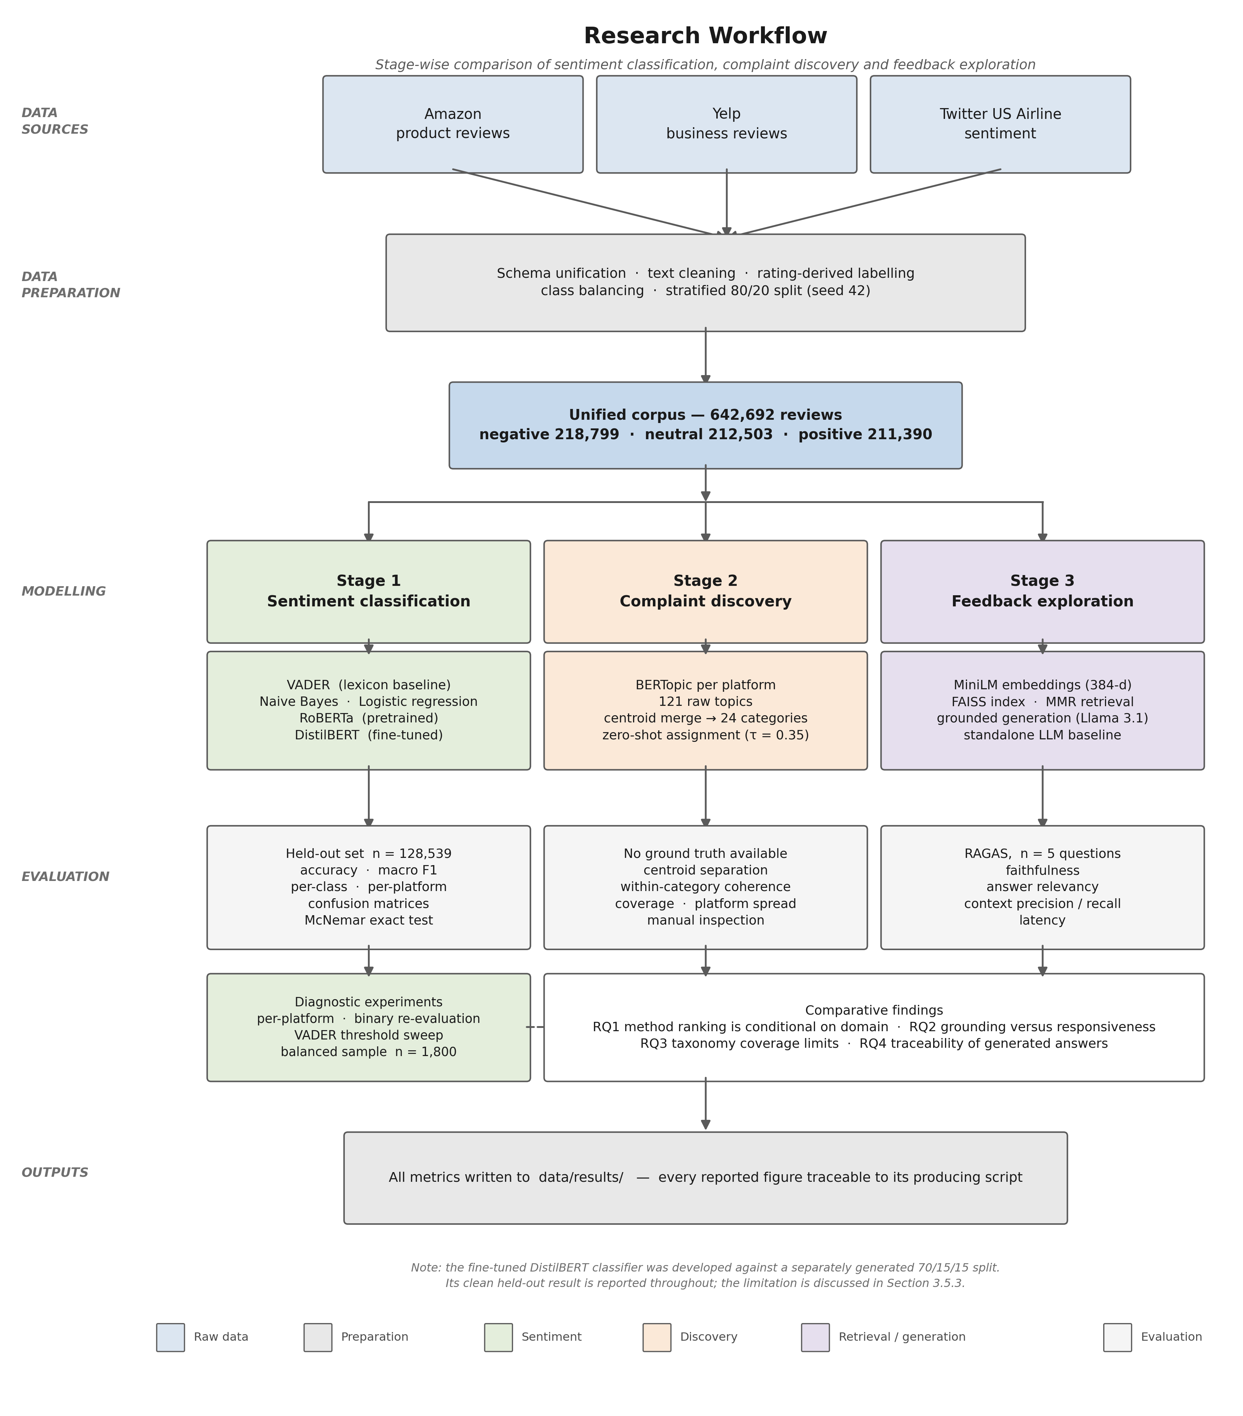
Figure 3.1
Figure 3.1 — End-to-end research workflow. Three raw review sources are unified into a single corpus feeding three independently evaluated stages.
Stage ordering is not arbitrary, and the dependencies propagate. Sentiment classification precedes discovery because discovery operates on negative reviews only, so a review misclassified as negative enters the topic model as noise. Discovery precedes retrieval because the taxonomy provides the vocabulary in which complaints are described. Each stage therefore inherits the limitations of the one before it — itself a finding worth reporting rather than a flaw to conceal.

3.4 Tools
Python 3 with pandas and scikit-learn for data handling, classical models, splitting and classification metrics. Hugging Face Transformers supplies RoBERTa and DistilBERT with the Trainer API, chosen because its model hub makes the exact checkpoints identifiable by name rather than description. vaderSentiment provides the lexicon baseline. BERTopic with UMAP and HDBSCAN handles discovery, configured explicitly rather than left at defaults so results are attributable to choices rather than library conventions. sentence-transformers supplies all-MiniLM-L6-v2 (384 dimensions) and FAISS provides the vector index, running locally with no external service — an index depending on a hosted service cannot be reconstructed once that service changes. Generation uses Groq’s llama-3.1-8b-instant at temperature 0.2, orchestrated with LangChain; low temperature is deliberate, since the task is evidence-grounded answering where output variability is a defect and a reproducible evaluation requires responses that do not swing between runs. RAGAS supplies generation metrics and MLflow tracks experiments, preserving parameters, metrics and artefacts per run.
Every dependency is version-pinned in requirements.txt, seeds are fixed at 42 throughout, and unit tests cover the topic-merging and category-shortlisting logic.
[AUTHOR TO ADD: exact Python version; hardware used for DistilBERT fine-tuning — GPU model and memory, or Colab tier; and the public repository URL if the code is released.]

3.5 Data Processing
Each source is mapped onto a common schema. Cleaning removes records with missing text or labels and reviews of five characters or fewer, normalises case and whitespace, and produces cleaned_text alongside the original text. Both are retained deliberately: models consume the cleaned version while retrieval serves the original, since an analyst reading a retrieved review as evidence needs it readable. The discovery stage additionally filters to English, since mixed languages cluster by language rather than subject, producing topics that describe the corpus’s composition instead of its complaints.

3.5.1 Data splitting
Splitting is where a comparative study is either controlled or not, so it is stated precisely.
For the sentiment comparison, the corpus is split 80/20 with stratification on sentiment label and random_state=42, giving a held-out test set of 128,539 reviews. Stratification keeps the class distribution identical across partitions, so a model cannot gain on the aggregate simply because one partition contained more of the class it handles best.
The fine-tuned DistilBERT model was trained using a 70/15/15 stratified split, also seeded at 42, with validation used for early stopping and best-checkpoint selection.
A limitation must be recorded here, and it is the most consequential methodological caveat in this dissertation. The fine-tuned model and the other four were developed against separately generated corpus versions. The partitions are therefore not identical, and a proportion of the shared test set overlaps data the fine-tuned model saw during training. The comparison is consequently controlled for four of the five models and not for the fifth.
Three things follow. The clean figure for the fine-tuned model is the one obtained on its own held-out partition, and that is the figure interpreted in Chapter 5. Any statement comparing it directly against the others on the shared set is qualified at the point it is made. And establishing a single canonical split, generated once and reused by every model, is Chapter 6’s first recommendation. Stating this openly is preferable to presenting a comparison whose controls do not hold; it also means the fine-tuned model’s advantage on the shared split should be read as an upper bound rather than a point estimate.

3.6 Model Development

3.6.1 Sentiment classification
Five models span four method families, each representing a distinct answer to the same problem rather than a variation on one answer.
VADER requires no training; its compound score maps to three classes at the conventional ±0.05 thresholds. Retaining the convention matters for comparability, and the threshold sweep in Section 3.6.5 tests whether that convention is what limits its performance.
Naive Bayes and logistic regression operate over TF-IDF features with unigrams and bigrams, logistic regression using lbfgs with max_iter=3000, both trained on the 80/20 split with five-fold stratified cross-validation during development. Tuning these properly is a methodological commitment rather than routine: Section 2.1.3 criticised published comparisons for pairing carefully fine-tuned transformers against under-tuned classical baselines, and repeating that asymmetry would reproduce the bias this study set out to test.
RoBERTa is used pretrained and unmodified in the twitter-roberta-base-sentiment-latest configuration, truncated at 512 tokens, and deliberately not fine-tuned. Its role is to represent what transfer learning achieves without task-specific training — the condition a practitioner faces adopting an off-the-shelf model — and since this checkpoint was pretrained on tweets (Barbieri et al., 2020), it makes the domain-transfer question directly testable across three registers.
DistilBERT is fine-tuned from distilbert-base-uncased with a three-class head; the full configuration is in Appendix B. Two choices deserve justification because both were non-obvious in implementation. Class weighting was applied through a custom trainer overriding the loss function, because the standard Trainer ignores class weights passed by configuration; without this the neutral class would be under-served despite a balanced corpus — a defect invisible in aggregate metrics and visible only per class. And early stopping selected on validation macro F1 rather than loss, because macro F1 is what the study reports, and selecting checkpoints on one quantity while reporting another risks presenting a model optimised for something other than the reported result.

3.6.2 Complaint discovery and category assignment
BERTopic runs separately on the negative reviews of each platform. This is a deliberate control: Yelp contributes 70% of the corpus, and pooling would let it dominate the topic space, producing a taxonomy that describes restaurant service and calls it customer feedback. The cost is that topics must afterwards be reconciled across platforms — the study accepts a harder consolidation problem in exchange for a taxonomy that is not simply a description of its largest source.
Minimum topic size is derived from corpus size rather than fixed, at approximately 0.15% of each platform’s document count, bounded between 30 and 300. This keeps granularity comparable across platforms of very different sizes; a fixed minimum would produce either an unusable proliferation of topics on the largest platform or almost none on the smallest. In practice this gave 86 for Amazon, 224 for Yelp and 30 for Twitter Airline, where the lower bound binds.
Per-platform topics are then merged by taking each topic’s centroid embedding and applying agglomerative clustering down to a target of 24 categories. Each merged cluster is named by a language model given the constituent topic labels and keywords, producing a category name, one-sentence description and exemplar phrases. The description is not presentational — it becomes the hypothesis used by the zero-shot classifier at assignment, so the naming step directly determines assignment quality, a dependency whose consequences Chapter 4 reports.
Assignment uses two stages. An embedding comparison ranks all categories and retains a shortlist of six; a zero-shot entailment model then scores only that shortlist, using each category’s description as the hypothesis sentence. This follows Schopf et al. (2022), who found similarity-based methods outperforming zero-shot approaches across four datasets — which is the external justification for shortlisting by similarity before applying entailment rather than running entailment over the full taxonomy. The shortlist also keeps entailment cost bounded as the taxonomy grows. A confidence threshold of 0.35 leaves weak matches unclassified rather than forcing a label: a deliberate trade of coverage for honesty, since the unclassified rate becomes a reportable measure of taxonomy coverage instead of a hidden error. As Chapter 4 shows, that decision is what made the taxonomy’s principal weakness measurable rather than invisible.

3.6.3 Retrieval and generation
The corpus is embedded with all-MiniLM-L6-v2 and indexed in FAISS with normalised vectors. Retrieval returns five reviews per query from a candidate pool of twenty, selected by maximal marginal relevance. MMR is preferred over plain similarity for a domain-specific reason: complaint questions tend to retrieve near-duplicate reviews expressing the same grievance, and five restatements of one complaint provide weaker grounding than five distinct ones while scoring identically on similarity.
Each retrieved review is tagged with platform, rating and sentiment before entering the prompt. This is not cosmetic — the prompt instructs the model to cite only platforms present in the evidence, and without the tags that instruction can neither be followed nor checked. It is also the one design decision Chapter 4 tests directly rather than argues for (Section 4.5.8). The prompt further requires that no statistic, category or quotation appear unless present in the retrieved text, and specifies a fixed refusal string for insufficient evidence, making refusal an available output rather than something the model must improvise.
Two guards sit in front of generation, and the difference between them matters. Section 2.1.2 established that a prompt-level instruction to refuse is a request, not a constraint: Ji et al. (2023) document models producing fluent, confident text with no evidential basis, and an instruction not to is enforced only by the model’s compliance. Two architectural gates therefore precede the prompt.
The first is a scope guard rejecting questions not about customer feedback at all. It runs in two stages — a keyword filter naming nine off-topic subjects, then a small LLM classifier for cases the keyword list cannot catch — and returns a fixed out-of-scope message without touching the retriever. The design assumption is that a wrongly rejected question is a cheaper failure than a confidently answered off-topic one. Chapter 4 finds a case testing that assumption.
The second is a similarity threshold on retrieval, set at 0.35. FAISS returns its top k regardless of how weakly documents match, so without a floor the pipeline hands the model five nearest-but-possibly-irrelevant reviews and relies on the prompt to talk it out of using them. The threshold makes “no relevant evidence exists” a fact the code checks rather than a judgement the model makes each time: candidates below it are discarded, and if nothing survives a fixed no-evidence message replaces generation. A post-generation check repeats the test for multi-turn queries, where the retrieval query is an LLM-reformulated question the pre-check never saw. The value 0.35 was chosen by inspecting this index’s score distribution and has not been tuned against a labelled set of in-scope and out-of-scope questions, which Chapter 6 identifies as outstanding work.
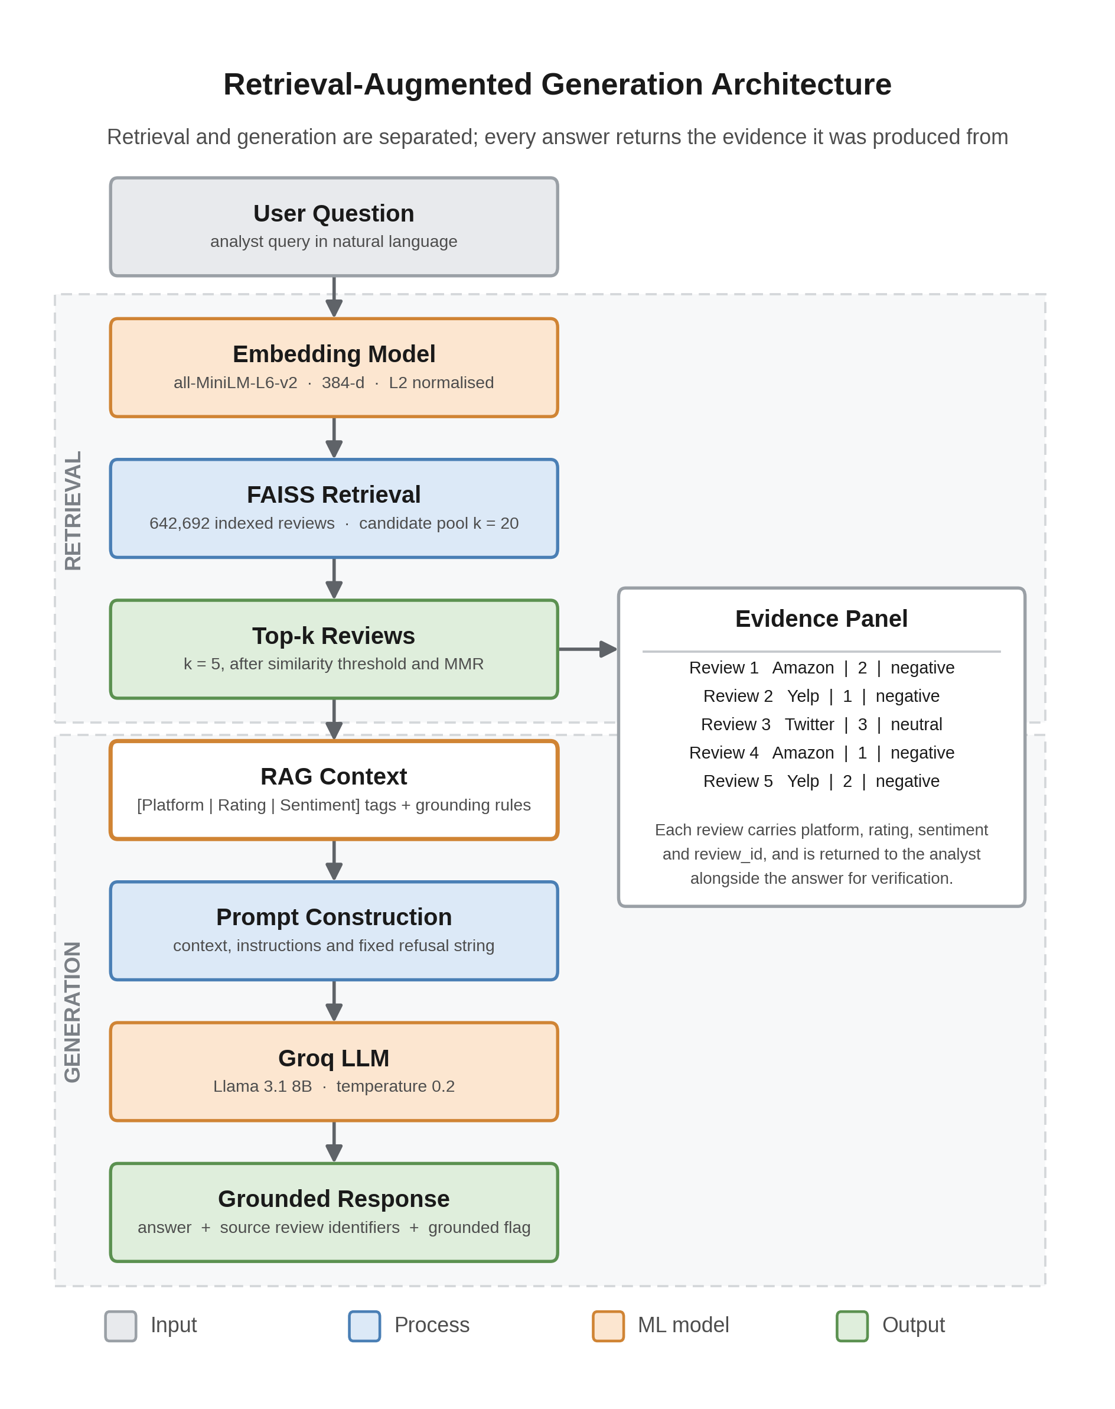
Figure 3.2
Figure 3.2 — Retrieval-augmented architecture. The scope guard runs before retrieval is attempted; the similarity threshold gates retrieval output before generation.
The same questions are then answered with no retrieval, providing the RQ2 baseline. Holding generator, temperature and question set constant means the difference is attributable to retrieval rather than model or prompt variation.

3.6.4 Evaluation metrics
Metrics are matched to what each stage permits.
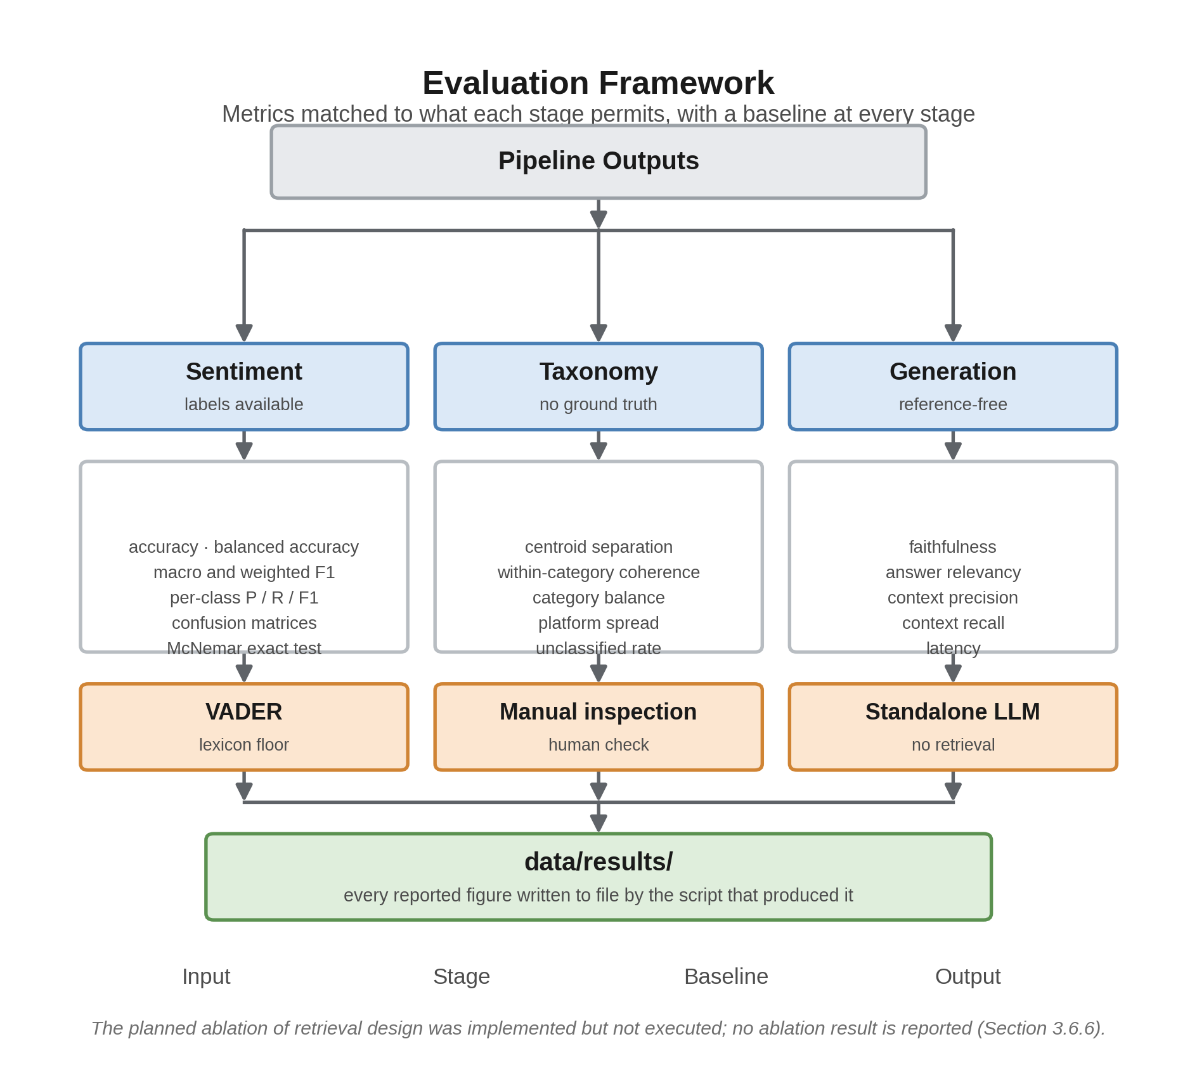
Figure 3.3
Figure 3.3 — Evaluation framework across the three stages.
Sentiment. Accuracy, macro F1, weighted F1, per-class precision, recall and F1, and confusion matrices. Macro F1 is the headline because it weights all classes equally and exposes the single-class collapse Section 2.1.3 identified as the literature’s blind spot. Per-platform metrics are reported alongside aggregates for the same reason. Pairwise comparison uses McNemar’s exact test, appropriate for paired predictions on a common test set.
Taxonomy. No ground truth exists, so no accuracy is computed and none implied. Quality is argued from mean pairwise similarity between merged centroids, within-category coherence, category frequency distribution, platform distribution, and unclassified rate, with a sample set aside for manual inspection. Reporting five weak indicators together is the direct methodological response to the coherence-validity critique in Section 2.1.3: if no single automated measure is trustworthy, a claim should not rest on one.
Generation. RAGAS faithfulness, answer relevancy, context precision and context recall, for both conditions. Four metrics are used because they disagree informatively — an unconstrained model can score highly on relevancy while having no evidential basis, so relevancy alone would reward precisely the behaviour the system exists to prevent.
Diagnostic experiments. Aggregate metrics establish a ranking but not a cause, and Chapter 2 criticised the literature for stopping at the ranking. Three experiments test proposed explanations rather than leaving them as speculation: a per-platform breakdown on a sample balanced across platform and class (600 per platform, 1,800 total); a binary re-evaluation removing the neutral class and requiring each model to choose between negative and positive from its own class scores; and a threshold sweep re-labelling VADER’s cached compound scores across progressively wider neutral bands. All three reuse one cached set of predictions, so each model runs over the sample once — a practical necessity given transformer inference cost, and one that guarantees the three diagnostics describe identical model behaviour. They are computed on the 1,800-review sample rather than the full test set, so their figures are not interchangeable with the headline metrics and are not treated as such.
A constraint on the generation evaluation belongs here rather than in the results: the model judging answers is the model producing them, introducing the self-enhancement bias documented in Section 2.2.3. This followed from free-tier API limits, which also constrained the number of evaluation questions. Both bound the RQ2 and RQ4 conclusions and are restated wherever those conclusions appear.

3.6.5 Ablation design, and what was carried out
Section 2.2.3 argued that reporting a system-level faithfulness score does not attribute grounding to any particular design decision, and that ablation is the standard remedy. Four conditions were designed, each isolating one decision while holding everything else constant: metadata tagging (tags present or absent in the prompt context), retrieval depth (k ∈ {3, 5, 10, 20}), retriever type (MMR against plain similarity) and prompt version (constrained grounding prompt against a plain instruction).
One was built and run; three were specified but never built. The metadata-tagging condition was executed in evaluate/ablation_metadata_tagging.py, running the same five questions twice through the same pipeline with retrieval held identical, so any difference in RAGAS scores is attributable to what the generator was shown rather than what was retrieved. Section 4.5.8 reports the result, which does not straightforwardly confirm the argument made above.
The remaining three exist as the specification and nothing more. Each requires a full pass over the question set with several judged sub-calls per answer, and the free-tier rate limit made that volume unreachable within the timeframe; rather than write code that could not be run, the effort went into completing one condition properly. The consequence is stated plainly: for retrieval depth, retriever type and prompt version, the contribution of each decision is argued from design reasoning, not measured.
Two scripts therefore carry the generation evaluation, both in the submitted codebase: evaluate/evaluate_llm_vs_rag.py and evaluate/ablation_metadata_tagging.py. The same rate limit constrained both to five questions, small enough that per-question variance dominates the reported means, so Chapter 5’s answer to RQ2 is framed as directional.

3.7 Ethical Considerations
All three datasets are publicly available and were collected and released by their original publishers. No data was scraped and none gathered from individuals, so no human participants were involved and no ethical approval for participant research was required.
The reviews contain no special-category personal data. Reviewer names are not used, and reviews are referenced by identifier only. Two residual risks are recorded. Review text occasionally contains personal detail written by the reviewer, so no attempt is made to link reviews to individuals or to reconstruct identity from content. And generated summaries describe named businesses, where acting on an unsupported summary could affect one unfairly — returning source reviews with every answer is a partial safeguard, since a claim can be checked before it is used.

3.8 Chapter Summary
This chapter set out a methodology built against four criticisms of the existing literature: a corpus spanning three genuinely different registers rather than one domain; per-class and per-platform reporting alongside aggregates; five indicators for the taxonomy rather than one contested coherence score; and a standalone baseline against which the retrieval-augmented system is measured rather than assumed superior. Where the design falls short of its own standard — the split limitation in Section 3.5.1, and the three ablation conditions never built — that is stated at the point it arises rather than deferred.
Chapter 4 reports what this methodology produced.

CHAPTER 4: DATA ANALYSIS
Chapter 3 set out a methodology built against four criticisms of the existing literature. This chapter reports what that methodology produced. Its purpose is to present the evidence in enough detail for the results to be reproduced and checked; the argument about what the evidence means is held back for Chapter 5. Where a result contradicts expectation, this chapter reports the contradiction and the diagnostic experiment that probes it, but leaves the explanation for the discussion.
Every figure quoted here is produced by a script that writes to data/results/, and the producing script is named alongside each table so that any number can be traced to its source.
The chapter follows the CRISP-DM phases adopted in Chapter 3. Section 4.1 restates the problem and defines the success criteria against which the work is judged. Section 4.2 reports the exploratory analysis of the three sources and the data quality issues it exposed. Section 4.3 covers preparation, feature extraction and splitting. Section 4.4 documents model development at each of the three pipeline stages. Section 4.5 reports evaluation, which supplies the evidence for all four research questions. Section 4.6 addresses deployment status, and Section 4.7 summarises.

4.1 Business Understanding
Chapter 1 established the problem: organisations hold more feedback than they can read, and the practical question is which method to trust to extract signal from it. Three analytically distinct sub-problems follow — supervised classification, unsupervised discovery, and grounded generation, where the risk is a fluent answer with no basis in evidence. This chapter delivers Objectives 2 to 6.
Success is defined per stage rather than as a single accuracy target. For classification, a controlled comparison in which differences between models cannot be attributed to differences in data, reported at a granularity that reveals class-level and platform-level behaviour; a ranking alone would not satisfy it. For discovery, with no ground truth, a taxonomy whose categories are separable, internally coherent, populated across platforms, and honest about what it fails to cover. For question answering, measurable grounding: answers traceable to identifiable source reviews, scored against a standalone baseline on the same questions.

4.2 Data Understanding

4.2.1 Register differences
The comparison in this study depends on the three sources differing in register, so that claim is measured rather than assumed. Figure 4.1 reports word counts from a seeded sample of up to 40,000 reviews per platform.
The differences are substantial and not in the direction intuition suggests. Yelp reviews are the longest by a wide margin, with a median of 85 words against Amazon’s 29 and Twitter Airline’s 19. Amazon reviews are shorter than expected at the median but carry a long tail: their 95th percentile reaches 138 words against Twitter’s 27, so the platform mixes very brief and very detailed reviews. Twitter Airline is both the shortest and by far the most uniform, which follows from the platform’s character limit — its interquartile range spans a narrower band than either of the others.
Two properties therefore separate the sources: central length, on which Yelp stands apart, and dispersion, on which Twitter stands apart. Amazon sits between them on both. This is the empirical basis for treating the corpus as multi-domain, and it is what makes the per-platform analysis in Section 4.5.4 meaningful.
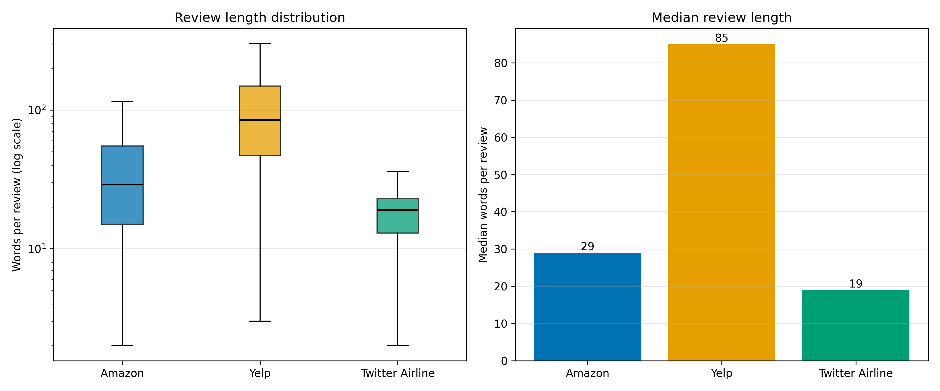
Figure 4.1
Figure 4.1 — Review length by platform: distribution on a log scale, with median word counts. Seeded sample of up to 40,000 reviews per platform. (Produced by evaluate/generate_figures.py.)

4.2.2 Composition
After preparation the corpus holds 642,692 reviews. Table 4.1 gives the composition.
Table 4.1 — Corpus composition by platform
Platform | Reviews | Share | Label origin | Register
Yelp | 449,858 | 70.0% | Star rating | Extended service narrative
Amazon | 178,883 | 27.8% | Star rating | Variable-length product review
Twitter Airline | 13,951 | 2.2% | Human annotation | Short, abbreviated, public
Total | 642,692 | 100%
Sentiment classes are close to balanced: negative 218,799 (34.0%), neutral 212,503 (33.1%), positive 211,390 (32.9%). This is a consequence of balanced sampling during preparation, and it is what makes macro F1 a fair headline metric.
Platform representation, by contrast, is heavily skewed. Yelp contributes seventy per cent and Twitter Airline barely two. This asymmetry drives two later design decisions: topic discovery runs per platform (Section 4.4.2), and the diagnostic evaluation samples equally from each platform (Section 4.5.4).

4.2.3 Data quality issues
Four issues carry forward into the interpretation of results, and the first two are the consequential ones. Rating-derived labels mean a four-star review containing a specific complaint is labelled positive, placing a ceiling on achievable accuracy that no model can exceed. Label provenance is also not uniform: Twitter labels come from human annotation, so “neutral” is a three-star rating on two platforms and a judgement of no clear sentiment on the third — not one construct but two, which matters once the neutral class turns out to be where most models fail. Twitter text also contains handles, abbreviations and truncation absent elsewhere, and some non-English reviews are retained in the corpus but filtered at the discovery stage, where mixed languages cluster by language rather than subject.

4.3 Data Preparation
Preparation followed the procedure specified in Section 3.5: schema unification, removal of records missing text or labels, case and whitespace normalisation, rule-based labelling from star ratings, and class balancing during sampling. A four-record sample of the resulting corpus, showing the schema and the effect of cleaning, is given in Appendix B.2.

4.3.1 Feature extraction
Feature representation differs by model family, which is itself part of the comparison.
Classical models use TF-IDF vectors over unigrams and bigrams. VADER requires no features, operating directly on raw text through its lexicon. Transformer models use their own subword tokenisers, with DistilBERT truncating at its tokeniser maximum. Topic discovery and retrieval use 384-dimensional sentence-transformer embeddings from all-MiniLM-L6-v2, L2-normalised so that inner product equals cosine similarity.
No manual feature selection or scaling was applied. TF-IDF weighting handles term importance implicitly, and embedding dimensions are not individually interpretable, so selecting among them would not be meaningful.

4.3.2 Splitting
The sentiment comparison uses an 80/20 stratified split with random_state=42, producing a held-out test set of 128,539 reviews with the class distribution preserved.
The fine-tuned model was trained on a separately generated 70/15/15 stratified split, also seeded at 42. Its validation partition drove early stopping and checkpoint selection; its test partition of 88,854 reviews was held out entirely.
As disclosed in Section 3.5.1, these two partitions are not identical, so a portion of the 128,539-review test set overlaps data the fine-tuned model saw in training. The uncontaminated figure for that model is the one from its own held-out partition, and it is that figure which is treated as definitive. Every comparison in Section 4.5.1 involving DistilBERT is annotated accordingly.

4.4 Model Development

4.4.1 Sentiment classifiers
Five models span four families, selected on the evidence reviewed in Section 2.3.1.
VADER serves as the lexicon baseline, requiring no training, with compound scores mapped to three classes at the conventional ±0.05 thresholds. Naive Bayes and logistic regression are trained over TF-IDF features, the latter using the lbfgs solver with max_iter=3000, with five-fold stratified cross-validation during development. RoBERTa is used pretrained and unmodified in its twitter-roberta-base-sentiment-latest form; it is deliberately not fine-tuned, since its role is to represent what transfer learning delivers without task-specific training.
DistilBERT was fine-tuned from distilbert-base-uncased with a three-class head. The full configuration is given in Appendix B.
Two choices warrant note. Class weights were applied through a custom trainer overriding the loss function, because the standard trainer ignores them; without this the neutral class would be under-served despite corpus-level balance. And checkpoint selection used macro F1 rather than validation loss, so that the quantity optimised matches the quantity reported.
Per-epoch training behaviour is reported in Appendix B.
Validation loss fell to epoch 2 then rose while training loss continued to decline — the standard signature of overfitting — so best-checkpoint restoration selected epoch 2. Training took 10,545 seconds.

4.4.2 Complaint discovery
BERTopic was applied to the negative-sentiment reviews of each platform separately, after English-language filtering. Running per platform rather than over the pooled corpus prevents Yelp’s seventy per cent share from dominating the topic space. Table 4.2 records configuration and outcome.
Table 4.2 — BERTopic discovery by platform (source: data/results/category_discovery/discovery_platform_topics.csv)
Platform | Documents clustered | Minimum topic size | Topics discovered
Amazon | 57,931 | 86 | 69
Yelp | 149,838 | 224 | 18
Twitter Airline | 8,890 | 30 | 34
Total | 216,659 | — | 121
Minimum topic size was derived from each platform’s document count rather than fixed, which is why it varies. The topic counts are themselves informative: Yelp produced only 18 topics from 149,838 documents while Amazon produced 69 from roughly a third as many. Product categories span a far wider semantic range than restaurant and service complaints, and the discovery stage reflects that.
The 121 raw topics were then merged by agglomerative clustering over topic centroid embeddings to a target of 24 categories, each named by a language model given its constituent topic labels and keywords.

4.4.3 Category assignment, retrieval and question answering
Assignment, retrieval and generation were implemented as specified in Sections 3.6.2 and 3.6.3: a six-category embedding shortlist scored by zero-shot entailment with a 0.35 confidence threshold; FAISS retrieval of five reviews per query by maximal marginal relevance, each tagged with platform, rating and sentiment before entering the prompt; and generation by Llama 3.1 8B at temperature 0.2 with source identifiers returned. The same questions were then answered with retrieval disabled, providing the RQ2 baseline.

4.5 Model Evaluation

4.5.1 Aggregate sentiment results
Table 4.3 reports all five models on the shared test set.
Table 4.3 — Sentiment classification results, shared held-out set (n = 128,539) (source: data/results/metrics_summary/overall_metrics.csv)
Model | Family | Accuracy | Balanced acc. | Macro P | Macro R | Macro F1 | Weighted F1
VADER | Lexicon baseline | 0.5142 | 0.5148 | 0.5213 | 0.5148 | 0.4381 | 0.4396
Naive Bayes | Classical ML | 0.7558 | 0.7557 | 0.7621 | 0.7557 | 0.7580 | 0.7579
Logistic Regression | Classical ML | 0.8034 | 0.8033 | 0.8033 | 0.8033 | 0.8033 | 0.8033
RoBERTa (pretrained) | Pretrained transformer | 0.6327 | 0.6314 | 0.6056 | 0.6314 | 0.5694 | 0.5709
DistilBERT (fine-tuned)† | Fine-tuned transformer | 0.8243 | 0.8245 | 0.8247 | 0.8245 | 0.8244 | 0.8244
† Partially contaminated: a portion of this test set overlaps DistilBERT’s training data (Section 4.3.2). The clean figure follows below.
Balanced accuracy tracks accuracy closely for every model, confirming that the class balancing described in Section 4.2.3 worked: no model is benefiting from an uneven class prior.
On its own uncontaminated held-out partition of 88,854 reviews, the fine-tuned model achieved accuracy 0.8437, macro F1 0.8375 and weighted F1 0.8454. This is the figure treated as definitive for DistilBERT throughout the remainder of this dissertation. Its closeness to the shared-set figure of 0.8244 suggests the contamination did not materially inflate the shared-set result, but the clean figure is used regardless, since the argument should not depend on that judgement.
Two results contradict the ordering the literature in Section 2.1.2 would predict.
The first is VADER’s weakness. Its accuracy of 0.5142 places just over half of reviews in the right class, but its macro F1 of 0.4381 is far lower, and the gap between the two is the finding: performance is unevenly distributed across classes in a way that accuracy alone conceals. For reference, a uniform random classifier on this balanced three-class problem would score approximately 0.333 on both measures, so VADER is well above chance — the point is not that it fails outright but that it fails asymmetrically.
The second is more consequential. The pretrained transformer falls below both classical models, with a macro F1 of 0.5694 against logistic regression’s 0.8033 — a gap of 23 points in the direction opposite to the one the literature predicts.

4.5.2 Per-class analysis
The aggregates conceal where the failure occurs. The full per-class report is given in Appendix B; the pattern it exposes is what makes the anomaly legible.
Both off-the-shelf models perform acceptably on negative and positive while collapsing on neutral, and separating precision from recall shows the nature of that collapse. VADER’s neutral precision is 0.377 while its neutral recall is 0.048; RoBERTa’s are 0.522 and 0.143. Precision is moderate in both cases and recall is near zero. Neither model is systematically wrong about what neutral text looks like when it does apply the label — both simply almost never apply it.
A second pattern appears in the positive column. VADER records 0.963 recall against 0.444 precision, so it captures nearly every genuinely positive review while being wrong about most of what it calls positive. This is the systematic positive skew visible in the confusion matrices.
The destinations of misclassified neutral reviews, given in full in Appendix B, sharpen this. VADER assigns the neutral label to only 4.8% of genuinely neutral reviews, pushing 78.3% to positive; RoBERTa splits them between both poles, 36.2% negative and 49.5% positive. Neither fails uniformly — both behave as binary classifiers confronted with a three-class task. VADER’s skew extends further: it labels 40.4% of genuinely negative reviews as positive.

4.5.3 Statistical significance of the differences
McNemar’s exact test was applied to every model pair on the balanced diagnostic sample, since a difference in macro F1 is only meaningful if it exceeds what sampling variation would produce.
An important scope note. The test requires paired per-review predictions, which the saved confusion matrices do not retain. It was therefore computed on the balanced diagnostic sample of 1,800 reviews described in Section 4.5.4, not on the full test set. The accuracies reported in Appendix B are consequently those observed on that sample and differ from Table 4.3; the test speaks to pairwise correctness on the balanced sample, and is not a direct significance test of the macro F1 differences reported in Table 4.3.
Nine of the ten comparisons are significant at p < 0.05, most by very wide margins. Two deserve specific note.
The gap between DistilBERT and logistic regression is significant at p = 1.7 × 10⁻²¹, so on this sample the advantage of fine-tuning is not attributable to sampling variation.
Naive Bayes and RoBERTa, by contrast, cannot be separated. Of the 675 reviews on which they disagree, each is correct on almost exactly half, giving p = 0.82. This does not establish that the two models are equivalent — a non-significant result is not evidence of equality — but the available paired evidence does not support ranking either above the other on this sample, despite RoBERTa being a transformer and Naive Bayes a bag-of-words classifier from a much earlier generation of methods.

4.5.4 Error analysis and diagnostic experiments
Three diagnostic experiments test the mechanism behind these results, using a balanced sample of 1,800 reviews drawn equally across platform and class so that no platform dominates. Because the sample is balanced rather than representative, the three-class figures in this section differ from Table 4.3 and should be compared only within the section. A qualitative inspection of individual misclassified reviews follows the three experiments.
Per-platform performance.
Table 4.4 — Macro F1 (neutral F1 in parentheses) by platform, 600 reviews per platform (source: data/results/sentiment_diagnostics/per_platform_metrics.csv)
Model | Amazon | Yelp | Twitter Airline
VADER | 0.4811 (0.152) | 0.4252 (0.019) | 0.5880 (0.480)
Naive Bayes | 0.7952 (0.728) | 0.7573 (0.693) | 0.4838 (0.154)
Logistic Regression | 0.7908 (0.724) | 0.7948 (0.721) | 0.6434 (0.509)
RoBERTa (pretrained) | 0.6218 (0.302) | 0.5544 (0.198) | 0.7853 (0.713)
DistilBERT (fine-tuned) | 0.8448 (0.782) | 0.8301 (0.748) | 0.8505 (0.836)
The result is decisive. RoBERTa scores 0.7853 on Twitter Airline against 0.5544 on Yelp — a spread of 23 points, with neutral F1 moving from 0.713 to 0.198 — and on Twitter it outperforms both classical models, beating logistic regression by 14 points. Naive Bayes shows the mirror pattern, 0.7952 on Amazon collapsing to 0.4838 on Twitter. The ranking reverses depending on which platform produces it. Only the fine-tuned model is stable across all three, with a spread of two points.
Binary re-evaluation. Removing the neutral class and forcing a choice between negative and positive from each model’s own class scores gives the following.
Table 4.5 — Effect of removing the neutral class, diagnostic sample (source: data/results/sentiment_diagnostics/binary_comparison.csv)
Model | Three-class macro F1 | Binary macro F1 (forced) | Gain
VADER | 0.5094 | 0.7974 | +0.2880
RoBERTa (pretrained) | 0.6669 | 0.9341 | +0.2672
Naive Bayes | 0.6959 | 0.8803 | +0.1844
Logistic Regression | 0.7449 | 0.9216 | +0.1766
DistilBERT (fine-tuned) | 0.8426 | 0.9533 | +0.1107
The ordering of the gains is itself the pattern: the more a model depends on task-specific training, the less it gains from removing neutral. RoBERTa’s binary macro F1 of 0.9341 exceeds logistic regression’s 0.9216, so once the class is removed the ranking implied by the literature is restored.
VADER threshold sensitivity. Widening the neutral band from the default ±0.05 raises macro F1 from 0.5094 to a maximum of 0.5353 at ±0.25, with neutral F1 rising from 0.253 to 0.349, after which macro F1 declines as the band swallows genuinely polar reviews. The full sweep is in Appendix B. The improvement is real but modest — 0.026 macro F1 at the optimum — so threshold choice explains part of VADER’s weakness on the neutral class, not most of it.
Qualitative error analysis. The three experiments establish where errors concentrate but not what they look like, so individual misclassified reviews were inspected by joining the cached per-review predictions back to the source text (evaluate/extract_error_examples.py). Three patterns account for most failures, each corresponding to one of the quantitative findings above. Representative examples are reproduced verbatim in Appendix B.
Pattern 1 — mixed evaluative content in three-star reviews. Of the 600 true-neutral reviews in the balanced sample, 300 were assigned a polar label by RoBERTa while the fine-tuned model assigned neutral correctly. These are not uninformative texts but reviews carrying clear praise and clear criticism together, where a three-star rating encodes a net judgement across both clauses. This is the concrete form of the label-definition mismatch that Section 5.1.1 argues explains RoBERTa’s neutral-class collapse.
Pattern 2 — positive vocabulary in negative reviews. VADER assigns positive compound scores to one-star reviews whose complaint is carried by temporal or concessive contrast rather than negative words. These errors sit confidently on the wrong side of the boundary rather than near it, which is why widening the neutral band recovers so little.
Pattern 3 — the labelling ceiling. A residual group is misclassified by all five models. Inspection shows reviews whose rating and text genuinely diverge, which is the ceiling imposed by rating-derived labelling rather than a modelling failure — the constraint recorded in Section 3.2.2 appearing in the data.

4.5.5 Taxonomy evaluation
Two distinct measures are used and should not be confused. Centroid separation is the mean pairwise cosine similarity between category centroids, where low is desirable. Within-category coherence is the mean similarity of reviews to their own centroid, where high is desirable. The implementation names the first taxonomy_coherence, which is misleading, and the distinction is drawn explicitly here so that the ambiguity is not carried into the results.
The merged taxonomy has a centroid separation of 0.2831 across its 24 categories, indicating well-separated categories. Had the 121 raw topics merged into 24 groups that still overlapped heavily, the consolidation would have been a relabelling exercise rather than a genuine reduction.
Applying the taxonomy to a held-out stratified sample of 450 reviews, 150 per platform, gives Table 4.6.
Table 4.6 — Taxonomy evaluation on held-out data (n = 450) (source: data/results/category_discovery/evaluation_summary.csv, category_frequency.csv)
Measure | Value
Categories used (of 24 available) | 21
Mean within-category coherence | 0.6334
Largest category | Product Performance Failures — 127 (28.2%)
Unclassified (below 0.35 confidence) | 124 (27.6%)
Categories with a single review | 3
Average category size | 21.4
Two categories between them absorb 251 of 450 reviews (55.8%): the largest substantive category and the unclassified bucket. The remaining 199 reviews are distributed across 20 categories, three of which hold a single review.
Coherence varies systematically with category size, and the relationship is inverse; representative values are given in Appendix B.
The three categories holding a single review each score 1.0, which is an artefact of measuring a review’s similarity to a centroid it alone defines, not a quality signal. These are excluded from interpretation.
Three defects are visible in the assignment output, and all three are reported rather than smoothed.
The largest category absorbs over a quarter of the sample while its internal coherence, 0.3997, is among the lowest recorded — the signature of a catch-all rather than a well-defined complaint type.
One category retained an un-renamed raw BERTopic label: “Spray Bottle, Continuous Spray, Dryer Diffuser, Fit Dryer”. The language-model naming step described in Section 4.4.2 failed on at least one cluster, and the failure passed through into the deployed taxonomy.
The sentiment breakdown shows the taxonomy assigning positive reviews to complaint categories. That same mis-named category received 19 positive reviews and zero negative; the unclassified group holds 60 positive against 34 negative. The taxonomy was built from negative reviews only and has no mechanism for rejecting non-complaints, so any review presented to it is assigned somewhere or left unclassified regardless of whether it expresses a complaint at all.
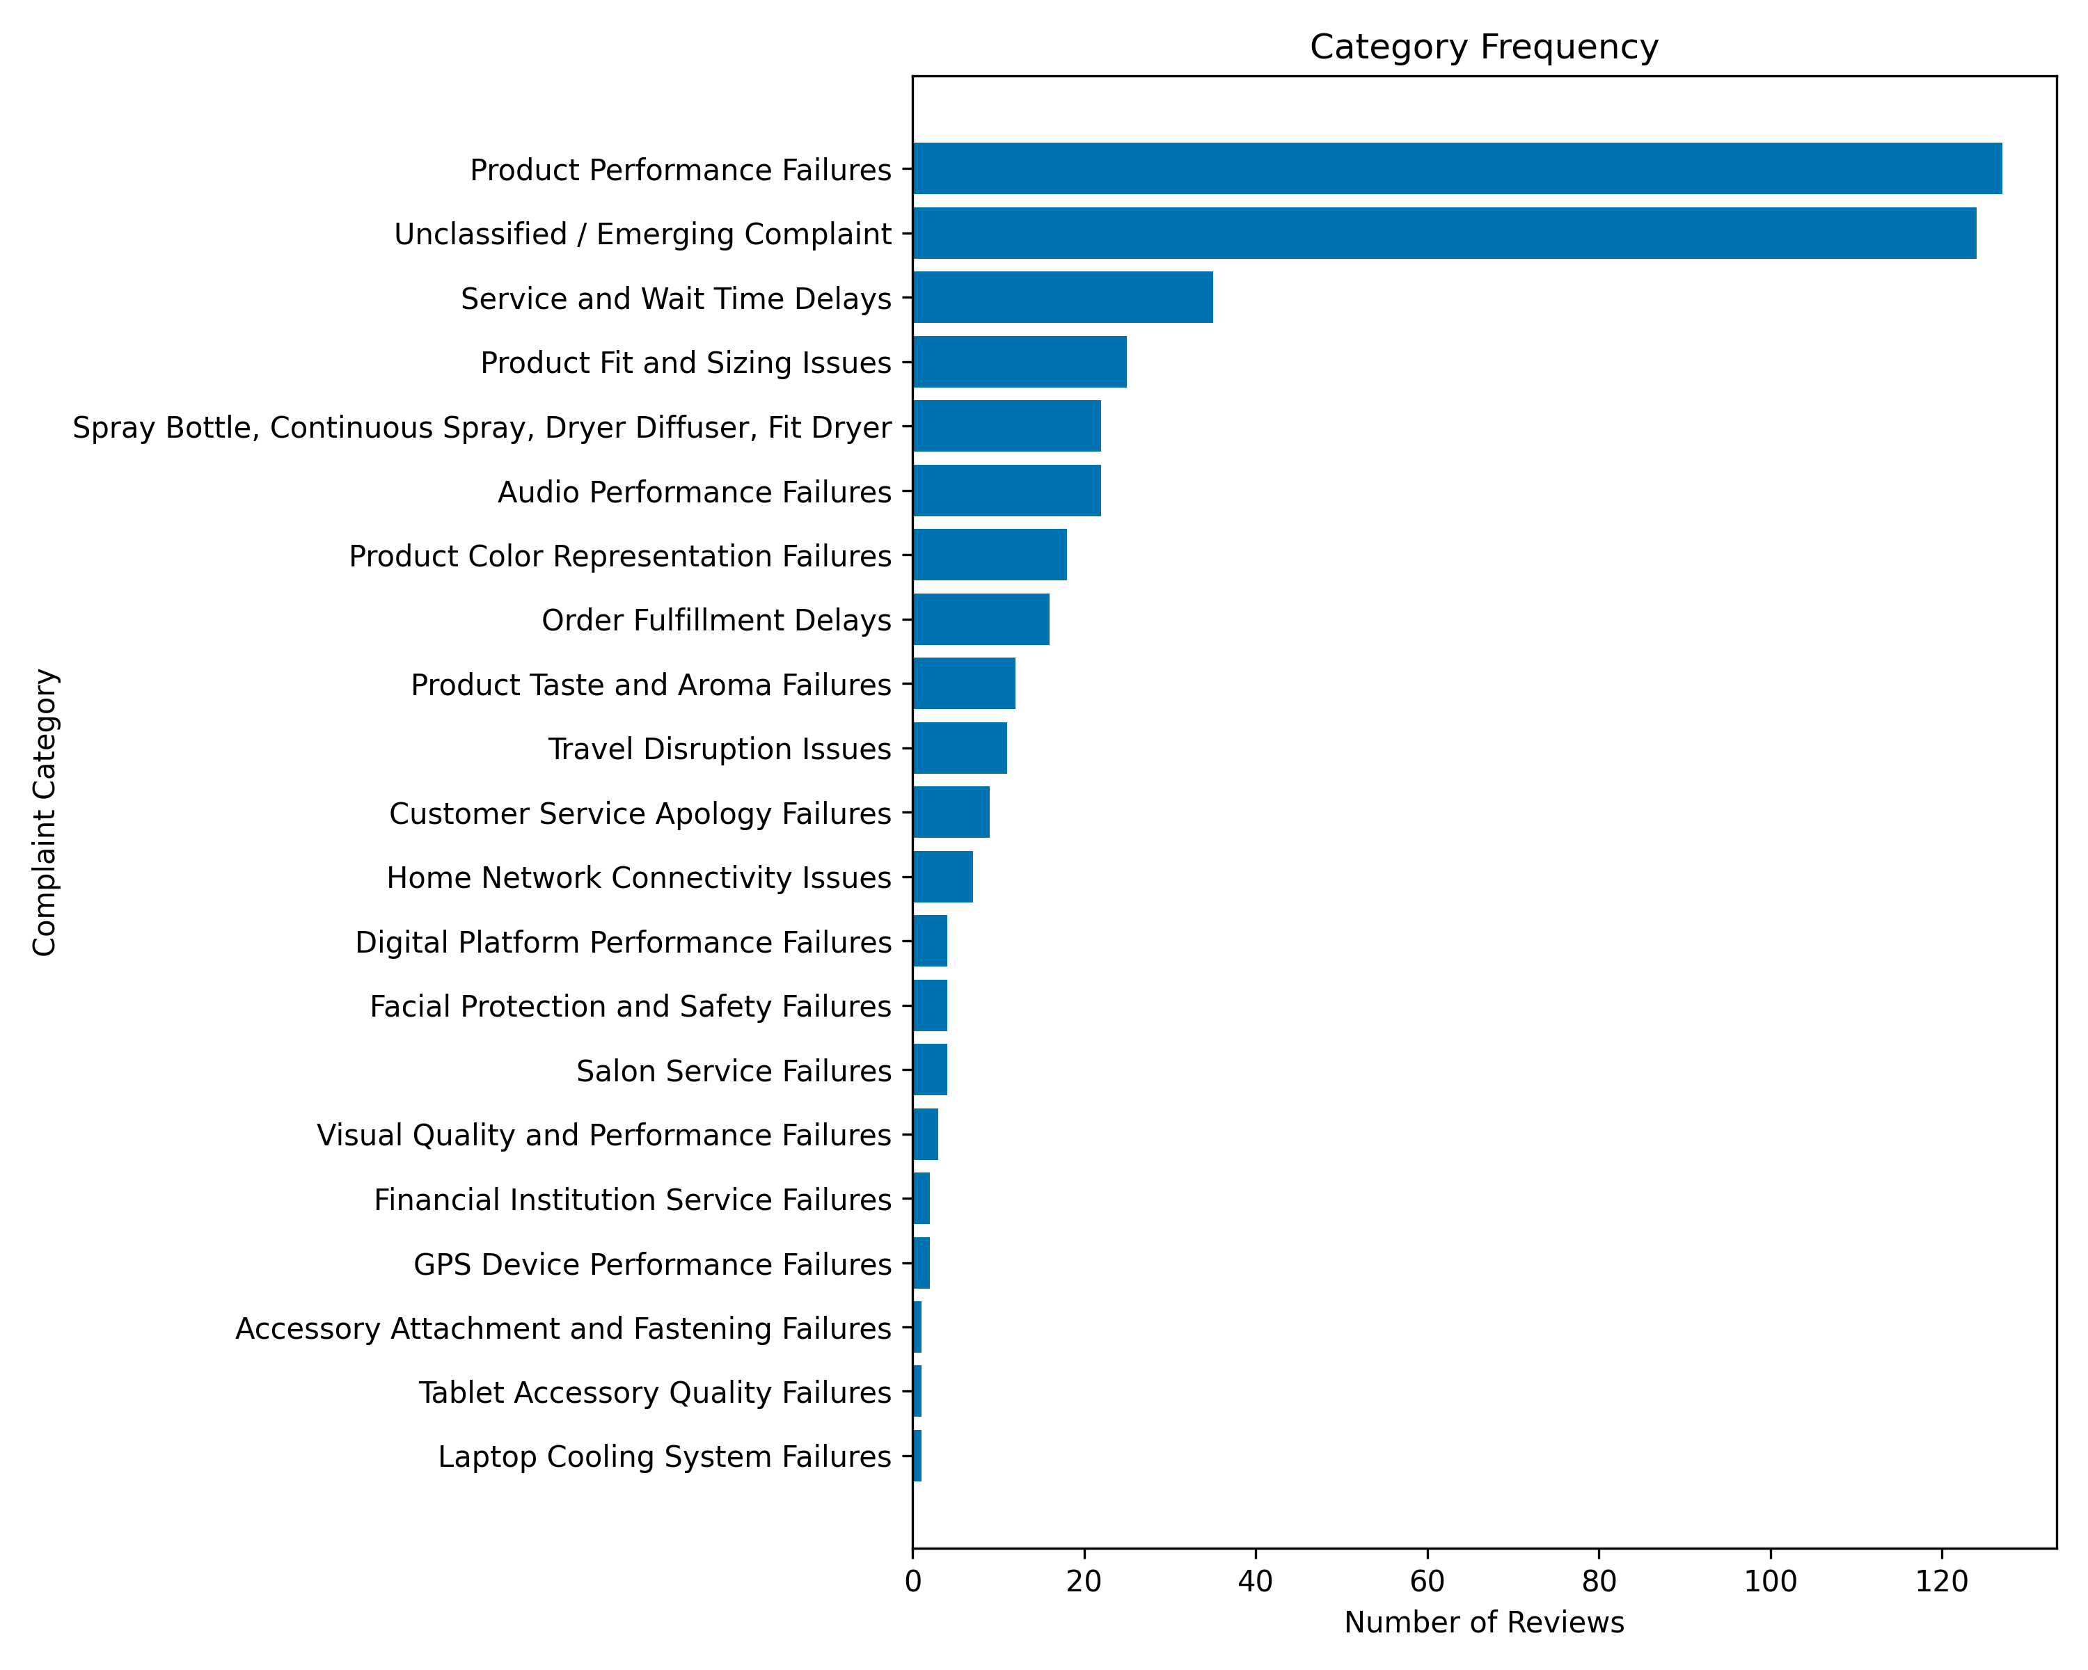
Figure 4.2
Figure 4.2 — Category frequency on the held-out sample (n = 450). Two categories account for 55.8% of assignments; three hold a single review each.
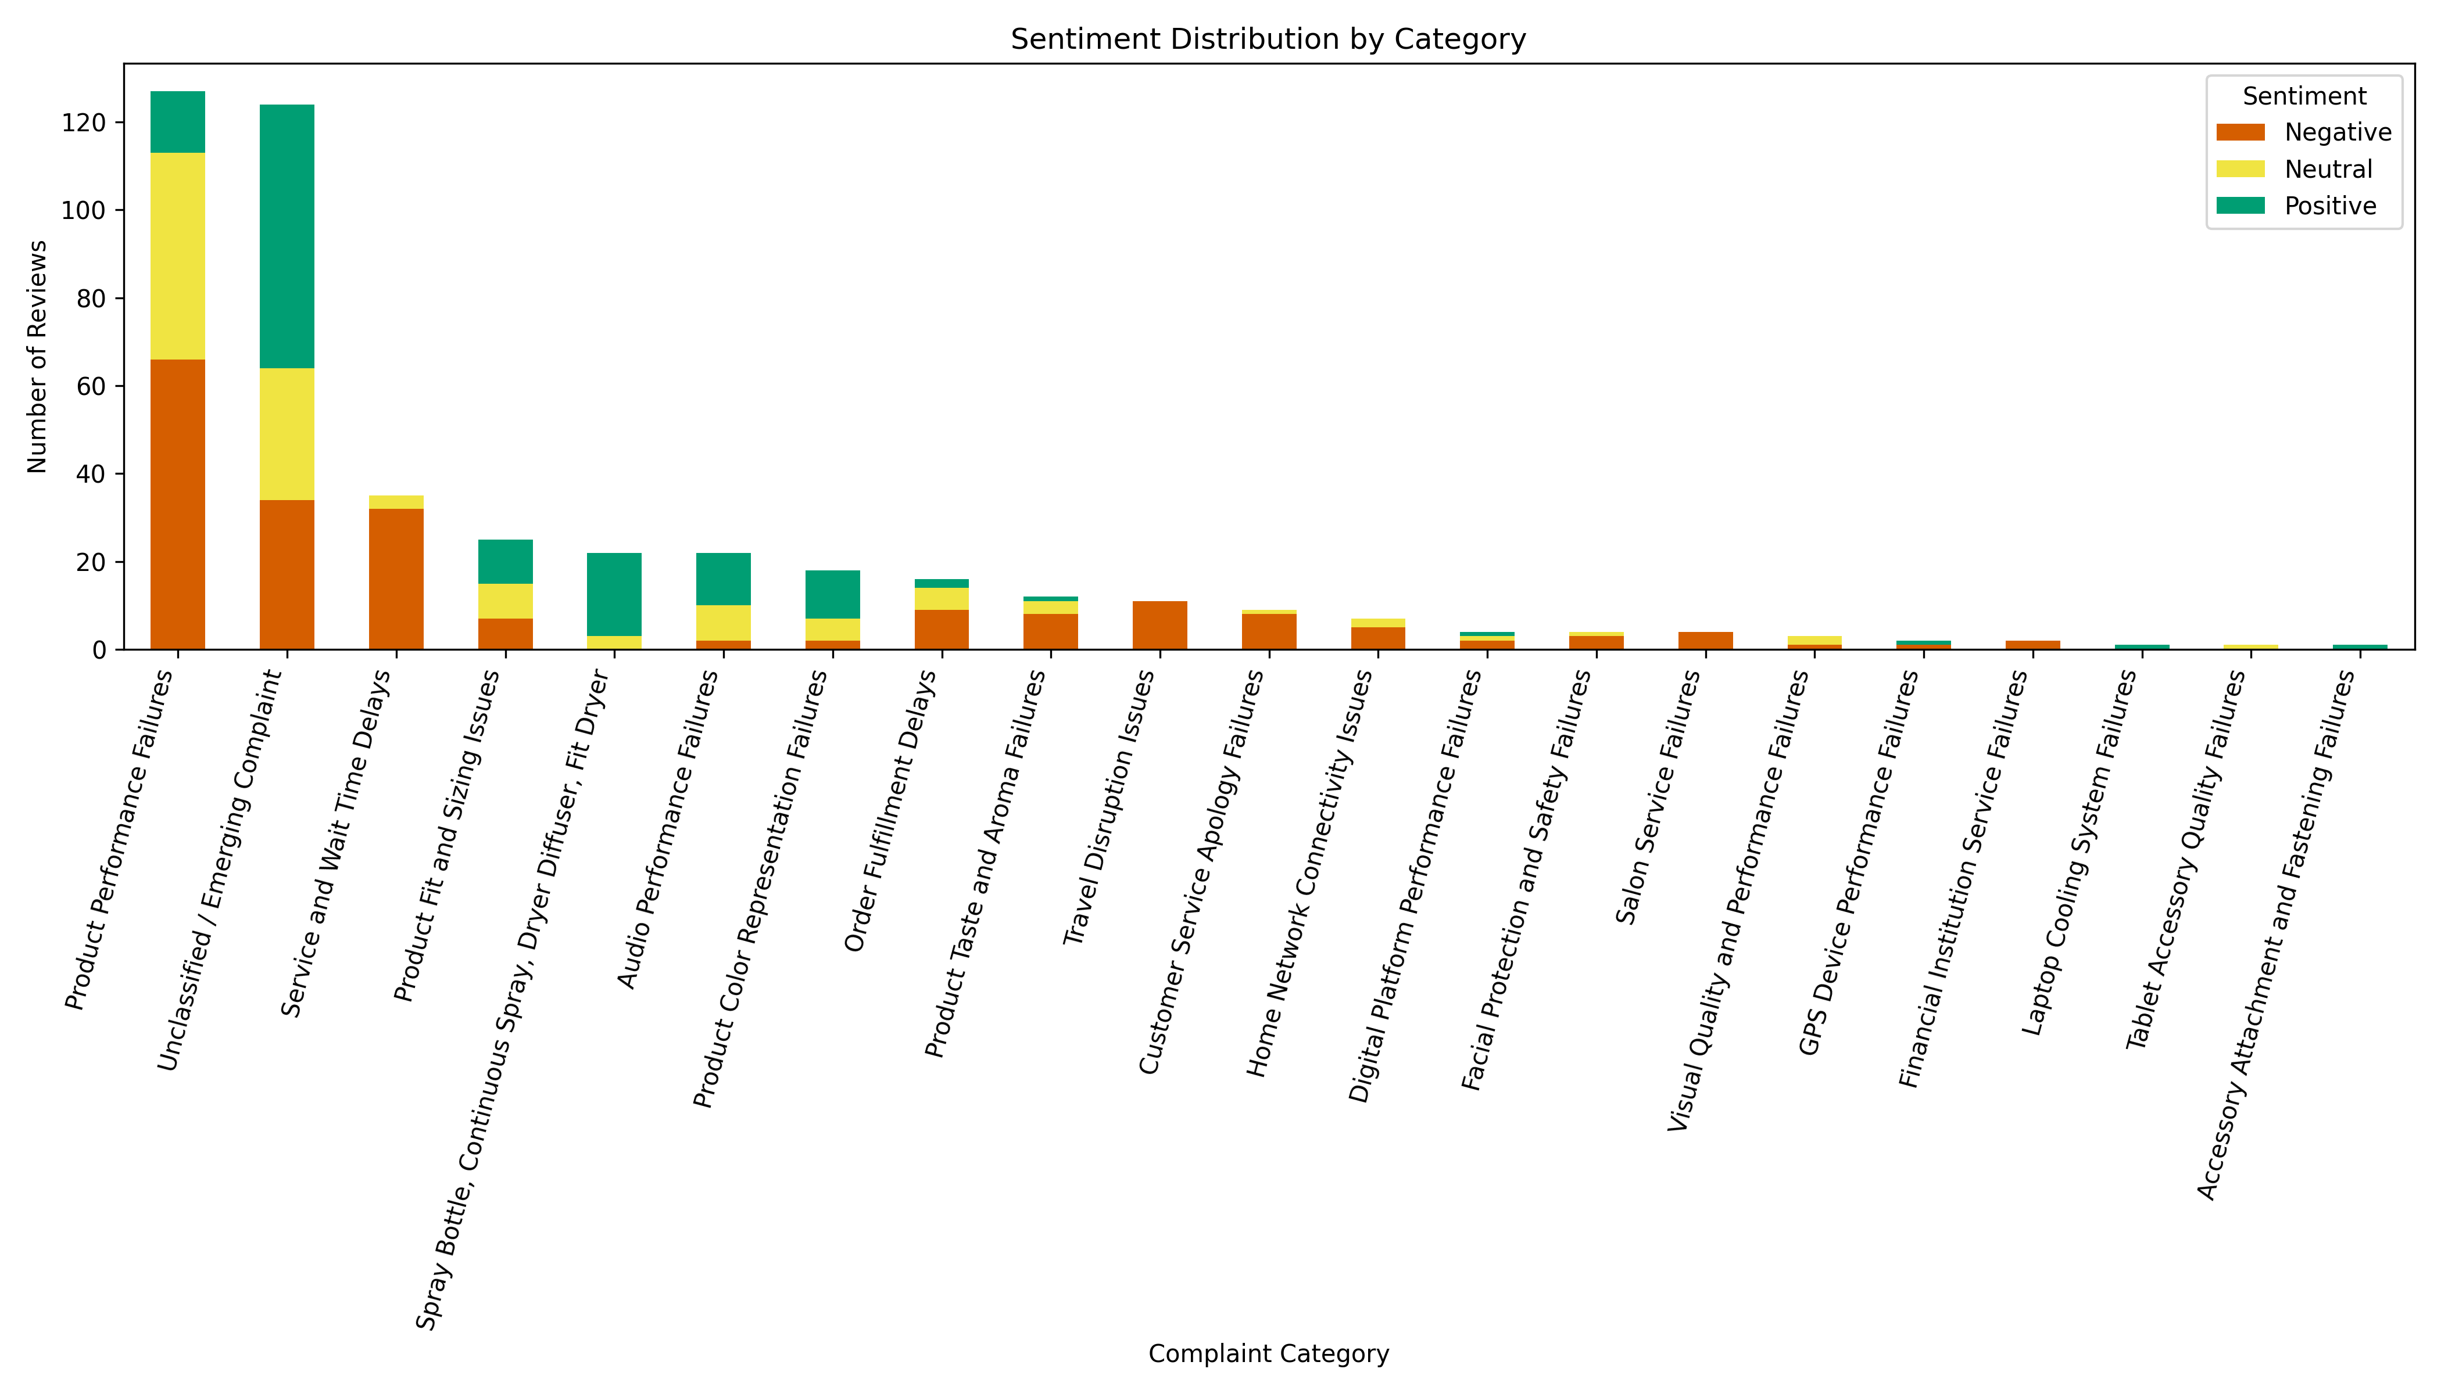
Figure 4.3
Figure 4.3 — Sentiment composition of each category. Several complaint categories contain predominantly positive reviews — the defect discussed above.

4.5.6 Retrieval evaluation
Table 4.7 — Retrieval comparison, 30 queries over 642,692 indexed reviews (source: data/results/comparison_embedding_models/retrieval_comparison.csv)
Metric | Semantic (MiniLM + FAISS) | TF-IDF
Mean retrieval time | 21.71 ms | 127.61 ms
Min / max retrieval time | 15.90 / 36.01 ms | 121.20 / 150.46 ms
Mean similarity score | 0.6833 | 0.5593
Precision@3 | 0.90 | 0.90
Query success rate | 100% | 100%
Dense retrieval is roughly 5.9 times faster, and its latency is also more variable in relative terms while remaining well below the TF-IDF minimum. Precision@3 is identical at 0.90.
Two cautions apply. The similarity scores are not comparable across methods, since cosine similarity over dense embeddings and over sparse TF-IDF vectors measure different quantities; the higher dense figure should not be read as better retrieval. And with 30 queries the comparison is small enough that a modest precision difference could pass undetected. On this evidence the case for dense retrieval rests on latency, not on retrieval quality.

4.5.7 Generation evaluation
Table 4.8 compares the retrieval-augmented pipeline against the standalone baseline on the same five questions, with the same generator, temperature and prompt structure. These figures were regenerated after a hard grounding threshold (SIMILARITY_THRESHOLD = 0.35, rag/pipeline.py) was added to the retriever, which discards a question outright — returning a fixed refusal rather than an answer — when nothing retrieved clears the threshold. An earlier run of the same script, before that threshold existed, produced higher aggregate scores; those figures are superseded and are not reported here, since they describe a pipeline configuration that is no longer the one in rag/pipeline.py. Section 4.6 describes the guard; this section is the evaluation of the system with it in place. One caveat belongs here rather than buried in a footnote: as the per-question data below shows, the threshold itself was not what produced the one refusal observed in this sample — a separate part of the pipeline was responsible, and the difference matters enough to walk through properly rather than gloss over.
Table 4.8 — RAG against standalone LLM (n = 5 questions) (source: data/results/llm_vs_rag/overall_results.csv, comparison_summary.csv)
Metric | RAG pipeline | Standalone LLM
Faithfulness | 0.540 | not computable
Answer relevancy | 0.610 | 0.753
Context precision | 0.416 | not applicable
Context recall | 0.400 | not applicable
Mean latency | 1,582.7 ms | 734.0 ms
Mean retrieved reviews | 3.4 | 0
Faithfulness cannot be computed for the standalone condition because the metric measures whether an answer follows from retrieved context, and no context exists. That absence is itself the finding: the baseline produces answers with no verifiable evidential basis, so the property the pipeline exists to provide is undefined for the alternative.
On the two metrics that can be compared, the standalone model scored higher on answer relevancy — 0.753 against 0.610 — while taking under half the time. Mean retrieved reviews falls to 3.4 because one question returns zero reviews (rejected before retrieval by the scope guard, not the grounding threshold — see the note under Table 4.9) and another returns only two, rather than the fixed five the earlier, un-gated retriever always returned.
Per-question variance is severe, and the aggregate means conceal a pattern that reverses part of this reading. Table 4.9 gives the full per-question breakdown.
Table 4.9 — Per-question RAGAS scores (n = 5) (source: data/results/llm_vs_rag/rag_ragas_scores.csv, llm_ragas_scores.csv)
Question | RAG faithfulness | RAG relevancy | RAG context precision | RAG context recall | LLM relevancy
Why are customers unhappy with battery life? | 0.417 | 0.442 | 0.325 | 1.000 | 0.988
What delivery problems are customers reporting? | 1.000 | 0.740 | 0.756 | 1.000 | 0.000
Why are airline passengers dissatisfied? | 0.400 | n/a¹ | 0.000 | 0.000 | 0.961
What customer service issues appear most often? | 0.000² | 0.437 | 0.000² | 0.000² | 0.964
Summarise the major customer complaints. | 0.882 | 0.819 | 1.000 | 0.000 | 0.853
Mean | 0.540 | 0.610¹ | 0.416 | 0.400 | 0.753
¹ The RAGAS judge raised an OutputParserException while scoring this question’s answer relevancy — the free-tier judge model returned prose instead of the expected structured output — so no score exists for that cell. The reported mean is computed over the remaining four questions, not five, which narrows an already small sample further. This is a concrete instance of the judge-model risk discussed in Section 5.3.4.
² This one needs unpacking rather than a one-line note, because the obvious explanation turns out to be the wrong one. It’s tempting to read this row as the grounding threshold doing its job — no evidence, so no answer — but the text returned doesn’t say that. It matches OUT_OF_SCOPE_MSG verbatim, the message the pipeline’s scope guard returns, not NO_EVIDENCE_MSG, the message the similarity threshold returns. That distinction matters: the scope guard runs first, before retrieval is even attempted, so this question never reached the grounding mechanism at all. Somewhere in the two-stage guard — most likely its LLM classifier, since the keyword list doesn’t contain anything this question would trigger — “What customer service issues appear most often?” was judged out of scope. It plainly isn’t; this is a legitimate complaint-exploration question of exactly the kind the system is built to answer. The same rejection, identical wording, recurred in both conditions of the metadata-tagging ablation described in Section 4.5.8, which rules out coincidence and points to a real, reproducible weak spot in the scope classifier rather than a one-off fluke. Faithfulness, context precision and context recall are mechanically zero here because no retrieval or generation ever happened for this question — not because the pipeline judged its own evidence insufficient.
Four observations follow directly from the table, and are recorded here as evidence rather than interpretation.
The standalone model’s relevancy advantage is driven by the same single anomalous score as before. Its per-question relevancy is 0.988, 0.000, 0.961, 0.964 and 0.853 — four high scores and one complete failure on the delivery question. Excluding that single zero would raise its mean to approximately 0.941; including it gives 0.753. The RAG pipeline’s four scored questions range from 0.437 to 0.819, a spread of 0.38 — wider than the earlier, un-gated run, but still narrower than the baseline’s spread of 0.99.
The false rejection on the customer-service question is the most consequential single result in this table, but it credits the wrong mechanism if read carelessly. It is not the grounding threshold working as designed — no retrieval was even attempted — it’s the scope guard misfiring on a question it should have passed straight through. The practical effect looks similar to a deliberate refusal (no answer, rather than a possibly wrong one), which limits the damage, but the cause is different, and Section 4.5.8’s ablation results depend on getting this distinction right rather than folding it into the grounding-threshold story. It also mechanically depresses three of the four aggregate metrics for this question, since a rejection scores zero on faithfulness, context precision and context recall by construction, the same way a grounding refusal would.
Retrieval quality is still the pipeline’s weakest measured component among the questions that actually reached it. Context precision fell to zero on two of five questions — airline and, by construction, the rejected customer-service question — and on the airline question, faithfulness fell with it, to 0.400, rather than remaining high as it did in the earlier, un-gated run, where a zero-precision question still produced an answer scored 0.917 on faithfulness. That’s a genuine improvement: the pipeline no longer generates a confident, well-formed answer from evidence its own retrieval judged irrelevant. Whether the grounding threshold itself deserves the credit for that, though, is a separate question from whether the scope guard behaved correctly, and this sample doesn’t actually contain a case of the threshold refusing a question with retrieved-but-irrelevant evidence — that’s a gap worth flagging for a future, larger evaluation, not something this table can settle either way.
Context recall is now 0.000 on three of five questions and 1.000 on the remaining two, and the three zero cases have different causes that should not be collapsed into one. On the summarisation question it repeats the earlier finding — an open-ended request with no specific topic to retrieve against, a structural limitation of similarity-based retrieval rather than a tuning failure. On the airline question it reflects genuinely thin retrieval: only two reviews cleared the threshold, and neither covers the reference answer’s specific topics (delays, cancellations, lost luggage). On the customer-service question it is the mechanical consequence of the scope guard’s false rejection, not of anything retrieval did.
Three constraints qualify all of these figures. Sample size follows from free-tier API rate limits, which capped the available evaluation call volume; with n = 5 (n = 4 for relevancy) the means carry very wide uncertainty and no confidence interval is reported because none would be meaningful at this sample size. The judge model is the model that generated the answers, so the self-enhancement bias documented in Section 2.1.2 applies — though that bias would act to inflate the pipeline’s scores rather than the baseline’s, so it cannot explain the relevancy result. And the judge’s own output failed to parse on one question, discussed above, which is itself evidence for that same judge-reliability concern rather than a separate issue.
A note on evaluation scope. Four ablation conditions were designed for the retrieval stage (Section 3.6.5). Three of them — retrieval depth, retriever type and prompt version — were specified but never built, so the contribution of those design decisions is still argued from reasoning rather than measured. The fourth, metadata tagging, was built and run, and Section 4.5.8 reports what it found.

4.5.8 Ablation: does metadata tagging actually help?
Section 3’s design chapter argues that tagging each retrieved review with its platform, rating and sentiment before it reaches the generator (DOCUMENT_PROMPT in rag/pipeline.py) is what makes RAG_PROMPT’s grounding rules enforceable rather than aspirational. Until now that was a claim defended by reasoning, not evidence. evaluate/ablation_metadata_tagging.py tests it directly: the same five questions, run twice through the same pipeline, once with the tags left in place and once with them stripped so the generator sees only the raw review text. Retrieval is identical in both runs — same threshold, same MMR selection — so any difference in the RAGAS scores can only come from what the generator was shown, not from what was retrieved.
Table 4.10 — Metadata tagging ablation (n = 5 questions) (source: data/results/ablation_metadata_tagging/comparison_summary.csv)
Metric | Tagged | Untagged | Delta
Faithfulness | 0.667 | 0.549 | +0.118
Answer relevancy | 0.452 | 0.654 | −0.202
Context precision | 0.416 | 0.416 | 0.000
Context recall | 0.400 | 0.400 | 0.000
The clean part of the result first: context precision and context recall are identical, to three decimal places, between conditions. That’s exactly what the design predicts, since neither condition touches retrieval, and it’s reassuring in a small way — it confirms the ablation is actually isolating what it claims to isolate, rather than some confound in how the two runs were set up.
The interesting part is that tagging doesn’t win cleanly. Faithfulness goes up with tags, by a solid margin — 0.667 against 0.549 — which does support the argument that citing each review’s platform and rating gives the model something concrete to stay anchored to. But answer relevancy goes the other way, and by more: 0.452 tagged against 0.654 untagged, a drop of 0.202. That’s not a rounding artefact; it’s the largest single delta in the table. A plausible explanation is that the tagged answers spend more of their length on citation-style attribution — “(Yelp, Rating: 1.0, Sentiment: negative)” — while the untagged answers read more like a direct response to the question, which is closer to what an answer-relevancy judge is actually scoring. If that’s right, the tagging design buys grounding at a real cost to how responsive the answer feels, and the honest conclusion is a trade-off rather than a validation.
One concrete example is worth quoting directly, because it’s exactly the failure mode the tagging is meant to prevent, caught in the act. For the battery-life question, the untagged run’s answer opens with “Platform(s) covered: Twitter Airline, Amazon” — but none of the five retrieved reviews for that question mention an airline; they’re about product batteries and an in-store replacement service, plausibly Amazon and Yelp. The tagged run’s answer for the same question and the same retrieved reviews says “Platform(s) covered: Yelp, Amazon,” which matches what was actually retrieved. That’s a real, observed instance of RAG_PROMPT rule 3 — never reference a platform absent from the retrieved reviews — being violated without the tags and respected with them. It’s one example, not a pattern established across many questions, but it’s the kind of concrete evidence the design argument in Section 3 didn’t have before this ablation ran.
The latency figures (1,704.6 ms tagged against 501.3 ms untagged) are reported for completeness but shouldn’t be read as an effect of tagging itself — the two conditions ran as separate sequential API calls to the same free-tier Groq endpoint, and a gap this large is more consistent with ordinary variance in queueing and network latency between calls than with tag text meaningfully changing generation time. No claim rests on it.
Taken together: this is the one piece of the planned ablation suite that got measured rather than argued, and it converts a two-line design justification into a genuine, if narrow, empirical finding — metadata tagging measurably improves faithfulness and produces at least one avoided platform hallucination, at a measurable cost to answer relevancy. The other three planned conditions (retrieval depth, retriever type, prompt version) remain unexecuted, and this single result should not be read as standing in for them.
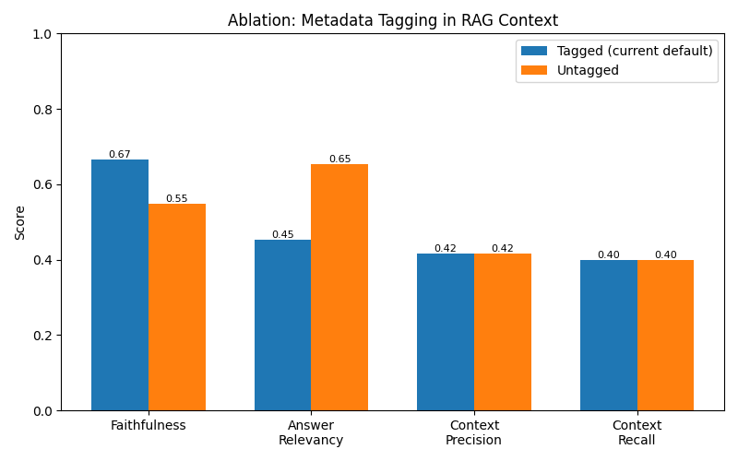
Figure 4.4
Figure 4.4 — Metadata-tagging ablation: tagged against untagged RAGAS scores across all four metrics. Context precision and recall are identical by construction; faithfulness and answer relevancy move in opposite directions. (Produced by evaluate/ablation_metadata_tagging.py.)

4.6 Deployment
The system was not deployed to production. What exists is a programmatic interface together with a local application layer built to make the components usable and demonstrable.
The ask() function in rag/pipeline.py accepts a question and optional conversation history, and returns the generated answer, the source reviews supporting it with their platform, rating, sentiment and review identifier, a retrieval count, and a flag indicating whether the answer is grounded. A similarity threshold and a two-stage scope guard reject out-of-domain questions and insufficient evidence before generation, and a post-generation check discards any answer produced without retrieved context. This is the form in which the system is used, and it is what the evaluation in Section 4.5.7 exercises.
A local FastAPI service and Streamlit interface expose these components for inspection. This layer is an engineering artefact supporting demonstration and manual checking; it is not a research result and no claim rests on it. Production deployment is identified as future work in Chapter 6.

4.7 Chapter Summary
The sentiment comparison produced a clear ranking, with the fine-tuned transformer highest at 0.8375 macro F1 on clean held-out data and the lexicon baseline lowest at 0.4381 on the shared test set. It also produced two results contradicting the expected ordering: a pretrained transformer 23 points of macro F1 below a linear model, and both off-the-shelf methods failing specifically on the neutral class while performing acceptably on the other two. McNemar’s exact test found nine of ten pairwise differences significant on the diagnostic sample, the exception being Naive Bayes against RoBERTa at p = 0.82.
The diagnostic experiments established where the anomaly comes from. RoBERTa’s macro F1 varies by 23 points across platforms and it outperforms both classical models on the Twitter data resembling its pretraining corpus, while removing the neutral class raises its binary macro F1 to 0.9341, above logistic regression’s 0.9216. VADER’s threshold sweep improved macro F1 by 0.026 at best, so decision-boundary choice accounts for part but not most of its weakness.
Complaint discovery produced 121 raw topics consolidated into 24 well-separated categories at 0.2831 centroid separation. Applied to held-out data the taxonomy used 21 of them, achieved 0.6334 mean within-category coherence, and left 27.6% of reviews unclassified. Two categories absorbed 55.8% of the sample between them. Three defects were recorded: a catch-all largest category with low internal coherence, a failed language-model naming step leaving a raw topic label in the taxonomy, and no mechanism for rejecting non-complaints, with positive reviews assigned to complaint categories.
Retrieval showed dense embeddings to be 5.9 times faster than TF-IDF at identical Precision@3 of 0.90. On five questions the retrieval-augmented pipeline, evaluated with a hard grounding threshold in place, achieved 0.540 faithfulness and 0.416 context precision, while the standalone baseline scored higher on mean answer relevancy, 0.753 against 0.610, despite having no evidence to be faithful to — an advantage that rests substantially on a single anomalous score in a set of five and is smaller in consistency terms, since the baseline’s per-question relevancy spans 0.99 against the pipeline’s 0.38. One question in this sample went unanswered, but tracing it back showed the grounding threshold wasn’t actually responsible: the scope guard rejected it before retrieval ran, a false positive rather than the threshold correctly declining insufficient evidence. A separate, executed ablation on metadata tagging (Section 4.5.8) found a genuine trade-off rather than a clean win — tagging lifted faithfulness by 0.118 and cost 0.202 on answer relevancy, with one directly observed case of a platform hallucination it prevented.
Chapter 5 interprets these results against the four research questions and the literature reviewed in Chapter 2.

CHAPTER 5: DISCUSSION
Chapter 4 reported what happened. This chapter argues about what it means: why the results took the form they did, how they sit against the literature reviewed in Chapter 2, and how far each objective was met. Section 5.1 interprets the sentiment findings, 5.2 the taxonomy, 5.3 the retrieval and generation results. Section 5.4 compares with existing research, 5.5 examines cost, 5.6 evaluates the study critically, and 5.7 assesses each research question.

5.1 Sentiment Classification

5.1.1 Why the pretrained transformer lost
RoBERTa scored 0.5694 macro F1 against logistic regression’s 0.8033. Taken at face value this contradicts a well-established finding. It does not, and the diagnostic evidence explains why.
One qualification narrows the claim first. McNemar testing shows the gap to logistic regression is robust at p = 2.6 × 10⁻⁴, but the gap to Naive Bayes is not: on the 675 reviews where those two disagree, each is correct on almost exactly half, giving p = 0.82. The defensible statement is that the pretrained transformer underperformed the stronger classical model, not classical machine learning as a family — a distinction visible only because the comparison was tested rather than read off a table.
The failure is confined to one class. RoBERTa’s per-class F1 is 0.743 negative and 0.740 positive, both respectable, against 0.225 neutral. The confusion matrices locate the error precisely: 85.7% of genuinely neutral reviews are pushed to a pole. Separating precision from recall sharpens this further — neutral precision is 0.522 while recall is 0.143. When the model does assign the label it is right about half the time; what it fails to do is assign it at all. A recall failure with intact precision is the signature of a decision boundary that never reaches the middle class.
Two experiments confirm rather than assert this. Removing the neutral class raises RoBERTa’s macro F1 from 0.6669 to 0.9341, above logistic regression’s 0.9216 — the expected ordering returns the moment the offending class is removed, which would not happen if the model were generally inferior. And the per-platform breakdown shows neutral F1 of 0.713 on Twitter Airline against 0.198 on Yelp: the same model handles the same class competently on one platform and fails on another.
The explanation follows from what the model is. twitter-roberta-base-sentiment-latest was pretrained on tweets for a scheme in which neutral means a human judged a post to express no clear sentiment (Barbieri et al., 2020). On Amazon and Yelp, neutral means a three-star rating — a compound judgement often containing both praise and complaint. A model trained to recognise affectively flat text will not recognise a mixed three-star review as neutral, because such a review is not flat but contradictory. The error analysis in Section 4.5.4 shows this concretely: the misclassified true-neutral cases carry explicit praise and explicit criticism together — “the tea is very good however the bags are fragile”. A three-star rating encodes a net judgement across both clauses; a model whose neutral class means no clear sentiment has no representation for that and must choose a pole.
The evidence supports this interpretation rather than proving it. Establishing causation would require re-testing the same checkpoint against human-annotated neutral labels on review prose, which was not done. What can be said is that four independent observations — the recall-specific failure, the platform-conditional reversal, the recovery under binary evaluation, and the character of individual errors — are jointly consistent with label mismatch and hard to explain by general inferiority.
The practical implication is direct: an off-the-shelf sentiment model is only as transferable as its label definition, and no benchmark accuracy tells a practitioner whether that definition matches their data.

5.1.2 The ranking reverses by platform
The per-platform evidence is stronger than a diagnosis of one anomaly. On Twitter Airline, RoBERTa achieves 0.7853 macro F1 against logistic regression’s 0.6434 and Naive Bayes’s 0.4838 — the transformer wins decisively. On Yelp the ordering inverts, RoBERTa at 0.5544 against logistic regression’s 0.7948. Naive Bayes shows the mirror image, 0.7952 on Amazon and 0.4838 on Twitter. Two models swap places entirely depending on which platform judges them.
No single ranking is correct. Which method is best depends on the relationship between training and target domain, and a study on one platform would have concluded confidently and incorrectly in either direction. This is the chapter’s most substantive finding for RQ1, and it exists only because the comparison ran across three registers with per-platform reporting — precisely the design that the aggregate-metric convention criticised in Section 2.1.3 would have prevented.

5.1.3 Why VADER failed, and why the obvious explanation is wrong
VADER’s macro F1 of 0.4381 against accuracy of 0.5142 is the widest gap between those measures of any model here, and the gap is the finding. Random guessing on this balanced three-class task scores about 0.333 on both, so VADER is well above chance; what it is not is evenly competent, and accuracy alone would have concealed that.
The intuitive explanation is miscalibrated thresholds: the default neutral band of ±0.05 is narrow, so few texts are assigned neutral. That is testable, and the threshold sweep largely rejects it. Widening the band raises macro F1 from 0.5094 to a maximum of 0.5353 at ±0.25 — a gain of 0.026 — after which it declines as the band swallows genuinely polar reviews. Threshold choice accounts for a modest fraction of the gap, not most of it.
The larger problem is the lexicon. VADER labels 40.4% of genuinely negative reviews positive, which is systematic failure of word-level scoring on mixed vocabulary. A one-star review reading “Worked well and looked good until keys stopped working after 3 months” scores +0.477, because the complaint is carried by temporal contrast rather than negative vocabulary. These errors sit confidently on the wrong side of the boundary rather than near it, which is why widening the band recovers so little.
The finding still supports VADER’s role. As a baseline it establishes what rules alone achieve, and the roughly 40-point gap to the fine-tuned transformer quantifies the value of learning from data — a floor invisible had no untrained method been included.

5.1.4 What fine-tuning actually buys
The fine-tuned model reached 0.8375 macro F1 on clean held-out data, and is notably stable: 0.8448 on Amazon, 0.8301 on Yelp, 0.8505 on Twitter. Where the pretrained model varied by 23 points across platforms, this varies by two. That stability is the real return, and it is a different claim from the usual one. The gain over logistic regression on aggregate macro F1 is modest — roughly two points, though McNemar confirms it at p = 1.7 × 10⁻²¹. The gain in cross-domain consistency is larger and less often reported, and for a practitioner processing several feedback sources it matters more.
Explaining the gap to the classical models requires accounting for three mechanisms. TF-IDF discards sequence, so “not worth the money” and “worth the money, not…” produce identical vectors, while self-attention conditions each token on context and can represent negation scope (Devlin et al., 2019). Subword tokenisation handles unseen vocabulary that Naive Bayes cannot represent at all. But the third mechanism is the most instructive and concerns the classical family itself: Naive Bayes trails logistic regression by 4.5 points despite identical features, because its conditional independence assumption is plainly false for text. Roughly two thirds of the distance between Naive Bayes and DistilBERT is recovered simply by replacing one linear model with a better-specified linear model — the transformer architecture accounts for less of the gap than it appears to.
The per-class evidence locates the remainder: DistilBERT’s gain over logistic regression concentrates in the neutral class, 0.747 against 0.718, precisely the case requiring contradictory evidence to be weighed within one review. The practical consequence follows directly. For a business separating satisfied from dissatisfied customers only, fine-tuning buys little — on binary re-evaluation the two models sit at 0.9533 and 0.9216, three points for three hours of GPU training and a 257 MB artefact.

5.2 Complaint Taxonomy

5.2.1 What worked, and the platform asymmetry that explains the rest
Consolidation worked at the level it was designed for: 121 raw topics reduced to 24 categories at 0.2831 centroid separation, with 0.6334 mean within-category coherence and 21 categories used. The per-platform discovery decision was vindicated — Yelp produced 18 topics from 149,838 documents while Amazon produced 69 from 57,931, so pooling would have let the larger corpus dominate and produced a taxonomy describing Yelp’s concerns while claiming to describe feedback generally.
That asymmetry is the most informative structural result, and it is not a parameter artefact — minimum topic size was scaled to each platform’s document count precisely to prevent that. The cause is semantic breadth. Amazon spans electronics, groceries, clothing and cosmetics, where a failing battery, a stale flavour and a distorted speaker share almost no vocabulary, so HDBSCAN finds many small dense regions. Yelp is narrow by comparison — restaurants, bars, salons, where complaints concentrate on service, waiting and food quality — so many documents describe few underlying concerns and produce few large clusters.
The merge therefore does different work on each platform: genuine consolidation for Amazon, closer to relabelling for Yelp, with compression ratios differing by almost a factor of four. The taxonomy consequently fits Yelp’s structure better than Amazon’s, and three consequences follow. The catch-all behaviour below is predictable rather than surprising. Imposing one target count across platforms of different intrinsic granularity is questionable. And the reduction discarded distinctions a business would care about — knowing complaints concern battery life is more actionable than knowing they concern product performance. The level of aggregation should follow the decision it supports: 24 categories suits executive reporting, but a product team investigating a specific failure needs the 69 Amazon topics the merge discarded.

5.2.2 Where it failed
Three defects are more informative than the headline figures, and none is softened.
First, 27.6% of held-out reviews fell below the confidence threshold and were left unclassified. This is a coverage failure, but a visible one: the threshold was set so weak matches would be recorded rather than forced. Had it been removed, those 124 reviews would have been distributed among existing categories and the taxonomy would have appeared to work considerably better than it does. The decision producing the unflattering number is the same decision making the number trustworthy.
Second, the largest category absorbed 28.2% of the sample while showing among the lowest coherence at 0.3997. The inverse relationship between size and coherence — 0.6763 for an eleven-review category against 0.3997 for a 127-review one — indicates a catch-all accumulating loosely related complaints because nothing more specific fits. Two buckets hold 55.8% of the sample while three categories hold one review each: a taxonomy simultaneously too coarse in one region and too sparse elsewhere. The target of 24 was chosen in advance rather than derived from the data, and this suggests that choice was not optimal.
Third, and most seriously, the taxonomy cannot reject non-complaints. It was built from negative reviews but applied to reviews of all sentiments, and positive reviews duly entered complaint categories: one category received 19 positive and zero negative, and the unclassified group holds 60 positive against 34 negative. The zero-shot classifier scores relative fit among candidates; it has no notion of whether a text is a complaint at all. A sentiment filter before assignment would fix this, which makes it a design error rather than a limitation of the method — a distinction worth keeping, since it means the finding is correctable.
A fourth, smaller defect signals a reliability issue: one category retained an un-renamed raw BERTopic label, meaning the naming step failed silently and no validation caught it. That the same category received 19 positive and zero negative reviews suggests both defects may share a cause — a cluster that resisted naming may have been incoherent to begin with.

5.2.3 The evaluation problem itself
These conclusions rest on unsupervised measures whose weakness deserves acknowledgement. Section 2.1.3 reviewed evidence that automated coherence corresponds to human judgement more weakly than routine use implies (Hoyle et al., 2021; Doogan and Buntine, 2021; Lim and Lauw, 2024). The approach taken here — several imperfect indicators plus a manual sample — follows that critique but does not escape it: the coherence figures are embedding-based, and the same MiniLM model produced both the clusters and the measure of their quality, which is a circularity worth naming.
This is why the argument above rests where it does. The strongest evidence against the taxonomy is not the coherence values but the structural observations — unclassified rate, size distribution, sentiment breakdown, failed naming step — all directly countable and dependent on no contested metric. Reporting only mean coherence of 0.6334 would have described a working taxonomy. The multi-indicator design prevented that conclusion, and this is the clearest instance in the dissertation of an evaluation choice changing a finding.

5.3 Retrieval and Generation

5.3.1 Retrieval
Dense retrieval was 5.9 times faster than TF-IDF at identical Precision@3 of 0.90. The honest reading is narrow: on these 30 queries the embedding retriever does not find relevant reviews more often, it finds them faster. The similarity scores cannot support a quality claim either, since cosine similarity over dense and sparse vectors measures different quantities. The result is still useful, because latency determines whether interactive question answering is viable — but the case for dense retrieval here is architectural rather than a claim about accuracy. With 30 queries a modest genuine difference could also pass undetected, so equal Precision@3 should be read as “no difference demonstrated” rather than “no difference exists”.

5.3.2 The relevancy comparison
On mean answer relevancy the standalone model scored 0.753 against the pipeline’s 0.610, in under half the time — 734.0 ms against 1,582.7 ms. On that metric, retrieval made the system worse.
The per-question breakdown complicates this in both directions. The baseline’s scores are 0.988, 0.000, 0.961, 0.964 and 0.853: it wins four of five, several by wide margins, and its mean is dragged down by one complete failure on the delivery question. Excluding that would place it near 0.941. The unconstrained model is genuinely more responsive on most questions, and reporting only means would understate that.
But the same data shows the two failing differently. The pipeline’s four scored questions span 0.437 to 0.819, a range of 0.38; the baseline’s spans 0.99. The baseline has the higher ceiling and the lower floor — on the question where it collapsed entirely, the grounded pipeline scored 0.740, its second-highest. A practitioner choosing between them is choosing between higher average responsiveness with occasional total failure, and lower average responsiveness that varies with retrieval quality. Five questions is far too few to establish which pattern generalises; one anomalous score moves the baseline’s headline by nearly two tenths, which is an argument about sample size rather than about the systems.
What retrieval demonstrably provides is measurable grounding. Faithfulness of 0.540 indicates a majority of claims follow from retrieved evidence, and the metric is simply undefined for the baseline, since there is no context for an answer to be faithful to. That absence is the finding, not a gap: the baseline’s fluent answers rest on nothing checkable, and its relevancy advantage is earned precisely by not being constrained to evidence. A study reporting only answer relevancy would have concluded that retrieval augmentation degrades performance — the concrete demonstration of why Section 2.2.3 argued for four metrics rather than one. Self-enhancement bias cannot explain the result away either: because the same model generates and judges, bias would inflate the pipeline’s scores rather than the baseline’s, so the threat runs against the observed result.

5.3.3 Three components, three different verdicts
The component metrics isolate where the pipeline underperforms, and the answer is not where prompt-engineering attention usually goes. It is also not one story: one part of this system needs a genuinely different fix.
Context precision averages 0.416, falling to zero on two questions. These two zeros look identical in the table but come from different places, and treating them as one finding would be a mistake. On the airline question retrieval genuinely happened and genuinely struggled — two thin, largely uninformative reviews cleared the threshold, and faithfulness fell with them to 0.400 rather than staying artificially high as it did in an earlier, un-gated version of this pipeline, where a comparable zero-precision question still scored 0.917. That earlier result described a system being faithful to evidence its own retrieval had judged irrelevant. The grounding threshold closes exactly that gap here.
The customer-service question is a different matter, and pinning it on the threshold would credit the wrong component. Retrieval was never attempted. The scope guard — the two-stage check meant to catch questions about weather or sport — rejected “What customer service issues appear most often?” as out of scope, which it plainly is not. The returned text matches the scope guard’s fixed message, not the threshold’s, and the same false rejection recurred identically across both conditions of the metadata-tagging ablation: three runs, one consistent misfire. That is a finding about the scope classifier’s precision, not a demonstration of the grounding threshold succeeding.
Context recall is 0.000 on three of five questions for three different reasons. On the summarisation question it repeats the earlier finding — the only open-ended question, with no specific topic to retrieve against, a structural limitation of similarity-based retrieval rather than a tuning failure. On the airline question it reflects genuinely thin retrieval. On the customer-service question it is the mechanical consequence of the false rejection.
This is exactly the diagnostic Yu et al. (2024) argue aggregate RAG scores cannot provide, and it matters twice over here: once for separating grounded-but-mediocre answers from confident hallucination, and again for separating a retrieval weakness from a scope-classification bug that looks similar in the numbers. A single composite score would have prompted prompt revision; the actual diagnosis is narrower — retrieval quality needs work on thinly-covered questions, and the scope guard needs a precision fix that has nothing to do with retrieval.

5.3.4 What the generation results cannot establish
Five questions is too few. Per-question faithfulness ranged from 0.000 to 1.000, context precision from 0.000 to 1.000, context recall was 0.000 on three of five. The specific values should not be quoted as measurements of system quality, and no confidence interval is reported because none would be meaningful. What the evidence supports is qualitative: that relevancy and faithfulness diverge, that grounding is measurable for one system and undefined for the other, that retrieval is the weaker component among questions it attempts, and that a false rejection can look indistinguishable from a deliberate refusal in aggregate numbers while meaning something very different about how far to trust the system.
The judge model is the second constraint, and this run produced a direct instance rather than a theoretical one: the RAGAS judge raised an OutputParserException scoring the airline question’s relevancy, so that score is missing rather than measured and the mean is computed over four questions. Using the generating model as evaluator is a known threat catalogued in Section 2.2.3 (Gu et al., 2024; Li et al., 2024). It was accepted because free-tier limits made an independent judge impractical, and it bounds confidence in the RQ2 and RQ4 conclusions.

5.4 Comparison with Existing Research
The overall ordering matches the literature — fine-tuned transformers best, classical next, lexicon worst — consistent with the comparative studies reviewed in Section 2.1.2, and BERTopic produced usable topics from short informal text where LDA is documented to struggle (Turan et al., 2024; Egger and Yu, 2022).
Table 5.1 — This study against published work
Source | Task | Dataset | This study
Areshey and Mathkour (2024) | Binary polarity, five transformers | Yelp | Binary re-evaluation: DistilBERT 0.9533, RoBERTa 0.9341
Ali et al. (2024) | Three-way ML/DL/transformer | Amazon | Three-class, three platforms: DistilBERT 0.8375
Sunar (2025) | Embedding comparison | Amazon Magazine Subscriptions | DistilBERT best in both
The apparent gap against published Yelp benchmarks is a task difference, not a modelling shortfall, and this study shows that with its own data rather than by quoting someone else’s. Binary studies remove the ambiguous middle class; removing it here — same corpus, same models, only the task definition changed — raises DistilBERT from 0.8375 to 0.9533 and RoBERTa from 0.6669 to 0.9341. Adding a third class costs this pipeline roughly twelve points of macro F1, so a substantial part of the headline performance in the binary literature depends on having excluded the hardest cases.
The divergence on cross-domain transfer is instructive rather than contradictory. Published comparisons report transformers outperforming classical models; this study finds a pretrained transformer 23 points below a linear model in aggregate. The difference is experimental design: those studies evaluate within one domain where a domain-matched model meets data resembling its pretraining distribution, whereas this study tests a Twitter-pretrained model on review prose and measures what happens. The cross-domain literature treats that as serious enough to warrant purpose-built architecture (Kong et al., 2023; Ganin et al., 2016), but rarely meets the applied comparison literature — which is the gap this study occupies, taking the applied position while testing the transferability assumption applied comparisons leave implicit.
The metadata-tagging ablation diverges more specifically. Section 2.2.3 noted that applied RAG work adopts grounding aids together and justifies them by reasoning, with the implicit expectation that they are close to free. The measured result is that tagging improves faithfulness by 0.118 while costing 0.202 on answer relevancy — a trade-off. The likely mechanism is mundane: tagged answers spend more length on attribution, and a relevancy judge scores directness. But it suggests studies reporting only faithfulness for a metadata-augmented system may be reporting the favourable half of a trade. This is one ablation on five questions, offered as an observation worth testing at scale rather than an established effect.
What is claimed as a contribution. Four things, stated at MSc level rather than inflated. The stage-wise cross-domain comparison is the principal one: comparisons of the same off-the-shelf methods across three registers with per-platform and per-class reporting did not appear in the literature reviewed here, and the finding that the ranking reverses is a direct product of that design. The diagnostic method is second — testing proposed explanations through independent experiments, one of which ruled out the intuitive explanation rather than confirming it. The same habit paid off again at the generation stage, where a zero that looked like the grounding threshold working turned out, on inspection of the returned text, to be a scope classifier misfiring; both cases make the point that a number consistent with your design working is not evidence that it worked. Third is the executed ablation, which converted a design justification into a measured effect with a cost attached. Fourth is negative and correspondingly honest: a complaint taxonomy built from negative reviews will assign positive reviews to complaint categories unless a filter intervenes, and a multi-indicator evaluation catches this where a single coherence score does not.

5.5 Cost and Deployment Trade-offs
Accuracy is one axis of method selection and rarely the binding one. Table 5.2 gives the cost profile.
Table 5.2 — Cost profile of the five sentiment classifiers
Model | Parameters | Training cost | Artefact | Serving | Interpretability
VADER | None | None | ~1 MB | CPU, trivial | High
Naive Bayes | ~vocabulary | Seconds, CPU | 76 MB | CPU | Moderate
Logistic Regression | ~vocabulary | Minutes, CPU | shared | CPU | Moderate
RoBERTa (pretrained) | ~125M | None | ~500 MB | GPU preferred | Low
DistilBERT (fine-tuned) | ~66M | 2 h 56 m, GPU | 257 MB | CPU viable | Low
The distillation choice is vindicated: DistilBERT carries 40% fewer parameters than BERT-base while retaining about 97% of its performance (Sanh et al., 2019), which made fine-tuning feasible on freely available hardware. The more interesting comparison is against logistic regression — two points of macro F1 for a 257 MB artefact, three hours of GPU training and higher inference cost, where the linear model trains in minutes on CPU. For a few thousand reviews daily the classical model is the defensible engineering choice. The counter-argument is stability: logistic regression spans 0.6434 to 0.7948 across platforms where DistilBERT spans 0.8301 to 0.8505, so an organisation processing one feedback stream can prefer the linear model while one processing several cannot.
At query time the dominant cost is generation, not retrieval: 21.71 ms retrieval against 1,582.7 ms end-to-end, roughly one per cent of the total. The additional 848.7 ms over the baseline comes from the larger prompt and the history-aware retriever’s extra call, and is avoided entirely when either guard rejects a question — the one rejection in this sample completed in 112 ms. Grounding therefore roughly doubles response time and increases token consumption proportionally, which on a metered API is a direct cost. Whether that is worth paying depends on the use case: for exploratory analysis where a wrong answer is noticed quickly it may not be; for reporting that informs a decision, the verifiability is difficult to obtain otherwise.
Two caveats bound this. Per-review inference latency was not measured, so the model comparison rests on parameter counts and published throughput rather than timings from this system. And interpretability is assessed qualitatively — no SHAP or LIME analysis was applied. Nothing here was tested in deployment.

5.6 Critical Evaluation
Strengths. The comparison rests on a large, genuinely multi-domain corpus with a stratified seeded split, evaluated on 128,539 held-out reviews. Reporting is at class and platform level throughout, which is what made the central finding visible. Baselines are present at every stage: a lexicon floor for sentiment, TF-IDF for retrieval, an unconstrained model for generation. Differences are tested for significance rather than asserted, which identified one pair that cannot be separated and prevented an overclaim. Unfavourable results are reported and explained rather than omitted.
Limitations, of unequal severity. The most serious concerns experimental control: the fine-tuned model was developed against a separately generated corpus version, so its shared-test-set figure is less tightly controlled than the other four, and the exact overlap cannot be recovered because the earlier version was not retained. The clean figure from the model’s own held-out partition is reported as definitive throughout. Label quality bounds everything downstream — rating-derived labels mean a four-star review containing a complaint is labelled positive, and “neutral” means different things on different platforms, so some part of every model’s neutral difficulty is attributable to labels rather than models. The generation evaluation rests on five questions with a self-grading judge and is the weakest evidence in the study. Categorisation has no ground truth, and the unsupervised measures used instead are contested and partly circular. Finally, three of four planned ablation conditions were not carried out, so the contribution of retrieval depth, retriever type and prompt design is argued rather than measured; given that Section 5.3.3 identifies retrieval quality as a genuine weak point, those remain the most consequential missing experiments.
On the methods themselves. BERTopic was the right choice and the per-platform decision was correct; the fixed target of 24 categories was not, and the platform asymmetry suggests a hierarchical structure would have served better than a flat one. Zero-shot assignment is sound in principle but applying it without a preceding sentiment filter was an error the results expose plainly. The prompt-level grounding constraints and metadata tagging were long defended only by reasoning; since one has now been tested, the honest position is that one of three design decisions has been measured and returned a trade-off, while the prompt rules and the threshold remain untested against each other. Using a free-tier hosted model was a resource decision whose consequences propagated further than anticipated — five questions, no independent judge, three ablations unrun. Budgeting a small amount for API access would have strengthened the evaluation more than any modelling change available within the same effort.

5.7 Assessment Against the Research Questions
RQ1 — How does sentiment classification performance differ between lexicon-based, classical machine learning, pretrained transformer and fine-tuned transformer approaches on multi-domain customer feedback? Answered. Fine-tuned DistilBERT performed best at 0.8375 macro F1 on clean held-out data, then logistic regression 0.8033, Naive Bayes 0.7580, pretrained RoBERTa 0.5694, VADER 0.4381. Significance testing supports most of this ordering: nine of ten pairwise differences hold at p < 0.05, while Naive Bayes and RoBERTa cannot be separated at p = 0.82. The substantive answer is that the ordering is not stable in a more important sense — on Twitter Airline the pretrained transformer outperforms both classical models, so the ranking depends on the match between pretraining and target domain. Fine-tuning’s clearest benefit is cross-domain consistency, not peak aggregate accuracy.
RQ2 — How effectively does retrieval-augmented generation improve complaint exploration compared with a standalone large language model? Partially answered. RAG achieved 0.540 faithfulness with source attribution while the baseline scored higher on relevancy, 0.753 against 0.610, in under half the time. The improvement RAG provides is verifiability, not responsiveness. The per-question data adds that the baseline’s advantage rests on four strong scores and one complete failure, giving it the higher ceiling and the lower floor. The metadata-tagging ablation adds a measured but mixed result: tagging helps faithfulness and costs relevancy rather than simply validating the design. With five questions, a judge that failed to parse on one, and context precision of 0.416, this conclusion is directional rather than precise.
RQ3 — Can BERTopic produce a coherent cross-domain complaint taxonomy from heterogeneous customer reviews? Answered with substantial qualification. It produced 24 well-separated categories from 121 raw topics at 0.2831 separation with 0.6334 coherence — but left 27.6% unclassified, allowed one category to absorb 28.2% of the sample at among the lowest coherence recorded, and cannot distinguish complaints from non-complaints. BERTopic can produce a usable cross-domain taxonomy, but not without a consolidation stage, a data-driven rather than fixed category count, and a sentiment filter at assignment.
RQ4 — To what extent can retrieval-augmented answers be traced to, and verified against, the source reviews used to produce them? Answered. Every answer returns the identifiers of the reviews producing it, and faithfulness of 0.540 quantifies how far answers follow from that evidence when the pipeline answers. Traceability is demonstrated as an architectural property rather than asserted. The one unanswered question demonstrates that the pipeline can decline rather than fabricate — a real safety property — but the specific decline came from the scope guard misjudging an in-scope question rather than the grounding threshold detecting insufficient evidence, so it shows the general principle rather than the specific mechanism. The figures bound the claim on questions that were answered: at 0.540 faithfulness roughly half of claims were not fully supported, and at 0.416 context precision the retrieved evidence was frequently not the best available. Traceability being available is not the same as every statement being grounded, and whether it is useful in practice would require the user study identified as future work.
Objectives 1 to 5 were met. Objective 6 was met partially: stage-appropriate metrics and baselines were delivered at every stage, and one of four planned ablation conditions was executed. Objective 7 is delivered by this chapter and the next.

5.8 Practical Implications and Summary
The clearest practical finding is that benchmark scores do not transfer. A practitioner selecting on published accuracy would likely choose a pretrained transformer and, on review prose, get worse performance than a linear model trained in minutes. The rule this study supports is narrower: check whether the candidate’s label definition matches your own before considering its accuracy, and where feedback arrives from several sources prefer the smallest variance rather than the highest mean.
The taxonomy is usable for executive reporting but not for automated routing: with 27.6% unclassified and one category absorbing 28.2%, routing on it would leave a quarter of complaints unhandled and overload a single queue. The retrieval-augmented component’s value is not speed or fluency, both of which the baseline wins on average — it is that every answer arrives with the reviews that produced it, so a claim can be checked before it informs a decision, and that its worst case is better.
The most transferable contribution may be methodological. Per-class and per-platform reporting, testing the mechanism behind an anomaly rather than reporting it and moving on, and reading several weak indicators together are what turned three apparently disappointing findings into this study’s main results.
Chapter 6 draws these together, assesses the aim as a whole, and sets out the future work each limitation implies.

CHAPTER 6: CONCLUSION
Chapter 5 interpreted the results one stage at a time. This chapter draws them together: what was done against what was promised, what the work contributes, what it cannot claim, and what follows from each limitation.

6.1 Summary of the Dissertation
This dissertation compared, stage by stage, the classical machine learning, transformer-based and retrieval-augmented approaches available at each point in a customer complaint analysis pipeline, on one corpus of 642,692 reviews from Amazon, Yelp and Twitter Airline, using a single evaluation protocol so that differences between methods could not be attributed to differences in data.
The motivation was practical. Method selection in applied feedback analysis is usually made on reputation, supported by benchmark figures from single-domain studies reporting aggregate metrics. This study tested whether that basis survives contact with data resembling what an organisation actually holds. It does not, and the way it fails proved more interesting than the fact of failure.
Objectives 1 to 5 were met. Chapter 2 delivered the literature review and located two gaps: the shortage of controlled comparison at each pipeline stage on multi-domain data, and the shortage of verification of what these systems produce. CRISP-DM was selected and adapted so that modelling and evaluation execute once per stage, and the corpus was assembled with a documented labelling rule, balanced classes and fixed seeds — with one qualification recorded in Section 3.5.1, that the fine-tuned model was developed against a separately generated corpus version. Five classifiers were evaluated on 128,539 held-out reviews with per-class, per-platform and confusion-matrix reporting, pairwise significance testing, and three diagnostic experiments. BERTopic produced 121 raw topics merged into 24 categories at 0.2831 centroid separation. The retrieval-augmented component and its standalone baseline were both built, with source identifiers returned on every answer.
Objective 6 was met in part. Supervised metrics, unsupervised coherence and coverage measures, and reference-free generation metrics were all applied, and differences between models were tested for statistical significance rather than asserted from a ranking. Of four planned ablation conditions, one — metadata tagging — was built and executed, and its result is reported in Section 4.5.8; the other three were specified in the design but never built, for the reasons given in Section 3.6.5.
Objective 7 is delivered by Chapter 5 and this chapter.
Taken together the objectives fulfil the aim unevenly. The aim was to establish which approach is justified at which stage and how far the output of each can be trusted. The first half is answered well by the comparative results, the per-platform breakdown and the significance testing. The second is answered at the classification and taxonomy stages, where class-level reporting and coverage figures quantify what can be trusted, and answered only directionally at the generation stage, where the evidence rests on five questions and a self-assessing judge.

6.2 Research Contributions

6.2.1 Key findings
The ranking of sentiment methods is conditional on domain, not fixed. Pretrained RoBERTa scored 0.7853 macro F1 on Twitter Airline against 0.5544 on Yelp, outperforming both classical models on the former. Naive Bayes showed the mirror pattern, 0.7952 on Amazon against 0.4838 on Twitter. No single ordering is correct, and a study conducted on one platform would have concluded confidently in either direction.
An apparently poor result had a specific and testable cause. RoBERTa’s aggregate weakness resolved into a single-class failure: neutral F1 of 0.225 against 0.743 and 0.740 on the other classes, with precision 0.522 but recall 0.143. Removing the neutral class raised its binary macro F1 to 0.9341, above logistic regression’s 0.9216. The evidence is consistent with a mismatch between the model’s learned label definition and the rating-derived scheme it was tested against, though establishing that causally would require a further experiment not carried out here.
Fine-tuning’s principal benefit is stability, not peak accuracy. DistilBERT gained roughly two points of macro F1 over logistic regression, confirmed significant at p = 1.7 × 10⁻²¹, but varied by only two points across platforms where the pretrained model varied by twenty-three. For a single-register feedback stream the linear model is defensible; for several registers it is not.
Retrieval augmentation buys verifiability, and the trade is visible in the distribution rather than the mean. The standalone model reached 0.753 mean answer relevancy against the pipeline’s 0.610 in under half the time, but its per-question scores span 0.000 to 0.988 against the pipeline’s 0.437 to 0.819: higher ceiling, lower floor. Faithfulness of 0.540 is measurable for the pipeline and undefined for the baseline, and on the question where retrieval was genuinely weak it fell rather than staying artificially high.
Component-level metrics located a real weakness in retrieval, and a separate one in scope classification. Context precision averaged 0.416 against faithfulness of 0.540. On the airline question, where precision fell to zero, faithfulness fell with it — direct evidence that the grounding threshold suppresses confident answers built on weak evidence. But not every zero had that cause: one question was never retrieved for at all, rejected beforehand by the scope guard on a false positive. Tracing that back mattered, because crediting it to the grounding threshold would have been a comfortable but wrong story.
Metadata tagging is a trade-off, not a free improvement. The one executed ablation found tagging lifting faithfulness by 0.118 while costing 0.202 on answer relevancy, alongside one directly observed platform hallucination that tagging prevented.

6.2.2 Academic and practical contributions
The stage-wise cross-domain comparison is the primary contribution. Controlled comparison of the same off-the-shelf methods across three registers, reported at class and platform level, did not appear in the literature reviewed here, and the finding that the ranking reverses by platform is a direct product of that design — applied evidence for a premise the cross-domain adaptation literature assumes.
The diagnostic method is second and more modest: testing a proposed explanation through three independent experiments, one of which ruled out the intuitive explanation rather than confirming it. With significance testing that identified one model pair which cannot be separated, this demonstrates a standard of evidence that costs little and applies to any comparative evaluation.
Third are negative results of a kind rarely published. A taxonomy built from negative reviews will assign positive reviews to complaint categories unless a filter intervenes. A fixed category count across platforms of differing semantic breadth produces a catch-all alongside a high unclassified rate. Answer relevancy alone rewards exactly the ungrounded behaviour retrieval augmentation exists to prevent. Each is a finding aggregate reporting conceals, surfaced by a reporting choice rather than a modelling one.
For practitioners the study offers a selection rule with evidence behind it: check whether a candidate’s label definition matches your own before considering its reported accuracy, and where feedback arrives from several sources prefer the model with the smallest variance rather than the highest mean. It also leaves reusable artefacts — a documented preprocessing pipeline, a taxonomy with measured coverage limits, and an evaluation suite in which every figure is written to file by the script that produced it.
No novel algorithm is proposed, and none is claimed. The contribution is comparative, diagnostic and methodological.

6.3 Limitations and Future Work

6.3.1 Limitations
Each constrains a specific claim rather than the study as a whole.
Split control. The fine-tuned model was developed against a separately generated corpus version, so its shared-test-set figure is less tightly controlled than the other four models’, and the extent cannot now be quantified because the earlier version was not retained. The uncontaminated figure from the model’s own held-out partition, 0.8375, is reported as definitive throughout. This weakens the precision of the DistilBERT comparison specifically; it does not affect the other four models, the per-platform findings, or the diagnostics.
Rating-derived labels. A four-star review containing a complaint is labelled positive, and “neutral” means a three-star rating on two platforms and a human judgement of affective flatness on the third. Some part of every model’s neutral-class difficulty is attributable to the labels rather than the models, and this study cannot separate the two.
Generation evidence. Five questions with a self-assessing judge is the weakest evidence here, and the judge’s reliability is part of that weakness — it failed to return a parseable score for one question, so answer relevancy is averaged over four. The qualitative findings are supported; the specific values should not be quoted as system performance.
No ground truth for categorisation. Without labelled data no accuracy can be reported, and the unsupervised measures used instead are contested and partly circular, since the embedding model that formed the clusters also measures their quality. The structural evidence — unclassified rate, size distribution, sentiment breakdown, failed naming step — is more reliable and is what the conclusions rest on.
Mostly unexecuted ablations. One of four conditions was executed. The other three — retrieval depth, retriever type and prompt version — remain argued from design reasoning. Given that Section 5.3.3 identifies retrieval quality as a genuine limiting factor, the unexecuted retrieval-depth condition is the most consequential of what is left.
A scope guard that rejects questions it should not. Chasing down why one generation question went unanswered turned up something more specific than insufficient evidence: the two-stage scope guard rejected a legitimate complaint-exploration question. The same false rejection recurred identically across three runs, which rules out a fluke and points to a real precision problem in the guard’s classifier. It was initially misread as the grounding threshold working correctly; tracing the exact returned message to its source corrected that. The practical consequence is mild — a false rejection is safer than a hallucinated answer — but the guard’s accuracy is now an open question this study did not set out to test.
No deployment or user study, so claims about practical value rest on demonstrable traceability rather than observed benefit. Significance testing used a balanced sample of 1,800 reviews; the single non-significant pair should be read as “not distinguishable on the available paired evidence”, not as established equivalence.

6.3.2 Future work
Ordered by how directly each addresses a limitation above.
Establish a single canonical split. Generating one stratified split, saving it, and having every script read it would remove the contamination issue entirely and make all five figures strictly comparable. It requires retraining the fine-tuned model but no methodological change.
Calibrate and test the scope guard. The false rejection is currently one observed case, reproduced three times but never systematically characterised. A set of roughly 100 questions — half clearly in scope, half outside, with a band of borderline phrasings between — would turn the guard’s precision and recall into measured quantities and let the 0.35 similarity threshold be calibrated against evidence rather than chosen by inspection. This is the cheapest experiment on the list and addresses a defect the evaluation found by accident.
Build and run the remaining three ablation conditions. They exist as a specification rather than as code, and evaluate/ablation_metadata_tagging.py establishes the pattern — same question set, one variable changed, everything else held constant. Retrieval depth is the one to do first, since a k-sweep would say directly whether five retrieved reviews is the right amount of evidence or simply the number that was chosen.
Use an independent judge and a larger question set. Scoring answers with a different model would remove self-enhancement bias, and expanding beyond five questions would reduce the variance that currently dominates. Both were prevented by free-tier rate limits rather than any methodological obstacle.
Build a manually labelled evaluation set. A gold set of 150 to 300 reviews annotated with complaint categories would convert RQ3 from an argument into a measurement and allow the 0.35 confidence threshold to be calibrated against human judgement.
Redesign the taxonomy stage. Four changes follow from Section 5.2: a sentiment filter before assignment so non-complaints are rejected; a category count derived per platform rather than fixed at 24; a hierarchical structure, with broad categories for reporting and finer per-platform topics retained beneath them; and validation on the language-model naming step, which failed silently and passed an un-renamed label into the deployed taxonomy.
Beyond these, deployment as an analyst-facing service would enable the user study RQ4 was deliberately narrowed to avoid claiming, and would test whether measurable traceability translates into analyst trust.

6.4 Personal Reflections
The strength I am most confident about is a willingness to investigate results that looked wrong rather than reporting them and moving on. When the pretrained transformer scored below a linear model, the easy path was to note it as an anomaly; testing the explanation with a per-platform breakdown and a binary re-evaluation took about a day and turned the weakest-looking result into the most interesting finding.
The clearest weakness was planning, not technique. I generated data splits separately in different scripts as I needed them, and discovered late that this left the fine-tuned model’s evaluation partially uncontrolled — and that the corpus version it trained on no longer existed, so the extent could not be measured afterwards. A single split file created at the outset would have prevented it. A related error was a mistyped tokeniser argument that was silently ignored, so the model trained on sequences padded to one length while inference truncated at another: no crash, no warning, and a reminder that code running successfully is not evidence it is doing what was intended.
Resource constraints shaped the work more than I expected. Free-tier limits reduced the generation evaluation to five questions, prevented an independent judge, and meant three of four designed ablations were never built — there was no point writing code I could not afford to run. Completing one of them late was enough to make me regret the other three.
Three lessons transfer. Reporting conventions determine what a study can see: had I reported only accuracy, the central finding would have been invisible. Statistical testing changes what can be claimed — testing the macro F1 ordering showed one difference does not hold, which meant narrowing a claim I had already written.
The third I found most uncomfortable. One question scored zero on three metrics and I wrote it up as the grounding threshold working exactly as intended. It fitted the design argument neatly. It was also wrong: the text the pipeline returned was the out-of-scope message, not the no-evidence message, meaning a scope classifier had rejected a valid question before retrieval ran. The numbers were identical either way; only the returned string distinguished a safety feature working from a component misfiring. I had confirmed my own design rather than tested it, and the correction surfaced only because later runs reproduced the rejection. The lesson is narrower than “be careful”: when a result agrees with what you designed for, that is the moment to check the artefact, not to write the sentence you were hoping to write.
For a similar project I would fix experimental controls first, verify that configuration is taking effect rather than assuming a silent run means a correct one, decide the evaluation design before building anything, and budget for compute and API access at the planning stage.

6.5 Closing Remarks
The study set out to test whether method selection in customer feedback analysis can rest on published benchmark scores. It cannot. The ranking of sentiment methods reverses depending on which platform judges it; a topic model producing well-separated categories can still leave a quarter of reviews unclassified and assign positive reviews to complaint categories; and a retrieval-augmented system can score worse than an unconstrained one on the metric most often reported while being the only one of the two whose answers can be checked at all.
None of these conclusions required a new algorithm. They required running the comparison across more than one domain, reporting at a granularity that admits failure, testing explanations rather than asserting them, ablating a design decision instead of arguing for it, and looking at distributions rather than means.
It is worth ending on what that discipline cost, since it produced the caveats as well as the findings. Reporting per-class results exposed a failure the aggregate would have hidden. Running the ablation returned a trade-off rather than the confirmation it was set up to provide. Checking the returned text turned a tidy claim about a safety mechanism into an admission that a classifier had misfired. Each made the dissertation harder to write and, I think, more worth reading. A study that finds only what it expected to find has usually not looked hard enough.

REFERENCES
Ali, H., Hashmi, E., Yayilgan Yildirim, S. & Shaikh, S. (2024) Analyzing Amazon products sentiment: a comparative study of machine and deep learning, and transformer-based techniques. Electronics, 13 (7), 1305. Available from: https://doi.org/10.3390/electronics13071305
Areshey, A. & Mathkour, H. (2024) Exploring transformer models for sentiment classification: a comparison of BERT, RoBERTa, ALBERT, DistilBERT, and XLNet. Expert Systems, 41 (11), e13701. Available from: https://doi.org/10.1111/exsy.13701
Barbieri, F., Camacho-Collados, J., Espinosa Anke, L. & Neves, L. (2020) TweetEval: unified benchmark and comparative evaluation for tweet classification. In: Findings of the Association for Computational Linguistics: EMNLP 2020, 1644–1650. November 16–20, Online. Available from: https://doi.org/10.18653/v1/2020.findings-emnlp.148
Blei, D.M., Ng, A.Y. & Jordan, M.I. (2003) Latent Dirichlet allocation. Journal of Machine Learning Research, 3, 993–1022. Available from: https://jmlr.org/papers/volume3/blei03a/blei03a.pdf
Campello, R.J.G.B., Moulavi, D. & Sander, J. (2013) Density-based clustering based on hierarchical density estimates. In: Proceedings of the 17th Pacific-Asia Conference on Knowledge Discovery and Data Mining (PAKDD 2013), Lecture Notes in Computer Science Vol. 7819, 160–172. April 14–17, Gold Coast, Australia. Berlin: Springer. Available from: https://doi.org/10.1007/978-3-642-37456-2_14
Chen, J., Lin, H., Han, X. & Sun, L. (2024) Benchmarking large language models in retrieval-augmented generation. Proceedings of the AAAI Conference on Artificial Intelligence, 38 (16), 17754–17762. Available from: https://doi.org/10.1609/aaai.v38i16.29728
Devlin, J., Chang, M.-W., Lee, K. & Toutanova, K. (2019) BERT: pre-training of deep bidirectional transformers for language understanding. In: Proceedings of the 2019 Conference of the North American Chapter of the Association for Computational Linguistics: Human Language Technologies, Vol. 1, 4171–4186. June 2–7, Minneapolis, USA. Available from: https://doi.org/10.18653/v1/N19-1423
Doogan, C. & Buntine, W. (2021) Topic model or topic twaddle? Re-evaluating semantic interpretability measures. In: Proceedings of the 2021 Conference of the North American Chapter of the Association for Computational Linguistics: Human Language Technologies, 3824–3848. June 6–11, Online. Available from: https://aclanthology.org/2021.naacl-main.300/
Egger, R. & Yu, J. (2022) A topic modeling comparison between LDA, NMF, Top2Vec, and BERTopic to demystify Twitter posts. Frontiers in Sociology, 7, 886498. Available from: https://doi.org/10.3389/fsoc.2022.886498
Es, S., James, J., Espinosa Anke, L. & Schockaert, S. (2024) RAGAs: automated evaluation of retrieval augmented generation. In: Proceedings of the 18th Conference of the European Chapter of the Association for Computational Linguistics: System Demonstrations, 150–158. March 17–22, St Julian’s, Malta. Available from: https://doi.org/10.18653/v1/2024.eacl-demo.16
Ganin, Y., Ustinova, E., Ajakan, H., Germain, P., Larochelle, H., Laviolette, F., Marchand, M. & Lempitsky, V. (2016) Domain-adversarial training of neural networks. Journal of Machine Learning Research, 17 (59), 1–35. Available from: https://jmlr.org/papers/v17/15-0239.html
Grootendorst, M. (2022) BERTopic: neural topic modeling with a class-based TF-IDF procedure. arXiv preprint arXiv:2203.05794. Available from: https://arxiv.org/abs/2203.05794
Gu, J., Jiang, X., Shi, Z., Tan, H., Zhai, X., Xu, C., Li, W., Shen, Y., Ma, S., Liu, H., Wang, Y. & Guo, J. (2024) A survey on LLM-as-a-judge. arXiv preprint arXiv:2411.15594. Available from: https://arxiv.org/abs/2411.15594
Hoyle, A.M., Goel, P., Hian-Cheong, A., Peskov, D., Boyd-Graber, J. & Resnik, P. (2021) Is automated topic model evaluation broken? The incoherence of coherence. In: Advances in Neural Information Processing Systems 34 (NeurIPS 2021), 2018–2033. December 6–14, Online. Available from: https://arxiv.org/abs/2107.02173
Hutto, C. & Gilbert, E. (2014) VADER: a parsimonious rule-based model for sentiment analysis of social media text. Proceedings of the International AAAI Conference on Web and Social Media, 8 (1), 216–225. Available from: https://doi.org/10.1609/icwsm.v8i1.14550
Ji, Z., Lee, N., Frieske, R., Yu, T., Su, D., Xu, Y., Ishii, E., Bang, Y.J., Madotto, A. & Fung, P. (2023) Survey of hallucination in natural language generation. ACM Computing Surveys, 55 (12), 1–38. Available from: https://doi.org/10.1145/3571730
Johnson, J., Douze, M. & Jégou, H. (2019) Billion-scale similarity search with GPUs. IEEE Transactions on Big Data, 7 (3), 535–547. Available from: https://doi.org/10.1109/TBDATA.2019.2921572
Kaur, A. & Wallace, J.R. (2024) Moving beyond LDA: a comparison of unsupervised topic modelling techniques for qualitative data analysis of online communities. arXiv preprint arXiv:2412.14486. Available from: https://arxiv.org/abs/2412.14486
Kong, Y., Xu, Z. & Mei, M. (2023) Cross-domain sentiment analysis based on feature projection and multi-source attention in IoT. Sensors, 23 (16), 7282. Available from: https://doi.org/10.3390/s23167282
Laurer, M., van Atteveldt, W., Casas, A. & Welbers, K. (2023) Building efficient universal classifiers with natural language inference. arXiv preprint arXiv:2312.17543. Available from: https://arxiv.org/abs/2312.17543
Lewis, P., Perez, E., Piktus, A., Petroni, F., Karpukhin, V., Goyal, N., Küttler, H., Lewis, M., Yih, W., Rocktäschel, T., Riedel, S. & Kiela, D. (2020) Retrieval-augmented generation for knowledge-intensive NLP tasks. In: Advances in Neural Information Processing Systems 33 (NeurIPS 2020), 9459–9474. December 6–12, Online. Available from: https://proceedings.neurips.cc/paper/2020/hash/6b493230205f780e1bc26945df7481e5-Abstract.html
Li, H., Dong, Q., Chen, J., Su, H., Zhou, Y., Ai, Q., Ye, Z. & Liu, Y. (2024) LLMs-as-judges: a comprehensive survey on LLM-based evaluation methods. arXiv preprint arXiv:2412.05579. Available from: https://arxiv.org/abs/2412.05579
Lim, J.P. & Lauw, H.W. (2024) Aligning human and computational coherence evaluations. Computational Linguistics, 50 (3), 893–952. Available from: https://doi.org/10.1162/coli_a_00518
Liu, Y., Ott, M., Goyal, N., Du, J., Joshi, M., Chen, D., Levy, O., Lewis, M., Zettlemoyer, L. & Stoyanov, V. (2019) RoBERTa: a robustly optimized BERT pretraining approach. arXiv preprint arXiv:1907.11692. Available from: https://arxiv.org/abs/1907.11692
McInnes, L., Healy, J. & Melville, J. (2018) UMAP: uniform manifold approximation and projection for dimension reduction. arXiv preprint arXiv:1802.03426. Available from: https://arxiv.org/abs/1802.03426
Mishra, M. (2026) Comparative analysis of BERTopic versus LDA: topic modelling in marketing research. Journal of Creative Communications. Advance online publication. Available from: https://doi.org/10.1177/14413582251399667
Ogunleye, B., Maswera, T., Hirsch, L., Gaudoin, J. & Brunsdon, T. (2023) Comparison of topic modelling approaches in the banking context. Applied Sciences, 13 (2), 797. Available from: https://doi.org/10.3390/app13020797
Pang, B. & Lee, L. (2008) Opinion mining and sentiment analysis. Foundations and Trends in Information Retrieval, 2 (1–2), 1–135. Available from: https://doi.org/10.1561/1500000011
Rahimi, H., Hoover, J.L., Mimno, D., Naacke, H., Constantin, C. & Amann, B. (2024) Contextualized topic coherence metrics. In: Findings of the Association for Computational Linguistics: EACL 2024, 1889–1900. March 17–22, St Julian’s, Malta. Available from: https://aclanthology.org/2024.findings-eacl.123/
Reimers, N. & Gurevych, I. (2019) Sentence-BERT: sentence embeddings using Siamese BERT-networks. In: Proceedings of the 2019 Conference on Empirical Methods in Natural Language Processing and the 9th International Joint Conference on Natural Language Processing (EMNLP-IJCNLP), 3982–3992. November 3–7, Hong Kong, China. Available from: https://doi.org/10.18653/v1/D19-1410
Sanh, V., Debut, L., Chaumond, J. & Wolf, T. (2019) DistilBERT, a distilled version of BERT: smaller, faster, cheaper and lighter. arXiv preprint arXiv:1910.01108. Available from: https://arxiv.org/abs/1910.01108
Schopf, T., Braun, D. & Matthes, F. (2022) Evaluating unsupervised text classification: zero-shot and similarity-based approaches. In: Proceedings of the 2022 6th International Conference on Natural Language Processing and Information Retrieval (NLPIR 2022), 6–15. December 16–18, Bangkok, Thailand. New York: Association for Computing Machinery. Available from: https://doi.org/10.1145/3582768.3582795
Shaukat, N. (2024) Sentiment analysis of product reviews using machine learning and pre-trained LLM. Big Data and Cognitive Computing, 8 (12), 199. Available from: https://doi.org/10.3390/bdcc8120199
Şilcenco, O., Machado, M.R., Ugulino, W.C. & Braun, D. (2025) A retail-corpus for aspect-based sentiment analysis with large language models. In: Proceedings of the International Conference on Natural Language and Speech Processing (ICNLSP 2025). Available from: https://aclanthology.org/2025.icnlsp-1.19/
Sunar, A.S. (2025) Transformer and pre-transformer model-based sentiment prediction with various embeddings: a case study on Amazon reviews. Entropy, 27 (12), 1202. Available from: https://doi.org/10.3390/e27121202
Turan, S.C., Yildiz, K. & Büyüktanir, B. (2024) Comparison of LDA, NMF and BERTopic topic modeling techniques on Amazon product review dataset: a case study. In: Computing, Internet of Things and Data Analytics (ICCIDA 2023), Studies in Computational Intelligence. Cham: Springer. Available from: https://doi.org/10.1007/978-3-031-53717-2_3
Yu, H., Gan, A., Zhang, K., Tong, S., Liu, Q. & Liu, Z. (2024) Evaluation of retrieval-augmented generation: a survey. arXiv preprint arXiv:2405.07437. Available from: https://arxiv.org/abs/2405.07437

APPENDIX A: ETHICAL APPROVAL
This study used three publicly available datasets released by their original publishers. No new data was collected, no human participants were involved, and no personal or special-category data was processed. Section 3.7 sets out the ethical considerations in full, including the two residual risks identified and the measures taken against each.
[INSERT ETHICAL APPROVAL LETTER OR SELF-ASSESSMENT HERE IF ONE WAS ISSUED.]

APPENDIX B: SUPPLEMENTARY MATERIAL

B.1 Code and reproducibility
All code, evaluation scripts and result files are provided with this submission. Every figure and table in Chapter 4 is written to disk by the script named alongside it, so each reported number can be traced to the code that produced it. Random seeds are fixed at 42 throughout and dependency versions are pinned in requirements.txt.
The evaluation scripts referenced in Chapter 4 are: scripts/evaluate_models.py (five-model sentiment comparison), evaluate/evaluate_sentiment_diagnostics.py (per-platform, binary and threshold-sweep diagnostics), evaluate/extract_error_examples.py (qualitative error analysis), evaluate/evaluate_category_discovery.py (taxonomy evaluation), scripts/compare_embedding.py (retrieval comparison), evaluate/evaluate_llm_vs_rag.py (generation comparison) and evaluate/ablation_metadata_tagging.py (metadata-tagging ablation).

B.2 Sample of the unified corpus
Four records drawn from reviews_unified.parquet, one per platform plus one neutral case, shown to document the schema the pipeline produces. Text is reproduced verbatim. Note the Twitter row, where the @VirginAmerica handle present in text has been removed in cleaned_text — models consume the cleaned field while the retrieval stage serves the original, as described in Section 3.5.
review_id | platform | product_category | text | cleaned_text | rating | sentiment_label | date
B08794J7GR_67312 | amazon | All_Beauty | Horrible product. Nothing. Awful product | horrible product. nothing. awful product | 1.0 | negative | 2022-08-18
B08TCDCL46_85769 | amazon | All_Beauty | Too large for women. Too big for a woman’s arm | too large for women. too big for a woman s arm | 3.0 | neutral | 2021-05-18
LWlkoBqZKJAK3AtJqkGzBA | yelp | (empty) | I think it’s meant for a different crowd. | i think it’s meant for a different crowd. | 2.0 | negative | 2016-10-22
570010571707256832 | twitter_airline | (empty) | @VirginAmerica wow this just blew my mind | wow this just blew my mind | 5.0 | positive | 2015-02-23
Two schema details are visible here. product_category is populated only for Amazon, since neither Yelp nor the airline corpus carries an equivalent field. And the airline rating of 5.0 is the pseudo-rating assigned when mapping that platform’s human annotation onto the shared schema (Section 3.2.2); it is not a star rating a customer gave.

B.3 DistilBERT fine-tuning configuration
Parameter | Value
Base model | distilbert-base-uncased
Split | 70 / 15 / 15 stratified, seed 42
Epochs | 4, early stopping patience 2
Batch size | 32 train / 64 evaluation
Learning rate | 2e-5
Warmup steps | 1,000
Weight decay | 0.01
Precision | fp16 mixed precision
Class imbalance | Balanced class weights in a weighted cross-entropy loss
Model selection | Best checkpoint by validation macro F1

B.4 Supplementary tables, figures and examples
The exhibits below are referenced from Chapter 4. They are placed here because the main text states the conclusions they support; they are retained in full so the analysis can be checked.
Table 4.3 — — DistilBERT validation performance by epoch
Epoch | Training loss | Validation loss | Accuracy | Weighted F1 | Macro F1
1 | 0.2612 | 0.4482 | 83.48% | 83.51% | 82.59%
2 | 0.2810 | 0.3977 | 84.08% | 84.13% | 83.28%
3 | 0.2355 | 0.4508 | 83.98% | 84.00% | 83.12%
4 | 0.2007 | 0.5225 | 83.73% | 83.71% | 82.80%
Table 4.6 — — Per-class precision, recall and F1 by model, shared test set (n = 128,539) (source: data/results/metrics_summary/per_class_metrics.csv)
Model | Neg. P | Neg. R | Neg. F1 | Neu. P | Neu. R | Neu. F1 | Pos. P | Pos. R | Pos. F1
VADER | 0.743 | 0.533 | 0.621 | 0.377 | 0.048 | 0.086 | 0.444 | 0.963 | 0.608
Naive Bayes | 0.757 | 0.766 | 0.761 | 0.654 | 0.704 | 0.678 | 0.876 | 0.798 | 0.835
Logistic Regression | 0.818 | 0.830 | 0.824 | 0.721 | 0.715 | 0.718 | 0.871 | 0.864 | 0.868
RoBERTa (pretrained) | 0.684 | 0.814 | 0.743 | 0.522 | 0.143 | 0.225 | 0.612 | 0.937 | 0.740
DistilBERT (fine-tuned) | 0.856 | 0.820 | 0.837 | 0.740 | 0.755 | 0.747 | 0.879 | 0.899 | 0.889
Table 4.8 — — McNemar pairwise comparisons, balanced diagnostic sample (n = 1,800) (source: data/results/metrics_summary/significance_tests.csv)
Model A | Model B | A acc. | B acc. | Discordant pairs | p-value | Significant | Better
VADER | DistilBERT | 0.5539 | 0.8417 | 734 | 1.6 × 10⁻⁸⁹ | yes | DistilBERT
VADER | Logistic Regression | 0.5539 | 0.7444 | 741 | 1.5 × 10⁻³⁷ | yes | Logistic Regression
Naive Bayes | DistilBERT | 0.6983 | 0.8417 | 444 | 2.6 × 10⁻³⁶ | yes | DistilBERT
VADER | RoBERTa | 0.5539 | 0.6944 | 429 | 3.2 × 10⁻³⁶ | yes | RoBERTa
RoBERTa | DistilBERT | 0.6944 | 0.8417 | 505 | 2.1 × 10⁻³³ | yes | DistilBERT
Logistic Regression | DistilBERT | 0.7444 | 0.8417 | 349 | 1.7 × 10⁻²¹ | yes | DistilBERT
VADER | Naive Bayes | 0.5539 | 0.6983 | 764 | 3.0 × 10⁻²¹ | yes | Naive Bayes
Naive Bayes | Logistic Regression | 0.6983 | 0.7444 | 295 | 1.6 × 10⁻⁶ | yes | Logistic Regression
Logistic Regression | RoBERTa | 0.7444 | 0.6944 | 596 | 2.6 × 10⁻⁴ | yes | Logistic Regression
Naive Bayes | RoBERTa | 0.6983 | 0.6944 | 675 | 0.82 | no | —
Table 4.13 — — Within-category coherence against category size, selected categories (source: data/results/category_discovery/category_coherence.csv)
Category | Reviews | Mean coherence
Travel Disruption Issues | 11 | 0.6763
Home Network Connectivity Issues | 7 | 0.6410
Service and Wait Time Delays | 35 | 0.5678
Audio Performance Failures | 22 | 0.5546
Product Fit and Sizing Issues | 25 | 0.4079
Product Performance Failures | 127 | 0.3997
Unclassified / Emerging Complaint | 124 | 0.3767
Figure 4.8
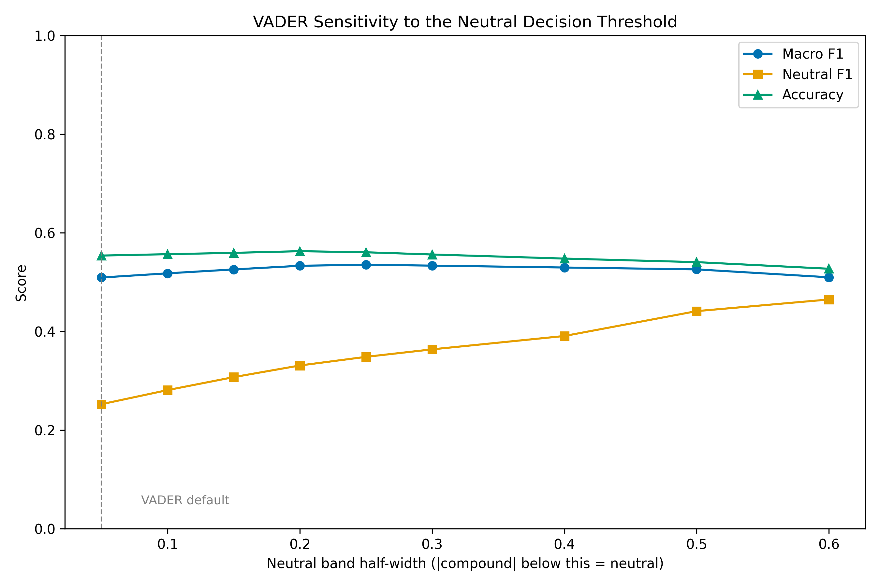
Figure 4.8
Figure 4.8 — VADER macro F1, neutral F1 and accuracy across neutral-band widths. Macro F1 peaks at ±0.25 and declines thereafter. (Produced by evaluate/evaluate_sentiment_diagnostics.py.)
Figure 4.10
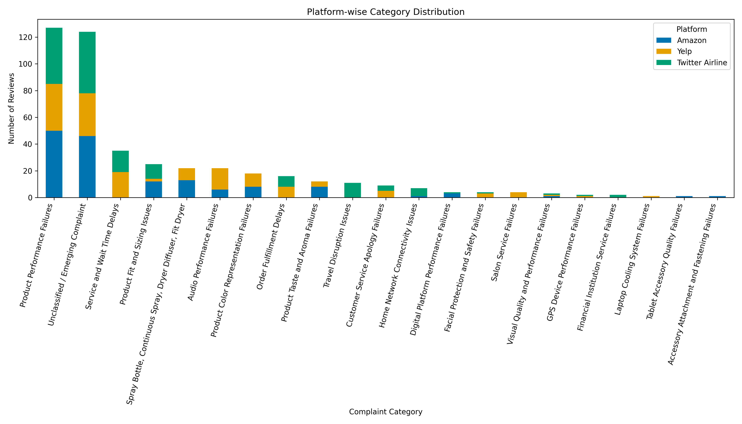
Figure 4.10
Figure 4.10 — Distribution of categories across the three platforms.
Figure 4.12
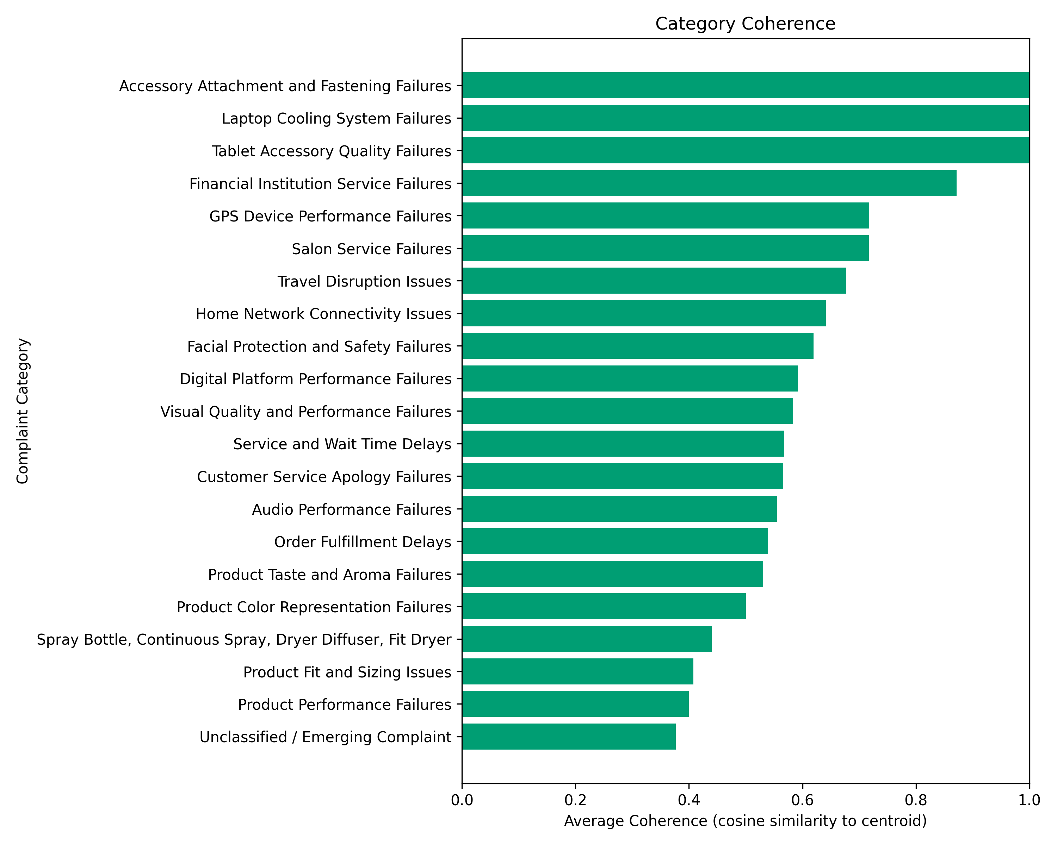
Figure 4.12
Figure 4.12 — Mean within-category coherence against category size. The two largest categories record the lowest coherence of any category holding more than three reviews. (All four produced by evaluate/evaluate_category_discovery.py.)
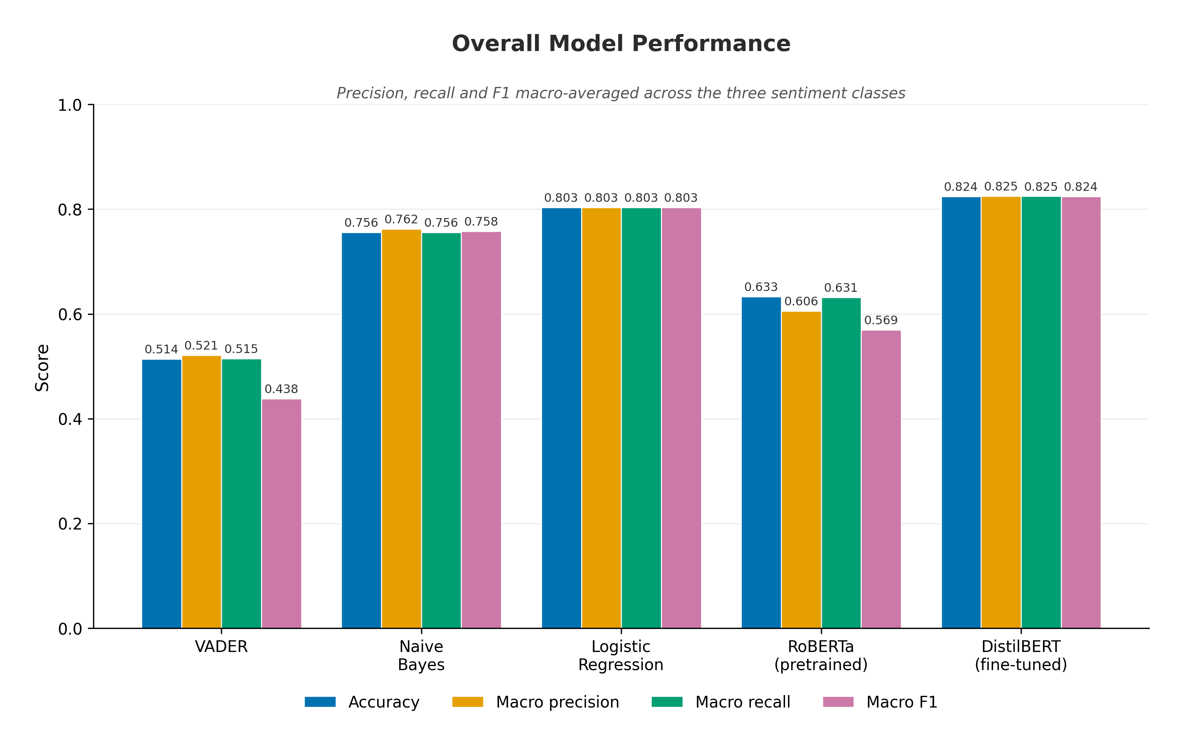
Figure 4.2
Figure 4.2 — Sentiment classification performance for all five models on the shared held-out set (n = 128,539): accuracy with macro-averaged precision, recall and F1. (Produced by evaluate/generate_all_metrics.py.)
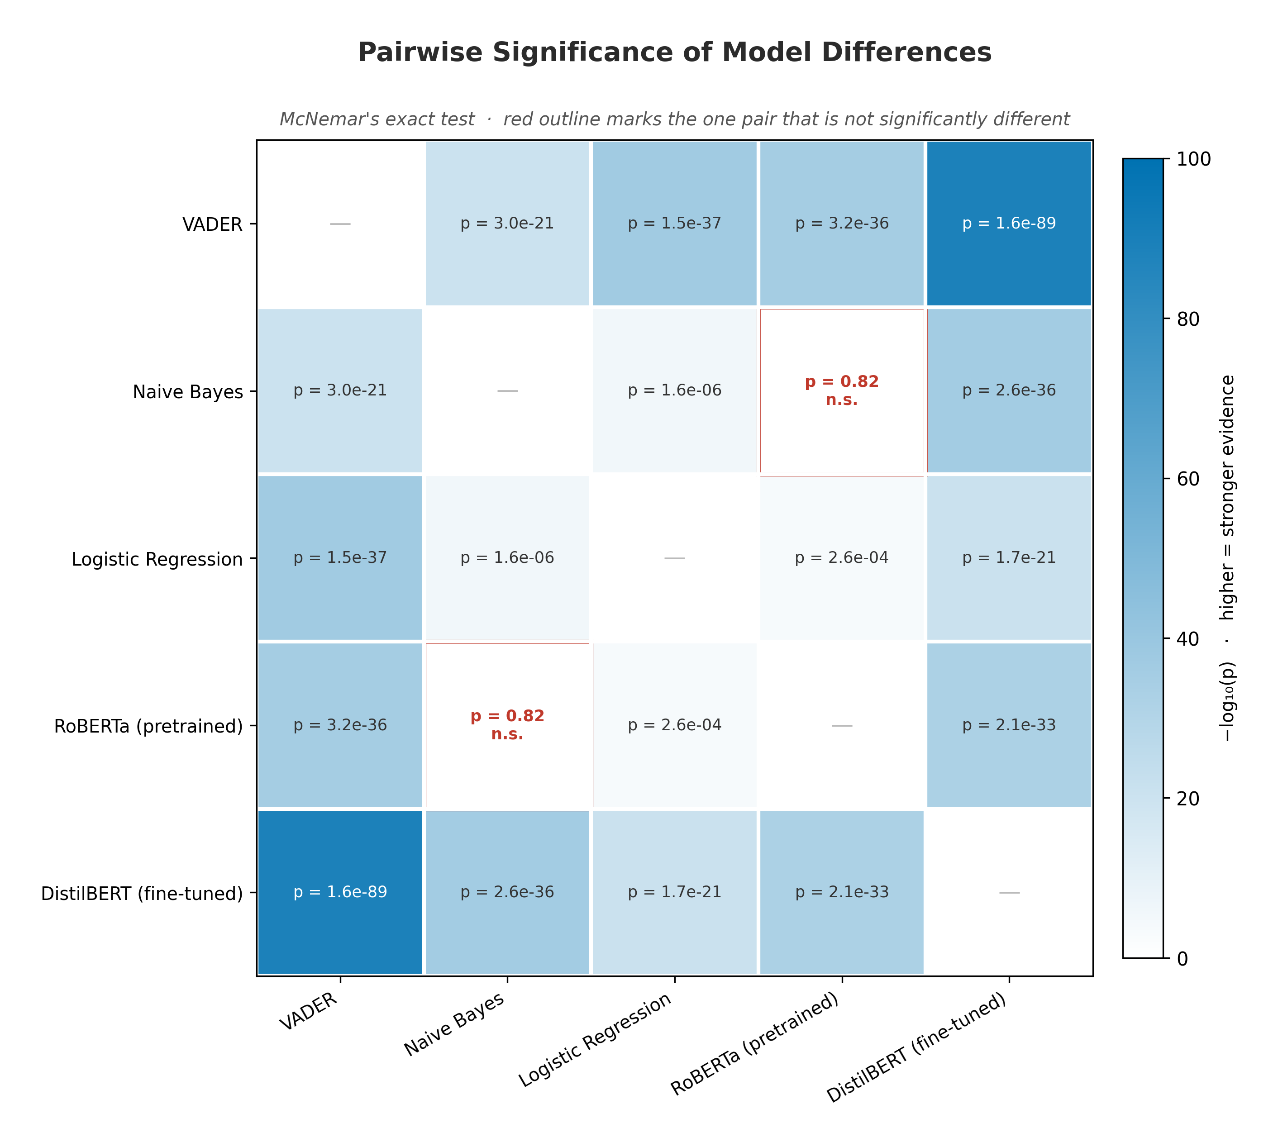
Figure 4.4
Figure 4.4 — Pairwise model comparison under McNemar’s exact test, balanced diagnostic sample (n = 1,800). Nine of ten comparisons are significant at p < 0.05. (Produced by evaluate/generate_all_metrics.py.)
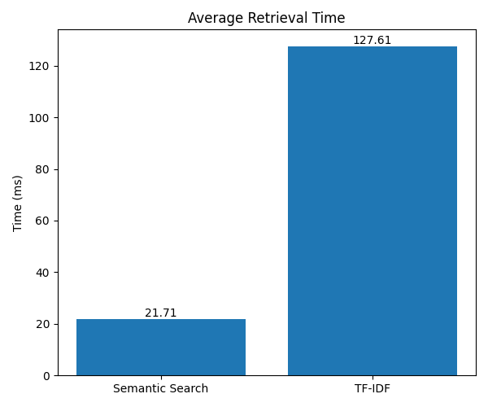
Figure 4.7
Figure 4.7 — Mean retrieval latency, dense semantic search against TF-IDF, 30 queries over 642,692 indexed reviews. Precision@3 is identical between methods at 0.90 and is therefore reported in Table 4.7 rather than charted. (Produced by scripts/compare_embedding.py.)
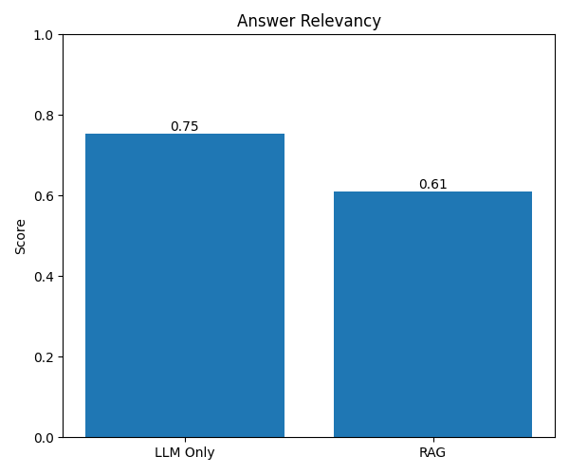
Figure 4.8
Figure 4.8 — Answer relevancy, retrieval-augmented pipeline against standalone LLM (n = 5, n = 4 scored for RAG). The baseline’s higher mean rests on four strong scores and one complete failure. (Produced by evaluate/evaluate_llm_vs_rag.py.)

Qualitative error-analysis examples (Chapter 4, Section 4.5.4)
Qualitative error analysis. The three experiments establish where errors concentrate but not what they look like, so individual misclassified reviews were inspected by joining the cached per-review predictions back to the source text (evaluate/extract_error_examples.py). Three patterns account for most failures, each corresponding to one of the quantitative findings above. Text is verbatim, truncated where long.
Pattern 1 — mixed evaluative content in three-star reviews. Of the 600 true-neutral reviews in the balanced sample, 300 were assigned a polar label by RoBERTa while the fine-tuned model assigned neutral correctly. Inspection shows these are not ambiguous in the sense of being uninformative; they are reviews containing clear praise and clear criticism in the same text:
“Nice curl finish. This product was hard to install could not put thick sections in small sections only curls came out pretty though” — Amazon, 3 stars. RoBERTa: negative. VADER: positive.
“Fenugreek Tea. The tea is very good however the bags are fragile and quite a few had already spilled its contents in the box” — Amazon, 3 stars. RoBERTa: positive. VADER: positive.
“Not a fan of the chewy tapioca balls. Heard good things and I’m very sure this kit is good if you go into it knowing what to expect but not a great experiment for a newbie.” — Amazon, 3 stars. RoBERTa: negative. VADER: positive.
Each contains an explicit positive clause and an explicit negative clause. A three-star rating encodes the reader’s net judgement across both; a model trained to detect the absence of clear sentiment has no representation for a text that expresses two strong sentiments simultaneously. This is the concrete form of the label-mismatch account developed in Section 5.1.1.
Pattern 2 — positive vocabulary in negative reviews. VADER assigned a positive label to 201 of the 600 true-negative reviews in the sample. The compound scores show why:
“Very bland. Ok, first off let me just say that I am a very clean eater and I HATE the sodium bloat…” — Amazon, 2 stars. VADER compound = +0.890.
“only lasted 3 months. Worked well and looked good until keys stopped working after 3 months. My previous keyboard lasted 3 years” — Amazon, 1 star. VADER compound = +0.477.
“Not a fan. I love nut pods but don’t care for this flavor.” — Amazon, 1 star. VADER compound = +0.752.
In each case the lexicon’s positive terms (“clean”, “love”, “worked well”, “looked good”) outweigh the negative ones, because scoring is applied to words rather than to the clauses those words sit in. The second example is the clearest: the complaint is carried entirely by the temporal contrast between “worked well” and “until keys stopped working”, which a bag-of-words score cannot represent. This is the mechanism behind the 40.4% negative-to-positive rate in Table 4.7, and it explains why the threshold sweep recovers so little — the errors are not near the decision boundary but confidently on the wrong side of it.
Pattern 3 — reviews all five models misclassify. In 74 of the 1,800 cases (4.1%) every model was wrong. These are qualitatively different from the two patterns above:
“Photos Off Color to What I Was Expecting. I love everything about this except the color depiction and description…” — Amazon, 2 stars, labelled negative. All five models predicted positive or neutral.
“Very unhealthy but tasted pretty good. Once preservatives and palm oil are removed we would consider b…” — Amazon, 2 stars, labelled negative. Four models predicted neutral, one positive.
Here the disagreement is arguably with the label rather than with the models. A reviewer who writes “I love everything about this except…” and awards two stars is expressing a judgement that the text alone does not convey, and no classifier reading only the text can recover it. This category is small but it is the empirical face of the labelling ceiling described in Section 4.2.4: some portion of the residual error in every model is imposed by rating-derived labels rather than by modelling capacity, and 4.1% is a lower bound on that portion for this sample.
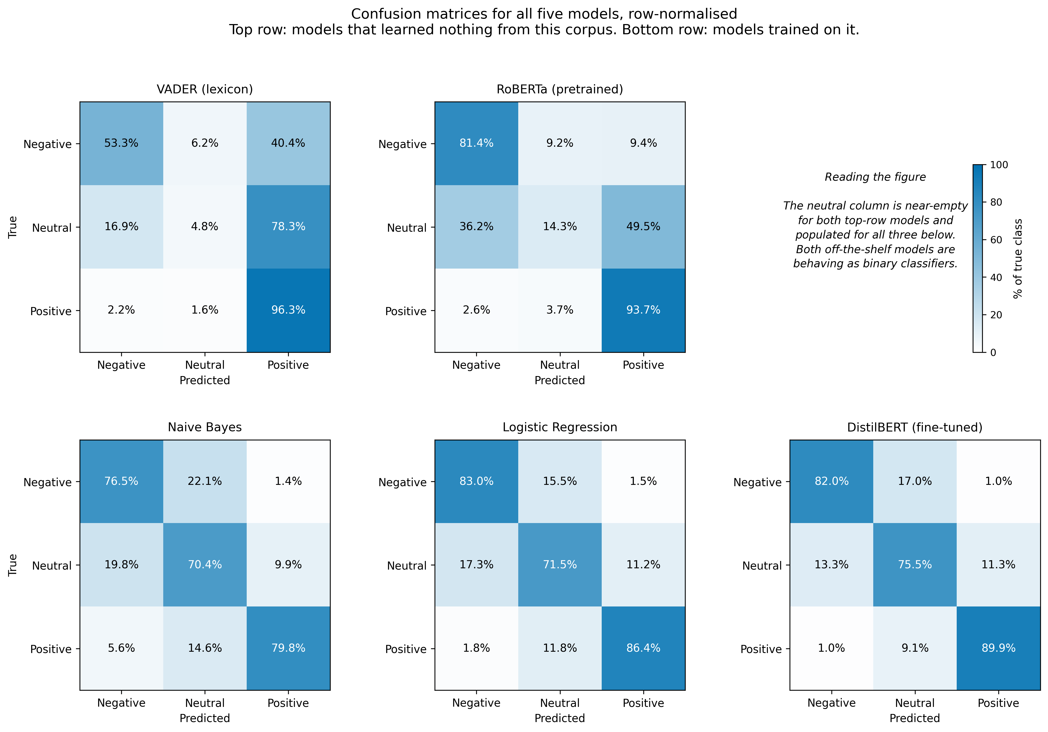
Figure 4.2
Figure 4.2 — Row-normalised confusion matrices for all five models (n = 128,539). VADER and RoBERTa push the majority of genuinely neutral reviews into the polar classes. (Produced by evaluate/generate_figures.py; the filename retains an earlier numbering.)

B.5 Note on the fine-tuned model’s evaluation partition
As recorded in Section 3.5.1, the fine-tuned DistilBERT classifier was developed against a separately generated version of the corpus, so its score on the shared five-model test set is less tightly controlled than the other four. The figure reported as definitive throughout, 0.8375 macro F1, was measured at fine-tuning time against that model’s own held-out partition and is unaffected.

