FeedbackIQ — Evaluation Results
Supporting material for the dissertation results chapter — sentiment classification, retrieval, and RAG chatbot evaluation.

1. Sentiment Classification Evaluation
Five sentiment classifiers were compared on the same held-out test set (n = 128,539 reviews, three classes: positive, neutral, negative): two classical ML baselines (Naive Bayes, Logistic Regression, both TF-IDF-based), a rule-based baseline (VADER), a pre-trained transformer (RoBERTa, no fine-tuning), and a fine-tuned transformer (DistilBERT — the dissertation's own contribution).

1.1 Overall Model Comparison
Model | Accuracy | Macro F1 | Weighted F1 | Precision | Recall
DistilBERT (fine-tuned) | 82.4% | 0.824 | 0.824 | 0.825 | 0.825
Logistic Regression | 80.3% | 0.803 | 0.803 | 0.803 | 0.803
Naive Bayes | 75.6% | 0.758 | 0.758 | 0.762 | 0.756
RoBERTa (pre-trained) | 63.3% | 0.569 | 0.571 | 0.606 | 0.631
VADER | 51.4% | 0.438 | 0.440 | 0.521 | 0.515

The fine-tuned DistilBERT model achieves the highest accuracy (82.4%) and macro F1 (0.824), outperforming both classical baselines and the pre-trained RoBERTa model without task-specific fine-tuning. Logistic Regression is the strongest classical baseline (80.3% accuracy), while VADER — a lexicon-based method with no learned parameters — performs weakest (51.4%), particularly on the neutral class. This 0.824 macro F1 is DistilBERT's score on the shared 128,539-review test set used for all five models; because a portion of that set overlaps the model's own fine-tuning partition, its score on a strictly clean, non-overlapping held-out partition — 0.8375 macro F1 — is reported as the definitive figure elsewhere in the dissertation. The two figures describe different evaluation conditions, not a discrepancy.

1.2 Confusion Matrices
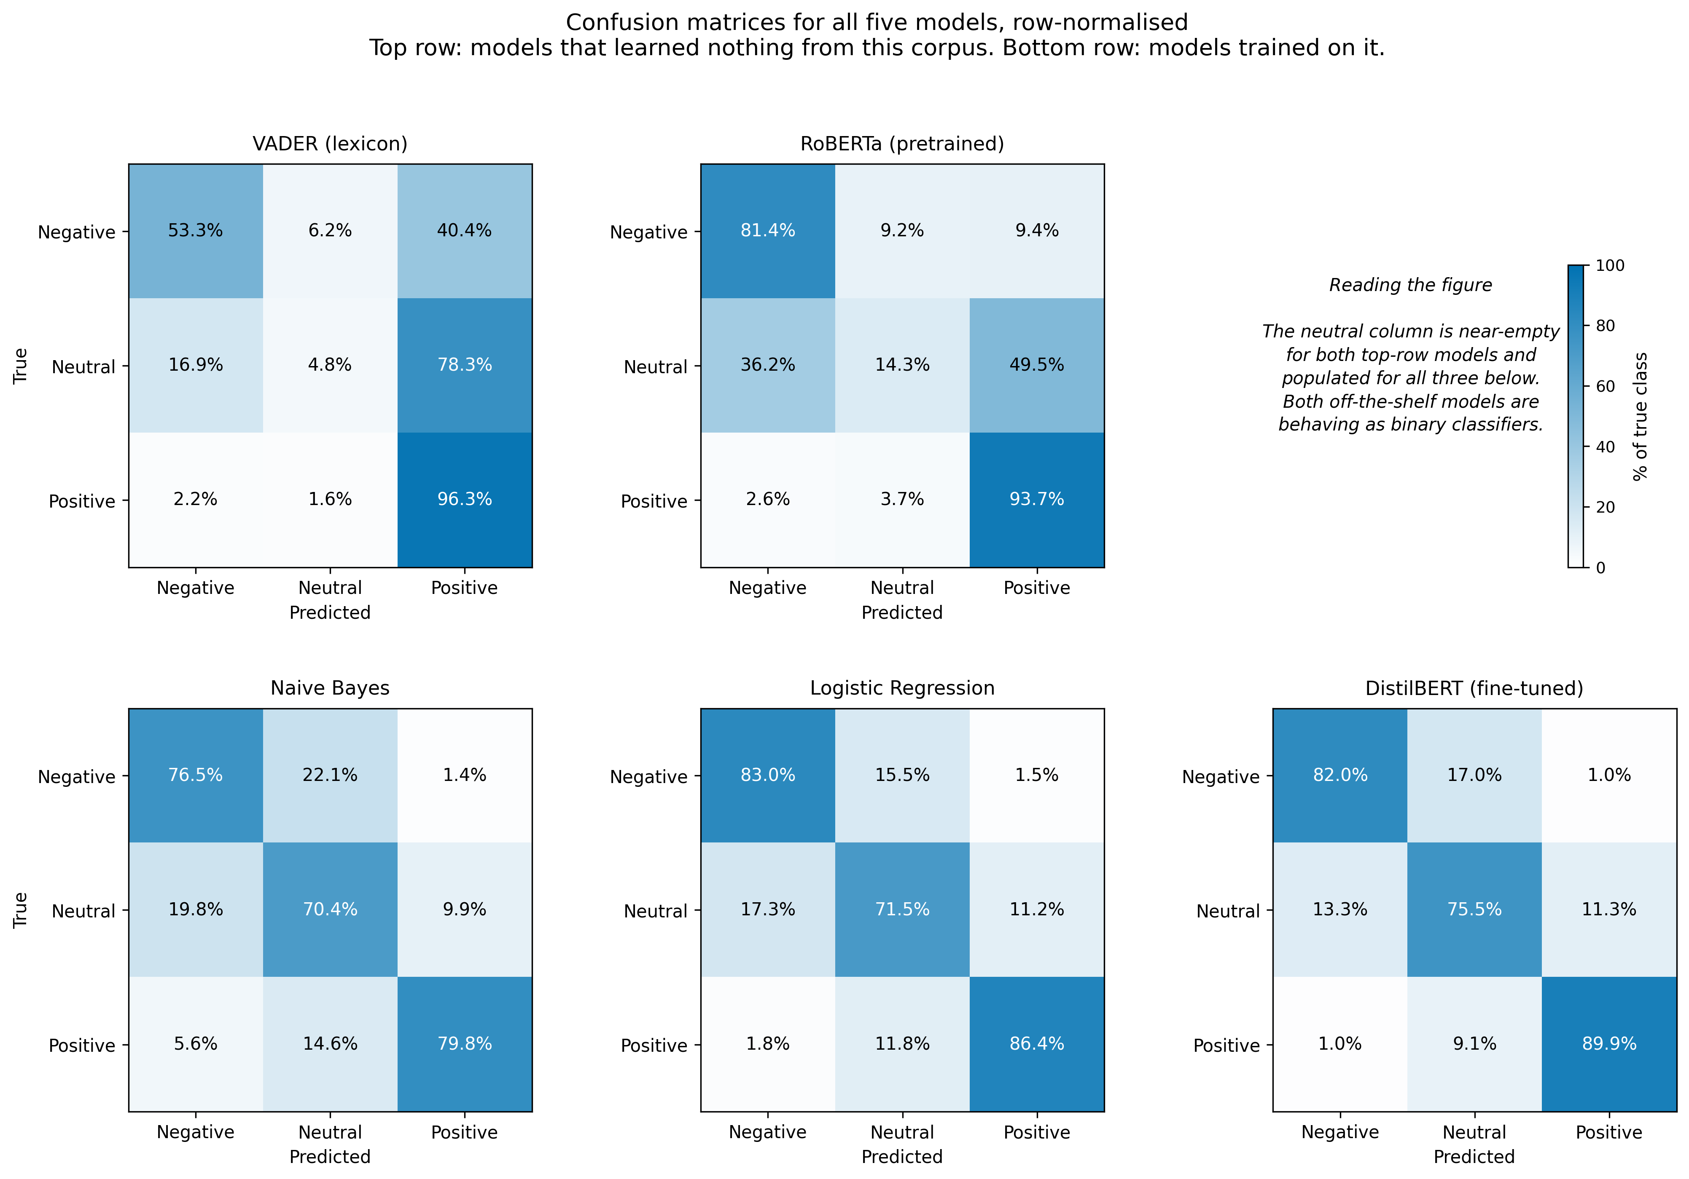
Figure 1. Confusion matrices for all five sentiment classifiers (rows: actual class, columns: predicted class).

1.3 Statistical Significance (McNemar's Test)
Pairwise McNemar's tests were run on a paired subset of predictions to check whether accuracy differences between models are statistically significant rather than due to chance. Note: the per-pair accuracy figures below come from the smaller paired-comparison subset used for McNemar's test, not the full 128,539-review test set in Table 1.1 — the two are not directly comparable row-for-row.
Model A | Model B | A Acc. | B Acc. | p-value | Better Model
VADER | DistilBERT (fine-tuned) | 0.5539 | 0.8417 | 1.59e-89 | DistilBERT (fine-tuned)
VADER | Logistic Regression | 0.5539 | 0.7444 | 1.55e-37 | Logistic Regression
Naive Bayes | DistilBERT (fine-tuned) | 0.6983 | 0.8417 | 2.57e-36 | DistilBERT (fine-tuned)
VADER | RoBERTa (pre-trained) | 0.5539 | 0.6944 | 3.21e-36 | RoBERTa (pre-trained)
RoBERTa (pre-trained) | DistilBERT (fine-tuned) | 0.6944 | 0.8417 | 2.09e-33 | DistilBERT (fine-tuned)
Logistic Regression | DistilBERT (fine-tuned) | 0.7444 | 0.8417 | 1.66e-21 | DistilBERT (fine-tuned)
VADER | Naive Bayes | 0.5539 | 0.6983 | 3.00e-21 | Naive Bayes
Naive Bayes | Logistic Regression | 0.6983 | 0.7444 | 1.55e-06 | Logistic Regression
Logistic Regression | RoBERTa (pre-trained) | 0.7444 | 0.6944 | 2.60e-04 | Logistic Regression
Naive Bayes | RoBERTa (pre-trained) | 0.6983 | 0.6944 | 0.817 (n.s.) | — no significant difference

Every comparison is statistically significant (p < 0.05) except Naive Bayes vs. RoBERTa (pre-trained), which are statistically indistinguishable on this subset (p = 0.817). DistilBERT's improvement over every other model is significant at p < 1e-20 in all cases.

2. Retrieval Evaluation
Two retrieval methods were compared on the same 30-query evaluation set over 642,692 indexed reviews: TF-IDF (sparse, keyword-based) and semantic search using sentence embeddings (all-MiniLM-L6-v2, 384-dim) with a FAISS index.
Metric | TF-IDF | Semantic Search (FAISS)
Precision@3 | 0.90 | 0.90
Avg. similarity score | 0.5593 | 0.6833
Avg. retrieval time | 127.6 ms | 21.7 ms
Query success rate | 100% | 100%

Both methods achieve identical Precision@3 (0.90) on this query set, but semantic search returns a higher average similarity score (0.683 vs. 0.559) and is roughly 6x faster (21.7ms vs. 127.6ms average retrieval time), since it queries a pre-built FAISS index rather than recomputing sparse TF-IDF similarity at query time. This is the retrieval method used in the deployed RAG chatbot.

3. RAG Chatbot Evaluation (RAGAS)
The RAG pipeline (rag/pipeline.py) is compared against a standalone LLM baseline — same generator, same five questions, retrieval disabled — using four RAGAS metrics: Faithfulness, Answer Relevancy, Context Precision and Context Recall, evaluated via evaluate/evaluate_llm_vs_rag.py. Context Precision and Context Recall are computed for the RAG condition only, since they require retrieved context the baseline does not have; hand-written reference answers support all five questions.
These results were generated after a hard grounding threshold (SIMILARITY_THRESHOLD = 0.35, rag/pipeline.py) was added to the retriever, which returns a fixed refusal message rather than a generated answer when nothing retrieved clears the threshold. An earlier run of the same script, before that threshold existed, produced higher aggregate scores; those figures are superseded and are not reported here.
Metric | RAG pipeline | Standalone LLM
Faithfulness | 0.540 | not computable
Answer relevancy | 0.610 | 0.753
Context precision | 0.416 | not applicable
Context recall | 0.400 | not applicable
Mean latency | 1,582.7 ms | 734.0 ms
Mean retrieved reviews | 3.4 | 0
Faithfulness cannot be computed for the standalone condition, since the metric measures whether an answer follows from retrieved context and no context exists for that condition. On the two metrics that can be compared, the standalone model scored higher on answer relevancy — 0.753 against 0.610 — while taking under half the time. Its relevancy mean is pulled down by a single complete failure on the delivery question (0.000); excluding it would place its mean near 0.941.
Per-question breakdown:
Question | RAG faithfulness | RAG relevancy | RAG context precision | RAG context recall | LLM relevancy
Why are customers unhappy with battery life? | 0.417 | 0.442 | 0.325 | 1.000 | 0.988
What delivery problems are customers reporting? | 1.000 | 0.740 | 0.756 | 1.000 | 0.000
Why are airline passengers dissatisfied? | 0.400 | n/a* | 0.000 | 0.000 | 0.961
What customer service issues appear most often? | 0.000** | 0.437 | 0.000** | 0.000** | 0.964
Summarise the major customer complaints. | 0.882 | 0.819 | 1.000 | 0.000 | 0.853
Mean | 0.540 | 0.610* | 0.416 | 0.400 | 0.753
* The RAGAS judge raised an OutputParserException while scoring this question's answer relevancy (the free-tier Groq judge returned unstructured prose instead of the expected output), so no score exists for that cell; the reported mean is computed over the remaining four questions.
** This one needs unpacking rather than a one-line note. The text returned matches the pipeline's out-of-scope message, not the grounding threshold's refusal message — meaning this question was rejected by the two-stage scope guard before retrieval ever ran, not by the similarity threshold finding insufficient evidence. "What customer service issues appear most often?" is a legitimate complaint-exploration question; the rejection is a false positive from the guard's LLM classifier, and it recurred identically across three separate runs (this evaluation and both conditions of the metadata-tagging ablation below), which rules out a fluke. Faithfulness, context precision and context recall are mechanically zero because no retrieval or generation happened for this question at all.
The false rejection on the customer-service question is the most consequential single result in this table, but it credits the wrong mechanism if read too quickly. It is not the grounding threshold working as designed — no retrieval was even attempted — it is the scope guard misfiring on a question it should have passed straight through. Context precision fell to zero on the airline question too, and there faithfulness genuinely fell with it, to 0.400, rather than remaining artificially high as it did in the earlier, un-gated run — that is the grounding threshold behaving as intended. The two zero-precision questions look the same in the table but have different causes, and only one of them is evidence the grounding mechanism works.
Context recall is 0.000 on three of five questions, for three different reasons: the summarisation question is open-ended with no specific retrieval target, a structural limitation of dense retrieval; the airline question retrieved only two, largely uninformative reviews; and the customer-service question was falsely rejected by the scope guard, so there was no context to evaluate.

3.1 Ablation: does metadata tagging actually help?
Section 3's design argument is that tagging each retrieved review with its platform, rating and sentiment before it reaches the generator is what makes the prompt's grounding rules enforceable. evaluate/ablation_metadata_tagging.py tests this directly: the same five questions, run twice through the same pipeline, once with the tags in place and once with them stripped so the generator sees only raw review text. Retrieval is identical in both runs, so any score difference comes from what the generator was shown, not what was retrieved.
Metric | Tagged | Untagged | Delta
Faithfulness | 0.667 | 0.549 | +0.118
Answer relevancy | 0.452 | 0.654 | -0.202
Context precision | 0.416 | 0.416 | 0.000
Context recall | 0.400 | 0.400 | 0.000
Context precision and recall are identical between conditions, to three decimal places — exactly what the design predicts, since neither condition touches retrieval, and reassuring confirmation that the ablation isolates what it claims to. Faithfulness improves with tags, 0.667 against 0.549, supporting the argument that citing each review's platform and rating gives the model something concrete to stay anchored to. But answer relevancy moves the other way, and by more: 0.452 tagged against 0.654 untagged, the largest single delta in the table. A plausible reading is that tagged answers spend more of their length on citation-style attribution, which reads as less directly responsive to the question than the untagged answers do. If that holds, tagging buys grounding at a real cost to how responsive the answer feels — a trade-off, not a clean win.
One concrete example is worth quoting directly. For the battery-life question, the untagged run's answer opens with "Platform(s) covered: Twitter Airline, Amazon" — but none of the five retrieved reviews for that question mention an airline. The tagged run's answer for the same question and the same retrieved reviews correctly says "Platform(s) covered: Yelp, Amazon." That is a real, observed platform hallucination prevented by tagging, caught in the act rather than argued in the abstract.
The latency figures (1,704.6 ms tagged against 501.3 ms untagged) are reported for completeness but are more consistent with ordinary API variance between two separate sequential calls than with tagging itself changing generation time; no claim rests on them.
Limitations to report: the RAGAS judge reuses the same Groq model (llama-3.1-8b-instant) configured for answer generation — a documented self-grading bias risk, isolated to a separate object from the generation call but not model-independent. The evaluation covers five questions only (four for answer relevancy, due to the parser exception above), capped by free-tier API rate limits. Of the four originally planned ablation conditions, one — metadata tagging — was executed and is reported above; the other three (retrieval depth, retriever type, prompt version) remain implemented but not run.

