Title
Sales Analysis Dashboard using Power BI – Atliq Hardware
Prepared By:
Shifa Siddiqui
Tool Used:
Microsoft Power BI
Project Type:
Data Analytics Project

1. Introduction
Atliq Hardware is a growing company operating in a highly competitive and dynamic market. The company sells products across multiple regions and receives sales reports from regional managers in the form of Excel files.
However, due to the increasing volume of data and market complexity, the sales manager finds it difficult to analyze performance using static Excel reports. As a result, the company faces challenges in identifying the reasons for declining sales and improving overall business performance.
This project aims to address these challenges by developing an interactive Sales Analysis Dashboard using Power BI.

2. Problem Statement
The sales manager at Atliq Hardware faces difficulty in analyzing sales performance because regional managers provide only raw Excel reports. These reports lack consolidated and visual insights, making it difficult to identify sales trends, regional performance, and the reasons behind declining sales. As a result, the sales manager is unable to make effective data-driven decisions to increase sales.

Aims Grid

Purpose

Stakeholders

- Unlock hidden sales insights
- Reduce manual Excel reporting

- Sales Manager
- Regional Managers
- Marketing & Finance Teams

End Result
End Success Criteria
- Faster decision-making
- Reduced Excel dependency
- Clear regional performance

- Interactive Power BI dashboard

- Real-time sales visibility

Data Source Description
The dataset used in this project was provided in the form of Excel files received from different regional managers. The data includes information related to sales transactions, customers, products, and markets. Due to multiple data sources, the dataset required cleaning and transformation before analysis.

ETL Process (Extract, Transform, Load)
🔹 Extract
Sales data was extracted from multiple Excel files containing transactional, product, customer, and market-level information.
🔹 Transform
Data transformation and cleaning were performed using Power Query in Power BI. The following steps were applied:
- Removed blank and null values to ensure data completeness.
- Filtered invalid sales records where sales values were less than or equal to zero.
- Removed duplicate records to maintain data accuracy and avoid double counting.
- Performed currency conversion by converting sales values from USD to INR.
- Standardized currency values by applying a uniform INR format across the dataset to ensure consistency.
- Cleaned and standardized column names and data formats for better readability and analysis.
🔹 Load
After completing the data cleaning and transformation steps, the final dataset was loaded into Power BI for data modeling and visualization.

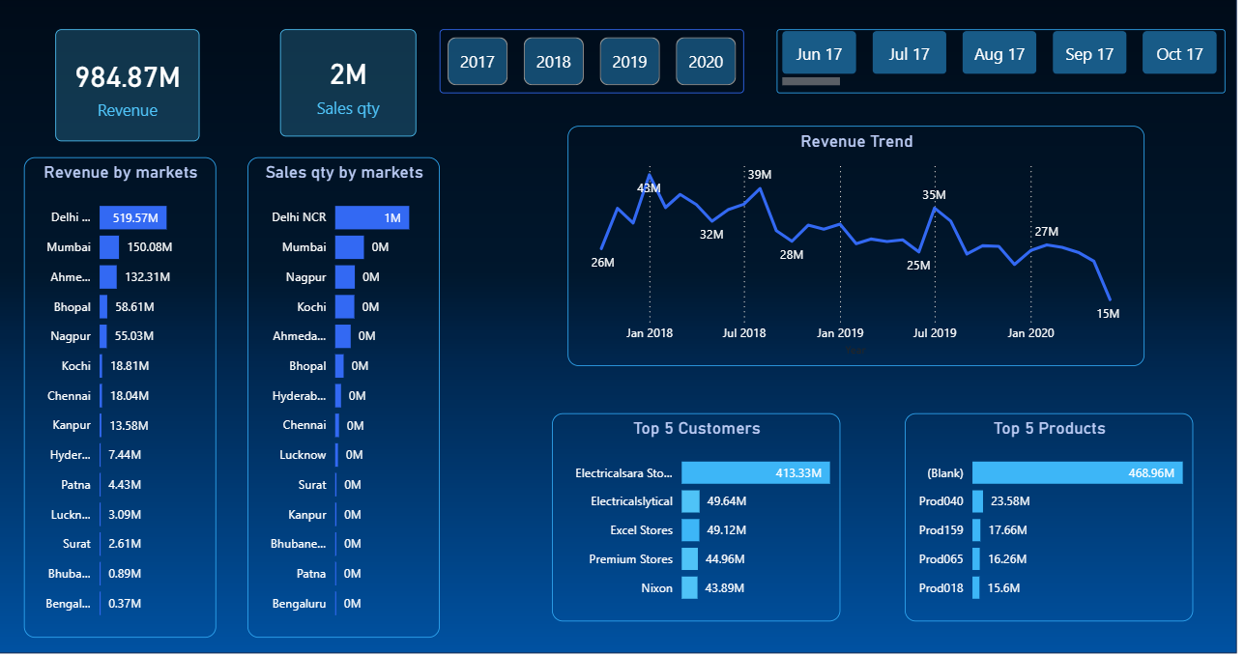

Dashboard Overview
The Sales Analysis Dashboard was developed using Microsoft Power BI to provide an interactive and consolidated view of Atliq Hardware’s sales performance.
The dashboard helps the sales manager to easily track key performance indicators (KPIs), analyze trends, and identify top-performing markets, customers, and products.
The dashboard is designed with slicers for Year and Month, allowing dynamic filtering of all visuals for better decision-making.

Key Performance Indicators (KPIs)
At the top of the dashboard, two important KPIs are displayed:
- Total Revenue: 948.87M
- Total Sales Quantity: 2M
These KPIs provide a quick snapshot of the company’s overall sales performance for the selected year and month.

Revenue and Sales Quantity Analysis by Market
🔹 Revenue by Markets
This bar chart shows the contribution of each market to total revenue.
Insights:
Delhi NCR is consistently the highest revenue-generating market across all years (2017 to 2020), indicating a strong and stable customer base along with sustained demand.
Mumbai and Ahmedabad consistently remain the second and third top-performing markets respectively, although their revenue values fluctuate year over year.
Markets such as Surat, Bhubaneswar, and Lucknow consistently contribute lower revenue across all years, highlighting potential regions for strategic improvement, targeted marketing, or market expansion initiatives.

🔹 Sales Quantity by Markets
This chart displays sales quantity distribution across markets.
Insights:
- Sales quantity varies significantly across regions.
- Even markets with lower revenue may have consistent sales quantity, suggesting differences in pricing or product mix.
- This comparison helps identify markets where sales volume is high but revenue is low, highlighting pricing or discount issues.
Both charts are connected to Year and Month slicers, enabling analysis of market performance over different time periods.

🔹 Revenue Trend Analysis
The revenue trend line chart shows monthly revenue performance across different years.
Insights:
- From 2017 to 2019, revenue generally increases during July and August, indicating a recurring seasonal boost.
- A consistent decline is observed after November each year, suggesting year-end slowdown.
- In 2020, revenue drops sharply, especially after May, which aligns with the impact of the COVID-19 pandemic, including lockdowns and reduced market activity.
This trend analysis helps management understand both seasonal patterns and the impact of external factors on sales performance.

🔹 Top 5 Customers Analysis
This chart displays the top 5 customers based on revenue contribution.
Insights:
- Electricalsara Stores consistently performs well in both revenue and sales quantity, making it the most stable and reliable customer.
- Nixon was the top customer in 2017 and 2018, but its revenue contribution declined significantly in 2019, indicating customer dependency risk.
- As Nixon’s contribution decreased, Excel Stores emerged as a more important customer, particularly in markets like Hyderabad, where it showed strong sales quantity and revenue performance.
This analysis highlights the business risk of relying heavily on a few customers.

🔹 Top 5 Products Analysis
The Top 5 Products chart shows products contributing the highest revenue.
Insights:
- Revenue is highly concentrated among a few products, indicating a skewed product performance.
- Prod040 was the second top product in 2018, dropped to third position in 2019, and declined further later, suggesting possible product lifecycle or demand issues.
- The “(Blank)” product category appears consistently and even increases over time, which indicates a data quality issue where product mapping is missing and requires further validation.
This analysis helps in identifying both strong-performing products and areas needing data cleanup.

🔹 Use of Slicers and Interactivity
The dashboard uses button-style slicers for:
- Year
- Month
These slicers are connected to all visuals, including KPIs, market performance, revenue trends, customers, and products.
Benefits:
- Helps identify exactly when sales started declining, not just that they declined.
- Improves analysis speed and supports better decision-making without modifying the dashboard structure.

🔹 Overall Business Insights
Insights:
- Continuous decline in sales over the years, with 2020 most impacted (COVID-19).
- Revenue heavily depends on a few key markets and customers → business risk.
- Some markets show high sales quantity but lower revenue → pricing/product mix inefficiency.
- Product revenue concentrated in few items; uncategorized products → data quality issues.
- Seasonal trends exist: revenue peaks mid-year, declines year-end.
Solutions / Actions Derived from Dashboard:
- Plan targeted strategies for post-September decline to avoid revenue drop.
- Monitor high-dependency customers and diversify to reduce business risk.
- Focus on smaller markets with growth potential for expansion or marketing campaigns.
- Clean uncategorized product data and monitor declining products for lifecycle or demand issues.
- Dashboard helps identify seasonal trends, revenue dependency on key customers, and actionable steps for low-performing regions.
- Enables non-technical managers to understand performance easily and make smarter, faster decisions.

🔹 Conclusion
This interactive Power BI dashboard successfully replaces static Excel reports, turning scattered data into actionable insights.
- Helps management track trends, identify risks, and plan strategies proactively.
- Combines analysis + storytelling to communicate insights clearly, even to non-technical stakeholders.
- Data is not just numbers — it’s about understanding patterns and driving smarter business decisions.

