AI-Based Personalized Learning Pathways Using Student Behavior Analysis
Name : Sidramayya
E-mail: matapatisiddu16@gamil.com
Project Topic : Personalized Learning Pathways Using Student Behavior Analysis
Dataset Information
Dataset Name: UCI Student Performance Dataset
Source: UCI Machine Learning Repository
Dataset URL: https://archive.ics.uci.edu/ml/machine-learning-databases/00320/student.zip
Number of Records: 395 student records
Number of Features: 33 original attributes
Features Used for Model Training: 17 selected features
Code Implementation
Google Colab Notebook URL: https://colab.research.google.com/drive/1N4mZjSAehQV2RpMugMk6R-ds0f-MSRZN?usp=sharing

Table of Contents
1. Introduction
2. Literature Review
3. Methodology
4. Implementation
5. Results and Discussion
6. Conclusion
7. References
8. List of Figures
9. List of Tables

Introduction
Artificial Intelligence (AI) has emerged as one of the most transformative technologies across various sectors, including healthcare, finance, manufacturing, transportation, and education. In recent years, educational institutions have increasingly adopted AI-based systems to improve teaching effectiveness, enhance student engagement, and support personalized learning experiences. Traditional educational approaches generally apply identical learning strategies to all students despite differences in learning capabilities, interests, behavioural patterns, and academic strengths. This limitation often prevents educators from providing individualized attention and may result in reduced learning outcomes for certain groups of students.
Educational Data Mining (EDM) and Learning Analytics have become important research areas that utilize student-related data to understand learning behaviour and predict academic outcomes. By analyzing historical academic records and behavioural indicators, AI systems can identify patterns that influence student performance. Such insights enable educational institutions to implement proactive interventions and support students before academic difficulties become severe. Research has shown that factors such as study time, attendance, previous grades, parental education, internet access, and extracurricular involvement significantly influence academic achievement.
One of the major challenges faced by educators is the early identification of students who may struggle academically. Traditional assessment methods primarily evaluate performance after examinations have already occurred. Consequently, corrective actions are often implemented too late to produce substantial improvements. Machine learning provides an opportunity to overcome this challenge by predicting future performance using existing behavioural and academic information.
Personalized learning has become increasingly important because students possess diverse learning requirements. A personalized learning system adapts educational recommendations according to an individual's characteristics, allowing learners to receive targeted support. Such systems can recommend additional study resources, time management strategies, remedial activities, or advanced learning opportunities depending on predicted performance levels.
The primary aim of this project is to develop an AI-based student performance prediction system that utilizes behavioural indicators to classify students into Low, Medium, and High performance categories and generate personalized learning recommendations. The project employs machine learning algorithms including Logistic Regression, Decision Tree, and Random Forest to identify the most effective predictive model.

Objectives
- To analyze student behavioural and academic data.
- To perform exploratory data analysis and identify influential factors.
- To preprocess and prepare educational data for machine learning.
- To train multiple classification models.
- To compare model performance using evaluation metrics.
- To generate personalized learning recommendations based on predicted performance.

Research Questions
- Can student behaviour effectively predict academic performance?
- Which machine learning algorithm performs best for the selected dataset?
- Can prediction results support personalized learning pathway generation?
- Which behavioural factors have the greatest influence on academic success?

Literature Review
The increasing availability of educational data has encouraged researchers to develop predictive systems capable of improving learning outcomes. Educational Data Mining (EDM) focuses on extracting meaningful knowledge from educational datasets to support decision-making and personalized education. Student Performance Prediction (SPP) has become one of the most important applications of EDM because early prediction enables timely intervention and academic support.
Romero and Ventura (2010) conducted one of the earliest comprehensive reviews of educational data mining. Their work demonstrated how machine learning and data mining techniques could identify patterns within educational environments. They highlighted classification, clustering, association rule mining, and prediction as key EDM applications.
Cortez and Silva (2008) introduced the Student Performance Dataset, which remains one of the most widely used educational datasets. Their research investigated how demographic, social, and academic variables affect student achievement. The study demonstrated that student grades could be predicted using machine learning techniques and identified previous academic performance as a significant predictor.
Kotsiantis et al. (2004) explored classification algorithms for educational prediction tasks. Their study compared several machine learning models and found that predictive analytics could effectively identify students at academic risk. The research emphasized the importance of early intervention.
Pandey and Taruna (2016) examined multiple machine learning algorithms for student performance prediction. Their results showed that ensemble methods and classification models achieved strong predictive performance when behavioural and academic features were included.
Namoun and Alshanqiti (2021) conducted a systematic literature review on student performance prediction using data mining and learning analytics techniques. Their review highlighted Decision Trees, Random Forests, Support Vector Machines, and Neural Networks as the most commonly used algorithms. The study concluded that predictive systems significantly improve educational decision-making.
Zhang et al. (2021) reviewed machine learning approaches used in student performance prediction and categorized research into data collection, model development, prediction, and practical application stages. The authors emphasized the importance of personalized education and noted that prediction accuracy depends heavily on feature quality.
Roslan and Chen (2022) reviewed 58 research articles and identified Decision Trees as one of the most frequently applied algorithms in educational prediction. Their findings indicated that demographic information and academic history are among the strongest predictors of student success.
Balaji et al. (2021) investigated machine learning models used for academic performance prediction and concluded that no single model consistently outperforms others across all datasets. Model performance depends on feature selection, dataset characteristics, and preprocessing quality.
Recent research has also explored deep learning approaches. Models such as Long Short-Term Memory (LSTM) networks and Bidirectional LSTM architectures have demonstrated strong predictive capabilities when temporal educational data are available. However, these models generally require larger datasets and greater computational resources.

Research Gap
Although numerous studies focus on predicting student performance, many systems stop at classification and do not provide actionable educational recommendations. Furthermore, several complex models achieve high accuracy but lack interpretability for educators. The present project addresses these limitations by combining performance prediction with personalized learning pathway generation using interpretable machine learning models. Additionally, the study evaluates multiple algorithms and identifies influential behavioural factors affecting academic success.

Methodology
The methodology adopted in this project follows a structured machine learning workflow consisting of data collection, preprocessing, feature engineering, model training, evaluation, and recommendation generation.

Dataset Description
The project uses the UCI Student Performance Dataset. The dataset contains information related to 395 students and includes 33 attributes describing academic, demographic, family, and behavioural characteristics.

Data Preprocessing
Several preprocessing operations were performed:
- Dataset inspection and verification.
- Missing value analysis.
- Feature selection.
- Binary feature encoding.
- Target variable creation.
- Train-test splitting.
- Feature scaling.
No missing values were identified within the dataset.

Target Variable Creation
Final grade (G3) was converted into three performance categories:
- Low Performance: G3 ≤ 9
- Medium Performance: 10 ≤ G3 ≤ 14
- High Performance: G3 ≥ 15

Feature Selection
Seventeen relevant features were selected:
studytime, failures, absences, freetime, goout, Dalc, Walc, health, G1, G2, traveltime, internet, higher, activities, famrel, Medu, and Fedu.

Machine Learning Models
Three supervised classification algorithms were implemented:
- Logistic Regression
- Decision Tree
- Random Forest

Evaluation Metrics
The following metrics were used:
- Accuracy
- Precision
- Recall
- F1-Score
- Confusion Matrix
These metrics provide a comprehensive evaluation of classification performance.

Implementation
The implementation was performed using Google Colab. Python was selected due to its extensive machine learning ecosystem and ease of integration with educational data mining workflows.

Libraries Used
- Pandas
- NumPy
- Matplotlib
- Seaborn
- Scikit-learn
The dataset was loaded and explored using Pandas. Data visualization was performed using Matplotlib and Seaborn. Machine learning models were developed using Scikit-learn.
The dataset was divided into training and testing subsets. A total of 316 records were used for training and 79 records were reserved for testing. Standardization was applied to ensure consistent feature scaling.
Three machine learning models were trained and evaluated. Predictions were generated for unseen test data, and performance metrics were computed. Additionally, a recommendation system was implemented to generate personalized learning pathways for students categorized as Low, Medium, or High performers.
The implementation also included visualization modules for performance distribution, feature relationships, model comparison, confusion matrix generation, and feature importance analysis

Results and Discussion
Logistic Regression achieved the best performance with 91.14% accuracy, outperforming Random Forest (87.34%) and Decision Tree (82.28%). Important features included G2, G1, failures, absences, and goout. The model effectively identified student performance categories and enabled personalized recommendations.

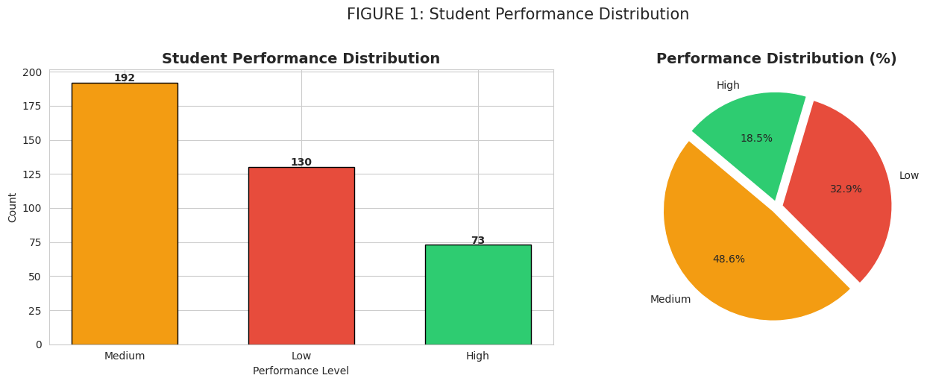
Figure 1: Student performance distrubution
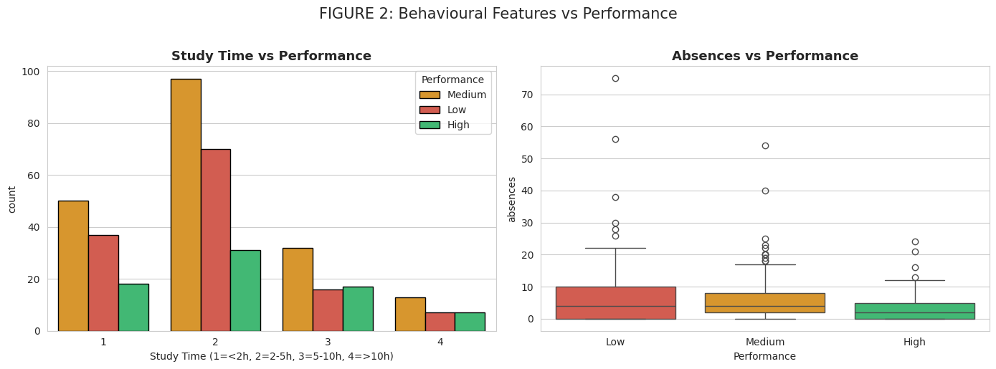
Figure 2: Behavioural feature vs performance
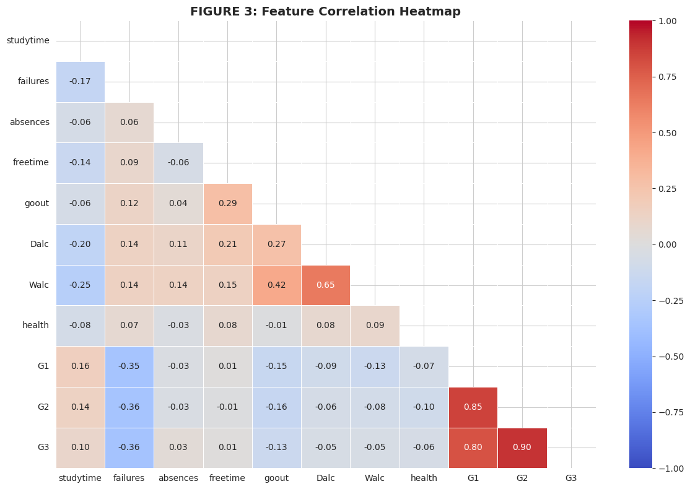
Figure 3: Feature corelation heatmap
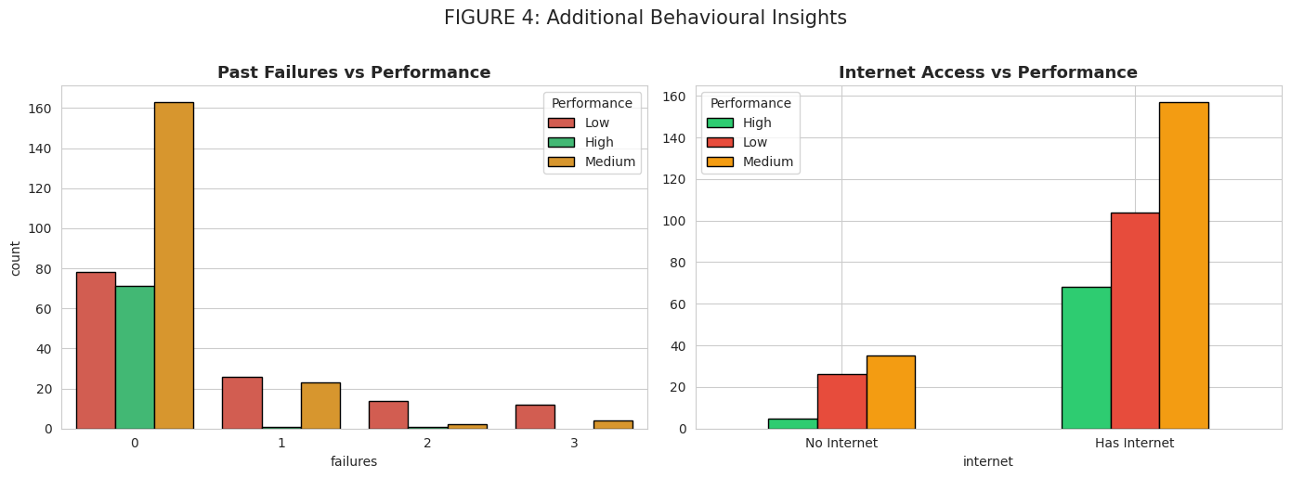
Figure 4: Additional behavioural insights
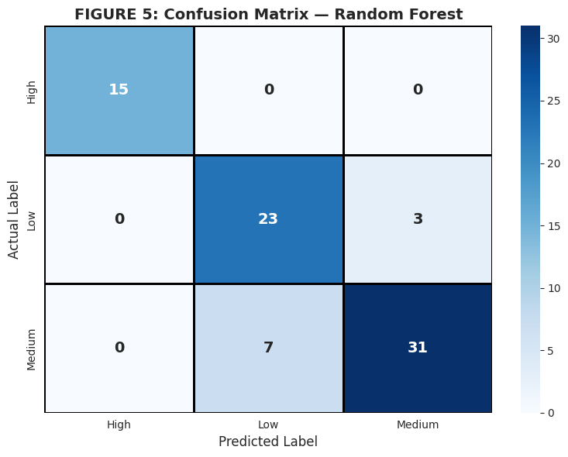
Figure 5: Confusion matrix – Random forest
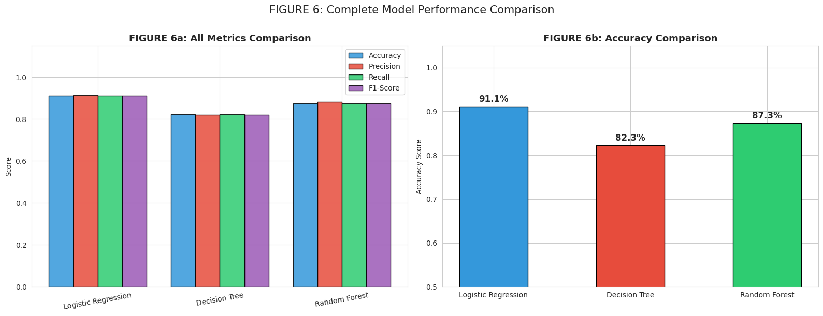
Figure 6: Model performance comparision
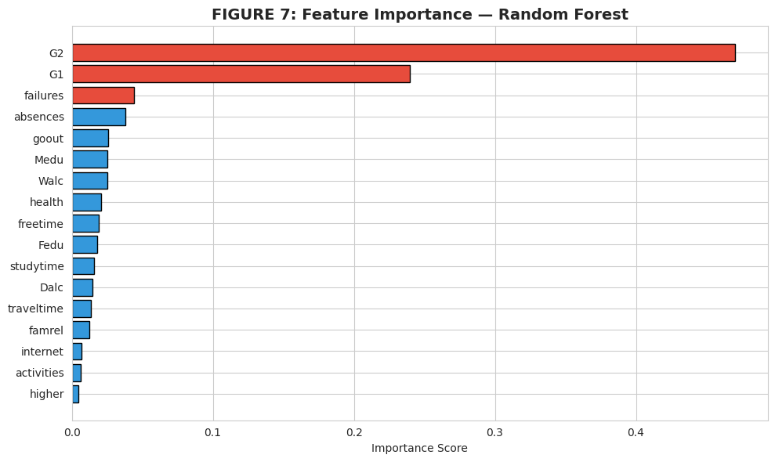
Figure 7: Feature importance – Random forest

Model Performance Summary
Logistic Regression: Accuracy 91.14%, Precision 0.9127, Recall 0.9114, F1 Score 0.9104
Decision Tree: Accuracy 82.28%, Precision 0.8205, Recall 0.8228, F1 Score 0.8205
Random Forest: Accuracy 87.34%, Precision 0.8808, Recall 0.8734, F1 Score 0.8744

Conclusion
This project successfully developed an AI-based personalized learning pathway system using student behavioural analysis. The study demonstrated that machine learning can effectively identify patterns within educational data and predict academic performance with high accuracy.
The project achieved all predefined objectives. Exploratory data analysis identified meaningful relationships between behavioural factors and academic performance. Data preprocessing techniques ensured dataset quality and prepared features for machine learning. Multiple classification algorithms were implemented and compared, enabling identification of the most effective predictive model.
The results showed that student behaviour plays a significant role in academic achievement. Features such as previous grades, study time, absences, and past failures emerged as important predictors. Logistic Regression achieved the best overall performance with an accuracy of 91.14%, outperforming Decision Tree and Random Forest models.
The research questions were successfully answered. First, student behaviour can effectively predict academic outcomes. Second, Logistic Regression was identified as the most suitable model for the selected dataset. Third, prediction results can be used to support personalized learning pathways through targeted educational recommendations.
Several limitations should be acknowledged. The dataset contains only 395 records, which may limit generalization to broader educational populations. Additionally, the project relies on structured tabular data and does not incorporate temporal learning behaviour, online activity logs, or psychological factors. The recommendation system is rule-based rather than dynamically adaptive.
Future improvements may include larger educational datasets, deep learning architectures, explainable AI techniques, real-time educational analytics, and deployment through web-based educational platforms. Integration with Learning Management Systems (LMS) could further enhance practical applicability.
Overall, the project demonstrates the potential of Artificial Intelligence and Educational Data Mining in supporting personalized education. By identifying students at risk and providing tailored learning recommendations, such systems can contribute to improved academic performance and more effective educational decision-making.

References

Romero, C. and Ventura, S., 2010. Educational Data Mining: A Review of the State of the Art. IEEE Transactions on Systems, Man, and Cybernetics.
Cortez, P. and Silva, A., 2008. Using Data Mining to Predict Secondary School Student Performance. EUROSIS Conference.
Kotsiantis, S., Pierrakeas, C. and Pintelas, P., 2004. Predicting Students’ Performance in Distance Learning Using Machine Learning Techniques.
Pandey, M. and Taruna, S., 2016. Towards the Integration of Machine Learning Techniques in Educational Prediction.
Namoun, A. and Alshanqiti, A., 2021. Predicting Student Performance Using Data Mining and Learning Analytics Techniques: A Systematic Literature Review. Applied Sciences.
Zhang, Y. et al., 2021. Educational Data Mining Techniques for Student Performance Prediction: Method Review and Comparison Analysis. Frontiers in Psychology.
Roslan, M.H. and Chen, C.J., 2022. Educational Data Mining for Student Performance Prediction: A Systematic Literature Review (2015–2021). International Journal of Emerging Technologies in Learning.
Balaji, P. et al., 2021. Contributions of Machine Learning Models towards Student Academic Performance Prediction: A Systematic Review. Applied Sciences.

