what happens when you type google.com in a browser?

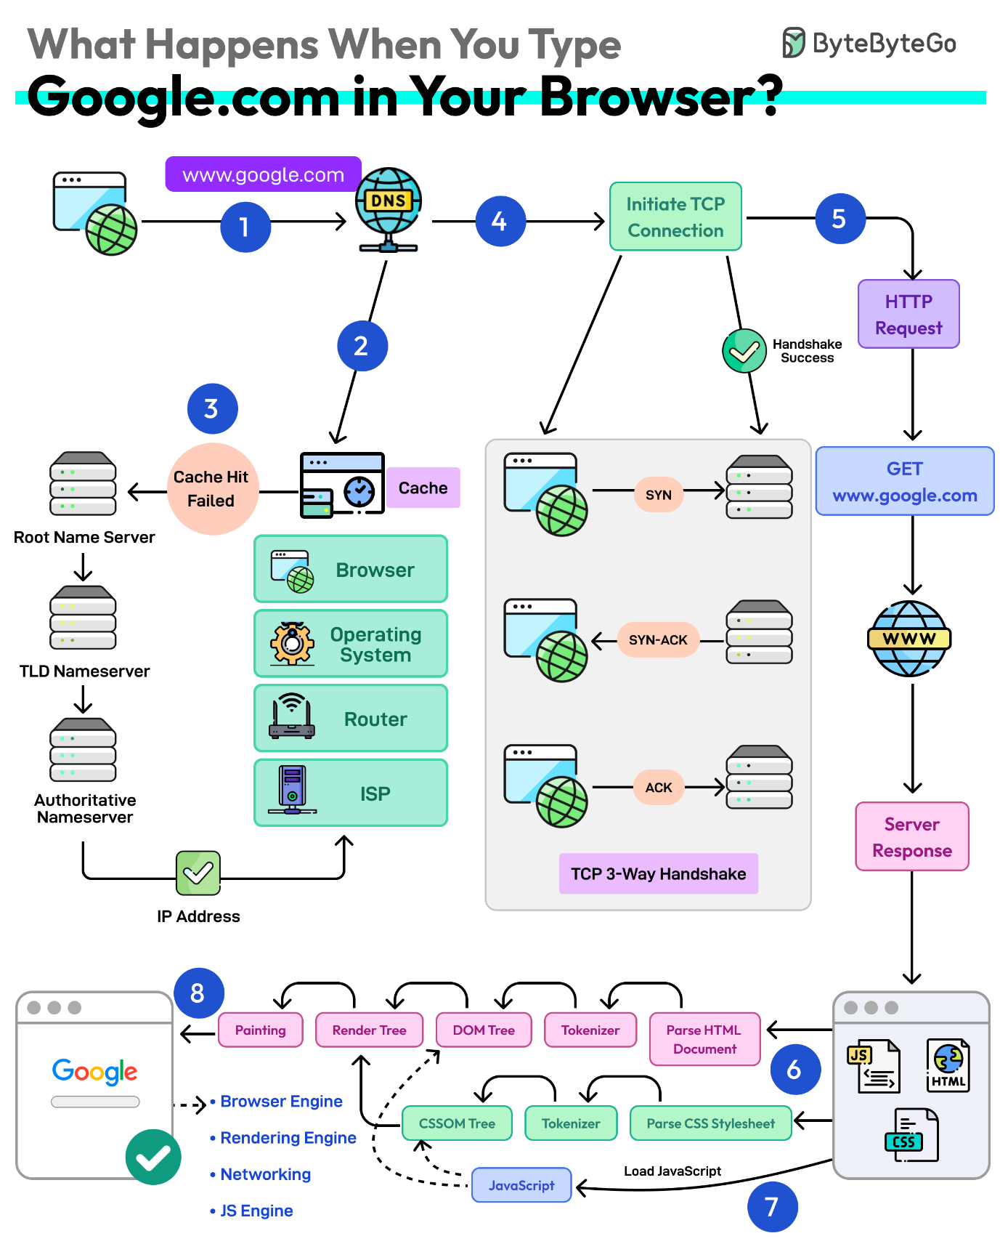

- First up, you type the website address in the browser’s address bar.
- The browser checks its cache first. If there’s a cache miss, it must find the IP address.
- DNS lookup begins (think of it as looking up a phone number). The request goes through different DNS servers (root, TLD, and authoritative). Finally, the IP address is retrieved.
- Next, your browser initiates a TCP connection like a handshake. For example, in the case of HTTP 1.1, the client and server perform a TCP three-way handshake with SYN, SYN-ACK, and ACK messages.
- Once the handshake is successful, the browser makes an HTTP request to the server and the server responds with HTML, CSS, and JS files.
- Finally, the browser processes everything. It parses the HTML document and creates DOM and CSSOM trees.
- The browser executes the JavaScript and renders the page through various steps (tokenizer, parser, render tree, layout, and painting).
- Finally, the webpage appears on your screen.

- What are these record types? Write one line each:
  - A, AAAA, CNAME, MX, NS
RECORD TYPE | DESCRIPTION
A | Maps a domain to an IPv4 address.
AAAA | Maps a domain to an IPv6 address.
CNAME | Aliases one domain name to another.
MX | Directs email to mail servers.
NS | Specifies the authoritative nameserver for a domain.
SOA | Contains administrative information about the domain, like the primary  nameserver and zone update settings.
TXT | Stores text information, often used for verification.
SRV | Specifies a service location for certain services, like servers handling  VoIP.
PTR | Maps an IP address to a domain name for reverse DNS lookups.

- Run: dig google.com — identify the A record and TTL from the output

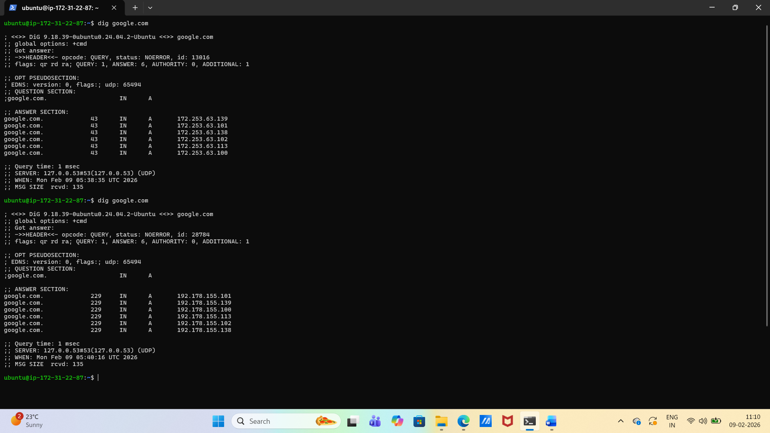

- What is an IPv4 address? How is it structured? (e.g., 192.168.1.10)
An IPv4 address is structured as follows:
Network Portion: Identifies the specific network segment a device belongs to (e.g., LAN network or "Home Wi-Fi"). All devices on the same local network share the same network portion.
Host Portion: Identifies the specific device within the network segment. It must be unique within the same network.
The structure of an IPv4 address is crucial for network routing and data transmission. It ensures that data packets are correctly addressed and delivered to their destination, facilitating seamless communication within and across networks.

- Difference between public and private IPs — give one example of each

An IP address (Internet Protocol address) is a unique numerical identifier assigned to devices for communication within a network or over the internet. These addresses are categorized into private and public IPs, each serving distinct purposes.
Private IP Addresses
Private IPs are used for communication within a local network (LAN). These addresses are assigned by routers and are not accessible directly from the internet. They are primarily used to enhance security and manage internal communication between devices.
Characteristics:
- Scope: Local to the network.
- Assigned By: Router or local network operator.
- Usage: Enables communication between devices within the same network.
- Security: More secure as they are not exposed to the internet.
- Cost: Free of charge.
- Examples: 192.168.1.1, 10.0.0.1.
- Ranges: 10.0.0.0 – 10.255.255.255 172.16.0.0 – 172.31.255.255 192.168.0.0 – 192.168.255.255
Limitations:
- Cannot communicate directly with external networks without NAT (Network Address Translation).
- Limited accessibility outside the local network.
Public IP Addresses
Public IPs are used for communication outside the local network, allowing devices to connect to the internet. These addresses are assigned by Internet Service Providers (ISPs) and are globally unique.
Characteristics:
- Scope: Global.
- Assigned By: ISP.
- Usage: Enables communication over the internet.
- Security: Requires additional measures like firewalls to prevent unauthorized access.
- Cost: Often incurs additional charges.
- Examples: 82.129.73.111, 203.0.113.1.
- Ranges: Any IP address not in the private IP ranges.
Limitations:
- Easier to trace, raising privacy concerns.
- Limited availability due to the exhaustion of IPv4 addresses.
Key Differences
- Scope: Private IPs are local, while public IPs are global.
- Communication: Private IPs work within a network; public IPs enable internet access.
- Security: Private IPs are inherently secure, while public IPs require additional protection.
- Cost: Private IPs are free; public IPs may involve costs.
- Uniqueness: Private IPs can be reused across different networks, whereas public IPs are unique globally.
Practical Use Cases
- Private IPs: Used in homes, offices, and organizations for internal communication (e.g., connecting printers, computers, and IoT devices).
- Public IPs: Used for hosting websites, accessing remote servers, or enabling direct communication over the internet.
Understanding the distinction between private and public IPs is essential for managing networks effectively and ensuring secure communication.

- What are the private IP ranges?
  - 10.x.x.x, 172.16.x.x – 172.31.x.x, 192.168.x.x

- Run: ip addr show — identify which of your IPs are private
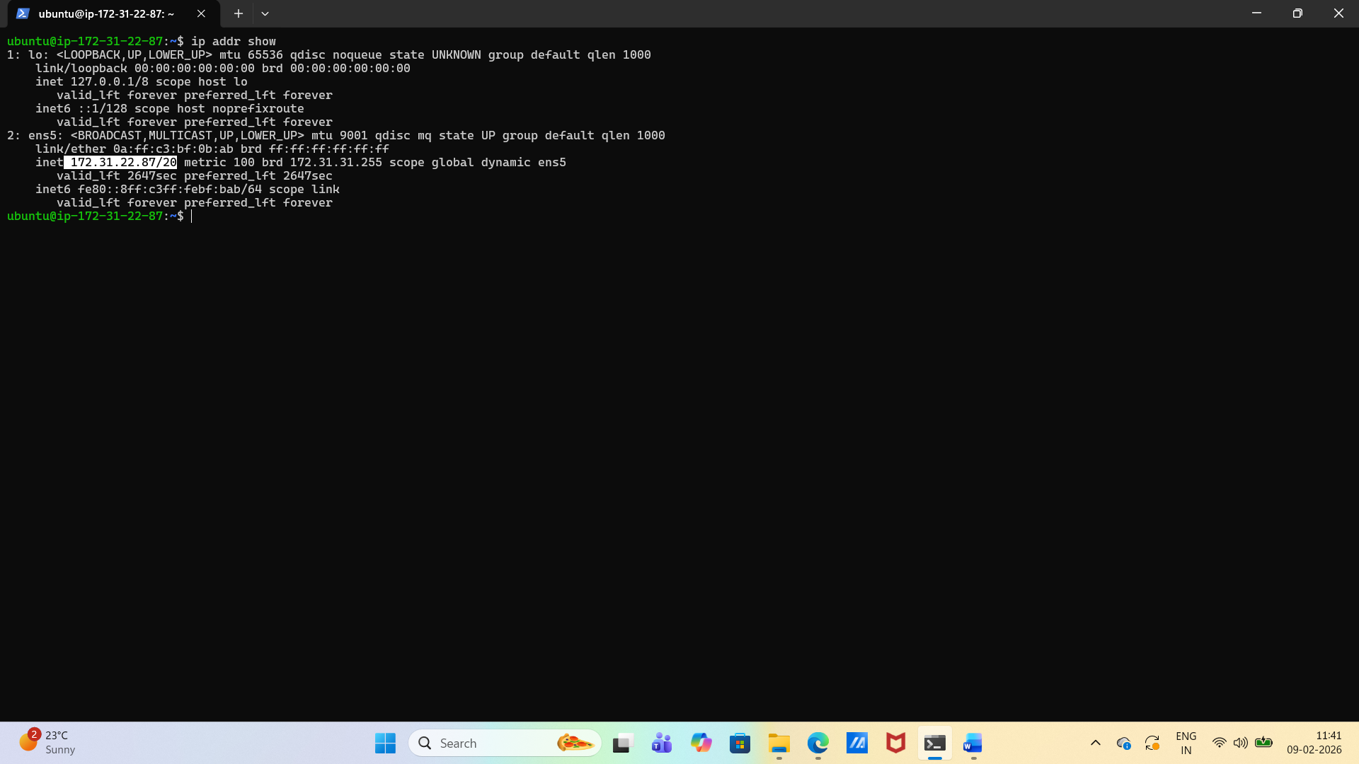

- What does /24 mean in 192.168.1.0/24?
In 192.168.1.0/24, the /24 indicates that the first 24 bits of the IP address are used to identify the network, which means the subnet mask is 255.255.255.0. This configuration allows for a total of 256 IP addresses (from 192.168.1.0 to 192.168.1.255), making it suitable for small to medium-sized networks.

- How many usable hosts in a /24? A /16? A /28?

The number of usable hosts in an IPv4 subnet depends on the subnet mask size:
- /24: Usable hosts = 2^8 - 2 = 254.
- /16: Usable hosts = 2^16 - 2 = 65,534.
- /28: Usable hosts = 2^28 - 2 = 1,048,576.
In general, the usable hosts can be calculated using the formula: Usable hosts = 2^(number of bits) - 2.

- Explain in your own words: why do we subnet?
Subnet is creating our own internet.
Subnetting is a process of dividing a large IP network into smaller logical networks called subnets. This division allows for more efficient use of IP addresses, improved performance, and enhanced security control. For example, in a company, a single network can be divided into multiple subnets for different departments, keeping departmental traffic separate and organized. This approach not only improves network performance but also enhances security by isolating different departments from each other. Subnetting is a powerful tool in network design that helps manage large networks more effectively and efficiently

- Quick exercise — fill in:
CIDR | Subnet Mask | Total IPs | Usable Hosts
/24 | 255.255.255.0 | 256 | 254
/16 | 255.255.0.0 | 65536 | 65534
/28 | 255.255.255.240 | 16 | 14

- What is a port? Why do we need them?
A port is a virtual endpoint in networking that directs network traffic to the correct application or service on a device. It allows multiple services to operate simultaneously on a single device by assigning unique port numbers to different applications
- Document these common ports:
Port | Service
22 | SSH
80 | HTTP web traffic
443 | HTTPS
53 | Domain Name System (DNS)
3306 | MYSQL database server
6379 | Redis – Client server communication
27017 | MongoDB database management system

- Run ss -tulpn — match at least 2 listening ports to their services

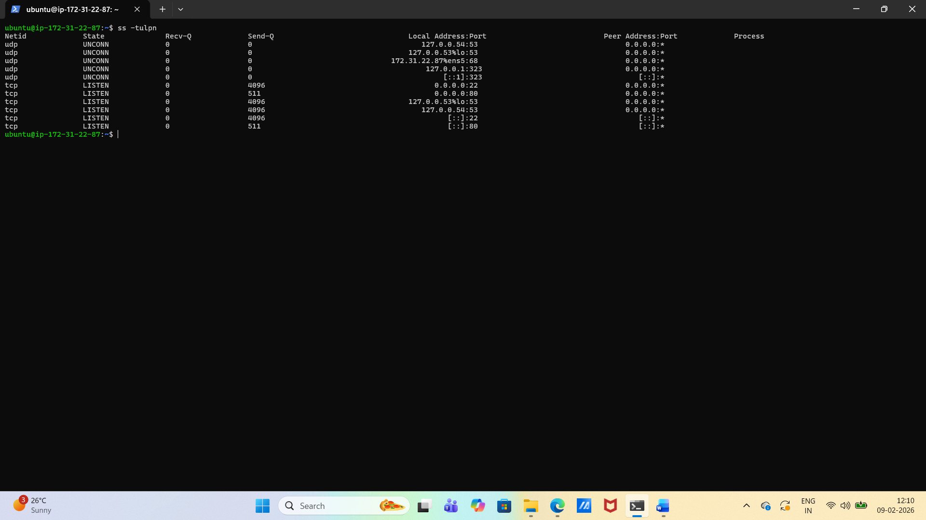

- You run curl http://myapp.com:8080 — what networking concepts from today are involved?

Running curl http://myapp.com:8080 touches several layers of networking concepts:

1. DNS Resolution
- myapp.com is a domain name.
- The client (curl) asks the DNS resolver to translate it into an IP address.
- This involves recursive queries through DNS servers until the authoritative server provides the IP.

2. Transport Layer (TCP)
- curl establishes a TCP connection to the resolved IP address on port 8080.
- TCP handles:
  - Three-way handshake (SYN, SYN-ACK, ACK).
  - Reliable delivery (acknowledgments, retransmissions).
  - Flow control and congestion control.

3. Application Layer (HTTP)
- curl sends an HTTP request (default is GET /).
- The server listens on port 8080 (commonly used for web apps, not the default 80).
- The server responds with HTTP headers and body.

4. Sockets & Ports
- On the client side, curl uses an ephemeral port (e.g., 49152+) to initiate the connection.
- On the server side, port 8080 is the listening port.
- Together, they form a socket pair: (client_IP:client_port, server_IP:8080).

5. Routing & IP Layer
- The request travels across routers using IP packets.
- Each packet has source/destination IP addresses.
- Routing tables determine the path across networks.

6. Link Layer
- Frames are transmitted over physical media (Ethernet, Wi-Fi).
- MAC addresses are used within local networks.
- ARP resolves IP → MAC mapping.

7. Security & Firewalls
- Firewalls may allow or block traffic on port 8080.
- If HTTPS were used (https://myapp.com:8080), TLS handshake would add encryption and certificate validation.
So, in short: DNS → TCP/IP → HTTP → Sockets → Routing → Link Layer → Security all play a role when you run that single curl command.

- Your app can't reach a database at 10.0.1.50:3306 — what would you check first?

When your app can’t reach a database at 10.0.1.50:3306, the first checks should focus on the most fundamental networking layers before diving deeper:

Immediate Checks
- Connectivity (Ping/Reachability) Test if the host 10.0.1.50 is reachable at all. If ICMP is blocked, try telnet 10.0.1.50 3306 or nc -vz 10.0.1.50 3306 to confirm the port is open.
- Firewall / Security Groups Ensure that inbound traffic on port 3306 (MySQL default) is allowed on the database host, and outbound traffic is permitted from the app host.
- Database Service Status Verify that MySQL (or the database engine) is actually running and listening on port 3306. Example: netstat -tulnp | grep 3306 or ss -ltnp | grep 3306.

Next Layer Checks
- Network Routing Confirm that the app’s subnet can route to 10.0.1.50. Misconfigured routes or VLANs can block traffic.
- Host Binding Check if the database is bound to 127.0.0.1 only (local connections) instead of 0.0.0.0 or the server’s private IP.
- Authentication / Permissions Even if the port is open, the app may fail if credentials or user grants are incorrect. But this comes after confirming connectivity.
So the very first thing I’d check is basic network connectivity to 10.0.1.50:3306 — if the port isn’t reachable, no higher-level troubleshooting matters yet.
