UNIT I:
Introduction to Information storage and retrieval systems: Domain Analysis of IR systems, IR and other types of Information Systems, IR System Evaluation.
Introduction to Data structures and algorithms related to Information Retrieval: Basic Concepts, Data structures, Algorithms: Inverted Index, K-Means Clustering Naïve Bayes

1. INTRODUCTION:
- The Systems which are used to store information gathered from different sources in such a way that it can be retrieved easily and effectively upon request are referred to as information storage and retrieval systems.
- Collecting information from different resources and storing it in either storage room(maintaining paper records) or the storage devices such as hard disk, DVD, CD is called as information storage. This information may be in any of the form that is audio, video, text. Information Retrieval System is mainly focus electronic searching and retrieving old documents.
- The process of searching, fetching and serving of information to the requested users is information retrieval. An IR System is capable of performing operations like methods for adding documents to the database, modifying or deleting them from the database, methods for searching and serving appropriate document to the users.
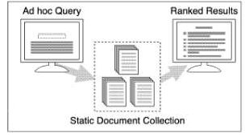
- Information Retrieval is an activity of obtaining relevant documents based on user needs from collection of retrieved documents.

Basic information retrieval system

- A static, or relatively static, document collection is indexed prior to any user query. A query is issued and a set of documents that are deemed relevant to the query are ranked based on their computed similarity to the query and presented to the user query.
- Information Retrieval (IR) is devoted to finding relevant documents, not finding simple matches to patterns.
- Many university, corporate, and public libraries now use IR systems to provide access to books, journals, and other documents.
- Commercial IR systems offer databases containing millions of documents in myriad subject areas.
- Dictionary and encyclopedia databases are now widely available for PCs. IR has been found useful in such disparate areas as office automation and software engineering.

2. DOMAIN ANALYSIS OF IR SYSTEMS:
- Domain Analysis of IR System is the process of analyzing number of related systems offering a method to create a conceptual framework.
- This framework is capable of determining, understanding and using data structures, algorithms and techniques efficiently.
- Prieto-Diaz and Arrango (1991) developed a framework as domain analysis which is nothing but a system analysis for multiple related systems. Via Domain Analysis, one attempts to discover and record the similarities and difference among related systems.
- The primary steps of domain analysis involve the following activities:
i. Determining the essential concepts and vocabulary in the domain.
ii. Defining these essential concepts and vocabulary.
- The figure below is faceted classification for IR systems:

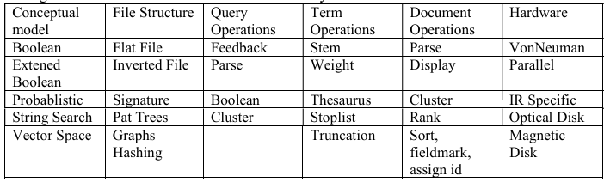

- The top row represents the facets(attributes used by IR System) which are the parts of the IR System and are common in all the systems but may vary in terms of their values or sub attributes .
- The facet values are known as terms. Occurrence of one term does not restrict the other terms to occur within a facet. Moreover a facet can have one or more facet values for a single system.
Conceptual Models:
- The most common facet in the faceted classification is conceptual model.
- Conceptual model has been classified by two analysis :
  - Faloutsos categorization
  - Belkin and Croft categorization
- Faloutsos (1985) gives three basic approaches:
  - Text pattern search – (Find all occurrences of a pattern (substring) within a text (string))
  - Inverted file search – (It maps terms (words, numbers, etc.) to their locations within a database, document, or set of documents.)
  - Signature search- (Searching based on some indexing technique)
- Belkin and Croft (1987) categorize IR conceptual models differently. They divide retrieval techniques first into exact match and inexact match.
- The exact match category contains text pattern search and Boolean search techniques.
- The inexact match category contains such techniques as probabilistic, vector space, and clustering.
- IR systems are either Boolean IR systems for major document collections or text pattern search systems for handling small document collections.
- Text pattern search queries are strings or regular expressions.
- In a Boolean IR system, documents are represented by sets of keywords, usually stored in an inverted file.
- An inverted file is a list of keywords and identifiers of the documents in which they occur.
- Boolean queries are keywords connected with Boolean logical operators (AND, OR, NOT) while Boolean systems have been criticized, improving their retrieval effectiveness has been difficult.
File Structures Facet of IR System:
Different types of file structures that can be adopted by IR system are:
- Inverted File
- Flat File
- Signature File
- Graphs
- PAT Trees
- Inverted File: This file structure is a type of indexed file having the following fields,
Keyword: Indexing term defining the document
Document Id: uses a unique identifiers to represent a document.
Field Id: uses a unique name to represent the path of keyword within document.
In addition to these fields, few systems maintains addresses of sentences , paragraphs . Searching is done by looking up query terms in inverted file.
- Flat Files: The file structure creates a file with one or more documents usually as ASCII or EBC DIC text. The search is usually done via pattern matching.
For Ex: UNIX carryout this type of storage using UNIX directories within which one entire document collection can be placed. Searching is carried out through pattern searching tools like grep or awk.
- Signature Files: This file structure deals with the signature (bit patterns) for representing the document. The signature can be created within different methods. One common method for creating the signatures is to split the document into logical blocks each containing a fixed numbers of distinct significant (i.e non stoplist, words). Each word in the block is hashed to give a signature. Through the generated signature, a block signature is produced by performing ‘OR’ operation on them. These block signatures are then processed by performing concatenation to generate the document signature. Searching is done by comparing the signature of queries with document signatures.
- Graphs: Collection of nodes connected by arc. It is also known as networks. A document can be represented as a kind of graph called a semantic net which can be used to represent the semantic relationships in text. These graph based techniques are impractical at present because of high manual effort.
- PAT Trees( Patricia trees): (Practical Algorithm To Retrieve Information Coded In Alphanumeric) They are specially used for sistrings in a text. Consider that the set of document is arranged as an orderly numbered set of characters , then the sistring can be defined as the subset of characters from the set starting at a particular point and expanding itself arbitrarily towards the right side of the set.

Query Operations:
- The queries are feeded to the IR System through specific means.
- Serving a query involves the operation that are considered as the function of query type and IR system capabilities.
- Parsing is the common query operation where the query is divided into constituent parts.
- For instance, Boolean queries are divided into terms and operations upon parsing, so that it can easily retrieve the collection of document identifiers that are linked with each query term.
- Feedback is a special type of query which makes use of historical data associated with search and modify the queries.

Term Operations:
There are various operations that are performed on terms in an IR System. They are:
- Stemming
- Weighting
- Thesaurus
- Stoplist
- Truncation
- Stemming: This operation involve interconnecting of relavant word in an automated way. The interconnected of words is typically reduces the words that resembles like a common root.
- Weighting: This operation allocates numbering to the indexing or query terms taking into consideration the information regarding the statistical distribution of terms.
- Thesaurus: This operation combines the words that are equal (or) similar meanings are related to each other.
- Stop List: This operation deals with the words that may not have indexing value. It simply removes the potential indexing terms by finding their presence in the stoplist.
- Truncation: This operation manually combines the terms with help of wildcard characters in the word where the truncated term is used for matching multiple words.
Document Operations:
- Documents are the primary objects in IR systems and there are many operations for them. Some of the operations are:
  - Addition of documents to database
  - Masking of document fields
  - Sorting of document fields
  - Displaying documents
  - Arranging the documents with some priority
  - Clustering of documents
Hardware:
- The IR System get affected by the hardware employed in them. This is because the operating speed which is a crucial element in interactive information system and the quantity and type of information to be stored in IR system are entirely dependent on hardware.
- Most IR systems in use today are implemented on von Neumann machines-general purpose computers with a single processor.

Functional View of Paradigm IR System:
Figure shows the activities associated with a common type of Boolean IR system, chosen because it represents the operational standard for IR systems.
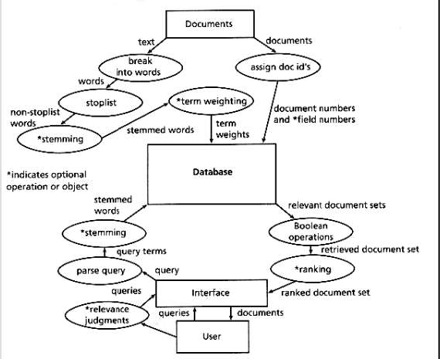

- When building the database, documents are taken one by one, and their text is broken into words.
- The words from the documents are compared against a stoplist--a list of words thought to have no indexing value.
- Words from the document not found in the stoplist may next be stemmed.
- Words may then also be counted, since the frequency of words in documents and in the database as a whole are often used for ranking retrieved documents.
- Finally, the words and associated information such as the documents, fields within the documents, and counts are put into the database.
- The database then might consist of pairs of document identifiers and keywords as follows. keyword1 - document1-Field_2. Such a structure is called an inverted file.
- In an IR system, each document must have a unique identifier, and its fields, if field operations are supported, must have unique field names.
- To search the database, a user enters a query consisting of a set of keywords connected by Boolean operators (AND, OR, NOT).
- The query is parsed into its constituent terms and Boolean operators.
- These terms are then looked up in the inverted file and the list of document identifiers corresponding to them are combined according to the specified Boolean operators.
- If frequency information has been kept, the retrieved set may be ranked in order of probable relevance. The result of the search is then presented to the user.

3. IR AND OTHER TYPES OF INFORMATION SYSTEMS:
 | Data Object | Primary Operation | Database Size
IR | Document | Retrieval | Small to very Large Size
DBMS | Table | Retrieval | Small to very Large Size
AI | Logical statements | Inference | Usually small
- Consider DBMS and Artificial Intelligence systems for illustrating relationship between IR system and other information systems.
- The IR system make use of document as data objects whereas DBMS and AI uses table and logical statements respectively. Here the usable structure of data object in IR system is less when compared with DBMS and AI system. IN DBMS and AI there is a possibility of manual assessment of document and also data storage about syntax and semantics. Hence, it is practically complex in case of huge set of documents.
- The IR systems compared to DBMS contains very large databases.
- The IR system has a typical feature that its retrieval is uncertain, that is there is no assurance about the exact match in required documents to the retrieved documents.
- IR System has following features:
  - Enabling user to add, change and delete in database.
  - Facilitating the user with the method for feeding query.
  - The IR system must support the database to handle megabyte or gigabyte range.
  - The IR system retrieves relevant documents quickly upon request.

4. IR System Evaluation:
- IR systems can be evaluated in terms of
  - Execution efficiency
  - Storage efficiency
  - Retrieval effectiveness.
- Execution efficiency is measured by the time it takes a system, or part of a system, to perform a computation.
- Storage efficiency is measured by the number of bytes needed to store data. It is typically measured through space overhead which is given by following formula,
Space overhead = (Size of the index files + Size of the document files)/ Size of the
document files
- Retrieval efficiency is the factor that is dependent on the decisions associated with relevancy of the documents.
The retrieval can be calculated as
- Recall: Recall is the ratio of relevant documents retrieved for a given query over the number of relevant documents for that query in the database.
- Precision: Precision is the ratio of the number of relevant documents retrieved over the total number of documents retrieved.
- Both recall and precision have values between 0 and 1.
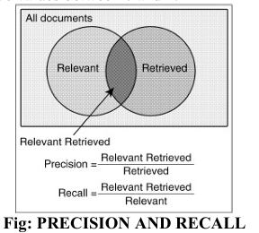
- Recall-precision plots show that recall and precision are inversely related.
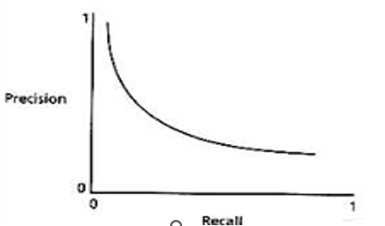

INTRODUCTION TO DATA STRUCTURES AND ALGORITHMS IN IR:
- BASIC CONCEPTS: The basic concepts related to text include
- Strings
- Regular Expressions
- Finite Automata
Strings:
- We use to denote the alphabet (a set of symbols).
- We say that the alphabet is finite if there exists a bound in the size of the alphabet, denoted by |Σ|.
- A string over an alphabet is a finite length sequence of symbols from Σ.
- The empty string (ε) is the string with no symbols.
- If x and y are strings, xy denotes the concatenation of x and y.
- If Ω = xyz is a string, then x is a prefix, and z a suffix of Ω.
- The length of a string x ( |x| ) is the number of symbols of x.
- Any contiguous sequence of letters y from a string is called a substring.
- If the letters do not have to be contiguous, we say that y is a subsequence.
Similarity between strings: Each similarity model is defined by a distance function d, such that for any strings s₁, s₂, and s_{3,} satisfies the following properties:
  - d(s1, s1)=0
  - d(s1, s2)>=0
  - d(s1, s3)<= d(s1, s2) + d(s1, s3) where, d= distance
s1 , s2 , s3 = different strings
- The two main distance functions are as follows:
  - The Hamming distance is defined over strings of the same length. The function d is defined as the number of symbols in the same position that are different (number of mismatches).
For example, d(text, that) = 2.
  - The edit distance is defined as the minimal number of symbols that is necessary to insert, delete, or substitute to transform a string s1 to s2.
For example, d (text, tax) = 2.
Regular Expressions:
- A regular expression is a sequence of characters that define a search pattern,
- Usually such patterns are used by string-searching algorithms for “find” or “find and replace” operations on strings, or for input validation.
- Regular expressions are used in search engines, search and replace dialogs of word processors and text editors.
- The regular expressions over Σ and the languages that they denote (regular sets or regular languages) are defined recursively as follows:
- Ø is a regular expression and denotes the empty set.
- ϵ is a regular expression and denotes the set {ϵ}.
- For each symbol a in Σ, a is a regular expression and denotes the set {a}.
- If p and q are regular expressions, then p + q (union), pq (concatenation), and p* (star) are regular expressions that denote L(p) υ L(q), L(p)L(q), and L(p)*, respectively.
Regex | Matches any string that contains
hello | {hello}
gray|grey | `
gr(a|e)y | {gray,grey}
gr[ae]y | {gray,grey}
b[aeiou]bble | {babble,bebble,bibble,bobble,bubble}
[b-chm-pP]at|ot | {bat,cat,hat,mat,bot,….}
go*gle ( * ranges from 0 to n) | {ggle,gogle,google……}
go+gle ( + ranges from 1 to n) | {gogle,google,gooogle…..}

Finite Automata:
- Finite automata is a state machine that takes a string of symbols as input and changes its state accordingly.
- Finite automata is a recognizer for regular expressions.
- When a regular expression string is fed into finite automata, it changes its state for each literal.
- If the input is successfully processed and the automata reaches its final state, it is accepted, i.e., the string just fed was said to be a valid token of the language in hand.
- A finite automata is a collection of 5-tuple(Q, Σ, δ,q0,F), where
    - Q is a finite set of states,
    - Σ is a finite set of input symbol,
    - q0 is the initial state,
    - F is the set of final states, and
    - δ is Transition function
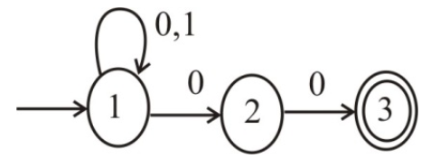
Figure: Example for Finite automata ending with “00”
- DATA STRUCTURES:
There are three basic data structures that are used to organize data in an IRS:
  - Search trees
  - Digital trees
  - Hashing
Search Trees:
- The most well-known search tree is the binary search tree.
- Each internal node contains a key, and the left subtree stores all keys smaller that the parent key, while the right subtree stores all keys larger than the parent key.
- Binary search trees are adequate for main memory.
- However, for secondary memory, multiway search trees are better, because internal nodes are bigger.
- In particular, we describe a special class of balanced multiway search trees called B-tree.
- A B-tree of order m is defined as follows:
    - The root has between 2 and 2m keys, while all other internal nodes have between m and 2m keys.
    - If ki is the i-th key of a given internal node, then all keys in the i - 1 - th child are smaller than ki, while all the keys in the i-th child are bigger.
    - All leaves are at the same depth.
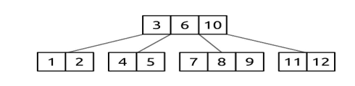
Figure: B-Tree
Digital Trees:
- Efficient prefix searching can be done using indices.
- One of the best indices for prefix searching is a binary digital tree or binary trie constructed from a set of substrings of the text.
- Tries are recursive tree structures that use the digital decomposition of strings to represent a set of strings and to direct the searching.
- If the alphabet is ordered, we have a lexicographically ordered tree.
- The root of the trie uses the first character, the children of the root use the second character, and so on. If the remaining subtrie contains only one string, that string's identity is stored in an external node.
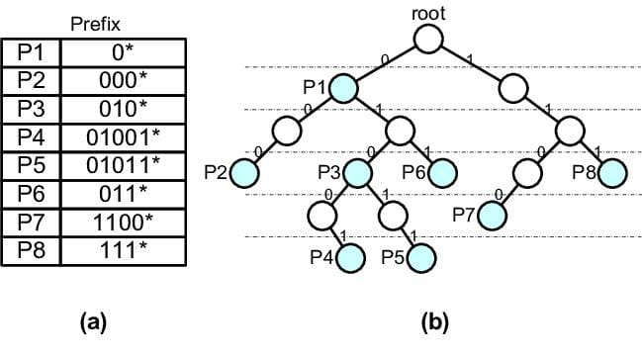
- A patricia tree is a trie with the additional constraint that each node that is the only child is merged with its parent.
- For n strings, such an index has n external nodes and n-1 internal nodes.
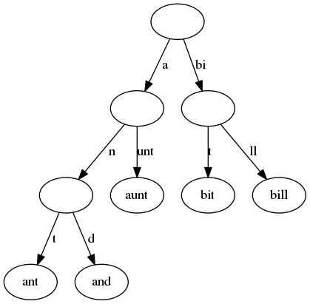
Hashing:
- A hashing function h (x) maps a key x to an integer in a given range (for example, 0 to m - 1).
- Hashing functions are designed to produce values uniformly distributed in the given range.
- The hashing value is also called a signature.
- A hashing function is used to map a set of keys to slots in a hashing table.
- If the hashing function gives the same slot for two different keys, we say that we have a collision.
- Hashing techniques mainly differ in how collisions are handled.
- There are two classes of collision resolution schemas: open addressing and overflow addressing.

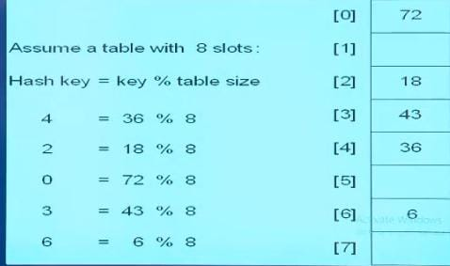
Figure: Hashing example
Open Addressing:
- In open addressing, the collided key is "rehashed" into the table, by computing a new index value.
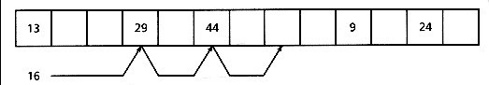
- The most used technique in this class is double hashing, which uses a second hashing function.
- Formula for double hashing is
- 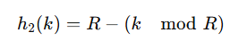
- Where R is the nearest prime(smaller than size of the table).
- The main limitation of this technique is that when the table becomes full, some kind of reorganization must be done.
Overflow Addressing:
- In overflow addressing, the collided key is stored in an overflow area, such that all key values with the same hashing value are linked together.
- The main problem of this schema is that a search may degenerate to a linear search.

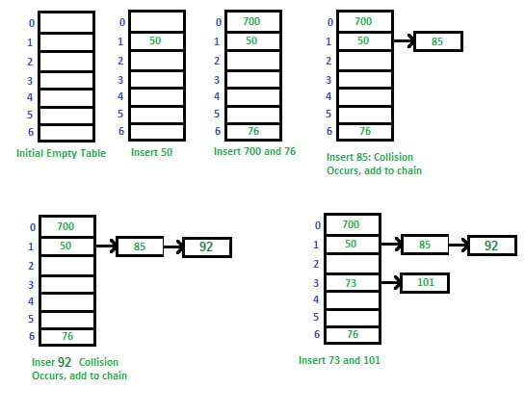
Figure: Example for overflow addressing
3.ALGORITHMS:
- Three main types of algorithms:
  - Retrieval Algorithms
  - Filtering Algorithms
  - Indexing Algorithms
- There are other algorithms used in IR that do not fall within our description, for example, user interface algorithms.
- The reason that they cannot be considered as IR algorithms is because they are inherent to any computer application.

Retrieval Algorithms:
- The main class of algorithms in IR is retrieval algorithms, that is, to extract information from a textual database.
- We can distinguish two types of retrieval algorithms, according to how much extra memory needed.
- Sequential scanning of the text: Extra memory is in the worst case a function of the query size, and not of the database size. On the other hand, the running time is at least proportional to the size of the text, for example, string searching.
- Indexed text: An "index" of the text is available, and can be used to speed up the search. The index size is usually proportional to the database size, and the search time is sublinear on the size of the text, for example, inverted files and signature files.

Filtering Algorithms:
- This class of algorithms is such that the text is the input and a processed or filtered version of the text is the output. This is a typical transformation in IR, for example to reduce the size of a text, and/or standardize it to simplify searching.
- The most common filtering/processing operations are:
  - Common words removed using a list of stopwords.
  - Uppercase letters transformed to lowercase letters.
  - Special symbols removed and sequences of multiple spaces reduced to one space.
  - Numbers and dates transformed to a standard format.
  - Spelling variants transformed using Soundex-like methods.
  - Word stemming (removing suffixes and/or prefixes).
  - Automatic keyword extraction.
  - Word ranking.

Indexing Algorithms:
- Indexing is building a data structure that will allow quick searching of the text. There are many classes of indices, based on different retrieval approaches.
- For example, inverted files, signature files, tries, and so on.
- Almost all type of indices are based on some kind of tree or hashing.
- Usually, before indexing, the text is filtered. Figure shows the complete process for the text.
