UNIT II:
Inverted Files and Signature Files: Introduction, Structures used in Inverted Files, building an Inverted file using a sorted array, Modifications to the Basic Techniques.
Signature Files: Concepts of Signature files, Compression, Vertical Partitioning, Horizontal Partitioning.

- INVERTED FILES: INTRODUCTION:
- Three of the most commonly used file structures for information retrieval can be classified as
- lexicographical indices (indices that are sorted)
- clustered file structures, and
- indices based on hashing.
- Two types of lexicographical index files are the inverted file and the Patricia (PAT) tree.
- The concept of the inverted file type of index is as follows.
- Assume a set of documents
- Each document is assigned a list of keywords or attributes, with optional relevance weights associated with each keyword (attribute).
- An inverted file is then the sorted list (or index) of keywords (attributes), with each keyword having links to the documents containing that keyword in below figure.
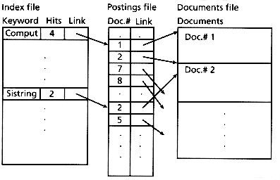

Fig: An inverted file implemented using a sorted array

- This is the kind of index found in most commercial library systems. The use of an inverted file improves search efficiency by several orders of magnitude, a necessity for very large text files.

- DATA STRUCTURES USED IN INVERTED FILE:
- There are several structures that can be used in implementing inverted files:
  - Sorted array
  - B-Trees
  - Tries
- These are sorted indices and can efficiently support range queries such as documents having keywords that start with “comput”.

Sorted Array:
- An inverted file implemented as a sorted array structure.
- It stores the list of keywords in a sorted array, including the number of documents associated with each keyword and a link to the documents containing that keyword.
- This array is commonly searched using a standard binary search.
- The main disadvantage of this approach is that updating the index (for example appending a new keyword) is expensive.
- On the other hand, sorted arrays are easy to implement and are reasonably fast.

B-trees:
- Another implementation structure for an inverted file is a B-tree.
- A special case of the B-tree, the prefix B-tree, uses prefixes of words as primary keys in a B-tree index and is particularly suitable for storage of textual indices.
- Each internal node has a variable number of keys.
- Each key is the shortest word (in length) that distinguishes the keys stored in the next level.
- The key does not need to be a prefix of an actual term in the index.
- The last level or leaf level stores the keywords themselves, along with their associated data.
- Because the internal node keys and their lengths depend on the set of keywords, the order (size) of each node of the prefix B-tree is variable.
- Updates are done similarly to those for a B-tree to maintain a balanced tree.
- The prefix B-tree method breaks down if there are many words with the same (long) prefix.
- In this case, common prefixes should be further divided to avoid wasting space.
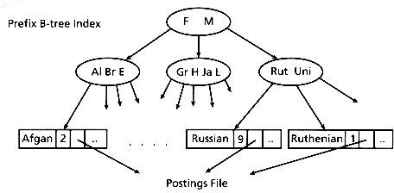

- The prefix B-tree method breaks down if there are many word with the same long prefix.
- Compared with sorted arrays, B-trees use more space.
- However, updates are much easier and the search time is generally faster, especially if secondary storage is used for the inverted file (instead of memory).
- The implementation of inverted files using B-trees is more complex than using sorted arrays.

Tries:
- Inverted files can also be implemented using a trie structure.
- This structure uses the digital decomposition of the set of keywords to represent those keywords.
- A special trie structure, the Patricia (PAT) tree, is especially useful in information retrieval.

- BUILDING AN INVERTED FILE USING A SORTED ARRAY:
- The i/p text must be parsed into a list of words along with their location in the text.
- The list must then be inverted from a list of terms in location order to a list of terms ordered for use in searching.
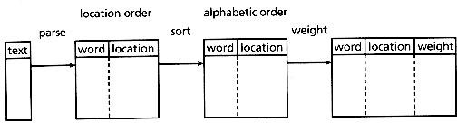
- It is post processing of those inverted files, such as adding term weights or for reorganizing or compressing the files.
Fig: Overall schematic of sorted array inverted file creation

Creating the initial word list requires several different operations:-
  - The individual words must be recognized from the text.
  - Each word is then checked against a stoplist of common words.
  - If it can be considered a non-common word, may be passed through a stemming algorithm. The resultant stem is then recorded in the word -within-location list.
  - The word list resulting from the parsing operation (typically stored as a disk file) is then inverted.
  - This is usually done by sorting on the word (or stem), with duplicates retained.
  - Even with the use of high-speed sorting utilities, however, this sort can be time consuming for large data sets (on the order of n log n).
  - One way to handle this problem is to break the data sets into smaller pieces, process each piece, and then correctly merge the results.
  - After sorting, the duplicates are merged to produce within -document frequency statistics. (A system not using within -document frequencies can just sort with duplicates removed.)
  - Note that although only record numbers are shown as locations in Figure 3.4, typically inverted files store field locations and possibly even word location.
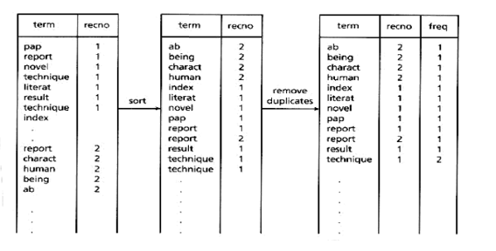
Inversion of word List:
  - Although an inverted file could be used directly by the search routine, it is usually processed into an improved final format.
  - This format is based on the search methods and the (optional) weighting methods used.
  - A common search technique is to use a binary search routine on the file to locate the query words.
  - This implies that the file to be searched should be as short as possible, and for this reason the single file shown containing the terms, locations, and (possibly) frequencies is usually split into two pieces.
  - The first piece is the dictionary containing the term.
  - The second piece is the postings file itself.
  - In this manner, the dictionary used in the binary search has only one "line" per unique term.

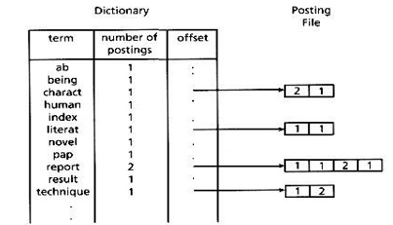
Fig: Dictionary and postings file from the last example
- MODIFICATIONS TO THE BASIC TECHNIQUE:
- Two different techniques are presented as improvements on the basic inverted file creation.
  - The first technique is for working with very large data sets using secondary storage (without sorting).
  - The second technique uses multiple memory loads for inverting files.
- Producing an Inverted File for Large Data Sets without Sorting:
  - Most computers cannot sort the very large disk files needed to hold the initial word list within a reasonable time.
  - By breaking the dataset into smaller pieces and then processing can be done, after merging can be taken place. But for small datasets it carries a significant overhead, so can’t be used.
  - The new indexing method (Harman & Candela 1990) is a two-step process that does not need the middle sorting step.
  - The first step produces the initial inverted file.
  - The second step adds the term weights to that file and reorganizes the file for maximum efficiency .
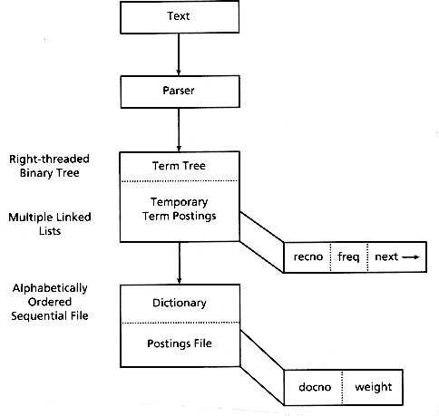
Fig: Flowchart of new indexing method
- The creation of the initial inverted file avoids the use of an explicit sort by using a right- threaded binary tree.
  - The data contained in each binary tree node is the current number of term postings and the storage location of the postings list for that term.
- Each term is identified by the text parsing program.
  - It is looked up in the binary tree, and either is added to the tree, along with related data , or causes tree data to be updated.
  - The postings are stored as multiple linked lists, one variable length linked list for each term, with the lists stored in one large file.
  - Each element in the linked postings file consists of a record number, the term frequency in that record, and a pointer to the next element in the linked list for that given term.
  - By storing the postings in a single file, no storage is wasted, and the files are easily accessed by following the links.
- As the location of both the head and tail of each linked list is stored in the binary tree, the entire list, does not need to be read for each addition, but only once for use in creating the final postings file (step two).
- Each term is consecutively read from the binary tree (this automatically puts the list in alphabetical order), along with its related data.
  - A new sequentially stored postings file is allocated, with two elements per posting.
  - The linked postings list is then traversed, with the frequencies being used to calculate the term weights (if desired).
  - The last step writes the record numbers and corresponding term weights to the newly created sequential postings file.
  - These sequentially stored postings files could not be created in step one because the number of postings is unknown at that point in processing, and input order is text order, not inverted file order.
  - The final index files therefore consist of the same dictionary and sequential postings file as for the basic inverted file.

FAST INVERSION ALGORITHM (FAST-INV):
- The second technique to produce a sorted array inverted file is a fast inversion algorithm called FAST –INV.
- This technique takes advantage of two principles:
    - The large primary memories available on today's computers.
    - The inherent order of the input data.
- The first principle is important since personal computers with more than 1 mega byte of primary memory are common, and mainframes may have more than 100 megabytes of memory. Even if databases are on the order of 1 gigabyte, if they can be split into memory loads that can be rapidly processed and then combined, the overall cost will be minimized.
- The second principle is crucial since with large files it is very expensive to use polynomial or even n log n sorting algorithms. These costs are further compounded if memory is not used, since then the cost is for disk operations.
- The input to FAST -INV is a document vector file containing the concept vectors for each document in the collection to be indexed.
  - The document numbers appear in the left -hand column and the concept numbers of the words in each document appear in the right- hand column.
  - This is similar to the initial word list for the basic method, except that the words are represented by concept numbers, one concept number for each unique word in the collection (i.e., 250,000 unique words implies 250,000 unique concept numbers).
  - Note however that the document vector file is in sorted order, so that concept numbers are sorted within document numbers, and document numbers are sorted within collection. This is necessary for FAST-INV to work correctly.
- Input to FAST-INV is a document vector file containing the concept vectors for each document. A sample document vector file is as shown:
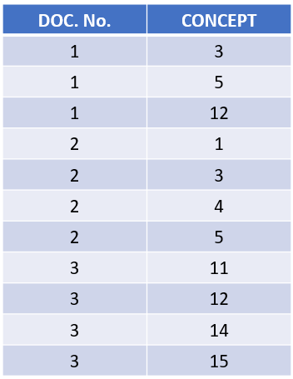
Fig: Sample document vector
- The Fast Inversion algorithm involves three phases:
  - Preparation
  - Splitting the Document vector file
  - Inverting each load
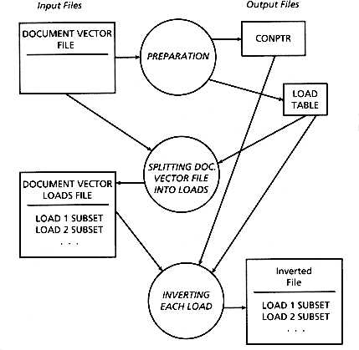
Fig: Overall scheme of FAST -INV
- Preparation involves the following:
- Allocate an array, con_entries_cnt, of size HCN, initialized to zero.
- For each <doc#,con#> entry in the document vector file: increment con_entries_cnt[con#].
- Use the just constructed con_entries_cnt to create a disk version of CONPTR.
- Initialize the load table.
- For each <con#,count> pair obtained from con_entries_cnt: if there is no room for documents with this concept to fit in the current load, then create an entry in the load table and initialize the next load entry; otherwise update information for the current load table entry.
After one pass through the input, the CONPTR file has been built and the load table needed in later steps of the algorithm has been constructed.
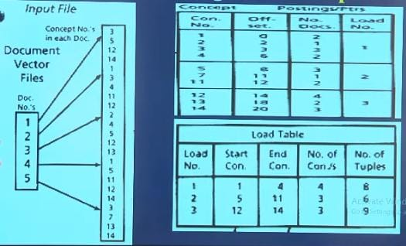

Fig: Preparation Phase
- Splitting document vector file:
- The load table indicates the range of concepts that should be processed for each primary memory load.
- To handle the multiplicity of loads, is to make a pass through the document vector file to obtain the input for each load.
- This has the advantage of not requiring additional storage space (though that can be obviated through the use of magnetic tapes), but has the disadvantage of requiring expensive disk I/O.
- Inverting each load:
- When a load is to be processed, the appropriate section of the CONPTR file is needed.
- An output array of size equal to the input document vector file subset is needed.
- As each document vector is processed, the offset (previously recorded in CONPTR) for a given concept is used to place the corresponding document/weight entry, and then that offset is incremented.
- Thus, the CONPTR data allows the input to be directly mapped to the output, without any sorting.
- At the end of the input load the newly constructed output is appended to the inverted file.
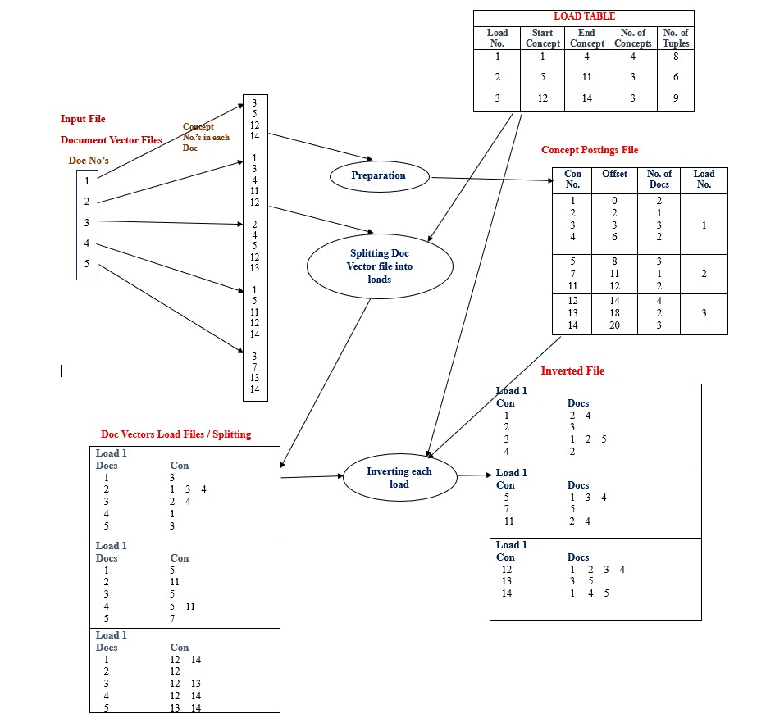

SIGNATURE FILES
    - INTRODUCTION:
- Text retrieval methods have attracted much interest recently. There are numerous applications involving storage and retrieval of textual data:
  - Electronic office filing.
  - Computerized libraries.
  - Library of Medicine.
  - Consumers' databases
  - Searching image databases …………..
- The main operational characteristics of all the above applications are the following two:
- Text databases are traditionally large
- Text databases have archival nature
- A qualitative comparison of the signature-based methods versus their competitors is as follows:
- The signature-based methods are much faster than full text scanning.
- Compared to inversion, they require a modest space overhead (typically 10-15%, as opposed to 50-300% that inversion requires).
- They can handle insertions more easily than inversion, because they need "append -only" operations -- no reorganization or rewriting of any portion of the signatures.
- Methods requiring "append only” insertions have the following advantages:
- (a) increased concurrency during insertions
- (b) these methods work well on Write-Once-Read -Many (WORM) optical disks, which constitute an excellent archival medium.
- On the other hand, signature files may be slow for large databases, precisely because their response time is linear on the number of items N in the database.

    - BASIC CONCEPTS:
- Signature files typically use superimposed coding to create the signature of a document. A brief description of the method follows.
- Each document is divided into "logical blocks," that is, pieces of text that contain a constant number D of distinct, noncommon words. (To improve the space overhead, a stoplist of common words is maintained).
- Each such word yields a "word signature," which is a bit pattern of size F, with m bits set to "1", while the rest are "0". F and m are design parameters.
- The word signatures are OR'ed together to form the block signature.
- Block signatures are concatenated, to form the document signature.
- The m bit positions to be set to "1" by each word are decided by hash functions.
- Searching for a word is handled by creating the signature of the word and by examining each block signature for "1" 's in those bit positions that the signature of the search word has a "1".
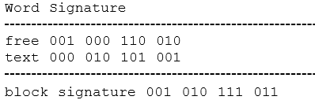
Figure: Illustration of the superimposed coding method. It is assumed that each logical block consists of D=2 words only. The signature size F is 12 bits, m=4 bits per word.

- In order to allow searching for parts of words, the following method has been suggested:
- Each word is divided into successive, overlapping triplets (e.g., "fr", "fre", "ree", "ee" for the word "free").
- Each such triplet is hashed to a bit position by applying a hashing function on a numerical encoding of the triplet, for example, considering the triplet as a base-26 number.
- In the case of a word that has l triplets, with l > m, the word is allowed to set l (nondistinct) bits.
- If l < m, the additional bits are set using a random number generator, initialized with a numerical encoding of the word.
- An important concept in signature files is the false drop probability Fd.
- Intuitively, it gives the probability that the signature test will fail, creating a "false alarm" (or "false hit" or "false drop").
- DEFINITION: False drop probability, Fd, is the probability that a block signature seems to qualify, given that the block does not actually qualify. Expressed mathematically:
Fd = Prob{signature qualifies/block does not}
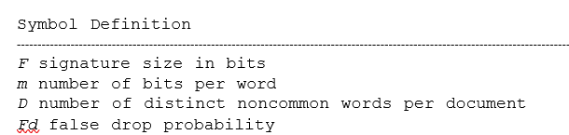

- The most straightforward way to store the signature matrix is to store the rows sequentially. For the rest of this work, the above method will be called SSF, for Sequential Signature File.

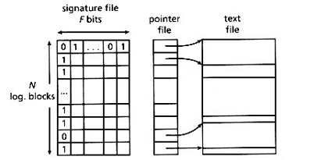
Figure: File structure for SSF

- Although SSF has been used as is, it may be slow for large databases. Many methods have been suggested, trying to improve the response time of SSF, trading off space or insertion simplicity for speed. The main ideas behind all these methods are the following:
- Compression: If the signature matrix is deliberately sparse, it can be compressed.
- Vertical partitioning: Storing the signature matrix column wise improves the response time on the expense of insertion time.
- Horizontal partitioning: Grouping similar signatures together and/or providing an index on the signature matrix may result in better-than-linear search.

    - COMPRESSION:
- In this we create sparse document signatures on purpose, and then compress them before storing them sequentially.
- Whenever compression is applied, the best value for m is 1. Also, it was shown that the resulting methods achieve better false drop probability than SSF for the same space overhead.
- The idea in these methods is that we use a (large) bit vector of B bits and we hash each word into one (or perhaps more, say n) bit position(s), which are set to "1" (see Figure 3.4).
- The resulting bit vector will be sparse and therefore it can be compressed.

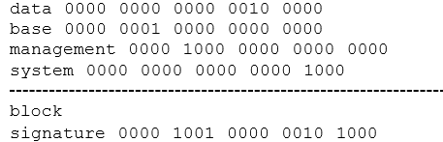
Figure: Illustration of the compression-based methods. With B = 20 and n = 1 bit per word, the resulting bit vector is sparse and can be compressed.
- The space wise best compression method is run-length encoding.

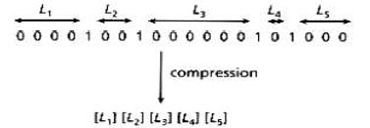
Figure: Compression using run-length encoding. The notation [x] stands for the encoded value of number x

  - Bit-block Compression (BC):
- This method accelerates the search by sacrificing some space, compared to the run-length encoding technique.
- The compression method is based on bit-blocks, and was called BC (for bit-Block Compression).
- To speed up the searching, the sparse vector is divided into groups of consecutive bits (bit-blocks); each bit-block is encoded individual.
- For each bit- block we create a signature, which is of variable length and consists of at most three parts (As shown in Figure):
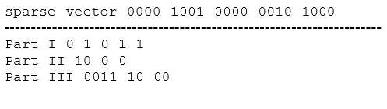
Figure: Illustration of the BC method with bit-block size b = 4.

Final Solution is 01011 | 1000 | 00111000

- Part I. It is one bit long and it indicates whether there are any "l"s in the bit-block (1) or the bit-block is empty (0). In the latter case, the bit-block signature stops here.
- Part II. It indicates the number s of "1"s in the bit-block. It consists of s - 1 "1"s and a terminating zero. This is not the optimal way to record the number of "1"s. However this representation is simple and it seems to give results close to the optimal.
- Part III. It contains the offsets of the "1"s from the beginning of the bit-block (1 gb bits for each "1", where b is the bit-block size).
3.2 Variable Bit-block Compression (VBC):
- The idea is to use a different value for the bit-block size bopt for each message, according to the number W of bits set to 1 in the sparse vector.
- The size of the sparse vector B is the same for all messages.
- Figure below illustrates an example layout of the signatures in the VBC method.
- The upper row corresponds to a small message with small W, while the lower row to a message with large W.
- Thus, the upper row has a larger value of bopt, fewer bit-blocks, shorter Part I (the size of Part I is the number of bit-blocks), shorter Part II (its size is W) and fewer but larger offsets in Part III (the size of each offset is log bopt bits).
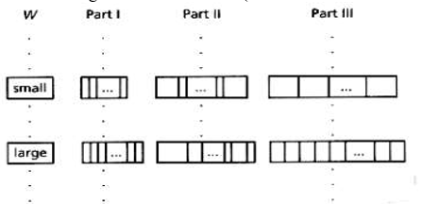
Figure: An example layout of the message signatures in the VBC method
3.3 Performance
- With respect to space overhead, the two methods (BC and VBC) require less space than SSF for the same false drop probability.
- Their response time is slightly less than SSF, due to the decreased I/0 requirements.
- The required main-memory operations are more complicated (decompression, etc.), but they are probably not the bottleneck.
- VBC achieves significant savings even on main -memory operations.
- With respect to insertions, the two methods are almost as easy as the SSF; they require a few additional CPU cycles to do the compression.

- VERTICAL PARTITIONING WITHOUT COMPRESSION:
- The idea behind the vertical partitioning is to avoid bringing useless portions of the document signature in main memory; this can be achieved by storing the signature file in a bit-sliced form or in “frame-sliced” form.
  - Bit-Sliced Signature Files (BSSF):
- The bit-sliced design is illustrated in Fig below.
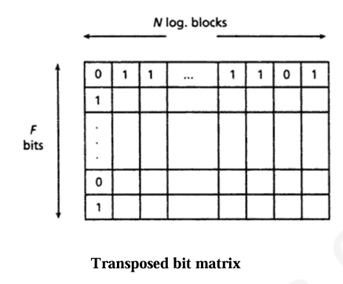
- To allow insertions, we propose using F different files, one per each bit position, which will be referred to as "bit-files."
- The method will be called BSSF, for "Bit-Sliced Signature Files."
- The figure below illustrates the proposed file structure.
- Searching for a single word requires the retrieval of m bit vectors (instead of all of the F bit vectors) which are subsequently ANDed together.
- The resulting bit vector has N bits, with "1"s at the positions of the qualifying logical blocks.
- An insertion of a new logical block requires F disk accesses, one for each bit-file, but no rewriting!
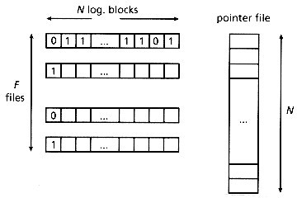
Figure: File structure for Bit-Sliced Signature Files. The text file is omitted.

4.2 Frame-Sliced Signature File:
- The idea behind this method is to force each word to hash into bit positions that are close to each other in the document signature.
- Then, these bit files are stored together and can be retrieved with few random disk accesses.
- The main motivation for this organization is that random disk accesses are more expensive than sequential ones, since they involve movement of the disk arm.
- More specifically, the method works as follows:
- The document signature (F bits long) is divided into k frames of s consecutive bits each.
- For each word in the document, one of the k frames will be chosen by a hash function; using another hash function, the word sets m bits (not necessarily distinct) in that frame. F, k, s, m are design parameters.
Word Signature
free 000000 110010
text 010110 000000
doc. signature 010110 110010
Figure: D = 2 words. F = 12, s = 6, k = 2, m = 3. The word free is hashed into the second frame and sets 3 bits there. The word text is hashed into the first frame and also sets 3 bits there.
- The signature matrix is stored framewise.
- Each frame will be kept in consecutive disk blocks.
- Only one frame has to be retrieved for a single word query, that is, only one random disk access is required.
- At most, n frames have to be scanned for an n word query.
- Insertion will be much faster than BSSF since we need only access k frames instead of F bit-slices.
- This method will be referred to as Frame-Sliced Signature file (FSSF).

4.3 The Generalized Frame-Sliced Signature File(GFSSF):
- In FSSF, each word selects only one frame and sets m bit positions in that frame.
- A more general approach is to select n distinct frames and set m bits (not necessarily distinct) in each frame to generate the word signature.
- The document signature is the OR-ing of all the word signatures of all the words in that document.
- This method is called Generalized Frame-Sliced Signature File.
- Notice that BSSF, FSSF, and SSF are actually special cases of GFSSF:
*When k = F, n = m, it reduces to the BSSF.
*When n = 1, it reduces to the FSSF method.
*When k = 1, n = 1, it becomes the SSF method (the document signature is broken down to one frame only).
4.4 Performance
- Since GFSSF is a generalized model, we expect that a careful choice of the parameters will give a method that is better (whatever the criterion is) than any of its special cases.
- Figure below plots the theoretically expected performance of GFSSF, BSSF and FSSF.
- Notice that GFSSF is faster than BSSF and FSSF, which are all its special cases.
- It is assumed that the transfer time for a page Ttrans = 1 msec and the combined seek and latency time Tseek is Tseek = 40 msec.
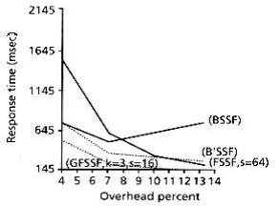
Figure: Response time vs. space overhead: a comparison between BSSF, B'SSF, FSSF and GFSSF. Analytical results on a 2.8Mb database.

- VERTICAL PARTITIONING AND COMPRESSION
- The idea in all the methods in this class is to create a very sparse signature matrix, to store it in a bit-sliced form, and compress each bit slice by storing the position of the "1"s in the slice.
- The methods in this class are closely related to inversion with a hash table.
5.1 Compressed Bit Slices (CBS)
- Although the bit-sliced method is much faster than SSF on retrieval, there may be room for two improvements:
- On searching, each search word requires the retrieval of m bit files, exactly because each word signature has m bits set to "1". The search time could be improved if m was forced to be "1".
- The insertion of a logical block requires too many disk accesses (namely, F).
- If we force m = l, then F has to be increased, in order to maintain the same false drop probability.
- For the next three methods, we shall use S to denote the size of a signature, to highlight the similarity of these methods to inversion using hash tables.
- The corresponding bit matrix and bit files will be sparse and they can be compressed.
- The easiest way to compress each bit file is to store the positions of the "1" ‘s.
- However, the size of each bit file is unpredictable.
- Therefore, we store them in buckets of size Bp, which is a design parameter.
- As a bit file grows, more buckets are allocated to it on demand.
- These buckets are linked together with pointers.
- Obviously, we also need a directory (hash table) with S pointers, one for each bit slice.
- Notice the following:
  - There is no need to split documents into logical blocks any more.
  - The pointer file can be eliminated. Instead of storing the position of each "1" in a (compressed) bit file, we can store a pointer to the document in the text file.
- Figure below illustrate a sparse bit matrix.
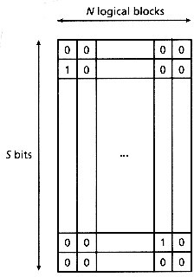
Figure : Sparse bit matrix
- Thus, the compressed bit files will contain pointers to the appropriate documents (or logical blocks).
- The set of all the compressed bit files will be called "leve1 1" or "postings file," to agree with the terminology of inverted files.
- The postings file consists of postings buckets, of size Bp bytes (Bp is a design parameter).
- Each such bucket contains pointers to the documents in the text file, as well as an extra pointer, to point to an overflow postings bucket, if necessary.
- Searching is done by hashing a word to obtain the postings bucket address. This bucket, as well as its overflow buckets, will be retrieved, to obtain the pointers to the relevant documents.
- To reduce the false drops, the hash table should be sparse. The method is similar to hashing.
- The differences are the following:
  - The directory (hash table) is sparse; Traditional hashing schemes require loads of 80-90 percent.
  - The actual word is stored nowhere. Since the hash table is sparse, there will be few collisions. Thus, we save space and maintain a simple file structure.
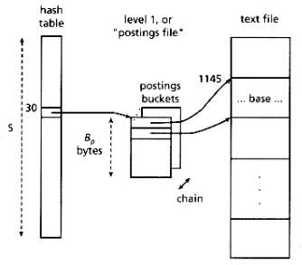
Figure: Illustration of CBS
5.2 Doubly Compressed Bit Slices (DCBS):
- The motivation behind this method is to try to compress the sparse directory of CBS.
- The file structure we propose consists of a hash table, an intermediate file, a postings file and the text file as in Figure below.
- The method is similar to CBS. It uses a hashing function h1(), which returns values in the range (0,(S-1)) and determines the slot in the directory.
- The difference is that DCBS makes an effort to distinguish among synonyms, by using a second hashing function h2(), which returns bit strings that are h bits long.
- These hash codes are stored in the "intermediate file," which consists of buckets of Bi bytes (design parameter).
- Each such bucket contains records of the form (hashcode, ptr ).
- The pointer ptr is the head of a linked list of postings buckets.
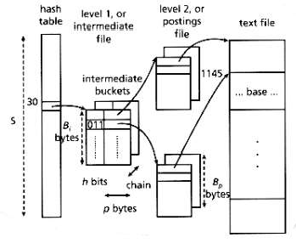
Figure: Illustration of DCBS
- Figure illustrates an example, where the word "base" appears in the document that starts at the 1145-th byte of the text file.
- The example also assumes that h = 3 bits, hl("base") = 30, and h2("base") = (011)2.
- Searching for the word "base" is handled as follows:
- Step 1 h1("base") = 30: The 30-th pointer of the directory will be followed. The corresponding chain of intermediate buckets will be examined.
- Step 2 h2("base") = (011)2: The records in the above intermediate buckets will be examined. If a matching hash code is found (at most one will exist!), the corresponding pointer is followed, to retrieve the chain of postings buckets.
- Step 3 The pointers of the above postings buckets will be followed, to retrieve the qualifying (actually or falsely) documents.

5.3 No False Drops Method (NFD):
- This method avoids false drops completely.
- The idea is to modify the intermediate file of the DCBS, and store a pointer to the word in the text file.
- Specifically, each record of the intermediate file will have the format (hashcode, ptr, ptr-to -word ), where ptr -to -word is a pointer to the word in the text file.
- Below Figure is an illustration.
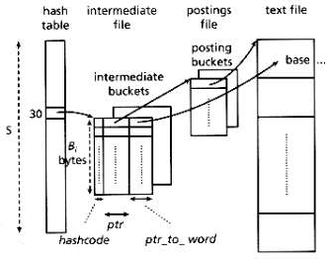
Figure: Illustration of NFD

- This way each word can be completely distinguished from its synonyms, using only h bits for the hash code and p (=4 bytes, usually) for the ptr-to -word .
- The advantages of storing ptr-to -word instead of storing the actual word are two: (1) space is saved and (2) the records of the intermediate file have fixed length.
- Thus, there is no need for a word delimiter and there is no danger for a word to cross bucket boundaries.
- Searching is done in a similar way with DCBS.
- The only difference is that, whenever a matching hash code is found in Step 2, the corresponding ptr-to -word is followed, to avoid synonyms completely.

5.4 Performance
- Figure below plots the theoretical performance of the methods (search time as a function of the overhead).
- The final conclusion is that these methods are fast, requiring few disk accesses, they introduce 20-25 percent space overhead, and they still require append-only operations on insertion.
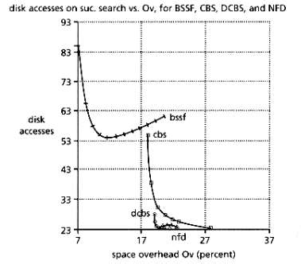
Figure: Total disk accesses on successful search versus space overhead.

- HORIZONTAL PARTITIONING:
- The motivation behind all these methods is to avoid the sequential scanning of the signature file (or its bit-slices), in order to achieve better than O(N) search time.
- Thus, they group the signatures into sets, partitioning the signature matrix horizontally.
- The grouping criterion can be decided beforehand, in the form of a hashing function h(S), where S is a document signature (data independent case).
- Alternatively, the groups can be determined on the fly, using a hierarchical structure (e.g. a B-tree--data dependent case).
6.1 Data Independent Case
Gustafson's method:
- Suppose that we have records with, say six attributes each.
- For example, records can be documents and attributes can be keywords describing the document.
- Consider a hashing function h that hashes a keyword w to a number h(w) in the range 0-15.
- The signature of a keyword is a string of 16 bits, all of which are zero except for the bit at position h(w).
- The record signature is created by superimposing the corresponding keyword signatures.
- If k < 6 bits are set in a record signature, additional 6 - k bits are set by some random method.
- Thus, there are comb (16,6)= 8,008 possible distinct record signatures (where C(m,n) denotes the combinations of m choose n items).
- Using a hash table with 8,008 slots, we can map each record signature to one such slot.
- Although elegant, Gustafson's method suffers from some practical problems:
  - Its performance deteriorates as the file grows.
  - If the number of keywords per document is large, then either we must have a huge hash table or usual queries (involving 3-4 keywords) will touch a large portion of the database.
6.2 Data Dependent Case
Two-level signature files
- The first level of signatures consists of document signatures that are stored sequentially, as in the SSF method.
- The second level consists of "block signatures"; each such signature corresponds to one block (group) of bibliographic records, and is created by superimposing the signatures of all the words in this block, ignoring the record boundaries.
- The second level is stored in a bit sliced form.
- Each level has its own hashing functions that map words to bit positions.
- Searching is performed by scanning the block signatures first, and then concentrating on these portions of the first-level signature file that seem promising.
S-tree:
- Deppisch (1986) proposed a B-tree like structure to facilitate fast access to the records (which are signatures) in a signature file.
- The leaf of an S-tree consists of k "similar" (i.e., with small Hamming distance) document signatures along with the document identifiers.
- The OR-ing or these k document signatures forms the "key" of an entry in an upper level node, which serves as a directory for the leaves.
- Recursively we construct directories on lower level directories until we reach the root.
- The S-tree is kept balanced in a similar manner as a B-trees: when a leaf node overflows it is split in two groups of "similar" signatures; the father node is changed appropriately to reflect the new situation.
- Splits may propagate upward until reaching the root.
- The method requires small space overhead; the response time on queries is difficult to estimate analytically.
- The insertion requires a few disk accesses (proportional to the height of the tree at worst), but the append-only property is lost.
- Another problem is that higher level nodes may contain keys that have many 1's and thus become useless.

