Міністерство освіти і науки України
Національний технічний університет України «Київський політехнічний інститут імені Ігоря Сікорського"
Факультет інформатики та обчислювальної техніки

Кафедра інформатики та програмної інженерії

Звіт

з лабораторної роботи № 5 з дисципліни
«Проектування алгоритмів»

„Проектування і аналіз алгоритмів для вирішення NP-складних задач ч.2”

Виконав(ла)
(шифр, прізвище, ім'я, по батькові)
ІП-11 Панченко С. В.

Перевірив

(прізвище, ім'я, по батькові)
Головченко М.Н.

Київ 2022

Варіант 23
Мета роботи – вивчити основні підходи розробки метаеврестичних алгоритмів для типових прикладних задач. Опрацювати методологію підбору прийнятних параметрів алгоритму.

Покроковий алгоритм
def Solve()
StartInitialGeneration()
SortGeneration()
bestChromosome = generation[size-1]
while timer :
parentOne = Generation[size - 1]
index = rand() % (size - 1)
parentTwo = Generation[index]
chrome = Crossover(parentOne, parentTwo)
if not isValid(chrome) skip
chromeCopy = chrome
Mutate(chrome)
if not isValid(chrome): chrome = chromeCopy
chromeCopy = chrome
Improve(chrome)
if not isValid(chrome): chrome = chromeCopy
if CalculatePrice(chrome)>CalculatePrice(BestChromosome):
BestChromosome = chrome
add BestChromosome to generation
SortGeneration()
erase first element from Generation

def isValid(chrome):
return CalculateWeight(chrome)<=m_uMaxWeight

def Crossover(one, two)
index = rand() % Crossovers.size()
return Crossovers[index](one, two)

def Mutate(chrome)
if Mutators:
index = rand() % Mutators.size()
Mutators[index](this, chrome)

def Improve(chrome):
if Improvers:
index = rand() % Improvers.size()
Improvers[index](chrome)

def StartInitialGeneration():
for i in m_uInitialPopulationNumber:
add FindFirstPossibleSolution() to generation

def SortGeneration():
sort generation by CalculatePrice(chromeOne)<CalculatePrice(chromeTwo)

def CalculatePrice(chrome):
price = 0
for i in inputSize:
if chrome[i]:
price += Input[i].price
return price

def CalculateWeight(chrome):
weight = 0
for i in inputSize:
if chrome[i]:
weight += Input[i].weight
return weight

def FindFirstPossibleSolution()
chromo = Chromosome()
curWeight = 0
while true:
index = rand() % inputSize
curWeight += Input[index].weight
if curWeight>m_uMaxWeight: break
chromo[index] = true
return chromo

def PointCrossover(one, two)
chromo = Chromosome()
if inputSize<pointNumber:
number = inputSize
else:
number = pointNumber
partition = inputSize / (number + 1)
for i in number:
for index in i*partition:
chromo[index] = (i%2)?one[index]:two[index]
for index in inputSize:
if i%2 == 0:
chromo[index] = one[index]
else:
chromo[index] = two[index]
return chromo

def SequenceCrossover(one, two)
chromo = Chromosome()
for i in inputSize:
if i%2==0:
chromo[i] = one[i]
else
chromo[i] = two[i]
return chromo

def SwapMutator(chromo):
indexOne = rand() % inputSize
indexTwo = rand() % inputSize
swap(chromo[indexOne], chromo[indexTwo])

def ChangeSignMutator(chromo)
index = rand() % inputSize
chromo[index] = not chromo[index]

def WorstPriceImprover(chromo)
for i in inputSize:
if chromo[i] and input[i].price<input[index].price:
index = i
weight = CalculateWeight(chromo)
weight -= m_vInput[index].weight
isImproved = false
for i in inputSize and not isImproved:
if not chromo[i] and input[index].price <= input[i].price:
posWeight = weight + m_vInput[i].weight
if posWeight <= m_uMaxWeight:
chromo[index] = false
chromo[i] = true
isImproved = true

def BestPriceImprover(chromo)
index = 0
for i in inputSize:
if chromo[i] and input[i].price > m_vInput[index].price:
index = i

weight = CalculateWeight(chromo)
weight -= m_vInput[index].weight
isImproved = false
for i in inputSize and not isImproved:
if not chromo[i] and input[index].price <= input[i].price:
posWeight = weight + m_vInput[i].weight
if posWeight <= m_uMaxWeight:
chromo[index] = false
chromo[i] = true
isImproved = true

Програмна реалізація алгоритму
//@formatter:off
#ifndef LAB5_TGENETICALGORITHM_H
#define LAB5_TGENETICALGORITHM_H
#include <cstdlib>
#include <random>
#include <vector>
#include <functional>
#include <algorithm>
#include <memory>
#include "TTimer.h"

class TTester;

template<unsigned inputSize>
class TGeneticAlgorithm {
friend class TTester;
public:
using Input = std::array<std::pair<unsigned, unsigned>, inputSize>;
using Chromosome = std::array<bool, inputSize>;
using Generation = std::vector<Chromosome>;
using Crossovers = std::vector<std::function<Chromosome(TGeneticAlgorithm<inputSize>*, const Chromosome&, const Chromosome&)>>;
using Mutators = std::vector<std::function<void(TGeneticAlgorithm<inputSize>*, Chromosome&)>>;
using Improvers = std::vector<std::function<void(TGeneticAlgorithm<inputSize>*, Chromosome&)>>;

public:
TGeneticAlgorithm()=default;
TGeneticAlgorithm(unsigned initialPopulationsNumber, unsigned milliseconds, unsigned maxWeight, const Input& input,
const Crossovers& crossovers, const Mutators& mutators, const Improvers& improvers) {
m_uInitialPopulationNumber = initialPopulationsNumber;
m_uMilliseconds = milliseconds;
m_uMaxWeight = maxWeight;
m_vInput = input;
m_vCrossovers = crossovers;
m_vMutators = mutators;
m_vImprovers = improvers;
}

public:
void Solve() {
StartInitialGeneration();
TTimer timer;
timer.start();
SortGeneration();
m_vBestChromosome = m_vGeneration.back();
while(timer.elapsedMilliseconds()<m_uMilliseconds) {
// pick parent
auto size = m_vGeneration.size();
auto& parentOne = m_vGeneration[size - 1];
auto index = rand() % (size - 1);
auto& parentTwo = m_vGeneration[index];
// crossover
auto chrome = Crossover(parentOne, parentTwo);
if(!isValid(chrome)) continue;
// mutate
auto chromeCopy = chrome;
Mutate(chrome);
if(!isValid(chrome)) chrome = chromeCopy;
// improve
chromeCopy = chrome;
Improve(chrome);
if(!isValid(chrome)) chrome = chromeCopy;
if(CalculatePrice(chrome)>CalculatePrice(m_vBestChromosome)) {
m_vBestChromosome = chrome;
}
m_vGeneration.push_back(m_vBestChromosome);
SortGeneration();
m_vGeneration.erase(m_vGeneration.begin());
}
}

protected:
bool isValid(const Chromosome& chrome) {
return CalculateWeight(chrome)<=m_uMaxWeight;
}

Chromosome Crossover(const Chromosome& one, const Chromosome& two) {
// randomly choose crossover
auto index = rand() % m_vCrossovers.size();
return m_vCrossovers[index](this, one, two);
}

void Mutate(Chromosome& chrome) {
if(m_vMutators.empty()) return;
auto index = rand() % m_vMutators.size();
m_vMutators[index](this, chrome);
}

void Improve(Chromosome& chrome) {
if(m_vImprovers.empty()) return;
auto index = rand() % m_vImprovers.size();
m_vImprovers[index](this, chrome);
}

void StartInitialGeneration() {
m_vGeneration.reserve(m_uInitialPopulationNumber);
for(unsigned i=0;i<m_uInitialPopulationNumber;++i) {
m_vGeneration.push_back(FindFirstPossibleSolution());
}
}

void SortGeneration() {
std::sort(m_vGeneration.begin(), m_vGeneration.end(),
[this](auto& chromeOne, auto& chromeTwo) {
return CalculatePrice(chromeOne)<CalculatePrice(chromeTwo);
}
);
}

unsigned CalculatePrice(const Chromosome& chrome) {
auto price = 0;
for(unsigned i=0;i<inputSize;++i) {
if(chrome[i]) {
price += m_vInput[i].first;
}
}
return price;
}

unsigned CalculateWeight(const Chromosome& chrome) {
auto weight = 0;
for(unsigned i=0;i<inputSize;++i) {
if(chrome[i]) {
weight += m_vInput[i].second;
}
}
return weight;
}

Chromosome FindFirstPossibleSolution() {
srand(time(NULL));
auto chromo = Chromosome();
auto curWeight = 0;
while(true) {
auto index = rand() % inputSize;
curWeight += m_vInput[index].second;
if(curWeight>m_uMaxWeight) break;
chromo[index] = true;
}
return chromo;
}

protected:
unsigned m_uInitialPopulationNumber = 0;
unsigned m_uMilliseconds = 0;
unsigned m_uMaxWeight = 0;

protected:
Input m_vInput;
Generation m_vGeneration;
Crossovers m_vCrossovers;
Mutators m_vMutators;
Improvers m_vImprovers;
Chromosome m_vBestChromosome;
};

#endif //LAB5_TGENETICALGORITHM_H
//@formatter:on

#ifndef LAB5_TTESTER_H
#define LAB5_TTESTER_H
#include <iostream>
#include <cassert>
#include <future>
#include <thread>
#include <mutex>
#include <filesystem>
#include "include/pbPlots.hpp"
#include "include/supportLib.hpp"
#include "TGeneticAlgorithm.h"

class TTester {
public:
TTester()=default;
TTester(const TTester&)=default;
TTester(TTester&&)=default;
virtual ~TTester()=default;

protected:
static constexpr char s_sBasePath[] = "/home/choleraplague/university/Algorithms_KPI_2_Year/lab5/results/";
static constexpr unsigned s_uInputSize = 100;
static constexpr unsigned s_uMaxWeight = 500;
static constexpr unsigned s_uLPrice= 2;
static constexpr unsigned s_uMPrice= 30;
static constexpr unsigned s_uLWeight = 1;
static constexpr unsigned s_uMWeight= 20;
static constexpr unsigned s_uInitialPopulation = 10;
static constexpr unsigned s_uThreads = 12;
static constexpr unsigned s_uStartTime = 100;
static constexpr unsigned s_uEndTime = 10000;
static constexpr unsigned s_uAddTime = 100;

protected:
using Chromosome = typename TGeneticAlgorithm<s_uInputSize>::Chromosome;
using Input = typename TGeneticAlgorithm<s_uInputSize>::Input;
using Crossovers = typename TGeneticAlgorithm<s_uInputSize>::Crossovers;
using Mutators = typename TGeneticAlgorithm<s_uInputSize>::Mutators;
using Improvers = typename TGeneticAlgorithm<s_uInputSize>::Improvers;
using AlgData = std::pair<std::vector<double>, std::vector<double>>;
using Results = std::vector<AlgData>;
using Tasks = std::vector<std::future<AlgData>>;

protected:
Input m_vInput;
Crossovers m_vCrossovers;
Mutators m_vMutators;
Improvers m_vImprovers;

protected:

#define VAR_TO_STR(x) \
""#x
#define ADD_FUNC_TO_VECTOR(func, vec, str) \
vec.push_back(func); \
AddFuncToStr(str, #func)

static void AddAttributeToStr(std::string& str, std::string&& attrStr, unsigned attr) {
str += attrStr + "_" + std::to_string(attr) + " ";
}
static void AddFuncToStr(std::string& str, std::string&& funcStr) {
str += funcStr + " ";
}

public:
void Test() {
auto legend = std::string();
AddAttributeToStr(legend, VAR_TO_STR(s_uInputSize), s_uInputSize);
AddAttributeToStr(legend, VAR_TO_STR(s_uMaxWeight), s_uMaxWeight);
AddAttributeToStr(legend, VAR_TO_STR(s_uInitialPopulation), s_uInitialPopulation);
AddAttributeToStr(legend, VAR_TO_STR(s_uStartTime), s_uStartTime);
AddAttributeToStr(legend, VAR_TO_STR(s_uEndTime), s_uEndTime);
AddAttributeToStr(legend, VAR_TO_STR(s_uAddTime), s_uAddTime);

auto directory = std::string();
ADD_FUNC_TO_VECTOR(PointCrossover<2>, m_vCrossovers, directory);
// ADD_FUNC_TO_VECTOR(PointCrossover<4>, m_vCrossovers, directory);
ADD_FUNC_TO_VECTOR(PointCrossover<1>, m_vCrossovers, directory);
ADD_FUNC_TO_VECTOR(SequenceCrossover, m_vCrossovers, directory);

ADD_FUNC_TO_VECTOR(ChangeSignMutator, m_vMutators, directory);
ADD_FUNC_TO_VECTOR(SwapMutator, m_vMutators, directory);
//
ADD_FUNC_TO_VECTOR(WorstPriceImprover, m_vImprovers, directory);
ADD_FUNC_TO_VECTOR(BestPriceImprover, m_vImprovers, directory);

auto funcs = s_sBasePath + directory;
auto params = funcs + "/" + legend;
std::filesystem::create_directory(funcs);
std::filesystem::create_directory(params);
std::filesystem::current_path(params);

GenerateInput();

auto results = Results();
auto tasks = Tasks();
DistributeTasks(tasks);
auto e = std::vector<wchar_t>();
for(auto& t : tasks) {
results.push_back(t.get());
}

auto x = std::vector<double>();
auto y = std::vector<double>();
for(const auto& res : results) {
x.insert(x.end(), res.first.begin(), res.first.end());
y.insert(y.end(), res.second.begin(), res.second.end());
}

auto series = GetDefaultScatterPlotSeriesSettings();
series->xs = &x;
series->ys = &y;
auto vs = std::vector<ScatterPlotSeries*>();
vs.push_back(series);

auto titleVec = std::vector<wchar_t>(legend.begin(), legend.end());
auto xlabelVec = std::vector<wchar_t>(directory.begin(), directory.end());

auto settings = GetDefaultScatterPlotSettings();
settings->width = 1280;
settings->height = 720;
settings->autoBoundaries = true;
settings->autoPadding = true;
settings->title = &titleVec;
settings->xLabel = &xlabelVec;
settings->scatterPlotSeries = &vs;

RGBABitmapImageReference* imageRef = CreateRGBABitmapImageReference();
StringReference* errorMessage = CreateStringReference(&e);
DrawScatterPlotFromSettings(imageRef, settings, errorMessage);

auto pngData = ConvertToPNG(imageRef->image);

WriteToFile(pngData, GenerateFileName());
DeleteImage(imageRef->image);
}

protected:
static std::basic_string<char> GenerateFileName() {
auto path = std::filesystem::current_path();
auto p = std::filesystem::current_path().string();
auto it = std::filesystem::directory_iterator(std::filesystem::current_path());
auto paths = std::vector<std::string>();
while(it!=std::filesystem::end(it)) {
paths.push_back(it->path().string());
++it;
}
auto index = 0;
while(std::find(paths.begin(), paths.end(), p + "/" + std::to_string(index) + ".png")!=paths.end()) {
++index;
}
return std::to_string(index) + ".png";
}

void DistributeTasks(Tasks& tasks) {
auto timePoints = std::array<std::pair<unsigned, unsigned>, s_uThreads>();
DistributeTimeEvenly(timePoints);
for(const auto& t : timePoints) {
tasks.push_back(std::async(std::launch::async, DoTest, t.first, t.second, s_uAddTime, m_vCrossovers, m_vMutators, m_vImprovers, m_vInput));
}
}

static void DistributeTimeEvenly(std::array<std::pair<unsigned, unsigned>, s_uThreads>& timePoints) {
auto initial = std::make_pair(s_uStartTime, s_uEndTime);
auto splitOne = SplitArea(initial, 2);

auto splitTwo = SplitArea(splitOne[0], 3);
auto sixthOne = splitTwo[0];
auto [sixthTwo, sixthThree] = SplitArea(splitTwo[1], 2);

auto splitThree = SplitArea(splitOne[1], 3);
auto sixthFour = splitThree[0];
auto [sixthFive, sixthSix] = SplitArea(splitThree[1], 2);

auto [one, two] = SplitArea(sixthOne, 2);
timePoints[0] = one;
timePoints[1] = two;
auto [three, four] = SplitArea(sixthTwo, 2);
timePoints[2] = three;
timePoints[3] = four;
auto [five, six] = SplitArea(sixthThree, 2);
timePoints[4] = five;
timePoints[5] = six;
auto [seven, eight] = SplitArea(sixthFour, 2);
timePoints[6] = seven;
timePoints[7] = eight;
auto [nine, ten] = SplitArea(sixthFive, 2);
timePoints[8] = nine;
timePoints[9] = ten;
auto [eleven, twelve] = SplitArea(sixthSix, 2);
timePoints[10] = eleven;
timePoints[11] = twelve;
}

static std::array<std::pair<unsigned, unsigned>, 2> SplitArea(const std::pair<unsigned, unsigned>& p, unsigned ratio) {
auto pairs = std::array<std::pair<unsigned , unsigned>, 2>();
auto len = unsigned(double(p.second - p.first) / sqrt(ratio)) + p.first;
pairs[0] = std::make_pair(p.first, len);
pairs[1] = std::make_pair(len, p.second);
return pairs;
}

protected:
static AlgData DoTest(double start, double end, double add,
const Crossovers& crossovers, const Mutators& mutators, const Improvers& improvers, const Input& input) {

auto x = std::vector<double>();
auto y = std::vector<double>();
for(auto i=start;i<end;i+=add) {
x.push_back(i);
auto alg = TGeneticAlgorithm<s_uInputSize>(s_uInitialPopulation, i, s_uMaxWeight, input,
crossovers, mutators, improvers);
alg.Solve();
auto price = alg.CalculatePrice(alg.m_vBestChromosome);
auto weight = alg.CalculateWeight(alg.m_vBestChromosome);
std::cout<<"Milliseconds: "<<i<<"\t"<<"Price: "<<price<<"\t"<<"Weight: "<<weight<<"\n";
y.push_back(price);
}
return std::make_pair(x, y);

}

protected:
void GenerateInput() {
for(unsigned i=0;i<s_uInputSize;++i) {
auto weight = s_uLWeight + rand() % (s_uMWeight - s_uLWeight - 1);
auto price = s_uLPrice + rand() % (s_uMPrice - s_uLPrice - 1);
m_vInput[i] = std::make_pair(price, weight);
}
}

template<unsigned pointNumber>
static Chromosome PointCrossover(TGeneticAlgorithm<s_uInputSize>* alg, const Chromosome& one, const Chromosome& two) {
assert(pointNumber>0);

auto chromo = Chromosome();
auto number = (s_uInputSize<pointNumber)?s_uInputSize:pointNumber;
auto partition = s_uInputSize / (number + 1);
auto i = 1;
auto index = 0;
for(;i<=number;++i) {
for(;index<i*partition;++index) {
chromo[index] = (i%2)?one[index]:two[index];
}
}
for(;index<s_uInputSize;++index) {
chromo[index] = (i%2)?one[index]:two[index];
}
return chromo;
}

static Chromosome SequenceCrossover(TGeneticAlgorithm<s_uInputSize>* alg, const Chromosome& one, const Chromosome& two) {
auto chromo = Chromosome();
for(unsigned i=0;i<s_uInputSize;++i) {
chromo[i] = (i%2)?one[i]:two[i];
}
return chromo;
}

static void SwapMutator(TGeneticAlgorithm<s_uInputSize>* alg, Chromosome& chromo) {
auto indexOne = rand() % s_uInputSize;
auto indexTwo = rand() % s_uInputSize;
std::swap(chromo[indexOne], chromo[indexTwo]);
}

static void ChangeSignMutator(TGeneticAlgorithm<s_uInputSize>* alg, Chromosome& chromo) {
auto index = rand() % s_uInputSize;
chromo[index] = !chromo[index];
}

static void WorstPriceImprover(TGeneticAlgorithm<s_uInputSize>* alg, Chromosome& chromo) {
unsigned index = 0;
for(unsigned i=0;i<s_uInputSize;++i) {
if(chromo[i] and alg->m_vInput[i].first<alg->m_vInput[index].first) {
index = i;
}
}
auto weight = alg->CalculateWeight(chromo);
weight -= alg->m_vInput[index].second;
auto isImproved = false;
for(unsigned i=0;i<s_uInputSize and !isImproved;++i) {
if(!chromo[i] and alg->m_vInput[index].first <= alg->m_vInput[i].first) {
auto posWeight = weight + alg->m_vInput[i].second;
if(posWeight<=alg->m_uMaxWeight) {
chromo[index] = false;
chromo[i] = true;
isImproved = true;
}
}
}
}

static void BestPriceImprover(TGeneticAlgorithm<s_uInputSize>* alg, Chromosome& chromo) {
unsigned index = 0;
for(unsigned i=0;i<s_uInputSize;++i) {
if(chromo[i] and alg->m_vInput[i].first>alg->m_vInput[index].first) {
index = i;
}
}
auto weight = alg->CalculateWeight(chromo);
weight -= alg->m_vInput[index].second;
auto isImproved = false;
for(unsigned i=0;i<s_uInputSize and !isImproved;++i) {
if(!chromo[i] and alg->m_vInput[index].first <= alg->m_vInput[i].first) {
auto posWeight = weight + alg->m_vInput[i].second;
if(posWeight<=alg->m_uMaxWeight) {
chromo[index] = false;
chromo[i] = true;
isImproved = true;
}
}
}
}
};

#endif //LAB5_TTESTER_H

#include <iostream>
#include "TTester.h"
int main() {
srand(time(NULL));

for(int i=0;i<5;++i) {
TTester test;
test.Test();
}
}
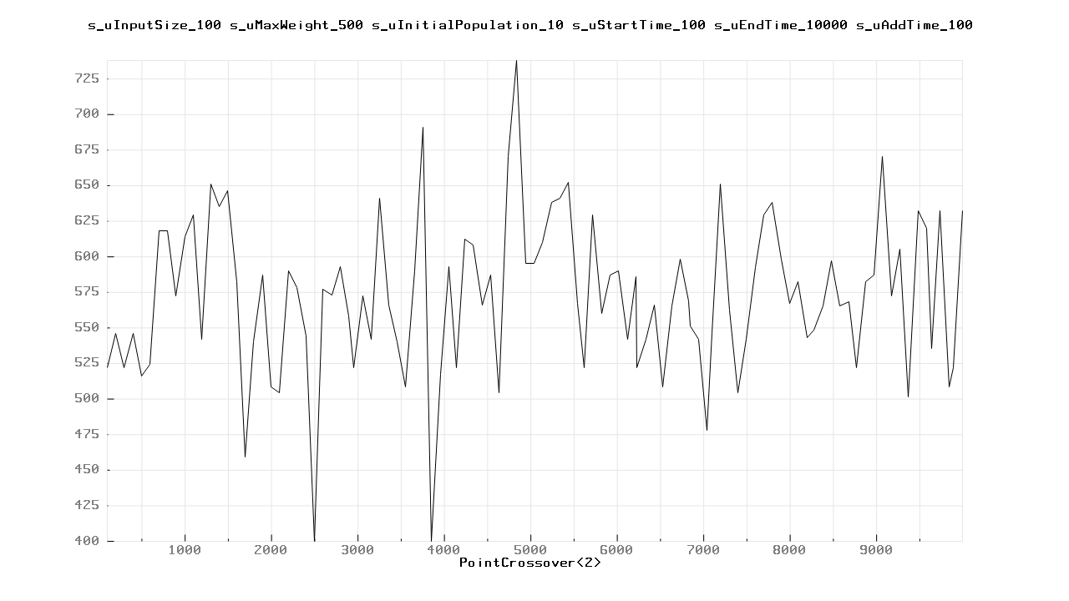
Рисунок 3.1 – PointCrossover<2>

Milliseconds | Price
100 | 522
200 | 546
300 | 522
400 | 546
500 | 516
600 | 524
700 | 618
800 | 618
900 | 572
1000 | 614
1100 | 629
1200 | 542
1300 | 651
1400 | 635
1500 | 646
1600 | 582
1700 | 459
1800 | 540
1900 | 587
2000 | 508
2100 | 504
2200 | 590
2300 | 578
2400 | 544
2500 | 400
2600 | 577
2700 | 573
2800 | 593
2900 | 558
2957 | 522
3057 | 572
3157 | 542
3257 | 641
3357 | 566
3457 | 540
3557 | 508
3657 | 590
3757 | 691
3857 | 400
3957 | 517
4057 | 593
4141 | 522
4241 | 612
4341 | 608
4441 | 566
4541 | 587
4641 | 504
4741 | 670
4841 | 738
4941 | 595
5041 | 595
5141 | 610
5241 | 638
5341 | 641
5441 | 652
5541 | 567
5620 | 522
5720 | 629
5820 | 560
5920 | 587
6020 | 590
6120 | 542
6220 | 586
6233 | 522
6333 | 542
6433 | 566
6533 | 508
6633 | 565
6733 | 598
6833 | 569
6846 | 551
6946 | 542
7046 | 478
7100 | 546
7200 | 651
7300 | 562
7400 | 504
7500 | 542
7600 | 592
7700 | 629
7800 | 638
7900 | 598
8000 | 567
8100 | 582
8200 | 543
8283 | 548
8383 | 565
8483 | 597
8583 | 565
8683 | 568
8774 | 522
8874 | 582
8974 | 587
9074 | 670
9174 | 572
9274 | 605
9374 | 501
9386 | 522
9486 | 632
9586 | 620
9640 | 535
9740 | 632
9840 | 508
9894 | 522
9994 | 632

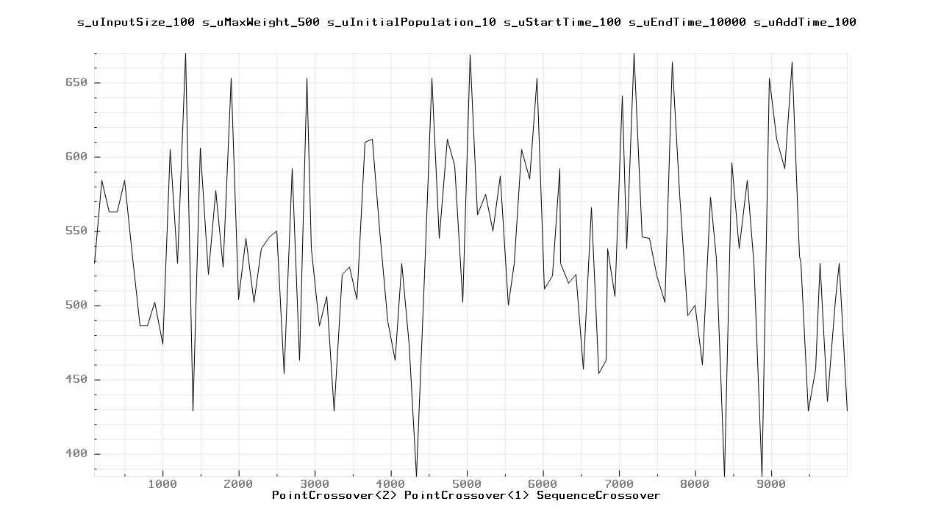
Рисунок 3.2 - PointCrossover<2> PointCrossover<1> SequenceCrossover

Milliseconds | Price
100 | 528
200 | 584
300 | 563
400 | 563
500 | 584
600 | 536
700 | 486
800 | 486
900 | 502
1000 | 474
1100 | 605
1200 | 528
1300 | 670
1400 | 429
1500 | 606
1600 | 521
1700 | 577
1800 | 526
1900 | 653
2000 | 504
2100 | 545
2200 | 502
2300 | 538
2400 | 546
2500 | 550
2600 | 454
2700 | 592
2800 | 463
2900 | 653
2957 | 538
3057 | 486
3157 | 506
3257 | 429
3357 | 521
3457 | 526
3557 | 504
3657 | 610
3757 | 612
3857 | 550
3957 | 489
4057 | 463
4141 | 528
4241 | 474
4341 | 385
4441 | 521
4541 | 653
4641 | 545
4741 | 612
4841 | 594
4941 | 502
5041 | 669
5141 | 561
5241 | 575
5341 | 550
5441 | 587
5541 | 500
5620 | 528
5720 | 605
5820 | 585
5920 | 653
6020 | 511
6120 | 520
6220 | 592
6233 | 528
6333 | 515
6433 | 521
6533 | 457
6633 | 566
6733 | 454
6833 | 463
6846 | 538
6946 | 506
7046 | 641
7100 | 538
7200 | 670
7300 | 546
7400 | 545
7500 | 520
7600 | 502
7700 | 664
7800 | 575
7900 | 493
8000 | 500
8100 | 460
8200 | 573
8283 | 531
8383 | 385
8483 | 596
8583 | 538
8683 | 584
8774 | 528
8874 | 385
8974 | 653
9074 | 612
9174 | 592
9274 | 664
9374 | 533
9386 | 528
9486 | 429
9586 | 457
9640 | 528
9740 | 435
9840 | 504
9894 | 528
9994 | 429
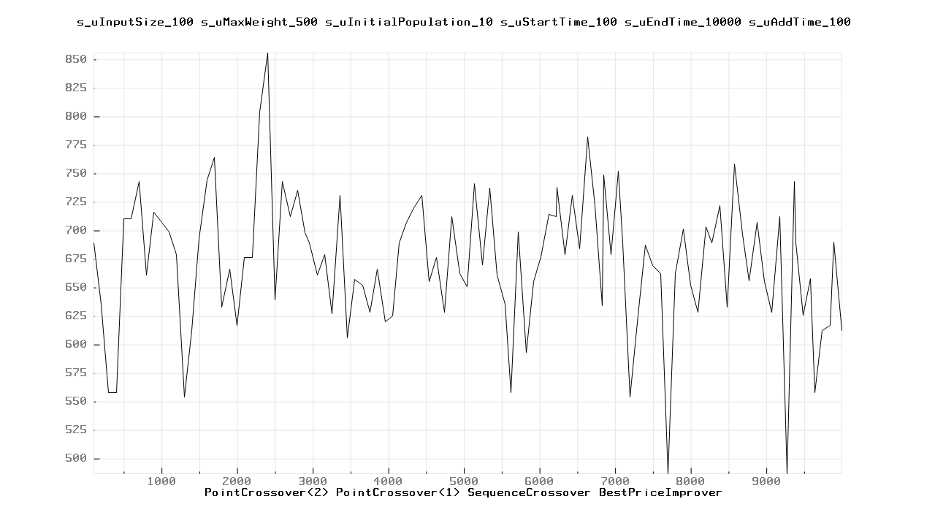

Рисунок 3.3 - PointCrossover<2> PointCrossover<1> SequenceCrossover BestPriceImprover

Milliseconds | Price
100 | 689
200 | 635
300 | 558
400 | 558
500 | 710
600 | 710
700 | 743
800 | 661
900 | 716
1000 | 707
1100 | 699
1200 | 679
1300 | 554
1400 | 612
1500 | 693
1600 | 744
1700 | 764
1800 | 633
1900 | 666
2000 | 617
2100 | 676
2200 | 676
2300 | 804
2400 | 856
2500 | 639
2600 | 743
2700 | 712
2800 | 735
2900 | 698
2957 | 689
3057 | 661
3157 | 679
3257 | 627
3357 | 731
3457 | 606
3557 | 657
3657 | 652
3757 | 628
3857 | 666
3957 | 620
4057 | 625
4141 | 689
4241 | 707
4341 | 720
4441 | 731
4541 | 655
4641 | 676
4741 | 628
4841 | 712
4941 | 662
5041 | 651
5141 | 741
5241 | 670
5341 | 737
5441 | 661
5541 | 635
5620 | 558
5720 | 699
5820 | 593
5920 | 655
6020 | 677
6120 | 714
6220 | 712
6233 | 738
6333 | 679
6433 | 731
6533 | 684
6633 | 782
6733 | 722
6833 | 634
6846 | 749
6946 | 679
7046 | 752
7100 | 689
7200 | 554
7300 | 626
7400 | 687
7500 | 669
7600 | 662
7700 | 487
7800 | 662
7900 | 701
8000 | 652
8100 | 628
8200 | 703
8283 | 689
8383 | 722
8483 | 633
8583 | 758
8683 | 697
8774 | 656
8874 | 707
8974 | 655
9074 | 628
9174 | 712
9274 | 487
9374 | 743
9386 | 689
9486 | 626
9586 | 658
9640 | 558
9740 | 612
9840 | 617
9894 | 690
9994 | 612

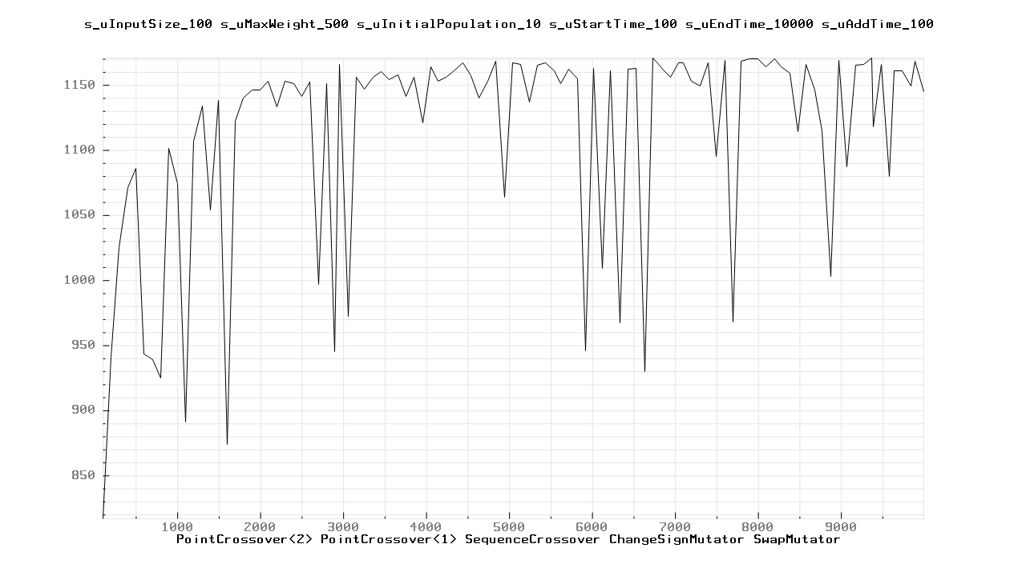

Рисунок 3.4 - PointCrossover<2> PointCrossover<1> SequenceCrossover ChangeSignMutator SwapMutator

Milliseconds | Price
100 | 817
200 | 941
300 | 1025
400 | 1071
500 | 1086
600 | 943
700 | 939
800 | 925
900 | 1101
1000 | 1074
1100 | 891
1200 | 1107
1300 | 1134
1400 | 1054
1500 | 1138
1600 | 874
1700 | 1122
1800 | 1140
1900 | 1146
2000 | 1146
2100 | 1153
2200 | 1133
2300 | 1153
2400 | 1151
2500 | 1141
2600 | 1152
2700 | 997
2800 | 1151
2900 | 945
2957 | 1166
3057 | 972
3157 | 1156
3257 | 1147
3357 | 1156
3457 | 1160
3557 | 1154
3657 | 1158
3757 | 1141
3857 | 1156
3957 | 1121
4057 | 1164
4141 | 1153
4241 | 1156
4341 | 1161
4441 | 1167
4541 | 1157
4641 | 1140
4741 | 1153
4841 | 1168
4941 | 1064
5041 | 1167
5141 | 1166
5241 | 1137
5341 | 1165
5441 | 1167
5541 | 1161
5620 | 1151
5720 | 1162
5820 | 1155
5920 | 946
6020 | 1163
6120 | 1009
6220 | 1161
6233 | 1148
6333 | 967
6433 | 1162
6533 | 1163
6633 | 930
6733 | 1171
6833 | 1164
6846 | 1162
6946 | 1156
7046 | 1167
7100 | 1167
7200 | 1153
7300 | 1149
7400 | 1167
7500 | 1095
7600 | 1169
7700 | 968
7800 | 1168
7900 | 1170
8000 | 1170
8100 | 1164
8200 | 1170
8283 | 1164
8383 | 1159
8483 | 1114
8583 | 1166
8683 | 1146
8774 | 1115
8874 | 1003
8974 | 1169
9074 | 1087
9174 | 1165
9274 | 1166
9374 | 1171
9386 | 1118
9486 | 1166
9586 | 1080
9640 | 1161
9740 | 1161
9840 | 1149
9894 | 1168
9994 | 1145

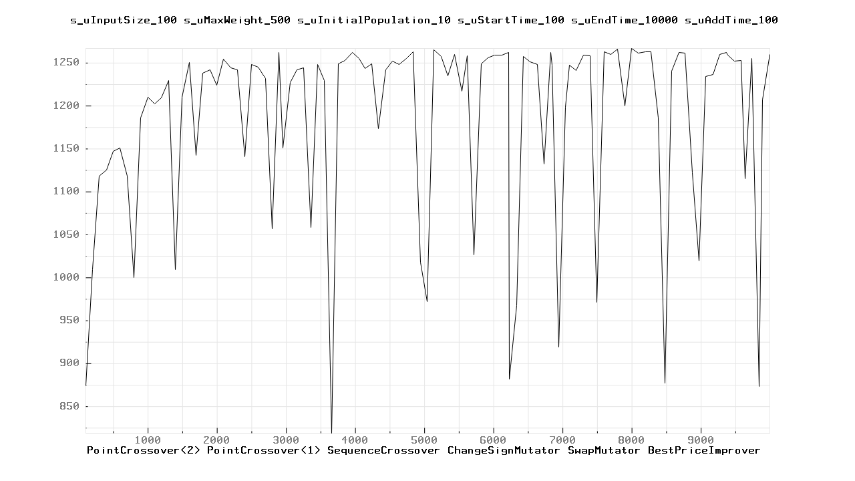
Рисунок 3.5 - PointCrossover<2> PointCrossover<1> SequenceCrossover ChangeSignMutator SwapMutator BestPriceImprover

Milliseconds | Price
100 | 874
200 | 1009
300 | 1118
400 | 1125
500 | 1147
600 | 1151
700 | 1118
800 | 1000
900 | 1186
1000 | 1210
1100 | 1202
1200 | 1209
1300 | 1229
1400 | 1009
1500 | 1210
1600 | 1250
1700 | 1142
1800 | 1238
1900 | 1242
2000 | 1224
2100 | 1254
2200 | 1244
2300 | 1242
2400 | 1141
2500 | 1248
2600 | 1245
2700 | 1232
2800 | 1057
2900 | 1262
2957 | 1151
3057 | 1227
3157 | 1242
3257 | 1244
3357 | 1058
3457 | 1248
3557 | 1229
3657 | 819
3757 | 1249
3857 | 1253
3957 | 1262
4057 | 1255
4141 | 1243
4241 | 1249
4341 | 1173
4441 | 1242
4541 | 1252
4641 | 1248
4741 | 1255
4841 | 1263
4941 | 1018
5041 | 972
5141 | 1265
5241 | 1257
5341 | 1235
5441 | 1260
5541 | 1217
5620 | 1258
5720 | 1026
5820 | 1249
5920 | 1256
6020 | 1259
6120 | 1259
6220 | 1262
6233 | 882
6333 | 967
6433 | 1257
6533 | 1251
6633 | 1248
6733 | 1132
6833 | 1262
6846 | 1247
6946 | 919
7046 | 1198
7100 | 1247
7200 | 1241
7300 | 1259
7400 | 1258
7500 | 971
7600 | 1263
7700 | 1260
7800 | 1266
7900 | 1200
8000 | 1267
8100 | 1261
8200 | 1263
8283 | 1263
8383 | 1186
8483 | 877
8583 | 1240
8683 | 1262
8774 | 1261
8874 | 1122
8974 | 1019
9074 | 1234
9174 | 1236
9274 | 1260
9374 | 1262
9386 | 1259
9486 | 1252
9586 | 1253
9640 | 1115
9740 | 1255
9840 | 873
9894 | 1207
9994 | 1260

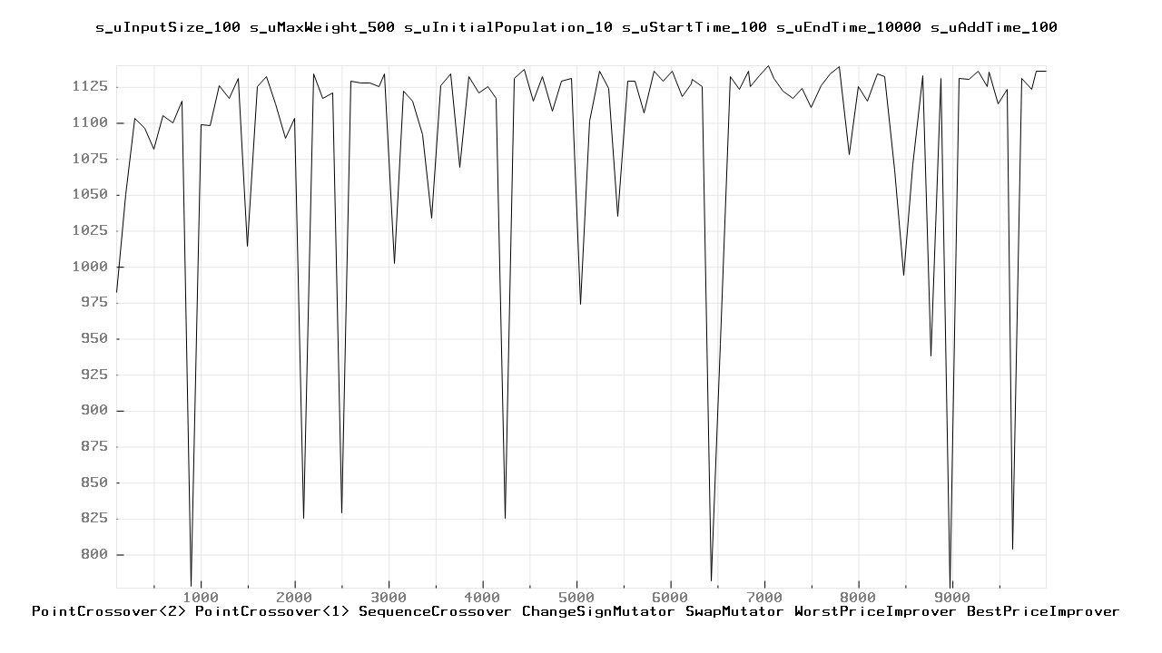

Рисунок 3.6 - PointCrossover<2> PointCrossover<1> SequenceCrossover ChangeSignMutator SwapMutator WorstPriceImprover BestPriceImprover

100 | 982
200 | 1050
300 | 1103
400 | 1096
500 | 1082
600 | 1105
700 | 1100
800 | 1115
900 | 778
1000 | 1099
1100 | 1098
1200 | 1126
1300 | 1117
1400 | 1131
1500 | 1014
1600 | 1125
1700 | 1132
1800 | 1113
1900 | 1089
2000 | 1103
2100 | 825
2200 | 1134
2300 | 1117
2400 | 1121
2500 | 829
2600 | 1129
2700 | 1128
2800 | 1128
2900 | 1125
2957 | 1134
3057 | 1002
3157 | 1122
3257 | 1115
3357 | 1092
3457 | 1034
3557 | 1126
3657 | 1134
3757 | 1069
3857 | 1132
3957 | 1121
4057 | 1125
4141 | 1117
4241 | 825
4341 | 1131
4441 | 1137
4541 | 1115
4641 | 1132
4741 | 1108
4841 | 1129
4941 | 1131
5041 | 974
5141 | 1101
5241 | 1136
5341 | 1124
5441 | 1035
5541 | 1129
5620 | 1129
5720 | 1107
5820 | 1136
5920 | 1129
6020 | 1136
6120 | 1118
6220 | 1127
6233 | 1130
6333 | 1125
6433 | 782
6533 | 946
6633 | 1132
6733 | 1123
6833 | 1136
6846 | 1125
6946 | 1133
7046 | 1140
7100 | 1131
7200 | 1122
7300 | 1117
7400 | 1124
7500 | 1111
7600 | 1126
7700 | 1134
7800 | 1139
7900 | 1078
8000 | 1125
8100 | 1115
8200 | 1134
8283 | 1132
8383 | 1067
8483 | 994
8583 | 1071
8683 | 1133
8774 | 938
8874 | 1131
8974 | 777
9074 | 1131
9174 | 1130
9274 | 1136
9374 | 1125
9386 | 1135
9486 | 1113
9586 | 1123
9640 | 804
9740 | 1131
9840 | 1123
9894 | 1136
9994 | 1136
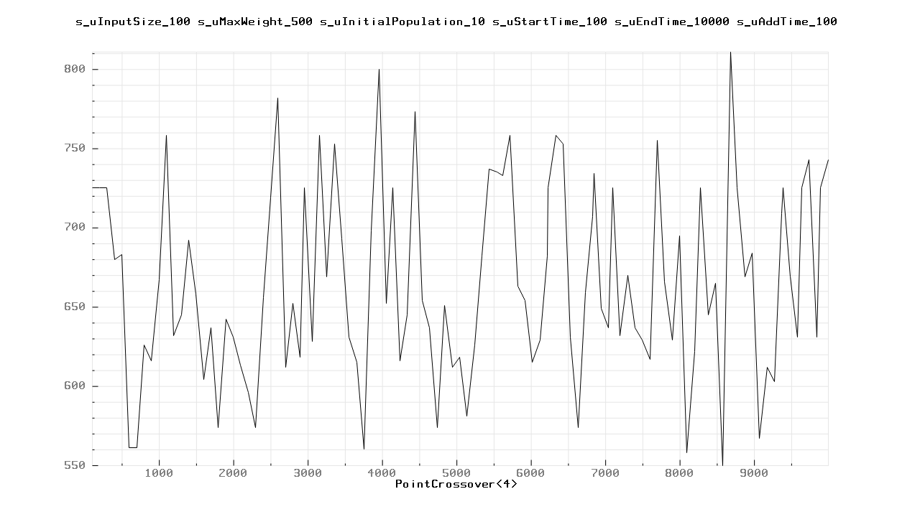

Рисунок 3.7 - PointCrossover<4>

100 | 725
200 | 725
300 | 725
400 | 680
500 | 683
600 | 561
700 | 561
800 | 626
900 | 616
1000 | 667
1100 | 758
1200 | 632
1300 | 645
1400 | 692
1500 | 658
1600 | 604
1700 | 637
1800 | 574
1900 | 642
2000 | 631
2100 | 613
2200 | 596
2300 | 574
2400 | 656
2500 | 719
2600 | 782
2700 | 612
2800 | 652
2900 | 618
2957 | 725
3057 | 628
3157 | 758
3257 | 669
3357 | 753
3457 | 693
3557 | 631
3657 | 615
3757 | 560
3857 | 698
3957 | 800
4057 | 652
4141 | 725
4241 | 616
4341 | 645
4441 | 773
4541 | 654
4641 | 637
4741 | 574
4841 | 651
4941 | 612
5041 | 618
5141 | 581
5241 | 626
5341 | 682
5441 | 737
5541 | 735
5620 | 733
5720 | 758
5820 | 663
5920 | 654
6020 | 615
6120 | 629
6220 | 682
6233 | 725
6333 | 758
6433 | 753
6533 | 631
6633 | 574
6733 | 659
6833 | 707
6846 | 734
6946 | 649
7046 | 637
7100 | 725
7200 | 632
7300 | 670
7400 | 637
7500 | 629
7600 | 617
7700 | 755
7800 | 666
7900 | 629
8000 | 695
8100 | 558
8200 | 622
8283 | 725
8383 | 645
8483 | 665
8583 | 550
8683 | 811
8774 | 725
8874 | 669
8974 | 684
9074 | 567
9174 | 612
9274 | 603
9374 | 709
9386 | 725
9486 | 669
9586 | 631
9640 | 725
9740 | 743
9840 | 631
9894 | 725
9994 | 743

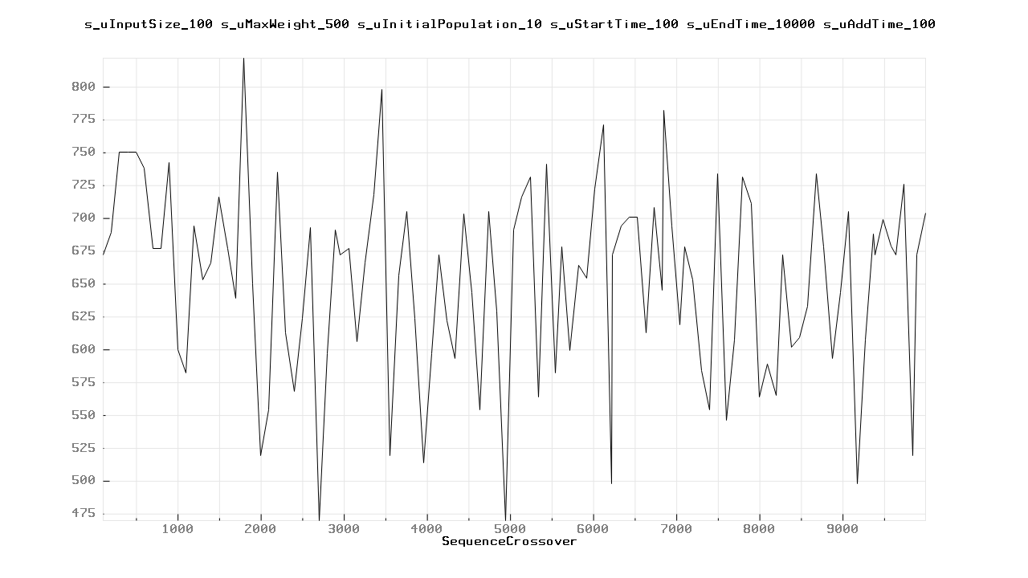
Рисунок 3.8 - SequenceCrossover

100 | 672
200 | 689
300 | 750
400 | 750
500 | 750
600 | 738
700 | 677
800 | 677
900 | 742
1000 | 600
1100 | 582
1200 | 694
1300 | 653
1400 | 666
1500 | 716
1600 | 677
1700 | 639
1800 | 822
1900 | 650
2000 | 519
2100 | 554
2200 | 735
2300 | 613
2400 | 568
2500 | 624
2600 | 693
2700 | 470
2800 | 597
2900 | 691
2957 | 672
3057 | 677
3157 | 606
3257 | 666
3357 | 718
3457 | 798
3557 | 519
3657 | 656
3757 | 705
3857 | 624
3957 | 514
4057 | 597
4141 | 672
4241 | 622
4341 | 593
4441 | 703
4541 | 643
4641 | 554
4741 | 705
4841 | 629
4941 | 470
5041 | 691
5141 | 716
5241 | 731
5341 | 564
5441 | 741
5541 | 582
5620 | 678
5720 | 599
5820 | 664
5920 | 654
6020 | 722
6120 | 771
6220 | 498
6233 | 672
6333 | 694
6433 | 701
6533 | 701
6633 | 613
6733 | 708
6833 | 645
6846 | 782
6946 | 694
7046 | 619
7100 | 678
7200 | 653
7300 | 584
7400 | 554
7500 | 734
7600 | 546
7700 | 607
7800 | 731
7900 | 711
8000 | 564
8100 | 589
8200 | 565
8283 | 672
8383 | 602
8483 | 609
8583 | 633
8683 | 734
8774 | 678
8874 | 593
8974 | 643
9074 | 705
9174 | 498
9274 | 607
9374 | 688
9386 | 672
9486 | 699
9586 | 679
9640 | 672
9740 | 726
9840 | 519
9894 | 672
9994 | 704

Висновок
Під час лабораторної роботи вивчив основні підходи розробки метаеврестичних алгоритмів для типових прикладних задач на прикладі задачі про рюкзак реалізованою за допомогою генетичного алгоритму. Опрацювати методологію підбору прийнятних параметрів алгоритму, де результатами є графіки та таблиці , що генеруються програмою. Як можна побачити за допомогою лише кросоверу високі результати не досягаються, але якщо додати ще й мутації, то зміни видно відразу і дають приріст у 2, а то і в 3 рази. Отже, важливим еволюційним фактором поколінь є не тільки їх змішування між собою, а й мутації, що мають виникати внаслідок пристосування до навколишнього середовища. Також додано локальне покращення, але приріст воно дає незначне, якщо і взагалі дає.

