Панченко Сергій Віталійович

студент 3 курсу, групи ІП-11

Національного технічного університету України

“Київський політехнічний інститут імені Ігоря Сікорського”

(099)-387-40-26

sideshowbobgot@gmail.com

Поперешняк Світлана Володимирівна,

кандидат фізико-математичних наук, доцент кафедри Інформатики та

програмної інженерії Національного технічного університету України

“Київський політехнічний інститут імені Ігоря Сікорського”, м. Київ

**NETWORK FILE SYSTEM**

**Key words:** nfs (network file system), distributed file system, remote file access, client-server architecture, file sharing, protocol.

**Introduction:** Network File System (NFS) is a distributed file system protocol that allows remote file access over a network. It was developed by Sun Microsystems and has since become a standard feature in Unix and Unix-like operating systems. NFS enables seamless sharing of files and resources among networked computers in a client-server architecture. The protocol facilitates efficient file access and management across disparate machines, promoting collaboration and resource utilization in networked environments.

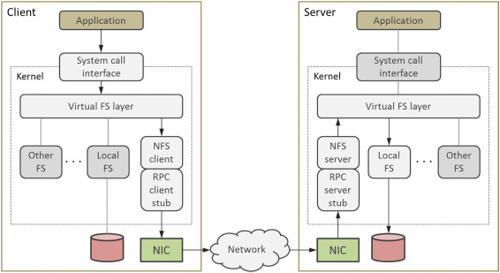

Figure 1 - NFS interaction scheme

**Objectives.** The primary objectives of Network File System (NFS) include facilitating transparent and efficient access to files stored on remote servers across a network, enabling seamless sharing of files and resources among multiple networked computers, providing a standardized protocol for file access to ensure interoperability across different operating systems, and improving efficiency by allowing clients to access remote files as if they were local, thereby minimizing the impact on the user experience.

**Methods.** NFS achieves its objectives through a client-server architecture, where servers export directories and clients mount them, seamlessly integrating remote files into the local file system. Employing a standardized protocol based on Remote Procedure Calls (RPC), NFS facilitates communication between clients and servers. This approach enables multiple clients to concurrently access shared files, fostering efficient collaboration and resource utilization across the network. The process of mounting remote directories from the server ensures that clients can access files on the server as if they were local, optimizing the overall user experience.

**Results.** The utilization of NFS yields several outcomes in networked environments. NFS streamlines file sharing, simplifying the process of collaborative work among networked computers. This efficiency extends to resource utilization, allowing multiple clients simultaneous access to shared files, thereby optimizing the network's resource allocation. NFS's cross-platform compatibility ensures standardized protocols for interoperability between various operating systems. Additionally, the protocol facilitates efficient remote access to files with minimal performance impact, contributing to a seamless and user-friendly experience across networked systems.

**Conclusion.** In conclusion, Network File System (NFS) stands as a fundamental technology in networked computing, providing a robust framework for remote file access and sharing. Its client-server architecture, standardized protocol, and efficient methods contribute to seamless collaboration and resource utilization across diverse operating systems. NFS remains a cornerstone in distributed file systems, facilitating transparent and efficient file access over networks.

**References:**

RFC 1094 - NFS: Network File System Protocol Specification. (2023). Retrieved November 20, 2023, from <https://tools.ietf.org/html/rfc1094>

Brian Pawlowski; Spencer Shepler; Carl Beame; Brent Callaghan; Michael Eisler; David Noveck; David Robinson; Robert Thurlow (2000). Retrieved November 20, 2023, from <http://www.sane.nl/events/sane2000/papers/pawlowski.pdf>.