Міністерство освіти і науки України
Національний технічний університет України
“Київський політехнічний інститут”
Кафедра АСОІУ

ЗВІТ
про виконання лабораторної роботи №1
з дисципліни
“ Аналіз даних в інформаційно-управляючих системах”
СТВОРЕННЯ СХОВИЩА ДАНИХ

Виконав Студент
3 курсу групи ІП-11
Панченко Сергій
Київ 2023

Мета роботи: ознайомитись з підходами до створення сховищ даних.
1 Відкриті джерела даних:
- Реєстр адміністративно-територіального устрою(28-ex_xml_atu.xml): https://data.gov.ua/dataset/a2d6c060-e7e6-4471-ac67-42cfa1742a19
- Відомості про транспортні засоби та їх власників (tz_opendata_z01012022_po01012023.csv ): https://data.gov.ua/dataset/06779371-308f-42d7-895e-5a39833375f0/resource/7a58e8f7-9323-47d4-a21d-19486e014eb4
- Перелік транспортних засобів комунальної власності Кременчуцької міської територіальної громади: https://data.gov.ua/dataset/a4e15058-8356-4a38-a78d-39ae957d2c7a/resource/f44a20c5-8446-422a-b932-5bc9eb998cef/download/perelik-obiektiv-komunalnoyi-vlasnosti-kremenchutskoyi-miskoyi-teritorialnoyi-gromadi.xls

Робота виконується на мові Python за допомогою ORM SQLAlchemy, що широко використовується провідними компаніями для безепечної та універсальної роботи з будь-яким діалектом SQL. Наразі я підключи PostgreSQL до даної ORM.
2 Моделювання Stage зони для ETL процесів:
!!!
Для кращого розуміння, як мій код працює, перейдіть на мій github:
https://github.com/SideShowBoBGOT/DataAnalysisFourthSemester
!!!
Код Stage Моделей:
stage_models.py
__init__.py
from sqlalchemy.ext.declarative import declarative_base
Base = declarative_base()
from .administrative_unit import AdministrativeUnit
from .communal_property import CommunalProperty
from .transport_info import TransportInfo

administrative_unit.py
from sqlalchemy import Column, String, Integer
from ..mixins import ReprAttributesString
from . import Base
class AdministrativeUnit(Base, ReprAttributesString):
__tablename__ = 'administrative_unit'
def __init__(self, obl: str, region: str, city: str, city_region: str, street: str) -> None:
self.obl = obl
self.region = region
self.city = city
self.city_region = city_region
self.street = street
id = Column(Integer, primary_key=True, autoincrement=True)
obl = Column(String)
region = Column(String)
city = Column(String)
city_region = Column(String)
street = Column(String)
communal_property.py
from sqlalchemy import Column, String, Integer, Float
from ..mixins import ReprAttributesString
from . import Base
class CommunalProperty(Base, ReprAttributesString):
__tablename__ = 'communal_property'
def __init__(self, balance_keeper: str, address: str, name: str,
area: float, land_area: float, components_name: str,
components_area: float, letters: str) -> None:
self.balance_keeper = balance_keeper
self.address = address
self.name = name
self.area = area
self.land_area = land_area
self.components_name = components_name
self.components_area = components_area
self.letters = letters
id = Column(Integer, primary_key=True, autoincrement=True)
balance_keeper = Column(String)
address = Column(String)
name = Column(String)
area = Column(Float)
land_area = Column(Float)
components_name = Column(String)
components_area = Column(Float)
letters = Column(String)

transport_info.py
from sqlalchemy import Column, String, Integer, BIGINT, Date, Float
from ..mixins import ReprAttributesString
from . import Base
class TransportInfo(Base, ReprAttributesString):
__tablename__ = 'transport_info'
def __init__(self, reg_addr_koatuu: int, oper_code: int,
oper_name: str, d_reg: str, dep_code: int, dep: str,
brand: str, model: str, vin: str, make_year: int,
color: str, kind: str, body: str, purpose: str, fuel: str,
capacity: float, own_weight: float, total_weight: float, n_reg_new: str) -> None:
self.reg_addr_koatuu = reg_addr_koatuu
self.oper_code = oper_code
self.oper_name = oper_name
self.d_reg = d_reg
self.dep_code = dep_code
self.dep = dep
self.brand = brand
self.model = model
self.vin = vin
self.make_year = make_year
self.color = color
self.kind = kind
self.body = body
self.purpose = purpose
self.fuel = fuel
self.capacity = capacity
self.own_weight = own_weight
self.total_weight = total_weight
self.n_reg_new = n_reg_new
id = Column(Integer, primary_key=True, autoincrement=True)
reg_addr_koatuu = Column(BIGINT)
oper_code = Column(Integer)
oper_name = Column(String)
d_reg = Column(Date)
dep_code = Column(Integer)
dep = Column(String)
brand = Column(String)
model = Column(String)
vin = Column(String)
make_year = Column(Integer)
color = Column(String)
kind = Column(String)
body = Column(String)
purpose = Column(String)
fuel = Column(String)
capacity = Column(Float)
own_weight = Column(Float)
total_weight = Column(Float)
n_reg_new = Column(String)

Схема Stage зони:
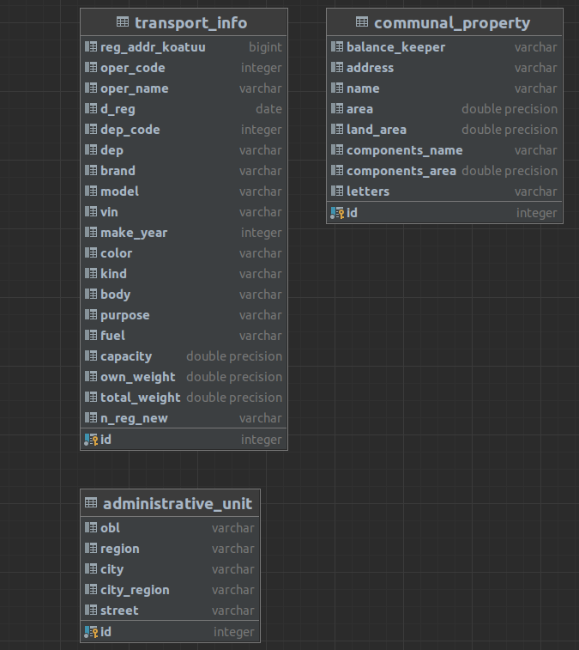

Схема основного сховища за типом “сніжинка” та код моделей:
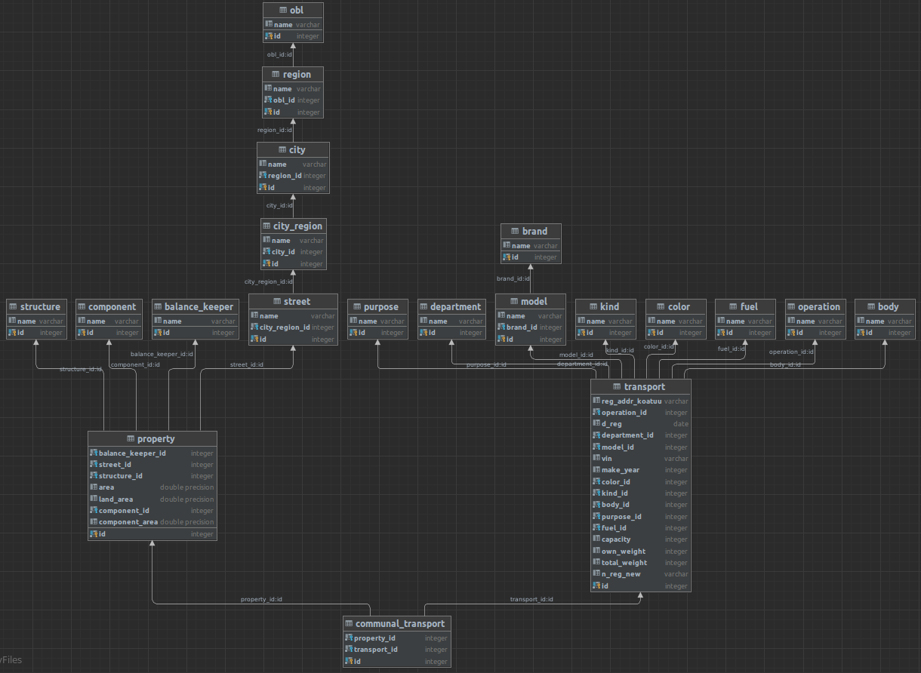
main_models.py
administrative_unit.py
__init__.py
from .. import Base, ReprAttributesString, ID_STR, CASCADE
from .obl import Obl
from .region import Region
from .city import City
from .city_region import CityRegion
from .street import Street

city.py
from sqlalchemy import Column, String, Integer, ForeignKey
from . import Base, ReprAttributesString, ID_STR, CASCADE
from .region import Region
class City(Base, ReprAttributesString):
__tablename__ = 'city'
def __init__(self, name: str, region_id: int) -> None:
self.name = name
self.region_id = region_id
id = Column(Integer, primary_key=True, autoincrement=True)
name = Column(String)
region_id = Column(Integer, ForeignKey(
Region.__tablename__ + ID_STR, ondelete=CASCADE), nullable=False)
city_region.py
from sqlalchemy import Column, String, Integer, ForeignKey
from . import Base, ReprAttributesString, ID_STR, CASCADE
from .city import City
class CityRegion(Base, ReprAttributesString):
__tablename__ = 'city_region'
def __init__(self, name: str, city_id: int) -> None:
self.name = name
self.city_id = city_id
id = Column(Integer, primary_key=True, autoincrement=True)
name = Column(String)
city_id = Column(Integer, ForeignKey(
City.__tablename__ + ID_STR, ondelete=CASCADE), nullable=False)
obl.py
from sqlalchemy import Column, String, Integer
from . import Base, ReprAttributesString
class Obl(Base, ReprAttributesString):
__tablename__ = 'obl'
def __init__(self, name: str) -> None:
self.name = name
id = Column(Integer, primary_key=True, autoincrement=True)
name = Column(String)
region.py
from sqlalchemy import Column, String, Integer, ForeignKey
from . import Base, ReprAttributesString, ID_STR, CASCADE
from .obl import Obl
class Region(Base, ReprAttributesString):
__tablename__ = 'region'
def __init__(self, name: str, obl_id: int) -> None:
self.name = name
self.obl_id = obl_id
id = Column(Integer, primary_key=True, autoincrement=True)
name = Column(String)
obl_id = Column(Integer, ForeignKey(
Obl.__tablename__ + ID_STR, ondelete=CASCADE), nullable=False)
street.py
from sqlalchemy import Column, String, Integer, ForeignKey
from . import Base, ReprAttributesString, ID_STR, CASCADE
from .city_region import CityRegion
class Street(Base, ReprAttributesString):
__tablename__ = 'street'
def __init__(self, name: str, city_region_id: int) -> None:
self.name = name
self.city_region_id = city_region_id
id = Column(Integer, primary_key=True, autoincrement=True)
name = Column(String)
city_region_id = Column(Integer, ForeignKey(
CityRegion.__tablename__ + ID_STR, ondelete=CASCADE), nullable=False)

communal_property.py
__init__.py
from .. import Base, ReprAttributesString, ID_STR, CASCADE
from ..administrative_unit import Street
from .balance_keeper import BalanceKeeper
from .structure import Structure
from .component import Component
from .property import Property
balance_keeper.py
from sqlalchemy import Column, String, Integer
from . import Base, ReprAttributesString
class BalanceKeeper(Base, ReprAttributesString):
__tablename__ = 'balance_keeper'
def __init__(self, name: str) -> None:
self.name = name
id = Column(Integer, primary_key=True, autoincrement=True)
name = Column(String)
component.py
from sqlalchemy import Column, String, Integer
from . import Base, ReprAttributesString
class Component(Base, ReprAttributesString):
__tablename__ = 'component'
def __init__(self, name: str) -> None:
self.name = name
id = Column(Integer, primary_key=True, autoincrement=True)
name = Column(String)
property.py
from sqlalchemy import Column, String, Integer, ForeignKey, Float
from . import Base, ReprAttributesString, ID_STR, CASCADE, Street
from .balance_keeper import BalanceKeeper
from .structure import Structure
from .component import Component
class Property(Base, ReprAttributesString):
__tablename__ = 'property'
def __init__(self, balance_keeper_id: int, street_id: int,
structure_id: int, area: Float, land_area: float,
component_id: int, component_area: float) -> None:
self.balance_keeper_id = balance_keeper_id
self.street_id = street_id
self.structure_id = structure_id
self.area = area
self.land_area = land_area
self.component_id = component_id
self.component_area = component_area
id = Column(Integer, primary_key=True, autoincrement=True)
balance_keeper_id = Column(Integer, ForeignKey(
BalanceKeeper.__tablename__ + ID_STR, ondelete=CASCADE), nullable=False)
street_id = Column(Integer, ForeignKey(
Street.__tablename__ + ID_STR, ondelete=CASCADE), nullable=False)
structure_id = Column(Integer, ForeignKey(
Structure.__tablename__ + ID_STR, ondelete=CASCADE), nullable=False)
area = Column(Float)
land_area = Column(Float)
component_id = Column(Integer, ForeignKey(
Component.__tablename__ + ID_STR, ondelete=CASCADE), nullable=False)
component_area = Column(Float)
structure.py
from sqlalchemy import Column, String, Integer
from . import Base, ReprAttributesString
class Structure(Base, ReprAttributesString):
__tablename__ = 'structure'
def __init__(self, name: str) -> None:
self.name = name
id = Column(Integer, primary_key=True, autoincrement=True)
name = Column(String)
transport_info.py
__init__.py
from .. import Base, ReprAttributesString, ID_STR, CASCADE
from .operation import Operation
from .department import Department
from .brand import Brand
from .model import Model
from .color import Color
from .kind import Kind
from .body import Body
from .purpose import Purpose
from .fuel import Fuel
from .transport import Transport
body.py
from sqlalchemy import Column, String, Integer
from . import Base, ReprAttributesString
class Body(Base, ReprAttributesString):
__tablename__ = 'body'
def __init__(self, name: str) -> None:
self.name = name
id = Column(Integer, primary_key=True, autoincrement=True)
name = Column(String)
brand.py
from sqlalchemy import Column, String, Integer
from . import Base, ReprAttributesString
class Brand(Base, ReprAttributesString):
__tablename__ = 'brand'
def __init__(self, name: str) -> None:
self.name = name
id = Column(Integer, primary_key=True, autoincrement=True)
name = Column(String)
color.py
from sqlalchemy import Column, String, Integer
from . import Base, ReprAttributesString
class Color(Base, ReprAttributesString):
__tablename__ = 'color'
def __init__(self, name: str) -> None:
self.name = name
id = Column(Integer, primary_key=True, autoincrement=True)
name = Column(String)
department.py
from sqlalchemy import Column, String, Integer
from . import Base, ReprAttributesString
class Department(Base, ReprAttributesString):
__tablename__ = 'department'
def __init__(self, id: int, name: str) -> None:
self.id = id
self.name = name
id = Column(Integer, primary_key=True)
name = Column(String)
fuel.py
from sqlalchemy import Column, String, Integer
from . import Base, ReprAttributesString
class Fuel(Base, ReprAttributesString):
__tablename__ = 'fuel'
def __init__(self, name: str) -> None:
self.name = name
id = Column(Integer, primary_key=True, autoincrement=True)
name = Column(String)
kind.py
from sqlalchemy import Column, String, Integer
from . import Base, ReprAttributesString
class Kind(Base, ReprAttributesString):
__tablename__ = 'kind'
def __init__(self, name: str) -> None:
self.name = name
id = Column(Integer, primary_key=True, autoincrement=True)
name = Column(String)
model.py
from sqlalchemy import Column, String, Integer, ForeignKey
from . import Base, ReprAttributesString, ID_STR, CASCADE
from .brand import Brand
class Model(Base, ReprAttributesString):
__tablename__ = 'model'
def __init__(self, name: str, brand_id: int) -> None:
self.name = name
self.brand_id = brand_id
id = Column(Integer, primary_key=True, autoincrement=True)
name = Column(String)
brand_id = Column(Integer, ForeignKey(
Brand.__tablename__ + ID_STR, ondelete=CASCADE), nullable=False)
operation.py
from sqlalchemy import Column, String, Integer
from . import Base, ReprAttributesString
class Operation(Base, ReprAttributesString):
__tablename__ = 'operation'
def __init__(self, id: int, name: str) -> None:
self.id = id
self.name = name
id = Column(Integer, primary_key=True)
name = Column(String)
purpose.py
from sqlalchemy import Column, String, Integer
from . import Base, ReprAttributesString
class Purpose(Base, ReprAttributesString):
__tablename__ = 'purpose'
def __init__(self, name: str) -> None:
self.name = name
id = Column(Integer, primary_key=True, autoincrement=True)
name = Column(String)
transport.py
from sqlalchemy import Column, String, Integer, Date, ForeignKey
from . import Base, ReprAttributesString, ID_STR, CASCADE
from .operation import Operation
from .department import Department
from .model import Model
from .color import Color
from .kind import Kind
from .body import Body
from .purpose import Purpose
from .fuel import Fuel
class Transport(Base, ReprAttributesString):
__tablename__ = 'transport'
def __init__(self, reg_addr_koatuu: str, operation_id: int,
d_reg: str, department_id: int, model_id: int, vin: str,
make_year: int, color_id: int, kind_id: int, body_id: int,
purpose_id: int, fuel_id: int, capacity: int,
own_weight: int, total_weight: int, n_reg_new: str) -> None:
self.reg_addr_koatuu = reg_addr_koatuu
self.operation_id = operation_id
self.d_reg = d_reg
self.department_id = department_id
self.model_id = model_id
self.vin = vin
self.make_year = make_year
self.color_id = color_id
self.kind_id = kind_id
self.body_id = body_id
self.purpose_id = purpose_id
self.fuel_id = fuel_id
self.capacity = capacity
self.own_weight = own_weight
self.total_weight = total_weight
self.n_reg_new = n_reg_new
id = Column(Integer, primary_key=True, autoincrement=True)
reg_addr_koatuu = Column(String)
operation_id = Column(Integer, ForeignKey(
Operation.__tablename__ + ID_STR, ondelete=CASCADE), nullable=False)
d_reg = Column(Date)
department_id = Column(Integer, ForeignKey(
Department.__tablename__ + ID_STR, ondelete=CASCADE), nullable=False)
model_id = Column(Integer, ForeignKey(
Model.__tablename__ + ID_STR, ondelete=CASCADE), nullable=False)
vin = Column(String)
make_year = Column(Integer)
color_id = Column(Integer, ForeignKey(Color.__tablename__ + ID_STR, ondelete=CASCADE), nullable=False)
kind_id = Column(Integer, ForeignKey(
Kind.__tablename__ + ID_STR, ondelete=CASCADE), nullable=False)
body_id = Column(Integer, ForeignKey(
Body.__tablename__ + ID_STR, ondelete=CASCADE), nullable=False)
purpose_id = Column(Integer, ForeignKey(
Purpose.__tablename__ + ID_STR, ondelete=CASCADE), nullable=False)
fuel_id = Column(Integer, ForeignKey(
Fuel.__tablename__ + ID_STR, ondelete=CASCADE), nullable=False)
capacity = Column(Integer)
own_weight = Column(Integer)
total_weight = Column(Integer)
n_reg_new = Column(String)
communal_transport.py
from sqlalchemy import Column, Integer, ForeignKey
from . import Base, ReprAttributesString, ID_STR, CASCADE
from my_models.main_models.transport_info import Transport
from my_models.main_models.communal_property import Property
class CommunalTransport(Base, ReprAttributesString):
__tablename__ = 'communal_transport'
def __init__(self, property_id: int, transport_id: int) -> None:
self.property_id = property_id
self.transport_id = transport_id
id = Column(Integer, primary_key=True, autoincrement=True)
property_id = Column(Integer, ForeignKey(
Property.__tablename__ + ID_STR, ondelete=CASCADE), nullable=False)
transport_id = Column(Integer, ForeignKey(
Transport.__tablename__ + ID_STR, ondelete=CASCADE), nullable=False)

staging.py
from my_etl_controller import get_main_engine, get_stage_engine, get_session, Extractor
from my_models import stage_models
def staging():
stage_engine = get_stage_engine(True)
stage_models.Base.metadata.create_all(stage_engine)
stage_session = get_session(stage_engine)
extractor = Extractor(stage_session)
extractor.extract_data()
staging()

ETL-Засоби:

extractor.py

import pandas as pd
import numpy as np
from sqlalchemy.orm import Session
from my_models.stage_models import AdministrativeUnit, CommunalProperty, TransportInfo
class Extractor:
transport_info_file: str = 'data_sets/small_transport_info.csv'
transport_info_delim: str = ';'
communal_property_file: str = 'data_sets/communal_property.xls'
administrative_unit_file: str = 'data_sets/administrative_unit.xml'
def __init__(self, stage_session: Session):
self.stage_session: Session = stage_session
def extract_data(self):
self.extract_communal_property_data()
self.extract_transport_info_data()
self.extract_administrative_unit_data()
def extract_transport_info_data(self) -> None:
data = pd.read_csv(self.transport_info_file,
delimiter=self.transport_info_delim)
data = data.replace({np.nan: None})
for el in data.values:
self.stage_session.add(TransportInfo(*el[1:]))
self.stage_session.commit()
def extract_communal_property_data(self) -> None:
data = pd.read_excel(self.communal_property_file)
data['components_area'] = data['components_area'].str.replace(',', '.').astype(float)
data['land_area'] = data['land_area'].str.replace(',', '.').astype(float)
data['object_area'] = data['object_area'].str.replace(',', '.').astype(float)
data = data.replace({np.nan: None})
for el in data.values:
self.stage_session.add(CommunalProperty(*el))
self.stage_session.commit()
def extract_administrative_unit_data(self) -> None:
data = pd.read_xml(self.administrative_unit_file)
data = data.replace({np.nan: None})
for el in data.values:
self.stage_session.add(AdministrativeUnit(*el))
self.stage_session.commit()

transloader.py
__init__.py
from abc import ABC, abstractmethod
from typing import Any
from sqlalchemy import MetaData
from sqlalchemy.engine import Engine
from my_models.main_models import Base
from my_etl_controller.connector import get_session
class TransLoader(ABC):
def __init__(self, stage_engine: Engine, main_engine: Engine) -> None:
self.stage_engine = stage_engine
self.main_engine = main_engine
self.stage_session = get_session(stage_engine)
self.main_session = get_session(main_engine)
self.meta = MetaData()
def update_row_and_latest_id(self, value: str, d: dict[str, int], latest_id_ref: [int]) -> int:
id = d.get(value)
if id is None:
id = latest_id_ref[0]
d.update([(value, id)])
latest_id_ref[0] = latest_id_ref[0] + 1
return id
def load_from_dict(self, d: dict[Any, Any], model: Base, autoincrement=True) -> None:
if autoincrement:
for name, _ in d.items():
self.main_session.add(model(name))
else:
for name, id in d.items():
self.main_session.add(model(id, name))
self.main_session.commit()
def load_from_list(self, l: list[tuple], model: Base) -> None:
for row in l:
self.main_session.add(model(*row))
self.main_session.commit()
@abstractmethod
def models(self) -> list[Base]:
pass
def create_models(self):
tables = list(map(lambda x: Base.metadata.tables[x.__tablename__], self.models()))
Base.metadata.create_all(bind=self.main_engine, tables=tables)
@abstractmethod
def transform(self) -> None:
pass
@abstractmethod
def load(self) -> None:
pass
def transload(self) -> None:
self.create_models()
self.transform()
self.load()
from .au_transloader import AUTransLoader
from .cp_transloader import CPTransLoader
from .ti_transloader import TITransLoader
from .ct_transloader import CTTransLoader
def transform_data(stage_engine: Engine, main_engine: Engine) -> None:
AUTransLoader(stage_engine, main_engine).transload()
CPTransLoader(stage_engine, main_engine).transload()
TITransLoader(stage_engine, main_engine).transload()
CTTransLoader(stage_engine, main_engine).transload()

au_transloader.py
import pandas as pd
from sqlalchemy.engine import Engine
from my_models.stage_models import AdministrativeUnit
from my_models.main_models import Base
from my_models.main_models.administrative_unit import Obl, Region, City, CityRegion, Street
from . import TransLoader
class AUTransLoader(TransLoader):
def __init__(self, stage_engine: Engine, main_engine: Engine) -> None:
TransLoader.__init__(self, stage_engine, main_engine)
self.df_administrative_unit = pd.read_sql_table(
AdministrativeUnit.__tablename__, self.stage_engine)
self.table = {}
def models(self) -> list[Base]:
return [Obl, Region, City, CityRegion, Street]
def transform(self) -> None:
for i, row in self.df_administrative_unit.iterrows():
_, obl_name, region_name, city_name, city_region_name, street_name = row
regions = self.table.get(obl_name)
if regions is None:
regions = {}
self.table.update([(obl_name, regions)])
cities = regions.get(region_name)
if cities is None:
cities = {}
regions.update([(region_name, cities)])
city_regions = cities.get(city_name)
if city_regions is None:
city_regions = {}
cities.update([(city_name, city_regions)])
streets = city_regions.get(city_region_name)
if streets is None:
streets = []
city_regions.update([(city_region_name, streets)])
streets.append(street_name)
def load_obl(self):
for obl_name, regions in self.table.items():
self.main_session.add(Obl(obl_name))
self.main_session.commit()
def load_region(self):
obl_id = 1
for obl_name, regions in self.table.items():
for region_name, cities in regions.items():
self.main_session.add(Region(region_name, obl_id))
obl_id = obl_id + 1
self.main_session.commit()
def load_city(self):
region_id = 1
for obl_name, regions in self.table.items():
for region_name, cities in regions.items():
for city_name, city_regions in cities.items():
self.main_session.add(City(city_name, region_id))
region_id = region_id + 1
self.main_session.commit()
def load_city_region(self):
city_id = 1
for obl_name, regions in self.table.items():
for region_name, cities in regions.items():
for city_name, city_regions in cities.items():
for city_region_name, streets in city_regions.items():
self.main_session.add(CityRegion(city_region_name, city_id))
city_id = city_id + 1
self.main_session.commit()
def load_street(self):
city_region_id = 1
for obl_name, regions in self.table.items():
for region_name, cities in regions.items():
for city_name, city_regions in cities.items():
for city_region_name, streets in city_regions.items():
for street_name in streets:
self.main_session.add(Street(street_name, city_region_id))
city_region_id = city_region_id + 1
self.main_session.commit()
def load(self):
self.load_obl()
self.load_region()
self.load_city()
self.load_city_region()
self.load_street()

cp_transloader.py
import pandas as pd
import numpy as np
from sqlalchemy.engine import Engine
from my_models.main_models import Base
from my_models.stage_models import CommunalProperty
from my_models.main_models.communal_property import BalanceKeeper, Component, Property, Structure
from my_models.main_models.administrative_unit import Street
from . import TransLoader
class CPTransLoader(TransLoader):
def __init__(self, stage_engine: Engine, main_engine: Engine) -> None:
TransLoader.__init__(self, stage_engine, main_engine)
self.df_communal_property = pd.read_sql_table(
CommunalProperty.__tablename__, self.stage_engine)
self.property: list[tuple[int, int, int, float, float, int, float]] = []
self.balance_keeper: dict[str, int] = {}
self.component: dict[str, int] = {}
self.structure: dict[str, int] = {}
def models(self) -> list[Base]:
return [BalanceKeeper, Component, Property, Structure]
def transform(self) -> None:
ids = {'bk_id': [1], 'struct_id': [1], 'comp_id': [1]}
street_count = self.main_session.query(Street).count()
for _, row in self.df_communal_property.iterrows():
_, balance_keeper_name, _, structure_name, area, land_area, components_name, component_area, _ = row
bk_id = self.update_row_and_latest_id(
balance_keeper_name, self.balance_keeper, ids['bk_id'])
struct_id = self.update_row_and_latest_id(
structure_name, self.structure, ids['struct_id'])
comp_id = self.update_row_and_latest_id(
components_name, self.component, ids['comp_id'])
street_id = np.random.randint(1, street_count)
self.property.append(
(bk_id, street_id, struct_id, area, land_area, comp_id, component_area))
def load(self) -> None:
self.load_from_dict(self.balance_keeper, BalanceKeeper)
self.load_from_dict(self.component, Component)
self.load_from_dict(self.structure, Structure)
self.load_from_list(self.property, Property)

ct_transloader.py
import pandas as pd
import numpy as np
from sqlalchemy.engine import Engine
from my_models.main_models import Base
from my_models.main_models.transport_info import Transport
from my_models.main_models.communal_property import Property
from my_models.main_models.communal_transport import CommunalTransport
from . import TransLoader
class CTTransLoader(TransLoader):
def __init__(self, stage_engine: Engine, main_engine: Engine) -> None:
TransLoader.__init__(self, stage_engine, main_engine)
self.df_transport = pd.read_sql_table(
Transport.__tablename__, self.main_engine)
self.df_property = pd.read_sql_table(
Property.__tablename__, self.main_engine)
self.table: [(int, int)] = []
def models(self) -> list[Base]:
return [CommunalTransport]
def transform(self) -> None:
property_count = self.main_session.query(Property).count()
for _, row in self.df_transport.iterrows():
self.table.append((np.random.randint(1, property_count), row[0]))
def load(self):
self.load_from_list(self.table, CommunalTransport)

ti_transloader.py

import pandas as pd
import numpy as np
from sqlalchemy.engine import Engine
from my_models.stage_models import TransportInfo
from my_models.main_models.transport_info import Body, Brand, Color, \
Department, Fuel, Kind, Model, Operation, Purpose, Transport
from my_models.main_models import Base
from . import TransLoader
class TITransLoader(TransLoader):
def __init__(self, stage_engine: Engine, main_engine: Engine) -> None:
TransLoader.__init__(self, stage_engine, main_engine)
self.df_transport_info = pd.read_sql_table(
TransportInfo.__tablename__, self.stage_engine)
self.transport: list[tuple] = []
self.color: dict[str, int] = {}
self.kind: dict[str, int] = {}
self.fuel: dict[str, int] = {}
self.body: dict[str, int] = {}
self.purpose: dict[str, int] = {}
self.reg_addr_koatuu: dict[int, int] = {}
self.purpose: dict[str, int] = {}
self.operation: dict[str, int] = {}
self.department: dict[str, int] = {}
self.purpose: dict[str, int] = {}
# brand contains models
self.brand: dict[str, dict[str, int]] = {}
def models(self) -> list[Base]:
return [Body, Brand, Color, Department, Fuel,
Kind, Model, Operation, Purpose, Transport]
def transform_brand_model(self) -> None:
model_id = 1
for _, row in self.df_transport_info.iterrows():
brand_name, model_name = (row[7], row[8])
models = self.brand.get(brand_name)
if models is None:
models = {}
self.brand.update([(brand_name, models)])
if models.get(model_name) is None:
models.update([(model_name, model_id)])
model_id = model_id + 1
def load_model(self) -> None:
brand_id = 1
for _, models in self.brand.items():
for model_name, _ in models.items():
self.main_session.add(Model(model_name, brand_id))
brand_id = brand_id + 1
self.main_session.commit()
def nan_to_zero(self, number: int) -> int:
result = number
if np.isnan(result):
result = 0
return result
def transform(self) -> None:
self.transform_brand_model()
ids = {'color_id': [1], 'kind_id': [1], 'fuel_id': [1],
'body_id': [1], 'purpose_id': [1]}
for _, row in self.df_transport_info.iterrows():
_, reg_addr_koatuu, oper_code, oper_name, d_reg, \
dep_code, dep_name, brand_name, model_name, vin, make_year, color_name, \
kind_name, body_name, purpose_name, fuel_name, \
capacity, own_weight, total_weight, n_reg_new = row
color_id = self.update_row_and_latest_id(color_name, self.color, ids['color_id'])
kind_id = self.update_row_and_latest_id(kind_name, self.kind, ids['kind_id'])
fuel_id = self.update_row_and_latest_id(fuel_name, self.fuel, ids['fuel_id'])
body_id = self.update_row_and_latest_id(body_name, self.body, ids['body_id'])
purpose_id = self.update_row_and_latest_id(
purpose_name, self.purpose, ids['purpose_id'])
self.department.update([(dep_name, dep_code)])
self.operation.update([(oper_name, oper_code)])
model_id = self.brand[brand_name][model_name]
capacity = self.nan_to_zero(capacity)
own_weight = self.nan_to_zero(own_weight)
total_weight = self.nan_to_zero(total_weight)
self.transport.append(
(reg_addr_koatuu, oper_code, d_reg, dep_code, model_id,
vin, make_year, color_id, kind_id, body_id, purpose_id,
fuel_id, capacity, own_weight, total_weight, n_reg_new))
def load(self) -> None:
self.load_from_dict(self.brand, Brand)
self.load_model()
self.load_from_dict(self.color, Color)
self.load_from_dict(self.kind, Kind)
self.load_from_dict(self.fuel, Fuel)
self.load_from_dict(self.body, Body)
self.load_from_dict(self.purpose, Purpose)
self.load_from_dict(self.operation, Operation, autoincrement=False)
self.load_from_dict(self.department, Department, autoincrement=False)
self.load_from_list(self.transport, Transport)

main.py
from my_etl_controller import get_main_engine, get_stage_engine, transform_data
def main():
stage_engine = get_stage_engine(False)
main_engine = get_main_engine(False)
transform_data(stage_engine, main_engine)
if __name__ == '__main__':
main()

Інші файли:
my_config.py
__init__.py
keys = ['user', 'passwd', 'host', 'port', 'db']
stage_connector = {
keys[0]: 'postgres',
keys[1]: 'qwerty',
keys[2]: 'localhost',
keys[3]: 5432,
keys[4]: 'da_lab_one_stage'
}
main_connector = {
keys[0]: 'postgres',
keys[1]: 'qwerty',
keys[2]: 'localhost',
keys[3]: 5432,
keys[4]: 'da_lab_one_main'
}

connector.py

from sqlalchemy import create_engine
from sqlalchemy.engine import Engine
from sqlalchemy.orm import sessionmaker, Session
from sqlalchemy_utils import database_exists, create_database, drop_database
import my_config
def get_engine(user: str, passwd: str, host: str, port: int, db: str, is_recreate_db: bool) -> Engine:
url = f"postgresql://{user}:{passwd}@{host}:{port}/{db}"
if is_recreate_db:
if database_exists(url):
drop_database(url)
create_database(url)
engine = create_engine(url, pool_size=50, echo=True)
return engine
def check_connect_info(info: dict) -> None:
if not all(key in my_config.keys for key in info.keys()):
raise Exception('Bad info connect')
def get_stage_engine(is_recreate_db: bool) -> Engine:
check_connect_info(my_config.stage_connector)
info = my_config.stage_connector
return get_engine(
user=info['user'],
passwd=info['passwd'],
host=info['host'],
port=info['port'],
db=info['db'],
is_recreate_db=is_recreate_db
)
def get_main_engine(is_recreate_db: bool) -> Engine:
check_connect_info(my_config.main_connector)
info = my_config.main_connector
return get_engine(
user=info['user'],
passwd=info['passwd'],
host=info['host'],
port=info['port'],
db=info['db'],
is_recreate_db=is_recreate_db
)
def get_session(engine: Engine) -> Session:
return sessionmaker(bind=engine)()

constants.py
ID_STR = '.id'
CASCADE = 'CASCADE'

Приклад завантажених даних:

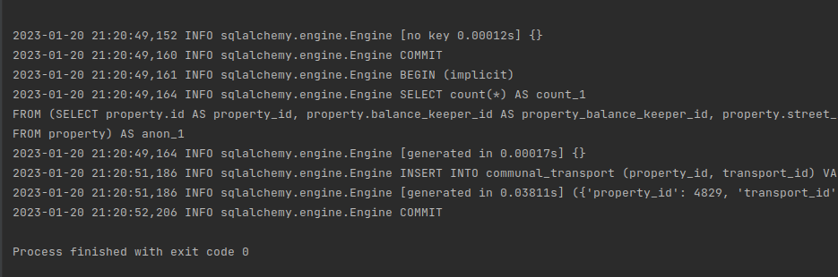
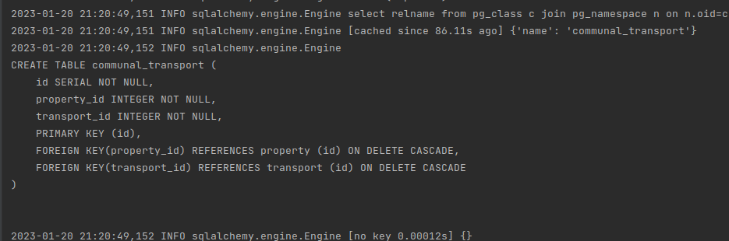

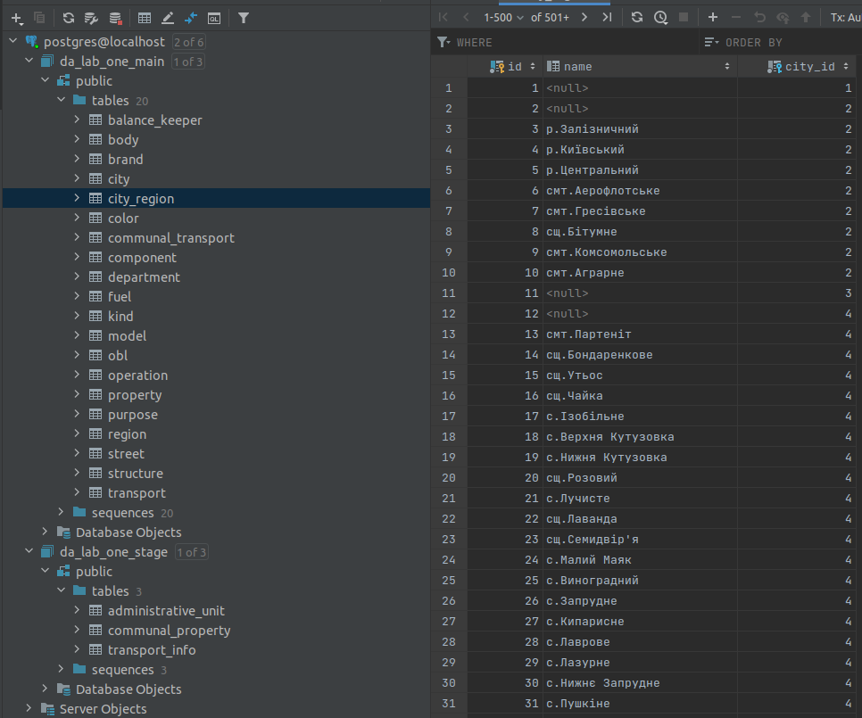

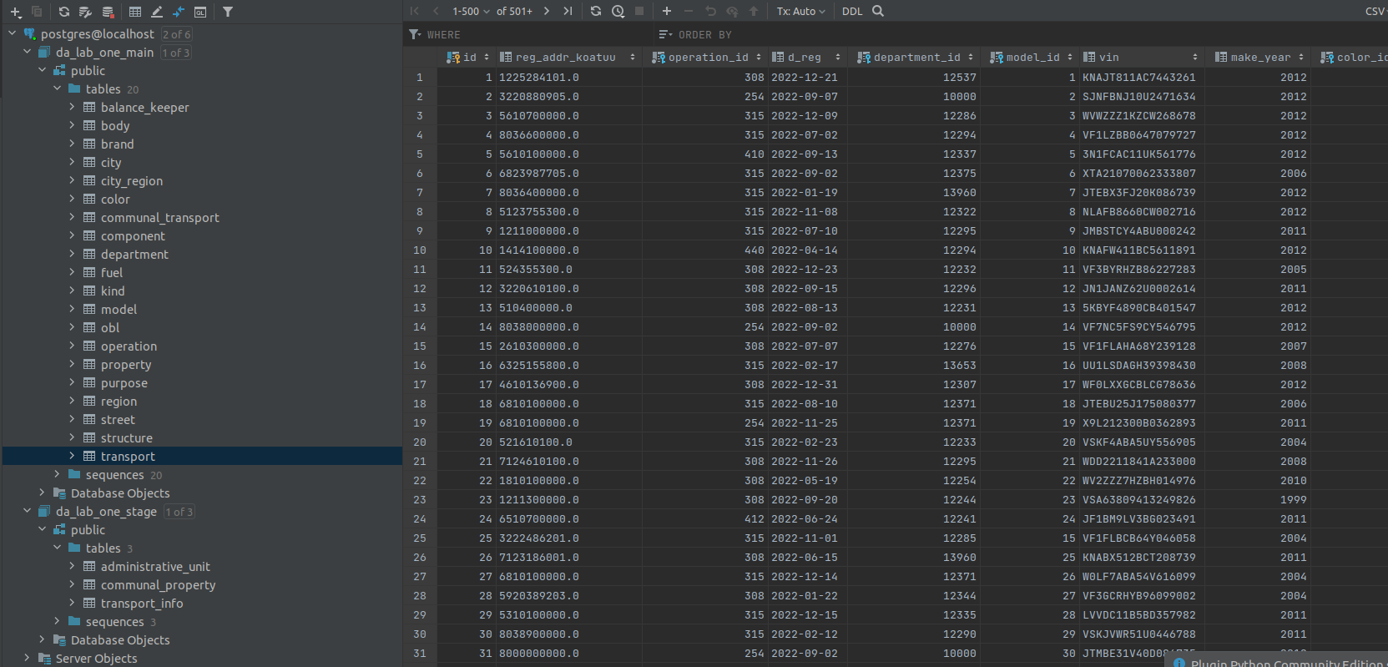

Висновок:
Під час лабораторної роботи ознайомився з підходами до створення сховищ даних. Була створена Stage зона для витягування даних з файлів. Модель основного сховища даних побудована у схемі “сніжинка”. Код ETL-контроллеру наведений та показаний результат роботи у вигляді кінцевої бази даних, приведеної до 3ьої нормальної форми. Схеми для кращого орієнтування також додані.

Запитання для самоперевірки:
1) Дайте визначення ETL:
ETL – це триетапний процес, де дані витягуються, трансформуються, завантажуються у вихідне сховище даних.
2) На чому базується процес ETL?
ETL базується на трьох етапах:
- Витягування включає у себе такі процеси як: вилучення даних з однорідних або різнорідних джерел; перетворення даних у належний формат/структуру зберігання для цілей запитів та аналізу; вставку даних у кінцеву цільову базу даних, таку як сховище операційних даних, вітрина даних, озеро даних або сховище даних.
- Перетворення даних включає серію правил або функцій, що застосовуються до витягнутих даних, щоб підготувати їх для завантаження в кінцеву ціль. Важливою частиною даного етапу є очищення даних, метою якого є передача лише «належних» даних до вихідного сховища. У інших випадках застосовується: закодовування значень, отримання похідного значення, генерування ключів, деагрегацію повторюваних стовпців тощо.
- Завантаження даних включає перенесення їх у плоский файл або сховище даних.

3) Переваги та недоліки схем «зірка» та сніжинка:
- “Зірка”:
  - Переваги:
    - Продуктивність запитів підвищується, оскільки вони використовують дуже прості об’єднання під час отримання даних
    - Отримати дані для звітності просто в будь-який момент часу за будь-який період.
  - Недоліки:
    - Схему зірок не рекомендується змінювати та використовувати повторно в довгостроковій перспективі, якщо планується багато змін.
    - Оскільки таблиці не розділені ієрархічно, то з’являється надлишковість даних.
- “Сніжинка”:
  - Переваги:
    - Надмірність даних повністю вирішується створенням нових таблиць розмірів.
    - У порівнянні із зірковою схемою таблиці розмірів Snow Flaking використовують менше місця.
    - Легко оновити та підтримувати таблиці.
  - Недоліки:
    - Через те, що існують нормалізовані таблиці розмірів, система ETL повинна завантажувати кількість таблиць.
    - Для виконання запиту вам можуть знадобитися складні об’єднання через кількість доданих таблиць. Отже, продуктивність запитів буде погіршена.
4) Підходи до створення багатовимірних моделей?
OLAP (англ. online analytical processing, аналітична обробка у реальному часі) - це інтерактивна система що дозволяє переглядати різні підсумки по багатовимірних даних.
Пропонуються різноманітні продукти OLAP, які можна згрупувати в три категорії:
- багатовимірний ROLAP:
        - ROLAP означає Relational Online Analytical Processing. ROLAP зберігає дані в стовпцях і рядках (також відомих як реляційні таблиці) і отримує інформацію на вимогу за допомогою запитів, наданих користувачем. Доступ до бази даних ROLAP можна отримати за допомогою складних запитів SQL для обчислення інформації. ROLAP може обробляти великі обсяги даних, але чим більше даних, тим повільніше час обробки.
        - Оскільки запити виконуються на вимогу, ROLAP не вимагає зберігання та попереднього обчислення інформації. Однак недоліком реалізації ROLAP є потенційні обмеження продуктивності та обмеження масштабованості, які є результатом великих і неефективних операцій з’єднання між великими таблицями.
- реляційний ROLAP:
      - MOLAP означає багатовимірну онлайн-аналітичну обробку. MOLAP використовує багатовимірний куб, який отримує доступ до збережених даних за допомогою різних комбінацій. Дані попередньо обчислюються, підсумовуються та зберігаються (відмінність від ROLAP, де запити обслуговуються на вимогу).
      - Багатокубовий підхід виявився успішним у продуктах MOLAP. У цьому підході серія щільних, маленьких, попередньо обчислених кубів утворює гіперкуб. Інструменти, які включають MOLAP, включають Oracle Essbase, IBM Cognos і Apache Kylin.
- гібридний HOLAP:
  - HOLAP означає Hybrid Online Analytical Processing. Як випливає з назви, режим зберігання HOLAP поєднує атрибути як MOLAP, так і ROLAP. Оскільки HOLAP передбачає зберігання частини ваших даних у сховищі ROLAP, а іншу частину – у сховищі MOLAP, розробники отримують переваги обох.
  - Завдяки такому використанню двох OLAP дані зберігаються як у багатовимірних базах даних, так і в реляційних базах даних. Рішення про доступ до однієї з баз даних залежить від того, яка з них найбільше підходить для запитаної програми або типу обробки. Це налаштування забезпечує набагато більшу гнучкість обробки даних. Для теоретичної обробки дані зберігаються в багатовимірній базі даних. Для важкої обробки дані зберігаються в реляційній базі даних.
Використані джерела:
How to do ETL: https://www.youtube.com/watch?v=XVms0SA-6Xs
ETL: https://uk.wikipedia.org/wiki/ETL

Snowflake schema: https://en.wikipedia.org/wiki/Snowflake_schema

Типи схем у моделюванні сховища даних - схема Star & SnowFlake: https://uk.myservername.com/schema-types-data-warehouse-modeling-star-snowflake-schema
Багатовимірна модель даних( пункт 1.8 ): https://elearning.sumdu.edu.ua/free_content/lectured:a8104441b8e00905159c1ff04257b014dd456247/20151109195846/162252/index.html

Багатовимірна модель даних: https://stud.com.ua/35697/informatika/bagatovimirna_model_danih

OLAP, ROLAP, MOLAP, HOLAP: https://www.sisense.com/glossary/olap/
OLAP: https://uk.wikipedia.org/wiki/OLAP

XML parsing in Python: https://www.geeksforgeeks.org/xml-parsing-python/

Python Tutorial: CSV Module - How to Read, Parse, and Write CSV Files: https://www.youtube.com/watch?v=q5uM4VKywbA

