Module 1 - Introduction to the NSX Network and Security Virtualization Platform
In this module you will be introduced to the VMware NSX platform and its capabilities.
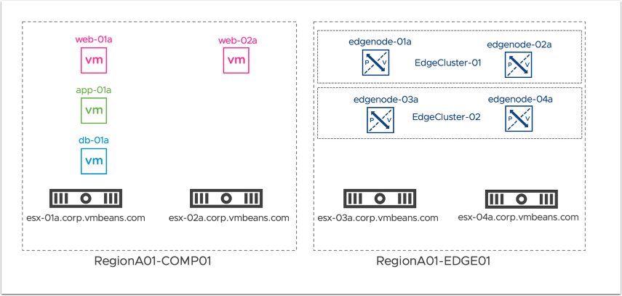
This diagram shows the topology that will be used for this lab. The lab includes four (4) ESXi hosts grouped as follows:
- Cluster: RegionA01-COMP01
  - Host: esx-01a.corp.vmbeans.com
  - Host: esx-02a.corp.vmbeans.com
- Cluster: RegionA01-EDGE01
  - Host: esx-03a.corp.vmbeans.com
  - Host: esx-04a.corp.vmbeans.com
Finally, this lab includes four (4) VM form factor NSX Edge Nodes, configured as follows:
- Edge Cluster: EdgeCluster-01
  - NSX Edge: edgenode-01a
  - NSX Edge: edgenode-02a
- Edge Cluster: EdgeCluster-02
  - NSX Edge: edgenode-03a
  - NSX Edge: edgenode-04a

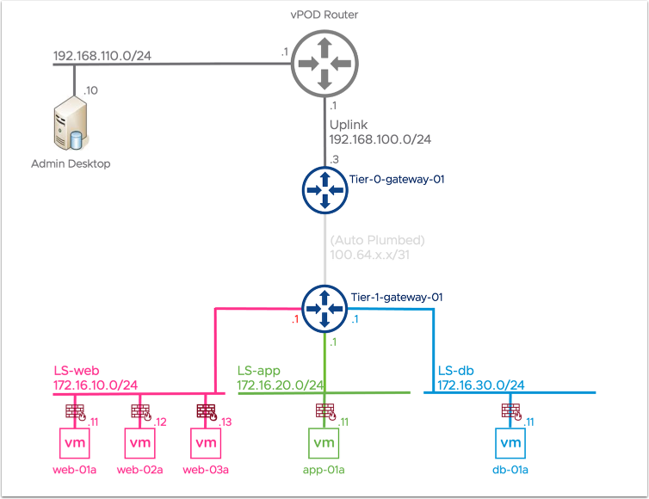
This diagram shows the logical network topology that will be used in this lab. The lab includes a single Tier-0 Gateway that has connected interfaces, configured as follows:
- Tier-0 Gateway: T0-GW-01
- Uplink Interface: EN1-Uplink1 (192.168.120.3/24)
- Interface: LS-web (172.16.10.1/24)
- Interface: LS-app (172.16.20.1/24)
- Interface (to be created) : LS-db (172.16.30.1/24)
VMware NSX provides an agile software-defined infrastructure to build cloud-native application environments. NSX works by implementing three separate but integrated planes: management, control, and data. The three planes are implemented as a set of processes, modules, and agents residing on two types of nodes: manager appliance and transport.

Module 2 - NSX Manager, Transport Nodes and Inventory Components

NSX Manager, Transport Nodes and Inventory Components, Module Overview
The goal of this module is to explore host and edge transport node preparation in NSX.

