Module 3 Introduction to IAM

Task 1. Explore the users and groups
In this task, you will explore the users and groups that have already been created for you in IAM. First, note the Region that you are in; for example, N. Virginia. The Region is displayed in the upper-right corner of the console page. You might need this information later in the lab.

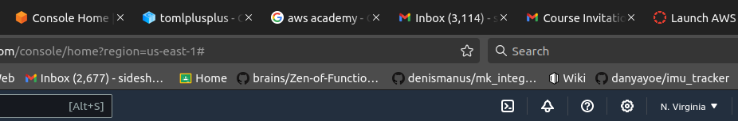
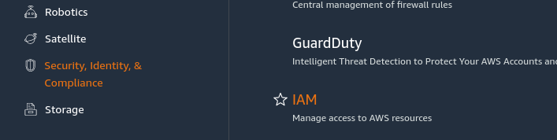
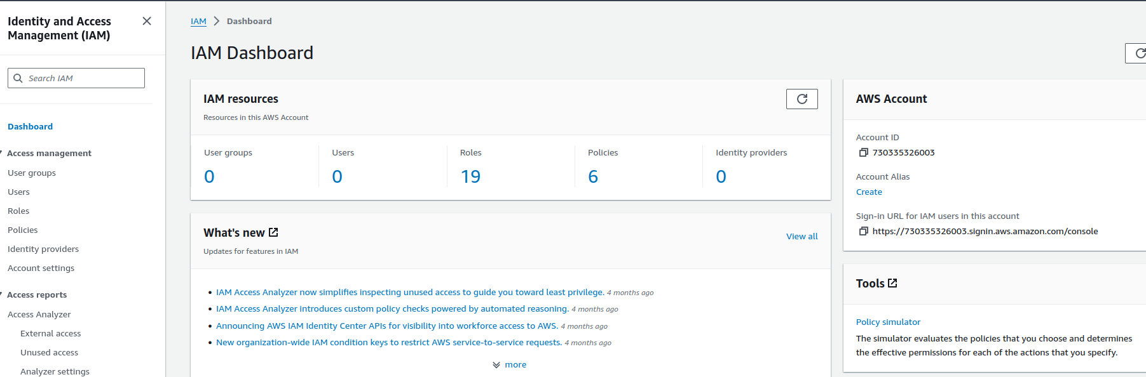

In the navigation pane on the left, choose Users.
Create the following IAM users: panchenko-1, panchenko-2, panchenko-3

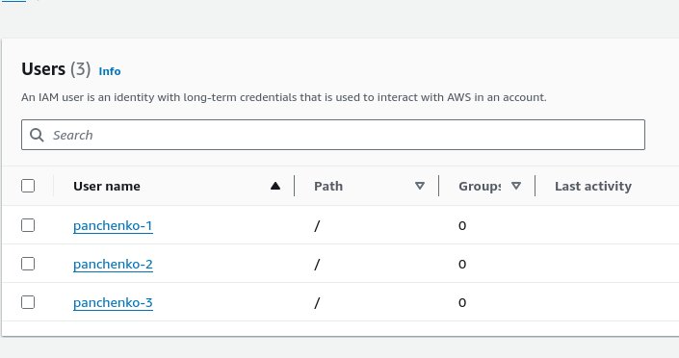

The users are assigned a Console password to allow them to access the AWS Management
Console. They does not have any permissions and are not a member of any groups.
5. In the navigation pane on the left, choose User groups.
Create the following groups: EC2-Admin, EC2-Support, S3-Support.

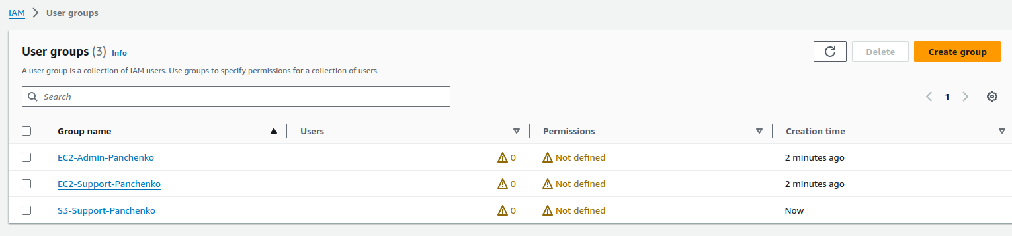
Choose the name of the EC2-Support group. This brings you to the summary page for the EC2-Support group.

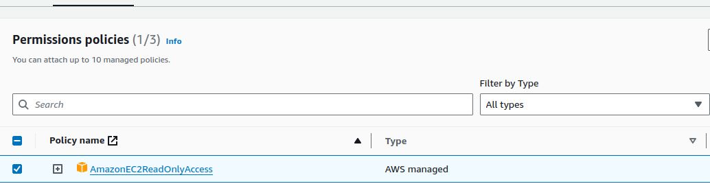
Choose the {} JSON tab. A policy defines what actions are allowed or denied for specific AWS resources. This policy is granting permission to List and Describe (view) information about Amazon Elastic Compute Cloud (Amazon EC2), Elastic Load Balancing, Amazon CloudWatch, and Amazon EC2 Auto Scaling. This ability to view resources, but not modify them, is ideal for assigning to a support role. Statements in an IAM policy have the following basic structure:
▪ Effect says whether to Allow or Deny the permissions.
▪ Action specifies the API calls that can be made against an AWS service (for example, cloudwatch:ListMetrics).
▪ Resource defines the scope of entities covered by the policy rule (for
example, a specific Amazon Simple Storage Service [Amazon S3] bucket or
Amazon EC2 instance; an asterisk [ * ] means any resource).

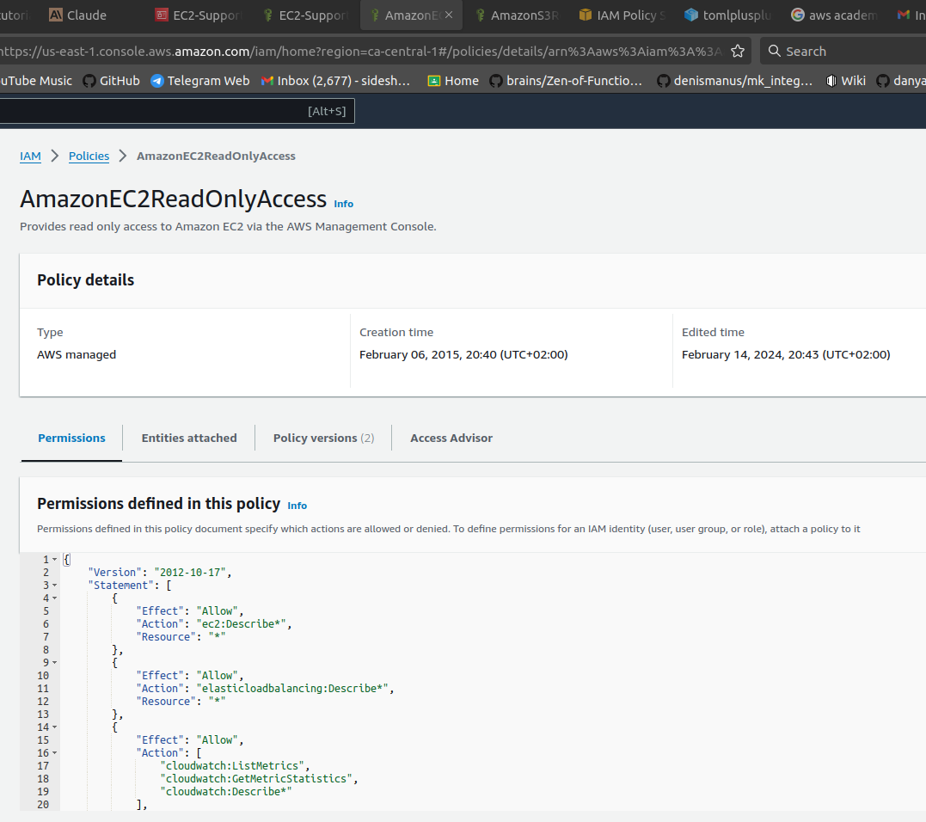

Choose the name of the S3-Support group. Choose the Permissions tab. Assign the group S3-Support the AmazonS3ReadOnlyAccess policy.
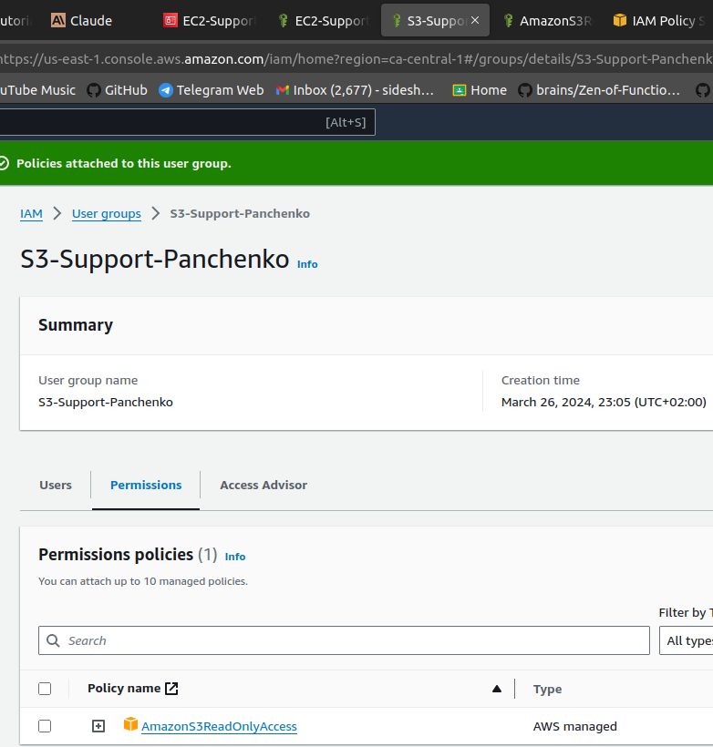

Under Policy Name, choose the link for the AmazonS3ReadOnlyAccess policy. Choose the {} JSON tab. This policy has permissions to Get and List for all resources in Amazon S3.

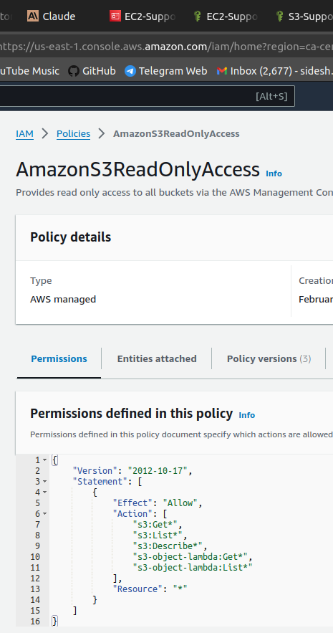

In the navigation pane on the left, choose User groups. Choose the name of the EC2-Admin group. Choose the Permissions tab. This group is different from the other two. Instead of a managed policy, assign the group an inline policy, which is a policy assigned to just one user or group. Inline policies are typically used to apply permissions for specific situations.

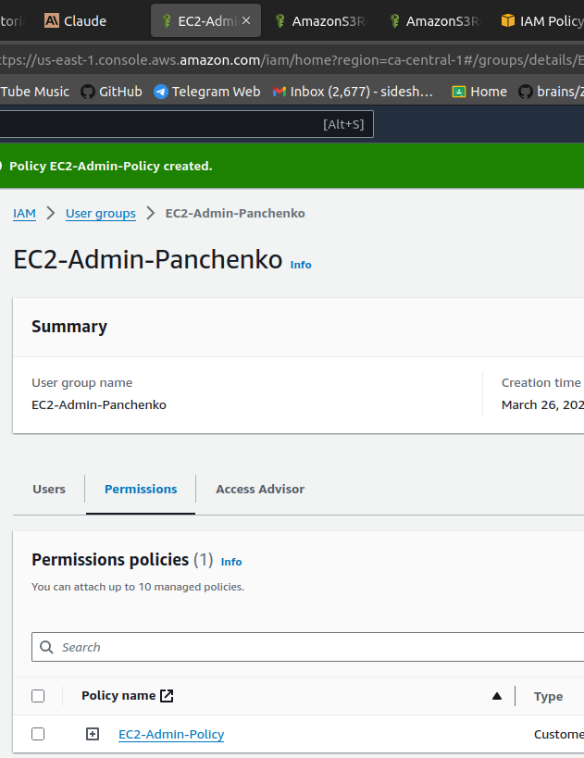

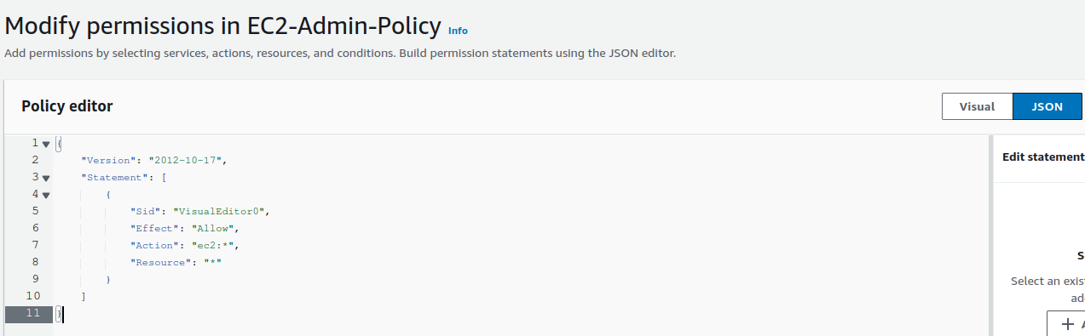

In the left navigation pane, choose User groups.27. Choose the name of the S3-Support group. On the Users tab, choose Add users. Select user-1, and choose Add users. On the Users tab, notice that user-1 has been added to the group.
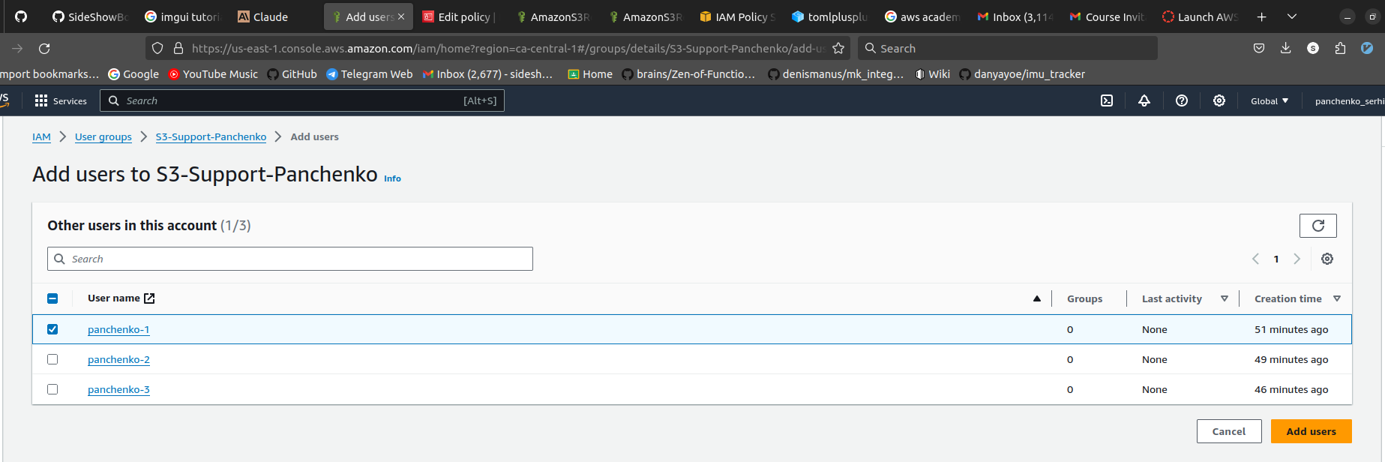

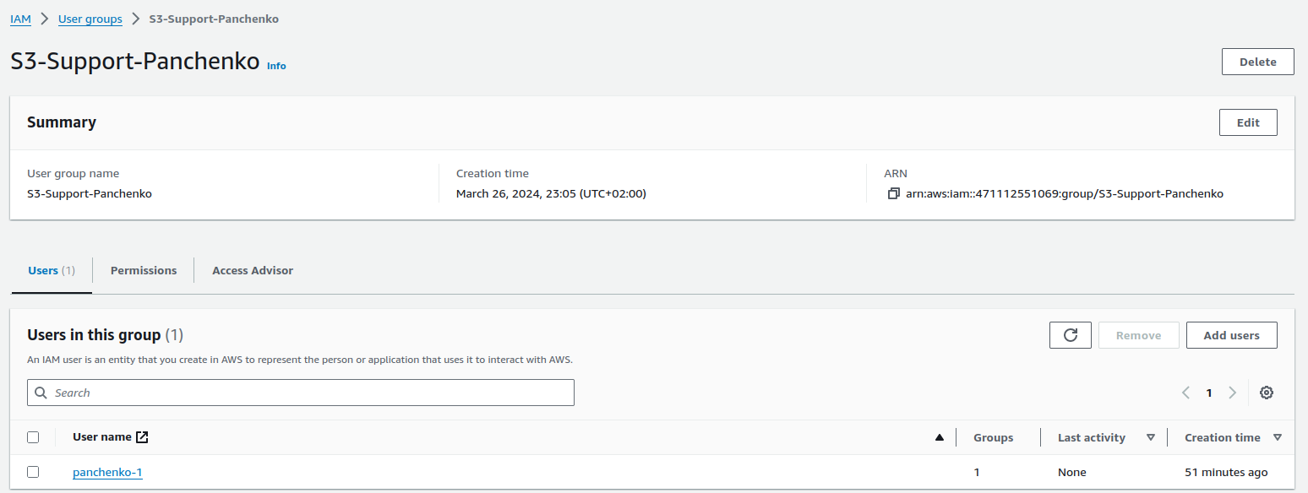

You have hired user-2 into a role where they will provide support for Amazon EC2. You will add them to the EC2-Support group so that they inherit the necessary permissions via the attached AmazonEC2ReadOnlyAccess policy. Use what you learned from the previous steps to add user-2 to the EC2-Support group. user-2 should now be part of the EC2-Support group.

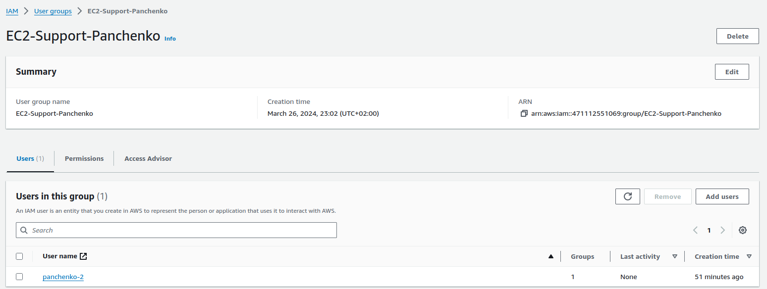

You have hired user-3 as your Amazon EC2 administrator to manage your EC2 instances. You will add them to the EC2-Admin group so that they inherit the necessary permissions via the attached EC2-Admin-Policy. Use what you learned from the previous steps to add user-3 to the EC2-Admin group. user-3 should now be part of the EC2-Admin group.

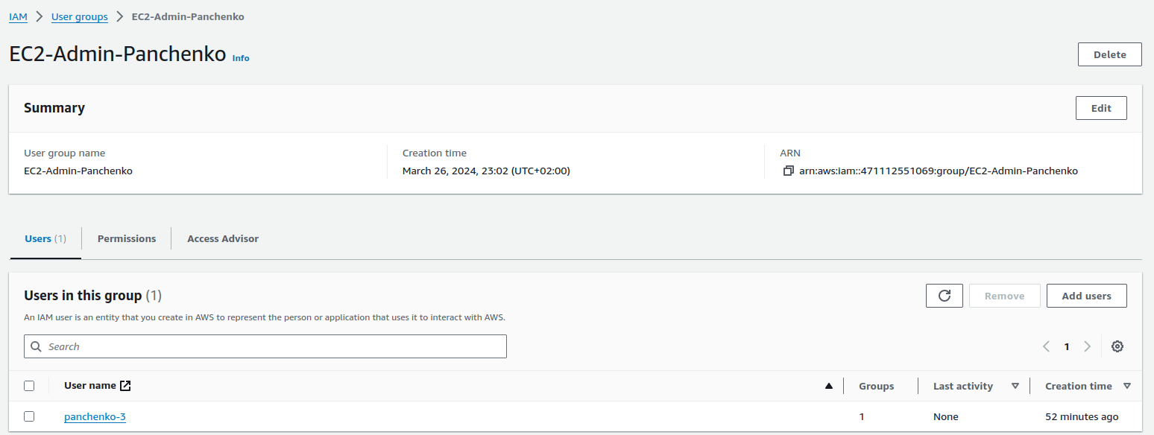
In the navigation pane on the left, choose User groups. Each group should have a 1 in the Users column. This indicates the number of users in each group.

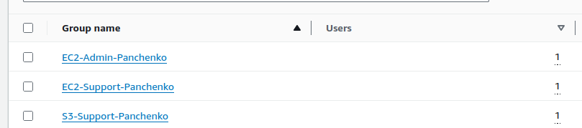
Now lets manage console access and set passwords for the users.
panchenko-1: +moGd3]v
panchenko-2: gTN)X%3^
panchenko-3: =AspS}9&

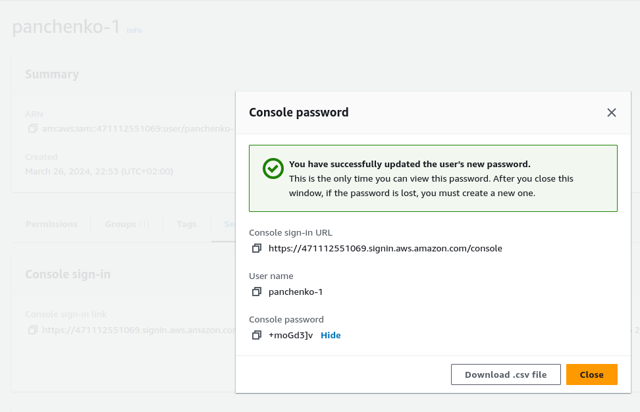
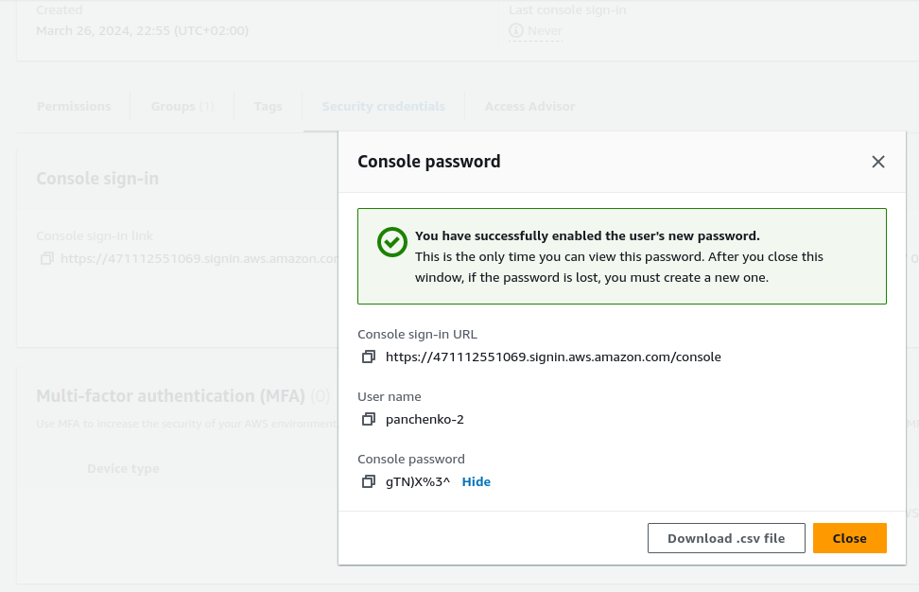
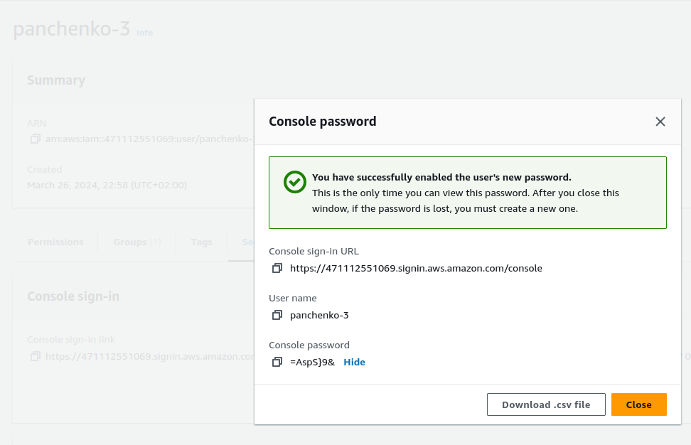

Task 3. Sign in and test users
In the navigation pane on the left, choose Dashboard. Notice the Sign-in URL for IAM users in this account section at the top of the page. The sign-in URL looks similar to the following:
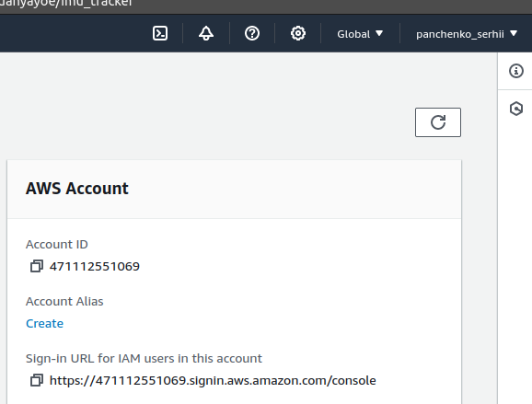
Open a private or incognito window in your browser.36. Paste the sign-in link into the private browser, and press ENTER. You will now sign-in as user-1, who has been hired as your Amazon S3 storage support staff. Sign in with the following credentials:
IAM user name: panchenko-1
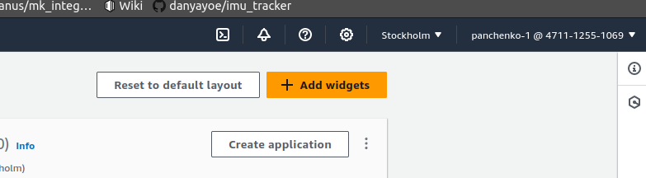
Password: +moGd3]v
Choose the Services menu, and choose S3. Choose the name of one of your buckets, and browse the contents.
Because this user is part of the S3-Support group in IAM, they have permissions to view a
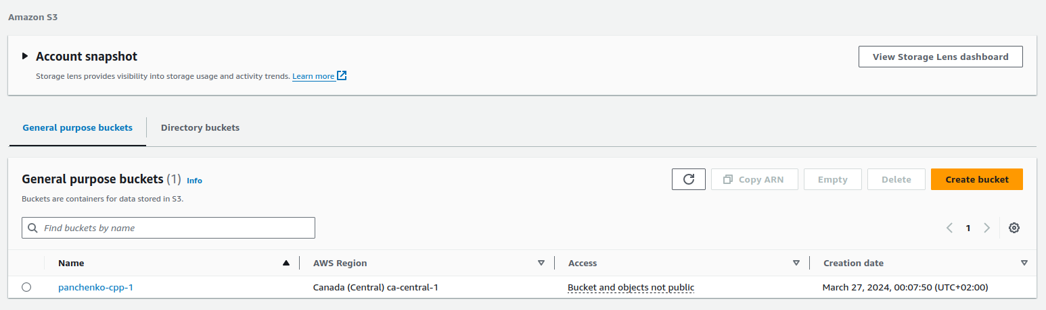
list of Amazon S3 buckets and their contents.
Now, test whether the user has access to Amazon EC2.

Choose the Services menu, and choose EC2. In the left navigation pane, choose Instances.
You cannot see any instances. Instead, an error message says you are not authorized to
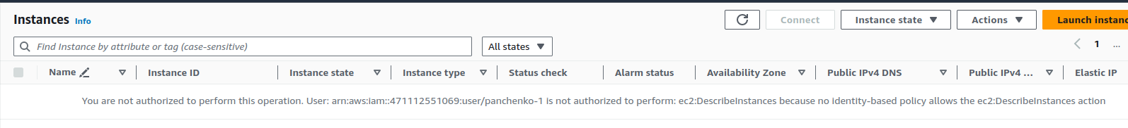
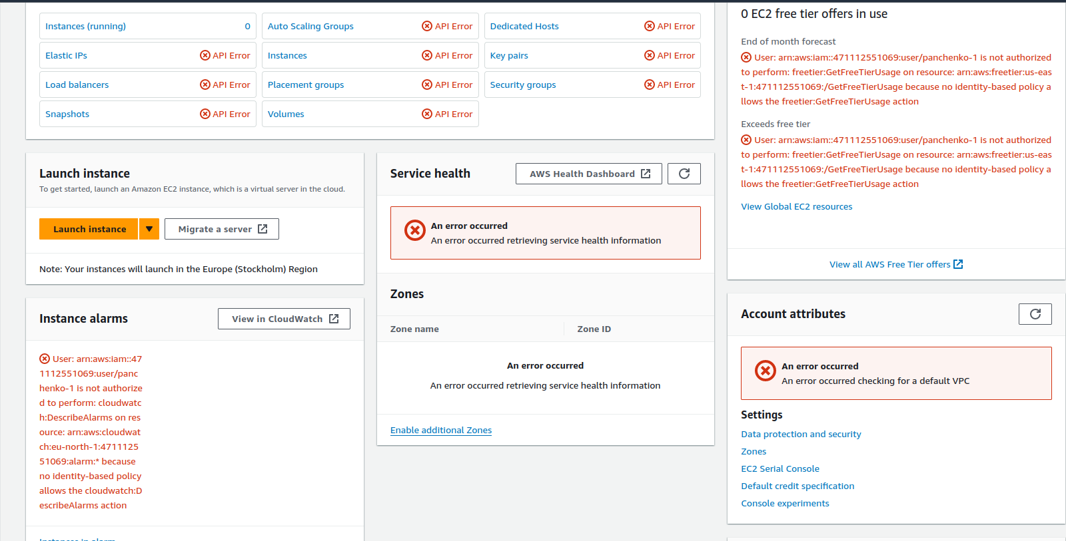
perform this operation. This user has not been assigned any permissions to use Amazon EC2.
You will now sign in as user-2, who has been hired as your Amazon EC2 support person. First, sign out panchenko-1 from the console:
In the upper-right corner of the page, choose user-1.
Choose Sign Out.

Paste the sign-in link into the private browser again, and press ENTER. Sign in with the following credentials:
IAM user name: panchenko-2
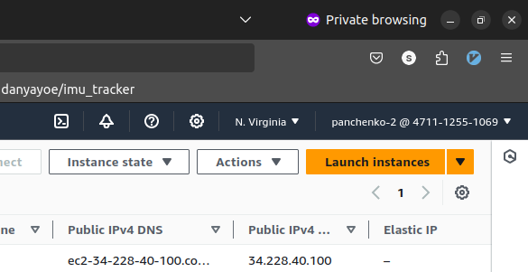
Password: gTN)X%3^
In the navigation pane on the left, choose Instances. You are now able to see an EC2 instance. However, you cannot make any changes to Amazon EC2 resources because you have read-only permissions.
Select the EC2 instance. Choose the Instance state menu, and then choose Stop instance. To confirm that you want to stop the instance, choose Stop. An error message appears and says that You are not authorized to perform this operation. This demonstrates that the policy only allows you to view information without making changes.
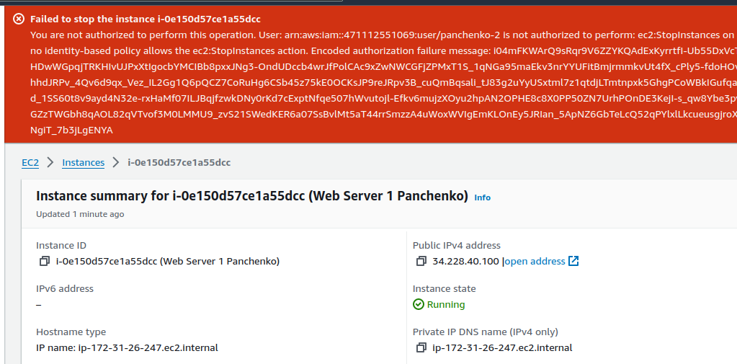
Choose the Services menu, and choose S3.An error message says You don't have permissions to list or create buckets because panchenko-2 does not have permissions to use Amazon S3.
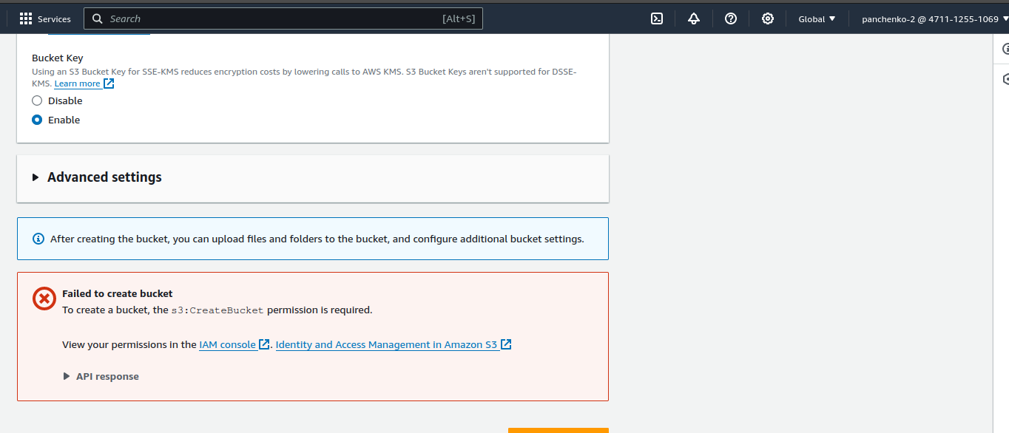
Paste the sign-in link into the private browser again, and press ENTER. Sign in with the following credentials:
IAM user name: panchenko-3
Password: =AspS}9&

Choose the Services menu, and choose EC2. In the navigation pane on the left, choose Instances. An EC2 instance is listed. As an Amazon EC2 Administrator, this user should have permissions to Stop the EC2 instance. Choose the Instance state menu, and then choose Stop instance. To confirm that you want to stop the instance, choose Stop. This time, the action is successful because user-3 has permissions to stop EC2 instances. The Instance state changes to Stopping and starts to shut down.

