View the New Distributed Port Group
In the Navigator, you will see the newly created Distributed Port Group. First, you will enable Host Lockdown Mode with the Normal setting on esx-01a.corp.vmbeans.com. This will mean the host will be accessible from vCenter and through the DCUI, but not remotely over SSH. From the Navigator, select the Hosts and Clusters tab. Next, select esx-01a.corp.vmbeans.com.
Before we configure Host Lockdown Mode, let's verify the SSH service is running on esx-01a.corp.vmbeans.com. Clicking Configure tab. Scroll down until you find the System section. Click Services.
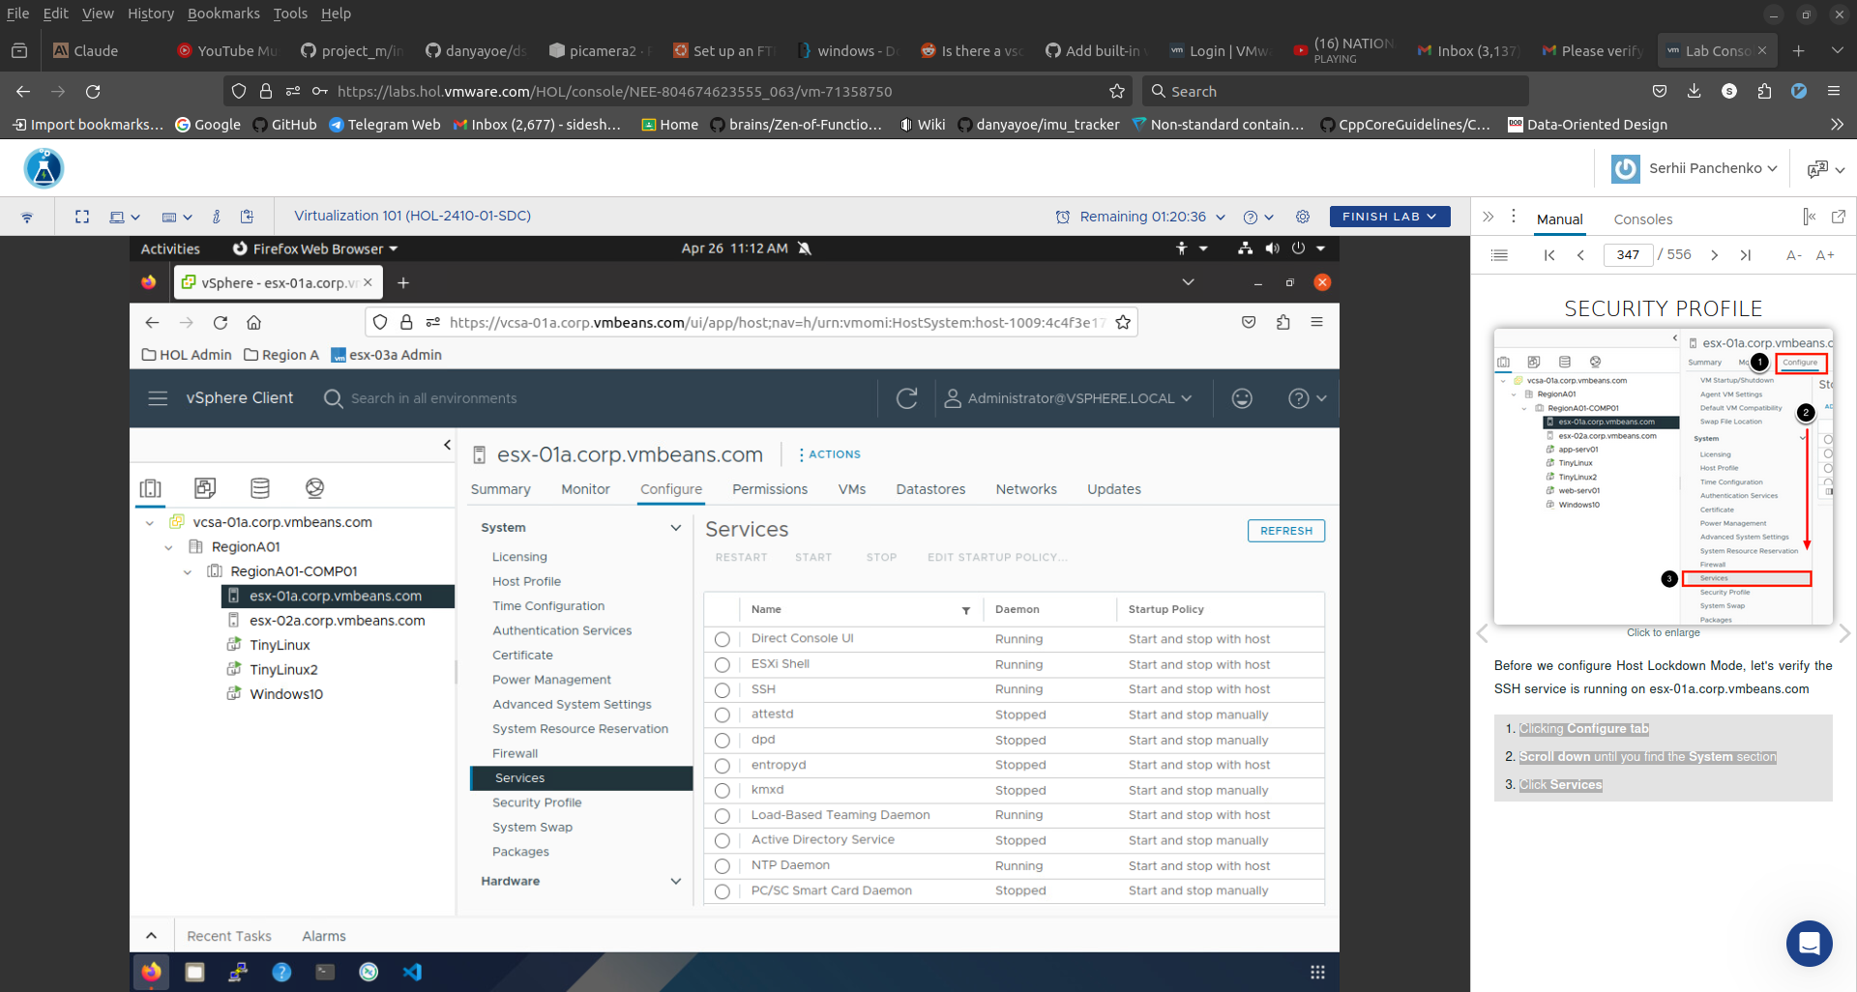
We can see that the SSH service is enabled and Running on esx-01a.corp.vmbeans.com.
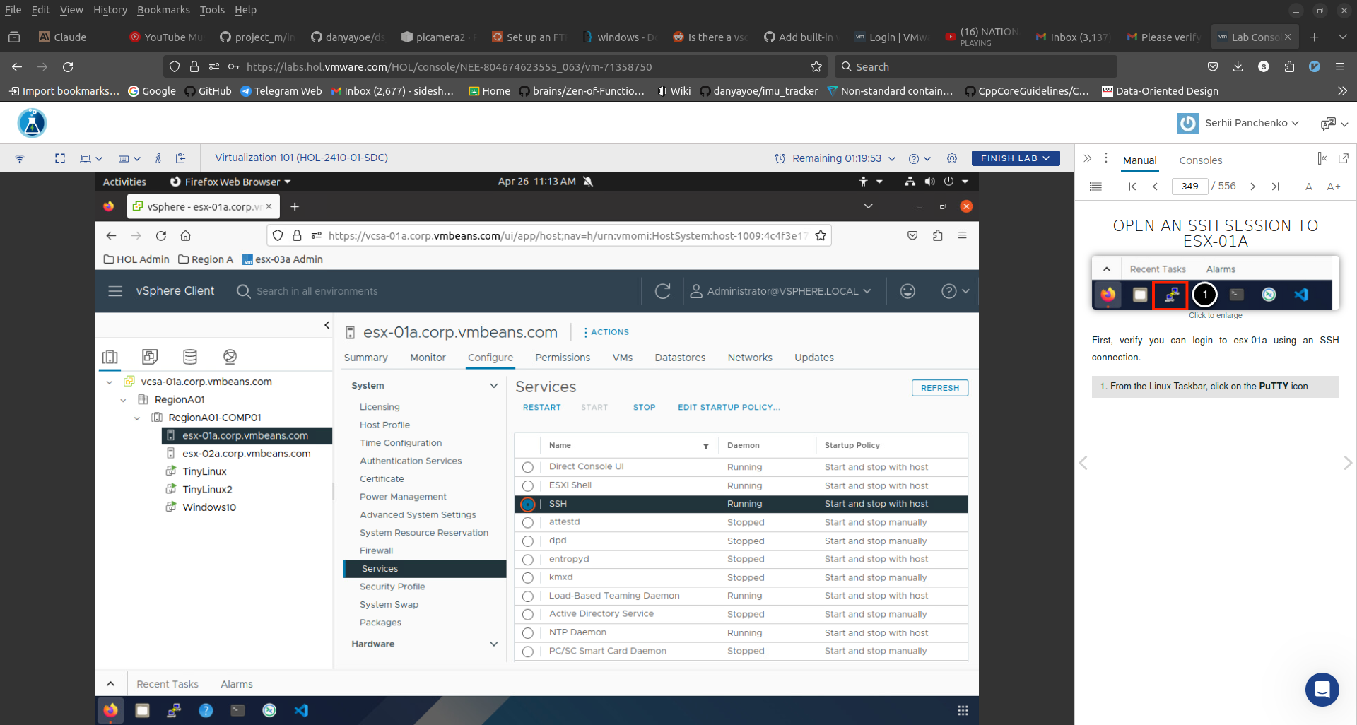
Under Saved Sessions, click on esx-01a.corp.vmbeans.com. Click Load. Click the Open button. You will be automatically logged in to esx-01a.corp.vmbeans.com because we have configured public-key authentication from the Main Console machine to the ESXi host.
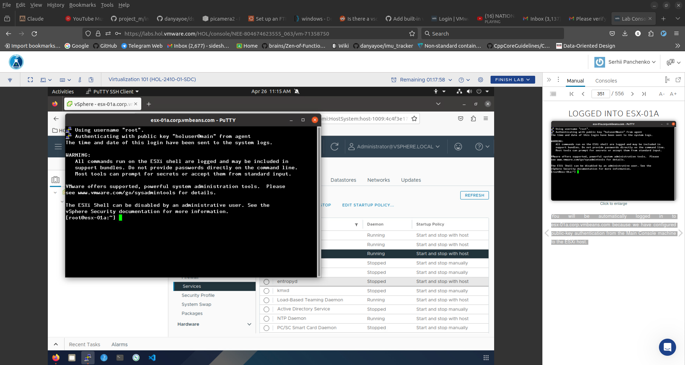
Close the PuTTY session by typing 'exit' and pressing Enter. Go back to the vSphere Client. Click Security Profile. Click on the Edit button next to Lockdown Mode.
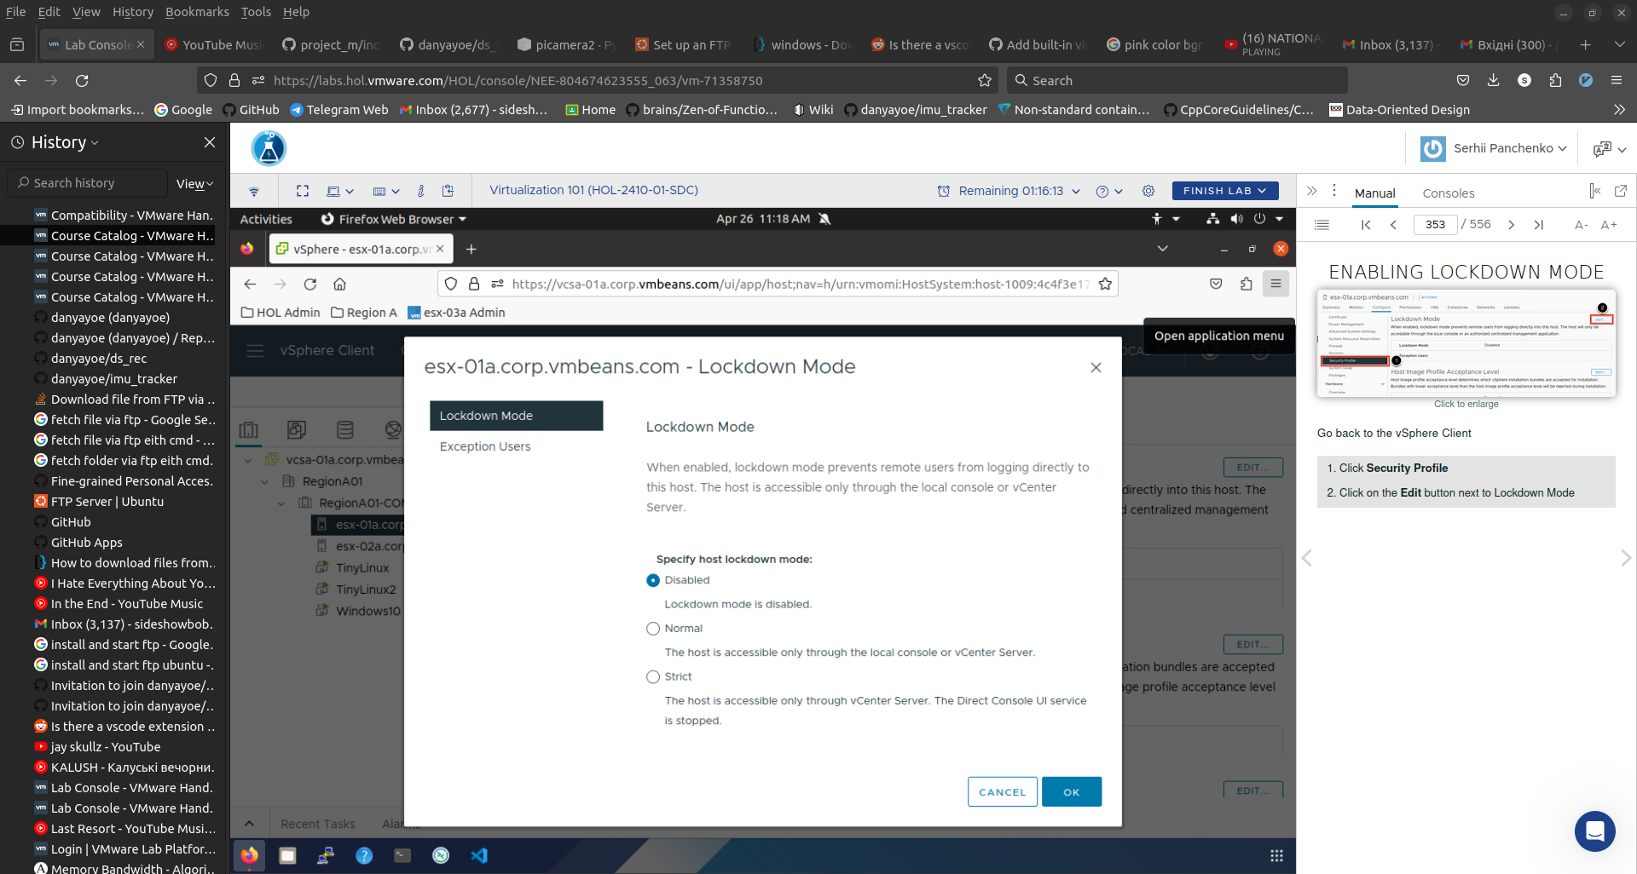
Lockdown Mode is currently disabled. If we set it to Normal, we will not be able to access the host over SSH and only through vCenter or the local console (physically in front of the host). Lockdown Mode can also be set to Strict, meaning only vCenter can access the host and SSH and the local console are disabled.
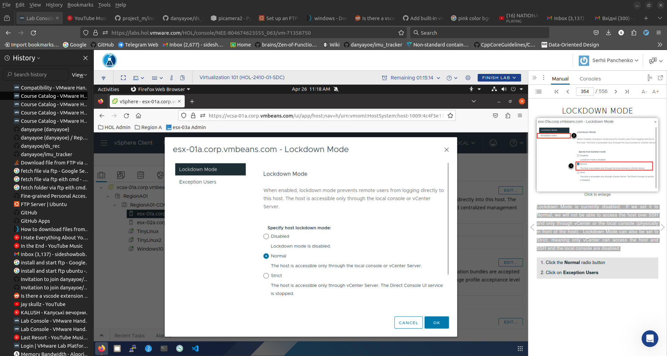
As previously noted, when Lockdown Mode is enabled, remote access to the host is disabled. Some third-party applications rely on this access and it can be granted by adding the accounts they use to the Exception List. This should not be a way for specific users to bypass security and should only be used for applications that require access. Click OK to enable Lockdown Mode.

