Module 1 - What's New with vSAN 8
Click Quick access. Click Lab-Prep-2-VSAN.
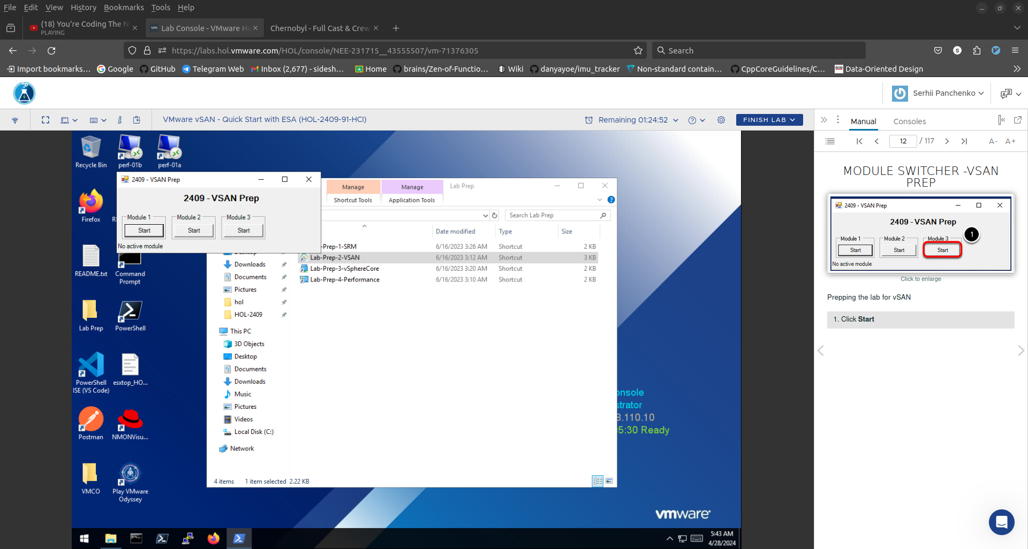
Click Start.
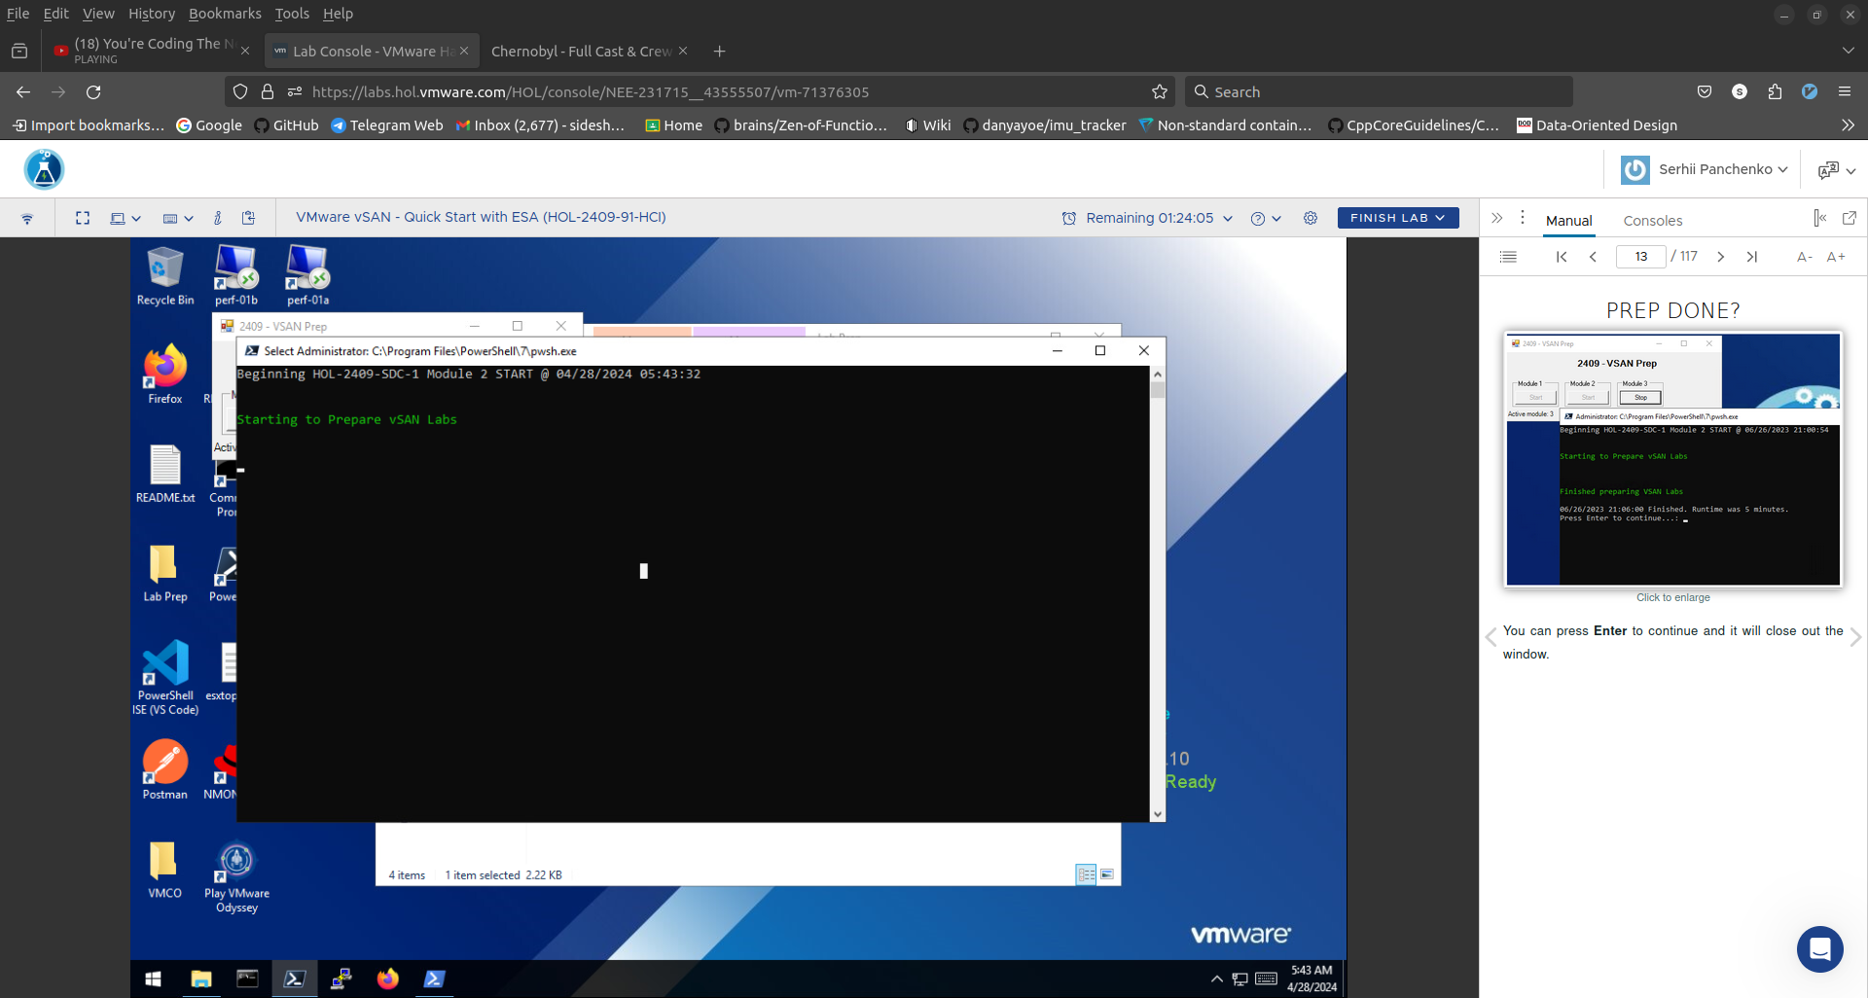
Expand vcsa-01a.corp.vmbeans.com. Right-click RegionA01. Select New Cluster... .

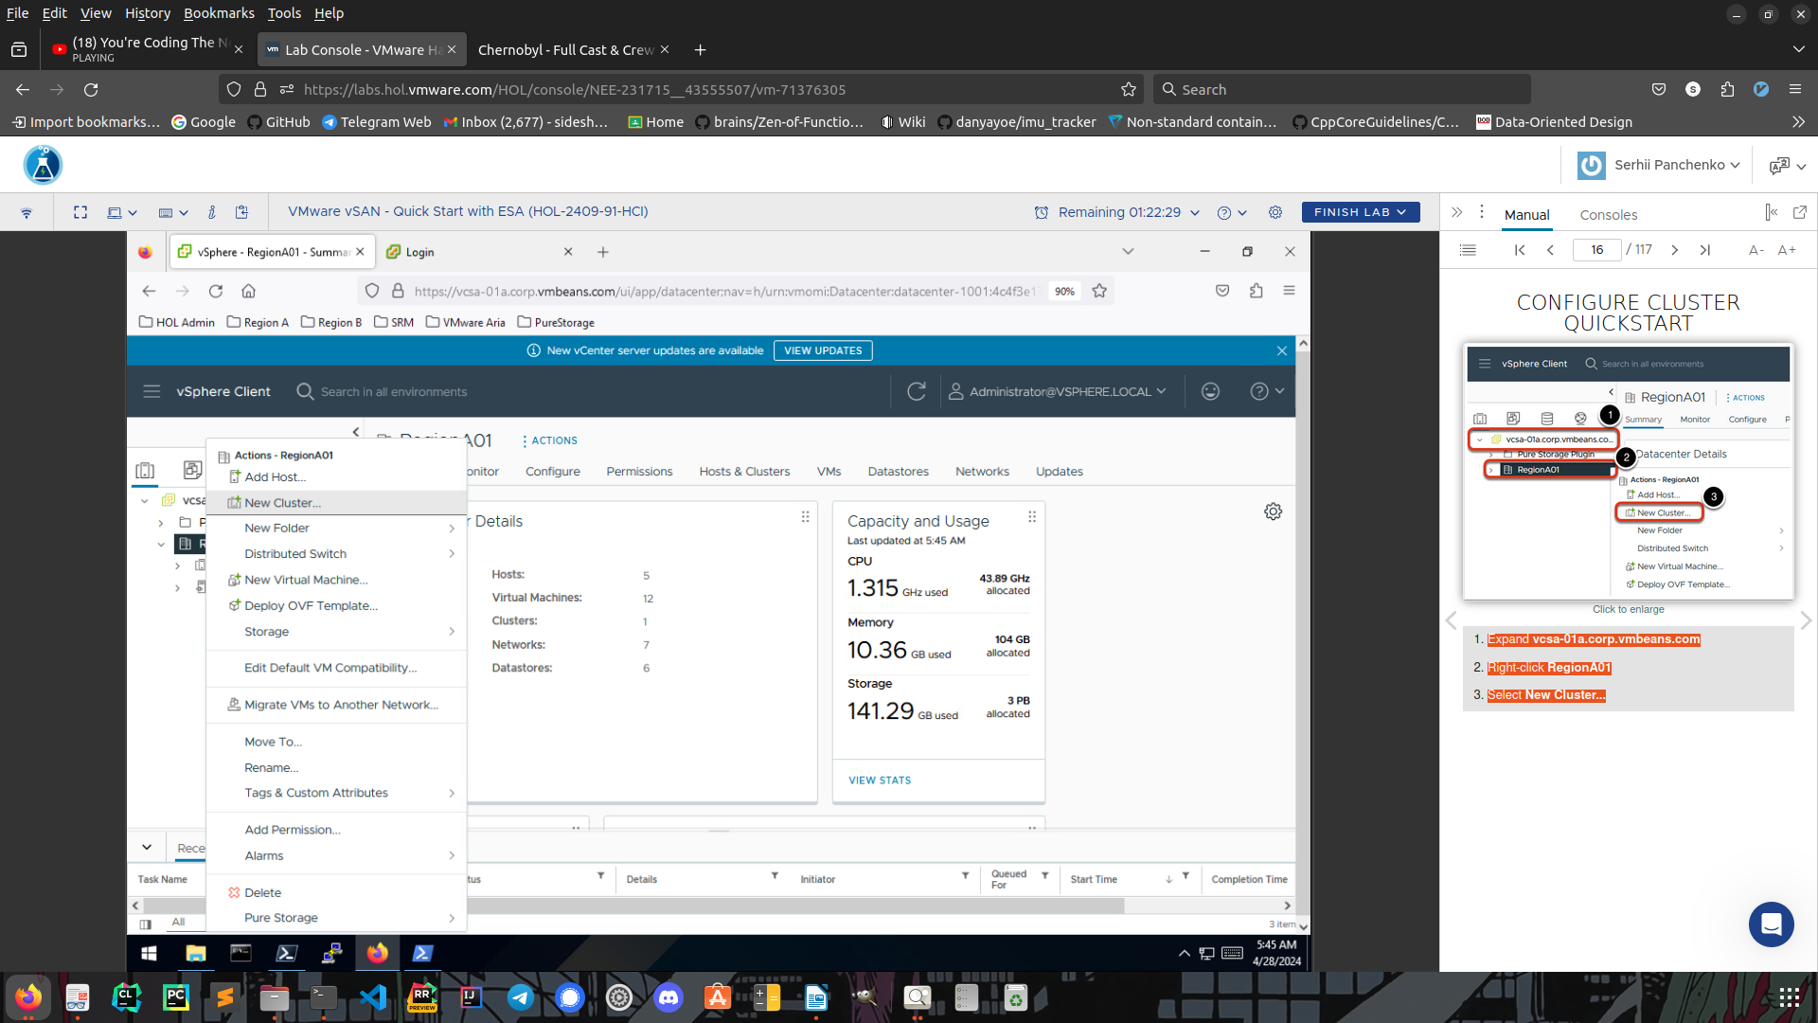
Enter parameters.
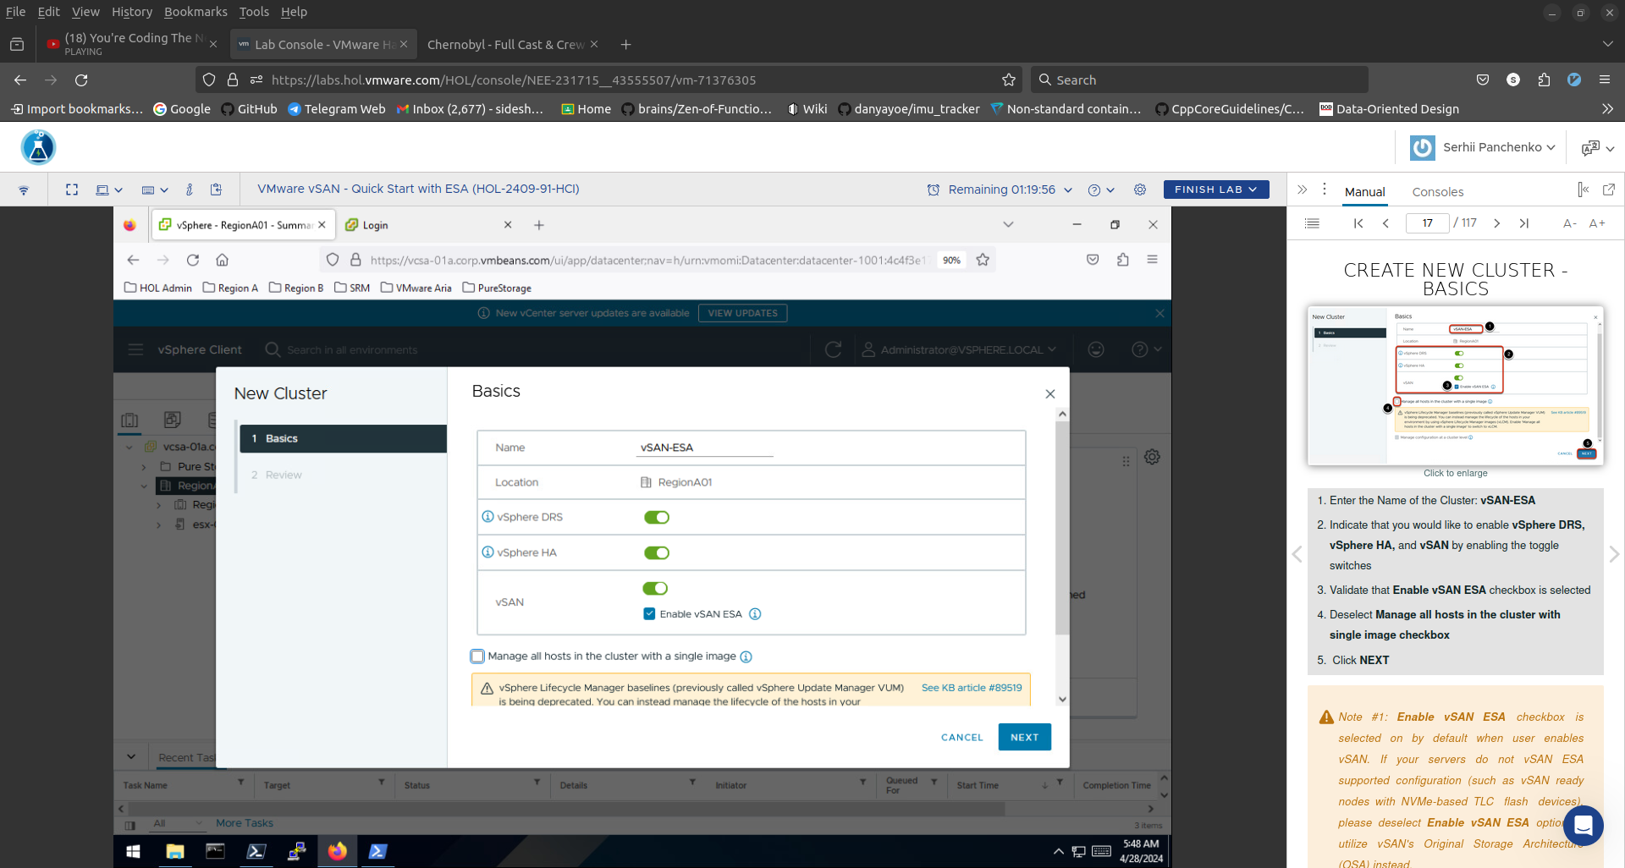

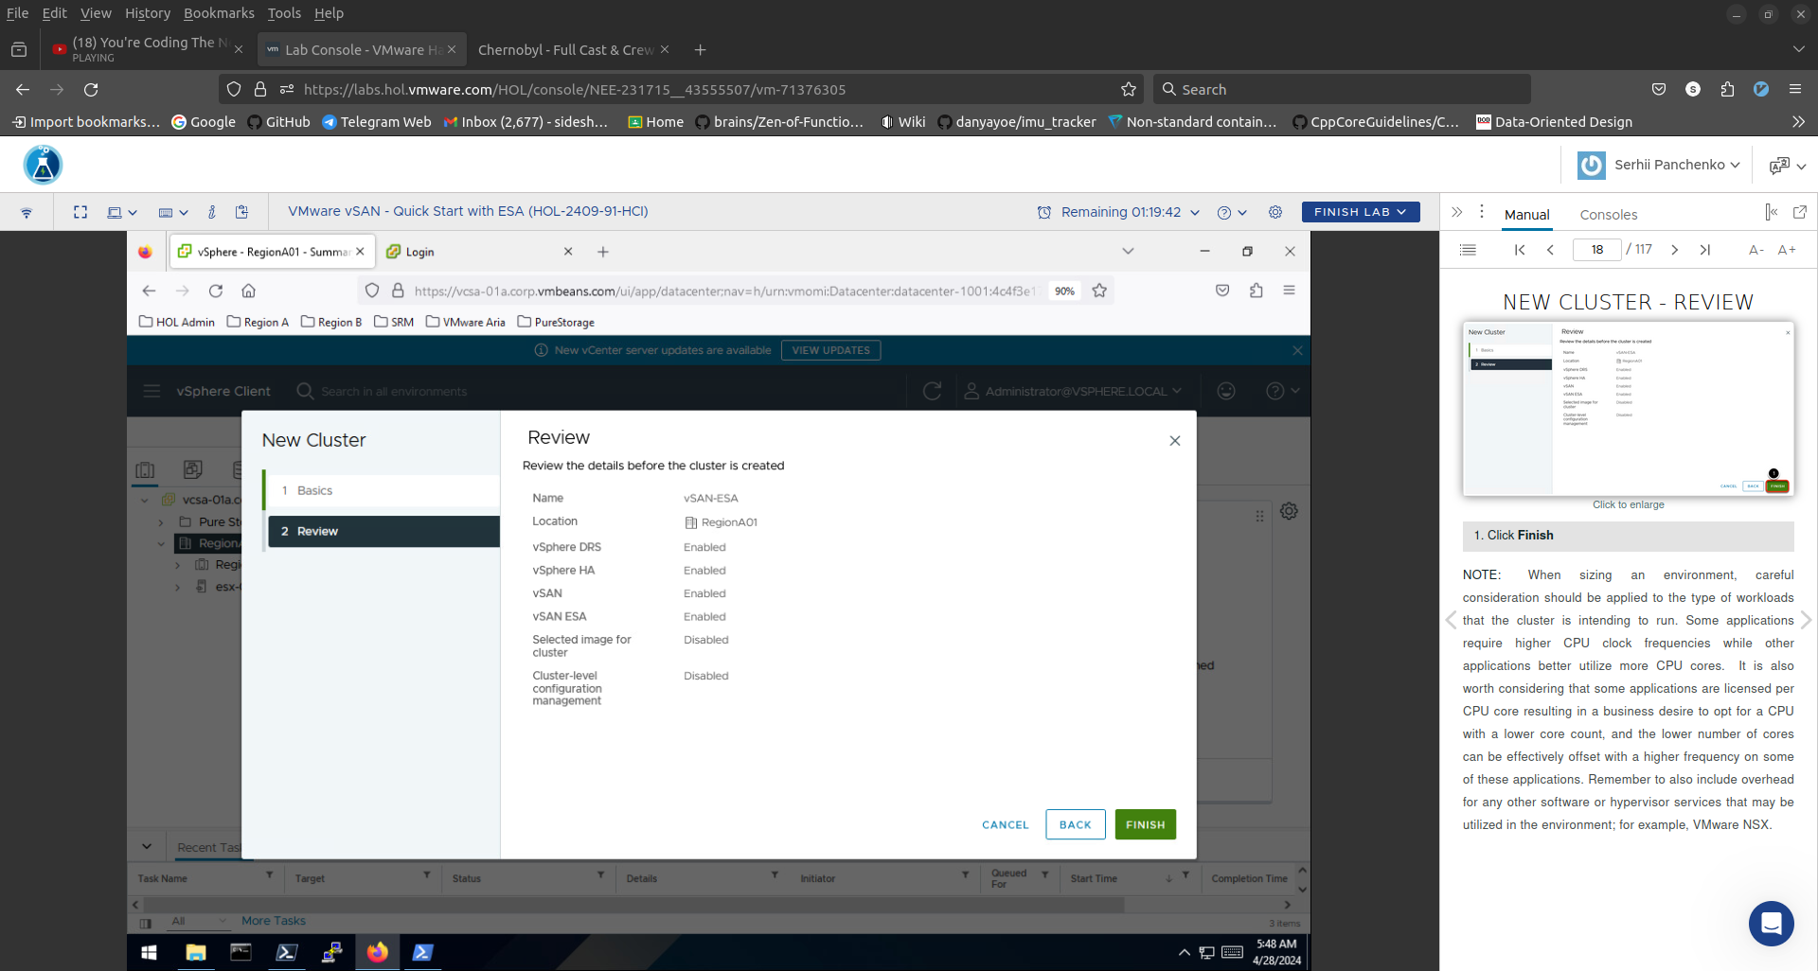
Expand and Select the newly created cluster RegionA01 -> vSAN-ESA. Select Configure. Select Quickstart. Underneath "2. Add hosts", Click ADD. On the Add hosts wizard, we will add hosts to the newly created cluster. Click Existing hosts (0 from 5). The number will change as you add more hosts to the cluster. ie: Existing hosts (1 from 5) and so on. Select esx-01a.corp.vmbeans.com, esx-02a.corp.vmbeans.com, and esx-03a.corp.vmbeans.com. Click NEXT.
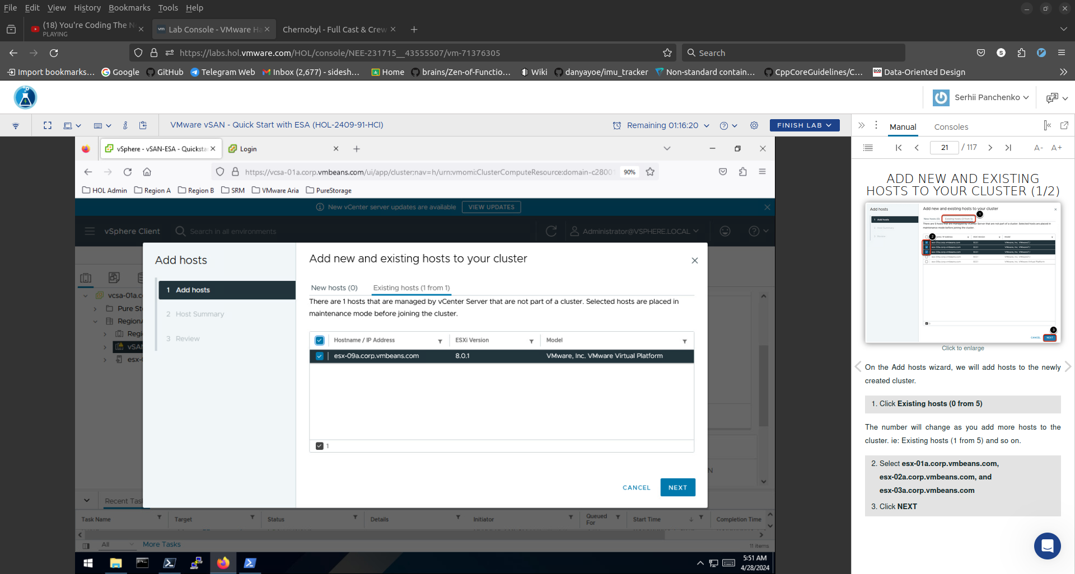

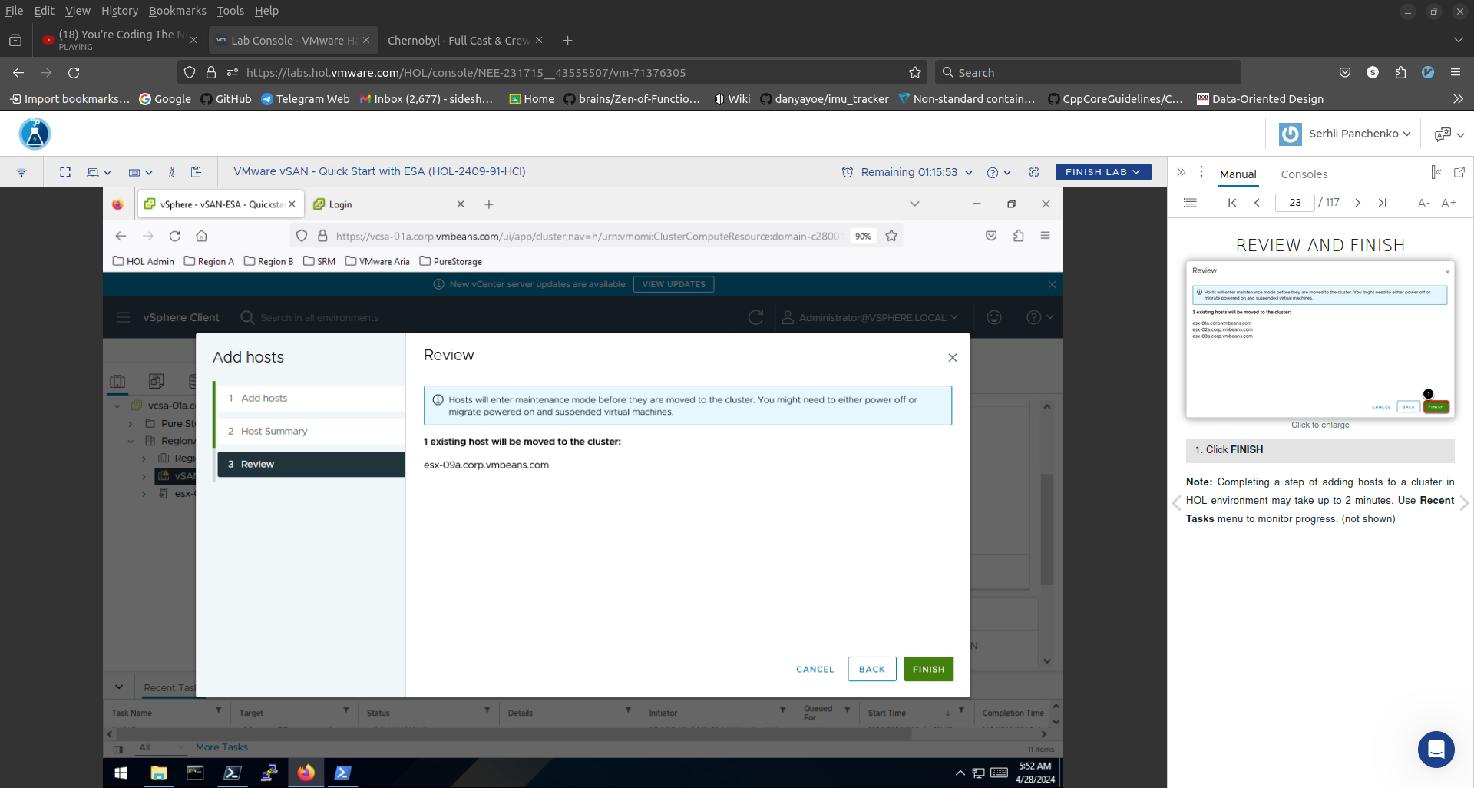
In the next few steps, you will be manually configuring VMkernel interfaces for each one of your ESXi hosts participating in the vSAN cluster. Configure Cluster. Click Configure networking settings later.

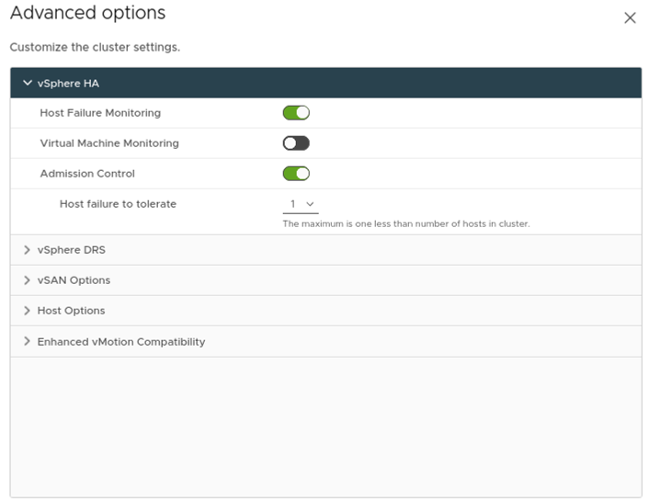
We need to add the vSAN license. Click on newly recreated vSAN Cluster, vSAN-ESA. Click Configure. Click Licensing > vSAN Cluster. Click ASSIGN LICENSE. Select the radio button for Region A VSAN. Click OK.
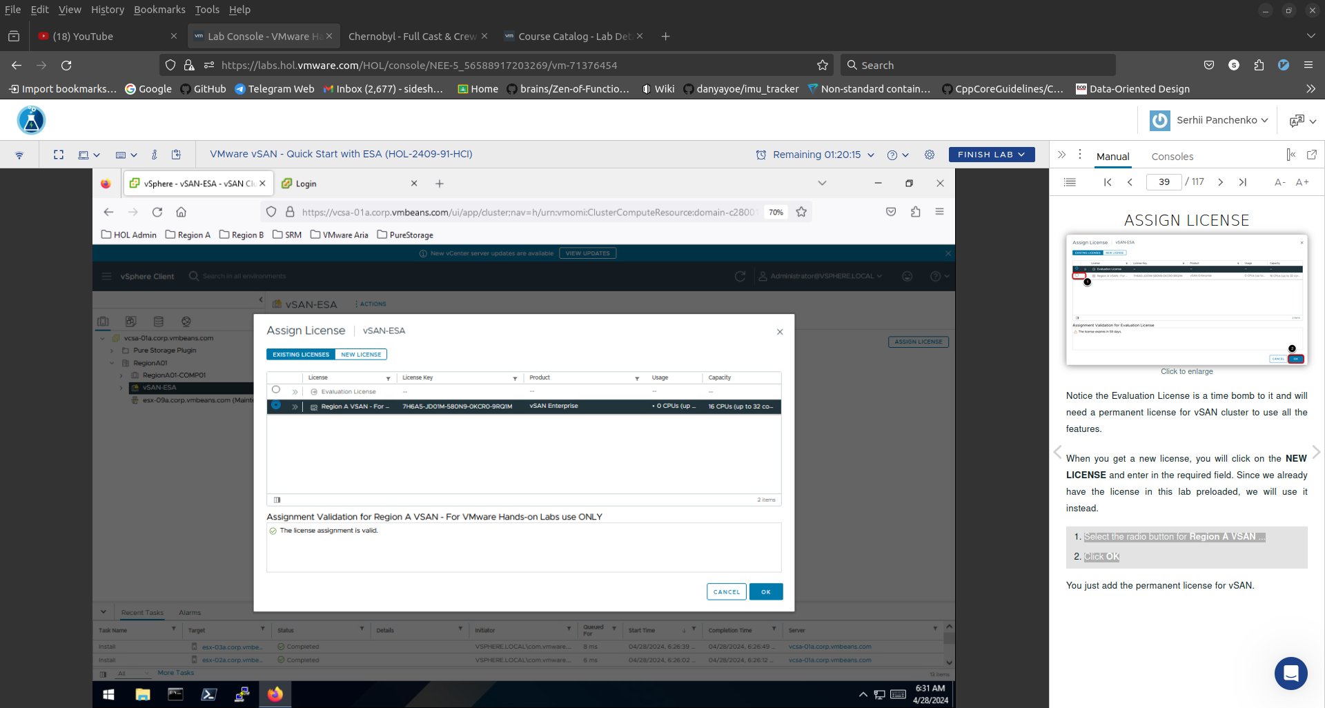
We are in compliance now with a valid vSAN license.
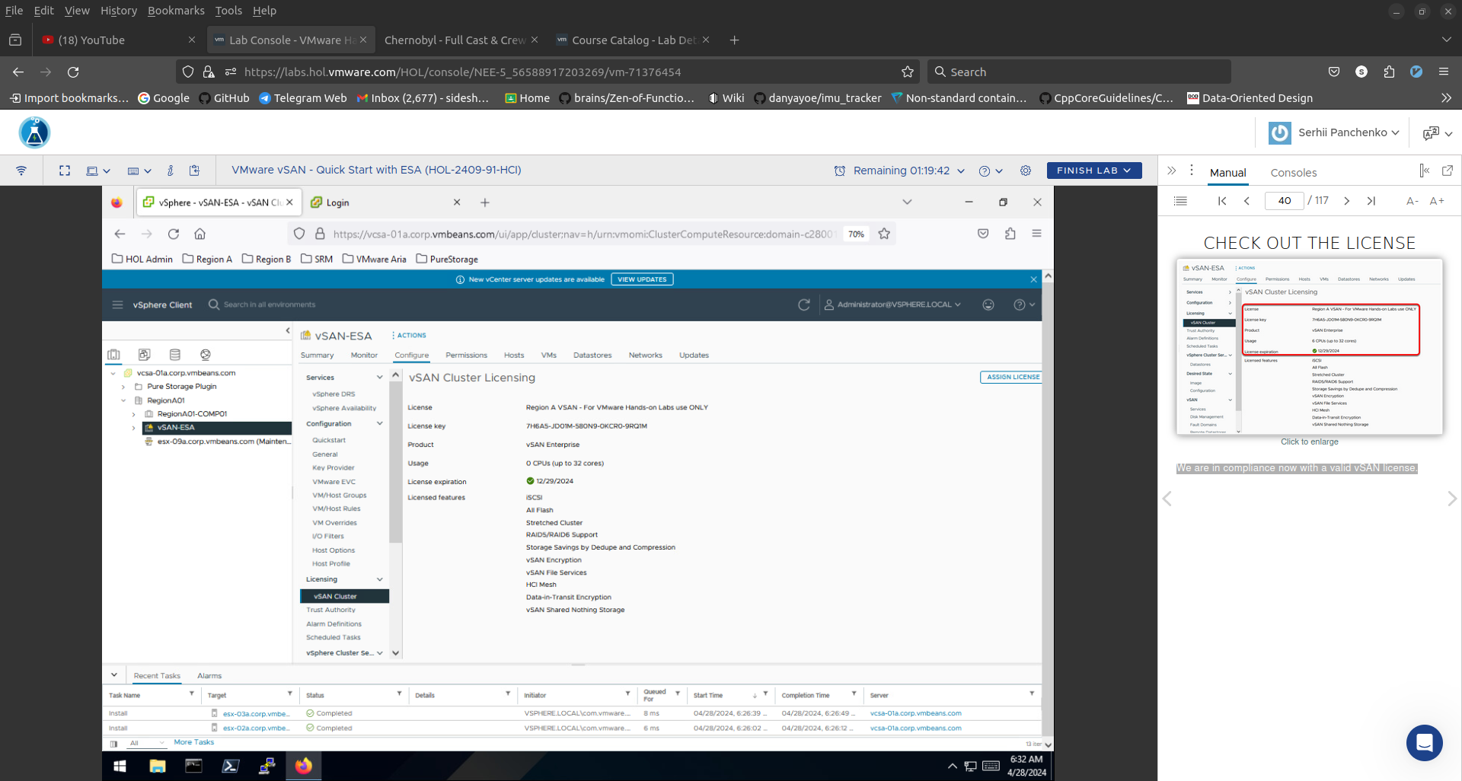
Select the Hosts and Clusters Icon. Select the vSAN-ESA Cluster. Select Monitor. Scroll Down. Select vSAN >Capacity.

