This worksheet will help you to prepare the information that you will need when creating or updating a budget in the BBBSA Online Reporting Site. Step-by-step instructions for creating and/or updating a budget are provided in the webinar slides which you will receive a copy of after the training webinar.

|  |  |  |  |
| --- | --- | --- | --- |
| Reference Number | Field Name | Description |  |
| 1 | Projected # of children served during the Grant Performance Period | Projected number of youth to be served from 10/1/2017-9/30/2018 across the affiliate organization |  |
| 2 | Projected # of children served with grant funding during the Grant Performance Period | Projected number of youth to be served from 10/1/2017-9/30/2018 using funding from JJ7. This should match the number of youth served from your MOU. |  |
| 3 | Number of Full Time Equivalent (FTE) Staff at Affiliate | If an affiliate has the following staff:   * 4 full time (@ 40 hrs/wk) = 4 FTE * 3 part time (@ 30 hrs/wk) = 2.25 FTE* * 2 part time (@ 15 hrs/wk) = .75 FTE*   Total = 7 Full Time Equivalent staff |  |

*This calculation can be done by multiplying the number of staff times the number of hours they work per week and then dividing by 40 (i.e. 3 x 30 = 90/40 = 2.25)

**Personnel**

Please have the following estimates available for each person that you plan to include in your budget

|  |  |  |  |  |  |  |
| --- | --- | --- | --- | --- | --- | --- |
| Ref. # | Name | Title | Hourly or Salaried | Hourly rate or annual salary | Total hours per week | Hours on JJ6 per week (estimated)** |
| 4 | Example: Bill T. | Match Specialist | Hourly | $15/hour | 20 | 5 |
| 5 | Example: Sally M. | Program Coordinator | Salaried | $30,000 per year | 40 | 10 |
|  |  |  |  |  |  |  |
|  |  |  |  |  |  |  |
|  |  |  |  |  |  |  |
|  |  |  |  |  |  |  |
|  |  |  |  |  |  |  |
|  |  |  |  |  |  |  |
|  |  |  |  |  |  |  |
|  |  |  |  |  |  |  |

**This figure should only include work done on JJ7, not all OJJDP programs

|  |  |  |  |  |  |  |  |  |
| --- | --- | --- | --- | --- | --- | --- | --- | --- |
| Ref. # | Name | FICA | Medical | Dental | Short Term Disability (ST disability) | Long Term Disability (LT disability) | Life Insurance (Life) | Other |
|  | (this will be automatically updated when you click on update amounts) | (this will be automatically updated based on 7.65% of the employee’s total salary) | * Include ONLY annual benefit costs paid by the affiliate organization, not those paid by the employee * Any benefits derived by % of salary (i.e. 401K match, etc.) must be calculated out to determine the annual cost * For any benefits not named (401K match, SUTA, etc.), add up the total annual cost of these benefits and enter it as one lump sum under “other) –Please remember to add notes when entering the “other” benefits in the system. | | | | | |
| 6 | Bill T. | $298.35 |  |  |  |  |  |  |
| 7 | Sally M. | $572.18 | $5000 | $350 | $125 | $105 | 150 |  |
|  |  |  |  |  |  |  |  |  |
|  |  |  |  |  |  |  |  |  |
|  |  |  |  |  |  |  |  |  |
|  |  |  |  |  |  |  |  |  |
|  |  |  |  |  |  |  |  |  |
|  |  |  |  |  |  |  |  |  |
|  |  |  |  |  |  |  |  |  |
|  |  |  |  |  |  |  |  |  |
|  |  |  |  |  |  |  |  |  |
|  |  |  |  |  |  |  |  |  |
|  |  |  |  |  |  |  |  |  |
|  |  |  |  |  |  |  |  |  |
|  |  |  |  |  |  |  |  |  |
|  |  |  |  |  |  |  |  |  |
|  |  |  |  |  |  |  |  |  |
|  |  |  |  |  |  |  |  |  |
|  |  |  |  |  |  |  |  |  |
|  |  |  |  |  |  |  |  |  |
|  |  |  |  |  |  |  |  |  |

Once you enter the annual benefit amounts for each employee and click on “update amounts”, the system will automatically calculate the total cost of benefits to be charged to the grant based on the percentage of time each staff member is dedicated to the grant

Indirect Rate

Will you be using an indirect rate?

Will you be using the 10% de minimis rate or a Negotiated Indirect Cost Rate?

Definitions:

* A **Negotiated Indirect Cost Rate** is one that your organization has received confirmation of with a cognizant federal agency. If you are using a NICRA, you must attach a copy of your NICRA documentation when submitting your budget. PLEASE NOTE: If your NICRA documented rate has expired, you will only be able to use a rate of 0% until the rate is re-approved and no de minimis rate can be used.
* The **de minimis rate** is an allowed rate to be charged by organizations that have never received a negotiated indirect cost rate. The de minimis rate is 10%

PLEASE NOTE: **Indirect rates can only be charged on direct costs** including personnel, supplies and other direct grant costs. Use of the indirect rate will prevent you from including costs such as Rent, Liability Insurance and other indirect or overhead costs in your budget.

|  |  |
| --- | --- |
| Budget Line Items included with use of Indirect Rate | Budget Line Items included w/o indirect rate (calculated based on FTE & TCS) |
| Salaries and Wages | Salaries and Wages |
| Fringe Benefits | Fringe Benefits |
| Supplies (only as direct costs) | Supplies |
| Travel (only as direct costs) | Travel |
| Background checks (only as direct costs) | Background checks |
|  | Rent |
|  | Liability Insurance |

**If you are using the Indirect Rate:**

|  |  |  |  |
| --- | --- | --- | --- |
| Item Name | Category**** | Monthly Rate | Total Expense*** |
| Example: Background Checks | Child Safety | 100 | 1,200 |
|  |  |  |  |
|  |  |  |  |
|  |  |  |  |
|  |  |  |  |
|  |  |  |  |
|  |  |  |  |
|  |  |  |  |

***For JJ7, this is the monthly rate x 12 months

**** Available Categories include:

* Child Safety
* Contract Specialist
* Equipment
* Supplies
* Travel
* Other Costs – If you include Other Costs as the category, you MUST provide a note explaining the item

EXPENSE ITEMS BASED ON FTE AND TCS – WHEN NO DIRECT COST RATE IS USED

NOTE: This system automatically calculates the FTE (full time effort) and TCS based on the information that you have provided on the first page. (in this system, TCS is called “% children served”)

A

D

C

B

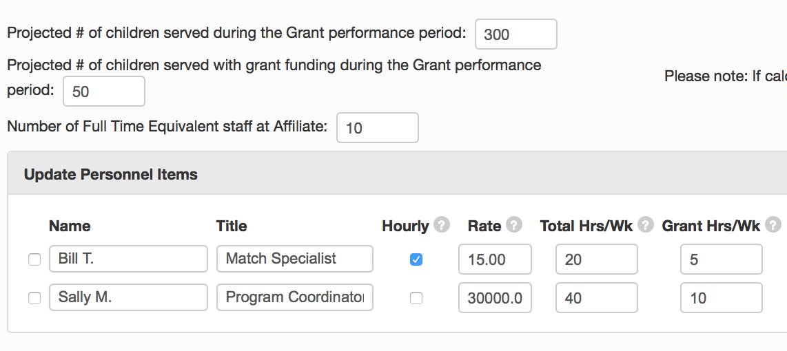

* TCS is calculated based on # children served with grant funds divided by total children served by affiliate - B/A
* FTE is calculated based on Total grant hours/week divided by (# Full Time Equivalent Staff at Affiliate x 40 hours per week) – Column D/(C x 40)

Some line items are provided below with the corresponding Factor Value. Feel free to use any or all of these or include others that you can include below. NOTE: You may want to have multiple line items for things such as ‘supplies’ or ‘travel’ to more specifically indicate what these are use for (i.e. Office supplies, orientation supplies, local travel, etc.)

|  |  |  |  |
| --- | --- | --- | --- |
| Budget Line Items included w/o indirect rate | Factor Value used | Monthly Amount | Total Expense |
| Supplies | TCS |  |  |
| Travel | TCS |  |  |
| Background checks | TCS or other |  |  |
| Rent | FTE |  |  |
| Liability Insurance | TCS |  |  |
|  |  |  |  |
|  |  |  |  |
|  |  |  |  |
|  |  |  |  |
|  |  |  |  |
|  |  |  |  |
|  |  |  |  |

Notes: