This worksheet will help you to prepare the information that you will need when creating or updating a budget in the BBBSA Online Reporting Site. Step-by-step instructions for creating and/or updating a budget are provided in the webinar slides which you will receive a copy of after the training webinar.

|  |  |  |  |
| --- | --- | --- | --- |
| Reference Number | Field Name | Description |  |
| 1 | Projected # of children served during the Grant Performance Period | Projected number of youth to be served across the agency organization during the full sub-grantee period. |  |
| 2 | Projected # of children served with grant funding during the Grant Performance Period | Projected number of youth to be served by the appropriate grant funding during the full sub-grantee period. * |  |
| 3 | Number of Full Time Equivalent (FTE) Staff at Agency | If an agency has the following staff:   * 4 full time (@ 40 hrs/wk) = 4 FTE * 3 part time (@ 30 hrs/wk) = 2.25 FTE* * 2 part time (@ 15 hrs/wk) = .75 FTE**   Total = 7 Full Time Equivalent staff |  |

* This should match the number of youth served with grant funding (match goal) from your MOA.

**This calculation can be done by multiplying the number of staff times the number of hours they work per week and then dividing by 40 (i.e. 3 x 30 = 90/40 = 2.25)

**Personnel**

Please have the following estimates available for each person that you plan to include in your budget

|  |  |  |  |  |  |  |  |  |
| --- | --- | --- | --- | --- | --- | --- | --- | --- |
| Ref. # | Name | Title | Hourly or Salaried | Hourly rate or annual salary | Total hours per week | Hours on grant per week (estimated)** | Start Date | End Date |
| 4 | Example: Sample Staffer | Program Staff | Salaried | $35,000 per year | 40 | 10 | 1/1/19 | 12/31/19 |
|  |  |  |  |  |  |  |  |  |
|  |  |  |  |  |  |  |  |  |
|  |  |  |  |  |  |  |  |  |
|  |  |  |  |  |  |  |  |  |
|  |  |  |  |  |  |  |  |  |
|  |  |  |  |  |  |  |  |  |
|  |  |  |  |  |  |  |  |  |
|  |  |  |  |  |  |  |  |  |

**This figure should only include work done on the grant you are submitting the reimbursement for, not all OJJDP programs

|  |  |  |  |  |  |  |  |  |
| --- | --- | --- | --- | --- | --- | --- | --- | --- |
| Ref. # | Name | FICA | Medical | Dental | Short Term Disability (ST disability) | Long Term Disability (LT disability) | Life Insurance (Life) | Other |
|  | (this will be automatically updated when you click on update amounts) | (this will be automatically updated based on 7.65% of the employee’s total salary)* | * Include ONLY annual benefit costs paid by the agency organization, not those paid by the employee * Any benefits derived by % of salary (i.e. 401K match, etc.) must be calculated out to determine the annual cost * For any benefits not named (401K match, SUTA, etc.), add up the total annual cost of these benefits and enter it as one lump sum under “other) –Please remember to add notes when entering the “other” benefits in the system. | | | | | |
|  |  | $298.35 |  |  |  |  |  |  |
| 5 | Sample Staffer | $572.18 | $1,200 | $400 | $300 | $500 | $500 | $1,245 |
|  |  |  |  |  |  |  |  |  |
|  |  |  |  |  |  |  |  |  |
|  |  |  |  |  |  |  |  |  |
|  |  |  |  |  |  |  |  |  |
|  |  |  |  |  |  |  |  |  |
|  |  |  |  |  |  |  |  |  |
|  |  |  |  |  |  |  |  |  |
|  |  |  |  |  |  |  |  |  |
|  |  |  |  |  |  |  |  |  |
|  |  |  |  |  |  |  |  |  |
|  |  |  |  |  |  |  |  |  |
|  |  |  |  |  |  |  |  |  |
|  |  |  |  |  |  |  |  |  |

*This field will automatically calculate in the budget form based on the entered salary. It is okay for the budget if you have a cafeteria plan or other circumstance that leads to the incorrect figure under FICA. On the reimbursement form you will be able to self-calculate FICA to ensure it matches your payroll documentation.

NOTE: This system automatically calculates the FTE (full time effort) and TCS based on the information that you have provided on the first page. (in this system, TCS is called “% children served”)

A

D

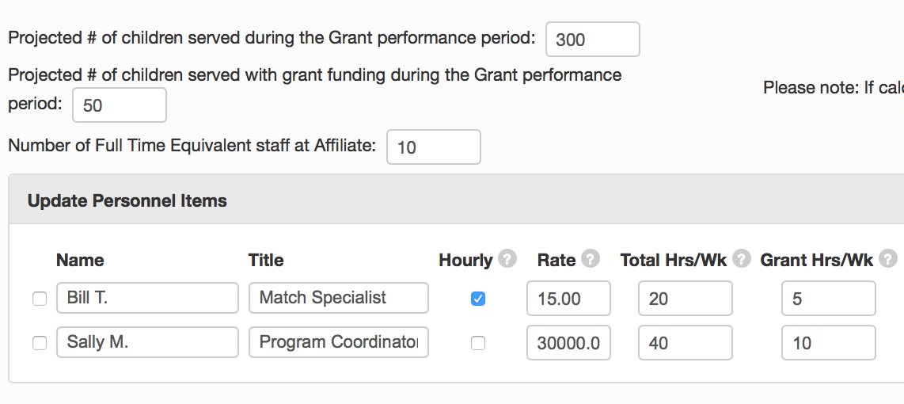

B

C

* TCS is calculated based on # children served with grant funds divided by total children served by agency - B/A
* FTE is calculated based on Total grant hours/week divided by (# Full Time Equivalent Staff at Affiliate x 40 hours per week) – Column D/(C x 40)

Some line items are provided below with the corresponding Factor Value. Feel free to use any or all of these or include others that you can include below. NOTE: You may want to have multiple line items for things such as ‘supplies’ or ‘travel’ to more specifically indicate what these are use for (i.e. Office supplies, orientation supplies, local travel, etc.)

|  |  |  |  |
| --- | --- | --- | --- |
| Budget Line Items included w/o indirect rate | Factor Value used | Monthly Amount | Total Expense |
| Supplies | TCS |  |  |
| Travel | TCS |  |  |
| Background checks | TCS |  |  |
| Rent | FTE |  |  |
| Liability Insurance | TCS |  |  |
|  |  |  |  |
|  |  |  |  |
|  |  |  |  |
|  |  |  |  |

**Other expenses do not require a Start and End Date.

Notes: