USING AND NAVIGATING THE DOCUMENTS REPOSITORY – PROGRAM COORDINATORS

1. Log in to your T.R.A.I.L. Online Reporting Site home page at <https://firstpic.force.com/ncai/>

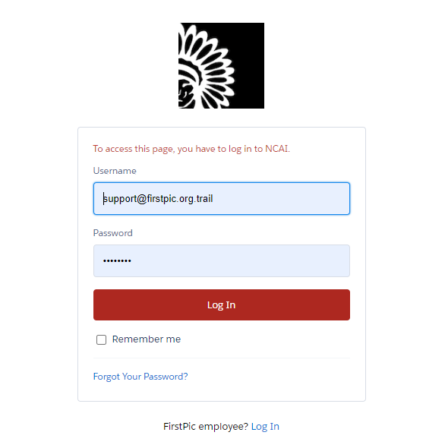

1. Once logged in, you will arrive at your Dashboard. From there, click on “Documents”.   
     
   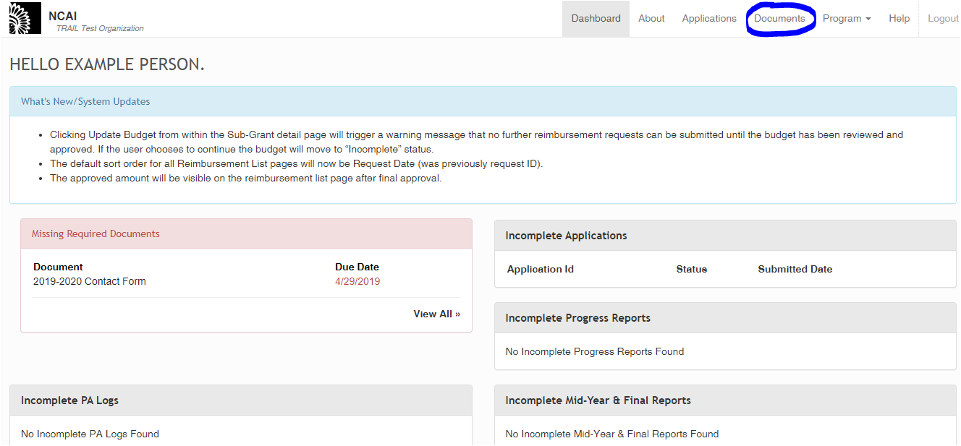

1. This will bring you to the “Organizations” Page. This is a list of your sites (TRAIL Test Site in the below example), as well as your organization (TRAIL Test Organization in the below example). To access site-specific documents (documents that are different per site, such as your implementation plans), click on your site(s). To access organization-specific documents (documents that apply for the entire organization, including contact forms and Community Health Partner MOAs), click on your organization.   
     
   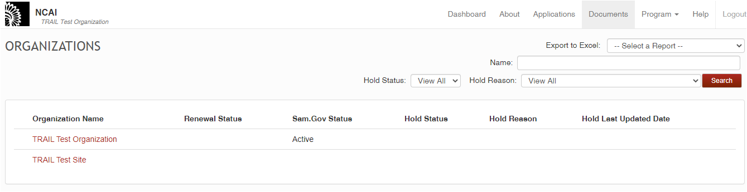
2. The “Grant Documentation and Compliance” page:  
   1. 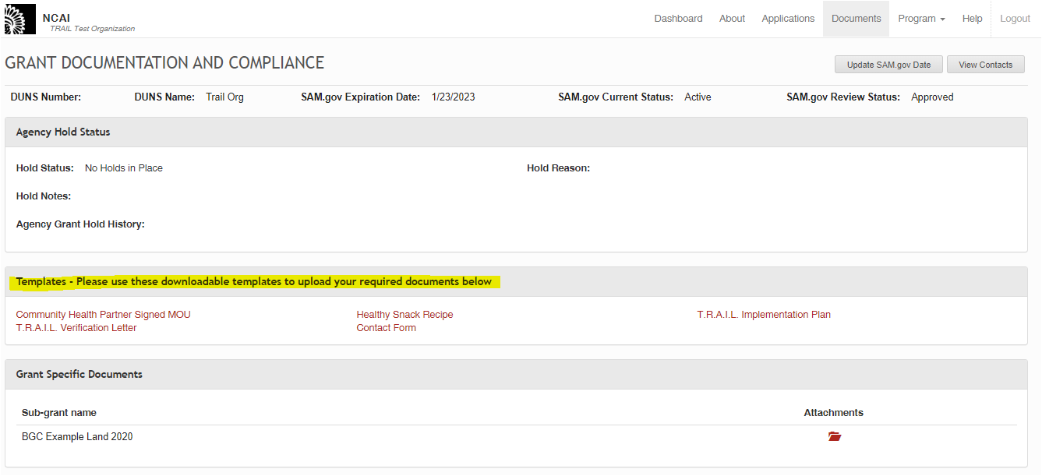If you click on the organization, you will go to your organization’s “Grant Documentation and Compliance” page. There, you will find a “Templates” section that includes templates for all relevant program documents (highlighted in yellow below), as well as an “All Required Documents” section for you to upload these documents once you have added necessary information (underlined in blue below).
   2. 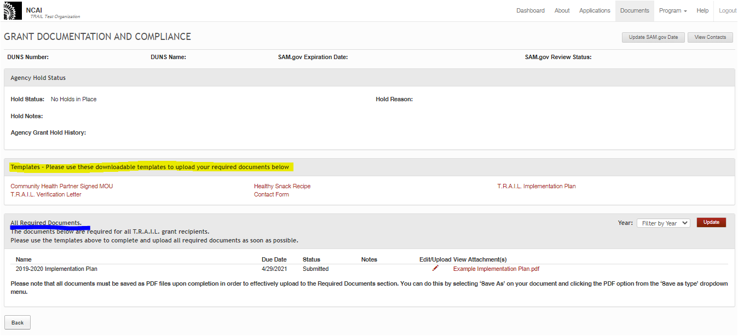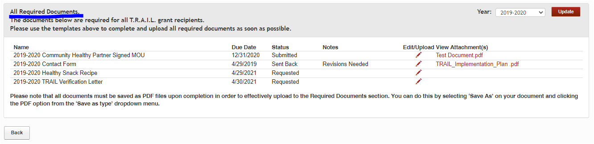If you click on the site(s), you will go to your site’s “Grant Documentation and Compliance” page. This page is similar to your organization-wide page, in that it has a “Templates” (highlighted in yellow) and “All Required Documents” (underlined in blue) section. However, you will notice that there is only one document listed in the “All Required Documents” section – the implementation plan. As your only site-specific document, this will be the only document you upload on the site level.
3. In order to upload a required document, select one of the templates in the “Templates” section. Once you select the template, it will open as either a Word or Excel document.   
     
   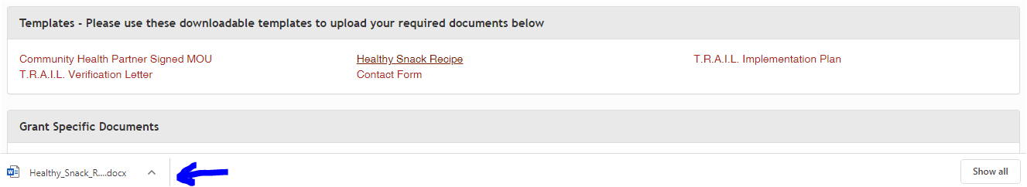

You would then complete and **save as a PDF** (all completed documents MUST be saved as a PDF as PDFs are the only allowable file type that can be uploaded).

1. When uploading the document, select the Edit/Upload Pencil within the “All Required Documents” section (circled in the picture below). You will also see that each document has a due date and a status; “Requested” means that it is still needed from your Org/site. 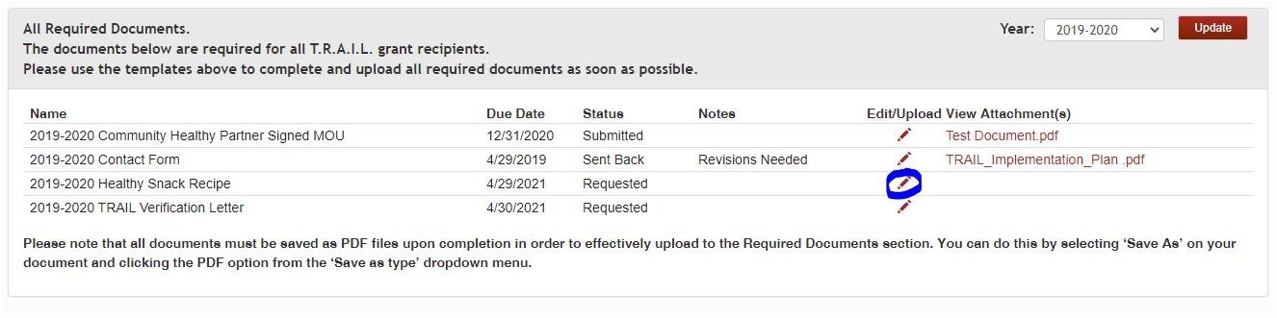
2. Once you select the Pencil, the below box will appear. Select, “Choose File”, and select your saved PDF document. 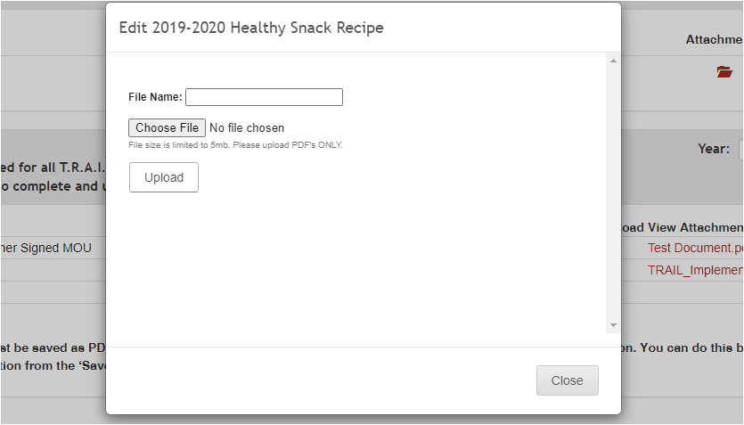

1. Once your document has been successfully uploaded, you will receive a notification indicating success, as seen below. Once this message is received, you may close the pop-up box by selecting the “close” button circled below.  
     
   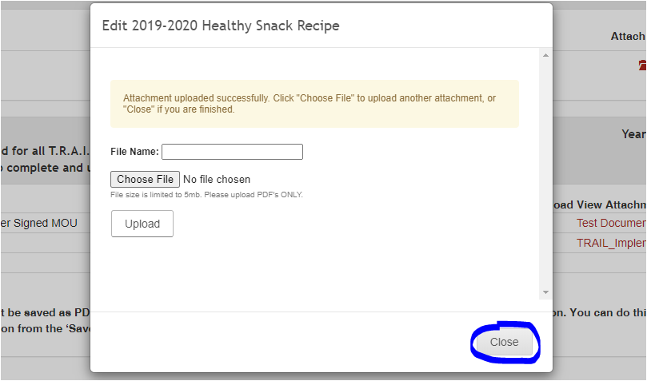

1. Your attached document(s) will be visible in the “View Attachment(s)” column and can be selected at any time to view by clicking on the name of the document (underlined below).   
     
   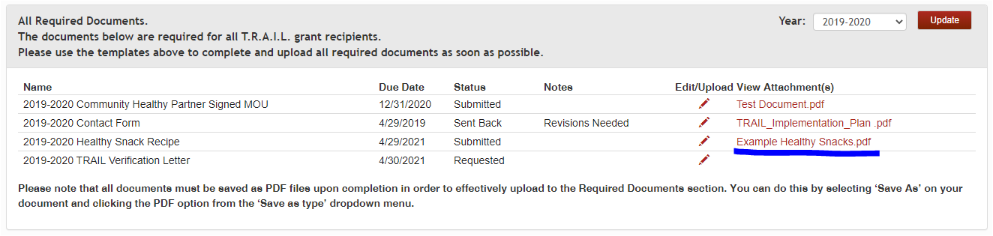
2. 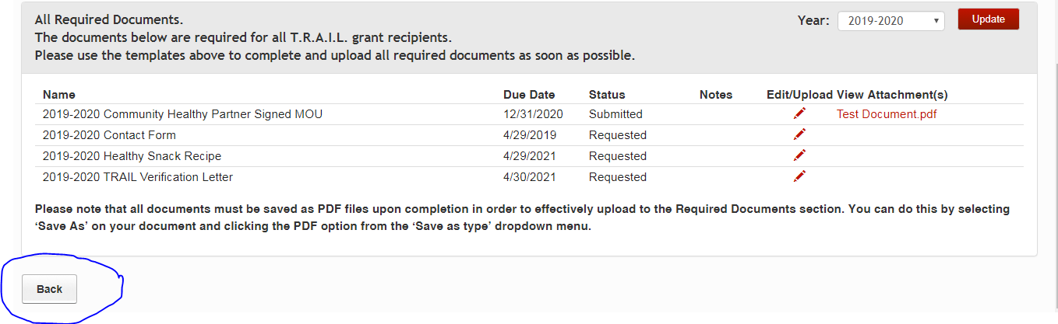If at any point you need to return from the “Grants Document and Compliance” page to the “Organizations” Page (as seen in Step 3), simply either hit the “Back” button on your browser, or scroll to the bottom of the page and hit the “Back” button. However, if you have made any changes to this page (i.e. uploaded any documents), please do not hit “Back” on your browser. Please instead hit the “Back” button in the image below.

1. All required documents will be reviewed by FirstPic, Inc. and NCAI, and then approved/returned as necessary.
   1. If a document is approved, you will receive an auto-email informing you of such (the status will also read as “Approved” in the Documents Repository itself).
   2. 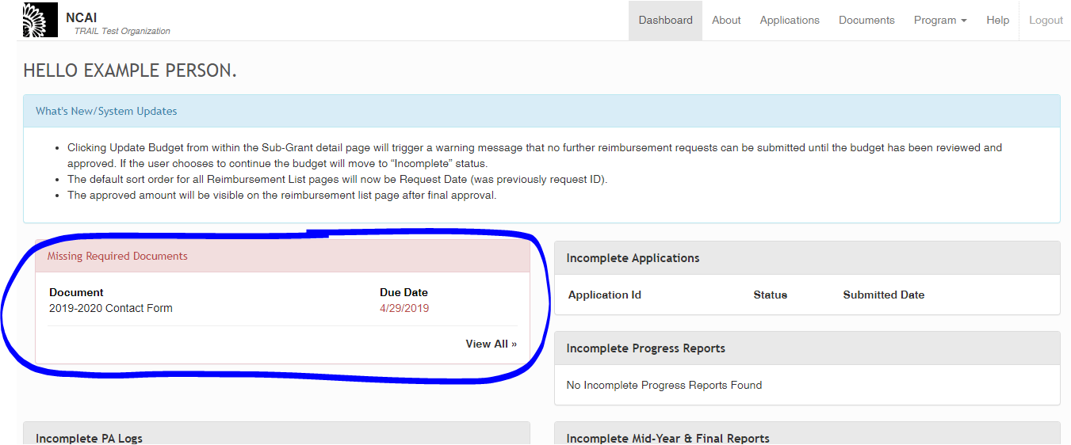If a document is returned for revisions, you will receive an auto-email informing you of this, as well as information as to why it was returned (the status will also change to “Sent Back” in the Documents Repository itself). Documents that are sent back will also show up on your dashboard (see image below).

If a document is returned to you, please refer to the notes provided by the reviewer (this will be available to you in the Revision Request auto-email) before making changes and re-uploading your revised document using the same process outlined in steps 5-8 (if you did not save your initial document to make edits to, you will need to re-download a template from the Templates section (Step 4)).

1. In the case that one of your documents is past-due, it will also appear on your Dashboard under the “Missing Required Documents” section. Clicking on the “View All” button (circled below) will allow you to access the Documents Repository in order to upload this document.   
     
   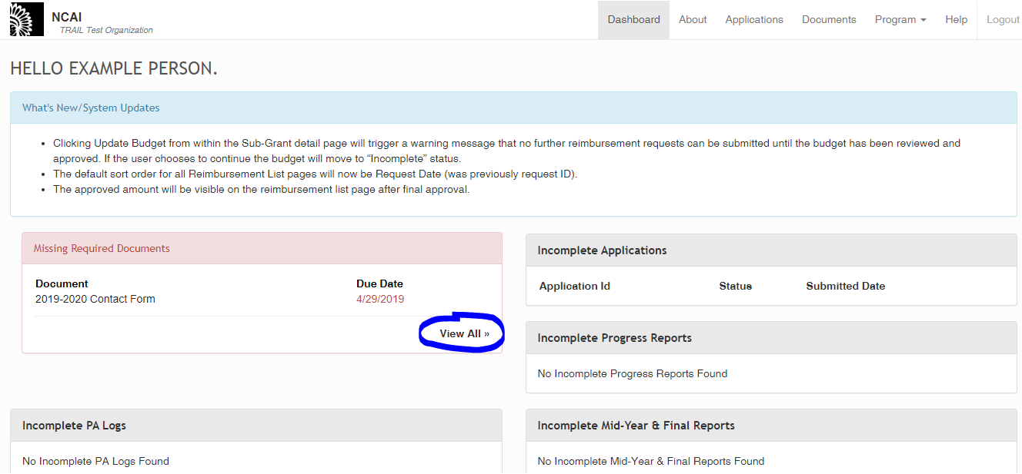

If you select the “View All” button, you will be taken directly to the “Grant Documentation and Compliance” page for your organization (to view site-specific documents, you will need to follow the process outlined in steps 2-3). Once you arrive at the “Grant Documents and Compliance” page, you will be able to follow steps 4-9 outlined above to upload your documents as needed.

