USING AND NAVIGATING THE DOCUMENTS REPOSITORY – SITE COORDINATORS

1. Log in to your T.R.A.I.L. Online Reporting Site home page at <https://firstpic.force.com/ncai/>

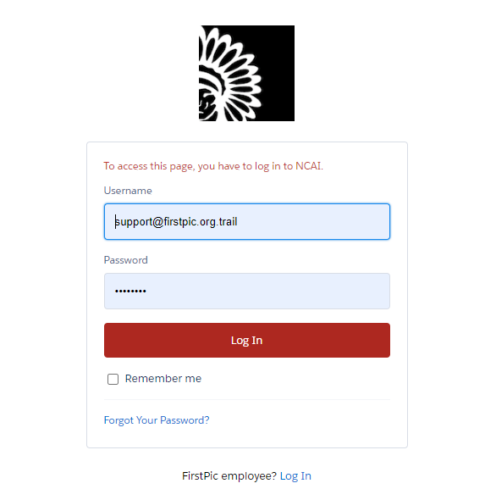

1. Once logged in, you will arrive at your “Dashboard.” From there, click on the “About” Tab.

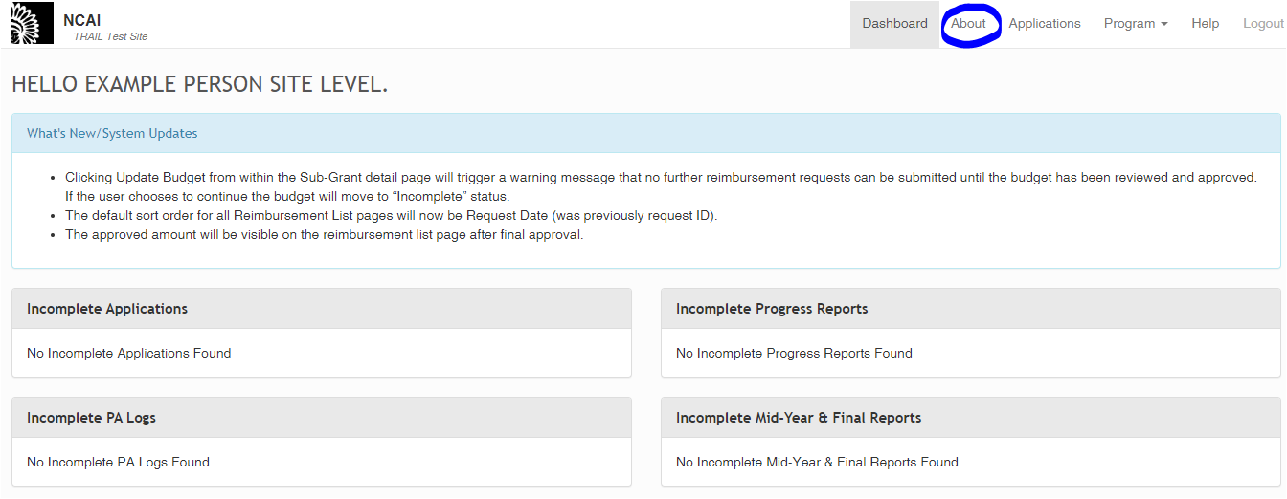

1. This will take you to the “About” page, which now includes a space for you to view and download templates (highlighted yellow in the image below), and upload documents (underlined blue in the image below).   
     
   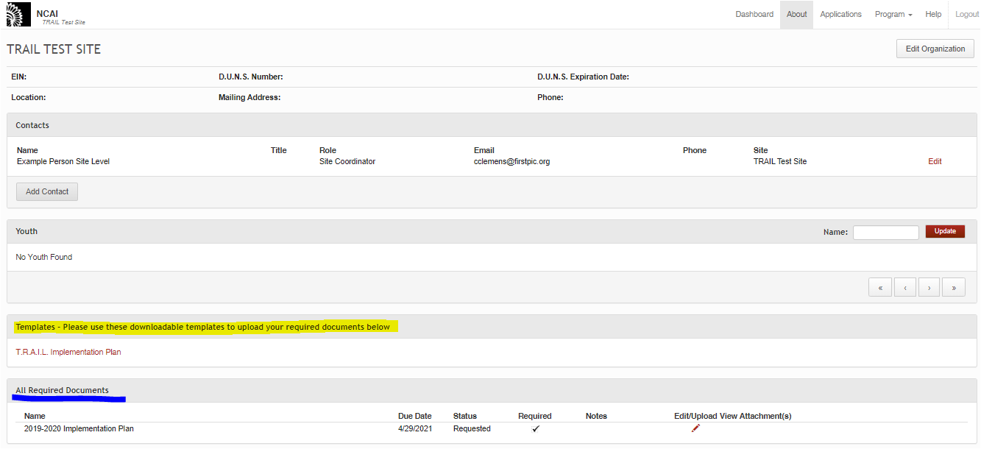
2. When downloading a template, click on the desired document name in the “Templates” section. Once that happens, the template file will download directly to your computer.   
     
   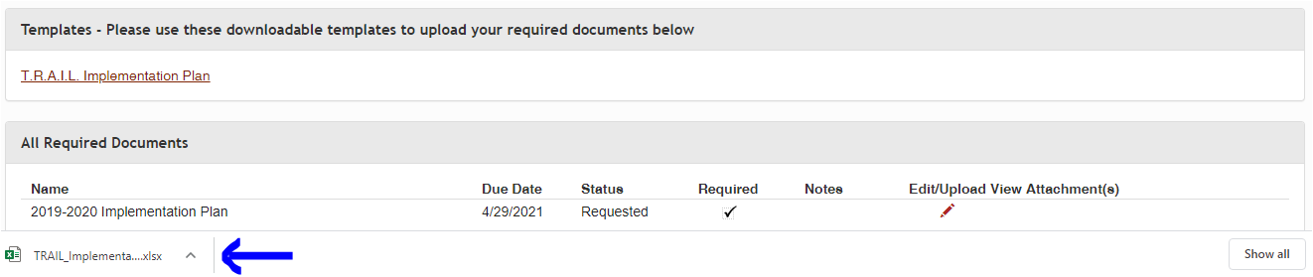
3. When uploading the document, select the Edit/Upload Pencil within the “All Required Documents” section (Circled in the picture below). You will also see that each document has a due date and a status; “Requested” means that it is still needed from your Org/site. Please note that you will be required to upload all documents as PDFs.   
     
   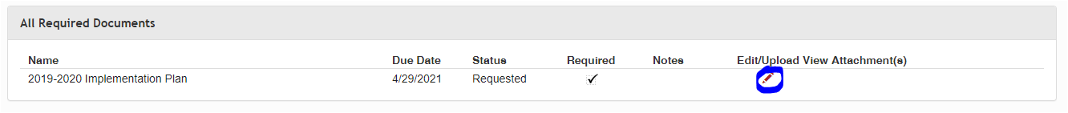
4. Once you select the Pencil, the below box will appear. Select, “Choose File”, and select your saved PDF document.   
     
   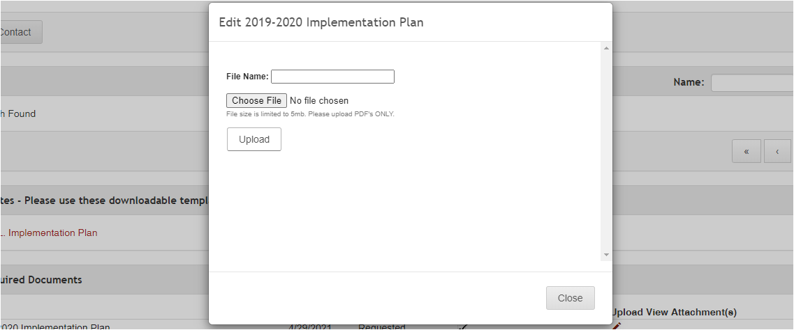
5. 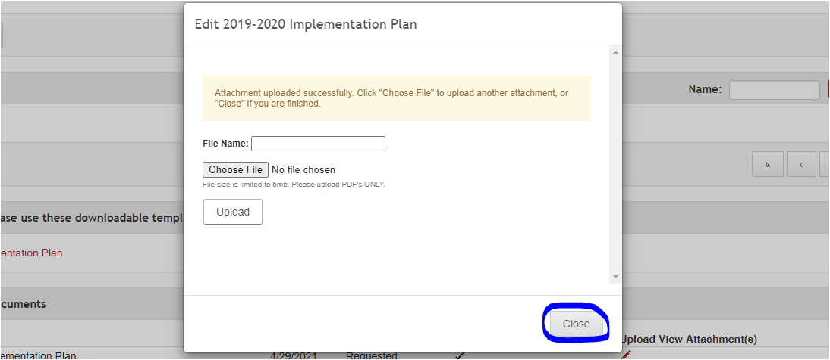Once your document has been successfully uploaded, you will receive a notification indicating success, as seen below. Once this message is received, you may close the pop-up box by selecting the ‘close’ button circled below.

1. Your attached document(s) will be visible in the “View Attachment(s)” column and can be selected at any time to view by clicking on the name of the document (underlined below).   
     
   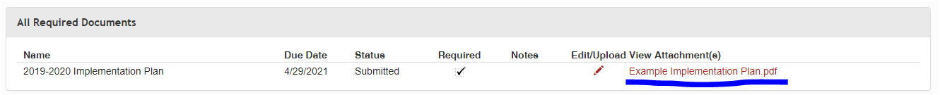
2. All required documents will be reviewed by FirstPic, Inc. and NCAI, and then approved/returned as necessary.
   1. If a document is approved, you will receive an auto-email informing you of such (the status will also read as “Approved” in the Documents Repository itself).
   2. If a document is returned for revisions, you will receive an auto-email informing you of this, as well as information as to why it was returned (the status will also change to “Sent Back” in the Documents Repository itself). Documents that are sent back will also show up on your dashboard (see image below).

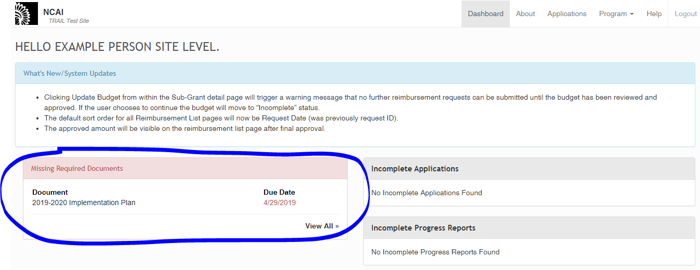

If a document is returned to you, please review any notes provided by the reviewer (this will be available to you in the Revision Request auto-email) before making changes and re-uploading your revised document using the same process outlined in steps 5-8 (if you did not save your initial document to make edits to, you will need to re-download a template from the Templates section (Step 4)).

1. 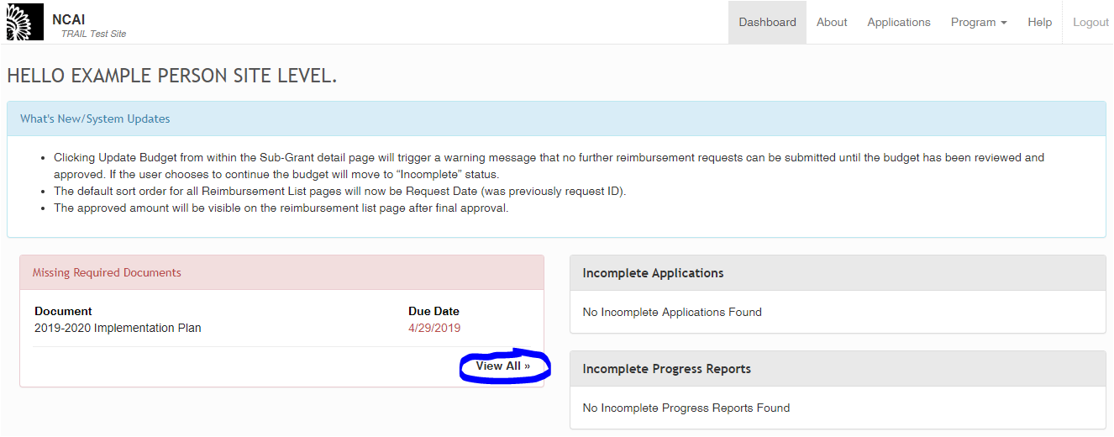In the case that one of your documents is past-due, it will appear on your Dashboard under the “Missing Required Documents” section. Clicking on the “View All” button (circled below) will allow you to access the Documents Repository in order to upload this document. You will follow steps 4-7 outlined above to re-upload your documents as needed.