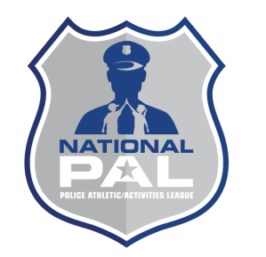 **NPAL Mentor Agreement Form**

As a volunteer mentor in National PAL’s mentoring initiative, I,

_______________________________________ agree that (please initial each of the following):

(Printed Name of Mentor)

1. _____ I will attend a mentoring orientation meeting prior to beginning as a mentor.

2. _____ I will complete my term of service with my mentee to the best of my ability.

3. _____ I will abide by all terms of my relationship with my mentee as may be described in our plan of work.

4. _____ I will meet with my mentees once a week for one hour or bi-weekly for two hours during the year

5. _____ I will be punctual for all scheduled meetings with my mentee and PAL personnel.

6. _____ I will notify PAL promptly if I am unable to keep a scheduled meeting with my mentee.

7. _____ I will seek and/or accept guidance and advice from PAL staff as appropriate.

8. _____ I will keep all information regarding my mentee and my relationship with him/her in the strictest confidence.

9. _____ I will notify PAL of any changes in my employment, address, phone number, e-mail address, etc.

10. _____ I will notify and discuss with PAL staff any thoughts that I have of terminating

my relationship with my mentee *prior to* discussing these with the mentee and/or

his/her family.

__________________________________________ ________________________

**Mentor Signature** **Date**

__________________________________________ ________________________

**PAL Center Staff (witness)**  **Date**