PHYSICAL ACTIVITY CHALLENGES

1. Login to your T.R.A.I.L. Online Reporting Site home page at <https://firstpic.force.com/ncai/>.

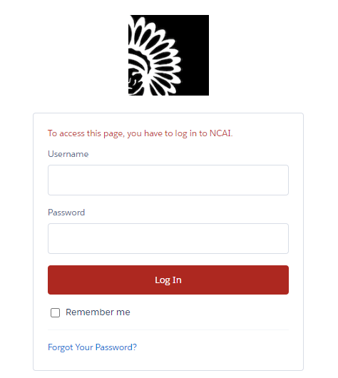

1. 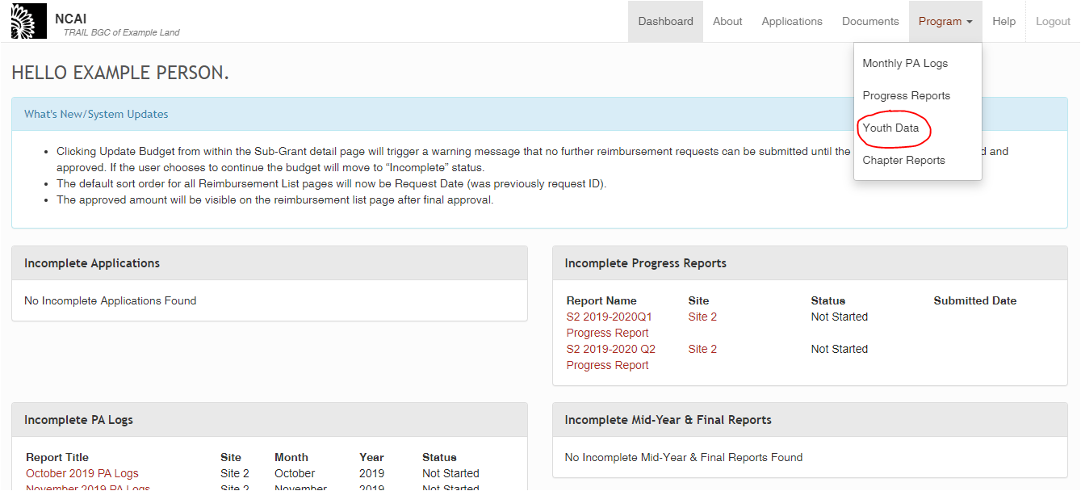Once logged in, you will arrive at your Dashboard. From there, click on the “Program” link in the top right corner of the screen, which will lead to a drop-down menu. Please select “Youth Data”.
2. 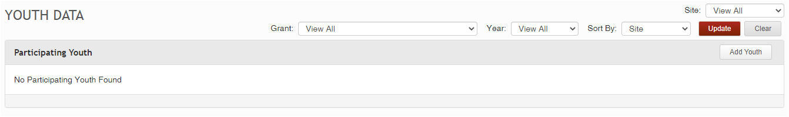You will see a section named “Participating Youth”. In order to find existing youth in your system, you will need to use the filter options at the top-right of your screen to specify which youth you would like to see.  
   1. The Grant dropdown menu helps to narrow the search based on which youth are associated with which grant (for this example, I am looking for youth associated with the “Test Grant”, as seen in the image below).

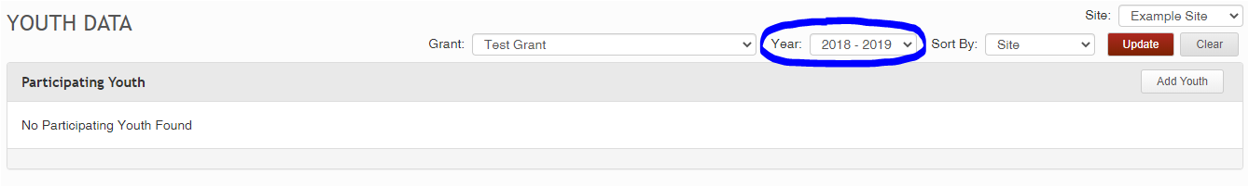

* 1. 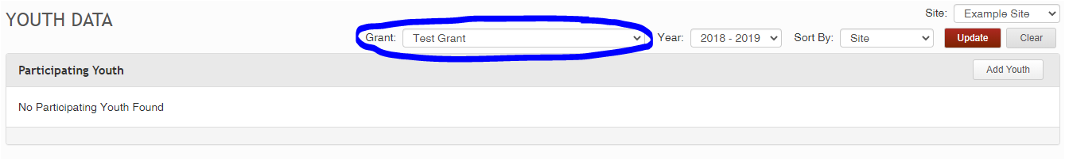The Year dropdown menu helps to narrow the search based on program year (for this example, the youth I am looking for were involved in the 2018-2019 program year, as seen in the image below).
  2. If you have more than one site, the Site dropdown menu helps to narrow the search based on which site your youth are located in (for this example, the youth I am looking for are located at Example Site, as seen in the image below).

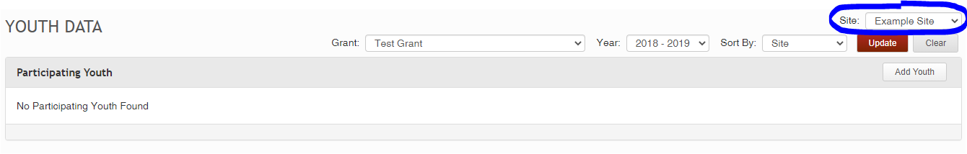

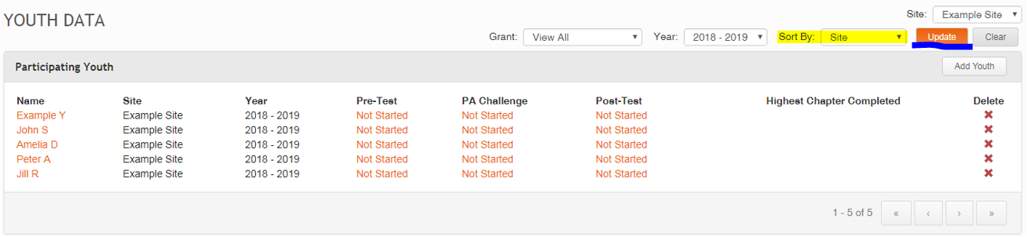Once you have selected the filters that you wish to use, click the “Update” button (underlined in the image below) to view the relevant list of youth. If you would like them sorted in a certain way, you can use the “Sort By” filter (highlighted in the image below) which allows you to sort the Youth List by Site, Grant Name, or Youth Name. Clicking the “Update” button again allows you to initiate this sort, as well as any updates to the filters as wished.

If you do not see your youth in this section after doing the relevant searches, you will need to first add youth into the system – please see the corresponding guide titled “Adding Youth to the Site”.

1. 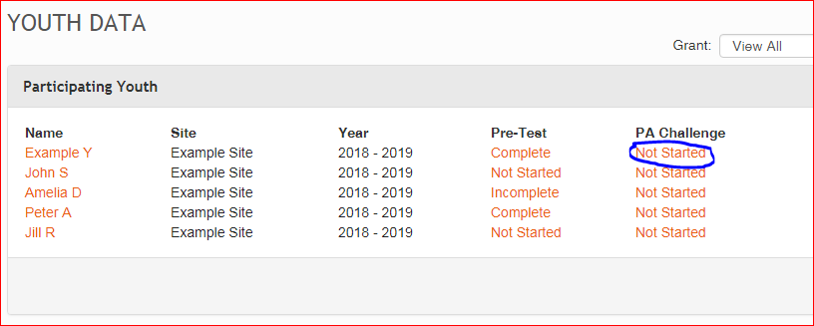In the “PA Challenge” column, click on one of the “Not Started” or “Incomplete” links to begin or continue entering the PA Challenge data for the corresponding youth. In the example shown below, I have not yet entered any PA Challenge data; therefore, all youth show a PA challenge status of “Not Started”. However, depending on the data status, these links may also say “Incomplete” or “Complete”.
2. 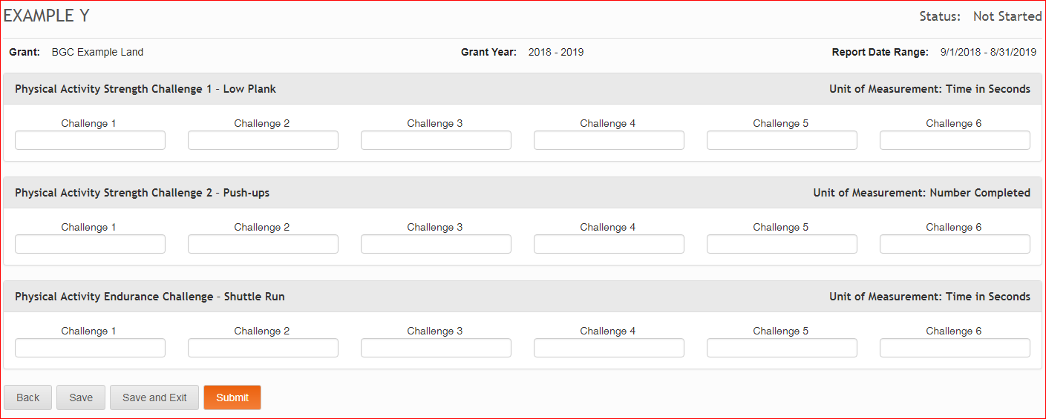You will then see the following screen that presents the three challenges that you will record throughout the T.R.A.I.L. curriculum. The strength challenges – Low Plank and Push-ups – are done for 6 of the 12 chapters (odd-numbered chapters), while the endurance challenge – Shuttle Run – is done for the other 6 (even-numbered chapters). Therefore, there are 6 boxes for each Challenge.
3. The “Example Y” Youth shown in the screenshot below, has completed chapters 1 through 5. This would mean that I would compile data for 3 of the low plank strength challenges and 3 of the push-up strength challenges (completed during chapters 1, 3, and 5), along with 2 endurance challenges (completed during chapters 2 and 4). *Reminder: when compiling data for the Low Plank and Shuttle Run, enter your number in seconds, not minutes.* When you successfully save, your Status will change from “Not Started” to “Incomplete” (upper right-hand corner).

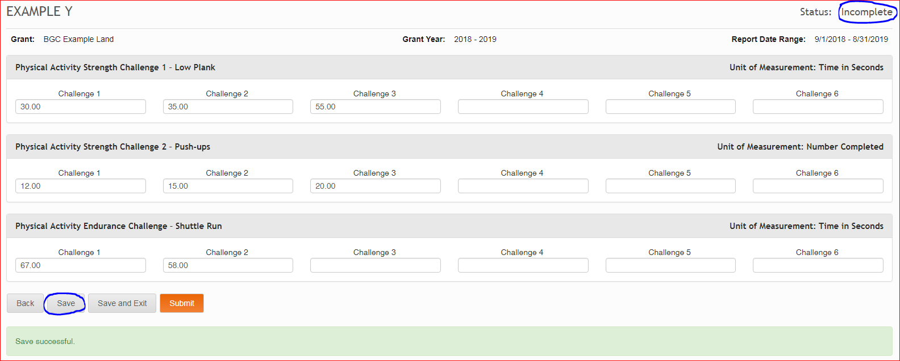

1. In order to update PA Challenges for more youth, click the “Back” link next to the “Save” option.

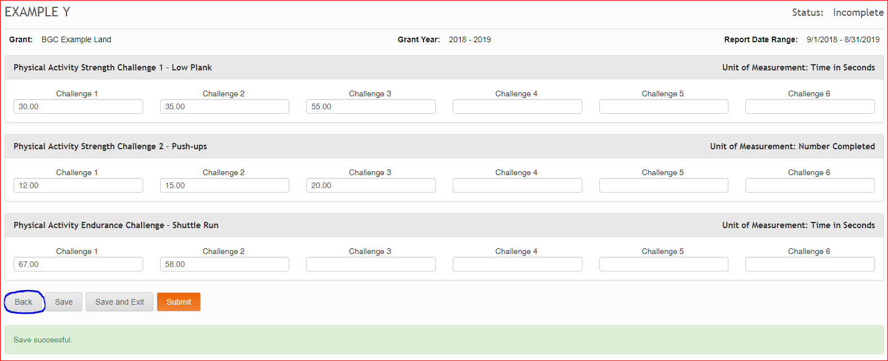

1. 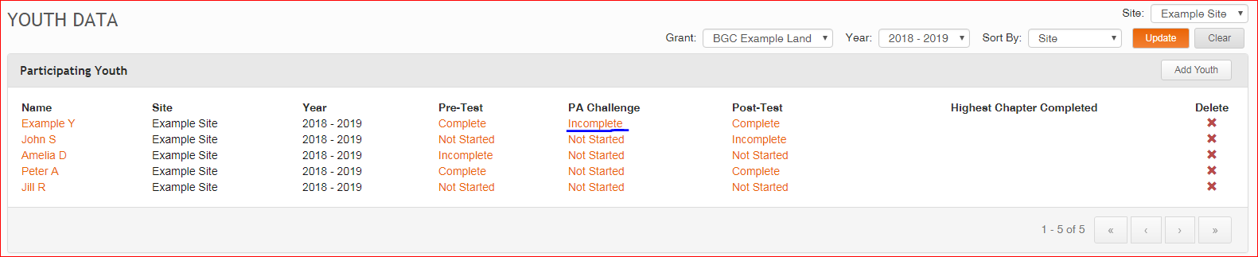You will now see that the Example Y’s PA Challenge is “Incomplete” which indicates that it is in-process of being completed.
2. Once you complete all 12 chapters, you will also need to ensure that the complete data for all your youth’s PA Challenges has been entered. To complete and finalize this data, you would go to the “Participating Youth” page and click on the PA Challenge status that corresponds with the individual youth, grant and year. If we wanted to enter the rest of the PA Challenges for “Example Y” under the “BGC Example Land” grant and the “2018 – 2019” year, we would click on the word “Incomplete” under PA Challenges.
3. 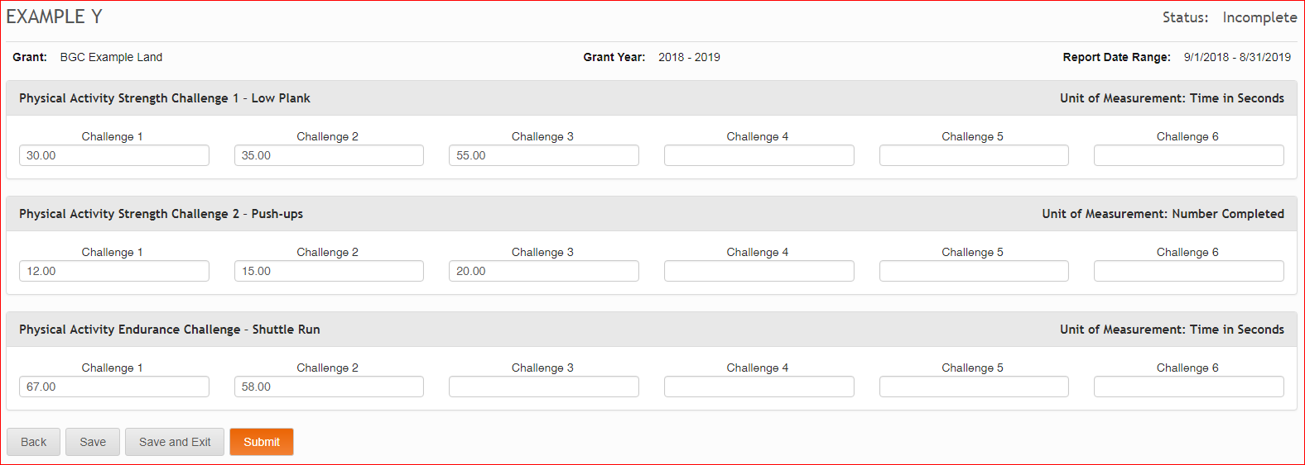If you have previously entered PA Challenge information, you will see that data on your screen. You will need to fill in the remaining information so that there are 6 Endurance Challenges (Shuttle Run) and 6 of each Strength Challenge (Push-ups and Low Plank). If a youth was absent during a PA challenge, you can put “0” for that day – but Club staff should strive to conduct make-up sessions to ensure the maximum amount of data is reported in the site.
4. 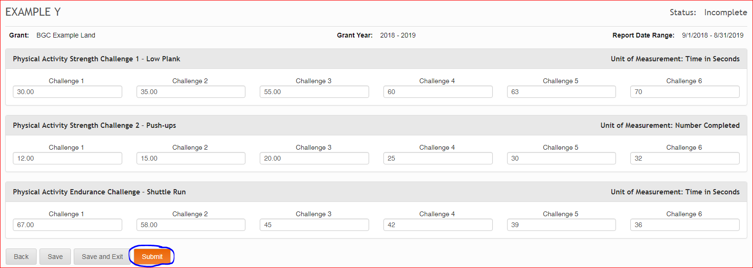Once you have compiled all of your data, hit the “Submit” button in the lower left-hand corner.
5. 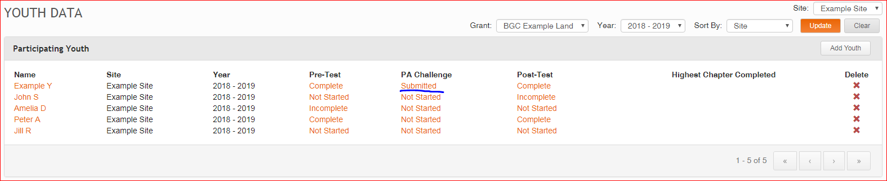You will be sent back to the “Participating Youth” screen. Now, because you have entered data into all of the PA Challenge slots for “Example Y” Youth, their PA Challenge status now reads “Submitted”. Complete these same steps for all youth in your program.

**Please note:** In order to help you visualize and gather data for these 18 challenges, we have provided a spreadsheet tracker which is accessible to you under the Help Tab. The Help Tab is available at the top-right of your screen, next to the “Logout” button. Located beneath the “Physical Activity Challenges” section of the Help Tab, this spreadsheet is titled “Physical Activity Challenge Tracker”.

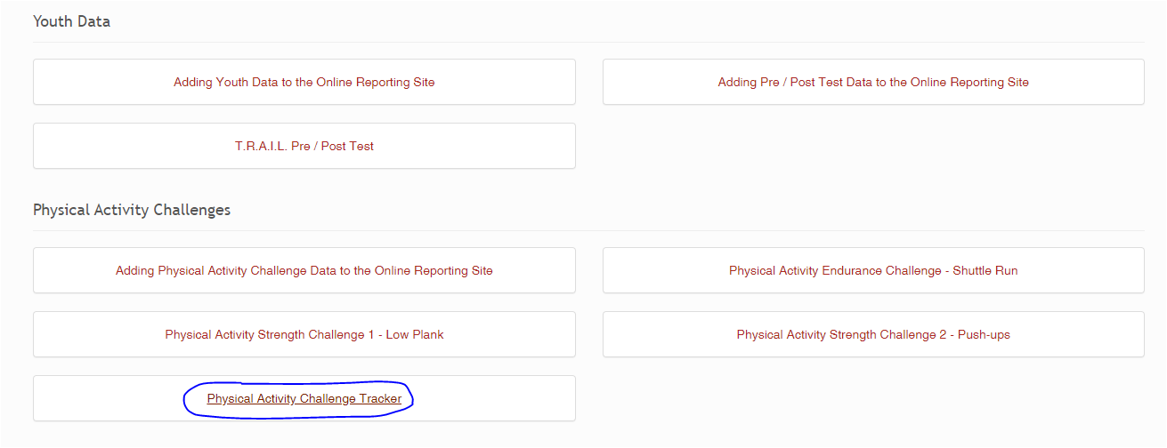

This tracker will open as an Excel spreadsheet, and looks like the below screenshot. Please feel free to use this throughout your program to help with the data-collection process.  
