PHYSICAL ACTIVITY LOGS

Physical Activity logs (or PA logs) are records of the Club-wide activity that has been conducted at your T.R.A.I.L. sites/units throughout the grant year. All T.R.A.I.L. units must complete PA logs for all 12 months of the grant year regardless of when curriculum implementation occurs.

1. To begin entering required PA log data, login to your T.R.A.I.L. Online Reporting Site home page at <https://firstpic.force.com/ncai/>

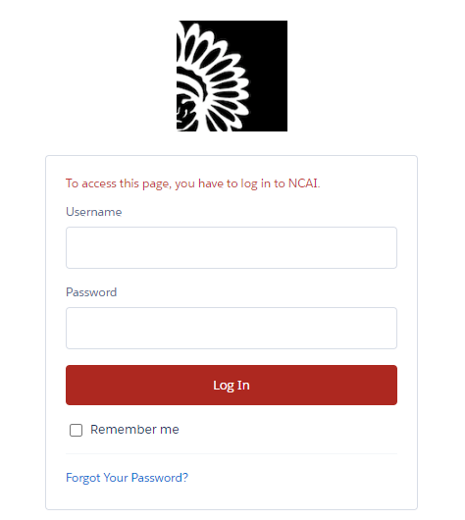

1. 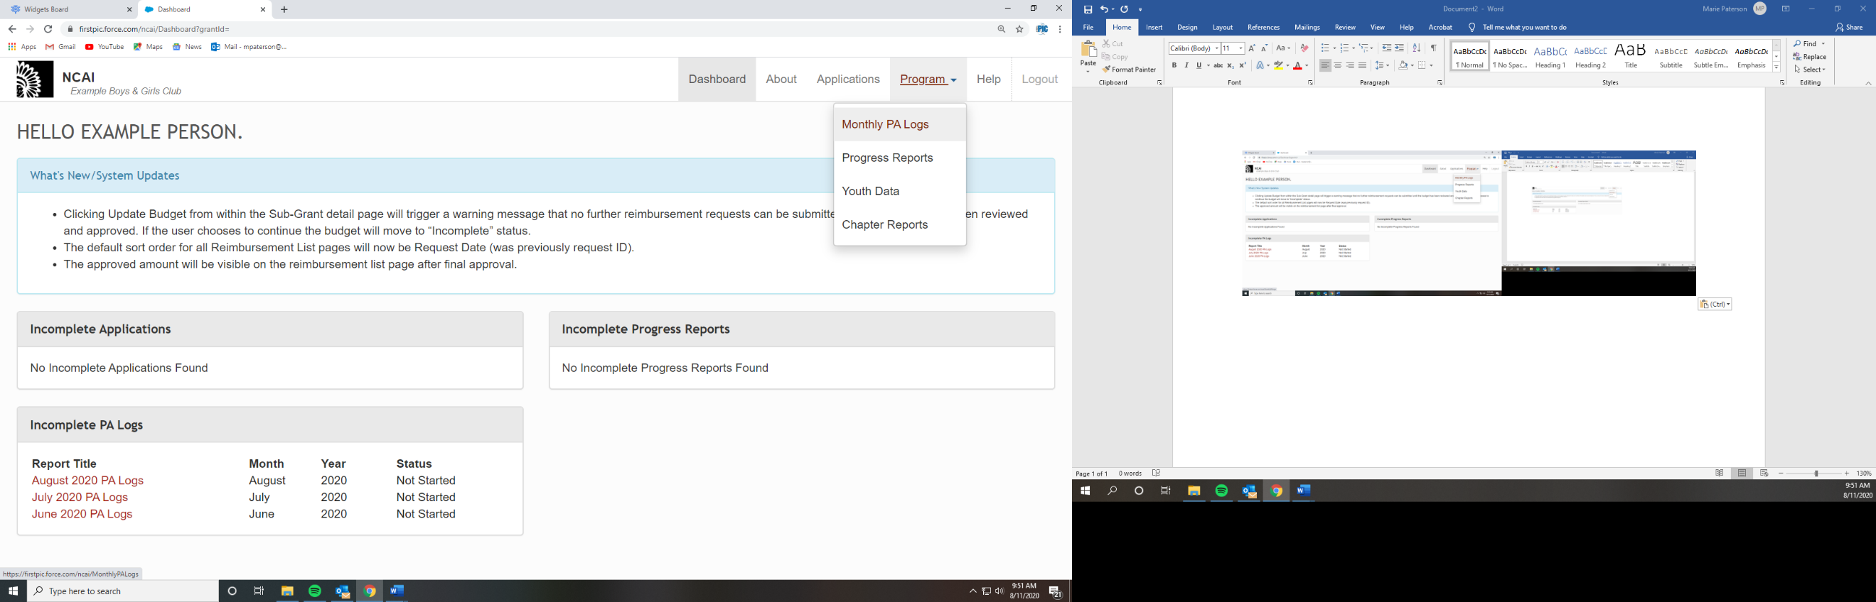Once logged in, you will arrive at your Dashboard. From there, drop down the “Program” Tab and click on the “Monthly PA Logs” option. *Note: You can also view incomplete PA Logs under the “Incomplete PA Logs” header directly on the dashboard.*
2. 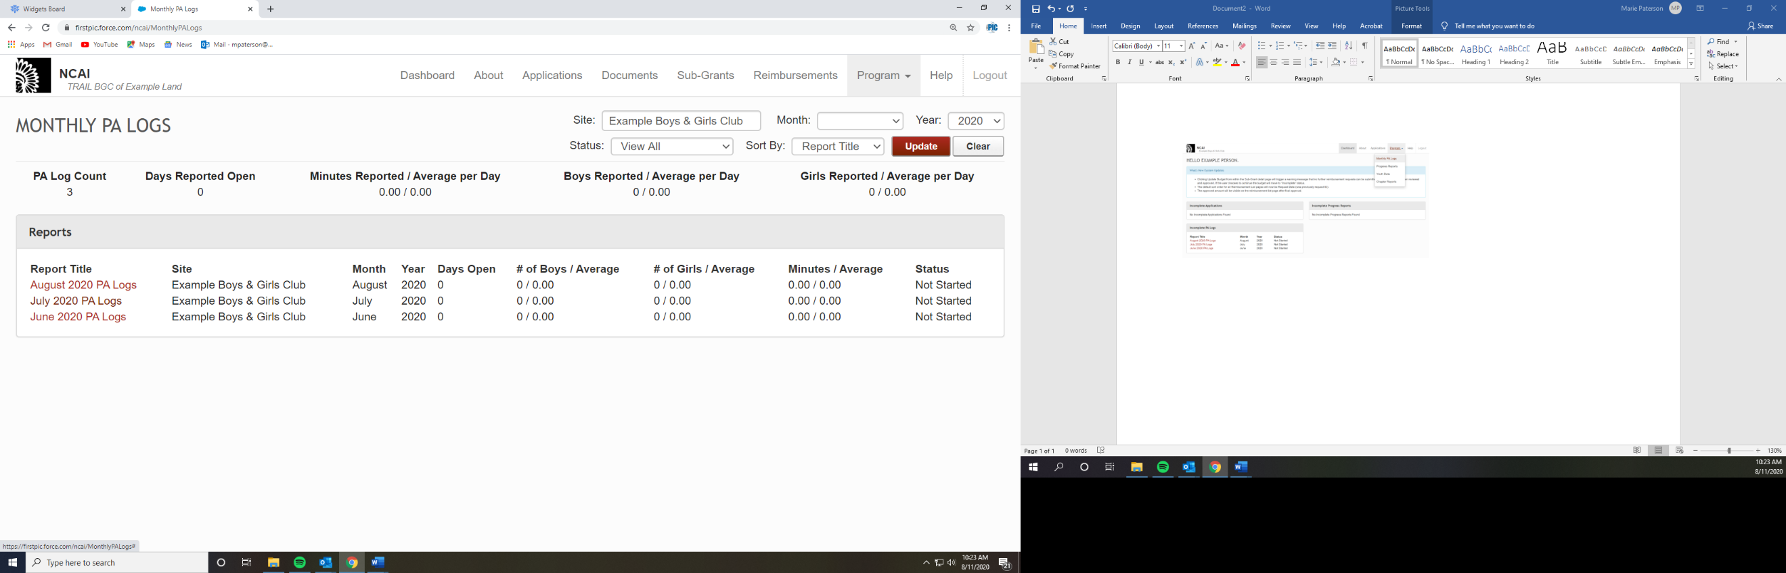In the *Monthly PA Logs* Section, click on the month that you will be entering data for under the “Report Title” column. In this example, we will be entering data for July 2020.
3. 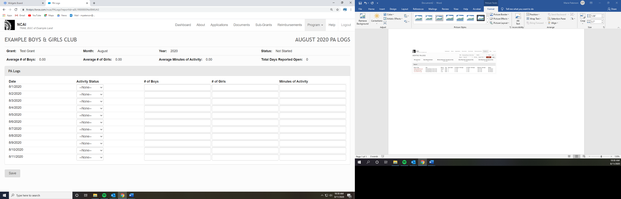Data should be entered for each day of the selected month. *You will notice when you go to fill out your PA Log that only the days that have already gone by will be populated for data entry. Therefore, the log cannot be fully completed and submitted before the month ends.* **For example, if it is August 11th you will only be able to enter data for the first 11 days of August.**
4. On each date, utilize the drop-down menu under “Activity Status” and choose **“Club Activity”**, **“Club Closed”**, or **“No Activity”.** 
   1. **“Club Activity”** indicates that the Club was open and physical activity occurred. Days with “Club Activity” must have both youth data and minutes of activity entered.
   2. **“Club Closed”** indicates that the Club was not open. The site will auto-populate zeros in all columns on days the Club was closed.
   3. **“No Activity”** indicates that the Club was open but no physical activity occurred. The site will auto-populate zeros in all data columns for “No Activity” days.   
        
        
        
        
        
        
        
        
        
        
        
        
        
        
        
      (*Note: Per T.R.A.I.L. LOA requirements all youth that attend the Club MUST participate in at minimum 60 minutes of physical activity every day the Club is open. If there are several days in a month with “No Activity” or less than 60 minutes please reach out to 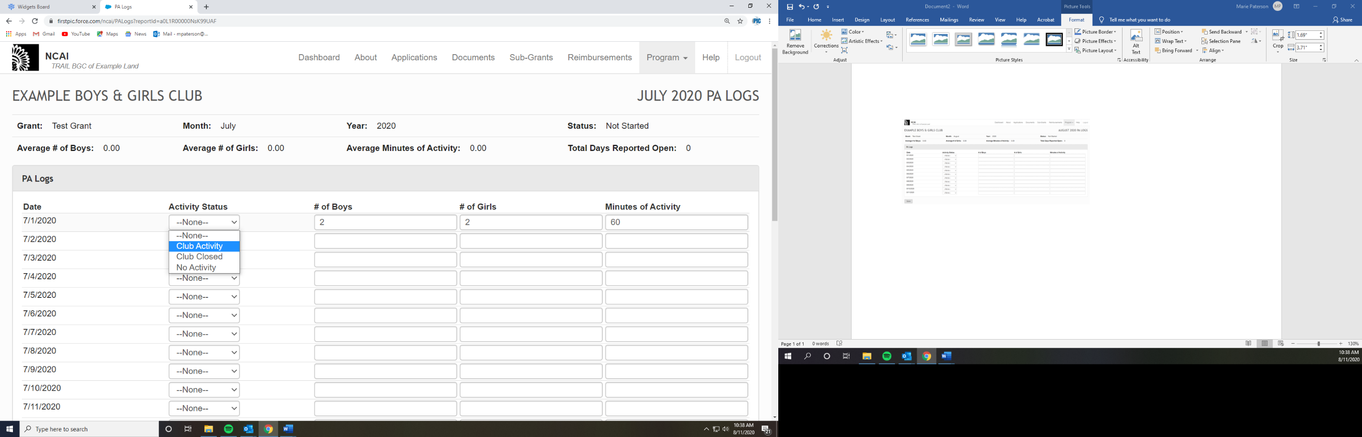FirstPic, Inc.)*
5. 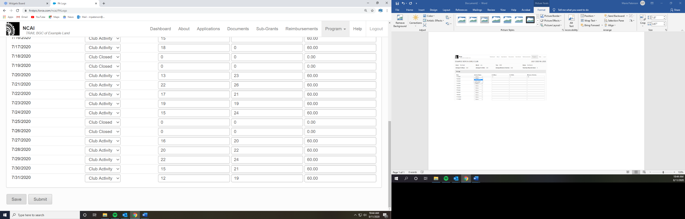Once you have updated your PA Log information, take a moment to review the information for any mistakes. Once you have confirmed the information is correct, scroll down to the bottom of the page and hit “Save”. Once this occurs, you can log out, and your progress will remain for when you return to add further PA Log information.
6. If there are still days left in the month you are currently adding data for, you will be unable to finalize and submit the report until all days have data entered. However, once the month is complete, you will have the option to “Submit”. Once your full month of data is correct in the system, hit the “submit” button.

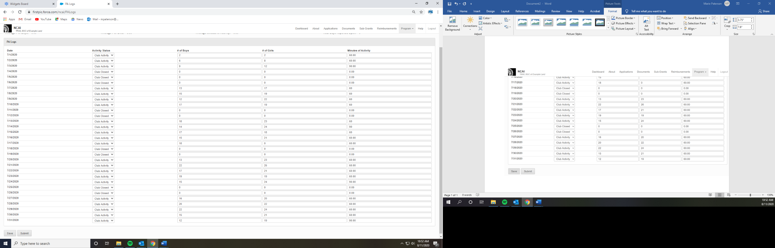

1. After you have submitted your report, FirstPic staff will review the logs for accuracy and either approve them or send them back for any necessary revisions.