COMPLETING PRE AND POST-TESTS

The T.R.A.I.L. Pre and Post-Tests are a way to measure youth knowledge of healthy living and diabetes prevention throughout the program. Youth will complete a test at the start of the curriculum (Chapter 1), and then again at the end (Chapter 12). The results of both of these tests must be documented in the Online Reporting Site (ORS).

1. 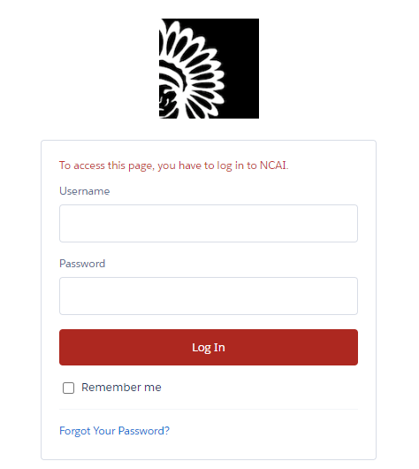In order to enter Pre-/Post-Test information into the ORS, you will first log in to your ORS account at <https://firstpic.force.com/ncai/>

1. 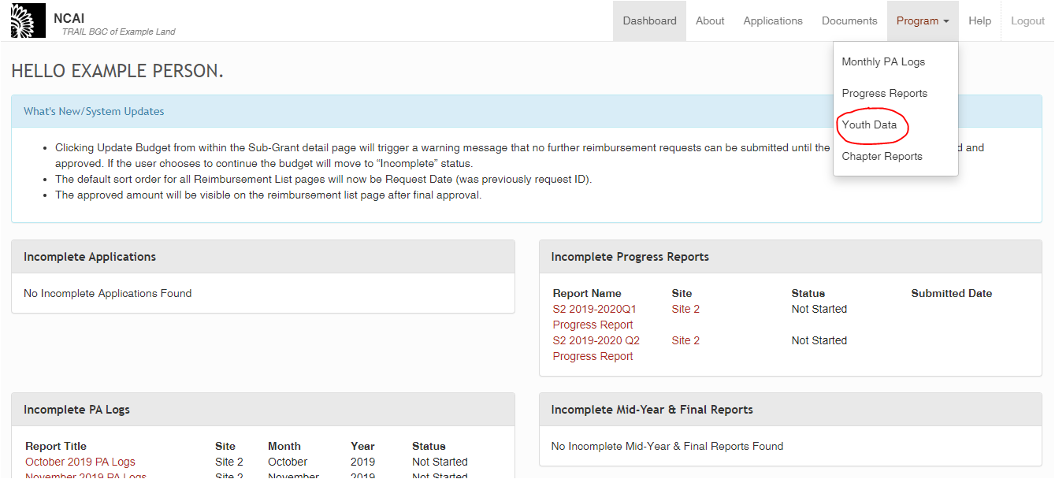Once logged in, you will arrive at your Dashboard. From there, click on the “Program” link in the top right corner of the screen, which will lead to a drop-down menu. Please select “Youth Data”.
2. 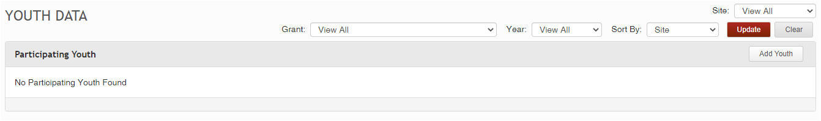You will see a section named “Participating Youth”. In order to find existing youth in your system, you will need to use the filter options at the top-right of your screen to specify which youth you would like to see.  
     
   1. The Grant dropdown menu helps to narrow the search based on which youth are associated with which grant (for this example, I am looking for youth associated with the “Test Grant”, as seen in the image below).

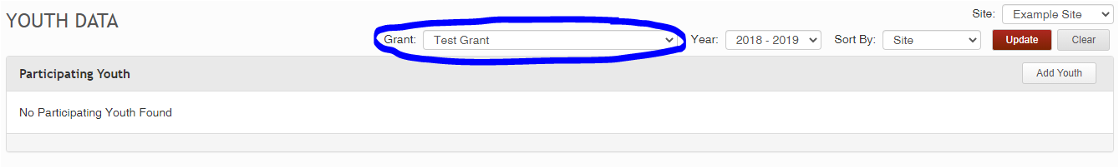

* 1. 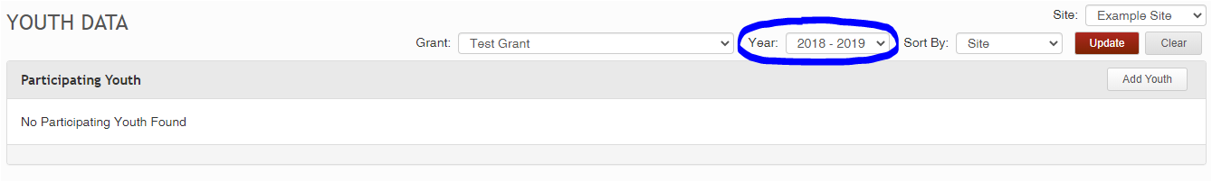The Year dropdown menu helps to narrow the search based on program year (for this example, the youth I am looking for were involved in the 2018-2019 program year, as seen in the image below).

* 1. If you have more than one site, the Site dropdown menu helps to narrow the search based on which site your youth are located in (for this example, the youth I am looking for are located at Example Site, as seen in the image below).

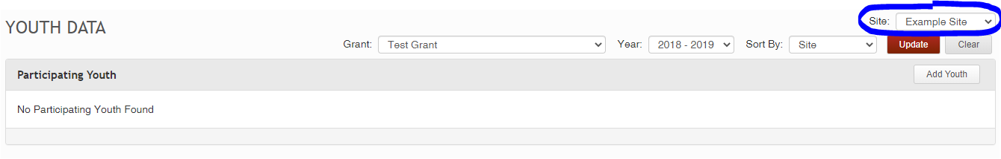

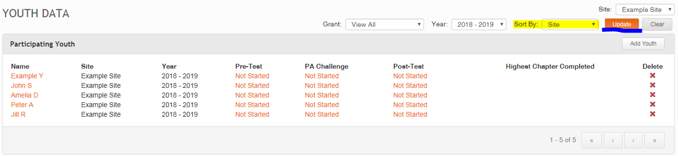Once you have selected the filters that you wish to use, click the “Update” button (underlined in the image below) to view the relevant list of youth. If you would like them sorted in a certain way, you can use the “Sort By” filter (highlighted in the image below) which allows you to sort the Youth List by Site, Grant Name, or Youth Name. Clicking the “Update” button again allows you to initiate this sort, as well as any updates to the filters as wished.

If you do not see your youth in this section after doing the relevant searches, you will need to first add youth into the system – please see the corresponding guide titled “Adding Youth to the Site”.

1. 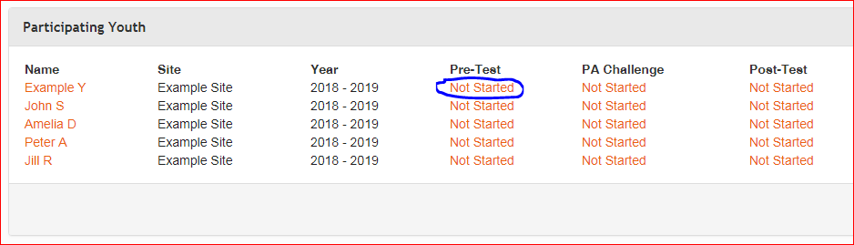When you have entered all participating youth into the system and they have completed the Pre-Tests, click on one of the “Not Started” links to begin entering the Pre-Test information for each youth.
2. 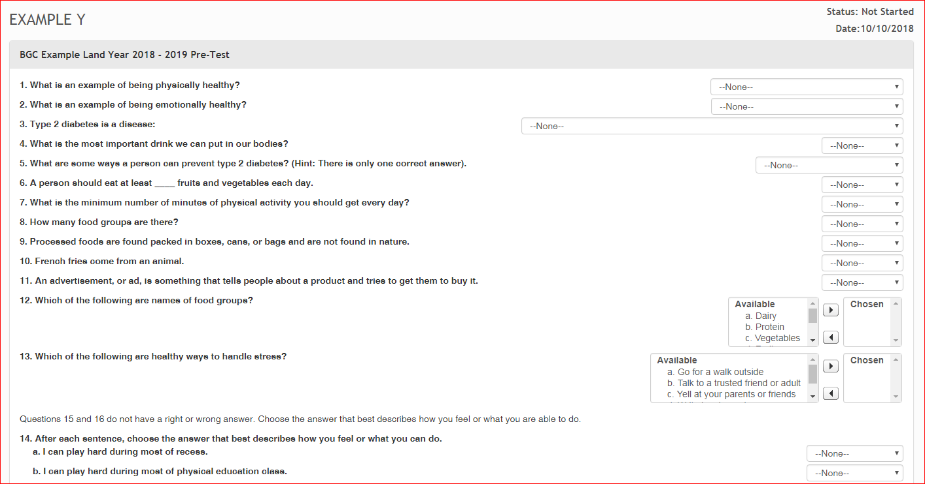For each youth Pre-Test you click on, you will see the following section. Here you will transcribe the youth’s answers to each question. Be sure to regularly hit the “save” button to ensure data is properly saved as you go.
3. 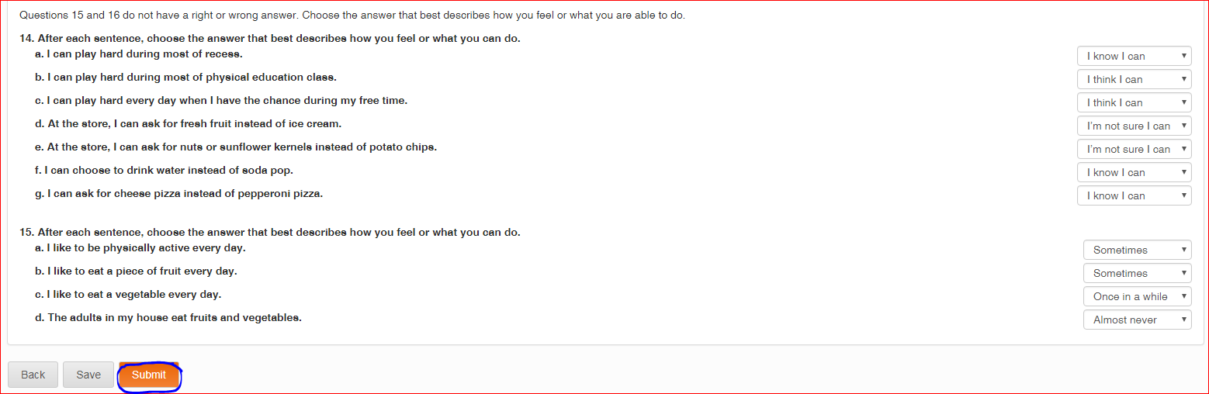Once you have transcribed all of your youth’s Pre-Test responses, be sure to review your work to ensure everything is accurate. Once you have finalized the responses click on the “Submit” link.
4. 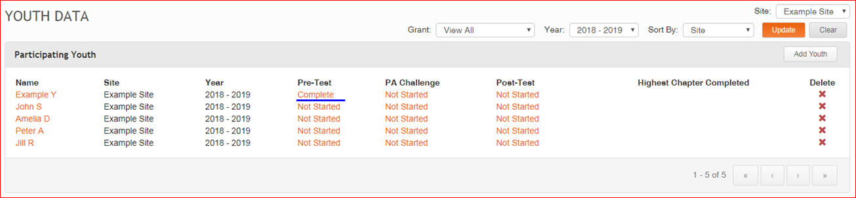You will then be taken back to the “Participating Youth” section. As you can see below, the ORS indicates youth that have a completed Pre-Test.

1. Continue filling in Pre-Tests for all of your youth. In addition to indicating “Complete” and “Not Started” Pre-Tests, the ORS also indicates “Incomplete” Pre-Tests for any test data that was saved before submission.

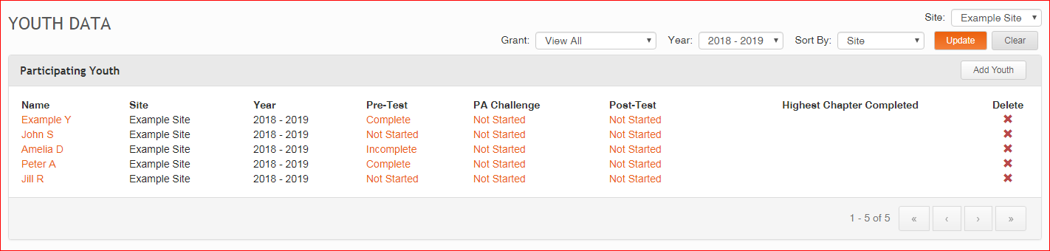

1. 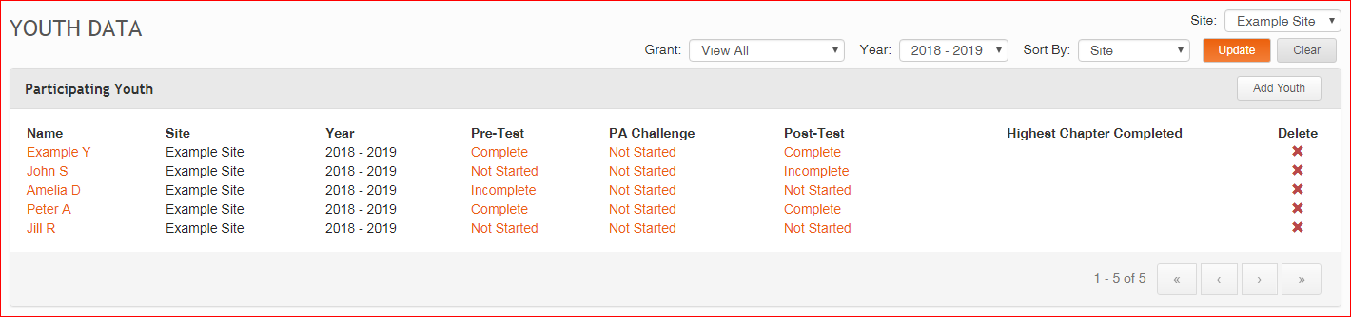The process to input Post-Tests – which are to be completed by youth following Chapter 12 – is the same as the process for inputting Pre-Tests. The content of the tests is identical to the Pre-Test. You will be able to map your progress with the Post-Test by seeing if they are complete, not started, or incomplete. Before the end of each Grant year, you must have fully documented Pre and Post test data into the ORS for all TRAIL participants.