ADDING YOUTH DATA TO THE ONLINE REPORTING SITE

Youth data is a critical requirement of the T.R.A.I.L. grant and is documented via the Online Reporting Site (ORS). This data is collected by the Indian Health Service (IHS) to measure the impact of the program in Native communities participating in the T.R.A.I.L. Program.

1. In order to add youth data into the ORS, you must first login to your T.R.A.I.L. Online Reporting Site home page at <https://firstpic.force.com/ncai/>.

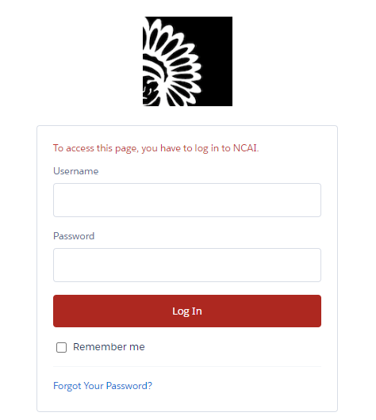

1. 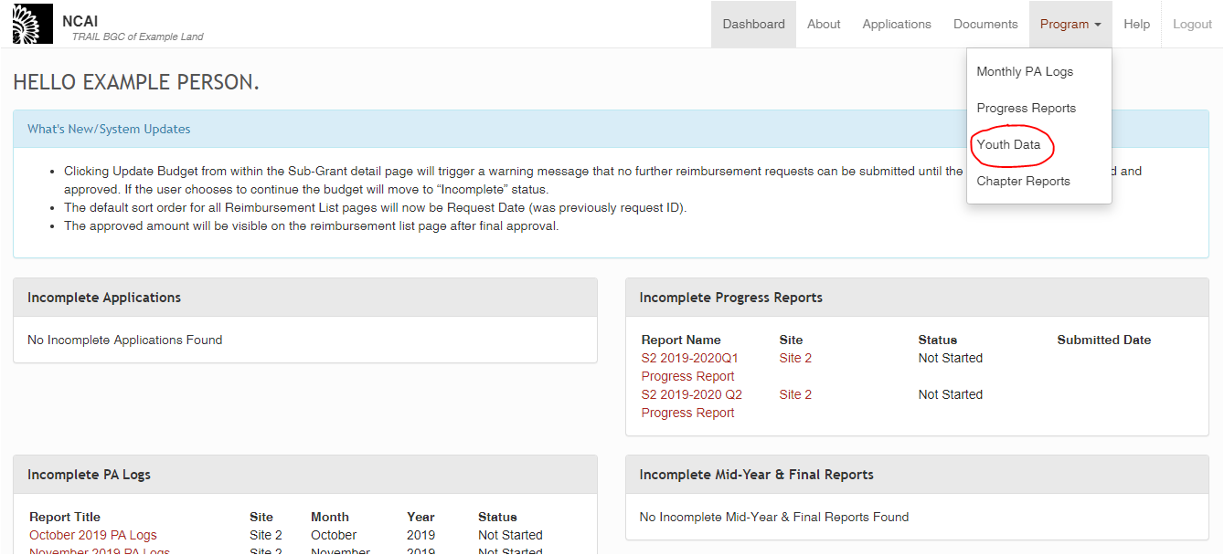Once logged in, you will arrive at your Dashboard. From there, click on the “Program” link in the top right corner of the screen, which will lead to a drop-down menu. Please select “Youth Data”.
2. 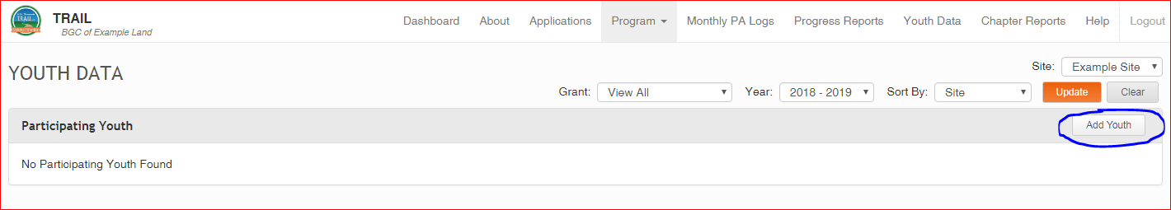You will then see a section named “Participating Youth”. In order to add youth to this section – and be able to add youth-specific information – you will click on the “Add Youth” link on the far-right side.

1. The following screen will allow you to enter in the relevant information for each of your participating T.R.A.I.L. youth.

*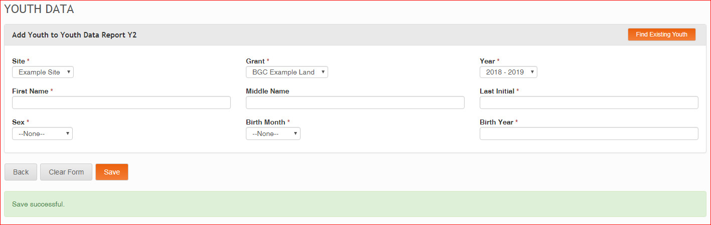Note: Be sure to select the correct site that the particular youth is being served at, as well as the correct grant and year of the program. For confidentiality purposes, please only enter your youth’s last initial. If two youth have the same first name and last initial, please use the “Middle Name” text box to differentiate between the two.*

1. 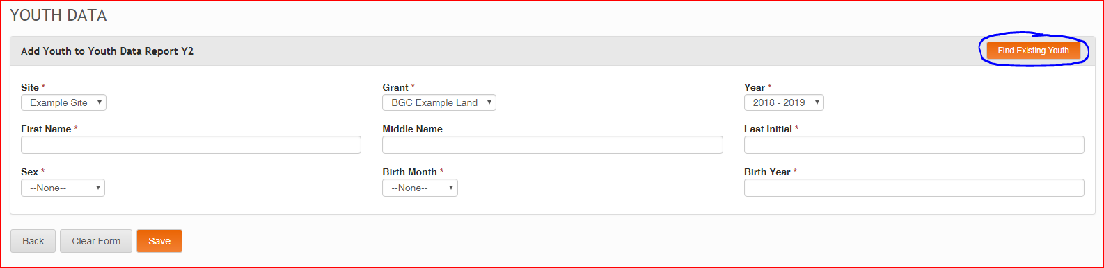If you have run the program in prior years and have already added a particular youth’s information to the Online Reporting Site who will be participating again, you can select the “Find Existing Youth” Button.

Select that individual’s name from the list. As an example, I will choose Adrian K. at the top of this list.

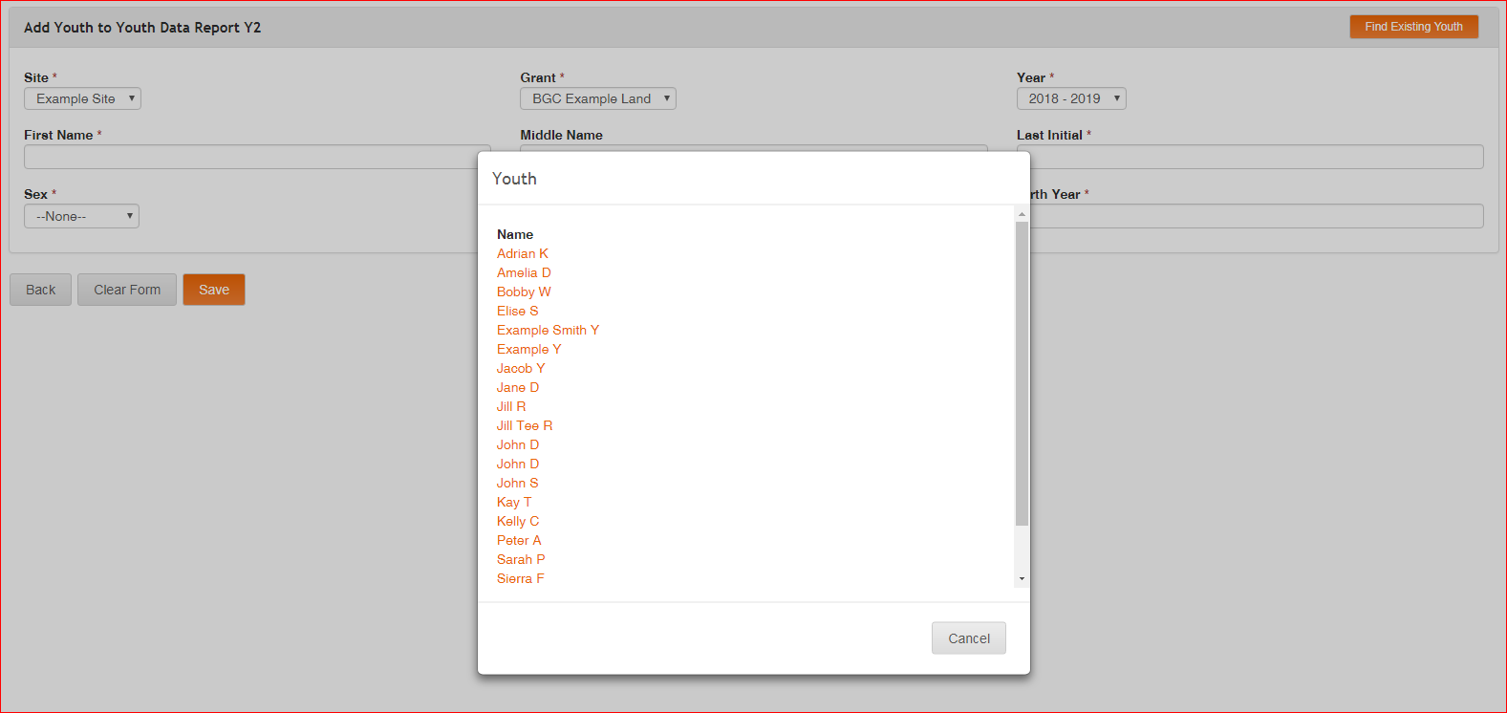

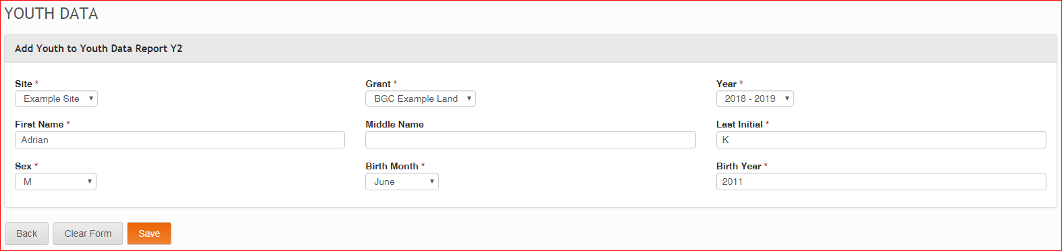Selecting the name will automatically populate the information that was entered in prior years to the required fields.

1. 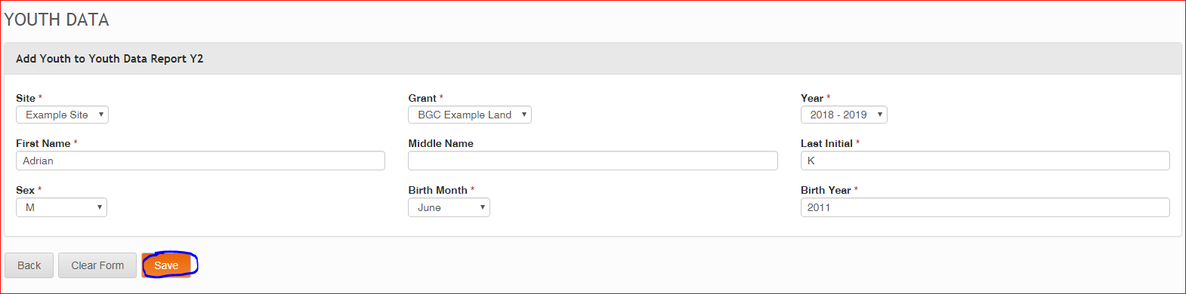After you have entered/updated your information for either your new or existing youth, click the orange “Save” link.

1. Once it has saved, you will see the “Save Successful” message in green to indicate that the youth data has been added. Repeat this process for all youth that you will be tracking for the T.R.A.I.L. grant. At minimum, you should be entering enough youth data records to fulfil the required number of youth to be served as outlined in your organization’s Letter of Award (LOA).
2. You will then return to the “Participating Youth” section, where you will see all of the youth that you have entered. As you can see in the circled filter drop-down options below, these youth have been associated with:
   1. 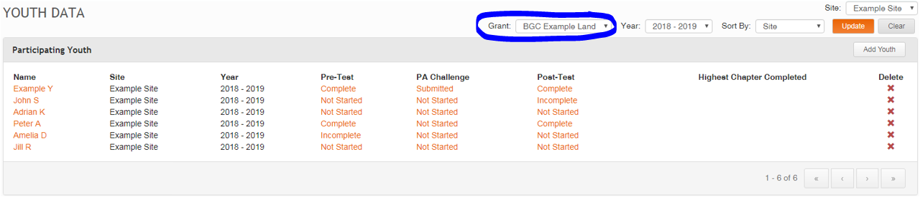A certain grant (“BGC Example Land” in the below example)
   2. 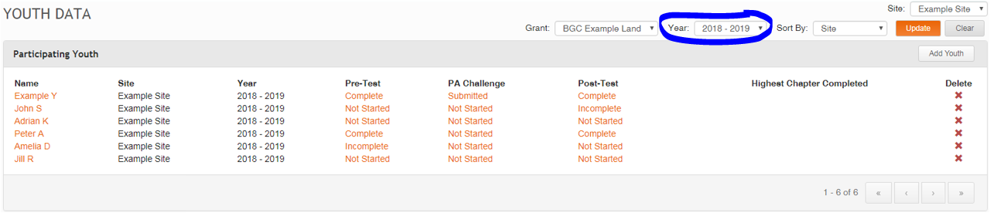A certain year (2018-2019 in the below example)
   3. 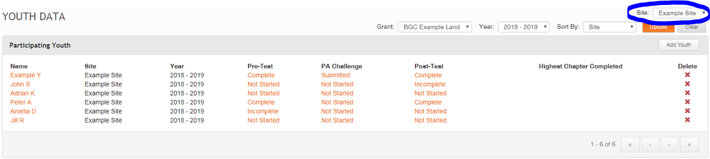A certain site (Example Site in the below example).

These specifications will be useful in the case that you need to review records of certain youth in the future (be that later in that same grant year, or in potential future grant years). If you need to search for a specific youth, please use the above filter drop-down menus to specify your search by grant, year, or site as needed. Once you have found your relevant youth, you will be able to review their information, as well as enter in any required additional information – including their Pre-Test, Physical Activity Challenge, and Post-Test.