1. PROJECT OVERVIEW

What the project does
The Smart Product Recommendation Agent is a Python application that:
- Fetches product data from the public DummyJSON Products API
- Filters and ranks products by category and budget
- Generates stock, discount, and price-change alerts
- Produces a natural-language summary of the top picks (Gemini when available, otherwise a text fallback)
- Exposes this through a Flask web UI (app.py) and a console CLI (main.py)

Main purpose
Help users discover products that match their shopping intent with explainable scores, actionable alerts, and an optional AI-written summary — without requiring AI for core ranking logic.
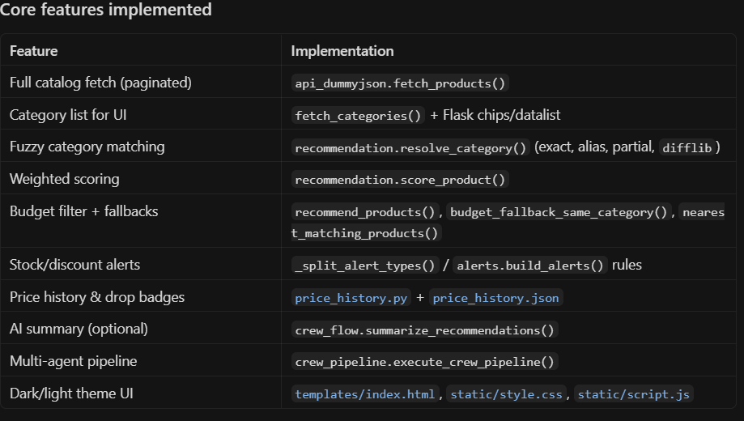
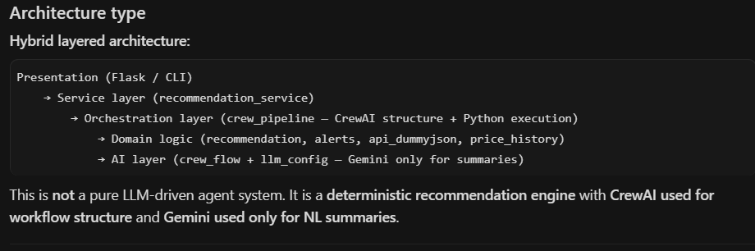

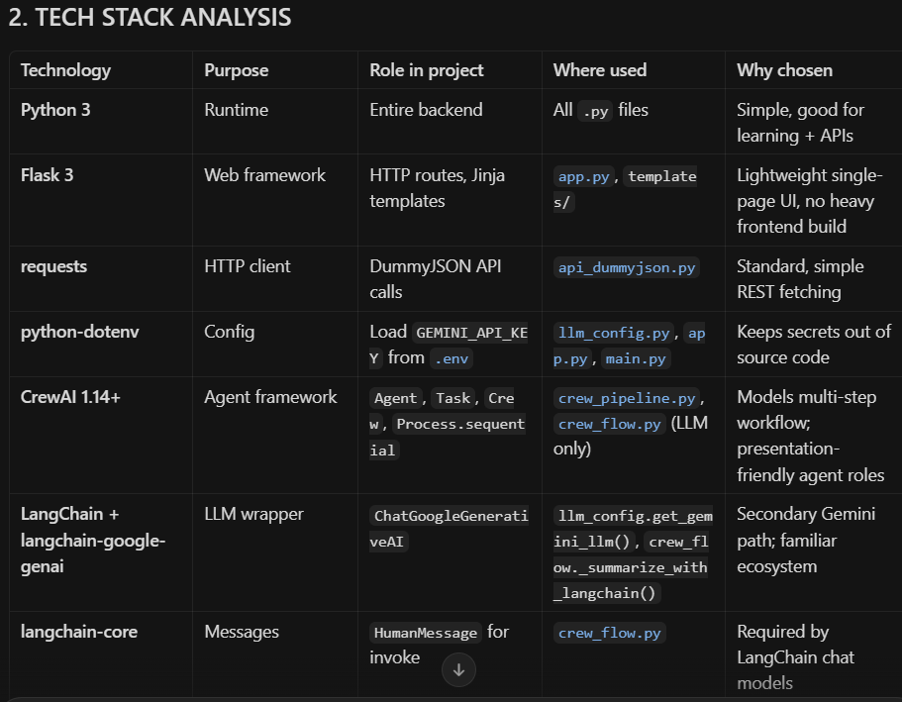
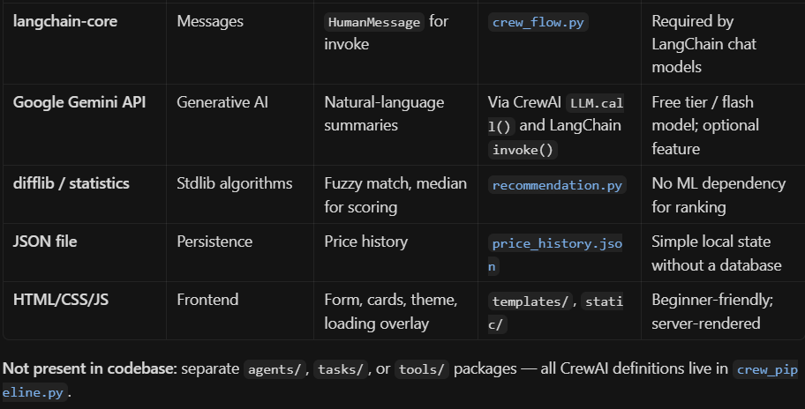

3. MULTI-AGENT ARCHITECTURE

Is this truly multi-agent?
Yes, structurally — with an important caveat.
- Structurally: Five Agent objects, five Task objects, one Crew with Process.sequential.
- Operationally: Steps run via Python functions (run_*_step), not via crew.kickoff(). The shared PipelineContext dataclass carries state between steps.
- AI-powered vs deterministic:
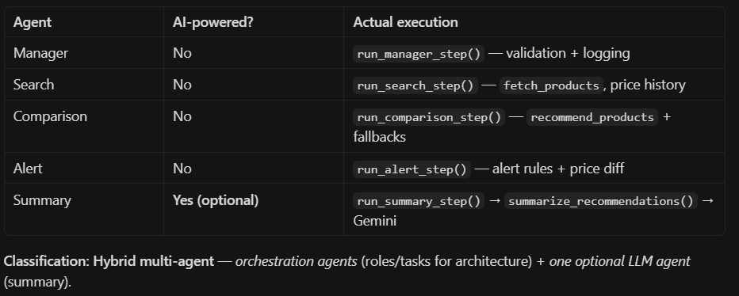

CrewAI usage pattern
CrewAI provides workflow orchestration and documentation structure, not autonomous tool-calling loops for search/compare/alert. The main crew is never kicked off; only the Summary path may call Gemini via get_crewai_llm().call(prompt).

All agents (detailed)

Manager Agent
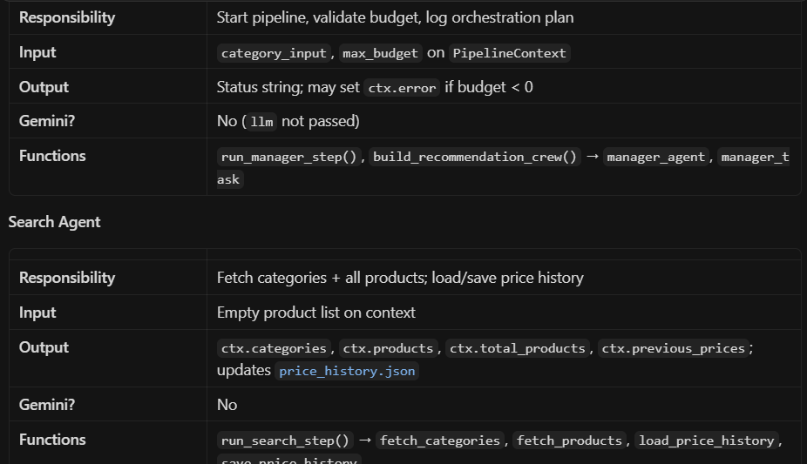
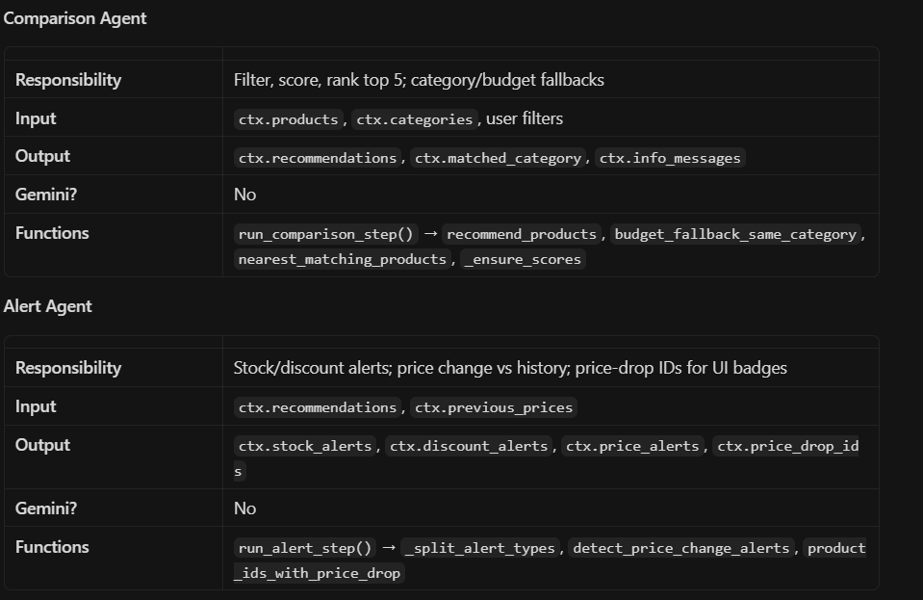
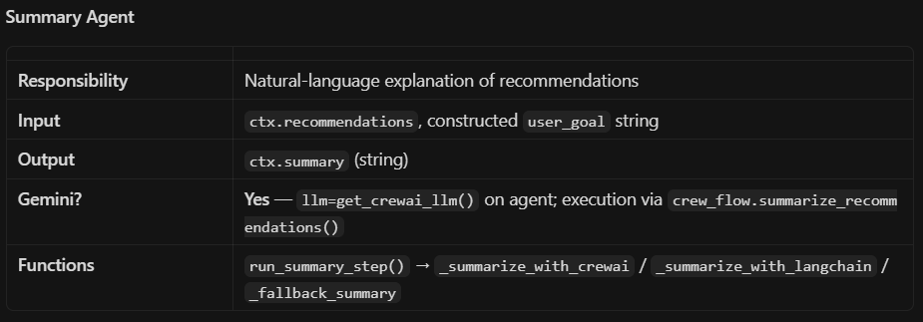

4. WORKFLOW ANALYSIS

Step-by-step execution (web path)
1. User opens GET /
→ app.index() → fetch_categories() for chips
→ render index.html
2. User submits POST (category, budget)
→ app._parse_budget()
→ recommendation_service.run_recommendations(category, max_budget)
3. run_recommendations()
→ execute_crew_pipeline(..., _ensure_scores, _split_alert_types)
4. execute_crew_pipeline()
→ build_recommendation_crew(ctx) # builds Agent/Task/Crew (structure only)
→ Sequential Python steps:
a. run_manager_step(ctx)
b. run_search_step(ctx)
c. run_comparison_step(ctx, _ensure_scores)
d. run_alert_step(ctx, _split_alert_types)
e. run_summary_step(ctx) → summarize_recommendations()
5. run_recommendations() maps ctx → response dict
→ _serialize_product_for_display() per product
→ return to Flask
6. Flask render_template(index.html, result=...)
→ Jinja shows cards, alerts, summary

Data flow between agents
All agents share one PipelineContext object (in-memory dataclass), not CrewAI task outputs:
PipelineContext
├── category_input, max_budget
├── categories[] ← Search
├── products[] ← Search
├── previous_prices{} ← Search (loaded)
├── recommendations[] ← Comparison
├── matched_category ← Comparison
├── info_messages[] ← Comparison
├── stock_alerts[] ← Alert
├── discount_alerts[] ← Alert
├── price_alerts[] ← Alert
├── price_drop_ids{} ← Alert
├── summary ← Summary
└── error (halts pipeline)

Workflow diagram (text)
┌─────────────┐
│ USER │ category + budget (form or CLI)
└──────┬──────┘
▼
┌─────────────┐ GET: categories only
│ app.py / │ POST: run_recommendations()
│ main.py │
└──────┬──────┘
▼
┌─────────────────────┐
│ recommendation_ │
│ service.py │
└──────┬──────────────┘
▼
┌─────────────────────┐
│ crew_pipeline.py │
│ execute_crew_ │
│ pipeline() │
└──────┬──────────────┘
│
├─► [Manager] validate / log
├─► [Search] DummyJSON + price_history.json
├─► [Comparison] recommendation.py scoring
├─► [Alert] alerts + price diff
└─► [Summary] crew_flow → Gemini (optional)
▼
┌─────────────────────┐
│ Serialize + return │ dict for UI/CLI
└─────────────────────┘

Architecture diagram (text)
┌──────────────────────────────────────┐
│ PRESENTATION │
│ Flask (app.py) │ CLI (main.py) │
│ templates/ │ │
│ static/ │ │
└────────────┬─────────────────────────┘
│
┌────────────▼─────────────────────────┐
│ recommendation_service.py │
│ run_recommendations() + UI serialize │
└────────────┬─────────────────────────┘
│
┌───────────────────────┼───────────────────────┐
│ │ │
┌────────▼────────┐ ┌──────────▼──────────┐ ┌────────▼────────┐
│ crew_pipeline │ │ recommendation.py │ │ crew_flow.py │
│ Agent/Task/Crew │ │ (deterministic) │ │ (Gemini NL) │
│ + run_*_step │ │ api_dummyjson │ │ llm_config │
│ │ │ alerts, price_hist │ │ │
└─────────────────┘ └─────────────────────┘ └─────────────────┘
│ │ │
│ DummyJSON REST API Google Gemini API
└──────────────────────────────────────────────────────────

5. CREWAI ANALYSIS

How CrewAI works here
- build_recommendation_crew() creates 5 agents and 5 tasks with context=[previous_task] chaining (documentation of dependencies).
- execute_crew_pipeline() runs a manual for-loop over step functions — it does not call crew.kickoff().
- Summary uses CrewAI’s LLM class (GeminiCompletion) via llm.call(prompt) in crew_flow.py, not a nested mini-crew.
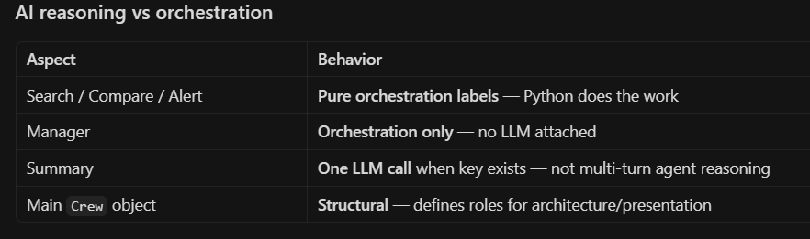

Where Agent / Task / Crew are used
- Defined: crew_pipeline.build_recommendation_crew()
- Stored: ctx.crew
- Executed via kickoff? No for the main pipeline

Why deterministic agents were chosen
- Reproducibility — same input → same ranked products
- Cost — no Gemini tokens for filtering/scoring
- Speed — local math vs API latency
- Correctness — business rules (budget ≤ price, stock < 10) should not be “interpreted” by an LLM
- Quota — project hit Gemini 429 errors when multiple agents used LLM

Evolution: normal Python → CrewAI orchestration
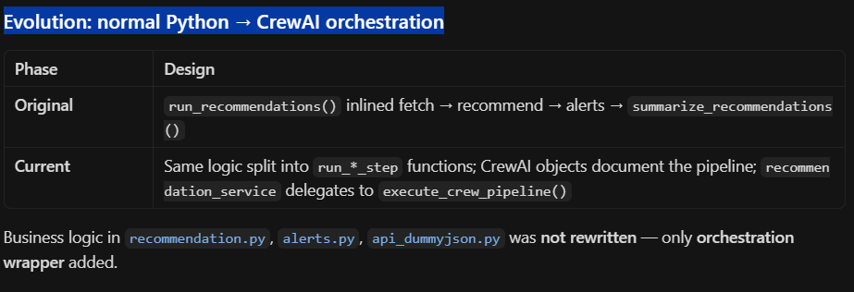

6. LANGCHAIN ANALYSIS

Where LangChain is used
Only in crew_flow.py for the secondary summary path:
from langchain_core.messages import HumanMessage
llm = get_gemini_llm() # ChatGoogleGenerativeAI
response = llm.invoke([HumanMessage(content=prompt)])
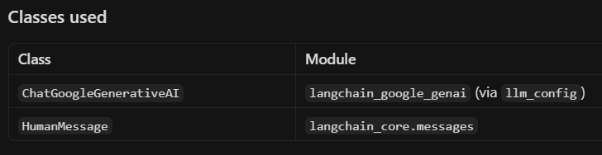

How Gemini is wrapped
llm_config.get_gemini_llm() builds a singleton ChatGoogleGenerativeAI with:
- model=get_gemini_model_name() (default gemini-2.0-flash)
- google_api_key from GEMINI_API_KEY
- temperature=0.7, max_output_tokens=400

Why LangChain is needed
- Backup when CrewAI llm.call() fails (non-quota errors)
- Same key/model as CrewAI path via shared llm_config
- Fallback chain: CrewAI Gemini → LangChain Gemini → deterministic text

Heavily used?
No — lightweight. LangChain is not used for chains, retrievers, memory, or tools. One invoke() per summary attempt when the primary path fails.

7. GEMINI API ANALYSIS

Where Gemini is used
Only in crew_flow.summarize_recommendations() (triggered by Summary Agent step).

Why only Summary Agent
- Summaries need natural language; ranking needs math and rules
- Reduces API cost, latency, and quota usage
- Avoids non-deterministic product ordering

Why removed from other agents
- Manager previously had llm=shared_llm → caused unnecessary API exposure
- Search/Comparison/Alert never needed generative AI
- Pipeline never calls crew.kickoff(), so other agents should not trigger LLM loops

Quota / rate-limit issues (observed in development)
- HTTP 429 RESOURCE_EXHAUSTED on free tier (gemini-2.0-flash)
- CrewAI and LangChain clients retry internally (multiple HTTP calls per summary attempt)
- Old design: nested crew.kickoff() amplified calls and event-bus warnings

Retry behavior (current)
- CrewAI path: llm.call(prompt) — single attempt; exception caught
- If quota exhausted: skip LangChain (_is_quota_exhausted) → deterministic fallback immediately
- Else: LangChain invoke() (may still retry inside google-genai client)
- Final: _fallback_summary() — numbered product list

Fallback mechanism
No products → "No products found..."
No GEMINI_API_KEY → _fallback_summary()
CrewAI success → return AI text
CrewAI 429/quota → _fallback_summary() (skip LangChain)
LangChain success → return AI text
All fail → _fallback_summary()

Optimizations applied
Change | Effect
Remove LLM from Manager | 0 Gemini calls from manager
No crew.kickoff() on main pipeline | No agent-loop API spam
Replace nested crew with llm.call() | 1 CrewAI call vs full kickoff
Quota detection → skip LangChain | Fewer redundant 429 retries
Shared singleton in llm_config | One key, one model config

8. PYTHON LOGIC ANALYSIS

Deterministic components
Module | Logic
recommendation.py | score_product(), resolve_category(), recommend_products(), fallbacks
alerts.py | build_alerts() — stock < 10, discount ≥ 15%
price_history.py | JSON load/save, price drop/increase detection
api_dummyjson.py | REST pagination, dedupe by id
recommendation_service.py | _ensure_scores, _serialize_product_for_display, alert split

Scoring formula (simplified)
score_product() combines:
- Rating (weight 8.0) — dominant
- Quality (rating/5 + small stock term)
- Discount (0.6×)
- Price percentile within category (budget-aware)
- Premium bonus for high-budget mode
- Penalty for rating < 3.0

Why these should NOT use AI
Reason | Explanation
Fairness | Users expect explainable scores
Testing | Unit-testable pure functions
Cost | 194 products × LLM = expensive and slow
Hallucination risk | LLM might invent prices or stock
Rules are explicit | Budget cap, category match, alert thresholds are business rules
AI is appropriate only for the final user-facing explanation (summary).

9. FILE / FOLDER STRUCTURE
SmartProductAgent/
├── app.py # Flask entry, routes, form handling
├── main.py # CLI entry, optional Gemini key prompt
├── requirements.txt # Dependencies
├── .env / .env.example # GEMINI_API_KEY (not in git)
├── price_history.json # Persisted product prices
├── README.md
├── src/
│ ├── api_dummyjson.py # DummyJSON HTTP client
│ ├── recommendation.py # Scoring, filtering, category match
│ ├── alerts.py # Alert message rules
│ ├── price_history.py # Local price tracking
│ ├── recommendation_service.py # Public API for UI/CLI
│ ├── crew_pipeline.py # Agents, tasks, crew, pipeline execution
│ ├── crew_flow.py # Gemini summary + fallbacks
│ └── llm_config.py # Shared Gemini singletons, .env loading
├── templates/
│ └── index.html # Jinja UI (form, results, alerts, summary)
└── static/
├── style.css # Theming, cards, layout
└── script.js # Theme toggle, loading overlay, chips
Note: There is no agents/, tasks/, or tools/ directory — agents are defined inside crew_pipeline.py.
File | Purpose
app.py | HTTP layer only; calls run_recommendations()
main.py | Interactive CLI; can save Gemini key to .env
crew_pipeline.py | Multi-agent structure + execute_crew_pipeline()
crew_flow.py | Only Gemini integration for summaries
llm_config.py | GEMINI_API_KEY, get_crewai_llm(), get_gemini_llm()
recommendation_service.py | Bridge: pipeline → response dict for templates

10. ERROR HANDLING & FALLBACKS
Scenario | Handling
Invalid budget (negative) | ctx.error in Manager step
Product fetch failure | ctx.error, pipeline stops
Category fetch failure | Warning; empty list; comparison may still use product categories
No recommendations | Info messages + fallbacks; or ctx.error
Step exception | Logged with logger.exception; ctx.error = "{Agent} failed: ..."
Missing Gemini key | Deterministic summary
Gemini 429 / quota | Skip LangChain; deterministic summary
Malformed price_history.json | Empty dict; fresh start
Flask category load error | categories_error shown in UI
Logging: logging.INFO in pipeline steps; WARNING on Gemini failures; basicConfig in crew_pipeline if no handlers.
Graceful degradation: App always returns products/alerts when pipeline succeeds; summary degrades to template text without crashing.

11. PERFORMANCE & OPTIMIZATION
Optimization | Benefit
Deterministic agents | No API latency for 4/5 steps
Single llm.call() | vs nested crew.kickoff() + agent iterations
Quota-aware skip of LangChain | Avoids 5+ retry storms on 429
Singleton LLMs | No repeated client construction
Paginated fetch once per request | Full catalog cached in ctx.products for one run
Local scoring O(n log n) sort | Fast vs LLM per product
Current optimized architecture: Structure-rich CrewAI pipeline + compute-heavy Python core + one optional Gemini call at the end.

12. VIVA / PRESENTATION PREPARATION

Probable viva questions & answers
Q: Why CrewAI if you don’t call kickoff()?
A: CrewAI models the multi-step workflow with Agent, Task, and Crew for clarity and presentation. Execution uses reliable Python functions that call existing business logic. This is orchestration-first, not full autonomous LLM delegation.
Q: Why LangChain if you already have CrewAI?
A: LangChain provides a second, direct ChatGoogleGenerativeAI path if CrewAI’s llm.call() fails (non-quota errors). Both share llm_config and the same API key.
Q: Why not use AI for comparisons?
A: Ranking must be consistent, fast, and explainable. Weighted scoring on rating, price, discount, and stock is deterministic. LLMs could hallucinate prices or violate budget rules.
Q: Is this truly multi-agent?
A: Yes at the architectural level — five specialized agents with sequential tasks. Operationally it’s a hybrid: four deterministic agents + one optional LLM-backed summary agent, with shared PipelineContext.
Q: How does CrewAI work here?
A: It defines roles, goals, tasks, and sequential process. execute_crew_pipeline() maps each agent to a Python run_*_step function. Only the summary step triggers Gemini.
Q: What problems were faced?
A: Gemini free-tier 429 quota exhaustion; nested crew.kickoff() caused extra retries; assigning LLM to Manager wasted quota. Fixed by LLM-only-on-summary, direct llm.call(), and quota-aware fallback.
Q: How was Gemini quota optimized?
A: Removed LLM from non-summary agents; removed nested kickoff; one CrewAI call per request; skip LangChain when quota exhausted; shared singleton config.
Q: What external APIs are used?
A: DummyJSON (products/categories) — required. Google Gemini — optional for summaries.
Q: How is the API key managed?
A: GEMINI_API_KEY in project-root .env via python-dotenv; llm_config.load_project_env(); no hardcoded keys; reset_gemini_llm_cache() after CLI key entry.

13. FINAL CLASSIFICATION
Hybrid CrewAI-orchestrated multi-agent product recommendation system that uses deterministic Python specialists for catalog search, weighted ranking, and rule-based alerts, with an optional Gemini-powered Summary Agent (CrewAI LLM.call + LangChain fallback) for natural-language explanations, delivered through a Flask server-rendered UI and CLI, backed by the DummyJSON Products API and local JSON price history.

Quick reference: Gemini calls per successful request
Step | Gemini API calls
Manager | 0
Search | 0
Comparison | 0
Alert | 0
Summary | 0–1 (CrewAI), or +1 (LangChain if CrewAI fails non-quota), or 0 (fallback text)
This matches the actual implementation in your repository today.

